File No.: VIS (2022-23)-PL346-Q079-304-562 Dated: 20/12/2022

LENDER’S INDEPENDENT ENGINEERING REPORT

OF

3.7 MWp ROOF TOP SOLAR PHOTOVOLTAIC POWER PROJECT

TO BE SET-UP AT
5 LOCATIONS IN NATIONAL CAPITAL REGION

COMPANY/PROMOTER
M/S SOLAR QUEST PROJECTS FOUR PRIVATE LIMITED

REPORT PREPARED FOR
M/S SOLAR QUEST PROJECTS FOUR PRIVATE LIMITED

TO BE SUBMITTED AT
STATE BANK OF INDIA, SME BRANCH, ASAF ALI ROAD, NEW DELHI

**Important - In case of any query/ issue or escalation you may please contact Incident Manager
at le@rkassociates.org. We will appreciate your feedback in order to improve our services.
NOTE: As per IBA Guidelines please provide your feedback on the report within 15 days of its submission after which report will be considered to be correct.

IMPORTANT NOTICE

COPYRIGHT FORMAT: This report is prepared on the copyright format of R.K Associates to serve our clients with the best possible information and analysis to facilitate them to take rational business decisions. Legally no one can copy or distribute this format without prior approval from R.K Associates. It is meant only for the advisory/ reference purpose for the organization/s as mentioned on the cover page of this report. Distribution or use of this format by any organization or individual other than R.K Associates will be seen as an unlawful act and necessary legal action can be taken against the defaulters.
This report is intended for the sole use of the intended recipient/s and contains material that is STRICTLY CONFIDENTIAL AND PRIVATE.

DEFECT LIABILITY PERIOD: - In case of any query/ issue or escalation you may please contact Incident Manager at le@rkassociates.org.
Though adequate care has been taken while preparing this report as per its scope, but still we can’t rule out typing, human errors, over sightedness of any information or any other mistakes. Therefore, the concerned organization is advised to satisfy themselves that the report is complete & satisfactory in all respect. Intimation regarding any discrepancy shall be brought into our notice immediately. If no intimation is received within 15 (Fifteen) days in writing from the date of issuance of the report, to rectify these timely, then it shall be considered that the report is complete in all respect and has been accepted by the client upto their satisfaction & use and further to which R.K Associates shall not be held responsible in any manner.

TABLE OF CONTENTS
SECTIONS | PARTICULARS | PAGE NO.
Part A | REPORT SUMMARY | 03
Part B | INTRODUCTION | 05
 | - Project Name | 05
 | - Project Overview | 05
 | - Scope of the Report | 07
 | - Purpose of the Report | 07
 | - Methodology Adopted | 07
 | - Performance Security | 07
 | - Project Schedule for Completion of the Project | 08
 | - Power Purchase Agreement | 08
Part C | PROJECT LOCATION CAPACITY AND SPECIFICATIONS | 09
Part D | CURRENT STATUS OF WORK | 11
Part E | PROJECT COST & EXPENDITURE | 12
Part F | PHOTOGRAPHS | 14
Part G | DISCLAIMER | 16

ABBREVIATIONS
SQP4 PL | Solar Quest Projects Four Private Limited
PV | Photovoltaic
RRTS | Regional Rapid Transit System
NCRTC | National Capital Region Transport Corporation
RESCO | Renewable Energy Service Company
COD | Commercial Operation Date

PART A | REPORT SUMMARY

 | Name of the Project | : | Roof Top Solar PV (Photovoltaic) Project with a capacity of 3.7 MWp in RESCO model.
 | Project Location | : | Delhi – Ghaziabad – Meerut RRTS Corridor of NCRTC
 | Name of the Borrower Company/  Promoter | : | M/s Solar Quest Projects Four Private Limited
 | Prepared for Organization | : | State Bank of India - SME, Asaf Ali Road, New Delhi
 | LIE Consultant Firm | : | M/s R.K. Associates Valuers & Techno Engineering Consultants (P) Ltd
 | Date of Survey | : | 4th November 2022
 | Date of Report | : | 9th December 2022
 | Expected COD | : | 30th June 2023
 | Details & documents provided by | : | Mr. Pranjal Dhariwal  (Authorized representative of the company)
 | Survey in presence of | : | Mr. Shravan  (Company’s Employee)
 | Report Type | : | Lender’s Independent Engineer’s Report
 | Purpose of the Report | : | Review, evaluate & comment on project implementation & present status details to facilitate the bank to take credit decision on the Project
 | Scope of the Report | : | To review Project cost, expenditure and examine the current status of installation, Commissioning of the Project
 | Documents produced for Perusal | : | DPR
 | Annexure with the Report | : | - Power Purchase Agreement  - Photographs  - Letter of Acceptance  - Notification of Commencement Date for Contract  - Project Company Approval Letter
 | Quoted Project Cost | : | ₹ 3.6 Cr./ MWp x 3.7 MWp = ₹ 13.32 Cr.  (as per Letter of Acceptance)

PART B | INTRODUCTION

- PROJECT NAME: Design, Engineering, Supply, Installation, Testing, Commissioning and Comprehensive Operation & Maintenance of Roof Top Solar PV Project and Associated support structure works on RESCO Model for a period of 25 years in Delhi-Ghaziabad-Meerut RRTS Corridor of NCRTC. (Contract: DM/EL/COR-OF/133, Package 20)

- PROJECT OVERVIEW: SQP4 PL is a wholly owned subsidiary (Project Company) of Solar Quest LLP (SQLLP) incorporated on 06th October 2021 for the purpose of executing projects of National Capital Region Transport Corporation (NCRTC) - a joint venture company of Govt. of India and States of Delhi, Haryana, Rajasthan and U.P. The directors/signatory of the subject company are Mr. Pranjal Dhariwal and Mr. Deepak Kumar Lalith.

SQP4 PL has been awarded with the above mentioned project vide Letter of Acceptance dated 19th August 2021 of the Bid no. DM/EL/COR-OF/133 for a period of 25 years @ rate of ₹ 3.89/ KWh and to execute this 3.7 MW, a dedicated project company was incorporated in lines with tender requirement. Following is the list of projects under the tender:
Sr. No. | Name of Station | Tentative Roof Area  (in Sq. Mtr.) | Tentative Roof Area for Solar Installation  (in Sq. Mtr.) | Tentative Capacity  of Generation  (kWp)
Section
1 | Sahibabad Station | 5,595 | 3,545 | 283.60
2 | Ghaziabad Station | 9,381 | 5,067 | 405.36
3 | Guldhar Station | 5,422 | 3,413 | 273.04
4 | Duhai Station | 6,506 | 4,615 | 369.20
Sub-Total (Stations) |  |  |  | 1,331.20
5 | Duhai Depot Station | 4,272 | 2,575 | 206
6.1 | Duhai Depot Boundary wall length (in mtr.) |  | 1,980 | 475.20
6.2 | Duhai Depot | 22,542 | 18,663 | 1,652.88
Total |  |  |  | 3,665.28
Approx. MWp |  |  |  | 3.7
(Source: Proposal for Solar Quest Project Four Pvt. Ltd.)
As per the National Energy Policy which commits the Government to promote electricity generation from renewable energy resources and had set the target of 175 GW to be generated from renewable energy by 2022. However, as per the news article by The Hindu dated 23rd September 2022, India has so far installed 66% of its targeted renewable energy installation of 175 GW with only Gujarat, Rajasthan, Karnataka and Telangana meeting State-wise targets, according to a report by global energy thinktank Ember.
As per an article by the Press Information Bureau, GOI, dated 09th September 2022, the country’s vision is to achieve Net Zero Emissions by 2070, in addition to attaining the short-term targets which include:
- Increasing renewables capacity to 500 GW by 2030,
- Meeting 50% of energy requirements from renewables,
Ministry of New and Renewable Energy (MNRE), Government of India desires to implement Grid Connected Rooftop Solar PV Projects on the vacant roofs of Government Buildings/ Offices as a part of its Renewable Energy Initiatives. To pursue the above target, the MNRE introduced the PPP/RESCO model policy setting tariff rates for solar to be arrived on transparent competitive bidding model through PPP route.

The RESCO model is one of the methods of implementing rooftop solar installations. Under the RESCO model, a renewable energy service company ("RESCO"), (i.e., an energy service company that provides energy to consumers from renewable energy sources), develops, installs, finances, operates and owns the rooftop solar power project ("Project"), and supplies power generated from the Project to the consumer on whose premises the Project is set up ("Customer") or to the grid through net-metering.

The RESCO and the Customer enters into a long-term power purchase agreement ("PPA") for an agreed tenure, which sets out, among others, the terms at which the power generated from the Project will be sold to the Customer and the tariff at which the power will be sold. Excess power from the Project (if any) could be sold by the Customer to the distribution utility through net metering system – the net metering regulations differ from state to state.

Under the PPA, the RESCO owns the Project and is responsible for its installation as well as its operation and maintenance of the Project throughout the tenure of the Project, and at the end of the PPA term, the ownership of the Project is transferred to the Customer. Thereafter, the Customer may either choose to retain the RESCO for operation and maintenance services or engage a third-party operator.

The procurement activities in respect of the aforesaid Project on behalf of Ministry of New and Renewable Energy, Government of India has been entrusted to Solar Energy Corporation of India Limited (A Government of India Enterprise).

As per the letter of ‘Notification of Commencement Date for Contract’ dated 08th February 2022, the commencement date for the subject project was notified as 15th February 2022.

- SCOPE OF THE REPORT: To verify the Project cost, expenditures and examine the commissioning, installation status of Solar Power Plant set-up/ proposed by M/s Solar Quest Projects Four Private Limited.

All the assessment carried out for the project is done based on the documents and information provided to us and its correlation by the Engineering team through physical and virtual site inspection and various other discussions with the project proponents and thus forming an opinion out of it.
Component wise verification is not carried out but Project installation & commissioning has been verified as a whole.
Any kind of technical & economic feasibility of the Project is out-of-scope of this Report. This report is only limited & related to the verification and examination of what has already been setup.

- PURPOSE OF THE REPORT: To provide fair detailed analysis report based on the “in-scope points” mentioned above for facilitating them to take appropriate business decision on the Project.

- METHADOLOGY ADOPTED:
- To gather relevant data/ information/ documents related to Project planning, execution, current status.
- Study of Project Planning documents/ LoA/ Sanction Letter to know the scope of work of the company.
- Study and analysis of the documents and information obtained from the company.
- Virtual site inspection of the sites for ascertaining the status of work and shadow analysis.
- Research about the Project/ sector from the sources in the public domain.
- Correlation of the provided information against Industry/ sector benchmarks/ trend.
- Information compilation, analysis and reporting.

- PERFORMANCE SECURITY: The successful bidder shall furnish the Performance Security for the allocated capacity in accordance with the Clause 17 of GCC of Section 7 for an amount of Rs. 40.00 Lakhs, the Performance Security Form included in Section 9 (Contract Forms) of the Bidding Document.

- PROJECT SCHEDULE FOR COMPLETION OF THE PROJECT:
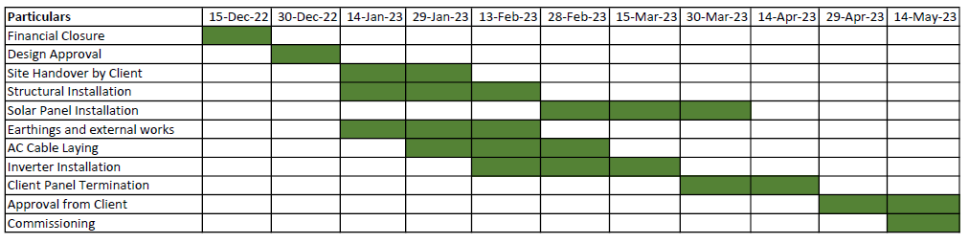

- POWER PURCHASE AGREEMENT:
S. No. | Particular | Description
1 | Power Producer | M/s Solar Quest Projects Four Private Limited
2 | Purchaser | National Capital Region Transport Corporation
3 | Date of PPA | 1st February 2022
Various Clauses of the PPA
F | The power producer herein/project company has agreed to install and operate a solar photovoltaic power plant of 3.7 MWp capacity at the premises as defined in Bid document and supply the entire Solar Power of the Project to the Employer on the terms and conditions contained in the agreement.
H | The purchaser has agreed to purchase the entire solar power of the project on the terms and conditions contained in the agreement.
 | Term and Termination
3.1 | Term | The term of the Agreement shall commence on the Effective date and shall continue for 25 years from the COD, unless and until terminated earlier pursuant to the provisions of the Agreement. After the Term, the ownership of the system shall be transferred to the Purchaser free of cost.
#Copy of the complete PPA has been annexed below

PART C | PROJECT LOCATIONS, CAPACITY AND SPECIFICATIONS
As per the information shared by the company, the subject company has planned to set up roof top Solar PV Plant at the location tabulated below:
S.  No. | Site Name / Roof Name | Estimated Modules | Module Capacity (W) | DC Capacity (kWp) | Probability distribution (MWh)
 |  |  |  |  | P50 | P75 | P90
1 | Duhai Depot
a | Admin-Building | 86 | 340 | 29.24 | 1,199.40 | 1,151.80 | 1,108.90
b | ETU-Shed | 170 | 340 | 57.80 | 1,199.40 | 1,151.80 | 1,108.90
c | Pit-Wheel-Lathe | 80 | 340 | 27.20 | 1,199.40 | 1,151.80 | 1,108.90
d | Workshop | 1,410 | 340 | 479.40 | 1,199.40 | 1,151.80 | 1,108.90
e | ETU-RCC | 56 | 340 | 19.04 | 1,199.40 | 1,151.80 | 1,108.90
f | P-Way-RCC | 87 | 340 | 29.58 | 1,199.40 | 1,151.80 | 1,108.90
g | NCRTC Duhai-Depot-Station | 516 | 340 | 175.44 | 1,199.40 | 1,151.80 | 1,108.90
h | Main-Store | 134 | 340 | 45.56 | 1,199.40 | 1,151.80 | 1,108.90
2 | Ghaziabad
a | RSS-Building | 54 | 380 | 20.52 | 1,257.80 | 1,242.50 | 1,228.80
b | NCRTC_RRTS-Station | 2,584 | 340 | 878.56 | 1,257.80 | 1,242.50 | 1,228.80
3 | NCRTC_RRTS-Station-Guldhar | 1,473 | 340 | 500.82 | 699.40 | 690.90 | 683.30
4 | NCRTC_RRTS-Station-Sahibabad | 1,473 | 340 | 500.82 | 700.30 | 691.80 | 684.10
5 | NCRTC_RRTS-Station-Duhai | 1,820 | 340 | 618.80 | 865.20 | 854.70 | 845.20

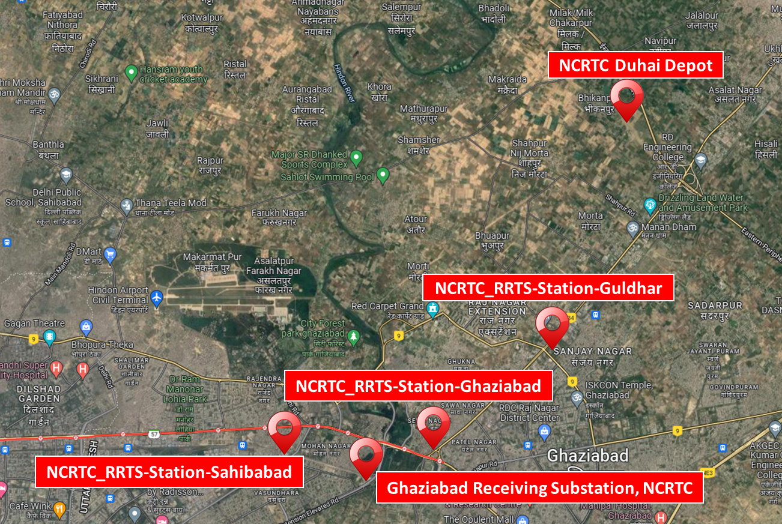

Brief description of a Solar Plant:
A photovoltaic (PV) system with its electricity-generating solar panels positioned on the roof of a residential or office building or structure is known as a rooftop solar power system, sometimes known as a rooftop PV system.
India commenced its solar energy journey in the year 2008 with the launch of the Government of India's National Action Plan on Climate Change (NAPCC). The Jawaharlal Nehru National Solar Mission (the Solar Mission) was launched under the NAPCC to significantly increase the share of solar energy in India's energy mix.
Under the Solar Mission, India set a target of 100 GW solar installations by 2022. Out of this, 40 GW was set as a target for rooftop solar sector. After a more modest start, rooftop solar capacity additions too, have increased over the years, growing at an annual rate of 80 percent in 2017 to reach 1.8 GW of installed capacity.
Process Flow Diagram:
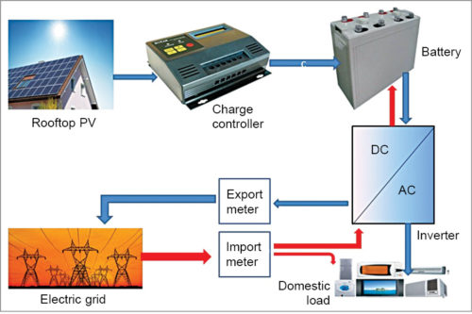

PART D | CURRENT STATUS OF WORK

For the subject project a PPA has been signed between NCRTC and the subject company M/s SQP4 PL. The rooftops on which the subject power plant is to be installed are under construction and it shall be installed after the construction of the related structures gets completed except a RSS building where only the Solar Panels and other equipments have arrived at site but yet to be installed.
Therefore, as of now, the work related to the subject project is yet to start.

PART E | PROJECT COST & EXPENDITURE

- Means of Finance: As per the details provided by the client the total expected project cost shall be Rs.16.00 Cr. Means of for the same has been tabulated below:

S. No. | Particulars | Amount  (in Rs. Cr.)
1 | Equity in form of CCD | 5.00
2 | Debt (TL 15 Years) | 11.00
Total |  | 16.00

- COST ASSESSMENT: As per secondary market research conducted by team of RKA, the benchmark cost for setting up a rooftop photovoltaic system varies from Rs. 39,080/- to Rs. 51,100/- per kW. However, this cost may vary depending upon the location, size of the project, type of installation etc. the project as per Benchmark Cost defined by Ministry of New & Renewable Energy, Government of India is tabulated below:-

- The project cost provided to us appears to be in line as per the benchmark cost of Grid Connected Rooftop Solar Photo Voltaic system of Ministry of New & Renewable Energy (MNRE).
https://solarrooftop.gov.in/rooftop_calculator

S. No. | Particulars | Benchmark Cost  (In Rs./kW) | Project Capacity  (In kW) | Total Project Cost  (Excluding GST)  (In Rs.) | Total Project Cost  (Including 12% GST)  (In Rs.)
1 | As per Ministry of New & Renewable Energy | 39,080 | 3,665.28 | 14,32,39,142 | 16,04,27,839
Or say |  |  | 3.7 MWp |  | Rs.16.00 Cr.

Note:
- Project cost is analyzed based on lumsum cost only and not item wise.
- Project cost is assessed for the current date only and due to price fluctuations it may vary at the time of actual purchase or installation.

Since, the current Project is in RESCO Model so cost of the Project doesn’t matter much.
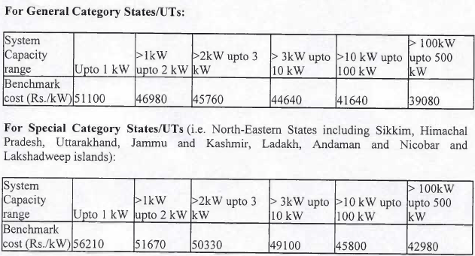

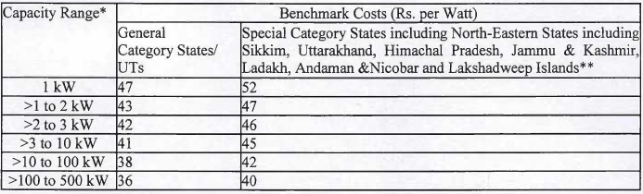

PART E | PHOTOGRAPHS

- Sahibabad Station
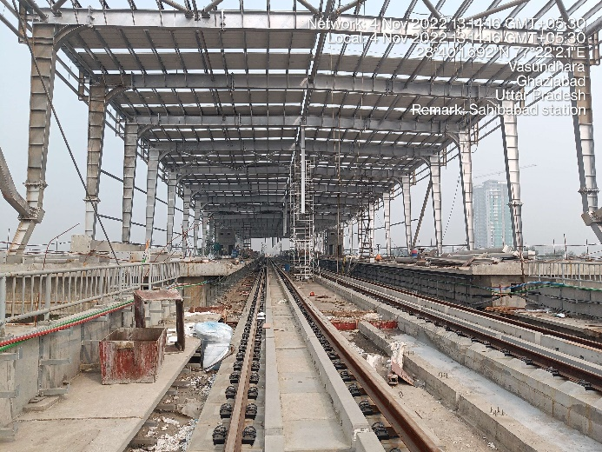 | 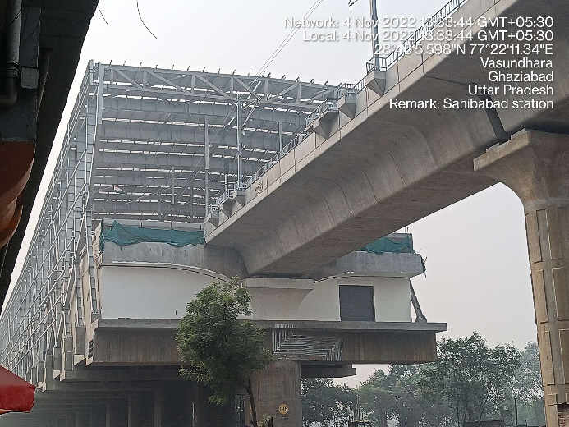
- Guldhar Station
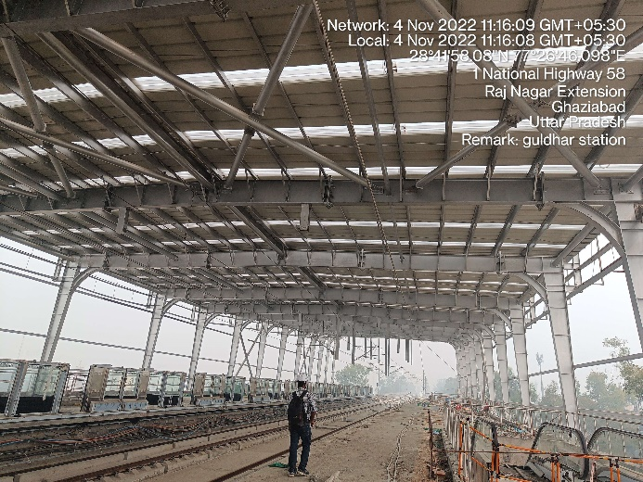 | 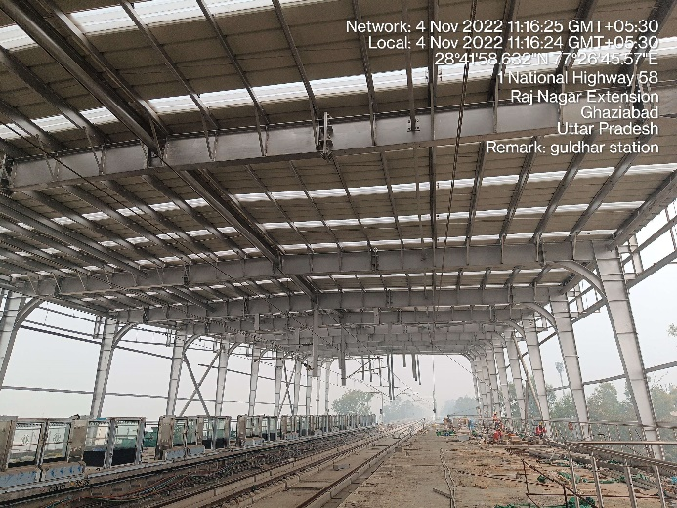
- Ghaziabad Station
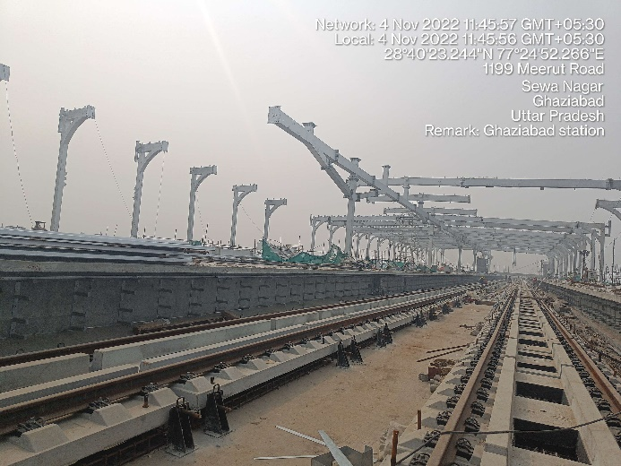 | 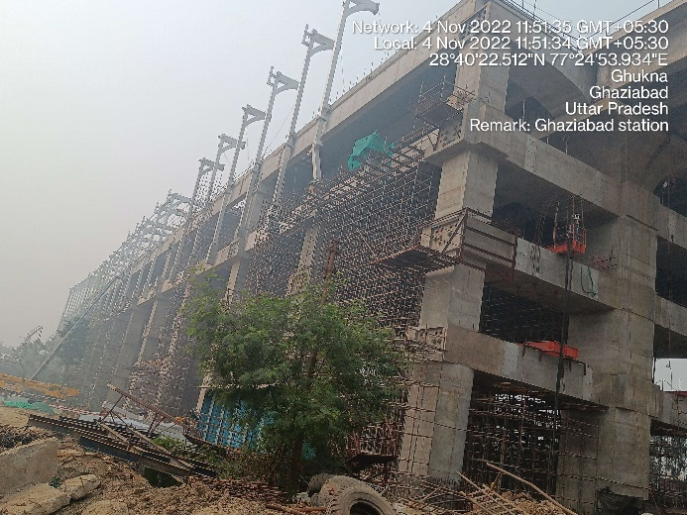

- Duhai Depot
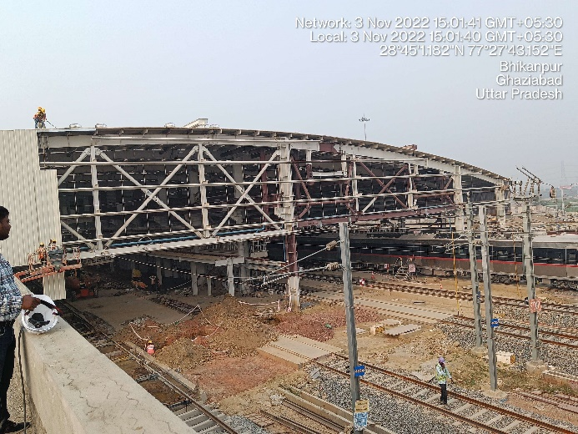 | 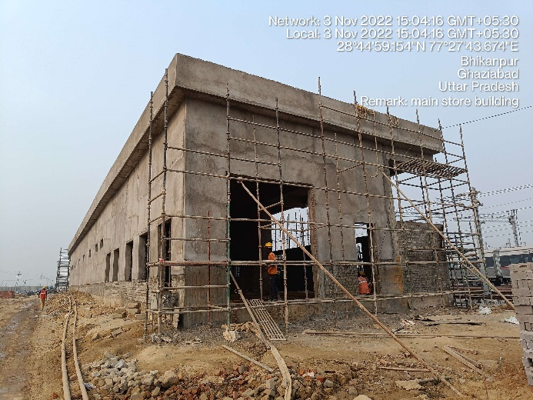
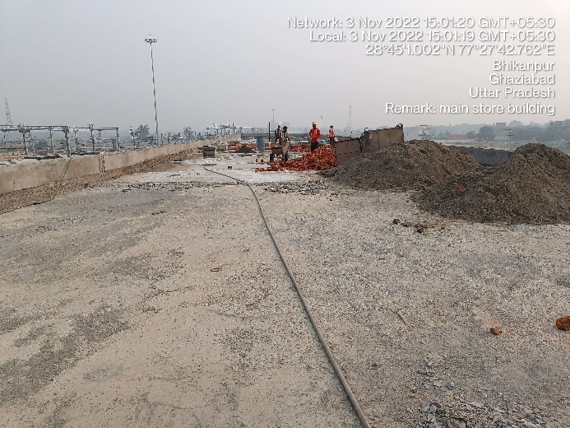 | 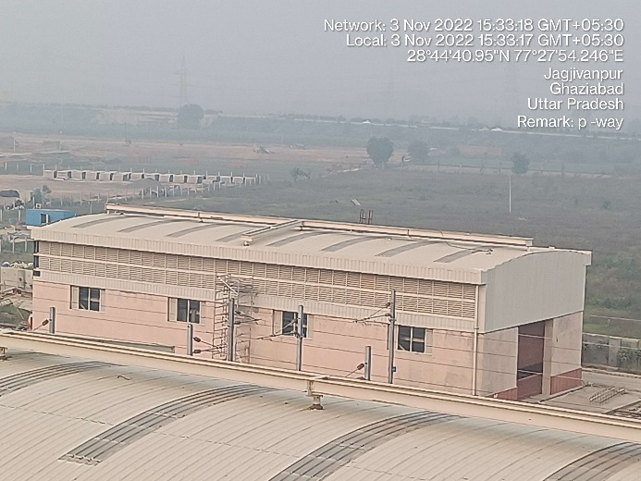
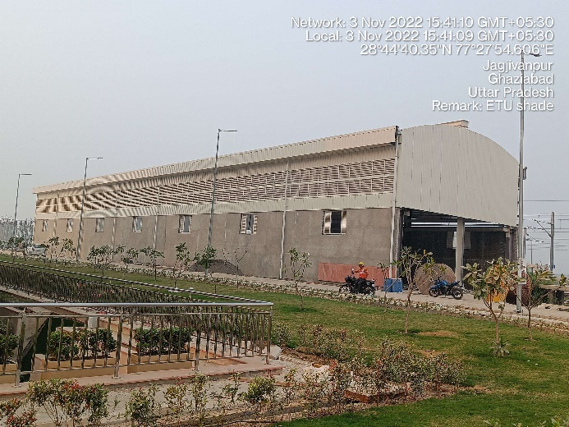 | 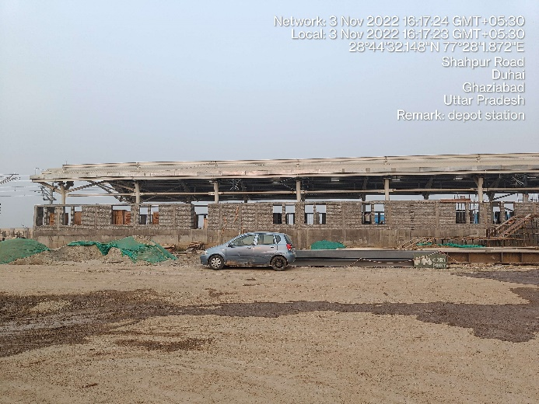

- RSS Building
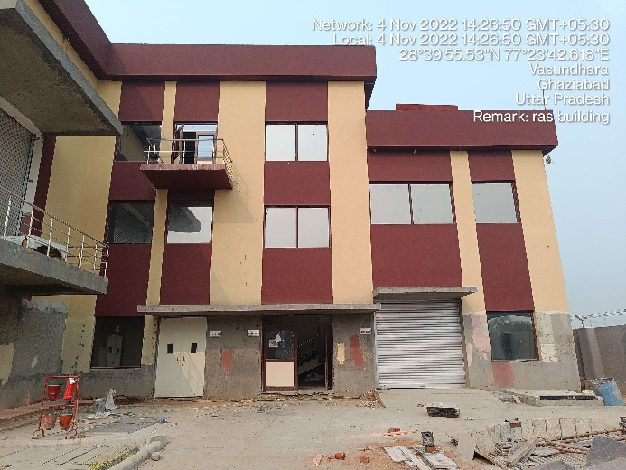 | 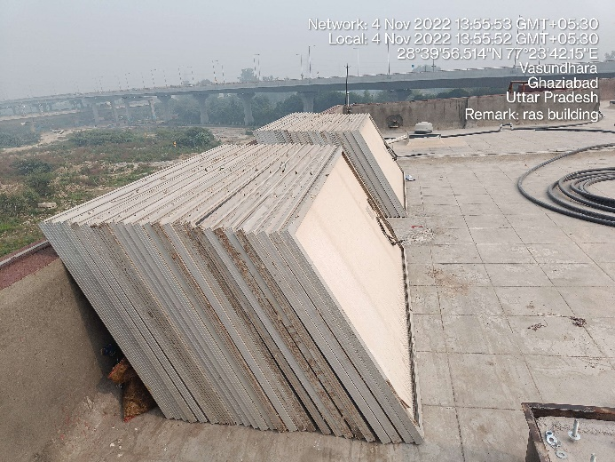
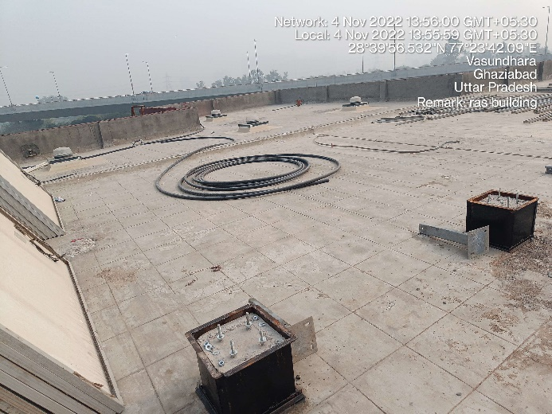 | 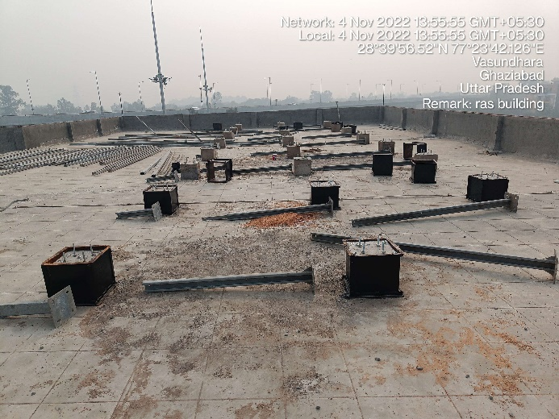
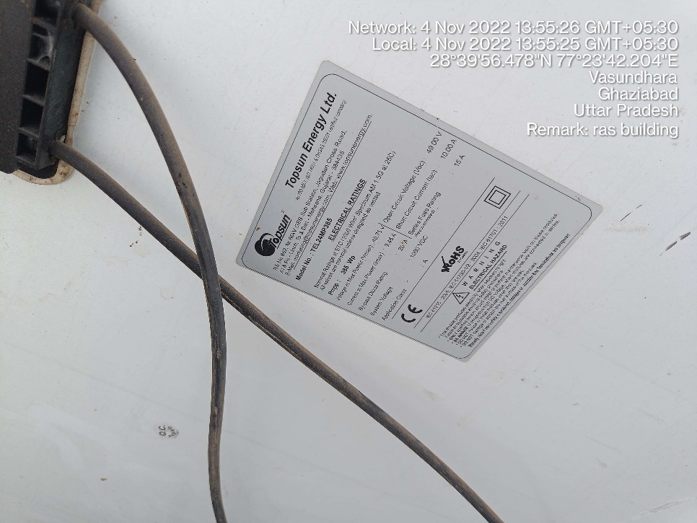 | 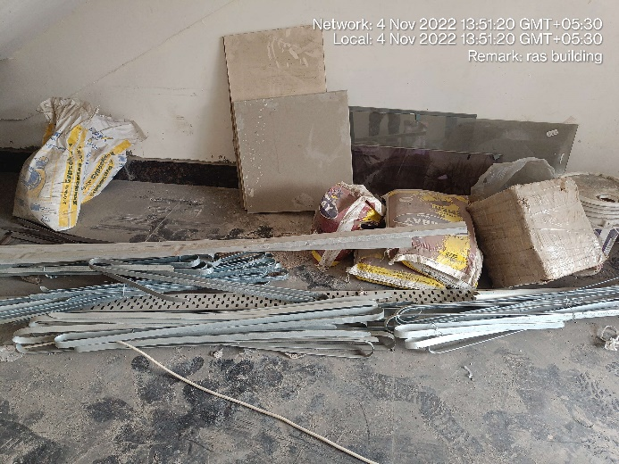

PART G | DISCLAIMER

      - No employee or member of R.K Associates has any direct/ indirect interest in the Project.
      - This report is prepared based on the copies of the documents/ information which the Bank/ Company has provided to us out of the standard checklist of documents sought from them and further based on our assumptions and limiting conditions. All such information provided to us has been relied upon in good faith and we have assumed that it is true and correct in all respect. Verification or cross checking of the documents provided to us has not been done at our end from the originals. If at any time in future, it is found or came to our knowledge that misrepresentation of facts or incomplete or distorted information has been provided to us then this report shall automatically become null & void.
      - This report is a general analysis of the project based on the scope mentioned in the report. This is not an Audit report, Design document, DPR or Techno-financial feasibility study. All the information gathered is based on the facts seen on the site during survey, verbal discussion & documentary evidence provided by the client and is believed that information given by the company is true best of their knowledge.
      - All observations mentioned in the report is only based on the visual observation and the documents/ data/ information provided by the client. No mechanical/ technical tests, measurements or any design review have been performed or carried out from our side during Project assessment.
      - Bank/FII should ONLY take this report as an Advisory document from the Financial/ Chartered Engineering firm and it’s specifically advised to the creditor to cross verify the original documents for the facts mentioned in the report which can be availed from the borrowing company directly.
      - In case of any default in loans or the credit facility extended to the borrowing company, R.K Associates shall not be held responsible for whatsoever reason may be and any request for seeking any explanation from the employee/s of R.K Associates will not be entertained at any instance or situation.
      - This Report is prepared by our competent technical team which includes Engineers and financial experts & analysts.
      - This is just an opinion report and doesn’t hold any binding on anyone. It is requested from the concerned Financial Institution which is using this report for taking financial decision on the project that they should consider all the different associated relevant & related factors also before taking any business decision based on the content of this report.
      - All Pages of the report including annexures are signed and stamped from our office. In case any paper in the report is without stamp & signature then this should not be considered a valid paper issued from this office.
      - Though adequate care has been taken while preparing this report as per its scope, but still we can’t rule out typing, human errors, over sightedness of any information or any other mistakes. Therefore, the concerned organization is advised to satisfy themselves that the report is complete & satisfactory in all respect. Intimation regarding any discrepancy shall be brought into our notice immediately. If no intimation is received within 15 (Fifteen) days in writing from the date of issuance of the report, to rectify these timely, then it shall be considered that the report is complete in all respect and has been accepted by the client upto their satisfaction & use and further to which R.K Associates shall not be held responsible in any manner.
      - Defect Liability Period is 15 DAYS. We request the concerned authorized reader of this report to check the contents, data and calculations in the report within this period and intimate us in writing if any corrections are required or in case of any other concern with the contents or opinion mentioned in the report. Corrections only related to typographical, calculation, spelling mistakes, incorrect data/ figures/ statement will be entertained within the defect liability period. Any new changes for any additional information in already approved report will be regarded as additional work for which additional fees may be charged. No request for any illegitimate change in regard to any facts & figures will be entertained.
      - R.K Associates encourages its customers to give feedback or inform concerns over its services through proper channel at le@rkassociates.org in writing within 30 days of report delivery. After this period no concern/ complaint/ proceedings in connection with the Lender’s Independent Engineering Services will be entertained due to possible change in situation and condition of the subject Project.
      - Our Data retention policy is of ONE YEAR. After this period, we remove all the concerned records related to the assignment from our repository. No clarification or query can be answered after this period due to unavailability of the data.
      - This Lender’s Independent Engineering report is governed by our (1) Internal Policies, Processes & Standard Operating Procedures, (2) Information/ Data/ Inputs given to us by the client and (3) Information/ Data/ Facts given to us by our field/ office technical team. Management of R.K Associates never gives acceptance to any unethical or unprofessional practice which may affect fair, correct & impartial assessment and which is against any prevailing law. In case of any indication of any negligence, default, incorrect, misleading, misrepresentation or distortion of facts in the report then it is the responsibility of the user of this report to immediately or at least within the defect liability period bring all such act into notice of R.K Associates management so that corrective measures can be taken instantly.
      - R.K Associates never releases any report doing alterations or modifications from pen. In case any information/ figure of this report is found altered with pen then this report will automatically become null & void.

Place : Noida FOR INTERNAL USE
Date : 20.12.2022 SURVEYED BY: Harshit Mayank
Note : This report contains 19 pages PREPARED BY: Adil Afaque
REVIEWED BY: MA

For R.K Associates Valuers & Techno
Engineering Consultants Pvt. Ltd.

- DEFECT LIABILITY PERIOD - In case of any query/ issue or escalation you may please contact Incident Manager by writing at valuers@rkassociates.org. We ensure 100% accuracy in the Calculations done, Rates adopted and various other data points & information mentioned in the report but still can’t rule out typing, human errors or any other mistakes. In case you find any mistake, variation, discrepancy or inaccuracy in any data point of the report, please help us by bringing all such points into our notice in writing at valuers@rkassociates.orgwithin 30 days of the report delivery, to get these rectified timely, failing which R.K Associates Valuers Techno Engineering Consultants (P) Ltd. won’t be held responsible for any inaccuracy in any manner. Also if we will not hear back anything from you within 30 days, we will assume that report is correct in all respect and no further claim of any sort will be entertained thereafter. We would welcome and appreciate your feedback & suggestions in order to improve our services.

COPYRIGHT FORMAT - This report is prepared on the copyright format of R.K Associates Valuers Techno Engineering Consultants (P) Ltd. to serve our clients in the best possible way. Legally no one can copy or distribute this format without prior approval from R.K Associates. It is meant only for the organization as mentioned on the cover page of this report. Distribution or use of this format other than R.K Associates will be seen as unlawful act and necessary legal action can be taken against the defaulter

