**REPORT FORMAT:** V-L5 | Version: 4.2_2017

**File No.: VIS (2022-23)-PL369-Q086-287-523 Dated: 28.10.2022**

**ENTERPRISE VALUATION REPORT**

**OF**

**M/S DANU WIND PARKS PRIVATE LIMITED**

**(WIND POWER PLANT OF 47.70 MW)**

**SITUATED AT**

**KURNOOL DISTRICT (DANU-I) & ANANTAPUR DISTRICT (DANU-II)**

**(ANDHRA PRADESH)**

**OWNER/PROMOTER**

**M/S ECOREN ONE WIND ENERGY PRIVATE LIMITED**

**REPORT PREPARED FOR**

**M/S PTC INDIA FINANCIAL SERVICES LIMITED**

***\*\*Important - In case of any query/ issue or escalation you may please contact Incident Manager***

***at valuers@rkassociates.org. We will appreciate your feedback in order to improve our services.***

***NOTE: As per IBA Guidelines please provide your feedback on the report within 15 days of its submission after which report will be considered to be correct.***

**IMPORTANT NOTICE**

***COPYRIGHT FORMAT:*** *This report is prepared on the copyright format of R. K. Associates Valuers & Techno Engineering Consultants (P) Ltd. (R. K. Associates) to serve our clients with the best possible information and analysis to facilitate them to take rational business decisions. Legally no one can copy or distribute this format without prior approval from R. K. Associates. It is meant only for the advisory/ reference purpose for the organization/s as mentioned on the cover page of this report. Distribution or use of this format or report or any of its content/ information/ data by any organization or individual other than R.K Associates will be seen as an unlawful act and necessary legal action can be taken against the defaulters.*

*This report is intended for the sole use of the intended recipient/s and contains material that is* ***STRICTLY CONFIDENTIAL AND PRIVATE.***

***DEFECT LIABILITY PERIOD:****In case of any query/ issue or escalation you may please contact Incident Manager at valuers@rkassociates.org. Though adequate care has been taken while preparing this report as per its scope, but still, we can’t rule out typing, human errors, over sightedness of any information or any other mistakes. Therefore, the concerned organization is advised to satisfy themselves that the report is complete & satisfactory in all respect. Intimation regarding any discrepancy shall be brought into our notice immediately. If no intimation is received within 15 (Fifteen) days in writing from the date of issuance of the report, to rectify these timely, then it shall be considered that the report is complete in all respect and has been accepted by the client up to their satisfaction & use and further to which R.K Associates shall not be held responsible in any manner.*

***Part H: R.K Associates Important Notes and Enclosure: 1–Valuer’s Remarks*** *are integral part of this report and Value is assessment is subject to both of these sections. Reader of the report is advised to read all the points mentioned in these sections carefully.*

|  |  |  |
| --- | --- | --- |
| **TABLE OF CONTENTS** | | |
|  | | |
| **SECTIONS** | **PARTICULARS** | **PAGE NO.** |
| **Part A** | **INTRODUCTION** | **4** |
| 1. About the Report | 4 |
| 1. Executive Summary | 4 |
| 1. Type of Report | 6 |
| 1. Purpose of the Report | 6 |
| 1. Scope of the Report | 6 |
| 1. Methodology/ Model Adopted | 7 |
| 1. Documents/ Data Referred | 7 |
| **Part B** | **PROJECT COMPANY** | **8** |
| 1. Incorporation details of the company | 8 |
| 1. Details of Promoters/Directors | 8 |
| 1. Snapshot of the Outstanding Debt of the Company | 8 |
| 1. Capital Structure | 10 |
| 1. Shareholding Pattern | 11 |
| 1. Current Status of the Project | 11 |
| 1. Reason for Financial Stress | 11 |
| **Part C** | **THE PROJECT** | **13** |
| 1. Brief Description about the Project | 13 |
| 1. Project Stretch Details and Location | 13 |
| 1. Maintenance of The Project | 14 |
| 1. Evacuation | 14 |
| 1. Key Approval & Clearance | 14 |
| **Part D** | **ASSESSMENT OF WIND ENERGY SECTOR** | **15** |
| 1. Introduction | 15 |
| 1. Global Scenario | 15 |
| 1. Domestic Scenario | 15 |
| 1. Key Challenges faced by the industry | 17 |
| 1. Government Initiatives | 17 |
| 1. Way Forward | 18 |
| **Part E** | **FINANCIAL PROJECTIONS** | **20** |
| 1. Historical P&L Statement | 20 |
| 1. Historical Ratio Analysis | 20 |
| 1. Graphical Representation of Historical Ratios | 20 |
| 1. Projected P&L Statement | 22 |
| 1. Projected Ratio Analysis | 23 |
| 1. Graphical Representation of Projected Ratios | 23 |
| **Part F** | **VALUATION OF THE COMPANY** | **26** |
| 1. Methodology/ Model Adopted | 26 |
| 1. Calculation of Free Cash Flow to Firm | 28 |
| 1. Key Inputs | 29 |
| 1. Calculation Of Enterprise Value | 29 |
| 1. Assumptions for Financial Projections | 30 |
| **Part G** | **IMPORTANT DEFINITIONS** | **35** |
| **Part H** | **DISCLAIMER/REMARKS** | **37** |

|  |  |
| --- | --- |
| **PART A** | **INTRODUCTION** |

1. **ABOUT THE REPORT:** Enterprise Valuation Report of 47.70 (22.4 & 25.30) MW Wind Power Plant set up by M/s Danu Wind Parks Private Limited (DWPPL), located at Kurnool and Anantapur districts of Andhra Pradesh known as Danu-1 & Danu-2 having the capacities of 22.4MW and 25.30 MW respectively.
2. **EXECUTIVE SUMMARY:** M/S. Danu Wind Park Private Limited was incorporated on 21st September 2011 is established for the development of 47.70 MW (22.40 MW +25.30 MW) wind power project in the state of Andhra Pradesh. The Project is divided into two projects with different capacities and at different locations namely, Danu-1 and Danu-2. Unit wise details of the project company is shown in the below table:

|  |  |  |
| --- | --- | --- |
| **Unit wise Details of the project Company** | | |
| **Particular** | **Danu-1** | **Danu-2** |
| **Year** | 2016 | 2016 |
| **Location** | Chinnakolumulapalle, Kurnool District, AP | Nelakota, Anantapur District, AP |
| **Promoters** | Ecoren One Wind Energy private Limited which is promoted by Ecoren Energy India private limited which is in the business of developing wind power projects and has executed the project as EPC/BoP contractor. | Ecoren One Wind Energy private Limited which is promoted by Ecoren Energy India private limited which is in the business of developing wind power projects and has executed the project as EPC/BoP contractor. |
| **Capacity** | 22.4 MW (14X1.6 MW) | 25.3 MW (11X2.3 MW) |
| **PPA** | 25 years PPA with Andhra Pradesh State Utility @ 4.83/Unit | 25 years PPA with Andhra Pradesh State Utility @ 4.84/Unit |

Both the projects of Danu Wind Park Private Limited has signed long term PPAs with Southern Power Distribution Company of Andhra Pradesh for 25 years. Danu-1 was commissioned 26th December 2016 and Danu-2 was commissioned on 20th March 2018. The Project cost of Danu-1 stands at Rs. 174 crore and for Danu-2 stands at Rs. 225.26 crore.

Moreover, Danu-1 Project has signed PPA with Southern Power Distribution Company of AP Ltd. on 04- August-2016 at a tariff of Rs. 4.84/ unit for a period of 25 years as per the order issued by Andhra Pradesh Electricity Regulatory Commission for the project which enters into PPA after April 1, 2016. For Danu-2 Project has signed PPAs with Southern Power Distribution Company of AP Ltd. on 31-October-2016 and 17-July-2017 at a tariff of Rs. 4.84/ unit and Rs.4.76/ unit receptively for a period of 25 years as per the order issued by Andhra Pradesh Electricity Regulatory Commission for the project which enters into PPA after April 1, 2016.

Danu-1 with capacity of 22.40 MW includes 14X1.6 MW WTG and 11X2.3 MW WTG for Danu-2 accumulating to a capacity of 25.3 MW. AII the Wind Turbine Generators (WTG) are supplied by GE Company. Furthermore, the both the projects has been implemented by way of package contracts. Contract for supply of the WTG has already been awarded to GE.

The first project deployed 14 nos. of GE make GE 1.6 XLE turbines of capacity MW each at a hub height of 80 m. work order/Contract for erection and commissioning was awarded to M/s Ecoren Energy India Pvt. Ltd. The second project deployed 11 nos. of GE make GE 2.3XLE turbines of capacity 2.30 MW each at a hub height of 94 m. Work order/Contract for erection and commissioning was awarded to M/s Ecoren Energy India Pvt. Ltd.

Below table shows the historical financial performance of the company from FY 2018-19 to FY 2021-22:

*(Figures in INR Crores)*

|  |  |  |  |  |  |
| --- | --- | --- | --- | --- | --- |
| **Particular** | **FY 2018 A** | **FY 2019 A** | **FY 2020 A** | **FY 2021 A** | **FY 2022 P** |
| Revenue | 39.23 | 69.47 | 61.3 | 40.37 | 61.11 |
| Operational & Maintenance | 1.3 | 4.86 | 7.26 | 5.4 | 7.7 |
| Administration & other expenses | 0.47 | 14.31 | 0.57 | 0.71 | 21.12 |
| **Total Expenses** | **1.77** | **19.17** | **7.83** | **6.11** | **28.82** |
| EBITDA | 37.46 | 50.3 | 53.47 | 34.26 | 32.29 |
| Depreciation & Amortization | 12.00 | 16.22 | 16.27 | 16.22 | 16.22 |
| **EBIT** | **25.46** | **34.08** | **37.20** | **18.04** | **16.07** |
| Finance cost | 24.12 | 33.88 | 36.24 | 35.58 | 33.29 |
| Profit Before Taxes | 1.34 | 0.20 | 0.96 | -17.54 | -17.22 |
| Tax | -5.71 | 4.65 | 7.62 | 3.19 | 3.19 |
| **Profit After Taxes** | **7.05** | **-4.45** | **-6.66** | **-20.73** | **-20.41** |

The state is having a high wind season from June to September while other months in the year are low wind seasons. In the present year, June to September has witnessed high wind season as per information provided by the client/company. As per site inspection by PTC as on 16-17th September, at Danu-1 the wind speed was 10.0-11.0 m/s on an average and power generation by one wind mill was 924kW. At Danu-2, it was at around 9.0m/s on an average and power generation by one wind mill was 1840kW.

As per site visit as on 16-17th September 2022 by PTC, at Danu-1, currently there are 15 wind mills at the site out of which 14 are assets of M/s Danu Wind Parks Pvt. Ltd. and 1 of NETCO all having PPA with AP Discom. Total project capacity is 24.00 MW out of which 22.4 MW is financed by PTC India Financial Services Limited. At Danu-2, currently there are 12 wind mills on the site out of which 11 are having PPA with AP Discom and 1 is not having PPA. It is under consideration that the energy from the one wind mill to be supplied directly to the industries. Both the units are having a Plant Availability Factor (PAF) of 98-99% on an average.

In Dec 2021, Hon’ble High Court had directed DISCOM to clear the outstanding amount for the first and second quarter of the year 2021 and directed DISCOM to file an affidavit for clearing dues of third and fourth quarter of the year 2021. Subsequently, AP DISCOM had cleared partial dues (@2.43/unit) of several other developers till 30th June 2021. However, Borrower had received the dues till Dec 2020 only. Subsequently, Borrower filed an interim appeal and prayed for making interim payments at 2.43/unit at par with other similarly situated power generators without any discrimination.

Final order was announced by Hon’ble Divisional bench on 15th March 2022.Court had directed DISCOM to make payment of all pending and future bills at the rate mentioned in the PPAs in 6 weeks from the date of order. However, the same was contested by APDISCOM and on account of these delays, there was no receipt of revenues in the projects till July 2022.

Currently M/s Danu Wind Parks Private limited is under financial stress, however the borrower has got interim stay order for classification of Loan Accounts as NPA from High Court. Hon’ble High Court, vide its order dated November 1, 2022, has again extended the stay on the matter of classification of the account as NPA for another 6 weeks.

**Hence, PTC India Financial Services Limited has appointed R. K Associates to determine the Fair Market Value/Enterprise Value of the Business/Company to take appropriate course of action on this stressed account.**

1. **TYPE OF REPORT:** Enterprise Valuation of M/s Danu Wind Parks Private Limited.
2. **PURPOSE OF THE REPORT:** To estimate & determine current Fair Enterprise Value of the Companyto enable the lenders/client to evaluate the further course of action on this account.
3. **SCOPE OF THE REPORT:** To estimate & determine current Enterprise Value of the Company based on Income based approach (Discounted Cash Flow method).

* ***This is just the enterprise valuation of the project based on its income generating capacity/ projections in future years. This Valuation shall not be construed as the physical asset valuation or should be directly related to cost approach or Project cost.***
* ***This Valuation only covers the cash flow generated from the two wind power project of the Company. It does not cover any transaction with the subject company’s subsidiary/ associate/ Joint Venture Companies.***
* ***This Enterprise Valuation report doesn’t cover vetting of the documents/ financial data/ projections or any other information provided to us by the Bank.***
* ***It doesn’t contain the principles of physical asset valuation and is not based on the site inspection of the project.***
* ***This exercise is neither an audit activity nor investigative in nature. We have relied on the data provided by the Bank and the Company in good faith.***
* ***The Market and Industrial assessment of the given company’s industry has not been done at our end. So, this valuation doesn’t cover the Market & industrial scenario in terms of the product demand & market potential.***

1. **METHODOLOGY/ MODEL ADOPTED:** Income-based Approach (Discounted Cash Flow Model) for the calculation of Enterprise Value of the Company.
2. **DOCUMENTS / DATA REFFERED:**

* Last five year’s audited Financial Statements of the company.
* Latest provisional financial statements of M/s Danu Wind Parks Private Limited.
* Purchasing Power Agreement
* Detailed Description and Current Status of the project Shared by client/company.
* Information available in the public domain.

.

|  |  |
| --- | --- |
| **PART B** | **THE PROJECT COMPANY** |

1. **INCORPORATION DETAILS OF THE COMPANY:** M/S. Danu Wind Park Private Limited was incorporated on 21st September 2011, for the development of 47.70 MW (22.40 MW +25.30 MW) wind power project in the state of Andhra Pradesh. The company is in the operations of wind power generation having two projects with different capacities of 22.40 MW and 25.30 MW. Below table shows the incorporation details of the company:

|  |  |
| --- | --- |
| **Incorporation Details** | |
| **COMPANY NAME** | M/s Danu Wind Parks Pvt. Ltd. |
| **CORPORATE IDENTITY NUMBER** | U40108TG2011PTC076645 |
| **INCORPORATION DATE** | 21st September 2011 |
| **CONSTITUTION** | Private Limited Company/Company limited by Shares |
| **SECTOR** | Renewable Power Generation |
| **REGISTERED / CORPORATE OFFICE ADDRESS** | **Registered Office:** Plot No. 1202, 1215A Door No. 8-2-293/82/A/1202 S.L. Jubilee, Road No.61, Jubilee Hills Hyderabad TG 500033  **Plant/ Works:** DWPPL-1- Kurnool District, AP & DWPPL-2- Anantapur District, AP |
| **AUTHORIZED SHARE CAPITAL** | INR 89,30,00,000/- |
| **ISSUED, SUBSCRIBED AND PAID-UP CAPITAL** | INR 85,70,00,000/- |

*Source: http://www.mca.gov.in/*

1. **DETAIL OF PROMOTERS/DIRECTORS:** As per information provided by the company/client, below table shows the details of directors/promoters of the company along with their DIN details, designation and Date of appointment:

**List of Directors of M/s Danu Wind Parks Pvt. Ltd.**

| **S.No.** | **Name** | **DIN** | **Designation** | **DOA** |
| --- | --- | --- | --- | --- |
| **1.** | VENKATA SUNIL KUMAR TALLA | 02247464 | Director | 23rd Jan 2017 |
| **2.** | LAKSHMI PRASAD YERNENI | 02320060 | Director | 6th Oct 2015 |

1. **SNAPSHOT OF OUTSTANDING DEBT OF THE COMPANY:** As per information provided by the company/client, the total outstanding in Danu-I is INR 112.07 Crores and in Danu-II is INR 169.27 Crores as on date. As per information available in the provisional financial statement of the company for FY 2022 below table shows the details of loans of the company as on 31st March 2022, however the dues has been taken as on valuation date shown in the below table:

|  |  |
| --- | --- |
| **Loans From Financial Institutions** | |
| **Particular** | **Description** |
| PTC India Financial Services Limited - Dhone | 1. PTC India Financial Services Limited has sanctioned Loan amount of Rs 117 Crores to Danu Wind Parks Private Limited out of which an amount of Rs.114.96 crores was disbursed during the FY 2016-17 and Rs 2.04 crores in FY 2017-18. 2. The Loan was sanctioned for the purpose of Development, Construction and Operation of 22.4 MW (14 * 1.6 MW) wind based power project in Kurnool District of Andhra Pradesh. 3. The facility shall be repaid in up to 58 structured quarterly installments (14.5 years) and the repayment shall be the first day of the beginning of each quarter. 4. Currently the interest rate is 11.90%. 5. Mortgage of all Immovable Properties. Hypothecation of all movable assets including current assets. Personal guarantee by Director (Mr. Lakshmi Prasad Yerneni). Pledge of 100% equity shares, CCPS and CCDS. Corporate guarantee of M/s Ecoren Energy India Private Limited (ultimate Indian Holding Company). 6. a) Principal Due as on 31-03-2022 : 84,240,000 7. Interest Accrued and due as on 31-03-2022 : 8. Interest Due : 210,012,605 9. Penal Interest : NIL |
| PTC India Financial Services Limited - Nelakote | 1. PTC India Financial Services Limited has sanctioned Loan amount of Rs. 169 Crores to Danu Wind Parks Private Limited out of which an amount of Rs.122.91 crore was disbursed during the FY 2016-17, Rs. 24 crore in FY 2017-18, Rs.13 crore in FY 2018-19 and Rs. 9.09 crores in FY 2019-20. 2. The Loan was sanctioned for the purpose of Development, Construction and Operation of 25.3 MW (11 * 2.3 MW) wind based power project in Ananthapur District of Andhra Pradesh. 3. The facility shall be repaid in up to 62 structured quarterly installments (15.5 years) and the repayment shall be the first day of the beginning of each quarter. 4. Currently the interest rate is 11.65%. 5. Mortgage of all Immovable Properties. Hypothecation of all movable assets including current assets. Personal guarantee by Director (Mr. Lakshmi Prasad Yerneni). Pledge of 100% equity shares, CCPS and CCDS. Corporate guarantee of M/s Ecoren Energy India Private Limited (ultimate Indian Holding Company). 6. a) Principal Due as on 31-03-2022 : 121,680,000   b) Interest Accrued and due as on 31-03-2022 :  i) Interest Due : 284,415,340  ii) Penal Interest : NIL |
| Compulsory Convertible Debentures (CCDS) | 1. The CCDs have been taken for Nelakota Project. 2. The CCDS have been issued on 31st March, 2017 and shall be eligible for conversion into equity shares of the company on completion of the period of 10 years from the date of issuance on the conversion factor of 1:10 such that each CCDS shall be converted into 10 equity shares of Rs. 10/- each. CCDS contains a coupon rate of 9% which shall be paid annually on or before September 30th of the succeeding year. 3. The Interest shall be paid by the Company with specific approval from the lenders and in the event the company is not able to pay the CCDs Interest in full/part in a particular year, the unpaid balance shall get automatically waived. The Interest on the CCDs in the first financial year shall accrued on a pro rata basis for the period commencing from the date of declaration of commercial operations till 31st March of the financial year. 4. During 2021-22, the Company has not provided for Interest on Compulsorily Convertible Debentures as there is no availability of distributable cash. |

1. **CAPITAL STRUCTURE:** As per information available in the latest provisional financial statement shared by client/company for FY 2022, the company is having an authorized share capital is INR 89,30,00,000 and its paid-up capital is INR 85,70,00,000.
2. **SHAREHOLDING PATTERN:** As per the latest financial statement shared by the client/company, the shareholding pattern of M/s Danu Wind Parks Pvt. Ltd. as on 31st March 2022 is provided below:

|  |  |  |  |
| --- | --- | --- | --- |
| **S. NO.** | **Shareholder’s Name** | **No. Of Shares** | **(%) Holding** |
| **1** | Equity Shares:  Ecoren One Wind Energy Private Limited | 5,77,70,010 | 100% |
| **2** | Preference Share  Ecoren One Wind Energy Private Limited | 2,79,29,990 | 100% |

M/s Ecoren Wind Energy Private Limited is holding 100% Equity and preference shares of the company.

1. **CURRENT STATUS OF THE PROJECT:** As per recent site visit details shared by the client/company as on 16th September 2022, at Danu-1, 14 wind mills are working properly and 1 wind mill was under regular half yearly maintenance due to it was not operational at that time. After maintenance the operations were resumed at the time of site inspection. At Danu-2, 9 wind mills were working properly. Working of One wind mill was affected owing to main bearing replacement (T-11) and one wind mill was not operating due to not having signed PPA. During the projections we have assumed that all the 11 wind mills will be working in future and generating revenue for the company.

Borrower has got interim stay order for classification of Loan Accounts as NPA from High Court. Hon’ble High Court, vide its order dated November 1, 2022, has again extended the stay on the matter of classification of the account as NPA for another 6 weeks.

Under the Late Payment Surcharge scheme from PFC and REC, Borrower has received Rs 7.67 Crs in August 2022 out of which Borrower has cleared Rs 3.37 Crs over dues of PFS post deduction of critical O&M payments. Subsequently, Borrower again received Rs 7.64 Crs in September 2022, out of which they have cleared Rs 4.64 Crs over dues of PFS post deduction of O&M payments. Borrower also received Rs 7.64 Crs in October 2022, out of which they have cleared Rs 7.00 Crs over dues of PFS.

The recovery of PFS is expected to improve in subsequent months. Borrower has also received payments from APDISCOM for the invoice raised in June 2022 in Danu-II in September 2022 and payment in Danu-I is awaited.

1. **REASON FOR FINANCIAL STRESS:** Currently, the project is under stress due to non-payment of dues from AP DISCOMS. Govt. of AP had constituted High Level Negotiation Committee (HLNC) to negotiate and bring down costs in all the high priced wind & solar PPAs in July’19Hon’ble High Court vide its order dated September 24, 2019 quashed the July 1, 2019 AP Government order as well as the July 12, 2019 letters issued by APDISCOM.. The court directed AP DISCOMS to pay at Rs.2.43 per unit to wind power plants till the disposal of the matter by APERC. It has also directed the state to avoid curtailing generation from RE plant.

In Dec 2021, Hon’ble High Court had directed DISCOMS to clear the outstanding amount for the first and second quarter of the year 2021 and directed DISCOM to file an affidavit for clearing dues of third and fourth quarter of the year 2021. Subsequently, APDISCOMS had cleared partial dues (@2.43/unit) of several other developers till 30th June 2021.

However, Borrower had received the dues till Dec 2020 only. Subsequently, Borrower filed an interim appeal and prayed for making interim payments at 2.43/unit at par with other similarly situated power generators without any discrimination.

Final order was announced by Hon’ble Divisional bench on 15th March 2022.Court had directed DISCOMS to make payment of all pending and future bills at the rate mentioned in the PPAs in 6 weeks from the date of order. However, the same was contested by AP DISCOM and on account of these delays, there was no receipt of revenues in the projects till July 2022.

**Hence, PTC India Financial Services Ltd, New Delhi has appointed R. K Associates to determine the Fair Market Value/Enterprise Value of the Business/Company to take appropriate course of action on this stressed account.**

|  |  |
| --- | --- |
| **PART C** | **THE PROJECT** |

* 1. **BRIEF DESCRIPTION ABOUT THE PROJECT:** The Company is in the operations of wind power generation having two projects with different capacities of 22.40 MW and 25.30 MW.

As per information by the client, at Danu-1, if any fault is detected then it can be resolved by the team at the same time, however owing to inspection or maintenance the operations are affected for longer duration. Energy is converted from AC to DC for transmission. There is a load dispatch center that curtail the load. Thereafter the power is transmitted to Unit Substation that can involve some transmission losses on the way. There are two meters installed at generation point one at Danu’s end for 14 wind mills and one at NETCO end for 1 wind mill. There is VCB installed after that point from which a single cable transmits the power sub-station. There is a meter installed at substation and the difference in power generated is owing to normal losses during transmission.

Danu-2 unit is having various indicators to improve the efficiency of the unit. Parrot indicator reflects operational wind mills. Light green indicator reflects some breakdown maintenance due to which operations has been interrupted. Yellow indicator reflects wind mill is not operation at present. Energy is converted from AC to DC for transmission. There is a load dispatch center that curtail the load. The power generated by wind mill transmitted by underground cables to this generator/convertor. Thereafter the power is transmitted to Unit Substation that can involve some transmission losses on the way.

* 1. **PROJECT LOCATION:** Both the projects of Danu Wind Parks Private Limited are situated in the state of Andhra Pradesh. However, both the wind projects are situated in different districts of the mate, DWPPL-1 is situated in Kurnool District and DWPPL-2 situated in Anantapur District.



* 1. **EPC:** Both the projects has been implemented by the means of package contracts, which means contracts for the supply of Wind Turbine Generators (WTG) by the GE Company. DWPPL- 1 has deployed 14 GE XLE 1.6 turbines each having a height of 80 m. For DWPPL-2, 11 number of GE turbines are installed with a height of 94 m. Further, work order/contract for erection and Commissioning was awarded to Ecoren Energy India Pvt. Ltd for both the projects.
  2. **OPERATION & MAINTENANCE:** DWPPL-I & II has entered into Operation and Maintenance (O&M) services agreement with Ecoren Energy India Pvt. Ltd.

At Danu-1 there are two type of maintenance (Annual & Half-yearly). Annual maintenance takes 2.5 day in total for one wind mill and bi-annual maintenance takes 1.5 day in total for one wind mill. EBOP- Transmission line and unit operations has been entrusted by to Ecoren. WTG maintenance has been entrusted to GEE team. The control room has 11 members in total out of which 6 from Ecoren and 5 from Gee. For night shift one member from each team stays at site.

At Danu-2, annual maintenance takes 16 dedicated hours for each wind mill and bi-annual maintenance takes6-8 dedicated hours for each wind mill. The control room has 9 members in total out of which 5 from Ecoren and 4 from GEE team. For night shift one member from each team stays at site.

* 1. **EVACUATION: DWPPL-I:** Power from the Project is being evacuated through Dhone Pooling Sub-Station of 2x31.5 MVA capacity. The distance from the project to the pooling sub-station is about 19 Km, the company has a valid power evacuation approval from AP Govt.

**DWPPL-II:** Power from the Project is being evacuated through Puttaparthy Pooling Sub- Station of 81.5 MVA capacity. The distance from the project to the pooling sub-station is about 15 Km, the company has a valid power evacuation approval from AP Govt.

* 1. **KEY APPROVAL & CLEARENCE:** Project sanction for allotment of 22.40 MW and 25.30 MW capacities by New and Renewable Energy Development Corporation of Andhra Pradesh has been transferred in favour of the company. Project does not require environmental clearance as it is a wind project. Further, no forest land is involved in the Project and hence no forest clearance is required, Consent to established is exempted for wind power project being set up in AP. Evacuation clearance from Transmission Corporation of Andhra Pradesh Limited for both 22.40 MW and 25.30 MW project has been received. C-WET clearance has been obtained.

|  |  |
| --- | --- |
| **PART D** | **ASSESSMENT OF WIND ENERGY SECTOR** |

1. **INTRODUCTION:** Wind power is the conversion of wind energy into electricity or mechanical energy using [wind turbines](https://energypedia.info/wiki/Wind_Turbine_Technology). The power in the wind is extracted by allowing it to blow past moving blades that exert torque on a rotor. The amount of power transferred is dependent on the rotor size and the wind speed.

In recent years, wind energy has become one of the most economical renewable energy technology. Today, electricity generating wind turbines employ proven and tested technology, and provide a secure and sustainable energy supply. At good, windy sites, wind energy can already successfully compete with conventional energy production. Many countries have considerable wind resources, which are still untapped.

1. **GLOBAL SCENARIO:** Globally, India ranks fourth in renewable energy capacity and wind power capacity. Global wind power growth must triple over the next decade to avoid the worst impact of climate change. Wind power is one of the fastest-growing renewable energy technologies. Usage is on the rise worldwide, in part because costs are falling. Global installed wind-generation capacity onshore and offshore has increased by a factor of almost 75 in the past two decades, jumping from 7.5 gigawatts (GW) in 1997 to some 564 GW by 2018, according to [IRENA's latest data](https://irena.org/publications/2019/Mar/Renewable-Capacity-Statistics-2019). Production of wind electricity doubled between 2009 and 2013, and in 2016 wind energy accounted for [16% of the electricity generated by renewables](https://irena.org/publications/2018/Jul/Renewable-Energy-Statistics-2018). Many parts of the world have strong wind speeds, but the best locations for generating wind power are sometimes remote ones. Offshore wind power offers tremendous potential.

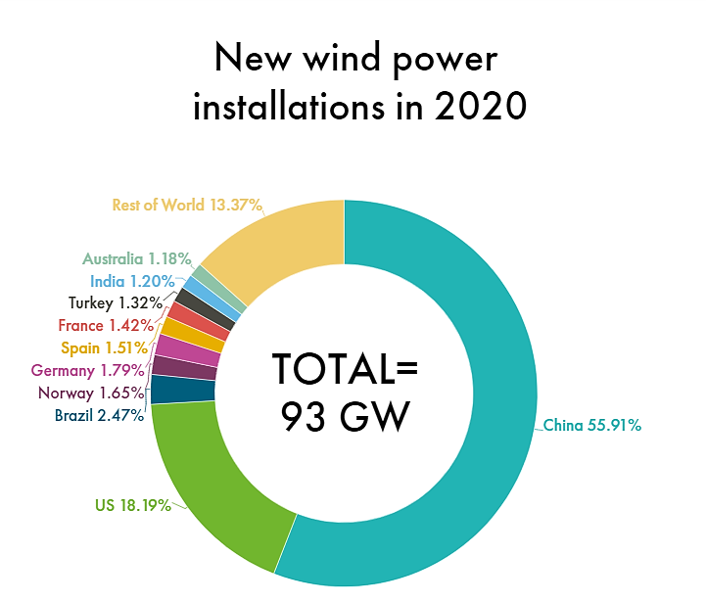

1. **DOMESTIC SCENARIO:** India’s wind energy sector is led by indigenous wind power industry and has shown consistent progress. The expansion of the wind industry has resulted in a strong ecosystem, project operation capabilities and manufacturing base of about 10,000 MW per annum. The country currently has the fourth highest wind installed capacity in the world with total installed capacity of 39.25 GW (as on 31st March 2021) and has generated around 60.149 Billion Units during 2020-21. Wind is an intermittent and site-specific resource of energy and therefore, an extensive Wind Resource Assessment is essential for the selection of potential sites. The Government, through National Institute of Wind Energy (NIWE), has installed over 800 wind-monitoring stations all over country and issued wind potential maps at [50m, 80m](https://niwe.res.in/department_wra_est.php), 100m and 120m above ground level. The recent assessment indicates a gross wind power potential of 302 GW in the country at 100 meter and 695.50 GW at 120 meter above ground level. Most of this potential exists in the windy States as given below:

|  |  |
| --- | --- |
| **State** | **Total Capacity (MW)** |
| [**Tamil Nadu**](https://en.wikipedia.org/wiki/Tamil_Nadu) | 9608.04 |
| [**Gujarat**](https://en.wikipedia.org/wiki/Gujarat) | 8561.82 |
| [**Maharashtra**](https://en.wikipedia.org/wiki/Maharashtra) | 5000.33 |
| [**Karnataka**](https://en.wikipedia.org/wiki/Karnataka) | 4938.60 |
| [**Rajasthan**](https://en.wikipedia.org/wiki/Rajasthan) | 4326.82 |
| [**Andhra Pradesh**](https://en.wikipedia.org/wiki/Power_sector_of_Andhra_Pradesh) | 4096.65 |
| [**Madhya Pradesh**](https://en.wikipedia.org/wiki/Madhya_Pradesh) | 2519.89 |
| [**Telangana**](https://en.wikipedia.org/wiki/Telangana) | 128.10 |
| [**Kerala**](https://en.wikipedia.org/wiki/Kerala) | 62.50 |
| **Others** | 4.30 |
| **Total** | **39247.05** |

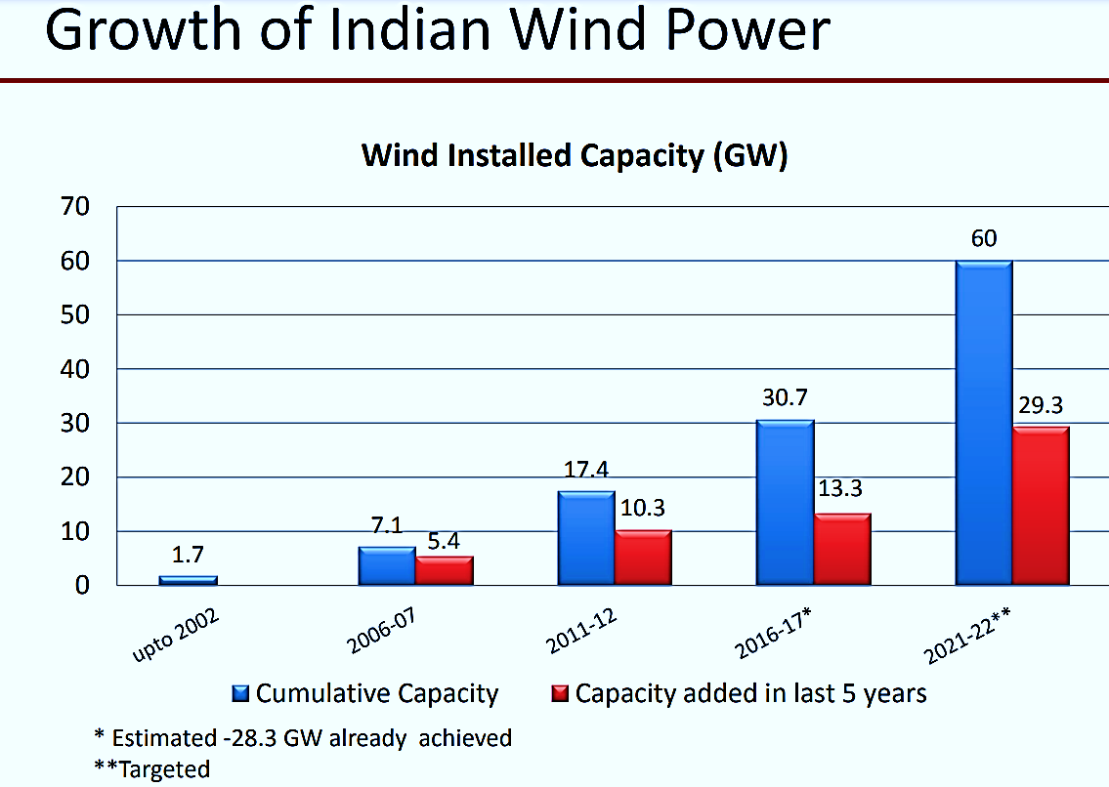

1. **MAJOR CHALLENGES:** Despite the economic and ecological advantages, so far even good wind resources in developing and emerging countries have not been used to the desirable extent. The essential reasons for this are based in the lack of knowledge in the developing and emerging countries.

* Infrastructure to support the installation, commissioning and maintenance of wind generators is not developed. Users and technicians are generally unaccustomed to the technology.
* Investment Cost. Although the lifetime cost of wind is often less than diesel or petrol-powered pumps, the investment cost of purchasing a wind pump is usually higher than that of diesel pumps. Groups purchasing water supplies often have limited funds and cannot take a long-term view toward the technology.
* Wind energy does not have as consistent an output as fuel-fired power plants. Small-scale wind generators require battery storage to allow usage in periods of low or no wind. For grid connected systems, a stable grid is required to act as the storage. Wind pumps require water storage.
* Wind generators are designed to work over a given range of wind speeds, usually 4– 12m/s. This means that the technology can only be used in areas with sufficient winds.
* Lack of qualified staff, especially in the field of service/maintenance.

1. **GOVERNMENT INITIATIVE:** The Government is promoting wind power projects in entire country through private sector investment by providing various fiscal and financial incentives such as Accelerated Depreciation benefit; concessional custom duty exemption on certain components of wind electric generators. Besides, Generation Based Incentive (GBI) Scheme was available for the wind projects commissioned before 31 March 2017.

**The wind power market has grown at a CAGR of 14% between 2010 and 2021 to reach 830 GW by end of 2021. This has largely been possible due to favorable government policies that have provided incentives to the sector. This has led to an increase in the share of wind in the capacity mix, going from a miniscule 4% in 2010 to 10% in 2021. This is further set to rise to 15% by 2030.**

**However, the recent commodity price increase has hit the sector hard, increasing risks for wind turbine manufacturers and project developers, and the Russia-Ukraine crisis has caused further price increase and supply chain disruption.**

In addition to fiscal and other incentives as stated above, following steps also have been taken to promote installation of wind capacity in the country:

* Technical support including wind resource assessment and identification of potential sites through the National Institute of Wind Energy, Chennai.
* In order to facilitate inter-state sale of wind power, the inter-state transmission charges and losses have been waived off for wind and solar projects to be commissioned by March, 2022.
* Issued Guidelines for Tariff Based Competitive Bidding Process for Procurement of Power from Grid Connected Wind Power Projects with an objective to provide a framework for procurement of wind power through a transparent process of bidding including standardization of the process and defining of roles and responsibilities of various stakeholders. These Guidelines aim to enable the Distribution Licensees to procure wind power at competitive rates in a cost effective manner.

The Government has taken several steps to promote renewable energy, including wind energy, in the country. These include:

* Permitting Foreign Direct Investment (FDI) up to 100 percent under the automatic route.
* Waiver of Inter State Transmission System (ISTS) charges for inter-state sale of solar and wind power for projects to be commissioned by 30th June 2025.
* Setting up of Ultra Mega Renewable Energy Parks to provide land and transmission to RE developers on a plug and play basis.
* Concessional custom duty exemption on certain components required for manufacturing of wind electric generators.
* Generation Based Incentive (GBI) is being provided to the wind projects commissioned on or before 31 March 2017.
* Technical support including wind resource assessment and identification of potential sites through the National Institute of Wind Energy, Chennai.

1. **WAY FORWARD:** The power from green sources such as wind and solar are aimed to fulfill several goals such as energy security, economic development, climate change mitigation, rural development and employment generation. To keep the wind program on track, in 1982, the government established the Department of Non-conventional Energy Sources (DNES), under the Ministry of Energy. In 2006, the ministry was renamed as the Ministry of New and Renewable Energy (MNRE).

The government started with the demonstration projects to attract private investment in the sector. From the commencement of the wind program, a market-oriented strategy was implemented. It didn’t involve itself in the direct execution and functioning of wind power projects; rather it worked out the strategy to encourage the involvement of private firms. Over US$ 42 billion investment was made in renewable energy in India during last 4 years.

* Transparent bidding and facilitation for procurement of solar and wind power through tariff based competitive bidding process have led to significant reduction in cost of solar and wind power.
* Government waived the Inter State Transmission System charges and losses for inter-state sale of solar and wind power for projects to be commissioned by March 2022.
* Off-shore from Tamil Nadu and Gujarat coast provides among the best locations from wind power generation. In order to harness this potential we have formulated offshore wind power policy and expression of interest for initial 1GW off-shore wind power have already been issued.
* The Green Energy Corridor projects seek creation of grid infrastructure for renewable power evacuation and to reshape grid for future requirements. The intra state transmission scheme (InSTS) being implemented by eight renewable rich states with an investment of INR 10,141 crores will set up about 9400 km transmission lines and substations of total capacity of approx. 19000 MVA to be completed March 2020.
* In December 2021, India’s largest energy provider, Tata Power, was awarded a contract by the Maharashtra State Electricity Distribution Company Limited (MSEDCL) to set up a 300 MW wind-solar hybrid power plant.
* In October 2021, Adani Green Energy Ltd. (AGEL) acquired SB Energy India for US$ 3.5 billion to strengthen its position in the renewable energy sector in India.
* Investment in renewable energy in India reached a record US$ 14.5 billion in FY22, an increase of 125% over FY21.

|  |  |
| --- | --- |
| **PART E** | **FINANCIAL PERFORMANCE** |

As per the audited financial statements provided by the company/client, below table shows the historical performance of the company.

1. **HISTORICAL PROFIT & LOSS STATEMENT: (FY 2018 to FY 2021-22)**

*(Figures in INR Crores)*

|  |  |  |  |  |  |
| --- | --- | --- | --- | --- | --- |
| **Particular** | **FY 2018 A** | **FY 2019 A** | **FY 2020 A** | **FY 2021 A** | **FY 2022 P** |
| Revenue | 39.23 | 69.47 | 61.3 | 40.37 | 61.11 |
| **Expenditure** |  |  |  |  |  |
| Operational & Maintenance | 1.3 | 4.86 | 7.26 | 5.4 | 7.7 |
| Administration & other expenses | 0.47 | 14.31 | 0.57 | 0.71 | 21.12 |
| **Total Expenses** | **1.77** | **19.17** | **7.83** | **6.11** | **28.82** |
| EBITDA | 37.46 | 50.3 | 53.47 | 34.26 | 32.29 |
| Depreciation & Amortization | 12.00 | 16.22 | 16.27 | 16.22 | 16.22 |
| **EBIT** | **25.46** | **34.08** | **37.20** | **18.04** | **16.07** |
| Finance cost | 24.12 | 33.88 | 36.24 | 35.58 | 33.29 |
| Profit Before Taxes | 1.34 | 0.20 | 0.96 | -17.54 | -17.22 |
| Tax | -5.71 | 4.65 | 7.62 | 3.19 | 3.19 |
| **Profit After Taxes** | **7.05** | **-4.45** | **-6.66** | **-20.73** | **-20.41** |

1. **KEY FINANCIAL RATIOS:**

|  |  |  |  |  |  |
| --- | --- | --- | --- | --- | --- |
| **Particular** | **FY 2018 A** | **FY 2019 A** | **FY 2020 A** | **FY 2021 A** | **FY 2022 P** |
| **EBITDA Margin %** | 95.49% | 72.41% | 87.23% | 84.86% | 52.84% |
| **EBIT Margin %** | 64.90% | 49.06% | 60.69% | 44.69% | 26.30% |
| **Net Profit Margin%** | 17.97% | -6.41% | -10.86% | -51.35% | -33.40% |
| **Revenue Growth % (Y.O.Y.)** |  | 77.08% | -11.76% | -34.14% | 51.37% |

1. **GRAPHICAL REPRESENTATION OF THE KEY FINANCIALS OF THE COMPANY:** Below graphs shows the historical operating and profit margins of the company.

**EBITDA MARGIN %**

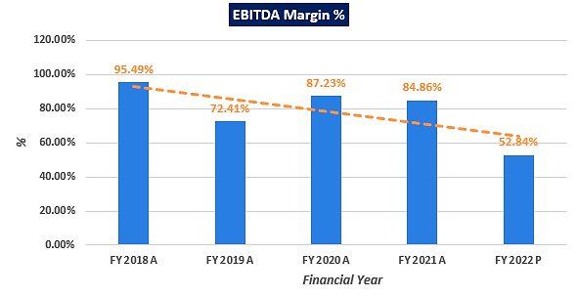

**EBIT MARGIN %**

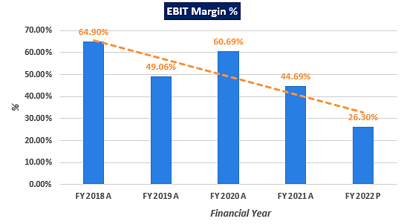

**NET PROFIT MARGIN %**

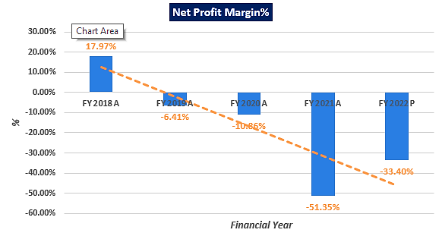

**REVENUE GROWTH% (Y.O.Y.)**

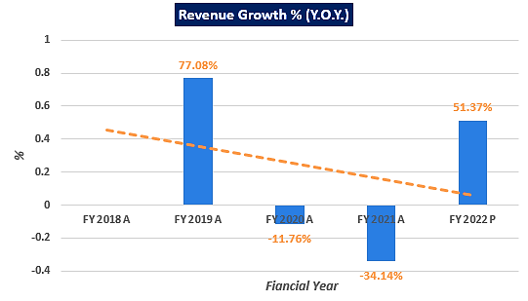

As per information provided by the client/company, figures are provisional for FY 2022, as shown above. As per the historical analysis, it is observed that operating margins are positive continuously. However, net profit margin (PAT) is constantly negative from FY 2019 to FY 2022 due to the higher financing costs. Moreover, after the adjustments of finance cod and tax expenses (PAT) margins remains in declining order from FY 2019 to FY 2022. Revenues of the company are constantly performing well in the line with historical trends.

1. **PROJECTED PROFIT & LOSS STATEMENT (From FY 2023 to FY 2042):** Based on the data/ information/ inputs provided by the Client/ company, projected P&L is shown in the below table:

*(Figures in INR Crores)*

|  |  |  |  |  |  |  |  |  |  |  |
| --- | --- | --- | --- | --- | --- | --- | --- | --- | --- | --- |
| **Particular** | **FY 2023 E** | **FY 2024 E** | **FY 2025 E** | **FY 2026 E** | **FY 2027 E** | **FY 2028 E** | **FY 2029 E** | **FY 2030 E** | **FY 2031 E** | **FY 2032 E** |
| Revenue | 63.10 | 63.10 | 62.68 | 60.37 | 60.37 | 60.37 | 60.37 | 60.37 | 60.37 | 60.37 |
| Total O&M Cost | 6.54 | 6.86 | 7.19 | 7.53 | 7.90 | 8.28 | 8.69 | 9.12 | 9.58 | 10.05 |
| **EBITDA** | **56.56** | **56.24** | **55.49** | **52.84** | **52.47** | **52.09** | **51.67** | **51.24** | **50.79** | **50.32** |
| Depreciation & Amortization | 14.77 | 14.77 | 14.77 | 14.77 | 14.77 | 14.77 | 14.77 | 14.77 | 14.77 | 14.77 |
| **EBIT** | **41.79** | **41.48** | **40.72** | **38.07** | **37.71** | **37.32** | **36.91** | **36.48** | **36.03** | **35.55** |
| Finance cost | 26.29 | 24.27 | 22.12 | 19.81 | 17.47 | 15.03 | 12.47 | 9.82 | 7.16 | 4.54 |
| Profit Before Taxes (PBT) | 15.51 | 17.21 | 18.61 | 18.26 | 20.24 | 22.29 | 24.44 | 26.66 | 28.87 | 31.01 |
| Tax | 0.00 | 0.00 | 0.00 | 0.00 | 5.09 | 5.61 | 6.15 | 6.71 | 7.27 | 7.80 |
| **Profit After Taxes (PAT)** | **15.51** | **17.21** | **18.61** | **18.26** | **15.14** | **16.68** | **18.29** | **19.95** | **21.60** | **23.21** |

|  |  |  |  |  |  |  |  |  |  |  |
| --- | --- | --- | --- | --- | --- | --- | --- | --- | --- | --- |
| **Particular** | **FY 2033 E** | **FY 2034 E** | **FY 2035 E** | **FY 2036 E** | **FY 2037 E** | **FY 2038 E** | **FY 2039 E** | **FY 2040 E** | **FY 2041 E** | **FY 2042 E** |
| Revenue | 60.37 | 60.37 | 60.37 | 60.37 | 60.37 | 60.37 | 60.37 | 60.37 | 60.37 | 33.98 |
| Total O&M Cost | 10.55 | 11.08 | 11.63 | 12.20 | 12.81 | 13.45 | 14.12 | 14.82 | 15.56 | 8.47 |
| **EBITDA** | **49.82** | **49.29** | **48.74** | **48.16** | **47.56** | **46.92** | **46.25** | **45.55** | **44.81** | **25.52** |
| Depreciation & Amortization | 14.77 | 14.77 | 14.77 | 14.77 | 14.77 | 14.77 | 14.77 | 14.77 | 14.77 | 14.77 |
| **EBIT** | **35.05** | **34.53** | **33.98** | **33.40** | **32.79** | **32.15** | **31.48** | **30.78** | **30.04** | **10.75** |
| Finance cost | 2.74 | 1.76 | 1.62 | 1.63 | 1.64 | 1.66 | 1.67 | 1.69 | 1.70 | 0.94 |
| Profit Before Taxes (PBT) | 32.31 | 32.77 | 32.36 | 31.77 | 31.15 | 30.50 | 29.81 | 29.09 | 28.34 | 9.81 |
| Tax | 8.13 | 8.25 | 8.14 | 8.00 | 7.84 | 7.68 | 7.50 | 7.32 | 7.13 | 2.47 |
| **Profit After Taxes (PAT)** | **24.18** | **24.52** | **24.22** | **23.77** | **23.31** | **22.82** | **22.31** | **21.77** | **21.21** | **7.34** |

1. **KEY FINANCIAL RATIOS:**

|  |  |  |  |  |  |  |  |  |  |  |
| --- | --- | --- | --- | --- | --- | --- | --- | --- | --- | --- |
| **Particular** | **FY 2023 E** | **FY 2024 E** | **FY 2025 E** | **FY 2026 E** | **FY 2027 E** | **FY 2028 E** | **FY 2029 E** | **FY 2030 E** | **FY 2031 E** | **FY 2032 E** |
| **EBITDA Margin %** | 89.63% | 89.13% | 88.53% | 87.52% | 86.92% | 86.28% | 85.60% | 84.89% | 84.14% | 83.35% |
| **EBIT Margin %** | 66.23% | 65.73% | 64.98% | 63.06% | 62.46% | 61.82% | 61.14% | 60.43% | 59.68% | 58.89% |
| **Net Profit Margin%** | 24.57% | 27.27% | 29.69% | 30.25% | 25.09% | 27.63% | 30.29% | 33.05% | 35.78% | 38.44% |
| **Revenue Growth % (Y.O.Y.)** |  | 0.00% | -0.67% | -3.68% | 0.00% | 0.00% | 0.00% | 0.00% | 0.00% | 0.00% |

|  |  |  |  |  |  |  |  |  |  |  |
| --- | --- | --- | --- | --- | --- | --- | --- | --- | --- | --- |
| **Particular** | **FY 2033 E** | **FY 2034 E** | **FY 2035 E** | **FY 2036 E** | **FY 2037 E** | **FY 2038 E** | **FY 2039 E** | **FY 2040 E** | **FY 2041 E** | **FY 2042 E** |
| **EBITDA Margin %** | 82.52% | 81.65% | 80.74% | 79.78% | 78.78% | 77.72% | 76.61% | 75.45% | 74.22% | 75.08% |
| **EBIT Margin %** | 58.06% | 57.19% | 56.28% | 55.32% | 54.32% | 53.26% | 52.15% | 50.99% | 49.77% | 31.63% |
| **Net Profit Margin%** | 40.05% | 40.62% | 40.11% | 39.38% | 38.61% | 37.80% | 36.96% | 36.06% | 35.13% | 21.61% |
| **Revenue Growth % (Y.O.Y.)** | 0.00% | 0.00% | 0.00% | 0.00% | 0.00% | 0.00% | 0.00% | 0.00% | 0.00% | -43.71% |

1. **GRAPHICAL REPRESENTATION OF THE PROJECTED KEY RATIOS OF THE COMPANY**:

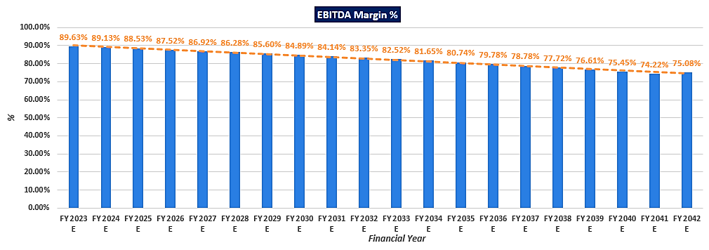

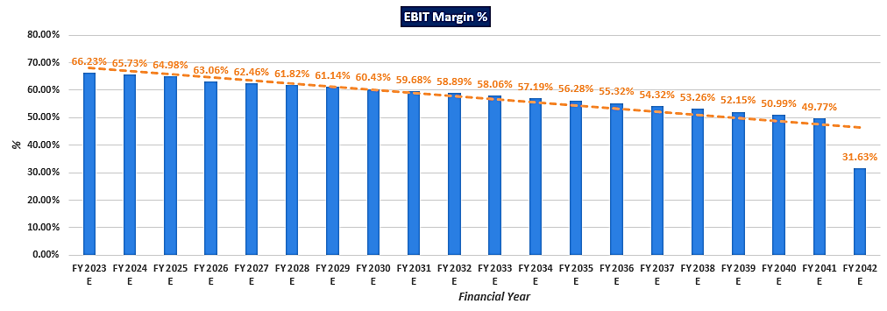

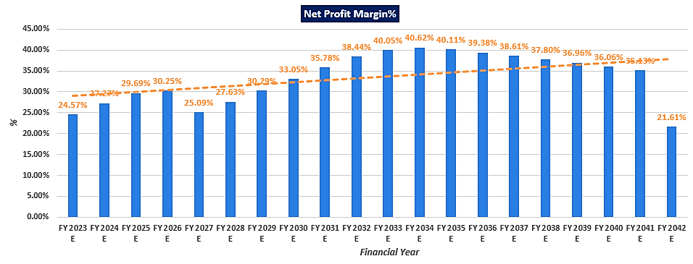

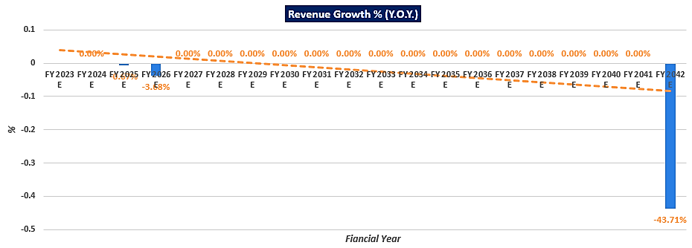

**Notes**:

* As per the ratio analysis performed, it is observed that EBITDA Margin and EBIT Margin of the company is positive throughout the forecasted period.
* Revenue is constant throughout the estimated period since there is no escalation in selling price due to purchasing power agreement for 25 years.

|  |  |
| --- | --- |
| **PART F** | **VALUATION OF THE COMPANY** |

1. **METHODOLOGY/ MODEL ADOPTED:** Out of the various models & theories available, we have adopted the most widely used & acceptable approach to calculate the Enterprise Value of the Company, which is, Income based approach (Discounted Cash Flow Model).
2. The free cash flow method is similar to the method used for public companies.
3. FCFF is more practical when substantial capital changes are expected because weighted average cost of capital (WACC) is less sensitive to the cost of equity.
4. In this method, we calculate the free cash flow to firm (FCFF) for the projected period.
5. Finally, we calculate the present value of future cash flows by using a required rate of return based on the riskiness of the project, which we determine by using the Weighted Average Cost of Capital (WACC).

**RATIONALE FOR USING DCF METHOD FOR ENTERPRISE VALUATION:**

1. The three broadly used approaches of the company/Business Valuations are – Income based approach (Discounted Cash Flow Model), Asset Based Approach (Net Asset Value Method) and Relative Valuation Approach (Market Multiple method).
2. Asset Based Model is inappropriate as the Company/project is a going concern and the model is unable to capture the Value of the company.
3. Market Multiple Approach is also not suitable approach as the company/project/business is not a listed and no proper similar recent comparable transactions are available.
4. Instead, DCF method is used which determines the value of a business based on its ability to generate desired economic benefit/ cash flows for the owners. Thus, considering the nature of business, we have used DCF method for valuing the Company.
5. Further, for the purpose of estimating the distress value of the project, 15% distress discount is taken into account on the present value of the free cash flows or Enterprise Value.
6. The DCF Model gives us a variety of input options to use while calculating the Value of the firm - Dividend, Free Cash Flow to the Firm, Free Cash Flow to Equity, Capitalized Cash Flows and Residual Earnings.
7. Dividends cannot be used as the Company has no history of paying dividends and we don’t foresee any dividend payments to occur in the future due to the high leverage of the firm.
8. The best method input option for the PV Model in the case of Danu Wind Park Private Limited will be FCFF as it represents the benefits accruable to all the stakeholders in the Business enterprise.
9. Further, the valuation is conducted based on the data/information provided by the company/client and based on our independent analysis.

**FCFF Model Formula and Key Inputs:**

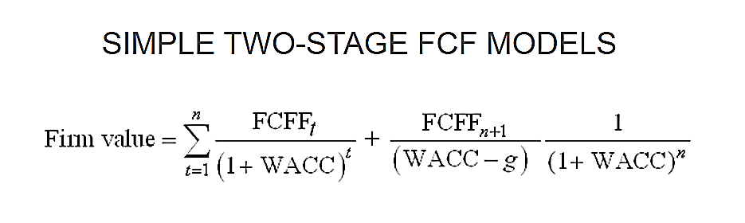

* **Free Cash Flow to Firm (FCFF):** FCFF is the [cash](http://www.investinganswers.com/node/5011) available to pay investors/stakeholders after a company pays its costs of doing business, invests in short-term assets like [inventory](http://www.investinganswers.com/node/2474), and invests in assets like property, plants and equipment.

**FCFF = Net Income + Non-Cash Charges + Interest (1 - tax rate) – Working Capital Investment – Fixed Capital Investment.**

* **Weighted Average Cost of Capital (WACC):**The weighted average cost of capital (WACC) is the rate that a company is expected to pay on average to all its security holders to finance its assets. The WACC is commonly referred to as the firm’s cost of capital. WACC is used as the discount rate to discount FCFF.

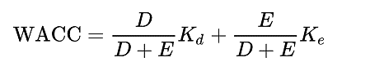

Where D is the total debt, E is the shareholders equity and Kd and Ke are the cost of debt and cost of equity, respectively.

1. **CALCULATION OF FREE CASH FLOW TO FIRM:**

*(Figures in INR Crores)*

|  |  |  |  |  |  |  |  |  |  |  |
| --- | --- | --- | --- | --- | --- | --- | --- | --- | --- | --- |
| **Particular (INR Crore)** | **FY 2023 E** | **FY 2024 E** | **FY 2025 E** | **FY 2026 E** | **FY 2027 E** | **FY 2028 E** | **FY 2029 E** | **FY 2030 E** | **FY 2031 E** | **FY 2032 E** |
| Number of Months | 5 | 12 | 12 | 12 | 12 | 12 | 12 | 12 | 12 | 12 |
| Revenue | 63.10 | 63.10 | 62.68 | 60.37 | 60.37 | 60.37 | 60.37 | 60.37 | 60.37 | 60.37 |
| Total Operating & Maintenance Cost | 6.54 | 6.86 | 7.19 | 7.53 | 7.90 | 8.28 | 8.69 | 9.12 | 9.58 | 10.05 |
| **EBITDA** | **56.56** | **56.24** | **55.49** | **52.84** | **52.47** | **52.09** | **51.67** | **51.24** | **50.79** | **50.32** |
| Depreciation & Amortization | 14.77 | 14.77 | 14.77 | 14.77 | 14.77 | 14.77 | 14.77 | 14.77 | 14.77 | 14.77 |
| **EBIT** | **41.79** | **41.48** | **40.72** | **38.07** | **37.71** | **37.32** | **36.91** | **36.48** | **36.03** | **35.55** |
| Effective Tax Rate | 0.00 | 0.00 | 0.00 | 0.00 | 5.09 | 5.61 | 6.15 | 6.71 | 7.27 | 7.80 |
| **NOPAT** | **41.79** | **41.48** | **40.72** | **38.07** | **32.61** | **31.71** | **30.76** | **29.77** | **28.76** | **27.75** |
| **+ Dep & Amortization** | 14.77 | 14.77 | 14.77 | 14.77 | 14.77 | 14.77 | 14.77 | 14.77 | 14.77 | 14.77 |
| **- Change in Working Capital** | 0.08 | 0.08 | -0.02 | -0.49 | 0.09 | 0.10 | 0.10 | 0.11 | 0.11 | 0.12 |
| **- Capex** | 0.00 | 0.00 | 0.00 | 0.00 | 0.00 | 0.00 | 0.00 | 0.00 | 0.00 | 0.00 |
| **FCFF** | **56.48** | **56.16** | **55.51** | **53.32** | **47.28** | **46.38** | **45.42** | **44.43** | **43.41** | **42.39** |

|  |  |  |  |  |  |  |  |  |  |  |
| --- | --- | --- | --- | --- | --- | --- | --- | --- | --- | --- |
| **Particular (INR Crore)** | **FY 2033 E** | **FY 2034 E** | **FY 2035 E** | **FY 2036 E** | **FY 2037 E** | **FY 2038 E** | **FY 2039 E** | **FY 2040 E** | **FY 2041 E** | **FY 2042 E** |
| Number of Months | 12 | 12 | 12 | 12 | 12 | 12 | 12 | 12 | 12 | 12 |
| Revenue | 60.37 | 60.37 | 60.37 | 60.37 | 60.37 | 60.37 | 60.37 | 60.37 | 60.37 | 33.98 |
| Total Operating & Maintenance Cost | 10.55 | 11.08 | 11.63 | 12.20 | 12.81 | 13.45 | 14.12 | 14.82 | 15.56 | 8.47 |
| **EBITDA** | **49.82** | **49.29** | **48.74** | **48.16** | **47.56** | **46.92** | **46.25** | **45.55** | **44.81** | **25.52** |
| Depreciation & Amortization | 14.77 | 14.77 | 14.77 | 14.77 | 14.77 | 14.77 | 14.77 | 14.77 | 14.77 | 14.77 |
| **EBIT** | **35.05** | **34.53** | **33.98** | **33.40** | **32.79** | **32.15** | **31.48** | **30.78** | **30.04** | **10.75** |
| Effective Tax Rate | 8.13 | 8.25 | 8.14 | 8.00 | 7.84 | 7.68 | 7.50 | 7.32 | 7.13 | 2.47 |
| **NOPAT** | **26.92** | **26.28** | **25.83** | **25.40** | **24.95** | **24.48** | **23.98** | **23.46** | **22.91** | **8.28** |
| **+ Dep & Amortization** | 14.77 | 14.77 | 14.77 | 14.77 | 14.77 | 14.77 | 14.77 | 14.77 | 14.77 | 14.77 |
| **- Change in Working Capital** | 0.13 | 0.13 | 0.14 | 0.14 | 0.15 | 0.16 | 0.17 | 0.18 | 0.19 | -8.37 |
| **- Capex** | 0.00 | 0.00 | 0.00 | 0.00 | 0.00 | 0.00 | 0.00 | 0.00 | 0.00 | 0.00 |
| **FCFF** | **41.56** | **40.91** | **40.46** | **40.02** | **39.56** | **39.08** | **38.58** | **38.05** | **37.49** | **31.41** |

1. **KEY INPUTS USED TO DISCOUNT CASH FLOWS DURING THE PROJECTION PERIOD:**

**Calculation of Weighted Average Cost of Capital (WACC)**

|  |  |
| --- | --- |
| **Particulars** | **Value** |
| **Valuation Date** | **28th Oct 2022** |
| **Post-tax Cost Of Debt (Kd)** | 8.91% |
| **Cost of Equity (Ke)** | 16.67% |
| **WACC** | **10.72%** |
| **Company Risk Premium** | 2.75% |
| **Applicable Discount Rate** | **13.47%** |

1. **CALCULATION OF ENTERPRISE VALUE:** Below is the calculation of Present Value of Free Cash Flow to Firm as shown in the below table by using appropriate discount rate:

|  |  |  |  |  |  |  |  |  |  |  |
| --- | --- | --- | --- | --- | --- | --- | --- | --- | --- | --- |
| **Particular** | **FY 2023 E** | **FY 2024 E** | **FY 2025 E** | **FY 2026 E** | **FY 2027 E** | **FY 2028 E** | **FY 2029 E** | **FY 2030 E** | **FY 2031 E** | **FY 2032 E** |
| **FCFF** | **56.48** | **56.16** | **55.51** | **53.32** | **47.28** | **46.38** | **45.42** | **44.43** | **43.41** | **42.39** |
| **WACC** | **13.47%** | | | | | | | | | |
| Discount Period | 0.42 | 1.42 | 2.42 | 3.42 | 4.42 | 5.42 | 6.42 | 7.42 | 8.42 | 9.42 |
| Discount Factor | 0.95 | 0.84 | 0.74 | 0.65 | 0.57 | 0.50 | 0.44 | 0.39 | 0.35 | 0.30 |
| **PV of FCFF** | **53.58** | **46.96** | **40.90** | **34.63** | **27.06** | **23.39** | **20.19** | **17.41** | **14.99** | **12.90** |

|  |  |  |  |  |  |  |  |  |  |  |
| --- | --- | --- | --- | --- | --- | --- | --- | --- | --- | --- |
| **Particular** | **FY 2033 E** | **FY 2034 E** | **FY 2035 E** | **FY 2036 E** | **FY 2037 E** | **FY 2038 E** | **FY 2039 E** | **FY 2040 E** | **FY 2041 E** | **FY 2042 E** |
| **FCFF** | **41.56** | **40.91** | **40.46** | **40.02** | **39.56** | **39.08** | **38.58** | **38.05** | **37.49** | **31.41** |
| **WACC** | **13.47%** | | | | | | | | | |
| Discount Period | 10.42 | 11.42 | 12.42 | 13.42 | 14.42 | 15.42 | 16.42 | 17.42 | 18.42 | 19.42 |
| Discount Factor | 0.27 | 0.24 | 0.21 | 0.18 | 0.16 | 0.14 | 0.13 | 0.11 | 0.10 | 0.09 |
| **PV of FCFF** | **11.15** | **9.67** | **8.43** | **7.35** | **6.40** | **5.57** | **4.85** | **4.21** | **3.66** | **2.70** |
| **Sum of PV’s** | **356.01** | | | | | | | | | |

|  |
| --- |
| **ENTERPRISE VALUE OF THE FIRM** |
| **INR 356.01 Crores** |
| **INR THREE FIFTY SIX CRORES AND ONE LAKHS** |

***NOTE:***

* The Company account is in stress due to untimely repayment of the debt on account of delay in receipt of tariff from Andhra Pradesh State Utility. The account is categorised as Early Warning System (EWS). We have assumed that M/s Danu Wind Parks Pvt Ltd will repay its pending dues as per the Andhra Pradesh high court directed the discom to clear the dues as per the power purchase agreement (PPA) rate.
* The overall valuation is estimated based on the financial statements up to FY 2021-22 and further it has been projected based on the previous data as reference from 2022-23 onwards.
* No claim amount or tenable claim amount has been considered in the financial projections as the cases are currently ongoing.

**Hence, the “Enterprise Value” of the Firm “M/s Danu Wind Parks Private Limited” is INR 356.01 Crores.**

*This is only a general assessment of the Fair market value of the Enterprise/Business based on the data/ input that the Bank/Client/Company could provide to us against our questions/ queries using the appropriate method with respect to the present scenario. In no manner this should be regarded as an audit activity/ report and NO micro analysis or detailed or forensic audit/ scrutiny of the financial transactions or accounts of any kind has been carried out at our end.*

1. **ASSUMPTIONS FOR FINANCIAL PROJECTIONS:** Assumptions in the Valuation assessment have been taken based on data/ information/ documents shared by the Client/Company, Project Cost Figures, and Operating History of the Project. Assumptions have been considered after thoroughly reviewing their feasibility.
   * + - 1. **KEY ASSUMPTION OF THE PROJECT:** Details of key inputs/assumption during the building of projection are as follows shown in the below table:

|  |  |  |
| --- | --- | --- |
| **Danu Wind Parks Private Limited Details** | | |
| **Particular** | **Unit** | **Description/Value** |
| **Life of Plant** | Years | 25 |
| **Installed Capacity of DWPPL-1** | MW | 22.40 |
| **Installed Capacity of DWPPL-2** | MW | 25.30 |
| **COD of the Project** | Date | 30-Jun-16 |
| **COD of the Project** | Date | 20-Mar-18 |
| **Selling price as per State** | INR per unit | 4.84 |
| **Escalation rate in selling price** | % | 0.00% |
| **Initial PLF of DWPPL-1** | % | 27.55% |
| **Initial PLF of DWPPL-2** | % | 31.35% |
| **O&M expenses per MW** | INR Crore | 0.12 |
| **O&M expenses escalation after first paid year** | % | 5.00% |

* + - * 1. **REVENUE/ INCOME:** The project company is having Purchasing Power Agreement with state. Thus, according to PPA the selling price is constant for 25 years. Revenue is being calculated by adding the Revenue from sales, applicable Generation based incentive (GBI) and CER Revenues (Certified Emission Reduction credits) for the respective years during the forecasted period. Below table shows the Total revenue (Danu-1 & Danu-2) during the estimated period:

|  |  |  |  |  |  |  |  |  |  |  |
| --- | --- | --- | --- | --- | --- | --- | --- | --- | --- | --- |
| **Particular (INR Crore)** | **FY 2023 E** | **FY 2024 E** | **FY 2025 E** | **FY 2026 E** | **FY 2027 E** | **FY 2028 E** | **FY 2029 E** | **FY 2030 E** | **FY 2031 E** | **FY 2032 E** |
| Danu 1 | 29.12 | 29.12 | 28.69 | 26.39 | 26.39 | 26.39 | 26.39 | 26.39 | 26.39 | 26.39 |
| Danu 2 | 33.98 | 33.98 | 33.98 | 33.98 | 33.98 | 33.98 | 33.98 | 33.98 | 33.98 | 33.98 |
| **Total Revenue** | **63.10** | **63.10** | **62.68** | **60.37** | **60.37** | **60.37** | **60.37** | **60.37** | **60.37** | **60.37** |

|  |  |  |  |  |  |  |  |  |  |  |
| --- | --- | --- | --- | --- | --- | --- | --- | --- | --- | --- |
| **Particular (INR Crore)** | **FY 2033 E** | **FY 2034 E** | **FY 2035 E** | **FY 2036 E** | **FY 2037 E** | **FY 2038 E** | **FY 2039 E** | **FY 2040 E** | **FY 2041 E** | **FY 2042 E** |
| Danu 1 | 26.39 | 26.39 | 26.39 | 26.39 | 26.39 | 26.39 | 26.39 | 26.39 | 26.39 | 0.00 |
| Danu 2 | 33.98 | 33.98 | 33.98 | 33.98 | 33.98 | 33.98 | 33.98 | 33.98 | 33.98 | 33.98 |
| **Total Revenue** | **60.37** | **60.37** | **60.37** | **60.37** | **60.37** | **60.37** | **60.37** | **60.37** | **60.37** | **33.98** |

* + - * 1. **OPERATING & MAINTENANCE EXPENSES:** O&M costs included O&M Cost to the contractors, transmission & wheeling charges, reactive power charges, salaries, management fees and insurance. Below table shows the total O&M expenses during the forecasted period:

|  |  |  |  |  |  |  |  |  |  |  |
| --- | --- | --- | --- | --- | --- | --- | --- | --- | --- | --- |
| **Particular (INR Crore)** | **FY 2023 E** | **FY 2024 E** | **FY 2025 E** | **FY 2026 E** | **FY 2027 E** | **FY 2028 E** | **FY 2029 E** | **FY 2030 E** | **FY 2031 E** | **FY 2032 E** |
| Danu 1 | 3.14 | 3.29 | 3.45 | 3.62 | 3.80 | 3.99 | 4.18 | 4.39 | 4.61 | 4.84 |
| Danu 2 | 3.40 | 3.56 | 3.73 | 3.91 | 4.10 | 4.30 | 4.51 | 4.73 | 4.97 | 5.21 |
| **Total O&M Cost** | **6.54** | **6.86** | **7.19** | **7.53** | **7.90** | **8.28** | **8.69** | **9.12** | **9.58** | **10.05** |

|  |  |  |  |  |  |  |  |  |  |  |
| --- | --- | --- | --- | --- | --- | --- | --- | --- | --- | --- |
| **Particular (INR Crore)** | **FY 2033 E** | **FY 2034 E** | **FY 2035 E** | **FY 2036 E** | **FY 2037 E** | **FY 2038 E** | **FY 2039 E** | **FY 2040 E** | **FY 2041 E** | **FY 2042 E** |
| Danu 1 | 5.08 | 5.33 | 5.60 | 5.88 | 6.17 | 6.48 | 6.80 | 7.14 | 7.49 |  |
| Danu 2 | 5.47 | 5.74 | 6.03 | 6.33 | 6.64 | 6.97 | 7.32 | 7.68 | 8.07 | 8.47 |
| **Total O&M Cost** | **10.55** | **11.08** | **11.63** | **12.20** | **12.81** | **13.45** | **14.12** | **14.82** | **15.56** | **8.47** |

* + - * 1. **TAXATION:** Effective tax rate has been considered as 29.12% as per applicability of taxation for fiscal year FY 2022-23, considering the 80IA applicability during the forecasted period. Determination of effective tax rate is shown in the below table:

|  |  |
| --- | --- |
| **Effective Tax Rates** | |
| **Particular** | **Description** |
| **Basic rate** | 22% |
| **(+) Cess/Health & education** | 4.00% |
| **(+) Surcharge** | 10% |
| **Effective tax rate** | 25.17% |
| **80IA Applicability** | Yes |
| **80IA Applicable from** | 31-03-2016 |
| **80IA Applicable till** | 31-03-2026 |
| **Effective tax rate** | **25.17%** |

* + - * 1. **WACC/COMPANY RISK PREMIUM:** As the company has been declared Early Warning System (EWS) due to unable the repay its liabilities on time while as per information provided by the client/company, PTC India Financial Services (PFS) is set to recover its pending dues from Danu Wind Parks Pvt. Ltd as the Andhra Pradesh high court directed the discom to clear the dues as per the power purchase agreement (PPA) rate. Due to these reasons, we have assumed a company-wide risk premium of 2.75%.

1. **VALUATION SUMMARY OF THE PROJECT/COMPANY:** Based on the data / information of M/s DWPPL received from PFS and our independent analysis, the summary of valuation of the project is mentioned in the table below:

|  |  |
| --- | --- |
| **VA LUATION OF M/S DANU WIND PARKS PRIVATE LIMITE D (DWPPL)** | |
| **Enterprise Value Of the Firm** | **INR 356.01 Crore** |
| **Distressed Value of the Firm @ 90%** | **INR 320.41 Crore** |

**Hence, the calculated Fair Market Value/Enterprise Value of M/s Danu Wind Parks Private Limited is INR 356.01 Crores, subject to the current micro & macro-economic assumptions, market, industry trends and inputs used during the forecasted period, market multiple and peers company used to compare the company, as well as the WACC used to calculate the Enterprise Value. Distressed Value factor has been considered as 90% to determine the distressed value of the firm as INR 320.41 Crore i.e. EV has been discounted by 10% considering the repayment capability of the project company assumed during the estimated period.**

|  |  |  |
| --- | --- | --- |
| **Declaration** | 1. *Since this is Enterprise Valuation hence no site inspection was carried out by us.* 2. *The undersigned does not have any direct/indirect interest in the above property.* 3. *The information furnished herein is true and correct to the best of our knowledge.* 4. *This valuation work is carried out by our Financial Analyst team on the request from* ***PTC India Financial Services Limited, New Delhi****.* 5. *We have submitted Valuation report to the Client.* | |
| **Name & Address of Valuer company** | | **Signature of the authorized person** |
| M/s R.K. Associates Valuers & Techno Engineering Consultants Pvt. Ltd.  D-39, Second Floor, Sector-2, Noida, UP-201301  India | |  |
| **Number of Pages in the Report** | | **39** |
| **Financial Analyst Team worked on the report** | | ***PREPARED BY: Mr. Gaurav Kumar*** |
| ***REVIEWED BY: HOD*** |

**For R.K Associates Valuers & Techno Place: Noida**

**Engineering Consultants (P) Ltd. Date: 28th October 2022**

**(Authorized Signatory)**

**Valuations**

|  |  |
| --- | --- |
| **PART G** | **IMPORTANT DEFINITION** |

***Definitions:***

* ***Enterprise Value:*** *Enterprise value (EV) is the corporate valuation of a company, determined by using market capitalization and total debt. Market cap comprises preference stocks, common stocks, and minority interest; total debt comprises short-term and long-term liabilities of the company. Enterprise value (EV) refers to the overall valuation—equity, debt, cash, and cash equivalents. In other words, it is the cost of acquiring a firm. The EV/EBITDA is an enterprise multiple. It correlates EV with earnings before interest, taxes, depreciation, and amortization. The metric determines whether the firm is undervalued or overvalued.*
* ***Fair Market Value****suggested by the competent Valuer is that prospective estimated amount in his expert & prudent opinion of the subject asset without any prejudice after he has carefully & exhaustively evaluated the facts & information came in front of him related to the subject asset at which the subject asset should be exchanged between a willing buyer and willing seller at an arm’s length transaction in an open & unrestricted market, after proper marketing, wherein the parties, each acted knowledgeably, prudently and without any compulsion on the date of the Valuation.*

*Forced, under compulsion & constraint, obligatory sales transactions data doesn’t indicate the Fair Market Value.*

* ***Realizable Value*** *is the minimum prospective estimated value of the Company which it may be able to realize at the time of actual transaction factoring in the potential prospects of deep negotiations carried out between the buyer & seller for ultimately finalizing the transaction across the table. Realizable value may be 10-20% less than the Fair Market Value depending on the various salability prospects of the subject asset and the needs of the buyer & the seller.*
* ***Forced/ Distress Sale Value*** *is the value when the company has to be sold due to any compulsion or constraint like financial encumbrances, dispute, as a part of a recovery process, legal issues or any such condition or situation. In this type of sale, minimum fetch value is assessed which can be 15-25% less than the estimated Fair Market Value. In this type of sale, negotiation power of the buyer is always more than the seller and eagerness & pressure of selling the asset is more than buying it. Therefore, the Forced/ Distress Sale Value will always fetch significantly less value compare to the estimated Fair Market Value.*
* ***Liquidation Value*** *is the amount that would be realized when an asset or group of assets are sold on a piecemeal basis that is without consideration of benefits (or detriments) associated with a going-concern business. Liquidation value can be either in an orderly transaction with a typical marketing period or in a forced transaction with a shortened marketing period.*
* ***Difference between Costs, Price & Value:*** *Generally, these words are used and understood synonymously. However, in reality each of these has a completely different meaning, premise and also have different definitions in the professional & legal terms. Therefore, to avoid confusion, it is our professional responsibility to describe the definitions of these words to avoid ambiguity & confusion in the minds of the user of this report.*
* *The* ***Cost*** *of an asset represents the actual amount spend in the construction/ actual creation of the asset.*
* *The* ***Price*** *is the amount paid for the procurement of the same asset.*
* *The* ***Value*** *is defined as the present worth of future rights in the asset and depends to a great extent on combination of various factors such as demand and supply, market situation, purpose, situation & needs of the buyer & seller, salability outlook, usability factor, market perception & reputation. Needs of the buyer & seller, salability outlook, usability factor, market perception & reputation.*
* *Therefore, in actual for the same asset, cost, price & value remain different since these terms have different usage & meaning.*

|  |  |
| --- | --- |
| **PART H** | **DISCLAIMER | REMARKS** |

* + - 1. No employee or member of R.K Associates has any direct/ indirect interest in the Project.
      2. This report is prepared based on the copies of the documents/ information which the Bank/ Company has provided to us out of the standard checklist of documents sought from them and further based on our assumptions and limiting conditions. The client/owner and its management/representatives warranted to us that the information they supplied was complete, accurate and true and correct to the best of their knowledge. All such information provided to us has been relied upon in good faith and we have assumed that it is true and correct in all respect. I/We shall not be liable for any loss, damages, cost or expenses arising from fraudulent acts, misrepresentations, or willful default on part of the owner, company, its directors, employee, representative or agents. Verification or cross checking of the documents provided to us from the originals or from any Govt. departments/ Record of Registrar has not been done at our end since this is beyond the scope of our work. If at any time in future, it is found or came to our knowledge that misrepresentation of facts or incomplete or distorted information has been provided to us then this report shall automatically become null & void.
      3. Legal aspects for e.g., investigation of title, ownership rights, lien, charge, mortgage, lease, sanctioned maps, verification of documents, etc. have not been done at our end and same has to be taken care by legal expert/ Advocate. It is assumed that the concerned Lender/ Financial Institution has satisfied them with the authenticity of the documents, information given to us and for which the legal verification has been already taken and cleared by the competent Advocate before requesting for this report. I/ We assume no responsibility for the legal matters including, but not limited to, legal or title concerns.
      4. This report is a general analysis of the project based on the scope mentioned in the report. This is not an Audit report, Design document, DPR or Techno feasibility study. All the information gathered is based on the facts seen on the site during survey, verbal discussion & documentary evidence provided by the client and is believed that information given by the company is true best of their knowledge.
      5. All observations mentioned in the report is only based on the visual observation and the documents/ data/ information provided by the client. No mechanical/ technical tests, measurements or any design review have been performed or carried out from our side during Project assessment.
      6. Bank/FII should ONLY take this report as an Advisory document from the Financial/ Chartered Engineering firm and its specifically advised to the creditor to cross verify the original documents for the facts mentioned in the report which can be availed from the borrowing company directly.
      7. In case of any default in loans or the credit facility extended to the borrowing company, R.K Associates shall not be held responsible for whatsoever reason may be and any request for seeking any explanation from the employee/s of R.K Associates will not be entertained at any instance or situation.
      8. The documents, information, data provided to us during the course of this assessment by the client is reviewed only up to the extent required in relation to the scope of the work. No document has been reviewed beyond the scope of the work.
      9. This report only contains general assessment & opinion as per the scope of work evaluated as per the information given in the copy of documents, information, data provided to us and/ and confirmed by the owner/ owner representative to us at site which has been relied upon in good faith. It doesn’t contain any other recommendations of any sort including but not limited to express of any opinion on the suitability or otherwise of entering into any transaction with the borrower.
      10. We have relied on data from third party, external sources & information available on public domain also to conclude this report. These sources are believed to be reliable and therefore, we assume no liability for the truth or accuracy of any data, opinions or estimates furnished by others that have been used in this analysis. Where we have relied on data, opinions or estimates from external sources, reasonable care has been taken to ensure that such data has been correctly extracted from those sources and /or reproduced in its proper form and context, however still we can’t vouch its authenticity, correctness or accuracy.
      11. This Report is prepared by our competent technical team which includes Engineers and financial experts & analysts.
      12. This is just an opinion report and doesn’t hold any binding on anyone. It is requested from the concerned Financial Institution which is using this report for taking financial decision on the project that they should consider all the different associated relevant & related factors also before taking any business decision based on the content of this report.
      13. All Pages of the report including annexures are signed and stamped from our office. In case any paper in the report is without stamp & signature then this should not be considered a valid paper issued from this office.
      14. Though adequate care has been taken while preparing this report as per its scope, but still, we can’t rule out typing, human errors, over sightedness of any information or any other mistakes. Therefore, the concerned organization is advised to satisfy themselves that the report is complete & satisfactory in all respect. Intimation regarding any discrepancy shall be brought into our notice immediately. If no intimation is received within 15 (Fifteen) days in writing from the date of issuance of the report, to rectify these timely, then it shall be considered that the report is complete in all respect and has been accepted by the client up to their satisfaction & use and further to which R.K Associates shall not be held responsible in any manner.
      15. Defect Liability Period is **15 DAYS**. We request the concerned authorized reader of this report to check the contents, data and calculations in the report within this period and intimate us in writing if any corrections are required or in case of any other concern with the contents or opinion mentioned in the report. Corrections only related to typographical, calculation, spelling mistakes, incorrect data/ figures/ statement will be entertained within the defect liability period. Any new changes for any additional information in already approved report will be regarded as additional work for which additional fees may be charged. No request for any illegitimate change in regard to any facts & figures will be entertained.
      16. R.K Associates encourages its customers to give feedback or inform concerns over its services through proper channel at valuers@rkassociates.org in writing within 15 days of report delivery. After this period no concern/ complaint/ proceedings in connection with the Financial Feasibility Study Services will be entertained due to possible change in situation and condition of the subject Project.
      17. Our Data retention policy is of **ONE YEAR**. After this period, we remove all the concerned records related to the assignment from our repository. No clarification or query can be answered after this period due to unavailability of the data.
      18. This Financial Feasibility Study report is governed by our (1) Internal Policies, Processes & Standard Operating Procedures, (2) Information/ Data/ Inputs given to us by the client and (3) Information/ Data/ Facts given to us by our field/ office technical team. Management of R.K Associates never gives acceptance to any unethical or unprofessional practice which may affect fair, correct & impartial assessment and which is against any prevailing law. In case of any indication of any negligence, default, incorrect, misleading, misrepresentation or distortion of facts in the report then it is the responsibility of the user of this report to immediately or at least within the defect liability period bring all such act into notice of R.K Associates management so that corrective measures can be taken instantly.
      19. R.K Associates never releases any report doing alterations or modifications from pen. In case any information/ figure of this report is found altered with pen then this report will automatically become null & void.