VACANT LAND SURVEY FORM
(Version 5.0)
Date of implementation: 09.02.2017 | Date of Revision: 04.01.2018 | Latest Revision: 31.10.2020

File No. RKA/DNCR/……/…............... | Date:-13.10.2022 | Time:

GENERAL DETAILS
1. | Name of the Surveyor | Mukund Dalal
2. | Property shown by | ☐ Representative,
2. | Property shown by | Name | Contact No.
2. | Property shown by | Vishal Jadvani | 9099208559
3. | Survey Type | Full survey (inside-out with measurements & photographs)
4. | Reason for Half survey or only photographs taken | Not applicable.
5. | How Property is Identified | - From schedule of the properties mentioned in the deed,
6. | Type of Land | Institutional Land, with dome
7. | Property Measurement | Self-measured,
8. | Reason for no measurement | Not applicable.
9. | Purpose of Valuation | - Value assessment of the asset for creating collateral mortgage
10. | Type of Loan | - Housing Loan, ☐ Housing Take Over Loan, ☐ Home Improvement Loan, ☐ Loan against Property, ☐ Construction Loan,  - Educational Loan, ☐ Car Loan, ☐Project Loan, ☐ Term Loan, ☐  CC Limit enhancement, ☐ Cash Credit Limit,  - Industrial Loan, ☐ NA
11. | Loan Amount

OWNERSHIP DETAILS
1. | Legal Owner Name/s | H.K. Jewels pvt. Ltd.
2. | Property Purchaser Name
3. | Property Address under | Plot no.-E/06, E/07, E/08, E/09, Gems & Jewelry Park Also Known As Gujarat Hira Bourse, Opp. ONGC Hazira Plant, Moje: Ichchhapore, Surat.

 | Valuation
4. | Present Residence Address of  the Owner/ Purchaser | Data not produced.
5. | Property constitution | ☐ Lease Hold  Lessor:-Gujarat Industrial Development Corporation.  Lessee:-Gujarat Hira Bourse  Sub lessee:- H.K. Jewels pvt. Ltd.  Lease is of 99 years starting from date 30.04.2007, At the end of 99 years lease period, the lessee shall have the right to renew this lease for a further a period of 99 years and in the event of the lessee exercising such option, the lessor (GIDC) shall have the right to increase the sum of yearly rent by a sum of 100% of the original rent. The land revenue is payable by the lessee.  Ground rent is Rs.2.00/sq.mt. per annum  (As per our record)

LOCATION DETAILS
1. | Adjoining Properties  (As per approve plan) | North |  | South |  |  |  | East |  |  | West
1. | Adjoining Properties  (As per approve plan) | Plot no.-F/01A & F/01B |  | 25.00mt. wide road |  |  |  | COP /18mt. wide road |  |  | Plot no.-E/05
 | AsAs Adjoining Properties  (As per site) | Open plots |  | 25.00mt. wide road / Harikrishna campus |  |  |  | COP /18mt. wide road |  |  | Adj. dome
2. | Property Facing | South Facing,
3. | Landmark | Opp. ONGC Hazira Plant, Moje: Ichchhapore, Surat
4. | Ward Name/ No. | Ward Ichhapore
5. | Zone Name | Ichhapore
6. | Main Road Name & Width and distance of the property from it | Name |  |  |  | Width |  |  |  | Distance from  property
6. | Main Road Name & Width and distance of the property from it | Surat – Hazira main road |  |  |  | 120mt. |  |  |  | Walking distance
7. | Approach Road Name & Width | Internal road of Gujarat Hira Bourse
8. | Location consideration of the Society | - Within Main city, ☐ Within Good Urban developed Area,
9. | Location of the Flat | - Not applicable.
10. | Characteristics of the Locality | Industrial,
11. | Category of Society/ Locality | Normal,
12. | Utilities/ Facilities in the locality | Garden, ☐ Landscaping,
13. | Proximity to civic amenities | School | Hospital |  | Market |  | Metro |  | Railway Station |  |  | Airport
13. | Proximity to civic amenities | 4-5 | 4-5 |  | 6-7 |  | --- |  | 14 |  |  | 11
14. | Any new development in  surrounding area | Developed area
15. | Jurisdiction limits | Gujarat Industrial Development Corporation
16. | Jurisdiction Development | GIDC
17. | Municipal Corporation Name | Surat Municipal Corporation,

PHYSICAL DETAILS
1. | Land Area | As per Title deed | As per Map | As per site  survey
1. | Land Area | 8133.12sq.yd. = 6800.00sq.mt. | 4 plots x 1700.00sq.mt. = 6800sq.mt. | 6800sq.mt.
2. | Any conversion to the land use | Industrial use
3. | Land Type | Solid,
4. | Shape of the Land | Rectangular,
5. | Level of Land | Above road level,
6. | Frontage to depth ratio | Large frontage,
7. | Are Boundaries matched | - Yes,
8. | Is Independent access available to the property? | - Clear independent access is available,
9. | Is property clearly demarcated with permanent boundaries? | ☒ No,
10. | Is the property merged or  colluded with any other property | Plot no.-E/1 to E/9 are merged together & one big dome is constructed on it without any spate plot marking.
11. | Property currently possessed by | Owner,
12. | Garden/ Landscaping | Yes,
13. | Boundary Wall (Only for individual property) | Height: | Width: | Finish:
14. | Guard Room | ☐ No,
15. | Water arrangements | No
16. | Power connection | available.
17. | Current activity carried out on the  Land | The dome is used for function such as Garba night, speech & company activity.
18. | Special comments if any | 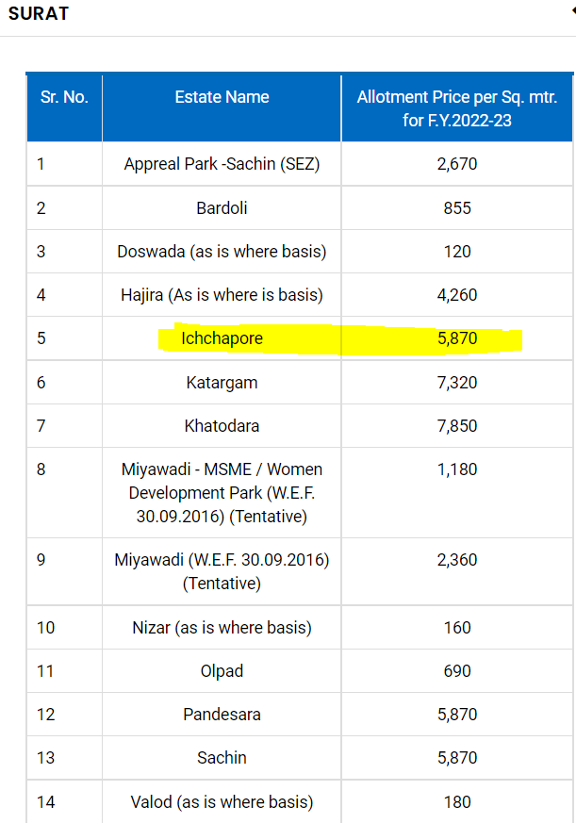  Government guideline rate / allotment price of GIDC
 | BUILT up area of dome is 5600.00/sq.mt. with 20ft. heights & 25ft. span between two coloum, side walls are not avilable.

MARKETABILITY/ SELABILITY/ UTLITY DETAILS
1. | Any issues in marketability of the property? | Marketability is excellent.
2. | How is Demand & Supply condition in the Market of such  properties? | Demand | Very Good,
2. |  | Supply | Good,
3. | Is property easily sellable & marketable? | - Yes,
4. | How is the current utility of the  property? | Very Good,
5. | At what True rate Owner bought this Property? | Year of purchase |  | Data not produced.
5. | At what True rate Owner bought this Property? | Purchase Price

USE THIS SPACE FOR PROVIDING ANY ADDITIONAL DETAILS/ INFORMATION

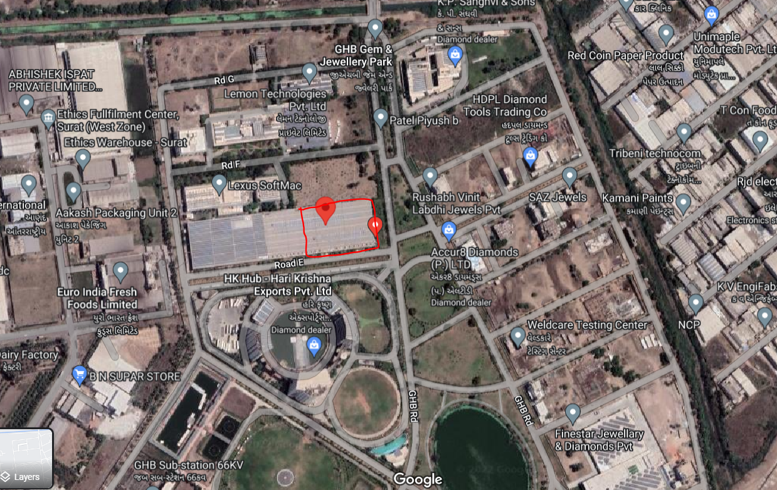

Location coordinates:- 21.187779, 72.736840

DRAW SITE KEY PLAN & SKETCH PLAN

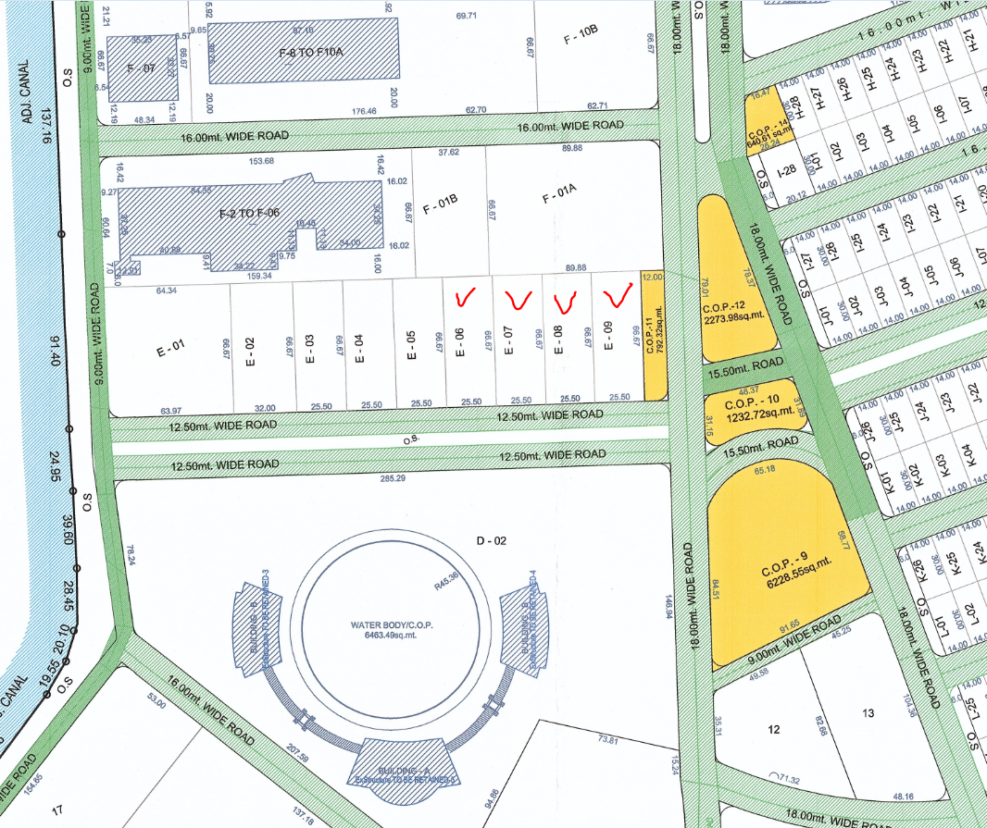
PROPERTY MARKET COMPARABLE RATE INFORMATION DETAILS
(Available for Sale or Transaction already happened in past)
S.No | Particulars | Subject Property | Comparable 1 | Comparable 2 | Comparable 3
1. | Name (source of information) | 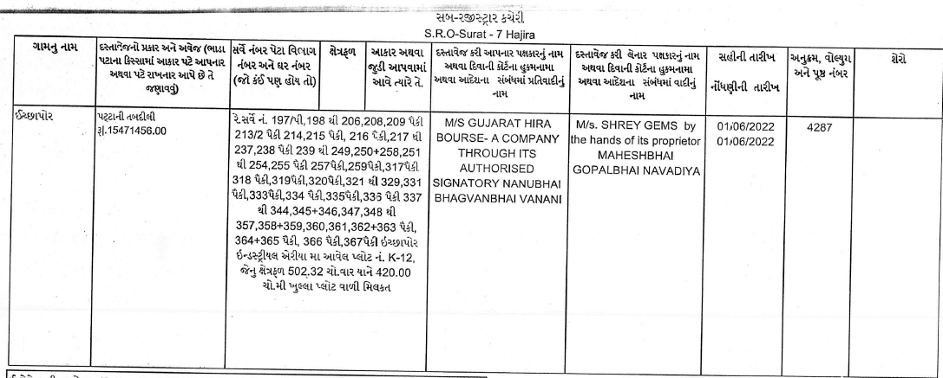  The sales attached herewith are of same campus & just abount @three months ago which is @30819.00/sq.yd. which is fair & reasonable.  Surrounding rate is also @30000 to 32000.00/sq.yd.
2. | Contact No.
3. | Type of source of information (Seller/ Property dealer/ nearby  people)
4. | Rates/ Price informed
5. | Rates Type (Sale/ Buy)
6. | Shape of the Property  (Square, Rectangular, Irregular)
7. | Area/ Size of the Property
8. | Legal Status (clear, negative, weak)/ No. of  owners
9. | Location/ surrounding/ neighborhood comparison with the subject property (Similar, Lower, Better, Highly Better than the  subject Property)
10. | Distance from the subject Property
11. | Level of Land (Below/ On/ Above road level)
12. | Frontage to depth ratio  (Normal, Less, Large)
13. | Approach road width
14. | Present Use
15. | Property Demarcation  (Yes, No, Partly, Temporarily)
16. | Other factors (Corner, 2 side open, North-East facing, Park facing, Legal/ Financial encumbrance, etc.)
17. | Any other details/ Discussion held
18. | Present expected Sale Value of the overall property?



Enclosure: 6
SURVEY SUMMARY SHEET
(TO BE ENCLOSED WITH VALUATION REPORT)

(Version 1.0) | Date of implementation: 10.04.2017

Every Valuation report at R.K Associates is prepared based on the thorough survey of the property carried out by our Engineering Surveyor. This Survey Summary Sheet is for the information of Banker/ concerned interested organization. Detailed Survey Form can also be made available to the interested organization in case it is required to cross check what information our surveyor has given in site inspection report based on which Valuation report is prepared.

1. | File No.
2. | Name of the Surveyor | Mukund Dalal
3. | Borrower Name | H.K. Jewels pvt. Ltd.
4. | Name of the Owner | H.K. Jewels pvt. Ltd.
5. | Property Address which has to be  valued | Plot no.-E/06, E/07, E/08, E/09, Gems & Jewelry Park Also Known As Gujarat Hira Bourse, Opp. ONGC Hazira Plant, Moje: Ichchhapore, Surat.
6. | Property shown & identified by at spot | Representative,
6. | Property shown & identified by at spot | Name |  | Contact No.
6. | Property shown & identified by at spot | Vishal Jadvani |  | 9099208559
7. | How Property is Identified by the Surveyor | - From schedule of the properties mentioned in the deed,
8. | Are Boundaries matched | Yes,
9. | Survey Type | Full survey (inside-out with measurements & photographs)
10. | Reason for Half survey or only  photographs taken | N.A.
11. | Type of Property | Industrial,
12. | Property Measurement | - Self-measured,
13. | Reason for no measurement | - N.A.
14. | Land Area of the Property | As per Title deed | As per Map |  | As per site survey
14. | Land Area of the Property | 4 plots x 1700.00sq.mt. = 6800sq.mt. | 4 plots x 1700.00sq.mt. = 6800sq.mt. |  | 6800sq.mt.
15. | Covered Built-up Area | As per Title deed | As per Map |  | As per site survey
15. | Covered Built-up Area |  |  |  | 5600/sq.mt.
16. | Property possessed by at the time of survey | Owner,
17. | Any negative observation of the | No

 | property during survey
18. | Is Independent access available to the property | Clear independent access is available
19. | Is property clearly demarcated with  permanent boundaries? | ☐ No,
20. | Is the property merged or colluded  with any other property | Plot no.-E/1 to E/9 are merged together & one big dome is constructed on it without any spate plot marking.
21. | Local Information References on  property rates | Please refer attached sheet named ‘Property rate Information Details.’

