File No.: VIS (2022-23)-PL449-357-635 Dated: 25.12.2022

TECHNO-ECONOMIC VIABILITY
STUDY REPORT

OF

PLASTIC PRODUCTS MANUFACTURING UNIT OF 4, 50,000 KGS PER ANNUM CAPACITY

SETUP BY

M/S PLASTO PACKAGING PRIVATE LIMITED

REPORT PREPARED FOR

M/S PLASTO PACKAGING PRIVATE LIMITED

**Important - In case of any query/ issue or escalation you may please contact Incident Manager Valuers@rkassociates.org. We will appreciate your feedback in order to improve our services.

NOTE: As per IBA Guidelines please provide your feedback on the report within 15 days of its submission after which report will be considered to be correct.

IMPORTANT NOTICE

COPYRIGHT FORMAT: This report is prepared on the copyright format of R. K. Associates Valuers & Techno Engineering Consultants (P) Ltd. (R. K. Associates) to serve our clients with the best possible information and analysis to facilitate them to take rational business decisions. Legally no one can copy or distribute this format without prior approval from R. K. Associates. It is meant only for the advisory/ reference purpose for the organization/s as mentioned on the cover page of this report. Distribution or use of this format or report or any of its content/ information/ data by any organization or individual other than R.K Associates will be seen as an unlawful act and necessary legal action can be taken against the defaulters.
This report is intended for the sole use of the intended recipient/s and contains material that is STRICTLY CONFIDENTIAL AND PRIVATE.

DEFECT LIABILITY PERIOD: In case of any query/ issue or escalation you may please contact Incident Manager at valuers@rkassociates.org. Though adequate care has been taken while preparing this report as per its scope, but still we can’t rule out typing, human errors, over sightedness of any information or any other mistakes. Therefore, the concerned organization is advised to satisfy themselves that the report is complete & satisfactory in all respect. Intimation regarding any discrepancy shall be brought into our notice immediately. If no intimation is received within 15 (Fifteen) days in writing from the date of issuance of the report, to rectify these timely, then it will be considered that the report is complete in all respect and has been accepted by the client up to their satisfaction & use and further to which R.K Associates shall not be held responsible in any manner.

Part N: R. K. Associates Important Disclaimer and Remarks are integral part of this report and Feasibility assessment is subject to this section. Reader of the report is advised to read all the points mentioned in these sections carefully.

TABLE OF CONTENTS
SECTIONS | PARTICULARS | PAGE NO.
Part A | Report Summary | 4-5
Part B | INTRODUCTION
 | - About the Report | 6
 | - Executive summary | 6
 | - Purpose of the Report | 11
 | - Scope of the Report | 11
 | - Methodology/ Model Adopted | 12
 | - Data Information received from | 12
 | - Documents/ Data Referred | 12
Part C | Company Profile
 | - Company Overview | 13
 | - Proposed Shareholding Details | 14
 | - Promoters/Directors Profile | 15
Part D | Proposed Unit’s Infrastructure Details
 | - Proposed Plant Location | 17
 | - Layout Plan | 17
 | - Location Map | 18
 | - Land Details | 19
 | - Site pictures | 19
 | - Building & Civil Works | 24
 | - Plant and Machinery/ Equipment details | 25
 | - Utilities | 26
Part E | Project Technical details
 | - Capacity of Manufacturing Facility | 27
 | - Basic Architecture: Flow Chart of Manufacturing Facility | 27
 | - Technical Specification of the Proposed Manufacturing Facility | 27
 | - Technology Used | 29
 | - Source of Procurement of Equipment’s | 30
 | - Testing Standards For Production | 30
 | - Manpower | 31
Part F | Product Category
 | - Introduction | 32
 | - Product Category | 34
 | - Marketing, Selling & Distribution Plan | 36
Part G | Industry Overview & Analysis | 37
Part H | SWOT Analysis | 43
Part I | Project Cost and Means of Finance | 44
Part J | Project Schedule | 46
Part K | Statutory Approvals | Licences | NOC | 48
Part L | Company’s Financial Feasibility
 | - Historical Financial Performance Analysis | 50
 | - Projections of the Firm | 51
 | - Key assumptions & Basics | 62
Part M | Conclusion | 69
Part N | Disclaimer | Remarks | 71

PART A | REPORT SUMMARY

- Name of the Company: | M/s Plasto Packaging Private Limited
- Address of the Company: | Registered office: 432 Ashok Road P S Jadavpur Kolkata, West Bengal, 700084, India
- Project Name : | Plastic Product such as Plastic bottle, mug, container etc. Manufacturing Unit
- Project Location: | S.K Industrial Plaza, Shakari Pota Main Road, Kalagachia, P.O- Thakurpukur, P.s- Mahestala, Kolkata-700063
- Project Type: | Plastic Product Manufacturing Unit with an installed capacity of 4,50,000 Kgs. Per Annum
- Project Industry: | Metal & Chemicals (Plastic Industry)
- Product Type/ Deliverables: | Plastic Ball Pen Barrel, Plastic Core, Plastic Cap, Plastic Dibbi For Oinment, Plastic Jarcap, Plastic Container
- Report Prepared for Organization: | M/s Plasto Packaging Private Limited
- TEV Consultant Firm: | M/s. R.K Associates Valuers & Techno Engineering Consultants (P) Ltd.
- Report type: | Techno-Economic Viability Report
- Purpose of the Report: | To assess the Project’s Techno-Economic Viability for the purpose of seeking external financial assistance on the Project.
- Scope of the Report: | To assess, evaluate & comment on Techno-Financial Viability of the Project as per data information provided by the client, independent Industry research and data/ information available on public domain.
- Date of Report: | 25th December, 2022
- Documents referred for the Project | - PROJECT PLANNING DOCUMENTS:  - Detailed Project Report  - Financial Projections of the Project  - Project proposed Schedule  - Statutory Approval Details  - Process Flow of manufacturing  - PROCUREMEMNT DOCUMENTS:  - High level breakup of Plant & Machinery Cost  - Land details and conversion Certificate  - List of major customers of the company  - Expected Building Details  - Expected manpower details  - Water and Electricity arrangements details
- Means of Finance: | Equity + Debt
- Key Financial Indicators | Key Indicators Value  Average DSCR 1.80  Average EBITDA Margin 24.76%  NPV INR 1122.00 Lakhs  IRR 30.04%

Note: Above financial indicators are based on the financial projections of the proposed project provided by the firm and assessment and analysis of the same done by us.

PART B | INTRODUCTION

- ABOUT THE REPORT:
Techno Economic Viability Study Report of the plastic products manufacturing company M/s Plasto Packaging Private Limited, proposed an expansion of installed capacity of 4, 50,000 Kgs. per annum for external financial assistance on the Project.

- EXECUTIVE SUMMARY:
M/s Plasto Packaging Private Limited was incorporated on 27th March, 1996 established for the purpose of carrying on business of manufacturing of plastic products such as plastic bottles, mugs, containers etc. As per the data/information shared by the client, currently the company is offering Plastic Ball Pen Barrel, Plastic Core, Plastic Cap, and Plastic Dibbi for Ointments, Plastic Jar cap, Plastic Container etc. in their portfolio.
The company is established as a private company limited by shares with Registration no. 78564 and Corporate Identification Number U25202WB1996PTC078564 and is promoted by the directors who appears to be well experience in businesses of metal & chemicals and their products as per the profile shared to us by the client and information available in the public domain about them.
The company is registered at Registrar of companies, Kolkata having registered office at 432 Ashok Road P S Jadavpur Kolkata, West Bengal, 700084, India under the directorship of M/s Kabita Bhattacherjee, Mr. Nabani Ranjan, Mr. Purkait Nirmalya Sen. As per financial statement as on 31st March 2022, the company is having an authorized capital of INR 50, 00,000 and the subscribed & paid up capital of INR 44, 40,000.
As per MSME Certificate provided by the client, the company is categorised as MICRO enterprise and having the Udyam Registration Number UDYAM-WB-10-0041867. As per the audited financial statement of the company as on 31st March 2022, the major shareholders of the company are Mrs. Kabita Bhattacharjee, Mr. Nirmalya Sen, Mr. Sandip Bhattacharjee and Mr. Nabani Ranjan Purkait who are holding 28.60%, 22.52%, 17.23%, 14.64% respectively, stake in the company at present.
Mrs. Kabita Bhattacharjee, Mr. Nirmalya Sen and Mr. Nabani Ranjan Purkait are holding the directorship of the company as well currently. As per information shared by company officials, M/s Kabita and M/r Nabani are having more than 32 years of experience in the associated industry.
As per data/information provided by the company’s representative during the site visit, currently company is having 5996 Sq. Ft. (Approximately 8 kattha) land at S.K Industrial Plaza, Shakari Pota Main Road, Kalagachia, P.O- Thakurpukur, P.s- Mahestala, Kolkata-700063, out of which the company is having an existing manufacturing facility of 3, 00,000 Kgs per annum capacity at 2160.01 Sq. Ft. (~3 Kattha) land. Below table shows the Gross KGPA capacity and maximum number of production line for at existing and proposed manufacturing facility.
Particular | Present Installed Capacity | Existing Production Line | Proposed Capacity | Proposed Production Line
Location | KGPA (Gross) | Production Line | KGPA (Gross) | Production Line
S.K Industrial Plaza, Shakari Pota Main Road, Mahestala, Kolkata | 3,00,000 | 3 | 4,50,000 | 5 (Estimated)
Total | 3,00,000 | 3 | 4,50,000
Source: Information provided by the company
As per communicated by company official’s during the site visit, the company was involved in outsourcing and sold the products before 2020. Currently company is operating with 3 production line, out of which, 1 production line was incepted in 2020 and another 2 lines were incepted in 2021.
India Plastics Market was worth US$ 36.07 Billion in 2020 and total revenue is expected to grow at a rate of 6.6% CAGR from 2021 to 2027, reaching almost US $ 56.42 Billion in 2027. The plastics industry in India has now developed to become one of the prominent areas in the nation’s economy, containing of over 30,000 companies & paying more than 4 Million people. India is also one of the world’s best exporters of plastics products. The productions & exports a range of raw materials, laminates, electronic equipment, medical ware, & consumer goods.
As local plastics demand & consumption in India endure to grow at about twice the rate of country’s total economy, polymers are one of the premier sectors with an anticipated growth rate of between 8-12 percent a year through 2021. India’s plastics Market will see more than double its polymer consumption by the year 2022, reaching 20 Million metric tons. Currently the company is offering Plastic Ball Pen Barrel, Pen Cap, Plastic Core, Plastic Cap, and Plastic Dibbi for Ointments, Plastic Jar cap, Plastic Container etc. in their portfolio. Apart from current product profile, company is planning to manufacture the entire pen, with its own brand name on it.
As per the latest proposed plan of expansion for taping the market of plastic in India and as per the growing demand of their finished goods, M/s Plasto Packaging Private Limited is planning to increase the current manufacturing capacity up to 7, 50,000 KGPA from the existing installed capacity of 3, 00,000 KGPA to increase the scope and scale of the production, at already purchased 3600.02 Sq. ft. (5 kattah) vacant land adjacent to existing unit at S.K Industrial Plaza, Shakari Pota Main Road, Kalagachia, P.O- Thakurpukur, P.s- Mahestala, Kolkata-700063.
We R.K associate is performing the Techno-Economic Viability study only for proposed expansion of manufacturing facility at S.K Industrial Plaza, Shakari Pota Main Road, Kalagachia, P.O- Thakurpukur, P.s- Mahestala, Kolkata-700063, for taking a term loan of INR 2.15 Crore and cash credit limit of INR 50.00 Lakhs from financial institutions for building construction and Plant & Machinery purchase & installation work.

PREVIOUS 4-YEARS KEY HISTORICAL FINANCIAL PARAMETERS: The below mentioned table shows the historical performance of the company for past 4 years:
(INR Lakhs)
Particular | FY 2019 A | FY 2020 A | FY 2021 A | FY 2022 A
Revenue from Operations | 76.55 | 95.91 | 125.08 | 159.04
Other income | 0.00 | 0.01 | 0.00 | 0.00
Total Income | 76.55 | 95.91 | 125.08 | 159.04
Cost of material Consumed | 32.26 | 50.08 | 51.76 | 71.43
Employees benefit Expenses | 0.00 | 0.00 | 6.28 | 8.06
Other Operating and General Expenses | 40.45 | 40.42 | 53.26 | 61.85
Total expenses | 72.70 | 90.50 | 111.31 | 141.34
EBITDA | 3.85 | 5.42 | 13.77 | 17.71
Dep & Amortisation Expenses | 0.93 | 3.78 | 9.64 | 12.86
EBIT | 2.92 | 1.63 | 4.13 | 4.85
Finance Costs | 0.00 | 0.00 | 0.00 | 0.00
Items pertaining to Previous year | 0.20 | 0.00 | 0.00 | 0.37
Profit/(Loss) before tax | 2.73 | 1.63 | 4.13 | 4.85
Current Tax | 0.53 | 0.42 | 1.45 | 1.16
Profit (Loss) after Tax | 2.20 | 1.21 | 2.68 | 3.68
EBITDA Margin % | 5.03% | 5.65% | 11.01% | 11.13%
EBIT Margin % | 3.82% | 1.70% | 3.30% | 3.05%
Net Profit Margin % | 2.88% | 1.26% | 2.15% | 2.32%
Revenue Growth % (Y.O.Y.) |  | 25.29% | 30.41% | 27.15%
Source: As per Audited financials shared by the client.
Note: Net operating margins shows positive trends in last four year. All the metrics shows that the company is having an increased growth with decreasing rate. Revenue growth rate Y-o-Y basis is more than 25% historically. Below is the graphical representation of the key financial metrics of the company, showing the historical efficiency and financial performance of the company:

PROPOSED PROJECT COST: The total cost of the project for the expansion of the existing manufacturing facility is being estimated as INR 374.07 Lakhs, which is proposed to be funded through equity of INR 159.07 Lakhs and debt of INR 215.00 Lakhs.
Total Project Cost (INR Lakhs)
Particulars | Existing | Proposed Addition | Total Cost | Equity | Debt | Margin | Bank Finance
Freehold Land & Land Development | 13.64 | 0.00 | 13.64 | 13.64 | 0.00 | 100% | 0.00
Civil Construction | 0.00 | 63.00 | 63.00 | 25.61 | 37.39 | 40% | 37.39
Plant And Machinery | 53.03 | 200.70 | 253.73 | 113.24 | 140.49 | 44.63% | 177.61
Miscellaneous Fixed Assets | 0.00 | 2.20 | 2.20 | 2.20 | 0.00 | 100% | 0.00
Preliminary & Pre-Operative Expenses | 0.00 | 1.00 | 1.00 | 1.00 | 0.00 | 100% | 0.00
Contingencies | 0.00 | 6.33 | 6.33 | 6.33 | 0.00 | 100% | 0.00
Margin Money For Working Capital | 0.00 | 34.17 | 34.17 | 34.17 | 0.00 | 100% | 0.00
Total | 66.67 | 307.40 | 374.07 | 196.19 | 177.88 |  | 215.00
As per the discussion with client/company officials, for the proposed expansion of 4, 50,000 KGPA capacity, the company has already purchased the land during the inception of existing manufacturing facility.
The major heads in the Total Project Cost will be civil construction and Purchase & installation cost of plant & machinery, for which they are taking a term loan of INR 2.15 Crore. Rest most of the heads will be funded through equity and approximately 2% of TPC is considered as contingencies which will also be funded through equity.
The company is planning to fund the project through term loan to initiate the expansion and approaching the financial institutions to provide the required capital.
CURRENT STATUS OF THE PROJECT:

  - Existing Unit: Company is operating a manufacturing unit at Thakurpukur, Mahestala, Kolkata with 3,00,000 KGPA capacity as per details provided by the company. As per the company the civil infrastructure at 3 Kattah land is already utilized for the operational 3 production lines. Existing unit infrastructure details has not been specifically reviewed at our end since this was out of scope of the work. Only its expansion and related projections has been taken into account.

  - Proposed Manufacturing Facility: As per land conversion certificate shared by the client, approx. 5996 Square feet land for the project has been purchased at Khatian No. 2307 Plot no. 308 & 309 and share no. 291 & 2777 at Thakurpukur, Mahestala, Kolkata 700063. Out of which existing unit is operational at 2160.01 Sq. ft. (3 kattha) and rest 3600.02 Sq. ft. (5 kattha) land will be utilized for the proposed expansion.
As per the site survey, land development work is completed, however foundation & plinth work will be initialized soon after loan sanction. As per purchased order shared by the client, major machinery will be delivered by end of April, 2023. As per the schedule shared by the client, the company is planning to achieve the COD by June, 2023. Currently, company is in discussion with financial institutions to fund the project through a term loan of INR 2.15 Crore. Company plans to achieve the financial closure by June, 2023 (expected).

Therefore to check and assess the Techno-Economic viability of the Project for submitting the proposal to financial institutions, M/s Plasto Packaging Private Limited has appointed us as TEV consultant to review technical, commercial and financial viability of the project based on our independent EIC research and information/data provided to us about the project by client/company.

- PURPOSE OF THE REPORT: To assess the Techno-Economic Feasibility of the green field proposed project to take further Project funding decision for the same.

- SCOPE OF THE REPORT: To assess, evaluate & comment on Techno-Financial Feasibility of the proposed plastic by-products manufacturing unit being set up by M/s Plasto Packaging Private Limited as per the data/information provided by the client/promoter/stakeholder and our independent EIC research.

NOTES:
- Project status is taken as per the information provided by the company/promoter/stakeholder.
- This has not been independently verified or inspected independently since this was out-of-scope of the work. Reviewing existing unit infrastructural details is out of scope of the work.
- Site inspection has been carried out for the existing and proposed units as proposed land is adjacent with existing Unit. Operating details regarding the existing unit is taken as per the information provided by the company which has been relied upon.
- Scrutiny about the company, background check, and credibility, credit worthiness of the company or its promoters is out-of-scope of this report.
- This report is only an opinion in respect to Technical and Financial Feasibility of the project as per the future Projections provided by the firm and independent analysis done by us and doesn’t contains any recommendations including taking decision on the financial exposure.
- This is not an audit activity of any kind. We have relied upon the data/ information supplied by the company in good faith that it is true and without any fabrication.
- Existing units infrastructural details wherever mentioned has not been correlated with the documentary evidence such as title deeds, Building Map since the same was out of scope of work.
- This is not a Detailed Project Report or a detailed design or architecture document. Land and property details mentioned in the report is only for illustration purpose as per the information provided to us by the client. The same doesn’t tantamount for taking any responsibility regarding its legality, ownership and conforming to statutory norms.

- METHODOLOGY/ MODEL ADOPTED:
- Data/ Information collection as per our standard checklist.
- Review of Data/ Information collected related to TEV study.
- Review and analysis of the Projections as per the market trends and futuristic growth opportunity of the industry and company.
- Independent review & assessment of technology used provided by the company/promoters.
- Projections of Revenue, Expenses, P&L, Balance Sheet, fixed assets, COGS.
- Assessment of Key Financial Metrics.
- Final conclusion.

- DATA/ INFORMATION RECEIVED FROM: All the data/Information has been received from Mr. Nabani Ranjan Purkait (Director) and the required details about him shown in the below table:
Particulars | Details
Designation | Director
Company | M/s Plasto Packaging Private Limited
Email Address | polyinject.kolkata@gmail.com
Contact No. | +91 9433801087

- DOCUMENTS / DATA REFFERED:
- Detailed Project Report & Proposed project cost.
- Latest audited financial statement for last 4 years.
- Memorandum of Association and Director’s details.
- Manufacturing Process Flow Chart
- List of proposed Plant & Machinery.
- Description of suppliers and buyers of the company.
- Electricity bill, Man power proposal, Land conversion certificate, MSME Certificate, GST Certificate, Enrolment Certificate.
PART C | COMPANY PROFILE

- COMPANY OVERVIEW:
M/s Plasto Packaging Pvt Ltd is a Private incorporated on 27 March 1996. It is classified as Non-govt. Company and is registered at Registrar of Companies, Kolkata. Its authorized share capital is Rs. 5,000,000 and its paid up capital is Rs. 4,440,000. It is inolved in Manufacture of plastic products.
As per information provided by client / company, before the year 2020, Plasto Packaging used to manufacture all the plastic products for other companies. But in the year 2020, company started to sell products with its own brand name.
As per data/information provided by the company’s representative during the site visit, currently company is having 5996 Sq. Ft. (Approximately 8 kattha) land, out of which the company is having an existing manufacturing facility of 3,00,000 Kgs per annum capacity at 2160.01 Sq. Ft. (~3 Kattha) land and operating with 3 production line (1 line was started in 2020 and 2 lines were started in 2021).
Company is planning for expansion of the plant, at the rest 5 kattha land by the initiation of construction (G+2 structure) with the increase in installed capacity by 4,50,000 KGPA through addition of new plant and machinery. This 5 kattha land is still vacant and currently, no construction or site development is going on.
M/s Plasto Packaging Pvt. Ltd. is a Manufacturer of the wide spectrum Flip Top Plastic Cap, Sample Container, Food Container etc. Plasto is offering these products at reasonable rates and deliver these within the promised time-frame. Below is the list of buyers/ customers for the company:
List of Finished Goods | List of Buyers
Plastic Ball Pen Barrel | Dream Enterprise
Plastic Ball Pen Cap | Dream Enterprise
Plastic Ball Pen Clip | Dream Enterprise
Plastic Core | Interact Text Lalels Pvt. Ltd.
Plastic Core | PB Holotechindia Pvt. Ltd.
Plastic Container For Balm | S.K. Ayurved / Fair Creative
Plastic Cap | Sri Ramkrishna
Plastic Dibbi For Oinment | Tarun Ayurvedic Products/Orissa Ayurved Bhawan
Plastic Jarcap | Chakraborty Enterprise/ K.S.Industries/Progressive Food Products
Plastic Jarcap | Gopal Krishna Industries
Plastic Container | Bijoli Grill Caterers Pvt. Ltd. / Cravemote Food Services Pvt. Ltd / N. S. Traders / Singhj's

Company is manufacturing these products using premium grade raw material that is procured from the authentic vendors of the market. Below table shows the list of suppliers of raw materials for the company:
Raw Material Plastic Grenuals | List of Suppliers
Polypropylene (PP) | HPCL/IOC/Relience
High-density polyethylene (HDPE) | HPCL/IOC/Relience
low density polyethylene (LDPE) | HPCL/IOC/Relience
Linear Low Density Polyethylene (LLDPE) | HPCL/IOC/Relience
High Impact Polystyrene Sheet (HIPS) | Suprim Petrochem Ltd.
Polycarbonate (PC) | Makrolon
Acrylonitrile butadiene styrene (ABS) | Ineos Styrolution/ Absolac
Colour MasterBatch | Probhu/Rachana/K K Polycolor

The promoters of the company are Ms. Kabita Bhattacherjee, Mr. Nabani Ranjan Purkait and and Ms. Nirmalya Sen who are also the Directors of the company. Ms. Kabita Bhattacherjee, Mr. Nabani Ranjan Purkait had more than 32 years of experience in plastic manufacturing industry and related activities.
As per the information available in the public domain about them and information provided by the company, they are not holding any other directorship in any other companies. Plasto is having an adroit team of employees, which keeps themselves abreast with advanced manufacturing techniques and designs.

- PROPOSED SHAREHOLDING DETAILS: As on 31st March 2022, the Company is having authorized share capital of Rs. 50,00,000 and the total paid-up capital is Rs 44,40,000 as per the latest audited financials shared by the client. The shareholder pattern of the company is mentioned below:
SHAREHOLDING DETAILS OF THE COMPANY

Particulars | As at  31st March, 2022 |  | As at  31st March, 2021
 | No. of Shares | (INR) | No. of Shares | (INR)
Authorised Share Capital
Equity share of Rs. 10/- each | 5,00,000 | 50,00,000 | 5,00,000 | 50,00,000
Issued
Equity share of Rs. 10/- each | 4,44,000 | 44,40,000 | 4,44,000 | 44,40,000
Subscribed & paid up
Equity share of Rs. 10/- each | 4,44,000 | 44,40,000 | 4,44,000 | 44,40,000
Source: Data/Information provided by the Client.

DETAILS OF SHAREHOLDERS HOLDING MORE THAN 5% SHARES IN THE COMPANY

Name of Shareholder | As at  31st March, 2022 |  | As at  31st March, 2021
 | No of Shares | % of Holding | No of Shares | % of Holding
Kabita Bhattacharjee | 126990 | 28.60% | 126990 | 28.60%
Sandip Bhattacharjee | 76500 | 17.23% | 76500 | 17.23%
Nirmalya Sen | 100000 | 22.52% | 100000 | 22.52%
Nabani Ranjan Purkait | 65000 | 14.64% | 65000 | 14.64%
Total | 3,68,490 | 82.99% | 3,68,490 | 82.99%
Source: Data/Information provided by the Client.

Ms. Kabita Bhattacharjee and Ms. Nirmalya Sen are the major shareholders of the company who are holding more than 50% share of the company in total.

- PROMOTERS/DIRECTORS PROFILE: Director’s details have been shown in the below table:
TABLE: DIRECTORS DETAILS
DIN | Name | Appointment Date | Qualifications/Experience
00175030 | Ms. Kabita Bhattacharjee | 27 March, 1996 | Ms. Kabita Bhattacharjee is entrepreneur and Founder of Plasto Packaging. With more than 32 years of experience, she brings a deep industry expertise, keen business sense and a clear vision of the future.  Ms. Kabita is High School Pass and working with Plasto Packaging as a Whole Time Director.
00226499 | Mr Nabani Ranjan Purkait | 1st August,2000 | Mr Nishat Rathi is the Founder Director and tech entrepreneur catapulting Plasto Packaging as one of the best plastic product manufacturer. With 32 years of industry knowledge and experience, he spells out the vision and the strategic direction of the company and oversees the company's expansion. He holds a Bachelor of Commerce degree.
08299059 | Ms. Nirmalya Sen | 17th December, 2018 | Ms. Nirmalya Sen holds Bachelor of science degree. He is one of the director of Plasto Packaging Private Limited. She is with company since last 6 years.  She is highly skilled and experienced professional, as she help the company in the attainment of a number of the firm’s targets.
Source: Data/Information provided by the client

PART D | PROPOSED UNIT’S INFRASTRUCTURE DETAILS

In this section, proposed extension of plant details are mentioned. Existing plant is already in operation and therefore infrastructure details related to it, has not been specifically mentioned here since this is out of scope of the work.

- PROPOSED PLANT LOCATION: The West Bengal based plant of M/s. Plasto Packaging Private Limited is proposed to setup the extension of plant at land at S.K Industrial Plaza, Shakari Pota Main Road, Kalagachia, Thakurpukur, Mahestala, Kolkata-700063, which is spread over an area of 3600.02 Square meter (5 Kattha).
As per data/information provided by the company’s representative during the site visit, company will be given permission to construct building on 60% of the total land, which is 2160 Square meter (60% of 3600.02 sq. ft. is 2160 sq. ft.). Company proposed G+2 structure on this 2160 Sq. Ft.
This property is a North-Facing free hold constitution. It comes under Aasuti Gram Panchayat. The land mark for the property is Joka Metro carshed. Distance from the main road i.e. Diamond Harbour Road (Width – 60 ft.) is 3 Km. Below table shows the adjoining properties details of the proposed plant:
Location | Adjoining Property
East | Pathak Enterprise
West | Vacant Industrial Land
North | Tulikas Packaging Industry
South | Vacant Industrial Land
Below table shows the connectivity details of the company with the city:
Connectivity | Details
Rail | B.B.D Bag railway station, which is 12 km away
Airport | Netaji Subhash Chandra Bose International Airport which is 40 km away
Road | Diamond Harbour Road, Mahestala, Kolkata which is 3 km away

- LAYOUT PLAN: Layout plan for the proposed manufacturing facility is not provided to us since layout plan is under preparation as on date of this TEV report and status of sanction approval is pending, however as per information shared by client/company, it will be available with the company soon as they are taking continue follow-up for the same.

- LOCATION MAP:
- Google Map Location: Project location would be 22°27'5" North and 88°16'35" East in Kolkata, West Bengal and the location as per the Google map has been attached below with the link.
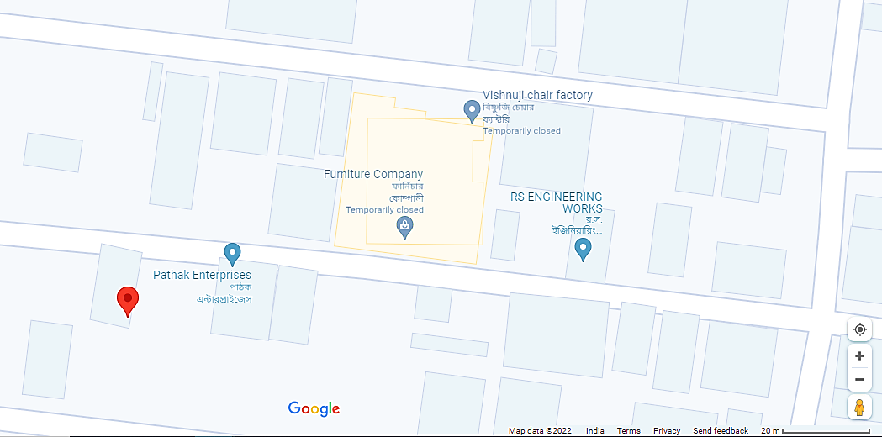
- Google Layout Plan: Demarcation of the land with measurement on the Google map is as shown in the below picture:
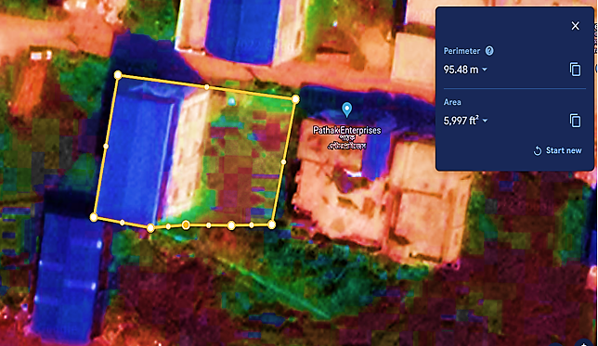
- LAND DETAILS:
M/s. Plasto Packaging Private Limited has acquired the piece of land, at S.K Industrial Plaza, Shakari Pota Main Road, Kalagachia, P.O- Thakurpukur, P.s- Mahestala, Kolkata-700063 before the inception of existing manufacturing unit.
As per land conversion certificate shared by the client, approx. 5996 Square feet land for the project has been purchased at Khatian No. 2307 Plot no. 308 & 309 and share no. 291 & 2777 at Thakurpukur, Mahestala, Kolkata 700063. Out of which existing unit (3, 00,000 KGPA) capacity is operational at 2160.01 Sq. ft. (3 kattha) and rest 3600.02 Sq. ft. (5 kattha) land will be utilized for the proposed expansion of 4,50,00 KGPA.
As per information provided in DPR, Land was acquired in the year of 2017-18 in total amount of Rs. 13.64 Lakhs. The land is an industrial land as per the land conversion certificate dated 25/02/2022. Land development work has been completed during FY 2021-22 and INR 20, 00,000 was spent by the company on its own, however the subject land is not demarcated with boundary wall till the survey date.
The company will initialize the grading and foundation work after loan will be sanctioned. The entry of the premises. Below are the details of land purchased for the proposed project in the tabulated form:
(Schedule of Land for which conversion is allowed vide case no. CN/2021/1614/220)

Sr. No. | Particulars | Plot Details
 | Plot no. | 308 & 309
 | Khatian Number | 2307
 | Share | 291 & 2777
 | Consideration Price | INR 13.64 Lakhs
 | Area sold to M/s Plasto Packaging Private Ltd. | 5996 Sq. Ft.
 | Purchase Year | During 2017-18
 | Land Type | Industrial as per conversion certificate
 | Document Number | CN/2021/1614/220

- SITE PICTURES: Some of the site pictures has been taken during the site survey as on 7th December 2022, are attached below:
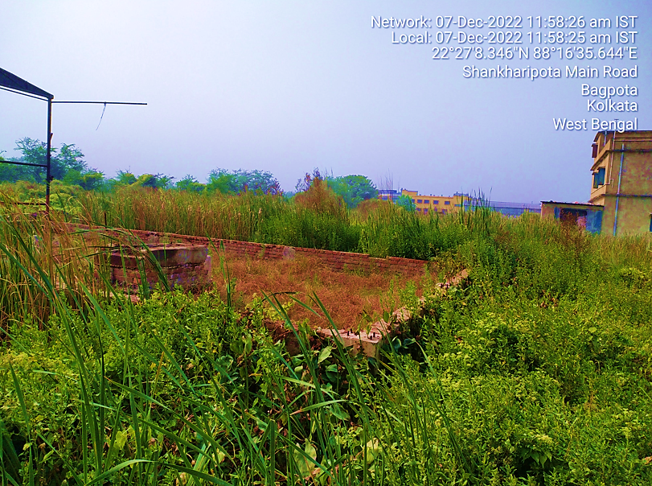
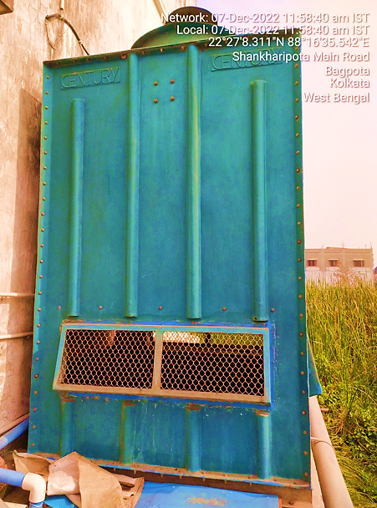
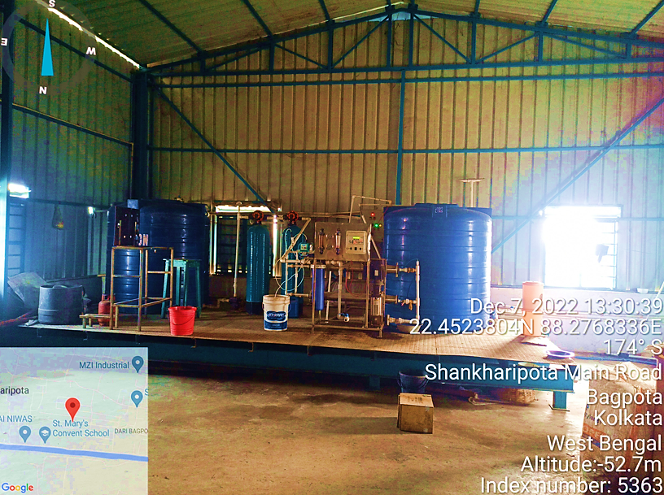
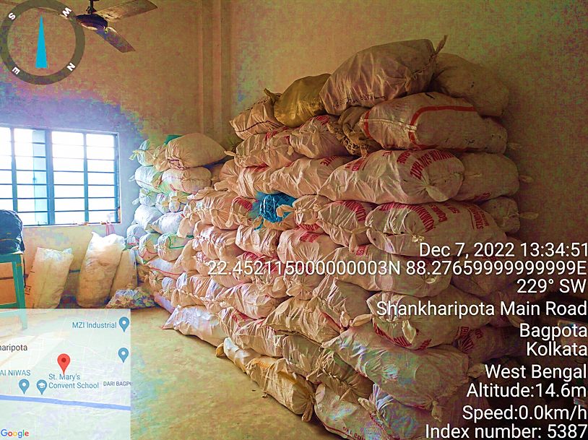
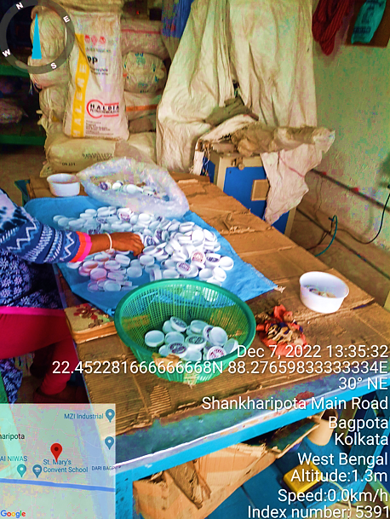
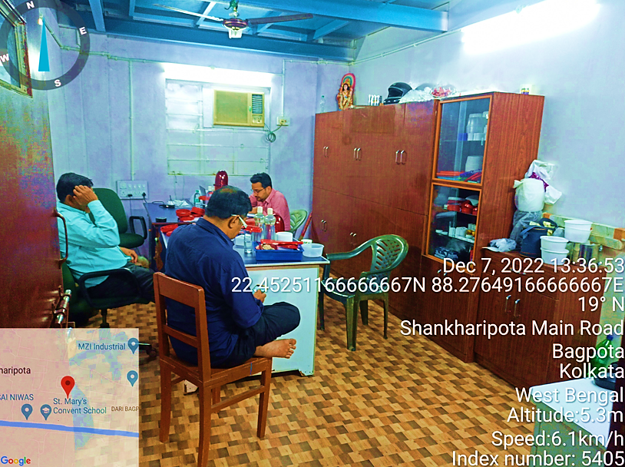
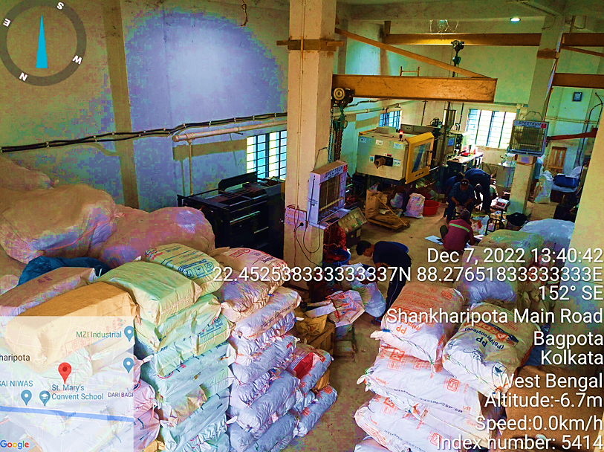
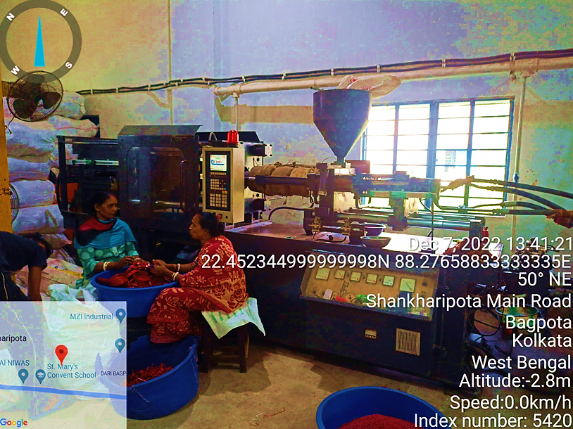
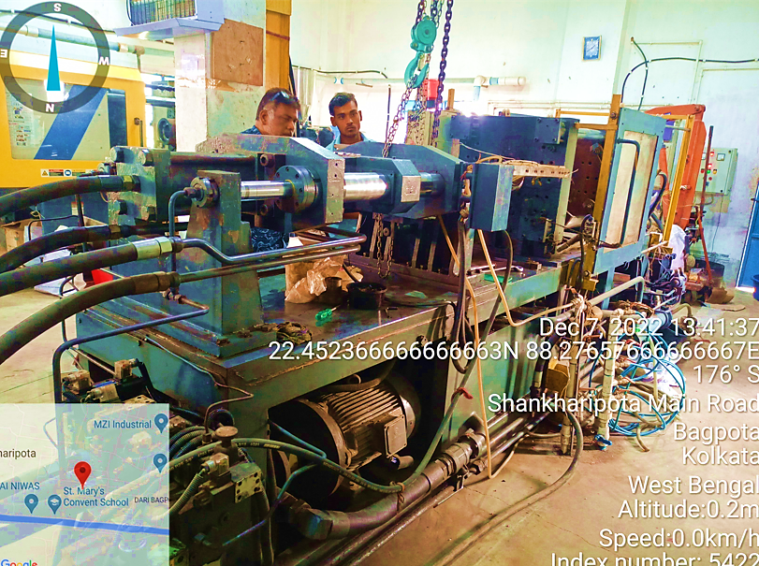
- BUILDING & CIVIL WORKS:
As per information provided by the client/company and verified during the site survey, currently company is having 5 kattha vacant land adjacent to the existing manufacturing facility and land development work has been done during FY 2021-22, as per financial statement shared by the client.
As per the current status of the Building and civil works provided by the company, boundary wall work is not initiated till the date of site visit and the foundation & plinth work is also required to start soon to achieve the expected trial run and COD successfully. Currently no site development/construction work is going on as on date.
As per communicated by the client, company has applied for Sanction map approval to the respective authority and it is still awaiting as on date. Company will appoint EPC contractor post sanction map approval.
As per the estimated cost shared by the client, the total cost of the building & civil works will be INR 64, 26,000 including all costs, taxes and contingencies for Design, Engineering, Fabrication, Supply and Erection of building bearing Ground+2 Floors + Lower & upper Terrace Floor at the rate of approximately @ INR 1000 Per Sq. Ft., however per sq. ft. rate range in the local market is 1000-1100 Sq. Ft. as per information provided by the client in the DPR.
The company has proposed the G+2 RCC construction on the 60% of 5 kattah land, which is around 2160.00 Sq. ft. As per the information provided by the company official, the total proposed built-up area is 6480.00 Sq. ft. (2160 x 3). Thus the company is in the process of getting the sanction approval from the respective authority.
Building Details for Manufacturing Unit
Floor Details | Area (Sq. Ft.)
Ground Floor | 2160.00
First Floor | 2160.00
Second Floor | 2160.00
Total Area | 6480.00

- PLANT AND MACHINERY/ EQUIPMENTS DETAILS: A typical plastic manufacturing facility include Injection moulding machine, mould temperature controller, Hopper dryer, Scrap grinder, cooling tower, chilling plant etc.
As per high level break-up cost of Plant & Machinery shared by the company/client, Cost break-up of the equipment’s are shown in the below table, according to this break-up, Total cost will be INR 200.70 Lakhs including GST and contingency cost, if any:
Cost Estimation of Major equipment’s, Plant & Machinery
Particulars | Quantity | Rate per unit(INR) | GST@18% | Total
Injection Moulding Machine | 2 | 2700000 | 4.86 | 58.86
Baby Blow Moulding | 1 | 600000 | 1.08 | 7.08
Crain | 1 | 300000 | 0.54 | 3.54
Volumetric Blending Units MB Mini | 1 | 126000 | 0.23 | 1.49
Cap Printing System
-Ped Printing Machine | 1 | 1381250 | 2.49 | 16.30
-Additional Printing Machine | 1 | 498000 | 0.9 | 5.88
Chilling Plant | 1 | 700000 | 1.26 | 8.26
Electrical Equipment | 1 | 1500000 | 2.7 | 17.7
Film Machine | 1 | 600000 | 1.08 | 7.08
18* Scrap Grinder Machine
-With 7.5 H.P. Crompton Motor with Starter | 1 | 120000 | 0.22 | 1.42
-With 7.5 H.P. Crompton Motor with Starter (Soundless) | 1 | 130000 | 0.23 | 1.53
-Without Motor & Starter | 1 | 105000 | 0.19 | 1.24
FRP Counter Flow Cooling Tower (Including Erection Charges Rs 4000) | LS | 68000 | 0.12 | 0.80
Plastic Injection Moulding Machine
-150 Ton | 1 | 1985000 | 3.57 | 23.42
-180 Ton | 1 | 2185000 | 3.93 | 25.78
Conveyor | 1 | 50000 | 0.09 | 0.59
Markem-Imaje 9028 Printer | 1 | 172000 | 0.31 | 2.03
Tool Room Equipment | 1 | 1000000 | 1.80 | 11.80
Office & Office Equipment | 1 | 500000 | 0.90 | 5.90
Total (INR Lakhs) |  |  | 26.50 | 200.70

As per purchase order shared by the client/company, company has purchased 5 set of injection moulding machine with auxiliary equipment from Shibaura Machine India Pvt. Ltd. In INR 1.45 Crore including all the other expenses. Thus, as per proposed plan the company will be operating with 5 production line.
As per information available in public domain and information provided by various vendors during the tertiary market research, we found that the cost of the machinery with these specification and capacity ranges from INR 25.00 Lakhs to INR 30.00 Lakhs.
For example IM 110 Standard Injection Moulding Machine with similar features such as frequency of 50/60 hertz, Hydraulic, Injection Blow Moulding, Horizontal structure, 110 ton capacity will be costing INR 28, 32,000, which is having almost all the similar feature to the purchased TS series injection moulding machine by M/s Plasto Packaging Pvt. Ltd with all the auxiliary items.

- UTILITIES: Details of Water, Electricity and other utilities are describes as below:
- WATER: As per information provided to us, the company is already having the water arrangement with the existing unit which will be sufficient for proposed expansion also.
- ELECTRICITY: Total H.P. requirements of machinery considering the motor requirements of all the machineries is 145 HP i.e., 97.35 KVA. The unit is proposed to install 450 KVA transformer. A power connection of 100 KVA will be sufficient to run the plant smoothly. Total power consumption at 100% capacity level will be 97.35 KVA* 0.9 (Power Factor) * 0.70 (Load Factor) * 16 Hrs. *300 Days = 2,94,386 Units.

PART E | PROJECT TECHNICAL DETAILS

- CAPACITY OF MANUFACTURING FACILITY: Below table shows the proposed and existing capacity of the company:
Particular | Existing Capacity | Existing Production Line | Proposed Capacity | Proposed Production Line
Location | KGPA (Gross) | Production Line | KGPA (Gross) | Production Line
S.K Industrial Plaza, Mahestala, Kolkata | 3,00,000 | 3 | 4,50,000 | 5 (Estimated)
Total | 3,00,000 | 3 | 4,50,000

- BASIC ARCHITECTURE: FLOW CHART OF MANUFACTURING FACILITY: Basic process flow of the manufacturing process:
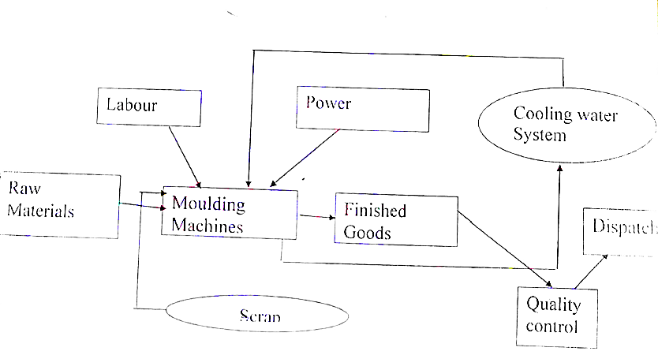

- TECHNICAL SPECIFICATIONS OF THE PROPOSED MAUNUFACTURING FACILITY: Company has planned to expand its existing manufacturing capacity up to 7, 50, 000 KGPA. Below table shows the details of major equipment, plant & machinery for the proposed 5 production line along with quantity, use and specifications:
Major Plant & Machinery & Equipment
Sr. No. | Equipment | Quantity | Use | Specification
1 | Injection Moulding Machine | 5 | Used for manufacturing mass-production of plastic products. Price per unit during injection moulded manufacturing is extremely low. | TS150-900 with auxiliary equipment THD75, LSG1 & LT150s  Capacity: 50 to 100 ton per day  Clamping Way: Hydraulic  Operation Mode: Automatic  Structure: Horizontal  Frequency: 60 hz  Application: Industrial
2 | Mould Temperature Controller | 5 | Used in Plastic Moulding for temperature control of mould surface. | Control Type: PID/On-Off  Transfer Medium: Oil And Water  Input Type: RTD  Control output Type: Relay  Temperature Range: Upto 250 Deg Cel  Water Based Temperature Controller: 95 Degree C  Oil Based Temperature Controller: 150 Degree C  Pump Pressure: 5 Bar  Pump Motor: 2.2 kW  Pump Flow Rate: 100 LPM
3 | Hopper Dryer | 5 | Dryer is used for drying and pre-heating plastics like ABC, PS etc. These dryers can reach a maximum temperature of up to 180°C. | Automation Grade: Automatic  Capacity: 25kg 50kg 75kg 100kg  Design: Standard  Dew point: 40 degree  Hot air flow rate: 80m3/hr  Accessories: Hot Air Recycler, Suction Box, Base Magnet etc.
4 | Scrap Grinder | 5 | Used in grind Plastic Material in some pieces. Size and output are different as per customer's requirement. | Plastic Type: PP  Voltage: 440 V  Motor Power: 15 HP AC 1440 RPM/  Frequency: 50 Hz  Application: Machine consists of specifically hardened 15" Blades, Along with C.I construction body  Transmission: By V-Belts & Pulleys  V Belts size: B - 68  Fly Wheel Diameter: 330 MM  Driver Pulley: 5 inch * 3 * B
5 | Cooling Tower | 1 | Used for heating, ventilation, and air conditioning (HVAC) and industrial purposes | Application: Water Cooling  Cooling Capacity: 3000 Lpm  Shape: Round  Tower Material: Metal  Tower Type: Natural Draft  Tower Design: Closed Loop
6 | Chilling Plant | 1 | Used to facilitate heat exchange from water to a refrigerant in a closed loop system. | Capacity: 500 TR  Usage/Application: Industrial  Type: Water-Cooled  Phase: 3  Refrigerant Used: Ammonia/ R22/ R134a/ R407C  Automation Grade: Automatic  Evaporator: Tube Heat Exchanger  Temperature Range: 0 to 20 degree

- TECHNOLOGY USED:
- PROPOSED TECHNOLOGY: As per information available in public domain regarding the injection moulding machine, Shibaura Machine TS Series offers five-point twin toggle clamping mechanism, robust injection unit, and closed loop servo hydraulics and user friendly LNC6 control system.
CLAMPING UNIT FEATURES: TS Series offers rugged and proven five-point twin toggle clamping mechanism with stroke amplification for faster cycling. Additional reserve locking force in toggle kinematics helps avoiding mould breathing during injection. Computer optimized kinematics of toggle re-produces high precise control over acceleration and breaking profiles of moving platen movement.
Precise control of mould sensing force by optimized tuning of servo pump system for low pressure control duly supported by optimized hydraulic circuit ensuring repeatability of mould safety. Less foot print due to optimum use of stroke amplification. Graphite impregnated bushes for toggles ensuring efficient lubrication and low maintenance.
Automated centralized lubrication system for toggles, Anti-friction roller bearings for moving platen & Mechanical drop bar is given to provide more safety for operator.
INJECTION UNIT FEATURES: TS Series comes with robust construction of injection units and modular concept in the selection of injection unit offering a high degree of flexibility. Injection unit movement on anti-friction bushes, Well-supported barrel assembly for easy alignment, Hopper throat temperature control, Larger cooling water channels to minimize effect of scale formation, Torque free nozzle sealing force, High kneading DBG profile screw –produces excellent melt homogeneity with low shear heat, Fast response rotating locking ring design, Melt temperature near to set point of barrel temperature, Consistent cavity & peak pressure.
DRIVE UNIT FEATURES: Lower power consumption through Reliable combination of servo pump, drive and servo-motor, Backlash free coupling for efficient transmission of power, Optimized drive parameters for dynamic response and longer life, Pressure and speed stability leading to consistent performance, Optimized P-Q characteristics (Combined efficiency of pump and servo motor), Option of Servo / Electronically controlled VDP (ECVDP) suitable for various applications, High pressure filter with automatic monitoring of clogging with advance warning and stoppage.
CONTROL UNIT FEATURES: TS Series is offered with highly advanced all new controller with a host of new features such as Touch sensitive, Transparent, User friendly, Precise, Fast, and T net enabled etc.
- MODERN/LATEST TECHNOLOGY:
New trends bring in a lot of change that affects the process of plastic manufacturing. Some of the leading injection moulding company in India that offer high-quality output for industrial and commercial purposes. As new trends evolve, they are more conscious of sustainability.
The initiative to introduce materials that can be recycled has paid off. Industry is looking at refining processes such that they can include recycling and scrap reduction to commit with less or no wastage in the manufacturing process. It helps the economy and environment adapt to more eco-friendly additives and resins in the manufacturing process.
Traditional resins have an impact on the environment and have been under scrutiny. Bio Resins are gaining attention from all quarters. It is a perfect alternative for traditional resins since it is made out of plant extracts and other renewable sources. Bio Resins enables green practices as it decreases poisonous emissions, disposes safely and follows the energy-efficient process.
Making use of conventional thermoplastic that is biodegradable can be foreseen in future with use of degradant concentrates like manganese stearate and cobalt separate as additives to promote disintegration and oxidation. This process will convert plastic into tiny fragments, which microorganisms will feed to convert plastic into biomass, water and carbon dioxide. It reduces the threat of harmful substances to nil.
Injection Moulding Manufacturers in India Shift to Reinforced Plastics and Lighter Tools to improve Efficiency with 3D Printing and Automation. Production efficiencies have been brought to the forefront, and plastic manufacturers in India adopt advanced technology like automation and 3D printing to improve manufacturing costs.
Technology has been a catalyst in reimagining different options for manufacturing plastic parts. Advanced technology has directly impacted the plastics manufacturing industry that has led to significant benefits and output. 3D printing reduces production time for projects that require 100 to 500 cycles. There is no compromise in quality with a more efficient mould printed in cooling channels. Prototyping can be done without hindering production.
A desktop polymer printer is used for specific applications to produce prototypes whose functionality is similar to the one built on the assembly line. Automation is another trend, and it is here to stay in the manufacturing industry. The benefit being cost-saving and simplification. Industry 4.0 has given immense opportunities for plastic manufacturers to explore the opportunities for introducing robotic technology.
Robotics and machine control improves speed and simplifies the process. It facilitates easier maintenance. Using automated cells can integrate multiple operations. Collaborative robots come with multiple arms, servo wrists and advanced safety features. It is faster, saves time and increases throughput.
Thus as per the above technical analysis, M/s Plasto packaging is using the conventional technology which is a going on, recognized and trending in the market at present.
- SOURCE OF PROCUREMENT OF EQUIPMENTS: As per the quotations and purchase oredres shared by the client, company has finalize the vendors/ suppliers. The company has procured 5 injection molding machine TS150-900 with auxiliary equipment from Shibaura Machine India Private Limited.
As per quotaion shared the company has approched Tempcon the cooling people firm for compact Air-cooled Process Chilling Plant of 5.0TR. For rest of the equipments the company will finalize the vendor in due course.
- TESTING STANDARDS FOR PRODUCTION: As per communicated by client, ccompany is having a quality control unit, wherein, they check the entire range on defined parameters like design, quality and finish. All units and equipped with all the essential tools, machine, and technology in order to manufacture a high-quality range of products.

- MANPOWER: As per information shared by the client/.company, an estimate of manpower requirement allowing for leave, absentecism, sickness and holidays for smooth and for efficient operation of different sections of the plant including its administrative and commercial departments, has been prepared based on technical and management ground primarly to indicate the order of manpower requirement.

In estimating the manpower requirement, a proper ratio between the administrative, managerial, supervisory and shop foor staff has been maintained with a view to affording proper industrial and professional management at various levels.
As per projections taken by the company, they have estimated around 19 workers will be required when all the 5 production line will be operational which is in the line with historical trends of the company. The basic structure of the manpower will require the following kind of resources:

Manpower Details
Particulars | Number of proposed employee
Labour | 10
Supervisor | 2
Operator | 2
Accountant | 1
Peon | 1
Guard | 2
Manager | 1
Total | 19

PART F | PRODUCT PROFILE

- INTRODUCTION:
Plastic became an integral part in our day to day life. Many products have been made with plastic. It has become a part of our world due to its versatility and cost effectiveness. If compared with other things such as metal, plastic make the total cost of the final product quite low.
M/s Plasto packaging Private Limited’s product range include a wide range of plastic products. As raw materials company is using variety of plastic granules like High-density polyethylene (HDPE), low density polyethylene (LDPE), Linear Low Density Polyethylene (LLDPE), High Impact Polystyrene Sheet (HIPS), Polypropylene (PP), Acrylonitrile butadiene styrene (ABS), and Polyvinyl chloride (PVC) to produce products like Plastic Pen Barrels, Pen Caps, Pen Clips, Plastic Food Containers, Stool Container/Urine Container, Plastic Balm Container, Plastic Jar Caps, Plastic Caps, Plastic Cores and Disposable Food Packaging Containers.
Below table shows the details of all the products of Plasto Packaging Private Limited along with their price range, capacity and specifications available in the public domain:

Product Profile of the Company
- Plastic Containers
S. No. | Name of the product | Price Range | Capacity | Specifications
 | Plastic Food Containers | Rs 2-7/piece | 300 ml also available in 750 ml and 1 L | Round & plain in shape, used in food packaging.
 | Stool Container/Urine Container | Rs 1-2/piece | 30 ml | Screw Cap and round in shape.
 | Plastic Balm Container | Rs 1-2/piece | 5 gm | Red Cap and round in shape.
 | Disposable Food Packaging Containers | Rs 2-7/piece | 500 ml also available in 750 ml and 1 L | Black, plain and circular in shape.
 | Plastic Balm Container | Rs 1-2/piece | 30 gm | Screw Cap, round in shape and used in Balm Packing.
 | Ayurvedic Medicine Container | Rs 1-2/piece | 30 gm | Printed, round in shape and used in medicine storage.
 | Plastic Balm Storage Container | Rs 1-2/piece | 20 gm | Screw Cap, round in shape and used in Balm Storage.
 | Printed Balm Container | Rs 1-2/piece | 20 gm | Screw Cap and round in shape.
- Plastic Cap
 | Plastic Cap | Rs 0.50 3/piece | 0-10 mm | Yellow colour screw cap, round in shape.
 | Disposable Flip Tops Cap | Rs 0.50-3/piece |  | Printed flip top caps, round in shape.
 | Round Disposable Plastic Flip Tops Cap | Rs 0.50-3/piece |  | Printed flip top caps, round in shape.
 | Disposable Flip Top Caps | Rs 0.50-3/piece |  | Water Bottle flip top caps, round in shape.
 | Flip Top Plastic Cap | Rs 0.50-3/piece | 19 mm | Pull-Push caps, round in shape.
 | Disposable Plastic Flip Tops Cap | Rs 0.50-3/piece |  | Printed flip top caps, round in shape.
- Balm Containers
 | Pain Balm Packaging Plastic Container | Rs 1-2/piece | 10 gm | Yellow colour screw cap, round in shape.
 | Balm Container Pad Printing Dibbi | Rs 0.50-3/piece |  | Printed Pull-Push caps, round in shape.
 | Printed Balm Container | Rs 0.50-3/piece |  | Printed Pull-Push caps, round in shape.
 | Pain Balm Container | Rs 0.50-3/piece |  | Screw Cap and round in shape.
- Pet Jar Cap
 | Pet Jar Caps | Rs 0.50-3/piece | 120 mm | Suitable for 2ltr, 3ltr and 5 ltr. Any colour available, with handle and without handle.
 | 83 Mm Plastic Jar Handle Cap | Rs 1-2/piece | 83 mm | Round cap with handle virgin pp and reprocessed pp material used.
- Cap and Container
 | 1000 mL Food Container | Rs 5-7/piece | 1000 ml | Virgin quality food grade plastic food container 100 Ml, 300 Ml, 500 Ml, 1000 Ml Food Container.
 | Homeopathic Medicine Container/Blood Sample Container | Rs 0.50-3/piece | 30 ml | Round & Screw Cap in shape, used in Clinical packaging.
 | 120 Mm Jar Cap Without Handle | Rs 0.50-3/piece | 120 mm | Without Handle cap, round in shape.
 | Hot Foil Transfer Job | Rs 0.50 -1/piece | L – 50M  W – 2mm | Printed and Roll Packaging Type.
 | Milky Printed Disposable Food Container | Rs 0.50-3/piece |  | Printed Pull-Push caps, round in shape.
 | Polypropylene Container | Rs 0.50-3/piece | 85 gm | Use and throw, printed and round in shape.

- PRODUCT CATEGORY:
- PLASTIC BALL PEN BARREL, BALL PEN CAP AND BALL PEN CLIP:
M/s Plasto packaging Private Limited produces ball point pen parts names are pen barrel, pen cap and clip. Company is producing plastic ball pen by injection moulding. Plastic injection moulding machines is the main pen maker machine. As it can be used to produce most of ball pen plastic parts like pen barrel, pen clip, pen cap, pen tip etc. Company uses plastic granules as a raw material and it is fed into a large hopper.
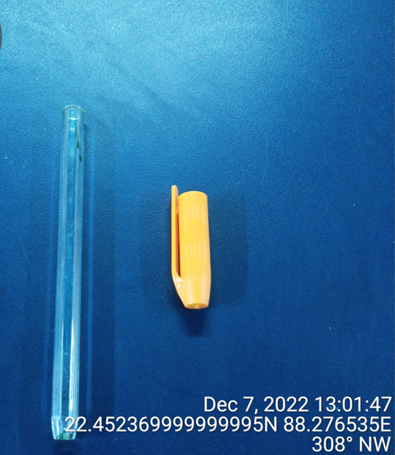

- PLASTIC CORE:
Plastic cores are precision cut tubing with chamfered ends, burr-free cuts, and tight tolerances. Plasto packaging, plastic cores come in a choice of materials and sizes and can be produced in standard and custom lengths in a variety of colours. Plastic cores are extruded from thermoplastics, cut to size, and machined so that the ends have a smooth, clean finish.
Plastic core tubing resists crushing and is moisture resistant and hygienic. It remains stable under humid conditions, resists most chemicals and solvents, and is seamless. Plastic extruded cores are used in a variety of industrial, commercial, and medical applications. M/s Plasto packaging produces tape cores and medical cores. Also Medical cores require hygienic plastic materials.

- PLASTIC CONTAINERS:
Plastic container manufacturing companies have many techniques at their discretion. The most popular of the techniques are extrusion blow moulding, injection blow moulding, stretch blow moulding, and co-extrusion. Each has its strengths.
Plasto packaging Pvt Ltd is using injection blow moulding machines to produce plastic containers. Injection blow moulding is completed in stages. First, melted plastic is injected into a shape to produce a parison. Compressed-air then blows through a key pin to increase the form. Eventually, the container is transferred to a third stop for ejection.
Plasto packaging product range includes a wide range of containers like Plastic Food Containers, Stool Container/Urine Container, Plastic Balm Container and Disposable Food Packaging Containers, Polypropylene Container etc.

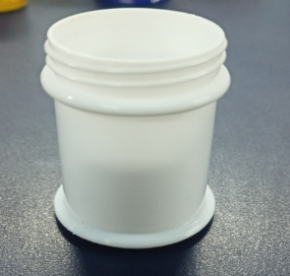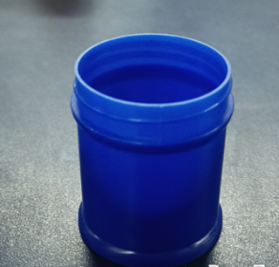

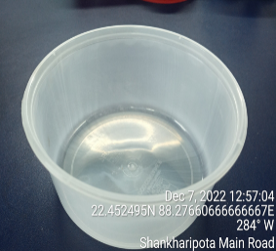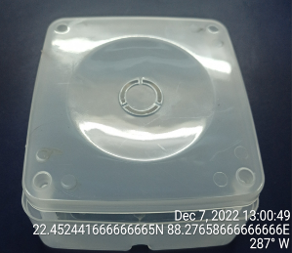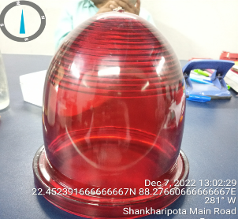

- PLASTIC CAPS: Plasto packaging’s one of the product is plastic cap. Company manufactured these Plastic caps through a process known as injection moulding. In this process, thermoplastic polymer pellets are heated in a metal hopper to the point that they become very soft and flexible. (It would be at this stage that any custom colouring would already be added).
The softened plastic is then injected under very controlled, high pressure into a complex, detailed steel mould. The mould forms the softened polymer into the desired shape for the bottle caps. Once the polymer material has cooled enough to harden, the mould is opened and the bottle caps are ejected. If several caps are being made from a single mould (as is often the case), they will be carefully separated from each other and prepare for further processing.

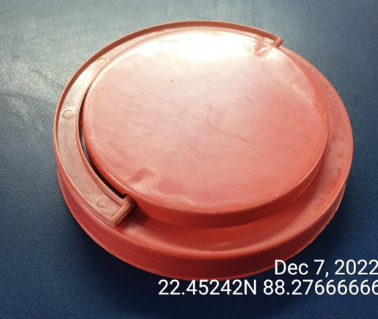

- MARKETING, SELLING & DISTRIBUTION PLAN:
As per our market research and information available in the public domain, some of the top most competitor of M/s Plasto Packaging Pvt Ltd in a range of around 80km from Kolkata.
As per the details shared by the client, M/s Plasto Packaging Private Limited is having a business model based on the orders received, where the company produces the finished goods as per the demand and requirement of the particular client. However the company was involved in the outsourcing production of finished goods before 2020.
As of now, the company is not having any specific marketing strategy as per communicated by the client, but we found that the company do advertisement on the various website available on public domain.

PART G | INDUSTRY OVERVIEW & ANALYSIS

- INTRODUCTION:
Indian plastic industry market is one of the leading sectors in the country’s economy. The history of the plastic industry in India dates to 1957 with the production of polystyrene. Since then, the industry has made substantial progress and has grown rapidly. The industry is present across the country and has more than 2,000 exporters. It constitutes 30,000 processing units; among these, 85-90% belong to small and medium enterprises.
India is one of the most promising exporters of plastics among developing countries. Indian plastics industry produces and exports a wide range of raw materials, plastic mould extruded goods, polyester films, laminates, moulded/ soft luggage items, writing instruments, plastic woven sacks and bags, PVC leather cloth and sheeting, packaging, consumer goods, sanitary fittings, electrical accessories, laboratory/medical surgical ware and travel ware, among other products. Wonders of plastics cut across all sections of society.
Due to its moulding capacity, its versatility, its non-corrosive and moisture resistant properties, its physical and chemical strengths, its economic viability, it's easy process ability and also its attractiveness and durability in all weather conditions, it has become a material of choice and of universal use.
Major uses of plastics are in the packaging industry, building industry and in the manufacturing of pipes, fittings, electrical accessories, consumer goods, house-ware, toys, and furniture and in host of other spheres of life. A time has come when plastics industry has the capacity to influence the progress of all other sectors. Plastic industry is regarded as 'sunrise' industry due to its increasing versatility and growing worldwide demand.
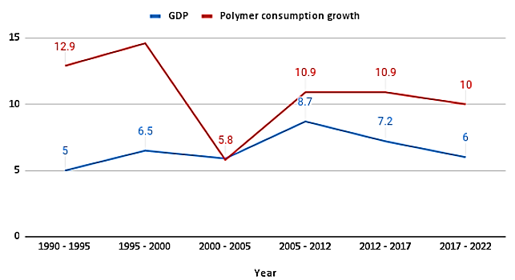
Plastic material is gaining notable importance in different spheres of activity and the per capita consumption is increasing at a fast pace. Continuous advancements and developments in Plastic technology, processing machineries, expertise, and cost effective manufacturing is fast replacing the typical materials.
Plastics could be categorised into 2 broad categories: Thermoset plastics and Thermoplastics. Thermoset plastics are irreversibly hardened when cooled. If one attempts to reheat and remould these plastics, it would result in burning and the chemical composition would be irreversibly altered. These forms of plastics are therefore not found in everyday products which require more versatility, which is present in thermoplastics. Thermoplastics are further divided based on their use into commodity plastics and engineering plastics.
Commodity plastics are the most used in items of everyday use and importantly in single use plastics (SUP). The following table shows the end use of each of the commodity plastics.
Use of commodity plastic
Type of plastic | End use
Polypropylene | Buckets, Bowls, Crates, Toys, Medical components, Washing machine drums, Battery cases, Bottle caps, Elastomer modified for bumpers, etc., Talc filled for additional stiffness at elevated temperatures-jug kettles, etc., OPP films for packaging (e.g., crisps, biscuits, etc.), Fibres for carpets, sports clothing.
Polyvinyl Chloride | Use in building, transport, packaging, electrical/electronic and healthcare applications, Infrastructure projects, Irrigation.
Low-Density Polyethylene | General purpose film, Extrusion coating, Milk packaging, Injection moulding, Wire & cables, Adhesive laminates, Containers: dispensing bottles, wash bottles, Tubing, Plastic bags for computer components, Moulded laboratory equipment, Trays and general-purpose containers, Corrosion-resistant work surfaces, Parts that need to be weldable and machinable, Parts that require flexibility, Very soft and pliable parts, Plastic wraps, Juice and milk cartons.
Polystyrene | - Packaging: Eggs and dairy products, meat, fish and poultry, cold drinks or carry-out meals.  - Appliances: From refrigerators and air conditioners, to ovens and microwaves, from hand-held vacuum cleaners to blenders Consumer electronics: Polystyrene is used for housing for TV's and all kind of emerging trends in IT equipment, media enclosures, cassette tape housing and clear jewel boxes to protect CD's and DVD's.  - Construction: Materials for building and construction applications, like Insulation foam, roofing, siding, panels, bath and shower units, lighting, plumbing fixtures.  - Medical: Wide range of disposable medical applications, including tissue culture trays, test tubes, petri dishes, diagnostic components, and housing for test kits.
Polyethylene Terephthalate | Plastic bottles used for soft drinks, Flexible food packaging and thermal insulation, tape applications, such as the carrier for magnetic tape or backing for pressure sensitive adhesive tapes packaging trays and blister packs, Used as a substrate in thin film solar cells, Waterproofing barrier in undersea cables, 3D printing filament, as well as in the 3D printing plastic PETG.
Polyurethane | Flexible, high-resilience foam seating, Rigid foam insulation panels, Microcellular foam seals and gaskets, Durable elastomeric wheels and tires (such as roller coaster wheels), Automotive suspension bushings, Electrical potting compounds, High performance adhesives, Surface coating and surface sealants, Synthetic fibres, Carpet underlay.
Below is the production capacity of the various types of commodity plastics. Production capacity of PP forms the largest category of commodity plastics with PETE and HDPE forming the next largest composition.
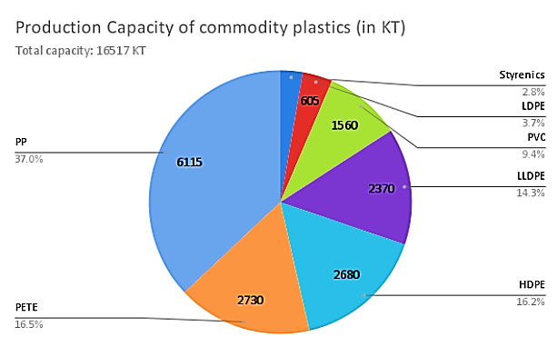

- EXPORT TREND:
The compounded annual growth rate of the global plastic industry fromn2010 to 2019 was 3.5% and is expected to grow at a CAGR of 3.4% from 2021 to 2028. Estimates put India’s plastic industry at a CAGR of 10% in volume in 2015 where production in 2010 was 8.3 MMTPA and 13.4 MMTPA in 2015.
India exported approximately USD 3.26 billion worth of plastic raw material in the financial year 2021. Estimates pitch the market size of the plastics industry in 2025 to grow at a CAGR of 8-10% until 2025. The Indian Chemicals and Petrochemicals industry, of which plastics is a part, is expected to harbour investments worth Rs. 8, 00,000 crore by 2025.
The cumulative exports of plastics and related materials during 2021-22 were valued at US$ 13.34 billion. This was a 33.4% increase from the 2020-21 exports valued at US$ 10 billion. Plastic raw materials were the largest exported category and constituted 30.7% of the total exports in 2021-22; it recorded a growth of 26.5% over the previous year. Plastic films and sheets were the second largest category, comprised 15.2% of the total exports, and grew 32.7% over the previous year.
In May 2022, the exports of plastics and linoleum from India were valued at US$ 1,073 million. During the same period, medical items of plastics; plastic films & sheets; plastic pipes & fittings; packaging items; cordage fishnets & monofilaments; and miscellaneous products recorded strong growth. The cumulative exports for April and May 2022 grew 2.6% YoY to US$ 2,173 million.
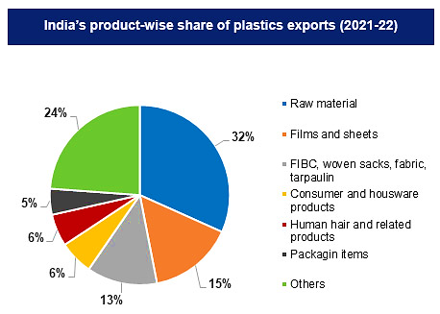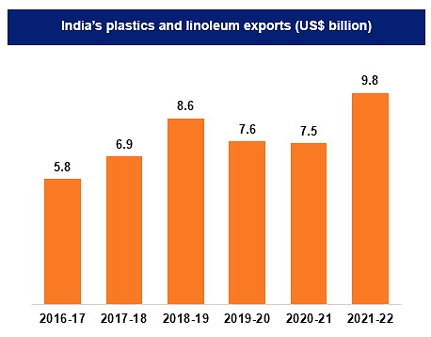

Overall, the total plastics exports between April-September 2022 stood at US$ 6.38 billion. During this time period, the exports of plastic raw materials, medical items, and pipes and fittings increased by 32.3%, 24.8% and 17.9% over the same time last year, respectively.

- CHALLENGES:
Despite the fact that India has a population of 1.15 billion people and a labour force of 467 million, plastics manufacturers have reported labour shortages. Aside from a skilled labour shortage, the plastics industry is also dealing with a nationwide power shortage.
Most equipment is physically and morally obsolete, which limits the capacity of the sector to apply new technologies and to obtain high technical products in conditions of productivity and low costs. Most of the equipment is old, with medium productivity and quality performance. Only some companies invested in new equipment with competitive performance.
Polymer price fluctuation is strongly connected to the price of crude oil. Raw material availability, such as Poly Vinyl Chloride (PVC), Polypropylene (PP), and Polyethylene (PE), is linked to crude oil prices. Low preoccupation for regaining past active traditional markets High production costs in companies created from the former great state enterprises with too much personnel, partially used production capacity, reduced productivity, high energy consumption, and others. Insufficient marketing on foreign markets High cost of finished plastic products Suffers from low productivity of workers Outdated machinery and equipment Derogatory industry image Lack of focus on exports.

- GOVERNMENT INITIATIVES:
The Union Ministry of Commerce and Industry of India targets to increase the plastic exports of the country to US$ 25 billion by 2025. There are multiple plastic parks are being set up in the country in a phased manner that will help improve the plastic manufacturing outputs of the country. Under the plastic park schemes, funds of up to 50% of the project costs or a ceiling cost of Rs. 40 crore (US$ 5 million) per project.
Government initiatives like “Digital India”, “Make in India”, and “Skill India” will also boost India’s Plastic industry. For instance, under the “Digital India” program, the government aims to reduce the import dependence of products from other countries, which will lift the local plastic part manufacturers.
The CIPET: School for Advanced Research in Petrochemicals (SARP) Centre works as multifunctional "one-stop" facility which consists of full-fledged material characterization with broad specialization in product development and simulation as per the national goals of 'Make in India'. International collaborative efforts has resulted in a number of research works carried out at the SARP, which has significantly helped the plastic industries in India & overseas through the Usage of new generation polymeric materials and introduction of new plastic products in every key sectors of the Indian Economy
CIPET will continue focusing and developing more new materials as well as products, developing cost-effective import substitution and developing high-quality intellectual property of international repute; which will definitely benefit the plastic industries and the allied industries.
Ten Plastic Parks have been approved in the country by The Department of Chemicals and Petrochemicals. Among these, 6 plastic parks have received final approval from the following states – Madhya Pradesh (2 parks), Assam (1 park), Tamil Nadu (1 park), Odisha (1 park) and Jharkhand (1 park). These parks are intended to boost employment and attain environmentally sustainable growth.

- CONCLUSION:
Indian plastic industry clearly has the potential to continue its fast growth. However, over the next few years, competition in the industry is expected to increase considerably, as a result of global trends, which will become applicable to the liberalizing economy of country to survive the competition, both polymer manufacturers and processors will need to adopt radically new methods and approaches to reduce costs, improve market and customer service and management of performance. Per capita consumption of plastics in India is well below the world average.
Indian industry has the potential to increase considerably. Industry currently provides employment to 3 million people. However, with per capita consumption increasing rapidly, which is likely to reach 12.3 million tons, the sector has potential to generate more employment. High growth in retail packaging, pipes, bulk packaging and agricultural use has triggered the polymer demand. Also, with the huge investments in infrastructure development happening in the recent times, the plastic industry will emerge as a giant in the industrial scenario of India

PART H | SWOT ANALYSIS

SWOT ANALYSIS OF PLASTIC INDUSTRY

PART I | PROJECT COST AND MEANS OF FINANCE

As per data/information shared by the client, below are the details of Total project Cost (TPC) and means of finance for the same. Category wise proposed project cost is shown in the below table:
(INR Lakhs)
Total Project Cost of M/s Plasto Packaging Pvt. Ltd.
PARTICULARS | COST
HARD COST
Freehold Land & Land Development | 13.64
Civil Construction | 63.00
Plant And Machinery | 253.73
Miscellaneous Fixed Assets | 2.20
Total Cost (Site wise) | 332.57
SOFT COST
Preliminary & Pre-Operative Expenses | 1.00
Contingencies | 6.33
Margin Money For Working Capital | 34.17
Total Project Cost | INR 374.07
Note: Project Cost have been provided by the company.
MEANS OF FINANCE
PARTICULARS | INR (Lakhs)
Promoters Contribution | 159.07
Term Loan | 215.00
Total | 374.07

Limit Applied For Fund Based Limit | Amount (INR Lakhs)
Term Loan | 215.00
Cash Credit | 50.00
Total Fund Based Limit | 265.00
Non-Fund Based Limit
Bank Guarantee | 0.00
Letter of Credit for Purchase | 100.00
Total Credit Exposure | 365.00
Notes:
- Land and conversion Charges has been taken as per audited financial statement provided by the client. Free hold land measuring 0.14 Acre, already acquired in 2017-18.
- Civil construction include three storied factory building situated at Mouza Shankharipota. Factory building Estimation enclosed for Civil construction works includes, plumbing and electrification of civil work and supervision charges. Construction and site development cost has been taken as per proposed total built-up area as 60% of 5 kattha proposed land (2160 Sq. Ft, G+2, RCC Construction) provided by the client and multiplied by an average plinth area rate of INR 1000 per square feet based on construction which may go high up to Rs.1100 – 1200/- per Sq. Ft.
- Plant & Machinery cost has been taken as per the details provided by the client and as per the break-up, the total cost of INR 200.70 Lakhs has been considered which is found to be reasonable based on the tertiary research and verbal communication with random vendors and players in this Industry and information available in the public domain.
- Miscellaneous Fixed Assets cost is being considered as per information provided by the client, historical analysis and industry benchmark which is found reasonable during our tertiary research.
- Preliminary & Pre-Operative Expenses has been taken as lump sum based on the time period of construction and estimate of company’s resources involvement during this time in supervision & monitoring of the construction.
- Contingency cost of INR 6.33 Lakhs has been considered as a part of app. 2% of total project cost based on general assumption and professional experience.
- There is no construction available for proposed expansion of infrastructure. Therefore company has to keep working capital margin money for construction work.

PART J | PROJECT SCHEDULE

Below is the tabulated presentation of the status of the project showing expected duration shared by the project manager of the company. The project is expected to be complete soon.
S. No. | Particulars | Activity | Expected completion date | Status
 | Land | Land Procurement | 2017-18 | As per Change of Land Use Certificate (CLU) Provided by the company, 0.14 acre of land was procured by the company during 2017-18.
 |  | Land Development | 2021-22 | Achieved in 2021-22
 | Sanction of Rupee Term Loan | Sanction of Rupee Term Loan | 31st January 2023 | Achieve 2022-2023
 | Building & Civil Works | Appointment of Architect | 15th Feb 2023
 |  | Building Plan Preparation | 1st March 2023
 |  | Building Plan Sanction | 15th March 2023
 |  | Appointment of Civil contractor/ developer | 30th March 2023
 |  | Building & Civil Works completion | 30th May 2023
 | Plant & Machinery | Finalization of P&M suppliers | 25th Nov 2022
 |  | Orders to P&M suppliers | 28th Nov 2022
 |  | Arrival of P&M | 30th April 2023 | Achieve 2023-2024
 |  | Installation of P&M | 1st June 2023 | Achieve 2023-2024
 |  | Utility Installation | 15th June 2023 | Achieve 2023-2024
 | Statutory Approvals, registrations & NOCs |  | 15th July 2023 | Achieve 2023-2024
 | Finishing & Trail Run |  | 20st July 2023 | Achieve 2023-2024
 | Commercial Operation Date |  | 1st August 2023 | Achieve 2023-2024

Notes:
- Schedule has been made as per feasibility to achieve different milestones.
- Achievement of Milestone will depend on sanction of term loan as per proposed timeline.
- As per this timeline, expected COD will be 1st August 2023.

PART K | STATUTORY APPROVALS | LICENCES | NOC
As per the information provided by the client below is the list of Approvals required for the proposed project:
S. No. | REQUIRED APPROVALS | REFERENCE NO./ DATE | STATUS  (Approved/ Applied For/ Pending)
 | Certificate of Registration | 19th May 2022 | Achieved from Ashuti-II Gram Panchayat (Thakurpukur Maheshtala Panchayat Samity).
 | Land conversion to Industrial/Non agriculture | 25th February 2022 | As per Land Conversion Certificate, land is converted into Industrial Land.
 | Building Plan Sanction Approval  Concerned local development authority | Pending | Pending
 | Building Occupancy Certificate | Pending | Pending
 | Provisional Fire NOC (pre sanction)  Fire Services Department | Pending | Pending
 | Fire NOC (on completion)  Fire Services Department | Pending | Pending
 | Power Load Sanction  Calcutta Electric Supply Corporation | Security deposit is pending for the start of new plant and machinery. | To be applied in due course
 | Consent to establish (under Water Act & Air Act)  State Pollution Control Board, WB | Pending | To be applied in due course
 | Permission for extraction of ground water | NA | NA
 | Approval of Factory Plan under the Factories Act, 1948 | Pending | To be applied in due course
 | Factory License under Factories Act, 1948 | Pending | To be applied in due course
 | Trade Licence | Pending | To be applied in due course

Observation Note:
- Existing unit approvals has not been mentioned here since that is not the part of scope of work.
- Company has achieved the land conversion certificate as on 25th Feb 2022.
- As per discussion with the client, company has already applied for building plan sanction approval, it is still awaiting to get the approval.
- For the Power Load Sanction, company is not required to apply newly since it was taken at the time of existing unit inception, only security deposits will be made for the start of new plant & machinery.
- Rest approvals are pending and will be applied in due course.

PART L | COMPANY’S FINANCIAL FEASIBILITY

- HISTORICAL FINANCIAL PERFORMANCE ANALYSIS:
- HISTORICAL PROFIT & LOSS STATEMENT (FROM FY 2019 TO FY 2022): As per latest audited financial statements from FY 2019 to FY 2022, shared by the client/company, below table shows the historical financial performance of the company:
Particular | FY 2019 A | FY 2020 A | FY 2021 A | FY 2022 A
Revenue from Operations | 76.55 | 95.91 | 125.08 | 159.04
Other income | 0.00 | 0.01 | 0.00 | 0.00
Total Income | 76.55 | 95.91 | 125.08 | 159.04
Cost of material Consumed | 32.26 | 50.08 | 51.76 | 71.43
Employees benefit Expenses | 0.00 | 0.00 | 6.28 | 8.06
Other Operating and General Expenses | 40.45 | 40.42 | 53.26 | 61.85
Total expenses | 72.70 | 90.50 | 111.31 | 141.34
EBITDA | 3.85 | 5.42 | 13.77 | 17.71
Dep.& Amortisation Expenses | 0.93 | 3.78 | 9.64 | 12.86
EBIT | 2.92 | 1.63 | 4.13 | 4.85
Finance Costs | 0.00 | 0.00 | 0.00 | 0.00
Items pertaining to Previous year | 0.20 | 0.00 | 0.00 | 0.37
Profit/(Loss) before tax | 2.73 | 1.63 | 4.13 | 4.85
Current Tax | 0.53 | 0.42 | 1.45 | 1.16
Profit (Loss) after Tax for the period | 2.20 | 1.21 | 2.68 | 3.68

- KEY FINANCIAL RATIOS:
Particular | FY 2019 A | FY 2020 A | FY 2021 A | FY 2022 A
EBITDA Margin % | 5.03% | 5.65% | 11.01% | 11.13%
EBIT Margin % | 3.82% | 1.70% | 3.30% | 3.05%
Net Profit Margin % | 2.88% | 1.26% | 2.15% | 2.32%
Revenue Growth % (Y.O.Y.) |  | 25.29% | 30.41% | 27.15%

Note: Net operating margins shows positive trends in last four year. All the metrics shows that the company is having an increased growth with decreasing rate. Revenue growth rate Y-o-Y basis is more than 25% historically.
- GRAPHICAL REPRESENTATION OF KEY RATIOS: Below is the graphical representation of the key financial metrics of the company, showing the historical efficiency and financial performance of the company:
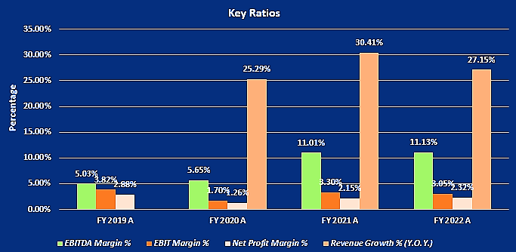

- PROJECTIONS OF THE FIRM: The projections of the firm are prepared as per the expected COD from FY 2023-24 to FY 2029-30 based on the revenue generation capacity of the project and total expected expenses.
Projections has made for the proposed expansion of 4, 50,000 KGPA since projection of existing manufacturing facility is out of scope of our TEV assignment. Projections has been prepared for next 7 years as per the best practice in industry for a Greenfield project to assess the financial feasibility of the project.
- PROJECTED PROFIT & LOSS ACCOUNT (FROM FY 2023-24 TO FY 2029-30):
Below table shows the Projected Profit & Loss Account of M/s Plasto Packaging Private Limited from the period FY 2023-24 to FY 2029-30.

Particular (INR Lakhs) | 2023-24 | 2024-25 | 2025-26 | 2026-27 | 2027-28 | 2028-29 | 2029-30
Revenue from Operations | 204.30 | 383.17 | 425.91 | 447.30 | 474.73 | 496.70 | 518.77
Other income | 8.17 | 15.33 | 17.04 | 17.89 | 25.14 | 26.71 | 28.29
Total Income | 212.47 | 398.50 | 442.95 | 465.19 | 499.87 | 523.42 | 547.06
Cost of material Consumed | 114.40 | 228.79 | 254.10 | 266.90 | 268.63 | 268.86 | 269.14
Salary and Wages | 19.32 | 23.19 | 23.19 | 23.19 | 23.19 | 23.19 | 23.19
Selling General Administrative Expenses | 15.20 | 16.72 | 18.39 | 20.23 | 20.23 | 20.23 | 20.23
Pre-Operative Exp. | 0.14 | 0.14 | 0.14 | 0.14 | 0.14 | 0.14 | 0.14
Other Operating and General Expenses | 33.52 | 40.65 | 44.87 | 47.63 | 49.73 | 52.04 | 54.57
Total expenses | 182.58 | 309.49 | 340.69 | 358.08 | 361.91 | 364.45 | 367.26
EBITDA | 29.89 | 89.01 | 102.26 | 107.11 | 137.96 | 158.97 | 179.80
Dep & Amortisation Expenses | 25.63 | 38.45 | 38.45 | 38.45 | 38.45 | 38.45 | 38.45
EBIT | 4.26 | 50.56 | 63.81 | 68.66 | 99.51 | 120.52 | 141.34
Finance Costs | 4.25 | 21.62 | 19.10 | 16.36 | 13.38 | 10.13 | 6.60
Profit/(Loss) before tax | 0.01 | 28.93 | 44.70 | 52.30 | 86.13 | 110.39 | 134.75
Current Tax | 0.00 | 7.67 | 14.35 | 18.25 | 29.95 | 38.53 | 46.98
Profit after Taxes for the period | 0.01 | 21.26 | 30.36 | 34.05 | 56.18 | 71.85 | 87.77

- KEY FINANCIAL RATIO:
Particular (INR Lakhs) | 2023-24 | 2024-25 | 2025-26 | 2026-27 | 2027-28 | 2028-29 | 2029-30
EBITDA Margin % | 14.07% | 22.34% | 23.09% | 23.02% | 27.60% | 30.37% | 32.87%
EBIT Margin % | 2.01% | 12.69% | 14.41% | 14.76% | 19.91% | 23.02% | 25.84%
Net Profit Margin % | 0.00% | 5.34% | 6.85% | 7.32% | 11.24% | 13.73% | 16.04%
Revenue Growth % (Y.O.Y.) |  | 87.55% | 11.15% | 5.02% | 7.46% | 4.71% | 4.52%

Note: EBITDA Margins are positive and increasing fairly during the estimated period. Net profit margins have increased from 0.00% in FY 2023 to 16.04% in FY 2030. Revenue growth rate is also ranging from 5% to 11% during the forecasted period.
Net Operating Margin (EBIT) Margins are positive and increasing fairly during the estimated period, however initially it is 0.00% due to 8 months of operations at 40% capacity utilization.
- GRAPHICAL REPRESENTATION OF KEY RATIOS: Below is the graphical representation of the key financial metrics of the company, showing the efficiency and financial performance of the company throughout the forecasted period:
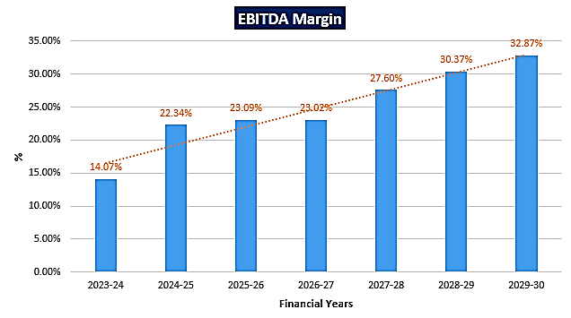
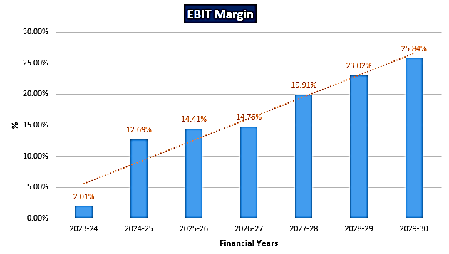
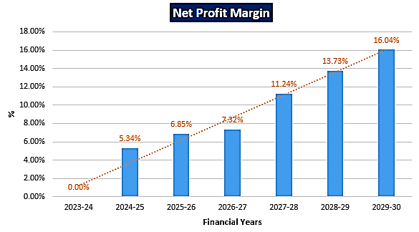
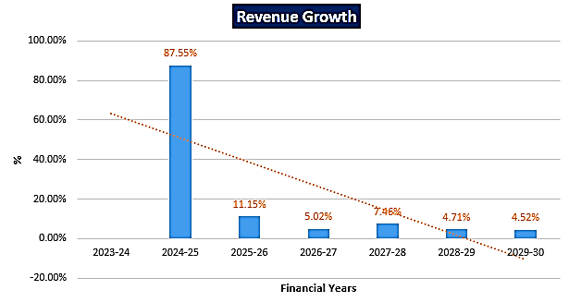

- PROJECTED BALANCE SHEET: Below table shows the Projected Balance Sheet of M/s Plasto Packaging Private Limited from the period FY 2023-24 to FY 2029-30.
Particular (INR Lakhs) | 2023-24 | 2024-25 | 2025-26 | 2026-27 | 2027-28 | 2028-29 | 2029-30
Shareholder’s Equity & Labilities:
Share Capital | 159.07 | 159.07 | 159.07 | 159.07 | 159.07 | 159.07 | 159.07
Reserves And Surplus | 0.01 | 21.27 | 51.63 | 85.68 | 141.85 | 213.71 | 301.47
Term Loan | 215.00 | 186.26 | 155.00 | 120.99 | 84.00 | 43.77 | 0.00
Bank Borrowings | 50.00 | 50.00 | 50.00 | 50.00 | 50.00 | 50.00 | 50.00
Other Current Liabilities | 0.00 | 0.00 | 0.00 | 0.00 | 0.00 | 0.00 | 0.00
Provision For Taxation | 0.00 | 7.67 | 14.35 | 18.25 | 29.95 | 38.53 | 46.98
Unsecured Loan | 0.00 | 0.00 | 0.00 | 0.00 | 0.00 | 0.00 | 0.00
Other Provision (other) | 1.42 | 2.25 | 4.18 | 6.62 | 9.52 | 12.57 | 15.75
Sundry Creditors For Goods | 5.58 | 9.41 | 10.46 | 10.98 | 11.51 | 12.03 | 12.55
Total | 431.08 | 435.94 | 444.68 | 451.59 | 485.91 | 529.67 | 585.82
Non-Current and Current Assets:
Gross Block | 338.90 | 338.90 | 338.90 | 338.90 | 338.90 | 338.90 | 338.90
Less: Depreciation | 25.63 | 64.08 | 102.54 | 140.99 | 179.44 | 217.89 | 256.34
Net Block | 313.27 | 274.82 | 236.36 | 197.91 | 159.46 | 121.01 | 82.56
Current Assets | 51.24 | 74.80 | 81.90 | 86.24 | 126.83 | 134.78 | 142.75
Cash and Bank Balance | 45.13 | 4.03 | 0.22 | 7.30 | 3.22 | 51.28 | 118.89
Fixed Deposits | 0.00 | 0.00 | 0.00 | 0.00 | 0.00 | 0.00 | 0.00
Advance Tax | 0.00 | 7.67 | 14.35 | 18.25 | 29.95 | 38.53 | 46.98
Advance to Suppliers | 16.34 | 30.65 | 34.07 | 35.78 | 37.98 | 39.74 | 41.50
Advance to Capital Goods | 0.00 | 0.00 | 0.00 | 0.00 | 0.00 | 0.00 | 0.00
Preliminary & Pre-Operative Exp. (Written Off in Five Years) | 0.86 | 0.72 | 0.58 | 0.42 | 0.28 | 0.14 | 0.00
Total | 431.08 | 435.94 | 444.69 | 451.61 | 485.92 | 529.68 | 585.83

- PROJECTED CASH FLOW STATEMENT: Below table shows the Projected Cash Flow of M/s Plasto Packaging Private Limited from the period FY 2023-24 to FY 2029-30:
Particular (INR Lakhs) | 2023-24 | 2024-25 | 2025-26 | 2026-27 | 2027-28 | 2028-29 | 2029-30
Source Of Funds:
Profit before tax with interest added back | 0.01 | 28.93 | 44.70 | 52.30 | 86.13 | 110.39 | 134.75
Depreciation & Preliminary Expenses | 25.77 | 38.59 | 38.59 | 38.59 | 38.59 | 38.59 | 38.59
Share Capital | 33.69 | 0.00 | 0.00 | 0.00 | 0.00 | 0.00 | 0.00
Term Loan | 0.00 | 0.00 | 0.00 | 0.00 | 0.00 | 0.00 | 0.00
Bank Borrowing for cash credit | 50.00 | 0.00 | 0.00 | 0.00 | 0.00 | 0.00 | 0.00
Increase in other liability | 0.00 | 0.00 | 0.00 | 0.00 | 0.00 | 0.00 | 0.00
Unsecured Loan | 0.00 | 0.00 | 0.00 | 0.00 | 0.00 | 0.00 | 0.00
Increase in Liabilities for Expenses | 1.42 | 0.83 | 1.93 | 2.44 | 2.90 | 3.05 | 3.18
Advance from customers | 5.58 | 3.84 | 1.05 | 0.52 | 0.52 | 0.52 | 0.52
Total | 116.47 | 72.19 | 86.27 | 93.85 | 128.14 | 152.55 | 177.04
Disposition of Funds:
Capital Expenditure | 0.00 | 0.00 | 0.00 | 0.00 | 0.00 | 0.00 | 0.00
Increase in Current Assets | 51.24 | 23.56 | 7.10 | 4.34 | 40.59 | 7.95 | 7.97
Interest on Term Loan | 0.00 | 17.37 | 14.85 | 12.11 | 9.13 | 5.88 | 2.35
Repayment of Term Loan | 0.00 | 46.12 | 46.12 | 46.12 | 46.12 | 46.12 | 46.12
Interest on Working Capital limits | 4.25 | 4.25 | 4.25 | 4.25 | 4.25 | 4.25 | 4.25
Income Tax | 0.00 | 7.67 | 14.35 | 18.25 | 29.95 | 38.53 | 46.98
Dividends | 0.00 | 0.00 | 0.00 | 0.00 | 0.00 | 0.00 | 0.00
Interest on Unsecured Loan | 0.00 | 0.00 | 0.00 | 0.00 | 0.00 | 0.00 | 0.00
Repayment of Unsecured Loan | 0.00 | 0.00 | 0.00 | 0.00 | 0.00 | 0.00 | 0.00
Payment to Creditors for F.A. | 0.00 | 0.00 | 0.00 | 0.00 | 0.00 | 0.00 | 0.00
Advance to Suppliers | 16.34 | 14.31 | 3.42 | 1.71 | 2.19 | 1.76 | 1.77
Margin for L/C and B/G | 0.00 | 0.00 | 0.00 | 0.00 | 0.00 | 0.00 | 0.00
Advance for Capital Goods | 0.00 | 0.00 | 0.00 | 0.00 | 0.00 | 0.00 | 0.00
Preliminary Expenses | 0.00 | 0.00 | 0.00 | 0.00 | 0.00 | 0.00 | 0.00
Total | 71.84 | 113.28 | 90.08 | 86.77 | 132.23 | 104.49 | 109.43
Cash Surplus/Loss | 44.64 | (41.09) | (3.81) | 7.08 | (4.08) | 48.06 | 67.61
Opening Cash Balance | 0.49 | 45.13 | 4.03 | 0.22 | 7.30 | 3.22 | 51.28
Closing Cash Balance | 45.13 | 4.03 | 0.22 | 7.30 | 3.22 | 51.28 | 118.89

- REVENUE BUILD-UP: Production has been considered based on the capacity utilization of 45% as a base case (Escalated by 5% during forecasted period) d.
Years | Capacity Utilization | Production (Pair) Kgs
Installed Capacity | 100% | 4,50,000
2023-24 | 40.0% | 1,20,000
2024-25 | 45.00% | 2,02,500
2025-26 | 50.00% | 2,25,000
2026-27 | 52.50% | 2,36,250
2027-28 | 55.00% | 2,47,500
2028-29 | 57.50% | 2,58,750
2029-30 | 60.00% | 2,70,000

SALES REALIZATION AT 100% CAPACITY UTILIZATION
Production Units | Proportion | Sales Price/Unit (INR) | In INR Lakhs
450000.00 | 1.00 | 190.00 | 855.00
@ 100% Utilization | - | - | 855.00
Total | 1.00 | 190.00 | 855.00
(INR Lakhs)
Net Sales Realisation | 2023-24 | 2024-25 | 2025-26 | 2026-27 | 2027-28 | 2028-29 | 2029-30
Capacity Utilisation | 40.0% | 45.0% | 50.0% | 52.5% | 55.0% | 57.5% | 60.0%
Sale value of production | 228.00 | 384.75 | 427.50 | 448.88 | 470.25 | 491.63 | 513.00
Add: Opening stock of WIP | 0.00 | 4.06 | 4.35 | 4.65 | 4.97 | 5.31 | 5.68
Less: Closing stock of WIP | 4.06 | 4.35 | 4.65 | 4.95 | 5.00 | 5.05 | 5.10
Add: Opening stock of finished goods | 0.00 | 19.64 | 20.93 | 22.22 | 23.32 | 24.48 | 25.71
Less: Closing stock of finished goods | 19.64 | 20.93 | 22.22 | 23.50 | 18.81 | 19.67 | 20.52
Sales Vales of Production | 204.30 | 383.17 | 425.91 | 447.30 | 474.73 | 496.70 | 518.77
Gross sales value | 204.30 | 383.17 | 425.91 | 447.30 | 474.73 | 496.70 | 518.77
Net sales value | 204.30 | 383.17 | 425.91 | 447.30 | 474.73 | 496.70 | 518.77

- ESTIMATED KEY FINANCIAL METRICS:
DEBT SERVICE COVERAGE RATIO (DSCR)
Particular | 2023-24 | 2024-25 | 2025-26 | 2026-27 | 2027-28 | 2028-29 | 2029-30
Cash Available
Cash Accruals | 25.78 | 59.85 | 68.95 | 72.64 | 94.77 | 110.44 | 126.36
Interest on Term Loan | 0.00 | 17.37 | 14.85 | 12.11 | 9.13 | 5.88 | 2.35
Total | 25.78 | 77.23 | 83.80 | 84.75 | 103.89 | 116.32 | 128.71
Cash Required
Interest on Term Loan | 0.00 | 17.37 | 14.85 | 12.11 | 9.13 | 5.88 | 2.35
Repayment Of Term Loan | 0.00 | 46.12 | 46.12 | 46.12 | 46.12 | 46.12 | 46.12
Total | 0.00 | 63.49 | 60.97 | 58.23 | 55.24 | 52.00 | 48.47
DSCR |  | 1.22 | 1.37 | 1.46 | 1.88 | 2.24 | 2.66
Average DSCR | 1.80
Maximum DSCR | 2.66
As per information provided by client/Company, initial one year will be moratorium period out of total loan repayment period of 7 years.
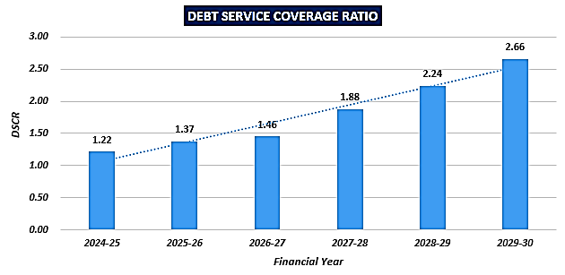
EBITDA MARGIN AND EBIT MARGIN

Particular | 2023-24 | 2024-25 | 2025-26 | 2026-27 | 2027-28 | 2028-29 | 2029-30
EBITDA Margin % | 14.07% | 22.34% | 23.09% | 23.02% | 27.60% | 30.37% | 32.87%
Average EBITDA Margin | 24.76%
EBIT Margin % | 2.01% | 12.69% | 14.41% | 14.76% | 19.91% | 23.02% | 25.84%
Average EBIT Margin | 16.09%
Net Profit Margin % | 0.00% | 5.34% | 6.85% | 7.32% | 11.24% | 13.73% | 16.04%
Average Profit Margin | 8.65%%

- NPV AND IRR OF THE PROJECT:
Particular | Construction | 2023-24 | 2024-25 | 2025-26 | 2026-27 | 2027-28 | 2028-29 | 2029-30
Project Cost | 339.90 | 0.00 | 0.00 | 0.00 | 0.00 | 0.00 | 0.00 | 0.00
Increase in Margin Money | 0.00 | 34.17 | 0.00 | 0.00 | 0.00 | 0.00 | 0.00 | 0.00
Total Cash Outflow | 339.90 | 34.17 | 0.00 | 0.00 | 0.00 | 0.00 | 0.00 | 0.00
EBITDA | 0.00 | 29.89 | 89.01 | 102.26 | 107.11 | 137.96 | 158.97 | 179.80
Release of Margin Money | 0.00 | 0.00 | 0.00 | 0.00 | 0.00 | 0.00 | 0.00 | 0.00
Salvage Value of Fixed Assets | 0.00 | 0.00 | 0.00 | 0.00 | 0.00 | 0.00 | 108.19 | 69.74
Total Cash Inflow | 0.00 | 29.89 | 89.01 | 102.26 | 107.11 | 137.96 | 267.16 | 249.54
Net Cash Inflow | (339.90) | (4.28) | 89.01 | 102.26 | 107.11 | 137.96 | 267.16 | 249.54
Free cash flow | -339.90 | -4.28 | 89.01 | 102.26 | 107.11 | 137.96 | 267.16 | 249.54
Discount rate |  | 13% (15 year average return of Nifty 50)
Terminal growth rate |  | 1% (Plastic Industry Expected CAGR 3.7%)
Discount Period |  | 0.67 | 1.67 | 2.67 | 3.67 | 4.67 | 5.67 | 6.67
Discount Factor |  | 0.92 | 0.82 | 0.72 | 0.64 | 0.57 | 0.50 | 0.44
PV of future cash flows | (339.90) | (3.94) | 72.60 | 73.82 | 68.42 | 77.99 | 133.66 | 110.48
Terminal value |  |  |  |  |  |  |  | 2100.26
PV Of TV |  |  |  |  |  |  |  | 929.86
PV of FCF + PV of Terminal value | (339.90) | (3.94) | 72.60 | 73.82 | 68.42 | 77.99 | 133.66 | 1040.34
NPV |  | INR 1122.99 Lakhs
XIRR |  | 30.04%

- BREAK-EVEN ANALYSIS:
Particular | 2023-24 | 2024-25 | 2025-26 | 2026-27 | 2027-28 | 2028-29 | 2029-30
Capacity | 40% | 45% | 50% | 53% | 55% | 58% | 60%
Sales Realisation | 228.00 | 384.75 | 427.50 | 448.88 | 470.25 | 491.63 | 513.00
Variable Cost
Raw Material | 133.90 | 225.96 | 251.06 | 263.62 | 276.17 | 288.72 | 301.28
Power & Fuel | 9.76 | 15.16 | 16.83 | 17.51 | 18.62 | 19.17 | 20.40
Consumable Store | 4.20 | 4.41 | 4.63 | 4.86 | 5.11 | 5.36 | 5.63
Working Capital Interest | 4.25 | 4.25 | 4.25 | 4.25 | 4.25 | 4.25 | 4.25
Selling Expenses | 6.80 | 7.48 | 8.23 | 9.05 | 9.05 | 9.05 | 9.05
Other Manufacturing Cost | 15.75 | 17.33 | 19.06 | 20.96 | 23.06 | 25.37 | 27.9
Total | 174.66 | 274.59 | 304.06 | 320.24 | 336.26 | 351.93 | 368.50
Fixed & Semi-Variable Cost
Repair & Maintenance | 6.51 | 6.51 | 7.16 | 7.16 | 7.16 | 7.16 | 7.16
Salary & Wages | 19.32 | 23.19 | 23.19 | 23.19 | 23.19 | 23.19 | 23.19
Administrative Expenses | 8.40 | 9.24 | 10.16 | 11.18 | 11.18 | 11.18 | 11.18
Interest on Term Loan | 0.00 | 17.37 | 14.85 | 12.11 | 9.13 | 5.88 | 2.35
Depreciation | 25.63 | 38.45 | 38.45 | 38.45 | 38.45 | 38.45 | 38.45
Interest on Unsecured Loan | 0.00 | 0.00 | 0.00 | 0.00 | 0.00 | 0.00 | 0.00
Total | 59.87 | 94.76 | 93.81 | 92.09 | 89.11 | 85.86 | 82.33
Contribution | 53.34 | 110.16 | 123.44 | 128.63 | 133.99 | 139.70 | 144.50
Break-Even Sales
Gross | 255.87 | 330.98 | 324.89 | 321.35 | 312.71 | 302.15 | 292.28
Cash | 146.32 | 196.68 | 191.73 | 187.17 | 177.77 | 166.84 | 155.77
Break-Even Point
Gross % | 44.89% | 38.71% | 38.00% | 37.59% | 36.57% | 35.34% | 34.19%
Cash % | 25.67% | 23.00% | 22.42% | 21.89% | 20.79% | 19.51% | 18.22%

As per the Break-even analysis, it can be seen that the company will be achieving the break-even sales from the 2nd year during the forecasted period, subject to the assumption & basis and micro & macro economic factors taken into consideration.
- LOAN AMORTIZATION SCHEDULE: As per Loan disbursement and amortization schedule shared by the client, according to the project costs incurred during the estimated period below table shows the closing balance of principle and intrest during the forecasted period.
Inputs for Loan Repayment Schedule
Total Term Loan | INR 215 Lakhs
Rate of Interest | 8.50%
Payment Per year | 4
No of years | 6

Year | Qtr. | Number | Payment | Principal | Interest | Balance
2024-25 | I | 1 | 11.53 | 6.96 | 4.57 | 208.04
 | II | 2 | 11.53 | 7.11 | 4.42 | 200.93
 | III | 3 | 11.53 | 7.26 | 4.27 | 193.67
 | IV | 4 | 11.53 | 7.41 | 4.12 | 186.26
Total |  |  | 46.12 |  | 17.37
2025-26 | I | 5 | 11.53 | 7.57 | 3.96 | 178.69
 | II | 6 | 11.53 | 7.73 | 3.80 | 170.96
 | III | 7 | 11.53 | 7.90 | 3.63 | 163.06
 | IV | 8 | 11.53 | 8.06 | 3.47 | 155.00
Total |  |  | 46.12 |  | 14.85
2026-27 | I | 9 | 11.53 | 8.24 | 3.29 | 146.76
 | II | 10 | 11.53 | 8.41 | 3.12 | 138.35
 | III | 11 | 11.53 | 8.59 | 2.94 | 129.76
 | IV | 12 | 11.53 | 8.77 | 2.76 | 120.99
Total |  |  | 46.12 |  | 12.11
2027-28 | I | 13 | 11.53 | 8.96 | 2.57 | 112.03
 | II | 14 | 11.53 | 9.15 | 2.38 | 102.89
 | III | 15 | 11.53 | 9.34 | 2.19 | 93.54
 | IV | 16 | 11.53 | 9.54 | 1.99 | 84.00
Total |  |  | 46.12 |  | 9.13
2028-29 | I | 17 | 11.53 | 9.74 | 1.79 | 74.26
 | II | 18 | 11.53 | 9.95 | 1.58 | 64.31
 | III | 19 | 11.53 | 10.16 | 1.37 | 54.14
 | IV | 20 | 11.53 | 10.38 | 1.15 | 43.77
Total |  |  | 46.12 |  | 5.88
2029-30 | I | 21 | 11.53 | 10.60 | 0.93 | 33.17
 | II | 22 | 11.53 | 10.82 | 0.70 | 22.34
 | III | 23 | 11.53 | 11.05 | 0.47 | 11.29
 | IV | 24 | 11.53 | 11.29 | 0.24 | 0.00
Total |  |  | 46.12 |  | 2.35

- DEPRECIATION SCHEDULE: Depreciation schedule is prepared based on the Companies Act, 1956 and Straight Line Method (SLM) is used to determine it. Below table shows the Depreciation Schedule along with applicable rate and allocated pre-opeartional and contingent expenses:
Allocation of Pre-operational And Contingencies Expenses
Particulars | Cost | Pre-operational/Contingencies | Total
Land and Site Development | 13.64 | 0.00 | 13.64
Factory Building | 63.00 | 1.26 | 64.26
Plant and Machinery | 253.73 | 5.07 | 258.8
Miscellaneous Fixed Assets | 2.20 | 0.00 | 2.20
Total | 332.57 | 6.33 | 338.90

DEPRECIATION SCHEDULE
Depreciation (As Per Companies Act,1956 On Straight Line Method)
Items | Total Cost | Rate | Depreciation
Land and Site Development | 13.64 | 0.00% | 0.00
Factory Building | 64.26 | 3.34% | 2.15
Plant and Machinery | 258.8 | 13.91% | 36.00
Miscellaneous Fixed Assets | 2.20 | 13.91% | 0.31
Total | 338.90 |  | 38.45

For the first year depreciation has been considered as INR 25.63 Lakhs = 38.35*8/12 considering the 8 months of operation in the initiall year. For the rest year during the forecasted period, depreciation has been considered same as INR 38.45 lakhs.
- KEY ASSUMPTIONS & BASIS:
Sl. No. | Item | Assumptions and Basis
 | General | - The projections of the firm are done for the period from FY 2023-24 to FY 2029-30, 7 years, to cover the term loan period as per the industry best practices.  - Revenue and expense modelling has been done based on the capacity utilization during the respective year.
 | Revenue Build up | - Total income for the financial years during the forecasted period will be generating from selling of plastic products.  - To calculate the operating revenue at 100% capacity utilization, Sales price INR 190.00 per unit is calculated to total installed capacity of the plant, which comes to the INR 855.00 Lakhs.  - Sales Value of the production has been calculated by multiplying the average price to the total production at the respective year capacity.  - Other income has been calculated as 4% of the operating income for the respective year.  - Thus the company is generating INR 212.47 Lakhs in the initial year which is in the line with historical trends. Further it has increased up to INR 547.06 Lakhs till FY 2029-30.  - Therefor the company is achieving a revenue growth rate Y-o-Y basis between 4% to 12%, which is also in the line with industrial & economic trends and on conservative side.
 | Pricing (Average Price Per kg) | - As per data/information shared by the client, company has sold their products at a price of INR 214 per kg and as per our tertiatiary research.  - Also as per secondary and tertiary research, industry trend and pricing offered by other companies and vendors in this line and data/information available in public domain, we found that the price per kg ranges from INR 160.00 to INR 215.00 per kg. For the offered product portfolio.  - It is expected that as the plastic industry will grow more, it will bring more competition and will lower the prices in the future as a general industry trend.  - Thus, justifiably average price has been considered as INR 190.00 per kg, which is reasonable and on conservative side.
 | Capacity Utilization | - For the proposed expansion, the company is planning to install new plant & machinery of total capacity of 4, 50,000 KGPA.  - We have considered the capacity utilisation at 40% in the first year (for 9 months only), 45% in the 2nd year and 50% in the 3rd year and then it will be increasing with an escalation rate of 2.5% because the new proposed expansion will take some time to achieve the economies of scale and will operate at a higher capacity in the later years.  - As per historical trends, the company was operating at a capacity utilization of 30% approximately, however prior to 2020 the company was involved in the outsourcing and selling activity.  - Thus to start the capacity utilization from 40% is in the line with industry and historical trends and it is reasonable and on conservative side to keep a mark-up for future market & economic risks in the Project.  - As per the plastic manufacturing sectoral trends, it is assumed that the project will be achieving a 60% capacity utilization in 7th year of the forecasted period.
 | Capital Expenditure | - As per information provided by the company, the existing freehold land for expansion, costs 13.64 Lakhs to the company, the company has already spent 20 lakhs for land development work as per information available in the audited financial statement for FY 2021-22.  - The company is planning to construct G+2, RCC structure on the 60% of 5 kattah (2160 Sq. ft.) proposed land therefore the proposed civil construction cost will be around INR 64.26 Lakhs including contingencies at the rate of approximately @ INR 1000 Per Sq. Ft., however per sq. ft. rate range in the local market is 1000-1100 Sq. ft. as per information provided by the client in the DPR.  - The existing plant and machinery cost is INR 53.03 Lakhs and proposed addition of plant and machinery will costs INR 200.07 Lakhs to the company. Here the contingency expenses for the plant and machinery is around 5 lakhs.  - The company has proposed to operate with 5 production line in the expanded manufacturing unit. As per shared quotations and purchase orders, tertiary research and information available in the public domain, we found that the cost of proposed plant and machinery is reasonable and justifiable.  - Capital expenditure also include miscellaneous fixed assets cost around INR 2.00 lakhs.
 | Expenses | - Major expenses includes raw material, power and fuel, salaries and wages, Repair and maintenance, SG&A, pre-operative expanses etc.  - For the proposed plant and machinery, quantity of raw material used will be 1575 kg per day including 5% Normal Loss at 100% capacity utilization.  - As per our independent research and information available on public domain raw material price ranging from Rs. 80/- to Rs 120/- per kg since polymer price fluctuation is strongly connected to the price of crude oil. These prices are based on the quality of the raw material granules, used by the company (Like: HDPE, LDPE, LLDPE, HIPS, PP, ABS & PVC etc.)  - Thus we considered the average price as INR 105 per kg which is reasonable and in the line with historical and industrial trends and multiplied it by raw material quantity used per day, to calculate total cost of raw material used per day.  - Hence, total raw material requirement per year, at 100% capacity utilization will be INR 502.13/- lakhs.  - Total Horsepower requirements of machinery, considering the motor requirements of all the machineries is 145 HP i.e., 97.35 KVA. A power connection of 100 KVA is sufficient to run the plant smoothly, which is already installed for to run the current plant. Also company has applied for the proposed unit to install 450 KVA transformer.  - Hence the total power consumption at 100% capacity level will be 2, 94,386 units. Total units consumed in different years would be calculated by multiplying the total power consumed per year with the % of capacity utilisation for that year.  - To calculate total power cost we have considered demand charges on 100 KVA Rs. 320/- per KVA per month, Energy Charges @ Rs. 6.85 per unit, Electricity Duty (10% on 6.85 unit) @ Rs. 1.02 per unit. Also we have considered 5% escalation rate in every 2nd year at energy charges per unit.  - In estimating the manpower requirement, salary and wages, a proper ratio between the administrative, managerial, supervisory and shop floor staff has been maintained with a view to affording proper industrial and professional management at various levels. The fringe benefits has been taken 10% of the basic salary.  - Pre-operative and preliminary expenses include establishment expenses, travelling & transportation expenses and consultancy fees, which in total, comes out 1 lakh. These expenses are considered as per historical analysis.  - All the other miscellaneous expenses are considered as per historical analysis, and these are cross checked from the similar Industries which is found economically viable.  - In the revenue at 100% capacity utilization, approximately 60% is raw material cost, from rest 40%, all other expenses like power generation cost, salary & wages, transportation cost will be deducted.  - Therefore company will keep 10 to 15 % margin of total revenue, which is as per industry standards.
 | Partial Loan | - As per the discussion with the client, company will apply for a partial loan of INR 215.00 lakhs from the total project cost of INR 374.07 lakhs for the expansion of the plant. It include civil construction cost and plant and machinery cost.  - The tenure of the loan will be 7 years in which first year will be considered as moratorium period.  - Interest rate has been considered as 8.5%.  - Also the loan repayment period will be from FY 2025 to FY 2030.

Conclusion:
      - DSCR, EBITDA and EBIT margins are positive in all years starting from initial year on 40% capacity utilization which has assumed maximum up to 60% till the end of 7th year with 5% and 2.5% escalation rate in later years.
      - DSCR, has achieved more than 1 during the loan repayment period.
      - Average DSCR, EBIDTA margin, EBIT margin is 1.80, 24.76%, and 16.09% respectively during the estimated period.
      - The company is having a positive NPV and IRR of INR 1122.99 Lakhs and 30.04% respectively at the base cases while it may vary with changes in the assumptions & micro and macro-economic trends considered as on date.
      - Based on the above key financial ratios of the proposed Project during the forecast period shows that the project looks financially viable if the Project Company & promoters are able to maintain minimum capacity utilization, revenue and can contain cost as assumed above.
PART M | CONCLUSION

Based on the technological, economical and market analysis done above, various assumptions of sectoral trends taken, product pricing to be adopted by the company, the Project appears to be Techno-commercially viable subject to the risks, threats, weaknesses, limitations of the product as detailed previously.
As per financial projections for the estimated period, Average DSCR, EBITDA Margin and EBIT Margin of the project are 1.80, 24.76% and 16.09% respectively, where higher DSCR is the indicator of the project capability to pay out its outstanding debt and EBITDA margin shows the capability of the project to generate the operating profits over the forecasted period.
The expanded manufacturing facility is having a positive NPV and IRR as INR 1122.99 Lakhs and 30.04% respectively at a 40% capacity (base case) utilization initially and 1.0% expected terminal growth rate as the industry is expectedly growing at a CAGR of 3-5.5% during the forecasted period. While it is not avoidable that the future projections may change in the upcoming years due to various factors impacting the operation, managerial, financial efficiency and economies of scale of the project.
While it would be depending on the management’s capability in future that how efficiently company adopts marketing and advertisement strategy, supply chain and carry out inventory & resource management to achieve higher profitability. Company is yet to identify its key customers and to form strategic planning for tie-up & product promotion with overseas and domestic customers for selling & distribution of its product which remains a major concern. Bank/ Financial Institution is advised to take firm plan from the company in this regard before taking any decision.
After considering the foreseen demand of the plastic and by-products domestically and globally, various initiatives taken by government, financial analysis of the project based on the assumptions taken over the projected period, it appears reasonable to comment that the proposed project is “Technically and Economically” Viable subject to current assumptions considered and occurring the same in the upcoming years same as the forecasted period which is dependent on the sincerity and efforts of the management and various micro and macroeconomic & industry situation.
We have tried our level best to analyse the Project techno-economic feasibility of the Project based on the Industry research, Project information and various futuristic assumption taken. However achieving the financial milestones depends on the ability, sincerity and efforts of the company, promoters and its key managerial performance.
Declaration | - The undersigned does not have any direct/indirect interest in the above property.  - The information furnished herein is true and correct to the best of our knowledge, logical and scientific assumptions.  - This TEV Report is carried out by our Financial Analyst team on the request from M/s Plasto Packaging Private Limited  - Meeting of Financial projections will be subject to subject to the market & economy stability factors, judicious business operations and proper & timely implementation of its process & product re-engineering & improvements plans for achieving high productivity, efficiency and achieving cost saving benefits.  - We have submitted TEV report to the Client.
Name & Address of consultant company |  |  | Signature of the authorized person
M/s. R.K. Associates Valuer & Techno Engineering Consultants Pvt. Ltd.
D-39, 2nd Floor. Sector-2, Noida- 201301
Enclosed Documents |  | Disclaimer & Remarks 71-74
Number of Pages in the Report |  | 74
Financial Analyst Team worked on the report |  | PREPARED BY: Mrs. Chhavi Toshan
 |  | REVIEWED BY: Mr. Gaurav Kumar

For R.K Associates Valuer & Techno Place: Noida

Engineering Consultants (P) Ltd. Date: 25/12/2022

(Authorized Signatory)

PART N | DISCLAIMER | REMARKS

      - No employee or member of R.K Associates has any direct/ indirect interest in the Project.
      - This report is prepared based on the copies of the documents/ information which the Bank/ Company has provided to us out of the standard checklist of documents sought from them and further based on our assumptions and limiting conditions. The client/owner and its management/representatives warranted to us that the information they supplied was complete, accurate and true and correct to the best of their knowledge. All such information provided to us has been relied upon in good faith and we have assumed that it is true and correct in all respect. I/We shall not be liable for any loss, damages, cost or expenses arising from fraudulent acts, misrepresentations, or wilful default on part of the owner, company, its directors, employee, representative or agents. Verification or cross checking of the documents provided to us from the originals or from any Govt. departments/ Record of Registrar has not been done at our end since this is beyond the scope of our work. If at any time in future, it is found or came to our knowledge that misrepresentation of facts or incomplete or distorted information has been provided to us then this report shall automatically become null & void.
      - Legal aspects for e.g. investigation of title, ownership rights, lien, charge, mortgage, lease, sanctioned maps, verification of documents, etc. have not been done at our end and same has to be taken care by legal expert/ Advocate. It is assumed that the concerned Lender/ Financial Institution has satisfied them with the authenticity of the documents, information given to us and for which the legal verification has been already taken and cleared by the competent Advocate before requesting for this report. I/ We assume no responsibility for the legal matters including, but not limited to, legal or title concerns.
      - This report is a general analysis of the project based on the scope mentioned in the report. This is not an Audit report, Design document, DPR or Techno feasibility study. All the information gathered is based on the facts seen on the site during survey, verbal discussion & documentary evidence provided by the client and is believed that information given by the company is true best of their knowledge.
      - This Techno Economic-Viability study is prepared based on certain futuristic assumption which are intra dependent on economic, market and sectorial growth condition in future and socio-economic, socio-political condition at macro and micro level.
      - Meeting of assumption and financial ratio will entirely depend on the sincerity and efforts of the company, promoters and its key managerial performance.
      - All observations mentioned in the report is only based on the visual observation and the documents/ data/ information provided by the client. No mechanical/ technical tests, measurements or any design review have been performed or carried out from our side during Project assessment.
      - Bank/FII should ONLY take this report as an Advisory document from the Financial/ Chartered Engineering firm and its specifically advised to the creditor to cross verifies the original documents for the facts mentioned in the report which can be availed from the borrowing company directly.
      - In case of any default in loans or the credit facility extended to the borrowing company, R.K Associates shall not be held responsible for whatsoever reason may be and any request for seeking any explanation from the employee/s of R.K Associates will not be entertained at any instance or situation.
      - The documents, information, data provided to us during the course of this assessment by the client are reviewed only up to the extent required in relation to the scope of the work. No document has been reviewed beyond the scope of the work.
      - This report only contains general assessment & opinion as per the scope of work evaluated as per the information given in the copy of documents, information, data provided to us and/ and confirmed by the owner/ owner representative to us at site which has been relied upon in good faith. It doesn’t contain any other recommendations of any sort including but not limited to express of any opinion on the suitability or otherwise of entering into any transaction with the borrower.
      - We have relied on data from third party, external sources & information available on public domain also to conclude this report. These sources are believed to be reliable and therefore, we assume no liability for the truth or accuracy of any data, opinions or estimates furnished by others that have been used in this analysis. Where we have relied on data, opinions or estimates from external sources, reasonable care has been taken to ensure that such data has been correctly extracted from those sources and /or reproduced in its proper form and context, however still we can’t vouch its authenticity, correctness or accuracy.
      - This Report is prepared by our competent technical team which includes Engineers and financial experts & analysts.
      - This is just an opinion report and doesn’t hold any binding on anyone. It is requested from the concerned Financial Institution which is using this report for taking financial decision on the project that they should consider all the different associated relevant & related factors also before taking any business decision based on the content of this report.
      - All Pages of the report including annexure are signed and stamped from our office. In case any paper in the report is without stamp & signature then this should not be considered a valid paper issued from this office.
      - Though adequate care has been taken while preparing this report as per its scope, but still we can’t rule out typing, human errors, over sightedness of any information or any other mistakes. Therefore, the concerned organization is advised to satisfy themselves that the report is complete & satisfactory in all respect. Intimation regarding any discrepancy shall be brought into our notice immediately. If no intimation is received within 15 (Fifteen) days in writing from the date of issuance of the report, to rectify these timely, then it shall be considered that the report is complete in all respect and has been accepted by the client up to their satisfaction & use and further to which R.K Associates shall not be held responsible in any manner.
      - Defect Liability Period is 15 DAYS. We request the concerned authorized reader of this report to check the contents, data and calculations in the report within this period and intimate us in writing if any corrections are required or in case of any other concern with the contents or opinion mentioned in the report. Corrections only related to typographical, calculation, spelling mistakes, incorrect data/ figures/ statement will be entertained within the defect liability period. Any new changes for any additional information in already approved report will be regarded as additional work for which additional fees may be charged. No request for any illegitimate change in regard to any facts & figures will be entertained.
      - R.K Associates encourages its customers to give feedback or inform concerns over its services through proper channel at valuers@rkassociates.org in writing within 15 days of report delivery. After this period no concern/ complaint/ proceedings in connection with the Techno- Economic Viability Study Services will be entertained due to possible change in situation and condition of the subject Project.
      - Our Data retention policy is of ONE YEAR. After this period, we remove all the concerned records related to the assignment from our repository. No clarification or query can be answered after this period due to unavailability of the data.
      - This Techno Economic Viability Study report is governed by our (1) Internal Policies, Processes & Standard Operating Procedures, (2) Information/ Data/ Inputs given to us by the client and (3) Information/ Data/ Facts given to us by our field/ office technical team. Management of R.K Associates never gives acceptance to any unethical or unprofessional practice which may affect fair, correct & impartial assessment and which is against any prevailing law. In case of any indication of any negligence, default, incorrect, misleading, misrepresentation or distortion of facts in the report then it is the responsibility of the user of this report to immediately or at least within the defect liability period bring all such act into notice of R.K Associates management so that corrective measures can be taken instantly.
      - R.K Associates never releases any report doing alterations or modifications from pen. In case any information/ figure of this report is found altered with pen then this report will automatically become null & void.
      - If this report is prepared for the matter under litigation in any Indian court, no official or employee of R.K Associates will be under any obligation to give in person appearance in the court as a testimony. For any explanation or clarification, only written reply can be submitted on payment of charges by the plaintiff or respondent which will be 10% of the original fees charged where minimum charges will be Rs. 15,000/.

