REPORT FORMAT: V-L5 (Very Large with P&M) | Version: 4.2_2017

File No.: VIS(2022-23)-PL243-Q052-242-443 Dated: 12.10.2022

PROJECT FIXED ASSET

VALUATION REPORT

OF

SUB-CRITICAL COAL-FIRED

3600 MW (6x600 MW)

THERMAL POWER PLANT

(3 UNITS UNDER CWIP)

SITUATED AT
DISTRICT JANJGIR- CHAMPA, CHHATTISGARH, INDIA

OWNER/ PROMOTER

A/C: M/S. KSK MAHANADI POWER COMPANY LIMITED (KMPCL)

REPORT PREPARED FOR
LIFE INSURANCE CORPORATION OF INDIA

**Important - In case of any query/ issue or escalation you may please contact Incident Manager
at valuers@rkassociates.org. We will appreciate your feedback in order to improve our services.

NOTE: As per IBA & Bank’s Guidelines please provide your feedback on the report within 15 days of its submission after which report will be considered to be correct.
Valuation Terms of Services & Valuer’s Important Remarks are available at www.rkassociates.org for reference.

IMPORTANT NOTICE

COPYRIGHT FORMAT: This report is prepared on the copyright format of R. K. Associates Valuers & Techno Engineering Consultants (P) Ltd. (R. K. Associates) to serve our clients with the best possible information and analysis to facilitate them to take rational business decisions. Legally no one can copy or distribute this format without prior approval from R.K Associates. It is meant only for the advisory/ reference purpose for the organization/s as mentioned on the cover page of this report. Distribution or use of this format by any organization or individual other than R.K Associates will be seen as an unlawful act and necessary legal action can be taken against the defaulters.

This report is intended for the sole use of the intended recipient/s and contains material that is STRICTLY CONFIDENTIAL AND PRIVATE.

DEFECT LIABILITY PERIOD: In case of any query/ issue or escalation you may please contact Incident Manager at valuers@rkassociates.org. Though adequate care has been taken while preparing this report as per its scope, but still, we can’t rule out typing, human errors, over sightedness of any information or any other mistakes. Therefore, the concerned organization is advised to satisfy themselves that the report is complete & satisfactory in all respect. Intimation regarding any discrepancy shall be brought into our notice immediately. If no intimation is received within 15 (Fifteen) days in writing from the date of issuance of the report, to rectify these timely, then it shall be considered that the report is complete in all respect and has been accepted by the client up to their satisfaction & use and further to which R.K Associates shall not be held responsible in any manner.

R.K Associates Important Notes and Part K–Valuer’s Important Remarks are integral part of this report and Value is assessment is subject to both of these sections. Reader of the report is advised to read all the points mentioned in these sections carefully.

TABLE OF CONTENTS
SECTIONS | PARTICULARS | PAGE NO.
Part A | INTRODUCTION
Part A | - Name of the Project | 05
Part A | - Brief Description of the Project | 05
Part A | - Purpose of the Report | 15
Part A | - Scope of the Report | 15
Part A | - Documents/Data Referred | 15
Part B | CHARACTERISTICS DESCRIPTION OF THE ASSET (As per SBI Format) | 16-23
Part C | AREA DESCRIPTION OF THE ASSET
Part C | - Land Area | 25
Part C | - Building & Structures | 26-45
Part D | INDUSTRY NOCS & STATUTORY APPROVAL DETAILS | 46
Part E | ASSET VALUATION & COSTING ASSESSMENT
Part E | - Total Project Cost Capex incurred/ to be incurred in the project | 47
Part E | - Present Status of the Project | 48
Part E | - Project Asset Valuation | 49
Part E | - Land Valuation Assessment | 50
Part E | - Building & Structure Valuation Assessment | 53-54
Part F | PLANT & MACHINERY HARD COST VALUATION ASSESSMENT FOR THE CAPITALIZED/COMMISSIONED 3 UNITS (UNIT 3, UNIT 4 AND UNIT 2) | 55 - 69
Part F | - Brief Description of The Plant  - Power Generation Process  - Fuel Supply Agreements  - Power Purchase Agreement  - Technology Collaborations  - Information Input For Assessment  - Survey Details  - Sales Transactions of Such Plants  - Construction Progress & Current Status of Unit 3  - Construction Progress & Current Status of Unit 4  - Construction Progress & Current Status of Unit 2  - Valuation Methodology Adopted  - Valuation Procedure  - Consolidated valuation summary of Plant & Machinery | 55 - 69
Part G | VALUATION OF CAPITAL WORK-IN PROGRESS (CWIP) FOR UNDER-CONSTRUCTION UNITS (UNIT#5, UNIT #1 & UNIT #6) | 70 - 80
Part G | - Overall Project Progress  - Cost Incurred in the Project  - Cost to Complete  - Valuation of CWIP | 70 - 80
Part H | VALUATION ASSESSMENT SUMMARY | 81 - 84
 | ENCLOSURES | 86 - 95
Part I | VALUER’S IMPORTANT REMARKS | 96 - 98

LIST OF ABBREVIATIONS
PFC | Power Finance Corporation Limited
TEV | Techno-Economic Viability
DPR | Detailed Project Report
FAR | Fixed Asset Register
TPP | Thermal Power Plant
SPV | Special Purpose Vehicle
IDC | Interest During Construction
EPC | Engineering, Procurement & Construction
COR | Cost-Overrun
COD | Commercial Operation Date
PPA | Power-Purchase Agreement
FSA | Fuel Supply Agreement
CERC | Central Electricity Regulatory Commission
GCV | Gross Calorific Value
RCC | Reinforced Cement Concrete
ESP | Electro-Static Precipitator
HVAC | Heating, Ventilation & Air-conditioning
CII | Cost Inflation Index
PLF | Plant Load Factor
GIS | Gas Insulated Switchyard
TG | Turbine-Generator

PART A | INTRODUCTION

- NAME OF THE PROJECT: Detailed Fixed Asset Valuation of (6 x 600) MW Pulverized Coal Fired Sub–Critical Thermal Power Plant set by M/s. KSK Mahanadi Power Company Limited (KMPCL) at Villages Nariyara, Rogada, Amora & Tarod of Tehsil Akaltara, Janjgir-Champa District of Chhattisgarh.
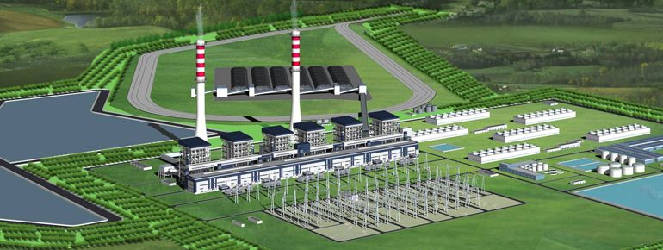

- BRIEF DESCRIPTION OF THE PROJECT: M/s. KSK Mahanadi Power Company Limited (hereinafter referred to as KMPCL), a subsidiary of KSK Energy Ventures is setting up a 3,600 MW (6x600) pulverized coal fired Sub- Critical Thermal Power Plant at villages Nariyara, Rogada, Amora & Tarod of Akaltara Tehsil in Janjgir- Champa district of Chhattisgarh State in India.

This is a Project Fixed Asset Valuation report comprises of Land & Building, Plant & Machinery and other miscellaneous assets of the Sub Critical Thermal Power plant located in Janjgir-Champa District of Chhattisgarh. Details of Land & Building and Plant & Machinery are enumerated in different section of this report. This report doesn’t includes Enterprise valuation and the current asset

This plant is approved for 6 Units of 600 MW each. However, out of the total 6 units, 3 units (that is 2nd, 3rd & 4th) are commissioned and the balance 3 units are at various stages of construction since long of which currently all construction is on hold from last more than 5 years. At the time of site inspection, only 2 units were in operation, that is, 2nd and 4th, the 3rd unit was on stand-by mode due to low demand. Accordingly 3 units are capitalized in the FAR and abrogated units are captured in CWIP. Thus, valuation of this whole plant is broadly computed based on the 3 commissioned units (2, 3 & 4) and CWIP separately for the noncommissioned units (1, 5 & 6).

Life Corporation of India (LIC) being one of the consortium lender has appointed us for the valuation of this plant only without considering the SPVs i.e. M/s. Raigarh Champa Rail Infrastructure Pvt. Ltd (RCRIPL) and M/s. KSK Water Infrastructure Pvt. Ltd. (KWIPL).
RCRIPL and KWIPL were established to develop a private railway siding and other related infrastructure from Akaltara railway station to the plant for transportation of coal and to transport water from river Mahanadi to the subject plant for meeting the water requirement respectively.
Valuation of the subject plant along with the SPVs was carried out by us in the year 2018 also. Since, the company is now under CIRP and IRP is appointed in it, therefore, during the present valuation exercise there were data & information limitation thus for the purpose of the present valuation, we have referred to a few previous data/ information which were available with us. The data which we have received during the current exercise are FAR, LIE report dated 16/12/2020 and some NOCs/ approvals only.
Present status of all the 6 units
Unit | Date of Contractual Schedule | COD Achieved | Current Status
Unit-2 | 25-Mar-13 | 28-Feb-17 | Operational
Unit-3 | 25-Jul-12 | 14-Aug-13 | Operational
Unit-4 | 25-Nov-12 | 26-Aug-14 | Operational
Unit-1 | 25-Nov-13 | - | Stalled condition. No construction activity ongoing since April 2018
Unit-5 | 25-Jul-13 | -
Unit-6 | 25-Mar-14 | -
Source: Technical Study Report by L&T-S&L | Dated: December 16, 2020

Project Location
The location of the project is right in the heart of the coal belt in Chhattisgarh-Orissa region which ensures ample availability of high grade of coal nearby. The Project is located at Akaltara Tehsil in Janjgir-Champa District of Chhattisgarh and the Project site is well connected by air, rail & road. The nearest town to the project site is Akaltara which is 10 km north east by road from the site. The National Highway NH-200 runs 0.5 km from the site.
The Bilaspur–Janjgir-Champa–Jharsugudha broad gauge railway line passes within a distance of 5 km from the site. Water is available in adequate quantity from the major perennial river Mahanadi. Thus, the two major ingredients that are required for the functioning of a thermal power plant are easily available nearby, which is a big advantage for it. For this reason, a number of other new independent power producers have set up or are in the process of setting up coal fired thermal power plants of a total capacity of more than 4000 MW within a radius of 100-150 Km of this plant.
The nearest airport is on the outskirts of Bilaspur, about 43 km from the project site. The condition of the roads is average, which provides connectivity to the Project Site.
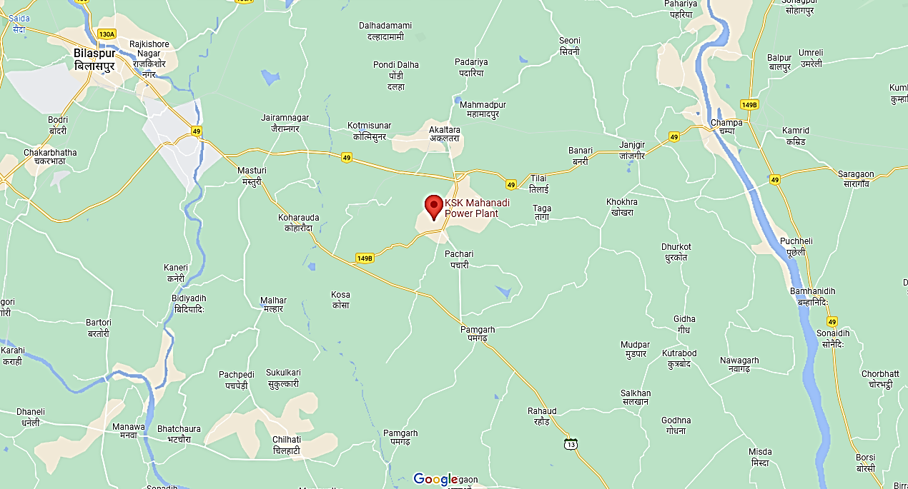

Land Requirement
For the purpose of setting up the Plant, KMPCL has acquired total land area of 2132.74 acres for the Power Project as shown in the table below:
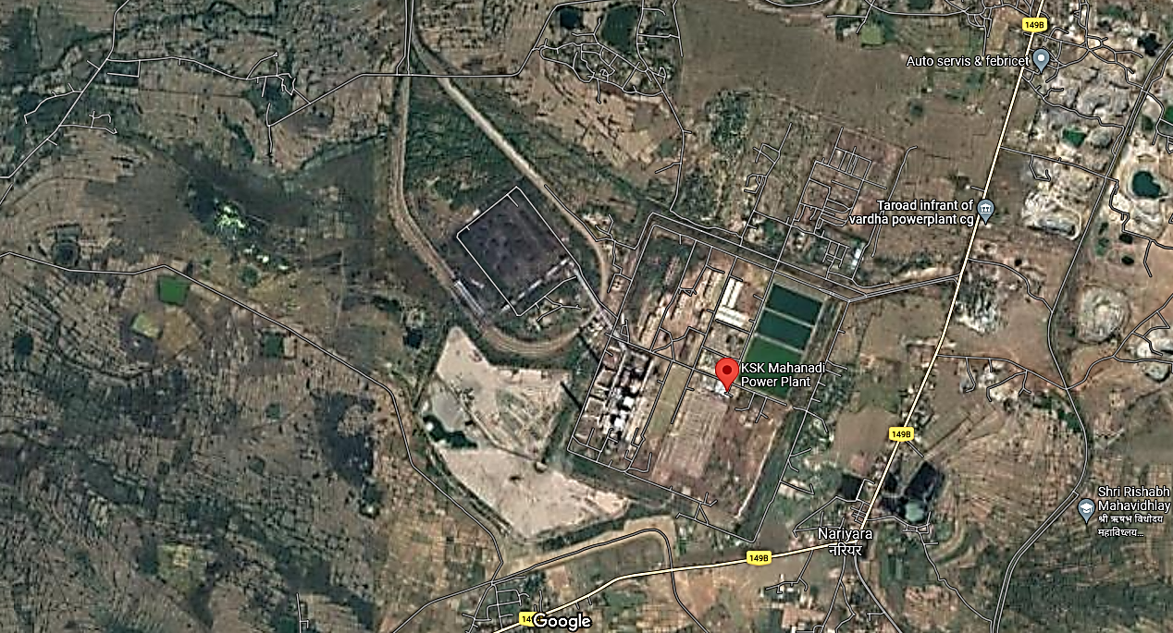
Implementation Agreement or EPC Contract
The Project is being implemented through a turnkey contract. The Engineering, Procurement and Construction (EPC) contract was executed with M/s. Shangdong Electric Power Construction Corporation (SEPCO), a China based EPC Contractor on 1st April 2009. The brief scope of EPC Contract is as under:
- Offshore supply: Design, engineering, manufacture, procurement, assembling, shop testing, seaworthy packing, forwarding and delivery of the plant and equipment including commissioning spares, consumables on CFR basis.
- Offshore services: Basic engineering, design & engineering services, technical services including interfacing integration and demonstration of Performance Guarantee Values of Units as well as training of KMPCL personnel.
- Onshore supply: Design, engineering, approval of drawings, manufacture, procurement, assembling, shop testing, packing, forwarding, transportation and delivery of the plant and equipment at the site including commissioning spares and consumables.
- Onshore services: Detailed services including project management, inspection, expediting, supervision of erection, testing and commissioning and such services as may be required from time to time for timely commissioning of the plant.
- Construction contract: Undertake earthworks, dewatering during construction, grading and leveling, excavation, foundations, buildings, all other civil works, architectural works, structural works, procurement services, project management, expediting, site mobilization, supervising, co-ordination, inspection, contractor’s permits and clearances etc.

Non- EPC Contracts
Project Company has also executed Non-EPC Contracts which includes:
• River water Intake System up to the raw water reservoir within plant boundary – Separate SPV
• Rail infrastructure covering tracks for Coal, fuel oil system etc. - Separate SPV
• Wagon Tippler
• Training Simulator
• CCTV for plant Surveillance
• Development of Green belt area
• Transmission lines
• External Boundary Wall
• Peripheral Storm Drain

According to the philosophy of construction in Phase-I, Phase-II and Phase-III, all Engineering, procurement, supply, construction, commissioning etc. including BOP, CHP, AHP, Switchyard, Rail infrastructure, Water infrastructure, Transmission lines etc. were planned and executed. Therefore, the 1st unit commissioned was Unit-3, then Unit-4 and finally Unit-2.

Main machinery of the plant includes Boiler, Turbine, Generator, Coal Handling Plant, Ash Handling Plant, Water Treatment Plant, Switchyard, Transmission line, Water pipeline system to bring raw water to the plant, and other auxiliary machinery for running the plant.

Plant is distributed into different blocks comprising of different buildings as per their utility. These mainly comprise of Industrial Structures consisting of massive steel structural members embedded in RCC base and covered by Industrial heavy duty corrugated steel sheets. Also, some buildings are made out of brickwork and RCC with RCC Roofs.

Some of the Buildings like Power House Building, Steel Structure for Raw Water Pump House etc. are capitalized in the Miscellaneous Equipment’s under P&M head. The list of the buildings capitalized under this head was not provided to us on request. So, it is not possible for our team to segregate the buildings.

We have considered the Buildings capitalized in the FAR of the subject company for the Valuation purpose under the buildings head in the Fixed Asset Register provided to us for the 3 commissioned units. Detailed break-up of the Buildings under Buildings head in the FAR is annexed with the report for reference however valuation is done on a complete block of buildings as a whole instead of individual structure.

Main sections of the Plant include Boiler House, ESP Building, ESP Control Room, Power House, Service Building, Coal bunker, Switchyard Control room, Control Room, Fly Ash Silos, Chimney among other buildings & sections.

Water Requirement & Raw Water Intake System
The total water requirement for the Project is estimated to be 8655 m³/hr. The water will be sourced from River Mahanadi which is about 45 km from the Project Site. To meet the lean flow period of 2 months in the river, it was decided by the Project Company to store 16 MCM of water at an intermediate reservoir.
Presently, the raw water is being pumped from Basantpur pump house to the reservoir in the plant which can cater to the three units of the plant; water is sufficiently available in the plant. It was informed that during the summer months KMPCL can pump 22.51 MCM (12.51 MCM from Basantpur + 10 MCM from Seorinarayan).
Railway Siding
As per the information gathered from the last valuation report, the railway siding work from Akaltara railway station till up to the plant boundary and return rail over rail bridges outside the plant boundary was being carried out by the SPV; RCRIPL. The siding work inside the plant boundary is being done by KMPCL only and contracts have been awarded to M/s Jhajharia Nirman Pvt. Ltd. for inside power plant boundary and Track and Towers Pvt. Ltd. for outside the power plant boundary. However, the railway siding work outside the boundary wall of the subject plant is owned, operated and carried out by RCRIPL which is not under scope of the present valuation, hence, the same is not included in this valuation.

Coal Linkage or Fuel Supply Agreement and Transportation
For KMPCL, the main source of the fuel is Indigenous Coal which will be supplied from various subsidiaries of Coal India Limited. However we have not got any latest information about the coal linkage or FSA status in the present exercise on our request. However, below we have described the details available from the previous report in this regard only for reference purpose:
The total requirement of coal for operation of 3,600 MW at 85% PLF works out to ~16 MTPA based on gross station heat rate of 2,240 kcal/kWh and average gross calorific value of about 4,000 kcal/kg.

Initially, coal for the Project was to be supplied from the Gare Pelma-III and Morga-II mines through GIDC/GMDC. To offset any delay in start of production from the new Morga-II mine, KMPCL was allocated tapering linkage of 7.49 MTPA for supply of coal to first three units. Subsequently, KMPCL had also entered into Fuel Supply Agreement (FSA) with South Eastern Coalfields Ltd. (SECL) for tapering linkage of 4.994 MTPA and with Eastern Coalfields Ltd. (ECL) for 1.76 MTPA.
However, the coal blocks were de-allocated after the Supreme Court judgment of 24th September 2014. Further, pursuant to directives from Ministry of Coal (MoC), the tapering FSA with SECL has ceased and a Memorandum of Understanding (MoU) has been executed on 13th July 2015 for supplying 67% of LOA quantity on “best effort basis”. Coal will be supplied under this MoU up to 31st March 2016 or until a policy in this regard is formulated by MoC, whichever is earlier.
As per previous report, KMPCL has been sourcing fuel from the open market including under the special forward e-auction for power sector by Coal India Limited (CIL) and coal imports, post the de-allocation of the Morga II and Gare Pelma III coal blocks tied up by the company as per the Supreme Court order dated September 24, 2014. However, the company was able to secure fuel linkage for supply of 6 MTPA (metric tons per annum) through the first reverse auction held by CIL for allocation of coal linkages under the SHAKTI policy.
Govt. of India in the month of May 2017 announced a policy for allocation of coal linkage auction for power sector, under ‘Shakti’ Scheme. Coal linkage under the policy for IPP’s with PPA’s would be based on bid for discount to existing tariffs. KMPCL had participated in the ‘Shakti’ Scheme for allocation of coal linkage for the existing units wherein the PPA tie up was in place. The fuel supply agreement (FSA) under this linkage was expected to be signed shortly with CIL, however we do not have the present status with us. This linkage was estimated to be sufficient for meeting about 38% of the fuel requirement of the project at 80% PLF. However, the fuel supply risk persisted for the remaining capacity.

KMPCL has been declared successful bidder pursuant to the Auction Process under ‘Shakti Scheme’, and was allocated the following:
S. No. | CIL Subsidiary | Quantity Allotted  (In Tonnes) | Indicative Grade of Coal
1 | Mahanadi Coalfields Limited | 11,00,000 | G12-G14
2 | South Eastern Coalfields Limited | 12,00,000 | G5-G6
3 | South Eastern Coalfields Limited | 45,00,000 | G10-G15
4 | Mahanadi Coalfields Limited | 20,700 | G13
Total |  | 68,20,700

For imported coal KMPCL had signed a sale agreement with M/s Ask RE Ltd. on 15th October, 2015 for a quantity of 1,50,000 MT+/- 4% having a typical GCV of 5900 kcal/kg and a rejection limit of less than 5700 kcal/kg. The coal shall be sourced from Gangavaram port.

Akaltara railway station is the nearest station to the power plant (10 km). As per previous report, Coal that will be transported to the Project by rail will use the Indian Railway network up to Akaltara railway station and thereafter use the railway siding up to the power plant for the transportation of coal.

Power Purchase Agreement
As per the Technical Study Report prepared by L&T – Sargent & Lundy Ltd. dated 16th December, 2020, the subject company has executed various Power Purchase Agreements (PPA) with Power DISCOMs as given in the table below:
S. No. | Counter Party | Contracted Capacity (MW) | Original PPA Date | PPA Term/ expiry Date
1 | GUVNL (under sub judice with GSERC) | 1010 MW | 03-Jun-2010 | 25 years
2 | CSPTradeco | ~90 MW (5% aggregate capacity of the Unit or the Power Station; 90 MW considering 3 units in operation) | 18-Oct-2013 | Perpetual
3 | TANGEDCO | 500 MW | 27-Nov-2013 | 15 years
4 | UP DISCOM | 1000 MW | 26-Feb-2014 | 25 years
Total |  | 2,600 MW

As can be seen from the above table, out of the total net capacity of 3,347 MW (considering 7.017% auxiliary consumption), only 2,600 MW has been tied up, and rest of the capacity needs to be tied up by the company. Also, PPA executed with GUVNL of 1010 MW is under sub-judice before Hon’ble GERC. Therefore, total net capacity for which PPAs have been executed is 1,590 MW only.
Power Evacuation Arrangement
As per RKA’s old valuation report, the initial plan for power evacuation was through 2 double circuit 400 kV lines to PGCIL’s 800 kV HVDC/765 kV/400 kV Champa pooling station, but due to the delay in commissioning of the Champa substation, the Generated power was being evacuated through a 400 kV double circuit LILO connection with PGCIL’s existing Raipur–Raigarh transmission line i.e. Line 1.

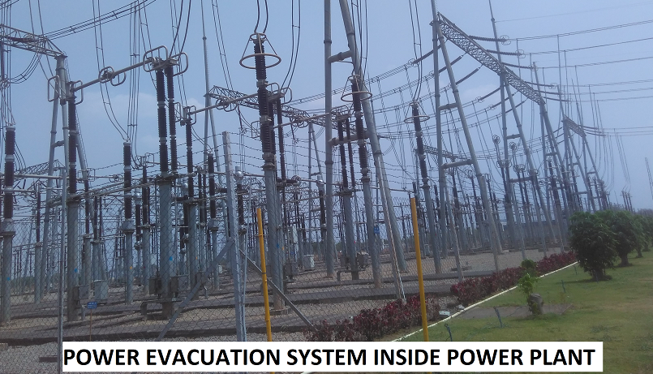

Operations and Maintenance (O&M) Agreements

As per the Technical Study Report prepared by L&T – Sargent & Lundy Ltd. dated 16th December, 2020, the subject company has engaged various O&M (Operations & Maintenance) contractors for various O&M activities of different activities of the plant as tabulated below:
Sr. No. | Package Description | Agency Name | Contract Completion Date
1 | Ash Handling Plant (AHP) | Globus Engineers | 31-10-2021
2 | Coal Handling Plant (CHP) | McNally Bharat | 31-10-2021
3 | BTG & BOP (Non Water Block)-O&M Services | Power Mech Projects Limited | 31-07-2021
4 | BOP-Chemistry O&M Services-Contract | Ion Exchange India Limited | 31-07-2021
5 | Analysis of Coal & Ash Samples (outside Plant) | Therapeutics Chemical Research Corporation | 30-04-2021
6 | Electrical and C&I Except CHP & AHP | Voltech O and M Services Pvt. Ltd | 30-06-2021
7 | Coal and Ash Sampling (Inside Plant) | Quality Services and Solutions | 31-07-2021
8 | Occupational Health Centre (OHC) | Renuka Diagnosis | 31-07-2021
9 | Coal Yard Management, Coal Quality & Quality Management and Crushing of coal | Refex Industries Limited | 30-04-2021
10 | O&M Special Services of BTG & it's Auxiliaries of 3 Units | Operational Energy Group India Ltd | 30-04-2021
11 | O&M Special Services of BOP (Excluding CHP & AHP) of 3 Units | Operational Energy Group India Ltd | 30-04-2021
12 | O&M Special Services of C&I systems of BTG & BOP (Excluding CHP & AHP) of 3 Units | Operational Energy Group India Ltd | 30-04-2021
13 | O&M Special Services of Electrical systems of BTG & BOP (Excluding CHP & AHP) of 3 Units | Operational Energy Group India Ltd | 30-04-2021
14 | Facility Management Services | Operational Energy Group India Ltd | 30-09-2021
15 | O&M Services of PS-1,Plant end switchyard, pipeline and Transmission Line Electrical systems of BTG & BOP (Excluding CHP &  AHP) of 3 Units | ACB(INDIA) Power Limited | 31-05-2021
16 | Private Railway Siding | ACB(INDIA) Power Limited | 31-05-2021
17 | O&M of 400kV Double Circuit Line (Water) | ACB(INDIA) Power Limited | 31-05-2021
18 | Disposal of Fly Ash | Ramky Infrastructure Limited | 31-05-2021
19 | Disposal of Pond Ash | Ramky Infrastructure Limited | 31-05-2021
20 | Post Project Environmental Monitoring Studies | Vimta Labs Limited | 31-03-2021
21 | Round the clock Security Services for Open Material Store Yard Area Inside Plant | Megha Security Services | 30-06-2021
All these contracts have been expired already and there is no latest information on whether these are renewed or not has been provided to us by the company.
Status of plant during site survey
At the time of the site survey, 3 units were commissioned out of the planned 6 units and construction of the balance 3 units is on hold from more than 5 years. The manpower is demobilized from the site and the balance work is standstill. Out of the three commissioned units, only two were operational during the site survey. The overall condition of the plant of the commissioned units is good.
CWIP main equipment & machines are also found to be packed and preserved properly under shed except structural material which is lying in open yards.
Recent Deals of Power Plants Under Implementation
Particulars | GMR Infra | Avantha | Jaypee’s | DB Power
Location | Raipur, Chhattisgarh | Gorakhpur, M.P. | Prayagraj, U.P. | Badadarha, Chhattisgarh
Capacity (MW) | 1,370 | 600 | 1,980 | 1,200
Purchase Price | Rs. 3,530 Cr. | Rs. 1,900 Cr. | Rs. 6,000 Cr. | Rs. 7,000 Cr.
EV Cr. per MW | 2.58 | 3.17 | 3.03 | 5.83
Purchaser | Adani Power | NTPC | Resurgent Power | Adani Power
Purchase Year | 2019 | 2019 | 2019 | 2022
Plant operation  Year | Unit-1: 2015 | Unit-1: 2016 | Unit-1: 2016 | 2015
Plant operation  Year | Unit-2: 2016 | Unit-1: 2016 | Unit-2: 2016 | 2015
Plant operation  Year | Unit-2: 2016 | Unit-1: 2016 | Unit-3: 2017 | 2015

- PURPOSE OF THE REPORT: To assess & determine the current Fair Market Value of the Fixed Assets of the Project pertaining to M/s. KSK Mahanadi Power Company Limited.

- SCOPE OF THE REPORT: To assess and determine Fair Market Valuation of the Assets as- on-where is basis of 6x600 MW KMPCL Thermal Power Plant covering following points:
- Valuation of Land.
- Valuation of Civil & Structures.
- Valuation of the Plant & Machinery of 3 commissioned Units.
- Valuation of Capital Work-In Progress of Under construction Units
- Valuation of other fixed assets of the Project only under M/s. KSK Mahanadi Power Company Limited

- DOCUMENTS/DATA REFFERED:
General
- Valuation Report prepared by RKA dated 05-06-2018
- Technical Study Report prepared by L&T- Sargent and Lundy Ltd. dated 16-12-2020
- Copies of Approvals and NOC’s from various Government agencies and departments
- Petitions under CERC for Approved Capital Cost of Coal based TPP
- Power Plants references available in public domain

Building and P&M
- Fixed Asset Register dated 31-03-2022

CWIP
- Cost bifurcation table shared by the company for CWIP Details for the Under-construction Units of Power Project
PART B | CHARACTERISTICS DESCRIPTION OF THE PROJECT

S.NO. | CONTENTS | DESCRIPTION
 | INTRODUCTION
 | Report prepared for | Non Banking Financial Institution
 | Name & Address of Organization | Life Insurance Corporation of India
 | Name of Owner/s | Under Resolution Professional
 | Name of Property Owner | Under Resolution Professional
 | Address & Phone Number of the owner | ---
 | Purpose of the Valuation | General Value Assessment
 | Date of Inspection of the Property | 28 September 2022 to 30 September 2022
 | Date of Valuation Report | 12 October 2022
 | Name of the Developer of the Property | EPC Contract given to M/s. Shangdong Electric Power Construction Corporation (SEPCO) & Non-EPC Contracts to various other contractors
 | Type of Developer | Private Contractor and EPC Consultant built
 | Type of Loan | NA
 | Type of the Property | Thermal Power Plant
 | Type of Valuation | Industrial Land & Building and Plant & Machinery Valuation
 | Report Type | Project Detailed Asset Valuation including Project value Addition Factors
 | Surveyed in presence of/ Information gathered during site survey | Owner's representative |  | Mr. P.K. Nanda (DGM)  Contact No.: +91-7024143971
 | Scope of the Report | Opinion on General Prospective Valuation Assessment of the Property identified by Property owner or through its representative
 | Out-of-Scope of Report | - Verification of authenticity of documents from originals or cross checking from any Govt. dept.  - Legal aspects of the property.  - Identification of the property is only limited to cross verification from its boundaries at site if mentioned in the provided documents.  - Getting cizra map or coordination with revenue officers for site identification.  - Measurement of the property as a whole.  - Measurement is only limited upto sample random measurement.  - Drawing Map & design of the property.  - Preparation of inventory list of items.  - Machines condition assessment is limited to visual observation as-on-is where basis.  - No technical testing of any accessories/equipment was carried out during survey.
 | Documents provided for perusal | Documents Requested |  | Documents Provided |  | Documents Reference No.
 | Documents provided for perusal | Total 04 documents requested. |  | Total 04 documents provided. |  | Total 04 documents provided.
 | Documents provided for perusal | Fixed Asset Register |  | Project Approval Documents |  | Dated 31/03/2022
 | Documents provided for perusal | Balance Sheet |  | Balance Sheet |  | Dated 31/03/2022
 | Documents provided for perusal | Property Title document |  | Sale Deed provided during the last valuation exercise |  | Refer Land Section
 | Documents provided for perusal | Approved Map |  | None |  | NA
 | Documents provided for perusal | TEV/ LIE Report |  | Technical Study Report |  | Dated 16/12/2020
 | Documents provided for perusal | Project Approval Documents |  | Project Approval Documents |  | Refer Part D
 | Identification of the property | ☐ | Cross checked from boundaries of the property mentioned in the deed
 | Identification of the property | ☒ | Done from the name plate displayed on the property
 | Identification of the property | ☒ | Identified by the owner/ owner representative
 | Identification of the property | ☐ | Enquired from local residents/ public
 | Identification of the property | ☐ | Identification of the property could not be done properly
 | Identification of the property | ☐ | Survey was not done |  | NA

 | PHYSICAL & LOCATION CHARACTERISTICS OF THE PROPERTY
- Brief description of the Property under Valuation: M/s. KSK Mahanadi Power Company Limited (KMPCL), a subsidiary of KSK Energy Ventures is setting up a 3600 MW (6x600) pulverized coal fired Sub- Critical Thermal Power Plant at villages Nariyara, Rogada, Amora & Tarod of Akaltara Tehsil in Janjgir- Chmapa district of Chhatisgarh State in India.
- This is a Sub-Critical pulverized coal fired Power Plant. The Plant comprises of 6 Units of 600 MW each. Out of the total 6 units, 3 units are commissioned and the balance 3 units are at various stages of construction.
The detailed COD dates is given in the table below:
Sr. No. | Unit No. | Dates of per Contractual Schedule | COD achieved
1 | Unit-3 | 25 July 2012 | 14 August 2013
2 | Unit-4 | 25 November 2012 | 26 August 2014
3 | Unit-2 | 25 March 2013 | 27 December 2017
4 | Unit-5 | 25 July 2013 | -
5 | Unit-1 | 25 November 2013 | -
6 | Unit-6 | 25 March 2014 | -

Other Project details are already described in ‘Brief description of the Project’ under Part-A Introduction section.
The location of the project is right in the heart of the coal belt in Chhattisgarh-Orissa region which ensures ample availability of high grade of coal nearby. The Project is located at Akaltara Tehsil in Janjgir Champa District of Chhattisgarh and the Project site is well connected by air, rail & road. The nearest town to the project site is Akaltara which is 10 km north east by road from the site. The National Highway NH-200 runs 0.5 km from the site. The Bilaspur–Janjgir-Champa–Jharsugudha broad gauge railway line passes within a distance of 5 km from the site. Water is available in adequate quantity from the major perennial river Mahanadi.
 | Is property clearly demarcated by permanent/ temporary boundary on site |  | Yes
 | Is the property merged or colluded with any other property |  | No, it is an independent singly bounded property
 |  |  | Coal Handling Plant & Railway Sidings area is not demarcated with permanent boundary
 | Current activity done in the property |  | Industrial
 | Type of Land |  | Solid
 | Area of the Plot/ Land |  | Power Project: 2,132.74 acres (863.46 ha.)
 |  |  | Also please refer to Part-B Area description of the property.
 | Covered Built-up área description  (Plinth/ Carpet/ Saleable Area) |  | Also please refer to Part-B Area description of the property.
 | Location attribute of the property
 | Nearby Landmark |  | Property is a landmark itself
 | Postal Address of the Property |  | - Villages Nariyara, Rogada, Amora & Tarod, Tehsil Akaltara, District Janjgir- Champa, Chhattisgarh, India
 | Independent access/ approach to the property |  | Clear independent access is available
 | Google Map Location of the Property with a neighborhood layout map |  | Enclosed with the Report
 |  |  | Coordinates or URL: 21°57'41.1"N 82°24'36.4"E
 | Details of the roads abutting the property
 | Main Road Name & Width |  | Akaltara to Pamgarh |  |  | NA
 | Front Road Name & width |  | Akaltara to Pamgarh |  |  | NA
 | Type of Approach Road |  | Bituminous Road
 | Distance from the Main Road |  | On main road
 | Description of adjoining property |  | Agricultural lands
 | Plot No. |  | Several
 | Village/ Zone |  | Villages: Nariyara, Rogada, Amora & Tarod |  |  | Tehsil Akaltara
 | Sub registrar |  | NA
 | District |  | Janjgir-Champa
 | City Categorization |  | Village |  |  | Rural
 | Characteristics of the locality |  | Average |  |  | Within unnotified Industrial area
 | Property location classification |  | On Wide Road |  | Road Facing |  | NA
 | Boundaries schedule of the Property
 | Are Boundaries matched |  | No, boundaries are not mentioned in the documents.
 | Directions | As per Sale Deed/TIR |  | Found as per Site Survey
 | North | NA |  | Agricultural Land Parcels
 | South | NA |  | Govt. Resham kendra Nariyara
 | East | NA |  | Agricultural Land Parcels
 | West | NA |  | Agricultural Land Parcels

 | TOWN PLANNING / ZONING PARAMETERS
 | Master Plan Area/ Zone | NA/
 | Provision of Building by-laws as applicable | PERMITTED | CONSUMED
 | - FAR/ FSI | Not available | Not available
 | - Ground coverage | Not available | Not available
 | - Number of floors | Not available | Not available
 | - Height restrictions | Not available | Not available
 | - Front/ Back/ Side Setback | Not available | Not available
 | Status of Completion/ Occupational certificate | No information available | No information available
 | Comment on unauthorized construction if any | Not available
 | Comment on Transferability of development rights | As per regulation of Chhattisgarh Govt.
 | Master plan currently in force | NA
 | Development controls/ Authority | Area not falling under development authority limits
 | Municipal limits | NA
 | Zoning regulations | Not yet under zoning regulations
 | Any notification on change of zoning regulation | NA
 | Is property usage as per applicable zoning | It is a village area, no zoning regulations defined
 | Comment on the surrounding land uses & adjoining properties in terms of uses | Majorly, all nearby lands are used for Agricultural purpose.
 | Any notification for Demolition | No
 | Any notification for Compounding/ Regularization | No
 | Any notification for land acquisition | NA
 | Any notification for road widening | No
 | Any information on encroachment | No
 | Any heritage site restrictions | No
 | Is the area part of unauthorized area/ colony | No (As per general information available)
 | Category of Land Use | Industrial
 | Any conversion of land use done | From Agricultural to Industrial
 | Street Notification | Not notified
 | Is property tax been paid for this property | Not Known
 | Property or Tax Id No. | Not provided

 | LEGAL OWNERSHIP ASPECTS OF THE PROPERTY
 | Ownership documents provided | Sale deed | Lease Deed |  |  | NA
 | Names of the Legal Owner/s | M/s. KSK Mahanadi Power Company Limited
 | Constitution of the Property | Free hold and Lease hold
 | Agreement of easement if any | NA
 | Notice of acquisition if any and area under acquisition | No
 | Notice of road widening if any and area under acquisition | No
 | Transferability rights of the property ownership | For Free hold, Complete transferable rights & for Lease hold, have to take NOC in order to transfer
 | Any known existing mortgages/ charges/ encumbrances on the property, if any | Yes |  |  | Consortium of Lenders led by Power Finance Corporation (PFC)
 | Whether the owners of the property have issued any guarantee (personal or corporate) as the case may be | Not Known |  |  | NA
 | Building plan sanction:
 | - Authority approving the plan | NA
 | - Name of the office of the Authority | NA
 | - Any violation from the approved Building Plan | NA
 | Whether the property SARFAESI complaint | Yes
 | - Information regarding municipal taxes (property tax, water tax, electricity bill) | Tax name |  | NA
 |  | Receipt number |  | NA
 |  | Receipt in the name of |  | NA
 |  | Tax amount |  | NA
 | - Observation on Dispute or Dues if any in payment of bills/ taxes | Not known to us
 | Whether entire piece of land on which the unit is set up / property is situated has been mortgaged or to be mortgaged | Yes
 | Qualification in TIR/Mitigation suggested if any | NA
 | Since how long owners owing the Property | 13-14 Years
 | Year of Acquisition/ Purchase | 2009-10
 | Property presently occupied/ possessed by | Legal Owner
 | Title verification | To be done by the competent Advocate
 | Details of leases if any | No

 | ECONOMIC ASPECTS OF THE PROPERTY
 | Reasonable letting value/ Expected market monthly rental | NA
 | Is property presently on rent | No
 | - Number of tenants | NA
 | - Since how long lease is in place | NA
 | - Status of tenancy right | NA
 | - Amount of monthly rent received | NA
 | Taxes and other outgoing | NA
 | Property insurance details | NA
 | Monthly maintenance charges payable | NA
 | Security charges, etc. | NA

 | SOCIO - CULTURAL ASPECTS OF THE PROPERTY
 | Social structure of the area (population, social stratification, regional origin, age groups, economic levels, location of slums/ squatter settlements nearby, etc.) | Rural Area
 | Whether property belongs to social infrastructure like hospital, school, old age homes etc. | No

 | FUNCTIONAL AND UTILITARIAN SERVICES, FACILITIES & AMENITIES
 | Space allocation |  |  |  | Yes
 | Storage spaces |  |  |  | Yes
 | Utility of spaces provided within the building |  |  |  | Yes
 | Car parking facilities |  |  |  | Yes
 | Balconies |  |  |  | Yes
 | Sewerage / sanitation |  |  |  | Yes
 | Drainage arrangements |  |  |  | Yes
 | Water Treatment Plant |  |  |  | Yes
 | Power Supply arrangements |  | Permanent |  | Yes/ As per sanctioned load
 |  |  | Auxiliary |  | Yes
 | HVAC system |  |  |  | Yes/ in the Service Building, Admin Building, Control Rooms and other buildings
 | Security provisions |  |  |  | Yes/ Private security guards
 | Lift/ Elevators |  |  |  | Yes/ In the Crusher House, Boiler House, Service Building, Admin Building
 | Compound wall/ Main Gate |  |  |  | Yes
 | Whether gated society |  |  |  | Yes
 | Solar lightening system |  |  |  | No
 | Internal development
 | Garden/ Park/ Land scraping | Water bodies |  | Internal roads |  | Pavements | Boundary Wall
 | Yes | Yes |  | Yes |  | Yes | Yes

 | INFRASTRUCTURE AVAILABILITY
 | Aqua Infrastructure availability
 | - Water Supply |  |  |  | Yes, Mahanadi River through dedicated pipelines
 | - Sewerage Treatment Plant (STP) |  |  |  | Yes
 | - Storm water drainage |  |  |  | Yes
 | Other Physical Infrastructure
 | - Solid waste management |  |  |  | Yes, Self- managed
 | - Electricity |  |  |  | Yes, Self-generated
 | - Road and Public Transport connectivity |  |  |  | Yes
 | - Availability of other public utilities nearby |  |  |  | Transport, Market, Hospital etc.
 | Proximity & availability of civic amenities & social infrastructure
 | School | Hospital | Market | Bus Stop |  | Akaltara Railway Station | Metro |  |  | Bilaspur Airport
 | ~10 km | ~10 km. | ~10 km. | ~2 km. |  | ~10 km. | NA |  |  | ~43 km.
 | MARKETABILITY ASPECTS OF THE PROPERTY:
 | Location attribute of the subject property |  |  |  | Good
 | Scarcity |  |  |  | Similar kind of properties are not easily available in this area.
 | Availability of recreation facilities  (parks, open spaces etc.) |  |  |  | This is a rural remote area. No recreational facility is available nearby.
 | New Development in surrounding area |  |  |  | No new development |  |  | NA
 | Market condition related to demand and supply of the kind of the subject property in the area |  |  |  | Demand of the subject property is in accordance with the current use/ activity perspective only which is currently carried out in the property.
 | Any negativity/ defect/ disadvantages in the property/ location |  |  |  | No |  |  | NA
 | Any other aspect which has relevance on the value or marketability of the property |  |  |  | No
 | ENGINEERING AND TECHNOLOGY ASPECTS OF THE PROPERTY:
 | Type of construction & design |  |  |  | Industrial corrugated GI Shed and RCC pillar beam column structures. Please refer Part-B of the report
 | Method of construction |  |  |  | Construction done by professional contractor and EPC consulant based on architect plan
 |  |  |  |  | Construction done using pre-fabricated as well as cast in-situ methodology
 | Specifications
 | - Appearance/ Condition of structures |  |  |  | Internal - Good
 |  |  |  |  | External - Good
 | - Roof |  |  |  | Floors/ Blocks |  |  |  | Type of Roof
 |  |  |  |  | Please refer Part-B of the report
 | - Floor height |  |  |  | Please refer Part-B Area Description Chart
 | - Type of flooring |  |  |  | Vitrified tiles, Kota stone, PCC
 | - Doors/ Windows |  |  |  | Aluminum flushed doors & windows, Wooden frame & panel doors
 | - Interior Finishing |  |  |  | POP punning, Simple Plastered Walls, Designer false ceiling in office areas.
 | - Exterior Finishing |  |  |  | Neatly plastered & putty coated walls, Glass facade, Architecturally designed & elevated
 | - Interior decoration/ Special architectural or decorative feature |  |  |  | Simple plain looking structure.
 | - Class of electrical fittings |  |  |  | Internal/ Normal quality fittings
 | - Class of sanitary & water supply fittings |  |  |  | Internal/ Normal quality fittings
 | Maintenance issues |  |  |  | No maintenance issue, structure is maintained properly
 | Age of building/ Year of construction/ Remaining life expected |  |  |  | Please refer Building Sheet in Part-B
 | Extent of deterioration in the structure |  |  |  | No deterioration came into notice through visual observation
 | Structural safety |  |  |  | Structure built on RCC technique so it can be assumed as structurally stable. However no structural stability certificate is available
 | Protection against natural disasters viz. earthquakes etc. |  |  |  | Not Applicable
 | Visible damage in the building if any |  |  |  | No visible damages in the structure
 | System of air conditioning |  |  |  | AC is installed in office area
 | Provision of firefighting |  |  |  | Fire Hydrant System
 | Status of Building Plans/ Maps |  |  |  | NA
 | Is Building as per approved Map |  |  |  | Yes appears to be as per visual observation
 | Details of alterations/ deviations/ illegal construction/ encroachment noticed in the structure from the original approved plan |  |  |  | ☐ Permissible Alterations |  |  |  | NA
 |  |  |  |  | ☐ Not permitted alteration |  |  |  | NA
 | Is this being regularized |  |  |  | NA
 | ENVIRONMENTAL FACTORS:
 | Use of environment friendly building materials like fly ash brick, other Green building techniques if any |  |  |  | Standard civil construction material used
 | Provision of rainwater harvesting |  |  |  | Yes
 | Use of solar heating and lighting systems, etc. |  |  |  | No
 | Presence of environmental pollution in the vicinity of the property in terms of industries, heavy traffic, etc. if any |  |  |  | NA
 | ARCHITECTURAL AND AESTHETIC QUALITY OF THE PROPERTY:
 | Descriptive account on whether the building is modern, old fashioned, etc., plain looking or with decorative elements, heritage value if applicable, presence of landscape elements,  etc. |  |  |  | Well-constructed Industrial Building

PART C | AREA DESCRIPTION OF THE ASSET

- LAND AREA: For the purpose of setting up the plant, KMPCL has acquired 2,132.74 acres of land via multiple sale deeds, lease deeds and land acquisition act. The area has been cross checked by the satellite tools, snapshot of which is shown below:

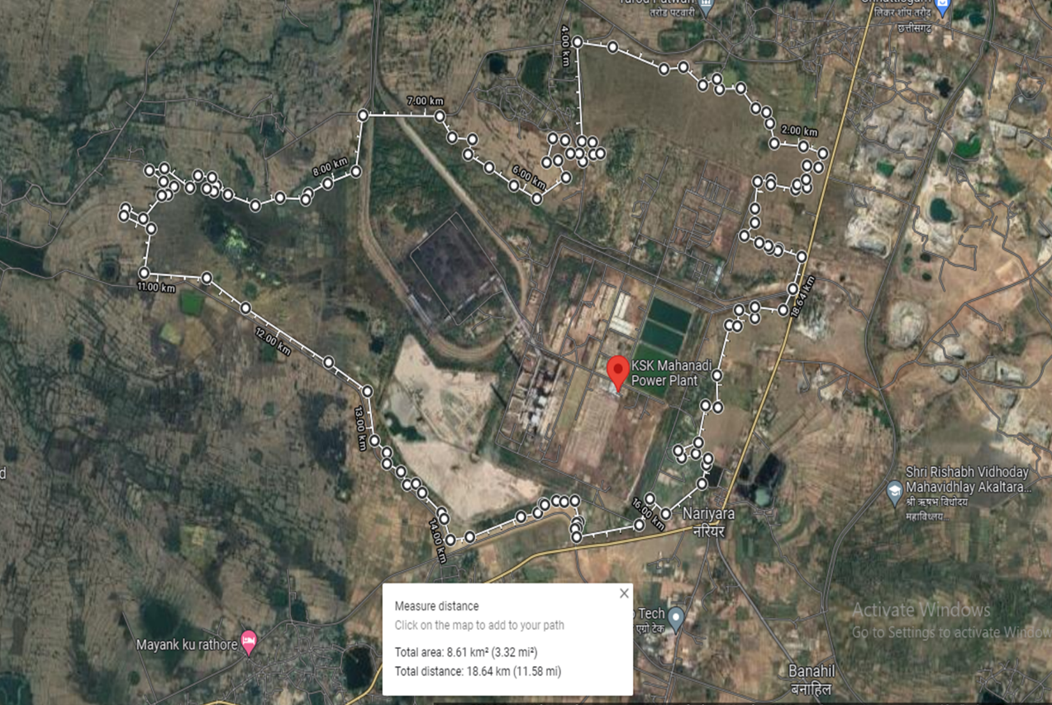
Most of the land was acquired in the year 2009 and 2010. Detailed description of land under possession is given in the table below:

Table: 9
- BUILDINGS & STRUCTURES: Several buildings and structures are erected as per the norms & requirement of a Sub-Critical Thermal Power Plant. Civil Works of the Plant includes construction of roads, boundary wall, sewerage and drainage, Power House, Service Building, Ash Water recovery Pump House, Township Buildings, Sea Water Intake Pump House etc. As per the information provided by the company the total built-up area of the buildings and civil works capitalized in the books of the subject company is 2,34,616 sq. mtr. or 25,24,467 sq. ft.
Detailed break-up of buildings capitalized under Buildings’ head in the provided FAR has been tabulated below:
Unit 2:
Asset - Unit 2 | Sub Asset - Unit 2 | Component description | Gross Block  (in ₹) | Net Block  (in ₹)
Plant Buildings | ABCD Row Columns | Completion Of All Abcd Row Main Column Foundations | 1,02,38,62,337 | 92,03,51,479
Plant Buildings | AB Bay Operating Floor | Completion Of Operating Floor Slab Of Ab Bay (0.82%) | 38,69,67,571 | 34,78,45,764
Plant Buildings | Cooling Towers | Completion Of Cooling Towers (1.63%) | 77,40,80,734 | 64,88,74,255
Plant Buildings | ABCD Row Columns |  | (1,10,19,190) | (99,05,167)
Plant Buildings | AB Bay Operating Floor |  | 16,75,12,760 | 15,05,77,485
Plant Buildings | Cooling Towers |  | 24,29,97,457 | 20,36,92,958
Plant Buildings | Track Hoppers |  | 15,97,79,147 | 13,82,41,255
Plant Buildings | Crusher House Building |  | 19,09,481 | 16,52,087
Plant Buildings | Control Rooms |  | 4,50,95,560 | 4,05,36,470
Plant Buildings | Buildings - Plant |  | 21,44,29,693 | 19,27,51,191
Plant Buildings | PB Construction Material Steel |  | 9,10,92,815 | 8,18,83,475
Non Plant Buildings | Green Belt Development |  | 37,25,94,891 | 31,23,28,187
Non Plant Buildings | Internal Roads & Compound Wall |  | 58,30,74,286 | 34,73,47,277
Non Plant Buildings | Intermediate Reservoir For Water Intake System |  | 57,38,29,432 | 48,10,13,322
Non Plant Buildings | Internal Roads & Compound Wall |  | 22,81,76,200 | 13,59,28,445
Non Plant Buildings | NPB - Temporary Constructions |  | 69,176 | -
Roads | NPB-Development of Approach Roads |  | 71,95,495 | -

Unit 3:
Asset - Unit 3 | Sub Asset - Unit 3 | Component description | Gross Block  (in ₹) | Net Block  (in ₹)
Plant buildings | ABCD Row Columns | COMPLETION OF ALL ABCD ROW MAIN COLUMN FOUNDATIONS (PRORATED FOR EACH UNIT) | 67,09,21,855 | 55,56,24,828
Plant buildings | AB Bay Operating Floor | COMPLETION OF AB BAY-OPERATING FLOOR (0.82%) - Mezanine Floor @ 6.lvl | 12,64,55,827 | 10,47,24,562
Plant buildings | AB Bay Operating Floor | COMPLETION OF AB BAY-OPERATING FLOOR (0.82%) - Operatign Floor @ 13.7 lvl | 12,64,55,827 | 10,47,24,562
Plant buildings | Cooling Towers | COMPLETION OF COOLING TOWERS - Basin Level | 20,07,40,672 | 14,43,80,246
Plant buildings | Cooling Towers | COMPLETION OF COOLING TOWERS - Eliminator Level | 12,54,62,921 | 9,02,37,654
Plant buildings | Cooling Towers | COMPLETION OF COOLING TOWERS- Deck Level | 17,56,48,089 | 12,63,32,719
Plant buildings | Track Hoppers | COMPLETION OF SIDE CONCRETE WALL OF TRACK HOPPERS | 12,54,62,921 | 9,63,80,463
Plant buildings | Track Hoppers | COMPLETION OF SIDE CONCRETE WALL OF TRACK HOPPERS | 12,54,62,921 | 9,63,80,463
Plant buildings | Track Hoppers | COMPLETION OF TRACK HOPPERS | 31,08,82,884 | 23,88,19,852
Plant buildings | Crusher House Building | COMPLETION OF CRUSHER HOUSE BUILDINGS - Works from -16 to -10 lvl | 8,78,24,044 | 6,74,66,324
Plant buildings | Crusher House Building | COMPLETION OF CRUSHER HOUSE BUILDINGS - Works from -10 to 0 Lvl | 8,78,24,044 | 6,74,66,324
Plant buildings | Crusher House Building | COMPLETION OF CRUSHER HOUSE BUILDINGS - Work from 0 to 10 lvl | 7,52,77,752 | 5,78,28,277
Plant buildings | Control Rooms | COMPLETION OF CONTROL ROOMS - Works upto 1.4 lvl | 6,32,27,913 | 5,23,62,280
Plant buildings | Control Rooms | COMPLETION OF CONTROL ROOMS - Works upto 10.4 Lvl | 7,58,73,496 | 6,28,34,736
Plant buildings | Control Rooms | COMPLETION OF CONTROL ROOMS - Works upto 10.4 to 21 Lvl | 7,58,73,496 | 6,28,34,736
Plant buildings | Control Rooms | COMPLETION OF CONTROL ROOMS- Works upto 21 to 27 Lvl | 3,79,36,748 | 3,14,17,371
Plant buildings | Plant Buildings | Cwip - Building - Plant | 38,23,02,129 | 31,66,04,020
Plant buildings | Plant Buildings | Pb Construction Material Steel | 37,17,34,930 | 30,78,52,775
Plant buildings | Plant Buildings | Coal Handling System | 5,91,857 | 4,90,146
Plant buildings | Plant Buildings | Switchyard | 18,925 | 15,670
Plant buildings | Track Hoppers | COMPLETION OF SIDE CONCRETE WALL OF TRACK HOPPERS | 26,82,65,389 | 10,68,54,336
Plant buildings | Track Hoppers | COMPLETION OF SIDE CONCRETE WALL OF TRACK HOPPERS | 26,82,65,389 | 10,68,54,336
Plant buildings | Track Hoppers | COMPLETION OF TRACK HOPPERS | 66,47,31,202 | 26,47,72,923
Plant buildings | Crusher House Building | COMPLETION OF CRUSHER HOUSE BUILDINGS - Works from -16 to -10 lvl | 18,77,85,772 | 7,47,98,036
Plant buildings | Crusher House Building | COMPLETION OF CRUSHER HOUSE BUILDINGS - Works from -10 to 0 Lvl | 18,77,85,772 | 7,47,98,036
Plant buildings | Crusher House Building | COMPLETION OF CRUSHER HOUSE BUILDINGS - Work from 0 to 10 lvl | 16,09,59,233 | 6,41,12,603
Plant buildings | Control Rooms | COMPLETION OF CONTROL ROOMS - Works upto 1.4 lvl | 13,51,94,213 | 5,49,22,642
Plant buildings | Control Rooms | COMPLETION OF CONTROL ROOMS - Works upto 10.4 Lvl | 16,22,33,056 | 6,59,07,169
Plant buildings | Control Rooms | COMPLETION OF CONTROL ROOMS - Works upto 10.4 to 21 Lvl | 16,22,33,056 | 6,59,07,169
Plant buildings | Control Rooms | COMPLETION OF CONTROL ROOMS- Works upto 21 to 27 Lvl | 8,11,16,528 | 3,29,53,584
Non plant buildings | Watch towers | Fabrication, erection & Sheeting of watch tower & other Miscellaneous work | 30,01,388 | 0
Non plant buildings | Fencing of Plant Area | M.S. ANGLE 90 X 90 X 8 , Fabrication & Erection of structure, fencing work at site | 2,53,77,152 | (0)
Non plant buildings | Green Belt Development | NPB : Green Belt Development | 1,66,86,951 | 0
Non plant buildings | Construction Of Staff Quarters | NPB : Construction Of Staff Quarters | 3,68,81,182 | 2,65,22,498
Non plant buildings | Civil Works On Property Not Owned By Company | NPB - Civil Works On Property Not Owned By Company | (2,97,115) | (0)
Non plant buildings | Parking Sheds | NPB - Parking Sheds | 1,09,012 | 0
Non plant buildings | Borewell | Borewell | 5,57,489 | (0)
Non plant buildings | Construction of Pulverizer Room | NPB - Construction of Pulverizer Room MS ANGLE 70X70X6 & HR SHEET 12MM | 31,68,911 | 24,35,019
Non plant buildings | Drains, Culverts and Crossovers | NPB - Drains, Culverts and Crossovers - Construction of surface drain, supply, laying & jointing of RCC pipes construction of bridge, fabrication & construction of shed etc., | 28,38,84,200 | 6,65,10,303
Non plant buildings | Office Building | Construction of block office civil works | (11,67,077) | (0)
Non plant buildings | Temporary Constructions | NPB - Temporary Constructions | 2,46,01,644 | (0)
Non plant buildings | Reservoir For Water Intake System |  | 12,79,23,773 | 9,20,41,229
Non plant buildings | Road | NPB-Development of Approach Roads | 5,22,020 | 0

Unit 4:
Asset - Unit 4 | Sub Asset - Unit 4 | Component description | Gross Block  (in ₹) | Net Block  (in ₹)
Plant buildings | ABCD Row Columns | COMPLETION OF ALL ABCD ROW MAIN COLUMN FOUNDATIONS (PRORATED FOR EACH UNIT) | 83,23,21,875 | 70,05,35,591
Plant buildings | AB Bay Operating Floor | COMPLETION OF OPERATING FLOOR SLAB OF AB BAY - Mezzanine Floor @ 6.lvl | 15,66,89,243 | 13,18,79,740
Plant buildings | AB Bay Operating Floor | COMPLETION OF OPERATING FLOOR SLAB OF AB BAY - Operatign Floor @ 13.7 lvl | 15,66,89,243 | 13,18,79,740
Plant buildings | Track Hoppers | COMPLETION OF SIDE CONCRETE WALL OF TRACK HOPPERS - Works upto Paddel Feeder Lvl | 47,01,35,137 | 37,08,87,416
Plant buildings | Track Hoppers | COMPLETION OF SIDE CONCRETE WALL OF TRACK HOPPERS - Works upto Rail Lvl | 47,01,35,137 | 37,08,87,416
Plant buildings | Track Hoppers | COMPLETION OF TRACK HOPPER | 1,15,70,10,865 | 91,27,60,474
Plant buildings | Crusher House Building | COMPLETION OF CRUSHER HOUSE BUILDINGS - Works from -16 to -10 lvl | 32,68,54,189 | 25,78,53,746
Plant buildings | Crusher House Building | COMPLETION OF CRUSHER HOUSE BUILDINGS - Works from -10 to 0 Lvl | 32,68,54,189 | 25,78,53,746
Plant buildings | Crusher House Building | COMPLETION OF CRUSHER HOUSE BUILDINGS - Work from 0 to 10 lvl | 28,01,60,734 | 22,10,17,495
Plant buildings | Control Rooms | COMPLETION OF CONTROL ROOMS - Works upto 1.4 lvl | 23,48,46,492 | 19,76,61,901
Plant buildings | Control Rooms | COMPLETION OF CONTROL ROOMS - Works upto 10.4 Lvl | 28,18,15,789 | 23,71,94,281
Plant buildings | Control Rooms | COMPLETION OF CONTROL ROOMS Works upto 10.4 to 21 Lvl | 28,18,15,789 | 23,71,94,281
Plant buildings | Control Rooms | COMPLETION OF CONTROL ROOMS - Works upto 21 to 27 Lvl | 14,09,07,895 | 11,85,97,141
Plant buildings | Buildings - Plant | Cwip - Building - Plant | 7,31,41,670 | 6,15,60,729
Plant buildings | Buildings - Plant | Pb Construction Material Steel | 2,58,24,00,726 | 2,17,35,14,438
Plant buildings | Buildings - Plant | Coal Handling System | 14,568 | 12,260
Non plant buildings | Fencing of Plant Area | NPB : Fencing of Plant Area | 20,43,616 | 0
Non plant buildings | Civil Works On Property Not Owned By Company | Miscellaneous Civil Works | 1,00,467 | 0
Non plant buildings | Buildings - Admin Block / Guesthouse | Buildings - Admin Block / Guesthouse | 56,90,649 | 42,49,127
Non plant buildings | Buildings - Security Room | Buildings - Security Room | 7,29,413 | 0
Non plant buildings | Drains, Culverts and Crossovers |  | 4,72,399 | 1,73,252
Non plant buildings | Office Building |  | 8,85,443 | (0)
Non plant buildings | Temporary Constructions | NPB - Temporary Constructions | 76,13,274 | (0)
Non plant buildings | Reservoir For Water Intake System | INTERMEDIATE RESERVOIR FOR WATER INTAKE SYSTEM - 171058 | 33,72,40,782 | 25,18,12,947
Non plant buildings | Roads | Approach Roads | 4,49,41,100 | 0

Plant Buildings (other than the commissioned units):
S. No. | Nature of Expenditure | Gross Block  (in ₹) | Net Block  (in ₹)
PLANT BUILDINGS
1 | Construction of coal sampling room under TT5 in CHP area | 3,26,133 | 2,55,759
2 | Supply and installation of cupboards for time office building | 4,41,347 | 3,71,436
WAGON TIPPLER HOUSE
1 | Supply of reinforcement steel for wagon tippler | 1,68,94,621 | 1,31,49,451
2 | Supply of steel (TMT BAR 32 MM) for wagon tippler | 71,50,381 | 55,65,300
3 | Civil works at wagon tippler area for 6*600 MW power plant & transfer tower at village Nariyara | 11,33,73,396 | 8,82,40,981
4 | Earth work excavation at wagon tippler area in connection with railway with railway siding | 2,94,32,032 | 2,29,07,590
5 | Supply of 8.89 MT TMT Bar steel to site | 27,03,785 | 21,04,416
6 | Supply of TMT bar 20 mm for wagon tippler | 2,29,01,905 | 1,78,25,049
7 | Supply of TMT Bar 25 mm for wagon trippler | 97,76,664 | 76,09,392
8 | Procurement of steel for wagon tippler | 1,17,17,969 | 91,20,351
9 | Supply of Electroformed grating for using as walkways on coal | 86,041 | 66,966
10 | Reimb of Freight, Debit Note No.1-2013-PAT | 1,16,278 | 90,503
11 | TMT Rebars and MS Plate | 30,11,106 | 23,43,610
12 | Earlier debited to Sepco Retention account now transferred to CWIP based email dtd.01.05.14 confirmation from project | 21,35,687 | 16,62,250
13 | Earlier debited to Sepco Retention account now transferred to CWIP based email dtd.01.05.14 confirmation from project | 1,82,394 | 1,41,960
14 | Earlier debited to Sepco Retention account now transferred to CWIP based email dtd.01.05.14 confirmation from project | 3,407 | 2,651
15 | Provision for works executed by Sepco as per mail dtd.23.07.15 of Mr. Repala Srinivasa Rao ref Elecon order No.1527 | 6,00,000 | 4,66,994

Other Civil Structures:
S. No. | Nature of Expenditure | Gross Block  (in ₹) | Net Block  (in ₹)
BUILDINGS – OTHERS
Development of Approach Roads - 171001 - 10 YEARS
1 | Supply & Fixing of 2 Nos Hume pipes for 33 KV Sub-Station Road at Nariyara | - | -
2 | Stone dust filling | 37,155 | -
3 | Construction of WBM road for the approach to 33 KV sub station | 28,001 | -
1 | Repairing of road in Km 49/8-10 on NH 49 at KMPCL junction | 5,88,637 | -
2 | Supply of 384 Cu Mtr Crusher Stone 10 mm to 20 mm | 2,06,880 | -
3 | Supply of 384 Cu Mtr Crusher Stone 10 mm to 20 mm | 2,07,137 | -
4 | Supply of 384 Cu Mtr Crusher Stone 10 mm to 20 mm | 82,635 | -
5 | Supply of 150 CU Mtrs Crusher Stone 10 mm to 20 mm | 81,823 | -
6 | Civil work for road block 1 & 2 and dining hall at plant area - nariyara site and Construction of roads at site block offices and dining hall at nariyara plant site | 1,19,822 | -
7 | Supply of RCC Hume pipe 600 MM dia NP3 for construction of approach roads to various facilities at Nariyara plant site | 89,251 | -
8 | Construction of Approach roads in Camp office area at Nariyara | 1,23,996 | -
9 | Construction of approach road at camp office, Nariyara | 11,08,396 | -
10 | Tariff room approach road in Switchyard area | 1,16,143 | 13,933
11 | Construction of CC Road in staff accommodation inside Sepco Living qtrs | 7,03,657 | 84,877
12 | Construction of Kesla road | 1,16,52,000 | 73,88,478
NPB - BOUNDARY WALL - 171006 - 30 YEARS
1 | Construction of Boundary wall | 44,74,264 | 39,38,626
2 | Construction of boundary wall (Sample) | 1,82,532 | 1,62,300
3 | Construction of outer peripheral boundary wall | 19,81,788 | 17,62,117
4 | Construction of outer peripheral boundary wall | 8,51,940 | 7,57,506
5 | Construction of outer peripheral boundary wall | 3,61,152 | 3,21,122
6 | Construction of outer peripheral boundary wall | 2,14,206 | 1,90,463
7 | Construction of outer peripheral boundary wall | 9,36,825 | 8,32,982
8 | Construction of outer peripheral boundary wall | 2,93,013 | 2,60,535
9 | Construction of outer peripheral boundary wall | 8,21,280 | 7,30,245
10 | Construction of peripheral boundary wall | 7,53,059 | 6,69,588
11 | Construction of boundary wall | 3,98,957 | 3,54,737
12 | Construction of boundary wall | 2,13,913 | 1,90,200
13 | Construction of outer peripheral boundary wall | 22,84,578 | 20,31,344
14 | Construction of outer peripheral boundary wall | 8,18,978 | 7,28,200
15 | Construction of outer peripheral boundary wall | 2,14,264 | 1,90,516
16 | Construction of outer peripheral boundary wall | 9,20,050 | 8,18,071
17 | Construction of outer peripheral boundary wall | 16,28,018 | 14,47,563
18 | Construction of outer peripheral boundary wall | 6,82,376 | 6,06,739
19 | Construction of outer peripheral boundary wall | 2,14,264 | 1,90,516
20 | Construction of peripheral boundary wall | 7,17,450 | 6,37,924
21 | Construction of peripheral boundary wall | 8,05,796 | 7,16,476
22 | Construction of peripheral boundary wall | 7,21,423 | 6,41,456
23 | Construction of peripheral boundary wall | 7,23,392 | 6,43,208
24 | Construction of peripheral boundary wall | 79,277 | 70,491
25 | Construction of peripheral boundary wall | 2,14,206 | 1,90,463
26 | Construction of boundary wall for proposed ITC land | 18,42,600 | 16,38,357
27 | Construction of outer boundary wall | 5,71,440 | 5,08,098
28 | Construction of outer boundary wall | 10,30,138 | 9,15,955
29 | Construction of outer boundary wall | 8,01,118 | 7,12,318
30 | Construction of outer boundary wall | 7,57,827 | 6,73,824
31 | Construction of outer boundary wall | 2,14,206 | 1,90,463
32 | Construction of outer peripheral boundary wall | 28,67,444 | 25,49,606
33 | Construction of boundary wall | 2,78,093 | 2,47,269
34 | Construction of boundary wall | 2,14,264 | 1,90,516
35 | Construction of outer peripheral boundary wall | 5,71,129 | 5,07,822
36 | Construction of outer peripheral boundary wall | 10,70,395 | 9,51,749
37 | Construction of outer peripheral boundary wall | 8,02,887 | 7,13,891
38 | Construction of outer peripheral boundary wall | 7,58,891 | 6,74,771
39 | Construction of peripheral boundary wall | 70,359 | 62,562
40 | Construction of peripheral boundary wall | 2,14,264 | 1,90,516
41 | Construction of outer peripheral boundary wall | 5,90,363 | 5,24,924
42 | Construction of outer peripheral boundary wall | 8,42,785 | 7,49,366
43 | Construction of outer peripheral boundary wall | 5,00,317 | 4,44,861
44 | Construction of boundary wall | 9,64,257 | 8,57,374
45 | Construction of boundary wall | 2,14,264 | 1,90,516
46 | Construction of outer peripheral boundary wall | 6,94,110 | 6,17,169
47 | Construction of peripheral boundary wall | 11,01,513 | 9,79,416
48 | Construction of boundary wall | 12,24,101 | 10,88,419
49 | Construction of outer peripheral boundary wall | 13,72,352 | 12,20,234
50 | Construction of outer peripheral boundary wall | 12,97,217 | 11,53,430
51 | Construction of boundary wall | 5,85,148 | 5,20,285
52 | Construction of boundary wall | 2,13,906 | 1,90,193
53 | Construction of boundary wall | 87,343 | 77,661
54 | Construction of outer peripheral boundary wall | 5,18,732 | 4,61,232
55 | Construction of outer peripheral boundary wall | 8,64,218 | 7,68,424
56 | Construction of outer peripheral boundary wall | 7,60,167 | 6,75,905
57 | Construction of outer peripheral boundary wall | 3,49,200 | 3,10,495
58 | Construction of boundary wall | 4,05,007 | 3,60,115
59 | Construction of boundary wall | 2,14,264 | 1,90,516
60 | Construction of peripheral boundary wall | 5,22,999 | 4,65,028
61 | Construction of peripheral boundary wall | 7,11,784 | 6,32,888
62 | Construction of peripheral boundary wall | 5,43,693 | 4,83,426
63 | Construction of peripheral boundary wall | 11,41,204 | 10,14,707
64 | Construction of peripheral boundary wall | 2,49,021 | 2,21,419
65 | Construction of peripheral boundary wall | 2,14,206 | 1,90,463
66 | Construction of peripheral boundary wall | 5,56,152 | 4,94,504
67 | Construction of peripheral boundary wall | 8,33,052 | 7,40,713
68 | Construction of peripheral boundary wall | 8,05,737 | 7,16,424
69 | Construction of peripheral boundary wall | 2,56,666 | 2,28,217
70 | Construction of peripheral boundary wall | 4,82,178 | 4,28,733
71 | Construction of peripheral boundary wall | 2,13,943 | 1,90,230
72 | Construction of peripheral boundary wall | 4,03,976 | 3,59,198
73 | Construction of peripheral boundary wall | 3,66,323 | 3,25,719
74 | Construction of peripheral boundary wall | 7,29,580 | 6,48,710
75 | Construction of peripheral boundary wall | 29,132 | 25,903
76 | Provision t/w Construction of peripheral boundary wall | 2,00,018 | 1,77,847
77 | Construction of outer peripheral boundary wall | 8,49,451 | 7,55,297
78 | Construction of outer peripheral boundary wall | 7,19,892 | 6,40,098
79 | Construction of boundary wall | 7,36,707 | 6,55,046
80 | Construction of boundary wall | 7,72,254 | 6,86,655
81 | Construction of boundary wall | 2,13,913 | 1,90,200
82 | Construction of outer peripheral boundary wall | 3,59,353 | 3,19,521
83 | Construction of outer peripheral boundary wall | 4,27,797 | 3,80,378
84 | Construction of outer peripheral boundary wall | 3,39,478 | 3,01,851
85 | Construction of outer peripheral boundary wall | 4,07,008 | 3,61,892
86 | Construction of peripheral boundary wall | 4,38,320 | 3,89,737
87 | Construction of peripheral boundary wall | 5,47,670 | 4,86,962
88 | Construction of peripheral boundary wall | 4,19,423 | 3,72,933
89 | Construction of peripheral boundary wall | 2,13,943 | 1,90,230
90 | Construction of peripheral boundary wall | 32,055 | 28,502
91 | Construction of boundary wall | 1,00,081 | 88,985
92 | Provision t/w Construction of boundary wall | 2,40,618 | 2,13,947
93 | Construction of outer peripheral boundary wall | 5,47,844 | 4,87,120
94 | Construction of outer peripheral boundary wall | 6,60,056 | 5,86,892
95 | Construction of outer peripheral boundary wall | 6,28,356 | 5,58,708
96 | Construction of outer peripheral boundary wall | 5,93,002 | 5,27,271
97 | Construction of peripheral boundary wall | 7,66,365 | 6,81,417
98 | Construction of peripheral boundary wall | 2,14,070 | 1,90,343
99 | Supply of 5 Nos Roller wheel 130mm, outer dia with shaft (L-100mm X dia-20mm), used in chimney#2 gate enter roller wheel at Site (MRN No.12-13/859 dt.19.02.13) | 15,500 | 13,783
100 | Supply of 1 No Roller wheel 130mm, Outer Dia with shaft (L-100mm X Dia-20mm) used in chimney #2 gate enter roller wheel at site (MRN No.12-13/858 dt.19.02.13) | 3,100 | 2,757
101 | Construction of peripheral boundary wall | 16,24,269 | 14,44,229
102 | Construction of peripheral boundary wall | 16,16,143 | 14,37,006
103 | Construction of peripheral boundary wall | 2,14,264 | 1,90,516
104 | Construction of peripheral boundary wall | 1,07,303 | 95,409
105 | Construction of outer peripheral boundary wall | 7,87,151 | 6,99,898
106 | Construction of outer peripheral boundary wall | 12,92,960 | 11,49,642
107 | Construction of outer peripheral boundary wall | 4,05,936 | 3,60,939
108 | Construction of peripheral boundary wall | 4,68,070 | 4,16,188
109 | Construction of peripheral boundary wall | 2,13,911 | 1,90,198
110 | Construction of boundary wall | 4,20,338 | 3,73,745
111 | Construction of outer peripheral boundary wall | 8,85,545 | 7,87,385
112 | Construction of outer peripheral boundary wall | 5,34,890 | 4,75,603
113 | Construction of outer peripheral boundary wall | 8,16,747 | 7,26,216
114 | Construction of boundary wall | 10,74,233 | 9,55,160
115 | Construction of boundary wall | 2,13,943 | 1,90,230
116 | Construction of boundary wall | 1,24,836 | 1,10,999
117 | Construction of outer peripheral boundary wall | 9,66,750 | 8,59,594
118 | Construction of outer peripheral boundary wall | 13,93,504 | 12,39,041
119 | Construction of peripheral boundary wall | 7,83,711 | 6,96,843
120 | Construction of peripheral boundary wall | 1,68,078 | 1,49,449
121 | Construction of peripheral boundary wall | 2,13,905 | 1,90,192
122 | Construction of outer peripheral boundary wall | 7,22,221 | 6,42,168
123 | Construction of outer peripheral boundary wall | 4,33,113 | 3,85,104
124 | Construction of outer peripheral boundary wall | 8,50,822 | 7,56,514
125 | Construction of peripheral boundary wall | 12,00,749 | 10,67,652
126 | Construction of peripheral boundary wall | 2,13,983 | 1,90,263
127 | Construction of outer peripheral boundary wall | 7,31,545 | 6,50,456
128 | Construction of outer peripheral boundary wall | 19,27,651 | 17,13,983
129 | Construction of outer peripheral boundary wall | 5,55,145 | 4,93,609
130 | Construction of outer peripheral boundary wall | 2,14,264 | 1,90,516
131 | Construction of outer peripheral boundary wall | 6,50,262 | 5,78,183
132 | Construction of outer peripheral boundary wall | 19,18,863 | 17,06,170
133 | Construction of outer peripheral boundary wall | 5,81,040 | 5,16,632
134 | Construction of outer peripheral boundary wall | 2,13,906 | 1,90,193
135 | Construction of outer peripheral boundary wall | 5,00,124 | 4,44,689
136 | Construction of outer peripheral boundary wall | 4,83,815 | 4,30,188
137 | Construction of boundary wall | 10,95,011 | 9,73,635
138 | Construction of outer peripheral boundary wall | 11,72,566 | 10,42,593
139 | Construction of outer peripheral boundary wall | 2,14,206 | 1,90,463
140 | Construction of outer peripheral boundary wall | 7,87,151 | 6,99,898
141 | Construction of outer peripheral boundary wall | 11,70,365 | 10,40,637
142 | Construction of outer peripheral boundary wall | 6,71,544 | 5,97,104
143 | Construction of peripheral boundary wall | 5,39,635 | 4,79,821
144 | Construction of peripheral boundary wall | 2,14,264 | 1,90,516
145 | Construction of peripheral boundary wall | 9,83,938 | 8,74,876
146 | Construction of peripheral boundary wall | 4,04,505 | 3,59,669
147 | Construction of peripheral boundary wall | 9,55,502 | 8,49,592
148 | Construction of boundary wall | 6,02,267 | 5,35,512
149 | Construction of boundary wall | 2,13,906 | 1,90,193
150 | Construction of peripheral boundary wall | 8,29,939 | 7,37,943
151 | Construction of peripheral boundary wall | 13,98,366 | 12,43,364
152 | Construction of boundary wall | 9,63,002 | 8,56,259
153 | Construction of boundary wall | 2,13,983 | 1,90,263
154 | Construction of peripheral boundary wall | 6,11,043 | 5,43,313
155 | Construction of peripheral boundary wall | 7,52,192 | 6,68,814
156 | Construction of peripheral boundary wall | 6,84,979 | 6,09,053
157 | Construction of peripheral boundary wall | 10,15,749 | 9,03,157
158 | Construction of boundary wall | 5,78,263 | 5,14,163
159 | Construction of outer peripheral boundary wall (Length 35 Mtr) | 2,25,165 | 2,00,206
160 | Construction of peripheral boundary wall | 11,95,436 | 10,62,927
161 | Construction of peripheral boundary wall | 8,98,041 | 7,98,500
162 | Construction of peripheral boundary wall | 8,43,304 | 7,49,829
163 | Construction of peripheral boundary wall | 2,13,911 | 1,90,198
164 | Construction of peripheral boundary wall | 12,80,694 | 11,38,736
165 | Construction of peripheral boundary wall | 8,89,380 | 7,90,798
166 | Construction of peripheral boundary wall | 7,30,442 | 6,49,479
167 | Construction of peripheral boundary wall | 2,09,906 | 1,86,641
168 | Construction of outer boundary wall | 10,20,764 | 9,07,619
169 | Construction of peripheral boundary wall | 16,26,763 | 14,46,448
170 | Construction of peripheral boundary wall | 2,14,264 | 1,90,516
171 | Provision t/w Construction of peripheral boundary wall | 6,78,717 | 6,03,486
172 | Construction of outer peripheral boundary wall | 5,44,164 | 4,83,846
173 | Construction of peripheral boundary wall | 2,55,785 | 2,27,434
174 | Construction of boundary wall | 5,72,349 | 5,08,907
175 | Construction of boundary wall | 4,92,698 | 4,38,084
176 | Construction of boundary wall | 10,60,222 | 9,42,705
177 | Construction of boundary wall | 2,13,913 | 1,90,200
178 | Provision t/w Construction of boundary wall | 2,77,611 | 2,46,841
179 | Construction of outer peripheral boundary wall | 6,61,193 | 5,87,903
180 | Construction of peripheral boundary wall | 7,45,789 | 6,63,123
181 | Construction of peripheral boundary wall | 56,209 | 49,980
182 | Construction of outer peripheral boundary wall | 15,483 | 13,766
183 | Construction of outer peripheral boundary wall | 15,99,487 | 14,22,193
184 | Construction of outer peripheral boundary wall | 6,68,648 | 5,94,530
185 | Construction of outer peripheral boundary wall | 2,14,264 | 1,90,516
186 | Construction of peripheral boundary wall | 4,82,140 | 4,28,695
187 | Construction of outer peripheral boundary wall | 14,64,383 | 13,02,065
188 | Construction of outer peripheral boundary wall | 10,33,943 | 9,19,335
189 | Construction of outer peripheral boundary wall | 2,14,264 | 1,90,516
190 | Provision t/w Construction of outer peripheral boundary wall | 8,36,961 | 7,44,188
191 | Construction of outer peripheral boundary wall | 10,29,019 | 9,14,957
192 | Construction of outer peripheral boundary wall | 8,42,280 | 7,48,919
193 | Construction of boundary wall | 4,47,844 | 3,98,204
194 | Construction of boundary wall | 6,62,007 | 5,88,626
195 | Construction of outer peripheral boundary wall | 2,14,206 | 1,90,463
196 | Construction of peripheral boundary wall | 14,53,153 | 12,92,078
197 | Construction of peripheral boundary wall | 6,13,226 | 5,45,253
198 | Construction of peripheral boundary wall | 5,68,820 | 5,05,770
199 | Construction of peripheral boundary wall | 2,14,264 | 1,90,516
200 | Construction of peripheral boundary wall | 3,24,446 | 2,88,480
201 | Construction of peripheral boundary wall | 11,32,166 | 10,06,670
202 | Construction of outer peripheral boundary wall | 19,17,895 | 17,05,307
203 | Construction of outer peripheral boundary wall | 2,13,906 | 1,90,193
204 | Fabrication & fixing of MS gate in west side boundary wall near chimney # 1 | 30,437 | 27,061
205 | Construction of peripheral boundary wall | 26,75,786 | 23,79,188
206 | Construction of boundary wall | 5,41,096 | 4,81,121
207 | Construction of boundary wall | 2,14,264 | 1,90,516
208 | Construction of peripheral boundary wall | 16,54,508 | 14,71,118
209 | Construction of boundary wall | 7,52,941 | 6,69,484
210 | Construction of peripheral boundary wall | 4,13,843 | 3,67,971
211 | Construction of peripheral boundary wall | 2,13,911 | 1,90,198
212 | Construction of peripheral boundary wall | 18,47,728 | 16,42,916
213 | Construction of boundary wall | 8,80,642 | 7,83,028
214 | Construction of boundary wall | 2,14,206 | 1,90,463
215 | Construction of boundary wall | 4,29,202 | 3,81,627
216 | Drilling in RCC Rotary hammer drill M/c.7 Bit of hole size & fixing of dowell/Re-bar with fosroc make LOKFIX-S in main gate foundation | 14,167 | 12,597
217 | Construction of outer peripheral boundary wall | 9,55,035 | 8,49,176
218 | Construction of outer peripheral boundary wall | 8,13,381 | 7,23,221
219 | Construction of outer peripheral boundary wall | 2,14,264 | 1,90,516
220 | Construction of outer peripheral boundary wall | 2,19,317 | 1,95,007
221 | Construction of outer peripheral boundary wall | 15,15,449 | 13,47,471
222 | Construction of outer peripheral boundary wall | 1,75,218 | 1,55,798
223 | Construction of outer peripheral boundary wall | 2,14,264 | 1,90,516
224 | Transportation charges for supply of fully automated sliding gates will all accessories, swing type wicket gates for scooters & pedestrains 2 sets (Entry & Exit) | 40,000 | 35,565
225 | Supply of fully automated sliding gates will all accessories, swing type wicket gates for scooter & accessories , swing type wicket gates for scooters and pedestrains 2 sets (entry & exit) | 6,93,000 | 6,16,185
226 | Deployment of 12/14 Ton hydra at site for fabrication & erection work near main gate near time office | 4,043 | 3,595
227 | Construction of boundary wall | 13,86,273 | 12,32,615
228 | Construction of boundary wall | 15,65,619 | 13,92,079
229 | Construction of boundary wall | 2,14,264 | 1,90,516
230 | Laying and fabrication work for barrier gate near wagon tippler | 6,973 | 6,201
231 | Hiring of JCB for the movement of Trespassers & other miscellaneous work at site | 30,857 | 27,437
232 | Supply of MS washer use in fencing work for boundary wall area | 21,000 | 18,674
233 | Hiring of JCB & Vibor for levelling & wedenning work of WBM road NH200 to Rogdha village through Taroud boundary wall outer | 58,366 | 51,894
234 | Hiring of excavator road work near NH200 | 51,450 | 45,748
235 | Construction of boundary wall | 6,94,908 | 6,17,883
236 | Supply of Hume pipe 450MM*2.5*MTR length NP-3 class for boundary wall | 36,285 | 32,263
237 | Hiring machinaries for construction of boundary wall | 40,685 | 36,173
238 | Construction of outer peripheral boundary wall | 2,46,634 | 2,19,298
239 | Construction of outer peripheral boundary wall | 4,906 | 4,360
240 | Hiring of water tnker for peripheral boundary wall | 40,775 | 36,256
241 | Hiring of machinaries for construction of boundary wall | 12,640 | 11,238
242 | Laying of approach road for construction of boundary wall | 42,697 | 37,963
243 | Hiring charges of water tanker for peripheral boundary wall | 12,815 | 11,394
244 | Hiring of JCB machinaries for construction of drain line in site | 16,037 | 14,259
245 | Hiring of water tanker for peripheral boundary wall | 13,430 | 11,939
246 | Hiring of water tanker for construction of boundary wall | 37,280 | 33,148
247 | Laying of approach road for construction of boundary wall | 32,865 | 29,223
248 | Hiring machinaries for construction of boundary wall | 49,854 | 44,327
249 | Laying of approach road for construction of boundary wall | 1,39,326 | 1,23,884
250 | Laying of approach road for construction of boundary wall | 28,090 | 24,978
251 | Construction of peripheral boundary wall | 14,59,488 | 12,97,711
252 | Construction of boundary wall | 58,427 | 51,953
253 | Construction of boundary wall | 19,805 | 17,612
254 | Construction of boundary wall | 2,14,264 | 1,90,516
255 | Laying of approach road for construction of boundary wall | 28,090 | 24,978
256 | Construction of peripheral boundary wall | 2,92,964 | 2,60,493
257 | Construction of peripheral boundary wall | 39,221 | 34,872
258 | Construction of peripheral boundary wall | 8,91,755 | 7,92,909
259 | Provision t/w Construction of peripheral boundary wall | 66,325 | 58,976
260 | Construction of additional work in our peripheral boundary wall | 40,300 | 35,832
261 | MS Gate foundation work near NH-200 civil work | 1,22,557 | 1,08,974
262 | Charges for dismantling of erected wall | 3,857 | 3,430
263 | Hiring excavator for earth work in area, north side of RWR-1 & VIP park area | 9,240 | 8,216
264 | Construction of boundary wall | 83,064 | 76,486
265 | Construction of boundary wall | 3,01,945 | 2,78,029
266 | Construction of outer peripheral boundary wall | 96,871 | 89,198
267 | Construction of peripheral boundary wall | 2,37,146 | 2,18,365
268 | Construction of boundary wall | 13,964 | 12,857
269 | Construction of outer peripheral boundary wall | 4,67,615 | 4,30,580
270 | Construction of peripheral boundary wall | 6,80,552 | 6,26,652
271 | Construction of boundary wall | 2,86,370 | 2,63,690
272 | Construction of peripheral boundary wall | 7,20,997 | 6,63,895
273 | Construction of peripheral boundary wall | 1,18,572 | 1,09,182
274 | Construction of peripheral boundary wall | 80,760 | 74,363
275 | Supply and erection of demarkation post in boundary | 50,266 | 46,286
276 | Construction of outer peripheral boundary wall | 61,713 | 56,827
277 | Cladding work of boundary wall near main gate | 6,42,686 | 5,91,785
278 | Construction of outer peripheral boundary wall | 1,38,715 | 1,27,728
279 | Construction of boundary wall | 1,78,845 | 1,64,679
280 | Construction of boundary wall | 1,23,970 | 1,14,150
281 | Construction of boundary wall | 3,50,350 | 3,22,604
282 | Construction of boundary wall | 51,648 | 47,559
283 | Construction of boundary wall | 53,900 | 49,631
284 | Construction of boundary wall | 26,950 | 24,817
285 | Construction of boundary wall | 80,850 | 74,447
CONSTRUCTION OF WATCH TOWER
1 | Fabrication and erection of watch tower for security | 30,66,487 | 23,81,365
Fencing of Plant Area - 30 YEARS
1 | Porta Cabin fencing & Barricating | - | -
2 | MS angles and Flats for fencing & ISA 65x65x6mm for fencing at site | 20,88,378 | 15,63,395
3 | Fabrication of PPOST for fencing, Shed for vehicle, security post-2 nso, post fencing for porta cabin | 2,00,574 | 1,50,155
4 | Fabrication charges of Angles & pipes with consumables & tools for fencing of plant green belt area | 3,23,629 | 2,42,274
5 | Structural steel ISA 90X90X8 MS Angles 20.570 MT | 6,16,803 | 4,61,750
6 | Structural steel 24.92 MT for our fencing work at aite (DBR No.157 dtd.16.10.10) | 7,87,053 | 5,89,203
7 | GI wiremesh, Red oxide & Tarpin oil for boundary fencing, GI Chain Link fencing 3.08 MT for boundary fencing work & GI Chain link fencing (7.51 MT) | 7,43,970 | 5,56,950
8 | Supply of GI fencing wire 1.830 MT for green belt | 83,807 | 62,740
9 | Supply of MS Bolt -200 Kg & Nut 25 Kg for boundary wall fencing | 13,043 | 9,765
10 | Supply of GI chain link fencing size 50*500 MM wire dia 8SWG, height 3 Mtr (MRN No.GE/11-12/41 dt.23.04.11) | 3,21,378 | 2,40,590
11 | Fabrication & Erection of Angles for fencing work at site | 12,69,636 | 9,50,473
12 | Supply of Structural steel 29.01 Mt for fencing work at site | 8,80,437 | 6,59,112
13 | Supply of Structural steel (19.95 MT) for fencing work at site (MRN No.220 dt.27.01.11) | 7,07,463 | 5,29,621
14 | Supply of MS Nuts M-16 (Qty 25 Kg) for fencing work at site | 1,709 | 1,280
15 | Supply of MS Nuts 25 Kg & MS Bolts 200 KS, GI Chain link fencing (6.85 Mt), G.I Chain & G.I chain link 7.47 mt for fencing work at site (MRN No.214 dt.14.01.11) | 10,23,293 | 7,66,053
16 | Supply of MS Nut M-16 (50 Kg) for site fencing work | 3,588 | 2,685
17 | Supply of MS Nut & Bolts for fencing work at site (MRN No.213 & 14.01.11) | 15,911 | 11,910
18 | Erection & Fabrication of Angles & Chain link with Civel Material for site fencing work (700 MT) | 5,54,090 | 4,14,801
19 | Supply of OG MS Nuts, Bolts, Red oxide (MRN No.219 dt.25.01.11) | 34,959 | 26,173
20 | Supply of 1.905 MT GI Chain Link fencing for fencing work at site (MRN No.218 dt.25.01.11), (8.74 MT) of G.I Chain Link fencing for site fencing work (MRN No.6 dt.16.02.11) & (6.75 MT) GI Chain Link fencing (MRN No.GE/KSK/19 dt.16.02.11 | 8,24,083 | 6,16,924
21 | Supply of GI Concernita coil 2.5 MM Dia (400 rolls) for fencing work at site (MRN No.GE/KSK/20 dt.26.02.11) | 4,07,219 | 3,04,848
22 | Supply of GI Concertina coil 2.5 mm Qty 600 roll & GI Concertina coil 2.5MM at nariyara site | 12,09,912 | 9,05,762
23 | Supply of material for fencing of boundary wall (MRN No.GE/KSK/43 dt.15.03.11) & GI Chain link fencing at site (MRN No.GE/11-12/19 dt.15.04.11) | 5,43,714 | 4,07,031
24 | Supply of material for fencing of boundary wall (MRN No.GE/KSK/65 dt.21.03.11) | 2,09,932 | 1,57,159
25 | Supply of material for fencing of boundary wall (MRN No.GE/KSK/42 dt.15.03.11) | 12,84,367 | 9,61,499
26 | Purchase of MS Nuts & Bolts for site fencing work | 4,368 | 3,269
27 | Erection of Angles and chain link with materials for fencing work at site, Nariyara | 5,54,090 | 4,14,801
28 | Supply of 20 Nos ball valve zoloto | 8,436 | 6,313
29 | Supply of ball valve & nipple at site, Nariyara | 17,634 | 13,201
30 | Erection of Angles for fencing work at site, nariyara | 1,43,132 | 1,07,152
31 | Supply of MS Square bar (Req. for island fencing work near NH) | 76,820 | 64,651
32 | Fabrication & Erection of angle chain fencing work | 1,07,993 | 90,885
33 | Erection of chain link fencing at Rly bridge No.07 & 10 | 5,578 | 4,693
34 | Development of two island fencing civil work near NH200 main gate area | 13,305 | 11,198
35 | Berbed wire fencing fixed on Rcc fencing | 2,50,607 | 2,10,908
CONSTRUCTION OF STORM WATER DRAIN - 30 YEARS
1 | Formation of earthen drains peripheral to plant area & construction of pipe culverts | 22,64,246 | 16,74,048
2 | Storm water drain inside KSK Living qtrs | 77,606 | 58,965
3 | Complete Earth work, laying of PCC etc . in Drains | 17,95,50,404 | 14,51,61,841
4 | Supply of TMT Bar 20 MM | 25,87,156 | 21,77,337
5 | Construction of storm water drain work incl civil works | 4,57,34,021 | 3,84,89,496
6 | Supply of TMT Bar 10 MM, 8MM, 16MM | 50,49,949 | 42,50,008
7 | Supply of TMT Bar for storm water drain (external), MSP Gold rebar for storm water drain | 29,79,714 | 25,07,712
8 | Supply of 16&10 MM TMT Bar 15.83 MT purchased and issued to Mayura Krishna for Storm water drain construction | 11,39,018 | 9,58,590
9 | Supply of TMT bar size 16mm (FE-500) | 36,41,029 | 30,64,268
10 | Supply of TMT bar 16 MM 24.44 for diversion storm water drain | 44,46,201 | 37,41,900
GREEN BELT DEVELOPMEN - 30 YEARS
1 | GI Corrugated sheet,bolt, Pipe Hook for fencing outside green belt | 45,611 | 34,002
2 | GI Chain link for fencing for outside green belt area | 2,77,801 | 2,07,080
3 | Supply of Red oxide-100 Ltr, Tarpine oil-20 Ltr, Wire brush-24 Nos, Paint brush-20 Nos, Plywood-2 Nos for Greenbelt fencing at Nariyara site \ | 14,208 | 10,592
4 | Purchase of 6.300 MT (176 Pcs) 65 MM NB Medium duty MS Pipe for Green Belt area pipelink work | 2,52,033 | 1,87,870
5 | Supply of Gate Valve 5.5 Inch-2 Nos, Gate Valve 1 Inch-20 Nos, Nipple (1x12) Inch -20 Nos, Nipple (1x6) -20 Nos & Flexible hose pipe -100 Mtrs for watering arrangement at Green Belt area | 15,302 | 11,406
6 | Supply of Gate valve & Nipple for watering of green belt area (MRN No.18 dt.24.02.11) | 15,642 | 11,662
7 | Supply of MS pipe (160 Pcs-5.67 MT) for green belt area (GE/KSK/17 dt.24.02.11) | 2,44,736 | 1,82,430
8 | Supply of material for green belt area (Gate valve & Nipple) (MRN No.GE/KSK/67 dt.14.03.11) | 17,577 | 13,102
CONSTRUCTION OF STAFF QUARTERS - 60 YEARS
1 | Construction of building for bachelor accommodation block-1 inside the camp office at Nariyara | 55,68,222 | 49,09,097
2 | Furniture works for bachelor quarters at our camp office on completion of 22 Nos rooms | 17,06,371 | 15,02,812
3 | Construction of Four Room quarters & Toilet Blocks at Nariyara Site | 7,46,244 | 6,56,614
4 | Plumbing, Electrical anf Finishing works for Bachelor quarters t our camp office, plant site and Finishing works & Plumbing and sanitory works for bachelor quarters | 65,69,489 | 57,92,126
5 | Construction of labour quarters super structure with aerocon v panels | 22,03,389 | 19,43,072
6 | Light fitting & other materials for site levelling qtrs | 27,594 | 24,351
7 | Construction of Sr.Management quarters inside the camp office at Akaltara | 68,80,955 | 60,72,936
8 | Fabrication, erection, sheeting work in bachelor accommodation | 41,008 | 36,216
9 | Construction plinth level for labour colony at Nariyara plant site | 6,18,048 | 5,44,917
10 | Construction of labour quarter with masonry foundation and super structure with aerocon panels, plinth for labour colony & security cabin at our project site-nariyara | 24,00,324 | 21,16,870
11 | Drinking water platform to facilitate labours at summer season at differenrent location at site | 30,374 | 26,781
12 | Water tank foundation work in labour colony area | 1,12,899 | 99,554
13 | Civil works for the construction of labour colony two blocks, 20 rooms at nariyara plant site | 23,68,264 | 20,89,264
14 | Civil works for labour colony block-3 at nariyara plant site | 13,68,991 | 12,07,725
15 | Construction of labour quarter with masonry foundation & super structure with aerocon panels, plinth for labour colony | 10,27,857 | 9,06,376
16 | Civil work for the construction of labour colony sheds & Civil works for 20 nos. rooms at labour colony block-4 at nariyara plant site | 10,08,200 | 8,89,428
17 | Septic tank in labour colony area at KMPCL site Nariyara | 1,13,463 | 1,00,074
18 | Plinth work for labour colony area at KMPCL site, Nariyara | 6,19,754 | 5,46,616
19 | Construction of building with 50 MM thick aerocon panel all including GI sheet / MS pipe/ C channel with window & door | 22,64,534 | 19,97,990
20 | Fabrication & erection of inter office connection passage at nariyara | 2,10,266 | 1,85,522
21 | Toilet block 14 nos work in labour colony area at nariyara | 2,49,864 | 2,20,463
22 | Construction of toilet block civil work | 6,98,425 | 6,16,242
23 | Miscellaneous works at camp office | 2,31,584 | 2,04,374
24 | Construction of servicing room, platfrom and Misc. civil works | 3,47,540 | 3,06,726
25 | Construction of labour quarter with masonry foundation | 1,71,925 | 1,51,742
26 | Shed work in labour colony | 5,84,056 | 5,15,598
27 | Miscellaneous works at camp office - site | 1,71,560 | 1,51,477
28 | Supply of stone dust with dressing for labour colony at Nariyara site TPP power plant | 62,652 | 55,317
29 | Supply of Ash bed for Labour colony at nariyara Site | 23,832 | 21,044
30 | Shed work in labour colony | 12,57,055 | 11,10,179
31 | Construction of Septic tank & water sump in staff accommodation inside Sepco Living qtrs | 2,42,629 | 2,14,320
32 | Supply of boulder & dust laying compaction in labour colony area | 12,28,723 | 10,85,167
33 | Shed work in labour colony | 12,88,171 | 11,37,665
34 | Construction of staff accommodation inside Sepco living quarter at project site Nariyara | 25,10,403 | 22,17,545
35 | Construction of proposed staff accommodation inside Sepco living qtr at Kmpcl, Nariyara | 25,26,453 | 22,31,719
36 | Construction of building for bachelor quarters 1 (block-2) & G+1 (66 DUS) inside the camp office for site | 2,56,005 | 2,26,112
37 | Construction of toilet block for admin staff in camp office site (between BAU 1&2) at Banahil staff accommodation - Sepco living qtrs | 1,33,254 | 1,17,702
38 | Construction of proposed staff accommodation (Block B) inside Sepco living qtrs at Nariyara | 25,55,167 | 22,57,223
39 | Constructed labour colony area for chimney civil work | 25,75,653 | 22,78,348
40 | Construction of staff accommodation in sepco living qtrs (Block-C) | 23,41,297 | 20,71,251
41 | Additional manpower for labour colony area | 25,74,950 | 22,77,918
42 | Construction of proposed project site staff accommodation (Block-G) inside Sepco living qtrs | 23,75,607 | 21,01,455
43 | Construction of staff accommodation inside Sepco living qtrs at Kmpcl, Nariyara | 23,60,400 | 20,88,005
44 | Water tank work in camp office Banahil | 41,244 | 36,494
45 | Inside Camp office, Banahil miscelleneous work | 2,18,847 | 1,93,634
46 | Plumbing connections & Driver room painting work | 1,59,422 | 1,41,075
47 | Construction of four room supporting staff quarters (Extension of existing four romm qtrs) with masonry foundations & super structure & other Misc works with aerocon panels at our camp office | 2,32,263 | 2,05,459
48 | Construction of toilet block for support staff (Adjacent to support staff accommodation) in our camp office site, banahil | 2,52,713 | 2,23,550
49 | Construction of Septic Tank in camp office Sr.Mgmnt qtrs, Banahil | 2,03,193 | 1,79,746
50 | Shed work in labour colony and LD charges | 6,38,869 | 5,65,143
51 | Construction of Sr.Management quarters inside the camp office at Akaltara | 3,22,604 | 2,85,677
52 | New Sewer line from Septic tank to main at site office | 14,851 | 13,176
53 | well | 20,641 | 18,315
CIVIL WORKS ON PROPERTY NOT OWNED BY COMPANY - 03 YEARS
1 | Supply, Erection, Testing And Commissioning of Panel | - | -
2 | Supply, Erection, Testing And Commissioning of Panel | - | -
N P B Parking Sheds - 30 YEARS
1 | Construction of Vehicle service platform & development at site | 1,40,590 | 1,05,240
2 | Vehicle parking Platlatform in Ramagreen (Bilaspur) | 8,74,596 | 6,64,131
3 | Sheeting, erection of structural steel and ply for vehicle shed and security post | 28,226 | 21,493
4 | THE SITE GRADING /DEVELOPMENT WORK FOR ADDITIONAL TEMPORARY TRUCK PARKING FACILITIES | 10,80,000 | 9,09,016
5 | ADDITIONAL TEMPORARY TRUCK PARKING WORK | 11,88,000 | 9,99,917
Bore well - 05 YEARS
1 | Borewells Wtith 5 Hp Submessible Pump | 2,694 | -
2 | Borewells 6" | 25,431 | -
3 | Submercible pum 5 HP 8 stage make CRI-2 Nos, GI Pipe 2"-300 nos, Socket GI 2"-30 nos, Cable wire 2.5 Sq mm-100 nos, Panel Board-2 nos, Bore Cap 6"-2 nos, Bend 2"-2 nos, Pipe Clamp with nut bolt size 2"-2 nos and fitting charge-2 nos | 24,716 | -
4 | Drilling of 2 Nos of Borewells of 6" size, supply & fixing of GI casing pipe of 150 mm diameter up to required depth as desired by our site engineer, providing and fixing of MS well cap, providing & fixing of socket and welding of each joint of pipe | 47,521 | -
5 | Submercible pump 2 HP 12 stage (Make-CRI)-2 nos, GI Pipe 1 1/2"-280 Feet, Socket 1 1/4"-30 nos, Bend 1 1/4"-2 nos, Clamp 1 1/4"-4 nos, Cap 1 1/4" x 6"-2 nos, Cable Cu. 2.5 Sqmm-100 Mtr and Ele.Panel Board-2 nos | 33,452 | -
6 | Sunmercible pump 5 HP 8 stage Make CRI-3 sets, GI Pipe 2"-450 feets, socket GI 2"-48 nos, Cable wire 2.5 Sq mm 153 mtr, Panel Board -1 set, Bore cap 3 nos, Bend 2"-3 nos and Fitting charges for 3 nos | 31,301 | -
1 | Drilling of Borewell size - 6" (04 Nos) | 53,629 | -
2 | Supply of Submersible pump cable 2.5 Sq. mmx3 core flat cable make bentex | 3,816 | -
3 | Drilling of 3 Nos guaranteed borewell aize 6" | 3,66,124 | -
4 | Supply of Submercible & fitting charges | 55,763 | -
5 | Drilling of borewell 468 feet | 31,943 | -
6 | Cable copper , panel board for submersible pump, pipe, socket, bend, clamp, borecap (MRN No.GE/11-12/309 dt.31.10.11) | 21,673 | -
ADMN BLOCK / GUESTHOUSE - 30 YEARS
1 | Construction charges of DG Set room near site meeting hall | 15,235 | 11,264
2 | Supply and fixing of Sintex tank with GI Pipe fitting etc. at Nariyara | 5,759 | 4,259
7 | Structural steel work new indoor batminton court-1 (Trfd from CWIP 2317-171021) | 4,26,315 | 3,91,559
8 | Supply & Installation of glazed aluminium door & window for badminton court shed (Trfd from CWIP 2317-171021) | 1,05,316 | 96,729
9 | Construction of new indoor badminton court at our kmpcl camp office accommodation area (Trfd from CWIP 2317-171021) | 5,78,361 | 5,31,208
10 | Supply of Lighting Materials for camp office badminton court, Village Banahil,Akaltara (Trfd from CWIP 2317-171021) | 68,590 | 62,997
SECURITY ROOM - 03 YEARS
1 | Supply of wooden ply for construction of security post, and GI corrugated sheet & pipe hook with washers for construction of security post | - | -
2 | Supply of fixing glass door, structural glazing & other work near main gate area, security room at time office permanent structure | 1,64,277 | -
3 | Balance civil work in security post room near main gate | 40,286 | -
4 | Electrical & painting work for security post near time office | 43,296 | -
OFFICE BUILDING - 60 YEARS
1 | Septic Tank at Porta cabin | 37,366 | 32,882
2 | Sock Pite at Porta Cabin | 27,384 | 24,097
3 | Construction of Site Meeting Hall | 14,84,656 | 13,06,324
4 | Water pipe line, Overhead tank 3000 ltrs - 2 Nos, Dining hall old tank 1000 ltrs - 1 No & Dining hall new tank 1000 ltrs-1 No, providing and laying pipe line incl excavation, planting anti corroslve paint, bends, tees, unlons, valve etc | 2,34,976 | 2,07,129
5 | Civil work for site office (Block-3&4) inside plant area | 5,67,684 | 5,00,509
6 | Supply of material at site for fabrication & erection of Prefab structure with Aerocon panels, roofing sheet & internal wall for our site | 21,28,446 | 18,76,591
7 | Construction of building for site office block 1 & 2 inside plant area | 26,94,152 | 23,75,355
8 | Fabrication, erection and fittings etc., | 1,99,842 | 1,76,192
9 | Supply, Installation and Re-installation of interior work for block-6 | 21,27,883 | 18,83,937
10 | Supply of PVC water tank capacity 2000 Ltr (Tripple layer) Make Johnson from MCC room wigen tripper area | 9,149 | 8,104
11 | Supply of PVC water tank capacity 1000 Ltr (Tripple layer) Make Johnson from MCC room wigen tripper area | 4,574 | 4,049
12 | Water tank 1000 Ltr sintex with material and fittings | 35,717 | 31,718
WARE HOUSE / STORAGE - 60 YEARS
1 | Toilet block & Store room in front of porta cabin | 1,58,629 | 1,39,722
2 | Construction of store building civil work in plant | 15,74,231 | 13,92,558
3 | Construction of waste material bin & small store near GMS office | 1,57,393 | 1,39,228
TEMPORARY CONSTRUCTIONS - 30 YEARS
1 | Sanitary Items for Toilets at Site near Porta Cabin | - | -
2 | Construction of labour quarter with masonry foundation and super structure with aerocon panels | - | -
3 | Cement stacking yard work | - | -
4 | Construction of H Block in KSK Living | 11,487 | 8,832
5 | Construction of J Block in KSK Living | 8,713 | 6,702
6 | Construction of J Block in KSK Living | 16,866 | 12,972
7 | Work of Block - B Sepco living quarters | 23,182 | 17,830
8 | Civil miscellaneous work for Block-C,H, J inside Sepco Living qtrs | 1,94,953 | 1,49,949
9 | Filling of pit holes parking area block-4 and approach road for main road to camp office and construction of storage space in work space-1 | 20,532 | 15,803
10 | Manpower supply for filling of pit holes parking area block-4 | 4,447 | 3,423
11 | Civil work for coal vehicle movement in CHP area | 10,43,012 | 8,02,232
12 | Construction of Temporary road work in KSK Labour colony | 2,27,908 | 1,75,319
13 | Supply, Laying, Filling, Spreading, Levelling & Dressing to stonedust in labour colony | 12,735 | 9,798
14 | Fabrication & Erection of coal checking platform at main gate & post barricating at out side road for coal and ash vehicle movement at site | 6,40,781 | 5,39,279
15 | Temporary two (2) sheed flooring work near security checking point | 28,931 | 24,346
CANTEEN - 30 YEARS
1 | 508 KG G.I Corrugated Sheet 0.3 MM , W-2.75Ft, L-8FT Make Jindal, 250 Nos. Self Tapping Screw, 4 Nos. Wooden ply 16 MM Thick 4x8, Make - Crown Brand for Tea stall at site | 35,362 | 26,156
2 | Dining Hall - Construction of foundation | 5,66,449 | 4,20,271
3 | Dining hall - Construction of Prefab Structure | 20,16,401 | 14,96,042
4 | Dining hall - Fall Ceiling work | 3,48,090 | 2,58,259
5 | Dining hall - Supply & laying of VINYL Flooring | 2,00,767 | 1,48,955
6 | Civil works for construction of building for dining hall and septic tank inside the camp office complex, | 4,81,527 | 3,57,648
1 | Supply of Pre-fabricated structure steel and Aerocon Panels for proposed dining hall at camp office | 8,54,058 | 6,36,636
2 | Fabrication & Erection of Aerocon Pre-Fab Structure for dinig hall at camp office | 3,63,428 | 2,70,907
3 | Plumbing, Sanitory, Flooring & Electrical works for dining hall at camp site at banahil | 9,97,786 | 7,43,775
4 | Plumbing, Sanitory, Flooring & Electrical works for dining hall at camp site at banahil | 9,74,001 | 7,26,044
5 | Construction of dining hall (5% of W.Ovalue on completion of work at site) | 2,28,845 | 1,72,269
6 | Construction of proposed Canteen/dining hall in staff accommodation inside Sepco living qtrs, Nariyara | 16,04,058 | 12,17,384
INTERNAL ROADS & COMPOUND WALL - 10 YEARS
1 | Temporary Road for inside camp office | 3,30,034 | -
2 | Construction of peripheral roads for 1 kilometre and Peripheral road works for 1 kilometer, Outer peripheral road 1 KM completion | 14,20,104 | -
3 | Construction of area filling, roads, DG set foundation and misc.works inside camp office at nariyara | 13,768 | -
4 | Construction of Internal road for camp office at nariyara, akaltara | 4,54,445 | -
5 | Supply and lying of concrete road at camp hostel, nariyara site | 4,62,290 | -
6 | Construction of new road and renovation of lod road at Tarod | 12,92,487 | -
7 | Internal road inside project complex | 8,39,877 | -
8 | M 15 Mix Concrete Concrete for Internal road in project site | 4,70,677 | -
9 | Construction of Peripheral road work 1 kilometer | 14,06,167 | 1,01,052
10 | Peripheral road work 1 kilometer | 15,19,697 | 1,09,208
11 | Peripheral road works for 1 km, outer peripheral road root no.3 | 15,01,627 | 92,925
12 | Construction of balance internal road for the camp office complex for KMPCL at Nariyara | 10,60,724 | 1,27,944
13 | Widening of road of plant area at site | 42,29,689 | 14,17,054
14 | Widening of road of plant area at site | 50,79,054 | 17,01,614
15 | Widening of road of plant area at site | 49,58,046 | 16,61,072
16 | Widening of road of plant area at site | 42,31,819 | 14,17,768
17 | Widening of road of plant area at site | 22,24,813 | 7,45,369
18 | Widening of road of plant area at site | 55,01,785 | 18,43,243
19 | Widening of road of plant area at site | 1,59,73,572 | 53,51,563
20 | Widening of road of plant area at site | 27,52,319 | 9,22,097
21 | Widening of road of plant area at site | 26,01,448 | 8,71,551
22 | Widening of road of plant area at site | 26,74,786 | 8,96,122
23 | Widening of road of plant area at site | 30,82,592 | 10,32,748
24 | TMT REBAR 10MM,16MM & 20MM | 33,39,892 | 17,52,574
25 | Peripheral road work for 1 kilometer, outer peripheral road work root no.2 (1 KM) | 16,87,200 | 8,85,342
26 | Construction of internal roads inside project / site office complex | 9,41,867 | 4,94,237
27 | Construction of temporary Kaccha road at various places Qty:467.2 @ 428/- | 9,99,845 | 5,24,660
28 | Peripheral road works 1 kilo meter (Section No.7) | 6,03,200 | 3,16,521
29 | RCC Hume Pipe NP3 Class 600 MM 24 Nos (MRN No.GE/11-12/244 dt.16.08.11) | 78,857 | 41,380
30 | RCC Hume pipe 900mm dia NP3, 24 nos (MRN No.GE/11-12/263 dt.03.09.11) | 1,41,480 | 74,241
31 | Permanent road near weigh bridge & control room | 4,23,759 | 2,22,364
32 | Widening of road of plant area at site | 16,10,703 | 8,45,200
33 | Construction of WBM road at outer peripheral of plant | 36,18,469 | 18,98,756
34 | Construction of WBM road at outer peripheral of plant | 35,05,392 | 18,39,418
35 | Widening of plant artea road | 42,80,712 | 22,46,260
36 | Construction of outer peripheral road | 16,11,925 | 8,45,842
37 | Additional work in our peripheral road | 1,27,872 | 67,101
38 | Construction of temporary road near fly ash silo | 90,672 | 47,579
39 | Widening of plant area roads | 16,68,242 | 8,75,394
40 | Widening of plant area roads | 19,23,321 | 10,09,245
41 | WBM road at wagon tippler area | 1,41,462 | 74,229
42 | Widening of plant area road | 15,76,407 | 8,27,202
43 | Widening of plant area road | 22,84,296 | 11,98,663
44 | Widening of plant area road | 26,96,435 | 14,14,928
45 | Widening of plant area road | 30,17,586 | 15,83,446
WORKSHOP AND STORE - 30 YEARS
1 | Construction of Electrical Panel Room inside plant area | 1,17,144 | 86,943
2 | Fabrication & Erection of prefab structure with Aerocon panels for our stores office block | 5,94,716 | 4,43,993
3 | Interior works for stores office building, false ceiling erection of partition walls & 25 after receipt of AC units, electrical panel energising, commission of sanitary fixtures for construction of store office building and completion towards interior works for storage buildings works at KMPCL at nariyara, akaltara | 35,93,424 | 26,82,549
4 | Civil work for Store office, DG set foundation, drain work | 9,12,840 | 6,80,454
INTERMEDIATE RESERVOIR FOR WATER INTAKE SYSTEM
1 | Construction of Raw water reservoir | 3,69,01,376 | 2,98,87,043
Nala Waste Water Diversion
1 | Supply of 1 lakh fly ash bricks for temporary Nala for rain water diversion outside plant | - | -
Drinking Water Facility at Plant - 30 YEARS
1 | Construction Overhead Tank Foundation at Plant site | 29,403 | 21,921
Water Sump - 30 YEARS
1 | Construction of water sump in our camp office site in Banahil | 98,172 | 73,946
2 | Construction of Septic tank & water sump in staff accommodation inside Sepco Living qtrs | 1,22,651 | 92,380
Helipads - 30 YEARS
1 | Construction and Civil work for helipad & high mast tower at plant site | 7,67,828 | 5,84,368
2 | Construction of Two (2) helipads and connecting pavement at Nariyara | 20,93,357 | 15,93,188

PART D | INDUSTRY STATUTORY APPROVAL & NOCS DETAILS

Sr. No. | Approvals/ NOCs Provided | Reference No./ Date | Status  (Approved/ Applied For/ Pending)
 | Certificate for the use of Boiler from Boiler Inspection Department, Chhattisgarh | Certificate No. 224131727729  Registry no. of Boiler : CG/619  Dated : 12-09-2022 | Valid Till  07-09-2023
 | Consent to establishment (Water, Air & Forest) from Chhattisgarh Environment Conservation Board | No. 1159/TS/CECB/2011  Dated : 28-05-2011 | NA
 | Factory License, Government of Chhattisgarh | Licence No.: 63030/63030/B-5/JNGR/2m(i)  Dated : 28-11-2021 | Expires on 31-12-2022
 | Consent to Operate Unit-2,3 & 4, from Chhattisgarh Environment Conservation Board | No. 786/TS/CECB/2022  Dated : 04-05-2022 | NA
 | Environment clearance, from Ministry of Environment, Forest and Climate Change | No. J-13012/44/2008-IA.II(T)  Dated: 19-04-2018 | Expired on 18-10-2019
 | Certificate for the use of a Boiler, Unit-2, Chhattisgarh Boiler Inspection Department | Certificate No. 224131727728  Dated: 12-09-2022 | Expires on 07-09-2023
 | Certificate for the use of a Boiler, Unit-3, Chhattisgarh Boiler Inspection Department | Certificate No. 224131727336  Dated: 15-06-2022 | Expires on 12-06-2023
 | Certificate for the use of a Boiler, Unit-4, Chhattisgarh Boiler Inspection Department | Certificate No. 224131727010  Dated: 24-03-2022 | Expires on 16-03-2023

OBSERVATIONS: Project meets preliminary necessary compliance statutory approvals except which are expired.

PART E | ASSET VALUATION & COSTING ASSESSMENT

- TOTAL PROJECT COST/ CAPEX INCURRED/ TO BE INCURRED IN THE PROJECT: As per the copy of Technical Study Report prepared by L&T – Sargent & Lundy Ltd. dated 16th December, 2020 the total cost incurred in the subject project is ₹ 20,942 Cr. and to complete the balance 3 units the company has to incur an amount of ₹ 8,693.32 Cr. However, at the time of inception of the project in 2009, the project cost was envisaged at ₹ 16,190 Cr.

For the purpose of this valuation, we have relied on the copy of latest FAR and provisional Balance sheet dated 31st March 2022 shared with us by the company which states that the Gross Block and the Net Block of the tangible assets including CWIP are ₹ 20,612.63 Cr. and ₹ 16,524.82 Cr. respectively. Details of the same has been tabulated below:
Sr. No. | Particulars | Gross Block  (in ₹ Cr.) | Net Block  (in ₹ Cr.)
1 | Land - Free Hold | 172.58 | 172.58
2 | Buildings | 2,006.94 | 1,508.61
3 | Leasehold improvements | 5.63 | -
4 | Plant and Machinery | 13,532.03 | 10,036.03
5 | Railway Siding | 323.24 | 246.34
6 | Furniture & Fixtures | 3.74 | 0.66
7 | Vehicles | 1.71 | 0.54
8 | Office Equipment | 5.87 | 0.13
9 | Computers | 1.23 | 0.27
10 | Computer Software | 0.02 | -
11 | CWIP | 4,559.66 | 4,559.66
Grand Total |  | 2,0612.63 | 16,524.82
Source: FAR provisional Balance Sheet dated: 31/03/2022
Details of the cost incurred and the estimated cost to complete the balance works same has been tabulated below:
Cost Already Incurred:
Particulars | Cost Capitalized (in ₹ Cr.)
Particulars | Commissioned  Unit 2, 3 and 4 | Under Construction  Unit 1, 5 and 6 | Total
Land (Freehold and Leasehold) | - | - | 324
EPC Cost* | 9,445 | 2,139 | 11,584
Non EPC Cost | 924 | 35 | 959
IDC, ERV and Preoperative Cost | 5,676 | 2,399 | 8,075
Total | 16,045 | 4,573 | 20,942
Source: Technical Study Report by L&T

Estimated cost to complete the balance works:
Sr. No. | Particular | Amount  (in ₹ Cr.)
A | P&M
1 | Unit-2 | 35.26
2 | Unit-5 | 1,862.50
3 | Unit-1&6 | 4,616.00
Total - A |  | 6,513.76
B | Building and Civil Works
1 | Unit-5 | 95.19
2 | Unit-1&6 | 200.373
Total – B |  | 295.56
C | Additional Cost towards meeting the Environment Norms
1 | FGD | 1,872.00
2 | ESP Modification | 12.00
Total - C |  | 1,884.00
Grand Total (A+B+C) |  | 8,693.32
Source: Technical Study Report by L&T

The cost of ancillary infrastructure set up through separate SPVs i.e. M/s. Raigarh Champa Rail Infrastructure Pvt. Ltd (RCRIPL) and M/s. KSK Water Infrastructure Pvt. Ltd. (KWIPL), is not considered in the above cost since that is not under scope of the valuation.
There was one cost overrun (COR) in the Project. Main reasons for the COR as advised in the IM dated: January, 2016 prepared by SBICAPS was due to various reasons like delay in financial closure, manpower mobilization constraint faced by EPC contractor, adjustment in EPC contractor’s scope and issues during detailed engineering, change in construction methodology, incessant rain and prolonged monsoon periods, commotion by villagers, non-infusion of equity by GIDC/GMDC, increase in Interest During Construction (IDC), adverse forex fluctuation, and increase in scope of work etc.

- PRESENT STATUS OF THE PROJECT: As per the information received during the site visit and the status mentioned in the Technical Study Report by L&T, following is the status of all the 6 units are the details related to the balance 3 under construction units (construction stalled since past 3 years).
Unit No. | Status
Units is in operation
2 | - Unit Synchronized on 27/12/2017  - The commercial operation commenced on 28/02/2018  - Final PG test balance
3 | - Commercial Operation Commenced on 14/08/2013  - Performance Guarantee Test completed on 14/04/2015  - On standby as on date of site visit from last 1 week
4 | - Commercial Operation Commenced on 26/08/2014  - Performance Guarantee Test completed on 24/01/2016
Units in the construction stage
1 | The construction activities were stopped since April 2018
5 | The construction activities were stopped since April 2018
6 | The construction activities were stopped since April 2018

- PROJECT ASSET VALUATION: Any Valuation assessment broadly falls under any of these 3
Methodologies: a. Cost approach, b. Market Approach, c. Income Approach.

Accordingly, all the asset items broadly grouped together under 3 categories viz., a. Land, b. Building, Structures & Civil works, c. Plant & Machinery and other assets are evaluated separately.

Land Valuation is done commonly for the all the Units of Power Project based on the “Comparable Market Sales approach” with taking adjustments for the Industrial Land.

Capitalized/Commissioned Units
Based on the nature of asset and our scope of work of Asset Valuation we have considered mixed approach of Cost + Market, wherein Land valuation is assessed based on the Market approach and Building, structures and Plant & Machinery & other assets are assessed based on the Depreciated Replacement Value of Asset.

Under Construction/CWIP Units
In CWIP Building, structures and Plant & Machinery & other assets are evaluated based on “Depreciated Replacement Value of Asset” after taking adjustment for replacement value of
the Project cost for 3600 MW and deductions for unreasonable cost and doing adjustments for uncertainty factor since the work is on standstill.

- LAND VALUATION ASSESSMENT

- METHODOLOGY ADOPTED: The total land acquired by KMPCL for the purpose of setting up the Project stands at 2132.74 acres.

Overall Land Valuation assessment is done considering the Land use for Power Project Land only as its highest & best use since the transaction of this land will be done based on the established Project only and separation of it from the Project will be virtually impossible, at least up to the complete economic life cycle of this Plant which is taken as 25 years.

Assessment is done based on Comparable Market Sales approach prevailing in the market at the time of survey that would cost as on date of Valuation if the similar land with similar area is acquired today. This includes individual negotiations, land aggregation, land acquisition consideration etc.

Fragmentation sale of a large land may have different values. While assessing the Valuation of the land in this Valuation Report, it is considered as on-is-where basis for the purpose it is used for which was found at the time of site survey.

Circle Rate Value: Circle rate of the land is calculated based on “General instructions for Market value assessment year 2019-20” guidelines issued by Stamp & Registration department of Akaltara Tehsil, Distt. Janjgir Champa, Chhattisgarh. In the procedure of assessment following points are taken into consideration:

- This Project Land is used for Industrial purpose. The prescribed circle rates are given for the agricultural land (irrigation) and agricultural land (non-irrigation) only.
- No rates are prescribed for Non-agricultural/industrial land separately for these villages.
- Project Company has acquired Agricultural Land (Non-irrigation) and further converted it to Industrial purpose.
- Hence for the reference indicative purpose, we have considered the prescribed Agriculture Land (Non-Irrigation) rates only.
- Copy of the guideline rates is annexed with the report for reference.
- The current ongoing Guideline/Circle Rates of Agricultural Land (Non-irrigation) in Villages named are as follows:

S. No. | Village | Circle/Guideline rate
S. No. | Village | Rs. Per Hectare | Rs. Per Acre
1 | Nariyara | 21,70,000 | 8,78,169
2 | Tarod | 21,00,000 | 8,49,841
3 | Amora | 14,25,900 | 5,77,042
4 | Rogda | 12,53,000 | 5,07,072

Fair Market Value: Market Value of this Project land would be the value which any new promoter company will be spending the amount in procuring the equal measurement of the land parcel if it wants to setup a similar plant today at the same or similar location.

- Significant recent sales comparable & market rate enquiries were made from local villagers and small shop owners of few villages where major land is acquired.
- A small shopkeeper in the village Nariyara (Mr. Ajay Kumar Yadav, Mob: +91- 62600 15465): As per him current ongoing transactional rates are ranging from Rs.15.00 – 20.00 Lacs per acre for land near to KSK Power Plant. He said that the transactional rates in the inside of the main road are around Rs.13.00 Lacs per acre.
- A resident of Tarod village: He said that the average asking rate by the villagers is ranging from Rs.14.00 – 18.00 Lacs per acre for the land parcels located near to road and near to KSK Power Plant. The land parcels will fetch lesser value as we go away from the road and KSK Power Plant.
- A resident of Amora village: He said that the average asking rate by the villagers is ranging from Rs.12.00 – 16.00 Lacs per acre for the land parcels located near to KSK Power Plant.
- A resident of Rogda village: He said that the average asking rate by the villagers is ranging from Rs.10.00 – 14.00 Lacs per acre for the land parcels located near to KSK Power Plant.

- During the site visit our engineering team has conducted a market survey of the area near to the plant and its suburbs. After interaction with around 5-6 local habitants, the rates which came into our knowledge ranges between Rs.12 Lacs to 20 Lacs per acres for agricultural land nearby KSK Power Plant. After purchasing agriculture land, it can be converted to industrial land as a normal practice for any non-industrial area land.

- Historical land transaction information for this land is also referred. KMPCL has shown the land value at Rs.344 cr. in the Revised Project Cost which translates to Rs.16.13 lakhs per acre.

- Out of the total Land area measuring 2,132.74 acres, it is estimated that around 45% & 25% of the total Project Land lies in Village Nariyara & Village Tarod respectively which lies near to the road. Rest of the land located in Village Amora & Rogda lies on the back side of the Power Plant.

- Acquisition and congregation of such a large land parcel is a highly cumbersome task through purchase of individual land parcels by individual negotiations which is nearly impossible job to do. Whenever such large land parcels are acquired for Industrial purpose then Land Acquisition Act, 2013 is taken into use and accordingly the state & district administration acquires the required land to setup such projects. According to the Land Acquisition Policy, the land rate comes out to be Rs.17.57 Lakhs per acre in village Nariyara, Rs.17.00 Lakhs per acre in village Tarod, Rs.11.55 Lakhs per acre in village Amora and Rs.10.15 Lakhs per acre in village Rogda.

- Based on the facts & information on record in our opinion applying the law of average for such a large land parcel, Rs.18,00,000/- per acre for the land parcels lying in Village Nariyara (since it is in front portion), Rs.16,00,000/- per acre for the land parcels lying in Village Tarod, Rs.14,00,000/- per acre for the land parcels lying in village Amora and Rs.12,00,000/- per acre for the land parcels lying in Village Rogda which lies on the back side of the power plant would be reasonable rate which can be considered for the project land.

- Additionally, 5% premium charges are added on this rate which covers the land arranging effort cost, land conversion charges etc. to reach out to Fair Market Value of Project Land and approximately Rs.20 Cr. for lump sum Charges for Land Levelling and Site Development.

Therefore, the land valuation is as follows:

Sr. No. | Village | Area  (in Acres) | Market Rates  (₹ Cr. per acre) | Market Value  (in ₹ Cr.) | Additional premium of 5%  (in ₹ Cr.) | Total  (in ₹ Cr.)
1 | Nariyara | 950.62 | 0.18 | 171.11 | 8.56 | 179.67
2 | Tarod | 515.67 | 0.16 | 82.51 | 4.13 | 86.63
3 | Amora | 335.15 | 0.14 | 46.92 | 2.35 | 49.27
4 | Rogda | 331.30 | 0.12 | 39.76 | 1.99 | 41.74
Sub-Total |  | 2,132.74 |  | 340.30 | 17.01 | 357.31
Lump sum Charges for Land Levelling, Site Development |  |  |  |  |  | 20.00
Fair Market Value |  |  |  |  |  | 377.31

- BUILDING & STRUCTURES VALUATION ASSESSMENT

- METHODOLOGY ADOPTED: The fair market value of the building as on the date of valuation is its cost of reproduction on that date less the depreciation & other deterioration deductions from the date of completion of the buildings to the date of its valuation.

- Value of the individual structure is not calculated based on the Depreciated Plinth Area Rate since the company has not capitalized the Buildings by its name in the Fixed Asset Register and it is not possible for our team to match the same with the building area sheet provided by the company.
- While preparing FAR, in such Plants many a times there is an overlapping in the categorization of building & civil works and Plant & Machinery.
- Therefore to avoid discrepancy and double valuation, we have considered FAR as the sole basis of the valuation calculation and the buildings mentioned in the FAR is taken as it is.
- As per the information received during the site visit, date of capitalization of each unit has been tabulated below:

Unit No. | Date of Capitalization
3 | 14th August, 2013
4 | 26th August, 2014
2 | 28th February, 2018

- The structures in Unit # 1, 5 and 6 are under construction and has been considered in the valuation of CWIP section of this report.
- For detailed break-up of the Buildings capitalized in the FAR, please refer Part C: Area description of the asset.
- Valuation is done on a complete block of buildings as a whole instead of individual structure.
- Replacement Cost of the Civil Structures is calculated based on the Cost Inflation Index (CII) from the date of capitalization till the date of valuation in Unit 2, 3 and 4.
- The CCI indices are available till the year 2021, further, as per the CPWD’s Office Memorandum dated 13th May 2022, Building cost index over plinth area rates (PAR) 2021 is approved as 110 as on 1st April 2022 with base 100 as on 1st April 2021.
- Depreciation is charged on the structures considering the life to be 30 years to absorb the residual value of the structure after completion of the economic life of the plant which is 25 years. (As per CERC the estimated life of Coal based Thermal Power is 25 years).
- It is assumed that the capitalized cost in the FAR is inclusive of all the Soft Cost (Finance Charges, Pre-operatives, Interests, etc.) related to Civil & Structures.
- A mark-up of ~15% is taken on the depreciated value of the structures for reaching out to the fair market value, since, the BTG building is half completed and is open from 2 ends and other miscellaneous supporting structures requires some finishing works.
- Except point above, the condition of the buildings and structures found to be good during the site visit.
- We have also referred some petitions before State Electricity Regulatory Commission for the approval of Capital Cost of TPP setup recently. The per MW cost of construction of the buildings/structures appears to be in the same line with the capitalized cost in the subject project.

- BUILDINGS & STRUCTURAL WORKS CALCULATIONS: Below table shows the Cost of Capitalization (EPC and NON-EPC) under Buildings head which is extracted from the Fixed Asset Register dated 31.03.2022 provided to us by the company & the Valuation of Civil and Structure as on date:
Figures in Cr.
Particular | Gross Block as  on 31-03-2022 | Net Block as  on 31-03-2022 | GCRC as on 12-10-2022 | Fair Value as  on 12-10-2022
Unit 2 | ₹ 487.97 | ₹ 400.98 | ₹ 538.59 | ₹ 389.13
Unit 3 | ₹ 607.18 | ₹ 370.72 | ₹ 684.24 | ₹ 424.57
Unit 4 | ₹ 821.18 | ₹ 667.32 | ₹ 917.40 | ₹ 592.64
Total Main Units | ₹ 1,916.32 | ₹ 1,439.02 | ₹ 2,140.23 | ₹ 1,406.34
Plant Buildings | ₹ 22.09 | ₹ 17.19 | ₹ 24.64 | ₹ 16.54
Other Buildings | ₹ 68.53 | ₹ 52.39 | ₹ 76.45 | ₹ 51.33
Leasehold Improvements | ₹ 5.63 | - | - | -
Total Others | ₹ 96.24 | ₹ 69.58 | ₹ 101.08 | ₹ 67.88
Grand Total | ₹ 2,012.56 | ₹ 1,508.61 | ₹ 2,241.31 | ₹ 1,474.22
Per MW cost | Rs.1.12 | Rs.0.84 | Rs.1.25 | Rs.0.82

PART F | PLANT & MACHINERY VALUATION ASSESSMENT FOR THE COMMISSIONED UNIT- 2, 3, 4 & OTHER SUPPORTING MACHINERY

- BRIEF DESCRIPTION OF THE PLANT: This Valuation report is prepared for the Project with a capacity of 6x600 MW Pulverized Coal Based Thermal Power Plant named setup by KSK Mahanadi Power Company Limited (KMPCL). This plant is based on Sub – Critical Technology.

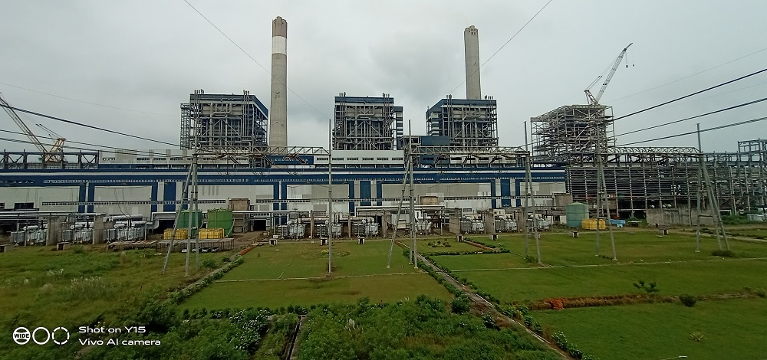

This is a Sub-Critical pulverized coal fired Power Plant. The Plant comprises of 6 Units of 600 MW each. Out of the total 6 units, 3 units have achieved COD and balance 3 units are at various stages of construction.

The below table shows the COD’s as per contractual schedule, Actual COD and Revised COD’s as per KMPCL:
Unit | Date of Contractual Schedule | COD Achieved | Current Status
Unit-2 | 25-Mar-13 | 28-Feb-17 | Operational
Unit-3 | 25-Jul-12 | 14-Aug-13 | Operational
Unit-4 | 25-Nov-12 | 26-Aug-14 | Operational
Unit-1 | 25-Nov-13 | - | Stalled condition. No construction activity ongoing since April 2018
Unit-5 | 25-Jul-13 | -
Unit-6 | 25-Mar-14 | -

At the time of site survey, out of the total 6 units, 3 units (2nd, 3rd & 4th) are commissioned and the balance 3 units are at various stages of construction since long of which currently all construction is on hold from last more than 5 years. It was also seen that only two units were in operation i.e. Unit 2 and 4, Unit 3 was on stand-by mode due to low demand. Accordingly 3 units are capitalized in the FAR and abrogated units are captured in CWIP. Thus, valuation of this whole plant is broadly computed based on the 3 commissioned units (2, 3 & 4) and CWIP separately for the noncommissioned units (1, 5 & 6).The Overall condition of the Plant is good.

The main sections of the KSK Mahanadi Power Plant includes Plant area, Railway line, Ash ponds, Coal handling unit and other miscellaneous structures. The location advantage for the plant site is proximity to Highway and Railway which makes the import of the coal more efficient.

The list below tabulates the make, technical details and physical condition of machineries installed in the plant:
Major Machinery
S. No. | Name of machinery | Make | Technical Specifications | Qty | Condition
1 | Boiler | Shanghai Boiler Works Ltd. | 600 MW Each | 3 | Fair
2 | Turbine | M/s. Dong Fang turbine factory ltd. CHINA | 600 MW Each | 3 | Fair
3 | Condenser | Shanghai power station auxiliary factory | 35000 TPH Each | 4 | Fair
4 | Coal Handling Plant | BSBK Engineers Pvt. Ltd. | 2500 TPH | 1 | Fair
5 | Compressor (Plant Air Compressor) | Atlas Capco | 3150 M³/Hr | 6 | Fair
6 | Ash Handling Plant Compressor | Algi | 16 M³/Hr | 9 | Fair
7 | Coal Mill | Shanghai heavy Machinery plant co ltd | 42 TPH | 1 | Fair
8 | Ash handling Plant | BSBK Engineers Pvt. Ltd | 32 TPH | 2 | Fair
9 | ESP | Shanghai metallurgical and mining machine manufactory | 99.95% | 1 | Fair
10 | FGD | Alstom |  | 1 | Fair
Auxiliary Machinery
Sr. No | Name of machinery | Make | Technical Specifications | Qty | Condition
1 | GIS | ABB | 420 KV | 1 | Fair
2 | Reactor | ABB | 50 MVA |  | Fair
3 | Transformer | ABB | 355 MVA | 4 | Fair
4 | DM Water tank | Local Manufacture | 100 CUM | 2 | Fair
5 | Fire Water tank | Local Manufacture | 1250 CUM | 2 | Fair
6 | Switch Gear | ABB | 4000Amp | 1 | Fair

The Project is being implemented through a turnkey contract. The Engineering, Procurement and Construction (EPC) contract was executed with M/s. Shangdong Electric Power Construction Corporation (SEPCO), a China based EPC Contractor on 1st April 2009. The brief scope of EPC Contract is as under:
- Offshore supply: Design, engineering, manufacture, procurement, assembling, shop testing, seaworthy packing, forwarding and delivery of the plant and equipment including commissioning spares, consumables on CFR basis.

- Offshore services: Basic engineering, design & engineering services, technical services including interfacing integration and demonstration of Performance Guarantee Values of Units as well as training of KMPCL personnel.

- Onshore supply: Design, engineering, approval of drawings, manufacture, procurement, assembling, shop testing, packing, forwarding, transportation and delivery of the plant and equipment at the site including commissioning spares and consumables.

- Onshore services: Detailed services including project management, inspection, expediting, supervision of erection, testing and commissioning and such services as may be required from time to time for timely commissioning of the plant.

- Construction contract: Undertake earthworks, dewatering during construction, grading and leveling, excavation, foundations, buildings, all other civil works, architectural works, structural works, procurement services, project management, expediting, site mobilization, supervising, co-ordination, inspection, contractor’s permits and clearances etc.

Project Company has also executed Non-EPC Contracts which includes the Railway Siding Works, Transmission Lines Works & Development of Green belt.

For the above works, KMPCL has signed agreements with the following contractors to execute the work:
- M/s. Track & Towers Pvt. Ltd. : Railway siding works
- M/s. Jhajharia Nirman Pvt Ltd.: Railway siding works
- Chhattisgarh Rajya Van Vikas Nigam Ltd. : Development of green belt in and around the power plant
- L&T Limited: Design, supply and construction of 400 kV transmission line from plant to PGCIL’s pooling station.

The construction of railway infrastructure from Akaltara railway station to project site and other related works like rail corridor, power evacuation and raw water system were the responsibilities of government agencies but since these got delayed therefore KMPCL took up the work by forming Special Purpose Vehicle (SPV) namely Raigarh Champa Rail Infrastructure Pvt. Ltd. (RCRIPL) and KSK Water Infrastructure Pvt. Ltd. (KSKWPIL) for the development of rail corridor and raw water system respectively. However since these 2 SPVs are not under scope of this report, therefore the works done under these SPVs are also not made part of this report.

The below is the list of the contracts awarded to various contractors by KMPCL Management for the establishment of this 6x600 MW Thermal Power Plant:
Main machinery of the plant includes Boiler, Turbine, Generator, Coal Handling Plant, Water Treatment Plant, Switchyard, Transmission line, Water pipeline system to bring raw water to the plant from Mahanadi River, and other auxiliary machinery for running the plant.
Main sections of the Plant include Boiler House, ESP Building, ESP Control Room, Turbine Building, Switchyard Building, Coal bunker, Station Building, Service Building, Control Room, Fly Ash Silos, Chimney among other additional buildings & sections.
This Power plant is compliant with all the required necessary statutory approvals, licenses, NOCs like Consent to Operate, NOC for Construction of Chimney, NOC from MoEF, Water drawl from River Mahanadi etc.
- POWER GENERATION PROCESS:

- First, the pulverized coal is burnt into the furnace of steam boiler.
- High pressure steam is produced in the boiler.
- This Steam is then passed through the super heater, where it is further heated up.
- This heated steam is then entered into a turbine at high speed.
- In the turbine, this steam at high pressure rotates the turbine blades i.e., potential energy of the high pressured steam is converted into mechanical energy.
- After rotating the turbine blades, the Steam loses its high pressure, passes out of turbine blades and enters into a condenser.
- In the condenser the cold water is circulated with help of pump which condenses the low pressure wet steam.
- This condensed water is then further supplied to low pressure steam increases the temperature of this feed water, it is then again heated in a high pressure heater where the high pressure of steam is used for heating.
- The turbine in thermal power station acts as a prime mover of the alternator.

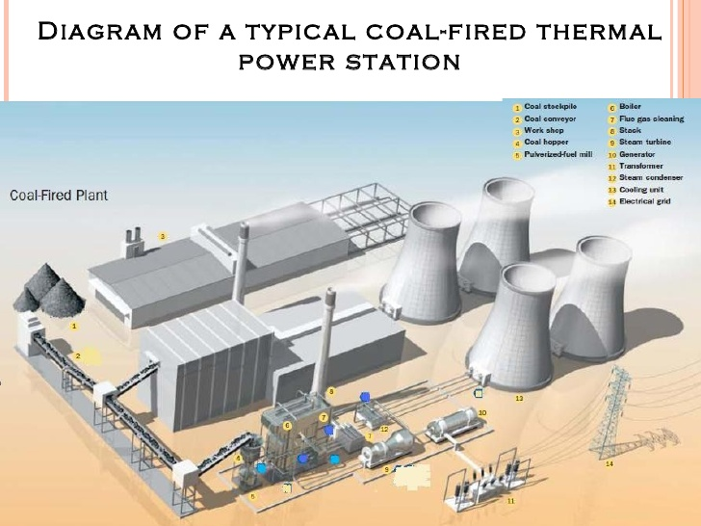
- FUEL SUPPLY AGREEMENTS (FSA): The project was planned to use domestic coal from two coal blocks namely Gare Pelma-III and Morga-II. After the Supreme Court's order to de-allocate the tied-up coal blocks on 24th September 2014, KMPCL has been sourcing fuel from the open market including under the special forward e-auction for power sector by Coal India Limited (CIL) and coal imports, However, the company has secured fuel linkage for supply of ~6.8 MTPA through the first reverse auction held by CIL for allocation of coal linkages under the SHAKTI policy (Scheme for Harnessing and Allocating Koyala (Coal) Transparently in India).
At present Coal is being purchased through FSA linkage coal, E-Auction or Market / Traders or Imported. The Coal is transported from Mines / Source / Port through Railways and Road as applicable:
SHAKTI  linkage sources | Acq. Qty. (MT) as per FSA  for PPA of 2128 MW | Acq. Qty. (MT) for  3 units (1800 MW)
Talcher (MCL) | 20,700 | 17,509
IB Valley (MCL) | 11,00,000 | 9,30,451
Korea Rewa (SECL) | 12,00,000 | 10,15,038
Korba & Mand-Raigarh (SECL) | 45,00,000 | 38,08,391
Total | 68,20,700 | 57,71,389

Additional Allocation of Linkage Coal
KMPCL has received the LOA from MCL and LOI from SECL for additional allocation of coal through auction process. KMPCL informed that FSAs for these allocations are yet to be made.
Source | LOA / LOI  Reference | Allocated  Qty. ( MT) | Coal Range | Remarks
IB Coalfields (MCL) | No. MCL/ SBP/ GM(M&S)/ Comml./ 2019-20/ 3087 Dated 12/03/2020 | 6,50,000 | G12 – G14 | 19.58% of premium on Notified Price
Talcher Coalfield (MCL) | No. MCL/ SBP/ GM(M&S)/ Comml./ 2019-20/ 3087 Dated 12/03/2020 | 2,00,000 | G12 – G14 | 12.24% of premium on Notified Price
Korba & Mand Raigarh (SECL) | No. SECL/ BSP/ M&S/ FSA/ SHAKTI/ LOI/ B(iii)(R-3)/ 2/ KSK/ 758 Dated 10/07/2020 | 4,34,200 | G10 – G15 | Levellised discount of 7 paise / kWh
Total | Total | 12,84,200

The allocation is for the specified end use plant of KMPCL. The LOA / LOI is only indicative of the quantity allocated and any entitlement to such quantities of coal is subject to execution of the FSA in accordance with the provisions of the Scheme Document and satisfaction of the conditions prescribed in the FSA.
- POWER PURCHASE AGREEMENTS (PPA): As details mentioned TEV Report by L&T-S&L dated 16th December 2020, KMPCL has signed power purchase agreements to sell power from its 6x600 MW Coal Fired Thermal Power Station as below:
S. No. | Counter Party | Contracted Capacity (MW) | Original PPA Date | PPA Term/ expiry Date
1 | GUVNL  (under sub judice with GSERC) | 1010 MW | 03-Jun-2010 | 25 years
2 | CSPTradeco | ~90 MW (5% aggregate capacity of the Unit or the Power Station; 90 MW considering 3 units in operation) | 18-Oct-2013 | Perpetual
3 | TANGEDCO | 500 MW | 27-Nov-2013 | 15 years
4 | UP DISCOM | 1000 MW | 26-Feb-2014 | 25 years
Total |  | 2,600 MW

As can be seen from the above table, out of the total net capacity of 3,347 MW (considering 7.017% auxiliary consumption), only 2,600 MW has been tied up, and rest of the capacity needs to be tied up by the company. Also, PPA executed with GUVNL of 1010 MW is under sub-judice before Hon’ble GERC. Therefore, total net capacity for which PPAs have been executed is 1,590 MW only.

- TECHNOLOGY COLLABORATIONS: M/s. SEPCO, a wholly owned subsidiary of Shandong Electric Power Corporation, China was the EPC (Engineering, Procurement and Construction) contractor for establishment of 6x600 MW Coal Based Thermal Power Plant of KMPCL. SEPCO is one of EPC company in the core area of technology and is engaged in the design, manufacture and sale of products including power generation equipment, power transmission and distribution equipment, transformers, switch gears, circuit breakers etc. However present service terms with SEPCO is not clear that whether they are still providing maintenance services to the Plant or not.

- INFORMATION INPUT FOR ASSESSMENT: One common fixed asset register was provided to our team having installed cost, WDV, Capitalization Cost, Unit Name, Asset Name etc. for three commissioned units. Break-up of Soft & Hard Cost is not mentioned in the shared FAR dated 31st March 2022.

- SURVEY DETAILS:
- This plant has been surveyed by our Engineering team comprising of Civil & Mechanical Engineers. Site inspection was done in the presence of plant representatives.
- Only major machinery, equipment & sections were cross checked as per the documents provided to us and sample random checking was done of the overall plant.
- Team visited all the different blocks of the plant.
- Permission to take photographs of each asset, were not allowed by the company’s management. However, we have been provided very few photographs of the plant over the mail.
- Plant and all its installed machinery equipment were found in good condition at the time of survey.
- At the time of site survey, out of the planned 6 units; only 3 units were commissioned and construction of the balance 3 units was stalled since the year 2018.
- Out of the three commissioned units, only Unit-2 & Unit-4 were operational during the site visit. As per information shared during the site visit, Unit-3 was not operational from last week due to low power demand.
- As per TSR dated 16th December 2020, prepared by L&T – Sargent & Lundy Ltd., there are some pending works of Unit-2 as described below related to the sections: TDBFP, W Pump-Common Standby, Workshop tools 7 tackles, Boiler elevator, One single phase GT, Bull Dozer, Fork lift, etc. which are yet to be done.
- Machine condition reported in this report is only based on the visual observation. No mechanical/ functional testing is carried out to know the efficiency or condition of the machines.
- This valuation is done only on the basis of the physical existence of the assets during the site survey rather than their technical expediency.
- Past yearly PLF report of the plant was not provided on request. However it was verbally informed that the Plant is running on 75% PLF.
- Balance works for Unit 2: As per the TSR Report dated 16th December 2020, following are the major concerns for Unit 2 continuous operation /full Load:
- Non-availability of 2nd TDBFP, not yet dispatched from China.
- Rectifications of Pump of 1st TDBFP: Thrust bearing found damaged during commissioning period, hence the Pump assembly has been replaced with 2nd TDBFP pump for Unit#2 COD (72 Hours continuous operation). 1st TD-BFP pump has to be rectified (as spare) before unit in continuous operation.
- Non-availability of 3rd / Standby BCC Pump, replacement/repair of 3rd BCCW pump
- Non-availability of 3rd CW Pump & Motor, not yet dispatched from China.
- Unit 2 Balance / Punch Points to be completed (List required for monitoring the works)

The detailed balance works for Unit 2 under various heads and the estimated cost of balance works is shown in the tables below:

BTG & BOP BALANCE WORKS:
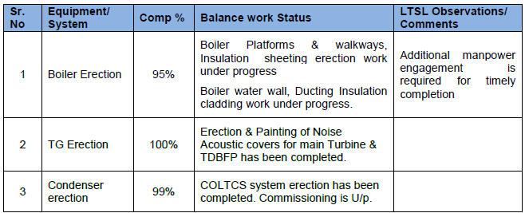
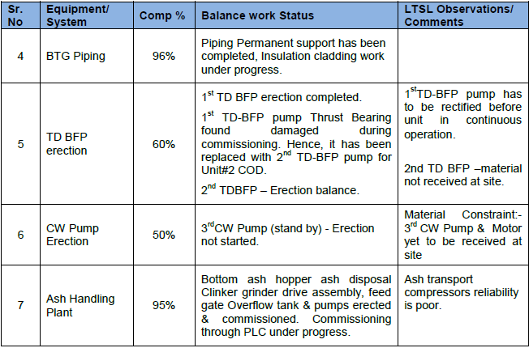

Estimated Cost to Complete for Unit- 2 (As per TSR dated 16th December 2020)
S. No. | Particulars | Amount  (In Rs. Cr.) | Remarks
 | Supply Cost
1 | TDBFP | 12.00 | 1 set of TDBFP
2 | CW Pump-Common Standby | 1.80 | 1 Set of CW Pump
3 | Workshop tools 7 tackles | 3.00 | 1 Set
4 | Boiler elevator | 0.60 | 1 No.
5 | One single phase GT | 6.50 | 1 No.
6 | Bull Dozer, Fork lift | 1.20 | 1 set
 | Total Supply Cost-A | 25.10
 | Erection, Testing, Commissioning of Balance Items- B | 3.48 | 20 % of the supply cost
 | Liquidation of punch point items - Service Cost-C | 5.00 | Ball Park estimate
7 | Total (A + B + C) | 33.58
8 | Contingency (5 %) | 1.68
Total (7+8) |  | 35.23

Some of the photographs shared by the company’s management are attached below:
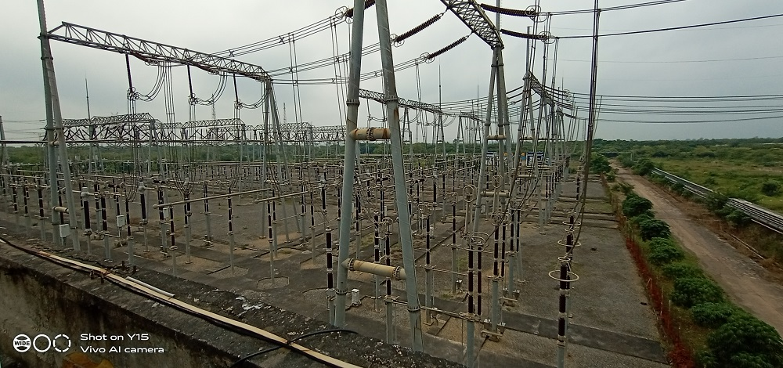
Power Evacuation Lines

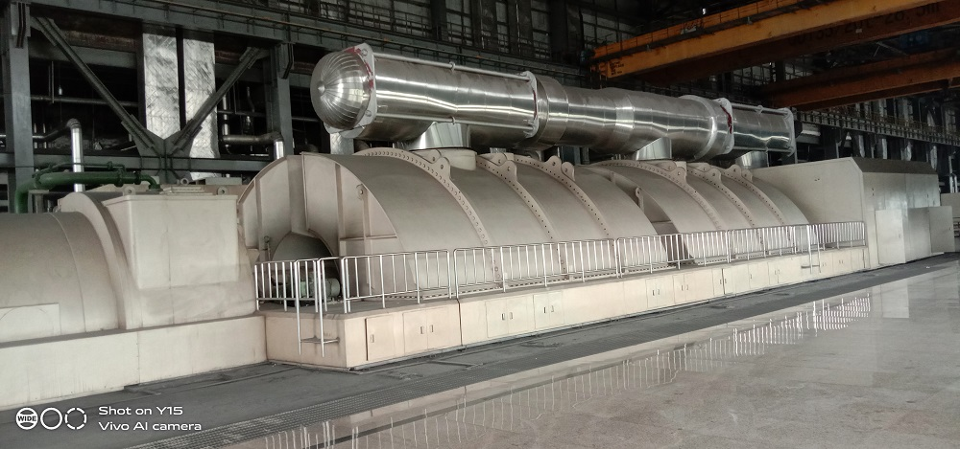
Turbo Generator
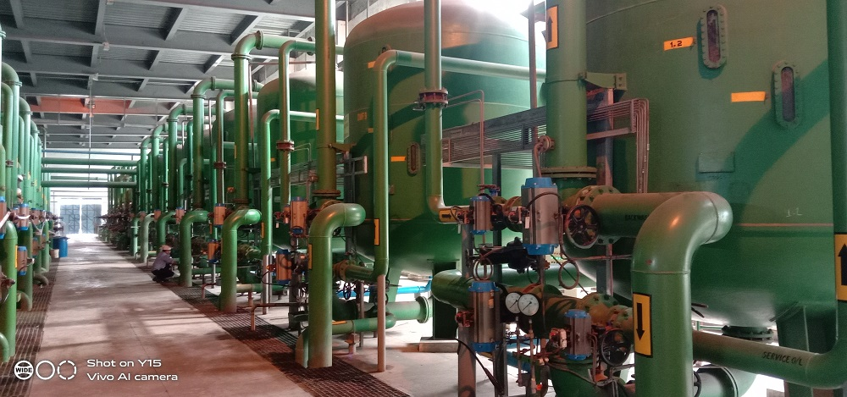
DM Tanks
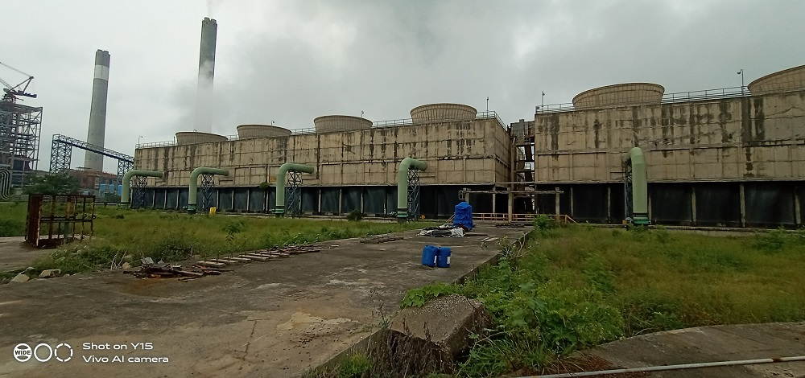
Cooling Tower
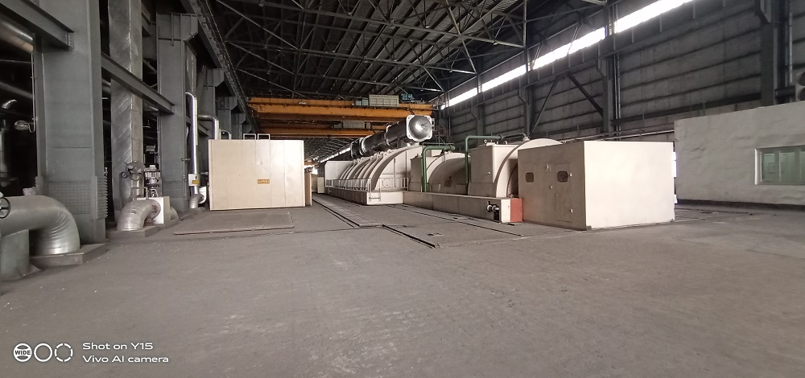
Turbine Hall
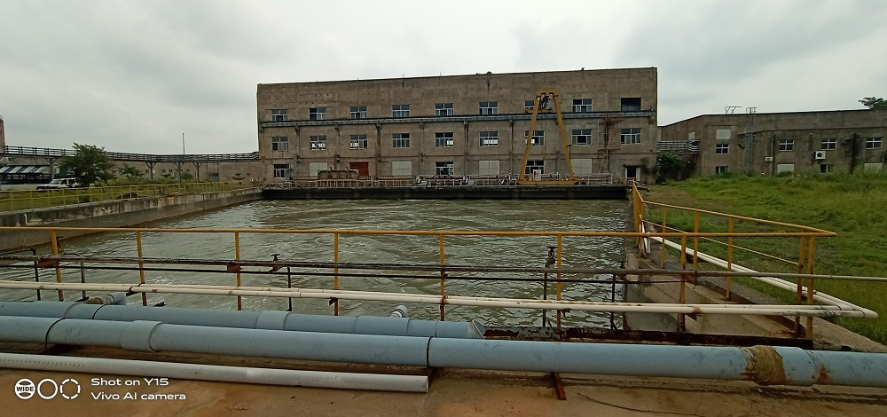
RO Reservoir
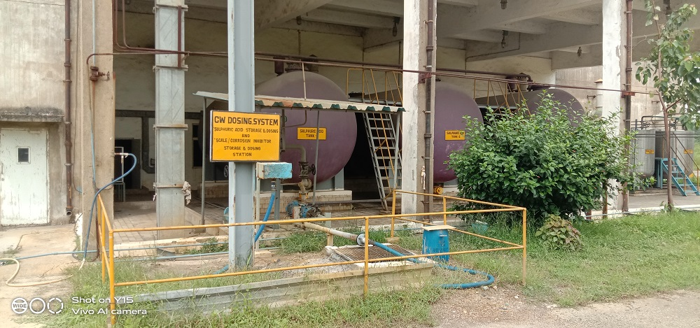
CW Dosing System
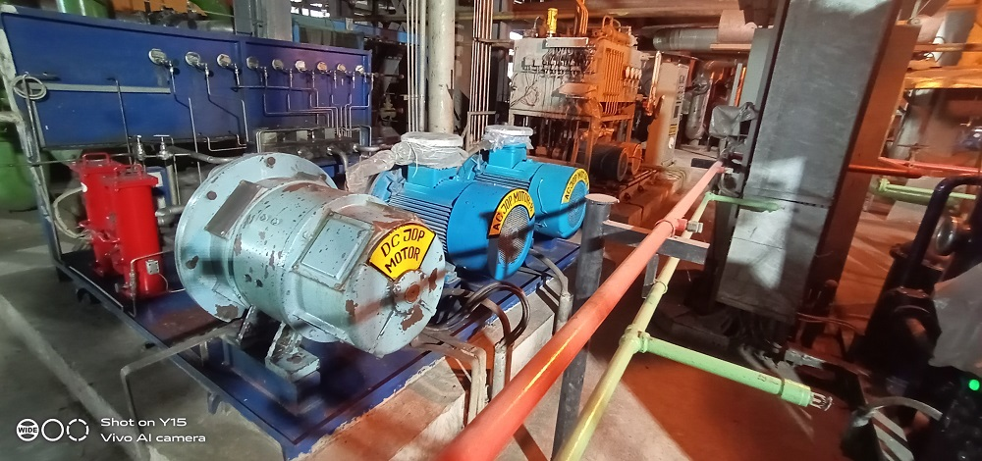
Motors
- SALES TRANSACTIONAL PROSPECTS OF SUCH PLANTS: Infrastructure assets like power plants are of great value for the nation and region and these have much greater socio-economic value, in addition to its core Asset value.

In case of sale transactions, such assets can be divested as a single entity only through strategic sales by way of acquisition or takeovers by the large conglomerates who are either already into the same business line or any other large corporates who may have business interest to diversify for entering into such sectors if they are already not into it.

This plant is based on the sub-critical technology. M/s. SEPCO (China) was the EPC Contractor for KMPCL. Also, 3 units of the Plant have been commissioned and having PPA and FSA in place. Also, the other 3 units are various stages of construction but stalled but Plant has scope of expansion by way of revival of these 3 stalled units as per the power requirement and demand in the country which is constantly increasing. Therefore, it can be a good option for major domestic & foreign big shots in energy sector keep on evaluating options to take up stakes in valuable assets.

- VALUATION METHODOLOGY ADOPTED: For arriving at the fair market value of P&M asset, our engineering team has rationally applied the ‘cost approach (depreciated replacement cost)’. Reliable market sales comparison references are not available hence market approach is not adopted. For reliable cost references, CERC benchmark is also referred before reaching out to the Fair Market Value of the Asset.

- VALUATION PROCEDURE: For arriving at fair market value of P&M asset our engineering team has rationally applied the ‘cost approach (depreciated replacement cost)’. Following points are taken into consideration during the assessment of Plant & Machinery:

- Main reference point for the assessment of the Valuation of P&M of 3 commissioned units is Fixed Asset register dated 31st March 2022 provided to us by the company which is relied upon in good faith.
- Core P&M Asset Valuation is done keeping in mind various factors like technology used, machines availability, its condition, average age, maintenance & service and parts replacement availability of the machines and more importantly demand in the market.
- Machinery items in this plant are specific purpose machines used for the thermal power plant which limits the realizable value to the particular purpose only.

- To arrive at the fair market value, firstly gross current replacement cost (GCRC) of the machines have to be assessed as on date.
- As per analysis and working done by the team of RKA, the Gross Current Replacement Cost of all the plant & machinery for Unit-1, Unit-2, Unit-3 & ancillary machines is Rs. 16,711.39 Cr. which translate to Rs. 9.28 Cr. per MW cost of capitalization for 1800 MW Thermal Power Plant. However, as per CERC Guidelines, the capitalization cost to setup a new thermal power plant reached maximum Rs.6.8 cr, per MW till the time sub critical plants were incepted and approved till 2017-18 or near about the period.
- Also no new sub-critical power plants have been set-up or approved from past 4-5 years. Only super critical & ultra-super critical power plants are been setup due to their higher efficiency than the sub-critical power plants. The project set-up cost of the sub critical power plants before the year 2018 was approx. Rs.6.8 Cr. per MW. Since no new plant is setup under this technology, therefore CII indexation is not followed in this case and the benchmark cost is considered.
- However Rs.6.8 Cr. per MW is for the complete Project cost which included Land & Buildings under Balance of Plant. As per our analysis of different projects, around 15% cost is of Land & Buildings under Balance of Plant.
- Thus, taking Rs.6.8 cr. Per MW as the benchmark cost for the whole Project, we have applied a deducted ~15% for cost is of Land & Buildings under Balance of Plant to arrive at the estimated GCRC for core Plant & Machinery. Accordingly Rs.5.7 cr. Per MW is adopted for core Plant & Machinery as a whole to arrive at reasonable GCRC of the project.
- There was no breakup of ex works, CST, loading and unloading fees, insurance fees, installation and commissioning fees, and pre-operative costs.
- For evaluating depreciation, Central Electricity Commission Guidelines & Chart of Companies Act-2013 for ascertaining useful life of different types of machines are followed. Useful life of Primary machines of the Plant like Boiler, Turbine, Generator, Coal Handling System etc. is taken as 25 years. For other auxiliary machinery & equipment average life varies from 5–20 years.
- As analysis conducted during the site visit, the overall condition of all the machine is fair and maintained property with regular maintenance and plant was running normally.
- Market & Industry scenario is also explored for demand of such Power Plants in the nearby area.
- This valuation would be more reasonable if anyone would buy this plant in as is installed condition. Also, Valuation may differ in case these assets are sold in dismantled/Uninstalled condition. The present valuation is not on the piecemeal basis but on the ongoing concern basis..
- All the gathered information & data is further collated & analyzed and obsolescence/ deterioration factor is applied to arrive at the Fair Market Value of the machines.
- Different similar assets in the FAR is categorized and grouped together to compute the depreciation as per its economic life and salvage value to arrive at the fair market value of the asset based on the cost approach.

- CONSOLIDATED VALUATION SUMMARY OF PLANT & MACHINERY:

As per KSK dated 31-03-2022 (in ₹ Cr.) |  |  |  | As per RKA dated 12-10-2022 (in ₹ Cr.)
Row Labels | Initial Gross Block | Gross Block as per IND AS dated  31-03-2015 | Net Block dated  31-03-2022 | GCRC | New GCRC | FV
P & M | 13,639.40 | 13,460.06 | 9,981.95 | 16,321.91 | 10,007.10 | 7,346.40
Railway Siding | 323.24 | 323.24 | 246.34 | 369.15 | 226.33 | 166.97
Office Equip | 9.62 | 5.87 | 0.13 | 12.01 | 7.36 | 1.05
F&F | 5.19 | 3.74 | 0.66 | 7.79 | 4.77 | 0.27
Vehicles | 2.20 | 1.71 | 0.54 | 2.59 | 1.59 | 0.12
Data Proc Equip. | 3.74 | 1.23 | 0.27 | 4.46 | 2.73 | 0.12
Computer Software | 1.98 | 0.02 | - | 1.81 | 1.11 | -
Total | 13,985.37 | 13,795.85 | 10,229.89 | 16,719.71 | 10,251.00 | 7,514.92

PART G | VALUATION OF CAPITAL WORK-IN PROGRESS (CWIP)  FOR UNDER-CONSTRUCTION UNITS (UNIT #1, UNIT#5 & UNIT #6)

- OVERALL PROGRESS OF THE PROJECT:
The complete project (3,600 MW) as on date is delayed by more than 8 years from the original scheduled date. Unit 1, 5 and 6 are under CWIP. Presently all the construction activities are halted since April 2018 i.e. from past 4 years. As per the Technical Study report by L&T – Sargent & Lundy Ltd., and information gathered during the site visit:
Phase I of the project which consists of Unit 3 & 4 were commissioned on 14th August 2013 and 26th August 2014 respectively. Accordingly, 100 % progress is achieved in this phase.
Phase II, which consists of Unit 2 & 5. COD has been achieved only for Unit 2 on 28th February 2018 and Unit 5 is under construction with no progress.
Phase III, which comprises Unit 1 and 6 are both under construction.
Percentage progress of the Plant – BTG for Unit 1, 5 and 6 is tabulated below:
Particulars | Estimated % Completion of BTG |  |  |  | Remarks for estimated %  Completion
Particulars | Weightage | Unit#1 | Unit#5 | Unit#6 | Remarks for estimated %  Completion
Engineering | 12% | 90% | 90% | 90% | Balance infrastructure, Township, non-plant buildings, As-built drawings, O&M manuals, Balance  vendor engineering, etc.
Supply | 55% | 0% | 45% | 0% | Based on site assessment and judgment
Erection | 27% | 0% | 25% | 0% | Based on site assessment and judgment
Commissioning | 6% | 0% | 0% | 0% | No pre-commissioning activities were performed due to non-availability of back charging power
Unit wise Progress |  | 10.8% | 42.3% | 10.8% | (Weightage X Unit progress)
Overall Progress |  | 21.3% |  |  | (Average)
Source: Technical Study report by L&T and site survey.

BOP and other infrastructures required for these units are 85% completed. Major balance activities are CT – Completion of balance civil works, mechanical erection and commissioning, CW pump erection and commissioning, CW pipe laying and backfilling, Fly ash collection and disposal systems, CHP conveyer system (CD lines from TT6 to respective units), piping, Electrical and C&I systems such as cabling, HT-LT panels, MCCs, DCS systems, TSI etc. with BTG packages of under construction units and to that of balance equipment erection of unit#2 (under operation).
Details of unit wise and cost wise break-up of CWIP as on March 2022
S. No. | Particulars | Unit-1 | Unit-5 | Unit-6 | Total
1 | EPC & Non-EPC cost | 311.05 | 1,467.82 | 208.04 | 1,986.91
2 | EPC - Material - In - Transit | - | 173.98 | - | 173.98
3 | Pre-operative expenditure | - | - | - | 580.91
4 | Interest During Construction | - | - | - | 1,716.22
5 | Exchange variation | - | - | - | 101.64
Total |  | 311.05 | 1,641.80 | 208.04 | 4,559.66

Present Status of Under Construction Units (Unit # 1, 5 & 6):
(As per Technical Study report by L&T)

Unit  No. | Package Description | Status of Supply | Status of  Erection | Remarks | % Progress  supply | % Progress  Construction
Unit #I | BTG:
1. | Steam Turbine and Auxiliaries | Not received | - | - | - | -
1. | Generator and auxiliaries | Not received | - | - | - | -
1. | Condenser, CEP, BFP, De-aerator, Critical piping, LP piping, Vacuum pump, CPU,  HP/IP/LP heaters, PHE | Not received | - | - | - | -
1. | Boiler and auxiliaries | Not received except few structure  materials | Structures up-to 2 Tier erected | Partial boiler structures  received | 1 | 1
1. | ESP | Not received | - | - | - | -
 | E&I Package:
2. | Electrical panels, DCS panels, operating stations, Engineering stations, TSI, Relay panels, Cables, cable trays, ESP control  panels, Battery, Battery charger, UPS etc. | Not received | - | - | - | -
2. | Transformers – Generator Transformer,  UAT, Auxiliary TRF, Bus-duct | Not received | - | - | - | -
Unit #5 | BTG:
1. | Steam Turbine and Auxiliaries | Not received | - | LP casings  received | - | -
1. | Generator and auxiliaries | Not received | - | - | - | -
1. | Condenser, CEP, BFP, De-aerator, Critical piping, LP piping, Vacuum pump, CPU, HP/IP/LP heaters, | Partial materials received | Condenser shells erected partially | Few parts of condenser, de- aerator, 3 HP  heaters, 4 nos. LP heaters received | 5 | -
1. | Boiler and auxiliaries | Partial materials received | Boiler Drum is placed in its position | Some parts of Boiler structures, Boiler drum, pressure parts,  APH | 67 | 32
1. | ESP | Majority of materials received | All the four pass major structures including electrodes etc.  erected | Insulation, Panels etc. not received | 91 | 70
 | E&I Package:
2. | Electrical panels, DCS panels, operating stations, Engineering stations, TSI, Relay panels, Cables, cable trays, ESP control panels etc. | Partial materials received- DCS panels, Turbine panels, cables  received | DCS panels placed in location only (Modules used in  operational units) |  | 15 | -
2. | Transformers – Generator Transformer,  UAT, Auxiliary TRF, Bus-duct | Not received | - | - | - | -
Unit #6 | BTG:
1. | Steam Turbine and Auxiliaries | Not received | - | - | - | -
1. | Generator and auxiliaries | Not received | - | - | - | -
1. | Condenser, CEP, BFP, De-aerator, Critical piping, LP piping, Vacuum pump, CPU,  HP/IP/LP heaters, PHE | Not received | - | - | - | -
1. | Boiler and auxiliaries | Not received | - |  | - | -
1. | ESP | Not Received
 | E&I Package:
2. | Electrical panels, DCS panels, operating stations, Engineering stations, TSI, Relay panels, Cables, cable trays, ESP control  panels, Battery, Battery charger, UPS etc. | Not received | - | - | - | -
2. | Transformers – Generator Transformer,  UAT, Auxiliary TRF, Bus-duct | Not received | - | - | - | -
#1, 5 & 6 | STG building Structure and Civil of BTG and other areas:
Unit # 5
1. | STG building structures | Major items received | Unit#5 major  structures erected. |  | 95 | 90
2. | Civil of TG, Boiler, ESP and TRF yard area | - | TG deck slab and floor (EL 13.9M) of Unit#5, TRF foundation & Fire wall, Unit#5 mill foundations etc.  completed | Floor finish, GF slab, IPS, panel room, and other finishing activities not done | - | 70
3. | Roads & drain, area paving, plinth  protection, finishing, painting | - | Partially done | - | - | 20
Unit # 1 & 6
1. | STG building structures | Partially received for Unit # 1 No Supply for Unit#6 | Unit#1 partial structure erected. Unit#6- no work  done |  | 10 | 10
2. | Civil of TG, Boiler, ESP and TRF yard area |  | Unit # 1 Partial work done  Unit# 6 almost No  work done |  | - | 10
3 | Roads & drain, area paving, plinth  protection, finishing, painting |  |  |  | - | -
#1,5 & 6 | BOP Packages:
1. | CW Pump and Piping (total 14 CW pumps  for all the 6 Units (6W+2S) | 7 nos. not received | - | - | - | -
2. | CW Piping | All received | For Unit#1,5 and 6, laying & connection with CW pumps and Condensers balance | Exposed portion of wrapping & coating of laid CW pipes (near CW pump house) is damaged. Need replacement. Also CW piping near condenser is submerged in water and needs to evaluate for  reusability. | 100 | 70
3 | Cooling Tower | For Unit#1 and 6 not received | Civil structure of Unit#1 & 6 in advanced stage, Unit#5 nearly  completed |  | 60 | 50
4 | Interconnection with pipes/cable between BTG packages, TRF packages , WTP, Fuel oil, CAS, FF, HT/LT panels, DCS,  Switchyard, HP, AHP etc. | - | Not done | - | - | -
#1,5 & 6 | CHP and AHP:
1 | CHP | Majority of materials received | CD line from TT0 to TT6 and TT7, Bunker floor balance, Erection of Stacker Reclaimer rails (approx. 120 meters), conveyor belts. Work for Unit 1, 5 and 6  balance |  | 95 | 85
2 | AHP | Majority of materials received | Work for Unit 1, 5  and 6 balance | Paving around ash silo balance (100M radius), 2  nos. Silos | 75 | 70
Common | Balance Non-Plant Structures:
 | Administrative Building, Canteen, Service building, Security building, Main gate, Petrol pump, Car & scooter sheds, training center,  Rain water harvesting etc. | Not yet constructed.

Present Status of Non-EPC Scope
Sr. No. | Description | Status
1. | Transmission Line:
a | Two double circuit 400 KV Transmission line (each line capacity 1200MW) from plant switchyard to TAGA pooling station of PGCL. The approx. length of TL is 27 KM from plant switchyard to TAGA pooling station. | Line1 double circuit tower is ready and the power generated by Unit 2, 3 and 4 is being evacuated through this line.  Line2 double circuit tower under construction. Balance work:  Total 83 towers per line. Foundation of 65 towers ready. 54 tower erection completed. 11 KM stringing completed
2. | Non-Plant structures:
b | Residential Colony | Not envisaged in KMPCL project. Refer KMPCL /PWC mail dated 20.10.2020
c | Outer boundary wall – 26KM length, Brick construction with barbed wire fixed on Y angle | Complete boundary wall was constructed as per scope. However, many places, the boundary walls are damaged including peripheral morum roads. KMPCL has taken up repair/re-doing the broken /damaged boundary wall from O&M budget
d | Roads and drain for areas outside  the inner boundary wall | Incomplete
e | Entry gate | Temporary structure made
f | Watch towers | Not made
g | Training center | Not made
h | CCTV | Completed
i | Silos for evacuation of fly ash through Railways – 2 nos. (earlier it was a part of EPC contract scope) | Roof of one silo balance. Column erected for other Silo is balance
j | Horticulture (green belt) and rain water harvesting | Rain water harvesting pond/ well not made. Green belt balance for areas around incomplete  structure/building

- COST INCURRED IN THE PROJECT:
Particulars | Cost Capitalized (in ₹ Cr.)
Particulars | Commissioned  Unit 2, 3 and 4 | Under Construction  Unit 1, 5 and 6 | Total
Land (Freehold and Leasehold) | 324* |  | 324
EPC Cost | 9,445 | 2,139 | 11,584
Non EPC Cost | 924 | 35 | 959
IDC, ERV and Preoperative Cost | 5,676 | 2,399 | 8,075
Total | 16,045 | 4,573 | 20,942
Source: Technical Study Report by L&T
*Note: As per FA Schedule dated 31st March 2022, the total gross block of land component is Rs. 172.58 Cr.

- COST TO COMPLETE:
Sr. No. | Particular | Amount  (in ₹ Cr.)
A | P&M
1 | Unit-2 | 35.26
2 | Unit-5 | 1,862.50
3 | Unit-1&6 | 4,616.00
Total - A |  | 6,513.76
B | Building and Civil Works
1 | Unit-5 | 95.19
2 | Unit-1&6 | 200.373
Total – B |  | 295.56
C | Additional Cost towards meeting the Environment Norms
1 | FGD | 1,872.00
2 | ESP Modification | 12.00
Total - C |  | 1,884.00
Grand Total (A+B+C) |  | 8,693.32
Source: Technical Study Report by L&T

- VALUATION OF CWIP (UNIT 1, 5 AND 6):

- As per the copy of provisional balance sheet dated 31st March 2022 shared by the subject company, the total book value of CWIP is ₹ 4,559.66 Cr. Further no latest bifurcation has been provided, therefore we rely on the data shared with us during the last valuation exercise dated 5th June 2018 and Technical Study Report by L&T– Sargent & Lundy Ltd. dated 16th December, 2020. Since, no new construction has been done from April 2018, therefore, the same has been considered fair for the purpose of this valuation assessment.
- Overall completion of the Unit 1, 5 and 6 is 21.30% as per the Technical Study Report prepared by L&T – Sargent & Lundy Ltd. dated 16th December, 2020. The estimated time of completion of these units has been tabulated below:
Sr. No. | Milestones | Timeline (Months)
Sr. No. | Milestones | Unit – 1 | Unit#5 | Unit#6
A | Pre NTP Activities | -4 | -4 | -4
1 | Release of LOI / WO to OEM /  Contractors | -1 | -1 | -1
2 | Statutory Approval | -1 | -1 | -1
3 | Site Mobilization | 0 | 0 | 0
4 | Reconciliation of Material | 0 | 0 | 0
B | NTP (Notice to Proceed) | 0 | 0 | 0
5 | Engineering work | 6 | 6 | 6
6 | Start of erection of Boiler, Turbine & it's  Auxiliaries | 13 | 1 | 16
7 | Supply of balance items at site | 17 | 12 | 19
8 | Boiler Hydro test | 25 | 13 | 28
10 | TG & Auxiliaries readiness | 22 | 15 | 27
11 | Oil Flushing | 24 | 17 | 29
13 | TG ready for Barring Gear | 25 | 17.5 | 30
14 | Boiler Light up | 28 | 19 | 31
15 | Steam Blowing and restoration | 29 | 21 | 32
16 | Synchronization | 31 | 23 | 33
17 | COD | 32 | 24 | 34
18 | PG Test | 32 | 24.5 | 35

- As per the estimated completion of balance work, COD of the Unit 1, 5 and 6 is envisaged to be achieved in 24th, 32nd and 34th month respectively after NTP (deviations + 3 months.
Any prudent buyer will weigh on the below points for reaching out to conclusion and accordingly below factors are considered for evaluating the Fair Market Value:

- Original Project cost
Original Hard Cost in the Project cost is taken into consideration. For complete Project planned in 2009, proposed hard cost for the complete 3600 MW was ₹ 13,680 Cr. However, as per the copy of Technical Study Report prepared by L&T – Sargent & Lundy Ltd. dated 16th December, 2020, total cost incurred in the project is ₹ 20,942 Cr. and as per the copy of FAR dated 31st March 2022, total gross block of PPE is ₹ 20,612.63 Cr.

- CWIP Cost
As per the details shared by the company and the copy of provisional balance sheet dated 31st March 2022 the total book value of CWIP IS Rs. 4,559.66 Cr. Details of the same has been tabulated in the above ‘Part G.1.

- Deduction of In-Transit item
As per the verbal confirmation received from the site representative during the site visit, the items which are not within the premise are difficult to procure now and the same has not been verified by us, therefore, the cost of In-Transit items of Rs. 173.98 Cr. mentioned in the above table has been deducted for fair market valuation assessment.

- CERC Benchmark
Capital Hard Cost is referred as per the CERC Order No. L-1/103/CERC/2012 for Benchmark Capital Cost of Coal based TPP which comes out to be ₹ 7.70 Cr. per MW. (This doesn’t includes the Railways, Transmission Lines, Locomotives etc.).

- Reasonable Cost
This is a sub-critical power plant and from past 4-5 years no new sub-critical power plants have been set-up. This is being an obsoleting technology, therefore, on conservative basis, taking the per MW cost of Rs. 6.40 Cr. only. This cost is also taking because the land component along with some auxiliary machinery are already available with the company. Therefore the same has also been deducted to reach at the reasonable cost for the subject CWIP component.
- Addition cost required for completion of Unit
As per the technical study report by L&T, a total of Rs. 8,693.32 Cr. is required for the completion of the units. For the purpose of assessing cost to complete the units, a detailed break-up of the cost is tabulated in the above ‘Part G.3’.

- Assessment of unreasonable capital expenditure
Further to it, assessment of unreasonable expenditure is evaluated by calculating difference between Total Capitalized Cost and Reasonable cost for setting up the P&M as on date.

- Uncertainty cum Utility and Risk Factor
As per the present situation:
- Work of all these 3 units is not completed yet and is stalled from past 4 years.
- No fuel supply agreement has been achieved for these units.
- PPA has not been achieved yet for these unit. The PPA executed with GUVNL of 1010 MW is under subjudice before Hon’ble GERC.
- Project has slipped into the category of Projects which are Uncertain for Benefits during 2017-22 as per the National Electricity Plan Report on Jan., 2018 issued by Central Electricity Authority.
- Based on the above, there is uncertainty whether project will be revived or not and will totally depend on the demand of the power and resourcefulness & willingness of the prospective buyer to revive the Project.
- Therefore in our opinion 50:50 chances exist for the revival of the project.
- Based on the above factors, there is an uncertainty for the completion of these units and the utility for any buyer has become very less. Hence, we have deducted 50% as uncertainty & utility factor for reaching out to the Fair Market Value.

Therefore, the valuation is as follows:
Particular | Sr. No. | Figures  (in ₹ Cr.)
Replacement Capital Cost for completion of Unit 1, 5 and 6  as per CERC/Industry Benchmark (inclusive of Non-EPC) | A=6.4*600*3 | 11,520.00
Replacement Cost of Capital Expenditure  (As per Balance sheet dated 31st March 2022) | B | 5,600.00
Balance cost to be incurred for completion of the Units  (As per Technical Study Report by L&T) | C | 8,693.32
Total Replacement Cost on Completion  (Replacement Cost of capex + Additional cost to be incurred) | D=B+C | 14,293.32
Assessment of Unreasonable Cost | E=D-A | 2,773.32
Total reasonable capital expenditure considered | F=B-E | 2,826.68
Cost of In-transit items | G | 173.98
Deduction of offshore supply cost | H=F-G | 2,652.70
Deduction of Uncertainty cum Utility Factor | I=50% of H | 1,326.35
Fair Market Value | J=H-I | 1,326.35

PART H | VALUATION ASSESSMENT SUMMARY

S. No. | Asset Class | As per KMPCL PBS dated 31-03-22 |  | As per RKA as on 12-10-22
S. No. | Asset Class | Gross Block  (in ₹ Cr.) | Net Block  (in ₹ Cr.) | GCRC  (in ₹ Cr.) | Fair Value  (in ₹ Cr.)
1 | Land | 172.58 | 172.58 | 377.31 | 377.31
2 | Building | 2,012.56 | 1,508.61 | 2,241.31 | 1,474.22
3 | Plant & Machinery | 13,867.82 | 10,283.97 | 16,719.71 | 7,514.92
4 | CWIP | 4,559.66 | 4,559.66 | 11,520.00 | 1,326.35
Total |  | 20,612.63 | 16,524.82 | 30,858.33 | 10,692.79

S.No. | Particulars | Book Value | Indicative & Estimated Prospective Fair Market Value
 | Land Value (A) | Tabulated Above | Tabulated Above
 | Building Value (B) | Tabulated Above | Tabulated Above
 | Plant & Machinery Value (C) | Tabulated Above | Tabulated Above
 | CWIP (D) | Tabulated Above | Tabulated Above
 | Total Indicative & Estimated Prospective Fair Market Value | ₹ 16,524.82 Cr. | ₹ 10,692.79 Cr.
 | Rounded Off | NA | ₹ 10,690.00 Cr.
 | Indicative & Estimated Prospective Fair Market Value in words | NA | Rupees Ten Thousand Six Hundred and Ninety Crores Only
 | Expected Realizable Value (@ ~15% less) | --- | ₹ 9,087.00 Cr.
 | Expected Distress Sale Value (@ ~25% less) | --- | ₹ 8,018.00 Cr.
 | Percentage difference between Circle Rate and Fair Market Value | Less than 20%
 | Likely reason of difference in Circle Value and Fair Market Value in case of more than 20% | Circle rates are determined by the District administration as per their own theoretical internal policy for fixing the minimum valuation of the property for property registration tax collection purpose and Market rates are adopted based on prevailing market dynamics found as per the discrete market enquiries which is explained clearly in Valuation assessment factors.
 | Concluding Comments/ Disclosures if any
- This valuation is based on the cost approach and basically shows the current depreciated replacement value of the asset. However, market players may weigh it differently keeping in mind the various macro & micro economic factors and demand & supply of power at the time of actual transaction.
- Further, the present market & economic scenario is uncertain and no one can predict it for a longer period of time due to various geo political and fast changing global and local markets. However, from the past ~6 months overall sentiments for Power sector in India are bullish due to increase in power demand.
- In spite of global recession and high inflation across major economies, still world over economist are bullish on India’s growth.
- Therefore based on the above points it appears that market sentiments towards this Plant should be positive because of high power demand.
- There may be instances in previous years where the sale of Power Plants has not yielded good value in comparison to its replacement value due to subdued demand of power which was mainly because of tepid economic growth and COVID period.
- However, at present, both the market and economic situation are positive. The subject power plant have 3 fully operational units and operating on an average PLF of 75% as per the verbal information provided to our engineers during site survey. Rest of the 3 units are approx. 21% completed and at various stages. Further, the construction is stalled from past 4 years but there is a good scope of expansion since ample land parcel is available with the company within the subject premise.
- As per the market research, there are a few prominent market players which might be interested in the subject power plant.
- Therefore for this reason we have not tried to match the previous market comparable to this Plant value and kept it only as computed from cost approach.
- This is just core Asset Valuation and not an Enterprise Valuation. This report doesn’t cover any prospective sale value of the Power Plant as a whole which is based on the cash flows of the business.
- Fragmented/ Individual component wise may fetch different values, however this Valuation is prepared based on the ongoing concern and the Values has been applied in totality/ group of assets.
- This valuation exercise has been performed to reach the prospective fair market value using the replacement cost for setting up such Greenfield integrated plants in current scenario. This should not be treated as the transactional value of these assets.
- Secondary/ Tertiary costs related to asset transaction like Stamp Duty, Registration charges, Brokerage, Bank interest etc. pertaining to the sale/ purchase of this property are not considered while assessing the Market Value.
- We are independent of client/ company and do not have any direct/ indirect interest in the property.
- This valuation has been conducted by R.K Associates Valuers & Techno Engineering Consultants (P) Ltd. and its team of experts.
- This Valuation is done for the property found on as-is-where basis as shown on the site by the Bank/ customer of which photographs is also attached with the report.
- Reference of the property is also taken from the copies of the documents/ information which interested organization or customer could provide to us out of the standard checklist of documents sought from them and further based on our assumptions and limiting conditions. All such information provided to us has been relied upon in good faith and we have assumed that it is true and correct. However we do not vouch the absolute correctness of the property identification, exact address, physical conditions, etc. based on the documents provided to us since property shown to us may differ on site Vs as mentioned in the documents or incorrect/ fabricated documents may have been provided to us.
- Legal aspects for eg. investigation of title, ownership rights, lien, charge, mortgage, lease, verification of documents from originals or from any Govt. department, etc. has to be taken care by legal experts/ Advocates and same has not been done at our end.
- The valuation of an asset is an estimate of the worth of that asset which is arrived at by the Valuer in his expert opinion after factoring in multiple parameters and externalities. This may not be the actual price of that asset and the market may discover a different price for that asset.
- This report only contains opinion based on technical & market information which came to our knowledge during the course of the assignment. It doesn’t contain any recommendations.
- This report is prepared following our Standard Operating Procedures & Best Practices and will be subject to Limitations, Conditions, Valuer’s Remarks, Important Notes, Valuation TOS and basis of computation & working as described above.
- The use of this report will become valid only after payment of full fees as per the Payment Terms. Using this report or any part content created in this report without payment of charges will be seen as misuse and unauthorized use of the report.
 | IMPORTANT KEY DEFINITIONS
Fair Value suggested by the competent Valuer is that prospective estimated amount in his expert & prudent opinion of the subject asset/ property without any prejudice after he has carefully & exhaustively evaluated the facts & information came in front of him or which he could reasonably collect during the course of the assessment related to the subject asset on an as-is, where-is basis in its existing conditions, with all its existing advantages & disadvantages and its potential possibilities which is just & equitable at which the subject asset/ property should be exchanged between a willing buyer and willing seller at an arm’s length transaction in an open & unrestricted market, in an orderly transaction after proper marketing, wherein the parties, each acted knowledgeably, prudently without any compulsion on the date of the Valuation.
Fair Value without using the term “Market” in it describes that the value suggested by the Valuer may not mandatorily follow or may not be in complete consonance to the established Market in his expert opinion. It may or may not follow market dynamics. But if the suggested value by the valuer is not within the prevailing Market range or is assessed for an asset is located in an un-established Market then the valuer will give reasonable justification & reasoning that for what reasons the value suggested by him doesn’t follow the prevailing market dynamics.
Fair Market Value suggested by the competent Valuer is that prospective estimated amount in his expert & prudent opinion of the subject asset/ property without any prejudice in consonance to the Market dynamics after he has carefully & exhaustively evaluated the facts & information came in front of him or which he could reasonably collect during the course of assessment related to the subject asset on an as-is, where-is basis in its existing conditions, with all its existing advantages & disadvantages and its potential possibilities which is just & equitable at which the subject asset/ property should be exchanged between a willing buyer and willing seller at an arm’s length transaction in an open & unrestricted market, in an orderly transaction after proper marketing, wherein the parties, each acted knowledgeably, prudently without any compulsion on the date of the Valuation.
Here the words “in consonance to the established Market” means that the Valuer will give opinion within the realms & dynamics of the prevailing market rates after exhaustively doing the micro market research. However due to the element of “Fair” in it, valuer will always look for the factors if the value should be better than the market realms which is just & equitable backed by strong justification and reasoning.
Market Value suggested by the competent Valuer is that prospective estimated amount which is average price of the similar comparable assets prevailing in an open & established market during the near period of the date of valuation at which the subject asset/ property should be exchanged between a willing buyer and willing seller on an as-is, where-is basis in its existing conditions, with all its existing advantages & disadvantages and its potential possibilities at an arm’s length transaction in an open, established & unrestricted market, in an orderly transaction, wherein the parties, each acted without any compulsion on the date of the Valuation.
Using the term “Market Value” without “Fair” omits the elements of proper marketing, acting knowledgeably & prudently.
Market and market participants can be sentimental, inclined towards the transaction without the element of complete knowledge & prudence about facts or due diligence of the asset therefore “each acted knowledgeably, prudently” has been removed from the marker Value definition.
 | Realizable Value is that minimum prospective estimated value of the asset/ property which it may be able to fetch at the time of actual property transaction factoring in the element of discount due to the prospects of deep negotiations between the buyer & seller when the parties in-principally find Fair Market Value reasonable and sits together to close the deal and the transaction across the table. Discount percentage on the Fair Market Value due to negotiation will depend on the nature, size, various salability prospects of the subject asset, the needs of the buyer & the seller and kind of payment terms. In some of the cases Realizable and Fair Market Value may also be equal.
 | Distress Sale Value* is that value when the property is attached with any process such as mortgaged financing, financial or operational dues which is under any stress condition or situation and the stakeholders are under process of finding resolution towards it to save the property from being attached to a formal recovery process. In this type of sale, minimum fetch value assessed will always be less than the estimated Fair Market Value where the discount of percentage will depend upon various circumstances and factors such as nature, size, salability prospects of the property and kind of encumbrance on the property. In this type of sale, negotiation power of the buyer is always more than the seller and eagerness & pressure of selling the property will be more on the seller than the buyer.
 | Liquidation Value is the amount that would be realized when an asset or group of assets are sold due to any compulsion or constraints such as in a recovery process guided by statute, law or legal process, clearance sale or any such condition or situation thereof where the pressure of selling the asset/ property is very high to realize whatever maximum amount can be from the sale of the assets in a limited time for clearance of dues or due to closure of business. In other words, this kind of value is also called as forced sale value.
Difference between Cost, Price & Value: Generally, these words are used and understood synonymously. However, in reality each of these has a completely different meaning, premise and also having different definitions in professional & legal terms. Therefore, it is our professional responsibility to describe the definitions of these words to avoid ambiguity & confusion in the minds of the user of this report.
The Cost of an asset represents the actual amount spend in the construction/ actual creation of the asset.
The Price is the amount paid for the procurement of the same asset.
The Value is defined as the present worth of future rights in the property/ asset and is a hypothetical or notional price that buyers and sellers are most likely to conclude for a good or service. Value is not a fact, but an estimate of the likely price to be paid for a good or service at a given time in accordance with a particular definition of value.
Therefore, in actual for the same asset/ property, cost, price & value remain different since these terms have different usage & meaning.

IMPORTANT NOTES
DEFECT LIABILITY PERIOD - In case of any query/ issue or escalation you may please contact Incident Manager by writing at valuers@rkassociates.org. We try our level best to ensure maximum accuracy in the Calculations done, Rates adopted and various other data points & information mentioned in the report but still can’t rule out typing, human errors, assessment or any other mistakes. In case you find any mistake, variation, discrepancy or inaccuracy in any data point mentioned in the report, please help us by bringing all such points into our notice in writing at valuers@rkassociates.org within 30 days of the report delivery, to get these rectified timely, failing which R.K Associates shouldn’t be held responsible for any inaccuracy in any manner. Also, if we do not hear back anything from you within 30 days, we will assume that the report is correct in all respect and no further claim of any sort will be entertained thereafter. We would welcome and appreciate your feedback & suggestions in order to improve our services.

Our DATA RETENTION POLICY is of ONE YEAR. After this period we remove all the concerned records related to the assignment from our repository. No clarification or query can be answered after this period due to unavailability of the data.

COPYRIGHT FORMAT - This report is prepared on the copyright format of R.K Associates to serve our clients in the best possible way. Legally no one can copy or distribute this format without prior approval from R.K Associates. It is meant only for the organization as mentioned on the cover page of this report. Distribution or use of this format or any content of this report wholly or partially other than R.K Associates will be seen as unlawful act and necessary legal action can be taken against the defaulters.

IF REPORT IS USED FOR BANK/ FIs
NOTE: As per IBA Guidelines in case the valuation report submitted by the valuer is not in order, the banks / FIs shall bring the same to the notice of the valuer within 15 days of submission for rectification and resubmission. In case no such communication is received, it shall be presumed that the valuation report has been accepted.
At our end we have not verified the authenticity of any documents provided to us. Bank is advised to verify the genuineness of the property documents before taking any credit decision.
Valuation Terms of Services & Valuer’s Important Remarks are available at www.rkassociates.org for reference.
SURVEY ANALYST |  | VALUATION ENGINEER |  | L1/ L2 REVIEWER
Adil Afaque, Abhinav Chaturvedi and Manas Upmanyu |  |  |  | Mohit Agarwal

ENCLOSURE: 1 – GOVT. CIRCLE RATES

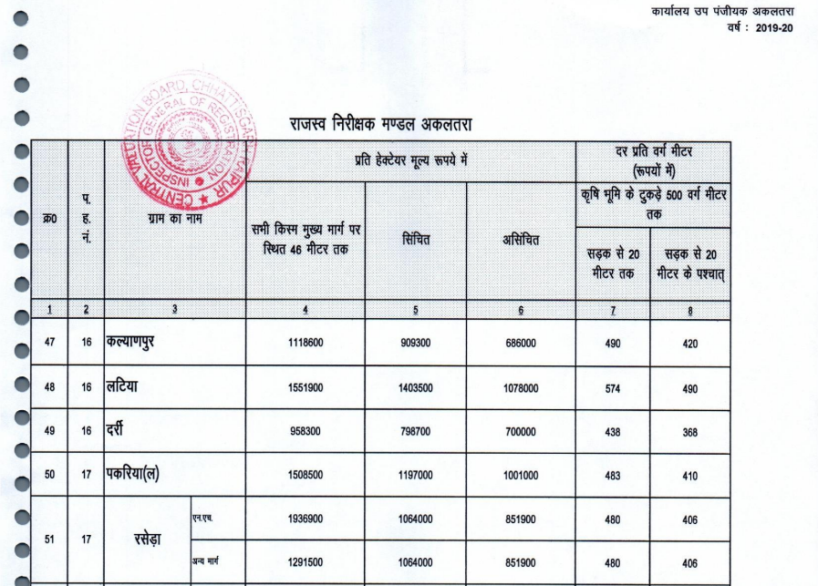
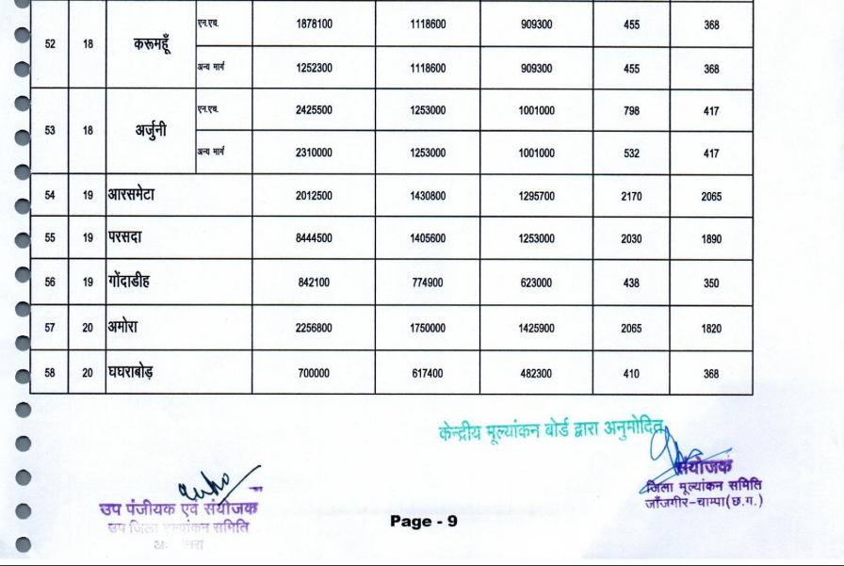
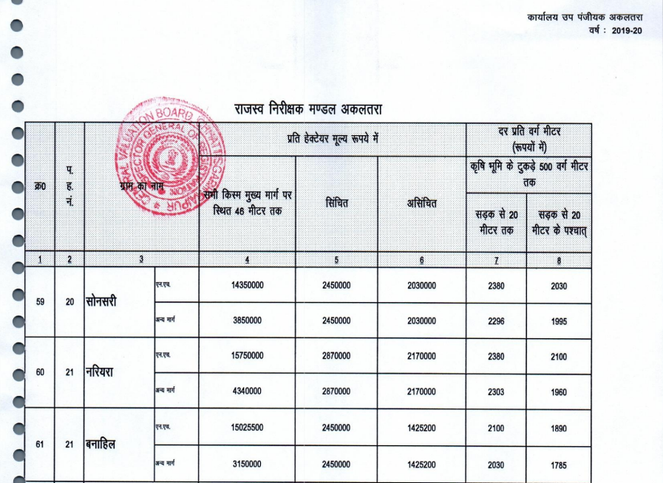
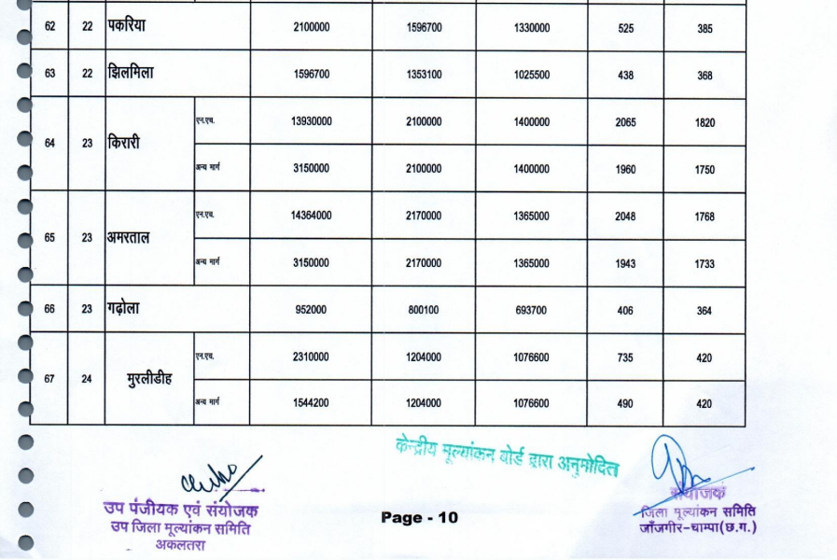
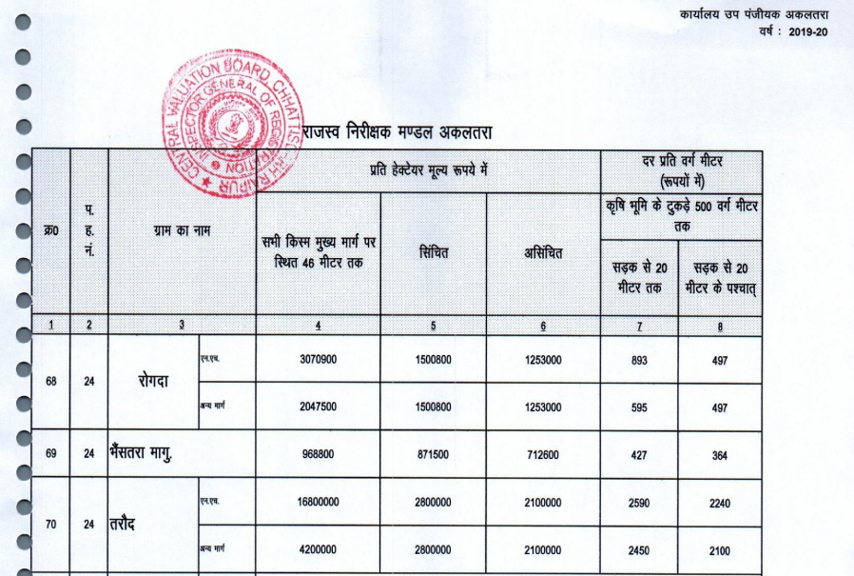
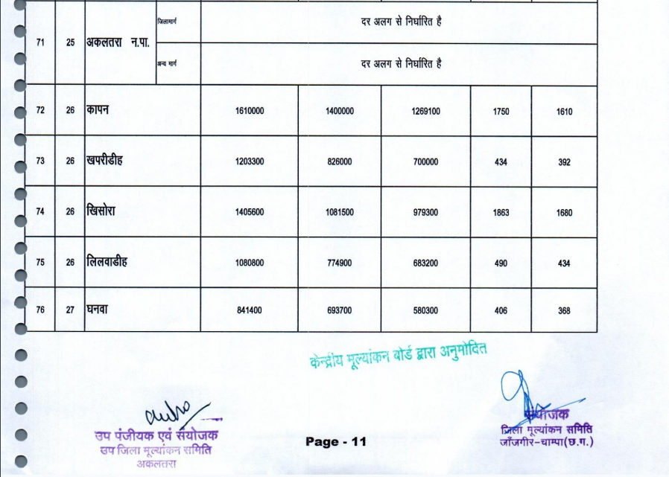

ENCLOSURE: 2 – LAND CONVERSION

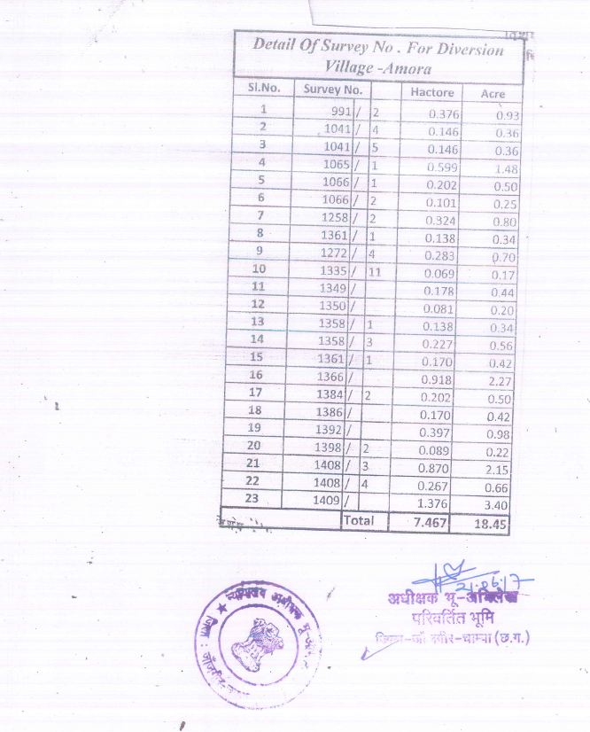

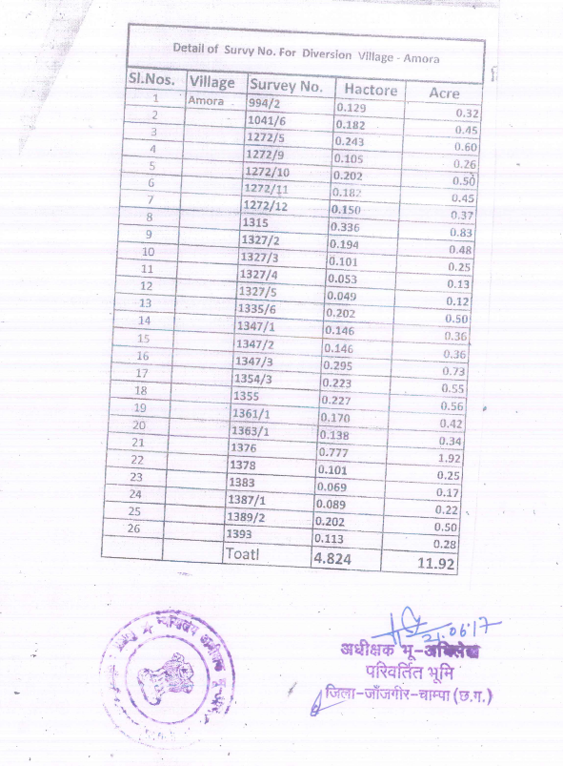

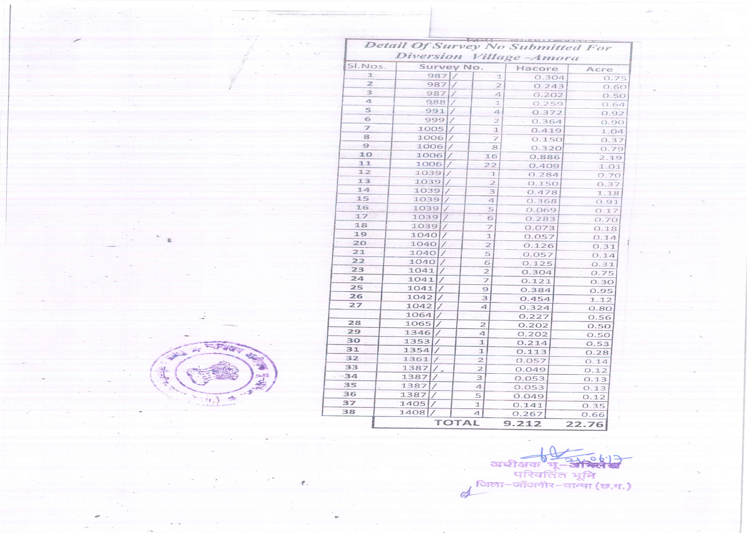

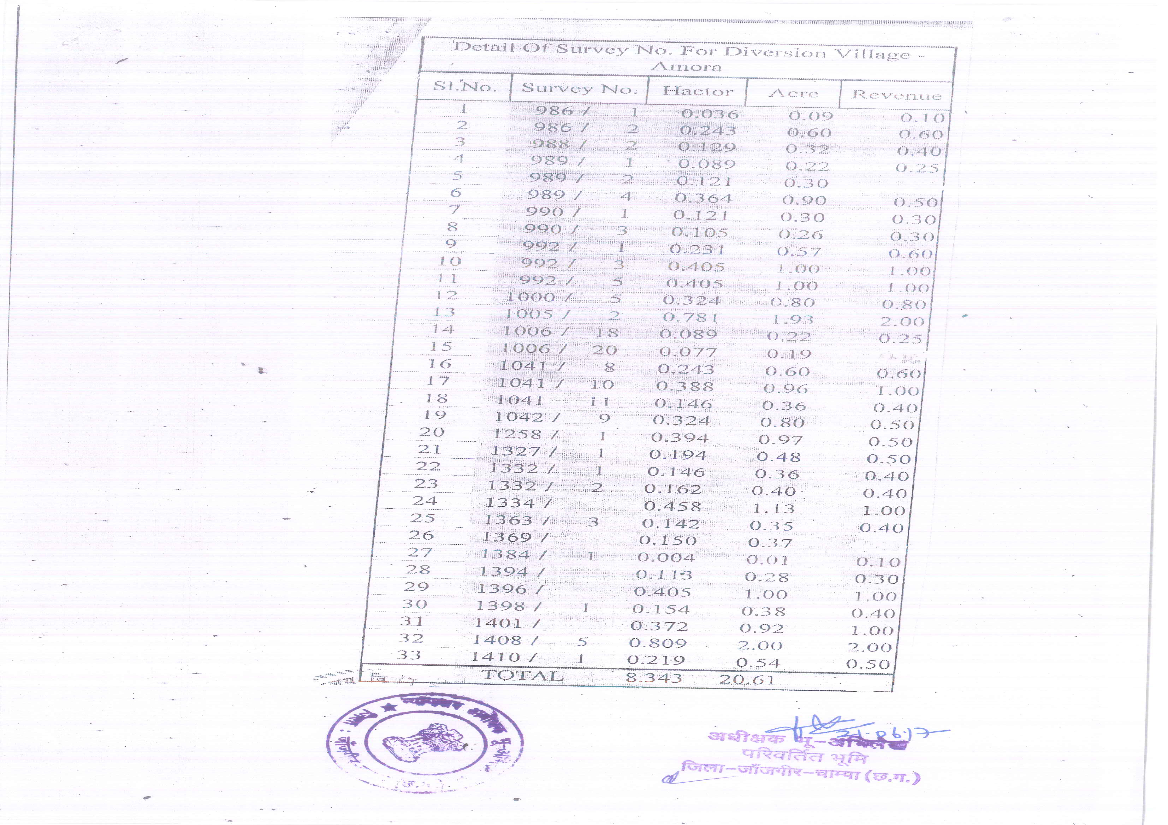

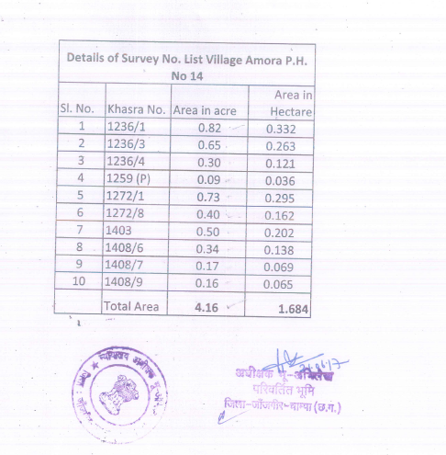
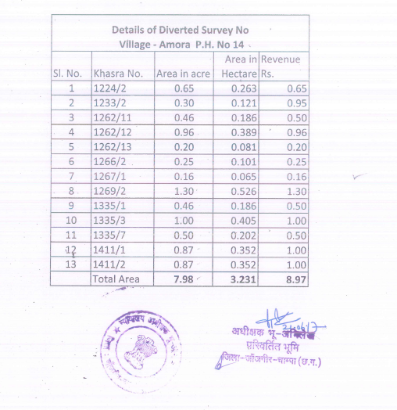
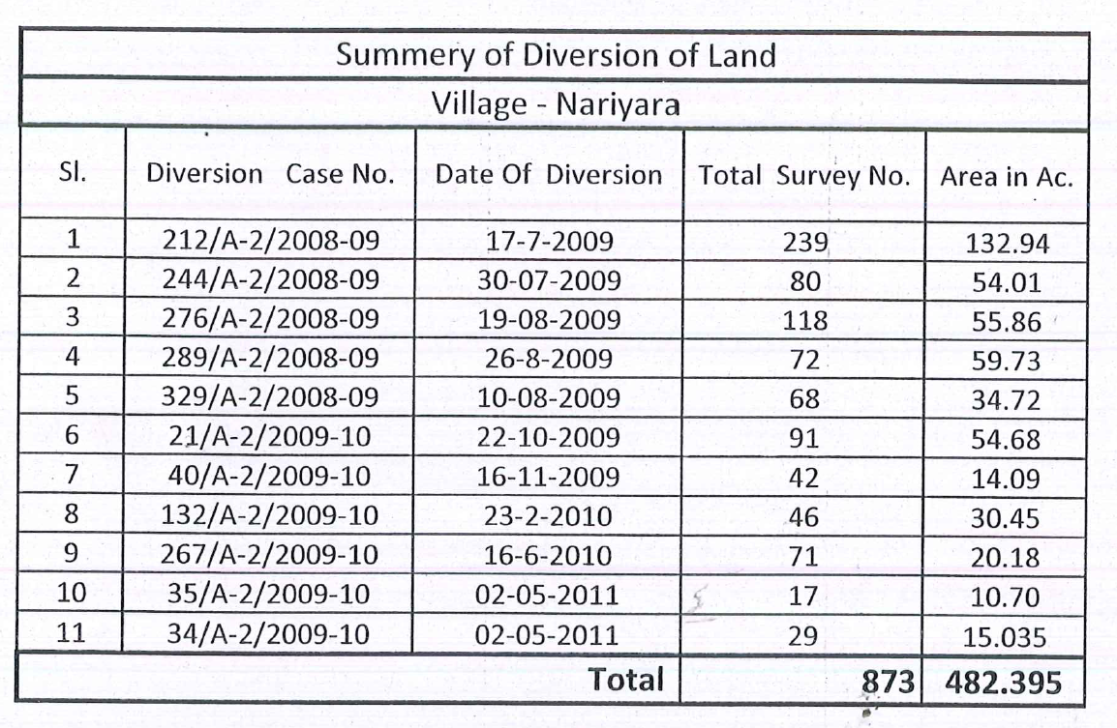

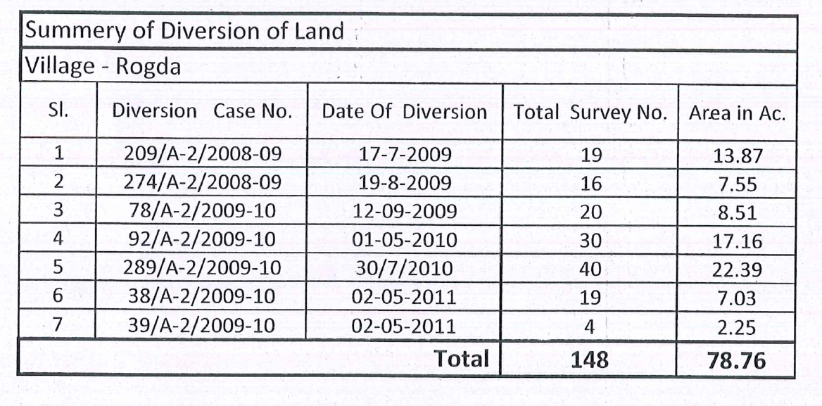

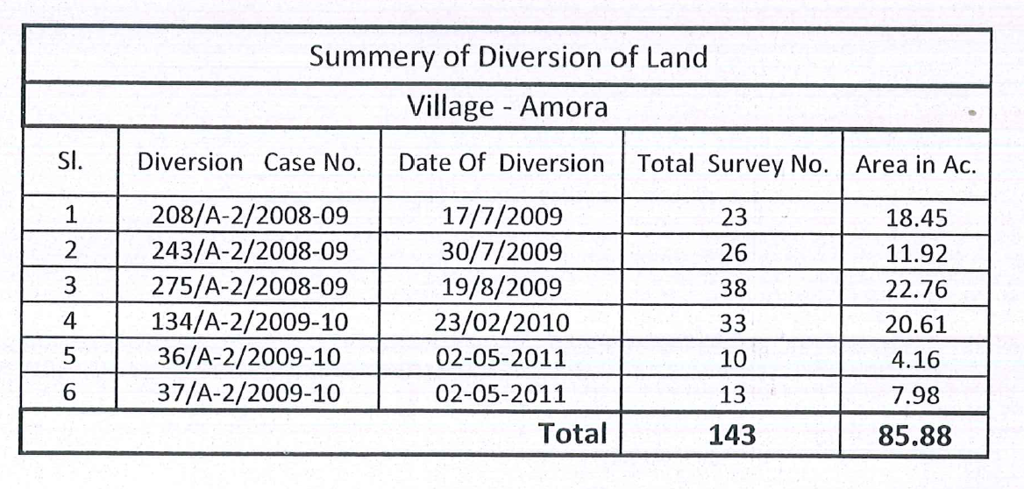
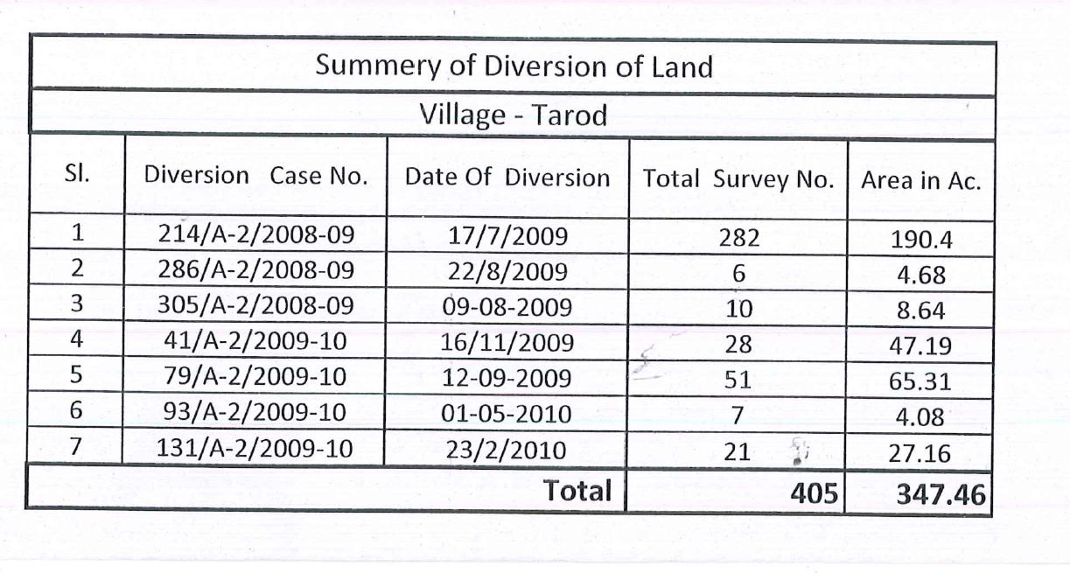

PART I | VALUER’S IMPORTANT REMARKS

Valuation is done for the asset found on as-is-where basis which owner/ owner representative/ client/ bank has shown/ identified to us on the site unless otherwise mentioned in the report of which some reference has been taken from the information/ data given in the copy of documents provided to us and informed verbally or in writing out of the standard checklist of documents sought from the client & its customer which they could provide within the reasonable expected time out of the standard checklist of documents sought from them and further based on certain assumptions and limiting conditions. The information, facts, documents, data which has become primary basis of the report has been supplied by the client which has been relied upon in good faith and is not generated by the Valuer.
The client/ owner and its management/ representatives warranted to us that the information they have supplied was complete, accurate and true and correct to the best of their knowledge. All such information provided to us either verbally, in writing or through documents has been relied upon in good faith and we have assumed that it is true & correct without any fabrication or misrepresentation. I/We shall not be held liable for any loss, damages, cost or expenses arising from fraudulent acts, misrepresentations, or willful default on part of the owner, company, its directors, employee, representative or agents.
Legal aspects for eg. Investigation of title, ownership rights, lien, charge, mortgage, lease, sanctioned maps, verification of documents provided to us such as title documents, Map, etc. from any concerned Govt. office etc. have to be taken care by legal expert/ Advocate and same is not done at our end. It is assumed that the concerned Lender/ Financial Institution has asked for the valuation of that property after satisfying the authenticity of the documents given to us for which the legal verification has been already taken and cleared by the competent Advocate before requesting for the Valuation report. I/ We assume no responsibility for the legal matters including, but not limited to, legal or title concerns.
In the course of the valuation, we were provided with both written and verbal information. We have however, evaluated the information provided to us through broad inquiry, analysis and review but have not carried out a due diligence or audit of the information provided for the purpose of this engagement. Our conclusions are based on the assumptions and other information provided to us by the client during the course of the assessment.
Getting cizra map or coordination with revenue officers for site identification is a separate activity and is not part of the Valuation services and same has not been done in this report unless otherwise stated.
Wherever any details are mentioned in the report in relation to any legal aspect of the property such as name of the owner, leases, etc. is only for illustration purpose and should not be construed as a professional opinion. Legal aspects are out of scope of this report. Details mentioned related to legal aspect are only based on the copy of the documents provided to us and whatever we can interpret as a non-legally trained person. This should be cross validated with a legal expert. We do not vouch any responsibility regarding the same
We have made certain assumptions in relation to facts, conditions & situations affecting the subject of, or approach to this exercise that has not been verified as part of the engagement rather, treated as “a supposition taken to be true”. If any of these assumptions prove to be incorrect then our estimate on value will need to be reviewed.
This is just an opinion report based on technical & market information having general assessment & opinion on the indicative, estimated Market Value of the property for which Bank has asked to conduct the Valuation. It doesn’t contain any other recommendations of any sort including but not limited to express of any opinion on the suitability or otherwise of entering into any transaction with the borrower.
We have relied on the data from third party, external sources & information available on public domain to conclude the valuation. These sources are believed to be reliable and therefore, we assume no liability for the truth or accuracy of any data, opinions or estimates furnished by others that have been used in this analysis. Where we have relied on the data, opinions or estimates from external sources, reasonable care has been taken to ensure that such data is extracted from authentic sources, however we still can’t vouch its authenticity, correctness, or accuracy.
Analysis and conclusions adopted in the report are limited to the reported assumptions, conditions and information came to our knowledge during the course of the work and based on the Standard Operating Procedures, Best Practices, Caveats, Limitations, Conditions, Remarks, Important Notes, Valuation TOR and definition of different nature of values.
Value varies with the Purpose/ Date/ Asset Condition & situation/ Market condition, demand & supply, asset utility prevailing on a particular date/ Mode of sale. The indicative & estimated prospective Value of the asset given in this report is restricted only for the purpose and other points mentioned above prevailing on a particular date as mentioned in the report. If any of these points are different from the one mentioned aforesaid in the Report then this report should not be referred.
Our report is meant ONLY for the purpose mentioned in the report and should not be used for any other purpose. The Report should not be copied or reproduced for any purpose other than the purpose for which it is prepared for. I/we do not take any responsibility for the unauthorized use of this report.
We owe responsibility only to the authority/client that has appointed us as per the scope of work mentioned in the report. We will not be liable for any losses, claims, damages or liabilities arising out of the actions taken, omissions or advice given by any other person. In no event shall we be liable for any loss, damages, cost or expenses arising in any way from fraudulent acts, misrepresentations or willful default on part of the client or companies, their directors, employees or agents.
This report is having limited scope as per its fields & format to provide only the general basic idea of the value of the property prevailing in the market based on the site inspection and documents/ data/ information provided by the client. The suggested indicative prospective estimated value should be considered only if transaction is happened as free market transaction.
The sale of the subject property is assumed to be on an all cash basis. Financial arrangements would affect the price at which the property may sell for if placed on the market.
The actual realizable value that is likely to be fetched upon sale of the asset under consideration shall entirely depend on the demand and supply of the same in the market at the time of sale.
While our work has involved an analysis & computation of valuation, it does not include detailed estimation, design/ technical/ engineering/ financial/ structural/ environmental/ architectural/ compliance survey/ safety audit & works in accordance with generally accepted standards of audit & other such works. The report in this work in not investigative in nature. It is mere an opinion on the likely estimated valuation based on the facts & details presented to us by the client and third party market information came in front of us within the limited time of this assignment, which may vary from situation to situation.
Where a sketched plan is attached to this report, it does not purport to represent accurate architectural plans. Sketch plans and photographs are provided as general illustrations only.
Documents, information, data including title deeds provided to us during the course of this assessment by the client is reviewed only upto the extent required in relation to the scope of the work. No document has been reviewed beyond the scope of the work. These are not reviewed in terms of legal rights for which we do not have expertise. Wherever any information mentioned in this report is mentioned from the documents like owners name, etc., it is only for illustration purpose and may not necessary represent accuracy.
The report assumes that the borrower/company/business/asset complies fully with relevant laws and regulations applicable in its area of operations and usage unless otherwise stated, and that the companies/business/assets is managed in a competent and responsible manner. Further, as specifically stated to the contrary, this report has given no consideration to matters of a legal nature, including issues of legal title and compliance with relevant laws, and litigations and other contingent liabilities that are not recorded/reflected in the documents/ details/ information/ data provided to us.
This valuation report is not a qualification for accuracy of land boundaries, schedule (in physical terms), dimensions & identification. For this land/ property survey report can be sought from a qualified private or Govt. surveyor.
This Valuation report is prepared based on the facts of the property on the date of the survey. Due to possible changes in market forces, socio-economic conditions, property conditions and circumstances, this valuation report can only be regarded as relevant as at the valuation date. Hence before financing, Banker/ FI should take into consideration all such future risk and should loan conservatively to keep the advanced money safe in case of the downward trend of the property value.
Valuation of the same asset/ property can fetch different values under different circumstances & situations. For eg. Valuation of a running/ operational shop/ hotel/ factory will fetch better value and in case of closed shop/ hotel/ factory it will have considerable lower value. Similarly, an asset sold directly by an owner in the open market through free market transaction then it will fetch better value and if the same asset/ property is sold by any financer due to encumbrance on it, will fetch lower value. Hence before financing, Lender/ FI should take into consideration all such future risks while financing and take decision accordingly.

Valuation is done for the property identified to us by the owner/ owner representative. At our end we have just visually matched the land boundaries, schedule (in physical terms) & dimensions of the property with reference to the documents produced for perusal. Method by which identification of the property is carried out is also mentioned in the report clearly. Responsibility of identifying the correct property to the Valuer/ its authorized surveyor is solely of the client/ owner for which Valuation has to be carried out. It is requested from the Bank to cross check from their own records/ information if this is the same property for which Valuation has to be carried out to ensure that owner has not misled the Valuer company or misrepresented the property due to any vested interest. Where there is a doubt about the precision position of the boundaries, schedule, dimensions of site & structures, it is recommended that a Licensed Surveyor be contacted.
In India more than 70% of the geographical area is lying under rural/ remote/ non municipal/ unplanned area where the subject property is surrounded by vacant lands having no physical demarcation or having any display of property survey or municipal number / name plate on the property clearly. Even in old locations of towns, small cities & districts where property number is either not assigned or not displayed on the properties clearly and also due to the presence of multiple/ parallel departments due to which ownership/ rights/ illegal possession/ encroachment issues are rampant across India and due to these limitations at many occasions it becomes tough to identify the property with 100% surety from the available documents, information & site whereabouts and thus chances of error, misrepresentation by the borrower and margin of chances of error always persists in such cases. To avoid any such chances of error it is advised to the Bank to engage municipal/ revenue department officials to get the confirmation of the property to ensure that the property shown to Valuer/ Banker is the same as for which documents are provided.
If this Valuation Report is prepared for the Flat/ dwelling unit situated in a Group Housing Society or Integrated Township then approvals, maps of the complete group housing society/ township is out of scope of this report and this report will be made for the specific unit based on the assumption that complete Group Housing Society/ Integrated Township and the subject unit must be approved in all respect.
Due to fragmented & frequent change in building/ urban planning laws/ guidelines from time to time, different laws/ guidelines between regions/ states and no strict enforceability of Building Bye-Laws in India specially in non-metro and scale b & c cities & Industrial areas, property owners many times extend or make changes in the covered area/ layout from the approved/ applicable limits. There are also situations where properties are decades old when there was no formal Building Bye-Laws applicable the time when the construction must have been done. Due to such discrete/ unplanned development in many regions sometimes it becomes tough for the Valuer to determine the exact lawful situation on ground. Unless otherwise mentioned in the report, the covered area present on the site as per site survey will be considered in the Valuation.
Area of the large land parcels of more than 2500 sq.mtr or of uneven shape in which there can be practical difficulty in sample measurement, is taken as per property documents which has been relied upon unless otherwise stated.

Drawing Map, design & detailed estimation of the property/ building is out of scope of the Valuation services.
Valuation is a subjective field and opinion may differ from consultant to consultant. To check the right opinion, it is important to evaluate the methodology adopted and various data point/ information/ factors/ assumption considered by the consultant which became the basis for the Valuation report before reaching to any conclusion.
Although every scientific method has been employed in systematically arriving at the value, there is, therefore, no indisputable single value and the estimate of the value is normally expressed as falling within a likely range.
Value analysis of any asset cannot be regarded as an exact science and the conclusions arrived at in many cases will, of necessity, be subjective and dependent on the exercise of individual judgment. Given the same set of facts and using the same assumptions, expert opinions may differ due to the number of separate judgment decisions, which have to be made. Therefore, there can be no standard formula to establish an indisputable exchange ratio. In the event of a transaction, the actual transaction value achieved may be higher or lower than our indicative analysis of value depending upon the circumstances of the transaction. The knowledge, negotiability and motivations of the buyers and sellers, demand & supply prevailing in the market and the applicability of a discount or premium for control will also affect actual price achieved. Accordingly, our indicative analysis of value will not necessarily be the price at which any agreement proceeds. The final transaction price is something on which the parties themselves have to agree. However, our Valuation analysis can definitely help the stakeholders to take informed and wise decision about the Value of the asset and can help in facilitating the arm’s length transaction.
This Valuation is conducted based on the macro analysis of the asset/ property considering it in totality and not based on the micro, component, or item wise analysis. Analysis done is a general assessment and is not investigative in nature.
This report is prepared on the RKA V-L1 (Basic) Valuation format as per the client requirement and scope of work. This report is having limited scope as per its fields & format to provide only the general estimated & indicative basic idea of the value of the property prevailing in the market based on the information provided by the client. No detailed analysis, audit or verification has been carried out of the subject property. There may be matters, other than those noted in this report, which might be relevant in the context of the transaction and which a wider scope might uncover.
This is just an opinion report and doesn’t hold any binding on anyone. It is requested from the concerned Client/ Bank/ Financial Institution which is using this report for mortgaging the property that they should consider all the different associated relevant & related factors & risks before taking any business decision based on the content of this report.
All Pages of the report including annexures are signed and stamped from our office. In case any paper in the report is without stamp & signature then this should not be considered a valid paper issued from this office.
As per IBA Guidelines & Bank Policy, in case the valuation report submitted by the valuer is not in order, the banks / FIs shall bring the same to the notice of the valuer within 15 days of submission for rectification and resubmission. In case no such communication is received, it shall be presumed that the valuation report has been accepted.
Defect Liability Period is 15 DAYS. We request the concerned authorized reader of this report to check the contents, data, information, and calculations in the report within this period and intimate us in writing at valuers@rkassociates.org within 15 days of report delivery, if any corrections are required or in case of any other concern with the contents or opinion mentioned in the report. If no intimation is received within 15 (Fifteen) days in writing from the date of issuance of the report, then it shall be considered that the report is complete in all respect and has been accepted by the client upto their satisfaction & use and further to which R.K Associates shall not be held responsible in any manner. After this period no concern/ complaint/ proceedings in connection with the Valuation Services will be entertained due to possible change in situation and condition of the property.
Though adequate care has been taken while preparing this report as per its scope, but still we can’t rule out typing, human errors, over sightedness of any information or any other mistakes. Therefore, the concerned organization is advised to satisfy themselves that the report is complete & satisfactory in all respect. Intimation regarding any discrepancy shall be brought into our notice immediately. If no intimation is received within 15 (Fifteen) days in writing from the date of issuance of the report, to rectify these timely, then it shall be considered that the report is complete in all respect and has been accepted by the client upto their satisfaction & use and further to which R.K Associates shall not be held responsible in any manner.
Our Data retention policy is of ONE YEAR. After this period we remove all the concerned records related to the assignment from our repository. No clarification or query can be answered after this period due to unavailability of the data.
This Valuation report is governed by our (1) Internal Policies, Processes & Standard Operating Procedures, (2) R.K Associates Quality Policy, (3) Valuation & Survey Best Practices Guidelines formulated by management of R.K Associates, (4) Information input given to us by the customer and (4) Information/ Data/ Facts given to us by our field/ office technical team. Management of R.K Associates never gives acceptance to any unethical or unprofessional practice which may affect fair, correct & impartial assessment and which is against any prevailing law. In case of any indication of any negligence, default, incorrect, misleading, misrepresentation or distortion of facts in the report then we request the user of this report to immediately or atleast within the defect liability period to bring all such act into notice of R.K Associates management so that corrective measures can be taken instantly.
R.K Associates never releases any report doing alterations or modifications by pen. In case any information/ figure of this report is found altered with pen then this report will automatically become null & void.
We are fully aware that based on the opinion of value expressed in this report, we may be required to give testimony or attend court / judicial proceedings with regard to the subject assets, although it is out of scope of the assignment, unless specific arrangements to do so have been made in advance, or as otherwise required by law. In such event, the party seeking our evidence in the proceedings shall bear the cost/professional fee of attending court / judicial proceedings and my / our tendering evidence before such authority shall be under the applicable laws.
The final copy of the report shall be considered valid only if it is in hard copy on the company’s original letter head with proper stamp and sign on it of the authorized official upon payment of the agreed fees. User shall not use the content of the report for the purpose it is prepared for only on draft report, scanned copy, email copy of the report and without payment of the agreed fees. In such a case the report shall be considered as unauthorized and misused.

