To, Date: 31.03.2023
The AGM & RM (AMT-IV)

IFB Branch, New Delhi
State Bank of India

Dear Sir,

Subject: Addendum to the Valuation Report Case No. VIS (2022-23)-PL471-375-652

Sir, please refer to your Work Order No. IFB-ND/AMT-IV/2022-23/352 dated: 28.11.2022, wherein it was requested from us to conduct the valuation of one constructed tower with name BPTP Capital City, Plot No.-02, Sector 94, District- Gautam Budh Nagar, Noida, Uttar Pradesh. Accordingly the valuation report is already submitted to you vide report No. VIS (2022-23)-PL471-375-652 dated: dated 02.02.2023, through built-up unit method which included the proportionate value of the land also required as per FAR consumed in the building in the composite rates adopted in built-up unit value.

Further to it through verbal communication, it was requested from us to give the balance land value out of total land area admeasuring 14.17 Acres.

In this regard please find attached the addendum report to Case No. VIS (2022-23)-PL471-375-652 dated 02.02.2023 for the balance vacant land out of total land area admeasuring 14.17 Acres.
Please note that this addendum should always be read in conjunction to previous Report No. VIS (2022-23)-PL471-375-652 dated 02.02.2023.
Thanks & Regards,
For R.K Associates Valuers & Techno Engg. Consultants (P) Ltd.

Enclosed:
1. Addendum report to Case No. VIS (2022-23)-PL471-375-652 dated 02.02.2023.
PART A | BRIEF DESCRIPTION OF THE PROPERTY UNDER VALUATION

SBI IFB, Jawahar Vyaapar Bhawan Branch, New Delhi vide Work Order No. IFB-ND/AMT-IV/2022-23/352 dated: 28.11.2022, has requested us to conduct the valuation of property located at North-West Tower, BPTP Capital City, Plot No.-02, Sector 94, District- Gautam Budh Nagar, Noida, Uttar Pradesh. During discussion, Bank requested to give the valuation of only the present constructed building on the total plot admeasuring 14.17 acres. Accordingly its Valuation through built-up unit method is given vide report no.VIS(2022-23)-PL471-375-652 dated 02.02.2023, which included the proportionate value of the land also required as per FAR consumed in the building in the composite rates adopted in built-up unit value.

Further to it through verbal communication, Bank again requested to give the balance land value out of total land area admeasuring 14.17 Acres.

In this respect, this report is an addendum to the earlier report Case No.VIS(2022-23)-PL471-375-652 dated 02.02.2023 only for the balance proportionate vacant land out of total land area. This report should be read in conjunction to the previous report issued for the building standing on the proportionate land underneath it.

As stated in the copy of the deed and approved plan, plot number 2B's total land area is 14.17 Acres. As per approved Map dated: 13.03.2021, total 4 towers are proposed on the land with proposed FAR 1,14,510 sq. mtr. Presently only one North-West tower is constructed for which a valuation report is already given to the Bank vide report no. VIS(2022-23)-PL471-375-652 dated 02.02.2023 from built-up unit method estimating the valuation of Rs.847,40,95,000/-

For the distribution of the land already consumed in the North-West Tower and the balance land, we have used the proportion of FAR consumed out of total proposed FAR as per the calculation below:
Particulars | In percentage | in sq. mtr. | in acres
Total Land area | NA | 57,344 | 14.17
Total Proposed FAR | 200% | 1,14,510 | 28.30
FAR consumed in the existing building | 40.49% | 46,361 | NA
Balance FAR | 59.51% | 68,149 | NA
Land Area consumed in North-West Tower (as per proportion of FAR) | 40.49% | 23,218.63 | 5.74
Balance Land Area considered for valuation (59.51% of total land ) | 59.51% | 34,125.47 | 8.43

Therefore as per table above in this addendum report we are estimating the value of balance vacant 34,125.47 sq. mtr. (8.43 acres) only.
The remaining 40.49% of the land value has already been taken into account in the first section of the report while estimating the value of North-West Tower through Built up method.

Since this is an addendum report to Case No. VIS(2022-23)-PL471-375-652 dated 02.02.2023, therefore only the Valuation details are shown in this report for brevity purpose. All other details of the property to be referred from the previous report only and this addendum should always be read in conjunction to previous Report No. VIS(2022-23)-PL471-375-652 dated 02.02.2023.

Valuation of the same has annexed below:

ENCLOSURE: I
PART B | AREA DESCRIPTION OF THE PROPERTY

 | Land Area considered for Valuation | 34,125.47 sq. mtr. (8.43 acres)
 | Area adopted on the basis of | Property documents only
 | Remarks & observations, if any | For area calculation please see table below.
 | Constructed Area considered for Valuation  (As per IS 3861-1966) | Covered Area | Not applicable since this is a vacant land
 | Area adopted on the basis of | Not applicable
 | Remarks & observations, if any | Not applicable

Note:

- Area measurements considered in the Valuation Report pertaining to Land & Building is adopted from relevant approved documents or actual site measurement whichever is less. All area measurements are on approximate basis only.

- Drawing Map, design & detailed estimation of the property/ building is out of scope of the Valuation services.

ENCLOSURE: II
PART C | PROCEDURE OF VALUATION ASSESSMENT

 | GENERAL INFORMATION
 | Important Dates | Date of Appointment |  | Date of Inspection of the Property | Date of Valuation Assessment | Date of Valuation Report
 | Important Dates | 28 November 2022 |  | 6 December 2022 | 31 March 2023 | 31 March 2023
 | Client | State Bank of India, IFB Branch, New Delhi
 | Intended User | State Bank of India, IFB Branch, New Delhi
 | Intended Use | To know the general idea on the market valuation trend of the property as per free market transaction. This report is not intended to cover any other internal mechanism, criteria, considerations of any organization as per their own need, use & purpose.
 | Purpose of Valuation | LRD (Lease Rental Discounting) purpose
 | Scope of the Assessment | Non binding opinion on the assessment of Plain Physical Asset Valuation of the property identified to us by the owner or through his representative.
 | Restrictions | This report should not be referred for any other purpose, by any other user and for any other date other then as specified above. This report is not a certification of ownership or survey number/ property number/ Khasra number which are merely referred from the copy of the documents provided to us.
 | Manner in which the proper is identified | ☐ | Identified by the owner
 | Manner in which the proper is identified | ☒ | Identified by owner’s representative
 | Manner in which the proper is identified | ☐ | Done from the name plate displayed on the property
 | Manner in which the proper is identified | ☒ | Cross checked from boundaries or address of the property mentioned in the deed
 | Manner in which the proper is identified | ☒ | Enquired from local residents/ public
 | Manner in which the proper is identified | ☐ | Identification of the property could not be done properly
 | Manner in which the proper is identified | ☐ | Survey was not done
 | Is property number/ survey number displayed on the property for proper identification? | No.
 | Type of Survey conducted | Full survey (inside-out with approximate sample random measurements verification & photographs).

 | ASSESSMENT FACTORS
 | Valuation Standards considered | Mix of standards such as IVS and others issued by Indian authorities & institutions and improvised by the RKA internal research team as and where it is felt necessary to derive at a reasonable, logical & scientific approach. In this regard proper basis, approach, working, definitions considered is defined below which may have certain departures to IVS.
 | Nature of the Valuation | Fixed Assets Valuation
 | Nature/ Category/ Type/ Classification of Asset under Valuation | Nature |  |  |  | Category |  |  |  |  |  | Type
 |  | VACANT LAND |  |  |  | COMMERCIAL |  |  |  |  |  | COMMERCIAL VACANT LAND
 |  | Classification |  |  |  | Only commercial use asset
 | Type of Valuation (Basis of Valuation as per IVS) | Primary Basis |  |  | Market Value & Govt. Guideline Value
 | Type of Valuation (Basis of Valuation as per IVS) | Secondary Basis |  |  | Not Applicable
 | Present market state of the Asset assumed (Premise of Value as per IVS) | Under Normal Marketable State
 |  | Reason: Asset under free market transaction state
 | Property Use factor | Current/ Existing Use |  |  |  |  | Highest & Best Use  (in consonance to surrounding use, zoning and statutory norms) |  |  |  |  | Considered for Valuation purpose
 | Property Use factor | Proposed to be Commercial |  |  |  |  | Commercial |  |  |  |  | Commercial
 | Legality Aspect Factor | Assumed to be fine as per copy of the documents & information produced to us.  However Legal aspects of the property of any nature are out-of-scope of the Valuation Services. In terms of the legality, we have only gone by the documents provided to us in good faith.  Verification of authenticity of documents from originals or cross checking from any Govt. deptt. have to be taken care by Legal expert/ Advocate.
 | Class/ Category of the locality | Upper Middle Class (Good)
 | Property Physical Factors | Shape |  |  |  |  |  | Size |  |  |  | Layout
 | Property Physical Factors | Irregular |  |  |  |  |  | Large |  |  |  | Good Layout
 | Property Location Category Factor | City Categorization |  | Locality Characteristics |  |  |  |  |  |  | Property location characteristics |  | Floor Level
 | Property Location Category Factor | Metro City |  | Good |  |  |  |  |  |  | Near to Metro Station |  | (Not Applicable)
 | Property Location Category Factor | Urban developed |  | Normal |  |  |  |  |  |  | Not Applicable |  | (Not Applicable)
 | Property Location Category Factor |  |  | Within urban developing zone |  |  |  |  |  |  | Not Applicable |  | (Not Applicable)
 | Property Location Category Factor | Property Facing
 | Property Location Category Factor | North Facing & South Facing
 | Physical Infrastructure availability factors of the locality | Water Supply |  | Sewerage/ sanitation system |  |  |  |  |  |  | Electricity |  | Road and Public Transport connectivity
 | Physical Infrastructure availability factors of the locality | Yes from borewell/ submersible |  | Underground |  |  |  |  |  |  | Yes |  | Easily available
 | Physical Infrastructure availability factors of the locality | Availability of other public utilities nearby |  |  |  |  |  |  |  |  | Availability of communication facilities
 | Physical Infrastructure availability factors of the locality | Transport, Market, Hospital etc. are available in close vicinity |  |  |  |  |  |  |  |  | Major Telecommunication Service Provider & ISP connections are available
 | Social structure of the area (in terms of population, social stratification, regional origin, age groups, economic levels, location of slums/ squatter settlements nearby, etc.) | Commercial area
 | Neighbourhood amenities | Good
 | Any New Development in surrounding area | None |  |  |  |  |  |  | ---
 | Any specific advantage in the property | The subject property is close to Okhkla Bird Sanctuary metro station
 | Any specific drawback in the property | None
 | Property overall usability/ utility Factor | Good
 | Do property has any alternate use? | Yes, for any commercial purpose
 | Is property clearly demarcated by permanent/ temporary boundary on site | Partly demarcated only. Not demarcated from east side
 | Is the property merged or colluded with any other property | No
 | Is the property merged or colluded with any other property | Comments: ---
 | Is independent access available to the property | Clear independent access is available
 | Is property clearly possessable upon sale | Yes
 | Best Sale procedure to realize maximum Value (in respect to Present market state or premise of the Asset as per point (iv) above) | Fair Market Value
 |  | Free market transaction at arm's length wherein the parties, after full market survey each acted knowledgeably, prudently and without any compulsion.
 | Hypothetical Sale transaction method assumed for the computation of valuation | Fair Market Value
 |  | Free market transaction at arm's length wherein the parties, after full market survey each acted knowledgeably, prudently and without any compulsion.
 | Approach & Method of Valuation Used | Land | Approach of Valuation |  |  |  |  |  |  |  | Method of Valuation
 | Approach & Method of Valuation Used | Land | Market Approach |  |  |  |  |  |  |  | Market Comparable Sales Method
 | Type of Source of Information | Level 3 Input (Tertiary)
 | Market Comparable
 | References on prevailing market Rate/ Price trend of the property and Details of the sources from where the information is gathered (from property search sites & local information) | 1. | Name: |  |  |  |  |  |  |  | Please refer below to “Adopted Rates Justification” for the details.
 |  | 1. | Contact No.:
 |  | 1. | Nature of reference:
 |  | 1. | Size of the Property:
 |  | 1. | Location:
 |  | 1. | Rates/ Price informed:
 |  | 1. | Any other details/ Discussion held:
 |  | NOTE: The given information above can be independently verified to know its authenticity.
 | Adopted Rates Justification | Through extensive research done from public domain we have gathered the following information: -  1) Availability of Commercial vacant plot nearby the subject property is very low.  2) We have found an E Auction notice dated 05.07.2021 from archive of Noida Official website (source: https://noidaauthorityonline.in/en/article/archive-live-land-allotment-scheme). As per the mentioned document the reserve land rate for a vacant commercial plot admeasuring 10,031 sq. mtr. was Rs.1,59,000/- per sq. mtr.  3) As per an article published by Economic times on 17.11.2022, M3M has bought 52,000 sq.mtr. of mixed use land in sector 94 through e auction conducted by NOIDA. The land has been bought at Rs 827.41 crore which comes to ~1,59,000/- per sq. mtr.  (source:https://realty.economictimes.indiatimes.com/news/industry/m3m-india-buys-13-acre-land-parcel-in-noida-for-rs-827-41-crore/95569045)  Based on the above references and taking a note of the proportionate value of land already covered under built-up unit method after making adjustments in the rate to remain in parity of the market rates for the whole land as per above references.  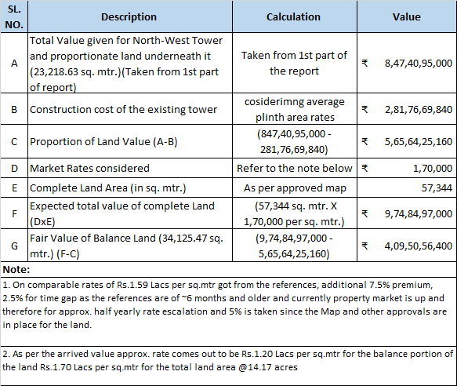
NOTE: We have taken due care to take the information from reliable sources. The given information above can be independently verified from the provided numbers to know its authenticity. However due to the nature of the information most of the market information came to knowledge is only through verbal discussion with market participants which we have to rely upon where generally there is no written record.
Related postings for similar properties on sale are also annexed with the Report wherever available.
 | Other Market Factors
 | Current Market condition | Normal
 | Current Market condition | Remarks: ---
 | Current Market condition | Adjustments (-/+): 0%
 | Comment on Property Salability Outlook | Easily sellable
 | Comment on Property Salability Outlook | Adjustments (-/+): 0%
 | Comment on Demand & Supply in the Market | Demand |  |  |  |  |  |  |  | Supply
 | Comment on Demand & Supply in the Market | Good |  |  |  |  |  |  |  | Low
 | Comment on Demand & Supply in the Market | Remarks: Good demand of such properties in the market
 | Comment on Demand & Supply in the Market | Adjustments (-/+): 0%
 | Any other special consideration | Reason: ----
 | Any other special consideration | Adjustments (-/+): 0%
 | Any other aspect which has relevance on the value or marketability of the property | NA  Valuation of the same asset/ property can fetch different values under different circumstances & situations. For e.g. Valuation of a running/ operational shop/ hotel/ factory will fetch better value and in case of closed shop/ hotel/ factory it will fetch considerably lower value. Similarly, an asset sold directly by an owner in the open market through free market arm’s length transaction then it will fetch better value and if the same asset/ property is sold by any financer or court decree or Govt. enforcement agency due to any kind of encumbrance on it then it will fetch lower value. Hence before financing, Lender/ FI should take into consideration all such future risks while financing.  This Valuation report is prepared based on the facts of the property & market situation on the date of the survey. It is a well-known fact that the market value of any asset varies with time & socio-economic conditions prevailing in the region/ country. In future property market may go down, property conditions may change or may go worse, property reputation may differ, property vicinity conditions may go down or become worse, property market may change due to impact of Govt. policies or effect of domestic/ world economy, usability prospects of the property may change, etc. Hence before financing, Banker/ FI should take into consideration all such future risk while financing.
 |  | Adjustments (-/+): 0%
 | Final adjusted & weighted Rates considered for the subject property | Please refer to the page no.07
 | Considered Rates Justification | As per the thorough property & market factors analysis as described above, the considered estimated market rates appears to be reasonable in our opinion.
 | Basis of computation & working
- In this report, proportionate land value is calculated.
- For the distribution of the land already consumed in the North-West Tower and the balance land, we have used the proportion of FAR consumed out of total proposed FAR as per the calculation explained in the executive summary above.as per which balance vacant comes out to be 34,125.47 sq. mtr. (8.43 acres) only.
- This value to be read in conjunction to the value already given in Report No. VIS(2022-23)-PL471-375-652 dated 02.02.2023
- Valuation of the asset is done as found on as-is-where basis on the site as identified to us during site inspection by our engineer/s unless otherwise mentioned in the report.
- Analysis and conclusions adopted in the report are limited to the reported assumptions, conditions and information came to our knowledge during the course of the work and based on the Standard Operating Procedures, Best Practices, Caveats, Limitations, Conditions, Remarks, Important Notes, Valuation TOR and definition of different nature of values.
- For knowing comparable market rates, significant discreet local enquiries have been made from our side based on the hypothetical/ virtual representation of ourselves as both buyer and seller for the similar type of properties in the subject location and thereafter based on this information and various factors of the property, rate has been judiciously taken considering the factors of the subject property, market scenario and weighted adjusted comparison with the comparable properties unless otherwise stated.
- References regarding the prevailing market rates and comparable are based on the verbal/ informal/ secondary/ tertiary information which are collected by our team from the local people/ property consultants/ recent deals/ demand-supply/ internet postings are relied upon as may be available or can be fetched within the limited time & resources of the assignment during market survey in the subject location. No written record is generally available for such market information and analysis has to be derived mostly based on the verbal information which has to be relied upon.
- Market Rates are rationally adopted based on the facts of the property which came to our knowledge during the course of the assessment considering many factors like nature of the property, size, location, approach, market situation and trends and comparative analysis with the similar assets. During comparative analysis, valuation metrics is prepared and necessary adjustments are made on the subject asset.
- The indicative value has been suggested based on the prevailing market rates that came to our knowledge during secondary & tertiary market research and is not split into formal & informal payment arrangements. Most of the deals takes place which includes both formal & informal payment components. Deals which takes place in complete formal payment component may realize relatively less actual transaction value due to inherent added tax, stamp registration liabilities on the buyer.
- Secondary/ Tertiary costs related to asset transaction like Stamp Duty, Registration charges, Brokerage, Commission, Bank interest, Selling cost, Marketing cost, etc. pertaining to the sale/ purchase of this property are not considered while assessing the indicative estimated Market Value.
- This report includes both, Govt. Guideline Value and Indicative Estimated Prospective Market Value as described above. As per the current market practice, in most of the cases, formal transaction takes place for an amount less than the actual transaction amount and rest of the payment is normally done informally.
- Area measurements considered in the Valuation Report pertaining to asset/ property is adopted from relevant approved documents or sample site measurement whichever is less unless otherwise mentioned. All area measurements are on approximate basis only.
- Verification of the area measurement of the property is done based on sample checking only.
- Drawing, Map, design & detailed estimation of the property/ building is out of scope of the Valuation services.
- Construction rates are adopted based on the present market replacement cost of construction and calculating applicable depreciation & deterioration factor as per its age, existing condition & specifications based on visual observation only of the structure. No structural, physical tests have been carried out in respect of it. No responsibility is assumed for latent defects of any nature whatsoever, which may affect value, or for any expertise required to disclose such conditions.
- Construction rates are adopted based on the plinth area rates prevailing in the market for the structure as a whole and not based on item wise estimation or Bills of Quantity method unless otherwise stated.
- The condition assessment and the estimation of the residual economic life of the structure are only based on the visual observations and appearance found during the site survey. We have not carried out any structural design or stability study; nor carried out any physical tests to assess structural integrity & strength.
- Any kind of unpaid statutory, utilities, lease, interest or any other pecuniary dues on the asset or on its owners has not been factored in the Valuation.
- This Valuation is conducted based on the macro analysis of the asset/ property considering it in totality and not based on the micro, component or item wise analysis. Analysis done is a general assessment and is neither investigative in nature nor an audit activity.
- Valuation is done for the asset found on as-is-where basis which has been shown to us on site of which some reference has been taken from the information/ data given in the copy of documents provided to us which have been relied upon in good faith and we have assumed that it to be true and correct.
 | ASSUMPTIONS
- Documents/ Information/ Data provided to us by the bank/ property owner or his representative is true and correct without any fabrication and has been relied upon in good faith.
- Local verbal enquiries during micro market research came to our knowledge are assumed to be taken on record as true & factual.
- The assets and interests therein have been valued free and clear of any liens or encumbrances unless stated otherwise. No hidden or apparent conditions regarding the subject assets or their ownership are assumed to exist. No opinion of title is rendered in this report and a good title is assumed unless stated otherwise.
- It is assumed that the concerned Lender/ Financial Institution has asked for the valuation of that property after satisfying the authenticity of the documents given to us and for which the legal verification has been already taken and cleared by the competent Advocate before requesting for the Valuation report. I/ We assume no responsibility for the legal matters including, but not limited to, legal or title concerns.
- Payment condition during transaction in the Valuation has been considered on all cash bases which includes both formal & informal payment components as per market trend.
- Sale transaction method of the asset is assumed as Free market transaction without any compulsion unless otherwise mentioned while assessing Indicative & Estimated Fair Prospective Market Value of the asset unless otherwise stated.
- If this Valuation Report is prepared for the Flat/ dwelling unit situated in a Group Housing Society or Integrated Township then approvals, maps of the complete group housing society/ township is out of scope of this report. This valuation report is prepared for the specific unit based on the assumption that complete Group Housing Society/ Integrated Township is approved and complied with all relevant laws and the subject unit is also approved within the Group Housing Society/ Township.
 | SPECIAL ASSUMPTIONS
 | None
 | LIMITATIONS
 | None

 | VALUATION OF LAND
 | Particulars | Govt. Circle/ Guideline Value | Indicative & Estimated Prospective Fair Market Value
 | Prevailing Rate range | --- | ---
 | Rate adopted considering all characteristics of the property | Rs.1,59,000/- per sq. mtr. | Refer to the page no. 07
 | Total Land Area considered (documents vs site survey whichever is less) | 34,125.47 sq. mtr. (8.43 acres) | 34,125.47 sq. mtr. (8.43 acres)
 | Total Value of land (A) | 34,125.47 sq. mtr. X Rs.1,59,000/- per sq. mtr. | Refer to the page no. 07
 | Total Value of land (A) | Rs.542,59,50,351/- | Rs.409,20,71,840/-

 | VALUATION OF ADDITIONAL AESTHETIC/ INTERIOR WORKS IN THE PROPERTY
S.No. | Particulars | Specifications | Depreciated Replacement Value
 | Add extra for Architectural aesthetic developments, improvements  (add lump sum cost) | ---- | ----
 | Add extra for fittings & fixtures  (Doors, windows, wood work, cupboards, modular kitchen, electrical/ sanitary fittings) | ---- | ----
 | Add extra for services  (Water, Electricity, Sewerage, Main gate, Boundary, Lift, Auxiliary power, AC, HVAC, Firefighting etc.) | ---- | ----
 | Add extra for internal & external development  (Internal roads, Landscaping, Pavements, Street lights, Green area development, External area landscaping, Land development, Approach road, etc.) | ---- | ----
 | Depreciated Replacement Value (B) | NA | ----
Note:
- Value for Additional Building & Site Aesthetic Works is considered only if it is having exclusive/ super fine work specification above ordinary/ normal work. Ordinary/ normal work value is already covered under basic rates above.

 | CONSOLIDATED VALUATION ASSESSMENT OF THE ASSET
S.No. | Particulars | Govt. Circle/ Guideline Value | Indicative & Estimated Prospective Fair Market Value
 | Land Value (A) | Rs.542,59,50,351/- | Rs.409,20,71,840/-
 | Total BUILT-UP UNIT (B) | Not applicable | Not applicable
 | Total Add (A+B) | Rs.542,59,50,351/- | Rs.409,20,71,840/-
 | Additional Premium if any | --- | ---
 | Details/ Justification | --- | ---
 | Deductions charged if any | --- | ---
 | Details/ Justification | --- | ---
 | Total Indicative & Estimated Prospective Fair Market Value | --- | Rs.409,20,71,840/-
 | Rounded Off | --- | Rs.409,00,00,000/-
 | Indicative & Estimated Prospective Fair Market Value in words | --- | Rupees Four Hundred & Nine Crore Only
 | Expected Realizable Value (@ ~15% less) | --- | Rs.347,65,00,000/-
 | Expected Distress Sale Value (@ ~25% less) | --- | Rs.3,06,75,00,000/-
 | Percentage difference between Circle Rate and Fair Market Value | More than 20%
 | Concluding Comments/ Disclosures if any
- This report is an addendum to the earlier report Case No. VIS (2022-23)-PL471-375-652 dated 02.02.2023 only for the balance proportionate vacant land out of total land area. This report should be read in conjunction to the previous report issued for the building standing on the proportionate land underneath it.
- We are independent of client/ company and do not have any direct/ indirect interest in the property.
- This valuation has been conducted by R.K Associates Valuers & Techno Engineering Consultants (P) Ltd. and its team of experts.
- This Valuation is done for the property found on as-is-where basis as shown to us on the site of which photographs is also attached with the report.
- Reference of the property is also taken from the copies of the documents/ information which interested organization or customer could provide to us out of the standard checklist of documents sought from them and further based on our assumptions and limiting conditions. All such information provided to us has been relied upon in good faith and we have assumed that it is true and correct.
- Legal aspects for eg. Investigation of title, ownership rights, lien, charge, mortgage, lease, verification of documents from originals or from any Govt. department, etc. has to be taken care by legal experts/ Advocates and same has not been done at our end.
- The valuation of an asset is an estimate of the worth of that asset which is arrived at by the Valuer in his expert opinion after factoring in multiple parameters and externalities. This may not be the actual price of that asset and the market may discover a different price for that asset.
- This report only contains opinion based on technical & market information which came to our knowledge during the course of the assignment. It doesn’t contain any recommendations.
- This report is prepared following our Standard Operating Procedures & Best Practices and will be subject to Limitations, Conditions, Valuer’s Remarks, Important Notes, Valuation TOS and basis of computation & working as described above.
- The use of this report will become valid only after payment of full fees as per the Payment Terms. Using this report or any part content created in this report without payment of charges will be seen as misuse and unauthorized use of the report.
 | IMPORTANT KEY DEFINITIONS
Fair Value suggested by the competent Valuer is that prospective estimated amount in his expert & prudent opinion of the subject asset/ property without any prejudice after he has carefully & exhaustively evaluated the facts & information came in front of him or which he could reasonably collect during the course of the assessment related to the subject asset on an as-is, where-is basis in its existing conditions, with all its existing advantages & disadvantages and its potential possibilities which is just & equitable at which the subject asset/ property should be exchanged between a willing buyer and willing seller at an arm’s length transaction in an open & unrestricted market, in an orderly transaction after proper marketing, wherein the parties, each acted knowledgeably, prudently without any compulsion on the date of the Valuation.
Fair Value without using the term “Market” in it describes that the value suggested by the Valuer may not mandatorily follow or may not be in complete consonance to the established Market in his expert opinion. It may or may not follow market dynamics. But if the suggested value by the valuer is not within the prevailing Market range or is assessed for an asset is located in an un-established Market then the valuer will give reasonable justification & reasoning that for what reasons the value suggested by him doesn’t follow the prevailing market dynamics.
Fair Market Value suggested by the competent Valuer is that prospective estimated amount in his expert & prudent opinion of the subject asset/ property without any prejudice in consonance to the Market dynamics after he has carefully & exhaustively evaluated the facts & information came in front of him or which he could reasonably collect during the course of assessment related to the subject asset on an as-is, where-is basis in its existing conditions, with all its existing advantages & disadvantages and its potential possibilities which is just & equitable at which the subject asset/ property should be exchanged between a willing buyer and willing seller at an arm’s length transaction in an open & unrestricted market, in an orderly transaction after proper marketing, wherein the parties, each acted knowledgeably, prudently without any compulsion on the date of the Valuation.
Here the words “in consonance to the established Market” means that the Valuer will give opinion within the realms & dynamics of the prevailing market rates after exhaustively doing the micro market research. However due to the element of “Fair” in it, valuer will always look for the factors if the value should be better than the market realms which is just & equitable backed by strong justification and reasoning.
Market Value suggested by the competent Valuer is that prospective estimated amount which is average price of the similar comparable assets prevailing in an open & established market during the near period of the date of valuation at which the subject asset/ property should be exchanged between a willing buyer and willing seller on an as-is, where-is basis in its existing conditions, with all its existing advantages & disadvantages and its potential possibilities at an arm’s length transaction in an open, established & unrestricted market, in an orderly transaction, wherein the parties, each acted without any compulsion on the date of the Valuation.
Using the term “Market Value” without “Fair” omits the elements of proper marketing, acting knowledgeably & prudently.
Market and market participants can be sentimental, inclined towards the transaction without the element of complete knowledge & prudence about facts or due diligence of the asset therefore “each acted knowledgeably, prudently” has been removed from the marker Value definition.
 | Realizable Value is that minimum prospective estimated value of the asset/ property which it may be able to fetch at the time of actual property transaction factoring in the element of discount due to the prospects of deep negotiations between the buyer & seller when the parties in-principally find Fair Market Value reasonable and sits together to close the deal and the transaction across the table. Discount percentage on the Fair Market Value due to negotiation will depend on the nature, size, various salability prospects of the subject asset, the needs of the buyer & the seller and kind of payment terms. In some of the cases Realizable and Fair Market Value may also be equal.
 | Distress Sale Value* is that value when the property is attached with any process such as mortgaged financing, financial or operational dues which is under any stress condition or situation and the stakeholders are under process of finding resolution towards it to save the property from being attached to a formal recovery process. In this type of sale, minimum fetch value assessed will always be less than the estimated Fair Market Value where the discount of percentage will depend upon various circumstances and factors such as nature, size, salability prospects of the property and kind of encumbrance on the property. In this type of sale, negotiation power of the buyer is always more than the seller and eagerness & pressure of selling the property will be more on the seller than the buyer.
 | Liquidation Value is the amount that would be realized when an asset or group of assets are sold due to any compulsion or constraints such as in a recovery process guided by statute, law or legal process, clearance sale or any such condition or situation thereof where the pressure of selling the asset/ property is very high to realize whatever maximum amount can be from the sale of the assets in a limited time for clearance of dues or due to closure of business. In other words, this kind of value is also called as forced sale value.
Difference between Cost, Price & Value: Generally, these words are used and understood synonymously. However, in reality each of these has a completely different meaning, premise and also having different definitions in professional & legal terms. Therefore, it is our professional responsibility to describe the definitions of these words to avoid ambiguity & confusion in the minds of the user of this report.
The Cost of an asset represents the actual amount spend in the construction/ actual creation of the asset.
The Price is the amount paid for the procurement of the same asset.
The Value is defined as the present worth of future rights in the property/ asset and is a hypothetical or notional price that buyers and sellers are most likely to conclude for a good or service. Value is not a fact, but an estimate of the likely price to be paid for a good or service at a given time in accordance with a particular definition of value.
Therefore, in actual for the same asset/ property, cost, price & value remain different since these terms have different usage & meaning.
Enclosures with the Report:

- Enclosure: III- Google Map
- Enclosure: IV- References on price trend of the similar related properties available on public domain, if available
- Enclosure: V- Copy of Circle Rate

ENCLOSURE: III – GOOGLE MAP LOCATION

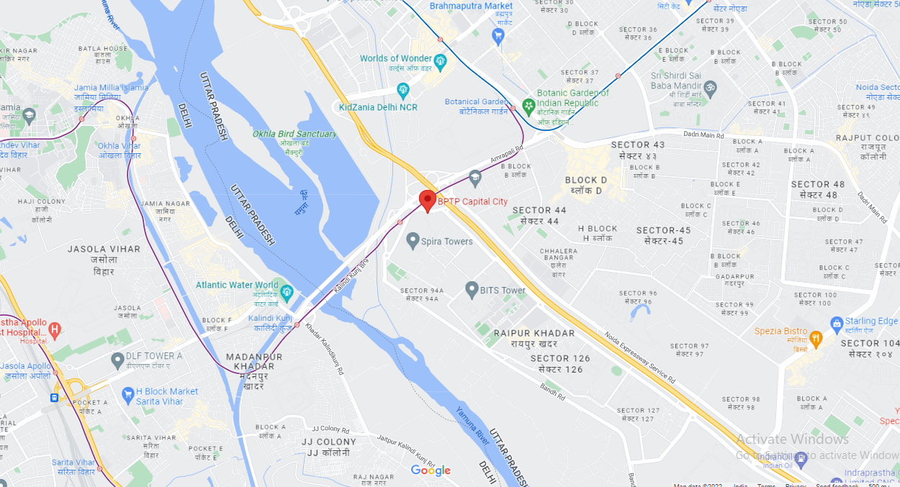
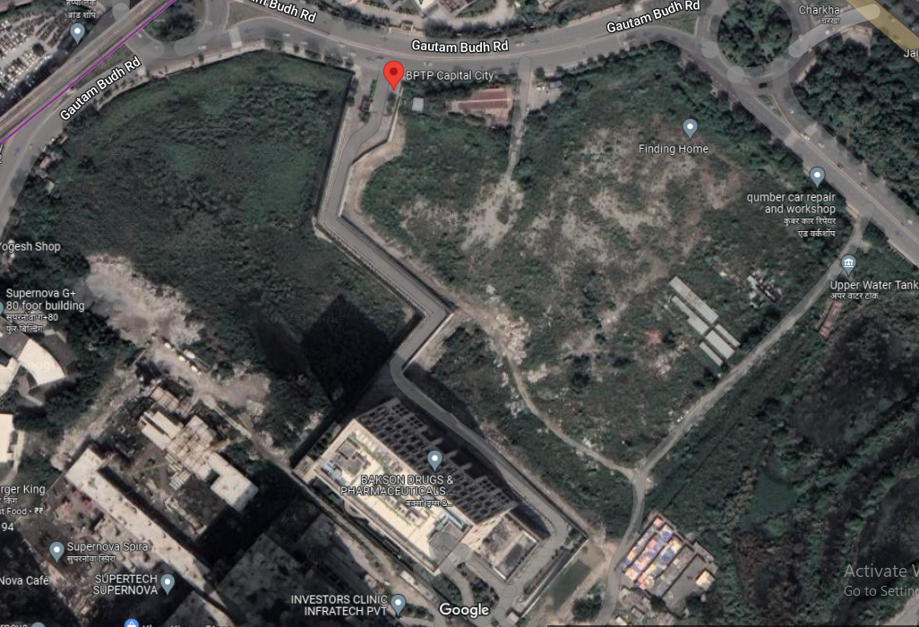

ENCLOSURE: IV - REFERENCES ON PRICE TREND OF THE SIMILAR RELATED PROPERTIES AVAILABLE ON PUBLIC DOMAIN

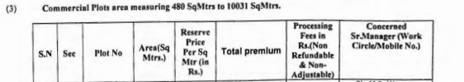
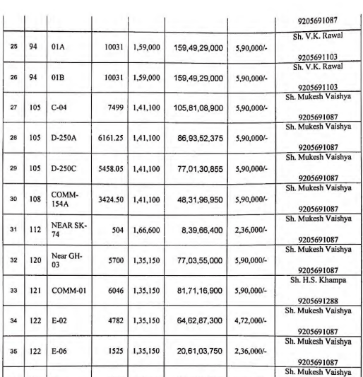

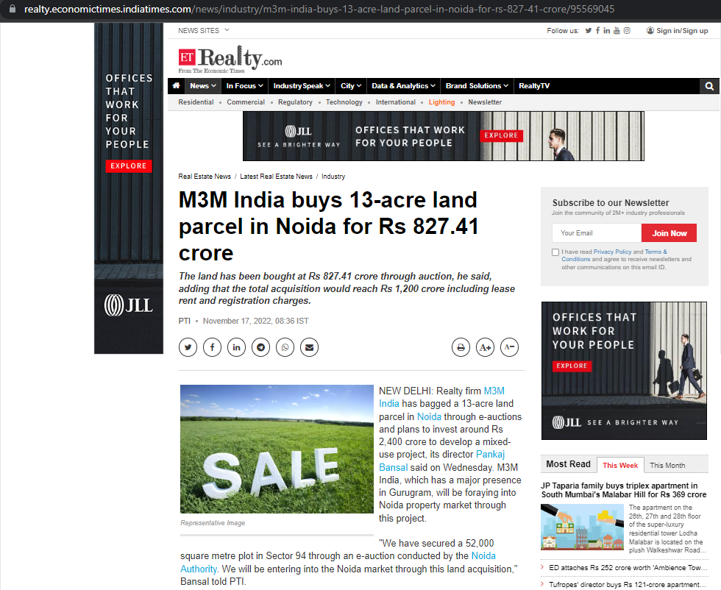

ENCLOSURE: V – COPY OF CIRCLE RATE

