REPORT FORMAT: CL-1 | Version: 1.0_2018

FILE No.: VIS (2022-23)-PL492-395-685 Date: 12-12-2022

- CERTIFICATE NAME: Cost Vetting Certificate for expansion of Ductile Cast Iron Foundry having capacity of 16,200 MTPA which is proposed to be installed at Raturia Industrial Area, Angadpur, Durgapur, District East Burdwan, West Bengal 713215.
- PREPARED FOR ORGANIZATION: State Bank of India, IFB Branch, Kolkata
- BORROWER COMPANY’S NAME: M/s. Shakambhari Overseas Trades Private Limited
- ASSET TYPE: Machines for manufacturing of Ductile Cast Iron Casting for automobile industry.
- CURRENT LOCATION OF THE MACHINES: Proposed to be installed at Raturia Industrial Area, Angadpur, Durgapur, District East Burdwan, West Bengal 713215.
TO WHOMSOEVER IT MAY CONCERN

S. NO. | PARTICULARS | DESCRIPTION
1. | Date of Survey | Survey was not conducted as machines are proposed to be installed at site. Assessment has been done based upon the list of machines provided to us.
2. | Date of Certificate | 12-12-2022
3. | Documents provided for perusal | Copy of quotations of machines proposed to be installed
4. | Current Location of the Machines | Proposed to be installed at Raturia Industrial Area, Angadpur, Durgapur, District East Burdwan, West Bengal 713215.
5. | Borrowing Company | M/s. Shakambhari Overseas Trades Private Limited
6. | Type of Asset | Machines for manufacturing of Ductile Cast Iron Casting for automobile industry
7. | Type of Assessment | Cost vetting
8. | Scope of Assessment | Cost vetting of the new machines, equipment which is proposed to be installed.
9. | Nature of Machinery | Machines for manufacturing of Ductile Cast Iron Casting for automobile industry.
10. | Year of Manufacturing | Plant is yet to be installed.
11. | Total Purchase Cost | Proposed to be purchase at a price of Rs. 49.07 Crore as per the information provided to us by the borrower company.
12. | Current Estimated Market Value | The range of such type of plant & machineries has been verified as per the information available on public domain. Transaction (sale/purchase) of similar kind of foundries has been taken into consideration with respect to their production capacity and further compared them with the proposed subject plant while arriving at the conclusion.  The proposed subject plant is having a capacity of 16,200 MTPA and cost of machines claimed corresponding to it is Rs 49.07 Crore i.e., Rs. 30,290/- per MTPA.  As per our market research cost for setting up ductile cast iron foundry varies within the range of Rs. 28,000/- per MTPA – Rs. 30,000/- per MTPA which majorly depends upon the brand value of the machines.  According to our observations, the rate as per the list of machinery and their total purchase price provided to us by the company/ bank is reasonable though there is still some scope of negotiation in it.  Details of comparable for doing analysis is attached below.
13. | Condition of Machines | Not Applicable, as the machines are yet to be installed.

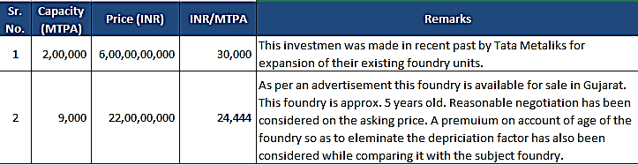

OBSERVATIONS:

- We have been provided with the copy of quotations with the cost of machines/ equipment to be purchased/ installed by the borrower company.
- We have done market research in order to gather price for setting up similar kind of foundry through which we have found that price quoted for the subject machines are reasonable with minor scope of negotiation.
- Based on the information provided by the subject company (M/s. Shakambhari Overseas Trades Private Limited) and enquiries made by us in the open market and references found in the public domain and quotations for similar machines/items, it is certified that the total cost for setting up plants of similar specification should be around Rs. 47.00 Crore. Therefore, the total purchase price of Rs. 49.07 Crore mentioned in the machinery details shared by the company (as per the quotations provided to us by the company) appears to be roughly reasonable in our opinion as there is still some scope of negotiation in them.

Disclaimer:

  - We can’t comment about the current status of machines whether these are purchased, installed or in transit. This cost vetting is done only on the basis of Quotations, Bills and Purchase Orders provided to us by the company and we don’t recommend any sort of recommendation in our Certificate.
  - There can be variation in the estimated price if the specification & make of any items procured is different from the list provided to us during assessment.
  - The estimated cost verification is made based on the third party information which has been replied upon in good faith.
  - The estimated price may vary at the time of actual procurement because of change in prices in the market for such kind of machinery/items for which we will not have any control. The cost vetting is only limited to the date of Certificate issued. We do not assume any responsibility in change of prices of the said machinery/items after this date.
  - This certificate doesn’t include any work related to drawing, design, sketch plan, procurement of the machines.
  - Ownership and other legal point of view in respect of the asset is not considered in this report as same is out of scope of this certificate.
  - This certificate is made at the request of the Bank.

For R.K Associates Valuers & Techno FOR INTERNAL USE Engineering Consultants (P) Ltd.
TYPED BY: Er. Gaurav Sharma
REVIEWED BY: Er. Mansa Upmanyu

ANNEXURE: - I (LIST OF MACHINES PROVIDED BY CLIENT)

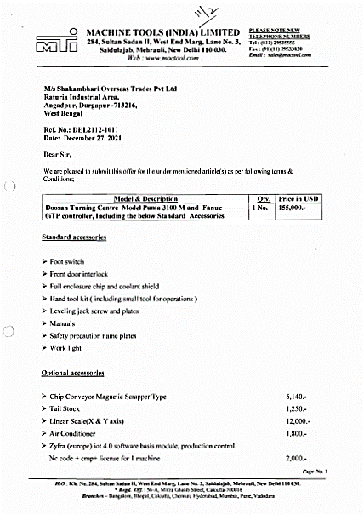

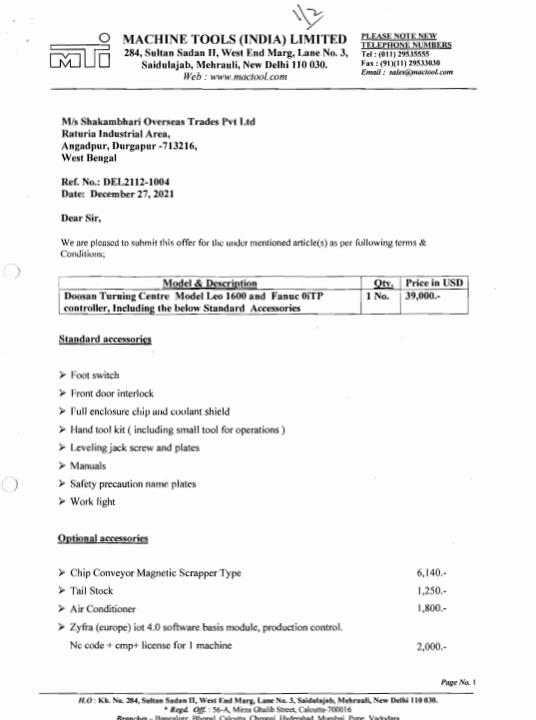

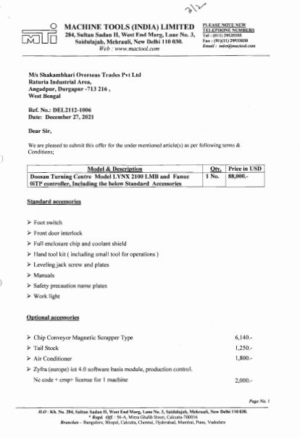

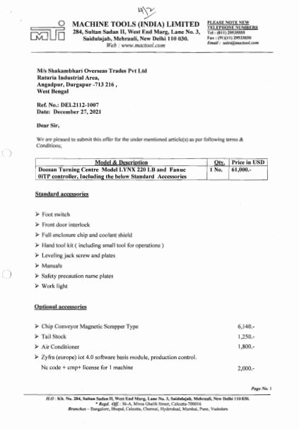

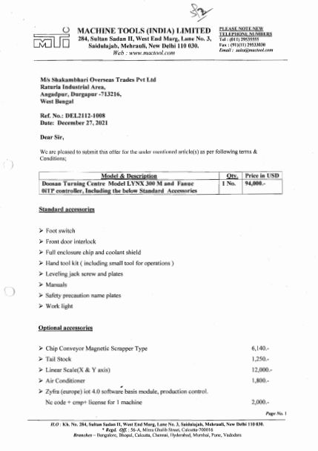

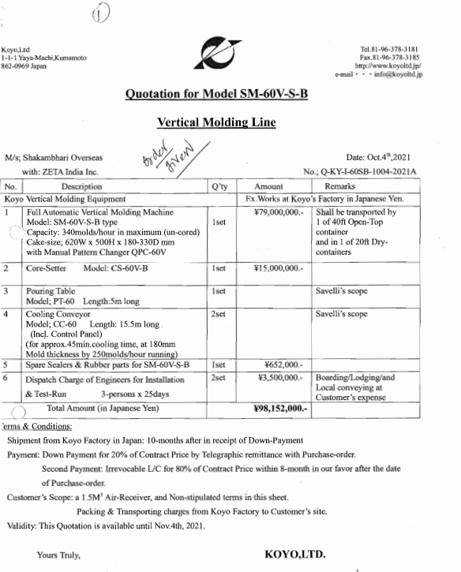

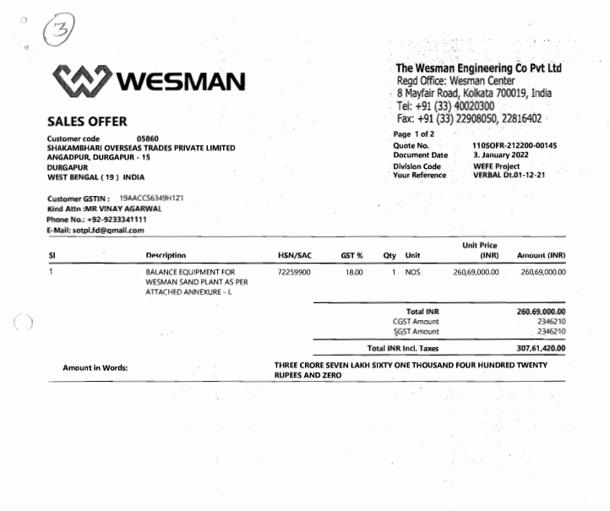

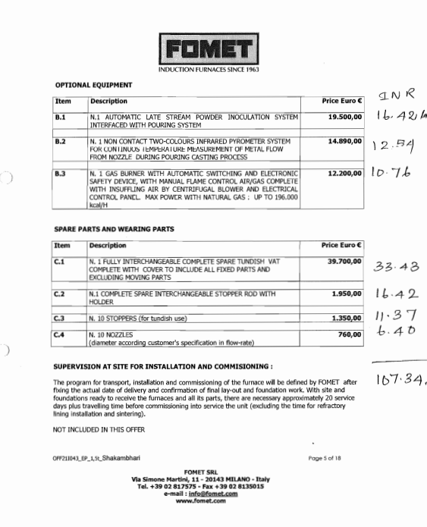

ANNEXURE: - II (REFERENCES ON PRICE TREND OF THE SIMILAR RELATED ASSETS AVAILABLE ON PUBLIC DOMAIN)

