**REPORT FORMAT:** CL-1 | Version: 1.0_2018

# FILE No.: VIS(2022-23)-PL492-395-685 Date: 12-12-2022

* **CERTIFICATE NAME:** Cost Vetting Certificate of the Project cost for proposed expansion of second line for manufacturing of the ductile iron cast auto parts and CNC machine by the company for the proposed manufacturing capacity of 16200 TPA for ductile iron cast auto parts
* **PREPARED FOR ORGANIZATION:** State Bank of India, IFB Branch, Kolkata
* **BORROWER COMPANY’S NAME:** M/s. Shakambhari Overseas Trades Private Limited
* **ASSET TYPE**: Machines & Infrastructure required for manufacturing of Ductile Cast Iron Casting for automobile industry.
* **CURRENT LOCATION OF THE MACHINES:** Proposed to be installed at Raturia Industrial Area, Angadpur, Durgapur, District East Burdwan, West Bengal - 713215.

**TO WHOMSOEVER IT MAY CONCERN**

|  |  |  |
| --- | --- | --- |
| **S. NO.** | **PARTICULARS** | **DESCRIPTION** |
|  | Date of Survey | Survey was not conducted as all the assets is proposed to be installed/ built at the site. |
|  | Date of Certificate | 12.12.2022 |
|  | Documents provided for perusal | 1. TEV Report 2. Copy of quotations of machines proposed to be installed |
|  | Current Location of the Machines | Proposed to be installed at Raturia Industrial Area, Angadpur, Durgapur, District East Burdwan, West Bengal 713215. |
|  | Borrowing Company | M/s. Shakambhari Overseas Trades Private Limited |
|  | Type of Asset | Machines & Infrastructure required for manufacturing of Ductile Cast Iron Casting for automobile industry. |
|  | Type of Assessment | Cost vetting |
|  | Scope of Assessment | Project cost vetting of second line for manufacturing of the ductile iron cast auto parts and CNC Machines |
|  | Nature of Machinery | Machines for manufacturing of Ductile Cast Iron Casting for automobile industry. |
|  | Year of Manufacturing | Plant is yet to be installed. |
|  | Total Project Cost | Proposed Project Cost is Rs. 75.57 Crore as per the TEV Report. |
|  | Approved Cost vetted by RKA | **Rs.70.15 Crores** |
|  | Approved cost basis | Based on market rates and documents, information submitted by the company. For detailed justification please refer the calculation sheets below. |

**SUMMARY SHEET**

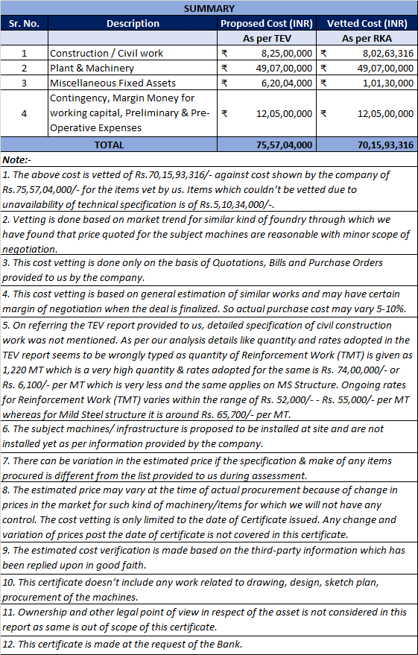

**Item 1: Civil & Construction Work**

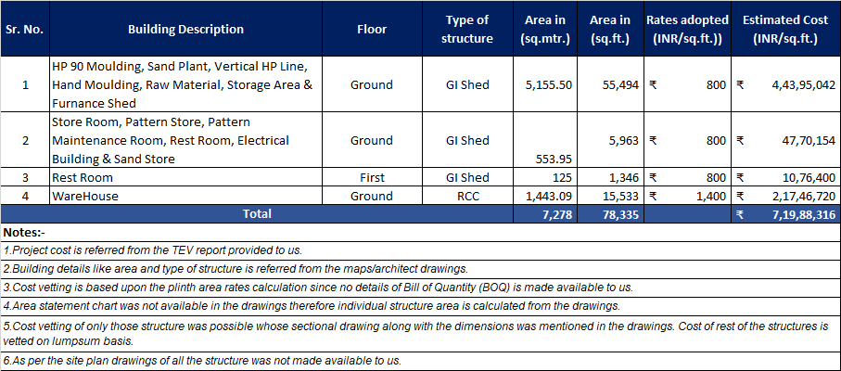

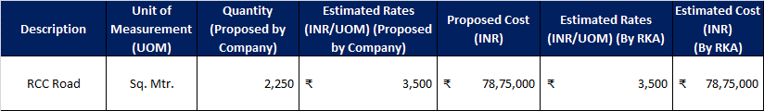



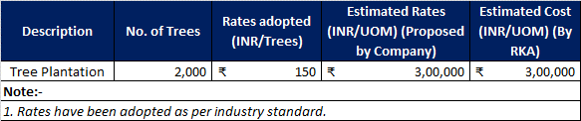

**Item 2 : Plant & Machinery**

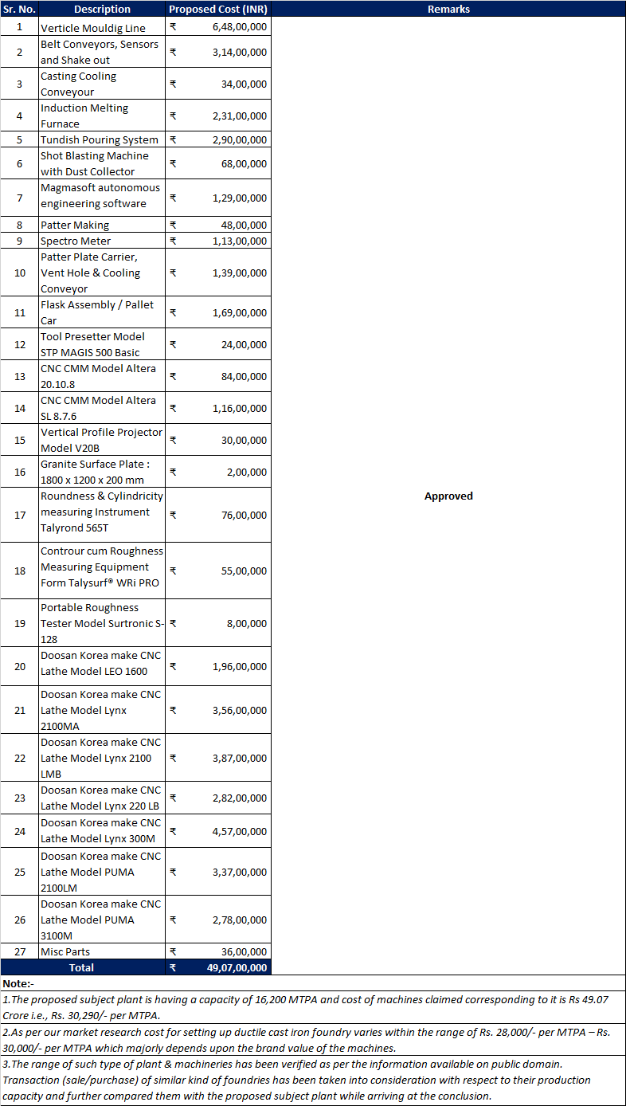

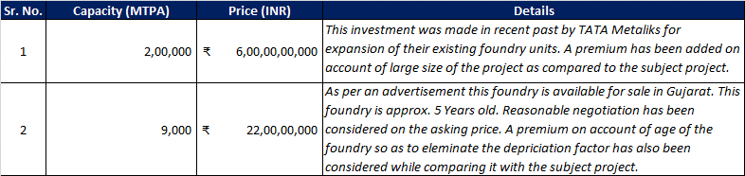

**Item 3: Miscellaneous Fixed Assets**

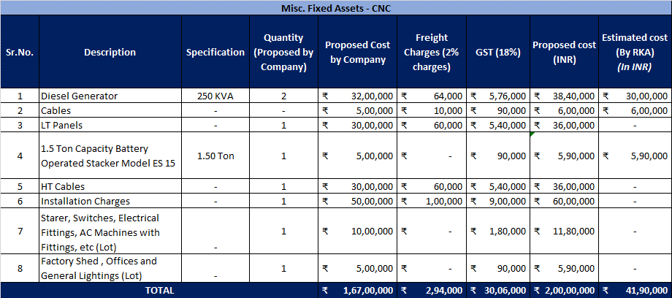

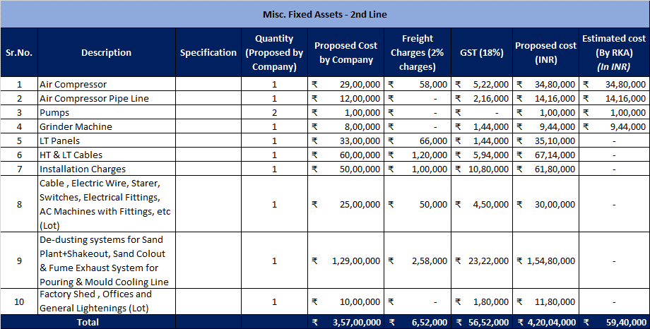

**NOTES:**

1. Some of the items above couldn’t be vetted because of unavailablity of technical specifications of the items.
2. The items which couldn’t be vetted is of Rs.5,10,34,000/- as shown by the company in Miscellaneous Fixed Assets.

**Item 4: Contingency, Margin Money for working capital, Preliminary & Pre-Operative Expenses**

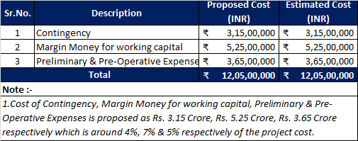

**For INTERNAL USE**

**For R.K Associates Valuers & T*YPED BY:*** *Er. Gaurav Sharma*

**Techno Engineering Consultants (P) Ltd *REVIEWED BY:*** *Er. Manas Upmanyu*

# ANNEXURE: - I (LIST OF MACHINES PROVIDED BY CLIENT)

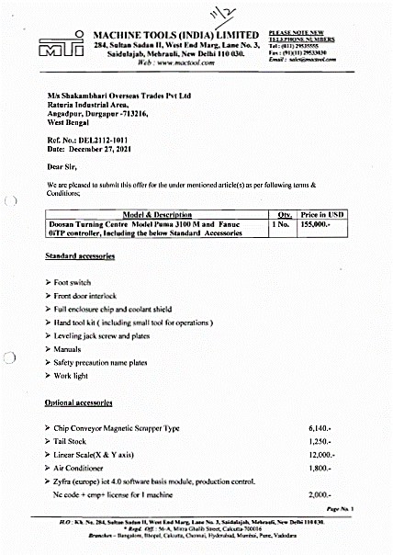

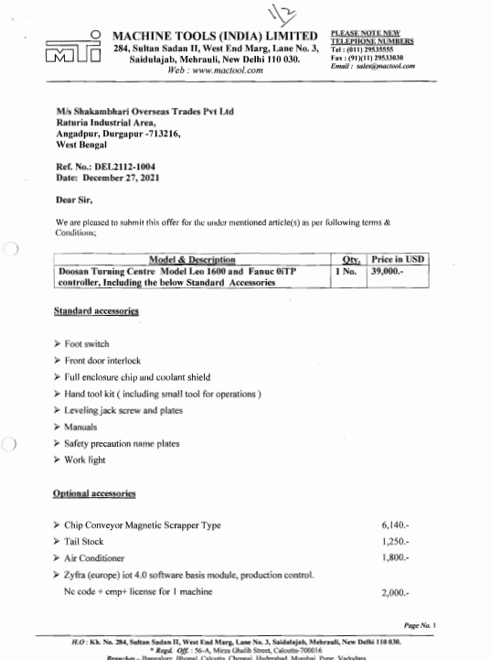

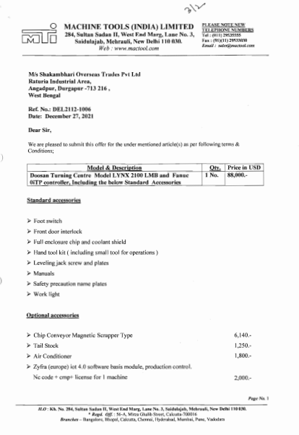

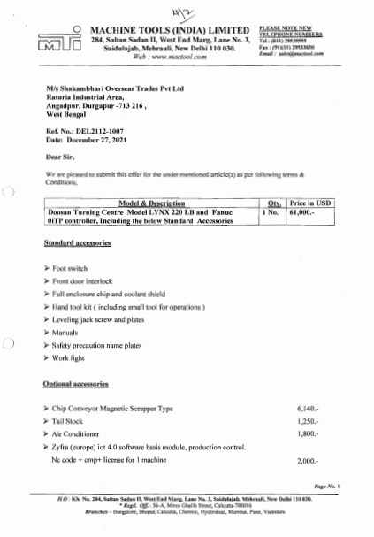

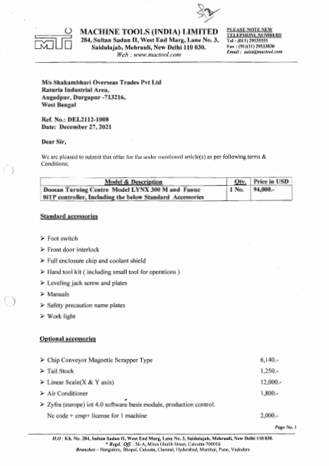

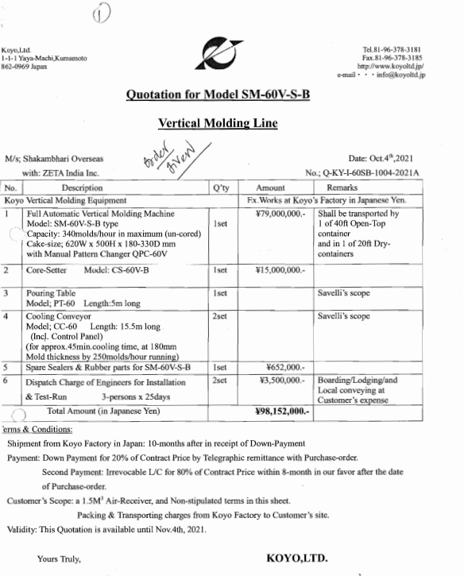

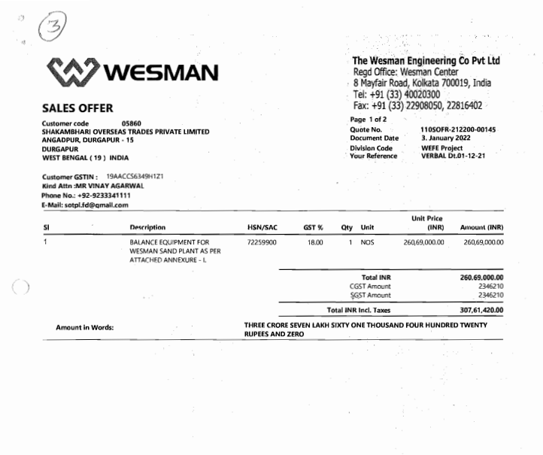

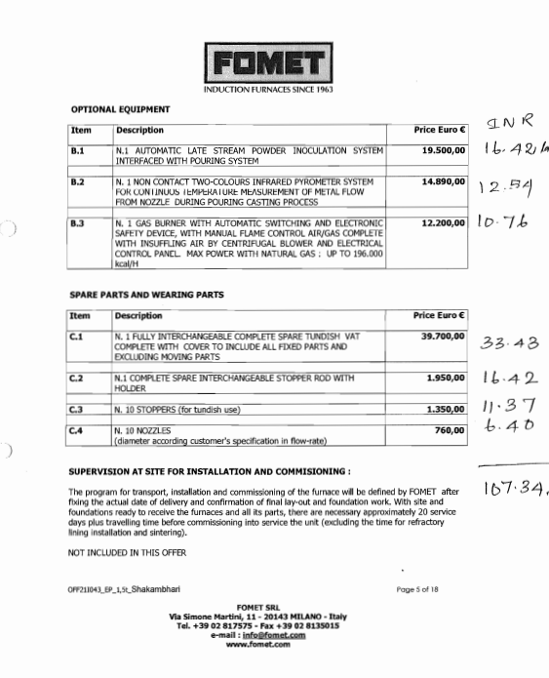

**ANNEXURE: - II (REFERENCES ON PRICE TREND OF THE SIMILAR RELATED ASSETS AVAILABLE ON PUBLIC DOMAIN)**

