**REPORT FORMAT:** CL-1 | Version: 1.0_2018

# FILE No.: VIS(2022-23)-PL492-395-685 Date: 12-12-2022

* **CERTIFICATE NAME:** Cost Vetting Certificate of the Project cost for proposed expansion of second line for manufacturing of the ductile iron cast auto parts and CNC machine by the company for the proposed manufacturing capacity of 16200 TPA for ductile iron cast auto parts
* **PREPARED FOR ORGANIZATION:** State Bank of India, IFB Branch, Kolkata
* **BORROWER COMPANY’S NAME:** M/s. Shakambhari Overseas Trades Private Limited
* **ASSET TYPE**: Machines & Infrastructure required for manufacturing of Ductile Cast Iron Casting for automobile industry.
* **CURRENT LOCATION OF THE MACHINES:** Proposed to be installed at Raturia Industrial Area, Angadpur, Durgapur, District East Burdwan, West Bengal - 713215.

**TO WHOMSOEVER IT MAY CONCERN**

|  |  |  |
| --- | --- | --- |
| **S. NO.** | **PARTICULARS** | **DESCRIPTION** |
|  | Date of Survey | Survey was not conducted as all the assets is proposed to be installed/ built at the site. |
|  | Date of Certificate | 12.12.2022 |
|  | Documents provided for perusal | 1. TEV Report 2. Copy of quotations of machines proposed to be installed |
|  | Current Location of the Machines | Proposed to be installed at Raturia Industrial Area, Angadpur, Durgapur, District East Burdwan, West Bengal - 713215. |
|  | Borrowing Company | M/s. Shakambhari Overseas Trades Private Limited |
|  | Type of Asset | Machines & Infrastructure required for manufacturing of Ductile Cast Iron Casting for automobile industry. |
|  | Type of Assessment | Cost vetting |
|  | Scope of Assessment | Project cost vetting of second line for manufacturing of the ductile iron cast auto parts and CNC Machines |
|  | Nature of Machinery | Machines for manufacturing of Ductile Cast Iron Casting for automobile industry. |
|  | Year of Manufacturing | Plant is yet to be installed. |
|  | Total Project Cost | Proposed Project Cost is Rs.75.62 Crores as per the TEV Report. |
|  | Approved Cost vetted by RKA | **~Rs.75.17 Crores** |
|  | Approved cost basis | Based on market rates and documents, information submitted by the company. For detailed justification please refer the calculation sheets below. |

**SUMMARY SHEET**



**Item 1: Civil & Construction Work**

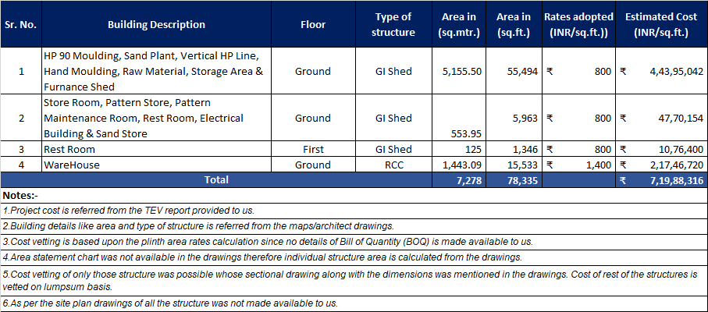

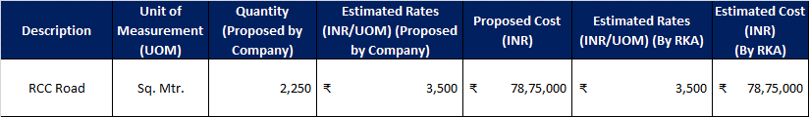



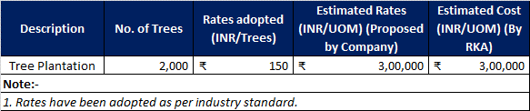

**Item 2 : Plant & Machinery**

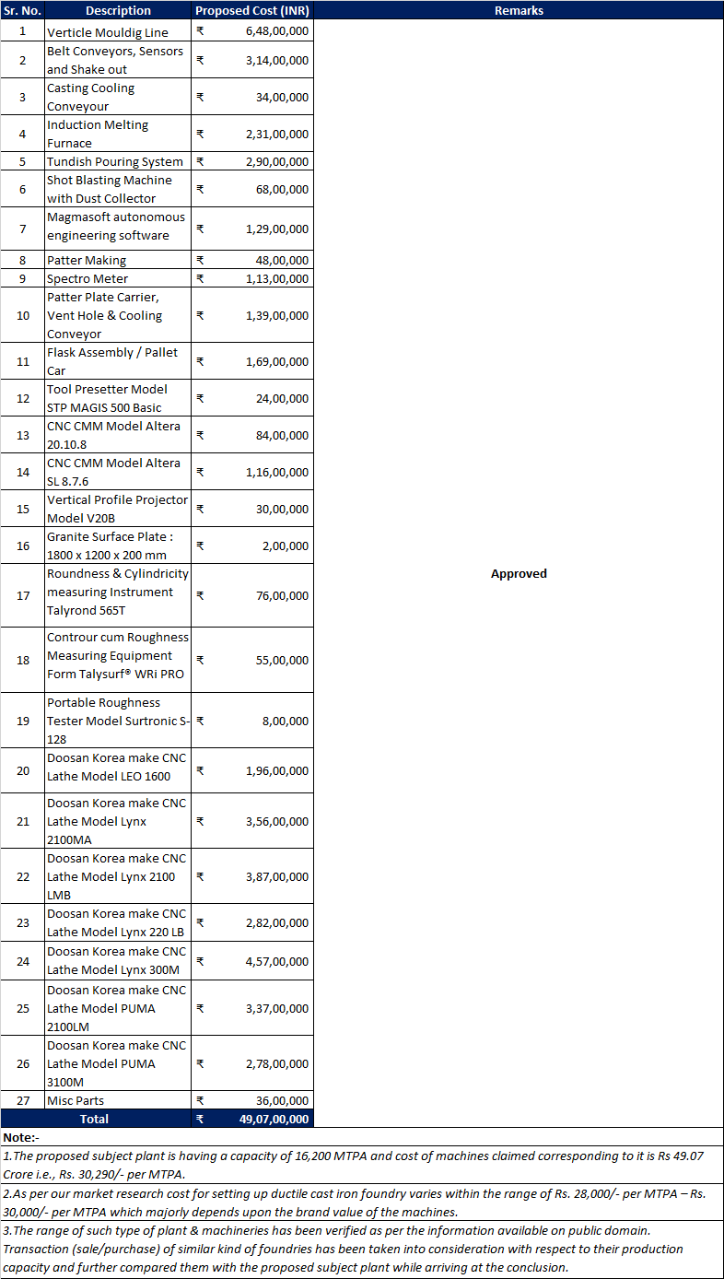

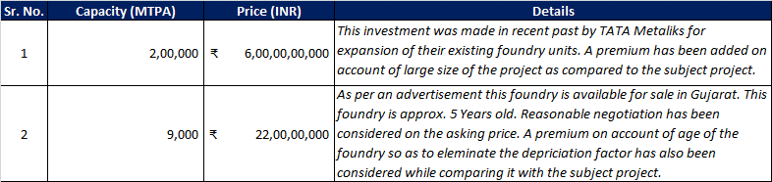

**Item 3: Miscellaneous Fixed Assets**



**NOTES:**

* 1. Cost related to LT panels, HT cables, installation charges, electric wires, starter switches, electrical fittings, AC machines with fittings, factory shed, offices and general lightnings, etc. shown above are taken on lumpsum based on the details that the company is expanding its captive power station from 12 MW to 20 MW and installing 132 kV sub-station as per TEV report. The above cost also includes the cost of transformer. It is assumed that the company will install minimum 20 MVA or two 20 MVA transformers as per Industry standard.
  2. The technical specifications of items such as LT panels, HT cables, installation charges, electric wires, starter switches, electrical fittings, AC machines with fittings, factory shed, offices and general lightnings, etc. are not provided to us on request, hence the only basis for cost assessment of these electrical items is expansion of captive power station from 12 MW to 20 MW and installation of 132 kV sub-station as per TEV report and our further assumptions and basis for its transformer configuration. It is a lumsum assessment and not an item wise assessment.

**Item 4: Contingency, Margin Money for working capital, Preliminary & Pre-Operative Expenses**



**For INTERNAL USE**

**For R.K Associates Valuers & T*YPED BY:*** *Er. Gaurav Sharma*

**Techno Engineering Consultants (P) Ltd *REVIEWED BY:*** *Er. Manas Upmanyu*

**Engineering Team**

# ANNEXURE: - I (LIST OF MACHINES PROVIDED BY CLIENT)

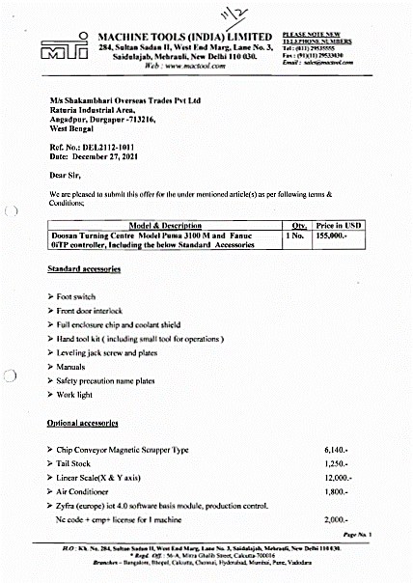

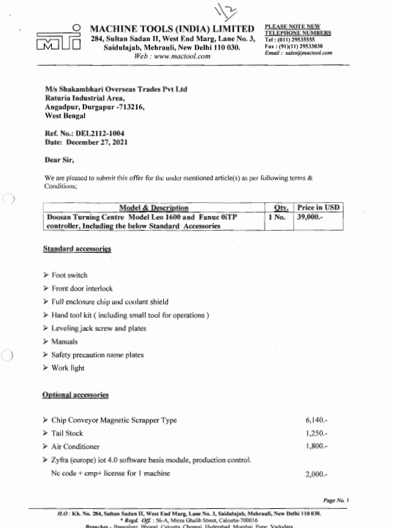

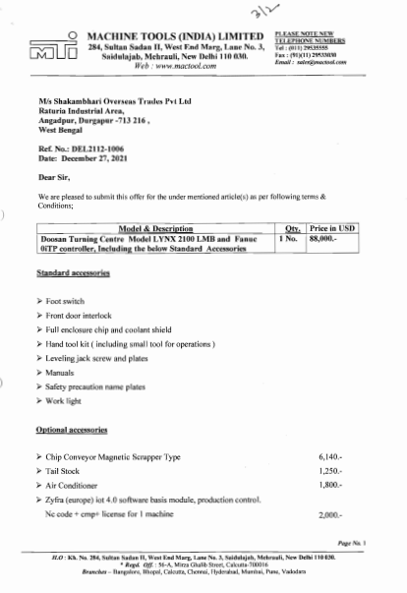

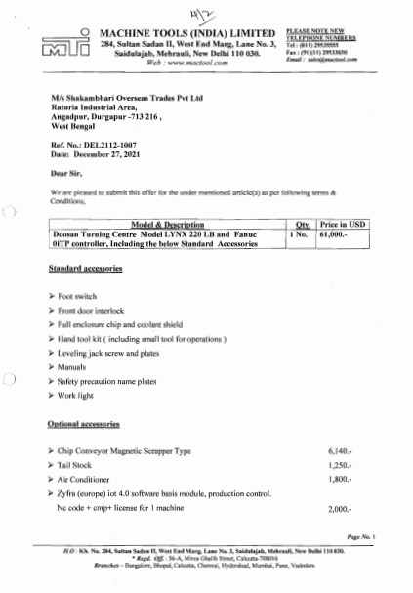

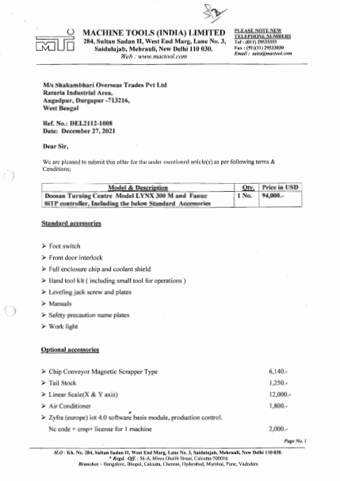

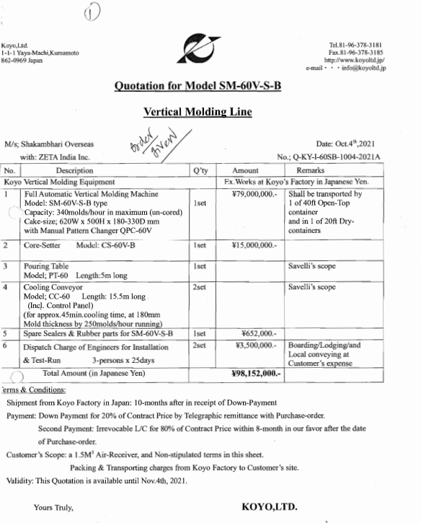

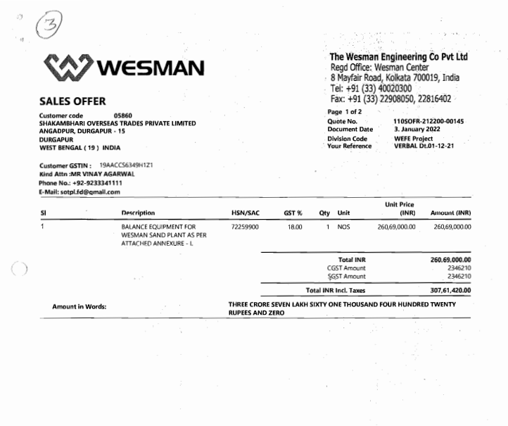

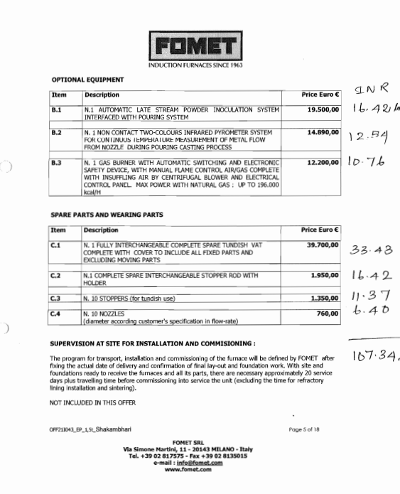

**ANNEXURE: - II (REFERENCES ON PRICE TREND OF THE SIMILAR RELATED ASSETS AVAILABLE ON PUBLIC DOMAIN)**

