**REPORT FORMAT:** V-L2 (Medium - SBI) | Version: 12.0\_Nov.2022

**CASE NO. VIS (2022-23)-PL495-398-689 Dated: 11.01.2023**

**FIXED ASSETS VALUATION REPORT**

**OF**

|  |  |
| --- | --- |
| **NATURE OF ASSETS** | **LAND & BUILDING** |
| **CATEGORY OF ASSETS** | **RESIDENTIAL** |
| **TYPE OF ASSETS** | **RESIDENTIAL HOUSING COMPLEX** |

**SITUATED AT**

**M/S. MCPI PRIVATE LIMITED, J.L. NO. 194, 195, MOUZA-BISWANATHDATTERCHAK, RATNAGUDARCHAK, DISTRICT-MIDNAPORE, WEST BENGAL**

**REPORT PREPARED FOR**

**STATE BANK OF INDIA, CCG BRANCH, KOLKATA, WEST BENGAL**

***\*\*Important - In case of any query/ issue or escalation you may please contact Incident Manager***

***at valuers@rkassociates.org. We will appreciate your feedback in order to improve our services.***

***NOTE: As per IBA & Bank’s Guidelines please provide your feedback on the report within 15 days of its submission after which report will be considered to be correct.***

***Valuation Terms of Services & Valuer’s Important Information are available at*** [***www.rkassociates.org***](http://www.rkassociates.org) ***for reference.***

|  |  |
| --- | --- |
| **PART A** | **SNAPSHOT OF THE ASSET/ PROPERTY UNDER VALUATION** |

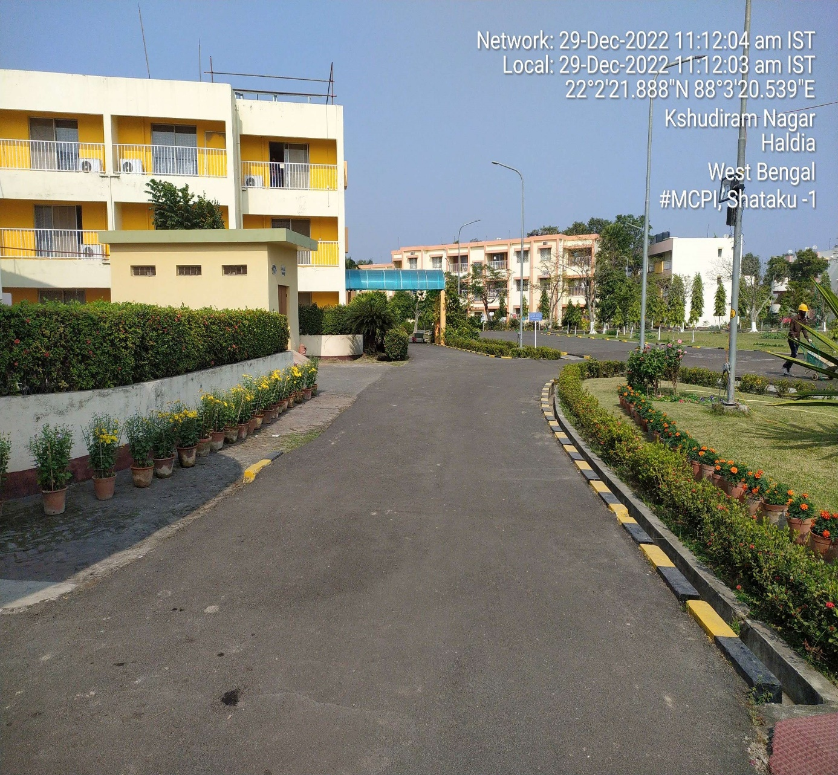

**SITUATED AT**

**M/S. MCPI PRIVATE LIMITED, J.L. NO. 194, 195, MOUZA-BISWANATHDATTERCHAK, RATNAGUDARCHAK, DISTRICT-MIDNAPORE, WEST BENGAL**

|  |  |
| --- | --- |
| **PART B** | **REPORT AS PER SBI FORMAT** |

|  |  |
| --- | --- |
| **Name & Address of Branch** | State Bank of India, CCG Branch, Kolkata, West Bengal |
| **Name of Customer (s)/ Borrower Unit** | M/s. MCPI Private Limited |
| **Work Order No. & Date** | Work order no. CCGK/AMT-II/2022-23/271 dated 06-10-2022 |

|  |  |  |  |  |
| --- | --- | --- | --- | --- |
| **S.NO.** | **CONTENTS** | **DESCRIPTION** | | |
|  | **INTRODUCTION** | | | |
|  | Name of Property Owner | M/s. MCPI Private Limited *(as per copy of Electricity Bill & Information shared during site survey)* | | |
| Address & Phone Number of the Owner | Registered Office: Bengal Eco Intelligent Park , Tower-1, Block-EM, Plot No-3, Salt lake City Sector-V, 3rd Floor, Kolkata, W.B.-700091 | | |
|  | Purpose of the Valuation | For Periodic Re-valuation of the mortgaged property | | |
|  | Date of Inspection of the Property | 29 December 2022 | | |
| Property Shown By | **Name** | **Relationship with Owner** | **Contact Number** |
| Mr. Sunil Pradhan | Owner's representative | +91 98317 80790 |
|  | Date of Valuation Report | 11 January 2023 | | |
|  | Name of the Developer of the Property | Purchased already commissioned plant | | |
| Type of Developer | --- | | |

|  |  |  |  |  |  |  |  |  |  |  |  |  |  |  |  |  |  |  |  |
| --- | --- | --- | --- | --- | --- | --- | --- | --- | --- | --- | --- | --- | --- | --- | --- | --- | --- | --- | --- |
|  | **PHYSICAL CHARACTERISTICS OF THE PROPERTY** | | | | | | | | | | | | | | | | | | |
|  | **BRIEF DESCRIPTION OF THE PROPERTY UNDER VALUATION**  This value estimation is opined for the township of M/s MCPI Private Limited situated at the aforesaid address. As per the copy of lease deed the subject property is purchased via lease deed no. 3870 dated 16th November 1999 having area of 25.116 acre. Details of lease deeds are attached below :-   |  |  |  |  |  |  | | --- | --- | --- | --- | --- | --- | | **Lessor** | **Lessee** | **Land Area**  **(In Acre)** | **Lease Period**  **(In Years)** | **Premium**  **(In Rs.)** | **Rent**  **(per Acre)** | | The Government of State of West Bengal | MCC PTA India Corporation Private Limited | 25.116 | 90 | 52,743,600 | 21,00,000 |   The land was allotted for a period of 90 years starting from 16th November 1999. The land was allotted for the construction of Residential Housing Complex used by Officers & Employed in the PTA Project. As per copy of TIR dated 14-11-2022, the ownership of land lies with M/s MCPI Private Limited.  As per lease deed clause no. 22, “ Lessee may, in order to secure any loan or financial facility obtained mortgage, or otherwise create any third party rights in or to its lease interest in the demised land in favour of any financial intitution(s) and/or bank(s), established by or in accordance with law, and person(s) other than financial institutions or banks, provided that for certain of third party rights in the leasehold interest in favour of any person(s) other than bank(s) and /or financial institution(s) the lessee have to obtain prior permission of the lessor which permission shall be withheld or delayed unreasonably.  As per information provided, it was acquired by The Chatterjee Group (TCG) in year 2016. Later the name changed to M/s MCPI Private Limited.  The subject property comprises different building category named as Type-A, Type-B, Type-C, Type-E, Type-EX, Type-SA & Type-SB and other supporting buildings having ground floor to second floor building. Details of the building structure as per details shared management and physical measurement during the time of site visit is attached below: -   |  |  |  |  |  |  | | --- | --- | --- | --- | --- | --- | | **S. No.** | **Building Name** | **Building Type** | **Total Floor area**  **(In sqm)** | **Height**  **(In mtr)** | **No. of Floor** | | 1 | Dormitory | Dormitory Block 36 Rooms | 1,317 | 10 | 3 | | 2 | Common House | Common House Block | 1,152 | 8.60 & 12.38 | 2 | | 3 | Guest House | Guest House Block 12 Rooms | 999 | 10 | 3 | | 4 | C-1 | C Type Flat 12 Flats in the Block | 920 | 10 | 3 | | 5 | C-2 | 920 | 10 | 3 | | 6 | E-1 | 920 | 10 | 3 | | 7 | E-2 | 920 | 10 | 3 | | 8 | E-3 | 920 | 10 | 3 | | 9 | SB-1 | SB Type Flat 06 Flats in the Block | 798 | 10 | 3 | | 10 | SB-2 | SB Type Flat 06 Flats in the Block | 798 | 10 | 3 | | 11 | SA-1 | SA Type Duplex Flat 03 Flats in the Block | 648 | 7 | 2 | | 12 | SA-2 | 648 | 7 | 2 | | 13 | SA-3 | 648 | 7 | 2 | | 14 | SA-4 | 648 | 7 | 2 | | 15 | A-1 | 507 | 7 | 2 | | 16 | A-2 | 507 | 7 | 2 | | 17 | A-3 | 507 | 7 | 2 | | 18 | A-4 | A Type Duplex Flat 03 Flats in the Block | 507 | 7 | 2 | | 19 | EX-1 | EX Type Bungalow | 340 | 7 | 2 | | 20 | EX-2 | 340 | 7 | 2 | | 21 | B-1 | B Type Flat 06 Flats in the Block | 310 | 10 | 3 | | 22 | B-2 | B Type Flat 04 Flats in the Block | 214 | 10 | 2 | | 23 | DEG Room & Sub-station | Generator Room & Electrical Sub-station | 193 | 5 | 1 | | 24 | Laundry | Laundry Block | 126 | 4 | 1 | | 25 | Rooms of Swimming Pool | Plant, Locker Rooms, Toilets & Bathing Room | 125 | 3.60 & 4.80 | 1 | | 26 | Pump & Main Room | Pump Room & Maintenance Room | 91 | 5 | 1 | | 27 | Locker Room | Locker Room & Toilet at Soccer Ground | 91 | 4 | 1 | | 28 | Fuel Store | Fuel Store Room | 64 | 3 | 1 | | 29 | Store | General Store Room | 48 | 4 | 1 | | 30 | PABX Room | PABX & Server Room | 40 | 7 | 2 | | 31 | Document Room | Finance Document  Room | 40 | 3 | 1 | | 32 | Drivers' Room | Drivers' Rest Room | 21 | 4 | 1 | | 33 | Security Office | Security Room &  Toilet at Main Gate | 12 | 4 | 1 | | 34 | Goomty | Security Outpost | 2 | 3 | 1 | | **Total** | | | **16,341** |  |  |   Haldia is a town and a municipality in Purba Medinipur district in the Indian state of West Bengal. It is located around 120 km south-west of the state capital, Kolkata. Haldia is well connected through both rail and road; it lies on the railway line connecting Kharagpur to Howrah. This Integrated Petrochemicals Plant is located at Post Box No. 12, Durgachak, Haldia, Purba Medinipur, West Bengal - 721602, India. The location of the Plant is around 60 Km from Purba Medinipur District and can be easily reached in just one an hour via Road. Nearest Railway station is Haldia Railway Station and nearest Airport is Netaji Subhash Chandra Bose International Airport (Kolkata) which is at a distance of 130 km from Plant by Road.  Valuation is conducted of the property as shown on the site by the customer of which photographs is also attached with the report and same is to be considered in this report irrespective of any details taken from any documents which might have been updated, changed or incorrect. | | | | | | | | | | | | | | | | | | |
|  | **Location attribute of the property** | | | | | | | | | | | | | | | | | | |
|  | Nearby Landmark | | Indian Coast Guard Residential Apartment | | | | | | | | | | | | | | | | |
|  | Postal Address of the Property | | M/S. MCPI Private Limited, J.L. No. 194, 195, Mouza-Biswanathdatterchak, Ratnagudarchak, District-Midnapore, West Bengal | | | | | | | | | | | | | | | | |
|  | Type of Land | | Solid Land/ on road level | | | | | | | | | | | | | | | | |
|  | Independent access/ approach to the property | | Clear independent access is available | | | | | | | | | | | | | | | | |
|  | Google Map Location of the Property with a neighborhood layout map | | Enclosed with the Report | | | | | | | | | | | | | | | | |
| Coordinates or URL: 22°02'22.2"N 88°03'19.8"E | | | | | | | | | | | | | | | | |
|  | Details of the roads abutting the property | | | | | | | | | | | | | | | | | | |
|  | 1. Main Road Name & Width | | Municipal Unnamed road | | | | | | | | | | | | | Approx. 25 ft. wide | | | |
|  | 1. Front Road Name & width | | Municipal Unnamed road | | | | | | | | | | | | | Approx. 20 ft. wide | | | |
|  | 1. Type of Approach Road | | Bituminous Road | | | | | | | | | | | | | | | | |
|  | 1. Distance from the Main Road | | 3.32 km Kolaghat-Haldia road | | | | | | | | | | | | | | | | |
|  | Description of adjoining property | | All adjacent properties are used for residential purpose | | | | | | | | | | | | | | | | |
|  | Plot No. / Survey No. | | Many surveys number. Please refer to annexure attached | | | | | | | | | | | | | | | | |
|  | Zone/ Block | | --- | | | | | | | | | | | | | --- | | | |
|  | Sub registrar | | Haldia Development Authority | | | | | | | | | | | | | | | | |
|  | District | | Midnapore | | | | | | | | | | | | | | | | |
|  | Any other aspect | | Valuation is done for the property found as per the information given in the copy of documents provided to us and/ or confirmed by the owner/ owner representative to us at site. | | | | | | | | | | | | | | | | |
| 1. List of documents produced for perusal | | **Documents Requested** | | | | **Documents Provided** | | | | | | | | | | **Documents Reference No.** | | |
| Total **05** documents requested. | | | | Total **02** documents provided | | | | | | | | | | Total **02** documents provided | | |
| Property Title document | | | | Lease Deed | | | | | | | | | | Dated-: 16/11/1999 | | |
| Copy of TIR | | | | Copy of TIR | | | | | | | | | | Dated: 14-11-2022 | | |
| Approved Map | | | | NA | | | | | | | | | | --- | | |
| Completion Certificate | | | | NA | | | | | | | | | | --- | | |
| Last paid Electricity Bill | | | | Last paid Electricity Bill | | | | | | | | | | Dated: 01-12-2022 | | |
| Possession Letter | | | | Possession Letter | | | | | | | | | | Dated: 16-11-1999 | | |
| 1. Documents provided by | | **Owner's representative** | | | | | | | | | | | | | | | | |
| **Name** | | | | **Relationship with Owner** | | | | | | | | | | **Contact Number** | | |
| Mr. Vinay  Jhunjhunwala | | | | Company’s  Representative | | | | | | | | | | +91 98303 74479 | | |
| Y:\Abhinav Chaturvedi\Check.png☒ | Identified by owner’s representative | | | | | | | | | | | | | | | |
| ☒Y:\Abhinav Chaturvedi\Check.png | Done from the name plate displayed on the property | | | | | | | | | | | | | | | |
| 1. Type of Survey | | Full survey (inside-out with approximate measurements & photographs). | | | | | | | | | | | | | | | | |
| 1. Is property clearly demarcated by permanent/ temporary boundary on site | | Yes demarcated properly | | | | | | | | | | | | | | | | |
| 1. Is the property merged or colluded with any other property | | No. It is an independent single bounded property | | | | | | | | | | | | | | | | |
| ------- | | | | | | | | | | | | | | | | |
| 1. City Categorization | | Tehsil | | | | | | | | | | | | | Semi Urban | | | |
| 1. Characteristics of the locality | | Ordinary | | | | | | | | | | | | | Within urban developing zone | | | |
| 1. Property location classification | | Road Facing | | | | | | | None | | | | | | | | | None |
| 1. Property Facing | | South Facing | | | | | | | | | | | | | | | | |
|  | **Area description of the Property**  *Also please refer to Part-B Area description of the property. Area measurements considered in the Valuation Report is adopted from relevant approved documents or actual site measurement whichever is less, unless otherwise mentioned. Verification of the area measurement of the property is done only based on sample random checking.* | | **Land** | | | | | | | | **Construction** | | | | | | | | |
| Built-up Area | | | | | | | | |
| **25.116 acre or 1,01,640 sqm** | | | | | | | | 16,341 Sq. mtr./  1,75,897 sq. ft. | | | | | | | | |
|  | **Boundaries schedule of the Property** | | | | | | | | | | | | | | | | | | |
|  | Are Boundaries matched | | Yes from the available documents | | | | | | | | | | | | | | | | |
|  | **Directions** | **As per Lease Deed** | | | | | | **Actual found at Site** | | | | | | | | | | | |
| East | HDA Land | | | | | | Anand Vidya Bhawan School road | | | | | | | | | | | |
| West | CPT Land | | | | | | Canal/ residential land | | | | | | | | | | | |
| North | Private & S.E. Railway Land | | | | | | IR Coach Factory | | | | | | | | | | | |
| South | HDA/Private Land | | | | | | Unnamed Municipal road | | | | | | | | | | | |
|  | **TOWN PLANNING/ ZONING PARAMETERS** | | | | | | | | | | | | | | | | | | |
|  | Master Plan provisions related to property in terms of Land use | | | | | Residential House (Plotted development) | | | | | | | | | | | | | |
| 1. Any conversion of land use done | | | | | Not Applicable | | | | | | | | | | | | | |
| 1. Current activity done in the property | | | | | Used for Residential purpose | | | | | | | | | | | | | |
| 1. Is property usage as per applicable zoning | | | | | Yes, used as residential as per zoning | | | | | | | | | | | | | |
| 1. Any notification on change of zoning regulation | | | | | No information available | | | | | | | | | | | | | |
| 1. Street Notification | | | | | Residential | | | | | | | | | | | | | |
|  | Provision of Building by-laws as applicable | | | | | **PERMITTED** | | | | | | | | | **CONSUMED** | | | | |
| 1. FAR/FSI | | | | | No information available | | | | | | | | | Refer Area sheet | | | | |
| 1. Ground coverage | | | | | No information available | | | | | | | | |
| 1. Number of floors | | | | | No information available | | | | | | | | |
| 1. Height restrictions | | | | | No information available | | | | | | | | |
| 1. Front/ Back/Side Setback | | | | | No information available | | | | | | | | |
|  | 1. Status of Completion/ Occupational certificate | | | | | No information provided | | | | | | | | | No information provided | | | | |
|  | Comment on unauthorized construction if any | | | | | No. | | | | | | | | | | | | | |
|  | Comment on Transferability of developmental rights | | | | | Lease hold, have to take NOC in order to transfer | | | | | | | | | | | | | |
|  | 1. Planning Area/ Zone | | | | | Haldia Development Authority | | | | | | | | | | | | | |
| 1. Master Plan Currently in Force | | | | | NA | | | | | | | | | | | | | |
| 1. Municipal Limits | | | | | Haldia Development Authority | | | | | | | | | | | | | |
|  | Developmental controls/ Authority | | | | | Haldia Development Authority | | | | | | | | | | | | | |
|  | Zoning regulations | | | | | Residential colony | | | | | | | | | | | | | |
|  | Comment on the surrounding land uses & adjoining properties in terms of uses | | | | | All adjacent properties are used for residential purpose | | | | | | | | | | | | | |
|  | Comment of Demolition proceedings if any | | | | | Not in our knowledge | | | | | | | | | | | | | |
|  | Comment on Compounding/ Regularization proceedings | | | | | Not in our knowledge | | | | | | | | | | | | | |
|  | Any other aspect | | | | | --- | | | | | | | | | | | | | |
| 1. Any information on encroachment | | | | | No | | | | | | | | | | | | | |
| 1. Is the area part of unauthorized area/ colony | | | | | No (As per general information available) | | | | | | | | | | | | | |
|  | **DOCUMENT DETAILS AND LEGAL ASPECTS OF THE PROPERTY** | | | | | | | | | | | | | | | | | | |
|  | Ownership documents provided | | | | Lease Deed | | | |  | | | | | | | | |  | |
|  | Names of the Legal Owner/s | | | | M/s. MCPI Private Limited | | | | | | | | | | | | | | |
|  | Constitution of the Property | | | | Lease hold, have to take NOC in order to transfer | | | | | | | | | | | | | | |
|  | Agreement of easement if any | | | | Not required | | | | | | | | | | | | | | |
|  | Notice of acquisition if any and area under acquisition | | | | No such information came in front of us and could be found on public domain | | | | | | | | | | | | | | |
|  | Notification of road widening if any and area under acquisition | | | | No such information came in front of us and could be found on public domain | | | | | | | | | | | | | | |
|  | Heritage restrictions, if any | | | | No | | | | | | | | | | | | | | |
|  | Comment on Transferability of the property ownership | | | | Lease hold, have to take NOC in order to transfer | | | | | | | | | | | | | | |
|  | Comment on existing mortgages/ charges/ encumbrances on the property, if any | | | | Yes | | | | | | | | | State Bank of India CAP Trustee Private Limited on behalf of Lenders | | | | | |
|  | Comment on whether the owners of the property have issued any guarantee *(personal or corporate)* as the case may be | | | | Not Known to us | | | | | | | | | NA | | | | | |
|  | Building plan sanction: | | | | | | | | | | | | | | | | | | |
| 1. Is Building Plan sanctioned | | | | Cannot comment since no approved map provided to us on our request | | | | | | | | | | | | | | |
| 1. Authority approving the plan | | | | NA | | | | | | | | | | | | | | |
| 1. Any violation from the approved Building Plan | | | | Can’t comment due to unavailability of sanction plan | | | | | | | | NA | | | | | | |
| 1. Details of alterations/ deviations/ illegal construction/ encroachment noticed in the structure from the original approved plan | | | | Permissible Alterations | | | | | | | | Can’t comment due to unavailability of sanction plan | | | | | | |
| Not permitted alteration | | | | | | | | Can’t comment due to unavailability of sanction plan | | | | | | |
|  | Whether Property is Agricultural Land if yes, any conversion is contemplated | | | | No not an agricultural property | | | | | | | | | | | | | | |
|  | Whether the property SARFAESI complaint | | | | Yes | | | | | | | | | | | | | | |
|  | 1. Information regarding municipal taxes *(property tax, water tax, electricity bill)* | | | | Property Tax | | | | | | | As per information shared by the company property tax is not applicable on this property. | | | | | | | |
| Water Tax | | | | | | | Yes, last bill attached | | | | | | | |
| Electricity Bill | | | | | | | Yes, last bill attached | | | | | | | |
| 1. Observation on Dispute or Dues if any in payment of bills/ taxes | | | | No such information came to knowledge on site | | | | | | | | | | | | | | |
| 1. Is property tax been paid for this property | | | | As per information shared by the company property tax is not applicable on this property. | | | | | | | | | | | | | | |
| 1. Property or Tax Id No. | | | | NA | | | | | | | | | | | | | | |
|  | Whether entire piece of land on which the unit is set up / property is situated has been mortgaged or to be mortgaged | | | | Yes, as per copy of TIR available. | | | | | | | | | | | | | | |
|  | Qualification in TIR/Mitigation suggested if any | | | | Signed 23 pages of TIR dated 14-11-2022 shared | | | | | | | | | | | | | | |
|  | Any other aspect | | | | Appears to be fine as per copy of TIR shared. This is just estimation on Valuation based on the copy of the documents/ information provided to us by the client. However due care has been taken as much as practically possible to adopt the information but the information supplied to us has been relied upon in good faith of the property found as per the information given in the documents provided to us and/ or confirmed by the owner/ owner representative to us on site. | | | | | | | | | | | | | | |
| 1. Property presently occupied/ possessed by | | | | Lessee | | | | | | | | | | | | | | |

*\*NOTE: Please see point 6 of Enclosure: VIII – Valuer’s Important Remarks*

|  |  |  |  |  |  |  |  |  |  |  |  |  |  |  |  |  |  |
| --- | --- | --- | --- | --- | --- | --- | --- | --- | --- | --- | --- | --- | --- | --- | --- | --- | --- |
|  | **ECONOMIC ASPECTS OF THE PROPERTY** | | | | | | | | | | | | | | | | |
|  | Reasonable letting value/ Expected market monthly rental | | | | | | | NA | | | | | | | | | |
|  | Is property presently on rent | | | | | | | No | | | | | | | | | |
| 1. Number of tenants | | | | | | | NA | | | | | | | | | |
| 1. Since how long lease is in place | | | | | | | NA | | | | | | | | | |
| 1. Status of tenancy right | | | | | | | NA | | | | | | | | | |
| 1. Amount of monthly rent received | | | | | | | NA | | | | | | | | | |
|  | Taxes and other outgoing | | | | | | | NA | | | | | | | | | |
|  | Property Insurance details | | | | | | | NA | | | | | | | | | |
|  | Monthly maintenance charges payable | | | | | | | NA | | | | | | | | | |
|  | Security charges, etc. | | | | | | | NA | | | | | | | | | |
|  | Any other aspect | | | | | | | NA | | | | | | | | | |
|  | **SOCIO - CULTURAL ASPECTS OF THE PROPERTY** | | | | | | | | | | | | | | | | |
|  | Descriptive account of the location of the property in terms of Social structure of the area in terms of population, social stratification, regional origin, age groups, economic levels, location of slums/squatter settlements nearby, etc. | | | | | | | Medium Income Group | | | | | | | | | |
|  | Whether property belongs to social infrastructure like hospital, school, old age homes etc. | | | | | | | No | | | | | | | | | |
|  | **FUNCTIONAL AND UTILITARIAN SERVICES, FACILITIES & AMENITIES** | | | | | | | | | | | | | | | | |
|  | Description of the functionality & utility of the property in terms of: | | | | | | | | | | | | | | | | |
|  | 1. Space allocation | | | | | | | Yes | | | | | | | | | |
| 1. Storage spaces | | | | | | | Yes | | | | | | | | | |
| 1. Utility of spaces provided within the building | | | | | | | Yes | | | | | | | | | |
| 1. Car parking facilities | | | | | | | Yes | | | | | | | | | |
| 1. Balconies | | | | | | | Yes | | | | | | | | | |
|  | Any other aspect | | | | | | | | | | | | | | | | |
|  | 1. Drainage arrangements | | | | | | | Yes | | | | | | | | | |
| 1. Water Treatment Plant | | | | | | | No | | | | | | | | | |
| 1. Power Supply arrangements | | | Permanent | | | | Yes | | | | | | | | | |
| Auxiliary | | | | Yes, D.G sets | | | | | | | | | |
| 1. HVAC system | | | | | | | No | | | | | | | | | |
| 1. Security provisions | | | | | | | Yes/ Private security guards | | | | | | | | | |
| 1. Lift/ Elevators | | | | | | | No | | | | | | | | | |
| 1. Compound wall/ Main Gate | | | | | | | Yes | | | | | | | | | |
| 1. Whether gated society | | | | | | | Yes | | | | | | | | | |
| Internal development | | | | | | | | | | | | | | | | |
| Garden/ Park/ Land scraping | | Water bodies | | | Internal roads | | | | Pavements | | | | | Boundary Wall | | |
| Yes | | Yes | | | Yes | | | | Yes | | | | | Yes | | |
|  | **INFRASTRUCTURE AVAILABILITY** | | | | | | | | | | | | | | | | |
|  | Description of Aqua Infrastructure availability in terms of: | | | | | | | | | | | | | | | | |
|  | 1. Water Supply | | | | | | | Yes from municipal connection, submersibles | | | | | | | | | |
| 1. Sewerage/ sanitation system | | | | | | | Underground | | | | | | | | | |
| 1. Storm water drainage | | | | | | | No | | | | | | | | | |
|  | Description of other Physical Infrastructure facilities in terms of: | | | | | | | | | | | | | | | | |
|  | 1. Solid waste management | | | | | | | Yes, by the local Authority | | | | | | | | | |
| 1. Electricity | | | | | | | Yes | | | | | | | | | |
| 1. Road and Public Transport connectivity | | | | | | | Yes | | | | | | | | | |
| 1. Availability of other public utilities nearby | | | | | | | Transport, Market, Hospital etc. available in close vicinity | | | | | | | | | |
|  | Proximity & availability of civic amenities & social infrastructure | | | | | | | | | | | | | | | | |
|  | School | Hospital | | | Market | | Bus Stop | | Railway Station | | | Metro | | | | | Airport |
| ~ 500 meter | ~ 2.5 km | | | ~ 2.0 km | | ~ 1.5 km | | ~ 1.5 km | | | --- | | | | | --- |
|  | Availability of recreation facilities (parks, open spaces etc.) | | | | | | No, | | | | | | | | | | |
|  | **MARKETABILITY ASPECTS OF THE PROPERTY** | | | | | | | | | | | | | | | | |
|  | Marketability of the property in terms of | | | | | | | | | | | | | | | | |
|  | 1. Location attribute of the subject property | | | | | | | Normal | | | | | | | | | |
| 1. Scarcity | | | | | | | Ample vacant land available nearby. There is no issue of land availability in this area. | | | | | | | | | |
| 1. Demand and supply of the kind of the subject property in the locality | | | | | | | Demand of the subject property is in accordance with the current use/ activity perspective only which is currently carried out in the property. | | | | | | | | | |
| 1. Comparable Sale Prices in the locality | | | | | | | Please refer to Part D: Procedure of Valuation Assessment | | | | | | | | | |
|  | Any other aspect which has relevance on the value or marketability of the property | | | | | | | Good developing area | | | | | | | | | |
|  | 1. Any New Development in surrounding area | | | | | | | No | | | | | | NA | | | |
| 1. Any negativity/ defect/ disadvantages in the property/ location | | | | | | | Demand is related to the current use of the property only and only limited to the selected type of buyers. | | | | | | NA | | | |
|  | **ENGINEERING AND TECHNOLOGY ASPECTS OF THE PROPERTY** | | | | | | | | | | | | | | | | |
|  | Type of construction | | | | | | | **Structure** | | | **Slab** | | | | | **Walls** | |
| RCC Framed structure | | | Reinforced Cement Concrete | | | | | Brick walls | |
|  | Material & Technology used | | | | | | | **Material Used** | | | | | **Technology used** | | | | |
| Grade B Material | | | | | RCC Framed structure | | | | |
|  | Specifications | | | | | | | | | | | | | | | | |
| 1. Roof | | | | | | | **Floors/ Blocks** | | | | | **Type of Roof** | | | | |
| Please refer to the building sheet attached | | | | | Please refer to the building sheet attached | | | | |
| 1. Floor height | | | | | | | Please refer to the building sheet attached | | | | | | | | | |
| 1. Type of flooring | | | | | | | Simple marble, Mosaic/ Terrazo, Ceramic Tiles | | | | | | | | | |
| 1. Doors/ Windows | | | | | | | Wooden frame with glass panel windows | | | | | | | | | |
| 1. Class of construction/ Appearance/ Condition of structures | | | | | | | Internal - Class B construction (Good) | | | | | | | | | |
| External - Class B construction (Good) | | | | | | | | | |
| 1. Interior Finishing & Design | | | | | | | , Simple/ Average finishing, Simple Plastered Walls | | | | | | | | | |
| 1. Exterior Finishing & Design | | | | | | | Super high class finishing, Simple Plastered Walls | | | | | | | | | |
| 1. Interior decoration/ Special architectural or decorative feature | | | | | | | Simple plain looking structure. | | | | | | | | | |
| 1. Class of electrical fittings | | | | | | | Internal / Normal quality fittings used | | | | | | | | | |
| 1. Class of sanitary & water supply fittings | | | | | | | Internal / Normal quality fittings used | | | | | | | | | |
|  | Maintenance issues | | | | | | | No maintenance issue, structure is maintained properly | | | | | | | | | |
|  | Age of building/ Year of construction | | | | | | | Approx. 22 years | | | | | Around year-2000 | | | | |
|  | Total life of the structure/ Remaining life expected | | | | | | | Approx. 60-65 years | | | | | Approx. 38-43 years subject to proper and timely maintenance | | | | |
|  | Extent of deterioration in the structure | | | | | | | No deterioration came into notice through visual observation | | | | | | | | | |
|  | Structural safety | | | | | | | Structure built on RCC technique so it can be assumed as structurally stable. However no structural stability certificate is available | | | | | | | | | |
|  | Protection against natural disasters viz. earthquakes etc. | | | | | | | Since this is a RCC structure so should be able to withstand moderate intensity earthquakes. Comments are been made only based on visual observation and not any technical testing. | | | | | | | | | |
|  | Visible damage in the building if any | | | | | | | No visible damages in the structure | | | | | | | | | |
|  | System of air conditioning | | | | | | | Only rooms are covered with window AC | | | | | | | | | |
|  | Provision of firefighting | | | | | | | Fire Hydrant System | | | | | | | | | |
|  | Copies of the plan and elevation of the building to be included | | | | | | | Copy of building plan is not shared | | | | | | | | | |
|  | **ENVIRONMENTAL FACTORS** | | | | | | | | | | | | | | | | |
|  | Use of environment friendly building materials like fly ash brick, other Green building techniques if any | | | | | | | No, regular building techniques of RCC and burnt clay bricks are used | | | | | | | | | |
|  | Provision of rainwater harvesting | | | | | | | No | | | | | | | | | |
|  | Use of solar heating and lighting systems, etc. | | | | | | | No | | | | | | | | | |
|  | Presence of environmental pollution in the vicinity of the property in terms of industries, heavy traffic, etc. if any | | | | | | | Yes property is near to Industrial area and therefore pollution is present | | | | | | | | | |
|  | **ARCHITECTURAL AND AESTHETIC QUALITY OF THE PROPERTY** | | | | | | | | | | | | | | | | |
|  | Descriptive account on whether the building is modern, old fashioned, etc., plain looking or with decorative elements, heritage value if applicable, presence of landscape elements,  etc. | | | | | | | Plain looking simple structure | | | | | | | | | |
|  | **VALUATION** | | | | | | | | | | | | | | | | |
|  | Methodology of Valuation – Procedures adopted for arriving at the Valuation | | | | | | | Please refer to ***Part D: Procedure of Valuation Assessment*** of the report. | | | | | | | | | |
|  | Prevailing Market Rate/ Price trend of the Property in the locality/ city from property search sites | | | | | | | Please refer to ***Part D: Procedure of Valuation Assessment*** of the report and the screenshot annexure in the report, if available. | | | | | | | | | |
|  | Guideline Rate obtained from Registrar’s office/ State Govt. gazette/ Income Tax Notification | | | | | | | Please refer to ***Point 3 of Part D: Procedure of Valuation Assessment*** of the report and the screenshot annexure in the report, if available. | | | | | | | | | |
|  | **Summary of Valuation** | | | | | | | For detailed Valuation calculation please refer to ***Part D: Procedure of Valuation Assessment*** of the report. | | | | | | | | | |
| 1. **Guideline Value** | | | | | | |  | | | | | | | | | |
| 1. **Land** | | | | | | | **Rs. 41,12,83,544/-** | | | | | | | | | |
| 1. **Building** | | | | | | | **--** | | | | | | | | | |
| 1. **Indicative Prospective Estimated Fair Market Value** | | | | | | | **Rs. 108,50,00,000/-** | | | | | | | | | |
| 1. **Expected Estimated Realizable Value** | | | | | | | **Rs. 97,65,00,000/-** | | | | | | | | | |
| 1. **Expected Forced/ Distress Sale Value** | | | | | | | **Rs. 86,80,00,000/-** | | | | | | | | | |
| 1. **Valuation of structure for Insurance purpose** | | | | | | | **NA** | | | | | | | | | |
|  | 1. Justification for more than 20% difference in Market & Circle Rate | | | | | | | Circle rates are determined by the District administration as per their own theoretical internal policy for fixing the minimum valuation of the property for property registration tax collection purpose and Market rates are adopted based on prevailing market dynamics found as per the discrete market enquiries which is explained clearly in Valuation assessment factors. | | | | | | | | | |
| 1. Details of last two transactions in the locality/ area to be provided, if available | | | | | | | No authentic last two transactions details could be known. However prospective transaction details as per information available on public domain and gathered during site survey is mentioned in ***Part D: Procedure of Valuation Assessment*** of the report and the screenshots of the references are annexed in the report for reference. | | | | | | | | | |
|  | **Declaration** | | 1. The information provided by us is true and correct to the best of our knowledge and belief. 2. The analysis and conclusions are limited by the reported assumptions, limiting conditions, remarks. 3. Firm have read the Handbook on Policy, Standards and Procedures for Real Estate Valuation by Banks and HFIs in India, 2009 issued by IBA and NHB, fully understood the provisions of the same and followed the provisions of the same to the best of our ability and this report is in conformity to the Standards of Reporting enshrined in the above Handbook as much as practically possible in the limited time available. 4. Procedures and standards adopted in carrying out the valuation and is mentioned in Part-D of the report which may have certain departures to the said IBA and IVS standards in order to provide better, just & fair valuation. 5. No employee or member of R.K Associates has any direct/ indirect interest in the property. 6. Our authorized surveyor **Anirban Roy & Rajat Kumar Choudhary** has visited the subject property on **29/12/2022** in the presence of the owner's representative with the permission of owner. 7. Firm is an approved Valuer of the Bank. 8. We have not been depanelled or removed from any Bank/Financial Institution/Government Organization at any point of time in the past. 9. We have submitted the Valuation Report directly to the Bank. | | | | | | | | | | | | | | |
|  | **ENCLOSED DOCUMENTS** | | | | | | | | | | | | | | | | |
|  | Layout plan sketch of the area in which the property is located with latitude and longitude | | | | | | | Google Map enclosed with coordinates | | | | | | | | | |
|  | Building Plan | | | | | | | Enclosed with the report | | | | | | | | | |
|  | Floor Plan | | | | | | | Enclosed with the report | | | | | | | | | |
|  | Photograph of the property (including geo-stamping with date) and owner (in case of housing loans, if borrower is available) including a “Selfie’ of the Valuer at the site | | | | | | | Enclosed with the report along with other property photographs | | | | | | | | | |
|  | Certified copy of the approved / sanctioned plan wherever applicable from the concerned office | | | | | | | Not in scope of the report | | | | | | | | | |
|  | Google Map location of the property | | | | | | | Enclosed with the Report | | | | | | | | | |
|  | Price trend of the property in the locality/city from property search sites viz Magickbricks.com, 99Acres.com, Makan.com etc. | | | | | | | No specific price trends available for this location on property search sites or public domain. | | | | | | | | | |
|  | Any other relevant documents/extracts  *(All enclosures & annexures to remain integral part & parcel of the main report)* | | | | | | | 1. Part C: Area Description of the Property 2. Part D: Procedure of Valuation Assessment 3. Google Map 4. References on price trend of the similar related properties available on public domain, if available 5. Photographs of the property 6. Copy of Circle Rate 7. Important property documents exhibit 8. Annexure: VI - Declaration-Cum-Undertaking 9. Annexure: VII - Model Code of Conduct for Valuers | | | | | | | | | |
|  | Total Number of Pages in the Report with enclosures | | | | | | | 47 | | | | | | | | | |

**ENCLOSURE: I**

|  |  |
| --- | --- |
| **PART C** | **AREA DESCRIPTION OF THE PROPERTY** |

|  |  |  |  |
| --- | --- | --- | --- |
|  | Land Area considered for Valuation | 25.116 acres or 1,01,640 sq.mtr | |
| Area adopted on the basis of | Property documents & site survey both | |
| Remarks & observations, if any | As per copy of lease deed, the land area is about 25.116 acre and the same was measured with satellite measurement tools. Thus, the same is considered for valuation purpose. | |
|  | Constructed Area considered for Valuation  (As per IS 3861-1966) | **Built-up Area** | 1,75,897 sq.ft or 16,341 sq.mtr |
| Area adopted on the basis of | Sample site measurement and building area details shared by the client | |
| Remarks & observations, if any | Company sanction plan is not shared with us. Thus, we have relied upon building area sheet shared by the client and sample site measurement. | |

**Note:**

1. *Area measurements considered in the Valuation Report pertaining to Land & Building is adopted from relevant approved documents or actual site measurement whichever is less. All area measurements are on approximate basis only.*
2. *Verification of the area measurement of the property is done based on sample random checking only.*
3. *Area of the large land parcels of more than 2500 sq.mtr or of uneven shape, is taken as per property documents verified with digital survey through google which has been relied upon.*
4. *Drawing Map, design & detailed estimation of the property/ building is out of scope of the Valuation services.*

**ENCLOSURE: II**

|  |  |
| --- | --- |
| **PART D** | **PROCEDURE OF VALUATION ASSESSMENT** |

|  |  |  |  |  |  |  |
| --- | --- | --- | --- | --- | --- | --- |
|  | **GENERAL INFORMATION** | | | | | |
|  | Important Dates | **Date of Appointment** | | **Date of Inspection of the Property** | **Date of Valuation Assessment** | **Date of Valuation Report** |
| 10 October 2022 | | 29 December 2022 | 11 January 2023 | 11 January 2023 |
|  | Client | State Bank of India, CCG Branch, Kolkata, West Bengal | | | | |
|  | Intended User | State Bank of India, CCG Branch, Kolkata, West Bengal | | | | |
|  | Intended Use | To know the general idea on the market valuation trend of the property as per free market transaction. This report is not intended to cover any other internal mechanism, criteria, considerations of any organization as per their own need, use & purpose. | | | | |
|  | Purpose of Valuation | For Periodic Re-valuation of the mortgaged property | | | | |
|  | Scope of the Assessment | To assess Plain Physical Asset Valuation of the property identified to us by the owner or through his representative or the documents/details provided to us. | | | | |
|  | Restrictions | This report should not be referred for any other purpose, by any other user and for any other date other then as specified above. This report is not a certification of ownership or survey number/ property number/ Khasra number which are merely referred from the copy of the documents provided to us. | | | | |
|  |  | Y:\Abhinav Chaturvedi\Check.png | Identified by owner’s representative | | | |
| Y:\Abhinav Chaturvedi\Check.png | Done from the name plate displayed on the property | | | |
|  | Is property number/ survey number displayed on the property for proper identification? | No. | | | | |
|  | Type of Survey conducted | Full survey (inside-out with approximate measurements & photographs). | | | | |

|  |  |  |  |  |  |  |  |  |  |  |  |  |  |  |  |
| --- | --- | --- | --- | --- | --- | --- | --- | --- | --- | --- | --- | --- | --- | --- | --- |
|  | **ASSESSMENT FACTORS** | | | | | | | | | | | | | | |
|  | Valuation Standards considered | Mix of standards such as IVS and others issued by Indian authorities & institutions and improvised by the RKA internal research team as and where it is felt necessary to derive at a reasonable, logical & scientific approach. In this regard proper basis, approach, working, definitions considered is defined below which may have certain departures to IVS. | | | | | | | | | | | | | |
|  | Nature of the Valuation | Fixed Assets Valuation | | | | | | | | | | | | | |
|  | Nature/ Category/ Type/ Classification of Asset under Valuation | **Nature** | | | | | **Category** | | | | | | | **Type** | |
| LAND & BUILDING | | | | | RESIDENTIAL | | | | | | | RESIDENTIAL BUILDER FLOOR | |
| **Classification** | | | | | Non - Income/ Revenue Generating Asset | | | | | | | | |
|  | Type of Valuation *(Basis of Valuation as per IVS)* | Primary Basis | | | | Market Value & Govt. Guideline Value | | | | | | | | | |
| Secondary Basis | | | | Not Applicable | | | | | | | | | |
|  | Present market state of the Asset assumed *(Premise of Value as per IVS)* | Under Normal Marketable State | | | | | | | | | | | | | |
| **Reason:** Asset under free market transaction state | | | | | | | | | | | | | |
|  | Property Use factor | **Current/ Existing Use** | | | | | | **Highest & Best Use**  *(in consonance to surrounding use, zoning and statutory norms)* | | | | | | **Considered for Valuation purpose** | |
| Residential | | | | | | Residential | | | | | | Residential | |
|  | Legality Aspect Factor | Assumed to be fine as per copy of the documents & information produced to us. For further information of Legal Aspect and Ownership please refer to TIR report of advocates. | | | | | | | | | | | | | |
|  | Class/ Category of the locality | Middle Class (Ordinary) | | | | | | | | | | | | | |
|  | Property Physical Factors | **Shape** | | | | | | | **Size** | | | | | **Layout** | |
| Irregular | | | | | | | Large | | | | | Normal Layout | |
|  | Property Location Category Factor | **City Categorization** | | | **Locality Characteristics** | | | | | | | **Property location characteristics** | | | **Floor Level** |
| Scale-B City | | | Good | | | | | | | On Wide Road | | | Ground + 2 |
| Urban developing | | | Normal | | | | | | | Not Applicable | | |
| Within urban developing zone | | | | | | | Not Applicable | | |
| **Property Facing** | | | | | | | | | | | | | |
| South Facing | | | | | | | | | | | | | |
|  | Physical Infrastructure availability factors of the locality | **Water Supply** | | | **Sewerage/ sanitation system** | | | | | | | **Electricity** | | | **Road and Public Transport connectivity** |
| Yes from municipal connection | | | Underground | | | | | | | Yes | | | Easily available |
| **Availability of other public utilities nearby** | | | | | | | | | | **Availability of communication facilities** | | | |
| Transport, Market, Hospital etc. are available in close vicinity | | | | | | | | | | Major Telecommunication Service Provider & ISP connections are available | | | |
|  | Social structure of the area (in terms of population, social stratification, regional origin, age groups, economic levels, location of slums/ squatter settlements nearby, etc.) | Medium Income Group | | | | | | | | | | | | | |
|  | Neighbourhood amenities | Good | | | | | | | | | | | | | |
|  | Any New Development in surrounding area | None | | | | | | | | --- | | | | | |
|  | Any specific advantage in the property | None | | | | | | | | | | | | | |
|  | Any specific drawback in the property | None | | | | | | | | | | | | | |
|  | Property overall usability/ utility Factor | Good | | | | | | | | | | | | | |
|  | Do property has any alternate use? | None | | | | | | | | | | | | | |
|  | Is property clearly demarcated by permanent/ temporary boundary on site | Demarcated with permanent boundary | | | | | | | | | | | | | |
|  | Is the property merged or colluded with any other property | No | | | | | | | | | | | | | |
| Comments: --- | | | | | | | | | | | | | |
|  | Is independent access available to the property | Clear independent access is available | | | | | | | | | | | | | |
|  | Is property clearly possessable upon sale | Yes | | | | | | | | | | | | | |
|  | Best Sale procedure to realize maximum Value *(in respect to Present market state or premise of the Asset as per point (iv) above)* | Fair Market Value | | | | | | | | | | | | | |
| Free market transaction at arm's length wherein the parties, after full market survey each acted knowledgeably, prudently and without any compulsion. | | | | | | | | | | | | | |
|  | Hypothetical Sale transaction method assumed for the computation of valuation | Fair Market Value | | | | | | | | | | | | | |
| Free market transaction at arm's length wherein the parties, after full market survey each acted knowledgeably, prudently and without any compulsion. | | | | | | | | | | | | | |
|  | Approach & Method of Valuation Used | **Land** | | **Approach of Valuation** | | | | | | | | **Method of Valuation** | | | |
| **Market Approach** | | | | | | | | **Market Comparable Sales Method** | | | |
| **Building** | | **Cost Approach** | | | | | | | | **Depreciated Reproduction Cost Method** | | | |
|  | Type of Source of Information | Level 3 Input (Tertiary) | | | | | | | | | | | | | |
|  | **Market Comparable** | | | | | | | | | | | | | | |
| References on prevailing market Rate/ Price trend of the property and Details of the sources from where the information is gathered *(from property search sites & local information)* | **1.** | Name: | | | | | | | | | | Mr. Subrajit Mandol | | | |
| Contact No.: | | | | | | | | | | +91 62904 83403 | | | |
| Nature of reference: | | | | | | | | | | Property Consultant | | | |
| Size of the Property: | | | | | | | | | | 4 nos. of plots of area 18.00 Decimal, 14.20 Decimal, 30.00 Decimal and 68.00 Decimal | | | |
| Location: | | | | | | | | | | Similar locality about 1.5km from the subject property | | | |
| Rates/ Price informed: | | | | | | | | | | Rs. 7.00 lakhs to Rs. 12.00 lakhs per decimal | | | |
| Any other details/ Discussion held: | | | | | | | | | | As per the discussion with the property dealer of the subject locality is one of the posh locality in Haldia Town. The land parcels are allotted by HDA. Above mentioned land parcels are commercial nature. The size of the same is small than compared to subject property. | | | |
| **2.** | Name: | | | | | | | | | | Mr. Amiral Islam | | | |
| Contact No.: | | | | | | | | | | +91 99330 72337 | | | |
| Nature of reference: | | | | | | | | | | Property Consultant | | | |
| Size of the Property: | | | | | | | | | | Not specified | | | |
| Location: | | | | | | | | | | Similar | | | |
| Rates/ Price informed: | | | | | | | | | | Around Rs. 3.00 Cr. to - Rs. 4.00 Cr. per acre. | | | |
| Any other details/ Discussion held: | | | | | | | | | | As per telephonic discussion with the property dealer, the prevailing residential land rates in the subject locality shall be about Rs. 4.00 Cr. per acre. If the property size increases beyond 10.00 acre, land rate shall be about Rs. 3.50 Cr. per acre. | | | |
| *NOTE: The given information above can be independently verified to know its authenticity.* | | | | | | | | | | | | | |
|  | Adopted Rates Justification | As per our discussion with the property dealers and habitants of the subject location we have gathered the following information:-   1. There is very less availability of larger plots (having similar size as our subject property). 2. Land in the locality are allotted by HDA. Most of the land parcels are commercial in nature. 3. The market rate of smaller land parcel in the locality is about Rs. 4.00 Cr. per acre. Since our land parcel is huge in size, thus, on conservative basis we are taking Rs. 3.50 Cr. per acre as fair market rate for the subject property.   Based on the above information and keeping in mind the less availability of plots in subject locality we are of the view to adopt a rate of **Rs. 3.50 Cr. per acre.** for the purpose of this valuation assessment. | | | | | | | | | | | | | |
| ***NOTE:*** *We have taken due care to take the information from reliable sources. The given information above can be independently verified from the provided numbers to know its authenticity. However due to the nature of the information most of the market information came to knowledge is only through verbal discussion with market participants which we have to rely upon where generally there is no written record.*  *Related postings for similar properties on sale are also annexed with the Report wherever available.* | | | | | | | | | | | | | | |
|  | **Other Market Factors** | | | | | | | | | | | | | | |
| Current Market condition | Normal | | | | | | | | | | | | | |
| **Remarks:** --- | | | | | | | | | | | | | |
| **Adjustments (-/+):** 0% | | | | | | | | | | | | | |
| Comment on Property Salability Outlook | Due to large size of the property, it will have limited buyers | | | | | | | | | | | | | |
| **Adjustments (-/+):** 0% | | | | | | | | | | | | | |
| Comment on Demand & Supply in the Market | **Demand** | | | | | | | | | **Supply** | | | | |
| Moderate | | | | | | | | | Low | | | | |
| **Remarks:** Less demand for such kind of properties | | | | | | | | | | | | | |
| **Adjustments (-/+):** 0% | | | | | | | | | | | | | |
|  | Any other special consideration | **Reason: ----** | | | | | | | | | | | | | |
| **Adjustments (-/+):** 0% | | | | | | | | | | | | | |
|  | Any other aspect which has relevance on the value or marketability of the property | NA  Valuation of the same asset/ property can fetch different values under different circumstances & situations. For eg. Valuation of a running/ operational shop/ hotel/ factory will fetch better value and in case of closed shop/ hotel/ factory it will fetch considerably lower value. Similarly, an asset sold directly by an owner in the open market through free market arm’s length transaction then it will fetch better value and if the same asset/ property is sold by any financer or court decree or Govt. enforcement agency due to any kind of encumbrance on it then it will fetch lower value. Hence before financing, Lender/ FI should take into consideration all such future risks while financing.  This Valuation report is prepared based on the facts of the property & market situation on the date of the survey. It is a well-known fact that the market value of any asset varies with time & socio-economic conditions prevailing in the region/ country. In future property market may go down, property conditions may change or may go worse, property reputation may differ, property vicinity conditions may go down or become worse, property market may change due to impact of Govt. policies or effect of domestic/ world economy, usability prospects of the property may change, etc. Hence before financing, Banker/ FI should take into consideration all such future risk while financing. | | | | | | | | | | | | | |
| **Adjustments (-/+):** 0% | | | | | | | | | | | | | |
|  | **Final adjusted & weighted Rates considered for the subject property** | **Rs. 3,50,00,000/- per acre** | | | | | | | | | | | | | |
|  | Considered Rates Justification | As per the thorough property & market factors analysis as described above, the considered estimated market rates appears to be reasonable in our opinion. | | | | | | | | | | | | | |
|  | **Basis of computation & working** | | | | | | | | | | | | | | |
| * *Analysis and conclusions adopted in the report are limited to the reported assumptions, conditions and information came to our knowledge during the course of the work and based on the Standard Operating Procedures, Best Practices, Caveats, Limitations, Conditions, Remarks, Important Notes, Valuation TOR and definition of different nature of values.* * *For knowing comparable market rates, significant discreet local enquiries have been made from our side based on the hypothetical/ virtual representation of ourselves as both buyer and seller for the similar type of properties in the subject location and thereafter based on this information and various factors of the property, rate has been judiciously taken considering the factors of the subject property, market scenario and weighted adjusted comparison with the comparable properties unless otherwise stated.* * *References regarding the prevailing market rates and comparable are based on the verbal/ informal/ secondary/ tertiary information which are collected by our team from the local people/ property consultants/ recent deals/ demand-supply/ internet postings are relied upon as may be available or can be fetched within the limited time & resources of the assignment during market survey in the subject location. No written record is generally available for such market information and analysis has to be derived mostly based on the verbal information which has to be relied upon.* * *Market Rates are rationally adopted based on the facts of the property which came to our knowledge during the course of the assessment considering many factors like nature of the property, size, location, approach, market situation and trends and comparative analysis with the similar assets. During comparative analysis, valuation metrics is prepared and necessary adjustments are made on the subject asset.* * *The indicative value has been suggested based on the prevailing market rates that came to our knowledge during secondary & tertiary market research and is not split into formal & informal payment arrangements. Most of the deals takes place which includes both formal & informal payment components. Deals which takes place in complete formal payment component may realize relatively less actual transaction value due to inherent added tax, stamp registration liabilities on the buyer.* * *Secondary/ Tertiary costs related to asset transaction like Stamp Duty, Registration charges, Brokerage, Commission, Bank interest, Selling cost, Marketing cost, etc. pertaining to the sale/ purchase of this property are not considered while assessing the indicative estimated Market Value.* * *This report includes both, Govt. Guideline Value and Indicative Estimated Prospective Market Value as described above. As per the current market practice, in most of the cases, formal transaction takes place for an amount less than the actual transaction amount and rest of the payment is normally done informally.* * *Area measurements considered in the Valuation Report pertaining to asset/ property is adopted from relevant approved documents or sample site measurement whichever is less unless otherwise mentioned. All area measurements are on approximate basis only.* * *Verification of the area measurement of the property is done based on sample random checking only.* * *Area of the large land parcels of more than 2500 sq.mtr or of uneven shape in which there can be practical difficulty in sample measurement, is taken as per property documents which has been relied upon unless otherwise stated.* * *Drawing, Map, design & detailed estimation of the property/ building is out of scope of the Valuation services.* * *Construction rates are adopted based on the present market replacement cost of construction and calculating applicable depreciation & deterioration factor as per its age, existing condition & specifications based on visual observation only of the structure. No structural, physical tests have been carried out in respect of it. No responsibility is assumed for latent defects of any nature whatsoever, which may affect value, or for any expertise required to disclose such conditions.* * *Construction rates are adopted based on the plinth area rates prevailing in the market for the structure as a whole and not based on item wise estimation or Bills of Quantity method unless otherwise stated.* * *The condition assessment and the estimation of the residual economic life of the structure are only based on the visual observations and appearance found during the site survey. We have not carried out any structural design or stability study; nor carried out any physical tests to assess structural integrity & strength.* * *Any kind of unpaid statutory, utilities, lease, interest or any other pecuniary dues on the asset or on its owners has not been factored in the Valuation.* * *This Valuation is conducted based on the macro analysis of the asset/ property considering it in totality and not based on the micro, component or item wise analysis. Analysis done is a general assessment and is neither investigative in nature nor an audit activity.* * *Valuation is done for the asset found on as-is-where basis which owner/ owner representative/ client/ bank has shown to us on site of which some reference has been taken from the information/ data given in the copy of documents provided to us which have been relied upon in good faith and we have assumed that it to be true and correct.* | | | | | | | | | | | | | | |
|  | **ASSUMPTIONS** | | | | | | | | | | | | | | |
| 1. *Documents/ Information/ Data provided by the client/ property owner or his representative both written & verbally is true and correct without any fabrication and has been relied upon in good faith.* 2. *Local verbal enquiries during micro market research came to our knowledge are assumed to be taken on record as true & factual.* 3. *The assets and interests therein have been valued free and clear of any liens or encumbrances unless stated otherwise. No hidden or apparent conditions regarding the subject assets or their ownership are assumed to exist. Ownership details have been taken from the documents provided to us and the copy of TIR shared by the Bank, which has been relied upon.* 4. *It is assumed that the concerned Lender/ Financial Institution has asked for the valuation of that property after satisfying the authenticity of the documents given to us and for which the legal verification has been already taken and cleared by the competent Advocate before requesting for the Valuation report. I/ We assume no responsibility for the legal matters including, but not limited to, legal.* 5. *Payment condition during transaction in the Valuation has been considered on all cash bases which includes both formal & informal payment components as per market trend.* 6. *Sale transaction method of the asset is assumed as Free market transaction without any compulsion unless otherwise mentioned while assessing Indicative & Estimated Fair Prospective Market Value of the asset unless otherwise stated.* 7. *If this Valuation Report is prepared for the Flat/ dwelling unit situated in a Group Housing Society or Integrated Township then approvals, maps of the complete group housing society/ township is out of scope of this report. This valuation report is prepared for the specific unit based on the assumption that complete Group Housing Society/ Integrated Township is approved and complied with all relevant laws and the subject unit is also approved within the Group Housing Society/ Township.* | | | | | | | | | | | | | | |
|  | **SPECIAL ASSUMPTIONS** | | | | | | | | | | | | | | |
| **None** | | | | | | | | | | | | | | |
|  | **LIMITATIONS** | | | | | | | | | | | | | | |
| **None** | | | | | | | | | | | | | | |

|  |  |  |  |
| --- | --- | --- | --- |
|  | **VALUATION OF LAND** | | |
|  | **Particulars** | **Govt. Circle/ Guideline Value** | **Indicative & Estimated Prospective Fair Market Value** |
|  | Prevailing Rate range | --- | Rs.3.00 Cr. to Rs. 4.00 per acres |
|  | Rate adopted considering all characteristics of the property | --- | Rs.3.50 per acres |
|  | Total Land Area considered *(documents vs site survey whichever is less)* | 25.116 acre / 1,01,640 sq.mtr. | 25.116 acre / 1,01,640 sq.mtr. |
|  | **Total Value of land (A)** | Rs. 41,12,83,544/- | 25.116 acre x Rs.3.50 Cr. per acres |
| Rs. 41,12,83,544/- | **Rs. 87,90,60,000/-** |

|  |  |
| --- | --- |
|  | **VALUATION COMPUTATION OF BUILDING & CIVIL WORKS** |

|  |  |  |  |  |  |
| --- | --- | --- | --- | --- | --- |
| **S. No.** | **Building  Name** | **Type of Flooring** | **Total Area (In sqft)** | **Cost of Construction**  **(in Rs./sqft)** | **Fair Market Value**  **(In Rs.)** |
| 1 | Dormitory | Terrazzo finish & Ceramic Tiles over Concrete | 14,176 | 1,480 | 1,40,54,223 |
| 2 | Common House | 12,400 | 1,480 | 1,22,93,443 |
| 3 | Guest House | 10,753 | 1,480 | 1,06,60,720 |
| 4 | C-1 | 9,903 | 1,480 | 98,17,680 |
| 5 | C-2 | 9,903 | 1,480 | 98,17,680 |
| 6 | E-1 | 9,903 | 1,480 | 98,17,680 |
| 7 | E-2 | 9,903 | 1,480 | 98,17,680 |
| 8 | E-3 | 9,903 | 1,480 | 98,17,680 |
| 9 | SB-1 | 8,590 | 1,480 | 85,15,770 |
| 10 | SB-2 | 8,590 | 1,480 | 85,15,770 |
| 11 | SA-1 | Marble & Ceramic Tiles over Concrete | 6,975 | 1,480 | 69,15,062 |
| 12 | SA-2 | 6,975 | 1,480 | 69,15,062 |
| 13 | SA-3 | 6,975 | 1,480 | 69,15,062 |
| 14 | SA-4 | 6,975 | 1,480 | 69,15,062 |
| 15 | A-1 | Terrazzo finish & Ceramic Tiles over Concrete | 5,457 | 1,585 | 57,96,852 |
| 16 | A-2 | 5,457 | 1,585 | 57,96,852 |
| 17 | A-3 | 5,457 | 1,585 | 57,96,852 |
| 18 | A-4 | 5,457 | 1,585 | 57,96,852 |
| 19 | EX-1 | Marble & Ceramic Tiles over Concrete | 3,660 | 1,902 | 46,64,923 |
| 20 | EX-2 | 3,660 | 1,902 | 46,64,923 |
| 21 | B-1 | Terrazzo finish & Ceramic Tiles over Concrete | 3,337 | 1,585 | 35,44,426 |
| 22 | B-2 | 2,303 | 1,585 | 24,46,798 |
| 23 | DEG Room & Sub-station | IPS finish over Concrete | 2,077 | 1,374 | 19,12,466 |
| 24 | Laundry | 1,356 | 1,374 | 12,48,553 |
| 25 | Rooms of Swimming Pool | IPS finish & Ceramic Tiles over Concrete | 1,346 | 1,374 | 12,38,644 |
| 26 | Pump & Main Room | IPS finish over Concrete | 980 | 1,374 | 9,01,733 |
| 27 | Locker Room | IPS finish & Ceramic Tiles over Concrete | 980 | 1,268 | 8,32,369 |
| 28 | Fuel Store | IPS finish over Concrete | 689 | 1,268 | 5,85,402 |
| 29 | Store | 517 | 1,268 | 4,39,052 |
| 30 | PABX Room | 431 | 1,268 | 3,65,876 |
| 31 | Document Room | 431 | 1,268 | 3,65,876 |
| 32 | Drivers' Room | 226 | 1,268 | 1,92,085 |
| 33 | Security office | 129 | 1,268 | 1,09,763 |
| 34 | Goomty | IPS finish over Concrete | 24 | 1,268 | 20,581 |
| **Total** | | | **1,75,897** |  | **17,75,09,451** |

|  |  |  |  |
| --- | --- | --- | --- |
|  | **VALUATION OF ADDITIONAL AESTHETIC/ INTERIOR WORKS IN THE PROPERTY** | | |
| **S.No.** | **Particulars** | **Specifications** | **Depreciated Replacement Value** |
|  | Add extra for Architectural aesthetic developments, improvements  *(add lump sum cost)* | ---- | ---- |
|  | Add extra for fittings & fixtures  *(Doors, windows, wood work, cupboards, modular kitchen, electrical/ sanitary fittings)* | ---- | ---- |
|  | Add extra for services  *(Water, Electricity, Sewerage, Main gate, Boundary, Lift, Auxiliary power, AC, HVAC, Firefighting etc.)* | ---- | ---- |
|  | Add extra for internal & external development  *(Internal roads, Landscaping, Pavements, Street lights, Green area development, External area landscaping, Land development, Approach road, etc.)* | ---- | Rs. 2,65,02,550/- (for compound wall, road, leveling and drainage) |
|  | **Depreciated Replacement Value (B)** | **Rs.NA/-** | **Rs. 2,65,02,550/-** |
|  | ***Note:***   * *Value for Additional Building & Site Aesthetic Works is considered only if it is having exclusive/ super fine work specification above ordinary/ normal work. Ordinary/ normal work value is already covered under basic rates above.* | | |

|  |  |  |  |
| --- | --- | --- | --- |
|  | **CONSOLIDATED VALUATION ASSESSMENT OF THE ASSET** | | |
| **S.No.** | **Particulars** | **Govt. Circle/ Guideline Value** | **Indicative & Estimated Prospective** Fair Market Value |
|  | Land Value (A) | **Rs. 41,12,83,544/-** | **Rs. 87,90,60,000/-** |
|  | Total **BUILDING & CIVIL WORKS** (B) | **---** | **Rs. 17,75,09,451/-** |
|  | Additional Aesthetic Works Value (C) | **---** | **Rs. 2,65,02,550/-** |
|  | **Total Add (A+B+C)** | **Rs. 41,12,83,544 /-** | **Rs. 108,30,72,001/-** |
|  | Additional Premium if any | **---** | **---** |
| Details/ Justification | **---** | **---** |
|  | Deductions charged if any | **---** | **---** |
| Details/ Justification | **---** | **---** |
|  | **Total Indicative & Estimated Prospective** Fair Market Value | **---** | **Rs. 108,30,72,001/-** |
|  | **Rounded Off** | **---** | **Rs. 108,50,00,000/-** |
|  | **Indicative & Estimated Prospective** Fair Market Value in words | **---** | **Rupees One Hundred Eight Crore and Fifty Lakh Only/-** |
|  | **Expected Realizable Value (@ ~10% less)** | **---** | **Rs. 97,65,00,000/-** |
|  | **Expected Distress Sale Value (@ ~20% less)** | **---** | **Rs. 86,80,00,000/-** |
|  | **Percentage difference between Circle Rate and** Fair Market Value | 53% | |
|  | **Concluding Comments/ Disclosures if any** | | |
| 1. We are independent of client/ company and do not have any direct/ indirect interest in the property. 2. This valuation has been conducted by R.K Associates Valuers & Techno Engineering Consultants (P) Ltd. and its team of experts. 3. This Valuation is done for the property found on as-is-where basis as shown on the site by the customer/documents provided, of which photographs is also attached with the report. 4. Ownership details have been taken from the documents provided to us and the copy of TIR shared by the Bank, which has been relied upon.in good faith. This should be construed as professional opinion in respect to title. 5. The valuation of an asset is an estimate of the worth of that asset which is arrived at by the Valuer in his expert opinion after factoring in multiple parameters and externalities. This may not be the actual price of that asset and the market may discover a different price for that asset. 6. This report only contains opinion based on technical & market information which came to our knowledge during the course of the assignment. It doesn’t contain any recommendations. 7. This report is prepared following our Standard Operating Procedures & Best Practices and will be subject to Limitations, Conditions, Valuer’s Remarks, Important Notes, Valuation TOS and basis of computation & working as described above. 8. The use of this report will become valid only after payment of full fees as per the Payment Terms. Using this report or any part content created in this report without payment of charges will be seen as misuse and unauthorized use of the report. 9. Due care has been taken while considering any document/ information as much as possible within limited time available. However its verification from originals or from any Govt. department, etc. has not been done at our end and considered to be good without fabrication. | | |
|  | **IMPORTANT KEY DEFINITIONS** | | |
| ***Fair Value*** *suggested by the competent Valuer is that prospective estimated amount in his expert & prudent opinion of the subject asset/ property without any prejudice after he has carefully & exhaustively evaluated the facts & information came in front of him or which he could reasonably collect during the course of the assessment related to the subject asset on an as-is, where-is basis in its existing conditions, with all its existing advantages & disadvantages and its potential possibilities which is just & equitable at which the subject asset/ property should be exchanged between a willing buyer and willing seller at an arm’s length transaction in an open & unrestricted market, in an orderly transaction after proper marketing, wherein the parties, each acted knowledgeably, prudently without any compulsion on the date of the Valuation.*  *Fair Value without using the term “Market” in it describes that the value suggested by the Valuer may not mandatorily follow or may not be in complete consonance to the established Market in his expert opinion. It may or may not follow market dynamics. But if the suggested value by the valuer is not within the prevailing Market range or is assessed for an asset is located in an un-established Market then the valuer will give reasonable justification & reasoning that for what reasons the value suggested by him doesn’t follow the prevailing market dynamics.* | | |
| ***Fair Market Value*** *suggested by the competent Valuer is that prospective estimated amount in his expert & prudent opinion of the subject asset/ property without any prejudice in consonance to the Market dynamics after he has carefully & exhaustively evaluated the facts & information came in front of him or which he could reasonably collect during the course of assessment related to the subject asset on an as-is, where-is basis in its existing conditions, with all its existing advantages & disadvantages and its potential possibilities which is just & equitable at which the subject asset/ property should be exchanged between a willing buyer and willing seller at an arm’s length transaction in an open & unrestricted market, in an orderly transaction after proper marketing, wherein the parties, each acted knowledgeably, prudently without any compulsion on the date of the Valuation.*  *Here the words “in consonance to the established Market” means that the Valuer will give opinion within the realms & dynamics of the prevailing market rates after exhaustively doing the micro market research. However due to the element of “Fair” in it, valuer will always look for the factors if the value should be better than the market realms which is just & equitable backed by strong justification and reasoning.* | | |
| ***Market Value*** *suggested by the competent Valuer is that prospective estimated amount which is average price of the similar comparable assets prevailing in an open & established market during the near period of the date of valuation at which the subject asset/ property should be exchanged between a willing buyer and willing seller on an as-is, where-is basis in its existing conditions, with all its existing advantages & disadvantages and its potential possibilities at an arm’s length transaction in an open, established & unrestricted market, in an orderly transaction, wherein the parties, each acted without any compulsion on the date of the Valuation.*  *Using the term “Market Value” without “Fair” omits the elements of proper marketing, acting knowledgeably & prudently.*  *Market and market participants can be sentimental, inclined towards the transaction without the element of complete knowledge & prudence about facts or due diligence of the asset therefore “each acted knowledgeably, prudently” has been removed from the marker Value definition.* | | |
| ***Realizable Value*** *is that minimum prospective estimated value of the asset/ property which it may be able to fetch at the time of actual property transaction factoring in the element of discount due to the prospects of deep negotiations between the buyer & seller when the parties in-principally find Fair Market Value reasonable and sits together to close the deal and the transaction across the table. Discount percentage on the Fair Market Value due to negotiation will depend on the nature, size, various salability prospects of the subject asset, the needs of the buyer & the seller and kind of payment terms. In some of the cases Realizable and Fair Market Value may also be equal.* | | |
| ***Distress Sale Value\**** *is that value when the property is attached with any process such as mortgaged financing, financial or operational dues which is under any stress condition or situation and the stakeholders are under process of finding resolution towards it to save the property from being attached to a formal recovery process. In this type of sale, minimum fetch value assessed will always be less than the estimated Fair Market Value where the discount of percentage will depend upon various circumstances and factors such as nature, size, salability prospects of the property and kind of encumbrance on the property. In this type of sale, negotiation power of the buyer is always more than the seller and eagerness & pressure of selling the property will be more on the seller than the buyer.* | | |
| ***Liquidation Value*** *is the amount that would be realized when an asset or group of assets are sold due to any compulsion or constraints such as in a recovery process guided by statute, law or legal process, clearance sale or any such condition or situation thereof where the pressure of selling the asset/ property is very high to realize whatever maximum amount can be from the sale of the assets in a limited time for clearance of dues or due to closure of business. In other words, this kind of value is also called as forced sale value.* | | |
| ***Difference between Cost, Price & Value:*** *Generally, these words are used and understood synonymously. However, in reality each of these has a completely different meaning, premise and also having different definitions in professional & legal terms. Therefore, it is our professional responsibility to describe the definitions of these words to avoid ambiguity & confusion in the minds of the user of this report.*  *The* ***Cost*** *of an asset represents the actual amount spend in the construction/ actual creation of the asset.*  *The* ***Price*** *is the amount paid for the procurement of the same asset.*  *The* ***Value*** *is defined as the present worth of future rights in the property/ asset and is a hypothetical or notional price that buyers and sellers are most likely to conclude for a good or service. Value is not a fact, but an estimate of the likely price to be paid for a good or service at a given time in accordance with a particular definition of value.*  *Therefore, in actual for the same asset/ property, cost, price & value remain different since these terms have different usage & meaning.* | | |
|  | ***Enclosures with the Report:***   * *Enclosure: III- Google Map* * *Enclosure: IV- References on price trend of the similar related properties available on public domain, if available* * *Enclosure: V- Photographs of the property* * *Enclosure: VI- Copy of Circle Rate* * *Enclosure: VII- Important property documents exhibit* * *Enclosure: VIII- SBI Annexure: VI - Declaration-Cum-Undertaking* * *Enclosure: IX- SBI Annexure: VII - Model Code of Conduct for Valuers* | | |

**IMPORTANT NOTES**

***DEFECT LIABILITY PERIOD****- In case of any query/ issue or escalation you may please contact Incident Manager by writing at valuers@rkassociates.org. We try our level best to ensure maximum accuracy in the Calculations done, Rates adopted and various other data points & information mentioned in the report but still can’t rule out typing, human errors, assessment or any other mistakes. In case you find any mistake, variation, discrepancy or inaccuracy in any data point mentioned in the report, please help us by bringing all such points into our notice in writing at* [*valuers@rkassociates.org*](mailto:valuers@rkassociates.org) *within 30 days of the report delivery, to get these rectified timely, failing which R.K Associates shouldn’t be held responsible for any inaccuracy in any manner. Also, if we do not hear back anything from you within 30 days, we will assume that the report is correct in all respect and no further claim of any sort will be entertained thereafter. We would welcome and appreciate your feedback & suggestions in order to improve our services.*

*Our* ***DATA RETENTION POLICY*** *is of* ***ONE YEAR****. After this period we remove all the concerned records related to the assignment from our repository. No clarification or query can be answered after this period due to unavailability of the data.*

***COPYRIGHT FORMAT*** *- This report is prepared on the copyright format of R.K Associates to serve our clients in the best possible way. Legally no one can copy or distribute this format without prior approval from R.K Associates. It is meant only for the organization as mentioned on the cover page of this report. Distribution or use of this format or any content of this report wholly or partially other than R.K Associates will be seen as unlawful act and necessary legal action can be taken against the defaulters.*

***IF REPORT IS USED FOR BANK/ FIs***

***NOTE:*** *As per IBA Guidelines in case the valuation report submitted by the valuer is not in order, the banks / FIs shall bring the same to the notice of the valuer within 15 days of submission for rectification and resubmission. In case no such communication is received, it shall be presumed that the valuation report has been accepted.*

***At our end we have not verified the authenticity of any documents provided to us. Bank is advised to verify the genuineness of the property documents before taking any credit decision.***

***Valuation Terms of Services & Valuer’s Important Remarks are available at*** [***www.rkassociates.org***](http://www.rkassociates.org) ***for reference.***

|  |  |  |
| --- | --- | --- |
| **SURVEY ANALYST** | **VALUATION ENGINEER** | **L1/ L2 REVIEWER** |
| **Anirban Roy & Rajat Kumar Choudhary** | Abhinav Chaturvedi | Rajani Gupta |
|  |  |  |

**ENCLOSURE: III – GOOGLE MAP LOCATION**

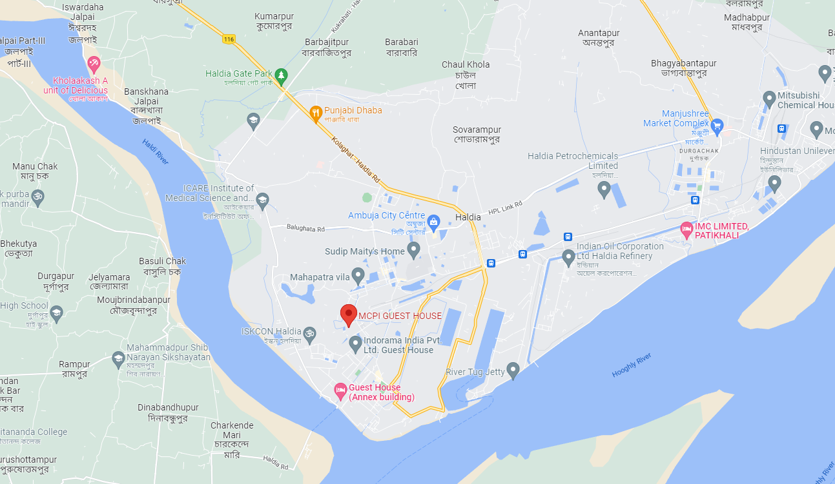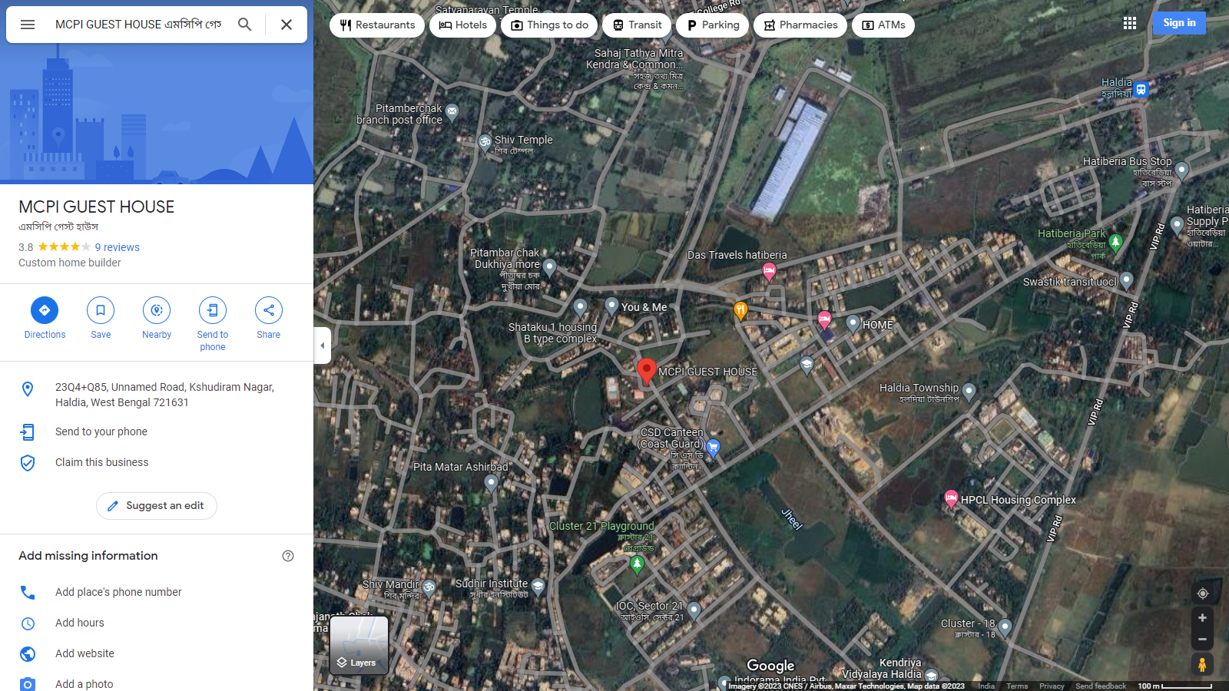

**ENCLOSURE: IV -** **REFERENCES ON PRICE TREND OF THE SIMILAR RELATED PROPERTIES AVAILABLE ON PUBLIC DOMAIN**

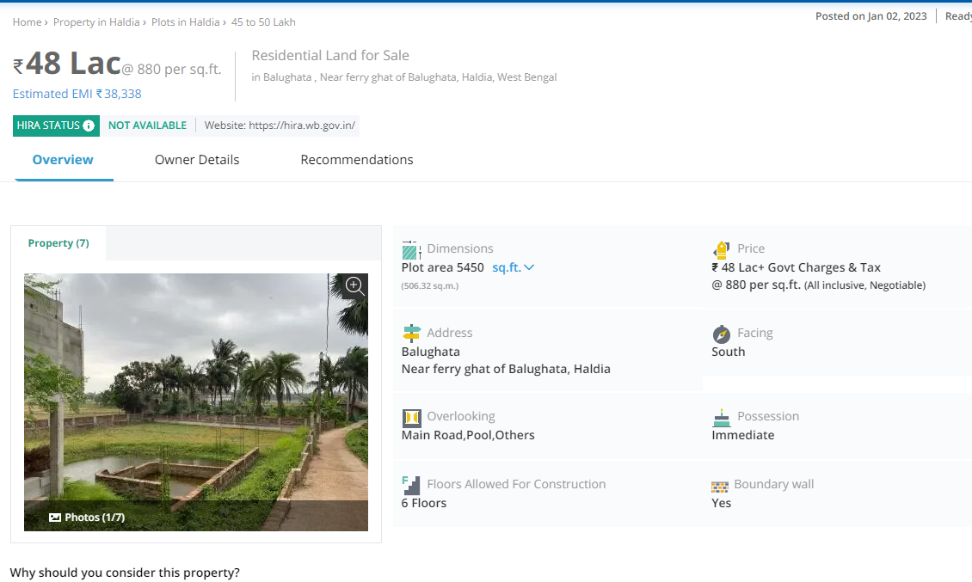

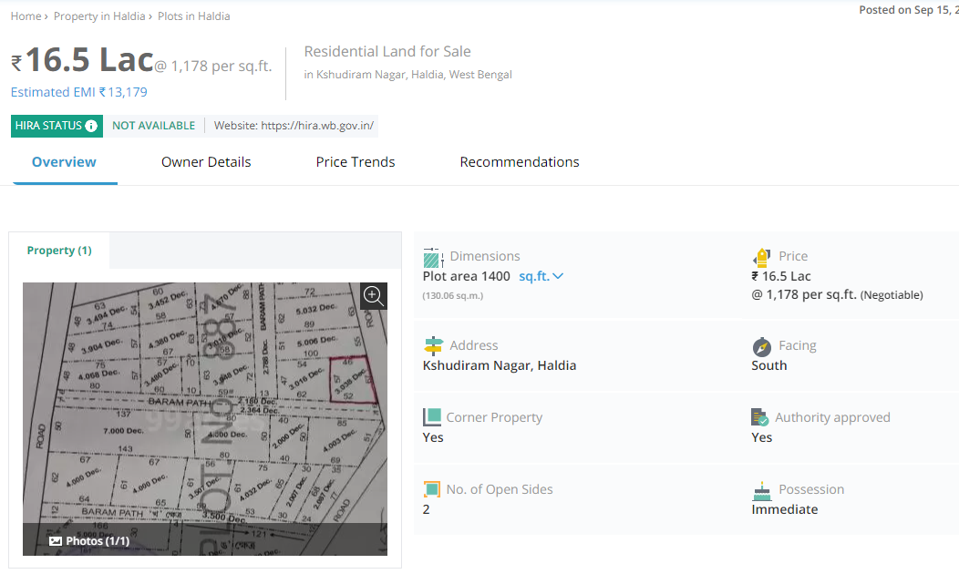

**ENCLOSURE: V – PHOTOGRAPHS OF THE PROPERTY**

|  |  |
| --- | --- |
| **Z:\In Progress Files\Abhinav Chaturvedi\VIS(2022-23)-PL495-398-689\SiteImage\c_TimePhoto_20221229_111746.jpg** | **Z:\In Progress Files\Abhinav Chaturvedi\VIS(2022-23)-PL495-398-689\SiteImage\c_TimePhoto_20221229_111203.jpg** |
| **Z:\In Progress Files\Abhinav Chaturvedi\VIS(2022-23)-PL495-398-689\SiteImage\c_TimePhoto_20221229_112534.jpg** | **Z:\In Progress Files\Abhinav Chaturvedi\VIS(2022-23)-PL495-398-689\SiteImage\c_TimePhoto_20221229_114005.jpg** |
| **Z:\In Progress Files\Abhinav Chaturvedi\VIS(2022-23)-PL495-398-689\SiteImage\c_TimePhoto_20221229_114423.jpg** | **Z:\In Progress Files\Abhinav Chaturvedi\VIS(2022-23)-PL495-398-689\SiteImage\c_TimePhoto_20221229_121221.jpg** |

|  |  |
| --- | --- |
| **Z:\In Progress Files\Abhinav Chaturvedi\VIS(2022-23)-PL495-398-689\SiteImage\c_TimePhoto_20221229_124115.jpg** | **Z:\In Progress Files\Abhinav Chaturvedi\VIS(2022-23)-PL495-398-689\SiteImage\c_TimePhoto_20221229_124754.jpg** |
| **Z:\In Progress Files\Abhinav Chaturvedi\VIS(2022-23)-PL495-398-689\SiteImage\c_TimePhoto_20221229_130539.jpg** | **Z:\In Progress Files\Abhinav Chaturvedi\VIS(2022-23)-PL495-398-689\SiteImage\c_TimePhoto_20221229_130658.jpg** |
| **Z:\In Progress Files\Abhinav Chaturvedi\VIS(2022-23)-PL495-398-689\SiteImage\c_TimePhoto_20221229_131609.jpg** | **Z:\In Progress Files\Abhinav Chaturvedi\VIS(2022-23)-PL495-398-689\SiteImage\c_TimePhoto_20221229_150149.jpg** |

|  |  |
| --- | --- |
| **Z:\In Progress Files\Abhinav Chaturvedi\VIS(2022-23)-PL495-398-689\SiteImage\c_TimePhoto_20221229_131737.jpg** | **Z:\In Progress Files\Abhinav Chaturvedi\VIS(2022-23)-PL495-398-689\SiteImage\c_TimePhoto_20221229_145822.jpg** |
| **Z:\In Progress Files\Abhinav Chaturvedi\VIS(2022-23)-PL495-398-689\SiteImage\c_TimePhoto_20221229_111901.jpg** | **Z:\In Progress Files\Abhinav Chaturvedi\VIS(2022-23)-PL495-398-689\SiteImage\c_TimePhoto_20221229_120342.jpg** |
| **Z:\In Progress Files\Abhinav Chaturvedi\VIS(2022-23)-PL495-398-689\SiteImage\c_TimePhoto_20221229_120605.jpg** | **Z:\In Progress Files\Abhinav Chaturvedi\VIS(2022-23)-PL495-398-689\SiteImage\c_TimePhoto_20221229_145828.jpg** |

**ENCLOSURE: VI – COPY OF CIRCLE RATE**

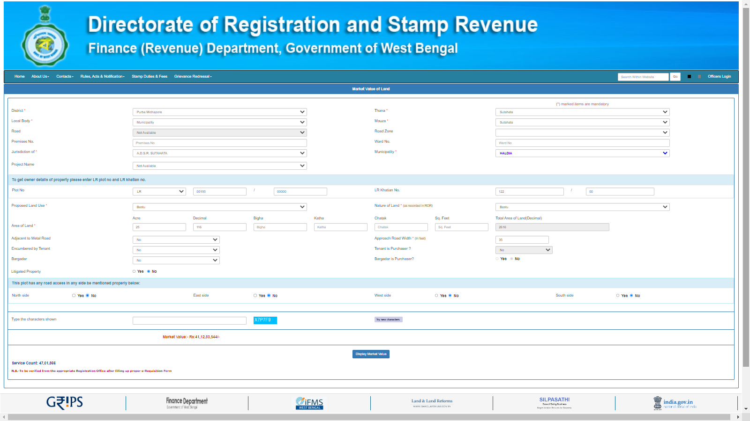

**ENCLOSURE VII:** **IMPORTANT PROPERTY DOCUMENTS EXHIBIT**

**Plot No.**

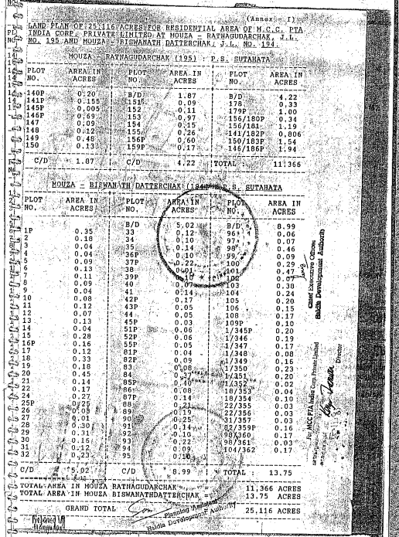

**Lease Deed**

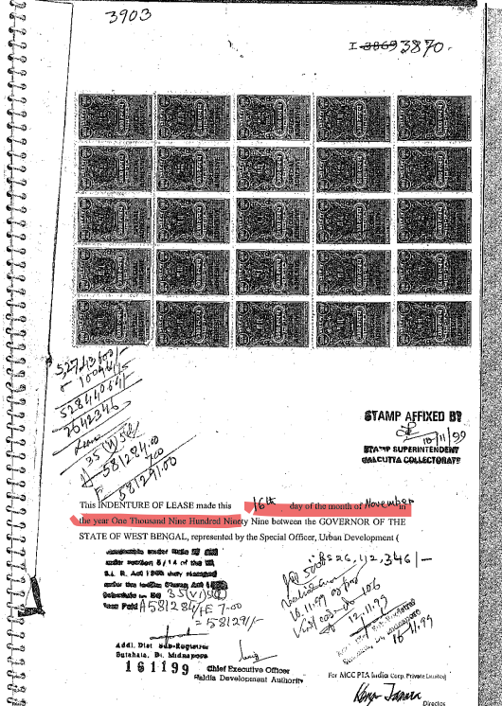

**Possession Certificate**

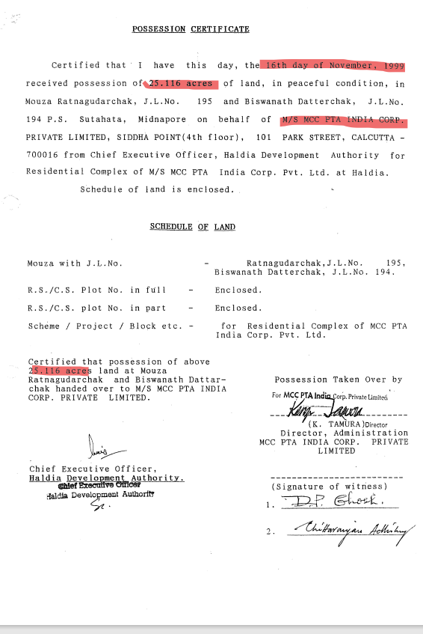

**Land Layout**

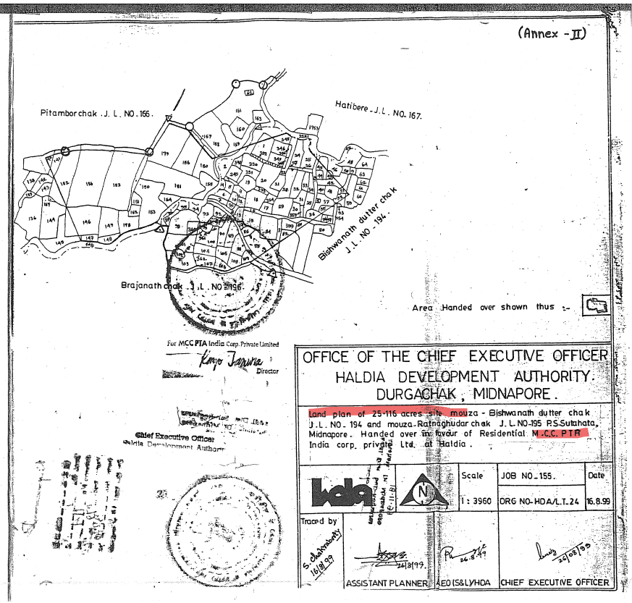

**Electricity Bill**

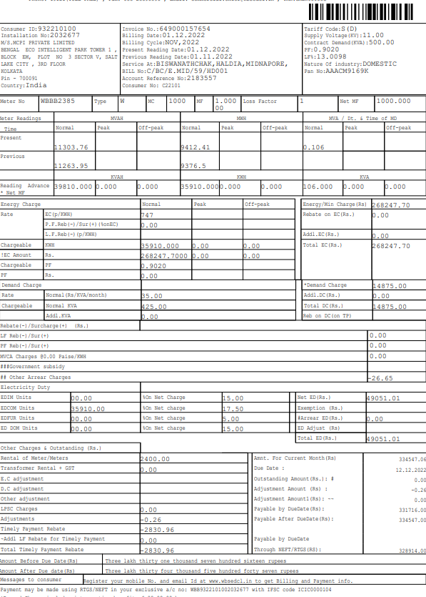

**Copy of Insurance**

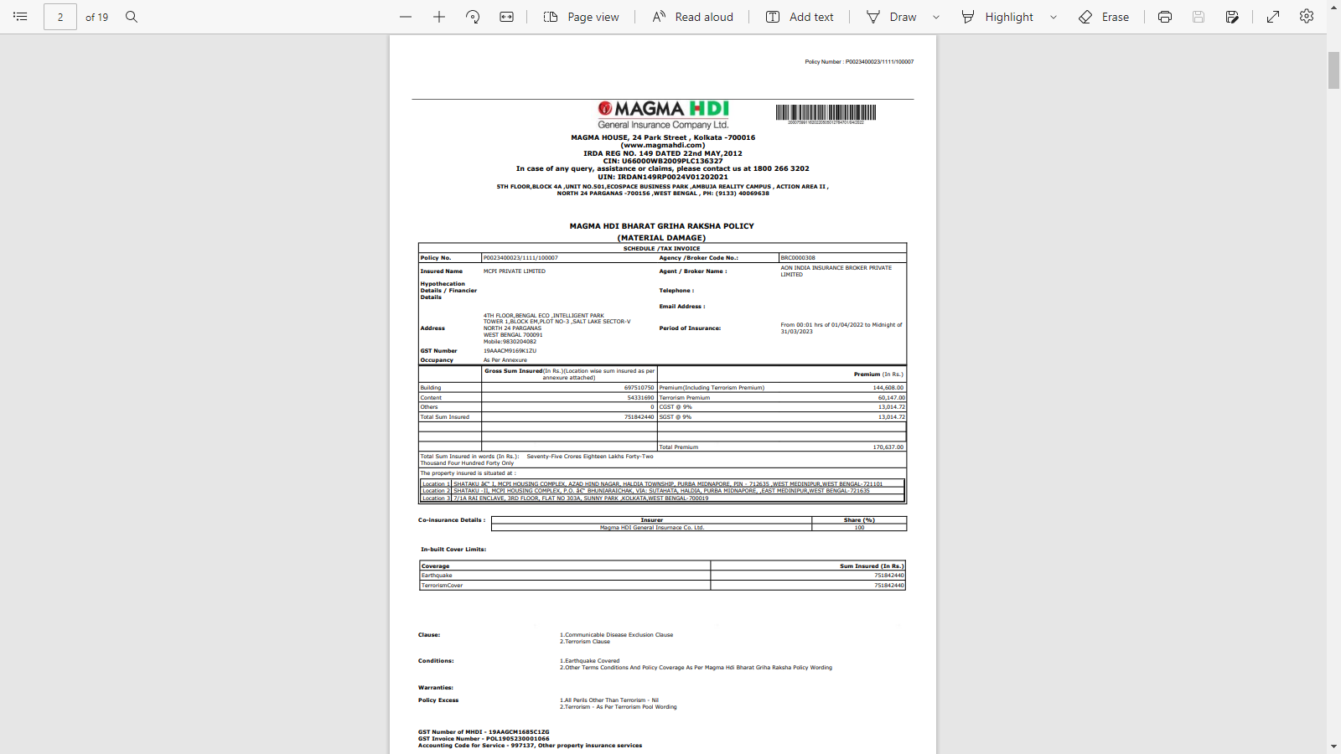

**Copy of Water Bill**

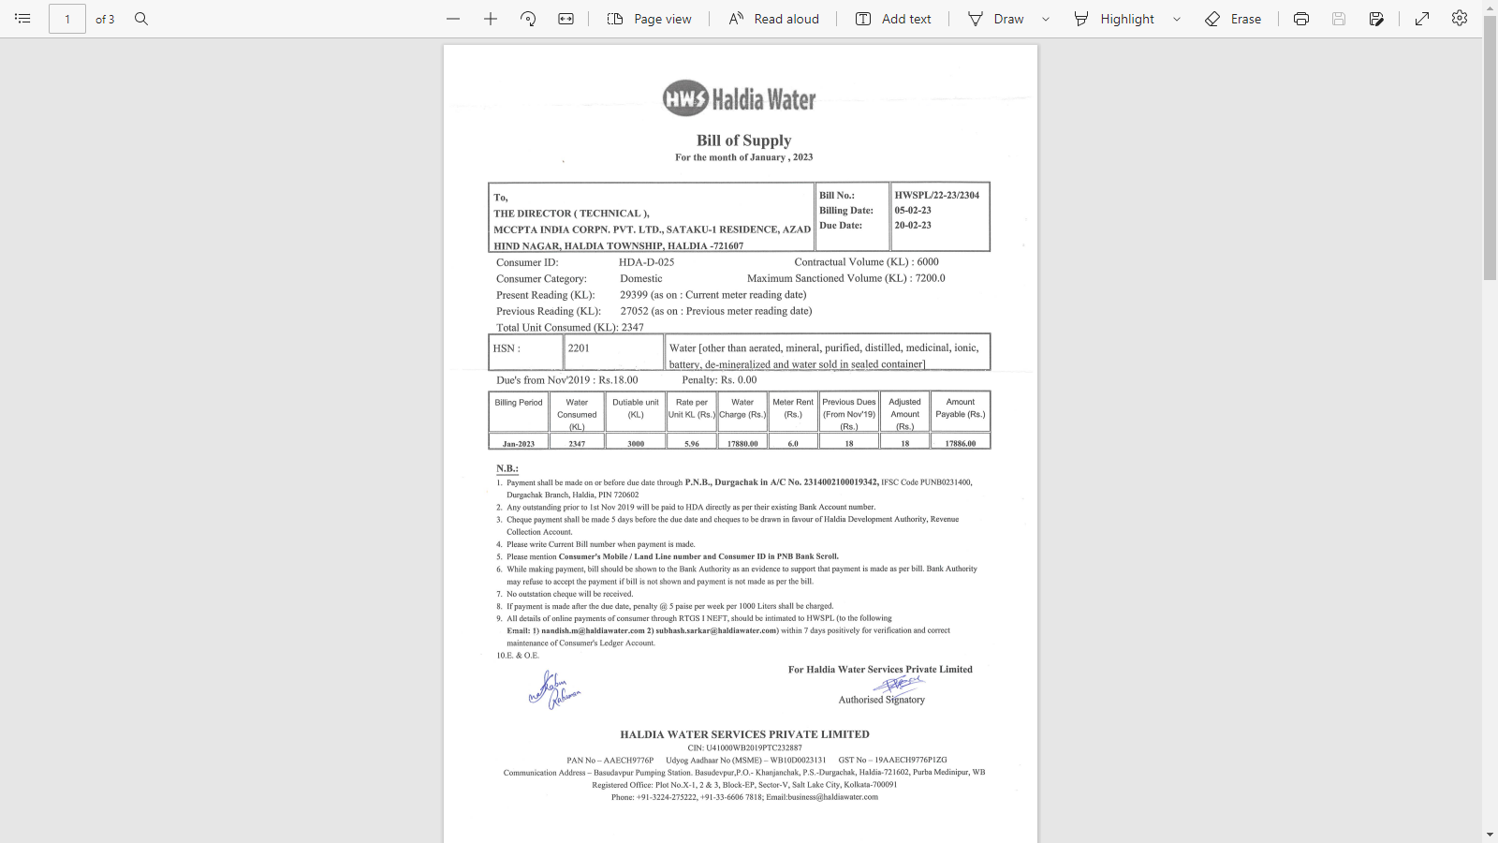

**ENCLOSURE VIII:** **ANNEXURE: VI - DECLARATION-CUM-UNDERTAKING**

1. Persons worked on this report are citizen of India.
2. No employee or member of R.K Associates has any direct/ indirect interest in the property or become so interested at any time during a period of three years prior to our appointment as valuer or three years after the valuation of assets was conducted by us.
3. The information furnished in our valuation report dated 11/1/2023 is true and correct to the best of our knowledge and belief and we have made an impartial and true valuation of the property.
4. Our authorized Engineer/ surveyor Mr. Anirban Roy and Rajat Kimar Choudhary have personally inspected the property on 29/12/2022 the work is not subcontracted to any other valuation firm and is carried out by us.
5. We have not been depanelled/ delisted by any other bank and in case any such depanelment by other banks during my empanelment with you, we will inform you within 3 days of such depanelment.
6. We have not been removed/ dismissed from service/employment earlier.
7. We have not been convicted of any offence and sentenced to a term of imprisonment.
8. Company is not found guilty of misconduct in professional capacity.
9. Persons worked on this report are not declared to be unsound mind.
10. Company is not undischarged bankrupt or has not applied to be adjudicated as a bankrupt.
11. Company is not an undischarged insolvent.
12. No penalty is levied under section 271J of Income-tax Act, 1961 (43 of 1961) and time limit for filing appeal before Commissioner of Income tax (Appeals) or Income-tax Appellate Tribunal, as the case may be has expired, or such penalty has been confirmed by Income-tax Appellate Tribunal, and five years have not elapsed after levy of such penalty.
13. Company is not been convicted of an offence connected with any proceeding under the Income Tax Act 1961, Wealth Tax Act 1957 or Gift Tax Act 1958 and
14. Our PAN Card number/ GST number as applicable is **AAHCR0845G/ 09AAHCR0845G1ZP.**
15. We undertake to keep you informed of any events or happenings which would make us ineligible for empanelment as a valuer.
16. We have not concealed or suppressed any material information, facts and records and we have made a complete and full disclosure.
17. We have read the Handbook on Policy, Standards and procedure for Real Estate Valuation, 2009 of the IBA and has tried to apply the “Standards” enshrined for valuation in the Part-B of the above handbook to the best of our ability as much as practically possible in the limited time available.
18. We have read the International Valuation Standards (IVS) and the report submitted to the Bank for the respective asset class and has tried to apply the “Standards” as enshrined for valuation in the IVS in “General Standards” and “Asset Standards” as applicable to the best of our ability as much as practically possible in the limited time available.
19. Procedures and standards adopted in carrying out the valuation and is mentioned in Part-D of the report which may have certain departures to the said IBA and IVS standards in order to provide better, just & fair valuation.
20. We abide by the Model Code of Conduct for empanelment of valuer in the Bank.
21. The authorized Engineers of the company who has worked on the assignment has signed this valuation report.
22. The work is taken on the instructions of the Bank.
23. Further, we hereby provide the following information**.**

|  |  |  |  |
| --- | --- | --- | --- |
| **S. No.** | **Particulars** | **Valuer comment** | |
|  | Background information of the asset being valued | This is a residential housing complex at aforesaid address having total land area of 25.116 acre as found on as-is-where basis which owner representative has shown/ identified to us on the site physically unless otherwise mentioned in the report of which some reference has been taken from the information/ data given in the copy of documents provided to us and informed verbally or in writing. | |
|  | Purpose of valuation and appointing authority | Please refer to Part-D of the Report. | |
|  | Identity of the experts involved in the valuation | **Survey Analyst:** Er. Mr. Anirban Roy and Rajat Kimar Choudhary  **Valuation Engineer:** Er. Abhinav Chaturvedi  **L1/ L2 Reviewer:** Er.Adil Afaque | |
|  | Disclosure of valuer interest or conflict, if any | No relationship with the borrower and no conflict of interest. | |
|  | Date of appointment, valuation date and date of report | **Date of Appointment:** | **10/8/2022** |
| **Date of Survey:** | **29/12/2022** |
| **Valuation Date:** | **11/1/2023** |
| **Date of Report:** | **11/1/2023** |
|  | Inspections and/ or investigations undertaken | Yes, by our authorized Survey Engineer Mr. Anirban Roy and Rajat Kimar Choudhary on29/12/2022. Property was shown and identified by **Mr.** Sunil Pradhan(🕿-+91 98317 80790) | |
|  | Nature and sources of the information used or relied upon | Please refer to Part-D of the Report. Level 3 Input (Tertiary) has been relied upon. | |
|  | Procedures adopted in carrying out the valuation and valuation standards followed | Please refer to Part-D of the Report. | |
|  | Restrictions on use of the report, if any | Value varies with the Purpose/ Date/ Market & Asset Condition & Situation prevailing in the market. We recommend not to refer the indicative & estimated prospective Value of the asset given in this report if any of these points are different from the one mentioned aforesaid in the Report.  This report has been prepared for the purposes stated in the report and should not be relied upon for any other purpose. Our client is the only authorized user of this report and is restricted for the purpose indicated in this report. I/we do not take any responsibility for the unauthorized use of this report.  During the course of the assignment, we have relied upon various information, data, documents in good faith provided by Bank/ client both verbally and in writing. If at any point of time in future it comes to knowledge that the information given to us is untrue, fabricated, misrepresented then the use of this report at very moment will become null & void.  This report only contains general assessment on the indicative, estimated Market Value of the property for which Bank has asked to conduct the Valuation for the asset as found on as-is-where basis which owner/ owner representative/ client/ bank has shown/ identified to us on the site unless otherwise mentioned in the report of which some reference has been taken from the information/ data given in the copy of documents provided to us and informed verbally or in writing which has been relied upon in good faith. It doesn’t contain any other recommendations of any sort including but not limited to express of any opinion on the suitability or otherwise of entering into any transaction with the borrower.  This report is not a certification of ownership or survey number/ property number/ Khasra number which are merely referred from the copy of the documents provided to us. | |
|  | Major factors that were taken into account during the valuation | Please refer to Part A, B & C of the Report. | |
|  | Major factors that were not taken into account during the valuation | Please refer to Part A, B & C of the Report. | |
|  | Caveats, limitations and disclaimers to the extent they explain or elucidate the limitations faced by valuer, which shall not be for the purpose of limiting his responsibility for the valuation report. | Please refer to Part C of the Report. Also, standard caveats, limitations, and disclaimers as per IBBI guidelines which can be referred on: <https://www.ibbi.gov.in/uploads/legalframwork/> e5e1300db2dd6a8bebe289ba579a7c14.pdf are also applicable on this. | |

**Date: 11/1/2023**

**Place:** Noida

**Signature**

**(Authorized Person of R.K Associates Valuers & Techno Engg. Consultants (P) Ltd.)**

**ENCLOSURE IX:** **ANNEXURE: VII - MODEL CODE OF CONDUCT FOR VALUERS**

**Integrity and Fairness**

1. A valuer shall, in the conduct of his/its business, follow high standards of integrity and fairness in all his/its dealings with his/its clients and other valuers.
2. A valuer shall maintain integrity by being honest, straightforward, and forthright in all professional relationships.
3. A valuer shall endeavor to ensure that he/it provides true and adequate information and shall not misrepresent any facts or situations.
4. A valuer shall refrain from being involved in any action that would bring disrepute to the profession.
5. A valuer shall keep public interest foremost while delivering his services.

**Professional Competence and Due Care**

1. A valuer shall render at all times high standards of service, ensure proper care and exercise independent professional judgment.
2. A valuer shall carry out professional services in accordance with the relevant technical and professional standards that may be specified from time to time.
3. A valuer shall continuously maintain professional knowledge and skill to provide competent professional service based on up-to-date developments in practice, prevailing regulations/guidelines and techniques.
4. In the preparation of a valuation report, the valuer shall not disclaim liability for his/its expertise or deny his/its duty of care, except to the extent that the assumptions are based on statements of fact provided by the company or its auditors or consultants or information available in public domain and not generated by the valuer.
5. A valuer shall not carry out any instruction of the client in so far as they are incompatible with the requirements of integrity, objectivity and independence.
6. A valuer shall clearly state to his client the services that he would be competent to provide and the services for which he would be relying on other valuers or professionals or for which the client can have a separate arrangement with other valuers.

**Independence and Disclosure of Interest**

1. A valuer shall act with objectivity in his/its professional dealings by ensuring that his/its decisions are made without the presence of any bias, conflict of interest, coercion, or undue influence of any party, whether directly connected to the valuation assignment or not.
2. A valuer shall not take up an assignment if he/it or any of his/its relatives or associates is not independent in terms of association to the company.
3. A valuer shall maintain complete independence in his/its professional relationships and shall conduct the valuation independent of external influences.
4. A valuer shall wherever necessary disclose to the clients, possible sources of conflicts of duties and interests, while providing unbiased services.
5. A valuer shall not deal in securities of any subject company after any time when he/it first becomes aware of the possibility of his/its association with the valuation, and in accordance with the Securities and Exchange Board of India (Prohibition of Insider Trading) Regulations, 2015 or till the time the valuation report becomes public, whichever is earlier.
6. A valuer shall not indulge in “mandate snatching or offering” convenience valuations” in order to cater to a company or client’s needs.
7. As an independent valuer, the valuer shall not charge success fee.
8. In any fairness opinion or independent expert opinion submitted by a valuer, if there has been a prior engagement in an unconnected transaction, the valuer shall declare the association with the company during the last five years.

**Confidentiality**

1. A valuer shall not use or divulge to other clients or any other party any confidential information about the subject company, which has come to his/its knowledge without proper and specific authority or unless there is a legal or professional right or duty to disclose.

**Information Management**

1. A valuer shall ensure that he/ it maintains written contemporaneous records for any decision taken, the reasons for taking the decision, and the information and evidence in support of such decision. This shall be maintained so as to sufficiently enable a reasonable person to take a view on the appropriateness of his/its decisions and actions.
2. A valuer shall appear, co-operate and be available for inspections and investigations carried out by the authority, any person authorised by the authority, the registered valuers organization with which he/it is registered or any other statutory regulatory body.
3. A valuer shall provide all information and records as may be required by the authority, the Tribunal, Appellate Tribunal, the registered valuers organization with which he/it is registered, or any other statutory regulatory body.
4. A valuer while respecting the confidentiality of information acquired during the course of performing professional services, shall maintain proper working papers for a period of three years or such longer period as required in its contract for a specific valuation, for production before a regulatory authority or for a peer review. In the event of a pending case before the Tribunal or Appellate Tribunal, the record shall be maintained till the disposal of the case.

**Gifts and hospitality.**

1. A valuer or his/its relative shall not accept gifts or hospitality which undermines or affects his independence as a valuer.

Explanation: For the purposes of this code the term ‘relative’ shall have the same meaning as defined in clause (77) of Section 2 of the Companies Act, 2013 (18 of 2013).

1. A valuer shall not offer gifts or hospitality or a financial or any other advantage to a public servant or any other person with a view to obtain or retain work for himself/ itself, or to obtain or retain an advantage in the conduct of profession for himself/ itself.

**Remuneration and Costs.**

1. A valuer shall provide services for remuneration which is charged in a transparent manner, is a reasonable reflection of the work necessarily and properly undertaken, and is not inconsistent with the applicable rules.
2. A valuer shall not accept any fees or charges other than those which are disclosed in a written contract with the person to whom he would be rendering service.

**Occupation, employability and restrictions.**

1. A valuer shall refrain from accepting too many assignments, if he/it is unlikely to be able to devote adequate time to each of his/ its assignments.
2. A valuer shall not conduct business which in the opinion of the authority or the registered valuer organization discredits the profession.

**Miscellaneous**

1. A valuer shall refrain from undertaking to review the work of another valuer of the same client except under written orders from the bank or housing finance institutions and with knowledge of the concerned valuer.
2. A valuer shall follow this code as amended or revised from time to time

Signature of the Authorized Person: \_\_\_\_\_\_\_\_\_\_\_\_\_\_\_\_

Name of the Valuation company: R.K Associates Valuers & Techno Engg. Consultants (P) Ltd.

Address of the Valuer: D-39, Sector-2, Noida-201301

Date: 11/1/2023

Place: Noida