**REPORT FORMAT:** V-L1 (Basic - SBI) | Version: 12.0_Nov.2022

**CASE NO.:VIS (2022-23)-PL502-Q107-401-693 Dated: 19.12.2022**

**LAND RATE VERFICATION**

**OF**

|  |  |
| --- | --- |
| **NATURE OF ASSETS** | **INDUSTRIAL LAND** |
| **CATEGORY OF ASSETS** | **INDUSTRIAL** |

**SITUATED AT**

**PLOT NO. 3810-3821, 4017-4043, 4050-4056, SURVEY NO. 498-P, 497-P, 501-P, 502-P&5P00, GIDC SARIGAM, VILLAGE-FANSA, UMBERGAON, VALSAD, GUJARAT-396155**

**REPORT PREPARED FOR**

**M/S AGRAWAL METAL WORKS PRIVATE LIMITED**

***\*\*Important - In case of any query/ issue or escalation you may please contact Incident Manager***

***at valuers@rkassociates.org. We will appreciate your feedback in order to improve our services.***

***NOTE: As per IBA & Bank’s Guidelines please provide your feedback on the report within 15 days of its submission after which report will be considered to be correct.***

***Valuation Terms of Services & Valuer’s Important Remarks are available at*** [***www.rkassociates.org***](http://www.rkassociates.org) ***for reference.***

|  |  |  |
| --- | --- | --- |
| **S.NO.** | **CONTENTS** | **DESCRIPTION** |
|  | **GENERAL DETAILS** | |
|  | Report prepared for | M/s Agrawal Metal Works Private Limited |
|  | Work Order No. & Date | Via mail dated 09.12.2022 |
|  | Name of Borrower unit | M/s. Rashtriya Metal Industries Limited |
|  | Type of the Property | Industrial Plot/Land |
|  | Report Type | Plain Asset Desktop Valuation |
|  | Date of Inspection of the Property | Physical inspection of the property was NOT done |
|  | Date of Assessment | 19 December 2022 |
|  | Date of Report | 19 December 2022 |
|  | Purpose of the Assessment | For personal information purpose |
|  | Scope of the Report | Non Binding Opinion on General Prospective Land Rate Assessment of the Property Information Provided by Property owner or through its representative |
|  | Out-of-Scope of Report | 1. Documents verification 2. Verification of authenticity of documents from originals or cross checking from any Govt. deptt. is not done at our end. 3. Legal aspects of the property are out-of-scope of this report. 4. Identification of the property is only limited to cross verification from its boundaries at site if mentioned in the provided documents. 5. Getting cizra map or coordination with revenue officers for site identification is not done at our end. 6. Measurement of the property as a whole is not done at our end. 7. Drawing Map & design of the property is out of scope of the work. |

|  |  |
| --- | --- |
| **2.** | **DESCRIPTION OF THE LOCATION** |
| **Brief Description: -** As information shared by the client, the subject land is addressed as Plot No. 3810-3821, 4017-4043, 4050-4056, Survey No. 498-P, 497-P, 501-P, 502-P&5P00, GIDC Sarigam, Village-Fansa, Umbergaon, Valsad, Gujarat-396155 admeasuring total land area about 58,287 sqm or 14.40 acre. The subject land is a part of GIDC, Industrial Area. The land is leasehold in nature and is expected to get converted into freehold next year. The status of present leasehold land parcels Lessor, Lessee and lease premium is not known to us.  **About Sarigam Industrial Area:** Gujarat Industrial Development Corporation has established Sarigam Industrial Estate in the year 1982 covering an area of about 400 Hectares of land with a vision to develop Sarigam estate. To encourage investments in this estate, Government of Gujarat offered investment subsidy to industries. Apart from this, Sarigam Industrial estate was segregated in to three zones namely Chemical, Plastic & Engineering zones keeping in view problems seen in other estates and with a motive to develop Sarigam as a model estate.  Nearby Industries such as Rashtriya Metal Industries Limited, Arihant Gold Plast Pvt. Paramount Adhesive Pvt. Ltd., Heranba Industries Ltd., Aaerti Drugs Limited, Premier Medical Corporation Pvt. Ltd., Mitsufuku Compound Pvt Ltd. etc are available in the vicinity.   |  |  |  |  |  |  | | --- | --- | --- | --- | --- | --- | | **Sarigam Industrial Area** | | | | | | | **Total Plots** | **Total Area**  **(In Sqm)** | **Plot Allotted** | **total allotted area**  **(In Sqm)** | **Unallotted plots** | **Unallotted area**  **(In Sqm)** | | 562 | 20,07,012 | 539 | 1930690 | 23 | 45772.2 |   **Location Map: -** | |

|  |  |  |  |  |  |  |  |  |  |  |
| --- | --- | --- | --- | --- | --- | --- | --- | --- | --- | --- |
| **3.** | **VALUATION ASSESSMENT FACTORS** | | | | | | | | | |
|  | Valuation Standards considered | Mix of standards such as IVS and others issued by Indian authorities & institutions and improvised by the RKA internal research team as and where it is felt necessary to derive at a reasonable, logical & scientific approach. In this regard proper basis, approach, working, definitions considered is defined below which may have certain departures to IVS. | | | | | | | | |
|  | Nature of the Valuation | Fixed Assets Valuation | | | | | | | | |
|  | Nature/ Category/ Type/ Classification of Asset under Valuation | **Nature** | | | | **Category** | | | | **Type** |
| INDUSTRIAL LAND | | | | INDUSTRIAL | | | | INDUSTRIAL PLOT |
| **Classification** | | | | Income/ Revenue Generating Asset | | | | |
|  | Type of Valuation *(Basis of Valuation as per IVS)* | Primary Basis | | | Market Value | | | | | |
| Secondary Basis | | | Not Applicable | | | | | |
|  | Present market state of the Asset assumed *(Premise of Value as per IVS)* | Under Normal Marketable State | | | | | | | | |
| **Reason:** Asset under free market transaction state | | | | | | | | |
|  | Property Use factor | **Current/ Existing Use** | | | | | **Highest & Best Use**  *(in consonance to surrounding use, zoning and statutory norms)* | | | **Considered for Valuation purpose** |
| Industrial | | | | | Industrial | | | Industrial |
|  | Legality Aspect Factor | Can not comment as copy of documents are not shared with us.  However Legal aspects of the property of any nature are out-of-scope of the Valuation Services. | | | | | | | | |
|  | Any specific advantage in the property | Subject property is a part of Gujarat Industrial Development Corporation. | | | | | | | | |
|  | Is property clearly demarcated by permanent/ temporary boundary on site | Cannot comment as physical inspection was not done. | | | | | | | | |
|  | Is the property merged or colluded with any other property | Cannot comment as physical inspection was not done. It seems that multiple land parcels are merged together to form single industrial set-up. | | | | | | | | |
|  | Is independent access available to the property | Cannot comment as physical inspection was not done. However, the rate range is assumes that the independent access is provided to the given land parcel/s. | | | | | | | | |
|  | Best Sale procedure to realize maximum Value *(in respect to Present market state or premise of the Asset as per point (iv) above)* | **Fair Market Value, (Desktop Valuation)** | | | | | | | | |
| Free market transaction at arm's length wherein the parties, after full market survey each acted knowledgeably, prudently and without any compulsion. | | | | | | | | |
|  | Approach & Method of Valuation Used | **Land** | | **Approach of Valuation** | | | | | **Method of Valuation** | |
| **Market Approach** | | | | | **Market Comparable Sales Method** | |
|  | Type of Source of Information | Level 3 Input (Tertiary) | | | | | | | | |
|  | **Market Comparable** | | | | | | | | | |
| References on prevailing market Rate/ Price trend of the property and Details of the sources from where the information is gathered *(from property search sites & local information)* | **1.** | Name: | | | | | Mr. Deepak Mistry | | |
| Contact No.: | | | | | +91 70468 38202 | | |
| Nature of reference: | | | | | Property Consultant (http://www.adproperties.in/) | | |
| Size of the Property: | | | | | 4,000-8,000 sqm | | |
| Location: | | | | | GIDC, Sarigam | | |
| Rates/ Price informed: | | | | | Rs. 15,000/- to Rs. 20,000/- per sqm | | |
| Any other details/ Discussion held: | | | | | As per discussion with the property consultant, The property admeasuring 19,000 sqm (vacant plot) was sold at a rate Rs. 18,000/- per sqm in February 2022.  Also plots of size 4,000-8,000 sqm are available for sale. The current market rate for plots having similar size is about Rs. 15,000/- to Rs. 20,000/- per sqm depending upon location, size, frontage, depth etc. | | |
| **2.** | Name: | | | | | Mr. Sunil Bharti | | |
| Contact No.: | | | | | +91 72858 49141 | | |
| Nature of reference: | | | | | Property Dealer | | |
| Size of the Property: | | | | | about 20,000 sqm | | |
| Location: | | | | | GIDC, Sarigam | | |
| Rates/ Price informed: | | | | | Rs. 20,000/- per sqm to Rs. 25,000/- per sqm | | |
| Any other details/ Discussion held: | | | | | As per discussion with the local property dealer, he has a land parcel admeasuring 20,000 sqm designated for Chemical plant usage. The current rate for the subject land is in the range of Rs. 20,000/- per sqm to Rs. 25,000/- per sqm which is negotiable while actual transaction. | | |
| **3.** | Name: | | | | | Mr. Shailesh Rajput | | |
| Contact No.: | | | | | +91 89053 33201 | | |
| Nature of reference: | | | | | Property Dealer | | |
| Size of the Property: | | | | | 14,000 sqm to 15,000 sqm | | |
| Location: | | | | | GIDC, Sarigam | | |
| Rates/ Price informed: | | | | | Rs. 15,000/- to Rs. 20,000/- per sqm | | |
| Any other details/ Discussion held: | | | | | As per discussion held over the phone with the local property consultant, plots in larger size are not available for sale in GIDC area w.r.t subject property. Only plots in smaller size lesser than 15,000 sqm are available for sale.  The property consultant mentioned on his website a vacant land of 18,443 sqm. The sale price of the land is Rs. 22.13 Cr. Which converts at a rate of Rs. 11,999/- per sqm. However, when contacted, the mentioned property was already sold (sale consideration amount was not shared by him).  As per property consultants, the current ongoing market rate in GIDC Sarigam is ranging from Rs. 15,000/- to Rs. 20,000/- per sqm. | | |
| *NOTE: The given information above can be independently verified to know its authenticity.* | | | | | | | | |
|  | Adopted Rates Justification | As per our discussion with the property dealers and habitants of the subject location we have gathered the following information:-   1. The GIDC Sarigam Industrial Area is segregated into 3-zones namely Chemical, Plastic & Engineering zones keeping in view problems seen in other estates and with a motive to develop Sarigam as a model estates. 2. The subject property is a part of Engineering Zone. 3. As per information received from property consultants, the plots of large size are not available in GIDC Sarigam, smaller plots of size less than 15,000 sqm are available. 4. As per information available at GIDC Website, there are about 23 plots available for sale. 5. The subject property is not on any major road/highway and it is at the rear side of industrial cluster abutting to some water canal/waste land. 6. Since our subject property/land parcel is one of the largest property in GIDC, Sarigam. Which may face difficulty while selling to single user. It shall require a large real investment. The acquired land parcel shall bear the burden of multiple licensing and liasoning requirement and different department’s NoCs like environmental, pollution, factory, labour etc. 7. We understand that Sarigam Area is allowed for Chemical Industry Set-up. As compared to the nearby industrial notified area. Which create demand potential the subject industrial area. 8. Smaller plots are available at a rate Rs. 15,000/- to Rs. 20,000/- per sqm. 9. Based on the above information and keeping in mind the size of the subject Property related to the references available and the location of the subject property we are of the view to adopt rate range of **Rs, 10,000/- to Rs.12,000/- per sqm** for the subject land under desktop valuation assessment. | | | | | | | | |
| ***NOTE:*** *We have taken due care to take the information from reliable sources. The given information above can be independently verified from the provided numbers to know its authenticity. However due to the nature of the information most of the market information came to knowledge is only through verbal discussion with market participants which we have to rely upon where generally there is no written record.*  *Related postings for similar properties on sale are also annexed with the Report wherever available.* | | | | | | | | | |
|  | **Other Market Factors** | | | | | | | | | |
|  | Any other aspect which has relevance on the value or marketability of the property | Valuation of the same asset/ property can fetch different values under different circumstances & situations. For eg. Valuation of a running/ operational shop/ hotel/ factory will fetch better value and in case of closed shop/ hotel/ factory it will fetch considerably lower value. Similarly, an asset sold directly by an owner in the open market through free market arm’s length transaction then it will fetch better value and if the same asset/ property is sold by any financer or court decree or Govt. enforcement agency due to any kind of encumbrance on it then it will fetch lower value.  This report is prepared based upon desktop valuation. It is a well-known fact that the market value of any asset varies with time & socio-economic conditions prevailing in the region/ country. In future property market may go down, property conditions may change or may go worse, property reputation may differ, property vicinity conditions may go down or become worse, property market may change due to impact of Govt. policies or effect of domestic/ world economy, usability prospects of the property may change, etc. The report may vary upon actual site visit and any documents provided. | | | | | | | | |
| **Adjustments (-/+):** 0% | | | | | | | | |
|  | **Final adjusted & weighted Rates range for the subject property** | **Rs. 10,000/- to Rs. 12,000/- per sqm.** | | | | | | | | |
|  | Considered Rates Justification | The fair market rates are arrived on the basis of Desktop valuation. However, the exact market rates may vary as the physical inspection of the site or locality is conducted.  As per the property & market factors analysis as described above, the considered estimated market rates appears to be reasonable in our opinion. | | | | | | | | |
|  | **Basis of computation & working** | | | | | | | | | |
| * *Valuation of the asset is carried out on basis of GPS location of the property shared.* * *Analysis and conclusions adopted in the report are limited to the reported assumptions, conditions and information came to our knowledge during the course of the work and based on the Standard Operating Procedures, Best Practices, Caveats, Limitations, Conditions, Remarks, Important Notes, Valuation TOR and definition of different nature of values.* * *For knowing comparable market rates, significant discreet local enquiries have been made from our side based on the hypothetical/ virtual representation of ourselves as both buyer and seller for the similar type of properties in the subject location and thereafter based on this information and various factors of the property, rate has been judiciously taken considering the factors of the subject property, market scenario and weighted adjusted comparison with the comparable properties unless otherwise stated.* * *References regarding the prevailing market rates and comparable are based on the verbal/ informal/ secondary/ tertiary information which are collected by our team from the local people/ property consultants/ recent deals/ demand-supply/ internet postings are relied upon as may be available or can be fetched within the limited time & resources of the assignment during market survey in the subject location. No written record is generally available for such market information and analysis has to be derived mostly based on the verbal information which has to be relied upon.* * *Market Rates are rationally adopted based on the facts of the property which came to our knowledge during the course of the assessment considering many factors like nature of the property, size, location, approach, market situation and trends and comparative analysis with the similar assets. During comparative analysis, valuation metrics is prepared and necessary adjustments are made on the subject asset.* * *The indicative value has been suggested based on the prevailing market rates that came to our knowledge during tertiary market research and is not split into formal & informal payment arrangements. Most of the deals takes place which includes both formal & informal payment components. Deals which takes place in complete formal payment component may realize relatively less actual transaction value due to inherent added tax, stamp registration liabilities on the buyer.* * *Secondary/Tertiary costs related to asset transaction like Stamp Duty, Registration charges, Brokerage, Commission, Bank interest, Selling cost, Marketing cost, etc. pertaining to the sale/ purchase of this property are not considered while assessing the indicative estimated Market Value.* * *Area considered in the Valuation Report pertaining to asset/ property is adopted from the information shared by the client.* * *Verification of the area of the property is not done.* * *Drawing, Map, design & detailed estimation of the property/ building is out of scope of the Valuation services.* * *Any kind of unpaid statutory, utilities, lease, interest or any other pecuniary dues on the asset or on its owners has not been factored in the Valuation.* * *This Valuation is conducted based on the macro analysis of the asset/ property considering it in totality and not based on the micro, component or item wise analysis. Analysis done is a general assessment and is neither investigative in nature nor an audit activity.* | | | | | | | | | |
|  | **ASSUMPTIONS** | | | | | | | | | |
| 1. *Information provided by the client owner or his representative both written & verbally is true and correct without any fabrication and has been relied upon in good faith.* 2. *Local verbal enquiries during micro market research came to our knowledge are assumed to be taken on record as true & factual.* 3. *The assets and interests therein have been valued free and clear of any liens or encumbrances unless stated otherwise. No hidden or apparent conditions regarding the subject assets or their ownership are assumed to exist. No opinion of title is rendered in this report and a good title is assumed unless stated otherwise.* 4. *It is assumed that the concerned client has asked for the valuation of that property after satisfying the authenticity of the information given to us. I/ We assume no responsibility for the legal matters including, but not limited to, legal or title concerns.* 5. *Sale transaction method of the asset is assumed as Free market transaction without any compulsion unless otherwise mentioned while assessing Indicative & Estimated Fair Prospective Market Value of the asset unless otherwise stated.* | | | | | | | | | |
|  | **LIMITATIONS** | | | | | | | | | |
| Physical inspection of the site/locality was not carried out. Since it is a desktop valuation. | | | | | | | | | |

|  |  |  |
| --- | --- | --- |
| **4.** | **PRICE/ RATES SUMMARY** | |
|  | Total Prospective Rates range for the subject property | **Rs. 10,000/- to Rs. 12,000/- per sqm.** |

This report only contains general assessment & opinion on the indicative, estimated Market Value of the property of which customer asked us to conduct the Valuation for the property found on as-is-where basis as information given by the customer No legal aspects in terms of ownership or any other legal aspect is taken into consideration. Even if any such information is mentioned in the report it is only referred from the information provided for which we do not assume any responsibility. Due care has been given while doing valuation assessment, but it doesn’t contain any due-diligence or audit or verification of any kind other than the valuation computation. Information given to us by client have been relied upon in good faith. This report doesn’t contain any other recommendations of any sort.

**ENCLOSURE: I -** **REFERENCES ON PRICE TREND OF THE SIMILAR RELATED PROPERTIES AVAILABLE ON PUBLIC DOMAIN**

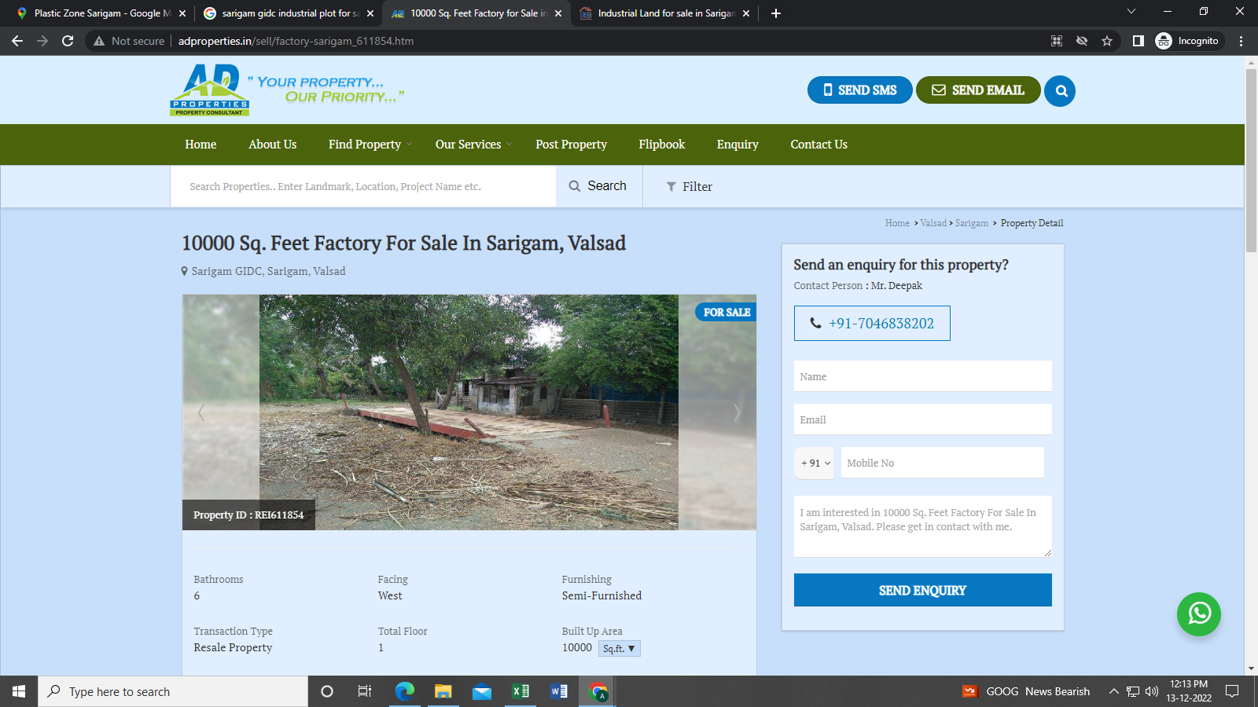

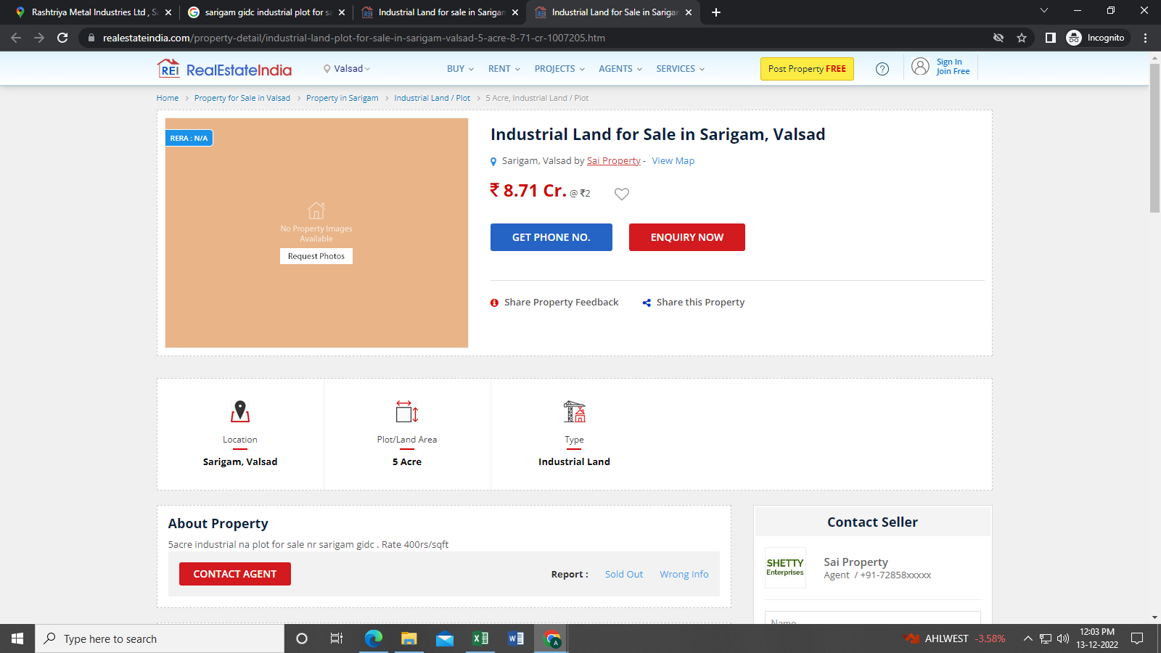

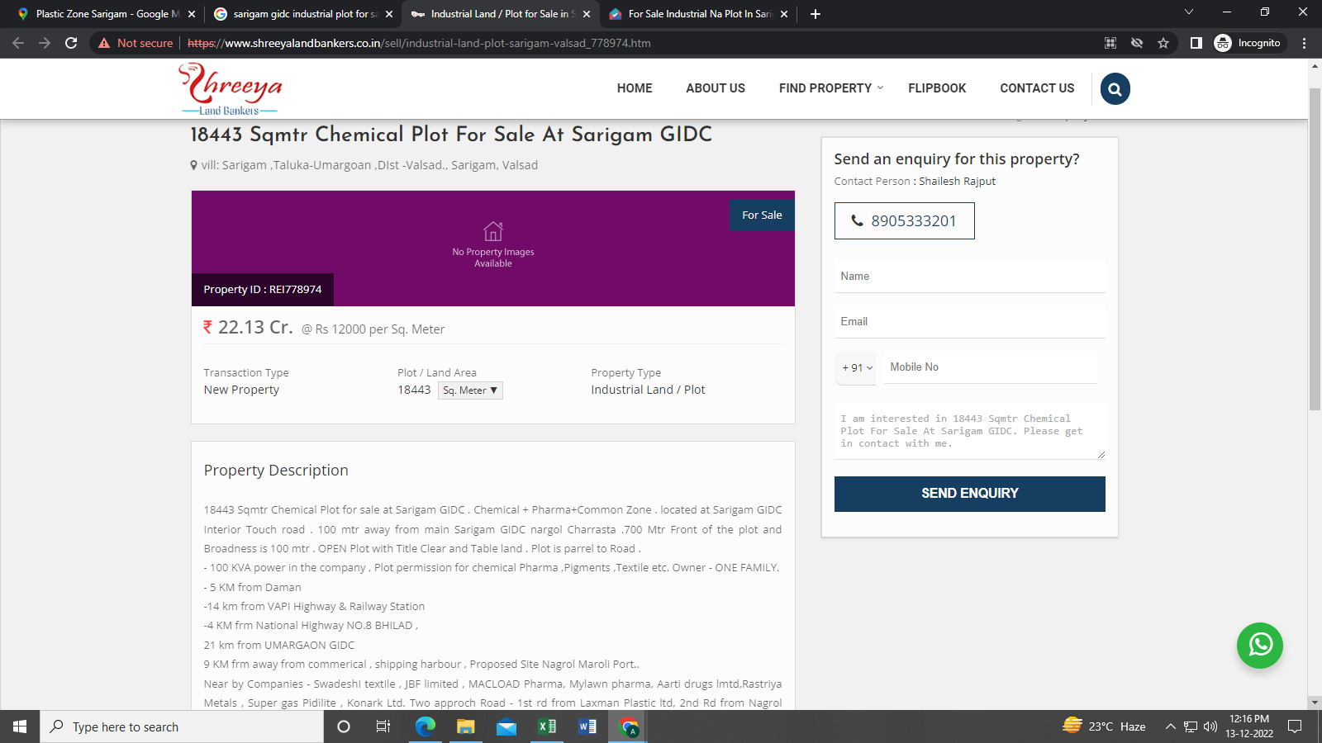

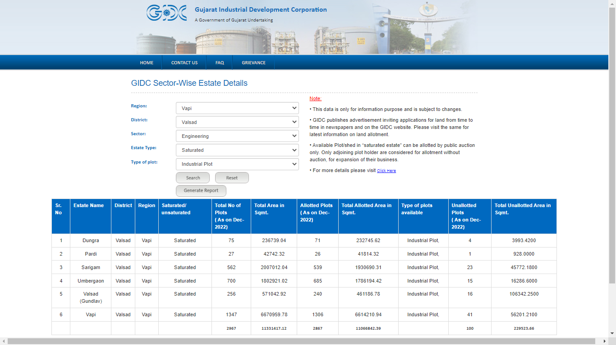

Source: [*https://egov.gidcgujarat.org/gidcgg/LandEstateDetails.aspx*](https://egov.gidcgujarat.org/gidcgg/LandEstateDetails.aspx)

**ENCLOSURE: II - VALUER’S REMARKS**

|  |  |
| --- | --- |
|  | This Land Rate Assessment Report is prepared based on the copies of the information which interested organization or customer could provide to us out of the standard checklist of documents sought from them and further based on our assumptions and limiting conditions. All such information provided to us has been relied upon in good faith and we have assumed that it is true and correct. Verification or cross checking of the documents provided to us from the originals has not been done at our end. |
|  | Legal aspects for eg. Investigation of title, ownership rights, lien, charge, mortgage, lease, verification of documents, etc. have to be taken care by legal expert/ Advocate and same are not done at our end. It is assumed that the concerned Lender/ Financial Institution has asked for the valuation of that property for which the legal verification has been already taken and cleared by the competent Advocate before requesting for the Land Rate Assessment Report. |
|  | Analysis and conclusions adopted in the report are limited to the reported assumptions, conditions and information came to our knowledge during the course of the work. |
|  | Value varies with the Purpose/ Date/ Condition prevailing in the market. We recommend not to refer the indicative & estimated prospective Value of the asset given in this report if any of these points are different from the one mentioned aforesaid in the Report. We also recommend that the indicative estimated Value in the Valuation Report holds good only upto the period of 3 months from the date of Land Rate Assessment Report. |
|  | This report is having limited scope as per its fields & format to provide only the general basic idea of the value of the property prevailing in the market based on the information provided by the client. The suggested indicative prospective estimated value should be considered only if transaction is happened as free market transaction. |
|  | This Land Rate Assessment Report is prepared based on the facts of the property on the Desktop valuation. It is a well-known fact that the market value of any asset varies with time & socio-economic conditions prevailing in the country. In future property Market may go down, property conditions may change or may go worse, Property reputation may differ, Property vicinity conditions may go down or become worse, Property market may change due to impact of Govt. policies or effect of World economy, Usability prospects of the property may change, etc. Hence before financing, Banker/ FI should take into consideration all such future risk and should loan conservatively to keep the advanced money safe in case of the downward trend of the property value. |
|  | Land Rate Assessment of the same asset/ property can fetch different values in different situations. For eg. Valuation of a running/ operational shop/ hotel/ factory will fetch better value and in case of closed shop/ hotel/ factory it will have considerable lower value. Similarly an asset sold directly by an owner in the market will fetch better value and if the same asset/ property is sold by any financer due to encumbrance on it will fetch lower value. In our case, we are unaware of plot establishment as industrial setup and hence, we have arrived desktop valuation relied on information provided by the client and general data/information available on public domain. |
|  | Getting cizra/layout map or coordination with revenue officers for site identification is not done at our end. |
|  | Valuation is done for the property information/GPS location provided to us by the client/owner’s representative. |
|  | The location of the said property is in GIDC, Notified Industrial Area. Any change in GIDC bye-laws will have impact on value assessment. |
|  | Valuation is a subjective field and opinion may differ from consultant to consultant. To check the right opinion, it is important to evaluate the methodology adopted and various data point/ information/ factors/ assumption considered by the consultant which became the basis for the Land Rate Assessment before reaching to any conclusion. |
|  | Value analysis of any asset cannot be regarded as an exact science and the conclusions arrived at in many cases will, of necessity, be subjective and dependent on the exercise of individual judgment. Given the same set of facts and using the same assumptions, expert opinions may differ due to the number of separate judgment decisions, which have to be made. Therefore, there can be no standard formula to establish an indisputable exchange ratio. In the event of a transaction, the actual transaction value achieved may be higher or lower than our indicative analysis of value depending upon the circumstances of the transaction. The knowledge, negotiability and motivations of the buyers and sellers and the applicability of a discount or premium for control will also affect actual price achieved. Accordingly, our indicative analysis of value will not necessarily be the price at which any agreement proceeds. The final transaction price is something on which the parties themselves have to agree. However our Valuation analysis can definitely help the stakeholders to make them informed and wise decision about the Value of the asset and can help in facilitating the arm’s length transaction. |
|  | This report is prepared on the RKA V-L1 (Basic) Valuation format as per the client requirement and scope of work. This report is having limited scope as per its fields & format to provide only the general estimated & indicative basic idea of the value of the property prevailing in the market based on the information provided by the client. No detailed analysis, audit or verification has been carried out of the subject property. |
|  | This is just an opinion report and doesn’t hold any binding on anyone. It is requested from the concerned Client which is using this report for mortgaging/transaction or any other purpose the property that they should consider all the different associated relevant & related factors & risks before taking any business decision based on the content of this report. |
|  | All Pages of the report including annexures are signed and stamped from our office. In case any paper in the report is without stamp & signature then this should not be considered a valid paper issued from this office. |
|  | Defect Liability Period is **10 DAYS.** We request the concerned authorized reader of this report to check the contents, data and calculations in the report within this period and intimate us in writing if any corrections are required or in case of any other concern with the contents or opinion mentioned in the report. Corrections only related to typographical, calculation, spelling mistakes will be entertained within the defect liability period. No request for any illegitimate value revision, date change or any other change will be entertained other than the one mentioned above. |
|  | R.K Associates encourages its customers to give feedback or inform concerns over its services through proper channel at [**valuers@rkassociates.org**](mailto:valuers@rkassociates.org) in writing within 30 days of report delivery. After this period no concern/ complaint/ proceedings in connection with the Valuation Services can be entertained due to possible change in situation and condition of the property. |
|  | Our Data retention policy is of **ONE YEAR**. After this period we remove all the concerned records related to the assignment from our repository. No clarification or query can be answered after this period due to unavailability of the data. |
|  | This Valuation report is governed by our (1) Internal Policies, Processes & Standard Operating Procedures, (2) R.K Associates Quality Policy, (3) Valuation & Survey Best Practices Guidelines formulated by management of R.K Associates, (4) Information input given to us by the customer and (4) Information/ Data/ Facts given to us by our field/ office technical team. Management of R.K Associates never gives acceptance to any unethical or unprofessional practice which may affect fair, correct & impartial assessment and which is against any prevailing law. In case of any indication of any negligence, default, incorrect, misleading, misrepresentation or distortion of facts in the report then it is the responsibility of the user of this report to immediately or at least within the defect liability period bring all such act into notice of R.K Associates management so that corrective measures can be taken instantly. |
|  | R.K Associates never releases any report doing alterations or modifications by pen. In case any information/ figure of this report is found altered with pen then this report will automatically become null & void. |

*-------------------------------------------------End of Report-----------------------------------------------*