**SECTION D 13 – IBMS System**

**TECHNICAL SPECIFICATIONS**

# Technical Specifications for Integrated Building Management System

# GENERAL

* 1. **SUMMARY**
     1. Furnish all labor, materials, equipment, and service necessary for a complete and operating Building Management System (BMS), utilizing Direct Digital Controls as per approved drawings and Input/Output Summary submitted by contractor and approved by Owner/PMC and as described herein.
     2. All labor, material, equipment and software not specifically referred to herein or on the plans, that is required to meet the functional intent of this specification, shall be provided without additional cost to the Owner.
     3. Owner shall be the named license holder of all software associated with all incremental work on the project(s).
  2. **SYSTEM DESCRIPTION**
     1. The entire Building Management System (BMS) shall be comprised of a network of interoperable, stand-alone digital controllers communicating via LonMark/LonTalk communication protocols to a Network Area Controller (NAC) / Router. Building Management System products shall be manufactured as per LonWorks products must be approved in writing by the consulting Engineer and be submitted for approval ten (10) days prior to the date of the bid submittal.
     2. The entire Integrated Control and Monitor Management System (IBMS) shall be comprise of a network of interoperable, stand-alone digital controllers communicating on an open protocol communication network to a host computer within the facility (when specified) and communicating via the Internet to a host computer in a remote location. The IBMS shall communicate to third party systems such as Chillers, Boilers, Air-Handling Systems, Energy metering systems, Lighting Management System & other energy management systems, Fire-Life safety systems and other building management related devices with open, interoperable communication capabilities.
     3. The IBMS framework shall utilize JAVA based automation products and services with built-in Internet connectivity to a broad range of distribution partners in the building automation, energy services, power/utility, and industrial sectors. The Framework shall bring together the computerization of control applications under the umbrella of single integrated system architecture. The suite of component software applications shall support true plug-and-play, multi-vendor interoperability, resulting in lower automation and information infrastructure costs. The Network Area Controllers (NAC’s) shall run a JAVA Virtual Machine (JVM) platform and use a common set of tools for accessing and integrating multiple protocols.
     4. The Building Management System (BMS) shall be comprised of Network Area Controller or Controllers (NAC) / Routers. The NAC / Router shall connect to the local or wide area network, depending on configuration. Access to the system, either locally in each building, or remotely from a central site or sites, shall be accomplished through standard Web browsers, via the Internet and/or local area network. Each NAC shall communicate to LonMark/LonTalk and/or BACnet Direct Digital Controllers (DDC) and other open protocol systems/devices.
     5. The following software packages shall be loaded into the system as minimum standard :-

a. Complete system operational software

b. Site specific data manipulation software

c. Active graphics software

d. Energy management system software

e. Alarm indication software

g. Data Visualization Package

h. Internet Enabled Remote Monitoring Package.

* 1. **SUBMITTAL**
     1. Eight copies of shop drawings of the components and devices for the entire control system shall be submitted and shall consist of a complete list of equipment and materials, including manufacturers catalog data sheets and installation instructions for all controllers, valves, dampers, sensors, routers, etc. Shop drawings shall also contain complete wiring and schematic diagrams, software descriptions, calculations, and any other details required to demonstrate that the system has been coordinated and will properly function as a system. Terminal identification for all control wiring shall be shown on the shop drawings. A complete written Sequence of Operation shall also be included with the submittal package. The contractor as part of their packages shall provide catalog data sheets, wiring diagrams and point lists to other contractors for proper coordination of work.
     2. Submittal shall also include a trunk cable schematic diagram depicting operator workstations, control panel locations and a description of the communication type, media and protocol. BMS contractors shall provide these diagrams for their portions of work; the Systems Integrator shall be responsible for integrating those diagrams into the overall trunk cable schematic diagrams for the entire Wide Area Network (WAN).
     3. Submittal shall also include a complete point list of all points to be connected to the BMS.
     4. Upon completion of the work, provide a complete set of ‘as-built’ drawings and application software on compact disk. Drawings shall be provided as AutoCAD™ compatible files. Eight copies of the ‘as-built’ drawings shall be provided in addition to the documents on compact disk. BMS contractors shall provide as-built for their portions of work. The contractor shall be responsible for as-built pertaining to overall BMS architecture and network diagrams. All as-built drawings shall also be installed into the BMS server in a dedicated directory.
  2. **SPECIFICATION NOMENCLATURE**
     1. Acronyms used in this specification are as follows:

DDC Direct Digital Controller

BMS Building Management System

OOT Object Oriented Technology

LAN Local Area Network

NAC Network Area Controller

WBI Web Browser Interface

GUI Graphical User Interface

FMCS Facility Management and Control System

IBC Interoperable BACnet Controller

PMI Power Measurement Interface

WAN Wide Area Network

PICS Product Interoperability Compliance Statement

* 1. **DIVISION OF WORK**
     1. The contractor shall be responsible for all controllers (DDC), control devices, control panels, controller programming, controller programming software, controller input/output and power wiring and controller network wiring.
     2. The contractor shall also be responsible for the Network Area Controller(s) (NAC), software and programming of the NAC, graphical user interface software (GUI), development of all graphical screens, Web browser pages, setup of schedules, logs and alarms, LonWorks network management and connection of the NAC to the local or wide area network.
  2. **AGENCY AND CODE APPROVALS**
     1. All products of the BMS shall be provided with the following agency approvals. Verification that the approvals exist for all submitted products shall be provided with the submittal package. Systems or products not currently offering the following approvals are not acceptable.
        1. UL-916; Energy Management Systems
        2. C-UL listed to Canadian Standards Association C22.2 No. 205-M1983 “signal Equipment”
        3. CE
        4. FCC, Part 15, Subpart J, Class A Computing Devices
  3. **SOFTWARE LICENSE AGREEMENT**
     1. The OWNER shall agree to the manufacturer's standard software and firmware licensing agreement as a condition of this contract. Such license shall grant use of all programs and application software to Owner as defined by the manufacturer's license agreement, but shall protect manufacturer's rights to disclosure of trade secrets contained within such software.
     2. The OWNER shall be the named license holder of all software associated with any and all incremental work on the project(s). In addition, OWNER shall receive ownership of all job specific configuration documentation, data files, and application-level software developed for the project. This shall include all custom, job specific software code and documentation for all configuration and programming that is generated for a given project and/or configured for use with the NAC, BMS Server(s), and any related LAN / WAN / Intranet and Internet connected routers and devices. Any and all required IDs and passwords for access to any component or software program shall be provided to the owner. The owner shall determine which organizations to be named in the SI organization ID (“orgid”) of all software licenses. Owner shall be free to direct the modification of the “orgid” in any software license, regardless of supplier.
  4. **DELIVERY, STORAGE AND HANDLING**
     1. Provide factory-shipping cartons for each piece of equipment and control device. Maintain cartons through shipping, storage, and handling as required to prevent equipment damage. Store equipment and materials inside and protected from weather.
  5. **JOB CONDITIONS**
     1. Cooperation with Other Contractors: Coordinate the Work of this section with that of other sections to ensure that the Work will be carried out in an orderly fashion. It shall be this Contractor's responsibility to check the Contract Documents for possible conflicts between his Work and that of other crafts in equipment location, pipe, duct and conduit runs, electrical outlets and fixtures, air diffusers, and structural and architectural features.

# MATERIALS

* 1. **GENERAL**
     1. The Building Management System (BMS) shall be comprised of a network of interoperable, stand-alone digital controllers, a computer system, graphical user interface software, printers, network devices, valves, dampers, sensors, and other devices as specified herein. All systems and software within BMS shall be Year 2000 compliant and shall be supported by compliance documentation from the manufacturer.
     2. The installed system shall provide secure password access to all features, functions and data contained in the overall BMS.
  2. **OPEN, INTEROPERABLE, INTEGRATED ARCHITECTURES**
     1. The intent of this specification is to provide a peer-to-peer networked, stand-alone, distributed control system with the capability to integrate ANSI/ASHRAE Standard 135-2001 BACnet, LonWorks technology, MODBUS, OPC, and other open and proprietary communication protocols in one open, interoperable system.
     2. The supplied computer software shall employ object-oriented technology (OOT) for representation of all data and control devices within the system. In addition, adherence to industry standards including ANSI / ASHRAE™ Standard 135-2001, BACnet and LonMark to assure interoperability between all system components is required. For each LonWorks device that does not have LonMark certification, the device supplier must provide an XIF file and a resource file for the device. For each BACnet device, the device supplier must provide a PICS document showing the installed device’s compliance level. Minimum compliance is Level 3; with the ability to support data read and write functionality. Physical connection of BACnet devices shall be via Ethernet (BACnet Ethernet/IP,) and/or RS-485 (BACnet MSTP) as specified.
     3. All components and controllers supplied under this Division shall be true “peer-to-peer” communicating devices. Components or controllers requiring “polling” by a host to pass data shall not be acceptable.
     4. The supplied system must incorporate the ability to access all data using standard Web browsers without requiring proprietary operator interface and configuration programs. An Open DataBase Connectivity (ODBC) or Structured Query Language (SQL) compliant server database is required for all system database parameter storage. This data shall reside on a supplier-installed server for all database access. Systems requiring proprietary database and user interface programs shall not be acceptable.
     5. A hierarchical topology is required to assure reasonable system response times and to manage the flow and sharing of data without unduly burdening the customer’s internal Intranet network. Systems employing a “flat” single tiered architecture shall not be acceptable.
        1. Maximum acceptable response time from any alarm occurrence (at the point of origin) to the point of annunciation shall not exceed 5 seconds for network connected user interfaces.
        2. Maximum acceptable response time from any alarm occurrence (at the point of origin) to the point of annunciation shall not exceed 60 seconds for remote or dial-up connected user interfaces.
  3. **NETWORKS**
     1. The Local Area Network (LAN) shall be a 100 Megabits/sec Ethernet network supporting BACnet, Java, XML, HTTP, and SOAP for maximum flexibility for integration of building data with enterprise information systems and providing support for multiple Network Area Controllers (NACs), user workstations and, if specified, a local server.
     2. Local area network minimum physical and media access requirements:
        1. Ethernet; IEEE standard 802.3
        2. Cable; 100 Base-T, UTP-8 wire, category 5
        3. Minimum throughput; 100 Mbps.
  4. **NETWORK ACCESS**
     1. Remote Access.
        1. For Local Area Network installations, provide access to the LAN from a remote location, via the Internet. The OWNER shall provide a connection to the Internet to enable this access via high speed cable modem, asynchronous digital subscriber line (ADSL) modem, ISDN line, T1 Line or via the customer’s Intranet to a corporate server providing access to an Internet Service Provider (ISP). Customer agrees to pay monthly access charges for connection and ISP.
  5. **NETWORK AREA CONTROLLER (NAC) / ROUTER**
     1. The contractor shall supply one or more Network Area Controllers (NAC) / Router as part of this contract. Number of area controllers required is dependent on the type and quantity of devices provided in IO Summary.
     2. The Network Area Controller (NAC) / Router shall provide the interface between the LAN or WAN and the field control devices, and provide global supervisory control functions over the control devices connected to the NAC / Router. It shall be capable of executing application control programs to provide:
        1. Calendar functions
        2. Scheduling
        3. Trending
        4. Alarm monitoring and routing
        5. Time synchronization
        6. Integration of LonWorks controller data and BACnet controller data
        7. Network Management functions for all LonWorks based devices
     3. The Network Area Controller must provide the following hardware features as a minimum:
        1. One Ethernet Port – 10/100 Mbps
        2. One RS-232 port
        3. One LonWorks Interface Port – 78KB FTT-10A
        4. One RS-485 ports
        5. Battery Backup
        6. Flash memory for long term data backup (If battery backup or flash memory is not supplied, the controller must contain a hard disk with at least 1 gigabyte storage capacity)
        7. The NAC / Router must be capable of operation over a temperature range of 32 to 122°F
        8. The NAC / Router must be capable of withstanding storage temperatures of between 0 and 158°F
        9. The NAC / Router must be capable of operation over a humidity range of 5 to 95% RH, non-condensing
     4. The NAC / Router shall provide multiple user access to the system and support for ODBC or SQL. A database resident on the NAC / Router shall be an ODBC-compliant database or must provide an ODBC data access mechanism to read and write data stored within it.
     5. The NAC / Router shall support standard Web browser access via the Intranet/Internet. It shall support a minimum of 32 simultaneous users.
     6. Event Alarm Notification and actions
        1. The NAC / Router shall provide alarm recognition, storage; routing, management, and analysis to supplement distributed capabilities of equipment or application specific controllers.
        2. The NAC / Router shall be able to route any alarm condition to any defined user location whether connected to a local network or remote via dial-up telephone connection, or wide-area network.
        3. Alarm generation shall be selectable for annunciation type and acknowledgement requirements including but limited to:
           1. To alarm
           2. Return to normal
           3. To fault
        4. Provide for the creation of a minimum of eight of alarm classes for the purpose of routing types and or classes of alarms, i.e.: Electricals, HVAC, Fire, etc.
        5. Provide timed (schedule) routing of alarms by class, object, group, or node.
        6. Provide alarm generation from binary object “runtime” and /or event counts for equipment maintenance. The user shall be able to reset runtime or event count values with appropriate password control.
     7. Control equipment and network failures shall be treated as alarms and annunciated.
     8. Alarms shall be annunciated in any of the following manners as defined by the user:
        1. Screen message text
        2. Email of the complete alarm message to multiple recipients. Provide the ability to route and email alarms based on:
           1. Day of week
           2. Time of day
           3. Recipient
        3. Pagers via paging services that initiate a page on receipt of email message
        4. Graphic with flashing alarm object(s)
        5. Printed message, routed directly to a dedicated alarm printer
     9. The following shall be recorded by the NAC / Router for each alarm (at a minimum):
        1. Time and date
        2. Location (building, floor, zone, office number, etc.)
        3. Equipment (air handler #, accessway, etc.)
        4. Acknowledge time, date, and user who issued acknowledgement.
        5. Number of occurrences since last acknowledgement.
     10. Alarm actions may be initiated by user defined programmable objects created for that purpose.
     11. Defined users shall be given proper access to acknowledge any alarm, or specific types or classes of alarms defined by the user.
     12. A log of all alarms shall be maintained by the NAC / Router and/or a server (if configured in the system) and shall be available for review by the user.
     13. Provide a “query” feature to allow review of specific alarms by user defined parameters.
     14. A separate log for system alerts (controller failures, network failures, etc.) shall be provided and available for review by the user.
     15. An Error Log to record invalid property changes or commands shall be provided and available for review by the user.
  6. **DATA COLLECTION AND STORAGE**
     1. The NAC / Router shall have the ability to collect data for any property of any object and store this data for future use.
     2. The data collection shall be performed by log objects, resident in the NAC / Router that shall have, at a minimum, the following configurable properties:
        1. Designating the log as interval or deviation.
        2. For interval logs, the object shall be configured for time of day, day of week and the sample collection interval.
        3. For deviation logs, the object shall be configured for the deviation of a variable to a fixed value. This value, when reached, will initiate logging of the object.
        4. For all logs, provide the ability to set the maximum number of data stores for the log and to set whether the log will stop collecting when full, or rollover the data on a first-in, first-out basis.
        5. Each log shall have the ability to have its data cleared on a time-based event or by a user-defined event or action.
     3. All log data shall be stored in a relational database in the NAC / Router and the data shall be accessed from a server (if the system is so configured) or a standard Web browser.
     4. All log data, when accessed from a server, shall be capable of being manipulated using standard SQL statements.
     5. All log data shall be available to the user in the following data formats:
        1. HTML
        2. XML
        3. Plain Text
        4. Comma or tab separated values
     6. Systems that do not provide log data in HTML and XML formats at a minimum shall not be acceptable.
     7. The NAC / Router shall have the ability to archive its log data either locally (to itself), or remotely to a server or other NAC / Router on the network. Provide the ability to configure the following archiving properties, at a minimum:
        1. Archive on time of day
        2. Archive on user-defined number of data stores in the log (buffer size)
        3. Archive when log has reached it’s user-defined capacity of data stores
        4. Provide ability to clear logs once archived]
  7. **AUDIT LOG**
     1. Provide and maintain an Audit Log that tracks all activities performed on the NAC / Router. Provide the ability to specify a buffer size for the log and the ability to archive log based on time or when the log has reached its user-defined buffer size. Provide the ability to archive the log locally (to the NAC / Router), to another NAC / Router on the network, or to a server. For each log entry, provide the following data:
        1. Time and date
        2. User ID
        3. Change or activity: i.e., Change setpoint, add or delete objects, commands, etc.
  8. **DATABASE BACKUP AND STORAGE**
     1. The NAC / Router shall have the ability to automatically backup its database. The database shall be backed up based on a user-defined time interval.
     2. Copies of the current database and, at the most recently saved database shall be stored in the NAC / Router. The age of the most recently saved database is dependent on the user-defined database save interval.
     3. The NAC / Router database shall be stored, at a minimum, in XML format to allow for user viewing and editing, if desired. Other formats are acceptable as well, as long as XML format is supported.
  9. **DIRECT DIGITAL CONTROLLERS (DDC)**
     1. Direct Digital Controllers shall be 32 bit microprocessor based Interoperable Bacnet / LonWorks Controllers.
     2. The Network Area Controller (NAC) / Router will provide all scheduling, alarming, trending, and network management for the LonMark / LonWorks based devices.
     3. The DDCs shall communicate with the NAC / Router at a baud rate of not less than 78.8K baud. The DDC shall provide LED indication of communication and controller performance to the technician, without cover removal.
     4. All DDCs shall be fully application programmable. Controllers offering application selection only (non programmable), require a 10% spare point capacity to be provided for all applications. All control sequences within or programmed into the DDC shall be stored in non-volatile memory, which is not dependent upon the presence of a battery, to be retained.
     5. The BMS contractor supplying the DDC’s shall provide documentation for each device, with the following information at a minimum:
        1. Network Variable Inputs (nvi’s); name and type
        2. Network Variable Outputs (nvo’s); name and type
        3. Network configuration parameters (nci, nco); name and type
     6. It is the responsibility of the BMS contractor to ensure that the proper Network Variable Inputs and Outputs (nvi and nvo) are provided in each DDC, as required by the point charts.
     7. The supplier of any programmable DDC shall provide one copy of the manufacturer’s programming tool, with documentation, to the OWNER.
     8. The controller shall be capable of either integrating with other LonMark™ devices or stand-alone operation.
     9. The controller shall have two microprocessors. The Host processor contains on-chip FLASH program memory, FLASH information memory, and RAM to run the main HVAC application. The second processor for LonWorks™ network communications.
        + 1. FLASH Memory Capacity: 60 Kilobytes with 8 Kilobytes for application program.
          2. FLASH Memory settings retained for ten years.
          3. RAM: 2 Kilobytes
     10. The controller shall have an FTT transformer-coupled communications port interface for common mode-noise rejection and DC isolation.
     11. The controller shall have an internal time clock with the ability to automatically revert from a master time clock on failure.
         + 1. Operating Range: 24 hour, 365 day, multi-year calendar including day of week and configuration for automatic day-light savings time adjustment to occur on configured start and stop dates.
           2. Accuracy: ±1 minute per month at 77° F (25° C).
           3. Power Failure Backup: 24 hours at 32° to 122° F (0° to 50° C).

1. The controller shall have Significant Event Notification, Periodic Update capability, and Failure Detect when network inputs fail to be detected within their configurable time frame.
2. Rated voltage: 20-30 VAC, 50/60 Hz
3. The controller shall have an internal DC power supply to power external sensors.
   1. Power Output: 20 VDC ±10% at 75 mA.
4. The controller shall have a visual indication (LED) of the status of the device:
   1. Controller operating normally.
   2. Controller in process of download.
   3. Controller in manual mode under control of software tool.
   4. Controller lost its configuration.
   5. No power to controller, low voltage, or controller damage.
   6. Processor and/or controller is not operating.
5. The minimum controller Environmental ratings:
   1. Operating Temperature Ambient Rating: -40° to 150° F (-40° to 65.5° C).
   2. Storage Temperature Ambient Rating: -40° to 150° F (-40° to 65.5° C).
   3. Relative Humidity: 5% to 95% non-condensing.
6. The controller shall have the additional approval requirements, listings, and approvals:
   1. UL/cUL (E87741) listed under UL916 (Standard for Open Energy Management Equipment) with plenum rating.
   2. CSA (LR95329-3) Listed
   3. Meets FCC Part 15, Subpart B, Class B (radiated emissions) requirements.
   4. Meets Canadian standard C108.8 (radiated emissions).
   5. Conforms requirements European Consortium standard EN 61000-6-1; 2001 (EU Immunity)
   6. //Conforms requirements European Consortium standard EN 61000-6-3; 2001 (EU Emission)
7. The controller shall have three analog outputs (AO).
   1. Analog outputs (AO) shall be capable of being configured as digital outputs (DO).
   2. Input and Output wiring terminal strips shall be removable from the controller without disconnecting wiring.
   3. Input and Output wiring terminals shall be designated with color coded labels.
8. The controller shall provide for **“user defined”** Network Variables (NV) for customized configurations.
   1. **GRAPHICAL USER INTERFACE SOFTWARE**
      1. Operating System:
         1. The GUI shall run on Microsoft Windows XP Professional.
      2. The GUI shall employ browser-like functionality for ease of navigation. It shall include a tree view (similar to Windows Explorer) for quick viewing of, and access to, the hierarchical structure of the database. In addition, menu-pull downs, and toolbars shall employ buttons, commands and navigation to permit the operator to perform tasks with a minimum knowledge of the HVAC Control System and basic computing skills. These shall include, but are not limited to, forward/backward buttons, home button, and a context sensitive locator line (similar to a URL line), that displays the location and the selected object identification.
      3. Real-Time Displays. The GUI, shall at a minimum, support the following graphical features and functions:
         1. Graphic screens shall be developed using any drawing package capable of generating a GIF, BMP, or JPG file format. Use of proprietary graphic file formats shall not be acceptable. In addition to, or in lieu of a graphic background, the GUI shall support the use of scanned pictures.
         2. Graphic screens shall have the capability to contain objects for text, real-time values, animation, color spectrum objects, logs, graphs, HTML or XML document links, schedule objects, hyperlinks to other URL’s, and links to other graphic screens.
         3. Graphics shall support layering and each graphic object shall be configurable for assignment to a layer. A minimum of six layers shall be supported.
         4. Modifying common application objects, such as schedules, calendars, and set points shall be accomplished in a graphical manner.
            1. Schedule times will be adjusted using a graphical slider, without requiring any keyboard entry from the operator.
            2. Holidays shall be set by using a graphical calendar without requiring any keyboard entry from the operator.
         5. Commands to start and stop binary objects shall be done by right-clicking the selected object and selecting the appropriate command from the pop-up menu. No entry of text shall be required.
         6. Adjustments to analog objects, such as set points, shall be done by right-clicking the selected object and using a graphical slider to adjust the value. No entry of text shall be required.
      4. System Configuration. At a minimum, the GUI shall permit the operator to perform the following tasks, with proper password access:
         * 1. Create, delete or modify control strategies.
           2. Add/delete objects to the system.
           3. Tune control loops through the adjustment of control loop parameters.
           4. Enable or disable control strategies.
           5. Generate hard copy records or control strategies on a printer.
           6. Select points to be alarmable and define the alarm state.
           7. Select points to be trended over a period of time and initiate the recording of values automatically.
      5. On-Line Help. Provide a context sensitive, on-line help system to assist the operator in operation and editing of the system. On-line help shall be available for all applications and shall provide the relevant data for that particular screen. Additional help information shall be available through the use of hypertext. All system documentation and help files shall be in HTML format.
      6. Security. Each operator shall be required to log on to that system with a user name and password in order to view, edit, add, or delete data. System security shall be selectable for each operator. The system administrator shall have the ability to set passwords and security levels for all other operators. Each operator password shall be able to restrict the operators’ access for viewing and/or changing each system application, full screen editor, and object. Each operator shall automatically be logged off of the system if no keyboard or mouse activity is detected. This auto log-off time shall be set per operator password. All system security data shall be stored in an encrypted format.
      7. System Diagnostics. The system shall automatically monitor the operation of all workstations, printers, modems, network connections, building management panels, and controllers. The failure of any device shall be annunciated to the operator.
      8. Programming software shall be same as GUI. The Same GUI can be used to configure the DDCs & NAC.
      9. Alarm Console
         1. The system will be provided with a dedicated alarm window or console. This window will notify the operator of an alarm condition, and allow the operator to view details of the alarm and acknowledge the alarm. The use of the Alarm Console can be enabled or disabled by the system administrator.
         2. When the Alarm Console is enabled, a separate alarm notification window will supercede all other windows on the desktop and shall not be capable of being minimized or closed by the operator. This window will notify the operator of new alarms and un-acknowledged alarms. Alarm notification windows or banners that can be minimized or closed by the operator shall not be acceptable.
      10. **SPECIAL ENERGY MANAGEMENT REPORTING AND PROFILING APPLICATIONS**

These reports are defined below.

1. **Aggregate Demand Summary** - This report aggregates (totalizes) multiple points (meters) and shows the peak, minimum, average, and total consumption as well as computes load factor. By reducing peak consumption and leveling the total load, volatility is reduced and energy customers can make significant improvements in their energy procurement. This report will help identify favorable aggregation combinations and unattractive peaks. Once the user selects this report, they define parameters such as sites, meters, time period, and commodity. The following screen shot is an example of Aggregate Demand Summary.

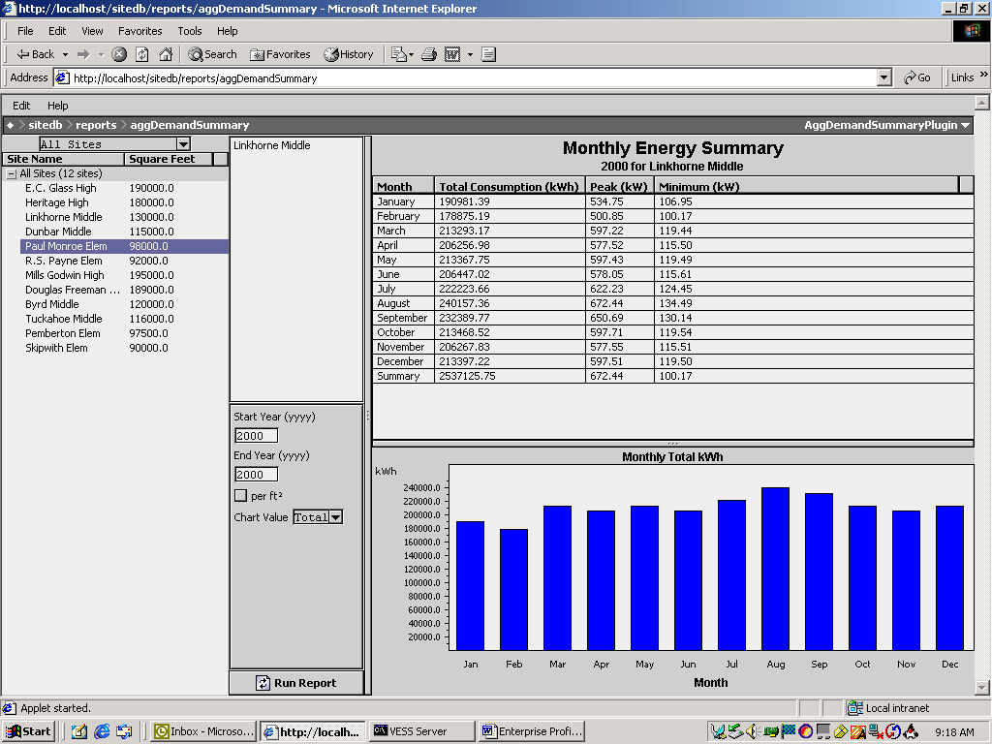

1. **Summary Ranking Reports** - By selecting this report, the user can identify the 10 worst or 10 best sites in the database. Once the report type has been selected, parameters to define before the report can be generated will include the following:
   1. Measurement unit – KW, therms, CCF gallons, PSI, etc. The database will search for all values matching the request.
   2. Compare an entire facility or normalize by square foot
   3. Time periods to compare
   4. Highest values or lowest values – Will be able to view either the best or worst 10 points matching the defined parameters
   5. Cost or consumption in future revisions



1. **Spectrum Summary Report –** A quick view of any point or aggregated point with color coding identifying the reasonableness of the data value. The chart can report on up to one year of data, with the ability to zoom to a higher definition. As data values approach and/or exceed historical ranges, the color on the graph will change to identify such. If all data values are within historical ranges, the user can move on to other functions. In the following screen shot, the Spectrum Summary Report is reporting on total electricity for an aggregated point, which consists of 6 schools. The reporting period is six weeks, with the blue identifying low loads overnight and on weekends. The fourth weekend in the report was a three day weekend which is identified by a larger blue gap. A user can also see rising consumption (red) as temperatures rise going into the summer season. When the user clicks on an area of the graph, the data value along with time stamp will appear. The colors and associated data value ranges are user definable. The following screen shot is an example of the Spectrum Summary Report.

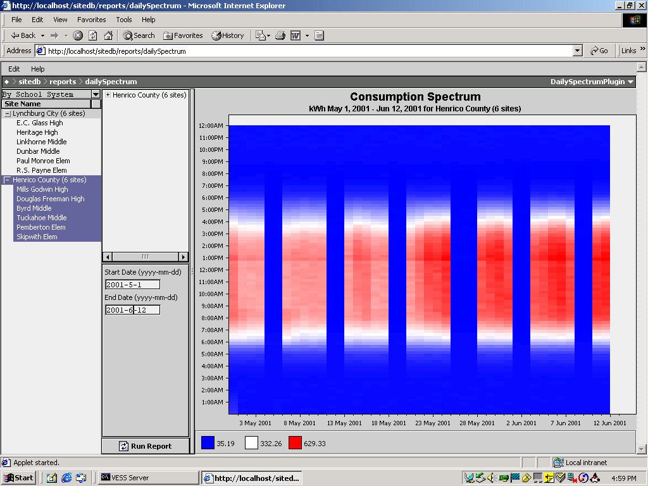

1. **Equipment Operation Reports** - Users will have the ability to analyse digital points and identify run times. Comparisons between sites or points can be made and run times can be graphed. For example, comparing lighting or HVAC run hours in a group of stores or comparing HVAC run hours in June for Store 1 versus Store 2. Data will be displayed in time and percentage.
2. **Relative Contribution Report** – This pie chart report will give users the ability to identify how individual points contribute to a total from a point group. The user would select a group of points, calculate the aggregate consumption of the group, and report on the individual contribution of each. Data will be displayed both graphically in a pie chart as well as in tabular format. Users could identify that HVAC is 48% of the building load; lighting is 42%, or Building 1 accounts for 14% of the total enterprise load and Building 2 contributes 19%. This report will allow users to identify inefficiencies and help perform budgeting.



1. **Average Profile** – The report will allow the user to average the load for a single load across time periods and give the average load, and/or aggregate multiple meters (loads) and view the average aggregated load. This report will be very beneficial when negotiating with energy service providers because it includes the load profile and consumption totals. With the ability to filter by time periods, measurement units, points or point groups, weekdays, and weekends, load profiles with associated data will allow the user to procure exactly the amount of energy required. This reduces risk for the energy provider and therefore reduces cost for the end-user.

The user will be able to manipulate between 1-minute intervals and hourly intervals. In addition, users will be able to choose between auto scale and manual scale. For example, if the minimum value is 100KW and the maximum is 500 kW, the user can have the chart automatically scale between those values or they can select any range to scale the 400kW range. When printing charts, this may be useful. This will be useful for sophisticated users who need a higher resolution of data. The following screen shot is an example of the Average Profile Report.

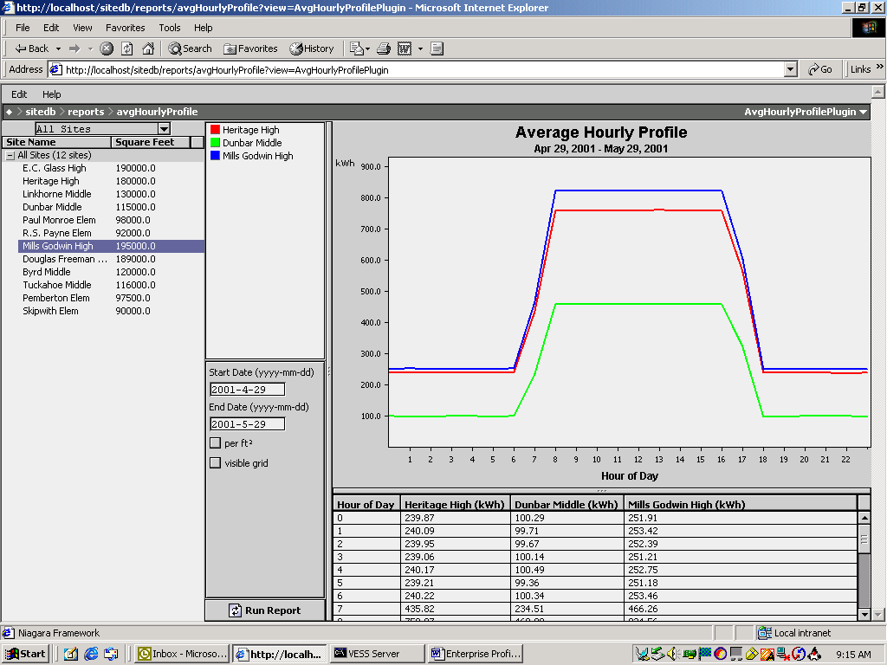

1. **Point Trending** – This report will allow the user to choose a single or multiple points and trend the values over a specified time period. Either analog or digital points can be trended and multiple variables can be selected to be report. For a visual representation of several point values, the user will view all points on the left Y-axis. If the user would like to perform a statistical analysis identifying correlation coefficient and standard deviation between variables, they will have the ability to select a single point for each Y-axis. If a point group has been created, it would be presented as a single point value. The same auto scale/manual scale feature discussed in Average Profile Report is available in Point Trending. The following screen shot is an example of the Point Trending Report.

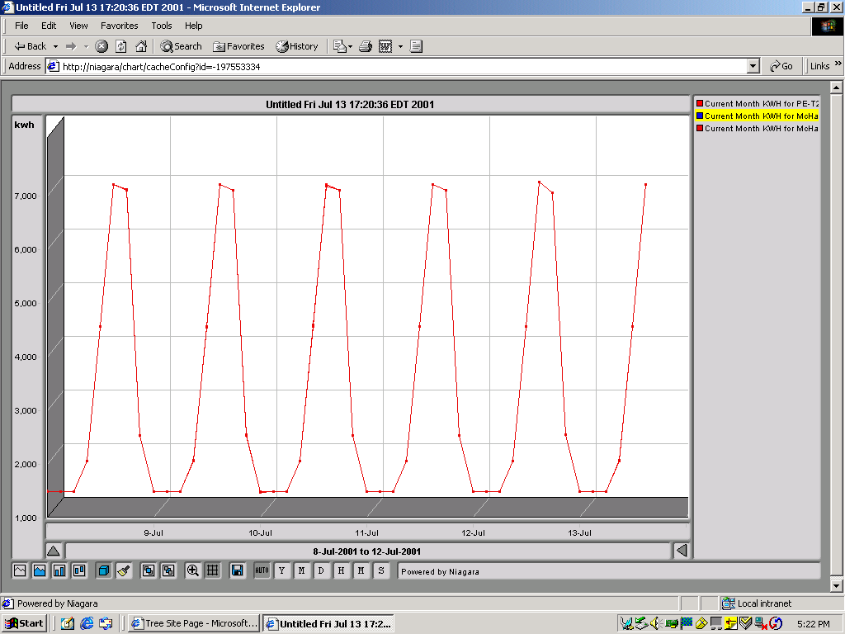

1. **Exception Report –** This report will identify all data values for the specified period that does not fall in a user-defined range. Although the range will be user definable, the benchmark or baseline to be compared against will be historical data. Users can get to this report by selecting it among the library of report templates, or can automatically be taken here from the Average Profile Report or Point Trending Report by clicking on an “Exception” button once a profile is being viewed.



* 1. **WEB BROWSER OWNERS**
     1. The system shall be capable of supporting an unlimited number of Owners using a standard Web browser such as Internet Explorer™ or Netscape Navigator™. Systems requiring additional software (to enable a standard Web browser) to be resident on the Owner machine, or manufacture-specific browsers shall not be acceptable.
     2. The Web browser software shall run on any operating system and system configuration that is supported by the Web browser. Systems that require specific machine requirements in terms of processor speed, memory, etc., in order to allow the Web browser to function with the FMCS, shall not be acceptable.
     3. The Web browser shall provide the same view of the system, in terms of graphics, schedules, calendars, logs, etc., and provide the same interface methodology as is provided by the Graphical User Interface. Systems that require different views or that require different means of interacting with objects such as schedules, or logs, shall not be permitted.
     4. The Web browser Owner shall support at a minimum, the following functions:
        1. User log-on identification and password shall be required. If an unauthorized user attempts access, a blank web page shall be displayed. Security using Java authentication and encryption techniques to prevent unauthorized access shall be implemented.
        2. Graphical screens developed for the GUI shall be the same screens used for the Web browser Owner. Any animated graphical objects supported by the GUI shall be supported by the Web browser interface.
        3. HTML programming shall not be required to display system graphics or data on a Web page. HTML editing of the Web page shall be allowed if the user desires a specific look or format.
        4. Storage of the graphical screens shall be in the Network Area Controller (NAC), without requiring any graphics to be stored on the Owner machine. Systems that require graphics storage on each Owner are not acceptable.
        5. Real-time values displayed on a Web page shall update automatically without requiring a manual “refresh” of the Web page.
        6. Users shall have administrator-defined access privileges. Depending on the access privileges assigned, the user shall be able to perform the following:
           1. Modify common application objects, such as schedules, calendars, and set points in a graphical manner.

Schedule times will be adjusted using a graphical slider, without requiring any keyboard entry from the operator.

Holidays shall be set by using a graphical calendar, without requiring any keyboard entry from the operator.

* + - * 1. Commands to start and stop binary objects shall be done by right-clicking the selected object and selecting the appropriate command from the pop-up menu. No entry of text shall be required.
        2. View logs and charts
        3. View and acknowledge alarms
        4. Setup and execute SQL queries on log and archive information
      1. The system shall provide the capability to specify a user’s (as determined by the log-on user identification) home page. Provide the ability to limit a specific user to just their defined home page. From the home page, links to other views, or pages in the system shall be possible, if allowed by the system administrator.
      2. Graphic screens on the Web Browser Owner shall support hypertext links to other locations on the Internet or on Intranet sites, by specifying the Uniform Resource Locator (URL) for the desired link.
  1. **SERVER FUNCTIONS AND HARDWARE**
     1. The contractor has to provide a central server. The server shall support all Network Area Controllers (NAC) / Router connected to the customer’s network whether local or remote.
     2. Local connections shall be via an Ethernet LAN. Remote connections can be via ISDN, ADSL, T1 or dial-up connection.
     3. It shall be possible to provide access to all Network Area Controllers via a single connection to the server. In this configuration, each Network Area Controller can be accessed from a remote Graphical User Interface (GUI) or from a standard Web browser (WBI) by connecting to the server.
     4. The server shall provide the following functions, at a minimum:
        1. Global Data Access: The server shall provide complete access to distributed data defined anywhere in the system.
        2. Distributed Control: The server shall provide the ability to execute global control strategies based on control and data objects in any NAC / Router in the network, local or remote.
        3. The server shall include a master clock service for its subsystems and provide time synchronization for all Network Area Controllers (NAC) / Routers.
        4. The server shall accept time synchronization messages from trusted precision Atomic Clock Internet sites and update its master clock based on this data.
        5. The server shall provide scheduling for all Network Area Controllers and their underlying field control devices.
        6. The server shall provide demand limiting that operates across all Network Area Controllers. The server must be capable of multiple demand programs for sites with multiple meters and or multiple sources of energy. Each demand program shall be capable of supporting separate demand shed lists for effective demand control.
        7. The server shall implement the BACnet Command Prioritization scheme (16 levels) for safe and effective contention resolution of all commands issued to Network Area Controllers / Routers. Systems not employing this prioritization shall not be accepted.
        8. Each Network Area Controller / Router supported by the server shall have the ability to archive its log data, alarm data and database to the server, automatically. Archiving options shall be user-defined including archive time and archive frequency.
        9. The server shall provide central alarm management for all Network Area Controllers / Routers supported by the server. Alarm management shall include:

Routing of alarms to display, printer, email and pagers

View and acknowledge alarms

Query alarm logs based on user-defined parameters

* + - 1. The server shall provide central management of log data for all Network Area Controllers / Routers supported by the server. Log data shall include process logs, runtime and event counter logs, audit logs and error logs. Log data management shall include:

Viewing and printing log data

Exporting log data to other software applications

Query log data based on user-defined parameters

* + 1. Server Hardware Requirements: The server hardware platform shall have the following requirements:
       1. The computer shall be an Intel Pentium M based computer (minimum processing speed of 2.4 GHz with 1 GB RAM and a 100-gigabyte minimum hard drive). It shall include a DVD-ROM/CD-RW Combination Drive, 2-parallel ports, 2-asynchronous serial ports and 2-USB ports. A minimum 17” flat panel color monitor, 1280 x 1024 optimal preset resolution, 25 ms response time shall also be included.
       2. The server operating system shall be Microsoft Windows XP Professional. Include Microsoft Internet Explorer 6.0 or later.
       3. Connection to the BMS network shall be via an Ethernet network interface card, 100 Mbps.
       4. A system printer shall be provided. Printer shall be laser type with a minimum 600 x 600-dpi resolution and rated for 60-PPM print speed minimum.
       5. For dedicated alarm printing, provide a dot matrix printer, either 80 or 132 column width. The printer shall have a parallel port interface.
  1. **SYSTEM PROGRAMMING**
     1. The Graphical User Interface software (GUI) shall provide the ability to perform system programming and graphic display engineering as part of a complete software package. Access to the programming functions and features of the GUI shall be through password access as assigned by the system administrator.
     2. A library of control, application, and graphic objects shall be provided to enable the creation of all applications and user interface screens. Applications are to be created by selecting the desired control objects from the library, dragging or pasting them on the screen, and linking them together using a built in graphical connection tool. Completed applications may be stored in the library for future use. Graphical User Interface screens shall be created in the same fashion. Data for the user displays is obtained by graphically linking the user display objects to the application objects to provide “real-time” data updates. Any real-time data value or object property may be connected to display its current value on a user display. Systems requiring separate software tools or processes to create applications and user interface displays shall not be acceptable.
     3. Programming Methods
        1. Provide the capability to copy objects from the supplied libraries, or from a user-defined library to the user’s application. Objects shall be linked by a graphical linking scheme by dragging a link from one object to another. Object links will support one-to-one, many-to-one, or one-to-many relationships. Linked objects shall maintain their connections to other objects regardless of where they are positioned on the page and shall show link identification for links to objects on other pages for easy identification. Links will vary in color depending on the type of link; i.e., internal, external, hardware, etc.
        2. Configuration of each object will be done through the object’s property sheet using fill-in the blank fields, list boxes, and selection buttons. Use of custom programming, scripting language, or a manufacturer-specific procedural language for configuration will not be accepted.
        3. The software shall provide the ability to view the logic in a monitor mode. When on-line, the monitor mode shall provide the ability to view the logic in real time for easy diagnosis of the logic execution. When off-line (debug), the monitor mode shall allow the user to set values to inputs and monitor the logic for diagnosing execution before it is applied to the system.
        4. All programming shall be done in real-time. Systems requiring the uploading, editing, and downloading of database objects shall not be allowed.
        5. The system shall support object duplication within a customer’s database. An application, once configured, can be copied and pasted for easy re-use and duplication. All links, other than to the hardware, shall be maintained during duplication.
  2. **LonWorks NETWORK MANAGEMENT**
     1. The Graphical User Interface software (GUI) shall provide a complete set of integrated LonWorks network management tools for working with LonWorks networks. These tools shall manage a database for all LonWorks devices by type and revision, and shall provide a software mechanism for identifying each device on the network. These tools shall also be capable of defining network data connections between LonWorks devices, known as “binding”. Systems requiring the use of third party LonWorks network management tools shall not be accepted.
     2. Network management shall include the following services: device identification, device installation, device configuration, device diagnostics, device maintenance and network variable binding.
     3. The network configuration tool shall also provide diagnostics to identify devices on the network, to reset devices, and to view health and status counters within devices.
     4. These tools shall provide the ability to “learn” an existing LonWorks network, regardless of what network management tool(s) were used to install the existing network, so that existing LonWorks devices and newly added devices are part of a single network management database.
     5. The network management database shall be resident in the Network Area Controller (NAC) / Router, ensuring that anyone with proper authorization has access to the network management database at all times. Systems employing network management databases that are not resident, at all times, within the control system, shall not be accepted.
  3. **OBJECT LIBRARIES**
     1. A standard library of objects shall be included for development and setup of application logic, user interface displays, system services, and communication networks.
     2. The objects in this library shall be capable of being copied and pasted into the user’s database and shall be organized according to their function. In addition, the user shall have the capability to group objects created in their application and store the new instances of these objects in a user-defined library.
     3. In addition to the standard libraries specified here, the supplier of the system shall maintain an on-line accessible (over the Internet) library, available to all registered users to provide new or updated objects and applications as they are developed.
     4. All control objects shall conform to the control objects specified in the BACnet specification.
     5. The library shall include applications or objects for the following functions, at a minimum:
        1. Scheduling Object. The schedule must conform to the schedule object as defined in the BACnet specification, providing 7-day plus holiday & temporary scheduling features and a minimum of 10 on/off events per day. Data entry to be by graphical sliders to speed creation and selection of on-off events.
        2. Calendar Object. The calendar must conform to the calendar object as defined in the BACnet specification, providing 12-month calendar features to allow for holiday or special event data entry. Data entry to be by graphical “point-and-click” selection. This object must be “linkable” to any or all scheduling objects for effective event control.
        3. Duty Cycling Object. Provide a universal duty cycle object to allow repetitive on/off time control of equipment as an energy conserving measure. Any number of these objects may be created to control equipment at varying intervals
        4. Temperature Override Object. Provide a temperature override object that is capable of overriding equipment turned off by other energy saving programs (scheduling, duty cycling etc.) to maintain occupant comfort or for equipment freeze protection.
        5. Start-Stop Time Optimization Object. Provide a start-stop time optimization object to provide the capability of starting equipment just early enough to bring space conditions to desired conditions by the scheduled occupancy time. Also, allow equipment to be stopped before the scheduled un-occupancy time just far enough ahead to take advantage of the building’s “flywheel” effect for energy savings. Provide automatic tuning of all start / stop time object properties based on the previous day’s performance.
        6. Demand Limiting Object. Provide a comprehensive demand-limiting object that is capable of controlling demand for any selected energy utility (electric, oil, and gas). The object shall provide the capability of monitoring a demand value and predicting (by use of a sliding window prediction algorithm) the demand at the end of the user defined interval period (1-60 minutes). This object shall also accommodate a utility meter time sync pulse for fixed interval demand control. Upon a prediction that will exceed the user defined demand limit (supply a minimum of 6 per day), the demand limiting object shall issue shed commands to either turn off user specified loads or modify equipment set points to effect the desired energy reduction. If the list of sheddable equipment is not enough to reduce the demand to below the set point, a message shall be displayed on the users screen (as an alarm) instructing the user to take manual actions to maintain the desired demand. The shed lists are specified by the user and shall be selectable to be shed in either a fixed or rotating order to control which equipment is shed the most often. Upon suitable reductions in demand, the demand-limiting object shall restore the equipment that was shed in the reverse order in which it was shed. Each sheddable object shall have a minimum and maximum shed time property to effect both equipment protection and occupant comfort.
     6. The library shall include control objects for the following functions. All control objects shall conform to the objects as specified in the BACnet specification.
        1. Analog Input Object - Minimum requirement is to comply with the BACnet standard for data sharing. Allow high, low and failure limits to be assigned for alarming. Also, provide a time delay filter property to prevent nuisance alarms caused by temporary excursions above or below the user defined alarm limits.
        2. Analog Output Object - Minimum requirement is to comply with the BACnet standard for data sharing.
        3. Binary Input Object - Minimum requirement is to comply with the BACnet standard for data sharing. The user must be able to specify either input condition for alarming. This object must also include the capability to record equipment run-time by counting the amount of time the hardware input is in an “on” condition. The user must be able to specify either input condition as the “on” condition.
        4. Binary Output Object - Minimum requirement is to comply with the BACnet standard for data sharing. Properties to enable minimum on and off times for equipment protection as well as interstart delay must be provided. The BACnet Command Prioritization priority scheme shall be incorporated to allow multiple control applications to execute commands on this object with the highest priority command being invoked. Provide sixteen levels of priority as a minimum. Systems not employing the BACnet method of contention resolution shall not be acceptable.
        5. PID Control Loop Object - Minimum requirement is to comply with the BACnet standard for data sharing. Each individual property must be adjustable as well as to be disabled to allow proportional control only, or proportional with integral control, as well as proportional, integral and derivative control.
        6. Comparison Object - Allow a minimum of two analog objects to be compared to select either the highest, lowest, or equality between the two linked inputs. Also, allow limits to be applied to the output value for alarm generation.
        7. Math Object - Allow a minimum of four analog objects to be tested for the minimum or maximum, or the sum, difference, or average of linked objects. Also, allow limits to be applied to the output value for alarm generation.
        8. Custom Programming Objects - Provide a blank object template for the creation of new custom objects to meet specific user application requirements. This object must provide a simple BASIC-like programming language that is used to define object behavior. Provide a library of functions including math and logic functions, string manipulation, and e-mail as a minimum. Also, provide a comprehensive on-line debug tool to allow complete testing of the new object. Allow new objects to be stored in the library for re-use.
        9. Interlock Object - Provide an interlock object that provides a means of coordination of objects within a piece of equipment such as an Air Handler or other similar types of equipment. An example is to link the return fan to the supply fan such that when the supply fan is started, the return fan object is also started automatically without the user having to issue separate commands or to link each object to a schedule object. In addition, the control loops, damper objects, and alarm monitoring (such as return air, supply air, and mixed air temperature objects) will be inhibited from alarming during a user-defined period after startup to allow for stabilization. When the air handler is stopped, the interlocked return fan is also stopped, the outside air damper is closed, and other related objects within the air handler unit are inhibited from alarming thereby eliminating nuisance alarms during the off period.
        10. Temperature Override Object - Provide an object whose purpose is to provide the capability of overriding a binary output to an “On” state in the event a user specified high or low limit value is exceeded. This object is to be linked to the desired binary output object as well as to an analog object for temperature monitoring, to cause the override to be enabled. This object will execute a Start command at the Temperature Override level of start/stop command priority unless changed by the user.
        11. Composite Object - Provide a container object that allows a collection of objects representing an application to be encapsulated to protect the application from tampering, or to more easily represent large applications. This object must have the ability to allow the user to select the appropriate parameters of the “contained” application that are represented on the graphical shell of this container.
     7. The object library shall include objects to support the integration of devices connected to the Network Area Controller (NAC) / Router. At a minimum, provide the following as part of the standard library included with the programming software:
        1. LonMark/LonWorks devices. These devices shall include, but not be limited to, devices for control of HVAC, lighting, access, and metering. Provide LonMark manufacturer-specific objects to facilitate simple integration of these devices. All network variables defined in the LonMark profile shall be supported. Information (type and function) regarding network variables not defined in the LonMark profile shall be provided by the device manufacturer.
        2. For devices not conforming to the LonMark standard, provide a dynamic object that can be assigned to the device based on network variable information provided by the device manufacturer. Device manufacturer shall provide an XIF file, resource file and documentation for the device to facilitate device integration.
        3. For BACnet devices, provide the following objects at a minimum:
           1. Analog In
           2. Analog Out
           3. Analog Value
           4. Binary
           5. Binary In
           6. Binary Out
           7. Binary Value
           8. Multi-State In
           9. Multi-State Out
           10. Multi-State Value
           11. Schedule Export
           12. Calendar Export
           13. Trend Export
           14. Device
        4. For each BACnet object, provide the ability to assign the object a BACnet device and object instance number.
        5. For BACnet devices, provide the following support at a minimum
           1. Segmentation
           2. Segmented Request
           3. Segmented Response
           4. Application Services
           5. Read Property
           6. Read Property Multiple
           7. Write Property
           8. Write Property Multiple
           9. Confirmed Event Notification
           10. Unconfirmed Event Notification
           11. Acknowledge Alarm
           12. Get Alarm Summary
           13. Who-has
           14. I-have
           15. Who-is
           16. I-am
           17. Subscribe COV
           18. Confirmed COV notification
           19. Unconfirmed COV notification
           20. Media Types
           21. Ethernet
           22. BACnet IP Annex J
           23. MSTP
           24. BACnet Broadcast Management Device (BBMD) function
           25. Routing
  4. **DDE DEVICE INTEGRATION**
     1. The Network Area Controller / Router shall support the integration of device data via Dynamic Data Exchange (DDE), over the Ethernet Network. The Network Area Controller shall act as a DDE Owner to another software application that functions as a DDE server.
     2. Provide the required objects in the library, included with the Graphical User Interface programming software, to support the integration of these devices into the BMS. Objects provided shall include at a minimum:
        1. DDE Generic AI Object
        2. DDE Generic AO Object
        3. DDE Generic BO Object
        4. DDE Generic BI Object
  5. **MODBUS SYSTEM INTEGRATION**
     1. The Network Area Controller / Router shall support the integration of device data from Modbus RTU, Ascii, or TCP control system devices. The connection to the Modbus system shall be via an RS-232, RS485, or Ethernet IP as required by the device.
     2. Provide the required objects in the library, included with the Graphical User Interface programming software, to support the integration of the Modbus system data into the BMS. Objects provided shall include at a minimum:
        1. Read/Write Modbus AI Registers
        2. Read/Write Modbus AO Registers
        3. Read/Write Modbus BI Registers
        4. Read/Write Modbus BO Registers
     3. All scheduling, alarming, logging and global supervisory control functions, of the Modbus system devices, shall be performed by the Network Area Controller.
     4. The BMS supplier shall provide a Modbus system communications driver. The equipment system vendor that provided the equipment utilizing Modbus shall provide documentation of the system’s Modbus interface and shall provide factory support at no charge during system commissioning
  6. **OPC SYSTEM INTEGRATION**
     1. The Network Area Controller / Router shall act as an OPC Owner and shall support the integration of device data from OPC servers. The connection to the OPC server shall be Ethernet IP as required by the device. The OPC Owner shall support third party OPC servers compatible with the Data Access 1.0 and 2.0 specifications.
     2. Provide the required objects in the library, included with the Graphical User Interface programming software, to support the integration of the OPC system data into the BMS. Objects provided shall include at a minimum:
        1. Read/Write OPC AI Object
        2. Read/Write OPC AO Object
        3. Read/Write OPC BI Object
        4. Read/Write OPC BO Object
        5. Read/Write OPC Date/Time Input Object
        6. Read/Write OPC Date/Time Output Object
        7. Read/Write OPC String Input Object
        8. Read/Write OPC String Output Object
     3. All scheduling, alarming, logging and global supervisory control functions, of the OPC system devices, shall be performed by the Network Area Controller / Router.
     4. The BMS supplier shall provide an OPC Owner communications driver. The equipment system vendor that provided the equipment utilizing OPC shall provide documentation of the system’s OPC server interface and shall provide factory support at no charge during system commissioning.
  7. **GRAPHICAL USER INTERFACE COMPUTER HARDWARE (DESKTOP)**
     1. The browser workstation shall be an Intel Pentium based computer (minimum processing speed of 2.4 Ghz with 1.0 GB RAM and a 100-gigabyte minimum hard drive). It shall include a DVD-ROM/CD-RW Combination Drive, 2-parallel ports, 2-asynchronous serial ports and 2-USB ports. A minimum 17”flat panel color monitor, 1280 x 1024 optimal preset resolution, 25 ms response time, shall also be included.
     2. Connection to the BMS network shall be via an Ethernet network interface card, 10 Mbps.
     3. A system printer shall be provided. Printer shall be laser type with a minimum 600 x 600-dpi resolution and rated for 8 PPM print speed minimum.
  8. **OTHER CONTROL SYSTEM HARDWARE**

FIELD DEVICES

**ELECTRIC AND ELECTRONIC CONTROLS RELATED EQUIPMENT**

General Requirements

All controls shall be capable of operating in ambient conditions varying between 0-55 deg. C and 90% R.H. non-condensing.

All Control devices shall have a 20 mm conduit knockout. Alternatively, they shall be supplied with adaptors for 20 mm conduit.

Ancillary Items

When items of equipment are installed in the situations listed below, the BAS contractor shall include the following ancillary items :

(i) Weather Protection

All devices required to be weatherproofed are detailed in the Schedule of Quantities. IP ratings for the equipment is mentioned in the respective section.

(ii) Pipework Immersion

Corrosion resisting pockets of a length suitable for the complete active length of the device, screwed ½” (13mm) or ¾” (20 mm) NPT suitable for the temperature, pressure and medium.

(iii) Duct Mounting (Metal or Builders Work)

Mounting flanges, clamping bushes, couplings, locknuts, gaskets, brackets, sealing glands and any special fittings necessitated by the device.

Additional features

(i) Concealed Adjustment: All two position switching devices shall have concealed adjustment unless detailed otherwise in the Schedule of Quantities.

(ii) Operating Voltage : All two position switching devices shall operate on 230 v a.c and all accessible live parts shall be shrouded. An earth terminal shall be provided.

* 1. **TEMPERATURE SENSOR**

Temperature sensors for space, pipes and ducts, shall be of the Resistance Temperature detector (RTD) type or thermistor. These shall be two wire type and shall conform to the following specifications :

1) Immersion sensors shall be high accuracy type with a high resistance versus temperature change. The accuracy shall be atleast ± 0.33 degrees F and sensitivity of atleast 2 ohm/F.

2) Immersion sensors shall be provided with separate stainless steel thermo well. These shall be manufactured from bar stock with hydrostatic pressure rating of atleast 10 kgf/cm2.

3) The connection to the pipe shall be screwed ¾ inch NPT (M). An aluminum sleeve shall be provided to ensure proper heat transfer from the well to the sensor. Terminations to be provided on the head. Flying leads shall not be acceptable.

4) The sensor housing shall plug into the base so that the same can be easily removed without disturbing the wiring connections.

5) Duct temperature sensors shall be with rigid stem and of averaging type. These shall be suitable for duct installation.

6) Outdoor air temperature sensor shall be provided with a sun shield.

7) The sensors shall not be mounted near any heat source such as windows, electrical appliances etc.

The temperature sensors may be of any of the following types :

1) PT 100, PT 1000, PT 3000

2) NI 100, NI 1000

3) Balco 500.

4) Thermistor

* 1. **HUMIDITY SENSOR**

Space and duct humidity sensors shall be of capacitance type with an effective sensing range of 10% to 90% RH. Accuracy shall be + 3% or better. Duct mounted humidity sensors shall be provided with a sampling chamber. Wall mounted sensors shall be provided with a housing. The sensor housing shall plug into the base so that the same can be easily removed without disturbing the wiring connections. The sensors shall not be mounted near any heat source such as windows, electrical appliances etc.

* 1. **FLOW METER**

Water flow meters shall be either Ultrasonic type or electromagnetic type. For electromagnetic flow meter, teflon lining with 316 SS electrodes must be provided. The housing shall have IP 55 protection. Vendors shall have to get their design/ selection approved by the Consultant, prior to the supply.

The exact ranges to be set shall be determined by the contractor at the time of commissioning. It should be possible to ‘zero’ the flowmeter without any external instruments, with the overall accuracy of atleast ± 1% full scale.

* 1. **PRESSURE TRANSMITTER FOR WATER**

Pressure transmitters shall be piezo-electric type or diaphragm type. (Bourdon Tube type shall not be acceptable). Output shall be 4-20mA or 0-10V DC and the range as specified in the data sheet depending on the line pressure. Power supply shall be either 24 V AC, 24 V DC or 230V AC. Connection shall be as per manufacturer’s standards. The pressure detector shall be capable of withstanding a hydraulic test pressure of twice the working pressure. The set point shall fall within 40%-70% of the sensing range and detector shall have sensitivity such that change of 1.5% from the stabilized condition shall cause modulation of the corrective element. The sensor must be pressure compensated for a medium temperature of -10 o C to 60o C with ambient ranging between 0 o C to 55 o C.

* 1. **DIFFERENTIAL PRESSURE SWITCH FOR PIPE WORK**

These shall be used to measure pressure differential across suction and discharge of pumps. The range shall be as specified in the data sheet. Switch shall be ON with increase in differential. Housing for these shall be weather proof with IP 55 protection. The pressure switch shall be capable of withstanding a hydraulic test pressure of 1.5 times the working pressure. The set point shall fall in 40-70% of the scale range and shall have differentials adjustable over 10%-30% of the scale range. The switches shall be provided with site adjustable scale and with 2 NO/NC contacts.

* 1. **DIFFERENTIAL PRESSURE SWITCH FOR AIR SYSTEMS**

These shall be diaphragm operated. Switches shall be supplied with air connections permitting their use as static or differential pressure switches.

The switch shall be of differential pressure type complete with connecting tube and metal bends for connections to the duct. The housing shall be IP 54 rated. The pressure switches shall be available in minimum of 3 ranges suitable for applications like Air flow proving, dirty filter, etc. The set point shall be concealed type. The contact shall be SPDT type with 230 VAC, 1 A rating.

The switch shall be supplied suitable for wall mounting on ducts in any plane. It should be mounted in such a way that the condensation flow out of the sensing tips. Proper adaptor shall be provided for the cables.

The set point shall fall within 40%-70% of the scale range and l has differentials adjustable over 10%-30% of the scale range.

The switches shall be provided with site adjustable scale and with 2 NO/NC contacts.

* 1. **AIR FLOW SWITCHES**

Air flow switches shall be selected for the correct air velocity, duct size and mounting attitude. If any special atmospheric conditions are detailed in the Schedule of Quantity the parts of the switches shall be suitably coated or made to withstand such conditions. These shall be suitable for mounting in any plane. Output shall be 2 NO/NC potential free. Site adjustable scale shall also be provided.

* 1. **AIR PRESSURE SENSOR**

The pressure sensor shall be differential type. The construction shall be spring loaded diaphragm type. The movement of the membrane in relation to the pressure should be converted by an inductive electromagnet coupling which would give an output suitable for the controller. The pressure sensor shall be in a housing having IP 54 ratings in accordance with IEC 529. Suitable mounting arrangement shall be available on the sensor. The sensor shall come complete with the PVC tubes & probes.

* 1. **WATER FLOW SWITCH**

These shall be paddle type and suitable for the type of liquid flowing in the line. Output shall be 2NO/2NC potential free.

* 1. **TRANSDUCERS FOR ELECTRICAL SERVICES**

Electrical transducers shall be integrated electronic type and rack mounted on the field. These shall work on 230 V supply with the output being standard type i.e. 4-20 mA, 0- 10 Volts etc.

Power factor, Voltage, Current, Frequency and Kilowatt transducers shall have standard output signal for measurement for the specified variable.

Kilowatt-Hour metering (if any) shall be poly-phase; three- element with current transformer (CT) operated type. The metering shall feature high accuracy with no more than +/- 1% error over the expected load range. The coils shall be totally encapsulated against high impulse levels.

* 1. **LEVEL SWITCH**

The level switches shall have to meet the following requirement:

Type : Float Type/Capacitance type/Conductivity type

Mounting : To suit application.

Connection : Flanged ANSI 150 lbs RF Carbon steel

Float material : 316 SS

Stem Material : 316 SS

Output : 2 NO, 2 NC potential free

Switch Enclosure : IP 55

* 1. **CONTROL VALVES (AIR HANDLING UNITS**)

Control valves for the Air Handling Unit’s shall be globe type, two way suitable for Variable flow hydronic system.

The Manufacturer’s standards shall be applicable for these valves.

Valves

|  |  |  |  |
| --- | --- | --- | --- |
| a. | Type | : | Two way mixing |
| b. | Stem / Trim | : | SS-316 or better |
| c. | Plug and seat | : | SS-316 or better |
| d. | Plug characteristics | : | Equal Percentage |
| e. | Service | : | Chilled water |
| f. | Packing | : | Teflon |

Actuator

|  |  |  |  |
| --- | --- | --- | --- |
| a. | Actuator | : | Electrical/Electronic/Magnetic. |
| b. | Actuator type | : | Proportionating (Modulating) |
| c. | Spring return function | : | Yes |
| d. | Travel limit switch | : | 2 Nos. for open and close. |
| e. | Hand wheel | : | Required |
| f. | Input signal | : | 0 – 10 V dc, 4 –20 mA |
| g. | Power Supply | : | 240 V ac |
| h. | Thrust | : | To be selected by the vendor |
| i. | End Connections | : | Screwed upto 2” Beyond that ANSI 150  Lb RF |
| j. | Noise Level | : | Not exceeding 70 DB |
| k. | Weather Proof | : | NEMAI |

Note :

Actuator should be directly coupled to the trim. Eccentric linkages not acceptable.

Leakage not to exceed 0.1% of flow.

* 1. **CONTROL FOR FCU**

Control valves for the Fan Coil Unit’s shall be globe type, two way suitable for Variable flow hydronic system as indicated in BOQ.

* 1. **Two way motorized valves**

Two way motorized valves shall be provided in chilled water lines at each fan coil units. The valve shall be actuated by space thermostat. Constant space conditions shall be maintained by allowing chilled water through the coil. The valve shall be provided with spring return function so that it revert to fully closed position when fan is shut off. Valve shall be two/three position with flare connections. Valve shall have the facility to replace motor \ actuator without removing the valve body Actuator shall be suitable for 240 V, 50 Hz ac or 24V ac. Maximum close off pressure shall be selected to suite the CV requirement.

* 1. **LCD Type Thermostat**

Thermostat shall be snap acting fixed differential type thermostat for air-conditioning application for actuating the two way valve at each fan coil unit with HI-MED-LO fan switch and system setting OFF-FAN-COOL. Switching off must break fan circuit. Thermostat shall be provided with necessary relays to operate valve of cooling coil.

* 1. **TWO WAY MOTORIZED BUTTERFLY VALVE**

Valve

|  |  |  |  |
| --- | --- | --- | --- |
| a. | Type of valve | : | Butterfly Valve. |
| b. | Body Material | : | Carbon steel ASTM A 216 |
| c. | Body seat ring (if applicable) | : | Gr WCB |
| d. | Vane | : | SS-316 |
| e. | Packing | : | Teflon |
| f. | Mounting Stool | : | Required. |
| g. | Shaft | : | SS-316 |
| h. | Seat | : | Nitrile rubber |
| J | Fasteners | : | SS-316 |

* 1. **Actuators**

|  |  |  |  |
| --- | --- | --- | --- |
| Type | : | Electric | . |
| Duty. | : | On/Off (Maximum 50 operations per day) |  |
| Motor power supply | : | 230 V AC or 415 V 3-phase |  |
| Travel limit switches | : | 2 Nos |  |
| Torque limit switches. | : | 2 Nos |  |
| Hand wheel | : | Required |  |
| Speed | : | Approx 150 mm/min |  |

**NOTES**

a. Actuator must open/ close with one changeover contact. Control panel, if required, must be supplied integral with the Actuator.

1. No gear box is envisaged, however if gear box is provided, the travel limit switches must be connected directly to the valve stem.

c. Cover tube for the valve stem must be provided

* 1. **VARIABLE FREQUENCY DRIVES: -**
     + 1. Variable frequency drives shall be UL listed and sized for the power and loads applied.
       2. Drives shall include built-in radio frequency interference (RFI) filters and be constructed to operate in equipment rooms and shall not be susceptible to electromagnetic disturbances typically encountered in such environments. Similarly, the drives must not excessively disturb the environment within which it is used.
       3. All VFDs over 3 horsepower shall be provided with an AC choke.
       4. VFDs shall be installed in strict conformance to the manufacturer’s installation instructions, and shall be rated to operate over a temperature range of 14 to 104 F.
       5. VFD automatic operation shall be suitable for an analog input signal compatible with the digital controller output.
       6. Each VFD shall be fan cooled and have an integral keypad and alphanumeric display unit for user interface. The display shall indicate VFD status (RUN motor rotation, READY, STOP, ALARM, and FAULT), and shall indicate the VFD current control source (DDC input signal, keypad, or field bus control). In addition to the alphanumeric display, the display unit shall have three pilot lights to annunciate when the power is on (green), when the drive is running (green, blinks when stopping and ramping down), and when the drive was shut down due to a detected fault (red, fault condition presented on the alphanumeric display).
       7. Three types of faults shall be monitored, “FAULT” shall shut the motor down, “FAULT Auto-reset” shall shut the motor down and try to restart it for a programmable number of tries, and “FAULT Trip” shall shut the motor down after a FAULT Auto-reset fails to restart the motor. Coded faults shall be automatically displayed for the following faults:

Over current

Over voltage

Earth ground

Emergency stop

System (component failure)

Under voltage

Phase missing

Heat sink under temperature

Heat sink over temperature

Motor stalled

Motor over temperature

Motor underload

Cooling fan failure

Inverter bridge over temperature

Analog input control under current

Keypad failure

Other product unique monitored conditions

* + - 1. In addition to annunciating faults, at the time of fault occurrence the VFD shall capture and make available to the user certain system data for subsequent analysis during fault trouble shooting, including duration of operation (days, hours, minutes, seconds),output frequency, motor current, motor voltage, motor power, motor torque, DC voltage, unit temperature, run status, rotation direction, and any warnings. The last 30 fault occurrences shall be retained as well as the fault data listed in the previous sentence of each fault. New faults beyond 30 shall overwrite the oldest faults.
      2. The display unit keypad shall allow setting operational parameters including minimum and maximum frequency, and acceleration and deceleration times. The display shall offer user monitoring of frequency, unit temperature, motor speed, current, torque, power, voltage, and temperature.

# EXECUTION

* 1. **INSTALLATION**
     1. All work described in this section shall be performed by system integrators or contractors that have a successful history in the design and installation of integrated control systems.
     2. Install system and materials in accordance with manufacturer’s instructions, and as detailed on the project drawing set.
     3. Drawings of the BMS network are diagrammatic only and any apparatus not shown, but required to make the system operative to the complete satisfaction of the Architect shall be furnished and installed without additional cost.
     4. Line and low voltage electrical connections to control equipment shown specified or shown on the control diagrams shall be furnished and installed by this contractor in accordance with these specifications.
     5. Equipment furnished by the HVAC Contractor that is normally wired before installation shall be furnished completely wired. Control wiring normally performed in the field will be furnished and installed by this contractor.
  2. **WIRING**
     1. All electrical control wiring and power wiring to the control panels, NAC, computers and network components shall be the responsibility of the this contractor.
     2. The electrical contractor shall furnish all power wiring to electrical starters and motors.
     3. All wiring shall be in accordance with the Project Electrical Specifications, the National Electrical Code and any applicable local codes. All BMS wiring shall be installed in the conduit types specified in the Electrical Specifications unless otherwise allowed by the National Electrical Code or applicable local codes. Where BMS plenum rated cable wiring is allowed it shall be run parallel to or at right angles to the structure, properly supported and installed in a neat and workmanlike manner.
  3. **WARRANTY**
     1. Within this period, upon notice by the OWNER, any defects in the work provided under this section due to faulty materials, methods of installation or workmanship shall be promptly (within 48 hours after receipt of notice) repaired or replaced by this contractor at no expense to the OWNER.
  4. **WARRANTY ACCESS**
     1. The OWNER shall grant to this contractor, reasonable access to the BMS during the warranty period.
     2. The OWNER shall allow the contractor to access the BMS from a remote location for the purpose of diagnostics and troubleshooting, via the Internet, during the warranty period.
  5. **SOFTWARE LICENSE**
     1. OWNER shall be the named license holder of all software associated with any and all incremental work on the project(s). The owner, or his appointed agent, shall determine which organizations to be named in the “**orgid**” of all software licenses.
     2. OWNER, or his appointed agent, shall be free to direct the modification of the “**orgid**” in any software license, regardless of supplier.
     3. The owner, or his appointed agent, shall receive ownership of all job specific software configuration documentation, data files, and application-level software developed for the project. This shall include all custom, job specific software code and documentation for all configuration and programming that is generated for a given project and /or configured for use within based controllers and/or servers and any related LAN / WAN / Intranet and Internet connected routers and devices. Any and all required Ids and passwords for access to any component or software program shall be provided to the owner.
  6. **ACCEPTANCE TESTING**
     1. Upon completion of the installation, this contractor shall load all system software and start-up the system. This contractor shall perform all necessary calibration, testing and de-bugging and perform all required operational checks to insure that the system is functioning in full accordance with these specifications.
     2. This contractor shall perform tests to verify proper performance of components, routines, and points. Repeat tests until proper performance results. This testing shall include a point-by-point log to validate 100% of the input and output points of the DDC system operation.
     3. Upon completion of the performance tests described above, repeat these tests, point by point as described in the validation log above in presence of OWNER's Representative, as required. Properly schedule these tests so testing is complete at a time directed by the OWNER's Representative. Do not delay tests so as to prevent delay of occupancy permits or building occupancy.
     4. System Acceptance: Satisfactory completion is when BMS contractor have performed successfully all the required testing to show performance compliance with the requirements of the Contract Documents to the satisfaction of OWNER Representative. System acceptance shall be contingent upon completion and review of all corrected deficiencies.
  7. **OPERATOR INSTRUCTION, TRAINING**
     1. During system commissioning and at such time acceptable performance of the BMS hardware and software has been established this contractor shall provide on-site operator instruction to the owner's operating personnel. Operator instruction shall be done during normal working hours and shall be performed by a competent representative familiar with the system hardware, software and accessories.
     2. This contractor shall provide 40 hours of instruction to the OWNER's designated personnel on the operation of the BMS and describe its intended use with respect to the programmed functions specified. Operator orientation of the systems shall include, but not be limited to; the overall operation program, equipment functions (both individually and as part of the total integrated system), commands, systems generation, advisories, and appropriate operator intervention required in responding to the System's operation.
     3. The training shall be in three sessions as follows:
        1. Initial Training: One day session (8 hours) after system is started up and at least one week before first acceptance test. Manual shall have been submitted at least two weeks prior to training so that the owners' personnel can start to familiarize themselves with the system before classroom instruction begins.
        2. First Follow-Up Training: Two days (16 hours total) approximately two weeks after initial training, and before Formal Acceptance. These sessions will deal with more advanced topics and answer questions.
        3. Warranty Follow Up: Two days (16 hours total) in no less than 4 hour increments, to be scheduled at the request of the owner during the warranty period. These sessions shall cover topics as requested by the owner such as; how to add additional points, create and gather data for trends, graphic screen generation or modification of control routines.