Krishna B Goyal

Chairman cum Managing Director

PERSONAL SUMMARY

A Entrepreneur with Vision and commitment. Son of a Bank Manager started for zero to build a fully integrated Jewellery company from manufacturing to Exports and Retail.

WORK EXPERINECE

**Jewellery Manufacturing – Dwarka Gems Limited (CMD) 1985- Present.**

Responsible for the day-to day running of the business with a particular emphasis on sales and business development. Making sure that the business continues to grow by way of developing new clients whilst maintaining its existing customer base.

KEY SKILLS AND COMPETENCIES

* Strong leadership’s skills in board governance, new business development. Comprehensive understanding of financial management principles.
* Entrepreneurial with commercial acumen and excellent management skills. A motivated team player who is results driven.
* Results-oriented with a positive outlook and a clear focus on high quality and business profit.

ACADEMIC QUALIFICATIONS

Bachelor in Commerce (B.COM).

PERSONAL DETAILS

Krishna B Goyal (CMD)

M/s. Dwarka Gems Ltd.

61-B, Sardar Patel Marg, C-Scheme, Jaipur, Rajasthan, India. 302001.

Tel. +911412369432, 2369798,

Mobile. +919829013252

Email:[krishna.goyal@dwarkas.com](mailto:krishna.goyal@dwarkas.com)

Website: [www.dwarkas.com](http://www.dwarkas.com) & [www.dwarkagems.com](http://www.dwarkagems.com)

Date of Birth: 27th April 1964

.

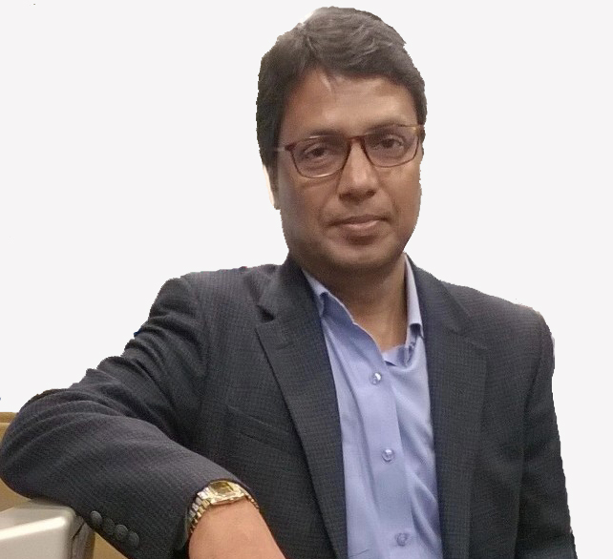

**Business Background**

With over 32 years of priceless experience and strong foundations of trust, transparency and quality Dwarka Gems Limited has set some benchmarks which keep us above the others.

Dwarka Gems Limited started it operations in the 1987. Company’s CMD (chairman and managing director) Mr. Krishna B. Goyal laid the foundation of the company with a vision of marking strong footsteps for building a brand in gems and jewelry industry. This first generation entrepreneur led the company with a professional approach and marched forward.

Early in the history, Dwarkas had a strong presence in the sterling silver, gold and the diamond & color gemstones industry. From a humble beginning Dwarkas has steadily expanded to be a vertically integrated jewelry company in India. Nearly total vertical integration ensures that Dwarkas is able to offer high Quality products to its customers at highly efficient prices – a philosophy that is clearly reflected in its core values.

Dwarka Gems Limited is focused for strengthening its position in both class and mass jewelry in international and domestic markets. Having two retail outlets in India and operating with two international offices in New York and London with corporate office at Jaipur (India) we are dedicatedly focused on our vision.

**Positions held in trade associations**

* Founder Member of **JPDC** a Jewellery manufacturing and designing institute an initiative of **Gems and Jewelry Export Promotion Council’s** (GJEPC).
* Former President of the **Sitapura Gems and Jewelry Industry Association**.
* State Council Member of **Confederation of Indian Industry** (headed the panel to promote Gems & Jewellery Industry of Rajasthan)
* State Council Member of **Federation of Indian Chambers of Commerce and Industry**.
* Past President of **Rotary club Jaipur Elite.**