**File No.: VIS(2022-23)-PL503-Q108-552-927 Dated: 09/05/2023**

**CONSTRUCTION COST VETTING REPORT**

**OF**

**GEMS AND JEWELLERY PARK IN MAHAPE, NAVI MUMBAI**

**SITUATED AT**

**PLOT NO. EL-237, TRANS THANE CREEK INDUSTRIAL AREA, VILLAGE MAHAPE, NAVI MUMBAI, TALUKA AND DISTRICT THANE, MAHARASHTRA**

**PROMOTER/S**

**GEM AND JEWELLARY EXPORT PROMOTION COUNCIL**

**REPORT PREPARED FOR**

**STATE BANK OF INDIA, DIAMOND BRANCH, D-3, TOWER, WEST CORE, G-BLOCK, BHARAT DIAMOND BOURSE, BANDRA-KURLA COMPLEX, BANDRA (E), MUMBAI – 400051**

***\*\*Important - In case of any query/ issue or escalation you may please contact Incident Manager***

***at le@rkassociates.org. We will appreciate your feedback in order to improve our services.***

***NOTE: As per IBA Guidelines please provide your feedback on the report within 15 days of its submission after which report will be considered to be correct.***

# IMPORTANT NOTICE

***COPYRIGHT FORMAT:*** *This report is prepared on the copyright format of R.K Associates, to serve our clients with the best available information and analysis to facilitate them to take rational business decisions. Legally no one can copy or distribute this format without prior approval from R.K Associates. It is meant only for the advisory/ reference purpose for the organization/s as mentioned on the cover page of this report. Distribution or use of this format by any organization or individual other than R.K Associates will be seen as unlawful act and necessary legal action can be taken against the defaulters.*

*This report is intended for the sole use of the intended recipient/s and contain material that is STRICTLY CONFIDENTIAL AND PRIVATE.*

***DEFECT LIABILITY PERIOD:*** *- In case of any query/ issue or escalation you may please contact Incident Manager: @ le@rkassociates.org. We try our level best to ensure correctness in the calculations done, rates adopted and various other data points & information mentioned in the report but still can’t rule out typing, human errors or any other mistakes. In case you find any such mistake or inaccuracy in any data point of the report please help us by bringing all such points into our notice immediately or within 15 days of the report delivery in writing, to rectify these timely failing after which R.K Associates won’t be held responsible for any such inaccuracy in any manner. We would highly appreciate your feedback in order to improve our services.*

|  |  |
| --- | --- |
| **PART A** | **REPORT SUMMARY** |

|  |  |  |
| --- | --- | --- |
| **S.NO.** | **PARTICULARS** | **DESCRIPTION** |
|  | Name of the Project | Gems and Jewellery park in Mahape, Navi Mumbai |
|  | Project Location | Plot No. El-237, Trans Thane Creek Industrial Area, Village Mahape, Navi Mumbai, Taluka And District Thane, Maharashtra. |
|  | Name of the Promotors/Company | M/s India Jewellery Park Mumbai, a special purpose vehicle (SPV) of the Gem and Jewellery Export Promotion Council |
|  | Address and Phone Number | D2B, Ground Floor, D Tower, West Core, Bharat Diamond Bourse, Bandra Kurla Complex, Bandra (E) Mumbai, Maharashtra-400051. |
|  | Prepared for Bank | State Bank Of India, Diamond Branch, D-3, Tower, West Core, G-Block, Bharat Diamond Bourse, Bandra-Kurla Complex, Bandra (E), Mumbai - 400051 |
|  | Consultant Firm | M/s. R.K. Associates Valuers & Techno Engineering Consultants (P) Ltd. |
|  | Work Order Details | Via email dated 31-01-2023 |
|  | Date of Survey | 28th February 2023 |
|  | Date of Report | 09th May 2023 |
|  | Purpose of the Report | Construction Cost Vetting Report. |
|  | Scope of the work provided by the Lender | Only to comment on the following below points based on the scope of work:   * Construction Cost Vetting Report.   *NOTE: This report doesn’t contains any other kind of recommendation or suggestions other than the above mentioned point.* |

|  |  |
| --- | --- |
| **PART B** | **INTRODUCTION** |

1. **THE PROJECT:** The Gems and Jewellery sector plays a significant role in the Indian economy, contributing around 6-7 per cent of the country’s GDP. The contributions are attributed to the efforts of the Gems and Jewellery Export Promotion Council (GJEPC), an autonomous body set up by the Ministry of Commerce and industry, Government of India (GoI) in 1966. GJEPC role has been to promote brand India, connect government and trade, spread education, look after health and well-being aspects of the Karigar community and bolster innovation and infrastructure.

**ABOUT THE COMPANY:** M/s India Jewellery Park Mumbai (IJPM) was incorporated on 17th January, 2018 established for the purpose of developing Gems and Jewellery Park. The company is established as a public company limited by guarantee and having a share capital as an SPV with Registration no. 304254 and Corporate Identification Number U74999MH2018NPL304254 and is promoted by the directors who appears to be well experience in gems and jewellery industry as per the profile shared to us by the client and information available in the public domain about them.

The company is registered at Registrar of companies, Mumbai having registration number 304254 and registered office at D2B, Ground Floor, D Tower, West Core, Bharat Diamond Bourse, Bandra Kurla Complex, Bandra (E) Mumbai, Maharashtra-400051. As per the MCA website, the company is having the authorized capital of INR 2,50,00,000 and paid-up capital of INR 2,50,00,000.

**PROJECT OVERVIEW:** Gems and Jewellery Export Promotion Council through IJPM has proposed to create an end-to-end jewellery manufacturing ecosystem under one roof and to provide state of the art infrastructure with ancillary facilities to manufacturers. The development of Gems and Jewellery Park in Mahape, Navi Mumbai, is envisaged with a view to provide an internationally competitive and environment for Gems and Jewellery industry in well planned zones with all infrastructural facilities and amenities of international standards.

As per details provide to us, the total land area of the project is 86053 sqm, total Built-up area of the project proposed 4,88,817 sq.mtr /5261622 sq.ft. Built-up area details attached below:

|  |  |
| --- | --- |
| **Conceptual Master Plan\*** | |
| Land Area | **86,056 sqm** |
| FSI Utilised | **3** |
| Ground Coverage | **31.30%** |
| Building Height | **G+31, G+14, G+9, G+1** |
| Total Built-up Area | **4,88,817 sqm (52,61,622 sq. ft.)** |
| Area of Karkhanas | **2,93,968 sqm** |
| Area of Shops/Showroom | **58,522.50 sqm** |
| Common Facility | **890 sqm** |
| Hotel | **1,35,410 sqm** |
| Basement | **2,93,968 sqm** |

***\* Provided by Bank/Client***

As per estimation details provided to us in excel sheet the total proposed Building & Civil Construction cost of the project was estimated to be Rs. 1,195 Cr.

Details of the same are tabulated below:-

|  |  |  |  |  |  |  |
| --- | --- | --- | --- | --- | --- | --- |
| **Sr No** | **Costs** | **INR Crores** | **Unit of Measurement** | **Quantity** | **Cost per sq.ft.** | **Remarks By Company**  **(Service Provider)** |
|
| 1 | Levelling & compaction works | 1.03 | sqm | 86,053 | 120.0 |  |
| 2 | Boundary wall works | 5.23 | cum | 2,039 | 25659.9 | Developed in two parts; Part 1: Initial boundary wall before commencement of works Part 2: Final boundary wall after completion of works and includes cost of foundation, excavation and supplementary installations |
| 3 | Project Office | 0.18 | sqft | 500 | 3500.0 |  |
| 4 | Sales Office | 0.70 | sqft | 2,000 | 3500.0 |  |
| 5 | Excavation | 5.67 | cum | 1,33,375 | 425.0 |  |
| 6 | Piling | 16.22 | cum | 24,961 | 6500.0 |  |
| 7 | Concrete | 109.62 | cum | 69,368 | 15802.5 | This includes cost of concrete, reinforcement steel, shuttering required for construction of sub-structure and parking in the building |
| 8 | Civil Works | 371.48 | cum | 1,92,954 | 19252.1 | This includes cost of concrete, reinforcement steel, shuttering required for construction of the building |
| 9 | Plumbing & Electrical | 193.40 | sqft | 89,99,359 | 214.9 |  |
| 10 | Brickwork & Plaster | 6.39 | sqm | 1,82,871 | 349.5 |  |
| 11 | Fixture Installation (Bathroom, Doors, Windows) | 11.82 | sqft | 31,35,596 | 37.7 |  |
| 12 | Painting, Finishing & Tiling in Common area | 77.45 | sqft | 36,51,763 | 212.1 |  |
| 13 | Façade | 16.08 | sqft | 16,083 | 10000.0 |  |
| 14 | STP | 9.00 | MLD | 6 | 15000000 |  |
| 15 | ETP | 12.50 | MLD | 5 | 25000000 |  |
| 16 | Amenity buildings | 1.45 | sqft | 9,580 | 1515.8 |  |
| 17 | Landscaping works | 30.78 | sqft | 4,16,669 | 738.8 |  |
| 18 | Road works | 6.94 | LS | 27,75,826 | 25.0 |  |
| 19 | Labor | 29.81 | Man days | 5,96,177 | 500.0 |  |
| 20 | MEP and machinary installations | 48.99 | sqft | 40,62,307 | 120.6 |  |
| 21 | EPC Tier I Premium | 96.92 | sqft | 52,61,622 | 184.2 |  |
| 22 | Escalation in rates | 98.66 | sqft | 52,61,622 | 187.5 |  |
| 23 | PMC | 10.42 | sqft | 52,61,622 | 19.8 |  |
| 24 | Architect | 28.89 | sqft | 52,61,622 | 54.9 |  |
| 25 | Cost consultant | 5.79 | sqft | 52,61,622 | 11.0 |  |
|  | **Total Construction Costs** | **1,195** |  |  |  |  |

**CURRENT STATUS OF THE PROJECT:**

As per information gathered and observed during the site visit dated 28th February 2023, the boundary wall on the land parcel of the project was completed for initial phase and no construction work of building has been started yet.

**Concluded comments on Civil and Building Construction:**

|  |  |  |  |  |  |  |
| --- | --- | --- | --- | --- | --- | --- |
| **Sr No** | **Costs** | **INR Crores** | **UoM** | **Quantity** | **Cost per sq.ft.** | **Remarks By RKA** |
|
| 1 | Levelling & compaction works | 1.03 | sqm | 86,053 | 1,20 | There is no compaction work because the whole land parcel is on Hard strata of rocks beneath. However, the estimation cost appears to be reasonable. |
| 2 | Boundary wall works | 5.23 | cum | 2,039 | 25,659.9 | The peripheral area is approx. 1.3KM or 1300 mtr. The estimation cost appears to be Higher. |
| 3 | Project Office | 0.18 | sqft | 500 | 3,500.0 | The estimation cost appears to be reasonable. |
| 4 | Sales Office | 0.70 | sqft | 2,000 | 3,500.0 | The estimation cost appears to be reasonable. |
| 5 | Excavation | 5.67 | cum | 1,33,375 | 4,25.0 | The estimation cost appears to be reasonable. |
| 6 | Piling | 16.22 | cum | 24,961 | 6,500.0 | The estimation cost appears to be reasonable. |
| 7 | Concrete | 109.62 | cum | 69,368 | 15,802.5 | The estimation cost seems to be on higher side. |
| 8 | Civil Works | 371.48 | cum | 1,92,954 | 19,252.1 | The estimation cost seems to be on higher side. |
| 9 | Plumbing & Electrical | 193.40 | sqft | 89,99,359 | 214.9 | The estimation cost appears to be reasonable. |
| 10 | Brickwork & Plaster | 6.39 | sqm | 1,82,871 | 349.5 | The estimation cost seems to be on lower side. |
| 11 | Fixture Installation (Bathroom, Doors, Windows) | 11.82 | sqft | 31,35,596 | 37.7 | The estimation cost seems to be on lower side. |
| 12 | Painting, Finishing & Tiling in Common area | 77.45 | sqft | 36,51,763 | 212.1 | The estimation cost seems to be on lower side. |
| 13 | Façade | 16.08 | sqft | 16,083 | 10,000.0 | The estimation cost seems to be on higher side. |
| 14 | STP | 9.00 | MLD | 6 | 150,00,000 | The estimation cost seems to be on lower side. |
| 15 | ETP | 12.50 | MLD | 5 | 250,00,000 | The estimation cost appears to be reasonable. |
| 16 | Amenity buildings | 1.45 | sqft | 9,580 | 1,515.8 | The estimation cost appears to be reasonable. |
| 17 | Landscaping works | 30.78 | sqft | 4,16,669 | 738.8 | The estimation cost seems to be on higher side. |
| 18 | Road works | 6.94 | LS | 27,75,826 | 25.0 | The estimation cost seems to be on higher side. |
| 19 | Labor | 29.81 | Man days | 5,96,177 | 500.0 | The estimation cost appears to be reasonable. |
| 20 | MEP and machinery installations | 48.99 | sqft | 40,62,307 | 120.6 | The estimation cost seems to be on lower side. |
| 21 | EPC Tier I Premium | 96.92 | sqft | 52,61,622 | 184.2 | The estimation cost appears to be reasonable. |
| 22 | Escalation in rates | 98.66 | sqft | 52,61,622 | 187.5 | The estimation cost appears to be reasonable. |
| 23 | PMC | 10.42 | sqft | 52,61,622 | 19.8 | The estimation cost appears to be reasonable. |
| 24 | Architect | 28.89 | sqft | 52,61,622 | 54.9 | The estimation cost seems to be on higher side. |
| 25 | Cost consultant | 5.79 | sqft | 52,61,622 | 11.0 | The estimation cost seems to be on higher side. |
|  | **Total Construction Costs** | **1,195** |  |  |  |  |

**OBSERVATIONS, REMARKS AND CONCLUSION BY RKA**

* We have not been provided the information required to apprised the above cost vetting such as BOQ, Approved Plan, basis of construction. However, we have considered excel sheet provided by the bank/client, and information available at government websites.
* In some of the costs items in civil and building construction, the rates provided in the excel sheet is not clear about its unit of measurements and other details.
* As per our physical observations during the survey, the site is adjacent to query site for stone crushing plant. Therefore, we have assumed our site to be on hard strata with rocky bed.
* During the course of site inspection, the boundary wall was constructed for first phase.
* The conceptual master plan provided for plot area 86056 sqm being provided with FSI of 3. Whereas additional FSI is permissible For Industrial Parks across the State, upto 200% additional floor space index will be admissible on basic admissible floor space index which is more depending upon availability of road width. Please refer below for reference.
* As per details provided to us, the total expenditure on construction of building and civil work by the company is Rs. 1195 /- Crore for built-up area of 5261622 sq.ft and it comes out to be Rs.2271 /- per sq.ft. appears to be reasonable.

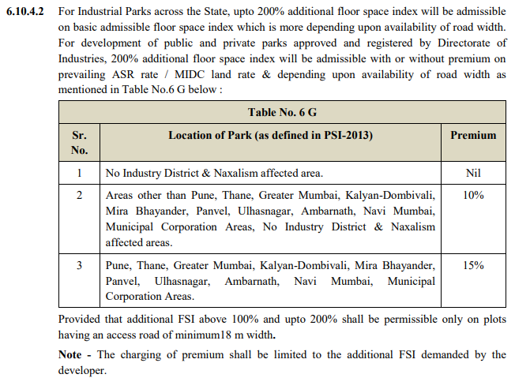

***Source:*** [***https://www.midcindia.org/***](https://www.midcindia.org/)

|  |  |
| --- | --- |
| **PART C** | **DISCLAIMER** |

* + - 1. No employee or member of R.K Associates has any direct/ indirect interest in the Project.
      2. This report is prepared based on the copies of the documents/ information which the Bank/ Company has provided to us out of the standard checklist of documents sought from them and further based on our assumptions and limiting conditions. All such information provided to us has been relied upon in good faith and we have assumed that it is true and correct in all respect. Verification or cross checking of the documents provided to us has not been done at our end from the originals. If at any time in future, it is found or came to our knowledge that misrepresentation of facts or incomplete or distorted information has been provided to us then this report shall automatically become null & void.
      3. This report is a general analysis of the project based on the scope mentioned in the report. This is not an Audit report, Design document, DPR or Techno-financial feasibility study. All the information gathered is based on the facts seen on the site during survey, verbal discussion & documentary evidence provided by the client and is believed that information given by the company is true best of their knowledge.
      4. All observations mentioned in the report is only based on the visual observation and the documents/ data/ information provided by the client. No mechanical/ technical tests, measurements or any design review have been performed or carried out from our side during Project assessment.
      5. Bank/FII should ONLY take this report as an Advisory document from the Financial/ Chartered Engineering firm and it’s specifically advised to the creditor to cross verify the original documents for the facts mentioned in the report which can be availed from the borrowing company directly.
      6. In case of any default in loans or the credit facility extended to the borrowing company, R.K Associates shall not be held responsible for whatsoever reason may be and any request for seeking any explanation from the employee/s of R.K Associates will not be entertained at any instance or situation.
      7. This is just an opinion report and doesn’t hold any binding on anyone. It is requested from the concerned Financial Institution which is using this report for taking financial decision on the project that they should consider all the different associated relevant & related factors also before taking any business decision based on the content of this report.
      8. All Pages of the report including annexures are signed and stamped from our office. In case any paper in the report is without stamp & signature then this should not be considered a valid paper issued from this office.
      9. Though adequate care has been taken while preparing this report as per its scope, but still we can’t rule out typing, human errors, over sightedness of any information or any other mistakes. Therefore, the concerned organization is advised to satisfy themselves that the report is complete & satisfactory in all respect. Intimation regarding any discrepancy shall be brought into our notice immediately. If no intimation is received within 15 (Fifteen) days in writing from the date of issuance of the report, to rectify these timely, then it shall be considered that the report is complete in all respect and has been accepted by the client upto their satisfaction & use and further to which R.K Associates shall not be held responsible in any manner.
      10. Defect Liability Period is **15 DAYS**. We request the concerned authorized reader of this report to check the contents, data and calculations in the report within this period and intimate us in writing if any corrections are required or in case of any other concern with the contents or opinion mentioned in the report. Corrections only related to typographical, calculation, spelling mistakes, incorrect data/ figures/ statement will be entertained within the defect liability period. Any new changes for any additional information in already approved report will be regarded as additional work for which additional fees may be charged. No request for any illegitimate change in regard to any facts & figures will be entertained.
      11. R.K Associates encourages its customers to give feedback or inform concerns over its services through proper channel at le@rkassociates.org in writing within 30 days of report delivery. After this period no concern/ complaint/ proceedings in connection with the Lender’s Independent Engineering Services will be entertained due to possible change in situation and condition of the subject Project.
      12. Our Data retention policy is of **ONE YEAR**. After this period, we remove all the concerned records related to the assignment from our repository. No clarification or query can be answered after this period due to unavailability of the data.
      13. R.K Associates never releases any report doing alterations or modifications from pen. In case any information/ figure of this report is found altered with pen then this report will automatically become null & void.

|  |  |
| --- | --- |
| **PREPARED BY** | **REVIEWED BY** |
|  |  |
| **Rahul Gupta**  **(Sr. Engineer Valuation)** | **Ashish Sawe** |
| **Date:09th May 2023** | **Date:09th May 2023** |

***DEFECT LIABILITY PERIOD - In case of any query/ issue or escalation you may please contact Incident Manager by writing at valuers@rkassociates.org. We ensure 100% accuracy in the Calculations done, Rates adopted and various other data points & information mentioned in the report but still can’t rule out typing, human errors or any other mistakes. In case you find any mistake, variation, discrepancy or inaccuracy in any data point of the report, please help us by bringing all such points into our notice in writing at*** [***valuers@rkassociates.org***](mailto:valuers@rkassociates.org) ***within 30 days of the report delivery, to get these rectified timely, failing which R.K Associates Valuers Techno Engineering Consultants (P) Ltd. won’t be held responsible for any inaccuracy in any manner. Also, if we will not hear back anything from you within 30 days, we will assume that report is correct in all respect and no further claim of any sort will be entertained thereafter. We would welcome and appreciate your feedback & suggestions in order to improve our services.***

***COPYRIGHT FORMAT - This report is prepared on the copyright format of R.K Associates Valuers Techno Engineering Consultants (P) Ltd. to serve our clients in the best possible way. Legally no one can copy or distribute this format without prior approval from R.K Associates. It is meant only for the organization as mentioned on the cover page of this report. Distribution or use of this format other than R.K Associates will be seen as unlawful act and necessary legal action can be taken against the defaulter***

|  |  |
| --- | --- |
| **PART D** | **PHOTOGRAPHS** |

|  |  |
| --- | --- |
|  |  |
|  |  |
|  |  |

|  |  |
| --- | --- |
|  |  |
|  |  |
|  |  |

|  |  |
| --- | --- |
|  |  |
|  |  |
|  |  |

|  |  |  |  |
| --- | --- | --- | --- |
|  | |  | |
|  | |  | |
|  | |  | |
|  |  | |
|  |  | |
|  |  | |

|  |  |
| --- | --- |
|  |  |
|  |  |
|  |  |

**Unit Details:**

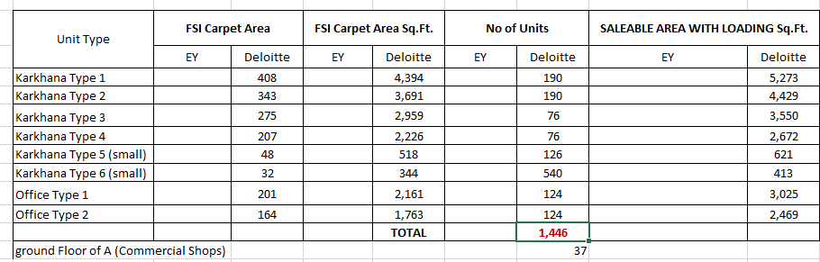

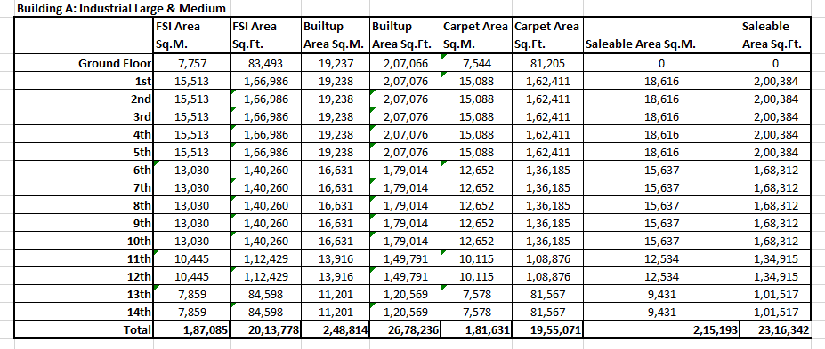

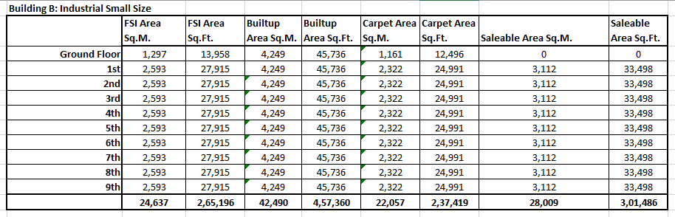

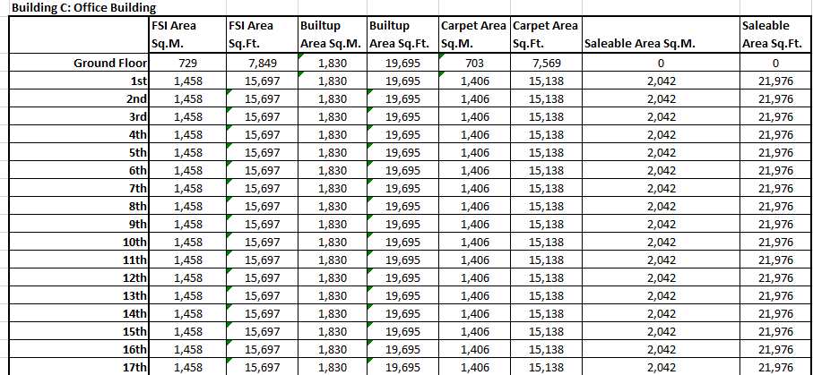

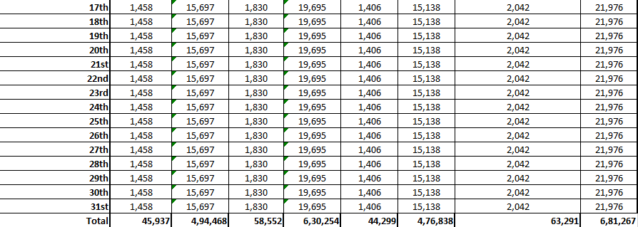

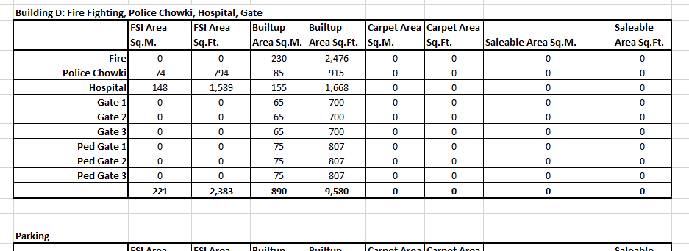

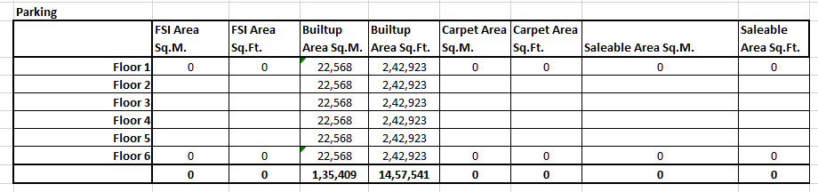

**Area Statement**

