**REPORT FORMAT:** CL-1 | Version: 1.0_2018

# FILE No.: VIS (2022-23)-PL517-416-718 Date: 22-12-2022

* **CERTIFICATE NAME:** Estimation of remainingEconomical Life of Assets situated at Village Mandapeta, District Rajahmundry, Andhra Pradesh
* **PREPARED FOR ORGANIZATION:** M/s. Kailashi Devi Pulps & Paper Products Private Limited
* **BORROWER COMPANY’S NAME:** M/s. Kailashi Devi Pulps & Paper Products Private Limited
* **ASSET TYPE**: Turbine & Boiler
* **CURRENT LOCATION OF THE MACHINES:** Village Mandapeta, District Rajahmundry, Andhra Pradesh

**TO WHOMSOEVER IT MAY CONCERN**

|  |  |  |
| --- | --- | --- |
| **S. NO.** | **PARTICULARS** | **DESCRIPTION** |
| 1. | Date of Survey | 16-12-2022 |
| 2. | Date of Certificate | 22-12-2022 |
| 3. | Documents provided for perusal | Technical Specification of assets. |
| 4. | Current Location of the Machines | Rajahmundry, Andhra Pradesh |
| 5. | Borrowing Company | M/s. Kailashi Devi Pulps & Paper Products Private Limited |
| 6. | Type of Asset | Turbine & Boiler |
| 7. | Type of Assessment | Remaining Economic Life Estimation of Turbine & Boiler |
| 8. | Scope of Assessment | To Calculate the Remaining Economic Life Estimation of Turbine & Boiler based on their current condition. |
| 9. | Nature of Machinery | Turbine & Boiler |
| 10. | Year of Manufacturing | Turbine: - 2015  Boiler: - 2009 |
| 11. | Total Economic Life | As per our general practice we took economical life of the Turbine and Boilers as 25 years which is generally the maximum life of any plant. However, in various documents like Companies Act 2013, American Society of Appraisers total economic life of Turbine is in the range of 30 – 40 Years whereas for Boiler it is 20 – 25 Years. Based on this we are of the view to adopt the total economic life of Turbine & Boiler as 40 Years & 25 Years respectively. |
| 12. | Current Age of the Assets | Turbine: - 07 Years  Boiler: - 13 Years |
| 13. | Assessment of Remaining Economical Life of the Assets | Remaining Economical Life of the Assets is calculated by subtracting Total Economic Life from Current Age of the Assets and further considering various Obsolescence. |
| 13. | Remaining Economical Life of the Assets | **Turbine: - 23 Years**  **Boiler: - 08 Years** |

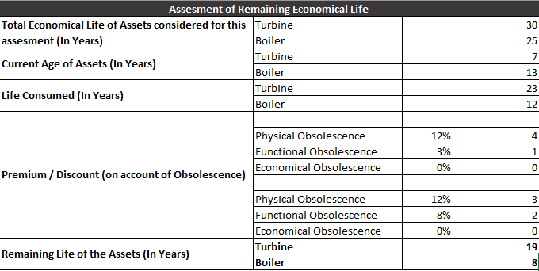

## OBSERVATIONS:

## During the time of our site visit, we have found that the Turbine as unoperational, further as per our discussion with the Trader (with whom the company is purchasing) we came to know that the Turbine is unoperational since January, 2022.

## Keeping in mind the fact that the assets are proposed to be dismantled and will be erected on other site therefore there are high chances of occurrence of normal wear and tear in this process.

## As per our discussion with the Industry Experts, maintenance which includes Pipe Flushing, several Health Test of components, Changes of Consumables would be required.

***Disclaimer:***

1. *The condition assessment and the estimation of the residual economic life of the structure are only based on the visual observations and appearance found during the site survey. We have not carried out any structural design or stability study; nor carried out any physical tests to assess structural integrity & strength.*
2. *This certificate doesn’t include any work related to drawing, design, sketch plan, procurement of the machines.*
3. *Ownership and other legal point of view in respect of the asset is not considered in this report as same is out of scope of this certificate.*
4. *This certificate is made at the request of the* M/s. Kailashi Devi Pulps & Paper Products Private Limited

**For R.K Associates Valuers & Techno FOR INTERNAL USE Engineering Consultants (P) Ltd.**

***TYPED BY:*** *Er. Gaurav Sharma*

***REVIEWED BY:*** *Er. Mansa Upmanyu*

# ANNEXURE: - I (LIST OFMACHINES PROVIDED BY CLIENT)

