File No.: VIS (2022-23)-PL519-Q110-553-926 Dated: 10.04.2023

ECONOMIC VIABILITY STUDY REPORT

OF

GEMS AND JEWELLERY PARK

SETUP BY

INDIA JEWELLERY PARK MUMBAI

PROMOTED BY

GEMS AND JEWELLERY EXPORT PROMOTION COUNCIL

REPORT PREPARED FOR
STATE BANK OF INDIA, DIAMOND BRANCH, D-3, TOWER, WEST CORE, G-BLOCK, BHARAT DIAMOND BOURSE, BANDRA-KURLA COMPLEX, BANDRA (E), MUMBAI - 400051

**Important - In case of any query/ issue or escalation you may please contact Incident Manager Valuers@rkassociates.org. We will appreciate your feedback in order to improve our services.

NOTE: As per IBA Guidelines please provide your feedback on the report within 15 days of its submission after which report will be considered to be correct.

IMPORTANT NOTICE

COPYRIGHT FORMAT: This report is prepared on the copyright format of R. K. Associates Valuers & Techno Engineering Consultants (P) Ltd. (R. K. Associates) to serve our clients with the best possible information and analysis to facilitate them to take rational business decisions. Legally no one can copy or distribute this format without prior approval from R. K. Associates. It is meant only for the advisory/ reference purpose for the organization/s as mentioned on the cover page of this report. Distribution or use of this format or report or any of its content/ information/ data by any organization or individual other than R.K Associates will be seen as an unlawful act and necessary legal action can be taken against the defaulters.
This report is intended for the sole use of the intended recipient/s and contains material that is STRICTLY CONFIDENTIAL AND PRIVATE.

DEFECT LIABILITY PERIOD: In case of any query/ issue or escalation you may please contact Incident Manager at valuers@rkassociates.org. Though adequate care has been taken while preparing this report as per its scope, but still, we can’t rule out typing, human errors, over sightedness of any information or any other mistakes. Therefore, the concerned organization is advised to satisfy themselves that the report is complete & satisfactory in all respect. Intimation regarding any discrepancy shall be brought into our notice immediately. If no intimation is received within 15 (Fifteen) days in writing from the date of issuance of the report, to rectify these timely, then it will be considered that the report is complete in all respect and has been accepted by the client up to their satisfaction & use and further to which R.K Associates shall not be held responsible in any manner.

Part N: R. K. Associates Important Disclaimer and Remarks are integral part of this report and Feasibility assessment is subject to this section. Reader of the report is advised to read all the points mentioned in these sections carefully.

TABLE OF CONTENTS
SECTIONS | PARTICULARS | PAGE NO.
Part A | Report Summary | 4-5
Part B | Introduction
 | - About the Report | 6
 | - Executive summary | 6-9
 | - Purpose of the Report | 9
 | - Scope of the Report | 9-10
 | - Methodology/ Model Adopted | 10
 | - Data Information received from | 10
 | - Documents/ Data Referred | 10-11
Part C | Company Profile
 | - Company Overview | 12
 | - Proposed Shareholding Details | 12-13
 | - Promoters/Directors Profile | 13-19
Part D | Infrastructure Details
 | - Proposed Location | 20
 | - Location Map | 20
 | - Land Details | 20-22
 | - Layout Plan | 23
 | - Site pictures | 23-26
 | - Building & Civil Works | 26-27
 | - Utilities | 27-28
 | - Manpower | 28
Part E | Inventory Profile
 | - Introduction | 29-30
 | - Inventory Category | 30-33
 | - Marketing, Selling & Distribution Plan | 33-36
Part F | Industry Overview & Analysis | 37-40
Part G | SWOT Analysis | 41
Part H | Risk Mitigation | 42-44
Part I | Project Cost and Means of Finance | 45-46
Part J | Project Schedule | 47
Part K | Statutory Approvals | Licences | NOC | 48
Part L | Company’s Financial Feasibility
 | - Projection of Firm | 49-56
 | - Graphical Representation of Key Financial Metrics | 56-57
 | - Loan Amortization Schedule | 58
 | - Construction Cost Schedule | 58-59
 | - Key assumptions & Basics | 59-63
Part M | Conclusion | 64
Part N | Disclaimer | Remarks | 66-69

PART A | REPORT SUMMARY

- Name of the Company: | M/s India Jewellery Park Mumbai
- Address of the Company: | D2B, Ground Floor, D Tower, West Core, Bharat Diamond Bourse, Bandra Kurla Complex, Bandra (E) Mumbai, Maharashtra-400051.
- Project Name: | Gems and Jewellery Park
- Project Location: | Mahape, Navi Mumbai
- Project Type: | Develop Jewellery Park to house jewellery units of various sizes.
- Project Industry: | Gems and Jewellery Industry
- Product Type / Deliverables: | Jewellery karkhanas and office units of various sizes.
- Report Prepared for Organization: | State Bank of India, Diamond Branch, D-3, Tower, West Core, G-Block, Bharat Diamond Bourse, Bandra-Kurla Complex, Bandra (E), Mumbai - 400051.
- TEV Consultant Firm: | M/s. R.K Associates Valuers & Techno Engineering Consultants (P) Ltd.
- Report type: | Economic Viability Report
- Purpose of the Report: | To assess Project’s Economic Viability for the purpose of seeking external financial assistance on the Project.
- Scope of the Report: | To assess, evaluate & comment on Economic Viability of the Project as per data information provided by the client, independent Industry research and data/ information available on public domain.
- Date of Report: | 10th April, 2023
- Documents referred for the Project: | - PROJECT PLANNING DOCUMENTS:  - Detailed Project Report  - Financial Projections of the Project  - Project proposed Schedule  - Statutory Approval Details  - Layout and Master Plan  - PROCUREMENT DOCUMENTS:  - High level breakup of Construction Cost  - Sanction/tentative/proposed map of the sites  - Land details and draft deeds  - Cost Estimations
- Means of Finance: | Equity & Debt
- Key Financial Indicators: | Key Indicators Value  Average DSCR 1.95  Maximum DSCR 2.78  Average EBITDA Margin 24.43%  Average Net Profit Margin 15.91%

Note: Above financial indicators are based on the financial projections of the proposed project provided by the firm and assessment and analysis of the same done by us.

PART B | INTRODUCTION

- ABOUT THE REPORT: Economic Viability Study Report of the Indian Jewellery Park, Mumbai to be develop by Gems and Jewellery Export Promotion Council (GJEPC).

- EXECUTIVE SUMMARY: The Gems and Jewellery sector plays a significant role in the Indian economy, contributing around 6-7 per cent of the country’s GDP. The contributions are attributed to the efforts of the Gems and Jewellery Export Promotion Council (GJEPC), an autonomous body set up by the Ministry of Commerce and industry, Government of India (GoI) in 1966. GJEPC role has been to promote brand India, connect government and trade, spread education, look after health and well-being aspects of the Karigar community and bolster innovation and infrastructure.

GJEPC is a Section 25 Company under the provisions of the Companies Act, 1966 as a Company limited by guarantee not having share capital. It represents the interests of more than 6,800 members across India. The Committee of Administration of GJEPC (Board of Directors) includes Government nominees representing from Representative from Ministry of Commerce & Industry (MoC&I), Director General of Export Promotion (DGEP), Director General of Foreign Trade (DGFT).
M/s India Jewellery Park Mumbai (IJPM) was incorporated on 17th January, 2018 established for the purpose of developing Gems and Jewellery Park. The company is established as a public company limited by guarantee and having a share capital as an SPV with Registration no. 304254 and Corporate Identification Number U74999MH2018NPL304254 and is promoted by the directors who appears to be well experience in gems and jewellery industry as per the profile shared to us by the client and information available in the public domain about them.
The company is registered at Registrar of companies, Mumbai having registration number 304254 and registered office at D2B, Ground Floor, D Tower, West Core, Bharat Diamond Bourse, Bandra Kurla Complex, Bandra (E) Mumbai, Maharashtra-400051. As per the MCA website, the company is having the authorized capital of INR 2,50,00,000 and paid-up capital of INR 2,50,00,000.
Gems and Jewellery Export Promotion Council through IJPM has proposed to create an end-to-end jewellery manufacturing ecosystem under one roof and to provide state of the art infrastructure with ancillary facilities to manufacturers. The development of Gems and Jewellery Park in Mahape, Navi Mumbai, is envisaged with a view to provide an internationally competitive and a hassle-free environment for Gems and Jewellery industry in well planned zones with all infrastructural facilities and amenities of international standards.
As per data provided by the client/company, below table shows the details of conceptual master plan with break-up:
Conceptual Master Plan
Land Area | 86,056 sqm
FSI Utilised | 3
Ground Coverage | 31.30%
Building Height | G+31, G+14, G+9, G+1
Total Build Up Area | 4,88,817 sqm (52,61,622 sq. ft.)
Area of Karkhanas | 2,93,968 sqm
Area of Shops/Showroom | 58,522.50 sqm
Common Facility | 890 sqm
Hotel | 1,35,410 sqm
Basement | 2,93,968 sqm

The vision of the jewellery park is to develop a state-of-the-art organized ecosystem for labour-intensive jewellery industry addressing the prevalent issues in existing unorganized clusters for Karigar community such as poor infrastructure and safety hazards, living and working conditions, redundant tools and machinery, cumbersome government procedures and legal issues. This dynamic venture will provide effective support to jewellery manufacturers/traders who are interested to relocate, expand or invest in the state of Maharashtra and the region to initiate new business or strengthen their existing business, benchmarking with the Jewellery Parks created in countries like China, Turkey, Italy, Thailand, etc.
GJEPC is primary stakeholder and implementing agency of the project and works closely with other stakeholders like MIDC, Government of Maharashtra, Ministry of Commerce and Industry, Central Government, DGFT, Board Members and COA of GJEPC, Trade and Industry association, for implementing and operating the project.
GJEPC signed a memorandum of understanding (MoU) with Maharashtra Industrial Development Corporation (MIDC) on 19 February 2018 to build Jewellery Park in Navi- Mumbai, to be christened as “India Jewellery Park Mumbai” on 21 acres of land, to house jewellery units of various sizes. IJPM is expected to enhance manufacturing, investment, export growth, working conditions of Karigars and overall economic development of Maharashtra and India. The MoU was signed at the convergence ‘Magnetic Maharashtra’ and the signing was graced by Hon’ble Union Minister of Commerce & Industry and Hon’ble Chief Minister of Maharashtra.
To procure the funding of INR 500 Crores, the company approached the State Bank of India for financial assistance. Further, the State Bank of India appointed R.K. associates to perform the Economic Viability study for proposed Jewellery Park at Mahape, Mumbai for taking term loan of INR 500 Crores from State Bank of India in case of shortage of funds for intervals where the collection/sales are less compared to actual expenditure or construction activity for that particular period.
PROPOSED PROJECT COST
As per data/information provided by the client, the total cost of the project for developing the jewellery park in Mahape, Navi Mumbai is being estimated as INR 1,964 Crores which is proposed to be funded through contribution from GJEPC of INR 130 Crores, advances from members is INR 1,334 Cores and debt of INR 500 Crores.
Total Project Cost (TPC)
Particulars | Cost (In INR Crores)
Freehold Land & Land Development | 250
Construction Cost | 808
Support Infrastructure | 386
Admin cost and other overheads | 104
Sales & Marketing Cost | 38
Interest During Construction (IDC) | 137
GST on Cost | 241
Total Project Cost | 1,964

CURRENT STATUS OF THE PROJECT
As per the information shared by the client/company and available on the company’s website, currently land demarcation and RCC boundary wall around the land parcel is constructed with the help of MIDC and no other major work has commenced yet. During the site survey, we found that the boundary wall of tin-shed was completed on two sides of the vacant land which were easily accessible on foot, as the vacant plot is situated on hill top. In the absence of any site coordinating person, we couldn’t verify the other two sides of the boundary wall due to the geographical restriction.
The company has appointed Voyant Solutions and Aditya Enviro as the Project Management Consultant (PMC) and Environment Clearance Consultant respectively. The company is also in the process of appointing the EPC contractor and the tender for the same has already been floated and the appointment is expected to be done by May 2023.
Land will be provided on lease of 99 years by MIDC for the purpose of developing a Gems and Jewellery Park. A draft lease deed for the land has been submitted and its execution and registration are expected to be done in May 2023. GJEPC though IJPM to develop the said land to create an end-to-end jewellery manufacturing ecosystem under one roof and provide state of the art infrastructure with ancillary facilities to manufacturers. Currently, company is in discussion with financial institutions to fund the project through term loan of INR 500 Crores.

Therefore, to check and assess the Economic viability of the Project for submitting the proposal to financial institutions, State Bank of India, Diamond Branch, Bharat Diamond Bourse, Bandra-Kurla Complex, Bandra (E), Mumbai has appointed us as TEV consultant to review commercial and financial viability of the project based on our independent EIC research and information/data provided to us about the project by M/s India Jewellery Park Mumbai.

- PURPOSE OF THE REPORT: To assess the Economic Feasibility of the green field proposed project to take further Project funding decision for the same.

- SCOPE OF THE REPORT: To assess, evaluate & comment on Economic Feasibility of the proposed Jewellery Park being set up by Gems and Jewellery Export Promotion Council (GJEPC) as per the data/information provided by the client/promoter/stakeholder and our independent EIC research.
NOTES:
- Project status is taken as per the information provided by the company/promoter/stakeholder and independently verified during the site inspection also.
- Scrutiny about the company, background check, credibility, credit worthiness of the company or its promoters is out-of-scope of this report.
- This report is only an opinion in respect to Financial Feasibility of the project as per the future Projections provided by the firm and independent analysis done by us and doesn’t contain any recommendations including taking decision on the financial exposure.
- This is not an audit activity of any kind. We have relied upon the data/ information supplied by the company in good faith that it is true and without any fabrication.
- Any kind of cost vetting of Total Project Cost, Land, Building, and Plant & Machinery, Comprehensive Maintenance Cost etc.is out of scope of the work. We have relied upon the data/information and justifications provided by banker/client in good faith based on the estimated costs done by appointed parties by bank and company.
- This is not a Detailed Project Report or a detailed design or architecture document.
- Land and property details mentioned in the report is only for illustration purpose as per the information provided to us by the client. The same doesn’t tantamount for taking any responsibility regarding its legality, ownership and conforming to statutory norms.

- METHODOLOGY/ MODEL ADOPTED:
- Data/ Information collection.
- Review of Data/ Information collected related to Economic Viability study.
- Independent review & assessment of financial projections provided by the company/promoters.
- Review and analysis of the Projections as per the market trends and futuristic growth opportunity of the industry and company.
- Projections of Revenue, Expenses, P&L, Balance Sheet, fixed assets, COGS.
- Assessment of Key Financial Ratios
- Final conclusion.

- DATA/ INFORMATION RECEIVED FROM: All the data/Information has been received from Mr. Krushal Tanna and the required details about him shown in the below table:
Particulars | Details
Name | Mr. Krushal Tanna
Company | Bajaj Advisors, Mumbai
Email Address | teambajajadvisors@gmail.com
Contact No. | +91 8097874433

- DOCUMENTS / DATA REFFERED:
- Financial Projections of the proposed project up to FY 2029.
- Information memorandum and description of the company (DPR)
- Promoter’s Details & Shareholding Pattern of IJPM.
- Proposed Total project cost.
- Draft lease deed of the land.
- Current booking details provided by the client/company.
- Cost Estimations for various components.
PART C | COMPANY PROFILE

- COMPANY OVERVIEW: M/s. India Jewellery Park Mumbai was incorporated on 17th January, 2018 with CIN: U74999MH2018NPL304254 is a company limited by guarantee having its Registered Office at D2B, Ground Floor, D Tower, West Core, Bharat Diamond Bourse, Bandra Kurla Complex, Bandra (E), Mumbai, Maharashtra – 400051, India. It is classified as Non-govt Company and is registered at Registrar of Companies, Mumbai. Its Authorised Capital is INR 2,50,00,000 and paid-up capital is INR 2,50,00,000.
As per brief description of the company provided by the client, The Gems and Jewellery Export promotion council (GJEPC) is an autonomous body sponsored by the Ministry of Commerce and Industry, Govt. of India in 1966. The GJEPC was set up to promote the Indian gems and jewellery industry and export of its products. GJEPC has formed a Special purpose vehicle (SPV), India Jewellery Park Mumbai (IJPM) to develop India’s first of its kind Gems and Jewellery Park over 21.3-acre land parcel earmarked by Govt. of Maharashtra in Mahape Industrial area. India Jewellery Park Mumbai (IJPM) is wholly owned subsidiary of The Gems and Jewellery Export promotion council.
India Jewellery Park Mumbai is administered by following members of the committee of administration of the GJEPC. They are elected by the members of GJEPC.
S. No. | Name of the COA Member | Designation
1 | Shri Vipul Shah | Chairman
2 | Shri Kirit Bhansali | Vice Chairman
3 | Shri Sanju Kothari | Director
4 | Shri Mitesh Gajera | Director
5 | Shri Naresh Lathiya | Director
6 | Shri Dr. Nawal Agrawal | Director
7 | Shri Krishna Behari Goyal | Director

The development of Gems and Jewellery Park in Mahape, Navi Mumbai, is envisaged with a view to provide an internationally competitive and a hassle-free environment for Gems and Jewellery industry in well planned zones with all infrastructural facilities and amenities of international standards.

- PROPOSED SHAREHOLDING DETAILS: As on 31st March 2023, the Company is having authorized share capital of Rs. 2,50,00,000 and the total paid-up capital is Rs 2,50,00,000 as per the data available on the MCA website. The shareholding details of the company is mentioned below:
S. No. | Name of the Shareholder | No. of Shares held | % Of Holding
1 | The Gem and Jewellery Export Promotion Council  Authorized Person: Sabyasachi Ray | 24,99,994 | 99.99976%
2 | Indian Institute of Gems and Jewellery  Authorized Person: Kirit Bhansali | 1 | 0.00004%
3 | Indian Institute of Gems and Jewellery Delhi  Authorized Person: Anil Sankhwal | 1 | 0.00004%
4 | Indian Institute of Gems and Jewellery Jaipur  Authorized Person: Pramod Agarwal | 1 | 0.00004%
5 | G&J KYC Information Centre  Authorized Person: Russell Mehta | 1 | 0.00004%
6 | Ashokkumar Gajera | 1 | 0.00004%
7 | Praveenshankar Pandya | 1 | 0.00004%
 | Total | 25,00,000 | 100%
Source: Data/Information provided by the Client.

- PROMOTERS/DIRECTORS PROFILE: Director’s details have been shown in the below table:
Director’s Profile
DIN | NAME | Appointment Date | Qualifications/Experience
00004746 | Shri Vipul Shah | 2nd December, 2020 | Shri Vipul P Shah has experience in the diamond industry & has knowledge of current business trends prevailing worldwide as well as deep insight of future needs of the diamond market. His expertise in financial matters remains undisputed. He is currently the CEO & Managing Director of Asian Star Co. Ltd.  As the Chairman of GJEPC, this is Mr. Shah’s second tenure. During his term from October 9, 2012 to October 16, 2015, he was at the forefront to drive export demand and was successful in strengthening ties with mining companies and diamond trade bodies. Among the many important milestones, he was instrumental in organizing GJEPC’s first World Diamond Conference that was attended by Hon. Prime Minister Narendra Modi and Finance Minister Smt. Nirmala Sitharaman. At the Council level, he implemented the policy to have members on a rotation policy so that new people come on board to bring in a fresh perspective and new energy levels.
03400455 | Shri Kirit Bhansali | 17th January, 2018 | Shri Kirit Bhansali R/o - 701, Elegant Orchid, Tagore Road, Santa Cruz West, Mumbai 400 054. He is currently a Diamantaire Partner at Smital Gems. He is also serving on the following councils/bodies.  - Chairman - IIGJ (Indian Institute of Gems & Jewellery)  - Chairman - IJPM (India Jewellery Park Mumbai)  - Committee Member - BDB (Bharat Diamond Bourse)  - Treasurer - BJP (Bhartiya Janata Party- Mumbai)
01441742 | Shri Sanju Kothari | 8th September, 2022 | Shri Sanju Kothari has more than 35 years of experience in the Diamond Industry, with noteworthy expertise in the manufacturing of rough diamonds as well as the trading of polished diamonds. He was amongst the first in the industry to introduce laser-drilling to improve diamond quality. In addition, his knowledge of the diamond industry in Africa is exhaustive, having been to a diverse range of countries including Angola, Mozambique, Zimbabwe, Guinea, Chad, Sierra Leone, South Africa, Mozambique, South Africa, Namibia, Botswana and the Central African Republic, in addition to half a dozen mines in the Democratic Republic of Congo.  He is a member of the Diamond Panel of the Gem and Jewellery Export Promotion Council (GJEPC a government body formed by Commerce Ministry of India) which oversees the development and well-being of the industry. He serves as Convener of the Banking, Insurance & Taxation committee (BITC) of the GJEPC, a role which sees him serve as liaison to RBI, IBA, ECGC, Commerce Ministry and Finance Ministry for matters that affect the diamond and jewellery sectors. He additionally serves on the Executive Committee of the Cricket Club of India (CCI – Brabourne Stadium).
01011862 | Shri Mitesh Gajera | 8th September, 2022 | Information sought but not available.
08007427 | Shri Naresh Lathiya | 8th September, 2022 | Information sought but not available.
00421875 | Dr. Nawal Agrawal | 8th September, 2022 | Dr. Nawal Agrawal is post graduate & has PhD. in science. He joined his family business of Gems & Jewellery in the year 1979. A veteran member of Jeweller’s Association of Jaipur. He is Co-Owner of M/s Birdhichand Ghanshyamdas Jeweller, having outlets at Jaipur & Delhi.  Dr. Agrawal is convener of Gold Jewellery & Other Precious Metal Committee of Gems & Jewellery export promotion council of India. He is also Chairman of Indian Institute of Gem Jewellery, a project of GJEPC. He is one of the patrons of Sarafa Trading Committee Jaipur. He is also Hon. Secretary Jaipur Calgary Eye Hospital.
00336157 | Shri Krishna Behari Goyal | 8th September, 2022 | Shri Krishna Behari Goyal R/o - 61-B, Sardar Patel Marg, C-Scheme, Jaipur, Rajasthan, India. 302001. He is a commerce graduate (B. Com.). He is serving as the CMD of Dwarka Gems Limited (1985 - Present). He also holds position in following trade associations:  - Founder Member of JPDC a Jewellery manufacturing and designing institute an initiative of Gems and Jewelry Export Promotion Council’s (GJEPC).  - Former President of the Sitapura Gems and Jewelry Industry Association.  - State Council Member of Confederation of Indian Industry (headed the panel to promote Gems & Jewellery Industry of Rajasthan)  - State Council Member of Federation of Indian Chambers of Commerce and Industry.  - Past President of Rotary club Jaipur Elite.
Source: Data/Information provided by the client
To give a brief overview of the background of Directors we have listed down the basic company information as found on public domain in general/ tertiary category research.
(Shri Vipul Shah)
S. No. | CIN/FCRN | Company Name | Begin Date
1 | L36910MH1995PLC086017 | Asian Star Company Limited | 26/12/2007
2 | U51900MH1973NPL017093 | Diamond Exporters Association Limited | 23/09/2015
3 | U85300DL2008NPL181612 | National Skill Development Corporation | 10/11/2022
4 | U85191MH2011NPL214395 | Samruddha Gram Vikas Foundation | 04/03/2011
5 | U36912MH1988PTC048315 | Asian Star Diamonds International Private Limited | 21/09/1991
6 | U72300MH2012PTC225962 | Asian Star Infotech Private Limited | 12/01/2012
7 | U74999MH2015NPL267877 | G&J KYC Information Centre | 28/09/2020
8 | U99100MH1966GAP013486 | The Gem and Jewellery Export Promotion Council | 09/06/2020
9 | U74999MH2015NPL268347 | India Diamond Trading Centre | 24/09/2020
10 | U74999MH2018NPL304254 | India Jewellery Park Mumbai | 24/08/2021
11 | U73100MH2019NPL328412 | IIGJ Research and Laboratories Centre | 08/09/2022
12 | U91990DL2021NPL390793 | National Gems and Jewellery Council of India | 22/12/2022
Source: Information extracted from MCA & public domain
(Shri Kirit Bhansali)
S. No. | CIN/FCRN | Company Name | Begin Date
1 | U80220MH2002NPL134963 | Indian Institute of Gems and Jewellery | 24/09/2016
2 | U51398MH1984NPL033787 | Bharat Diamond Bourse | 23/12/2010
3 | U74999MH2015NPL267877 | G&J KYC Information Centre | 08/09/2022
4 | U74999MH2015NPL268347 | India Diamond Trading Centre | 06/11/2022
5 | U74999MH2017NPL303266 | Institute Of Gems and Jewellery (Mumbai)Alumni Association | 26/12/2017
6 | U74999MH2018NPL304254 | India Jewellery Park Mumbai | 17/01/2018
7 | U93090MH2018NPL313212 | AIC-Rambhau Mhalgi Prabodhini Foundation | 30/09/2020
8 | U73100MH2019NPL328412 | IIGJ Research and Laboratories Centre | 08/09/2022
Source: Information extracted from MCA & public domain
(Shri Sanju Kothari)
S. No. | CIN/FCRN | Company Name | Begin Date
1 | U74999MH2018NPL304254 | India Jewellery Park Mumbai | 08/09/2022
2 | U99100MH1966GAP013486 | The Gem and Jewellery Export Promotion Council | 12/01/2018
3 | U74999MH2015NPL267877 | G&J KYC Information Centre | 28/09/2018
4 | U36911MH2003PTC140382 | Sidds Jewels Private Limited | 30/12/2020
5 | U70100MH2005PTC153453 | Armaan Estates Private Limited | 29/09/2007
6 | U70100MH2005PTC157689 | Ocean View Estates Private Limited | 29/09/2007
7 | U70100MH2005PTC155897 | Infinite Realities Private Limited | 29/03/2007
8 | U45200MH2005PTC153304 | Sneha Constructions Private Limited | 29/03/2007
9 | U70100MH2005PTC155837 | Petrician Estates Private Limited | 29/09/2007
10 | U70100MH2005PTC153443 | STK Estate Private Limited | 29/09/2007
11 | U70100MH2005PTC153468 | S Kothari Reality Developers Private Limited | 29/09/2007
12 | U36910MH2005PTC154901 | Evershine Gems Private Limited | 29/03/2007
13 | U70101MH2005PTC153497 | Ami Estates Private Limited | 29/09/2007
14 | U70100MH2005PTC153268 | Belle-Vue Estates Private Limited | 29/09/2007
15 | U92411MH1933PLC002813 | The Cricket Club of India Limited | 12/11/2010
16 | U70100MH2005PTC153603 | Posh Estates Private Limited | 29/09/2007
17 | U45400MH2013PTC246564 | Canthus Estates Private Limited | 01/08/2013
18 | U45400MH2013PTC246569 | Red Rocks Estates Private Limited | 01/08/2013
19 | U45203MH2013PTC246000 | Resplendent Estates Private Limited | 22/07/2013
20 | U45400MH2013PTC245949 | Living Edge Estates Private Limited | 22/07/2013
21 | U55101MH2008PTC185283 | Verna Resorts & Lifestyle Private Limited | 31/07/2008
Source: Information extracted from MCA & public domain
S. No. | LLPIN/FLLPIN | LLP Name | Begin Date | End Date
1 | AAA-7598 | Belle-Vue Estates LLP | 03/06/2016 | 01/11/2019
2 | AAD-3295 | Posh Estates LLP | 06/02/2015 | 18/03/2021
3 | AAD-3202 | Petrician Estates LLP | 05/02/2015 | 03/11/2018
4 | AAD-3204 | S Kothari Reality Developers LLP | 05/02/2015 | 03/11/2018
5 | AAD-3371 | Sneha Constructions LLP | 10/02/2015 | 18/03/2021
6 | AAD-4384 | Verna Resorts & Lifestyle LLP | 25/02/2015 | 03/11/2018
7 | AAD-3201 | Evershine Gems LLP | 05/02/2015 | 03/11/2018
Source: Information extracted from MCA & public domain
(Shri Mitesh Gajera)
S. No. | CIN/FCRN | Company Name | Begin Date
1 | U36910GJ1999PTC035847 | Shraddha Jewels Private Limited | 01/11/2006
2 | U51100GJ2003PTC042256 | DDAMOT Private Limited | 18/02/2022
3 | U36912MH1992PTC068743 | Laxmi Dia Jewel Private Limited | 01/11/2006
4 | U36910MH1999PTC120648 | Laxmi Jewel Private Limited | 07/07/2007
5 | U72900MH2000PLC127850 | Shree Laxmi Infosolutions and Jewellery Limited | 07/07/2007
6 | U36911MH2006PTC161091 | Laxmi Diamond Private Limited | 20/03/2008
7 | U52390MH2007PTC172584 | Ambition Retail Private Limited | 24/07/2007
8 | U74999MH2018NPL304254 | India Jewellery Park Mumbai | 08/09/2022
9 | U73100GJ2020PTC113877 | Superhard Research Centre Private Limited | 10/06/2020
10 | U36999MH2021PTC357448 | Ambition Jewels Private Limited | 19/03/2021
Source: Information extracted from MCA & public domain
S. No. | LLPIN/FLLPIN | LLP Name | Begin Date | End Date
1 | AAU-3603 | Elizia Jewels LLP | 23/03/2021 | -
Source: Information extracted from MCA & public domain
(Shri Naresh Lathiya)
S. No. | CIN/FCRN | Company Name | Begin Date
1 | U74999MH2018NPL304254 | India Jewellery Park Mumbai | 08/09/2022
2 | U36999GJ2022PTC135833 | Paashaan Lab Diamond Private Limited | 15/11/2022
Source: Information extracted from MCA & public domain
(Dr. Nawal Agrawal)
S. No. | CIN/FCRN | Company Name | Begin Date
1 | U36911RJ1993PTC007349 | B.G. Jewellers Pvt. Ltd | 15/04/1993
2 | U80302RJ2007NPL025326 | Indian Institute of Gems and Jewellery Jaipur | 05/08/2016
3 | U74999MH2018NPL304254 | India Jewellery Park Mumbai | 08/09/2022
4 | U73100MH2019NPL328412 | IIGJ Research and Laboratories Centre | 08/09/2022
Source: Information extracted from MCA & public domain
(Shri Krishna Behari Goyal)
S. No. | CIN/FCRN | Company Name | Begin Date
1 | U36911RJ1992PLC007105 | Dwarka Gems Limited | 01/12/2010
2 | U52190RJ2012PTC039424 | MNV Enterprises Private Limited | 05/07/2012
3 | U74999MH2018NPL304254 | India Jewellery Park Mumbai | 08/09/2022
Source: Information extracted from MCA & public domain

PART D | INFRASTRUCTURE DETAILS OF THE PROPOSED PROJECT

- PROPOSED LOCATION: The company proposes to establish a Gems and Jewellery Park at Plot No EL-237, TTC Industrial Area, Mahape, Navi Mumbai, Maharashtra – 400705, which is spread over an area of ~21.3 acres (86,053 square meter) as per the information shared by client/company.
Connectivity | Details
Rail | Thane Railway Station which is 15.6 km away
Airport | Mumbai International Airport which is 25.5 km away
Airport | Navi Mumbai International Airport which is 16.7 km away
Port | JN Port which is 34.6 km away

- LOCATION MAP:
Google Map: Project location would be 19°06'10.2"N and 73°01'47.4"E East in Mumbai, Maharashtra and the location as per the Google map is attached below with the link.
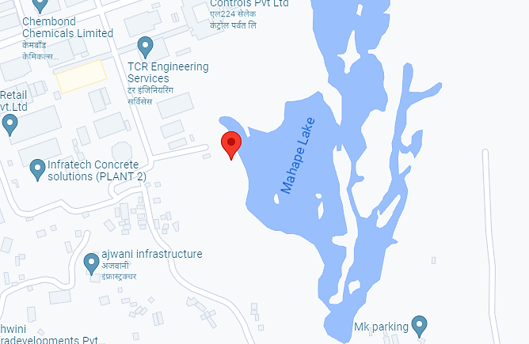

- LAND DETAILS: For the purpose of developing the Gems and Jewellery Park at Mumbai, M/s India Jewellery Park Mumbai (IJPM) is in the process of leasing the piece of land at Plot No. EL-237 in the Trans-Thane Creek Industrial Area within the village Limits of MAHAPE and within the limits of Navi Mumbai Municipal Corporation Taluka and Registration, Sub-District Thane District and Registration District Thane. The total land is spread over an area of 86,053 Square meter as per the Draft Lease Deed of assignment and proposed map provided to us by the company. As per the information shared by the client, the company has submitted a draft lease deed with MIDC and its execution and registration are expected to be done in the 2nd Quarter of 2023. The company has paid one instalment of the lease premium on December 2020.
As per the information shared by the client, the subject land is demarcated with boundary wall, but during the site survey, we were only able to confirm that the boundary wall of tin shed is on the two sides of the plot as the plot is located on uneven land/hilly terrain. The cost of the plot is estimated at INR 250 crores, including stamp duty and registration cost. The total amount for the land will be paid in 4 instalments and details have been shown below:
Instalment No. | Amount to be Paid | Timeline
1 | INR 56,71,53,810 /- | By December 2020
2 | INR 56,71,53,810 /- | By June 2023
3 | INR 56,71,53,810 /- | By December 2023
4 | INR 45,37,23,000/- (after adjustment 5% earnest money deposited (EMD) of INR 11,34,30,800/- paid being reservation charges). | By December 2024

Below are the details of land purchased for the proposed project in the tabulated form:
S. No. | Particulars | Plot Details
1. | Plot no. | EL-237
2. | Consideration Price  (incl. Stamp Duty & Registration) | INR 250 Crores
3. | Lessor Name | Maharashtra Industrial Development Corporation (MIDC)
4. | Lessee Name | M/s India Jewellery Park Mumbai (IJPM)
5. | Area leased to M/s India Jewellery Park Mumbai | 86053 Sq. Mt.
6. | Date of Lease Deed | Pending

As per the draft lease deed shared by the client/company, the proposed map of the land is shown below:
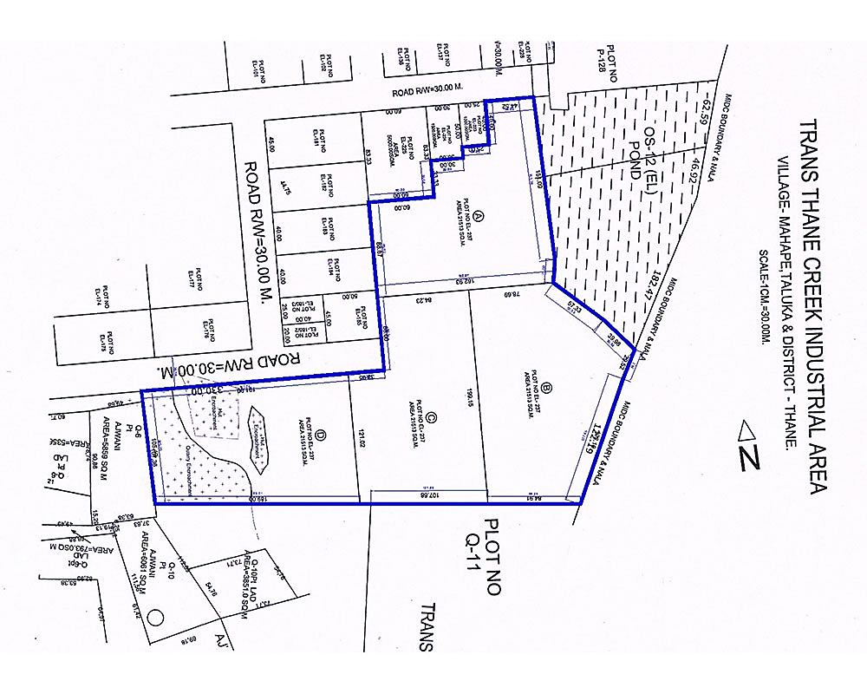
As per proposed map shared by the company the construction work is under process, grading and foundation is under construction and the entry of the premises from South-East. MIDC road is adjacent to the land parcel which is 400 meters away in the East, Plot no. 225 (Shiv Krupa Bhavan) is adjacent from West, Sigma IT Park in the North and MIDC road in the South. The details of the adjacent boundary walls to the plot are shown in the table below:
Directions | Boundary Wall Details
On or towards the North | Plot No. EL-223, EL-224, EL-225; Road R/w = 30 M
On or towards the South | Quarry No. 11 & Quarry No. 8pt.
On or towards the East | Plot No. OS-12 EL, Nalla
On or towards the West | Quarry No. 6 Pt Road R/W = 30 M; EL-185, EL-184, EL-183

As per the draft lease deed shared by the client/company, the land is procured @ INR 26,363 per square meter while as per our research/information collected during survey/Data information available in public domain, we found that the prevailing rate in the vicinity is around INR 40,000-45,000 per square metre, which seems to be an economically viable decision.
- LAYOUT PLAN: As per the information shared by the client/company, the sanctioned layout plan of the gems and jewellery has been shown below:
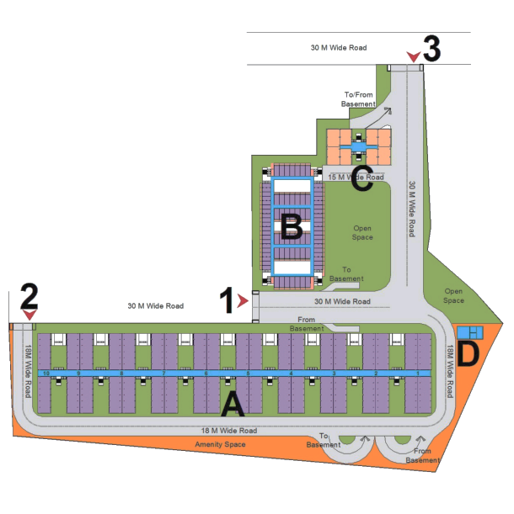

- SITE PICTURES: Some of the site pictures has been taken during the site survey, are attached below:
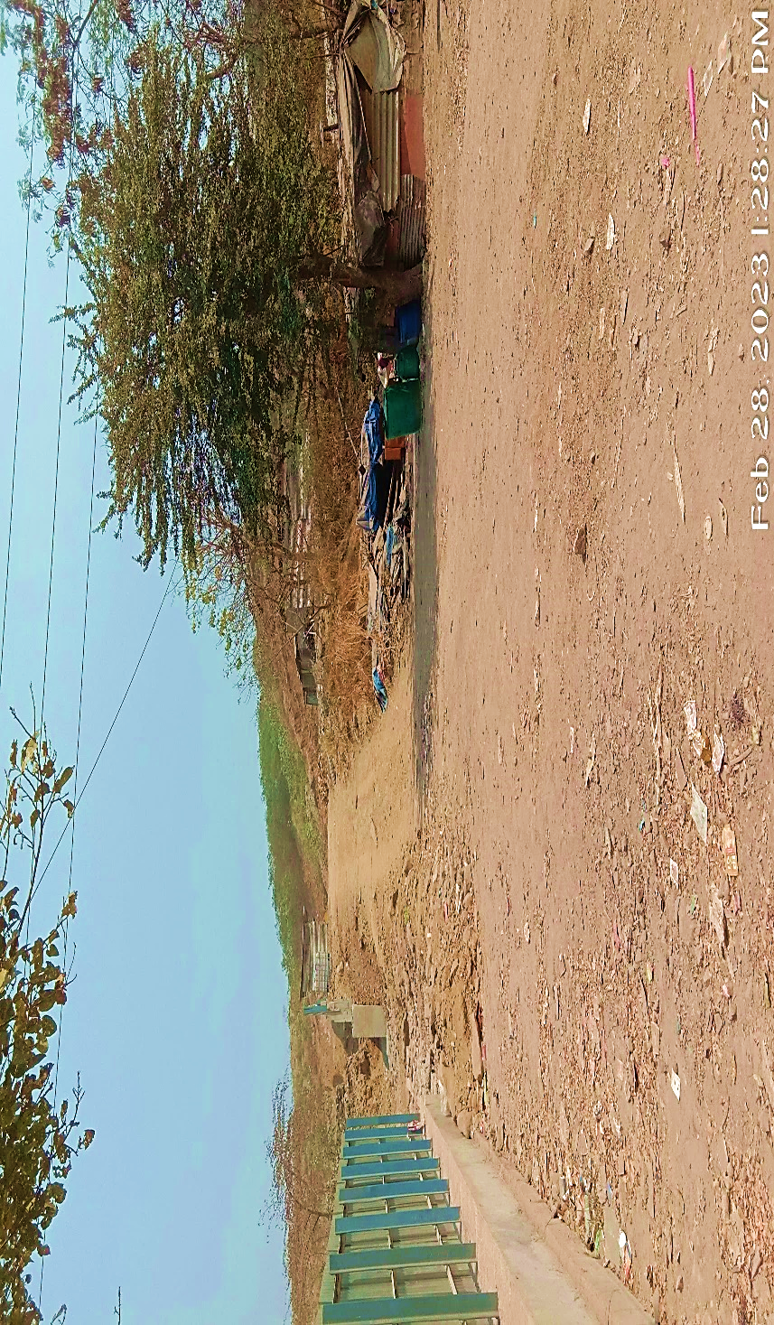
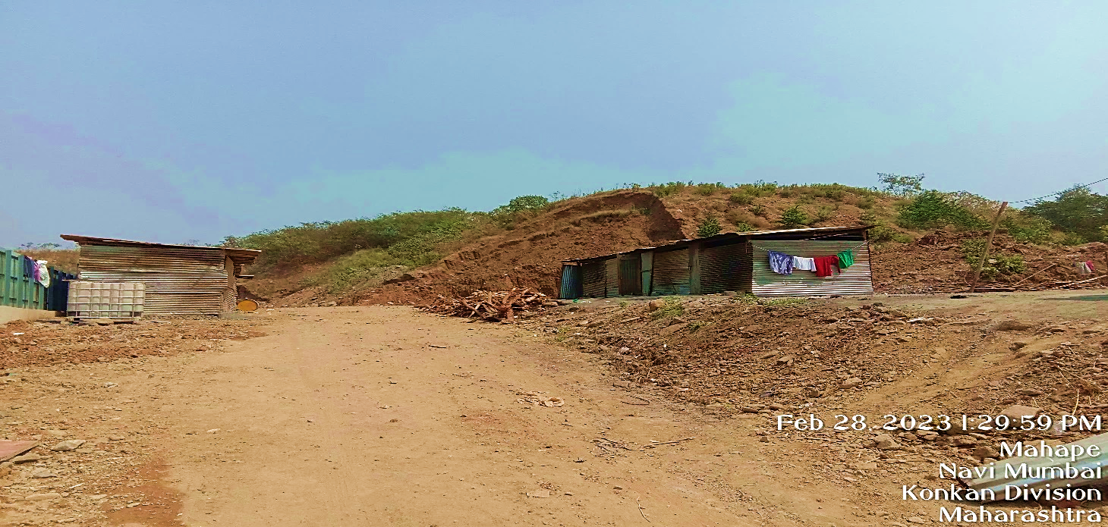
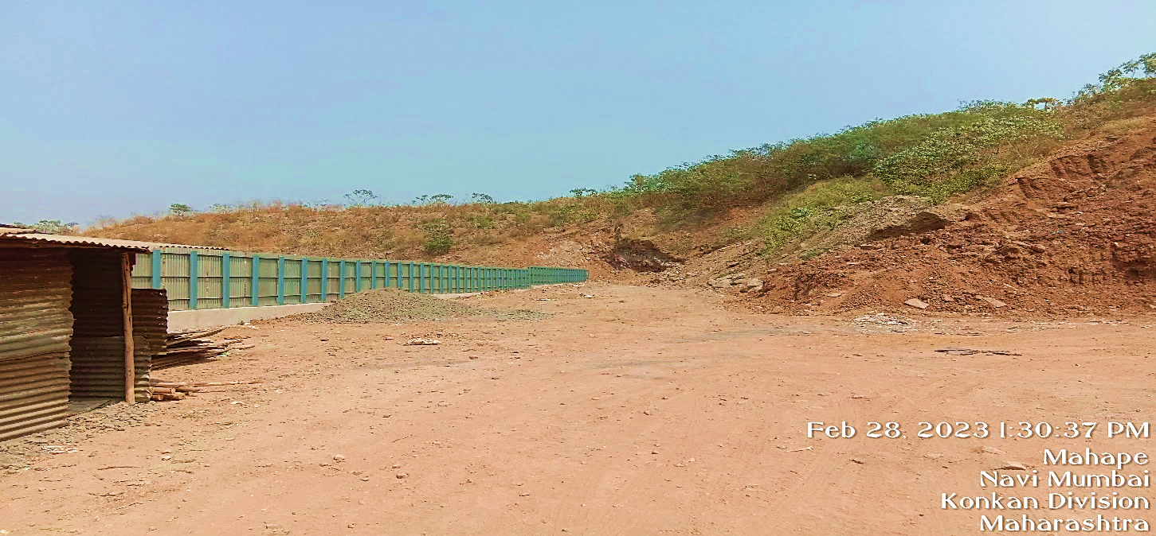
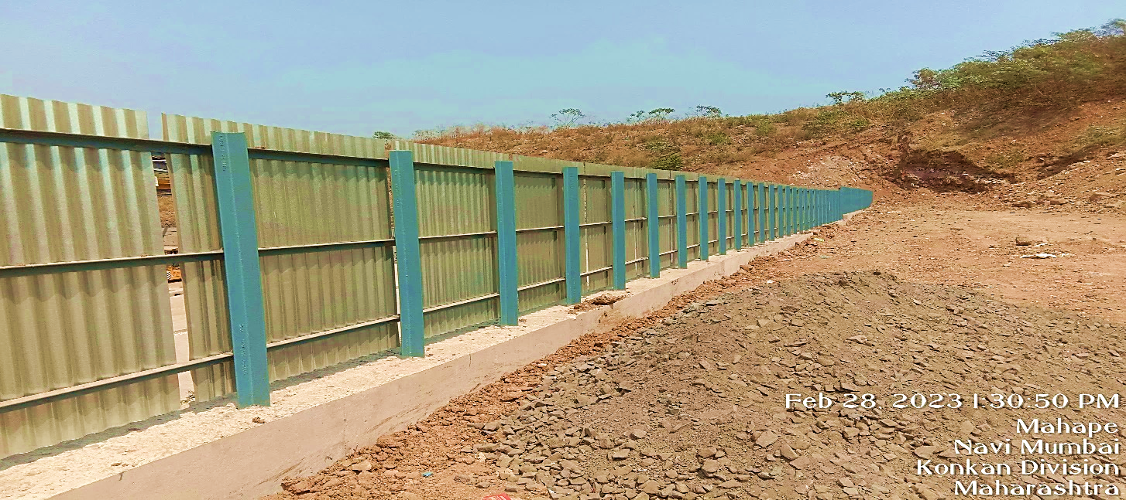
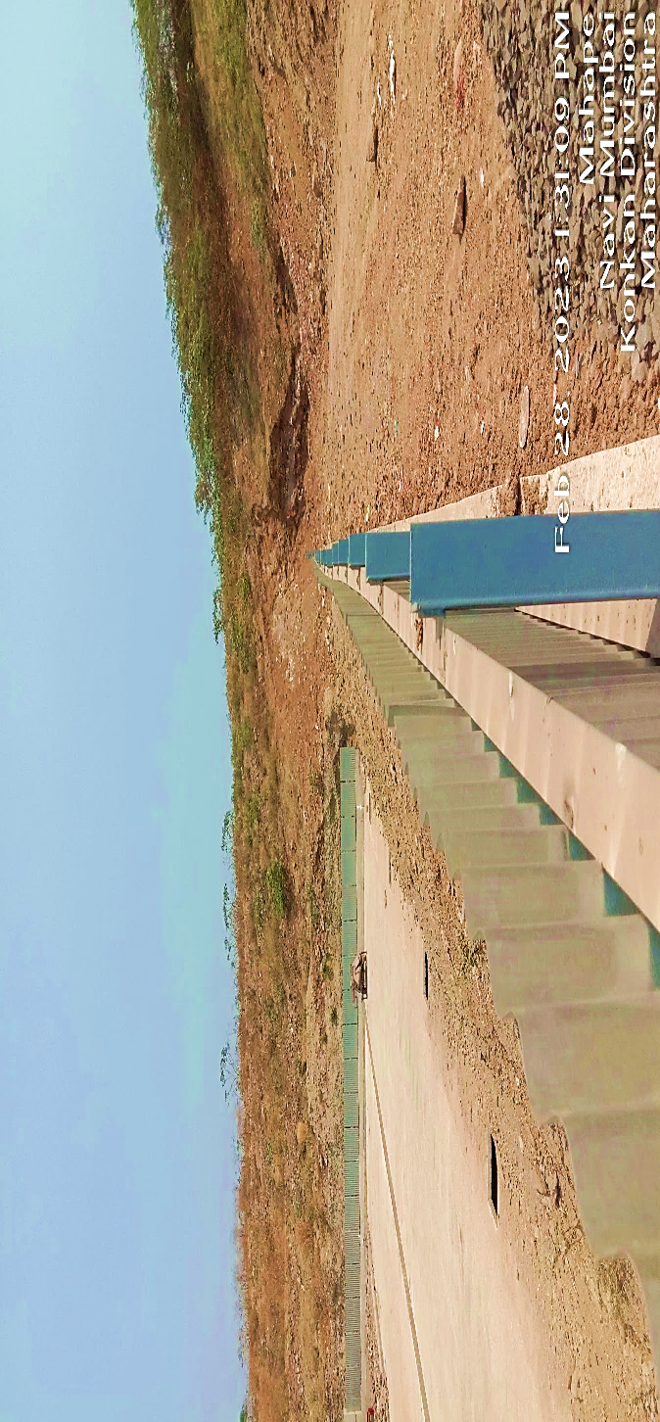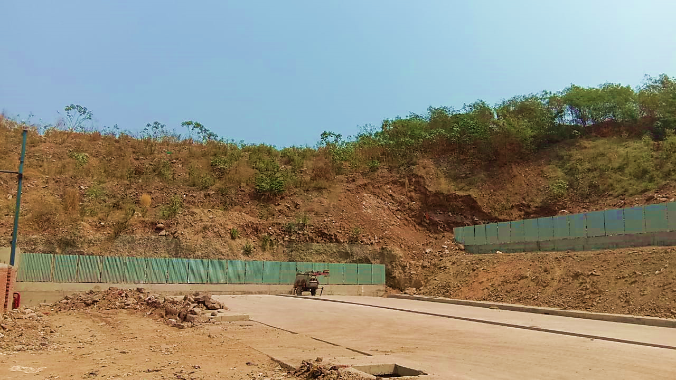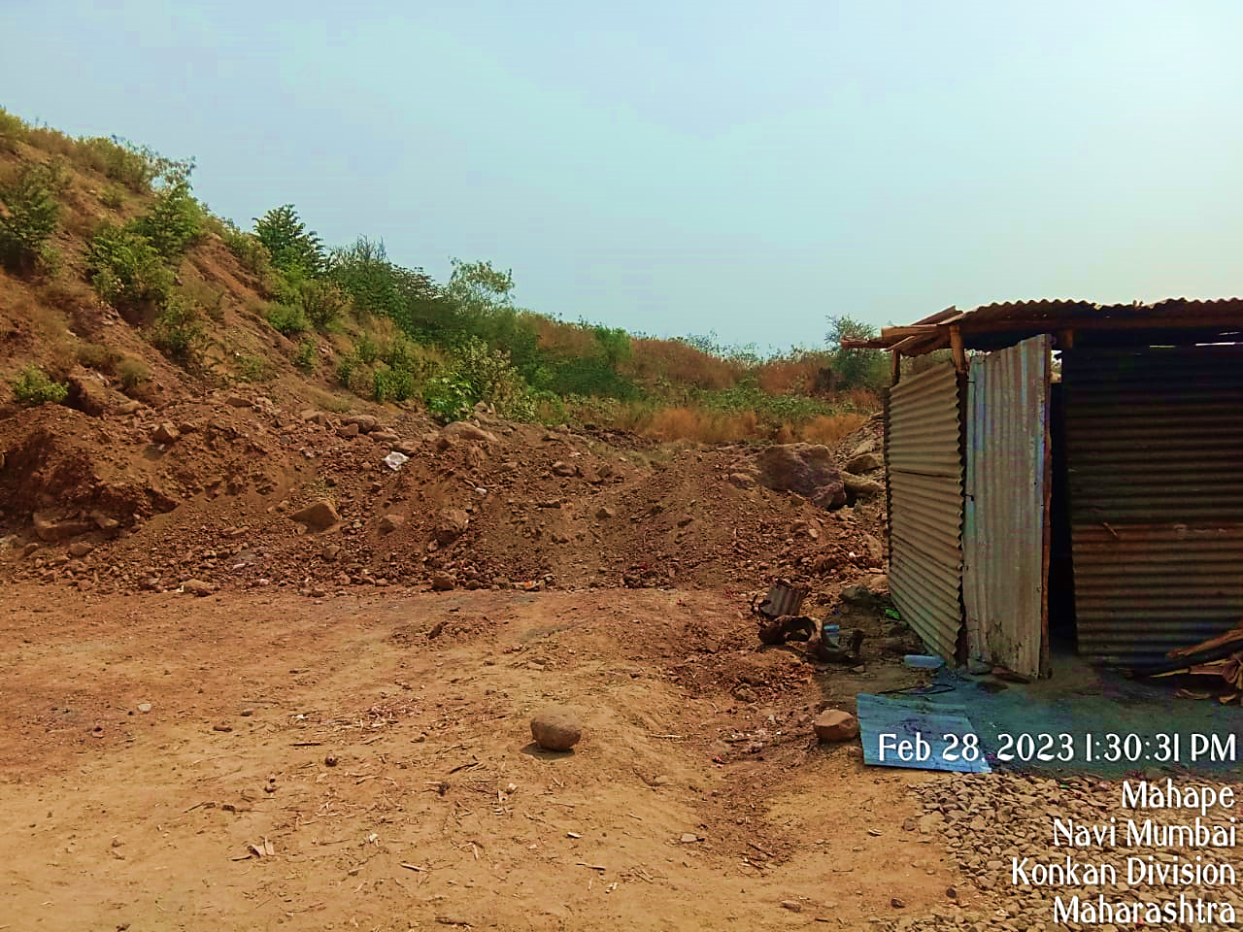

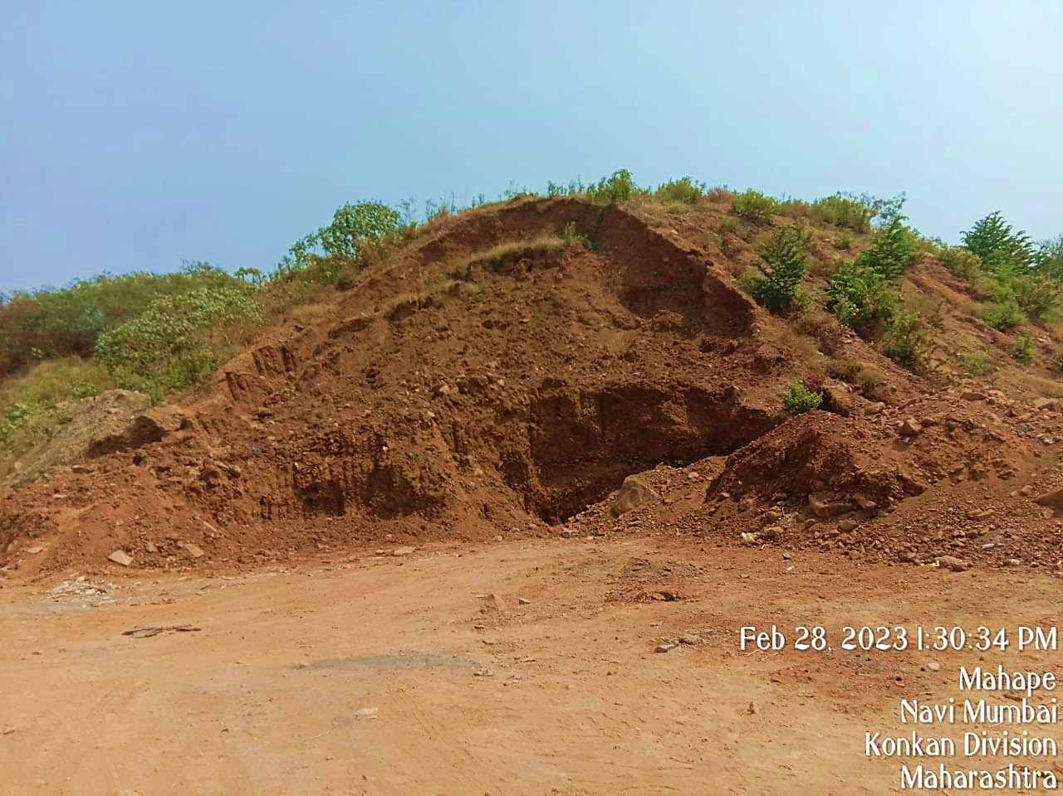
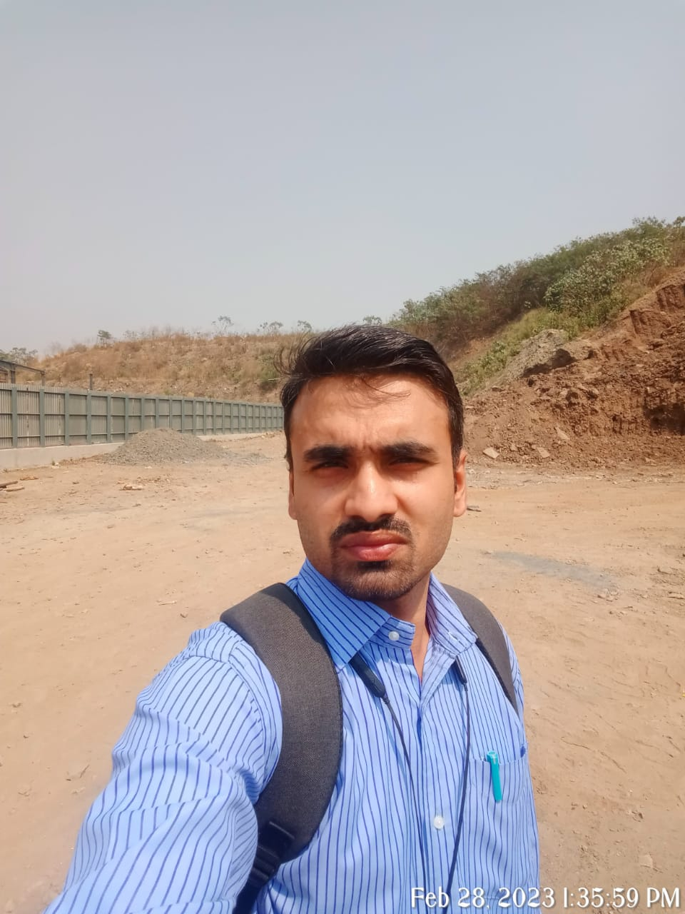

- BUILDING & CIVIL WORKS: Maharashtra Industrial Development Corporation (MIDC) has allotted the ~86,053 sq. m. (21.3 acres) of land to GJEPC for the Gems and Jewellery project at TTC industrial area at Mahape, Navi Mumbai. The plot area of 86,053 sq. m. has been divided into 4 development categories with an assumption of 3.00 x FSI available on the entire plot and 31.30% ground coverage:
Construction Type | Structure / Plot area | Carpet Area (sq. ft.) | Built-up area (sq. ft.)
Building A | Ground + 14 floors of large and medium industrial units (interconnected wings); 2 level basements | 20,13,778 | 26,78,236
Building B | Ground + 9 floors of small industrial units (interconnected wings): 2 level basements | 2,65,196 | 4,86,011
Building C | Ground + 31 floors of office units (2  interconnected wings); 2 level basements | 4,94,468 | 6,30,254
Building D | Firefighting, Policy Chowki, Hospital, | 2,383 | 9,580

Type | Carpet area (sq. ft.) | Saleable area (sq. ft.) * | Total units
Industrial Units | 4,394 | 5,273 | 190
 | 3,691 | 4,429 | 190
 | 2,959 | 3,550 | 76
 | 2,226 | 2,672 | 76
 | 518 | 621 | 126
 | 344 | 413 | 540
Office Type 1 | 2,161 | 3,025 | 124
Office Type 2 | 1,763 | 2,469 | 124
Commercial Shops (Ground Floor of Building A) | 5,273 | 7,382 | 37
Total Units |  |  | 1483
As per information shared by the client/company, *20% loading factor has been considered on carpet area for industrial units of Building A and B. In the case of Building C and ground floor of Building A, the loading factor is considered as 40%.

- UTILITIES: Details of Water, Electricity and other utilities are describing as below:
- Water: As per information shared by the client, total water supply required is approx. 4 MLD, 1.7 MLD water can be availed from Reusable Water for Flush and Gardening. Hence the remaining requirement of fresh water would be 2.29 MLD.
- Electricity: Power substation has already been established at the proposed site of MIDC. As per early estimates power requirement of ~33.5MW has been established that shall be required to power common areas at the park.
- Firefighting Water Storage Requirement: As per the information shared by client/company, the total firefighting tank capacity required for mega projects is 500,000 litres.

- MANPOWER: As per information shared by the client/company, it has been proposed that the park shall be run by an operating team on ground consisting of a CEO, team of accounting staff, and admin staff who will manage the day-to-day operations. Apart from key staff directly employed by the SPV, most of other staff for housekeeping, security and other managed services should be outsourced.

PART E | INVENTORY PROFILE

- INTRODUCTION: A world-class jewellery park enhancing global competitiveness and contributing to economic development of Maharashtra and India by attracting investments of over INR 14,000 crore and creating employment opportunities for over 1 lakh workers
India Jewellery Park Mumbai is a project by GJEPC for the jewellery manufacturers. The vision of the jewellery park is to provide state-of-the-art facilities to manufacturers and bring entire jewellery manufacturing ecosystem under one roof. The project is envisaged to house more than ~1,000 Gems and Jewellery units on 21.3-acre plot of land (Permitted FSI3) in Mahape, Navi Mumbai. It will also support MSMEs to create more job opportunities in the employment-intensive gems and jewellery sector.
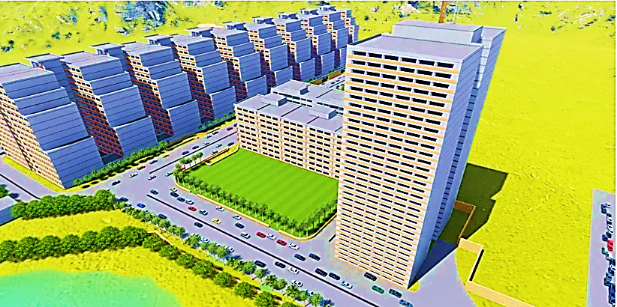
PROJECT’S OBJECTIVE: The objective of the jewellery park project is to develop an integrated facility housing under one roof the complete value chain of the gems and jewellery manufacturing industry and its supporting ecosystem:
- To augment the jewellery manufacturing ecosystem in the State, complemented by ease of doing business initiatives, thereby evolving it into a preferred destination for global manufacturers and investors.
- To look after health and wellbeing aspects of the Karigar community.
- To attract an estimated investment of INR 14,000 crores spread over the period of five years post commencement of the project.
- To strengthen employment intensive Gems and Jewellery sector through MSME promotion and inclusive growth.
- To promote local handmade jewellery.
In the proposed master plan, there are building with 4 types of building – G+1, G+9, G+14 and G+31. The building height of Block A is G+14, with Karkhanas units on all the floors. Block B is again Karkhanas units, having a height of G+9. Block C has office units with a height of G+31.

- INVENTORY CATEGORY: M/s India Jewellery Park Mumbai has proposed their portfolio of inventories under following categories as described below:
Unit Type | FSI Carpet Area Sq. Ft. | No. of Units | Saleable Area with Loading Sq. Ft. | Loading Factor on Carpet FSI
Karkhana Type 1 | 4,394 | 190 | 5,273 | 1.2
Karkhana Type 2 | 3,691 | 190 | 4,429 | 1.2
Karkhana Type 3 | 2,959 | 76 | 3,550 | 1.2
Karkhana Type 4 | 2,226 | 76 | 2,672 | 1.2
Karkhana Type 5 (Small) | 518 | 126 | 621 | 1.2
Karkhana Type 6 (Small) | 344 | 540 | 413 | 1.2
Office Type 1 | 2,161 | 124 | 3,025 | 1.4
Office Type 2 | 1,763 | 124 | 2,469 | 1.4
Commercial Shops (Ground Floor of Building A) | 5,273 | 37 | 7,382 | 1.4
TOTAL |  | 1,483
- BLOCK A: Block A will mainly be designed for Karkhana Units and will be of G+14 floors. The size of Karkhana Units at different floors will be of different size, depending upon the number of floors on which they are located.
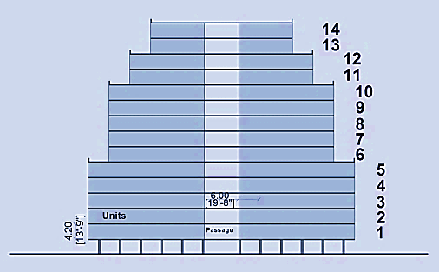
The floor wise detailing of size and section design for Karkhana units has been explained as shown below:
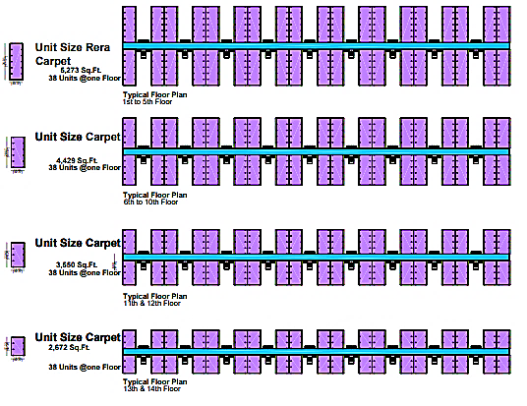
As depicted in the figure shown above, from 1st to 5th floor, there would be 38 units of Karkhanas on each floor. The area of each unit of Karkhana will be 4,394 sq. ft. These units will be biggest in size A Block. From 6th to 10th floor, there would be 38 units of Karkhanas on each floor with each unit size of 3,691 sq. ft.
The area of each unit of Karkhana on 11th and 12th Floors will be 2,959 sq. ft. and there would be 38 units of Karkhanas on each floor. The area of each unit of Karkhana on 13th and 14th Floors will be 2,226 sq. ft. and there would be 38 units of Karkhanas on each floor. On the ground floor, there will be 37 commercial shops with a FSI Carpet Area of 5,273 sq. ft.
- BLOCK B: The highest units of Karkhanas have been proposed in Block B, which includes 1 tower of G+9 height, as shown in the table below:
Industrial Units | FSI Carpet Area Sq. Ft. | No. of Units | Saleable Area with Loading Sq. Ft.
Karkhana Type 5 (Small) | 518 | 126 | 621
Karkhana Type 6 (Small) | 344 | 540 | 413
 | Total | 666
- BLOCK C: Retail shopping and commercial offices under commercial use have been proposed in Block C which is G+31 floors.

In commercial zone, one hotel has been proposed near the exhibition open space. Total number of retail/shopping units with their carpet area and saleable area can be seen in the table given below:
Commercial Units | FSI Carpet Area Sq. Ft. | No. of Units | Saleable Area with Loading Sq. Ft.
Karkhana Type 5 (Small) | 2,161 | 124 | 3,025
Karkhana Type 6 (Small) | 1,763 | 124 | 2,469
 | Total | 248
- BLOCK D: One of the key objectives in preparing the Master Plan for G&J Park, Mahape would be to make the provision of adequate amenities at appropriate level. Such facilities have been proposed in the Eastern Part and Southern Part along the main entry Roads, as shown in the figure below. These amenities will include Fire Fighting, Police Chowki, Hospital, Gate etc.
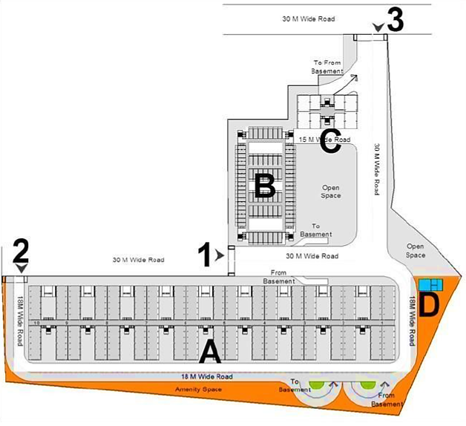
Other main management functions for the operation of the park include infrastructure management and operation, along with the provision of administrative, business and social services, which will be proposed as per the requirement and suitability. Open space for exhibitions/workshops would be provided in the front. Visitors’ tour organized in the premises based on their interests and their customized requirements.
- AMENITIES/FACILITIES: The following facilities are being proposed to be provided in the gems and jewellery park:
  - Fixed parking allotted as per MIDC norms with ample of guest parking
  - Common Air Handling gas chamber with dedicated pipeline up to unit.
  - ETP for water re-cycling
  - STP for waste re-cycling
  - Food supplier / Canteen (common for all blocks)
  - Machine supplier (common for all blocks)
  - Essential back-up electric supply for power failures
  - Other statutory equipment supplier
  - Common area security systems
  - Bare shell unit with 14+ Ft. ceiling height
  - Kota flooring in common areas
  - Tremix flooring in unit
  - Common equipment lifts with 2 Tonne capacity
  - There is a provision for additional parking – However, the same shall be for additional charges (Tentative charges shall be INR 500,000 per parking- for internal use only)
  - Proposed low-cost accommodation nearby for workers.

- MARKETING, SELLING & DISTRIBUTION PLAN: This dynamic venture will provide effective support to jewellery manufacturers/traders who are interested to relocate, expand or invest in the state of Maharashtra. The success of park depends on innovative efforts and constant interaction with prospective tenants and investors.
The aim is to successfully establish the Park and market the space for setting up of the industrial/gems & jewellery processing units and market the available space for units in the first three years with the major bulk in the very first year.
PRODUCT POSITIONING: The product will be positioned to highlight the advantages such as First of Kind highly secured all under one roof manufacturing zone for gems & jewellery, Competitive built up space/ land cost with shared cost of common facilities, Complex ensuring low investment per unit of production and transaction cost, Facilitating regulatory environment with single window clearance and access to MSME schemes enabling trade and business environment, Promotion of handmade jewellery making and tourism avenues, Industrial park which works round the clock, Adequately networked for power and water availability, Complex with world standard centralized Facilities with self-content units promoting healthier work environment.
TARGET MARKET: As per the information provided by the client/company, Zaveri Bazaar Units, Units located in Dahisar, MIDC, Dadar, Lower Parel and Bandra region of Mumbai city and suburban districts, Leading players outside Greater Mumbai Region, Leading players outside Maharashtra will be the target markets for the company offerings.
PROMOTION STRATEGIES: The marketing pitch will revolve around the key park features, primarily being the first integrated complex of India and providing assistance from government to create a Gems & Jewellery industry complete with all the facilities of hard & soft infrastructure as what one is accustomed to in a cluster. The key elements of this strategy are shown below.
- Actively promote gems and Jewellery Park in all the events and seminars of GJEPC, IJPM and other jewellery associations. Investment promotion for the jewellery park in both domestic and international market.
- Host the IIJS premiere and signature shows at the jewellery park to attract investors from India and overseas. Partnership with banks for easy financing options. Facilitate in identifying accommodation and promoting healthier work environment for karigars.
- Facilitate regulatory environment with single window clearance and access to government schemes enabling trade and businesses environment.
- Partnering with global institutions for training and skill development of Karigars.
Indicative approach to be adopted for aggressive marketing is spread across four phases during a tenure of 24 months.
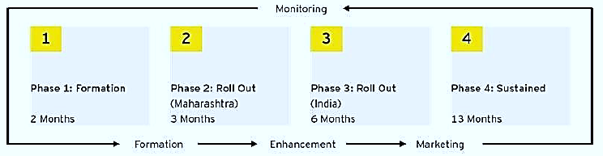
An aggressive marketing is also planned as per the below picture as per information provided by the client/company:
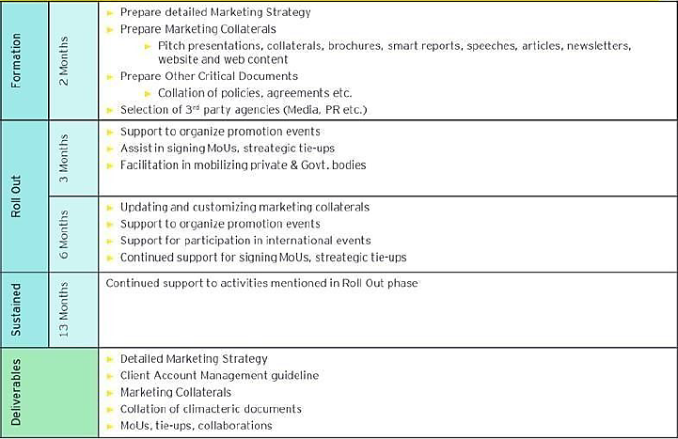
COMMUNICATION STRATEGY: As per the data/information provided by the client/company, the promotional activities will be done by using all the possible mode of advertisements available in the market at present:
- Organize sensitization workshops with Zaveri Bazaar to update about project USPs and advantages.
- Promote as key project during Magnetic Maharashtra Investor Summit. Create shelf of projects to market across the State and Country to attract investors
- Develop Gems & Jewellery Park advantage document in various formats – brochure/ e-mailer/ direct mailer/ presentation/ video
- Organize inauguration events, make media announcements, organise interviews with electronic media, publish write ups
- Meet select large players (who in all probability are going ahead with new ventures) personally and make the pitch.
- Conduct roadshows to promote and create awareness in the industry in specific clusters
- The selling strategy will hinge on direct marketing with direct mailers and personal visits straight at the doorsteps of each of the prospective investor.



PART F | GEMS & JEWELLERY INDUSTRY OVERVIEW

- INTRODUCTION: The Indian gems and jewellery industry is well recognized and renowned world over for its craftsmanship and variety. It is labour intensive and involves workmanship as well as patience and dedication to the art of jewellery making. The Gems and Jewellery sector plays a significant role in the Indian economy, contributing around 6-7 per cent of the country’s GDP.
One of the fastest growing sectors, it is extremely export-oriented and labour intensive. Based on its potential for growth and value addition, the Government of India has declared the Gems and Jewellery sector as a focus area for export promotion. The Government has recently undertaken various measures to promote investments and to upgrade technology and skills to promote ‘Brand India’ in the international market.
India is deemed to be the hub of the global jewellery market because of its low costs and availability of high-skilled labour. India is the world’s largest cutting and polishing centre for diamonds, with the cutting and polishing industry being well supported by government policies. Moreover, India exports 33 per cent of the world’s diamonds, as per statistics from the Gems and Jewellery Export Promotion Council (GJEPC). The industry has generated US$ 72.52 billion of revenue from exports in 2021, making it the largest exporter of diamonds in the world. As per the information available on the GJEPC’s website, the following table shows Global vis-à-vis India’s position in the year 2021.
Commodities | World Exports (US$ Billion) | India's Exports (US$ Billion) | India's Share (%) | India's Ranking
Gold Jewellery | 87.8 | 8.43 | 9.6 | 4th
Cut & Polished Diamonds | 72.53 | 23.84 | 32.9 | 1st
Silver Jewellery | 10.35 | 2.12 | 20.5 | 2nd
Coloured Gems Stones | 9.44 | 0.759 | 8 | 3rd
Imitation Jewellery | 7.78 | 0.165 | 2.1 | 8th
Synthetic Diamonds/Stones | 4.41 | 1.25 | 28.4 | 1st
India’s Gems and Jewellery sector has been contributing in a big way to the country’s foreign exchange earnings (FEEs). The Government of India has viewed the sector as a thrust area for export promotion. The Indian government presently allows 100 per cent Foreign Direct Investment (FDI) in the sector through the automatic route. The Indian Government also signed a Comprehensive Economic Partnership Agreement (CEPA) with the United Arab Emirates (UAE) in March 2022, this will allow the Indian Gems and Jewellery industry to further boost exports. CEPA will provide the industry duty-free access to the UAE market. India’s Gems Jewellery Export Promotion Council (GJEPC) aims to triple its exports to the UAE post the CEPA.

- MARKET SIZE: The gems and jewellery market in India is home to more than 500,000 players, with the majority being small players. India is one of the largest exporters of gems and jewellery and the industry is considered to play a vital role in the Indian economy as it contributes a major chunk to the total foreign reserves of the country. UAE, US, Russia, Singapore, Hong Kong, Latin America and China are the biggest importers of Indian jewellery.
India’s gems and jewellery market size was at US$ 78.50 billion in FY21. Growth in exports is mainly due to revived import demand in the export market of the US and fulfilment of orders received by numerous Indian exhibitors during the Virtual Buyer-Seller Meets (VBSMs) conducted by GJEPC. GJEPC also organised virtual trade events like e-International Gems & Jewellery Show, India Global Connect, Webinars etc.
India’s gems and jewellery exports reached US$ 39.14 billion in 2021-22, a 54.13% rise from the previous year. In December 2022, India’s gems and jewellery exports has achieved its annual export target of USD 48 billion. The Government of India is aiming at US$ 70 billion in jewellery export in the next five years (until 2025), up from US$ 35 billion in 2020.

- RECENT INVESTMENTS/ DEVELOPMENTS: Cumulative FDI inflows in diamond and gold ornaments stood at US$ 1,213.06 million between April 2000-June 2022, according to the Department for Promotion of Industry and Internal Trade (DPIIT). Some of the key developments in this industry are listed below:
- In September 2021, Malabar Group invested Rs. 750 crore (US$ 100 million) in a gold refinery and jewellery unit in Hyderabad.
- GJEPC organised the first ever international physical show post pandemic - International Gem & Jewellery Show (IGJS), from 10th to 12th May 2022, in the pink city Jaipur, at the Jaipur Exhibition and Convention Centre (JECC).
- In May 2021, GJEPC and Embassy of India, Morocco, co-hosted the ‘India Global Connect’ to better understand the present business climate in the gems and jewellery sector and seek trade prospects for manufacturers, exporters and importers from both countries.
- From March 31st, it will be mandatory for all gold jewellery and artefacts sold in the country to carry a unique identification number known as Hallmark Unique Identification Number (HUID).
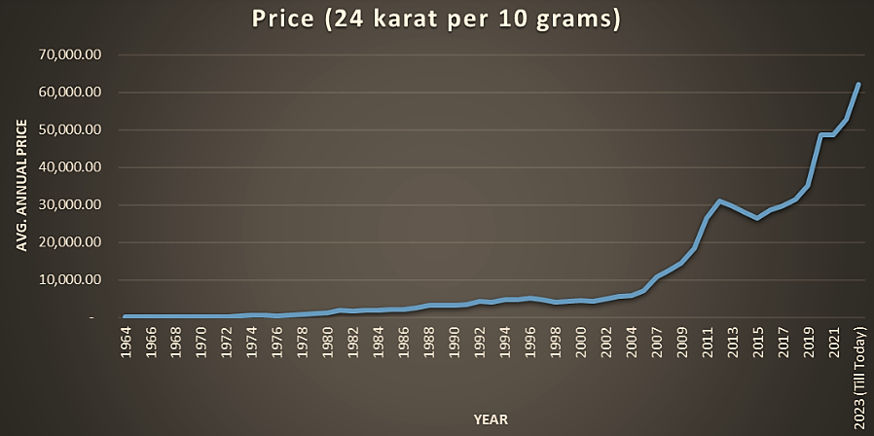
- CHALLENGES WITH THE GEMS AND JEWELLERY SECTOR: The industry faces several challenges impacting consumption and the investment demand side of the market, which are such as Dependency on Imports, Trust and Transparency, Large investment demand and associated supply infrastructure, Risk of Talent Shortage, Unorganised Nature.
- GOVERNMENT INITIATIVES: Some of the major initiatives taken by the Government of India to promote the Indian gems and jewellery industry are as follows:
- Replacement of SEZ Act with a new SEZ regime which is also expected to boost exports of gems and jewellery.
- India has signed an FTA with the UAE which will further boost exports and is expected to reach the target of US$ 52 billion. Reduction in import duty on cut & polished diamonds from 7% to 5%
- Extension of Emergency Credit Line Guarantee Scheme (ECLGS) for MSMEs up to March 2023. (Over 90% of units in G&J sector are MSMEs)
- GJEPC (Gems and Jewellery Export Promotion Council) has signed a MOU with MIDC (Maharashtra Industrial Development Corporation) to build the country’s largest jewellery park.
- The government has reduced import duty for Gold & Silver (from 12.5% to 7.5%) and Platinum & Pallidum (from 12.5% to 10%) to bring down the prices of precious metals in the local market.

- ROAD AHEAD: India plays a very significant role in global gems and jewellery market, equally as a source and consumer. The industry is one of the fastest growing and leading earners of foreign exchange in the country. The improvement in availability along with the reintroduction of low-cost gold metal loans and likely stabilisation of gold prices at lower levels is expected to drive volume growth for jewellers over short to medium term. The demand for jewellery is expected to be significantly supported by the recent positive developments in the industry.
As the wealth of the middle class increases they acquire gold for consumption and also as an investment. Gold, rather than being an ornament, is considered as a celebration across the nation. In the North, Baisakhi and Karva Chauth, in the East, Durga Puja, in the West, it is Gudi Pavda and in the South, Akshaya Tritiya. Approximately 50 per cent of the annual gold demand is generated by Indian weddings.
In global comparison, most revenue is generated in India (US$76,770.00m in 2023). In relation to total population figures, per person revenues of US$54.08 are generated in 2023. By 2023, 98% of sales in the Jewellery segment will be attributable to Non-Luxury goods.
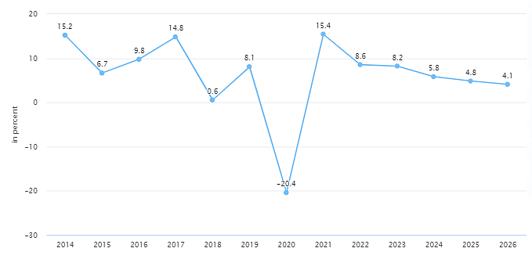
The Government has permitted 100% FDI under the automatic route** in this sector. The Government has reduced custom duty on cut and polished diamond and coloured gemstones from 7.5% to 5% and NIL. However Import Dependency, Unorganised Nature and Trust & Transparency are still considerable challenges for the industry.
India Gems and Jewellery Market Stood at $78.50 Billion in 2021 and is Expected to Grow with a CAGR of 8.34% to Reach $119.80 Billion by 2027. According to estimates, around 55% of the population is expected to join the middle class by 2025. Further digitalization of India and online selling will also boost the margins of players tuned with the technical advancement and industrial policies.
That is why GJEPC (Gems and Jewellery Export Promotion Council) has signed a MOU with MIDC (Maharashtra Industrial Development Corporation) to build the country’s largest jewellery park. As per the overall industry analysis, outlook of the industry seems to be positive in upcoming years driven by government’s initiatives, rising spendable income, cultural richness of Indian society.
PART G | SWOT ANALYSIS OF GEMS & JEWELLERY INDUSTRY

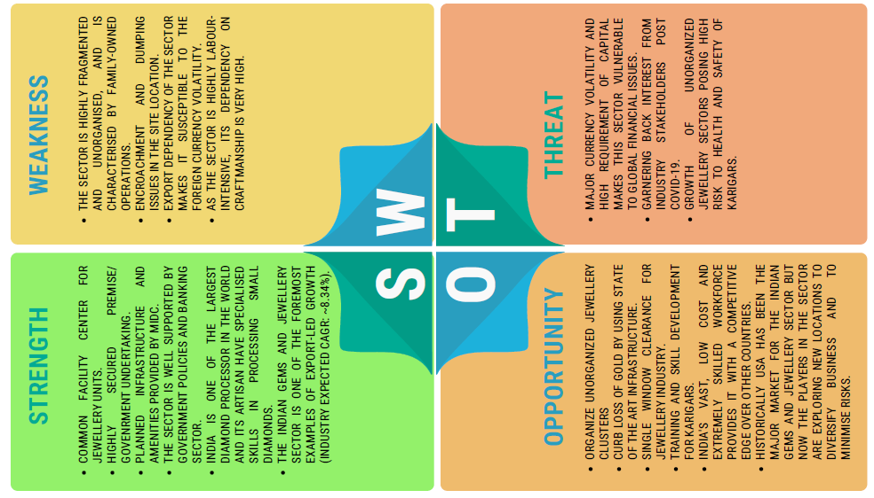

PART H | RISK MITIGATION

RISK | RISK MITIGATION MECHANISM
Conceptualization Stage Risk | - The project delays are majorly due to land allotment, approvals, etc. can be mitigated by the selection of renowned Project Implementation agency to represent and pursuance of approval closely monitoring the progress would mitigate this risk.  - Risk of delay in various approvals that are required from various state, local development and municipal agencies can be mitigated by the SPV by obtaining requisite planning and construction approvals requires extensive liasioning with various Government Authorities. The SPV is better suited to obtain requisite approvals and clearances to mitigate the delay of approval risk. Therefore, one of the key components of the scope of work of SPV is to obtain requisite planning and building approvals for the complete land.  - Risks related to financing the project can be mitigated by acquiring Government liasioning and support for availing central and state incentives right from beginning of the project as the timelines extend for more than a year for availing the funds.  - Risk related to inflation and interest rate fluctuations can be mitigated by adhering to the project timelines.
Construction Stage Risk | - Inadequate site data can affect the progress of excavation, foundation and construction. To mitigate the risk, various surveys incl. detailed soil investigations as may be necessary shall be conducted in advance not to affect the project progress.  - Due to the appointment to various multiple contractors, a risk regarding the coordination between them may arise which can be mitigated if the quality management consultant can adopt a proper communication channel for the flow of information. IJPM can also try to bundle similar works together to mitigate these risks.  - Delay in the construction of the project due to the competency of contractors can be mitigated by verifying the organizational capabilities and site organization during the selection process. By supervising and regular follow-up of the level of construction achieved by the project and by day- to-day management of availability and requirements of material land resources.  - Risks which are created due to design variations, Technology changes, unforeseen factors which are considered during the financial analysis can be mitigated by appointing an Environmental Consultant to assist in obtaining necessary environmental clearances/ approvals from State/ Central Govt. agencies (as the case may be).  - Risk related to cash flow management of the project will be mitigated by the grant from GoI will be available as the project progresses. The funding can also be obtained from the Banks/ Financial institutions for the implementation of the project. A suitable Trust and Retention Account (TRA) would also be maintained.
Operationalization Stage Risk | - Significant portion of funds available comes through internal accruals. This risk can be mitigated by early stakeholder engagement for project awareness amongst members.  - The project does not achieve projected revenues, this will negatively impact the project’s cash flows and its ability to repay debt. To mitigate this, a comprehensive marketing strategy should be adopted and implemented to setup units in Jewellery Park. Benefits of Industrial policy and other state policies will be made applicable for establishing industries.  - Environmental risks can be mitigated by only allowing orange and green category industries to set up in the industrial park. Further a standardized mechanism could be adopted for operationalization of Industry.  - Safety related risks can be mitigated by insisting that the contractors establish a systematic construction program scheduling and adhere to the same and also provide safety training to on-site staff to improve their awareness of safety liabilities including third party shall be clearly defined in the contract document with mandatory provisions for insurance.  - Risk involving change in laws that can adversely impact the project can be mitigated by significant amount of liasoning between different govt. departments. Although GJEPC and MIDC being the authorities are better placed to handle this risk.  - The Force Majeure risk has to be borne by all the SPV partners as it is beyond control of either. There would be detailed provisions in the development agreement on the conditions that would be triggering the force majeure clauses by either partner. Suitable insurance cover would be obtained for insurable force majeure events.  - Risk involving Government/tenants/Private default are quite common in projects and can be avoided through arbitration mechanism.

PART I | PROJECT COST AND MEANS OF FINANCE

As per data/information provided by the company/client, category wise proposed project cost is shown in the below table:
(INR Crores)
Total Project Cost (TPC)
Particulars | Cost
Freehold Land & Land Development | 250
Construction Cost | 808
Support Infrastructure | 386
Admin cost and other overheads | 104
Sales & Marketing Cost | 38
Interest During Construction (IDC) | 137
GST on Cost | 241
Total Project Cost | 1,964
Note: Cost projections have been provided by the company
MEANS OF FINANCE
Particulars | Proposed Cost
Advances from members | 1,334
Debt | 500
Contribution from GJEPC | 130
Total | 1,964
Notes:
- The company has a draft lease prepared for allotment of land admeasuring approx. 86,053 Sq. Mt. at Plot numbers- EL-237, TTC Industrial Area, Mahape, Navi Mumbai, Maharashtra - 400 705, in the company’s name.
- The cost of the land is estimated at INR 250 crores, including stamp duty and the cost of sanctioning the map.
- The cost of construction has been estimated at INR 808 crores, including development of all the office units and Industrial Kharkhanas of different sizes.
- The Company proposes to develop the required support infrastructure for the project at an estimated cost of INR 386 Crores will include Parking, Fire Fighting, Police Chowki, Hospital, Gate, etc.
- The Company has estimated the admin costs & other overheads at INR 104 Crores and Sales & marketing expenses at INR 38 Crores.

MEANS OF FINANCE: In the total project cost of INR 1,964 crores, it is proposed that the INR 1,334 crores will be from advances from members with respect to the units booked. The remaining amount of INR 500 crores will be met through a bank term loan and a balance of INR 130 crores as contribution from GJEPC.
PART J | PROJECT SCHEDULE

Below is the tabulated presentation of the status of the project showing expected duration shared by the project manager of the company:
S. No. | Particulars | Activity | Expected completion date | Status
1. | Land | Land Procurement | December 2024 | EMD + 1st instalment paid; 2nd instalment due
 |  | Land Development | June 2023 | Scheduled
2. | Building & Civil Works | Appointment of Architect/Civil contractor/developer | May 2023 | Scheduled
 |  | Building Plan Preparation | May 2023 | Scheduled
 |  | Building Plan Sanction | May 2023 | Scheduled
 |  | Building & Civil Works completion | September 2027 | Scheduled
3. | Statutory Approvals, registrations & NOCs |  | December 2023 | Scheduled
4. | Finishing & Trail Run |  | February 2028 | Scheduled
5. | Commercial Operation Date |  | June 2028 | Scheduled

Notes:
- Schedule has been made as per feasibility to achieve different milestones.
- Achievement of Milestone will depend on sanction of term loan as per proposed timeline.

PART K | STATUTORY APPROVALS | LICENCES | NOC
As per the information provided by the client below is the list of Approvals required for the proposed project:
S. No. | Name Of License/ Registration  Issuing Authority | Purpose | Licence No. With Date | Current Status
1. | Registration with RoC | RoC registration | U74999MH2018NPL304254 | Completed
 | Registrar of Companies |  | 17th January, 2018
2. | Approval of Building / Site Plans | Grant of approval on building plans | MIDC/IFMS/THANE I/E&MD/EEThane2/2022/B-44968 | Received NOC on master plan for the project
 | Executive Engineer & SPA, MIDC |  | 28th April, 2022
3. | NOC for fire fighting | NOC under firefighting scheme | - | Yet to be received
4. | Approval for Ground Water Extraction | NOC for Water & Environment | - | Yet to be received
5. | Power load sanction / Electric connection | For Power load sanction | - | Yet to be received
6. | Environmental and Pollution control | Environmental clearance (EC) certificate for the project | - | EC clearance in progress

Observations & Comments:
- Company has obtained preliminary statutory clearances and approvals except those which are mentioned as in Process or Pending above.

PART L | COMPANY’S FINANCIAL FEASIBILITY

- PROJECTIONS OF THE FIRM: As a greenfield project, the projections of the proposed Jewellery park are done from FY 2023-24 to FY 2029-30 based on the revenue generation capacity by selling the industrial & commercial space and total expected expenses are shown as below:
- PROJECTED PROFIT & LOSS ACCOUNT: Below table shows the Projected Profit & Loss Account of M/s India Jewellery Park Mumbai Ltd. from the period FY 2021-22 to FY 2029-30.
(INR Crores)
Particulars | 2021-22 A | 2022-23 A | 2023-24 P | 2024-25 P | 2025-26 P | 2026-27 P | 2027-28 P | 2028-29 P | 2029-30 P
- Sales |  |  |  |  |  |  | 1071 | 1039 | 183
Cost of Construction:
Land Cost | 70 | 0 | 116 | 58 | 6 | 0 | 0 | 0 | 0
Construction cost | 0 | 0 | 92 | 247 | 257 | 143 | 71 | 0 | 0
Admin Cost & other Overheads | 0 | 1 | 3 | 22 | 31 | 20 | 0 | 0 | 0
Sales & Marketing Cost | 0 | 0 | 9 | 9 | 7 | 5 | 0 | 0 | 0
Cost for amenity, parking and support structures | 0 | 1 | 74 | 157 | 153 | 1 | 0 | 0 | 0
Interest Cost (IDC) | 0 | 0 | 9 | 37 | 50 | 42 | 0 | 0 | 0
Total | 70 | 2 | 301 | 529 | 503 | 211 | 71 | 0 | 0
Add: Opening Work-in-Progress | 0 | 70 | 72 | 373 | 901 | 1404 | 1616 | 961 | 135
Less: Closing Work -in-Progress | 70 | 72 | 373 | 901 | 1404 | 1616 | 961 | 135 | 0
Total Cost of Construction Recognised | 0 | 0 | 0 | 0 | 0 | 0 | 726 | 826 | 135
Admin. & Selling Expenses |  |  |  |  |  |  | 17 | 15 | 5
(2) Total Cost |  |  |  |  |  |  | 743 | 841 | 140
(3) Operating Profit before Interest (1-2) |  |  |  |  |  |  | 328 | 198 | 43
(4) Finance Cost |  |  |  |  |  |  | 30 | 17 | 5
(5) Profit before Tax (3-4) |  |  |  |  |  |  | 298 | 181 | 39
(6) Provision for Taxation @ 28% |  |  |  |  |  |  | 84 | 51 | 11
(7) Net Profit (5-6) |  |  |  |  |  |  | 215 | 130 | 28
Above Projected P & L is built as per the revenue and cost recognition in which the recognised cost has been considered from FY 2027-28 since the revenue has been recognised from FY 2027-28. Before FY 2027-28, the construction costs incurred have been capitalised as per the relevant guidelines and standards (IAS/IFRS). Tax rate has been considered as per the information provided by the client/bank.

- PROJECTED BALANCE SHEET: Below table shows the Projected Balance Sheet of M/s India Jewellery Park Mumbai Ltd. from the period FY 2021-22 to FY 2029-30.
(INR Crores)
Particulars | 2021-  22 A | 2022-  23 A | 2023-  24 P | 2024-  25 P | 2025-  26 P | 2026-  27 P | 2027-  28 P | 2028-  29 P | 2029-  30 P
Shareholder’s Equity & Liabilities:
Promotors Contribution | 70 | 70 | 128 | 130 | 130 | 130 | 130 | 130 | 130
Reserves and Surplus | 0 | 0 | 0 | 0 | 0 | 0 | 215 | 345 | 373
Secured Borrowings | 0 | 0 | 200 | 500 | 469 | 344 | 219 | 94 | 0
Other Current Liabilities
Advance from Buyers | 0 | 0 | 70 | 352 | 913 | 1410 | 856 | 0 | 0
Provision for Tax | 0 | 0 | 0 | 0 | 0 | 0 | 84 | 135 | 145
Total Liabilities | 70 | 70 | 398 | 982 | 1512 | 1883 | 1504 | 703 | 648
Assets:
CWIP | 70 | 72 | 373 | 901 | 1404 | 1616 | 961 | 135 | 0
Other Current Assets
Cash And Bank Balances | 0 | -2 | 6 | 33 | 81 | 268 | 543 | 569 | 648
GST | 0 | 0 | 19 | 47 | 26 | 0 | 0 | 0 | 0
Income Tax | 0 | 0 | 0 | 0 | 0 | 0 | 0 | 0 | 0
Total Assets | 70 | 70 | 398 | 982 | 1512 | 1883 | 1504 | 703 | 648
Balance | 0 | 0 | 0 | 0 | 0 | 0 | 0 | 0 | 0

- PROJECTED CASH FLOW STATEMENT: Below table shows the Projected Cash Flow Statement of M/s India Jewellery Park Mumbai Ltd. from the period FY 2021-22 to FY 2029-30.
(INR Crores)
Particulars | 2021-  22 A | 2022-  23 A | 2023-  24 P | 2024-  25 P | 2025-  26 P | 2026-  27 P | 2027-  28 P | 2028-  29 P | 2029-  30 P
Sales | - | - | 67 | 275 | 552 | 481 | 498 | 161 | 161
Revenue from Car Parks | - | - | 3 | 6 | 10 | 16 | 20 | 20 | 23
Collection without GST | - | - | 70 | 281 | 562 | 496 | 517 | 182 | 185
GST on Collection | - | - | 13 | 51 | 101 | 89 | 93 | 33 | 33
Total Collection | - | - | 83 | 332 | 663 | 586 | 611 | 214 | 218
Land Cost | 70 | - | 116 | 58 | 6 | - | - | - | -
Construction cost | - | - | 92 | 247 | 257 | 143 | 71 | - | -
Admin Cost & other Overheads | - | 1 | 3 | 22 | 31 | 20 | 13 | 12 | 2
Sales & Marketing Cost | - | - | 9 | 9 | 7 | 5 | 3 | 3 | 3
Support infrastructure |  | 1 | 74 | 157 | 153 | 1 | - | - | -
Cost | 70 | 2 | 293 | 492 | 453 | 169 | 88 | 15 | 5
GST on cost | - | - | 32 | 78 | 80 | 30 | 16 | 3 | 1
Total Cost | 70 | 2 | 324 | 570 | 534 | 199 | 103 | 18 | 6
GST to be Paid | - | - | - | - | - | 33 | 77 | 30 | 32
Net Operating Cash Flows | -70 | -2 | -241 | -238 | 129 | 354 | 430 | 166 | 179
GJEPC Contribution | 70 | - | 58 | 2 | - | - | - | - | -
Unleveraged Cash Flow | - | -2 | -183 | -236 | 129 | 354 | 430 | 166 | 179
Construction loan inflow | - | - | 200 | 300 | - | - | - | - | -
Interest on construction loan | - | - | 9 | 37 | 50 | 42 | 30 | 17 | 5
Repayment of construction loan | - | - | - | - | 31 | 125 | 125 | 125 | 94
Leveraged Cash Flow | - | -2 | 8 | 27 | 48 | 187 | 275 | 24 | 81

Particulars | 2021-  22 A | 2022-  23 A | 2023-  24 P | 2024-  25 P | 2025-  26 P | 2026-  27 P | 2027-  28 P | 2028-  29 P | 2029-  30 P
Opening Balance |  | 1 | -1 | 7 | 34 | 82 | 268 | 544 | 568
Increase/Decrease |  | -2 | 8 | 27 | 48 | 186 | 276 | 24 | 80
Closing Balance | 1 | -1 | 7 | 34 | 82 | 268 | 544 | 568 | 648

As per the assumptions there would be a need of ~INR 200 crore of debt in the financial year 2024 and ~INR 300 crore in financial year 2025, as the collection from all the revenue streams falls short as compared to expected expenditure.
- REVENUE BUILD-UP:
The analysis is based on assumptions with regards to current financial environment, construction period, sales phasing whereas at the time of actual implementation the situation might be different altogether.
However, it is pertinent to note that the assumptions may vary, and any different assumption may produce different financial results. We have assumed that sales of components will begin one quarter before a respective segment begins construction.
As per the discussions/assumptions & information shared by the client/company, below are the details of expected revenue from the project:
- Total expected revenue from all the potential revenue streams is INR 2,706 crores inclusive of GST.
- Sale of constructed Industrial units at 1st floor and above of Building A and B.
- Sale of units built for office space at Building C
- Sale of commercial shops at ground floor of Building A.
- Apart from sale/rental income from constructed space at park, the SPV is also expected to earn revenue from sale of additional car parking space to the occupants.
Below tables summarizes the potential revenue streams and the expected revenue collection excluding GST:
Category | Average Selling Price (sq. ft.) | Carpet area (sq. ft.) | Realized amount (INR crore)
Building A | 7,098 | 20,13,778 | 1,429
Building B | 7,850 | 2,65,196 | 208
Building C | 11,283 | 4,94,468 | 558
Total |  |  | 1,641

Category | Realized amount (INR crore)
Revenue from Car Parks | 98
Notes:
- Selling price of one unit of parking space is assumed at INR 5,00,000/-
- Revenue has been derived through construction linked payment mechanism and below is the assumption for collection schedule (percentage):
Category | Sep-23 | Dec-23 | Mar-24 | Jun-24 | Sep-24 | Dec-24 | Mar-25 | Jun-25 | Sep-25
Building A | 10.0% | 5.0% | 0.0% | 10.0% | 0.0% | 12.0% | 0.0% | 0.0% | 12.0%
Building B | 10.0% | 5.0% | 0.0% | 0.0% | 10.0% | 0.0% | 0.0% | 12.0% | 0.0%
Building C | 10.0% | 5.0% | 10.0% | 0.0% | 0.0% | 12.0% | 0.0% | 12.0% | 0.0%
Average Collection | 10.0% | 5.0% | 3.3% | 3.3% | 3.3% | 8.0% | 0.0% | 8.0% | 4.0%
Cumulative Collection | 10.0% | 15.0% | 18.3% | 21.7% | 25.0% | 33.0% | 33.0% | 41.0% | 45.0%

Category | Dec-25 | Mar-26 | Jun-26 | Sep-26 | Dec-26 | Mar-27 | Jun-27 | Sep-27 | Dec-27 | Mar-28
Building A | 0.0% | 12.0% | 0.0% | 12.0% | 12.0% | 0.0% | 15.0% | 0.0% | 0.0% | 0.0%
Building B | 12.0% | 0.0% | 0.0% | 12.0% | 0.0% | 12.0% | 0.0% | 12.0% | 0.0% | 15.0%
Building C | 0.0% | 0.0% | 0.0% | 12.0% | 0.0% | 12.0% | 0.0% | 12.0% | 0.0% | 15.0%
Average Collection | 4.0% | 4.0% | 0.0% | 12.0% | 4.0% | 8.0% | 5.0% | 8.0% | 0.0% | 10.0%
Cumulative Collection | 49.0% | 53.0% | 53.0% | 65.0% | 69.0% | 77.0% | 82.0% | 90.0% | 90.0% | 100.0%
Sales for each category have been planned to be launched in 2023 after beginning of construction activity for phase 1 and below is the assumption for beginning of sales period:
- Building A: July - September 2023
- Building B: July - September 2023
- Building C: July - September 2023
Sales for all the categories put together is expected to get completed in 32 quarters from the initiation of construction activity for the project and below is the quarter-wise assumption for sales phasing (in percentage):
Category | 1 | 2 | 3 | 4 | 5 | 6 | 7 | 8 | 9 | 10 | 11 | 12 | 13 | 14 | 15 | 16
Building A |  |  |  |  |  | 10% | 5% | 2% | 2% | 2% | 5% | 15% | 10% | 5% | 10% | 2%
Building B |  |  |  |  |  | 10% | 5% | 2% | 2% | 2% | 5% | 15% | 10% | 5% | 10% | 2%
Building C |  |  |  |  |  | 10% | 5% | 2% | 2% | 2% | 5% | 15% | 10% | 5% | 10% | 2%

Category | 17 | 18 | 19 | 20 | 21 | 22 | 23 | 24 | 25 | 26 | 27 | 28 | 29 | 30 | 31 | 32
Building A | 2% | 2% | 2% | 2% | 2% | 2% | 2% | 2% | 2% | 2% | 2% | 2% | 2% | 2% | 2% | 2%
Building B | 2% | 2% | 2% | 2% | 2% | 2% | 2% | 2% | 2% | 2% | 2% | 2% | 2% | 2% | 2% | 2%
Building C | 2% | 2% | 2% | 2% | 2% | 2% | 2% | 2% | 2% | 2% | 2% | 2% | 2% | 2% | 2% | 2%
Note: As per information shared by client/company, it has been assumed that IJPM shall be required to avail debt (in the form of term loan or any other instrument) from September 2023 due to paucity of funds for continuing the construction activity.

- ESTIMATED KEY FINANCIAL METRICS: For revenue earning & recognition period:
Particulars | Mar-28 | Mar-29 | Mar-30
EBITDA Margin | 30.64% | 19.06% | 23.58%
Net Profit Margin | 20.06% | 12.53% | 15.14%
Times Interest Earned (EBIT/Interest Exp.) | 1105.03% | 1152.18% | 922.88%

- NPV & IRR & PAYBACK PERIOD:
Particular | 2021-23 | FY 2024 | FY 2025 | FY 2026 | FY 2027 | FY 2028 | FY 2029 | FY 2030
Unlevered Cash Flow | -72 | -241 | -238 | 129 | 354 | 430 | 166 | 179
Discount rate | 12% (10-year average return of Nifty-50)
Discount Period | 0 | 1 | 2 | 3 | 4 | 5 | 6 | 7
Discount Factor | 1.0000 | 0.8696 | 0.7561 | 0.6575 | 0.5718 | 0.4972 | 0.4323 | 0.3759
PV of Cash Flow | -72 | -216 | -190 | 92 | 225 | 244 | 84 | 81
NPV | INR 248.46 Crores
IRR | 12.78%

- DEBT SERVICE COVERAGE RATIO (DSCR): Calculated for repayment period:
(INR Crores)
Particulars | Mar-26 | Mar-27 | Mar-28 | Mar-29 | Mar-30 | Total
Cash Accruals | 79 | 312 | 400 | 149 | 175 | 1,114
Interest | 50 | 42 | 30 | 17 | 5 | 144
Total Inflow | 129 | 354 | 430 | 166 | 179 | 1,258
Instalment | 31 | 125 | 125 | 125 | 94 | 500
Interest | 50 | 42 | 30 | 17 | 5 | 144
Total outflow | 81 | 167 | 155 | 142 | 98 | 644
DSCR | 1.59 | 2.12 | 2.78 | 1.17 | 1.82 | 1.95
Avg. DSCR | 1.95
Maximum DSCR | 2.78

- SENSITIVITY ANALYSIS:
WHEN THERE IS A DECREASE IN REVENUE BY 5%
(INR Crores)
Particulars | FY 2026 | FY 2027 | FY 2028 | FY 2029 | FY 2030
Revenue | 630 | 556 | 580 | 204 | 207
Land Cost | 6 | 0 | 0 | 0 | 0
Construction cost | 257 | 143 | 71 | 0 | 0
Admin Cost & other Overheads | 31 | 20 | 13 | 12 | 2
Sales & Marketing Cost | 7 | 5 | 3 | 3 | 3
Cost for amenity, parking and support structures | 153 | 1 | 0 | 0 | 0
Total Cost | 453 | 169 | 88 | 15 | 5
GST on cost | 80 | 30 | 16 | 3 | 1
Total Cost to be incurred | 534 | 199 | 103 | 18 | 6
GST to be Paid | 0 | 20 | 73 | 28 | 31
Net Operating Cash Flow | 96 | 337 | 404 | 157 | 170
Cash Accruals | 46 | 295 | 374 | 140 | 165
Interest | 50 | 42 | 30 | 17 | 5
Total Inflow | 96 | 337 | 404 | 157 | 170
Instalment | 31 | 125 | 125 | 125 | 94
Interest | 50 | 42 | 30 | 17 | 5
Total outflow | 81 | 167 | 155 | 142 | 98
DSCR | 1.18 | 2.02 | 2.61 | 1.11 | 1.73
Average DSCR | 1.81

WHEN THERE IS A INCREASE IN COST BY 5%
(INR Crores)
Particulars | FY 2026 | FY 2027 | FY 2028 | FY 2029 | FY 2030
Revenue | 663 | 586 | 611 | 214 | 218
Land Cost | 6 | 0 | 0 | 0 | 0
Construction cost | 269 | 150 | 74 | 0 | 0
Admin Cost & other Overheads | 32 | 21 | 14 | 13 | 2
Sales & Marketing Cost | 7 | 5 | 3 | 3 | 3
Cost for amenity, parking and support structures | 161 | 2 | 0 | 0 | 0
Total Cost | 476 | 177 | 92 | 16 | 6
GST on cost | 84 | 32 | 17 | 3 | 1
Total Cost to be incurred | 560 | 209 | 109 | 19 | 7
GST to be Paid | 0 | 22 | 77 | 30 | 32
Net Operating Cash Flow | 103 | 355 | 425 | 166 | 179
Cash Accruals | 53 | 313 | 396 | 148 | 174
Interest | 50 | 42 | 30 | 17 | 5
Total Inflow | 103 | 355 | 425 | 166 | 179
Instalment | 31 | 125 | 125 | 125 | 94
Interest | 50 | 42 | 30 | 17 | 5
Total outflow | 81 | 167 | 155 | 142 | 98
DSCR | 1.26 | 2.12 | 2.75 | 1.16 | 1.82
Average DSCR | 1.91

- GRAPHICAL REPRESENTATION OF KEY FINANCIAL METRICS:
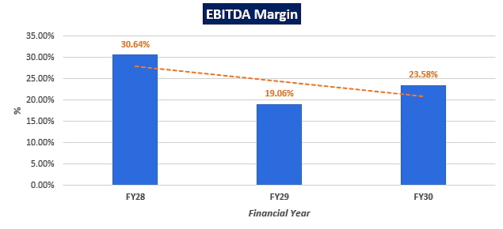
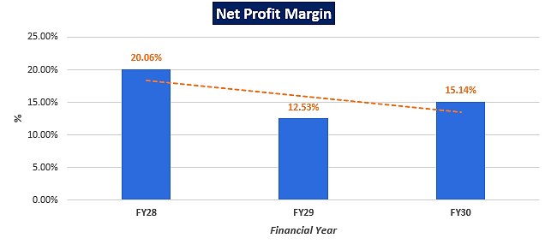

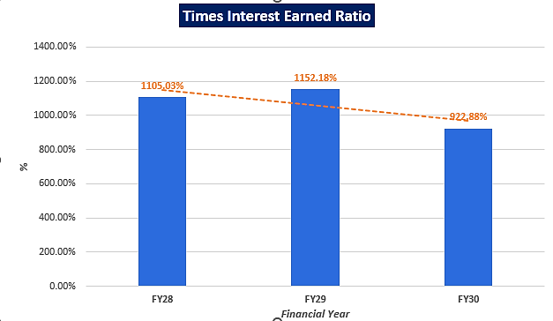

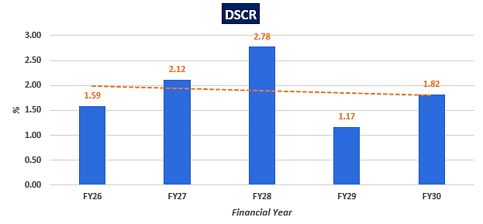
- LOAN AMORTIZATION SCHEDULE: As per Loan disbursement and amortization schedule shared by the client/company, according to the project costs incurred during the estimated period below table shows the balance of principle and intrest during the projected period.
(INR Crores)
Particulars | Mar-24 | Mar-25 | Mar-26 | Mar-27 | Mar-28 | Mar-29 | Mar-30 | Total
ROI Assumption | 10.00%
Interest Expenses Yearly | 9 | 37 | 50 | 42 | 30 | 17 | 5 | 189
Repayment of Principal Yearly | - | - | 31 | 125 | 125 | 125 | 94 | 500
Repayment % | - | - | 6.20% | 25% | 25% | 25% | 18.80% | 100%
Total Repayment | 9 | 37 | 81 | 167 | 155 | 142 | 98 | 689

Details of Term Loan
Particular | Value
Amount Of Term Loan | INR 500 Cr.
Rate Of Interest | 10.00%
First drawdown | July - September 2023
Last drawdown | January - March 2025
First repayment instalment | January - March 2026
Last repayment instalment | October - December 2029
Door to door tenor | 25 quarters
No. of quarterly instalments | 16
Instalment in INR crores | 31.25

- CONSTRUCTION COST SCHEDULE: As per the inforrmation shared by the client/company and as per the Construction Cost Vetting Report (Refer: VIS(2022-23)-PL503-Q108-552-927)) by R K Associates, below table shows the details of the estimated construction cost to be incurred by the company to develop this project.
S. No. | Costs | INR Crore | UoM | Quantity | Cost Per Sq. ft. | Remarks By RKA
1 | Levelling & compaction works | 1.03 | SQM. | 86,053 | 120 | The estimation costs appear to be reasonable.
2 | Boundary wall works | 5.23 | cum | 2,039 | 25,659.90
3 | Project Office | 0.18 | sq. ft. | 500 | 3,500.00
4 | Sales Office | 0.70 | sq. ft. | 2,000 | 3,500.00
5 | Excavation | 5.67 | cum | 1,33,375 | 425.00
6 | Piling | 16.22 | cum | 24,961 | 6,500.00
7 | Concrete | 109.62 | cum | 69,368 | 15,802.50
8 | Civil Works | 371.48 | cum | 1,92,954 | 19,252.10
9 | Plumbing & Electrical | 193.40 | sq. ft. | 89,99,359 | 214.90
10 | Brickwork & Plaster | 6.39 | SQM. | 1,82,871 | 349.50
11 | Fixture Installation (Bathroom, Doors, Windows) | 11.82 | sq. ft. | 31,35,596 | 37.70
12 | Painting, Finishing & Tiling in Common area | 77.45 | sq. ft. | 36,51,763 | 212.10
13 | Façade | 16.08 | sq. ft. | 16,083 | 10,000.00
14 | STP | 9.00 | MLD | 6 | 150,00,000
15 | ETP | 12.50 | MLD | 5 | 250,00,000
16 | Amenity buildings | 1.45 | sq. ft. | 9,580 | 1,515.80
17 | Landscaping works | 30.78 | sq. ft. | 4,16,669 | 738.80
18 | Road works | 6.94 | LS | 27,75,826 | 25.00
19 | Labor | 29.81 | Man days | 5,96,177 | 500.00
20 | MEP and machinery installations | 48.99 | sq. ft. | 40,62,307 | 120.60
21 | EPC Tier I Premium | 96.92 | sq. ft. | 52,61,622 | 184.20
22 | Escalation in rates | 98.66 | sq. ft. | 52,61,622 | 187.50
23 | PMC | 10.42 | sq. ft. | 52,61,622 | 19.80
24 | Architect | 28.89 | sq. ft. | 52,61,622 | 54.90
25 | Cost consultant | 5.79 | sq. ft. | 52,61,622 | 11.00
Total Construction Costs |  | INR 1,195 Crores

- KEY ASSUMPTIONS & BASIS:
S. No. | Item | Assumptions and Basis
 | General | - The projections of the firm are done for the period from FY 2023-24 to FY 2029-30, 7 years) to cover the term loan period.  - We have considered Revenue and cost recognition-based model while making the future financial projections.
 | Pricing (Average Selling Price per sq. ft.) | - Company has decided INR 7,098 per sq. ft. for Building A, INR 7,850 per sq. ft. for Building B and INR 11,283 per sq. ft. for Building C in terms of carpet area.  - Selling Price of one unit of parking space is assumed at INR 5,00,000/-.  - Revenue has been estimated in line of the prevailing market rates in Trans Thane Creek (TTC) Industrial Area. Since, the proposed project is a government project, it will enjoy the benefits of subsidized rates for land, etc., which in turn will be beneficial for the current and future stakeholders of the project.  - Factors such as prominent location, past rich experience of promoters, latest data in public domain, information collected during survey, peers pricing has been considered to decide the said prices of proposed units.
 | Revenue Build up | - Total income for the financial years during the forecasted period will be generating from selling of industrial, commercial office space and parking amenities as per the below table (Estimated realised Revenues are shown excluding GST):  Category Average Selling Price (sq. ft.) Carpet area (sq. ft.) Realized amount (INR crore)  Building A 7,098 20,13,778 1,429  Building B 7,850 2,65,196 208  Building C 11,283 4,94,468 558  Total 1,641  Category Realized amount (INR crore)  Revenue from Car Parks 98  - We have assumed that sales of components will begin one quarter before a respective segment begins construction. Revenue has been derived through construction linked payment mechanism.  - Apart from sale income from constructed space at park, the SPV is also expected to earn revenue from sale of additional car parking space to the occupants.
 | Capacity Utilization | - As per the information provided by the client/company, for the proposed gems and jewellery park, Sales for all the categories put together is expected to get completed in 32 quarters from the initiation of construction activity for the project and below is the quarter-wise assumption for sales phasing (in percentage):  Quarter Building A Building B Building C  1 0% 0% 0%  2 0% 0% 0%  3 0% 0% 0%  4 0% 0% 0%  5 0% 0% 0%  6 10% 10% 10%  7 5% 5% 5%  8 2% 2% 2%  9 2% 2% 2%  10 2% 2% 2%  11 5% 5% 5%  12 15% 15% 15%  13 10% 10% 10%  14 5% 5% 5%  15 10% 10% 10%  16 2% 2% 2%  17 2% 2% 2%  18 2% 2% 2%  19 2% 2% 2%  20 2% 2% 2%  21 2% 2% 2%  22 2% 2% 2%  23 2% 2% 2%  24 2% 2% 2%  25 2% 2% 2%  26 2% 2% 2%  27 2% 2% 2%  28 2% 2% 2%  29 2% 2% 2%  30 2% 2% 2%  31 2% 2% 2%  32 2% 2% 2%  - We have considered the capacity utilization on conservative basis to keep a mark-up for future market & economic risks in the Project.
 | Capital Expenditure | - As per discussion with the client, company has made a decision to lease land from MIDC, which is economically viable, since the lease/rent rate of the property at the said location is very much higher on monthly/annual basis and purchase price prevailing in the said location is also higher than the agreed draft lease deed.  - The freehold land for proposed project, costs INR 250 crores (inclusive of all charges) to the company, the company has already paid one instalment towards the lease premium of the land and still they have to pay 3 more instalments to get full authorization on land.  - The proposed project's total construction cost is approx. INR 1,194 Crores including applicable GST charges.  - The building A of the proposed project consists of the large and medium size kharkhanas will incur an estimated construction cost of INR 466 crores.  - The building B of the proposed project consists of the small size kharkhanas will incur an estimated construction cost of INR 78 crores.  - The building C of the proposed project consists of the office building which will incur an estimated construction cost of INR 133 crores.  - Support Infrastructure will mainly consist of Fire Fighting, Police Chowki, Hospital, Gate, etc. will have an estimated construction cost of INR 386 cores.  - Parking Block of all 3 buildings (i.e., A, B & C) will have an estimated construction cost of INR 132 Crores.
 | Expenses | - Major expenses include Cost of power & fuels, Administration & Misc. Exp, Cost of Transportation, Salary & Wages, Other Operating Expenses, Repair & Maintenance, Rent Rates & Taxes, Insurance etc.  - For the proposed gems and jewellery park, the administrative costs are assumed to be @ 12% of the construction costs and Sales & marketing cost are assumed to be @ 2% of the construction costs.
 | Term Loan | - Term loan of INR 500 Crores is disbursed in 2 parts, i.e., INR 200 Crores in FY 23-24 and INR 300 Crores in FY 24-25.  - The tenure of the loan will be 8 years in which first repayment will be made in FY 25-26.  - Interest rate is considered to be 10% as per the latest information provided by the client/company for the whole period of the term loan.  - Thus, the loan repayment period will be from FY 2025-26 to FY 2029-30.
Conclusion:
      - DSCR, EBITDA and Net Profit margin are positive in all the projected relevant years. The company has achieved DSCR of more than 1 during the loan repayment period.
      - Average DSCR, EBIDTA margin, Net Profit margin is 1.95, 24.43%, and 15.91% respectively during the estimated period.
      - As per the information shared by the client and as per the projections, the project is generating enough cash surplus that the contingencies would be met through the surplus, if needed.
      - Based on the above key financial ratios of the Project during the forecast period for the proposed project shows that the project looks financially and economically viable if the Project Company & promoters are able to maintain sales phasing, revenue and also able to contain cost as assumed above. However, the above-mentioned projections are calculated on the basis of the plan shared by the client/company. If the company differs from the approved plan during the implementation, the projections may differ resulting to altered concluded viability.

PART M | CONCLUSION

Based on the economic and market analysis done above, various Industry assumptions taken, pricing to be adopted by the company, the Project appears to be Commercially-Economically viable subject to the risks, threats, weaknesses, limitations of the services and equipment as detailed previously. Due to it being a government project, the company is enjoying a subsidized rate which be beneficial for all current and future stakeholders. This can also be used as one of the key attributes while promoting the project.
As per financial projections for the estimated period, Average DSCR, EBITDA Margin of the project are 1.95, and 24.43% respectively, where higher DSCR is the indicator of the project capability to pay out its outstanding debt and EBITDA margin shows the capability of the project to generate the operating profits over the forecasted period. The proposed facility is having a positive NPV and IRR as INR 248.46 Crores positive and 12.78% respectively. While it is not avoidable that the future projections may change in the upcoming years due to various factors impacting the operation, managerial, financial efficiency and economies of scale of the project.
It would be depending on the management’s capability in future that how efficiently company adopts marketing and advertisement strategy, supply chain and carry out inventory & resource management to achieve higher profitability. Company has identified its key customers as the members of GJEPC although the company is yet to identify and form strategic planning for tie-up & product promotion with overseas and domestic customers for selling & distribution of its product which remains a major concern. Bank/ Financial Institution is advised to take firm plan from the company in this regard before taking any decision.
After considering the high demand of the proposed gems and jewellery centres domestically and globally, various initiatives taken by government, financial analysis of the project based on the assumptions taken over the projected period, it appears reasonable to comment that the proposed project is “Economically” viable subject to current assumptions considered and occurring the same in the upcoming years same as the forecasted period which is dependent on the sincerity and efforts of the management and various micro and macroeconomic & industry situation.
We have tried our level best to analyse the economic feasibility of the Project based on the industry research, Project information and various futuristic assumption taken. However, achieving the financial milestones depends on the ability, sincerity and efforts of the company, promoters and its key managerial performance.
Declaration | - The undersigned does not have any direct/indirect interest in the above property.  - The information furnished herein is true and correct to the best of our knowledge, logical and scientific assumptions.  - This TEV Report is carried out by our Financial Analyst team on the request from State Bank of India, Diamond Branch, D-3, Tower, West Core, G-Block, Bharat Diamond Bourse, Bandra-Kurla Complex, Bandra (E), Mumbai - 400051.  - Meeting of Financial projections will be subject to subject to the market & economy stability factors, judicious business operations and proper & timely implementation of its process & product re-engineering & improvements plans for achieving high productivity, efficiency and achieving cost saving benefits.  - We have submitted TEV report to the Client.
Name & Address of consultant company |  |  | Signature of the authorized person
M/s. R.K. Associates Valuer & Techno Engineering Consultants Pvt. Ltd.
D-39, 2nd Floor, Sector-2, Noida- 201301
Enclosed Documents |  | Disclaimer & Remarks 66-69
Number of Pages in the Report |  | 69
Financial Analyst Team worked on the report |  | PREPARED BY: Mr. Rachit Gupta
 |  | REVIEWED BY: Mr. Gaurav Kumar

For R.K Associates Valuer & Techno Place: Noida

Engineering Consultants (P) Ltd. Date: 10/04/2023

(Authorized Signatory)

PART N | DISCLAIMER | REMARKS

      - No employee or member of R.K Associates has any direct/ indirect interest in the Project.
      - This report is prepared based on the copies of the documents/ information which the Bank/ Company has provided to us out of the standard checklist of documents sought from them and further based on our assumptions and limiting conditions. The client/owner and its management/representatives warranted to us that the information they supplied was complete, accurate and true and correct to the best of their knowledge. All such information provided to us has been relied upon in good faith and we have assumed that it is true and correct in all respect. I/We shall not be liable for any loss, damages, cost or expenses arising from fraudulent acts, misrepresentations, or wilful default on part of the owner, company, its directors, employee, representative or agents. Verification or cross checking of the documents provided to us from the originals or from any Govt. departments/ Record of Registrar has not been done at our end since this is beyond the scope of our work. If at any time in future, it is found or came to our knowledge that misrepresentation of facts or incomplete or distorted information has been provided to us then this report shall automatically become null & void.
      - Legal aspects for e.g. investigation of title, ownership rights, lien, charge, mortgage, lease, sanctioned maps, verification of documents, etc. have not been done at our end and same has to be taken care by legal expert/ Advocate. It is assumed that the concerned Lender/ Financial Institution has satisfied them with the authenticity of the documents, information given to us and for which the legal verification has been already taken and cleared by the competent Advocate before requesting for this report. I/ We assume no responsibility for the legal matters including, but not limited to, legal or title concerns.
      - This report is a general analysis of the project based on the scope mentioned in the report. This is not an Audit report, Design document, DPR or Techno feasibility study. All the information gathered is based on the facts seen on the site during survey, verbal discussion & documentary evidence provided by the client and is believed that information given by the company is true best of their knowledge.
      - This Techno Economic-Viability study is prepared based on certain futuristic assumption which are intra dependent on economic, market and sectorial growth condition in future and socio-economic, socio-political condition at macro and micro level.
      - Meeting of assumption and financial ratio will entirely depend on the sincerity and efforts of the company, promoters and its key managerial performance.
      - All observations mentioned in the report is only based on the visual observation and the documents/ data/ information provided by the client. No mechanical/ technical tests, measurements or any design review have been performed or carried out from our side during Project assessment.
      - Bank/FII should ONLY take this report as an Advisory document from the Financial/ Chartered Engineering firm and its specifically advised to the creditor to cross verifies the original documents for the facts mentioned in the report which can be availed from the borrowing company directly.
      - In case of any default in loans or the credit facility extended to the borrowing company, R.K Associates shall not be held responsible for whatsoever reason may be and any request for seeking any explanation from the employee/s of R.K Associates will not be entertained at any instance or situation.
      - The documents, information, data provided to us during the course of this assessment by the client are reviewed only up to the extent required in relation to the scope of the work. No document has been reviewed beyond the scope of the work.
      - This report only contains general assessment & opinion as per the scope of work evaluated as per the information given in the copy of documents, information, data provided to us and/ and confirmed by the owner/ owner representative to us at site which has been relied upon in good faith. It doesn’t contain any other recommendations of any sort including but not limited to express of any opinion on the suitability or otherwise of entering into any transaction with the borrower.
      - We have relied on data from third party, external sources & information available on public domain also to conclude this report. These sources are believed to be reliable and therefore, we assume no liability for the truth or accuracy of any data, opinions or estimates furnished by others that have been used in this analysis. Where we have relied on data, opinions or estimates from external sources, reasonable care has been taken to ensure that such data has been correctly extracted from those sources and /or reproduced in its proper form and context, however still we can’t vouch its authenticity, correctness or accuracy.
      - This Report is prepared by our competent technical team which includes Engineers and financial experts & analysts.
      - This is just an opinion report and doesn’t hold any binding on anyone. It is requested from the concerned Financial Institution which is using this report for taking financial decision on the project that they should consider all the different associated relevant & related factors also before taking any business decision based on the content of this report.
      - All Pages of the report including annexure are signed and stamped from our office. In case any paper in the report is without stamp & signature then this should not be considered a valid paper issued from this office.
      - Though adequate care has been taken while preparing this report as per its scope, but still we can’t rule out typing, human errors, over sightedness of any information or any other mistakes. Therefore, the concerned organization is advised to satisfy themselves that the report is complete & satisfactory in all respect. Intimation regarding any discrepancy shall be brought into our notice immediately. If no intimation is received within 15 (Fifteen) days in writing from the date of issuance of the report, to rectify these timely, then it shall be considered that the report is complete in all respect and has been accepted by the client up to their satisfaction & use and further to which R.K Associates shall not be held responsible in any manner.
      - Defect Liability Period is 15 DAYS. We request the concerned authorized reader of this report to check the contents, data and calculations in the report within this period and intimate us in writing if any corrections are required or in case of any other concern with the contents or opinion mentioned in the report. Corrections only related to typographical, calculation, spelling mistakes, incorrect data/ figures/ statement will be entertained within the defect liability period. Any new changes for any additional information in already approved report will be regarded as additional work for which additional fees may be charged. No request for any illegitimate change in regard to any facts & figures will be entertained.
      - R.K Associates encourages its customers to give feedback or inform concerns over its services through proper channel at valuers@rkassociates.org in writing within 15 days of report delivery. After this period no concern/ complaint/ proceedings in connection with the Techno- Economic Viability Study Services will be entertained due to possible change in situation and condition of the subject Project.
      - Our Data retention policy is of ONE YEAR. After this period, we remove all the concerned records related to the assignment from our repository. No clarification or query can be answered after this period due to unavailability of the data.
      - This Techno Economic Viability Study report is governed by our (1) Internal Policies, Processes & Standard Operating Procedures, (2) Information/ Data/ Inputs given to us by the client and (3) Information/ Data/ Facts given to us by our field/ office technical team. Management of R.K Associates never gives acceptance to any unethical or unprofessional practice which may affect fair, correct & impartial assessment and which is against any prevailing law. In case of any indication of any negligence, default, incorrect, misleading, misrepresentation or distortion of facts in the report then it is the responsibility of the user of this report to immediately or at least within the defect liability period bring all such act into notice of R.K Associates management so that corrective measures can be taken instantly.
      - R.K Associates never releases any report doing alterations or modifications from pen. In case any information/ figure of this report is found altered with pen then this report will automatically become null & void.
      - If this report is prepared for the matter under litigation in any Indian court, no official or employee of R.K Associates will be under any obligation to give in person appearance in the court as a testimony. For any explanation or clarification, only written reply can be submitted on payment of charges by the plaintiff or respondent which will be 10% of the original fees charged where minimum charges will be Rs. 15,000/.

