File No.: VIS(2022-23)-PL528-425-735 Dated: 23rd December 2022

LENDER’S INDEPENDENT ENGINEER REPORT (3rd)
(FOR QUARTER ENDING SEPTEMBER 2022)

OF

COTTON COMBED COMPACT YARN MANUFACTURING PLANT
SITUATED AT

8 KM, KHASRA NO. 71, 72, 73, 83, 84, 85 and 86 VILLAGE HUMAYUPUR, PARGANA, TEHSIL & DISTT. MUZAFFARNAGAR, U.P.

IMPLEMENTED BY

M/S SANGAL INDUSTRIES PVT. LTD. (SIPL) GROUP COMPANY OF

“SIDHARTH GROUP”

REPORT PREPARED FOR
STATE BANK OF INDIA, SME BRANCH JANSATH ROAD, MUZAFFARNAGAR, UTTAR PRADESH.

**Important - In case of any query/ issue or escalation you may please contact Incident Manager at le@rkassociates.org. We will appreciate your feedback in order to improve our services.
NOTE: As per IBA Guidelines please provide your feedback on the report within 15 days of its submission after which report will be considered to be correct.

TABLE OF CONTENTS
SR. NO. | DESCRIPTION | PAGE NO.
PART A | Report Summary | 03
PART B | Introduction | 05
 | 1. The Project | 05
 | 2. About the Borrower | 05
 | 3. Location of the Project | 06
 | 4. Project Overview | 07
 | 5. Scope of the Project During Project Duration | 10
 | 6. Purpose of the Report | 10
 | 7. Methodology Adopted | 10
PART C | Plant Infrastructure Sections & Facility Details with Actual Progress | 11
 | 1. Land Details | 11
 | 2. Building and Structure Details | 11
 | 3. Plant Machinery and Equipment | 15
PART D | Project Consultants, Contractors & Suppliers | 21
PART E | Project Cost and Means of Finance | 22
 | 1. Cost of Project | 22
 | 2. Current Status and Total Expenditure Incurred Till Date | 23
 | 3. Sources of Finance & Utilization of Funds | 28
PART F | Statutory & Regulatory Approvals, Clearances & NOC | 29
PART G | Project Schedule & Current Status | 31
PART H | Observations and Comments | 33
PART I | Disclaimer | 34

IMPORTANT NOTICE

COPYRIGHT FORMAT: This report is prepared on the copyright format of R.K Associates, to serve our clients with the best available information and analysis to facilitate them to take rational business decisions. Legally no one can copy or distribute this format without prior approval from R.K Associates. It is meant only for the advisory/ reference purpose for the organization/s as mentioned on the cover page of this report. Distribution or use of this format by any organization or individual other than R.K Associates will be seen as unlawful act and necessary legal action can be taken against the defaulters.

This report is intended for the sole use of the intended recipient/s and contain material that is STRICTLY CONFIDENTIAL AND PRIVATE.

DEFECT LIABILITY PERIOD: - In case of any query/ issue or escalation you may please contact Incident Manager: le@rkassociates.org. We try our level best to ensure correctness in the calculations done, rates adopted and various other data points & information mentioned in the report but still can’t rule out typing, human errors or any other mistakes. In case you find any such mistake or inaccuracy in any data point of the report please help us by bringing all such points into our notice immediately or within 15 days of the report delivery in writing, to rectify these timely failing after which R.K Associates won’t be held responsible for any such inaccuracy in any manner. We would highly appreciate your feedback in order to improve our services.

PART A | REPORT SUMMARY

1. | Name of Project: | To Set Up a Greenfield spinning plant for manufacturing of Cotton Combed Compact Yarn with an Installed Capacity of 5500 MT/ annum.
2. | Project Location: | 8 KM, Khasra no. 71, 72, 73, 83, 84, 85 and 86 Village Humayupur, Pargana & Tehsil Distt. Muzaffarnagar, U.P.
3. | Name of the Borrower: | M/s. Sangal Industries Private Limited
4. | Director’s as per MCA | Mr. Shishir Sangal  Mr. Vineet Kumar Sangal Mr. Vinod Kumar Gupta
5. | Prepared for Bank: | State Bank of India, Jansath Road, Muzaffarnagar, Uttar Pradesh.
6. | LIE Consultant Firm: | M/s. R.K. Associates Valuers & Techno Engineering Consultants (P) Ltd.
7. | Date of Survey: | 24th June 2022
8. | Date of Report: | 31th July 2022
9. | Purpose of the Report: | To provide fair detailed analysis report to the Bank based on the “in-scope points” mentioned below for facilitating them to take appropriate credit decision on the Project.
10. | Scope of the work provided by the Lender: | a. Detailed Inception Report for Project Review and Assessment

 |  | b. Quarterly Construction Monitoring & Status Reports as and when requested by the bank
11. | Documents perused for Proposal: | - Techno economic feasibility report  - CA certificate
12. | Annexure with the report: | - Copies of Project Statutory approvals  - CA Certificate

PART B | INTRODUCTION

THE PROJECT:
M/s Sangal Industries Private Limited (SIPL) is setting up a Greenfield Cotton Combed Compact Yarn manufacturing plant of 5500 MT/ annum production capacity at Village Humayupur, Pargana & Tehsil Distt. Muzaffarnagar, U.P. SIPL has acquired land adjoining to the existing Kraft paper manufacturing plant of M/s Siddeshwari Industries Pvt Ltd situated at Jansath Road, Muzaffarnagar for setting up the plant. The cost of project is estimated at Rs.74.66 Cr.

ABOUT THE BORROWER:

SIPL is a private limited company incorporated on 04/05/2021 with the Registrar of Companies, UP with CIN No. U17299UP2021PTC145844 to set-up a spinning plant for manufacturing of Cotton Combed Compact Yarn.

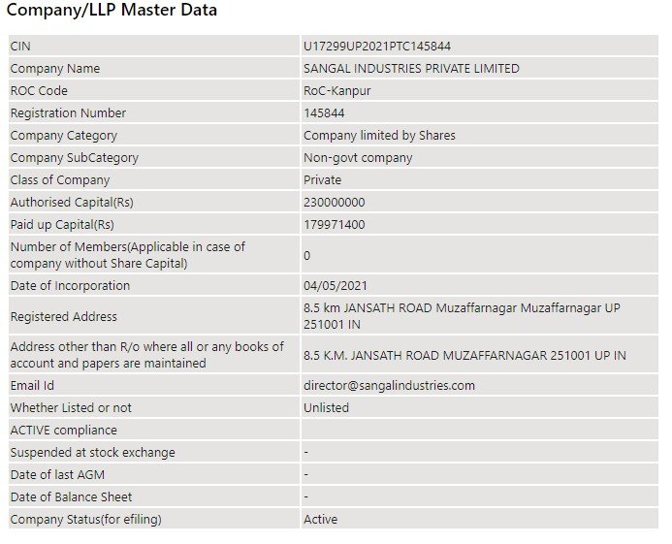

The primary set of directors of “SIPL” as on date are:

  - Mr. Shishir Sangal
  - Mr. Vineet Kumar Sangal
  - Mr. Vinod Kumar Gupta

M/s Sangal Industries Private Limited (SIPL) is setting up a Greenfield Cotton Combed Compact Yarn manufacturing plant of 5500 MT/ annum production capacity at Village Humayupur, Pargana & Tehsil Distt. Muzaffarnagar, U.P.
As per the information available in TEV report, SIPL is a group company of Sidharth Group which is engaged in manufacturing of Duplex and Kraft paper. M/s Sidharth Group is having following units:

- M/s Sidharth Paper Private Limited (SPPL), Kashipur
- M/s Sidharth Paper Private Limited (SPPL), Udham Singh Nagar
- M/s Siddeshwari Paper Udyog Pvt. Ltd. (SPUPL), Kashipur
- M/s Siddeshwari Industries Pvt. Ltd. (SIPL), Muzaffarnagar

PROJECT LOCATION:

Details about Location of Unit is as below:

Particulars | Description
Latitude | 29°25'03.1"N
Longitude | 77°45'23.6"E
Connectivity Systems
Road | The project site of the subject under construction plant is well connected by road network and Lies 400m in the interior from the Miranpur-Muzaffarnagar Road (National Highway 709 AD). The Project site can be approach from the Road at the back of M/s Siddheshwari Industries Pvt. Ltd. which can be easily accessed via National Highway towards Muzaffarnagar from Miranpur. It is around 10 Km from main Muzaffarnagar city. District  Muzaffarnagar is around 133 Km away from Delhi (National Capital).
Rail | The Nearest Railway station to the subject locality is Muzaffarnagar Railway Station which is about 10 Km from the Subject Project or unit toward North  -west Direction
Air | The nearest Domestic and international Airport to the subject project is  Indira Gandhi Airport which is about 150 Km form the subject project.

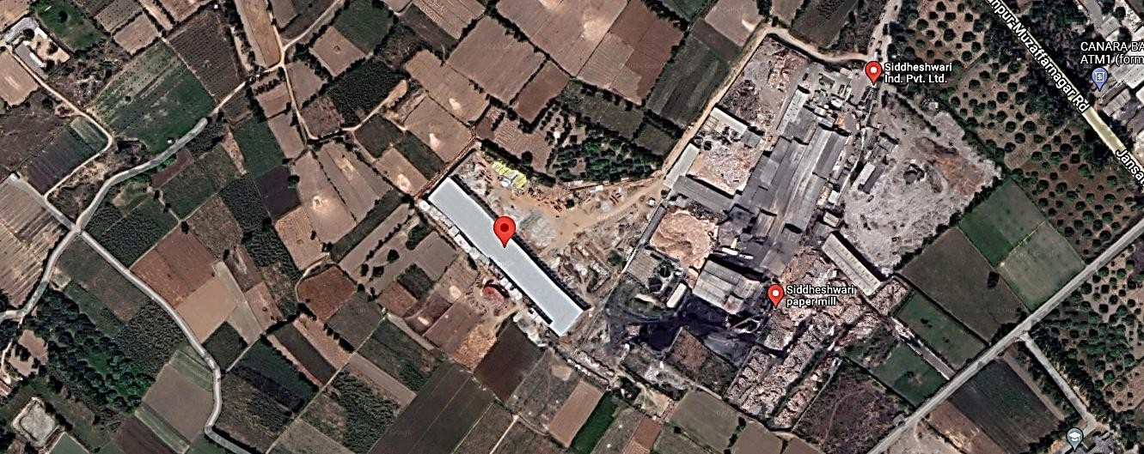

Figure 1: Location of Manufacturing Unit

PROJECT OVERVIEW:

M/s Sangal Industries Pvt. Ltd. (SIPL) is setting up a Greenfield Plant of 5500 MT/ annum installed Capacity of Manufacturing of Cotton Combed Compact Yarn at 8 Km, Khasra No. 71, 72, 73, 83, 84, 85 and 86 Village- Humayupur, Pargana, Tehsil & Distt. Muzaffarnagar,
U.P. with a total land area ad measuring 2.7613 Hectares.

The company has estimated The cost of project amounting to Rs.74.66 Crore which includes Rs.62.42 Crore towards Hard cost, Rs.4.15 Crore towards Soft cost and Rs.8.09 Crore towards Margin for working capital requirement. The project is estimated to start the commercial productions by April 2023.

As per the TEV Report the plant is proposed to have installed capacity of 16.60 MT per day which considering 330 working days calculate to be 16.6 x 330 = 5478 MT (approx. 5500 MT/ annum) of cotton combed compact yarn is being Setup at village Humayupur, pargana, tehsil & dist. Muzaffarnagar, U.P. However, the total production Capacity as per the consent to establish is approved at a capacity of 18 MT /day. Thus, the actual production capacity

documented in the TEV report is well within the production capacity approved in Consent to establish.

In the Subject unit, SIPL has proposed to produce following Products as listed below: -

SR. NO. | PRODUCT | MARKET SEGMENT | AREA TO BE TARGETED
1. | Single combed yarn | Knitting | Delhi NCR, Ludhiana, Kolkata  and Tripura
2. | Double combed yarn | Home furnishing | Meerut and Modinagar
3. | Single woven yarn | Suiting & Shirting | Ludhiana, Kolkata and Mumbai

MANUFACTURING PROCES OF PLANT

- Mixing (Mixing various lots of cotton etc. to achieve uniform and desired quality)
- Production stage-1 (Opening and partial cleaning through Blow Room)
- Production stage-2 (To further clean cotton fibre and convert blow room laps into card sliver through Carding)
- Production stage-3 (Lap Former - To convert card sliver into uniform laps for feeding to combers)
- Production stage-4 (Comber to remove short fibers and impurities from cotton laps and convert into clean better quality combed sliver).
- Production stage-5 (Draw Frame- To homogenize and make even sliver so that variation do not occur in yarn)
- Production stage-6 (Simplex (Roving- To convert sliver into roving to feed into Ring Frame)
- Production stage-7 (Spinning (Ring Frame- Converting roving into yarn of required count and twist).
- Production stage-8 (Package Winding through Automatic Package Winders Autoconer X6 Type V / 48 Positions in the Machine Frame 44 Winding Heads Type V; Automatic Package Winders Autoconer X6 Type V / 48 Positions in the Machine Frame 48 Winding Heads Type V; Automatic Package Winders Autoconer X6 Type V / 40 Positions in the Machine Frame 36 Winding Heads Type V; Automatic Package Winders Autoconer X6 Type V / 40 Positions in the Machine Frame 36 Winding Heads Type V; (Use of Uster Jossi Vision Shield with Uster Jossi Magic Eye 2 for Elimination of Foreign Matter and Plastic Parts including White and Transparent Polypropylene: Uster Polypropylene Options for Uster Quantum 4.0

Clearers Installed on 12 ACX6 Winders (Total Spindles 475); (Use of compressed filtered Air thr’ in Winders thr' Rotary Screw Compressor CSD-5; Compressed Air Filter)
- End Products.’ Grey Cotton Combed Yarn,’ Blended Cotton Combed Yarn
- Post-production stage (Quality Testing)
- Post-production stage (Packing)
- Dispatch

WATER REQUIREMENT

The water requirement is estimated at 10,000 L/ day (10KL/Day). Water requirement is proposed to be primarily met from tube wells/borewell which is to be installed at the site ensuring regular supply of water. However as per CTE the company has been approved only for 9KL/Day of ground water extraction only.

POWER REQUIREMENT

As per TEV report The power requirement for the unit is 2.60 MW for which SIPL has been sanctioned connected load of 3.50 MW from Pashchimanchal Vidyut Vitran Nigam Ltd. U.P. However, no supporting document in this regard is provided to us.

GEOGRAPHICAL CONDITIONS ON THE SITE:

- The area has generally hot climate. The maximum temperature is around 100°F while the minimum is 48°F.
- The average annual rainfall of this area is about 593.5 mm.
- The annual relative humidity varies from 30% to 90%.
- The above plant site area falls in Seismic Zone IV.

SCOPE OF WORK DURING PROJECT DURATION:

  - Detailed Inception Report for Project Review and Assessment
  - Quarterly Construction Monitoring & Status Reports as and when requested by the bank
  - Monitoring of Term loan utilisation amounting to Rs.43.00 Crore sanctioned to the company for the purchase and installation of Plant and machineries.

Note:
    - The scope of work is for the complete duration and not for a specific report.
    - Carrying out the scope of work will depend on the details/ information/ data provided to us by the borrower from time to time.

- PURPOSE OF THE REPORT: To provide fair detailed analysis report to the Bank based on the “in-scope points” mentioned above for facilitating them to take appropriate credit decision on the Project.

METHODOLOGY ADOPTED:

- Study of Project Planning documents/ reports to know about the Project.
- Additional information, data, documents collection from the borrower.
- Study and analysis of the documents and information obtained from the borrower.
- Information compilation, analysis and reporting.

PART C | PLANT INFRASTRUCTURE SECTIONS & FACILITY DETAILS WITH  ACTUAL PROGRESS

LAND DETAILS:

The borrower has proposed an expenditure amounting to Rs.74.66 Crores out of which Rs.1.89 cr. is envisaged towards purchase of land and its subsequent development.

As per the copy of sale deed bearing Registration No. 7900 provided to us by the company, M/s Sangal industries Private limited has purchased the Agricultural Land ad measuring 2.7613 Hectare for the purpose of setting up the Subject Plant for the consideration amount of approx. Rs.1.66 Crore and Rs.8.30 Lakh has been paid as stamp duty on the purchase of the same. The company has obtained CLU of 2.7612 ha from agricultural to non-agricultural as per documents below.

Sr. No. | Document No. | CLU Area
1. | Case no. 9826/2021 | 2.3926
2. | Case No. 9050/2021 | 0.3686
 | Total | 2.7612

The copy of Sale deed and CLU document is attached as annexures with this report.

BUILDING & STRUCTURAL DETAILS:

SIPL Envisages setting up of below mentioned units/Sections in the Project:

Sr. No. | Description | Length/ Width | Area
 |  |  | (m²)
1 | Machinery Hall with Galvalume Sheet Roof raw materials section, blow room & card section, preparatory & ring frame section, finishing house, H - plant, Gen Set Room, Administrative Office, lab, time office, stores, workshop, electric room, canteen,(Including Underground Trenches, False Ceiling, RCC Ground  Flooring) | 185X40 | 7400
2 | Stock Godown with Galvalume Sheet Roof | 30X40 | 1200
3 | Compound Wall with Iron Gates
4 | Internal Roads & Drainage System
5 | Site Developments
 | Total |  | 8600

For setting up/ development of above listed sections, SIPL has estimated Rs.5.00 Crore out of Total project cost amounting to Rs.74.66 Crore. Bifurcation of Rs.5.00 Crore is as below:

Sr. No. | Description | Amount in Crore
1 | Machinery Hall with Galvalume Sheet Roof raw materials section, blow room & card section, preparatory & ring frame section, finishing house, H - plant, Gen Set Room, Administrative Office, lab, time office, stores, workshop, electric room, canteen,(Including Underground Trenches, False Ceiling, RCC Ground  Flooring) | 4.07
2 | Stock Godown with Galvalume Sheet Roof | 0.48
3 | Compound Wall with Iron Gates | 0.15
4 | Internal Roads & Drainage System | 0.20
5 | Site Developments | 0.10
 | Total | 5.00

As can be inferred from the TEV report and the sanction letter the construction cost has been submitted for a construction area admeasuring 8600 sq. mtr only. The actual stipulated construction area as per approved building plan is 15,316 sq. mtr. However as per the latest building sheet provided to us during the site visit the covered area of 13,751 sq.mtr. is already constructed till the September quarter. Refer sheet below (Table A).
Clarification for the cost difference and subsequent funding of the extra area to be constructed was discussed with the company. Accordingly, the company informed that they are constructing area greater than the stipulated area in TEV report and the excess cost will be funded by the company from their own sources only. Lender to take note of it.

Notes:

    - The above estimation of cost is as per the TEV report provided to us by the Bank.
    - Building Plans have been prepared by Yash Madhu and Associates and is approved by Zilla Panchayat, Muzaffarnagar.
    - During the site visit it was observed that the essential building for operating the plant was completed and some ancillary building are under construction.
    - As per the site visit and the information provided on site the company is building its office space on first floor of combine VCB, DG and store room. The RCC Slab work for the office space on the first floor has been completed. Originally the office Building was proposed to be constructed separately as per the building plan shared with us.

As per Layout Plan provided by the borrower following buildings are proposed to be constructed at site:
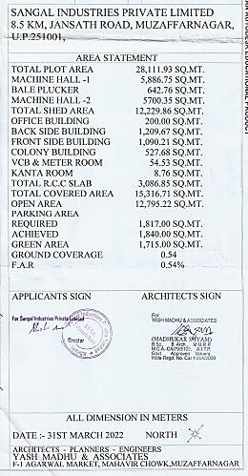
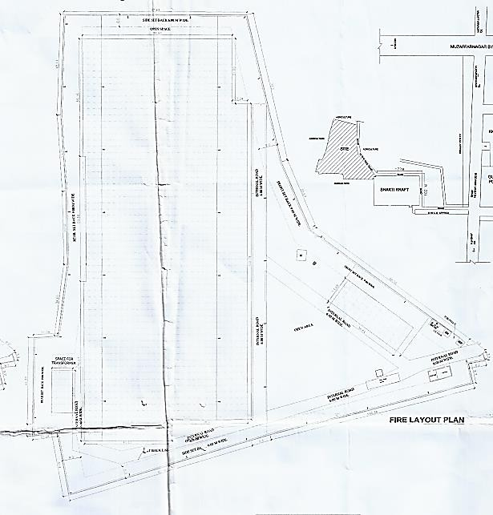

Progress of Building and Civil Structures for the Plant is considered as per the information provided by the Client about the status of Progress for Civil Work:
1. The Physical progress is considered based on approximate observation during our visit on 20th December 2022 of the Subject Plant, during the Course of our visit to the subject Project Site in Month of December following observations were made:

Table: - 01

Sr. No. | Building Details As Per Company | Building Name As Per Previous Report | Remarks
1 | Machine Hall and Blow Room | Machine Hall 1 and Bale Plucker | Civil work Completed and operational
2 | Finish Godown | Machine Hall 2 | Civil work Completed and operational
3 | Loading Point
4 | Raw Material Godown
5 | Time Office | - | Civil work Completed and operational
6 | H Plant | Back Side Building (Humidification Plant) | Civil work Completed and operational
7 | H Plant | Back Side Building (Humidification Plant) | Civil work Completed and operational
8 | H Plant | Back Side Building (Humidification Plant) | Civil work Completed and operational
9 | Store | Back Side Building | Ground Floor work completed and operational and on First Floor RCC slab work is completed however, brick work, plaster and other civil work on first floor is not started yet.
10 | D.G Room
11 | L.T Room (Power Sub Station | VCB
12 | Ist Floor on DG Room | - | Slab Work Completed only.
13 | Colony | Colony | 1.Civil work on the 1/2 portion on Ground floor work was completed and it was ready for use and remaining half portion on ground floor the plaster work was going on. On First Floor civil work was complete and plaster work is pending. On second floor civil work is going on and it is under WIP.
14 | Meter Room | Meter room | Civil work Completed and operational
15 | Guard Room | - | Civil work Completed and operational
16 | Dispensery & Kanta Room | Kanta Room | Civil work Completed and operational
17 | Weigh Bridge (only slab) | - | Civil work Completed and operational
18 | Canteen | - | Civil work Completed and operational
19 | Office Building | Not Yet Started | Not Yet Started
20 | Front Side Building | Not Yet Started | Not Yet Started

Table: - 02

S.NO. | NAME OF BUILDING-(M.S.SHED) | AREA- SQ.M.
1 | MACHINE HALL & BLOW ROOM | 6604.00
2 | FINISH GODOWN | 972.63
3 | LOADING POINT | 43.90
4 | RAW MATERIAL GODOWN | 1904.54
5 | TIME OFFICE | 52.80
 | TOTAL SQ.M. | 9577.87
S.NO. | NAME OF BUILDING-(R.C.C.) | AREA- SQ.M.
1 | H PLANT BUILDING | 1362
2 | H PLANT BUILDING-SECCOND STOREY | 840
3 | H PLANT BUILDING-THIRD STOREY | 245
4 | STORE | 125.6
5 | DG ROOM | 62.17
6 | L.T. ROOM(POWER SUB STATION) | 178.9
7 | COLONY-TRIPLE STOREY | 550
8 | METER ROOM | 51
9 | GUARD ROOM | 45.5
10 | DISPENSARY N KANTA ROOM | 48
11 | WEIGHR BRIDGE | 108
12 | CANTEEN | 126
13 | 1ST FLOOR AT DG ROOM SIDE | 431
 | TOTAL SQ.M. | 4173.63
 | Grand Total | 13751.50

The Expenditure on the civil work in the current quarter is only of Rs.48 Lakhs as inferred from the CA certificates of this quarter and previous Quarter. The progress of the civil work captured in the report is for cumulative till the September Quarter. The Total Progress of the Plant civil work till this quarter as assessed is ~86% of the total work need to be executed.

MACHINERIES & OTHER EQUIPMENTS AND UTILITIES:

The total amount envisaged against the purchase and installation of Plant and Machinery amounts to Rs.55.53 cr. Breakup of which is as below:

MACHINERIES AND OTHER EQUIPMENT’S
Sr. No. | Particulars | Amount (Cr.)
1. | Plant & Machinery | 49.6
2. | Electrical Equipment’s | 1.9
3. | Utilities | 4.03
 | Total | 55.53

The details list of machineries and other equipment’s to be delivered to the site area is as below:
Sr.No. | Detail of Machines | Quantity (Set/Nos.) | Name of Supplier | Total Amount
1 | Automatic Package Winders (Link Coner) | 475 | Saurer spinning  Solution gmbh & co. Kg, germany | 11,46,29,051
2 | Contamination sorter | 2 | Uster Technologies Ag, Switzerland | 1,65,00,000
3 | Usterpolypropylenes Options | 12 | Uster technologies ag,  Switzerland | 17,63,437
4 | Rotary Screw Compressor CSD | 2 | kaeser compressors (india) pvt. ltd | 22,54,415
 | Compressed Air Filter | 2
5 | Blow room (2 Lines):- Bale Plucker, Vario Clean,  Unimix, flexiclean & Accessories | 35 | lakshmi machine works ltd. coimbatore | 38,34,70,027
 | Carding LC 363 | 16
 | Fine Feed Chute LA7/6 | 16
 | Accessories for Carding Machine | 1

S.No. | Detail of Machines | Quantity (Set/Nos.) | Name of Supplier | Total Amount
 | Draw frame LDB3 ( Single Del) | 1
 | Draw frame LDB3 ( Double Del) | 2
 | Lap Former LH20 S | 2
 | Comber LK69 | 11
 | Accessories for Combing Machine | 7
 | Draw frame- finisher - LDF3S | 6
 | Speed frame LF4280/A | 4
 | Ring Frame LRJ 9/SX/SXL | 4
 | Ring Frame LRJ 9/SX/SXL | 8
6 | Overhead cleaners Ring Frame ( CWC with) | 12 | Elgi Electric And Industries Limited, Coimbatore | 51,07,123
 | Centralised Waste Collection System | 1
 | Overhead cleaners Link Coner | 12
 | Overhead cleaners Speed Frame | 4
7 | Argus Spark Blocker System Fire Protection | 10 | Elgi electric and industries limited,  Coimbatore | 15,77,564
 | Digitel Contral Panel Z10 | 1 | Elgi Electric And Industries Limited, Coimbatore
8 | Fire System For Bale Plucker | 1 | Elgi Electric And Industries Limited, Coimbatore | 3,26,735
9 | Sieger Yarn Conditioning Plant 1000 NG | 1 | Sieger spintech equipments pvt. Ltd | 25,25,200
10 | Bobbin Handling System | 1 | Am Innospin System Pvt Ltd | 48,38,000
11 | Luwa Auto Control Humidification Plant for Ring Spinning and parts thereof with standard and essential accessories | 1 | Luwa India Pvt Ltd | 1,78,18,000
12 | Automatic Bale Press | 1 | Tinytop engineering india Private limited | 31,27,000
13 | HFT Semi Auto High Volume Cotton Testing Equipment. |  | Premier Evolvics Pvt Ltd | 1,88,80,000
 | Aqura 2 Fibre And Process info System |  | Premier Evolvics Pvt Ltd
 | Iq3 Evenness tester |  | Premier Evolvics Pvt Ltd
 | Turbo Maxx 7 High Speed Single Yarn Strength Tester | 4 | Premier Evolvics Pvt Ltd

S.No. | Detail of Machines | Quantity (Set/Nos.) | Name of Supplier | Total Amount
14 | Godrej 3 Ton Electric  Forklift GX 300 E UNO- 4.5M LIFT | 1 | Urja Systems | 12,56,700
15 | Simplex Bobbin | 35000 | Ideal sheet metal stampings & prssings pvt. Ltd | 50,96,420
 | Hig Ring Spinning Tube | 20500
 | HCC Ring Spinning Tube | 16500
 | HCC Ring Spinning Tube | 16500
16 | Multi Roller Mouting Machine LC 363 | 1 | Lakshmi Card Clothing Manufacturing Company  (P) Ltd | 22,40,490
 | Automatic Flat Clipping Machine LCFM40 | 1
 | Automatic Flat Grindging Machine AFGM 40 | 1
 | Grinding Plate | 2
17 | Perfect Twin Head Cot Grindign M/C: TWG-TF | 1 | Perfect Equipments Pvt Ltd. | 32,46,180
 | Perfect Hydraulic Cot Mounting M/C: CMHY | 1
 | Perfect U.V. Treatment Machine: UVTM | 1
 | Perfect Cot Checking Device: CCD | 1
 | Perfect Automatic Arbour  Greasing M/C: ARG | 1
 | Perfect Spindle Lubricating M/C: SL-3 | 1
 | Perfect Clearer roller cleaning M/C: CRCSFAF | 1
 | Perfect Roving Waste Opening M/C: RWO | 1
 | Perfect Flutted roller truing M/C: FRTM | 1
 | Perfect Shore Hardness Tester | 1
18 | Hdpe Can Spinning Can Size 40" X 48" X 3.00 Mm | 230 | Rimtex industries | 51,34,180
 | Hdpe Can Spinning Can Size 24" X 48" X 2.5 Mm | 115
 | Hdpe Can Spinning  Can Size 20" X 48" X 2.0 Mm | 1400
19 | Testing equipment (QC) | 15 | Tecchno Qualicon Solutions (P) Ltd. | 9,94,551
20 | 2500 KVA Electrical Transformer Level2 | 2 | Power Star | 52,51,000
21 | Main PCC Panel & PDB Panel With Switch Gear | 11 | Shakumbri Enterprises | 83,78,000
22 | Grandlay 1100 volts XLPE  Armoured cable with Aluminium Conductor | 2 | Industrial Venture | 46,15,452

S.No. | Detail of Machines | Quantity (Set/Nos.) | Name of Supplier | Total Amount
 | Grandlay 1100 volts XLPE  Armoured cable with Copper Conductor | 10 |  | 34,09,365
23 | Identification Band 20" Orange & Green | 720 | Rimtex industries | 1,02,291
 | Identification Band 24" Violet | 70 |  | 11,436
 | Identification Band 40" Yellow. Red | 140 |  | 38,359
24 | Flooring Material and Flooring job | 8537 sqm | Master Floor India Pvt. Ltd. | 54,28,000
25 | Armoured H.T. cable 3C X185 mm² | 800 Mtr | Gupta Power Infrastructure Ltd. | 13,31,040
 | Armoured H.T. cable 3C X300 mm² | 1600 Mtr |  | 34,92,800
26 | H.T. VCB Panel | 1 | Asiatic Electrical & Switchgear Pvt. Ltd | 27,14,000
27 | Lysaght Trimdek Profile Sheet |  | Shree Ji & Company | 68,67,544
28 | Fiber Glass Insulation | 8487 | Anand Insulation Pvt.  Ltd | 21,03,078
29 | Ducting For H.plant, False Ceiling with Board and  Installation work |  | Aala Technocraft | 1,21,34,966
30 | Roofing Sheeting & Underdeck insulation Installation Work |  | Zetex Marketing (P) Ltd. | 16,54,950
31 | Hyraulic Hanh Lift pallet Trucks |  | Agromec | 1,08,560
 | Total |  |  | 64,83,17,360

From the Machines listed in the above table following machines were verified at the site during the site visit:-
S.No. | Detail of Machines |  |  |  | Quantity  (Set/Nos.) |  | Verified at Site |  | Remarks
1 | Automatic (Link Corner) | Package | Winders |  | 475 |  | Verified with the help of Representative |  | Completely Installed and Operational.
2 | Contamination sorter |  |  |  | 2 |  | Verified with the help of Representative |  | Completely Installed and Operational.
3 | Uster Poly Propylrne Options |  |  |  | 12 |  | Verified with the help of Representative |  | Completely Installed and Operational.
4 | Rotary Screw Compressor CSD |  |  |  | 2 |  | Verified with the help of Representative |  | Completely Installed and Operational.
 | Compressed Air Filter |  |  |  | 2 |  | Verified with the help of Representative |  | Completely Installed and Operational.
5 | Blow room (2 Lines):- Bale Plucker, Vario Clean, Unimix, FlexiClean & Accessories. |  |  |  | 35 |  | Verified with the help of Representative |  | Completely Installed and Operational.
 | Carding LC 363 |  |  |  | 16 |  | Verified with the help of Representative |  | Completely Installed and Operational.
 | Fine Feed Chute LA7/6 |  |  |  | 16 |  | Verified with the help of Representative |  | Completely Installed and Operational.
 | Accessories for Carding Machine |  |  |  | 1 |  | Verified with the help of Representative |  | Completely Installed and Operational.
 | Draw frame LDB3 ( Single Del) |  |  |  | 1 |  | Verified with the help of Representative |  | Completely Installed and Operational.
 | Draw frame LDB3 ( Double Del) |  |  | 2 |  |  | Verified with the help of Representative | Completely Installed and Operational.
 | Lap Former LH20 S |  |  | 2 |  |  | Verified with the help of Representative | Completely Installed and Operational.
 | Comber LK69 |  |  | 11 |  |  | Verified with the help of Representative | Completely Installed and Operational.
 | Accessories for Combing Machine |  |  | 7 |  |  | Verified with the help of Representative | Completely Installed and Operational.
 | Draw frame- finisher - LDF3S |  |  | 6 |  |  | Verified with the help of Representative | Completely Installed and Operational.
 | Lap Former LH20 S |  |  | 2 |  |  | Verified with the help of Representative | Completely Installed and Operational.
 | Comber LK69 |  |  | 11 |  |  | Verified with the help of Representative | Completely Installed and Operational.
 | Accessories For Combing Machine |  |  | 7 |  |  | Verified with the help of Representative | Completely Installed and Operational.
 | Speed frame LF4280/A |  |  | 4 |  |  | Verified with the help of Representative | Completely Installed and Operational.
 | Ring Frame LRJ 9/SX/SXL |  |  | 4 |  |  | Verified with the help of Representative | Completely Installed and Operational.
6. | Overhead Cleaners Ring  Frame (CWC With) |  |  | 12 |  |  | Verified with the help of Representative | Completely Installed and Operational.
 | Centralised Waste Collection System |  |  | 1 |  |  | Verified with the help of Representative | Completely Installed and Operational.
 | Over head cleaners Link Coner |  |  | 12 |  |  | Verified with the help of Representative | Completely Installed and Operational.
 | Over head cleaners Speed Frame |  |  | 4 |  |  | Verified with the help of Representative | Completely Installed and Operational.
7 | Argus Spark Blocker System Fire Protection |  |  | 10 |  |  | Verified with the help of Representative | Completely Installed and Operational
 | Digitel Contral Panel Z10 |  |  | 1 |  |  | Verified with the help of Representative | Completely Installed and Operational
8 | Fire System For Bale Plucker |  |  | 1 |  | Verified with the help of Representative |  | Completely Installed and Operational
9 | Sieger Yarn Conditioning Plant 1000 NG |  |  | 1 |  | Verified with the help of Representative |  | Completely Installed and Operational
10 | Bobbin Handling System |  |  | 1 |  | Verified with the help of Representative |  | Completely Installed and Operational
11 | Luwa Auto Control Humidification Plant for Ring Spinning and parts thereof with standard and  essential accessories |  |  | 1 |  | Verified with the help of Representative |  | Completely Installed and Operational
12 | Automatic Bale Press |  |  | 1 |  | Verified with the help of Representative |  | Completely Installed and Operational
13 | HFT Semi Auto High Volume Cotton Testing Equipment. |  |  | 1 |  | Verified with the help of Representative |  | Completely Installed and Operational
 | Aqura 2 Fibre And Process info System |  |  | 1 |  | Verified with the help of Representative |  | Completely Installed and Operational
 | iQ3 Evenness tester |  |  | 1 |  | Verified with the help of Representative |  | Completely Installed and Operational
 | Turbo Maxx 7 High Speed Single Yarn Strength Tester |  |  | 4 |  | Verified with the help of Representative |  | Completely Installed and Operational
14 | Godrej 3 Ton Electric Forklift GX 300 E UNO-4.5M LIFT |  |  | 1 |  | Verified with the help of Representative |  | Completely Installed and Operational
15 | Simplex Bobbin |  |  | 35000 |  | Verified with the help of Representative |  | Completely Installed and Operational
 | Hig Ring Spinning Tube |  |  | 20500 |  | Verified with the help of Representative |  | Completely Installed and Operational
 | HCC Ring Spinning Tube |  |  | 16500 |  | Verified with the help of Representative |  | Completely Installed and Operational
 | HCC Ring Spinning Tube |  |  | 16500 |  | Verified with the help of Representative |  | Completely Installed and Operational
16 | Multi Roller Mouting Machine LC 363 |  |  | 1 |  | Verified with the help of Representative |  | Completely Packed and Not Installed yet.
 | Automatic Flat Clipping Machine LCFM40 |  |  | 1 |  | Verified with the help of Representative |  | Completely Packed and Not Installed yet.
 | Automatic Flat Grindging Machine AFGM 40 |  |  | 1 |  | Verified with the help of Representative |  | Completely Packed and Not Installed yet.
 | Grinding Plate |  |  | 2 |  | Verified with the help of Representative |  | Completely Packed and Not Installed yet.
17 | Perfect Twin Head Cot Grindign M/C: TWG-TF |  |  | 1 |  | Verified with the help of Representative |  | Completely Installed and Operational
 | Perfect Hydraulic Cot Mounting M/C: CMHY |  |  | 1 |  | Verified with the help of Representative |  | Completely Installed and Operational
 | Perfevt U.V. Treatment Machine: UVTM |  |  | 1 |  | Verified with the help of Representative |  | Completely Installed and Operational
 | Perfect Cot Checking Device: CCD |  |  | 1 |  | Verified with the help of Representative |  | Completely Installed and Operational
 | Perfect Automatic Arbour  Greasing M/C: ARG |  |  | 1 |  | Verified with the help of Representative |  | Completely Installed and Operational
 | Perfect Spindle Lubricating M/C: SL-3 |  |  | 1 |  | Verified with the help of Representative |  | Completely Installed and Operational
 | Perfect Clearer roller cleaning M/C: CRCSFAF |  |  | 1 |  | Verified with the help of Representative |  | Completely Installed and Operational
 | Perfect Roving Waste Opening M/C: RWO |  |  | 1 |  | Verified with the help of Representative |  | Completely Installed and Operational
 | Perfect Flutted roller truing M/C: FRTM |  |  | 1 |  | Verified with the help of Representative |  | Completely Installed and Operational
 | Perfect Shore Hardness Tester |  |  | 1 |  | Verified with the help of Representative |  | Completely Installed and Operational
18 | HDPE CAN SPINNING CAN SIZE 40" x 48" X 3.00 MM |  |  | 230 |  | Verified with the help of Representative |  | Completely Installed and Operational
 | HDPE CAN SPINNING CAN SIZE 24" x 48" X 2.5 MM |  |  | 115 |  | Verified with the help of Representative |  | Completely Installed and Operational
 | HDPE CAN SPINNING  CAN SIZE 20" x 48" X 2.0 MM |  |  | 1400 |  | Verified with the help of Representative |  | Completely Installed and Operational
19 | Testing equipment (QC) |  |  | 15 |  | Verified with the help of Representative |  | Completely Installed and Operational
20 | 2500 KVA Electrical Transformer Level2 |  |  | 2 |  | Verified with the help of Representative |  | Completely Installed and Operational
21 | Main PCC Panel & PDB Panel With Switch Gear |  |  | 11 |  | Verified with the help of Representative |  | Completely Installed and Operational
22 | Grandlay 1100 volts XLPE  armoured cable with Aluminium Conductor |  |  | 2 |  | Verified with the help of Representative |  | Completely Installed and Operational
 | Grandlay 1100 voltsXLPE armoured cable with Copper  Conductor |  |  | 10 |  | Verified with the help of Representative |  | Completely Installed and Operational
23 | Identification Band 20" Orange & Green |  |  | 720 |  | Verified with the help of Representative |  | Completely Installed and Operational
 | Identification Band 24" Violet |  |  | 70 |  | Verified with the help of Representative |  | Completely Installed and Operational
 | Identification Band 40" Yellow. Red |  |  | 140 |  | Verified with the help of Representative |  | Completely Installed and Operational
24 | Flooring Material and Flooring job |  |  | 8537 sqm |  | Verified with the help of Representative |  | Completely Installed and Operational
25 | Armoured H.T. cable 3C X185 mm² |  |  | 800 Mtr |  | Verified with the help of Representative |  | Completely Installed and Operational
 | Armoured H.T. cable 3C X300 mm² |  |  | 1600 Mtr |  | Verified with the help of Representative |  | Completely Installed and Operational
26 | H.T. VCB Panel |  |  | 1 |  | Verified with the help of Representative |  | Completely Installed and Operational
27 | Lysaght Trimdek Profile Sheet |  |  |  |  | Verified with the help of Representative |  | Completely Installed and Operational
28 | Fiber Glass Insulation |  |  | 8487 |  | Verified with the help of Representative |  | Completely Installed and Operational
29 | Ducting For H.plant, False Ceiling with Board and installation work |  |  |  |  | Verified with the help of Representative |  | Completely Installed and Operational
30 | Roofing Sheeting & Underdeck insulation Installation Work |  |  |  |  | Verified with the help of Representative |  | Completely Installed and Operational
31 | Hydraulic Hanh Lift pallet Trucks |  |  |  |  | Verified with the help of Representative |  | Completely Installed and Operational

Note:
  - The Machineries verified at the site during the site visit are incorporated in the above table and as the type of the machineries are only “31” but the no. of Machineries are large as can be seen in the table, the sample out of the bulk of machineries are verified and whole batch of the machineries are assessed on approximate basis and the exact number put in the above table are as per the Information provided by the representative during the site visit .At the time of visit the plant was in running and operational condition.
  - The total project cost of purchase and installation of machineries and other equipment’s amounts to Rs.55.53 Crore. However as per the detailed list of machineries and other equipment’s the same amounts to Rs.64.84 Crore which is approximately 9.30 Crore more than the envisaged cost.
  - The bank has sanctioned term Loan amounting to Rs.43.00 Crore as per the Cost of machineries and other equipment’s amounting to Rs.55.53 Crore. However, the actual cost of machineries and equipment’s to be purchased by the company for this project amounts to Rs.64.84 Crore as per detailed list of machineries and other equipment’s attached above.
  - The Machinery for the Plant Comprises of Both Indigenous Machines and imported Machine’s. As per our verbal discussion with the company the major vendor for the Indigenous Machines is M/s Lakshmi Machine Works Ltd (LMW), Coimbatore and for the Imported machines are M/s Saurer, Germany and M/s Uster, Switzerland. Copies of Purchase Orders/Quotations were sought from the company however the same is not provided to us citing that there are no such formal agreements with the companies.

PART D | PROJECT CONSULTANTS, CONTRACTORS & SUPPLIERS

According to the SIPL officials, the company has not appointed any Construction Contractor and the project is establishing under the in-house engineering team only. However, the company has signed an agreement with the Steinberg Engineering Consultants, Gorakhpur for designing civil infrastructure. Agreement copies of the same is not provided to us. Therefore, we are unable to comment on the terms and condition of the same.

We have sought the copies of Performa Invoices/Purchase orders of the machineries listed in the previous section. However, the same is not provided to us by the company citing that no formal agreements have been made with the machinery suppliers.

PART E | PROJECT COST & MEANS OF FINANCE








- TOTAL PROJECT COST: Sangal Industries Private Limited has estimated the Total Project Cost amounting to Rs.74.66 Crore which has been proposed to be funded in DER of 2.38. Details of Rs.74.66 Crore is as below:
COST OF PROJECT (Rs.74.66 Crore.)
11% 2% 7%
2%
5%
3%
13%%
66%
Land and Development Building & Civil Works Plant & Machinery Electrical Equipment’s Utilities
Preoperative expenses
COST OF PROJECT
S. No. | Particulars | Estimated cost  (Rs. in Cr.)
HARD COST
1 | Land and Development | 1.89
2 | Building & Civil Works | 5.00
1 | Plant & Machinery | 49.60
2 | Electrical Equipments | 1.90
3 | Utilities | 4.03
SUB-TOTAL (HARD COST) |  | 62.42
SOFT COST
6 | Preoperative expenses | 1.75
7 | Margin for BG | 0.40
8 | Interest During Construction | 2.00
SUB-TOTAL (SOFT COST) |  | 4.15
9 | Margin for Working capital requirement | 8.09
 | GRAND TOTAL INCL. WC MARGIN | 74.66

Note: -
As per the above details, the cost of project of the company proposed was Rs. 74.66 Cr but as per the latest CA Certificate dated 30th November 2022 for the period ending September the borrower company has already incurred Rs.83.75 Cr for the particular project which indicates the cost of project is overrun. And the reason for Cost overrun was anticipated since the area to be constructed is more than the area envisaged in TEV report and considered by the bank in their records.

- CURRENT STATUS & TOTAL EXPENDITURE INCURRED TILL DATE: Details of the expenditure in the Table below is recorded for the expenditure incurred up to 30th September 2022 as per CA Certificate dated 30th November 2022 with UDIN No. 22077650BESHMZ5847.

SR.  NO. | PARTICULARS | TOTAL ESTIMATED  COST | INCURRED TILL  30.06.2022 | CURRENT STATUS OF WORK AND REMARKS
 |  | (All figures in cr.)
1. | Land and  Development | Allocated Amount | 1.89 | The borrower has estimated an expenditure amounting to Rs.1.89 Crore towards Land and site development.  As per the CA certificate dated 30th November 2022 with UDIN No. 22077650BESHMZ5847 the borrower has made an expenditure amounting to Rs.1.91 Crore towards land and site development. As per sale deed the company has incurred Rs.1.74 cr. including stamp duty cost towards purchase of land parcels. Balance expenditure amounting to Rs.0.17 Crore is spent towards site development works and the seems fine as per the extent of project area.
 |  | Incurred up to period ending September 2022 | 1.91
2. | Building & Civil Works | Allocated Amount | 5.00 | The borrower has estimated an expenditure amounting to Rs.5.00 Crore towards Building and Civil Structures.  However, as per the breakup of expenditure mentioned in CA certificate dated 30th November 2022 with UDIN No. 22077650BESHMZ5847 the expenditure shown is Rs.6.58 crores.
 |  | Incurred up to period ending September 2022 | 6.58

As per internal assessment of the construction Progress observed during the site survey the amount seems to be justifiable.

Cost overrun was anticipated since the area to be constructed is more than the area envisaged in TEV report and considered by the bank in their records. The same can be seen in this quarter as the allocated amount is overrun by the Cost incurred till date for civil work by 1.58 cr.
3. | Plant & Machinery | Allocated Amount | 49.60 | As per CA certificate the company has incurred 58.42 Crore towards purchase and installation of machineries and other equipment’s. Rs.58.42 Crore includes Rs.53.05 Crore paid towards plant and machineries under erection, Rs.0.15 Crore paid towards purchase of office equipment’s, Rs.5.12 Crore are paid as advances against plant and machineries and Rs.0.10 Crore are paid towards purchase of Vehicle.  During the course of site survey we observed the plant was running and operational .On the site random verification of the machineries were performed with the reference of the detailed list of machineries that have been delivered to the site provided to us.  Supporting documents of the above expenditure were sought from the company. Accordingly, the company has provided us copies of invoices for the September quarter 2022 amounting to Rs.25.46 crores. Therefore, The total expenditure upto September 2022 amounts to Rs.51.61 Crore under the head of Plant and Machinery and the same is approved by us.  On the basis of Invoices provided to us and the Physical Progress observed during the site Survey. Over and above this amount the Company has also paid the advances amounting to Rs.5.12 crores. The details of the same was sought from the borrower however, no details were provided to us, and therefore we have relied on CA Certificate for the advances incurred.
 |  | Incurred up to period ending September 2022 | 58.42

4. | Electrical Equipment | Allocated Amount | 1.90 | No expenditure is shown under this head.
 |  | Incurred up to period  ending September 2022 | 0.00
5. | Utilities | Allocated Amount | 4.03 | No expenditure is shown under this head.
 |  | Incurred up to period  ending September 2022 | 0.00
6. | Pre-operative Expenses | Allocated Amount | 1.75 | For expenditure towards soft cost, we have relied on CA certificate only.
 |  | Incurred up to period  ending September 2022 | 4.21
7. | Margin for Bank Guarantee | Allocated Amount | 0.40 | No expenditure is shown under this head.
 |  | Incurred up to period  ending September 2022 | NA
8. | Interest During Construction. | Allocated Amount | 2.00 | No expenditure is shown under this head.
 |  | Incurred up to period  ending September 2022 | NA
9. | Margin for  Working capital requirement. | Allocated Amount | 8.09 | No expenditure is shown under this head
 |  | Incurred up to period  ending September 2022 | NA
 |  | Expenditure approved  under his head | NA
10. | Fixed deposit in Bank | Allocated Amount | NA | There is no head as such in the estimated Proposed Cost. Although as per the CA certificate Rs.0.69 Crore are paid and we have relied on CA Certificate.

 |  | Incurred up to period ending September 2022 | 0.69
11. | Cash and bank balance | Allocated Amount | NA | There is no head as such in the estimated Proposed Cost. Although as per the CA certificate an amount of Rs.0.37 crore is Incurred toward this head.
 |  | Incurred up to period ending September 2022 | 0.37
12 | Inventories | Allocated Amount | NA | There is no head as such in the estimated Proposed Cost. Although as per the CA certificate an amount of Rs.3.11 crore is Incurred toward this head.
 |  | Incurred up to period ending September 2022 | 3.11
13 | Security for Electricity | Allocated Amount | NA | There is no head as such in the estimated Proposed Cost. Although as per the CA certificate an amount of Rs.0.64 crore is Incurred toward this head.
 |  | Incurred up to period ending September 2022 | 0.64
14 | Trade Receivables | Allocated Amount | NA | There is no head as such in the estimated Proposed Cost. Although as per the CA certificate an amount of Rs.0.30 crore is Incurred toward this head.
 |  | Incurred up to period ending September 2022 | 0.30
15. | GST recoverable | Allocated Amount | NA | There is no head as such in the estimated Proposed Cost. Although as per the CA certificate an amount of Rs.7.52 crore is Incurred toward this head.
 |  | Incurred up to period ending September 2022 | 7.52
16. | Total | Allocated Amount | 74.66 | Details of expenditure, Copies of PO’s/WO’s are not provided to us by the borrower however the Invoices for the machines purchased are provided to us by the company/borrower. Therefore, we have relied on the invoices and the amount incurred as per the invoices for the machines. But analysis for other heads is not done at our end due to unavailability of related documents and we have relied on CA certificate for them.  We have given a general overview of the project based on expenses shown by chartered accountant in their CA certificate dated 30th November 2022 with UDIN No. 22077650BESHMZ5847 and Physical progress up to 20th December 2022 observed during the site survey and copies of machinery invoices provided by the company although this LIE report is for September quarter only and the progress observed is satisfactory.  However, Inventory and Trade receivables are not considered in the total expenditure shown above. Since they are not the part of the project cost and hence it is not in scope of our work.
 |  | Incurred up to period ending September 2022 | 83.75
 |  | Approved by the LIE for the Quarter ending September 2022 | 80.34

Comments:

- The borrower has estimated an expenditure amounting to Rs.5.00 Crore towards Building and Civil Structures. However, as per the breakup of expenditure mentioned in CA certificate the company has occurred an expense of Rs.6.58 Cr till September quarter.
- As per the physical progress observed during the site visit, the plant was operational and detailed list of machineries that have been delivered to the site is provided to us and same is randomly verified at the site as attached in the Report above. Supporting documents of the above expenditure were sought from the company. Accordingly, the company has provided us copies of invoices for the quarter ending September 2022. Therefore, we have approved the amount of Rs.51.61 Crore under this head based on the invoices provided to us. Ledger for the advances is provided by the company and the amount approved is as per the CA certificate and the ledgers provided to us.

- We have given a general overview of the project based on expenses shown by chartered accountant in their CA certificate dated 30th November 2022 with UDIN No. 22077650BESHM5847 and construction progress up to September 2022 based on the Data/ information gathered from client and the observation made during the site survey.

3. SOURCES OF FINANCE & UTILIZATION OF FUNDS: The Project cost mentioned above has been planned to be covered from following resources:

(Amount in Rs. Crore)
PARTICULARS | ENVISAGED MEANS OF FINANCE
Promoter’s Contribution (Equity) | 18.00
Term Loan (Debt) | 43.00
Unsecured loan | 13.66
TOTAL | 74.66
Mean of Finance (Rs.74.66 Crore)
24%
58%
Equity Term Loan Unsecured loan
18%
(Amount in Rs. Crore)

PARTICULARS | PLANNED AMOUNT | AMOUNT INFUSED UP TO 31.09.2022 | BALANCE
Share Capital | 18.00 | 18.23 | -0.23
Term Loan from Bank | 43.00 | 41.63 | 1.37
Unsecured Loan | 13.66 | 22.10 | -8.44
CC Limit From SBI | --- | 1.05
Creditors Payable | --- | 0.74 | -0.74
TOTAL | 74.66 | 83.75 | -8.04
Source: As per CA Certificate dated 30th November 2022 with UDIN No. 22077650BESHMZ5847.

Comments:
The sanctioned DER of the project is 2.38 and current DER of the project stands at 2.28.

PART F | STATUTORY & REGULATORY APPROVALS, CLEARANCES & NOC

Sr.  No. | NAME OF LICENSE/  REGISTRATION |  | PURPOSE |  |  | DATE OF ISSUE | Current Status
 | ISSUING AUTHORITY |  |  |  |  | LICENCE NO.
1. | Building Plan |  | Approval plans | of | building | 13/05/2022 | Approval for the Building Plan is obtained by the Company from the competent Authority.
 | State PWD |  |  |  |  | 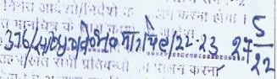
2. | Change of Land  (143) (for Land 2.3926 Hectare) | Use area | Conversion of Land from Agricultural to  Non-Agricultural land |  |  | 03/01/2022 | Collector Muzaffarnagar | Office,
 |  |  |  |  |  | Case No. 9826/2021
2.1. | Change of Land  (143) (for Land 2.3926 Hectare) | Use area | Conversion of Land  from Agricultural to Non-Agricultural land |  |  | 25/10/2021 | Collector Muzaffarnagar | Office,
 |  |  |  |  |  | Case No. 9050/2021
3. | Environment Clearance |  | Approval as per environment guidelines in the area |  |  | NA | Not Provided
 | Ministry of Environment, Forest and Climate  Change |  |  |  |  | NA
4. | Consent to Establish |  | Approval as per Pollution norms applicable in that area |  |  | 03/09/2021 | As on date the clearance is valid and will be valid up to 02/09/2023
 | UP State Pollution control board |  |  |  |  | 132465/UPPCB/MU ZAFFARNAGAR(UP PCBRO)/CTE/MUZA FFARNAG  AR/2021
5. | Provisional Fire NOC |  | Approval of fire protection technique in the project |  |  | 24/01/2022 | The company has obtained the Fire NOC from the competent authority.
 | State Fire authority |  |  |  |  | UPFS/2022/43339/  MZN/MUZAFFARNA GAR/355/JD

6. | Groundwater Abstraction Clearance | Approval for groundwater abstraction for construction purpose | NA | Not Provided
 | Central Groundwater  Authority |  | NA
7. | IEM Certificate | Industrial Entrepreneurs  memorandum | NA | Not Provided
 | Ministry of Commerce  and Industry |  | NA
8. | Power Connection | Power connection for construction works | NA | Not Provided
 | State Power Authority |  | NA
Observations & Comments:

1. All approvals including approvals/consents required under local regulations, building codes and approvals required from the Distribution Utility etc. relating to installation of unit are listed above and their current status.

PART G | PROJECT SCHEDULE & CURRENT STATUS

 | IMPLEMENTATION SCHEDULE OF SIPL, MUZZAFARNAGAR, UTTAR PRADESH
 | S.No. | Particular |  |  | Commencement |  | Completion |  | Current Status
 | 1 | Acquisition of land |  |  |  |  | Acquired |  | The company has already acquired the Land for the  Plant
 | 2 | Construction of civil work |  |  | Aug-21 |  | Apr-22 |  | Refer the Table:- 01,  As per the Schedule the Construction work is delayed and observing the current status of construction, the timeline is anticipated to be delayed by a year from the actual timeline. Although the original timeline was put in accordance with the construction of 8,600 sq.mtr. of built up area but as the Proposed Built up area is revised, the timeline should be revised which is not  Provided to us.
 | 3 | Electrical works |  |  | Jan 2022 |  | May-22 |  | Electrical Works in the Machine Hall-1 and the VCB room was complete and operational.
 | 4 | Installation of machines |  |  | May-22 |  | Feb-23 |  | As per the site survey the machine was completely installed and the plant was in operational condition.  Only few machines was in packed conditions which is used for maintenance as per the information provided during the survey.  .
 | 5 | Trial operation |  |  | - |  | Mar-23 |  | Completed on dated 1st September 2022 as per the information shared during the survey.
6 |  |  | Commercial operation |  |  | Apr-23 |  | As per the site survey and information shared on site the commercial operation of the plant was started on 16th September 2022.

PART H | OBSERVATIONS & COMMENTS

- The estimation of cost considered in the report is as per the TEV provided to us by the Bank.

- The Physical progress captured in the report is based on approximate observations of status of structures constructed on site for the quarter ending September.

- The Progress of the Plant and machinery is considered as per the site survey and Invoices provided by the company and the insight of the Project for the quarter ending September as the site visit to the Plant during the December month.

- As per CA certificate dated 30th November 2022 with UDIN No. 22077650BESHMZ5847
Detail of Expense, Copies of PO’s/WO’s is not provided to us by the borrower. Therefore, we have not analysed the physical progress of structures and have relied on expense shown by chartered accountant in their CA certificate dated 30th November 2022 with UDIN No. 22077650BESHMZ5847 for the project. However, as the Company/ Borrower have provided us with the Invoices for the Machinery so, we have relied0 on the invoices for the expenses toward Plant and machinery.

- This is the 3nd LIE Report of the project and as per CA certificate showing expenditure in the project up to 30th September 2022, the borrower has made an expenditure on the project amounting to Rs.83.75 Crore out of which the term loan amount to Rs.41.63 Crore which has been disbursed by the lender up to 30th September 2022.

- The borrower has obtained Building plan approval and Provisional Fire NOC for the Unit. However, we have not been provided by the approved building Plan Letter.

- As per our observation of the subject plant during the site visit in the December month, the project seems to be satisfactory, as the work was in full swing as observed. The plant has started its commercial production dated 16th September 2022. Although there is a delay in some construction considering the original schedule submitted to the bank but if weighed according to the revised construction/Built up area seems to be reasonable.

PART I | DISCLAIMER

- No employee or member of R.K Associates has any direct/ indirect interest in the Project.
- This report is prepared based on the copies of the documents/ information which the Bank/ Borrower has provided to us out of the standard checklist of documents sought from them and further based on our assumptions and limiting conditions. The client/owner and its management/representatives warranted to us that the information they supplied was complete, accurate and true and correct to the best of their knowledge. All such information provided to us has been relied upon in good faith and we have assumed that it is true and correct in all respect. I/We shall not be liable for any loss, damages, cost or expenses arising from fraudulent acts, misrepresentations, or wilful default on part of the owner, borrower, its directors, employee, representative or agents. Verification or cross checking of the documents provided to us from the originals or from any Govt. departments/ Record of Registrar has not been done at our end since this is beyond the scope of our work. If at any time in future, it is found or came to our knowledge that misrepresentation of facts or incomplete or distorted information has been provided to us then this report shall automatically become null & void.
- Legal aspects for eg. investigation of title, ownership rights, lien, charge, mortgage, lease, sanctioned maps, verification of documents, etc. have not been done at our end and same has to be taken care by legal expert/ Advocate. It is assumed that the concerned Lender/ Financial Institution has satisfied them with the authenticity of the documents, information given to us and for which the legal verification has been already taken and cleared by the competent Advocate before requesting for this report. I/ We assume no responsibility for the legal matters including, but not limited to, legal or title concerns.
- This report is a general analysis of the project based on the scope mentioned in the report. This is not an Audit report, Design document, DPR or Techno feasibility study. All the information gathered is based on the facts seen on the site during survey for the quarter ending June 2022, verbal discussion & documentary evidence provided by the client and is believed that information given by the borrower is true best of their knowledge.
- All observations mentioned in the report is only based on the visual observation and the documents/ data/ information provided by the client. No mechanical/ technical tests, measurements or any design review have been performed or carried out from our side during Project assessment.
- Bank/FII should ONLY take this report as an Advisory document from the Financial/ Chartered Engineering firm and its specifically advised to the creditor to cross verify the original documents for the facts mentioned in the report which can be availed from the borrowing borrower directly.

- In case of any default in loans or the credit facility extended to the borrowing borrower, R.K Associates shall not be held responsible for whatsoever reason may be and any request for seeking any explanation from the employee/s of R.K Associates will not be entertained at any instance or situation.
- The documents, information, data provided to us during the course of this assessment by the client is reviewed only upto the extent required in relation to the scope of the work. No document has been reviewed beyond the scope of the work.
- This report only contains general assessment & opinion as per the scope of work evaluated as per the information given in the copy of documents, information, data provided to us and/ and confirmed by the owner/ owner representative to us at site which has been relied upon in good faith. It doesn’t contain any other recommendations of any sort including but not limited to express of any opinion on the suitability or otherwise of entering into any transaction with the borrower.
- We have relied on data from third party, external sources & information available on public domain also to conclude this report. These sources are believed to be reliable and therefore, we assume no liability for the truth or accuracy of any data, opinions or estimates furnished by others that have been used in this analysis. Where we have relied on data, opinions or estimates from external sources, reasonable care has been taken to ensure that such data has been correctly extracted from those sources and /or reproduced in its proper form and context, however still we can’t vouch its authenticity, correctness or accuracy.
- This Report is prepared by our competent technical team which includes Engineers and financial experts & analysts.
- This is just an opinion report and doesn’t hold any binding on anyone. It is requested from the concerned Financial Institution which is using this report for taking financial decision on the project that they should consider all the different associated relevant & related factors also before taking any business decision based on the content of this report.
- All Pages of the report including annexures are signed and stamped from our office. In case any paper in the report is without stamp & signature then this should not be considered a valid paper issued from this office.
- Though adequate care has been taken while preparing this report as per its scope, but still we can’t rule out typing, human errors, over sightedness of any information or any other mistakes. Therefore, the concerned organization is advised to satisfy themselves that the report is complete & satisfactory in all respect. Intimation regarding any discrepancy shall be brought into our notice immediately. If no intimation is received within 15 (Fifteen) days in writing from the date of issuance of the report, to rectify these timely, then it shall be considered that the

report is complete in all respect and has been accepted by the client upto their satisfaction & use and further to which R.K Associates shall not be held responsible in any manner.
- Defect Liability Period is 15 DAYS. We request the concerned authorized reader of this report to check the contents, data and calculations in the report within this period and intimate us in writing if any corrections are required or in case of any other concern with the contents or opinion mentioned in the report. Corrections only related to typographical, calculation, spelling mistakes, incorrect data/ figures/ statement will be entertained within the defect liability period. Any new changes for any additional information in already approved report will be regarded as additional work for which additional fees may be charged. No request for any illegitimate change in regard to any facts & figures will be entertained.
- R.K Associates encourages its customers to give feedback or inform concerns over its services through proper channel at valuers@rkassociates.org in writing within 15 days of report delivery. After this period no concern/ complaint/ proceedings in connection with the Financial Feasibility Study Services will be entertained due to possible change in situation and condition of the subject Project.
- Our Data retention policy is of ONE YEAR. After this period, we remove all the concerned records related to the assignment from our repository. No clarification or query can be answered after this period due to unavailability of the data.
- This Lender’s Independent Engineer report is governed by our (1) Internal Policies, Processes & Standard Operating Procedures, (2) Information/ Data/ Inputs given to us by the client and (3) Information/ Data/ Facts given to us by our field/ office technical team. Management of R.K Associates never gives acceptance to any unethical or unprofessional practice which may affect fair, correct & impartial assessment and which is against any prevailing law. In case of any indication of any negligence, default, incorrect, misleading, misrepresentation or distortion of facts in the report then it is the responsibility of the user of this report to immediately or at least within the defect liability period bring all such act into notice of R.K Associates management so that corrective measures can be taken instantly.
- R.K Associates never releases any report doing alterations or modifications from pen. In case any information/ figure of this report is found altered with pen then this report will automatically become null & void.

Place: Noida | FOR INTERNAL USE
Date: 23rd December 2022 | SURVEYED BY: S.E. Rahul Gupta and Er. Sachin Pandey
Note: Report contains 64 pages | PREPARED BY: PE Team
For R.K. Associates Valuers and Techno
Engineering Consultants Pvt. Ltd.

1. DEFECT LIABILITY PERIOD - In case of any query/ issue or escalation you may please contact Incident Manager by writing at valuers@rkassociates.org. We ensure 100% accuracy in the Calculations done, Rates adopted and various
other data points & information mentioned in the report but still can’t rule out typing, human errors or any other
mistakes. In case you find any mistake, variation, discrepancy or inaccuracy in any data point of the report, please help us by bringing all such points into our notice in writing at valuers@rkassociates.orgwithin 30 days of the report delivery, to get these rectified timely, failing which R.K Associates Valuers Techno Engineering Consultants (P) Ltd. won’t be held responsible for any inaccuracy in any manner. Also if we will not hear back anything from you within 30 days, we will assume that report is correct in all respect and no further claim of any sort will be entertained thereafter.
We would welcome and appreciate your feedback & suggestions in order to improve our services.

COPYRIGHT FORMAT - This report is prepared on the copyright format of R.K Associates Valuers Techno Engineering Consultants (P) Ltd. to serve our clients in the best possible way. Legally no one can copy or distribute this format without prior approval from R.K Associates. It is meant only for the organization as mentioned on the cover page of this report. Distribution or use of this format other than R.K Associates will be seen as unlawful act and necessary legal action can be taken against the defaulter

ENCLOSURE 1: IMPORTANT DOCUMENTS EXHIBIT

DOCUMENT-1: CA CERTIFICATE DATED 30th November 2022
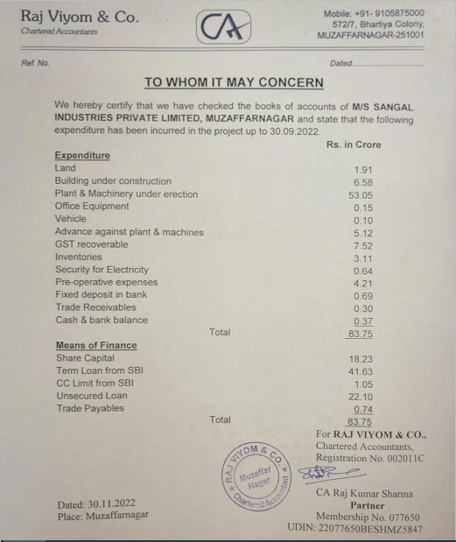

DOCUMENT-2: CLU FOR “0.5530” HECTARE LAND

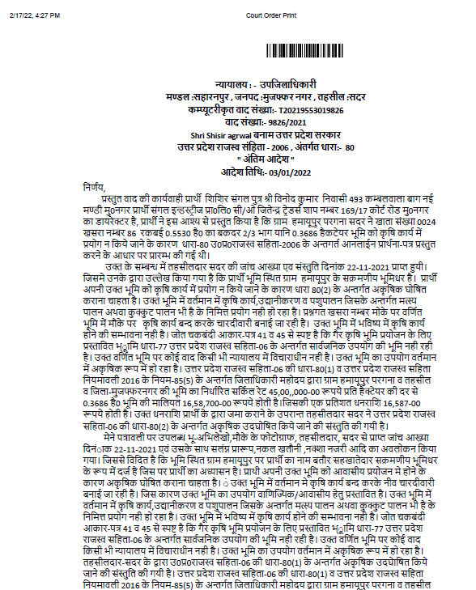


DOCUMENT-3: CLU FOR “2.3926” HECTARE LAND

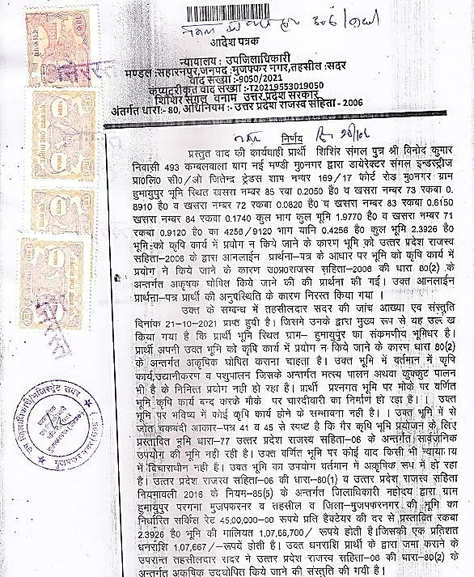

DOCUMENT- 4: SALE DEED
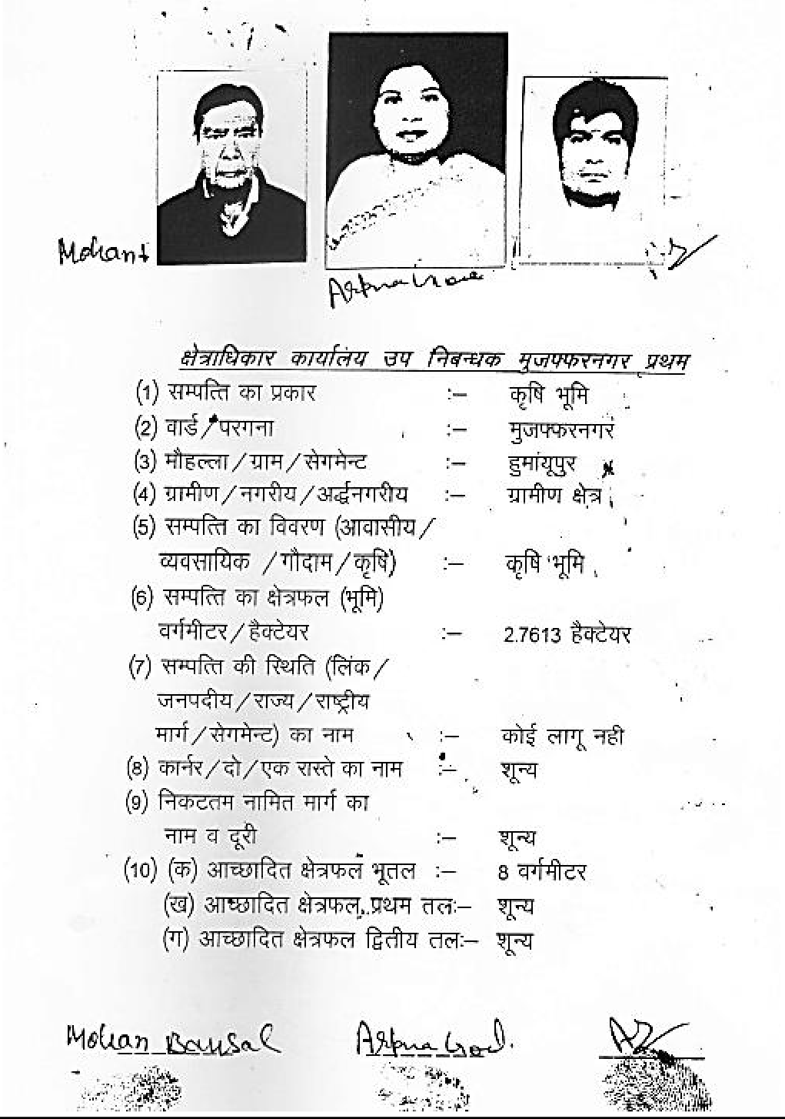

DOCUMENT- 5: NOC FROM U.P. POLLUTION CONTROL BOARD
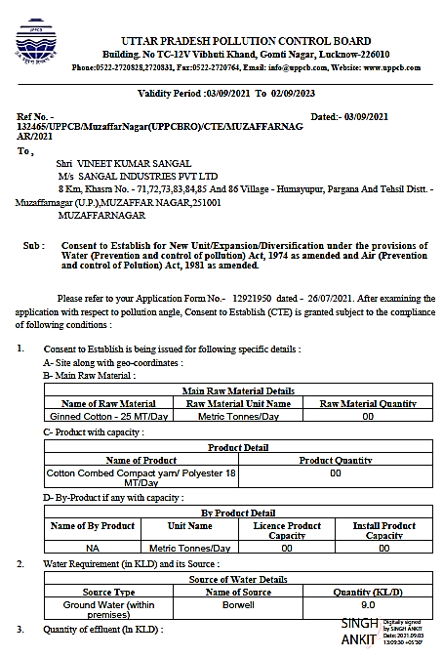

DOCUMENT-7: SANCTION LETTER

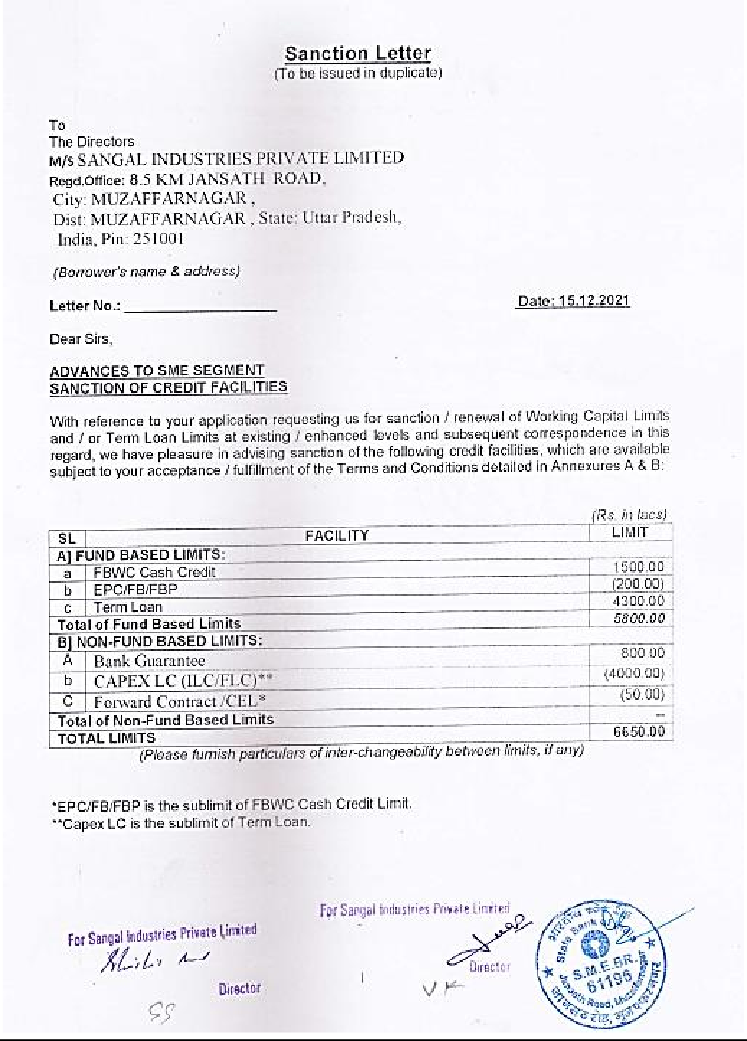

DOCUMENT-7: NOC FROM FIRE DEPARTMENT

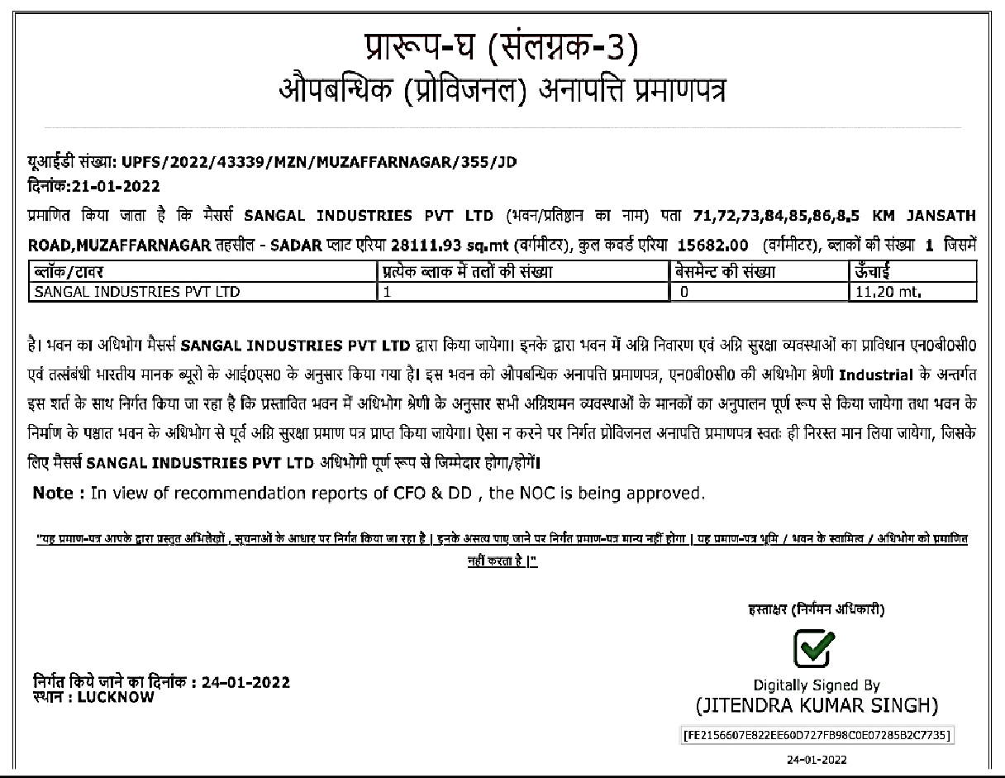

LIST OF MACHINERIES INFERRED FROM INVOICES OF JUNE LIST.
S.NO. | Vendor Name | Dated | Invoice No. | Amount
1 | Uster Technologies AG | 31- 03-2022 | 17-910099233 | 1,65,00,000.00
2 | Lakshmi Machine Works Limited | 12-04-2022 | 1112200028 | 18,62,012.15
3 | Luwa India Private Limited | 30-03-2022 | 21-22/3523 | 14,28,980.00
4 | Lakshmi Machine Works Limited | 11-04-2022 | 1112200024 | 26,96,043.35
5 | Lakshmi Machine Works Limited | 25-03-2022 | 1112101965 | 26,96,043.35
6 | Lakshmi Machine Works Limited | 29-03-2022 | 1112101985 | 18,62,012.15
7 | Lakshmi Machine Works Limited | 31-03-2022 | 1112102043 | 37,24,024.30
8 | Lakshmi Machine Works Limited | 31-03-2022 | 1112102044 | 26,96,043.35
9 | Lakshmi Machine Works Limited | 24-03-2022 | 1212102640 | 44,81,869.39
10 | Lakshmi Machine Works Limited | 24-03-2022 | 1212102641 | 48,664.62
11 | Lakshmi Machine Works Limited | 24-03-2022 | 1212102643 | 1,38,198.60
12 | Urja System | 15-03-2022 | US/GST1761/21-22 | 12,56,700.00
13 | Kaeser Compressor | 04-02-2022 | PL1000035104 | 3,540.00
14 | Luwa India Private Limited | 08-03-2022 | 21-22/3243 | 8,85,000.00
15 | Lakshmi Machine Works Limited | 22-03-2022 | 1212102625/1 | 12,43,900.00
16 | Lakshmi Machine Works Limited | 22-03-2022 | 1212102625/2 | 12,43,900.00
17 | Lakshmi Machine Works Limited | 15-03-2022 | 1212102574/1 | 12,43,900.00
18 | Lakshmi Machine Works Limited | 15-03-2022 | 1212102562/1 | 3,77,682.31
19 | Lakshmi Machine Works Limited | 15-03-2022 | 1212102564/1 | 3,77,682.31
20 | Lakshmi Machine Works Limited | 15-03-2022 | 1212102563 | 57,877.82
21 | Lakshmi Machine Works Limited | 15-03-2022 | 1212102565 | 57,877.82
22 | Lakshmi Machine Works Limited | 15-03-2022 | 1212102566 | 57,877.82
23 | Lakshmi Machine Works Limited | 15-03-2022 | 1212102567 | 57,877.82
24 | Lakshmi Machine Works Limited | 15-03-2022 | 1212102568 | 57,877.82
25 | Lakshmi Machine Works Limited | 17-03-2022 | 1212102562/2 | 3,77,682.31
26 | Lakshmi Machine Works Limited | 17-03-2022 | 1212102596 | 17,50,154.41
27 | Lakshmi Machine Works Limited | 17-03-2022 | 1212102564/2 | 3,77,682.31
28 | Lakshmi Machine Works Limited | 22-03-2022 | 1212102625/2 | 12,43,900.66
29 | Lakshmi Machine Works Limited | 22-03-2022 | 1212102625/1 | 12,43,900.66
30 | Lakshmi Machine Works Limited | 08-06-2022 | 1122330972 | 17,87,420.64
31 | Lakshmi Machine Works Limited | 06-06-2022 | 1212200612 | 1,33,23,946.64
32 | Shakumbari Enterprises | 21-06-2022 | 41 | 1,77,000.00
33 | Shakumbari Enterprises | 20-06-2022 | 39 | 5,31,000.00
34 | Shakumbari Enterprises | 21-06-2022 | 40 | 1,77,000.00
35 | Shakumbari Enterprises | 21-06-2022 | 42 | 2,36,000.00
36 | Luwa India Pvt. Ltd. | 16-06-2022 | 22-23/0893 | 23,33,775.00
37 | Lakshmi Machine Works Limited | 11-05-2022 | 1212200391 | 1,33,23,946.64
38 | Ideal Steel Stamping and pressings Pvt. Ltd. | 16-06-2022 | TAX/22-23/0450 | 28,76,038.00
39 | Sieger Spintech Equipments Pvt. Ltd. | 04-04-2022 | S22-23/000001 | 25,25,200.00

40 | Lakshmi Machine Works Limited | 12-04-2022 | 1112200028 | 37,24,024.00
41 | Kusum Tradex Pvt. Limited | 27-04-2022 | KTPL/22-23/0987 | 4,93,830.00
42 | Lakshmi Machine Works Limited | 23-04-2022 | 1212200194 | 56,460.40
43 | Lakshmi Machine Works Limited | 23-04-2022 | 1212200195 | 1,12,448.00
44 | Lakshmi Machine Works Limited | 23-04-2022 | 1212200196 | 1,04,888.78
45 | Lakshmi Machine Works Limited | 23-04-2022 | 1212200197 | 85,989.90
46 | Lakshmi Machine Works Limited | 23-04-2022 | 1212200198 | 1,12,448.34
47 | Lakshmi Machine Works Limited | 23-04-2022 | 1212200199 | 1,04,888.78
48 | Lakshmi Machine Works Limited | 23-04-2022 | 1212200200 | 5,197.19
49 | Lakshmi Machine Works Limited | 23-04-2022 | 1212200201 | 1,38,199.06
50 | Lakshmi Machine Works Limited | 23-04-2022 | 1212200202 | 5,197.19
51 | Saurer | 03-01-2022 | 56030/1 | 11,90,85,340.00
52 | Lakshmi Machine Works Limited | 18-04-2022 | 111220066 | 90,21,262.00
53 | Lakshmi Machine Works Limited | 09-05-2022 | 1112200249 | 27,76,954.00
54 | Luwa India Pvt. Ltd. | 14-05-2022 | 22-23/0513 | 20,65,000.00
55 | ELGI ELECTRIC AND INDUSTRIES LIMITED | 17-05-2022 | 1250361 | 3,26,735.00
56 | ELGI ELECTRIC AND INDUSTRIES LIMITED | 17-05-2022 | 1250362 | 15,77,564.00
57 | ELGI ELECTRIC AND INDUSTRIES LIMITED | 17-05-2022 | 1250363 | 10,16,086.00
58 | ELGI ELECTRIC AND INDUSTRIES LIMITED | 18-05-2022 | 1250372 | 7,13,634.00
59 | Luwa India Pvt. Ltd. | 20-05-2022 | 22-23/0576 | 15,69,400.00
60 | ELGI ELECTRIC AND INDUSTRIES LIMITED | 31-05-2022 | 1250512 | 7,13,634.00
61 | Lakshmi Machine Works Limited | 28-05-2022 | 1112200388 | 36,77,249.00
62 | Lakshmi Machine Works Limited | 24-05-2022 | 1112200350 | 28,83,614.00
63 | Lakshmi Machine Works Limited | 01-06-2022 | 1112200459 | 7,00,794.00
64 | Lakshmi Machine Works Limited | 18-05-2022 | 1212200439 | 1,33,23,946.00
65 | Luwa India Pvt. Ltd. | 06-09-2022 | 22-23/0815 | 21,84,644.00
66 | PERFECT EQUIPMENTS PRIVATE LIMITED | 10-06-2022 | G218 | 46,020.00
67 | Lakshmi Machine Works Limited | 18-04-2022 | 1112200066/1 | 15,03,543.00
68 | Lakshmi Machine Works Limited | 19-04-2022 | 1112200066/3 | 15,03,543.00
69 | Lakshmi Machine Works Limited | 18-04-2022 | 1112200066/2 | 15,03,543.00
70 | Lakshmi Machine Works Limited | 19-04-2022 | 1112200066/4 | 15,03,543.00
71 | Lakshmi Machine Works Limited | 19-04-2022 | 1112200066/5 | 15,03,543.00
 | TOTAL |  |  | 26,14,83,394.89

LIST OF MACHINERIES INFERRED FROM INVOICES OF TILL SEPTEMBER QUARTER.
S.No. | Vendor Name | Invoice Dated | Invoice No. | Amount
1 | Lakshmi Machine Works Limited | 20-06-2022 | 1112200574 | 53,12,357
2 | Lakshmi Machine Works Limited | 21-06-2022 | 1212200751 | 1,40,27,575
3 | Lakshmi Machine Works Limited | 16-06-2022 | 1212200709 | 1,41,36,244
4 | Lakshmi Machine Works Limited | 20-06-2022 | 1112200573 | 53,12,357
5 | Lakshmi Machine Works Limited | 25-06-2022 | 1112200618 | 53,12,357
6 | Kaeser Compressor India Pvt Ltd. | 29-09-2022 | - | -
7 | Tiny Top Engineering Pvt Ltd. | 30-05-2022 | TTEIPL/22-23/136 | 31,27,000
8 | Lakshmi Machine Works Limited | 27-06-2022 | 1112200623 | 28,83,614
9 | Lakshmi Machine Works Limited | 27-06-2022 | 1112200625 | 7,00,794
10 | Lakshmi Machine Works Limited | 28-06-2022 | 1112200635 | 7,00,794
11 | SSB Electronics Weighing System | 11-07-2022 | 20 | 8,26,000
12 | Lakshmi Machine Works Limited | 28-06-2022 | 1112200634 | 28,83,614
13 | Hilti India Pvt Limited | 06-07-2022 | H127-16215-2022 | 43,003
14 | Lakshmi Machine Works Limited | 13-05-2022 | 1112200283 | 95,64,368
15 | LUWA India Private Limited | 06-07-2022 | 22-23/1099 | 12,89,849
16 | Perfect Equipments Private Limited. | 13-07-2022 | G315 | 27,02,000
17 | LUWA India Private Limited | 21-07-2022 | 22-23/1299 | 36,85,282
18 | AM Innopsin Systems Pvt. Ltd. | 27-07-2022 | 35-M/22-23 | 46,02,000
19 | Shift Air Pneumatics | 25-07-2022 | 22-23/799 | 8,98,736
20 | Rimtex Industries | 22-07-2022 | G-22230461 | 10,26,010
21 | Lakshmi Machine Works Limited | 16-07-2022 | 1112200778 | 7,43,316
22 | Lakshmi Machine Works Limited | 15-07-2022 | 1112200760 | 7,43,316
23 | Lakshmi Machine Works Limited | 16-07-2022 | 1112200777 | 30,27,954
24 | Elgi Electric and Industries Limited | 22-07-2022 | 1250948 | 8,68,962
25 | Lakshmi Machine Works Limited | 26-07-2022 | 1212201126 | 1,40,27,575
26 | Lakshmi Machine Works Limited | 15-07-2022 | 1112200759 | 30,27,954
27 | Lakshmi Machine Works Limited | 20-07-2022 | 1112200807 | 53,12,357
28 | Lakshmi Machine Works Limited | 26-07-2022 | 1212201124 | 1,40,27,575
29 | Elgi Electric and Industries Limited | 27-07-2022 | 1250994 | 17,94,805
30 | Lakshmi Machine Works Limited | 28-07-2022 | 1212201138 | 1,40,27,575
31 | Lakshmi Machine Works Limited | 05-08-2022 | 1212201234 | 10,29,398
32 | Lakshmi Machine Works Limited | 30-07-2022 | 1222249497 | 99,983
33 | Lakshmi Machine Works Limited | 05-08-2022 | 1212201228 | 57,877
34 | Lakshmi Machine Works Limited | 08-08-2022 | 1212201248 | 1,40,27,575
35 | Lakshmi Machine Works Limited | 12-08-2022 | 1112201007 | 54,76,245
36 | Lakshmi Machine Works Limited | 10-08-2022 | 1212201275 | 1,40,27,575
37 | Umesh Machinery Store | 29-08-2022 | 1033 | 23,211
38 | Umesh Machinery Store | 31-08-2022 | 1052 | 31,270
39 | Lakshmi Machine Works Limited | 13-08-2022 | 1112201013 | 49,44,419
40 | Umesh Machinery Store | 28-08-2022 | 1018 | 4,816
41 | Umesh Machinery Store | 29-08-2022 | 1036 | 66,215
42 | Umesh Machinery Store | 28-08-2022 | 1025 | 9,351
43 | Lakshmi Machine Works Limited | 19-08-2022 | 1112201046 | 54,76,245
44 | Premier Evolvics Pvt.Ltd | 31-05-2022 | PEL/1007649 | 1,88,80,000
45 | AM Innopsin Systems Pvt. Ltd. | 31-08-2022 | 47/M/22-23 | 2,83,200
46 | Shift Air Pneumatics | 31-08-2022 | 22-23/1121 | 28,593
47 | Pawan Hardware Store | 02-09-2022 | 3359 | 79,093
48 | Swastik Engineers | 02-09-2022 | SE/2022-23/971 | 7,08,000
49 | Kaeser Compressor India Pvt Ltd. | 02-09-2022 | - | -
50 | Lakshmi card clothing manufacturing co.pvt ltd. | 25-08-2022 | 132210383 | 22,28,666
51 | Lakshmi Machine Works Limited | 29-08-2022 | 1112202210 | 30,27,954
52 | LUWA India Private Limited | 25-08-2022 | 22-23/1690 | 1,18,590
53 | Lakshmi Machine Works Limited | 29-08-2022 | 1112201148 | 54,76,245
54 | Singhal Spintax Pvt Ltd. Kashipur | 13-09-2022 | 2022-2023/WST/0071 | 1,19,180
55 | Lakshmi Machine Works Limited | 30-08-2022 | 1212201454 | 1,40,27,575
56 | Micro Filteration Technologies | 13-09-2022 | MFT/2022-23/215 | 64,900
57 | Lakshmi Machine Works Limited | 08-09-2022 | 1212201558 | 1,40,27,575
58 | Lakshmi Machine Works Limited | 09-09-2022 | 1112201232 | 52,41,131
59 | Lakshmi Machine Works Limited | 09-09-2022 | 1112201235 | 30,27,954
60 | Lakshmi Machine Works Limited | 12-09-2022 | 1112201257 | 7,43,316
61 | Lakshmi Machine Works Limited | 14-09-2022 | 1112201282 | 27,76,954
62 | Mehra Wax Produts Pvt Ltd. | 18-09-2022 | GST 607 | 36,558
63 | Ideal Sheet Metal Stampings & Pressing Pvt Ltd. | 22-09-2022 | TAX/22-23/0938 | 18,45,072
 | Total |  |  | 25,46,50,079

ENCLOSURE-3 : - SITE PHOTOGRAPHS

