**GENERAL SURVEY FORM**

**(FOR PROPERTIES OTHER THAN FLATS)**

(Version 5.0)

Date of implementation: 9.02.2011 | Last Revision: 04.01.2018 | Latest Revision: 31.10.2020

|  |  |  |
| --- | --- | --- |
| **File No.** RKA/DNCR/……/…......... | **Date: 21.12.2022** | **Time:10:30AM** |

|  |  |  |  |
| --- | --- | --- | --- |
| **GENERAL DETAILS** | | | |
| 1. | Name of the Surveyor | Mukund R. Dalal | |
| 2. | Property shown by | Representative, | |
| **Name** | **Contact No.** |
| Chetanbhai | 98792 03008 |
| 3. | Survey Type | Full survey (inside-out with measurements & photographs) | |
| 4. | Reason for Half survey or only photographs taken | Not applicable. | |
| 5. | How Property is Identified | From schedule of the properties mentioned in the deed, ☐ From name plate displayed on the property, | |
| 6. | Type of Property | Flat in Multistoried Apartment, | |
| 7. | Property Measurement | Self-measured, | |
| 8. | Reason for no measurement | Not applicable. | |
| 9. | Purpose of Valuation | * Value assessment of the asset for creating new collateral mortgage * Periodic Re-Valuation for Bank, | |
| 10. | Type of Loan | * Housing Loan, ☐ Housing Take Over Loan, | |
| 11. | Loan Amount |  | |

|  |  |  |
| --- | --- | --- |
| **OWNERSHIP DETAILS** | | |
| 1. | Legal Owner Name/s | M/s. Ankit Gems Pvt. Ltd. |
| 2. | Property Purchaser Name | M/s. Ankit Gems Pvt. Ltd. |
| 3. | Property Address under  Valuation | Revnue survey no.-3/3, Revised survey no.-60, T.P.S. no.-04(Rundh – Magdalla) F.P. no.-23, Sub plot no.-2, Flat No. 201, 2nd Floor, Happy Exotica, B/h. V.R. Mall, Opp. Maple Leaf Apartment, Nr. Y Junction, Off. Surat Dumas Road, Village, Rundh, Surat.  (395007) |
| 4. | Present Residence Address of  the Owner/ Purchaser | N.A. |
| 5. | Property constitution | * Free Hold, |

|  |  |  |  |  |  |  |  |  |  |  |  |  |
| --- | --- | --- | --- | --- | --- | --- | --- | --- | --- | --- | --- | --- |
| **LOCATION DETAILS** | | | | | | | | | | | | |
| 1. | Adjoining Properties  *(Match it with papers with the help of compass or Sun direction and*  *also confirm it with nearby people)* | **East** | | **West** | | | | **North** | | | **South** | |
| Margin / Road | | Margin | | | | COP /T.P. road | | | Passage/Stair/Flat no.-202 | |
| 2. | Property Facing | North & South Facing, | | | | | | | | | | |
| 3. | Landmark | B/h. V.R. Mall, Opp. Maple Leaf Apartment, Nr. Y Junction, Off. Surat Dumas Road, Village, Rundh, Surat. | | | | | | | | | | |
| 4. | Ward Name/ No. | N.A. | | | | | | | | | | |
| 5. | Zone Name | South west (Athwa Zone) | | | | | | | | | | |
| 6. | Main Road Name & Width | **Name** | | | | **Width** | | | | **Distance from property** | | |
| Surat – Dummas road | | | | 60mt. | | | | 500mt. | | |
| 7. | Approach Road Name & Width | T.P. road (18mt.) | | | | | | | | | | |
| 8. | Location consideration of the Society | * Within Main city, ☐ Within Good Urban developed Area, ☐ Highly posh locality, | | | | | | | | | | |
| 9. | Special Location consideration of the property | Entrance North-  East Facing, | | | | | | | | | | |
| 10. | Characteristics of the locality | Urban developed, | | | | | | | | | | |
| 11. | Category of Society/ locality | High End | | | | | | | | | | |
| 12. | Utilities/ Facilities in the locality | * Lifts, ☐ Garden, ☐ Gym,   ☐ Walk Trails, ☐ Kids play zone, ☐ 100% Power Backup | | | | | | | | | | |
| 13. | Proximity to civic amenities | School | Hospital | | Market | | Metro | | Railway Station | | | Airport |
| 1-2kms. | 1kms. | | .5-1 kms. | | N.A. | | 12-13kms. | | | 4-5kms. |
| 14. | Any new development in  surrounding area | Yes, | | | | | | | | | | |

|  |  |  |
| --- | --- | --- |
| 15. | Jurisdiction limits | Surat Municipal Corporation. |
| 16. | Jurisdiction Development Authority Name | Surat Municipal Corporation. |
| 17. | Municipal Corporation Name | Surat Municipal Corporation. |

|  |  |  |  |  |
| --- | --- | --- | --- | --- |
| **PHYSICAL DETAILS** | | | | |
| 1. | Land Area | **As per Title deed** | **As per Map** | **As per site survey** |
| Not applicable for flat. | | |
| 2. | Any conversion to the land use | Nonagricultural land. | | |
| 3. | Land Type | Solid, | | |
| 4. | Shape of the Land | Trapezoid, | | |
| 5. | Level of Land | Above road level, | | |
| 6. | Frontage to depth ratio | * Normal frontage, | | |
| 7. | Are Boundaries matched | * Yes, | | |
| 8. | Is Independent access available to the property | Clear independent access is available, | | |
| 9. | Is property clearly demarcated with permanent boundaries? | * Yes | | |
| 10. | Is the property merged or colluded with any other property | No | | |
| 11. | Property possessed by at the time of survey | Tenant occupied. | | |
| 12. | Current activity carried out in the property | Residential purpose, | | |

|  |  |  |  |  |  |  |  |
| --- | --- | --- | --- | --- | --- | --- | --- |
| **BUILDING/ CONSTRUCTION/ UTLITY DETAILS** | | | | | | | |
| 1. | Construction Status | Built-up property in use, | | | | | |
| 2. | Covered Built-up Area  *(Tick one on the basis of which valuation is to be calculated)* | * Covered Area, ☐ Floor Area, ☐ Super Area, ☐ Carpet Area | | | | | |
| **As per Title deed** | | **As per Map** | | **As per site survey** | |
| 4725.00sq.ft. SBUA  2890.00sq.ft. BUA  2835.00sq.ft. Carpet | |  | | Brochure attached. | |
| 3. | Total Number of Floors in the Building | Basement + G.F.+11 floors | | | | | |
| 4. | Floor on which property is situated | 2nd floor | | | | | |
| 5. | Type of Unit/ Number of Rooms/ Cabins/ Cubicles | 5BHK | | | | | |
| 6. | Building Type | RCC Framed Structure, | | | | | |
| 7. | Roof | RCC, | | | | | |
| b. **Height:11ft.** | | | | | |
| c. **Finish:** Simple plaster, | | | | | |
| 8. | Flooring | * Vitrified tiles, ☐ Italian Marble, | | | | | |
| 9. | Appearance/ Condition of the Building | **Internal -**Good, | | | | | |
| **External -** Good, | | | | | |
| 10. | Maintenance of the Building | * Very Good, | | | | | |
| 11. | Interior decoration | Simple, | | | | | |
| 12. | Interior Finishing | * Simple plastered walls, | | | | | |
| 13. | Exterior Finishing | Architecturally designed or elevated, | | | | | |
| 14. | Kitchen | Modular with chimney, | | | | | |
| 15. | Class of Electrical fittings | Internal | | | | | |
| Concealed lightning, | | | | | |
| 16. | Class of Sanitary/ Plumbing & water supply fittings | Internal | | | | | |
| Good, | | | | | |
| 17. | Water arrangements | Submersible, | | | | | |
| 18. | Fixed Wooden Work | Simple, | | | | | |
| 19. | Age of Building/ Recent  Improvements done | 8 years old. | | | | | |
| 20. | Maintenance of the Building | * Very Good, | | | | | |
| 21. | Any defects in the building | No | | | | | |
| 22. | Any violation done in the property | Plan is approved by SMC vide TDO no.-381 dated 31.12.2011 &  Also BUC Is obtained on 04.10.2014 by Order no.-CTDO/BUC/125 as per our record. | | | | | |
| 23. | Boundary Wall *(Only for individual property)* | Common boundary wall of a complex | | | | | |
| **Running Mtr.** | **Height** | | **Width** | | **Finish** |
|  |  | |  | |  |
| 24. | Lift/ elevators | * Passenger 3no. | | | | | |
| Make:  Johnson | | | Capacity:  10people | | |
| 25. | Power backup | ☐ DG Set | | | | | |
| 26. | Garden/ | * Yes, | | | | | |
| 27. | Parking facilities | * Available within the property | | | Ground, In Basement, | | |

|  |  |  |  |  |
| --- | --- | --- | --- | --- |
| **MARKETABILITY/ SELABILITY/ UTLITY DETAILS** | | | | |
| 1. | Any issues in marketability of the property? | No | | |
| 2. | How is Demand & Supply condition in the Market of such properties? | Demand | * Good | |
| Supply | Good, | |
| 3. | Is property easily sellable & marketable? | No | | |
| Comments: As Flat is on 2nd floor | | |
| 4. | How is the current utility of the  property? | Good, | | |
| 5. | At what True rate Owner bought this Property? | Year of purchase | | Data not produced. |
| Purchase Price | |
| 6. | Present expected Sale Value of the overall property? | Rs.5000.00/sq.ft. on SBUA due to lower floor. | | |

Broker contact no.-9427113963 (Shaileshbhai)

9375215782 (Abhay jain)

**RAW SITE KEY PLAN & SKETCH PLAN**

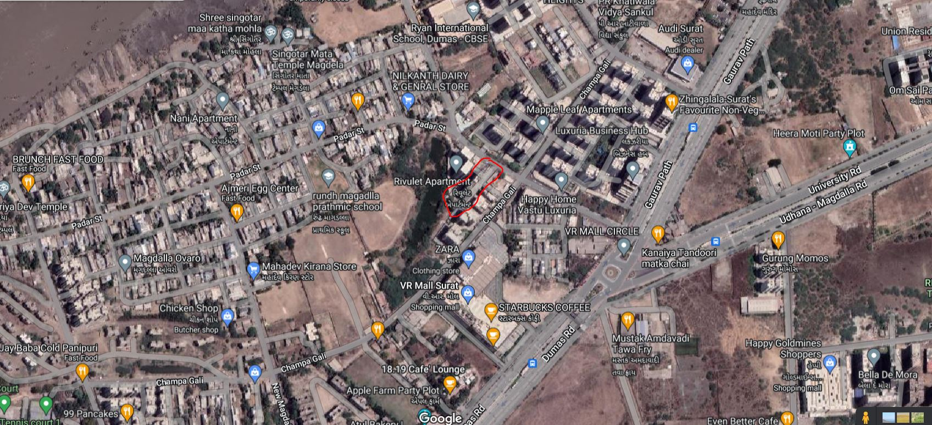

**Location coordinates:- 21.147001, 72.757261**

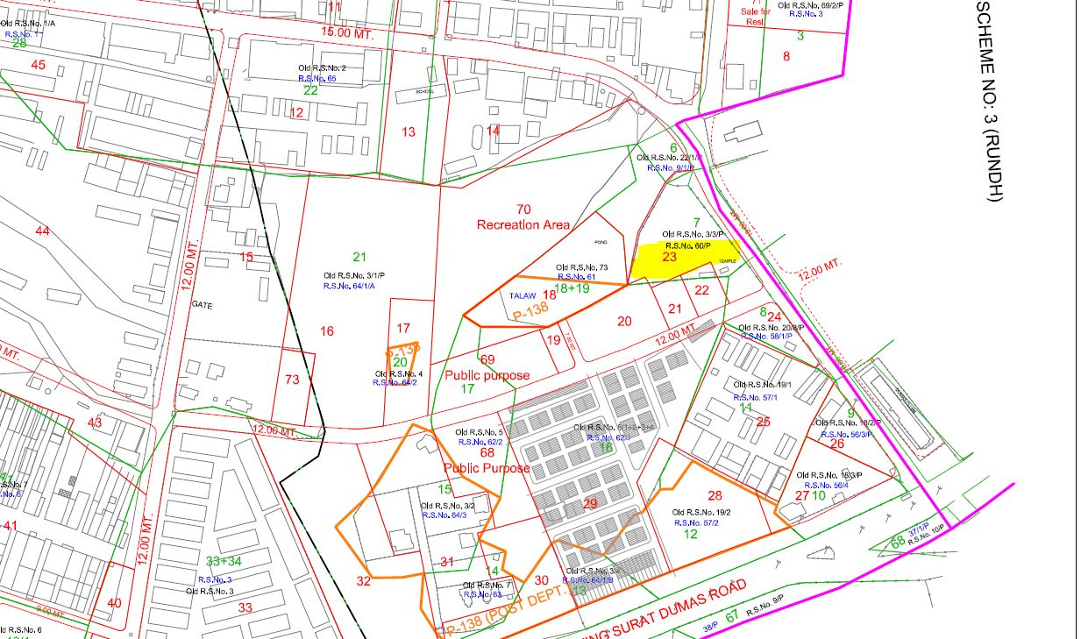

T.P.S. no.-04(Rundh – Magdalla)

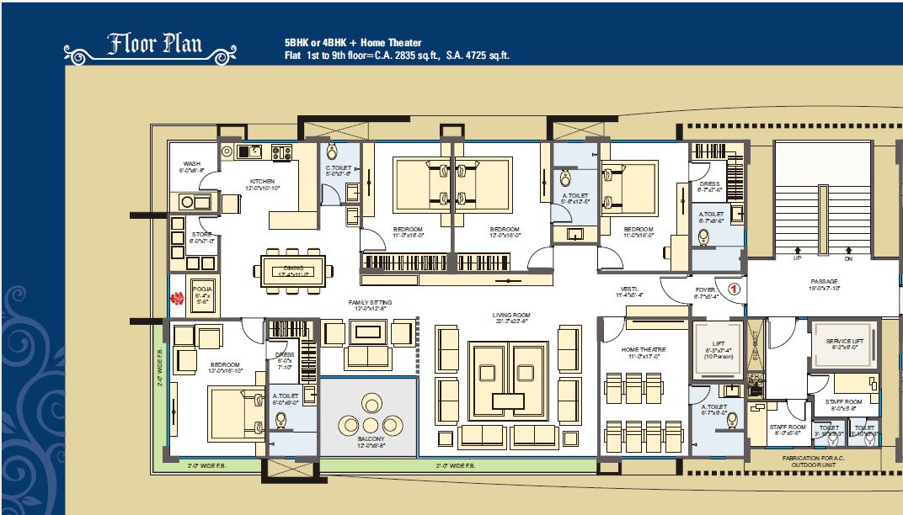

## UNDERTAKING BY THE SURVEYOR

I confirm that I have carried out the Survey of the property properly as per the fair professional best practices and Valuation & Survey policy guidelines issued by R.K Associates. I have not taken any cash or kind from the customer nor have I come into any kind of influence of the customer / bank for arbitrary providing the Property Valuation as per one’s need. I further state that I have not given any assurances to the customer nor given any wrong or false information or statement. In case at any point of time it is found that I have done any kind of fraudulent activity in this case and misled the company then I understand its legal consequences and appropriate penal action which company can take against me. Also in regard to it any monetary or reputation loss will be recovered from me by the company.

|  |  |
| --- | --- |
| **For File No.** |  |
| **Surveyor Name** | Mukund Dalal |
| **Signature** |  |
| **Date** | 21.12.2022 |



### Enclosure: 6

**SURVEY SUMMARY SHEET**

(TO BE ENCLOSED WITH VALUATION REPORT)

#### (Version 1.0) | Date of implementation: 10.04.2017

Every Valuation report at R.K Associates is prepared based on the thorough survey of the property carried out by our Engineering Surveyor. This Survey Summary Sheet is for the information of Banker/ concerned interested organization. Detailed Survey Form can also be made available to the interested organization in case it is required to cross check what information our surveyor has given in site inspection report based on which Valuation report is prepared.

|  |  |  |  |  |  |
| --- | --- | --- | --- | --- | --- |
| 1. | File No. |  | | | |
| 2. | Name of the Surveyor | Mukund Dalal | | | |
| 3. | Borrower Name | M/s. Ankit Gems Pvt. Ltd. | | | |
| 4. | Name of the Owner | M/s. Ankit Gems Pvt. Ltd. | | | |
| 5. | Property Address which has to be  valued | Revnue survey no.-3/3, Revised survey no.-60, T.P.S. no.-04(Rundh – Magdalla) F.P. no.-23, Sub plot no.-2, Flat No. 201, 2nd Floor, Happy Exotica, B/h. V.R. Mall, Opp. Maple Leaf Apartment, Nr. Y Junction, Off. Surat Dumas Road, Village, Rundh, Surat.  (395007) | | | |
| 6. | Property shown & identified by at spot | Representative, | | | |
| **Name** | | **Contact No.** | |
| Chetanbhai | | 98792 03008 | |
| 7. | How Property is Identified by the Surveyor | From schedule of the properties mentioned in the deed, ☐ From name plate displayed on the property, | | | |
| 8. | Are Boundaries matched | Yes, | | | |
| 9. | Survey Type | Full survey (inside-out with measurements & photographs) | | | |
| 10. | Reason for Half survey or only  photographs taken | Not applicable. | | | |
| 11. | Type of Property | Flat in Multistoried Apartment, | | | |
| 12. | Property Measurement | * Self-measured, | | | |
| 13. | Reason for no measurement | * It’s a flat in multi storey building so measurement not required | | | |
| 14. | Land Area of the Property | **As per Title deed** | **As per Map** | | **As per site survey** |
| Undivided land area | | | |
| 15. | Covered Built-up Area | **As per Title deed** | **As per Map** | | **As per site survey** |
| 4725.00sq.ft. SBUA  2890.00sq.ft. BUA  2835.00sq.ft. Carpet |  | |  |
| 16. | Property possessed by at the time of survey | Tenant | | | |
| 17. | Any negative observation of the | No | | | |

|  |  |  |
| --- | --- | --- |
|  | property during survey |  |
| 18. | Is Independent access available to the property | Clear independent access is available, |
| 19. | Is property clearly demarcated with  permanent boundaries? | * Yes, |
| 20. | Is the property merged or colluded  with any other property | No |
| 21. | Local Information References on  property rates | Please refer attached sheet named *‘Property rate Information Details.’* |

### Endorsement:

1. **Signature of the Person who was present from the owner side to identify the property:**

**Undertaking:** I have shown the correct property and provided the correct information about the property to the surveyor of R.K Associates to the best of my knowledge for which Valuation has to be prepared. In case I have shown wrong property or misled the valuer company in any way then I’ll be solely responsible for this unlawful act.

* 1. Name of the Person:
  2. Relation:
  3. Signature:
  4. Date:

In case not signed then mention the reason for it: ☐ No one was available, ☐ Property is locked, ☐ Owner/ representative refused to sign it, ☐ Any other reason:

### Surveyor Signature who did site inspection:

**Undertaking:** I have inspected the property and cross verified the property details at site to the extent of *a. Matching boundaries of the property, b. Sample measurement of its area, c. Physical condition, d. Property rates as per local information* with what is mentioned in the property documents provided to me by the Bank/ interested organization. I have not come under influence of anyone during site inspection and have only recorded the true and factual details in the survey form which I come across during the site survey. I understand that giving any manipulative information in the survey form will lead to incorrect Valuation report which is an unlawful act and i’ll be solely responsible for doing it.

* 1. Name of the Surveyor:Mukund Dalal
  2. Signature:
  3. Date: 21.12.2022