**FILE NO.: VIS(2022-23)-PL545-Q113-441-756 Dated: 29/12/2022**

**COST ASSESSMENT AND REQUIREMENT ANALYSIS REPORT**

**OF**

**250 kW ROOFTOP MOUNTED SOLAR POWER PROJECT**

**PROPOSED TO BE SET UP AT**

**MAA VANKAL EXPORT LOCATED AT**

**BHANDU KALA LUNI, JODHPUR, RAJASTHAN**

**COMPANY/PROMOTER**

**MAA VANKAL EXPORT**

**REPORT PREPARED FOR**

**YES BANK HOUSE, MUMBAI**

***\*\*Important - In case of any query/ issue or escalation you may please contact Incident Manager***

***at le@rkassociates.org. We will appreciate your feedback in order to improve our services.***

***NOTE: As per IBA Guidelines please provide your feedback on the report within 15 days of its submission after which report will be considered to be correct.***

**IMPORTANT NOTICE**

***COPYRIGHT FORMAT:*** *This report is prepared on the copyright format of R.K Associates to serve our clients with the best possible information and analysis to facilitate them to take rational business decisions. Legally no one can copy or distribute this format without prior approval from R.K Associates. It is meant only for the advisory/ reference purpose for the organization/s as mentioned on the cover page of this report. Distribution or use of this format by any organization or individual other than R.K Associates will be seen as an unlawful act and necessary legal action can be taken against the defaulters.*

*This report is intended for the sole use of the intended recipient/s and contains material that is STRICTLY CONFIDENTIAL AND PRIVATE.*

***DEFECT LIABILITY PERIOD:*** *- In case of any query/ issue or escalation you may please contact Incident Manager at*[le@rkassociates.org](mailto:le@rkassociates.org)*.*

*Though adequate care has been taken while preparing this report as per its scope, but still, we can’t rule out typing, human errors, over sightedness of any information or any other mistakes. Therefore, the concerned organization is advised to satisfy themselves that the report is complete & satisfactory in all respect. Intimation regarding any discrepancy shall be brought into our notice immediately. If no intimation is received within 15 (Fifteen) days in writing from the date of issuance of the report, to rectify these timely, then it shall be considered that the report is complete in all respect and has been accepted by the client up to their satisfaction & use and further to which R.K Associates shall not be held responsible in any manner.*

|  |  |
| --- | --- |
| **PART A** | **REPORT SUMMARY** |

|  |  |  |
| --- | --- | --- |
| **S.NO.** | **PARTICULARS** | **DESCRIPTION** |
|  | Name of the Project | Setting up of 250 kW Rooftop Solar Project |
|  | Project Location | Maa Vankal Export located At Bhandu Kala Luni, Jodhpur, Rajasthan |
|  | Name of the Company | M/s. Maa Vankal Export |
|  | Prepared for Bank | Yes Bank, Mumbai |
|  | LIE Consultant Firm | M/s. R.K. Associates Valuers & Techno Engineering Consultants (P) Ltd. |
|  | Work Order Details | Via mail dated 29-12-2022 |
|  | Date of Survey | Only Desktop Report |
|  | Date of Report | 29th December 2022 |
|  | Purpose of the Report | To review Estimated Project cost and eligibility criteria check of the proposed project. |
|  | Scope of the work provided by the Lender | Only to comment on the following below points based on the documents provided to us:   * Estimated Project cost * Requirement analysis of 250 KW rooftop solar Plant.   *NOTE: This report doesn’t contains any other kind of recommendation or suggestions other than the above 2 points.* |
|  | Documents perused for Proposal: | 1. Techno Commercial Proposal from Solar Nation 2. Copies of Electricity Bill (Sep, Nov., Dec.) |
|  | Annexure with the report: | 1. Copies of Electricity Bill |

|  |  |
| --- | --- |
| **PART B** | **PEOJECT DESPCRIPTION** |

1. **NAME OF THE PROJECT:** Installation and Commissioning of 450 kW of Roof Mounted Solar Power Project.
2. **PROJECT OVERVIEW:** As per information shared by the bank, company is proposing to set-up a Rood Top Solar Power Project of 250kW. As per information shared by company official, the company is in the business of Guar Gum Agro Commodity. Company has installed 3 machine plants naming grinder, pulverizer and roaster.

The company wants to reduce its electricity expenditure by installing 250kW Rooftop Solar Power Plant. The company has approx. shed area of 280x80 ft for installing solar panel.

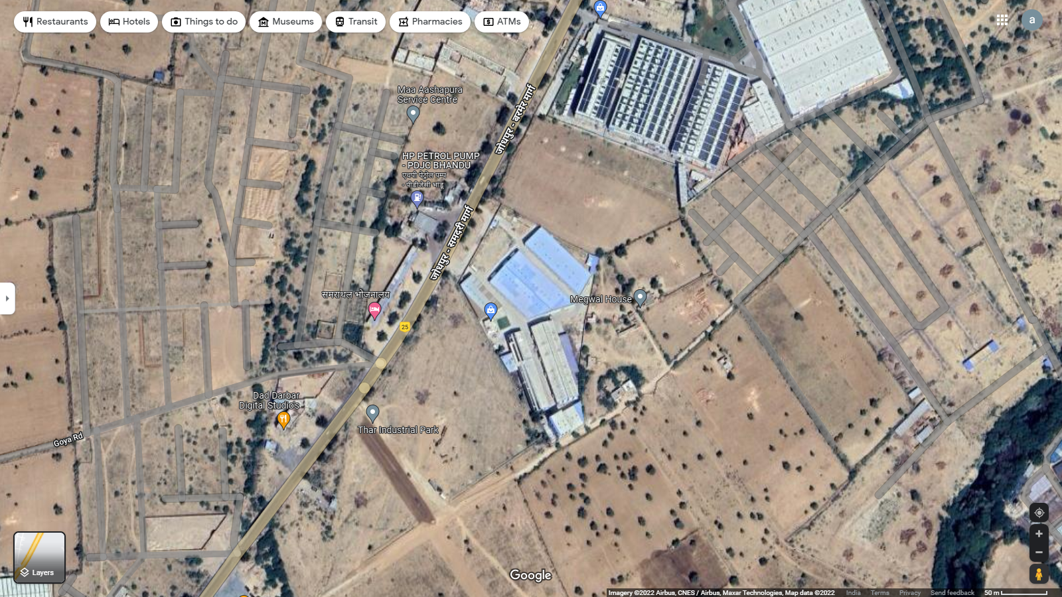

**280x80 ft shed**

**GPS Coordinates:** 26°07'13.8"N 72°53'56.7"E

In this respect Bank has approached us to comment specifically on the cost reasonability shown by the supplier in its Techno Commercial Offer and the requirement of 250KW based on the copies of the electricity bills provided to us.

|  |  |
| --- | --- |
| **PART C** | **POWER REQUIREMENT ANALYSIS** |

1. **POWER CONSUMPTION:** As per the copy of electricity bills for the month August, October & November 2022 shared, company has a contract load of 250 kVA from Jodhpur Vidyut Vitran Nigam Limited. Important details extracted from the bills for the power requirement analysis are tabulated below:-

|  |  |  |  |  |
| --- | --- | --- | --- | --- |
| **Bill Month** | **Net Consumption (in KWH)** | **Peak Load** | **Average Power Factor** | **Average Load Factor** |
| August-2022 | 28,101 | 130.92 | 0.993 | 15.11% |
| October-2022 | 28,731 | 58.86 | 0.994 | 14.97% |
| November-2022 | 27,843 | 65.58 | 0.994 | 15.76% |

|  |  |  |  |
| --- | --- | --- | --- |
| **Bill Month** | **Power Factor (PF)** | **Contracted Demand**  **(In kVA)** | **Energy Consumed**  **(In kW=PF x kVA)** |
| August-2022 | 0.993 | 250 | 248 |
| October-2022 | 0.994 | 250 | 249 |
| November-2022 | 0.994 | 250 | 249 |

|  |  |  |
| --- | --- | --- |
| **Particulars** | **Unit** | **Remark** |
| Total Connection Load (kW) | 250 | As per Electricity Bill |
| Total Peak Power Load (kVA) | 130.92 | As per Electricity Bill (max. taken as per Sep.22 bill) |
| Total Power Generation (Kwh in a day) | 1050 | As per Techno Commercial Proposal |
| **Average Power Generation (Kwh in month)** | **31,500** | **As per Techno Commercial Proposal** |
| **Average consumption (Kwh in month)** | **28,225** | **As per Electricity Bill (average of Sep., Nov., Dec. Bills)** |

**Conclusion:** Based on the above analysis as shown in table above, it appears that as per current usage as reflected from the copy of electricity bills and power generation claimed by Solar Nation Techno Commercial Offer provided to us that this Plant has the requirement of 250 KW rood top solar power plant.

|  |  |
| --- | --- |
| **PART D** | **COST ASSESSMENT** |

1. **PROJECT COST:** As perTechno Commercial Proposal for the said project installation, quoted by M/s Solar Nation is Rs. 1,06,25,000/- (Including GST). Break-up of the same is tabulated below:-

|  |  |  |
| --- | --- | --- |
| **S. No.** | **Description** | **Cost (In Rs.)** |
| 1 | Turnkey EPC prices for Design, Supply, Erection, Testing & Commissioning of 250 KW Solar Power Generating System | 94,35,000 |
| 2 | GST (12%) | 11,90,000 |
| **Total** | | **1,06,25,000** |

1. **COST ASSESSMENT:** As persecondary market research conducted by team of RKA, the benchmark cost for setting up a rooftop photovoltaic system varies from Rs. 39,080/- to Rs. 51,100/- per kW. However, this cost may vary depending upon the location, size of the project, type of installation etc. the project as per Benchmark Cost defined by Ministry of New & Renewable Energy, Government of India is tabulated below:-

|  |  |  |  |  |  |
| --- | --- | --- | --- | --- | --- |
| **S. No.** | **Particulars** | **Benchmark Cost**  **(In Rs./kW)** | **Project Capacity**  **(In kW)** | **Total Project Cost**  **(Excluding GST)**  **(In Rs.)** | **Total Project Cost**  **(Including 12% GST)**  **(In Rs.)** |
| 1 | As per Ministry of New & Renewable Energy | 39,080 | 250 | Rs.97,70,000/- | Rs.1,09,42,400/- |
| 2 | As per MNRE Rooftop Solar Calculator | 35,886 | 250 | Rs.89,71,500/- | Rs.1,00,48,080/- |
| 3 | As per market standards for 250kW | From Rs. 1,12,50,000/- to Rs. 1,21,75,000/- | | | |

**Note:**

1. Project cost is analyzed based on lumsum cost only and not item wise.
2. Project cost is assessed for the current date only and due to price fluctuations it may vary at the time of actual purchase or installation.

|  |  |
| --- | --- |
| **PART F** | **DISCLAIMER** |

* + - 1. No employee or member of R.K Associates has any direct/ indirect interest in the Project.
      2. This report is prepared based on the copies of the documents/ information which the Bank/ Company has provided to us out of the standard checklist of documents sought from them and further based on our assumptions and limiting conditions. All such information provided to us has been relied upon in good faith and we have assumed that it is true and correct in all respect. Verification or cross checking of the documents provided to us has not been done at our end from the originals. If at any time in future, it is found or came to our knowledge that misrepresentation of facts or incomplete or distorted information has been provided to us then this report shall automatically become null & void.
      3. This report is a general analysis of the project based on the scope mentioned in the report. This is not an Audit report, Design document, DPR or Techno-financial feasibility study. All the information gathered is based on the facts seen on the site during survey, verbal discussion & documentary evidence provided by the client and is believed that information given by the company is true best of their knowledge.
      4. All observations mentioned in the report is only based on the visual observation and the documents/ data/ information provided by the client. No mechanical/ technical tests, measurements or any design review have been performed or carried out from our side during Project assessment.
      5. Bank/FII should ONLY take this report as an Advisory document from the Financial/ Chartered Engineering firm and it’s specifically advised to the creditor to cross verify the original documents for the facts mentioned in the report which can be availed from the borrowing company directly.
      6. In case of any default in loans or the credit facility extended to the borrowing company, R.K Associates shall not be held responsible for whatsoever reason may be and any request for seeking any explanation from the employee/s of R.K Associates will not be entertained at any instance or situation.
      7. This is just an opinion report and doesn’t hold any binding on anyone. It is requested from the concerned Financial Institution which is using this report for taking financial decision on the project that they should consider all the different associated relevant & related factors also before taking any business decision based on the content of this report.
      8. All Pages of the report including annexures are signed and stamped from our office. In case any paper in the report is without stamp & signature then this should not be considered a valid paper issued from this office.
      9. Though adequate care has been taken while preparing this report as per its scope, but still we can’t rule out typing, human errors, over sightedness of any information or any other mistakes. Therefore, the concerned organization is advised to satisfy themselves that the report is complete & satisfactory in all respect. Intimation regarding any discrepancy shall be brought into our notice immediately. If no intimation is received within 15 (Fifteen) days in writing from the date of issuance of the report, to rectify these timely, then it shall be considered that the report is complete in all respect and has been accepted by the client upto their satisfaction & use and further to which R.K Associates shall not be held responsible in any manner.
      10. Defect Liability Period is **15 DAYS**. We request the concerned authorized reader of this report to check the contents, data and calculations in the report within this period and intimate us in writing if any corrections are required or in case of any other concern with the contents or opinion mentioned in the report. Corrections only related to typographical, calculation, spelling mistakes, incorrect data/ figures/ statement will be entertained within the defect liability period. Any new changes for any additional information in already approved report will be regarded as additional work for which additional fees may be charged. No request for any illegitimate change in regard to any facts & figures will be entertained.
      11. R.K Associates encourages its customers to give feedback or inform concerns over its services through proper channel at le@rkassociates.org in writing within 30 days of report delivery. After this period no concern/ complaint/ proceedings in connection with the Lender’s Independent Engineering Services will be entertained due to possible change in situation and condition of the subject Project.
      12. Our Data retention policy is of **ONE YEAR**. After this period, we remove all the concerned records related to the assignment from our repository. No clarification or query can be answered after this period due to unavailability of the data.
      13. This Lender’s Independent Engineering report is governed by our (1) Internal Policies, Processes & Standard Operating Procedures, (2) Information/ Data/ Inputs given to us by the client and (3) Information/ Data/ Facts given to us by our field/ office technical team. Management of R.K Associates never gives acceptance to any unethical or unprofessional practice which may affect fair, correct & impartial assessment and which is against any prevailing law. In case of any indication of any negligence, default, incorrect, misleading, misrepresentation or distortion of facts in the report then it is the responsibility of the user of this report to immediately or at least within the defect liability period bring all such act into notice of R.K Associates management so that corrective measures can be taken instantly.
      14. R.K Associates never releases any report doing alterations or modifications from pen. In case any information/ figure of this report is found altered with pen then this report will automatically become null & void.

|  |  |
| --- | --- |
| **PREPARED BY** | **REVIEWED BY** |
|  |  |
| **Abhinav Chaturvedi**  **(Valuation Engineer)** | **Mohit Agarwal**  **(Sr. Vice President – Projects)** |
| **Date: 29th December 2022** | **Date: 29th December 2022** |

***DEFECT LIABILITY PERIOD - In case of any query/ issue or escalation you may please contact Incident Manager by writing at valuers@rkassociates.org. We ensure 100% accuracy in the Calculations done, Rates adopted and various other data points & information mentioned in the report but still can’t rule out typing, human errors or any other mistakes. In case you find any mistake, variation, discrepancy or inaccuracy in any data point of the report, please help us by bringing all such points into our notice in writing at*** [***valuers@rkassociates.org***](mailto:valuers@rkassociates.org) ***within 30 days of the report delivery, to get these rectified timely, failing which R.K Associates Valuers Techno Engineering Consultants (P) Ltd. won’t be held responsible for any inaccuracy in any manner. Also, if we will not hear back anything from you within 30 days, we will assume that report is correct in all respect and no further claim of any sort will be entertained thereafter. We would welcome and appreciate your feedback & suggestions in order to improve our services.***

***COPYRIGHT FORMAT - This report is prepared on the copyright format of R.K Associates Valuers Techno Engineering Consultants (P) Ltd. to serve our clients in the best possible way. Legally no one can copy or distribute this format without prior approval from R.K Associates. It is meant only for the organization as mentioned on the cover page of this report. Distribution or use of this format other than R.K Associates will be seen as unlawful act and necessary legal action can be taken against the defaulter***

|  |  |
| --- | --- |
| **PART E** | **ANNEXURES** |

**Benchmark Cost as per MNRE**

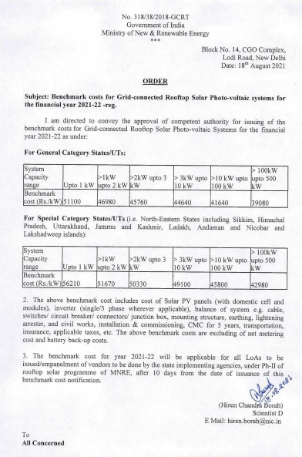

**Benchmark Cost as per MNRE Calculator (without GST)**

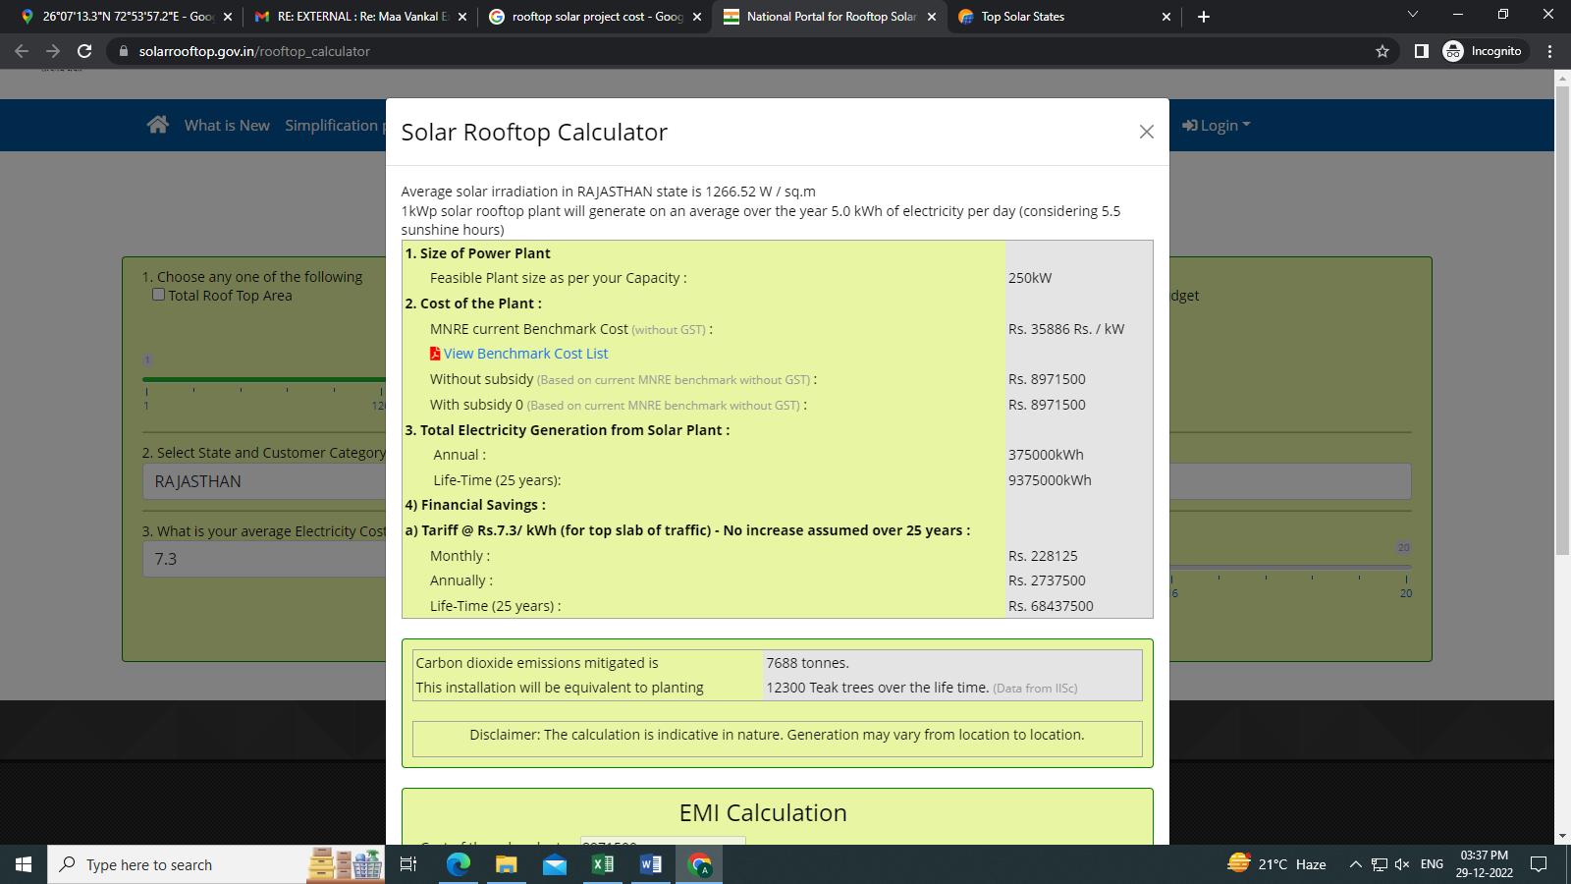

**1 MW Solar Power Plant Setup by Adani Solar Energy Group’s In Dhar, M.P.**

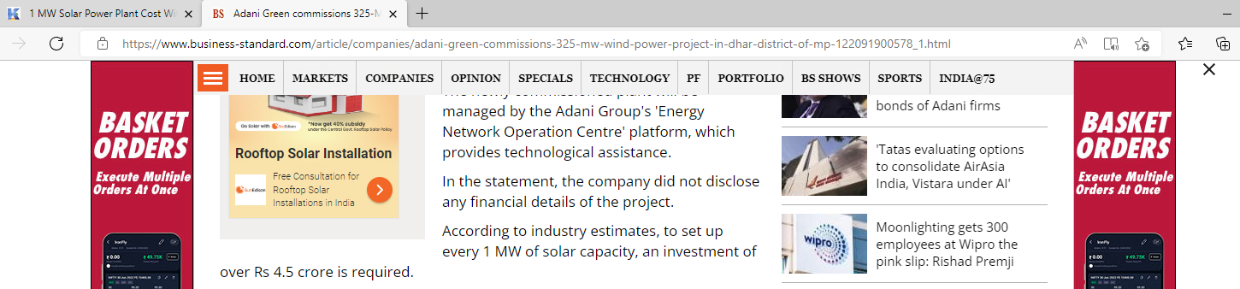

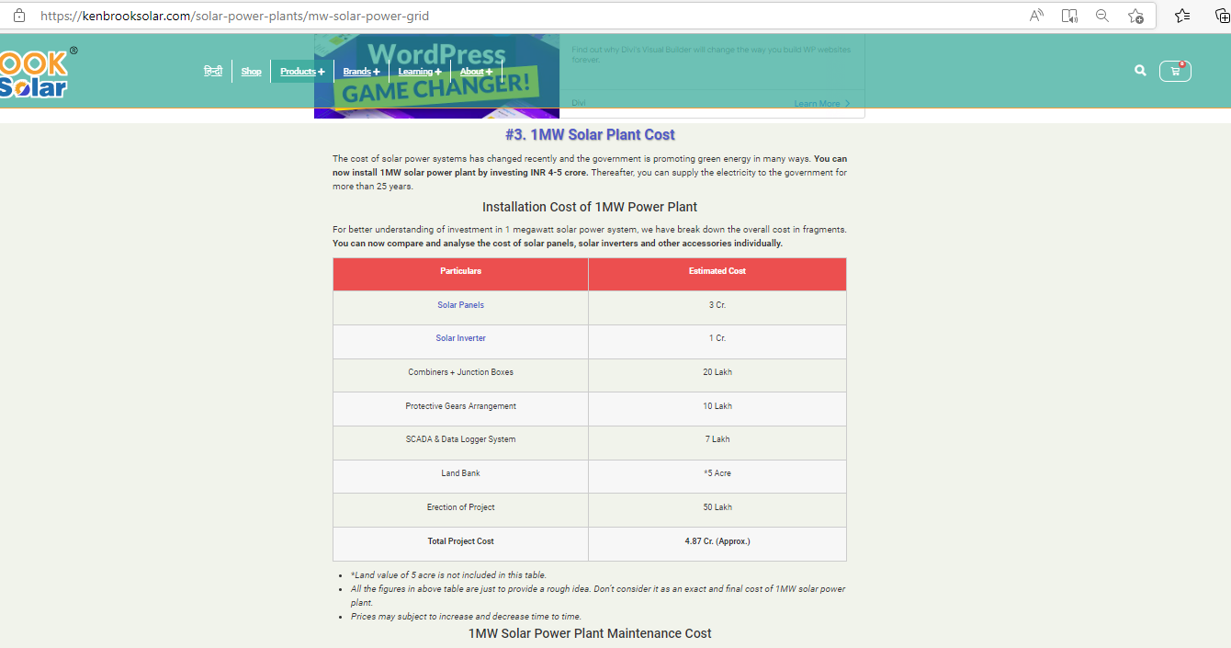

**Electricity Bills**

