File No.: VIS (2022-23)-PL563-458-781 Dated: 02.01.2023

TECHNO-ECONOMIC VIABILITY
STUDY REPORT

OF

RADIOLOGY AND PATH LAB DIAGNOSTIC CENTRE

SETUP BY

M/S DIXITAL TECHNOLOGIES INDIA PRIVATE LIMITED

PROMOTED BY

HK NULIFE HOSPITAL PRIVATE LIMITED

REPORT PREPARED FOR
STATE BANK OF INDIA, SME ASAF ALI, 3/8 ASAF ALI ROAD, NEW DELHI – 110002

**Important - In case of any query/ issue or escalation you may please contact Incident Manager Valuers@rkassociates.org. We will appreciate your feedback in order to improve our services.

NOTE: As per IBA Guidelines please provide your feedback on the report within 15 days of its submission after which report will be considered to be correct.

IMPORTANT NOTICE

COPYRIGHT FORMAT: This report is prepared on the copyright format of R. K. Associates Valuers & Techno Engineering Consultants (P) Ltd. (R. K. Associates) to serve our clients with the best possible information and analysis to facilitate them to take rational business decisions. Legally no one can copy or distribute this format without prior approval from R. K. Associates. It is meant only for the advisory/ reference purpose for the organization/s as mentioned on the cover page of this report. Distribution or use of this format or report or any of its content/ information/ data by any organization or individual other than R.K Associates will be seen as an unlawful act and necessary legal action can be taken against the defaulters.
This report is intended for the sole use of the intended recipient/s and contains material that is STRICTLY CONFIDENTIAL AND PRIVATE.

DEFECT LIABILITY PERIOD: In case of any query/ issue or escalation you may please contact Incident Manager at valuers@rkassociates.org. Though adequate care has been taken while preparing this report as per its scope, but still, we can’t rule out typing, human errors, over sightedness of any information or any other mistakes. Therefore, the concerned organization is advised to satisfy themselves that the report is complete & satisfactory in all respect. Intimation regarding any discrepancy shall be brought into our notice immediately. If no intimation is received within 15 (Fifteen) days in writing from the date of issuance of the report, to rectify these timely, then it will be considered that the report is complete in all respect and has been accepted by the client up to their satisfaction & use and further to which R.K Associates shall not be held responsible in any manner.

Part N: R. K. Associates Important Disclaimer and Remarks are integral part of this report and Feasibility assessment is subject to this section. Reader of the report is advised to read all the points mentioned in these sections carefully.

TABLE OF CONTENTS
SECTIONS | PARTICULARS | PAGE NO.
Part A | Report Summary | 4-5
Part B | Introduction
 | - About the Report | 6
 | - Executive summary | 6-8
 | - Purpose of the Report | 8
 | - Scope of the Report | 9
 | - Methodology/ Model Adopted | 9-10
 | - Data Information received from | 10
 | - Documents/ Data Referred | 10
Part C | Company Profile
 | - Company Overview | 11
 | - Proposed Shareholding Details | 11-12
 | - Promoters/Directors Profile | 12-16
Part D | Infrastructure Details
 | - Proposed Location | 17
 | - Layout Plan | 17
 | - Location Map | 17-18
 | - Land Details | 18-19
 | - Site pictures | 19-21
 | - Building & Civil Works | 22-23
 | - Furniture ad Fixture for the Proposed Building | 23-25
 | - Plant and Machinery/ Equipment details | 25-26
 | - Utilities | 26
Part E | Project Technical details
 | - Proposed Capacity | 27
 | - Technical Specification of Proposed Facility | 27-29
 | - Technology Used | 29-33
 | - Source of Procurement of Equipment | 34
 | - Testing/Quality Assurance for Medical Diagnostic Centre | 34
 | - Manpower | 34-35
Part F | Services Profile
 | - Introduction | 36
 | - Services Category | 36-40
 | - Marketing, Selling & Distribution Plan | 40
Part G | Industry Overview & Analysis | 41-45
Part H | SWOT Analysis | 46
Part I | Project Cost and Means of Finance | 47-49
Part J | Project Schedule | 50-51
Part K | Statutory Approvals | Licences | NOC | 52-53
Part L | Company’s Financial Feasibility
 | - Projection of Firm | 54-59
 | - Graphical Representation of Key Financial Metrics | 59-61
 | - Sensitivity Analysis | 61-62
 | - Cost-Volume Price or Sensitivity | 62-64
 | - Loan Amortization Schedule | 64
 | - Key assumptions & Basics | 64-69
Part M | Conclusion | 70
Part N | Disclaimer | Remarks | 72-75

PART A | REPORT SUMMARY

- Name of the Company: | M/s Dixital Technologies India Private Limited
- Address of the Company: | Plot No. 1655, 2nd Floor Guru Teg Bahadur Nagar Outram Line, Landmark Near New Life Hospital, North-West Delhi, Delhi-110009
- Project Name: | Radiology and Path Lab Diagnostic Centre
- Project Location: | Commercial Plot Number- 41, 42 & 58, Sector-53, Urban Estate, Gurgaon-II, Haryana, India
- Project Type: | Radiology and Path Lab Diagnostic Centre
- Project Industry: | Healthcare Industry
- Product Type/ Deliverables: | MRI, CT-Scan, X-ray, Color Doppler test, Ultrasound, and other Path lab tests
- Report Prepared for Organization: | State Bank of India, SME, Asaf Ali Branch, Delhi
- TEV Consultant Firm: | M/s. R.K Associates Valuers & Techno Engineering Consultants (P) Ltd.
- Report type: | Techno-Economic Viability Report
- Purpose of the Report: | To assess Project’s Techno-Economic Viability for the purpose of seeking external financial assistance on the Project.
- Scope of the Report: | To assess, evaluate & comment on Techno-Financial Viability of the Project as per data information provided by the client, independent Industry research and data/ information available on public domain.
- Date of Report: | 2nd January, 2023
- Documents referred for the Project | - PROJECT PLANNING DOCUMENTS:  - Detailed Project Report  - Financial Projections of the Project  - Project proposed Schedule  - Statutory Approval Details  - Layout and Master Plan  - PROCUREMEMNT DOCUMENTS:  - High level breakup of Equipment Cost  - Sanction/tentative/proposed map of the sites  - Land details and deeds  - Quotations of Equipment Required  - Cost Estimations
- Means of Finance: | Equity + Debt
- Key Financial Indicators | Key Indicators Value  Average Net DSCR 2.31  Maximum Net DSCR 2.48  Average EBITDA Margin 60.62%  Average EBIT Margin 51.33%

Note: Above financial indicators are based on the financial projections of the proposed project provided by the firm and assessment and analysis of the same done by us.

PART B | INTRODUCTION

- ABOUT THE REPORT:
Techno Economic Viability Study Report of the Radiology and Path Lab Diagnostic Centre Company, M/s Dixital Technologies India Private Limited.

- EXECUTIVE SUMMARY:
M/s Dixital Technologies India Private Limited was incorporated on 22nd May, 2021 established for the purpose of building a new Radiology and Path Lab Diagnostic Centre. The company is established as a private company limited by shares with Registration no. 381426 and Corporate Identification Number U72900DL2021PTC381426 and is promoted by the directors who appears to be well experience in healthcare industry as per the profile shared to us by the client and information available in the public domain about them.
The company is registered at Registrar of companies, Delhi having registration number 381426 and registered office at Plot No. 1655, 2nd Floor Guru Teg Bahadur Nagar Outram Line, Landmark near New Life Hospital, North-West Delhi, Delhi-110009 under the directorship of Mr. Javinder Singh and Dr. Akshay Kumar. As per 31st March 2022 the company is having the authorized capital of INR 15, 00,000 and paid-up capital of INR 1, 00,000.
The management of Nulife group has proposed to setting up this new Diagnostic Centre (Greenfield Project) in new company to provide MRI, CT-Scan, X-Ray, Colour Doppler test, Ultrasound, and other Path lab tests in the proposed Radiology and Diagnostic centre. For this purpose, they are proposing to purchase and install the latest and advanced technology medical equipment/testing equipment in its proposed Radiology and diagnostic centres.
As per data provided by the client/company, below table shows the details of proposed category wise installed capacity of the services:
Proposed Capacity of Radiology and Diagnostic Centre
Particular | Maximum Capacity Per Day
MRI & CT-SCAN CENTRE:
MRI SCAN:-
Maximum Capacity of MRI SCAN Tests | 40
CT SCAN:-
Maximum Capacity of CT SCAN Tests | 40
Total MRI & CT-SCAN | 80
Colour Doppler/ Ultra Sound SCAN:-
Maximum Capacity of Colour Doppler Scan Tests | 120
Total Colour Doppler/ Ultra Sound SCAN | 120
X-RAY SCAN:-
Maximum Capacity of X-RAY Scan Tests | 60
Total X-RAY SCAN | 60
LAB Tests:-
Maximum Capacity of LAB Tests | 60
Total LAB Tests | 60

As per data/information provided by the client and information available in the public domain, The promoters/Directors of the company are already running a diagnostic centre in the name of SGD Diagnostic centre at Model Basti, New Delhi & one Hospital in the name of Nulife Hospital at GTB Nagar, New Delhi, in their one other company named M/s HK Nulife Hospital Private Limited for a long. It seems that the promoters have rich knowledge and experience in this business line since the management is successfully running multi-speciality hospital and Diagnostic centre.
As per communicated by the client/company, both units are well equipped with state-of-the-art medical equipment and devices to provide world-class services to their clients and having a qualified team of doctors, technicians, lab technicians, and other experienced teams of professionals in these two existing units where quality test reports, medical services, and treatments with competitive pricing provided. The company’s promoters plan to establish this new proposed radiology and diagnostic to expand their business operation area in Gurgaon, Haryana.
We R.K associate is performing the Techno-Economic Viability study for proposed Radiology and Path Lab Diagnostic Centre at Gurgaon for taking term loan of INR 25.10 Crores and CC limit of INR 0.50 Crore from State Bank of India under Bank’s Aarogyam Non-metro healthcare business loan under Loan Guarantee Scheme for Covid affected Sectors (LGSCAS) where Debt-Equity Ratio of 3:1 and Promoters Contribution Margin of 25% has been stipulated by the bank, as the company planned to establish Diagnostic Centre at Sector-53, Gurugram.
PROPOSED PROJECT COST: As per data/information provided by the client, the total cost of the project for establishing a new Radiology and Path Lab Diagnostic Centre is being estimated as INR 34.35 Crores which is proposed to be funded through equity of INR 9.25 Crores and debt of INR 25.10 Crores.

Total Project Cost
Particulars | Already Incurred | To be Incurred | Total Cost
Purchase of Land + Stamp Duty + Sanction of Map | 4.38 | 14.40 | 18.78
Construction of Building + Dep. of Land | 0.00 | 3.46 | 3.46
Purchase of Plant and Machinery | 0.00 | 7.41 | 7.41
Furniture & Fixtures | 0.00 | 1.77 | 1.77
Other Assets | 0.00 | 0.45 | 0.45
Contingencies @ 2% | 0.00 | 0.26 | 0.26
Trade Deposits, Govt. Deposits and other Advances | 0.00 | 0.15 | 0.15
Construction period Interest | 0.00 | 1.75 | 1.75
Working Capital Margin | 0.00 | 0.31 | 0.31
Total Project Cost | 4.38 | 29.96 | 34.35
The company is planning to fund the project through term loan to initiate the development of the project and approaching the financial institutions to provide the required capital.
CURRENT STATUS OF THE PROJECT: As per the information shared by the client/company, Company got the allotment of three commercial properties in its name from HSVP (Haryana Shahri Vikas Pradhikaran) in FY 2022, total land admeasuring 363.00 Sq. Mt. at Commercial Plot Number- 41, 42 & 58, Sector-53, Urban Estate, Gurgaon-II, Haryana. Company has already paid INR 4.35 Crore/25.00% of the allotment charges to HUDA, However conveyance deed would be executed by HUDA after payment of Total land Charges INR 17.49 Crore.
Currently, company is in discussion with financial institutions to fund the project through term loan of INR 25.10 Crore. Company plans to achieve the financial closure by February, 2023 (expected) and expected to start its commercial operations (COD) till Dec 2023.

Therefore, to check and assess the Techno-Economic viability of the Project for submitting the proposal to financial institutions, State Bank Of India, S.M.E Asaf Ali Road Branch, New Delhi has appointed us as TEV consultant to review technical, commercial and financial viability of the project based on our independent EIC research and information/data provided to us about the project by M/s Dixital Technologies India Private Limited.
- PURPOSE OF THE REPORT: To assess the Techno-Economic Feasibility of the green field proposed project to take further Project funding decision for the same.
- SCOPE OF THE REPORT: To assess, evaluate & comment on Techno-Financial Feasibility of the proposed Radiology and Path Lab Diagnostic Centre being set up by M/s Dixital Technologies India Private Limited as per the data/information provided by the client/promoter/stakeholder and our independent EIC research.

NOTES:
- Project status is taken as per the information provided by the company/promoter/stakeholder. This has not been independently verified or inspected independently since this was out-of-scope of the work.
- Site inspection has been carried out for the Gurgaon location. Other existing units has also not been visited at our end. Operating details regarding the same is taken as per the information provided by the company which has been relied upon.
- Scrutiny about the company, background check, credibility, credit worthiness of the company or its promoters is out-of-scope of this report.
- This report is only an opinion in respect to Technical and Financial Feasibility of the project as per the future Projections provided by the firm and independent analysis done by us and doesn’t contain any recommendations including taking decision on the financial exposure.
- This is not an audit activity of any kind. We have relied upon the data/ information supplied by the company in good faith that it is true and without any fabrication.
- Any kind of cost vetting of Total Project Cost, Land, Building, and Plant & Machinery, Comprehensive Maintenance Cost etc.is out of scope of the work. We have relied upon the data/information and justifications provided by banker/client in good faith based on the estimated costs done by appointed parties by bank and company.
- This is not a Detailed Project Report or a detailed design or architecture document.
- Land and property details mentioned in the report is only for illustration purpose as per the information provided to us by the client. The same doesn’t tantamount for taking any responsibility regarding its legality, ownership and conforming to statutory norms.

- METHODOLOGY/ MODEL ADOPTED:
- Data/ Information collection.
- Review of Data/ Information collected related to TEV study.
- Independent review & assessment of technology used and financial projections provided by the company/promoters.
- Review and analysis of the Projections as per the market trends and futuristic growth opportunity of the industry and company.
- Projections of Revenue, Expenses, P&L, Balance Sheet, fixed assets, COGS.
- Assessment of Key Financial Ratios
- Final conclusion.

- DATA/ INFORMATION RECEIVED FROM:

All the data/Information has been received from Mr. Rajeev Kumar and the required details about him shown in the below table:

PERSON FROM WHOM DATA OBTAINED
Particulars | Details
Name | Mr. Rajeev Kumar
Company | State Bank Of India, S.M.E, Asaf Ali Road Branch
Email Address | sbi.62203@sbi.co.in
Contact No. | +91 9310063616

- DOCUMENTS / DATA REFFERED:

- Financial Projections of the proposed project up to FY 2033.
- Information memorandum and description of the company (DPR)
- Promoter’s Details.
- Proposed Total project cost.
- Sale deed/CLU of the land.
- List of Plant and Machinery along with their acquisition cost.
- Quotations and Purchase Orders provided by the client/company.
- Cost Estimations done by appointed parties for various components
- Details of Furniture & Fixtures along with acquisition cost.
- Layout Plan.
- Man power proposal
PART C | COMPANY PROFILE

- COMPANY OVERVIEW: M/s. Dixital Technologies India Private Limited was incorporated on 22nd May, 2021 with CIN: U72900DL2021PTC381426 is a private limited company having its Registered Office at Plot No. 1655, 2nd Floor Guru Teg Bahadur Nagar Outram Line, Landmark Near New Life Hospital, North West Delhi, Delhi - 110009, India. It is classified as Non-govt Company and is registered at Registrar of Companies, Delhi. Its Authorised Capital is INR 15, 00,000 and paid-up capital is INR 1, 00,000.
As per brief description of the company provided by the client, M/s Dixital Technologies India Private Limited is formed to be engaged in the business of establishing a new Radiology and Path Lab Diagnostic Centre (MRI, CT-Scan, X-ray, Color Doppler test, Ultrasound, and other Path lab tests) focusing on quality test reports at Commercial Plot Number- 41, 42 & 58, Sector-53, Urban Estate, Gurgaon-II, Haryana, India admeasuring 363 Sq. Mt. to generate good income by running it.
The promoters of the company are Sh. Javinder Singh & Dr. Akshay Kumar who are also the Directors of the company. The promoters/Directors of the company are already running a diagnostic center in the name of SGD Diagnostic center at Model Basti, New Delhi & one Hospital in the name of Nulife Hospital at GTB Nagar, New Delhi, in their one other company named M/s HK Nulife Hospital Private Limited for a long.
The company’s promoters plan to establish this new proposed radiology and diagnostic center in Gurgaon, Haryana, to expand their business operation area in Gurgaon, Haryana. Services provided by M/s Dixital Technologies India private limited under the five broad categories are MRI Scan, CT scan, Colour Doppler/ Ultra Sound Scan, X-Ray Scan, Lab Tests.

- PROPOSED SHAREHOLDING DETAILS: As on 31st March 2022, the Company is having authorized share capital of Rs. 15, 00,000 and the total paid-up capital is Rs 1, 00,000 as per the data available on the MCA website. The shareholding details of the company is mentioned below:
Shareholding Pattern
S. No. | Name | No. of shares held | % Of holding | Value @ 10/- per share
1 | Mr. Javinder Singh | 5000 | 50 % | 50000
2 | Dr. Akshay Kumar | 5000 | 50 % | 50000
Total |  | 10000 | 100% | 100000
Source: Data/Information provided by the Client.
Mr. Javinder Singh and Dr. Akshay Kumar are the major shareholders of the company who are each holding 50% share of the company.

- PROMOTERS/DIRECTORS PROFILE: Director’s details have been shown in the below table:
Director’s Profile
DIN | NAME | Appointment Date | Qualifications/Experience
08578920 | Mr. Javinder Singh | 11th April, 2022 | Mr. Javinder Singh (PAN AALPS3627A), S/o of Sh. Puran Singh, R/o – House No- 1655, Outram Line, GTB Nagar, Delhi-110009. He has aged about 66 years and is a Commerce Graduate from Delhi University.  He is a successful businessman and a key person in the company having a rich experience and reputation in the market. He is a seasoned executive with over 40 years of rich experience in the area of Finance, Corporate Strategy, Marketing, etc.  He is successfully running his other businesses of public health services, Hospitals, and exports & manufacturing of cutlery. After getting vast experience and knowledge of the open market, he decided to expand his business of public health services. He started this new company to establish and run the new proposed radiology and diagnostic centers at Gurgaon, Haryana.  The total day-to-day business operation of the unit is proposed to be handled by him with a supportive technical team of experts in medical care, lab technicians, marketing, Sales, Advertising, and administration.
08814924 | Dr. Akshay Kumar | 11th April, 2022 | Dr. Akshay Kumar (PAN COTPK5933H) S/o Lt. Sh. Harish Kumar, R/o-.House No- 1616, Outram Line, GTB Nagar, Delhi-110009. He is aged about 29 years and has done his MBBS from Maulana Azad Medical College, New Delhi.  He is one of the Directors of the company. He looks after all the company's administration, sales, staffing, and marketing work. He is also engaged in his other businesses of Public Health care in the name and style of M/s HK Nulife Hospitals Pvt. Ltd.  He has a very long experience in public medical services and holds goodwill in the market.
Source: Data/Information provided by the client
To give a brief overview of the background of Directors we have listed down the basic company information as found on public domain in general/ tertiary category research.
(Mr. Javinder Singh)
S. No. | CIN/FCRN | Company Name | Begin Date
1 | U21095DL2017PTC313184 | Vans Packaging Private Limited | 11/03/2022
2 | U25199DL2019PTC355824 | Maxworth International Private Limited | 04/10/2019
3 | U72900DL2021PTC381426 | Dixital Technologies India Private Limited | 11/04/2022
4 | U52609DL2021PTC381660 | Brisk Delivery Private Limited | 29/08/2022
5 | U85110DL2021PTC387254 | Bharat Healthways Private Limited | 28/09/2021
6 | U36109DL2021PTC391525 | Bharat Cutlery Private Limited | 21/12/2021
7 | U85100DL2022PTC392609 | Bharat Health & Wellness Private Limited | 19/01/2022
8 | U85110DL2022PTC396769 | Bharat Health Tech Private Limited | 18/04/2022
9 | U45309DL2022PTC402664 | Nulife Luxury Realtors Private Limited | 01/08/2022
10 | U85300DL2022PTC403313 | Nulife Advanced Diagnostics Private Limited | 18/08/2022
11 | U85190DL2022PTC404659 | Bharat Elite Hospitals Private Limited | 16/09/2022
12 | U85110DL2022PTC405110 | Bharat Healthserve Private Limited | 26/09/2022
Source: Information extracted from MCA & public domain
(Dr. Akshay Kumar)
S. No. | CIN/FCRN | Company Name | Begin Date
1 | U85110UP2002PTC026531 | Meerut Scan Centre Private Limited | 28/12/2021
2 | U21095DL2017PTC313184 | Vans Packaging Private Limited | 11/03/2022
3 | U85300DL2020PTC370628 | Hk Nulife Hospitals Private Limited | 15/03/2022
4 | U72900DL2021PTC381426 | Dixital Technologies India Private Limited | 11/04/2022
5 | U52609DL2021PTC381660 | Brisk Delivery Private Limited | 29/08/2022
6 | U85100DL2022PTC392609 | Bharat Health & Wellness Private Limited | 19/01/2022
7 | U85110DL2022PTC396769 | Bharat Health Tech Private Limited | 18/04/2022
8 | U85100DL2022PTC400389 | Shashikala Healthcare Private Limited | 21/06/2022
9 | U45309DL2022PTC402664 | Nulife Luxury Realtors Private Limited | 01/08/2022
10 | U85300DL2022PTC403313 | Nulife Advanced Diagnostics Private Limited | 18/08/2022
11 | U85190DL2022PTC404659 | Bharat Elite Hospitals Private Limited | 16/09/2022
12 | U85110DL2022PTC405110 | Bharat Healthserve Private Limited | 26/09/2022
Source: Information extracted from MCA & public domain
Key Technical, Professional & Management Team of Project
S. No. | Name | Profile | Age | Description
 | Deepak Tomar | Project Head | 40 years | Dr. Deepak Tomar is proposed to be a unit head in the proposed diagnostic center. He is a MBBS & MD (Radio diagnosis).  He has a very vast experience in this business line and proposed to a senior radiologist at the proposed unit.  Post academic, he successfully served as a senior consultant at City X-ray Clinic, Dr. Madhu MRI and Path Lab, and senior resident doctor at Hindu Rao Hospital in New Delhi.  He will look after all the MRI, CT scan, X-ray, and other path lab work at the proposed unit with the help of other junior/senior doctors, technicians, and Lab technicians.
 | Dr. Vipin Kumar Grover | Senior Consultant Doctor | 15 Years | Dr. Vipin Kumar Grover is proposed to be a senior consultant doctor at the proposed unit. He has a vast experience in the medical line and holds a degree in MBBS, MS, FMAS, and FIAGES. He has the following work experience:  - House Surgeon in Hindu Rao Hospital, Delhi (1985 to 1986).  - Resident Surgeon at GSVM Medical College and Associated Hospitals, Kanpur (1986 to 1988).  - Chief Senior Resident (Surgery), Moolchand Khairati Ram Hospital (1988-1991), Registrar Surgery at DDU Hospital (1991-1994).  - Consultant- Gen Surgery at Kukreja Hospital, West Delhi (1994-1998).  - Senior Consultant Laparoscopic, Surgery & Chief of Surgery at Kukreja Hospital and Heart Hospital (1998-2010).  - Sr. Consultant and Unit Head at BL Kapur Memorial Hospital (2010-2011).  - Visiting Consultant at RLKC Metro Hospital and Max Hospital, New Delhi.  - Full-time Sr. Consultant and unit head at MAX Hospital and Max Super Specialty Hospital, Shalimar Bagh, ND (2014 to till date).  He will oversee all the final preparation of the test reports at the proposed diagnostic center and will look after the work done by the other junior doctors/ staff/ technicians.
 | Dr. Shakuntla Kumar | Senior Consultant Doctor | 55 Years | Dr. Shakuntla Kumar is proposed to be the head of the department at the proposed Radiology and diagnostic center. Currently, she is a senior consultant at Fortis Hospital, Delhi, and holds the post of senior consultant/ Medical Director at Nulife Hospitals, New Delhi. She has affiliations with FICOG, FIAOG, and Dip Endoscopy Kiel Germany.  She will supervise and manage the overall medical supervision, quality control, TAT, and other medical practitioner management at the proposed unit to serve its clients in a time-bound and professional manner.  She will also provide her professional consultancy on different aspects of the day-to-day business operation of the company.
Source: Data/Information provided by the Client

PART D | INFRASTRUCTURE DETAILS OF THE PROPOSED PROJECT

- PROPOSED LOCATION: The company proposes establishing a new Radiology and Path Lab Diagnostic Centre at Commercial Plot Number- 41, 42 & 58, Sector-53, Urban Estate, Gurgaon-II, Haryana, India which is spread over an area of 363 Square meter as per information shared by client/company. During the site visit the location is found to be appropriate and prominent residential and commercial hub of Gurgaon at Golf Link Road.
Connectivity | Details
Rail | Gurgaon Railway Station, Haryana which is 7 km away
Airport | Indira Gandhi International Airport which is 13 km away

- LAYOUT PLAN: The map of the proposed diagnostic centre’s buildings shall be applied after getting the registration of these plots in the company name for approval from the concerned authorities. The land of these three plots is freehold, and the management of the company is proposed to obtain permission from the Government authorities to establish its proposed Diagnostic centres.
The proposed Radiology and Diagnostic Centre buildings shall be constructed as per the sanctioned MAP. It will consist of the MRI Scan Rooms, X-Ray Rooms, CT Scan Rooms, Sample taking areas, Lab Area, Reception, Point of Sales area, Waiting area, Admin Block, Processing area, Godown, Lab, Power room, and other utility areas for the smooth working of the proposed unit from here. After obtaining all the permissions from local authorities and Government agencies, the company will start the construction of the proposed unit.
The company has also arranged with the Delhi-based renowned Architectural firm M/s R.S. Yadav & Associates to get help in the building, civil work, and designing of the proposed radiology and diagnostic centres as per industry norms.
This consultancy firm will also provide full consultancy and professional solutions in the construction of buildings, civil work, and interior work with power solutions.
- LOCATION MAP:
- Google Map: Location: Project location would be 28°26'57.84" North and 77°5'26.56" East in Gurgaon, Haryana and the location as per the Google map is attached below with the link.

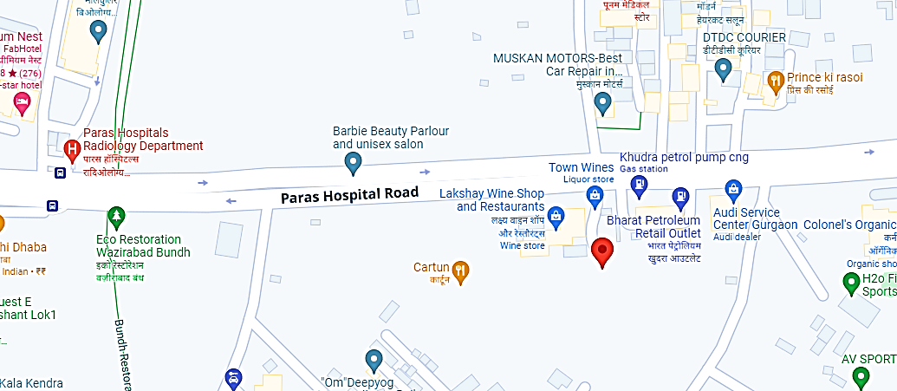

- Demarcation: Demarcation of the land on the Google map can’t be done since the ownership will be transferred by the authorities after the balance payment will be made post loan sanction.
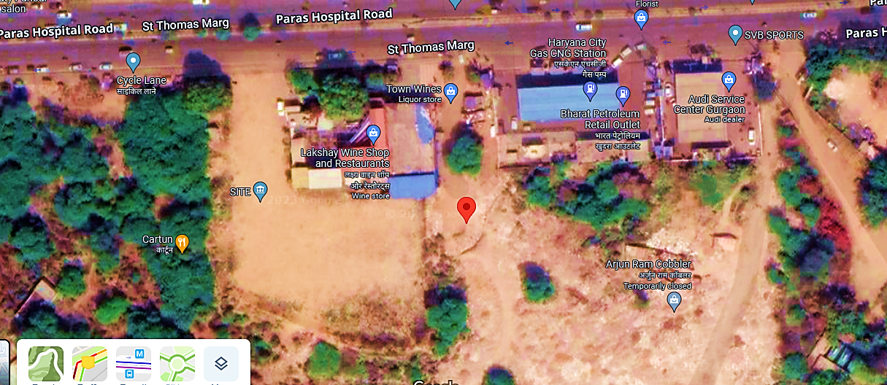

- LAND DETAILS: The Company has already got an allotment of commercial land admeasuring approx. 363.00 Sq. Mt. at Plot numbers- 41, 42 & 58, Sector-53, Urban Estate, Gurgaon-II, Haryana, in the company’s name. As per data/information provided by the client/company, valuation of the land has been done by government registered valuer Er. Dharmendra Kumar Gupta and we have not vetted it as per scope of work.
The cost of these three plots is estimated at Rs. 18.78 crores, including stamp duty and the cost of sanctioning the map. Out of the total cost of Rs. 18.78 crores, an amount of Rs. 4.38 crores have already been paid to the HSVP (Haryana Shahri Vikas Pradhikaran), and the balance is proposed to be paid from the bank loan funds.
This land consists of three plots of 121 sqmtrs each, and out of three plots, two are adjoining each other, and the third one is separated and situated in front of these two plots. Therefore, two separate buildings are proposed on these plots. And the proposed radiology and diagnostic centre is proposed to be established here.
As per communicated by the client, decision of purchase of land through auction from HUDA has been taken by the management as per economically and commercially viable basis since the lease/rent rate of the property at the said location is very much higher on monthly/annual basis.
For example as per our tertiary research, information available in various public domain and informed by various dealers, lease/rent rate of the commercial property at the said location ranges from INR 80- INR 120 per Sq. Ft. (Approx.) Accordingly, the lease/rent for a Total proposed covered area of 14066.40 Sq. Ft. (commercial building B+G+2) will be ranging from INR 1, 35, 03,744 to INR 2, 02, 55,616 annually. Thus, it would more economic decision if company hold the ownership of land and building initially.

- SITE PICTURES: Some of the site pictures has been taken during the site survey, are attached below:
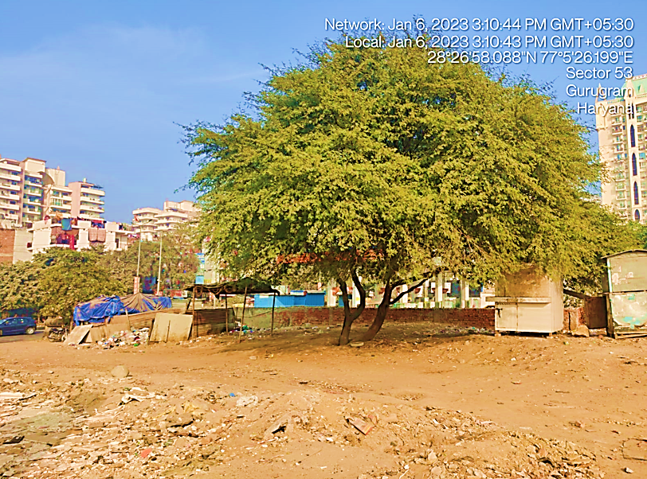
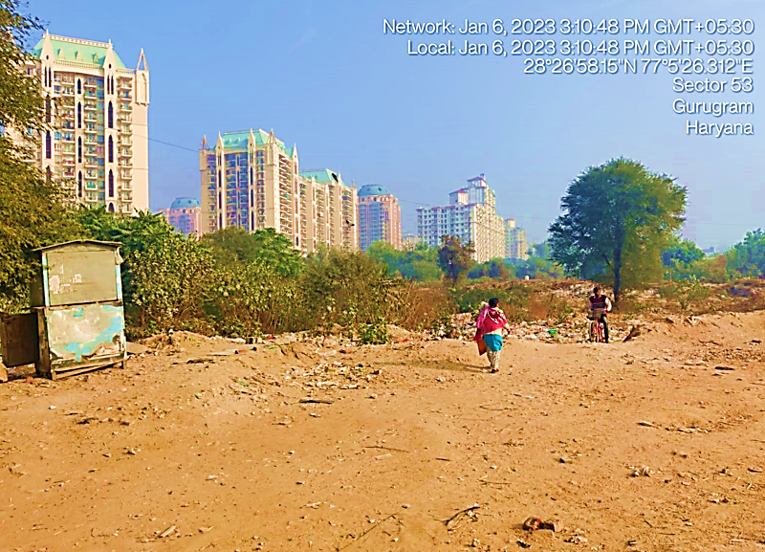
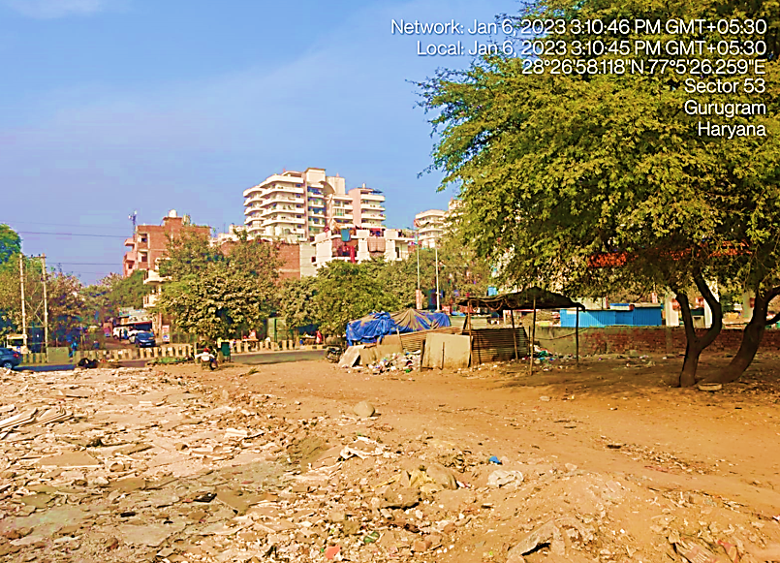
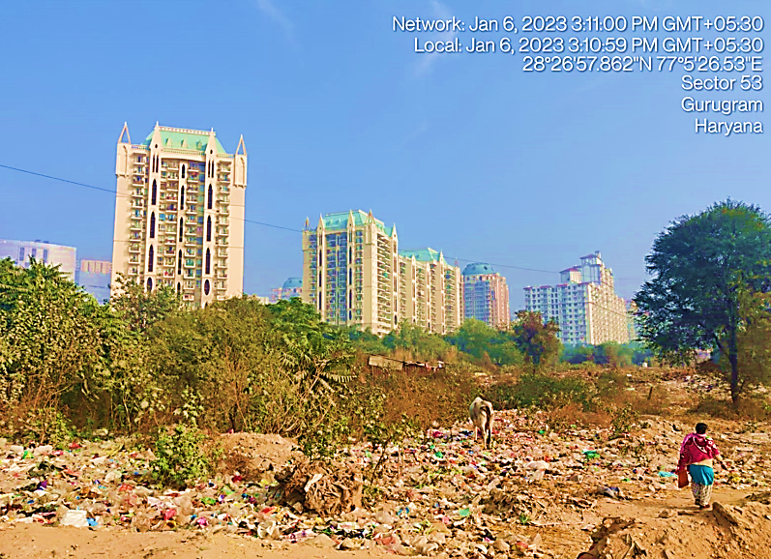
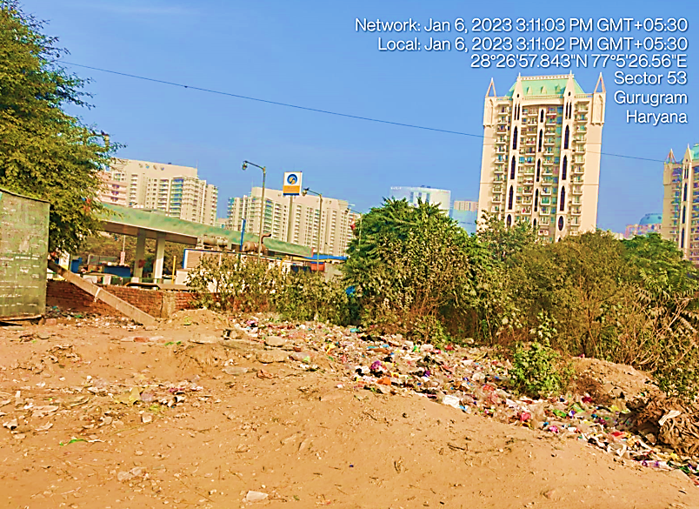
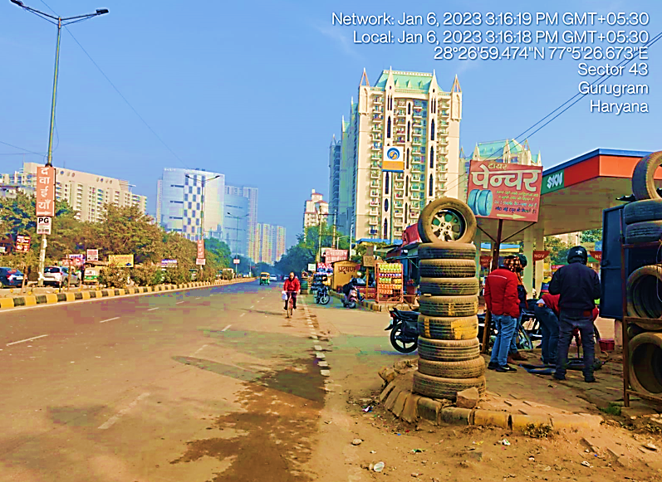
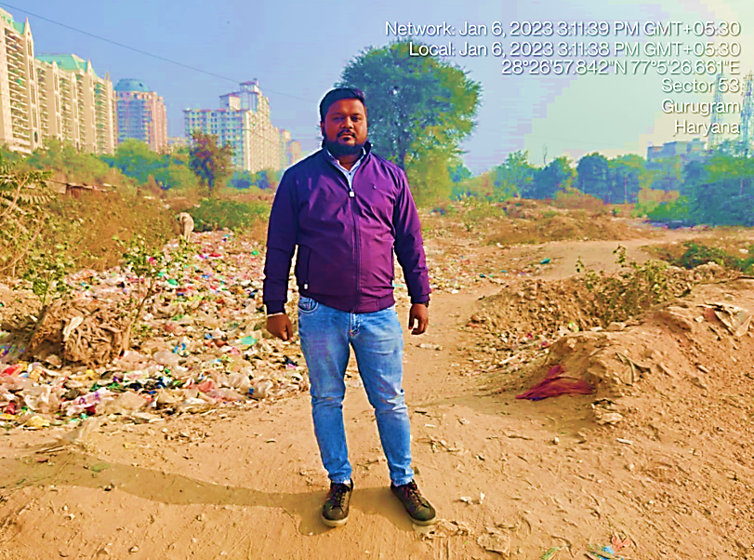
- BUILDING & CIVIL WORKS: The proposed Radiology and Diagnostic Centre buildings shall be constructed per the sanctioned MAP. It will consist of the MRI Scan Rooms, X-Ray Rooms, CT Scan Rooms, Sample taking areas, Lab Area, Reception, Point of Sales area, Waiting area, Admin Block, Processing area, Godown, Lab, Power room, and other utility areas for the smooth working of the proposed unit from here among other supportive facilities like adequate parking space and other public utilities.
As per the proposed plan, reception, waiting room, and sample-taking area on the ground floor, MRI, CT scan, Ultra Sound, Colour Doppler scan, and other diagnostic facilities on the First Floor, and Lab, Test report preparation facility, Doctors, Technicians, and other utilities on the second floor.
The proposed building will be in two parts. One part will be constructed on the adjoining plots number 41 & 52 on a total land area of 242.00 Sq. Mt. and the other will be on plot number 58 on a total area of 121.00 Sq. Mt. Both the proposed buildings will be facing each other. Both buildings will be a basement and three floors (Basement + Ground Floor +2).
Construction Details For Plot No. – 41, 42
Particular | Details
Area of Plots | 121.00+121.00 = 242 Sq. Mt.
Covered Area of Basement | 217.80 Sq. Mt.
Covered Area of Ground Floor | 217.80 Sq. Mt.
Covered Area of First Floor | 217.80 Sq. Mt.
Covered Area of Second Floor | 217.80 Sq. Mt.
Total Proposed Covered Area | 871.20 Sq. Mt. Or 9377.60 Sq. Ft.
@ Rs. 2000/- per Sq. Ft. | 1,87,55,200.00
Add: Cost of installation of lift including Machine room etc. | 8,00,000.00
Total: | 1,95,55,200.00
Applicable GST @ 18% | 35,19,936.00
Total: | INR 2,30,75,136.00

Construction Details For Plot No. – 58
Area of Plots | 121.00 Sq. Mt.
Covered Area of Basement | 108.90 Sq. Mt.
Covered Area of Ground Floor | 108.90 Sq. Mt.
Covered Area of First Floor | 108.90 Sq. Mt.
Covered Area of Second Floor | 108.90 Sq. Mt.
Total Proposed Covered Area | 435.60 Sq. Mt. or 4688.80 Sq. Ft.
@ Rs. 2000/- per Sq. Ft. | 93,77,200.00
Add: Cost of installation of lift including Machine room etc. | 4,00,000.00
Total: | 97,77,200.00
Applicable GST @ 18% | 17,59,896.00
Total: | INR 1,15,37,096.00

The basement will be used as a Godown area to keep stationary, past reports, records, spares, and other items. There would be much open space which will be landscaped, laying of pathway & planted with flowers & trees which will add to the beauty of the building.
After obtaining all the permissions from local authorities and Government agencies, the company will start the construction of the proposed diagnostic centre building. The company has also arranged with the Delhi-based renowned Architectural firm RS Yadav & Associates to get help in the construction, civil work, and designing of the proposed unit as per industry norms. This firm will provide full consultancy and professional solutions in building construction, civil and interior, and other construction work with complete consultancy and professional services for the construction of the proposed buildings. Construction estimates of Rs. 3.46 crores have also been obtained from this architectural firm.
Every corner of the proposed facility is proposed to be well equipped with high-quality security cameras and firefighting systems with the latest and most modern technology to remedy the threats of fire, burglary, theft, and other unknown and unwanted circumstances.
Cost estimation of civil construction including land development cost is done by Architectural firm RS Yadav & Associates and as per the information shared by the banker, same has been vetted and verified by the government approved valuer Er. Dharmendra Kumar Gupta. We have not done any cost vetting due to out of scope of work. There is also a provision for a water storage tank.
The projected building's total construction cost, including complete civil work, interior work, open drains, Tube well and electrification, internal and external sanitary fittings, etc., is approx. INR 3.46 Crores including applicable GST charges.
The company is expecting the completion of the proposed diagnostic centre buildings by September 2023, and it is expected to start its commercial operations in December 2023.

- FURNITURE AND FIXTURE FOR THE PROPOSED BUILDING: As per the cost estimates done by Design Art Consultant shared by client/company, below table shows the details of furniture and fixture for the proposed building as per the applicable covered area:
- Property No – 58, Sector-53, Urban Estate, HUDA, Gurgaon-II, 122002, Haryana: Total Plot Area = 121.0 (Sq. Mt.)
Expected Covered Area = 3000.0 Sq. Ft.
S.No. | Description For Item of Works | Unit | Quantity | Rate | Amount
1. | Patient Examination Bench | Nos. | 5 | 35000.00 | 175000.00
2. | 10 Chairs | Nos. | 10 | 4000.00 | 40000.00
3. | Waiting Area Sofa (For 30 Peoples) | Lumpsum |  |  | 500000.00
4. | 5 Nos Office Tables | Nos. | 5 | 15000.00 | 75000.00
5. | Ceramic Tiles in Toilet/Pantry(Labour+Material) | Lumpsum |  |  | 470000.00
6. | Steel Main Gate/Stair Case & Balcony Railing | Lumpsum |  |  | 200000.00
7. | Marbel Flooring (Marbel) | Sq. Ft. | 3000 | 400.00 | 1200000.00
8. | Marbel Rubbing & Polishing Labour & P.C.C. for Flooring | Sq. Ft. | 3000 | 150.00 | 450000.00
9. | Electric Fittings in Building (Labour Charges) | Sq. Ft. | 3000 | 100.00 | 300000.00
10. | Electric Material (Wire, Pipes, Switch Board etc.) | Lumpsum |  |  | 300000.00
11. | Sanatry Material (Pipe, Wash Basin, Toilet Seat, Sink etc.) | Lumpsum |  |  | 250000.00
12. | Sanatry Fittings in Building (Labour Charges) 15000/- Each Toilet & Pantry (Lumpsum) | 4000 | 3 | 15000 | 45000.00
13. | Pop False Ceiling (Labour+Material) | 3000 | 4200 | 130.00 | 546000.00
14. | Wall Putty & Royal Wall Paint (Material+Labour) | 3000 | 9000 | 50.00 | 450000.00
Total Estimated Cost |  | INR 50,00,000 (Rupees Fifty Lakhs Only)

- Property No – 41, 42, Sector-53, Urban Estate, HUDA, Gurgaon-II, 122002, Haryana: Total Plot Area = 121.0 +121.0 = 242 (Sq. Mt.)
Expected Covered Area = 4000.0 Sq. Ft.
S.No. | Description For Item of Works | Unit | Quantity | Rate | Amount
1. | 5 Nos Stretcher | Nos. | 5 | 50000.00 | 250000.00
2. | 50 Chairs | Nos. | 50 | 4000.00 | 200000.00
3. | Fittings & Fixtures for wood works in rooms & lobby | Lumpsum |  |  | 1125000.00
4. | 10 Nos Office Tables | Nos. | 10 | 15000.00 | 150000.00
5. | Ceramic Tiles in Toilet/Pantry(Labour+Material) | Lumpsum |  |  | 900000.00
6. | Steel Main Gate/Stair Case & Balcony Railing | Lumpsum |  |  | 1404100.00
7. | Marbel Flooring (Marbel) | Sq. Ft. | 4000 | 500.00 | 2000000.00
8. | Marbel Rubbing & Polishing Labour & P.C.C. for Flooring | Sq. Ft. | 4000 | 150.00 | 600000.00
9. | Electric Fittings in Building (Labour Charges) | Sq. Ft. | 4000 | 100.00 | 400000.00
10. | Electric Material (Wire, Pipes, Switch Board etc.) | Lumpsum |  |  | 800000.00
11. | Sanatry Material (Pipe, Wash Basin, Toilet Seat, Sink etc.) | Lumpsum |  |  | 600000.00
12. | Sanatry Fittings in Building (Labour Charges) 15000/- Each Toilet & Pantry (Lumpsum) | 4000 | 5 | 15000 | 75000.00
13. | Pop False Ceiling (Labour+Material) | 4000 | 5600 | 160.00 | 896000.00
14. | Wall Putty & Royal Wall Paint (Material+Labour) | 4000 | 12000 | 50.00 | 600000.00
Total Estimated Cost |  | INR 1,00,00,000 (Rupees One Crore Only)

Thus furniture and fixture will be costing approx. INR 1.50 Crore as per the rough estimation provided by the said consultant. We have not performed any cost estimation as per scope of work.
- PLANT & MACHINERY (EQUIPMENT): The Company is proposed to provide MRI, CT-Scan, X-Ray, Colour Doppler test, Ultrasound, and other Path lab tests in the proposed Radiology and Diagnostic centre. The company’s management has finalized the vendors of these equipment, and the final negotiation with these vendors is in process as per information provided by the client. Below table shows the details of major equipment, plant & machinery along with expected cost and suppliers as per quotation of the respective vendor’s shared by the client:
Cost Estimation of Major Equipment, Plant & Machinery
S. No. | Equipment | Qty. | Amount (INR Crore) | Expected Supplier
 | X-Ray Machine | 1 | 0.07 | Unique X-ray House
 | X-Insight High End Colour Doppler System | 1 | 0.36 | Apex Systems
 | Lab Test Equipment | 1 | 0.16 | TRANASIA
 | Pre-Owned Toshiba Aquilion 64 Slice CT Scanner | 1 | 1.68 | Biomex
 | Pre-Owned Philips Achieva 3.0T 16 Channel MRI with complete equipment, tables, UPS etc. | 1 | 5.04 | Biomex
 | DG Set- 60 KVA | 1 | 0.10 | SUDHIR GENSETS
Total |  | 6 | 7.41 | -

The management of the company has taken a economically viable decision to purchase the pre-owned machineries and equipment such as MRI and CT scanner, since as per communicated by client and information available in public domain the new machinery will be costing approx. INR 13.00-14.00 Crore with the same specification as described in the above table, which will be costing much higher than the expected Total cost of INR 7.41 Crore for pre-owned and will not be a commercially viable decision.
As per data/information provided by the client/company, Bank’s empanelled chartered engineer’s certificate regarding cost vetting as well as useful life of the machinery for more than 10 years would be obtained before disbursement of TL of machinery and insurance will be done as per bank’s extant norms.
- UTILITIES:
Details of Water, Electricity and other utilities are describes as below:

- Electricity: Presently power connection has not been taken yet in any of the unit. Company will require to apply for the appropriate load connection at the facility once the detailed design working of the electricity load is computed.

- Fuel: Company will be requiring enough fuel storage space to operate the diesel generator set to supply uninterrupted power supply to the facility in case of any power failure. If by capacity calculation, company may require to store 2500 Ltrs in drums and 1000 Ltrs of diesel in receptacles/ tanks then it will also require PESO license for the storage of diesel in its facility.

PART E | PROJECT TECHNICAL DETAILS

- PROPOSED CAPACITY: Below table shows the proposed category wise capacity of Radiology and Path lab diagnostic centre:
Proposed Capacity of Radiology and Diagnostic Centre
Particular | Maximum Capacity Per Day
MRI & CT-SCAN CENTRE:
MRI SCAN:-
Maximum Capacity of MRI SCAN Tests | 40
CT SCAN:-
Maximum Capacity of CT SCAN Tests | 40
Total MRI & CT-SCAN | 80
Colour Doppler/ Ultra Sound SCAN:-
Maximum Capacity of Colour Doppler Scan Tests | 120
Total Colour Doppler/ Ultra Sound SCAN | 120
X-RAY SCAN:-
Maximum Capacity of X-RAY Scan Tests | 60
Total X-RAY SCAN | 60
LAB Tests:-
Maximum Capacity of LAB Tests | 60
Total LAB Tests | 60

- TECHNICAL SPECIFICATION OF THE PROPOSED FACILITY: For the proposed Radiology and Path lab centre below table shows the details of major equipment, plant & machinery along with quantity, Use and specification:
Specification of Major Proposed Equipment’s, Plant & Machinery
S. No. | Equipment | Qty. | Use | Specification
1 | X-Ray Machine | 1 | Ultisys is a Digital Radiography System with best-in-class features and robust design that offers the patients the first choice for all radiographic examinations from skull, pelvis to extremities. | Model Name/Number: UlTISYS 20  Is It Portable: Portable  Frequency: 50 Hz  Current: 300 mA  Usage/Application: Radiotherapy  Type: Floor-mounted  Operation Mode: Automatic  Output Rating: 32 KW  KV Range: 125 kv  Vertical Travel: 1260 mm  MA (Milliamperage) Range: 400mA  mAs Range: 400mA - 80kV,320mA - 100kV and 250mA - 125kV  Leakage Radiation: <2mR/hr  Tube rotation angle: +- 180 Degree  Longitudinal Travel: 2500mm  Brake Mechanism: Electro-magnetic  Balance: Counter Weight
2 | X-Insight High End Colour Doppler System | 1 | Deliver high efficiency with precision imaging, which is empowered by more clarity at hand and to improve scanning efficiency with more accuracy and consistency, and benefits from an experience with high productivity. | Model Name/Number: DC 70 X Insight  Imaging Mode: 3D/ 4D  Type: 4D  Equipment Type: Ultrasound Machine  Monitor Size: 19 Inch LED Monitor
3 | Lab Test Equipment | 1 | Lists of general laboratory equipment include sample handling and preparation equipment in addition to the general items that are necessary for everyday work. | Electrical items include balances, ovens, sieves, shakers, stirrers, vacuum pumps, furnaces, water baths, water stills, thermometers, compressors etc. General hardware includes items such as spatulas, filters and safety equipment, and the required plastic and glassware would include flasks, beakers, bottles, measuring cylinders, pipettes etc. Chemicals and reference materials are also necessary.
4 | Pre-Owned Toshiba Aquilion 64 Slice CT Scanner | 1 | The refurbished Toshiba Aquilion 64-slice CT scanner capture superior, precise images of the heart to help early detection of heart disease, in a single breath-hold of 6-10 seconds. It comes with workflow-enhancing software that delivers unsurpassed image quality, improved dose management, superior patient care and is twice as fast as a 32-detector row CT system. | Number Of Slices: 64- Slice System  Brand: Toshiba  Machine Condition: Refurbished  Model Name/Number: Acquilion  Rotation Time: 0.5 sec  Types: Spiral, Helical  Generator: 60 kW  Tube size: 7.5 MHU  Contrast detection: 12 Frames Per Second
5 | Pre-Owned Philips Achieva 3.0T 16 Channel MRI with complete equipment, tables, UPS etc. | 1 | The Diamond Select Achieva 3.0T TX with MultiTransmit parallel RF transmission technology reduces dielectric shading to provide superb image uniformity, consistency, and fast scanning. Opening the way to new 3T MRI breast & body studies. | Brand: Philips  Model Name/Number: Achieva 3.0T  Magnetic Strength: 3 T (Tesla)  Machine Type: Closed  Magnet Type: Supercon  Bore Size: 70 cm  Max. Amplitude: 45 mT/m  Max. Slew Rate: 200 T/m/s  No. of Independent Receiver Channels: 16  Weight: 5800 kg  Minimum Sitting Requirement: 30 m2  Max Scan Matrix: 1024 (2048 optional)  Output Power: 2 x 18 kW
6 | DG Set- 60 KVA | 1 | A diesel generator is used to generate electric energy by using a diesel engine along with an electric generator. A diesel generator can be used as an emergency power supply in case of power cuts or in places where there is no connection with the power grid. | Usage/Application: Commercial  Noise Level: Silent or Soundproof  Cooling System: Air Cooling  Voltage: 220V  Power: 60KVM  Fuel Type: Diesel  Output Type: AC Three Phase  Bore X Stroke: 4 Stroke

- TECHNOLOGY USED: Below table shows the comparison between proposed technology and latest/modern technology prevailing in the market for the Radiology and path lab diagnostic centre for the purpose of
Comparison b/w Proposed & Latest Technologies
S. No. | Machinery / Equipment | Proposed Technology | Latest/Morden Technology
1. | MRI Machine | - Company will use unique Multi Transmit technology to overcome dielectric shading and simultaneous (parallel) transmissions from multiple RF sources.  - It automatically optimizes the power, amplitude, phase, and waveform for optimal RF uniformity.  - Dixital will use gradient systems for all benefits of proven 3.0T technology. The system’s exclusive Quasar (lighter, larger and more efficient way to quantify MRI geometric distortion in 3D) and Quasar Dual gradient systems offer gradient amplitudes up to 80 mT/m to provide superb performance with excellent linearity. | - The new technique, called direct imaging of neuronal activity (DIANA) works by modifying a traditional MRI machine to create images faster on the millisecond scale potentially at the speed of thought.  - It does so by creating partial images that are combined afterward to create a high-resolution image that represents an instance of brain activity.  - After a single scan, multiple high-resolution images are created that show the state of the brain as it responds to a stimulus, such as a jolt of electricity applied to the whiskers of test mice.  - By generating images so quickly, the technique allows researchers to observe the propagation of brain signals from one part of the brain to another in a non-invasive manner.
2. | CT Scanner | - M/s Dixital will use the 64-slice CT technology, which represents an innovation of great magnitude that allows for information to be obtained faster and more accurately than ever before.  - This technology also allows to view the coronary arteries without having to utilize a catheter and to obtain a three-dimensional image of the body part. With this new 64-slice technology, the entire heart can be imaged with a breath hold of 8 to 10 seconds when previously it required 25 or more seconds. | - Advanced CT scan technology include:  - High-resolution CT: This type of CT scan uses very thin slices (less than 0.1 inches), which are effective in providing greater detail in certain conditions, such as lung disease.  - Helical or spiral CT: During this type of CT scan, both the patient and the X-ray beam move continuously, with the X-ray beam circling the patient. The images are obtained much more quickly than with standard CT scans.  - Ultrafast CT (also called electron beam CT): This type of CT scan produces images very rapidly, thus creating a type of "movie" of moving parts of the body, such as the chambers and valves of the heart. This scan may also be used to obtain information about calcium build-up inside the coronary arteries of the heart, but the helical scanners are much more common.  - Computed tomographic angiography (CTA): Angiography (or arteriography) is an X-ray image of the blood vessels. A CT angiogram uses CT technology rather than standard X-rays or fluoroscopy to obtain images of blood vessels.
3. | X-Ray | - M/s Dixital will use ULTISYS 20 model for x-ray. Ultisys is a Digital Radiography System with best-in-class features and robust design that offers, patients the first choice for all radiographic examinations from skull, pelvis to extremities.  - ULTISYS 20 System consists of: A Celling Free tube stand sliding on flat rails, four-way floating Bucky table, and Vertical Bucky stand and high frequency generator with control console.  - Company is using Intuitive Control Console offering “Anatomical Programming (APR)” and optional "Automatic Exposure Control (AEC)" to do x-ray. Ultisys model has Ergonomic design offering a wide spectrum of clinical applications. | - With advancements in computer vision, machine learning (ML), artificial intelligence (AI), and deep learning algorithm technologies the field of radiology has made huge strides in analysing and interpreting imaging data.  - Through AI-aided X-ray interpretation, radiology professionals can improve the quality of patient care by speeding up and improving the accuracy of the diagnosis and treatment of injuries and diseases.  - AI-aided X-ray interpretation analyses data and images at high speed from public and proprietary medical databases.  - Benefits of AI-aided X-ray interpretation in diagnostic imaging includes: Faster tracking of crucial information for diagnosis, the ability to prioritize critical cases better; Reduction of errors in reading electronic health records (EHRs).
4. | Colour Doppler System | - As an intimate partner, DC-70 with X-Insight technology, focuses on deep insights into customer needs. The X-Engine integrated with both GPU and CPU enables multi-core parallel processing for fast imaging and superb clarity. With the advanced imaging engine technology, the imaging processing speed is accelerated three or four times faster than traditional processing, resulting in extremely fast imaging and superb clarity for 3D/4D and other applications.  - DC-70 with X-Insight uses Hyaline, which is a new rendering method that dynamically applies transparency to rendered structures for a more comprehensive view of anatomy, therefore better displaying internal anatomy from a solid surface. | - Latest Technologies used:  - 3D And 4D Real-Time Ultrasound Imaging: Four-dimensional (4D) ultrasound imaging technology is even more convenient for healthcare specialists such as gynaecologists. Compared to 3D ultrasound technology, 4D ultrasound shows live motion with the help of several images.  - Artificial Intelligence: AI-enabled ultrasound machines can quickly and accurately interpret images. AI can help identify early signs of several serious diseases, including cancer, heart disease, and stroke.  - Tissue Harmonic Imaging: THI is an advanced technology that produces images with greater clarity than standard ultrasound. HI technology requires less power and can be performed more quickly, making it more convenient for both patients and clinicians.  - Volumetric Ultrasound: Volumetric ultrasound provides 3D images of the body by steering a 2D array transducer in a scan format, using sound waves and computer algorithms to create images of the inside of the body. This imaging modality can be helpful in identifying cancer cells, tumour cells, and other abnormalities, as well as diagnosing various conditions, such as various heart diseases.
5. | Lab Equipments for Test | - Below are the list of Lab Equipments, which will be used by M/s Dixital for Lab testing:  - Semi-Automated Bio-chemistry Analyser, Model: Erba Chem-7, Fully Automated Bio-chemistry Analyser, Model: EM-200, Fully Automated 5-Part differential Haematology Analyser, Model: H 560, Single Channel Coagulation Analyser, Model: ECL-105, Elisa reader, Model: Lisa Scan, Electrolyte Analyser, Model: EC-90, Urine Chemistry Analyser, Model: Laura Smart  - These all are premium quality biochemistry machines. Most of the Lab Equipments are fully automatic. | - Many advancements have been made in the field of digital radiography in recent years, including AI-aided X-ray interpretation, dual-energy imaging, tom synthesis, computer-aided diagnosis, automatic image stitching, and digital mobile radiography.  - Additionally, the use of digital radiography reduces the need for retakes, which provides the benefit of lower radiation exposure. Digital radiography also offers the following advantages:  - Shorter exposure times, Improved detail detectability, Extremely high image quality, Faster processing and diagnosis, Images that are easier to store and share with doctors, Capability for remote viewing from connected digital devices.

Robotics and machine control improves speed and simplifies the process. It facilitates easier maintenance. Using automated cells can integrate multiple operations. Collaborative robots come with multiple arms, servo wrists and advanced safety features. It is faster, saves time and increases throughput.
As per the above technical analysis, M/s Dixital Technology is using the conventional technology which is a prevailing, going on, recognized and still trending in the market at present. Thus based on the above comparative study of technologies, it seems to be reasonable to comment that the company will be technologically viable by holding the ownership of the proposed equipment, plant & machinery.
- SOURCE OF PROCUREMENT OF EQUIPMENTS: As per the information shared by the company, they have finalize the vendors/ suppliers and the final negotiation with these vendors is in process. Company has shared some quotations of machinery and equipments from Biomex Redefining Medical Services, AND Services, Transasia Bio-Medicals Ltd. Below is the details of expected suppliers and equipments shared by the company:
Expected Supplier details
S.No. | Description of Equipment | Supplier Name
1 | Fixed X-Ray Machine, Make: Kiram Medical, Model-ULTISYS20 | Unique X-ray House
2 | DC-70, X-Insight High End Colour Doppler System | Apex Systems
3 | Lab Test Equipment | TransAsia Bio-Medicals Ltd
4 | Pre-Owned Toshiba Aquilion 64 Slice CT Scanner | Biomex
5 | Pre-Owned Philips Achieva 3.0T 16 Channel MRI with complete equipment, tables, UPS etc. | Biomex
6 | DG Set- 60 KVA | Sudhir Gensets

- TESTING/QUALITY ASSURANCE FOR MEDICAL DIAGNOSTIC CENTRE: Quality Assurance (QA) of medical diagnostic equipment means systematic actions necessary to provide adequate confidence to the end-user(s) that a medical diagnostic equipment will perform satisfactory in compliance with safety standards specified by the Competent Authority.
As per our tertiary reseach key area/parameters of quality assurance tests for diagnostic centre are Congruence of radiation and optical fields, Central beam alignment, Effective Focal spot size measurement, Timer Accuracy, Accuracy of Accelerating Tube Potential, Linearity of radiation output, Reproducibility of radiation output, Total filtration, Radiation leakage through tube housing, Exposure rate at table top, Fluoroscopic image quality parameters etc.
M/s Dixital’s objective/aim of quality assurance tests is to optimum image quality of radiological procedures with minimum possible dose to the patient(s). To fulfil the aim routine QA tests are necessary to ensure that the functional performance of the equipment is similar to its baseline values and within the tolerance values as specified by regulatory body.
These tests should be performed by qualified service engineer(s) at user institution(s). And tests should be performed at regular intervals and at major repairs of equipment.
- MANPOWER: As per our As per information shared by the client/company, an estimate of manpower requirement allowing for leave, absentecism, sickness and holidays for smooth and for efficient operation of different sections of the Radiology Lab including all of its departments, has been prepared based on technical, skills and management ground primarly to indicate the order of manpower requirement.
In estimating the manpower requirement, a proper ratio between the administrative & managerial staff, Radiologist, Stenographer, Cardiologist, Lab Technician, Pathologist, supervisory and foor staff has been maintained with a view to affording proper industrial and professional management at various levels.
As per information provided by the company, it is estimated that around 35 workers will be required when radiology center will be operational. The basic structure of the manpower will require the following kind of resources:
Proposed Manpower Details
Particulars | Number of Proposed Employee | Salary (INR Lakhs) | Full/Part Time
Radiologist | 1 | 4.50 | Full Time
Radiologist | 1 | 2.25 | Part Time
Radiology Technicians | 4 | 0.40 | -
Stenographer | 2 | 0.35 | -
Cardiologist | 1 | 1.00 | Part Time
Lab technician | 2 | 0.25 | -
Pathologist | 1 | 0.65 | -
Skilled | 12 | 11.2
Front desk | 3 | 0.25 | -
IT support | 1 | 0.25 | -
Ambulance Drivers | 3 | 0.20 | -
Security Guard | 2 | 0.18 | -
Marketing Staff | 3 | 0.35 | -
Accountant | 1 | 0.45 | -
Accounts Staff | 1 | 0.20 | -
Semiskilled | 14 | 3.66
Field Boy | 1 | 0.12 | -
Office Boy | 1 | 0.12 | -
Cleaning Staff | 5 | 0.12 | -
Ward Boy | 2 | 0.15 | -
Unskilled | 9 | 1.14
Total | 35 | 16.00

PART F | SERVICES PROFILE

- INTRODUCTION: Diagnostic radiology centre refers to the field of medicine that uses non-invasive imaging scans to diagnose a patient. The tests and equipment used sometimes involves low doses of radiation to create highly detailed images of an area. Examples of diagnostic radiology include Radiography (X-rays), Ultrasound, Computed Tomography (CT) Scans, Magnetic Resonance Imaging (MRI) Scans, Nuclear Medicine Scans.
Diagnostic radiology can be used to identify a wide range of problems. Broken bones, heart conditions, blood clots, and gastrointestinal conditions are just a few of the problems that can be identified by diagnostic imaging. In addition to identifying problems, doctors can use diagnostic radiology to monitor how your body is responding to a current treatment. Diagnostic radiology can also screen for diseases such as breast cancer and colon cancer.
M/s Dixital will offers high-end Radiology and Imaging services in its laboratories and diagnostic centers using the latest MRI, CT Scan, X-Ray and Ultrasound equipment backed by trained and experienced Radiologists and Ultrasonologists. Balance of technology and human skill enables Dixital to offer a wide range of services in this domain. The services offered by Dixital includes MRI (Magnetic Resonance Imaging), CT (Computed Tomography) Scan, X-Rays of head/body/limbs, Ultrasound of Obstetric/upper and lower abdomen/ Color Doppler tests & Lab Tests.

- SERVICES CATEGORY: M/s Dixital has been propsed their portfolio of services under five broad catagories as described below:
- MRI (MAGNETIC RESONANCE IMAGING): Magnetic Resonance Imaging (MRI) is a non-invasive imaging technology that produces three dimensional detailed anatomical images. It is often used for disease detection, diagnosis, and treatment monitoring. It is based on sophisticated technology that excites and detects the change in the direction of the rotational axis of protons found in the water that makes up living tissues.
One kind of specialized MRI is functional Magnetic Resonance Imaging (fMRI.) This is used to observe brain structures and determine which areas of the brain “activate” (consume more oxygen) during various cognitive tasks. It is used to advance the understanding of brain organization and offers a potential new standard for assessing neurological status and neurosurgical risk.

Physicians are able to tell the difference between various types of tissues based on these magnetic properties. To obtain an MRI image, a patient is placed inside a large magnet and must remain very still during the imaging process in order not to blur the image. Contrast agents (often containing the element Gadolinium) may be given to a patient intravenously before or during the MRI to increase the speed at which protons realign with the magnetic field. The faster the protons realign, the brighter the image.
MRI scanners are particularly well suited to image the non-bony parts or soft tissues of the body. The brain, spinal cord and nerves, as well as muscles, ligaments, and tendons are seen much more clearly with MRI than with regular x-rays and CT resulting MRI is often used to image knee and shoulder injuries.
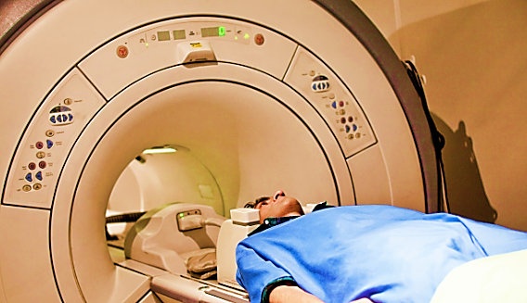
In the brain, MRI can differentiate between white matter and grey matter and can also be used to diagnose aneurysms and tumours. Since MRI does not use x-rays or other radiation, it is the imaging modality of choice when frequent imaging is required for diagnosis or therapy, especially in the brain. However, MRI is more expensive than x-ray imaging or CT scanning.
- CT (COMPUTED TOMOGRAPHY) SCAN: It is a computerized x-ray imaging procedure in which a narrow beam of x-rays is aimed at a patient and quickly rotated around the body, producing signals that are processed by the machine’s computer to generate cross-sectional images, or “slices.”
These slices are called tomographic images and can give a clinician more detailed information than conventional x-rays. Once a number of successive slices are collected by the machine’s computer, they can be digitally “stacked” together to form a three-dimensional (3D) image of the patient that allows for easier identification of basic structures as well as possible tumours or abnormalities.
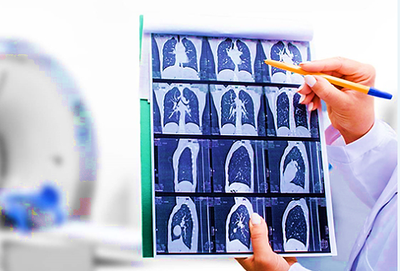

During a CT scan, the patient lies on a bed that slowly moves through the gantry while the x-ray tube rotates around the patient, shooting narrow beams of x-rays through the body. Instead of film, CT scanners use special digital x-ray detectors, which are located directly opposite the x-ray source. As the x-rays leave the patient, they are picked up by the detectors and transmitted to a computer.
CT scans used to identify disease or injury, detecting possible tumours or lesions within the abdomen, suspected heart disease or abnormalities, to image the head in order to locate injuries, tumors, clots leading to stroke, haemorrhage, and other conditions. It can image the lungs in order to reveal the presence of tumors, pulmonary embolisms (blood clots), excess fluid, and other conditions such as emphysema or pneumonia.
- X-Rays: Medical x-rays are used to generate images of tissues and structures inside the body. If x-rays traveling through the body also pass through an x-ray detector on the other side of the patient, an image will be formed that represents the “shadows” formed by the objects inside of the body.
One type of x-ray detector is photographic film, but there are many other types of detectors that are used to produce digital images. The x-ray images that result from this process are called radiographs.

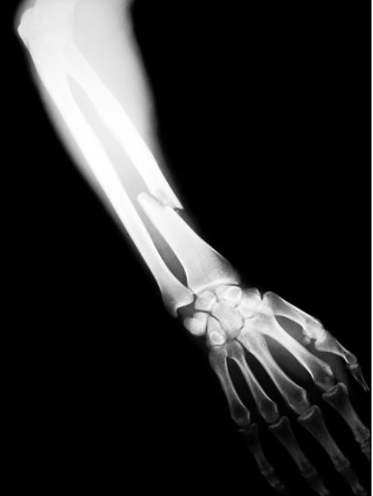
Some of the examples of examinations and procedures that use x-ray technology to either diagnose or treat disease are X-ray radiography, Mammography, Computed tomography (CT), Fluoroscopy, Therapeutic, Radiation therapy in cancer treatment.
- ULTRASOUND: Medical ultrasound falls into two distinct categories: diagnostic and therapeutic.
Diagnostic Ultrasound is a non-invasive diagnostic technique used to image inside the body. Most diagnostic ultrasound probes are placed on the skin. However, to optimize image quality, probes may be placed inside the body via the gastrointestinal tract, vagina, or blood vessels. In addition, ultrasound is sometimes used during surgery by placing a sterile probe into the area being operated on.
Diagnostic ultrasound is able to non-invasively image internal organs within the body. However, it is not good for imaging bones or any tissues that contain air, like the lungs. One of the most common uses of ultrasound is during pregnancy, to monitor the growth and development of the fetus, but there are many other uses, including imaging the heart, blood vessels, eyes, thyroid, brain, breast, abdominal organs, skin, and muscles. Ultrasound images are displayed in either 2D, 3D, or 4D (which is 3D in motion).
Functional ultrasound applications include Doppler and colour Doppler ultrasound for measuring and visualizing blood flow in vessels within the body or in the heartDoppler ultrasound is commonly used to determine whether plaque build-up inside the carotid arteries is blocking blood flow to the brain.
Therapeutic Ultrasound also uses sound waves above the range of human hearing but does not produce images. Its purpose is to interact with tissues in the body such that they are either modified or destroyed.
Therapeutic ultrasound produces high levels of acoustic output that can be focused on specific targets for the purpose of heating, ablating, or breaking up tissue. One type of therapeutic ultrasound uses high-intensity beams of sound that are highly targeted, and is called High Intensity Focused Ultrasound (HIFU).
HIFU is being investigated as a method for modifying or destroying diseased or abnormal tissues inside the body (e.g. tumors) without having to open or tear the skin or cause damage to the surrounding tissue. Either ultrasound or MRI is used to identify and target the tissue to be treated, guide and control the treatment in real time, and confirm the effectiveness of the treatment. HIFU is currently FDA approved for the treatment of uterine fibroids, to alleviate pain from bone metastases, and most recently for the ablation of prostate tissue.
- LAB TESTS: Laboratory tests check sample of human blood, urine, or body tissues. A technician or doctor analyses the test samples to see if patient’s results fall within the normal range. The tests use a range because what is normal differs from person to person. Many factors affect test results. Like: age, sex, what you eat and drink, medicines patient take and how well patient followed pre-test instructions. Laboratory tests are often part of a routine check-up to look for changes in health. They also help doctors diagnose medical conditions, plan or evaluate treatments, and monitor diseases.

- MARKETING, SELLING & DISTRIBUTION PLAN: As per the details shared by the client containing the information of marketing & selling strategy of M/s Dixital technologies India Pvt. Ltd., initially the assigned marketing team will be approaching the local clinics, where the doctor refer the patients to the diagnostic centre. Thus the company will built a new customer base.
MRI, CITY Scan, Ultrasound, Doppler and Pathological test are very important diagnose and treat any patient. It is done by Modern equipment’s under the expert team of radiologist and technicians. The company is in the process of having tie-ups with several Government and semi government agencies clinics. Private Doctors, and hospitals to serve their medical patients on a large scale at the proposed diagnostic center.
However, the promoters/Directors of the company are already running a diagnostic centre in the name of SGD Diagnostic centre at Model Basti, New Delhi and one Hospital in the name of Nulife Hospital at GTB Nagar, New Delhi, in their one other company named M/s HK Nulife Hospital Private Limited for a long which will be helping them to make a faster presence in the market.

PART G | DIAGNOSTIC INDUSTRY OVERVIEW & ANALYSIS

- INTRODUCTION:
Healthcare comprises hospitals, medical devices, clinical trials, outsourcing, telemedicine, medical tourism, health insurance and medical equipment. The Indian healthcare sector is growing at a brisk pace due to its strengthening coverage, services, and increasing expenditure by public as well private players.
The growth in the industry is largely volume-driven and is highly fragmented. That is, dominated by a few large (organised) players and various small and regional players. Analysts point out that 80-85% of the industry is unorganised or dominated by regional players. So far, higher life expectancy and changes in lifestyle, a health-conscious population, and improvement in testing services, could directly contribute to the growth of the companies in the diagnostics industry.
It is observed that the Indian diagnostic market is significantly under-penetrated - pathology tests per 1,000 population in India is 1,111, versus 5,924 in Brazil, 10,000 in Australia, and 20,958 in the US. The number of CT, MRI tests per 1,000 population in India was 36 compared to 53 in Brazil, 144 in the UK, 192 in Australia, and 407 in the US.
The market is highly fragmented and urbanised as standalone centres and hospital-based labs (including government labs) have an 85% share of the market. Urban areas account for 74% of the whole market, though with reasonable penetration in Tier 2 and 3 cities in terms of number of labs.
The outbreak of Covid in 2020 has helped improve volumes and realisations for the companies including Metropolis, Dr Lal Path labs and Vijaya Diagnostics. This also helped in increasing the penetration of testing services across the country. Government too has promised to increase healthcare spending which bodes well for all the companies operating in this industry.
While all the indicators appear to be positive for the industry, it has pricing pressure. That is, the players in the diagnostics industry cannot take advantage of the pricing. Their services are offered at a steep discount considering the competition, particularly from small regional players.
India is a cost competitive compared to its peers in Asia and western countries. The low cost of medical services has resulted in a rise in the country’s medical tourism, attracting patients from across the world. Moreover, India has emerged as a hub for R&D activities for international players due to its relatively low cost of clinical research.

- POTENTIAL FOR GROWTH IN THE DIAGNOSTICS INDUSTRY IN INDIA:
According to various reports in the media, experts expect consolidation in the industry as various Government healthcare-related policies are introduced and implemented. This not only offers potential for growth in the coming years but could also offer pricing advantages for the companies. Indian diagnostics market set to double to $20 billion by FY26.
Further, the penetration of testing centres in India is still low, especially in the rural regions where the dependence on primary health centres is high. This bodes well for diagnostics companies in terms of expansion. For instance, in December last year, Lupin announced the launch of diagnostic labs. Similarly, SRL Diagnostics has planned investments for expansion purposes. Metropolis too said in a statement about expanding to smaller cities.
The diagnostics industry has two categories – pathology (offered by all and accounts for nearly 58% of the revenue in the industry) relates to testing of all major illnesses. And radiology (which accounts for 42% of revenue in the industry) relates to imaging diagnoses such as x-rays, CT scans and Ultrasound.
It is expected that the radiology category has a higher potential to grow in the coming years which is estimated at INR 425 billion by FY 2023. The key differentiator among the large, organised players including Metropolis, Dr Lal Path labs and Vijaya Diagnostics services include pathology and radiology tests, pricing, and services offered.
For instance, Dr Lal Path labs offer better radiology tests compared to other large players. The company offers 1947 radiology tests as of 31, March 2021. Vijaya Diagnostics offers nearly 550 radiology tests.
Specialised tests, which now comprise 15-22% by volume and 40-45% by value, are going to drive growth of the market. Molecular pathology is poised to grow at 35-40% year on year. Wellness tests currently comprises only 1-3% by volume and 10-15% by revenue, but growth is likely to be driven by general wellness and condition-specific monitoring packages.
- MARKET SIZE:
- Indian Healthcare Sector: The Indian healthcare sector is expected to record a three-fold rise, growing at a CAGR of 22% between FY 2016-22 to reach US$ 372 billion in 2022 from US$ 110 billion in 2016. By FY22, Indian healthcare infrastructure is expected to reach US$ 349.1 billion. In FY22, premiums underwritten by health insurance companies grew to Rs. 73,582.13 crore. The health segment has a 33.33% share in the total gross written premiums earned in the country.
The Indian medical tourism market was valued at US$ 2.89 billion in 2020 and is expected to reach US$ 13.42 billion by 2026. India has been ranked 10th in the Medical Tourism Index (MTI) for 2020-21 out of 46 destinations by the Medical Tourism Association. The e-health market size is estimated to reach US$ 10.6 billion by 2025. As per Minister of Health & Family Welfare the doctor, population ratio in the country is 1:854, assuming 80% availability of 12.68 lakh registered allopathic doctors and 5.65 lakh AYUSH doctors.
- Indian Diagnostic Sector: The Indian diagnostics market, now with a size of $10 billion in FY2021, is projected to grow at a compounded annual growth rate (CAGR) of 14% to reach $20 billion by FY 2026 as per new industry research reports. Out of the $10 billion worth market, standalone centres account for 48% market share, followed by hospital labs with 37% share and national chains with 5% share. While the pathology segment contributes 57% to the diagnostic market share, radiology accounts for 43% of the market, comprising tests like computed tomography (CT) scans, magnetic resonance imaging (MRI), colour Doppler ultrasound scans, etc.
This growth will be primarily driven by increasing demographics, urbanisation, penetration, and better realisations per tests. The diagnostic industry in India is characterised by a high degree of fragmentation with over 1, 00,000 labs. This fragmentation poses a challenge in terms of capability, scalability, and quality of labs, but on the other hand, it also provides an opportunity to consolidate newer business models to evolve.
New business models around tele radiology and tele pathology to improve access, quality, and efficiency of diagnostics is an emerging area. Tele radiology was estimated to be a $356 million market in 2020 and is likely to evolve into $700 million market by 2025, growing at a CAGR of 15%. Network of partnerships and supply chain innovations, increased use of technology and digital solutions are also likely to fuel growth.
- RECENT INVESTMENTS/ DEVELOPMENTS: FDI inflow for the drugs and pharmaceuticals sector stood at US$ 19.90 billion from April 2000 to June 2022, according to the data released by Department for Promotion of Industry and Internal Trade (DPIIT). Some of the recent developments in the Indian healthcare industry are as follows:
- As of November 24, 2022, more than 219.88 crore COVID-19 vaccine doses have been administered across the country. As of November 16, 2022, India has exported 28.13 crore vaccine doses.
- Multinational healthcare company Abbott has committed to converting 75 Primary Health Centres (PHCs) to Health and Wellness Centres (HWCs) in nine Indian States, in collaboration with Americares India Foundation, a non-profit organisation dedicated to relief and development in the field of health. This will benefit over 2.5 million people from under-resourced communities every year.
- In November 2022, diabetes management app BeatO raised US$ 33 million in its Series B funding round led by impact investor Light rock India.
- In August 2022, Edelweiss General Insurance partnered with the Ministry of Health, Government of India, to help Indians generate their Ayushman Bharat Health Account (ABHA) number.
- The healthcare and pharmaceutical sector in India had M&A activity worth US$ 4.32 billion in the first half of 2022.
- CHALLENGES WITH THE HEALTHCARE SECTOR:
India imports nearly 90% of its medical devices and for radiology equipment - X- -ray machines, MRI machines, and CT scan machines - the import dependency rises to 95%. There are hardly any multinational companies manufacturing these devices in India. For a nation pushing for self-reliance this is a major red flag. It is time to address the supply chain issues plaguing the sector with local innovation taking the centre stage.
However, key challenges facing the industry include regulatory issues, fragmented market with a low focus on quality, commoditisation and increasing competitive intensity, non-access to specialised resources, and value-conscious Indian customers.
Additionally, some of the key challenges are Inadequate Access, Low Budget, Lack of Preventive Care, Lack of Medical Research, Policymaking, Shortage in Professionals, Paucity of Resources.

- GOVERNMENT INITIATIVES: Some of the major initiatives taken by the Government of India to promote the Indian healthcare industry are as follows:
- In the Union Budget 2022-23: INR 86,200.65 crore was allocated to the Ministry of Health and Family Welfare. Pradhan Mantri Swasthya Suraksha Yojana (PMSSY) was allocated Rs. 10,000 crore. Human Resources for Health and Medical Education was allotted Rs. 7,500 crore. National Health Mission was allotted Rs. 37,000 crore. Ayushman Bharat – Pradhan Mantri Jan Arogya Yojana (AB-PMJAY) was allotted Rs. 6,412 crore. The Government of India approved continuation of ‘National Health Mission’ with a budget of Rs. 37,000 crore. INR 5,156 crore was allocated to the newly announced PM-ABHIM to strengthen India’s health infrastructure and improve the country’s primary, secondary and tertiary care services.
- In July 2022, the World Bank approved a US$ 1 billion loan towards India's Pradhan Mantri-Ayushman Bharat Health Infrastructure Mission.
- In order to promote medical tourism in the country, the government of India is extending the e-medical visa facility to the citizens of 156 countries.
- In May 2022, the Union Government approved grants for five new medical colleges in Gujarat with a grant of Rs. 190 crore each. These colleges will come up in Navsari, Porbandar, Rajpipla, Godhra and Morbi.
- ROAD AHEAD:
The Government aims to develop India as a global healthcare hub, and is planning to increase public health spending to 2.5% of the country's GDP by 2025. The hospital industry in India is forecast to increase to Rs. 8.6 trillion by FY 2022 from INR 4 trillion in FY17 at a CAGR of 16–17%. The growing prevalence of various chronic and infectious diseases such as cancer, cardiovascular diseases, gastrointestinal disorders, renal disorders, and urological problems has significantly increased the demand for getting diagnoses and treatments done for these diseases.
This, in turn, is expected to positively influence the growth of India diagnostic labs market. According to research papers, there were around 1,324,413 new cancer cases reported in India in 2020, out of these, 646,030 were reported in males, and 678,383 were reported in females. Similarly, the number of COVID-19 tests conducted in India as of 9th November 2022 was around 44,664,810. All these tests are conducted in diagnostic laboratories only, thereby supporting market growth.
However, India imports nearly 90% of its medical devices and for radiology equipment - X- -ray machines, MRI machines, and CT scan machines - the import dependency rises to 95%. For a nation pushing for self-reliance this is a major red flag. It is time to address the supply chain issues plaguing the sector with local innovation taking the centre stage.

PART H | SWOT ANALYSIS OF DIAGNOSTIC SECTOR

PART I | PROJECT COST AND MEANS OF FINANCE

As per data/information provided by the company/client, category wise proposed project cost is shown in the below table:
(INR Crores)
Total Project Cost (TPC)
Particulars | Cost
HARD COST | Already Incurred | To be Incurred | Total Cost
Freehold Land & Land Development | 4.38 | 14.40 | 18.78
Civil Construction | 0.00 | 3.46 | 3.46
Plant And Machinery | 0.00 | 7.41 | 7.41
Furniture & Fixtures | 0.00 | 1.77 | 1.77
Miscellaneous Fixed Assets | 0.00 | 0.45 | 0.45
Total Cost (Site wise) | 4.38 | 27.49 | 31.87
SOFT COST | Already Incurred | To be Incurred | Total Cost
Contingencies @2% | 0.00 | 0.26 | 0.26
Trade Deposits, Govt. Deposits and other Advances | 0.00 | 0.15 | 0.15
Interest During Construction (IDC) | 0.00 | 1.75 | 1.75
Working Capital Margin | 0.00 | 0.31 | 0.32
Total Project Cost | 4.38 | 29.96 | 34.35
Note: Cost projections have been provided by the company.

MEANS OF FINANCE
Particulars | Already Done | Proposed | Total
Promoters Contribution | 4.38 | 4.87 | 9.25
Bank Finance (Term Loan) | 0.00 | 25.10 | 25.10
Bank Finance (Working Capital) | 0.00 | 0.50 | 0.50
Total | 4.38 | 30.47 | 34.85
Notes:
- The company has already got an allotment of commercial land admeasuring approx. 363.00 Sq. Mt. at Plot numbers- 41, 42 & 58, Sector-53, Urban Estate, Gurgaon-II, Haryana, in the company’s name.
- The cost of these three plots is estimated at Rs. 18.78 crores, including stamp duty and the cost of sanctioning the map. Out of the total cost, an amount of INR 4.38 crores have already been paid to the HSVP (Haryana Shahri Vikas Pradhikaran), and the balance is proposed to be paid from the bank loan funds.
- Out of the total three plots, two are adjoining each other, and one other is separated from these two plots. Therefore, civil construction includes two separate buildings on these plots. Both the proposed buildings will be facing each other and both buildings will have a basement and three floors (B+G+2). Construction Cost estimates of INR 3.46 crores have been obtained as per architectural firm RS Yadav & Associates, appointed by company for full consultancy and professional solutions in building construction, civil and interior, and other construction work.
- The cost of Plant & Machinery and other fixed Assets has been estimated at Rs. 7.41 crores, including purchases of all the required latest and modern equipment, Plant & Machinery for the proposed radiology and diagnostic centre.
- The Company proposes introducing aesthetic, innovative interiors/furniture& fixtures in the proposed unit. All the furniture/fixture items will be manufactured by purchasing wood from the open market or bought from reputed dealers. As per information provided by the client/company, the cost estimates are assessed by Design Art consultant based on present market rates and offer received from vendors/suppliers. A provision of Rs. 1.77 crores have been made under this head.
- Other assets will mainly consist of Electricals Fitting & Installation, Fire Fighting Systems, Security Equipment, Office Equipment, Air Conditioners, etc. This will also include Office equipment, Computers, Printers, etc. A provision of Rs. 0.45 crores have been made under this head. All the payments will be made directly to the suppliers.
- The Company has estimated the contingency expenses at Rs.0.26 Crores (2% of the project cost). Any contingencies, if they arise, beyond the stipulated amount will be borne by the company from its self-sourced funds.
- The main deposits are projected with the State Electricity Board, Fire NOC, Excise Department, Water Department, Pollution Department, other Approvals, etc. The company has launched these figures (0.15 crores) after consultations with the government bodies and its consultant team. A total of Rs. 0.15 crores have been projected under Trade Deposits, Govt. Deposits and other Advances.
- The company has proposed an amount of Rs. 1.75 Crores. under construction period Interest, and the company is projecting construction & installation of the proposed plant and machinery period for 12 months from December 2022 to November 2023 to construct the proposed factory building with complete installation of the proposed plant and machinery.
- The Working Capital Finance limit of Rs.0.50 crore has been assessed for business purposes, with a projected sale of Rs.12.96 crores for FY 2025. The stocks and receivables holding has been evaluated on market trends and industry-wise requirements for this business.

MEANS OF FINANCE: In the total project cost of Rs. 34.85 crores, it is proposed that the company’s promoters bring in equity of INR 9.25 crores as their share of contribution to the project. The remaining amount of Rs. 25.60 crores will be met through a bank term loan of Rs. 25.10 crores and a balance of Rs. 0.50 crores as bank working capital finance to the company. The Company has already invested approx. 4.38 crores by way of factory land & the remaining amount shall be brought on a pro-rata basis.
Thus the company is fulfilling the criteria for term loan of INR 25.10 Crores and CC limit of INR 0.50 Crore from State Bank of India under Bank’s Aarogyam Non-metro healthcare business loan under Loan Guarantee Scheme for Covid affected Sectors (LGSCAS) where Debt-Equity Ratio of 3:1 and Promoters Contribution Margin of 25% has been stipulated by the bank, as the company planned to establish Diagnostic Centre at Sector-53, Gurugram.

PART J | PROJECT SCHEDULE

Below is the tabulated presentation of the status of the project showing expected duration shared by the project manager of the company:

S. No. | Particulars | Activity | Expected completion date | Status
1. | Acquisition of Land | Land Procurement | December 2022 | Allotment Done.  Title execution in January 2023.
 |  | Land Development | February 2023 | Achieve in Feb 2023
2. | Sanction of Rupee Term Loan | Sanction of Rupee Term Loan | 31st Jan 2023 | Achieve till Jan 2023
3. | Building & Civil Works | Appointment of Architect | March 2023 | Pending
 |  | Building Plan Preparation | March 2023 | Pending
 |  | Building Plan Sanction | March 2023 | Pending
 |  | Appointment of Civil contractor/ developer | April 2023 | Pending
 |  | Building & Civil Works completion | Sep, 2023 | Achieved till 30th Sep 2023
4. | Plant & Machinery | Finalization of P&M suppliers | May 2023-June-2023 | Achieved till June 2023
 |  | Orders to P&M suppliers | May 2023-June-2023 | Achieved till June 2023
 |  | Arrival of P&M | July 2023 | Achieved till August 2023
 |  | Installation of P&M | Sep-2023- Oct 2023 | Achieved till Oct 2023
 |  | Utility Installation | Oct 2023 | Achieved till Oct 2023
5. | Furniture and Fixtures | Purchase of other Fixed Assets/ Furniture & Fixtures | November 2023 | Achieved till Nov 2023
6. | Statutory Approvals, registrations & NOCs |  | December 2023 | Achieved Before Trial Run
7. | Finishing & Trail Run |  | January 2024 | Achieved till Jan 2024
8. | Commercial Operation Date |  | 1st Feb 2024 | Achieved till 1st Feb 2024

Notes:
- Schedule has been made as per feasibility to achieve different milestones.
- Achievement of Milestone will depend on sanction of term loan as per proposed timeline.

PART K | STATUTORY APPROVALS | LICENCES | NOC
As per the information provided by the client below is the list of Approvals required for the proposed project:
S. No. | REQUIRED APPROVALS | REFERENCE NO./ DATE | STATUS  (Approved/ Applied For/ Pending)
1. | Sale Deeds of the Land  Haryana Shehri Vikas Pradhikaran (HSVP) | Post Loan Sanction | To be done on final payments of the land
2. | Building Plan & FSI (Floor Space Index) / FAR (Floor Area Ratio)  Local Authority/HSVP/ Nagar Nigam (As the case may be) | March 2023 | To be obtained before starting the construction work.
3. | Pollution Control Board Clearance  Haryana Pollution Control Board | To be applied in due course | To be obtained before starting the commercial business in the unit.
4. | Electric Load and Maximum Demand  Haryana Electrity Board | To be applied in due course | Shall be applied before starting the construction work.
5. | Water Supply Requirement  Local water body | To be applied in due course | Shall be applied before starting the construction work.
6. | Fire & Safety  Fire & Safety Department | To be applied in due course | Shall be obtained after completion of Building
7. | Labour Law - Registration under Contract Labour law  Labour Commissioner | To be applied in due course | To be registered before COD.
9. | Establishment of Enterprises.  State Nodal Agency, Govt. of Haryana | To be applied in due course | To be obtained before the COD of the unit.
10. | Registration for License under Clinical Establishment Act.  State Bio-Medical Waste treatment Board or Authority | To be applied in due course | Before COD.
11. | National Accreditation Board for Testing and Calibration Laboratories (NABL) Accreditation  Accreditation from National Accreditation Board for Testing and Calibration Laboratories. | To be applied in due course | Before COD.
12. | Consent to Operation (CTO)  Member Secretary, PCB | To be applied in due course | Before COD.
13. | Licenses / Registration under various labour laws, including Contract, Appropriate Authority/ Labour Regulation & Abolition Act  Labour Department | To be applied in due course | Awaited, To be obtained before COD
14. | License for operations from AERB (Atomic Energy Regulatory Board) for running radiology and X-ray centre  E-governance application-LORA (e-Licensing of Radiation Applications) | To be applied in due course | Before COD.

PART L | COMPANY’S FINANCIAL FEASIBILITY

- PROJECTIONS OF THE FIRM: The projections of the firm are done From FY 2023-24 to FY 2032-33 based on the revenue generation capacity of the project and total expected expenses are shown as below:
- PROJECTED PROFIT & LOSS ACCOUNT: Below table shows the Projected Profit & Loss Account of M/s Dixital Technologies India Pvt. Ltd. from the period FY 2024 to FY 2033.
PARTICULARS | Mar-24 | Mar-25 | Mar -26 | Mar -27 | Mar -28 | Mar -29 | Mar -30 | Mar -31 | Mar -32 | Mar -33
Operating Months | 2 | 12 | 12 | 12 | 12 | 12 | 12 | 12 | 12 | 12
Capacity utilisation | 40% | 50% | 60% | 65% | 70% | 75% | 80% | 82% | 84% | 85%
Total Revenue | 1.44 | 10.80 | 12.96 | 14.04 | 15.12 | 16.20 | 17.28 | 17.71 | 18.14 | 18.36
Cost of Stationery and Medicines | 0.16 | 0.52 | 0.55 | 0.57 | 0.60 | 0.63 | 0.66 | 0.67 | 0.69 | 0.72
Power & Fuel | 0.15 | 0.86 | 1.04 | 1.07 | 1.10 | 1.13 | 1.16 | 1.19 | 1.22 | 1.25
Administration & Misc. Expenses | 0.12 | 0.86 | 1.04 | 1.12 | 1.21 | 1.30 | 1.38 | 1.42 | 1.45 | 1.47
Cost of Transportation for patients from Hospitals | 0.02 | 0.11 | 0.13 | 0.14 | 0.15 | 0.16 | 0.17 | 0.18 | 0.18 | 0.18
Salary & Wages | 0.17 | 1.30 | 1.56 | 1.68 | 1.81 | 1.94 | 2.07 | 2.13 | 2.18 | 2.20
Other Operating Expenses | 0.01 | 0.11 | 0.13 | 0.14 | 0.15 | 0.16 | 0.17 | 0.18 | 0.18 | 0.18
CMC Cost for Machinery Maintenance company/ PA | 0.02 | 0.40 | 0.40 | 0.40 | 0.40 | 0.40 | 0.40 | 0.40 | 0.40 | 0.40
Repair & Maintenance (% of Building, P&M) | 0.00 | 0.16 | 0.18 | 0.20 | 0.22 | 0.24 | 0.26 | 0.25 | 0.24 | 0.23
Rent Rates & Taxes (% of Building , &M,MFA) | 0.02 | 0.05 | 0.05 | 0.05 | 0.05 | 0.05 | 0.05 | 0.05 | 0.05 | 0.05
Insurance (of Net Block) | 0.03 | 0.15 | 0.14 | 0.13 | 0.12 | 0.11 | 0.10 | 0.09 | 0.09 | 0.08
Total Cost of Operation | 0.70 | 4.52 | 5.21 | 5.50 | 5.81 | 6.12 | 6.42 | 6.54 | 6.68 | 6.77
% of Revenue | 48.63 | 41.82 | 40.18 | 39.21 | 38.43 | 37.76 | 37.16 | 36.92 | 36.80 | 36.86
EBIDTA | 0.74 | 6.28 | 7.75 | 8.54 | 9.31 | 10.08 | 10.86 | 11.17 | 11.47 | 11.59
Depreciation | 0.31 | 1.84 | 1.60 | 1.40 | 1.22 | 1.06 | 0.93 | 0.81 | 0.71 | 0.62
EBIT | 0.43 | 4.44 | 6.15 | 7.14 | 8.09 | 9.02 | 9.93 | 10.36 | 10.76 | 10.97
Financial Expenses : Interest on Term Loan | 0.33 | 1.96 | 1.82 | 1.65 | 1.63 | 1.71 | 1.38 | 1.02 | 0.61 | 0.14
Financial Expenses : Interest on WC | 0.01 | 0.03 | 0.03 | 0.03 | 0.03 | 0.03 | 0.03 | 0.03 | 0.03 | 0.03
Profit before Tax | 0.08 | 2.46 | 4.30 | 5.46 | 6.43 | 7.28 | 8.52 | 9.31 | 10.12 | 10.80
Income Tax | 0.02 | 0.68 | 1.20 | 1.52 | 1.79 | 2.02 | 2.37 | 2.59 | 2.81 | 3.00
Profit After Tax | 0.06 | 1.77 | 3.10 | 3.94 | 4.64 | 5.25 | 6.15 | 6.72 | 7.30 | 7.80

- PROJECTED BALANCE SHEET: Below table shows the Projected Balance Sheet of M/s Dixital Technology Private Ltd. from the period FY 2024 to FY 2033.
PARTICULARS | Mar-24 | Mar-25 | Mar-26 | Mar-27 | Mar-28 | Mar-29 | Mar-30 | Mar-31 | Mar-32 | Mar-33
Months | 2 | 12 | 12 | 12 | 12 | 12 | 12 | 12 | 12 | 12
Capacity Utilisation | 40% | 50% | 60% | 65% | 70% | 75% | 80% | 82% | 84% | 85%
Capital | 9.25 | 9.25 | 9.25 | 9.25 | 9.25 | 9.25 | 9.25 | 9.25 | 9.25 | 9.25
Reserve & Surplus | 0.06 | 1.83 | 4.94 | 8.88 | 13.52 | 18.77 | 24.92 | 31.63 | 38.94 | 46.73
Long Term Borrowing | 23.80 | 21.88 | 19.48 | 16.96 | 13.96 | 10.96 | 7.36 | 3.40 | 0.00 | 0.00
Short Term Liability (Part of Long Term Liability) | 1.30 | 1.92 | 2.40 | 2.52 | 3.00 | 3.00 | 3.60 | 3.96 | 3.40 | 0.00
Working Capital Loan | 0.50 | 0.50 | 0.50 | 0.50 | 0.50 | 0.50 | 0.50 | 0.50 | 0.50 | 0.50
Sundry Creditors | 0.00 | 0.01 | 0.01 | 0.01 | 0.01 | 0.01 | 0.01 | 0.01 | 0.01 | 0.02
Total | 34.91 | 35.39 | 36.58 | 38.12 | 40.24 | 42.49 | 45.64 | 48.76 | 52.10 | 56.50
Fixed Assets | 33.57 | 31.73 | 30.12 | 28.73 | 27.51 | 26.45 | 25.52 | 24.71 | 24.00 | 23.38
Sundry Debtors | 0.12 | 0.90 | 1.08 | 1.17 | 1.26 | 1.35 | 1.44 | 1.48 | 1.51 | 1.53
Closing Stock | 0.04 | 0.04 | 0.05 | 0.05 | 0.05 | 0.05 | 0.06 | 0.06 | 0.06 | 0.06
Cash & Bank Balances | 0.50 | 1.00 | 1.00 | 1.50 | 1.50 | 2.00 | 2.00 | 2.50 | 2.50 | 2.50
Preliminary Ex. | 0.00 | 0.00 | 0.00 | 0.00 | 0.00 | 0.00 | 0.00 | 0.00 | 0.00 | 0.00
Deposits with Govt. /private | 0.15 | 0.15 | 0.15 | 0.15 | 0.15 | 0.15 | 0.15 | 0.15 | 0.15 | 0.15
Advance Taxes / Loans and advances, Advance to suppliers etc. | 0.53 | 1.57 | 4.18 | 6.52 | 9.97 | 12.49 | 16.47 | 19.86 | 23.88 | 28.88
Total Assets | 34.91 | 35.39 | 36.58 | 38.12 | 40.44 | 42.49 | 45.64 | 48.75 | 52.10 | 56.50

- REVENUE BUILD-UP: Production has been considered based on the capacity utilization start from 40% for 2 months in the initial year and then 50% as a base case (Escalated by 5% for next 5 forecasted years than 2% for next 2 years and then 1% for 1 year) during the estimated period.
PARTICULARS | Mar-24 | Mar-25 | Mar -26 | Mar -27 | Mar -28 |  | Mar -29 | Mar -30 | Mar -31 | Mar -32 | Mar -33
Months | 2 | 12 | 12 | 12 | 12 |  | 12 | 12 | 12 | 12 | 12
Capacity utilisation | 40% | 50% | 60% | 65% | 70% |  | 75% | 80% | 82% | 84% | 85%
MRI SCAN:-
Maximum Capacity of MRI SCAN Tests /Per day |  |  |  |  |  | 40
Selling Price per test |  |  |  |  |  | 5000
Monthly Sale |  |  |  |  |  | INR 60,00,000
Revenue from MRI SCAN TESTS -Sales (PA) | 0.48 | 3.60 | 4.32 | 4.68 | 5.04 |  | 5.40 | 5.76 | 5.90 | 6.05 | 6.12
CT SCAN:-
Maximum Capacity of CT SCAN Tests /Per day |  |  |  |  |  | 40
Selling Price per test |  |  |  |  |  | 4000
Monthly Sale |  |  |  |  |  | INR 4800000
Revenue from CT SCAN TESTS -Sales (PA) | 0.38 | 2.88 | 3.46 | 3.74 | 4.03 |  | 4.32 | 4.61 | 4.72 | 4.84 | 4.90
Colour Doppler/ Ultra Sound SCAN:-
Maximum Capacity of COLOR DOPPLER SCAN Tests /Per day |  |  |  |  |  | 120
Selling Price per test |  |  |  |  |  | 1500
Monthly Sale |  |  |  |  |  | INR 540,0,000
Revenue from COLOR DOPPLER SCAN TESTS -Sales (PA) | 0.43 | 3.24 | 3.89 | 4.21 | 4.54 |  | 4.86 | 5.18 | 5.31 | 5.44 | 5.51
X-RAY SCAN:-
Maximum Capacity of X-RAY SCAN Tests /Per day |  |  |  |  |  | 60
Selling Price per test |  |  |  |  |  | 500
Monthly Sale |  |  |  |  |  | INR 9,00,000
Revenue from X-RAY SCAN TESTS -Sales (PA) | 0.07 | 0.54 | 0.65 | 0.70 | 0.76 |  | 0.81 | 0.86 | 0.89 | 0.91 | 0.92
LAB TESTS:-
Maximum Capacity of LAB TESTS /Per day |  |  |  |  |  | 60
Selling Price per test |  |  |  |  |  | 500
Monthly Sale |  |  |  |  |  | INR 9,00,000
Revenue from LAB TESTS -Sales (PA) | 0.07 | 0.54 | 0.65 | 0.70 | 0.76 |  | 0.81 | 0.86 | 0.89 | 0.91 | 0.92
Total Revenue | 1.44 | 10.80 | 12.96 | 14.04 | 15.12 |  | 16.20 | 17.28 | 17.71 | 18.14 | 18.36

- ESTIMATED KEY FINANCIAL METRICS:
PARTICULARS | Mar-24 | Mar-25 | Mar -26 | Mar -27 | Mar -28 | Mar -29 | Mar -30 | Mar -31 | Mar -32 | Mar -33
Months | 2 | 12 | 12 | 12 | 12 | 12 | 12 | 12 | 12 | 12
Net Profit Margin (%) | 4.20% | 16.42% | 23.95% | 28.06% | 30.68% | 32.42% | 35.57% | 37.94% | 40.25% | 42.46%
EBITDA Margin (%) | 51.37% | 58.18% | 59.82% | 60.79% | 61.57% | 62.24% | 62.84% | 63.08% | 63.20% | 63.14%
EBIT Margin (%) | 29.60% | 41.14% | 47.47% | 50.85% | 53.52% | 55.69% | 57.47% | 58.51% | 59.29% | 59.76%
Revenue Growth (Y.O.Y.) (%) |  | 650.00% | 20.00% | 8.33% | 7.69% | 7.14% | 6.67% | 2.50% | 2.44% | 1.19%

- DEBT SERVICE COVERAGE RATIO (DSCR):
PARTICULARS | Mar-24 | Mar-25 | Mar-26 | Mar-27 | Mar-28 | Mar-29 | Mar-30 | Mar-31 | Mar-32 | Mar-33
Months | 2 | 12 | 12 | 12 | 12 | 12 | 12 | 12 | 12 | 12
Capacity utilisation | 40% | 50% | 60% | 65% | 70% | 75% | 80% | 82% | 84% | 85%
PAT | 0.06 | 1.77 | 3.10 | 3.94 | 4.64 | 5.25 | 6.15 | 6.72 | 7.30 | 7.80
Depreciation | 0.31 | 1.84 | 1.60 | 1.40 | 1.22 | 1.06 | 0.93 | 0.81 | 0.71 | 0.62
Cash Accruals (A) | 0.37 | 3.61 | 4.71 | 5.33 | 5.86 | 6.31 | 7.07 | 7.53 | 8.01 | 8.42
TL Interest (B) | 0.33 | 1.96 | 1.82 | 1.65 | 1.63 | 1.71 | 1.38 | 1.02 | 0.61 | 0.14
Total (A+B) | 0.71 | 5.57 | 6.53 | 6.99 | 7.49 | 8.03 | 8.46 | 8.55 | 8.62 | 8.56
TL Repayment (C) | 0.00 | 1.30 | 1.92 | 2.40 | 2.52 | 3.00 | 3.00 | 3.60 | 3.96 | 3.40
Total (B+C) | 0.33 | 3.26 | 3.74 | 4.05 | 4.15 | 4.71 | 4.38 | 4.62 | 4.57 | 3.54
Gross DSCR (A+B)/(B+C) | 2.12 | 1.71 | 1.74 | 1.72 | 1.80 | 1.70 | 1.93 | 1.85 | 1.89 | 2.42
Average Gross DSCR | 1.89
Maximum Gross DSCR | 2.42
Net DSCR (A/C) |  | 2.78 | 2.45 | 2.22 | 2.32 | 2.10 | 2.36 | 2.09 | 2.02 | 2.48
Average Net DSCR | 2.31
Maximum Net DSCR | 2.48

- SECURITY MARGIN AND FIXED ASSET COVERAGE RATIO (FACR):
PARTICULARS | Mar-24 | Mar-25 | Mar-26 | Mar-27 | Mar-28 | Mar-29 | Mar-30 | Mar-31 | Mar-32 | Mar-33
Months | 2 | 12 | 12 | 12 | 12 | 12 | 12 | 12 | 12 | 12
Capacity utilisation | 40% | 50% | 60% | 65% | 70% | 75% | 80% | 82% | 84% | 85%
WDV of Fixed Assets | 33.57 | 31.73 | 30.12 | 28.73 | 27.51 | 26.45 | 25.52 | 24.71 | 24.00 | 23.38
Aggregate TL Outstanding | 23.80 | 21.88 | 19.48 | 16.96 | 13.96 | 10.96 | 7.36 | 3.40 | 0.00 | 0.00
Security Margin available | 9.77 | 9.85 | 10.64 | 11.77 | 13.55 | 15.49 | 18.16 | 21.31 | 24.00 | 23.38
% Margin | 29.10 | 31.04 | 35.34 | 40.97 | 49.26 | 58.56 | 71.16 | 86.24 | 100.0 | 100.0
Fixed asset coverage ratio (FACR) | 1.41 | 1.45 | 1.55 | 1.69 | 1.97 | 2.41 | 3.47 | 7.27 | - | -

- GRAPHICAL REPRESENTATION OF KEY FINANCIAL METRICS:
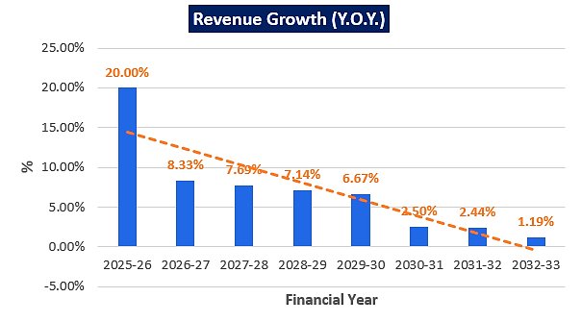
EBITDA MARGIN %

Below graph shows the EBITDA Margin of the project during the forecasted period, while margin are constantly growing during the forecasted period. EBITDA margins are higher as compared to industry standards and peers due to absence of rental/lease expenses as company has decided to own the land, building, plant & machinery in its name.
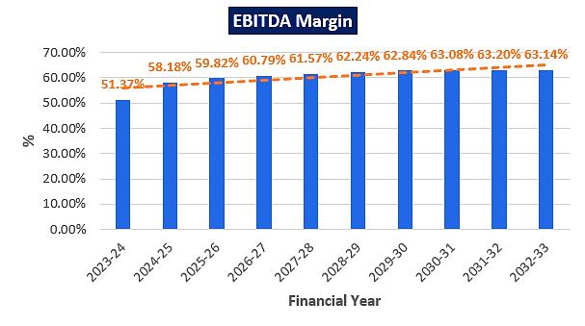

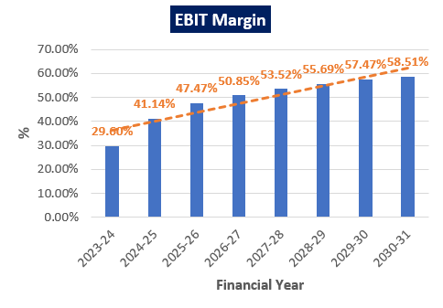

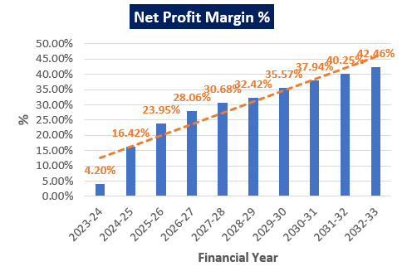

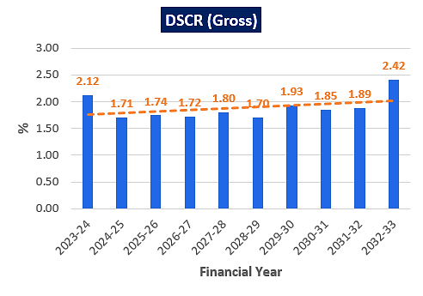

- SENSITIVITY ANALYSIS:
PARTICULARS | Mar-24 | Mar-25 | Mar-26 | Mar-27 | Mar-28 | Mar-29 | Mar-30 | Mar-31 | Mar-32 | Mar-33
Months | 2 | 12 | 12 | 12 | 12 | 12 | 12 | 12 | 12 | 12
Capacity utilisation | 40% | 50% | 60% | 65% | 70% | 75% | 80% | 82% | 84% | 85%
Sales % Variation | 5% | 5% | 5% | 5% | 5% | 5% | 5% | 5% | 5% | 5%
Variation expense % | 5% | 5% | 5% | 5% | 5% | 5% | 5% | 5% | 5% | 5%
Fixed expense % Variation | 5% | 5% | 5% | 5% | 5% | 5% | 5% | 5% | 5% | 5%
Sales (with Variation) | 1.37 | 10.26 | 12.31 | 13.34 | 14.36 | 15.39 | 16.42 | 16.83 | 17.24 | 17.44
VC (with variation) | 0.51 | 3.09 | 3.50 | 3.66 | 3.83 | 3.99 | 4.16 | 4.22 | 4.30 | 4.36
FC (with variation) | 0.78 | 4.84 | 4.73 | 4.50 | 4.43 | 4.48 | 4.17 | 3.76 | 3.32 | 2.82
PBT | 0.08 | 2.33 | 4.08 | 5.18 | 6.11 | 6.91 | 8.09 | 8.84 | 9.61 | 10.26
PBT % | 5.81 | 22.75 | 33.17 | 38.87 | 42.51 | 44.92 | 49.29 | 52.56 | 55.77 | 58.82
PAT72.18% | 0.06 | 1.68 | 2.95 | 3.74 | 4.41 | 4.99 | 5.84 | 6.38 | 6.94 | 7.41
Cash Accruals (A) | 0.36 | 3.43 | 4.47 | 5.07 | 5.56 | 6.00 | 6.72 | 7.15 | 7.61 | 8.00
TL Interest (B) | 0.32 | 1.86 | 1.73 | 1.57 | 1.55 | 1.63 | 1.32 | 0.97 | 0.58 | 0.13
Total (A+B) | 0.67 | 5.29 | 6.20 | 6.64 | 7.12 | 7.63 | 8.04 | 8.13 | 8.19 | 8.13
Total (B+C) | 0.32 | 3.16 | 3.65 | 3.97 | 4.07 | 4.63 | 4.32 | 4.57 | 4.54 | 3.53
Gross DSCR (A+B)/(B+C) | 2.12 | 1.68 | 1.70 | 1.67 | 1.75 | 1.65 | 1.86 | 1.78 | 1.80 | 2.30

- COST-VOLUME PRICE OR SENSITIVITY:
PARTICULAR | Mar-28 | Mar-29 | Mar-30 |  | Mar-31 | Mar-32 | Mar-33
COST-VOLUME PRICE OR SENSITIVITY ANALYSIS |  | 10% increase in variable cost | 10% decrease in volume of sales |  | 10% decrease in selling price | Decrease in Revenue by 5% and Increase in Opex by 5% and Interest Rate Increase by 1%
Operating Profit Before Interest | 9.31 | 10.08 | 10.86 |  | 11.17 | 11.47 | 11.59
Sales | 15.12 | 15.12 | 13.61 |  | 13.61 | 14.36 | 14.36
Variable expenses | 4.03 | 4.43 | 4.43 |  | 4.43 | 4.65 | -
Contribution | 11.09 | 10.69 | 9.18 |  | 9.18 | 9.71 | -
Fixed Expenses | 4.67 | 4.67 | 4.67 |  | 4.67 | 4.67 | -
Operating profit (3- 4) | 6.43 | 6.02 | 4.51 |  | 4.51 | 5.05 | -
Break-even sales | 6.36 | 6.60 | 6.92 |  | 6.92 |  | -
Tax | 1.79 | 1.68 | 1.26 |  | 1.26 | 1.40 | -
PAT | 4.64 | 4.35 | 3.26 |  | 3.26 | 3.64 | -
Depreciation | 1.22 | 1.22 | 1.22 |  | 1.22 | 1.22 | -
Cash Accruals (A) | 5.86 | 5.57 | 4.48 |  | 4.48 | 4.86 | -
TL Interest (B) | 1.63 | 1.63 | 1.63 |  | 1.63 | 1.63 | -
Total (A+B) | 7.49 | 7.20 | 6.11 |  | 6.11 | 6.50 | -
TL Repayment (C) | 2.52 | 2.52 | 2.52 |  | 2.52 | 2.52 | -
Total (B+C) | 4.15 | 4.15 | 4.15 |  | 4.15 | 4.15 | -
Gross DSCR (A+B)/(B+C) | 1.80 | 1.73 | 1.47 |  | 1.47 | 1.56 | -
Net DSCR (A/C) | 2.32 | 2.21 | 1.78 |  | 1.78 | 1.93 | -
Increase in Interest Rate by 1.00% |  |  |  |  | 1.65
Gross DSCR |  |  |  | 2.80

DSCR AT DIFFERENT CAPACITIES

Sensitivity Condition | Minimum DSCR
Base Case Scenario | 1.8
Decrease in Revenue by 10% | 1.47
Increase in Opex by 10% | 1.73
Increase in Interest rate by 1% | 1.79
Decrease in Revenue by 5% and Increase in Opex by 5% and Interest Rate Increase by 1% | 1.93

BREAK-EVEN ANALYSIS

PARTICULARS | Mar-24 | Mar-25 | Mar-26 | Mar-27 | Mar-28 | Mar-29 | Mar-30 | Mar-31 | Mar-32 | Mar-33
Months | 2 | 12 | 12 | 12 | 12 | 12 | 12 | 12 | 12 | 12
Capacity utilisation | 40% | 50% | 60% | 65% | 70% | 75% | 80% | 82% | 84% | 85%
Sales (S) | 1.44 | 10.80 | 12.96 | 14.04 | 15.12 | 16.20 | 17.28 | 17.71 | 18.14 | 18.36
PBT | 0.08 | 2.46 | 4.30 | 5.46 | 6.43 | 7.28 | 8.52 | 9.31 | 10.12 | 10.80
% of VC | 37.32 | 30.10 | 28.41 | 27.42 | 26.63 | 25.94 | 25.34 | 25.09 | 24.96 | 25.03
VC (V) | 0.54 | 3.25 | 3.68 | 3.85 | 4.03 | 4.20 | 4.38 | 4.44 | 4.53 | 4.59
FC (F) | 0.82 | 5.09 | 4.98 | 4.73 | 4.67 | 4.72 | 4.39 | 3.96 | 3.50 | 2.97
Contribution (S-V) | 0.90 | 7.55 | 9.28 | 10.19 | 11.09 | 12.00 | 12.90 | 13.27 | 13.61 | 13.77
Breakeven Sales (F/C*S) | 1.31 | 7.29 | 6.95 | 6.52 | 6.36 | 6.37 | 5.87 | 5.29 | 4.66 | 3.96
Breakeven installed capacity (F/C*U) | 0.36 | 0.34 | 0.32 | 0.30 | 0.29 | 0.30 | 0.27 | 0.24 | 0.22 | 0.18
Cash Breakeven Installed capacity (F-Depreciation/C*U) | 0.22 | 0.22 | 0.22 | 0.21 | 0.22 | 0.23 | 0.21 | 0.19 | 0.17 | 0.14
Break-Even Sales, breakeven installed capacity and cash breakeven installed capacity of the company has been shown in the above table during the forcasted period. Therefore, given the fixed costs and variable costs, and selling price of all the rediology medical tests, Company would need to sell its services as per numbers calculated in the above table to break even.
- LOAN AMORTIZATION SCHEDULE: As per Loan disbursement and amortization schedule shared by the banker, according to the project costs incurred during the estimated period below table shows the balance of principle and intrest during the projected period.
PARTICULARS | Numbers in lakhs
Cost of Project (COP) | 34.35
Debt-Equity Ratio | 2.71
Term Loan | 25.10
Loan Sanctioned | 25.10
No. of Instalment | 104
Gestation Period | 18
Rate of Interest | In %
1st- 5 years | 7.95%
2nd-5 years | 11.00%

PARTICULARS | Mar-23 | Mar-24 | Mar-25 | Mar-26 | Mar-27 | Mar-28 | Mar-29 | Mar-30 | Mar-31 | Mar-32 | Mar-33 | Total
Interest Expanses Yearly | 0.28 | 1.80 | 1.96 | 1.82 | 1.65 | 1.63 | 1.71 | 1.38 | 1.02 | 0.61 | 0.14 | 14.02
Repayment of Principal Yearly | 0.00 | 0.00 | 1.30 | 1.92 | 2.40 | 2.52 | 3.00 | 3.00 | 3.60 | 3.96 | 3.40 | 25.10
Total Repayment | 0.28 | 1.80 | 3.26 | 3.74 | 4.05 | 4.15 | 4.71 | 4.38 | 4.62 | 4.57 | 3.54 | 39.12

- KEY ASSUMPTIONS & BASIS:
S. No. | Item | Assumptions and Basis
 | General | - The projections of the firm are done for the period from FY 2023-24 to FY 2032-33, 10 years) to cover the term loan period.  - We have considered Revenue and cost based model while making the future financial projections.
 | Revenue Build up | - Total income for the financial years during the forecasted period will be generating from selling of radiology tests.  - Revenue has been estimated in line of the prevailing market rates in Delhi-NCR. Since the Nulife Group is also coming up with Nuclear Medicine Centre with Gama Camera diagnosis in the adjoining premises it would be helpful for the company.  - Monthly sales has been calculated based on the assumption of expected average test per day multiplied by average selling price per day and then calculated annually for all the tests.  - Total revenue has been calculated based on the assumption of, monthly sales from all the tests multiplied by assumed capacity utilisation for that particular year.  - Thus the company is generating INR 10.80 Crores in the initial year which is in the line with historical trends. Further it has increased up to INR 18.36 Crores till FY 2032-33.  - Therefor the company is achieving a revenue growth rate Y-o-Y basis, which is also in the line with industrial & economic trends and on conservative side.
 | Pricing (Average Revenue Per test Per Annum) | - Company has decided INR 5000 per MRI Tests, 4000 per CT scan, 1500 per colour Doppler/ultra sound and 500 per X-ray and lab test both.  - We have also verified it with invoices shared by the company for their existing Diagnostic centre (SDG Labs).  - Factors such as prominent location, past rich experience of promoters, latest data in public domain, peers pricing has been considered to rectifying the said prices of proposed services.
 | Capacity Utilization | - For the proposed new radiology centre, since the company’s promoters are having prior experience in the same industry, thus initially we have assumed a 40% capacity utilization for starting 2 months and then for next 2 years there is 10% escalation rate, then 5% escalation rate for next 4 years and then 2% and 1% escalation rate for last 2 years has been considered because the new proposed centre will take some time to achieve the economies of scale and will operate at a higher capacity in the later years.  - Hence, the company’s capacity utilization has been envisaged at 50% of available capacity for the first full operating year, 60% in the Second, 65% in the third year, 70% in the fourth year, 75% in the fifth year, 80% in the Sixth year, 82% in the seventh and 84% in the eighth year, 85% in the Ninth year.  - We have considered the capacity utilization on conservative basis to keep a mark-up for future market & economic risks in the Project.
 | Capital Expenditure | - As per discussion with the client, company has made a decision to purchase a land through auction from HUDA, which is economically viable, since the lease/rent rate of the property at the said location is very much higher on monthly/annual basis.  - The freehold land for proposed project, costs 18.78 Lakhs to the company, the company has already spent 4.38 lakhs for the purchase land and still they have to pay 14.40 lakhs to get full authorization on land.  - The proposed building's total construction cost is approx. INR 3.46 Crores including applicable GST charges.  - The company has an agreement with Delhi-based renowned Architectural firm M/s RS Yadav & Associates to get help in the construction, civil work, and designing of the proposed unit as per industry norms. Construction estimates of Rs. 3.46 crores have also been obtained from this architectural firm.  - The cost of Plant & Machinery and other fixed Assets has been estimated at Rs. 7.41 crores, including purchases of all the required equipment for the proposed radiology and diagnostic centre.  - As per shared quotations and purchase orders, tertiary research and information available in the public domain, we found that the cost of proposed plant and machinery is reasonable in case of pre-owned equipment such as MRI etc.  - For the expensive machines like MRI and CITY Scan machinery, company has made an economically viable decision of purchasing second hand machinery because as per the information available in public domain the new machinery will be costing approx. INR 13.00-14.00 Crore, which will be costing much higher than company’s expected budget.  - All the furniture and fixture items will be manufactured by purchasing wood from the open market or bought from reputed dealers. A provision of Rs. 1.77 crores have been made for the furniture and fixture.  - Other assets will mainly consist of Electricals Fitting & Installation, Fire Fighting Systems, Security Equipment, Office Equipment, Air Conditioners, etc. This will also include Office equipment, Computers, Printers, etc. Total cost of Rs. 0.45 crores have been considered under this head.
 | Expenses | - Major expenses includes Cost of Stationery and Medicines, power & fuels, Administration & Misc. Exp, Cost of Transportation, Salary & Wages, Other Operating Expenses, CMC Cost for Machinery Maintenance, Repair & Maintenance, Rent Rates & Taxes, Insurance etc.  - For the proposed radiology centre, the cost of stationery and medicines for full capacity will be Rs. 5, 00,000 per month. As per our independent research and information available on public domain this cost is proportionated to the number of test done in that year, which is in line with the industry standards.  - As per tertiary research regarding the average number of employees required to operate a radiology centre and proposed employees details shared by the client, we have considered salary and wages as 12% of the revenue earned in that particular year. The company will be having 35 employees initially to start the operations of radiology centre. Average salary is being provided by the client based on the trending in the market.  - CMC is estimated by the company as INR 40 lakhs which seems to be reasonable since they are purchasing pre owned MRI and City scan machinery which will be under 1 year of warranty, as per quotation provided by suppliers. And life of the machineries are expected to be 10 years. However we have relied upon these figures in good faith, as it is estimated by the experienced company officials after the discussion with technical consultant, venders and suppliers. Cost vetting was out of scope of work.  - All the other cost are considered as a % of revenue and are growing with the company’s revenue as it is growing Y-o-Y basis, which is also in the line with industrial & economic trends and on conservative side.  - As compared to industry trends and peers scales, Company is expected to have a higher EBITDA due absence of rental/lease expenses.
 | Partial Loan | - Term loan of INR 25.10 Crores and CC limit of INR 0.50 Crore from State Bank of India under Bank’s Aarogyam Non-metro healthcare business loan under Loan Guarantee Scheme for Covid affected Sectors (LGSCAS) where Debt-Equity Ratio of 3:1 and Promoters Contribution Margin of 25% has been stipulated by the bank, as the company planned to establish Diagnostic Centre at Sector-53, Gurugram.  - The tenure of the loan will be 10 years in which first one years will be considered as moratorium period.  - Interest rate has been decided for first 5 years will be 7.95% and for next 5 years it will be 11% applied by the bank.  - Thus the loan repayment period will be from FY 2025 to FY 2033.
Conclusion:
      - DSCR, EBITDA and EBIT margin is positive in all years starting from initial year on 40% utilization capacity which has assumed maximum up to 85% up to end of 9th year.
      - DSCR, has achieved more than 1 during the loan repayment period.
      - Average Net DSCR, EBIDTA margin, EBIT margin is 2.31, 60.62%, and 51.33% respectively during the estimated period.
      - Based on the above key financial ratios of the Project during the forecast period for the proposed project shows that the project looks financially viable if the Project Company & promoters are able to maintain minimum capacity utilization, revenue and can contain cost as assumed above.
PART M | CONCLUSION

Based on the technological, economical and market analysis done above, various Industry assumptions taken, pricing to be adopted by the company, the Project appears to be Techno-commercially viable subject to the risks, threats, weaknesses, limitations of the services and equipment as detailed previously.
As per financial projections for the estimated period, Average Net DSCR, EBITDA Margin of the project are 2.31, and 60.62% respectively, where higher DSCR is the indicator of the project capability to pay out its outstanding debt and EBITDA margin shows the capability of the project to generate the operating profits over the forecasted period. While it is not avoidable that the future projections may change in the upcoming years due to various factors impacting the operation, managerial, financial efficiency and economies of scale of the project.
It would be depending on the management’s capability in future that how efficiently company adopts marketing and advertisement strategy, supply chain and carry out inventory & resource management to achieve higher profitability. Company is yet to identify its key customers and to form strategic planning for tie-up & services promotion with customers to increase the capacity utilization which remains a major concern. Bank/ Financial Institution is advised to take firm plan from the company in this regard before taking any decision.
After considering the foreseen high demand of the data centres domestically and globally, various initiatives taken by government, financial analysis of the project based on the assumptions taken over the projected period, it appears reasonable to comment that the proposed project is “Technically and Economically” Viable subject to current assumptions considered and occurring the same in the upcoming years same as the forecasted period which is dependent on the sincerity and efforts of the management and various micro and macroeconomic & industry situation.
We have tried our level best to analyse the Project techno-economic feasibility of the Project based on the Industry research, Project information and various futuristic assumption taken. However achieving the financial milestones depends on the ability, sincerity and efforts of the company, promoters and its key managerial performance.

Declaration | - The undersigned does not have any direct/indirect interest in the above property.  - The information furnished herein is true and correct to the best of our knowledge, logical and scientific assumptions.  - This TEV Report is carried out by our Financial Analyst team on the request from State Bank of India, S.M.E Asaf Ali Road Branch, New Delhi.  - Meeting of Financial projections will be subject to subject to the market & economy stability factors, judicious business operations and proper & timely implementation of its process & product re-engineering & improvements plans for achieving high productivity, efficiency and achieving cost saving benefits.  - We have submitted TEV report to the Client.
Name & Address of consultant company |  |  | Signature of the authorized person
M/s. R.K. Associates Valuer & Techno Engineering Consultants Pvt. Ltd.
D-39, 2nd Floor. Sector-2, Noida- 201301
Enclosed Documents |  | Disclaimer & Remarks 72-75
Number of Pages in the Report |  | 75
Financial Analyst Team worked on the report |  | PREPARED BY: Mrs Chhavi Toshan
 |  | REVIEWED BY: Mr Gaurav Kumar

For R.K Associates Valuer & Techno Place: Noida

Engineering Consultants (P) Ltd. Date: 02/01/2023

(Authorized Signatory)

PART N | DISCLAIMER | REMARKS

      - No employee or member of R.K Associates has any direct/ indirect interest in the Project.
      - This report is prepared based on the copies of the documents/ information which the Bank/ Company has provided to us out of the standard checklist of documents sought from them and further based on our assumptions and limiting conditions. The client/owner and its management/representatives warranted to us that the information they supplied was complete, accurate and true and correct to the best of their knowledge. All such information provided to us has been relied upon in good faith and we have assumed that it is true and correct in all respect. I/We shall not be liable for any loss, damages, cost or expenses arising from fraudulent acts, misrepresentations, or wilful default on part of the owner, company, its directors, employee, representative or agents. Verification or cross checking of the documents provided to us from the originals or from any Govt. departments/ Record of Registrar has not been done at our end since this is beyond the scope of our work. If at any time in future, it is found or came to our knowledge that misrepresentation of facts or incomplete or distorted information has been provided to us then this report shall automatically become null & void.
      - Legal aspects for e.g. investigation of title, ownership rights, lien, charge, mortgage, lease, sanctioned maps, verification of documents, etc. have not been done at our end and same has to be taken care by legal expert/ Advocate. It is assumed that the concerned Lender/ Financial Institution has satisfied them with the authenticity of the documents, information given to us and for which the legal verification has been already taken and cleared by the competent Advocate before requesting for this report. I/ We assume no responsibility for the legal matters including, but not limited to, legal or title concerns.
      - This report is a general analysis of the project based on the scope mentioned in the report. This is not an Audit report, Design document, DPR or Techno feasibility study. All the information gathered is based on the facts seen on the site during survey, verbal discussion & documentary evidence provided by the client and is believed that information given by the company is true best of their knowledge.
      - This Techno Economic-Viability study is prepared based on certain futuristic assumption which are intra dependent on economic, market and sectorial growth condition in future and socio-economic, socio-political condition at macro and micro level.
      - Meeting of assumption and financial ratio will entirely depend on the sincerity and efforts of the company, promoters and its key managerial performance.
      - All observations mentioned in the report is only based on the visual observation and the documents/ data/ information provided by the client. No mechanical/ technical tests, measurements or any design review have been performed or carried out from our side during Project assessment.
      - Bank/FII should ONLY take this report as an Advisory document from the Financial/ Chartered Engineering firm and its specifically advised to the creditor to cross verifies the original documents for the facts mentioned in the report which can be availed from the borrowing company directly.
      - In case of any default in loans or the credit facility extended to the borrowing company, R.K Associates shall not be held responsible for whatsoever reason may be and any request for seeking any explanation from the employee/s of R.K Associates will not be entertained at any instance or situation.
      - The documents, information, data provided to us during the course of this assessment by the client are reviewed only up to the extent required in relation to the scope of the work. No document has been reviewed beyond the scope of the work.
      - This report only contains general assessment & opinion as per the scope of work evaluated as per the information given in the copy of documents, information, data provided to us and/ and confirmed by the owner/ owner representative to us at site which has been relied upon in good faith. It doesn’t contain any other recommendations of any sort including but not limited to express of any opinion on the suitability or otherwise of entering into any transaction with the borrower.
      - We have relied on data from third party, external sources & information available on public domain also to conclude this report. These sources are believed to be reliable and therefore, we assume no liability for the truth or accuracy of any data, opinions or estimates furnished by others that have been used in this analysis. Where we have relied on data, opinions or estimates from external sources, reasonable care has been taken to ensure that such data has been correctly extracted from those sources and /or reproduced in its proper form and context, however still we can’t vouch its authenticity, correctness or accuracy.
      - This Report is prepared by our competent technical team which includes Engineers and financial experts & analysts.
      - This is just an opinion report and doesn’t hold any binding on anyone. It is requested from the concerned Financial Institution which is using this report for taking financial decision on the project that they should consider all the different associated relevant & related factors also before taking any business decision based on the content of this report.
      - All Pages of the report including annexure are signed and stamped from our office. In case any paper in the report is without stamp & signature then this should not be considered a valid paper issued from this office.
      - Though adequate care has been taken while preparing this report as per its scope, but still we can’t rule out typing, human errors, over sightedness of any information or any other mistakes. Therefore, the concerned organization is advised to satisfy themselves that the report is complete & satisfactory in all respect. Intimation regarding any discrepancy shall be brought into our notice immediately. If no intimation is received within 15 (Fifteen) days in writing from the date of issuance of the report, to rectify these timely, then it shall be considered that the report is complete in all respect and has been accepted by the client up to their satisfaction & use and further to which R.K Associates shall not be held responsible in any manner.
      - Defect Liability Period is 15 DAYS. We request the concerned authorized reader of this report to check the contents, data and calculations in the report within this period and intimate us in writing if any corrections are required or in case of any other concern with the contents or opinion mentioned in the report. Corrections only related to typographical, calculation, spelling mistakes, incorrect data/ figures/ statement will be entertained within the defect liability period. Any new changes for any additional information in already approved report will be regarded as additional work for which additional fees may be charged. No request for any illegitimate change in regard to any facts & figures will be entertained.
      - R.K Associates encourages its customers to give feedback or inform concerns over its services through proper channel at valuers@rkassociates.org in writing within 15 days of report delivery. After this period no concern/ complaint/ proceedings in connection with the Techno- Economic Viability Study Services will be entertained due to possible change in situation and condition of the subject Project.
      - Our Data retention policy is of ONE YEAR. After this period, we remove all the concerned records related to the assignment from our repository. No clarification or query can be answered after this period due to unavailability of the data.
      - This Techno Economic Viability Study report is governed by our (1) Internal Policies, Processes & Standard Operating Procedures, (2) Information/ Data/ Inputs given to us by the client and (3) Information/ Data/ Facts given to us by our field/ office technical team. Management of R.K Associates never gives acceptance to any unethical or unprofessional practice which may affect fair, correct & impartial assessment and which is against any prevailing law. In case of any indication of any negligence, default, incorrect, misleading, misrepresentation or distortion of facts in the report then it is the responsibility of the user of this report to immediately or at least within the defect liability period bring all such act into notice of R.K Associates management so that corrective measures can be taken instantly.
      - R.K Associates never releases any report doing alterations or modifications from pen. In case any information/ figure of this report is found altered with pen then this report will automatically become null & void.
      - If this report is prepared for the matter under litigation in any Indian court, no official or employee of R.K Associates will be under any obligation to give in person appearance in the court as a testimony. For any explanation or clarification, only written reply can be submitted on payment of charges by the plaintiff or respondent which will be 10% of the original fees charged where minimum charges will be Rs. 15,000/.

