**File No.: VIS(2022-23)-PL569-463-786 Dated: 26-04-2023**

**PROJECT COMPLETION REPORT**

**OF**

**12.82 MW GRID TIED SOLAR ROOF TOP POWER PLANT**

**SET-UP AT**

**27 LOCATIONS IN INDIA**

**COMPANY/PROMOTER**

**JYOTIKIRAN ENERGY MUMBAI PVT. LTD.**

**REPORT PREPARED FOR**

**JYOTIKIRAN ENERGY MUMBAI PVT. LTD.**

**TO BE SUBMITTED AT**

**STATE BANK OF INDIA, SME BRANCH, SOUTH EXTENSION, DELHI**

***\*\*Important - In case of any query/ issue or escalation you may please contact Incident Manager***

***at le@rkassociates.org. We will appreciate your feedback in order to improve our services.***

***NOTE: As per IBA Guidelines please provide your feedback on the report within 15 days of its submission after which report will be considered to be correct.***

**IMPORTANT NOTICE**

***COPYRIGHT FORMAT:*** *This report is prepared on the copyright format of R.K Associates to serve our clients with the best possible information and analysis to facilitate them to take rational business decisions. Legally no one can copy or distribute this format without prior approval from R.K Associates. It is meant only for the advisory/ reference purpose for the organization/s as mentioned on the cover page of this report. Distribution or use of this format by any organization or individual other than R.K Associates will be seen as an unlawful act and necessary legal action can be taken against the defaulters.*

*This report is intended for the sole use of the intended recipient/s and contains material that is STRICTLY CONFIDENTIAL AND PRIVATE.*

***DEFECT LIABILITY PERIOD:*** *- In case of any query/ issue or escalation you may please contact Incident Manager at*[*le@rkassociates.org*](mailto:le@rkassociates.org)*.*

*Though adequate care has been taken while preparing this report as per its scope, but still we can’t rule out typing, human errors, over sightedness of any information or any other mistakes. Therefore, the concerned organization is advised to satisfy themselves that the report is complete & satisfactory in all respect. Intimation regarding any discrepancy shall be brought into our notice immediately. If no intimation is received within 15 (Fifteen) days in writing from the date of issuance of the report, to rectify these timely, then it shall be considered that the report is complete in all respect and has been accepted by the client upto their satisfaction & use and further to which R.K Associates shall not be held responsible in any manner.*

|  |  |  |
| --- | --- | --- |
| **TABLE OF CONTENTS** | | |
|  | | |
| **SECTIONS** | **PARTICULARS** | **PAGE NO.** |
| **Part A** | **REPORT SUMMARY** | 03 |
| **Part B** | **INTRODUCTION** | 05 |
|  | 1. Name of the Project | 05 |
| 1. Project Overview | 05 |
| 1. Scope of the Report | 08 |
| 1. Purpose of the Report | 08 |
| 1. Methodology Adopted | 09 |
| **Part C** | **PROJECT LOCATION AND CAPACITY** | 10 |
| **Part D** | **PROJECT WISE COD AND CURENT STATUS** | 12 |
| **Enclosure-I** | **PHOTOGRAPHS** | 17 |
| **Enclosure-II** | **PROJECT RELATED DOCUMENTS** | 31 |
| **Part E** | **DISCLAIMER** | 35 |

|  |  |
| --- | --- |
| **PART A** | **REPORT SUMMARY** |

|  |  |  |
| --- | --- | --- |
|  | **Name of the Project** | 12,818.3 KW Grid Tied Solar Rooftop Photo Voltaic |
|  | **Project Location** | 29 locations across PAN India |
|  | **Name of the Borrower Company/ Promoter** | M/s Jyotikiran Energy Mumbai Pvt. Ltd. |
|  | **Prepared for Organization** | State Bank of India, SME Branch, South Extension, Delhi |
|  | **LIE Consultant Firm** | M/s. R.K. Associates Valuers & Techno Engineering Consultants (P) Ltd |
|  | **Date of Survey** | 23-Jan-2023 to 25-Apr-2023 |
|  | **Date of Report** | 26-04-2023 |
|  | **Details & documents provided by** | Mr. Prashant Malhotra, Senior Manager, Project Finance  **E-mail:** [pmalhotra@sunsource-energy.com](mailto:pmalhotra@sunsource-energy.com)  **Mob:** +91 99538 90449  Mr. Shekhar Biswas Deputy Manager, Asset Management,  **E-mail:** [shekhar.biswas@sunsource-energy.com](mailto:shekhar.biswas@sunsource-energy.com)  **Mob:** +91 88879 69504 |
|  | **Survey in presence of** | |  |  |  | | --- | --- | --- | | 1 | Mr. Abhishek Jain Designation: Assistant Manager | +91-9958277543 | | 2 | Mr. Ajay Bisht Designation: Asset Management Executive | +91-8368473577 | | 3 | Mr. Gourav Goyal Designation: Assistant Manager | +91-9599198719 | | 4 | Mr. Tajuddin Menduk Designation: Executive | +91-9967647262 | | 5 | Mr. Vishal Kumar Bharti  Designation: Assistant Manager | +91-7749995790 | | 6 | Mr. Harshit Designation: Site Engineer | +91- 9140808517 | |
|  | **Concerned Bank Officer** | Ms. Neha Vidhyarthi, RMSME, SME, South EX  **E-mail:** [rmsme1.13913@sbi.co.in](mailto:rmsme1.13913@sbi.co.in)  **Mob:** +91 73024 63636 |
|  | **Report Type** | Project Completion Report |
|  | **Purpose of the Report** | Review, evaluate & comment on project present status details to facilitate bankers to take business decision on the Project. |
|  | **Scope of the Report** | To examine the current status of installation/ Commissioning of the Project based on virtual site inspections and the details provided by the company. |
|  | **Documents produced for Perusal** | 1. Copy of Commencement Orders 2. Copy of NOCs 3. Copy of Plant Layouts 4. Energy Production data month-wise from the date of incorporation/ COD. 5. Screenshot of AC Power/ AC Energy production graph for each site as of date. |
|  | **Annexure with the Report** | * Photographs * Screenshot of AC Power/ AC Energy production Graphs * Commencement Certificate |

|  |  |
| --- | --- |
| **PART B** | **INTRODUCTION** |

1. **NAME OF THE PROJECT:** Grid Connected Solar Rooftop Photo Voltaic Solar Power Project to be installed and commissioned at 29 locations across PAN India with the capacity of 12,818.3 KW by M/s Jyotikiran Energy Mumbai Pvt. Ltd. (JEMPL) a SPV of SunSource Energy Private Limited.
2. **PROJECT OVERVIEW:** SunSource Energy Private Limited (SSEPL) a company incorporated under the provisions of companies Act 2013, dated 18/01/2010. SunSource Energy Private Limited is a solar project development and turnkey execution company, founded by Mr. Adarsh Das and Mr. Kushagra Nandan in 2010.

The procurement activities in respect of the aforesaid Project on behalf of Ministry of New and Renewable Energy, Government of India has been entrusted to Solar Energy Corporation of India Limited (A Government of India Enterprise) incorporated under the Companies Act, 2013, having its Registered Office at D-3, 1st Floor, Wing - A, Prius Platinum Building, District Centre, Saket, New Delhi - 110 017 (hereinafter referred to as ‘SECI’/ ‘EMPLOYER’).

SECI, therefore, invited sealed bids from eligible bidders to participate in Request for Selection (RfS) for Site Survey, Design, Manufacture, Supply, Erection, Testing and Commissioning including Warranty, Operation and Maintenance of Grid Connected Rooftop Solar PV Power System in different Zones of India as per RfS No.SECl/C&P/RfS/MNRE/97.5MW GCRT/R1/IND/082019 dated 29.08.2019 which further amended as per Amendment no. I dated 18.10.2019.

Further, Solar Energy Corporation of India has appointed Sunsource Energy Private Limited for setting up of 97.50MWp Grid Connected Rooftop Solar PV Scheme for government buildings in different zones of India under CAPEX/ RESCO Model, as per the LOA vide dated: 15/01/2020, Ref No.- SECI/C&P/RfS/MNRE/97.5MW GCRT/R1/IND/082019/LOA/ 35415.

Further in line with the provisions of the tender document SECI has given approval for the incorporation of Project company named M/s. Jyotikiran Energy Mumbai Pvt. Ltd. (JEMPL) an SPV company of M/s. Sunsource Energy Private Limited (SEPL) through letter vide Ref. No. SECI/C&P/RFS/MNRE/97.5MW GCRT/IND/R1/082019/PROJ COMP/36881 dated: 19.03.2020 to undertake and perform the obligations and exercise the rights of the Successful Bidder under the LOA. Projects have been sanctioned as per the different sanction letters all dated: 13.10.2021 by SECI after identification of the sites by M/s Jyotikiran Energy Mumbai Pvt. Ltd.

SunSource Energy Pvt. Ltd. has got the allocation of 8,000 KWp from SECI. However, under the scope of this report and information shared by the company, there are only 27 projects located across pan India having a total capacity of 12,818.3 KWp. Project under SECI are eligible for certain incentives. However, out of which 21 Projects to be implemented by JEMPL 8 are non SECI Projects which will not be eligible for incentive which are:

1. Marelli Motherson Automotive Lightning India Private Limited
2. Samarth Fablon Private Limited
3. Samarth Ad Protex Private Limited
4. Krishna Ishizaki Auto Limited
5. Schreiber Dynamix Dairies Private Limited
6. Crosslay Remedies Limited
7. Jindal India Limited

Sunsoure Energy Pvt. Ltd. has made an SPV Jyotikiran Energy Mumbai Pvt. Ltd. for setting up the project and Sunsource Energy Pvt. Ltd. has become the Turnkey contractor of all the projects for SPV Jyotikiran Energy Mumbai Pvt. Ltd.

The Scope of the Work for the successful bidder would essentially cover, but not limited to identification and Site Survey of Roof Tops, Site Visit, Solar Potential Assessment, Finalization of Feasibility Report for Identified Locations, Design, Engineering, Manufacture, Supply, Storage, Civil Works, Erection, Testing, Commissioning, Submission of Project Proposals and PCRs in SPIN Portal, ensuring net metering as per the concerned State/ UT Policies, Quality Control of the Grid Connected Solar PV Rooftop Project including Operation and Maintenance (0 & M) of the Project for a period of 05 (Five) Years under PART-A and PART-C and for a period of 25 (Twenty Five) Years under PART-B after Commissioning of Project.

The scope of work under the Letter of Allocation (LOA) shall also include all such items which are not specifically mentioned in the Bidding Documents and/ or your bid but are necessary for the successful completion of the scope under the Contract for the Implementation of 97.5MWp Grid Connected Rooftop Solar PV System Scheme for Government Buildings in different Zones of India under CAPEX/ RESCO Model, unless otherwise specifically excluded in the bidding documents or in this LOA.

**Other Conditions:**

The details of Zone-wise allocated capacity along with project cost and/ or tariff as per the following break-up:

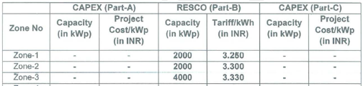

1. **SCHEDULE FOR COMPLETION OF PROJECT/ SANCTION PERIOD:**

|  |  |  |  |
| --- | --- | --- | --- |
| **S.NO.** | **MILESTONES** | **SCHEDULE FOR COMPLETION** | **PENALTY IN CASE OF NONCOMPLIANCE** |
|  | Complete   1. The roofs identification and survey 2. Submission of project sanction documents 3. Commissioning of sanctioned Project(s) | By the date 20/04/2022. | 1. In case of delay beyond this scheduled commissioning period, no incentive shall be disbursed to the Successful Bidder/ Developer. 2. However, further period of 06 (Six) Months shall be allowed without incentives to the Successful Bidder/ Developer for completion of entire unexecuted allocated capacity. 3. In such a condition Penalty/ LD on per day basis calculated for the Performance Security on a 06 (Six) Months period would be levied. 4. After 06 months [i.e. total 15 (Fifteen) Months/ 18 (Eighteen) Months, as the case may be, from the date of issuance of LOA], the project will get cancelled and the pro-rata PBG would be forfeited. |
|  | Submission of project sanction documents by the bidder to SECI | Zone-1, Zone-2 and Zone-3: Maximum 06 (Six) Months  Zone-4: 09 (Nine) Months from the date of issuance of allocation letter which can be extended depending upon the merit of the case. | If after 09 (Nine) Months/ 12 (Twelve) Months, as the case may be, from the date of issuance of Letter of Allocation the successful bidder could not submit Project Sanction Documents, in such case PBG for unsanctioned allocated capacity shall be forfeited. |
|  | Time and date stamping photographs of the roofs and location details (Address) with SECI before taking sanction of the project | Before taking sanction of the project. | Project will not be sanctioned |

1. **SCOPE OF THE REPORT:** To perform virtual site visit through video call, examine the commissioning/ installation status of Solar Power Plants set-up by the subject company.

*All the assessment carried out for the Project is done based on the documents and information provided to us and its correlation by the Engineering team through virtual site inspection and various other discussions with the Project proponents and thus forming an opinion out of it.*

*Component wise verification is not carried out but Project installation & commissioning has been verified as a whole.*

*Any kind of technical & economic feasibility of the Project is out-of-scope of this Report. This report is only limited & related to the verification and examination of what has already been setup.*

1. **PURPOSE OF THE REPORT:**  To provide project completion status to the Bank based on the “in-scope points” mentioned above for facilitating them to take appropriate business decision on the Project.
2. **METHADOLOGY ADOPTED:**
3. To gather relevant data/ information/ documents related to Project planning, execution, current status.
4. Study of Project Planning documents/ LoA/ Sanction Letter to know the scope of work of the company.
5. To procure additional information, data, documents collection from the company.
6. Study and analysis of the documents and information obtained from the company.
7. Virtual site inspection of the sites for ascertaining the status of work and shadow analysis.
8. Information compilation, analysis and reporting.

|  |  |
| --- | --- |
| **PART C** | **PROJECT LOCATION AND CAPACITY** |

As per the list of projects and information provided by the company, M/s JEMPL has proposed to set up 29 roof top Solar projects across pan India out of which 2 project are excluded. These 2 projects location has been changed and are out of the scope of this report. Details of the same has been tabulated below:

| **Sr. No.** | **Off-taker** | **Capacity (DC) KWp** | **Site Address** | **GPS Coordinates** |
| --- | --- | --- | --- | --- |
| 1 | Indian Institute of Science Education and Research (IISER) | 606.0 | Campus Rd. Mohanpur,Kolkata, West Bengal- 741246 | 22°57'54.1"N 88°31'29.4"E |
| 2 | Damodar Valley Corporation (Koderma Thermal Power Station) KTPS | 1,137.5 | Koderma, Bhanjidih,Jharkhand-825421 | 24°23'27.8"N 85°33'31.4"E |
| 3 | Damodar Valley Corporation (Raghunathpur Thermal Power Station) RTPS | 951.0 | Raghunathpur, Dist- Purulia, Dumdumi-723133 | 23°36'46.9"N 86°39'29.8"E |
| 4 | Damodar Valley Corporation (Durgapur Steel Thermal Power Station) DSTPS | 248.0 | Grand Trunk Rd, Andal, West Bengal 713321 | 23°34'55.3"N 87°12'09.5"E |
| 5 | Pandit Bhagwat Dayal Sharma University of Health Sciences | 488.4 | UH2, PGIMS Road, Dariyao Nagar, Rohtak, Haryana 124001 | 28°53'06.9"N 76°36'31.8"E |
| 6 | ICAR - Central Institute of Agricultural Engineering(CIAE) | 382.0 | Nabi Bagh, Berasia Road, Bhopal – 462038, Madhya Pradesh | 23°18'38.3"N 77°24'09.1"E |
| 7 | ICAR - Indian Institute of Millets Research | 235.0 | ICAR –Indian Institute of Millets Research, Rajendranagar, Hyderabad - 500030, Telangana | 17°19'14.6"N 78°23'45.7"E |
| 8 | ICAR - Indian Institute of Rice Research | 91.1 | ICAR –Indian Institute of Rice Research, Rajendranagar, Hyderabad - 500030, Telangana | 17°19'13.1"N 78°23'37.7"E |
| 9 | ICAR- National Research Centre on Meat, Hyderabad | 117.9 | Chengicherla, P.B No.- 19,Boduppal Post, 500092 | 17°26'10.1"N 78°36'53.6"E |
| 10 | ICAR- Indian Institute of Oilseeds Research, Hyderabad | 131.0 | Rajendranagar,near Prof Jayshankar Agricultural University, Rajendra Nagr Mandal,500030 | 17°19'15.3"N 78°24'49.1"E |
| 11 | JC Bose University of Science & Technology | 266.0 | NH-2, Sector 6, Mathura Road, Faridabad- 121006 | 28°22'00.1"N 77°18'59.3"E |
| 12 | DVC,Mejia Thermal Power Station | 241.0 | Durlabhpur, Bankura, 722183 | 23°28'00.6"N 87°07'52.0"E |
| 13 | DVC,Mejia Thermal Power Station | 794.8 | Durlabhpur, Bankura, 722183 | 23°28'00.6"N 87°07'52.0"E |
| 14 | DVC, Maithon Project | 267.6 | Maithon, DVC | 23°46'42.8"N 86°48'42.0"E |
| 15 | DVC,Durgapur Steel Thermal Power Station | 181.0 | Durgapur Steel Thermal Power Station, DVC | 23°34'55.3"N 87°12'09.5"E |
| 16 | ICAR- National Academy of Agricultural Research Management | 235.0 | ICAR, NAARM Rd, Acharya Ng Ranga Agricultural University, Rajendranagar mandal, Hyderabad, Telangana 500030 | 17°18'49.4"N 78°24'44.3"E |
| 17 | National Institute of Technology, Raipur | 490.0 | G.E. Road, Raipur - 492010, Chattisgarh | 21°15'00.4"N 81°36'31.2"E |
| 18 | Biju Patnaik University of Technology | 166.0 | Chhend Colony, Rourkela, Odisha 769004 |  |
| 19 | ICAR - Indian Institute of soil Science | 95.5 | Berasia Rd, Navi Bagh, Bhopal, Madhya Pradesh 462038 | 23°18'28.7"N 77°24'25.8"E |
| 20 | Odisha University of Agriculture and Technology, Bhubaneswar | 182.0 | Near Post Office, Unit 8, Surya Nagar, Bhubaneswar, Odisha 751003 | 20°15'54.5"N 85°48'41.0"E |
| 21 | Odisha University of Agriculture and Technology, Bhawanipatna | 110.0 | College of Agriculture, Bahadur Bagicha Pada, Bhawanipatna, Odisha 766001 | 19°55'07.8"N 83°09'30.7"E |
| 22 | Marelli Motherson Automotive Lighting India Private Limited | 80.1 | Marelli Matherson Automotive Lighting India Private Limited, Unit-2, Oat No. 148-150, Village Ambethan, Taluka Khed, Chakan, Pune - 410501 , Maharashtra, India | 18°46'19.7"N 73°49'04.2"E |
| 23 | Marelli Motherson Automotive Lighting India Private Limited | 598.0 | Marelli Motherson Automotive lighting India Pvt. Ltd. Gate No. 165/1-165/3 Village Ambethan, Taluka Khed, Chakan Pune 410501, Maharashtra, India | 18°46'29.5"N 73°48'55.3"E |
| 24 | Samarth Fabalon Private Limited | 1,499.0 | Samarth Fablon Pvt. Ltd.Puruliya, Near Aims College, Jhalda, Purulia-723202, West Bengal | 23°22'06.1"N 85°59'27.7"E |
| 25 | Samarth Ad Protex Private Limited | 1,485.0 | Samarth Fablon Pvt. Ltd.Puruliya, Near Aims College, Jhalda, Purulia-723202, West Bengal | 23°22'06.1"N 85°59'27.7"E |
| 26 | Krishna Ishizaki Auto Limited | 515.0 | 58th KM,NH-8,Delhi-Jaipur-Highway, Village-Binola,Gurgaon,Haryana | 28°18'31.5"N 76°52'35.0"E |
| 27 | Schreiber Dynamix Dairies Private Limited | 4,300.0 | E-94,MIDC,Bhigwan Road, Baramati, Maharashtra, 413133 |  |
| 28 | Crosslay Remedies Limited | 392.4 | Pushpanjali Crosslay Hospital,W 3, Sector 1, Vaishali, Ghaziabad, 201012 UP | 28°38'04.2"N 77°19'58.8"E |
| 29 | Jindal India Limited | 998.0 | NH-6, Village & Mouza Ranihati, Kulai PO - Biki Hakola, PS - Panchala, District - Howrah, West Bengal - 711322 | 22°32'57.4"N 88°09'26.7"E |
| **Total** | | **17,284.3** | **Excluded-** | |
| **Total excluding not implemented projects** | | **12,818.3** |

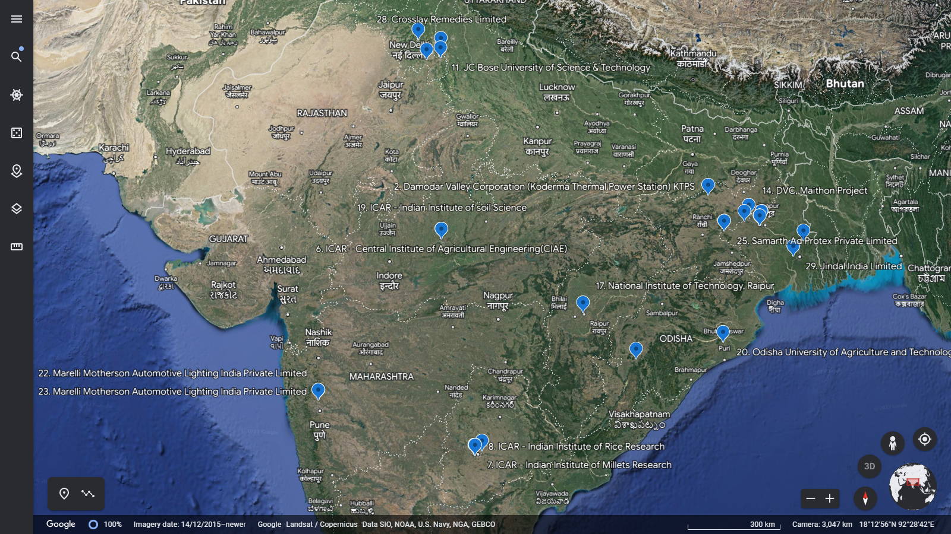

**View:** Project Sites **Source:** Google Earth

|  |  |
| --- | --- |
| **PART D** | **PROJECT WISE COD AND CURENT STATUS** |

As per the information and COD letters shared by the company along with verification of the same through virtual site survey, details has been tabulated below:

| **S. No.** | **Projects** | **Capacity (DC- kWp)**  **As per COD Letter** | **Energization Date / COD** | **Date of Virtual Site Visit** | **Net Metering Starting Month** |
| --- | --- | --- | --- | --- | --- |
| 1 | Indian Institute of Science Education and Research (IISER) | 605.68 | 20-10-2021 | 13-03-2023 | Nov-22 |
| 2 | DVC Koderma Thermal Power Station | 1,137.00 | 20-10-2021 | 21-02-2023 | Feb-22 |
| 3 | DVC (Raghunathpur Thermal Power Station) RTPS | 165.49 | 20-10-2021 | 17-03-2023 | Apr-22 |
| 3 | DVC (Raghunathpur Thermal Power Station) RTPS | 951.40 | 20-10-2021 | 17-03-2023 | Apr-22 |
| 4 | DVC,Durgapur Steel Thermal Power Station | 247.90 | 20-10-2021 | 28-02-2023 | Feb-22 |
| 5 | Pandit Bhagwat Dayal Sharma University of Health Sciences | 488.43 | 19-10-2021 | 27-03-2023 | Jan-22 |
| 6 | ICAR - Central Institute of Agricultural Engineering(CIAE) | 381.90 | 20-10-2021 | 30-01-2023 | Oct-22 |
| 7 | ICAR - Indian Institute of Millets Research (IIMR) | 234.83 | 20-10-2021 | 24-01-2023 | Oct-21 |
| 8 | ICAR - Indian Institute of Rice Research | 91.12 | 20-10-2021 | 24-01-2023 | Feb-22 |
| 9 | ICAR-National Research Centre on Meat | 117.92 | 20-10-2021 | 25-01-2023 | Feb-22 |
| 10 | Indian Institute of Oilseeds Research (IIOR) | 131.32 | 20-10-2021 | 24-01-2023 | Mar-22 |
| 11 | JC Bose University of Science & Technology | 265.99 | 20-10-2021 | 06-04-2023 | Jan-22 |
| 12 | DVC,Mejia Thermal Power Station | 241.20 | 20-10-2021 | 15-03-2023 / 16-03-2023 | Feb-22 |
| 13 | DVC,Mejia Thermal Power Station | 794.96 | 20-10-2021 | 15-03-2023 / 16-03-2023 | Feb-22 |
| 14 | DVC, Maithon Project | 102.18 | 20-10-2021 | 27-02-2023 | Apr-22 |
| 15 | DVC,Durgapur Steel Thermal Power Station | 180.56 | 20-10-2021 | 28-02-2023 | Mar-22 |
| 16 | ICAR-National Academy of Agricultural Research Management | 234.50 | 20-10-2021 | 23-01-2023 | Oct-22 |
| 17 | National Institute of Technology, Raipur | 490.10 | 19-10-2021 | 28-03-2023 | Jul-22 |
| 19 | ICAR - Indian Institute of soil Science | 95.48 | 20-10-2021 | 30-01-2023 | Feb-22 |
| 20 | Odisha University of Agriculture and Technology, Bhubaneswar | 181.57 | 20-10-2021 | 29-03-2023 | Jul-22 |
| 21 | Odisha University of Agriculture and Technology, Bhawanipatna | 110.22 | 20-10-2021 | 25-04-2023 | - |
| 22 | Marelli Motherson Automotive Lighting India Private Limited | 80.10 | 20-10-2021 | 01-02-2023 | Nov-21 |
| 23 | Marelli Motherson Automotive Lighting India Private Limited | 598.31 | 20-10-2021 | 01-02-2023 | Nov-21 |
| 24 | Samarth Fabalon Private Limited | 1,499.21 | 20-10-2021 | 22-03-2023 | May-22 |
| 25 | Samarth Ad Protex Private Limited | 1,484.97 | 20-10-2021 | 22-03-2023 | May-22 |
| 26 | Krishna Ishizaki Auto Limited | 514.56 | 20-10-2021 | 15-02-2023 | Apr-22 |
| 28 | Crosslay Remedies Limited | 392.40 | 20-10-2021 | 08-02-2023 | Jul-22 |
| 29 | Jindal India Limited | 998.00 | 20-10-2021 | 07-04-2023 | - |
| **Total** | | **12,817.29** |  |  |  |

**DC to AC Ratio**

|  |  |  |  |  |
| --- | --- | --- | --- | --- |
| **S. No.** | **Projects** | **Capacity (DC) kWp** | **Installed Inverter Capacity-AC (kW)** | **DC:AC** |
| 1 | Indian Institute of Science Education and Research (IISER) | 605.68 | 613 | 0.99 |
| 2 | DVC Koderma Thermal Power Station | 499.83 | 501 | 1.00 |
| 422.77 | 415 | 1.02 |
| 214.40 | 215 | 1.00 |
| 3 | DVC (Raghunathpur Thermal Power Station) RTPS | 165.49 | 168 | 0.99 |
| 3 | DVC (Raghunathpur Thermal Power Station) RTPS | 951.40 | 950 | 1.00 |
| 4 | DVC,Durgapur Steel Thermal Power Station | 247.90 | 246 | 1.01 |
| 5 | Pandit Bhagwat Dayal Sharma University of Health Sciences | 488.43 | 486 | 1.01 |
| 6 | ICAR - Central Institute of Agricultural Engineering(CIAE) | 381.90 | 380 | 1.01 |
| 7 | ICAR - Indian Institute of Millets Research (IIMR) | 234.83 | 233 | 1.01 |
| 8 | ICAR - Indian Institute of Rice Research | 91.12 | 90 | 1.01 |
| 9 | ICAR-National Research Centre on Meat | 117.92 | 120 | 0.98 |
| 10 | Indian Institute of Oilseeds Research (IIOR) | 131.32 | 130 | 1.01 |
| 11 | JC Bose University of Science & Technology | 265.99 | 265 | 1.00 |
| 12 | DVC,Mejia Thermal Power Station | 241.20 | 240 | 1.01 |
| 13 | DVC,Mejia Thermal Power Station | 794.96 | 795 | 1.00 |
| 14 | DVC, Maithon Project | 102.18 | 105 | 0.97 |
| 15 | DVC,Durgapur Steel Thermal Power Station | 180.56 | 180 | 1.00 |
| 16 | ICAR-National Academy of Agricultural Research Management | 234.50 | 235 | 1.00 |
| 17 | National Institute of Technology, Raipur | 490.10 | 491 | 1.00 |
| 19 | ICAR - Indian Institute of soil Science | 95.48 | 100 | 0.95 |
| 20 | Odisha University of Agriculture and Technology, Bhubaneswar | 181.57 | 180 | 1.01 |
| 21 | Odisha University of Agriculture and Technology, Bhawani Patna | 110.22 | 110 | 1.00 |
| 22 | Marelli Motherson Automotive Lighting India Private Limited | 80.10 | 60 | 1.34 |
| 23 | Marelli Motherson Automotive Lighting India Private Limited | 598.31 | 400 | 1.50 |
| 24 | Samarth Fabalon Private Limited | 1,499.21 | 1,160 | 1.29 |
| 25 | Samarth Ad Protex Private Limited | 1,484.97 | 1,180 | 1.26 |
| 26 | Krishna Ishizaki Auto Limited | 514.56 | 390 | 1.32 |
| 28 | Crosslay Remedies Limited | 392.40 | 280 | 1.40 |
| 29 | Jindal India Limited | 998.00 | 720 | 1.39 |
| **Total** | | **12,817.29** | **11,438** | **1.12** |

**Power generation; Estimated v/s Actual:**

| **S. No.** | **Projects** | **Capacity-DC KWp** | **Total** | **Total CUF (in %)** | **Time since Net Metering**  **(in months)** | **Annual Production (MWh)** | | **(A) : (B)** |
| --- | --- | --- | --- | --- | --- | --- | --- | --- |
| **Actual- As per Company**  **(A)** | **Estimated- As per PVSyst Report at P90 (B)** |
| 1 | Indian Institute of Science Education and Research (IISER) | 605.68 | **3,67,281** | 12% | 7 | 629.63 | 828.30 | 0.73 |
| 2 | DVC Koderma Thermal Power Station | 1,137.00 | **15,76,821** | 14% | 14 | 1,351.56 | 1,626.70 | 0.70 |
| 3 | DVC (Raghunathpur Thermal Power Station) RTPS | 165.49 | **1,15,964** | 8% | 12 | 115.96 | NA | -- |
| 3 | DVC (Raghunathpur Thermal Power Station) RTPS | 951.40 | **7,81,387** | 10% | 12 | 781.39 | 1,341.00 | 0.71 |
| 4 | DVC, Durgapur Steel Thermal Power Station | 247.90 | **3,09,221** | 12% | 14 | 265.05 | 344.90 | 0.72 |
| 5 | Pandit Bhagwat Dayal Sharma University of Health Sciences | 488.43 | **6,81,983** | 13% | 15 | 545.59 | 659.50 | 0.74 |
| 6 | ICAR - Central Institute of Agricultural Engineering(CIAE) | 381.90 | **2,58,390** | 16% | 6 | 516.78 | 591.60 | 0.65 |
| 7 | ICAR - Indian Institute of Millets Research (IIMR) | 234.83 | **4,57,525** | 15% | 18 | 305.02 | 339.70 | 0.69 |
| 8 | ICAR - Indian Institute of Rice Research | 91.12 | **1,46,083** | 16% | 14 | 125.21 | 136.40 | 0.67 |
| 9 | ICAR-National Research Centre on Meat | 117.92 | **1,83,118** | 17% | 13 | 169.03 | 176.58 | 0.67 |
| 10 | Indian Institute of Oilseeds Research (IIOR) | 131.32 | **1,64,396** | 16% | 11 | 179.34 | 193.70 | 0.68 |
| 11 | JC Bose University of Science & Technology | 265.99 | **3,63,430** | 13% | 15 | 290.74 | 347.50 | 0.77 |
| 12 | DVC, Mejia Thermal Power Station | 241.20 | **2,88,761** | 12% | 14 | 247.51 | 333.70 | 0.72 |
| 13 | DVC, Mejia Thermal Power Station | 794.96 | **8,80,984** | 11% | 14 | 755.13 | 1,096.70 | 0.72 |
| 14 | DVC, Maithon Project | 102.18 | **97,589** | 11% | 12 | 97.59 | NA |  |
| 15 | DVC, Durgapur Steel Thermal Power Station | 180.56 | **2,00,204** | 12% | 13 | 184.80 | NA |  |
| 16 | ICAR-National Academy of Agricultural Research Management | 234.50 | **1,61,877** | 16% | 6 | 323.75 | 349.60 | 0.67 |
| 17 | National Institute of Technology, Raipur | 490.10 | **2,74,629** | 9% | 9 | 366.17 | 704.10 | 0.70 |
| 19 | ICAR - Indian Institute of soil Science | 95.48 | **1,69,656** | 18% | 14 | 145.42 | 141.20 | 0.68 |
| 20 | Odisha University of Agriculture and Technology, Bhubaneswar | 181.57 | **1,29,836** | 11% | 9 | 173.11 | 249.00 | 0.73 |
| 21 | Odisha University of Agriculture and Technology, Bhawani Patna | 110.22 | - | - | - | - | 163.00 | - |
| 22 | Marelli Motherson Automotive Lighting India Private Limited | 80.10 | **1,32,702** | 14% | 17 | 93.67 | 112.90 | 0.71 |
| 23 | Marelli Motherson Automotive Lighting India Private Limited | 598.31 | **9,68,784** | 13% | 17 | 683.85 | 877.10 | 0.68 |
| 24 | Samarth Fabalon Private Limited | 1,499.21 | **13,16,699** | 11% | 11 | 1,436.40 | 2,024.00 | 0.74 |
| 25 | Samarth Ad Protex Private Limited | 1,484.97 | **14,39,703** | 12% | 11 | 1,570.59 | 2,023.80 | 0.73 |
| 26 | Krishna Ishizaki Auto Limited | 514.56 | **5,49,120** | 12% | 12 | 549.12 | 685.50 | 0.75 |
| 28 | Crosslay Remedies Limited | 392.40 | **2,74,629** | 11% | 9 | 366.17 | 528.60 | 0.74 |
| 29 | Jindal India Limited | 998.00 | **-** |  | - |  | 1,317.00 |  |
| **Total** | | **12,817.29** | **1,22,90,772** | **- Complete Information Unavailable** | | | | |

***#Note:*** *For the**power**plants which are operational for a period less than 12 months, the actual production has been extrapolated to 12 Months to compare the actual annual production to that of the estimated annual production (at P90) mentioned in PVSyst reports.*

**Remarks:**

* As per the observations made during the virtual site visits, all the plants are operational as on the date of their respective site visit except the project located in Jindal India Limited (S. No. 29 above as highlighted) where installation work was in progress as on the date of its site visit. It was informed by the site in-charge that the same shall be completed within a month.
* Virtual site visit was conducted based on the availability of the respective site representatives on the particular project site confirmed through email from the client.
* The virtual site visit starts by asking the ‘Live Location’ of the site representative on WhatsApp.
* Then, a video call (recorded through screen recorder) is placed between the respective site representative and RKA’s engineer on WhatsApp.

*(Screenshot of the same has been attached in Enclosure I: Photographs)*

* During the virtual site visit, our major observations were regarding the condition, specifications’ tag plate, installation status, etc. of all the equipments like Modules, Data Logger, ACDB, Lighting Arrester, Inverters, Isolator Box, etc. along with observing the cleaning of the modules and inverter readings.
* The main observation to check that the operational status of the solar plants was the generation status displayed in the inverters.
* As per the COD dated 02-12-21, out of a total power production allocation of 267.67 kWp at DVC-Maithon Project, power plant of production capacity of only 102.18 kWp has been installed here and the balance 165.49 kWp solar power plant has been shifted to Damodar Valley Corporation (Raghunathpur Thermal Power Station) RTPS.
* As per the information provided by the company’s management, net metering is yet to start at the project site – Odisha University of Agriculture and Technology, Bhawani Patna and as on date of virtual site visit i.e. 25-Apr-2023 the plant was made operational to confirm us that it is in operational condition. COD of the same has been obtained on 20-Oct-2021.
* Out of the total capacity of all the plants combined i.e. ~12.82 MWp, COD has been obtained for a capacity of ~11.82 MWp and net metering has been done for ~11.71 MWp only.
* To ascertain the Project actual capacity installed we have checked the solar modules array, sought the Energy Production Data and total installed Inverter output capacity.
* As per our observations made in the table of power generation; Estimated v/s actual above, the actual production of the plants are on the lower side (23-35% less). Reason has been sought from the company for the same. Company has given the reason that some projects are under stabilization and additionally, certain project sites have encountered a reduction in irradiation levels in comparison to the initial projections, and certain sites have also experienced capacity breakdowns due to storms, resulting in an adverse effect on power generation. Moreover, as per our analysis one of the factor may be that some projects were operational in winter season and when they will operate in summer season shall give maximum output. Further, it is advised that the company can contact the OEM for the support required in maximizing the power output and achieve the rated CUF. Company can also check if the system including modules requires some recalibration in terms of angle & positioning to achieve the maximum output.
* As per analysis, total capacity of all the inverters installed in all the projects is 11,438 kW (AC Power Output) against the installed project capacity of 12,817.29 kWp (DC) of Solar modules. Which results in the DC to AC ratio of 1.12. Further, the industry average of DC:AC ranges between 1.3 to 1.6 however, to maximize system yield the DC:AC should be closer to 1.2.

**ENCLOSURE: I- PHOTOGRAPHS**

|  |  |  |
| --- | --- | --- |
| 1. **Indian Institute of Science Education and Research (IISER)** | | **13-Mar-23** |
| Z:\In Progress Files\Adil Afaque\PL569-463-786 - Jyotikiran Energy Mumbai Ltd. Project Pictures\Project Pictures\1.Indian Institute of Science Education and Research (IISER)\CV Raman 2 Arrays (4).jpg | Z:\In Progress Files\Adil Afaque\PL569-463-786 - Jyotikiran Energy Mumbai Ltd. Project Pictures\Project Pictures\1.Indian Institute of Science Education and Research (IISER)\Sports Complex (1).jpg | |
| Z:\In Progress Files\Adil Afaque\PL569-463-786 - Jyotikiran Energy Mumbai Ltd. Project Pictures\Project Pictures\1.Indian Institute of Science Education and Research (IISER)\APC Roy Lecture Hall (1).jpg | Z:\In Progress Files\Adil Afaque\PL569-463-786 - Jyotikiran Energy Mumbai Ltd. Project Pictures\Project Pictures\1.Indian Institute of Science Education and Research (IISER)\CV Raman 2 Arrays (8).jpg | |
| 1. **DVC - Koderma Thermal Power Station (KTPS)** | | **21-Feb-23** |
| Z:\In Progress Files\Adil Afaque\PL569-463-786 - Jyotikiran Energy Mumbai Ltd. Project Pictures\Project Pictures\2. Damodar Valley Corporation (Koderma Thermal Power Station) KTPS\WhatsApp Image 2023-02-20 at 3.39.44 PM.jpeg | Z:\In Progress Files\Adil Afaque\PL569-463-786 - Jyotikiran Energy Mumbai Ltd. Project Pictures\Project Pictures\2. Damodar Valley Corporation (Koderma Thermal Power Station) KTPS\WhatsApp Image 2023-02-20 at 3.13.21 PM.jpeg | |
| Z:\In Progress Files\Adil Afaque\PL569-463-786 - Jyotikiran Energy Mumbai Ltd. Project Pictures\Project Pictures\2. Damodar Valley Corporation (Koderma Thermal Power Station) KTPS\WhatsApp Image 2023-02-21 at 11.49.30 AM.jpeg | Z:\In Progress Files\Adil Afaque\PL569-463-786 - Jyotikiran Energy Mumbai Ltd. Project Pictures\Project Pictures\2. Damodar Valley Corporation (Koderma Thermal Power Station) KTPS\WhatsApp Image 2023-02-21 at 11.34.50 AM.jpeg | |

|  |  |  |
| --- | --- | --- |
| 1. **DVC-Raghunathpur Thermal Power Station (RTPS)** | | **17-Mar-23** |
| **Z:\In Progress Files\Adil Afaque\PL569-463-786 - Jyotikiran Energy Mumbai Ltd. Project Pictures\Project Pictures\3.Damodar Valley Corporation (Raghunathpur Thermal Power Station) RTPS\Admin (8).jpeg** | **Z:\In Progress Files\Adil Afaque\PL569-463-786 - Jyotikiran Energy Mumbai Ltd. Project Pictures\Project Pictures\3.Damodar Valley Corporation (Raghunathpur Thermal Power Station) RTPS\165.49 additional plant\WhatsApp Image 2023-03-17 at 12.42.38 PM.jpeg** | |
| **Z:\In Progress Files\Adil Afaque\PL569-463-786 - Jyotikiran Energy Mumbai Ltd. Project Pictures\Project Pictures\3.Damodar Valley Corporation (Raghunathpur Thermal Power Station) RTPS\WhatsApp Image 2023-03-17 at 2.38.29 PM.jpeg** | **Z:\In Progress Files\Adil Afaque\PL569-463-786 - Jyotikiran Energy Mumbai Ltd. Project Pictures\Project Pictures\3.Damodar Valley Corporation (Raghunathpur Thermal Power Station) RTPS\Store 1, 2 & 3 (10).jpeg** | |
| 1. **DVC-Durgapur Steel Thermal Power Station (DSTPS)** | | **28-Feb-23** |
| **Z:\In Progress Files\Adil Afaque\PL569-463-786 - Jyotikiran Energy Mumbai Ltd. Project Pictures\Project Pictures\15. DVC,Durgapur Steel Thermal Power Station\WhatsApp Image 2022-12-15 at 3.21.31 PM (1).jpeg** | **Z:\In Progress Files\Adil Afaque\PL569-463-786 - Jyotikiran Energy Mumbai Ltd. Project Pictures\Project Pictures\15. DVC,Durgapur Steel Thermal Power Station\Fire Station Building.jpeg** | |
| **Z:\In Progress Files\Adil Afaque\PL569-463-786 - Jyotikiran Energy Mumbai Ltd. Project Pictures\Project Pictures\15. DVC,Durgapur Steel Thermal Power Station\WhatsApp Image 2023-02-28 at 2.27.53 PM.jpeg** | **Z:\In Progress Files\Adil Afaque\PL569-463-786 - Jyotikiran Energy Mumbai Ltd. Project Pictures\Project Pictures\15. DVC,Durgapur Steel Thermal Power Station\WhatsApp Image 2023-02-28 at 2.41.23 PM.jpeg** | |

|  |  |  |
| --- | --- | --- |
| 1. **Pandit Bhagwat Dayal Sharma University of Health Sciences** | | **27-Mar-23** |
| Z:\In Progress Files\Adil Afaque\PL569-463-786 - Jyotikiran Energy Mumbai Ltd. Project Pictures\Project Pictures\5 - PGIMS\Admin Building (4).jpeg | Z:\In Progress Files\Adil Afaque\PL569-463-786 - Jyotikiran Energy Mumbai Ltd. Project Pictures\Project Pictures\5 - PGIMS\Admin Building (5).jpeg | |
| Z:\In Progress Files\Adil Afaque\PL569-463-786 - Jyotikiran Energy Mumbai Ltd. Project Pictures\Project Pictures\5 - PGIMS\Admin Building (3).jpeg | |
| 1. **ICAR - Central Institute of Agricultural Engineering (CIAE)** | | **30-Jan-23** |
|  |  | |
|  | |

|  |  |  |
| --- | --- | --- |
| 1. **ICAR - Indian Institute of Millets Research** | | **24-Jan-23** |
|  |  | |
| 1. **ICAR - Indian Institute of Rice Research** | | **24-Jan-23** |
|  |  | |

|  |  |  |
| --- | --- | --- |
| 1. **ICAR- National Research Centre on Meat, Hyderabad** | | **25-Jan-23** |
|  |  | |
| 1. **ICAR- Indian Institute of Oilseeds Research, Hyderabad** | | **24-Jan-23** |
|  |  | |

|  |  |  |
| --- | --- | --- |
| 1. **JC Bose University of Science & Technology** | | **06-Apr-23** |
|  |  | |
| 1. **DVC, Mejia Thermal Power Station-241.2 kW** | | **15-03-2023 / 16-03-2023** |
| **Z:\In Progress Files\Adil Afaque\PL569-463-786 - Jyotikiran Energy Mumbai Ltd. Project Pictures\Project Pictures\12 DVC,Mejia Thermal Power Station- 241.0 kW\Central Store Array 1 (2).jpeg** | **Z:\In Progress Files\Adil Afaque\PL569-463-786 - Jyotikiran Energy Mumbai Ltd. Project Pictures\Project Pictures\12 DVC,Mejia Thermal Power Station- 241.0 kW\Central Store Array 1 (6).jpeg** | |
| **Z:\In Progress Files\Adil Afaque\PL569-463-786 - Jyotikiran Energy Mumbai Ltd. Project Pictures\Project Pictures\12 DVC,Mejia Thermal Power Station- 241.0 kW\Image -2.jpeg** | **Z:\In Progress Files\Adil Afaque\PL569-463-786 - Jyotikiran Energy Mumbai Ltd. Project Pictures\Project Pictures\12 DVC,Mejia Thermal Power Station- 241.0 kW\Image-3.jpeg** | |

|  |  |  |  |
| --- | --- | --- | --- |
| 1. **DVC, Mejia Thermal Power Station-794.8 kW** | | **15-03-2023 / 16-03-2023** | |
| **Z:\In Progress Files\Adil Afaque\PL569-463-786 - Jyotikiran Energy Mumbai Ltd. Project Pictures\Project Pictures\13 DVC,Mejia Thermal Power Station- 794.8 kW\Image 2.jpeg** | **Z:\In Progress Files\Adil Afaque\PL569-463-786 - Jyotikiran Energy Mumbai Ltd. Project Pictures\Project Pictures\13 DVC,Mejia Thermal Power Station- 794.8 kW\DAV School (1).jpeg** | | |
| **Z:\In Progress Files\Adil Afaque\PL569-463-786 - Jyotikiran Energy Mumbai Ltd. Project Pictures\Project Pictures\13 DVC,Mejia Thermal Power Station- 794.8 kW\DAV School (5).jpeg** | **Z:\In Progress Files\Adil Afaque\PL569-463-786 - Jyotikiran Energy Mumbai Ltd. Project Pictures\Project Pictures\13 DVC,Mejia Thermal Power Station- 794.8 kW\Reservoir Switch House (1).jpeg** | | |
| 1. **DVC, Maithon Project** | | | **27-Feb-23** |
| **Z:\In Progress Files\Adil Afaque\PL569-463-786 - Jyotikiran Energy Mumbai Ltd. Project Pictures\Project Pictures\14.DVC, Maithon Project\WhatsApp Unknown 2023-02-27 at 1.13.49 PM\WhatsApp Image 2023-02-27 at 12.57.34 PM.jpeg** | **Z:\In Progress Files\Adil Afaque\PL569-463-786 - Jyotikiran Energy Mumbai Ltd. Project Pictures\Project Pictures\14.DVC, Maithon Project\WhatsApp Unknown 2023-02-27 at 1.13.49 PM\WhatsApp Image 2023-02-27 at 12.01.51 PM.jpeg** | | |
| **Z:\In Progress Files\Adil Afaque\PL569-463-786 - Jyotikiran Energy Mumbai Ltd. Project Pictures\Project Pictures\14.DVC, Maithon Project\WhatsApp Unknown 2023-02-27 at 1.13.49 PM\WhatsApp Image 2023-02-27 at 12.01.08 PM.jpeg** | | |

|  |  |  |
| --- | --- | --- |
| 1. **DVC, Durgapur Steel Thermal Power Station** | | **28-Feb-23** |
| **Z:\In Progress Files\Adil Afaque\PL569-463-786 - Jyotikiran Energy Mumbai Ltd. Project Pictures\Project Pictures\15. DVC,Durgapur Steel Thermal Power Station\Fire Station Building (3).jpeg** | **Z:\In Progress Files\Adil Afaque\PL569-463-786 - Jyotikiran Energy Mumbai Ltd. Project Pictures\Project Pictures\15. DVC,Durgapur Steel Thermal Power Station\WhatsApp Image 2023-02-28 at 2.18.03 PM.jpeg** | |
| **Z:\In Progress Files\Adil Afaque\PL569-463-786 - Jyotikiran Energy Mumbai Ltd. Project Pictures\Project Pictures\15. DVC,Durgapur Steel Thermal Power Station\WhatsApp Image 2022-12-15 at 3.21.31 PM.jpeg** | **Z:\In Progress Files\Adil Afaque\PL569-463-786 - Jyotikiran Energy Mumbai Ltd. Project Pictures\Project Pictures\15. DVC,Durgapur Steel Thermal Power Station\WhatsApp Image 2023-02-28 at 2.41.47 PM.jpeg** | |
| 1. **ICAR- National Academy of Agricultural Research Management** | | **23-Jan-23** |
| **C:\Users\engineer9\Downloads\WhatsApp Unknown 2023-05-24 at 13.04.02\WhatsApp Image 2023-05-24 at 13.01.26 (2).jpeg** | **C:\Users\engineer9\Downloads\WhatsApp Unknown 2023-05-24 at 13.04.02\WhatsApp Image 2023-05-24 at 13.01.27.jpeg** | |
| **C:\Users\engineer9\Downloads\WhatsApp Unknown 2023-05-24 at 13.04.02\WhatsApp Image 2023-05-24 at 13.01.28 (2).jpeg** | |

|  |  |  |
| --- | --- | --- |
| 1. **National Institute of Technology, Raipur** | | **28-Mar-23** |
|  | **Z:\In Progress Files\Adil Afaque\PL569-463-786 - Jyotikiran Energy Mumbai Ltd. Project Pictures\Project Pictures\17. National Institute of Technology, Raipur\Architecture Building (9).jpeg** | |
| **Z:\In Progress Files\Adil Afaque\PL569-463-786 - Jyotikiran Energy Mumbai Ltd. Project Pictures\Project Pictures\17. National Institute of Technology, Raipur\Boys Hostel H (1).jpeg** | |
| 1. **ICAR - Indian Institute of soil Science** | | **30-Jan-23** |
|  |  | |

|  |  |  |
| --- | --- | --- |
| 1. **Odisha University of Agriculture and Technology, Bhubaneswar** | | **29-Mar-23** |
|  | **Z:\In Progress Files\Adil Afaque\PL569-463-786 - Jyotikiran Energy Mumbai Ltd. Project Pictures\Project Pictures\20.Odisha University of Agriculture and Technology, Bhubaneswar\College of Basic Science (4).jpeg** | |
| **Z:\In Progress Files\Adil Afaque\PL569-463-786 - Jyotikiran Energy Mumbai Ltd. Project Pictures\Project Pictures\20.Odisha University of Agriculture and Technology, Bhubaneswar\College of Basic Science (1).jpeg** | |
| 1. **Odisha University of Agriculture and Technology, Bhawanipatna** | | **25-Apr-23** |
|  | **Z:\In Progress Files\Adil Afaque\PL569-463-786 - Jyotikiran Energy Mumbai Ltd. Project Pictures\Project Pictures\21.Odisha University of Agriculture and Technology, Bhawanipatna\Admin (4).jpeg** | |
| **Z:\In Progress Files\Adil Afaque\PL569-463-786 - Jyotikiran Energy Mumbai Ltd. Project Pictures\Project Pictures\21.Odisha University of Agriculture and Technology, Bhawanipatna\Girl's Hostel (5).jpeg** | |

|  |  |  |  |
| --- | --- | --- | --- |
| 1. **Marelli Motherson Automotive Lighting India Private Limited-80.1 kW** | | **01-Feb-23** | |
|  |  | | |
|  | | |
| 1. **Marelli Motherson Automotive Lighting India Private Limited-598.31 kW** | | | **01-Feb-23** |
|  |  | | |

|  |  |  |
| --- | --- | --- |
| 1. **Samarth Fabalon Private Limited** | | **22-Mar-23** |
| **Z:\In Progress Files\Adil Afaque\PL569-463-786 - Jyotikiran Energy Mumbai Ltd. Project Pictures\Project Pictures\24. samarth fablon pvt  ltd\Array 9-16 (10).jpeg** | **Z:\In Progress Files\Adil Afaque\PL569-463-786 - Jyotikiran Energy Mumbai Ltd. Project Pictures\Project Pictures\24. samarth fablon pvt  ltd\Array 1-8 (21).jpeg** | |
| **Z:\In Progress Files\Adil Afaque\PL569-463-786 - Jyotikiran Energy Mumbai Ltd. Project Pictures\Project Pictures\24. samarth fablon pvt  ltd\Array 9-16 (14).jpeg** | **Z:\In Progress Files\Adil Afaque\PL569-463-786 - Jyotikiran Energy Mumbai Ltd. Project Pictures\Project Pictures\24. samarth fablon pvt  ltd\Array 9-16 (16).jpeg** | |
| 1. **Samarth Ad Protex Private Limited** | | **22-Mar-23** |
| **Z:\In Progress Files\Adil Afaque\PL569-463-786 - Jyotikiran Energy Mumbai Ltd. Project Pictures\Project Pictures\24. samarth fablon pvt  ltd\Array 9-16 (19).jpeg** | **Z:\In Progress Files\Adil Afaque\PL569-463-786 - Jyotikiran Energy Mumbai Ltd. Project Pictures\Project Pictures\24. samarth fablon pvt  ltd\Array 9-16 (7).jpeg** | |
| **Z:\In Progress Files\Adil Afaque\PL569-463-786 - Jyotikiran Energy Mumbai Ltd. Project Pictures\Project Pictures\24. samarth fablon pvt  ltd\Array 9-16 (8).jpeg** | **Z:\In Progress Files\Adil Afaque\PL569-463-786 - Jyotikiran Energy Mumbai Ltd. Project Pictures\Project Pictures\24. samarth fablon pvt  ltd\Array 1-8 (13).jpeg** | |

|  |  |  |
| --- | --- | --- |
| 1. **Krishna Ishizaki Auto Limited** | | **15-Feb-23** |
| **Z:\In Progress Files\Adil Afaque\PL569-463-786 - Jyotikiran Energy Mumbai Ltd. Project Pictures\Project Pictures\26 - KIALKRISHNA ISHIZAKI LIMITED , BINOLA\Site Visit Pics\WhatsApp Image 2023-02-15 at 11.36.50 AM.jpeg** | **Z:\In Progress Files\Adil Afaque\PL569-463-786 - Jyotikiran Energy Mumbai Ltd. Project Pictures\Project Pictures\26 - KIALKRISHNA ISHIZAKI LIMITED , BINOLA\Site Visit Pics\WhatsApp Image 2023-02-15 at 12.02.12 PM.jpeg** | |
| **Z:\In Progress Files\Adil Afaque\PL569-463-786 - Jyotikiran Energy Mumbai Ltd. Project Pictures\Project Pictures\26 - KIALKRISHNA ISHIZAKI LIMITED , BINOLA\Site Visit Pics\WhatsApp Image 2023-02-15 at 11.11.43 AM.jpeg** | **Z:\In Progress Files\Adil Afaque\PL569-463-786 - Jyotikiran Energy Mumbai Ltd. Project Pictures\Project Pictures\26 - KIALKRISHNA ISHIZAKI LIMITED , BINOLA\Site Visit Pics\WhatsApp Image 2023-02-15 at 11.10.49 AM.jpeg** | |
| 1. **Crosslay Remedies Limited** | | **08-Feb-23** |
| Z:\In Progress Files\Adil Afaque\PL569-463-786 - Jyotikiran Energy Mumbai Ltd. Project Pictures\Project Pictures\28 - Max Healthcare - Crosslay\Site visit pics\WhatsApp Image 2023-02-09 at 11.30.57 PM (1).jpeg | **Z:\In Progress Files\Adil Afaque\PL569-463-786 - Jyotikiran Energy Mumbai Ltd. Project Pictures\Project Pictures\28 - Max Healthcare - Crosslay\Site visit pics\WhatsApp Image 2023-02-09 at 11.29.37 PM (1).jpeg** | |
| Z:\In Progress Files\Adil Afaque\PL569-463-786 - Jyotikiran Energy Mumbai Ltd. Project Pictures\Project Pictures\28 - Max Healthcare - Crosslay\Site visit pics\WhatsApp Image 2023-02-09 at 11.29.35 PM (1).jpeg | **Z:\In Progress Files\Adil Afaque\PL569-463-786 - Jyotikiran Energy Mumbai Ltd. Project Pictures\Project Pictures\28 - Max Healthcare - Crosslay\Site visit pics\WhatsApp Image 2023-02-09 at 11.30.59 PM (1).jpeg** | |
| 1. **Jindal India Limited** | | **07-Apr-23** |
|  | **Z:\In Progress Files\Adil Afaque\PL569-463-786 - Jyotikiran Energy Mumbai Ltd. Project Pictures\Project Pictures\29- Jindal India Limited\WhatsApp Image 2023-04-07 at 11.26.49.jpeg** | |
| **Z:\In Progress Files\Adil Afaque\PL569-463-786 - Jyotikiran Energy Mumbai Ltd. Project Pictures\Project Pictures\29- Jindal India Limited\WhatsApp Image 2023-04-07 at 11.26.59.jpeg** | |

**ENCLOSURE – II: PROJECT RELATED DOCUMENTS**

**Inverters AC Power Utilization**

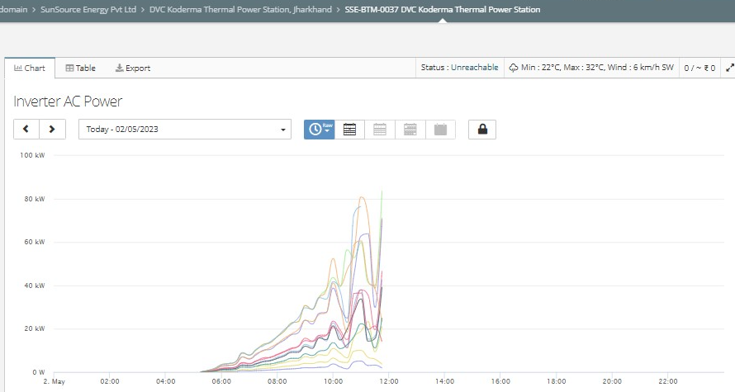

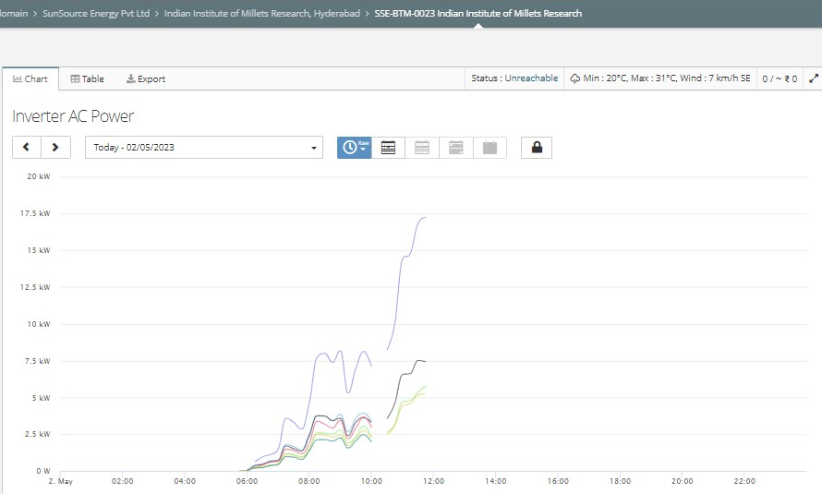

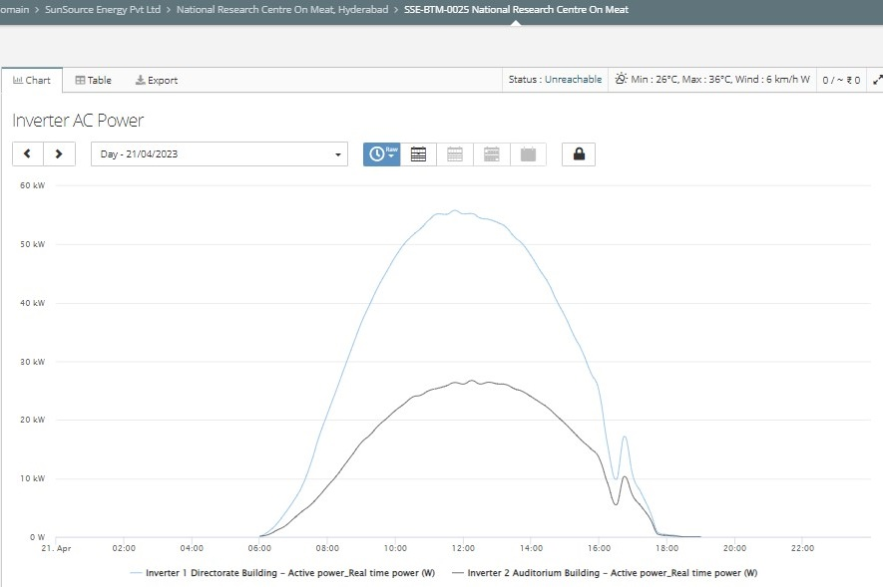

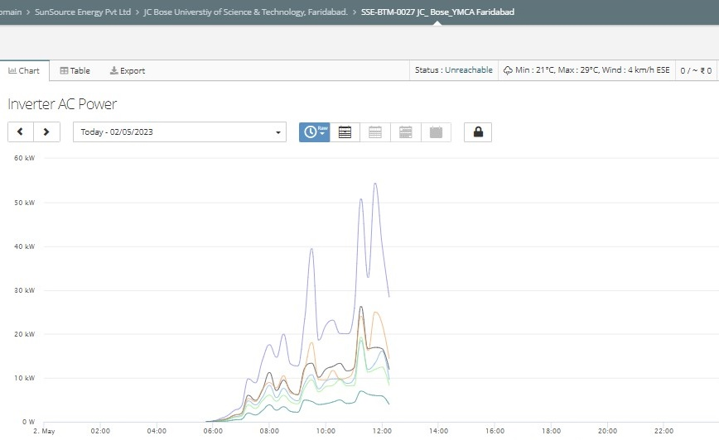

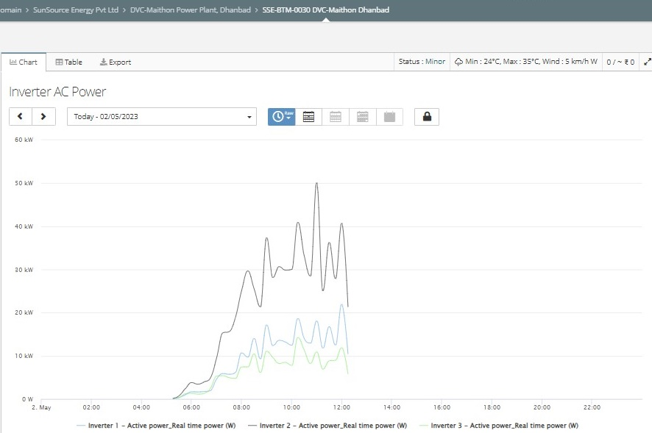

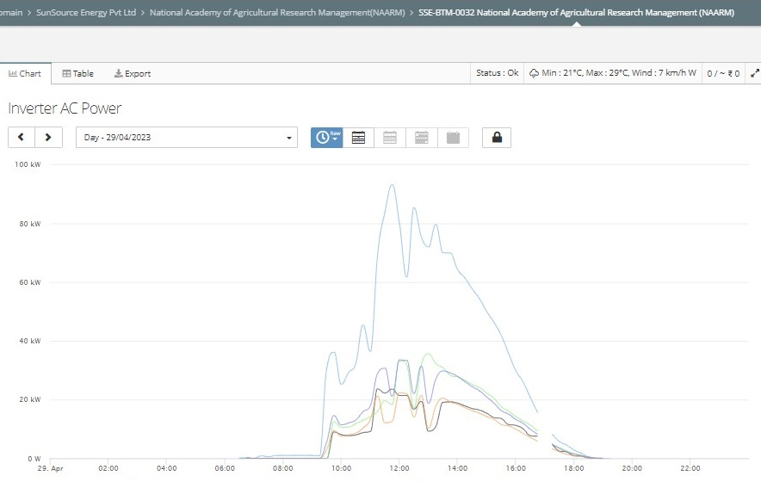

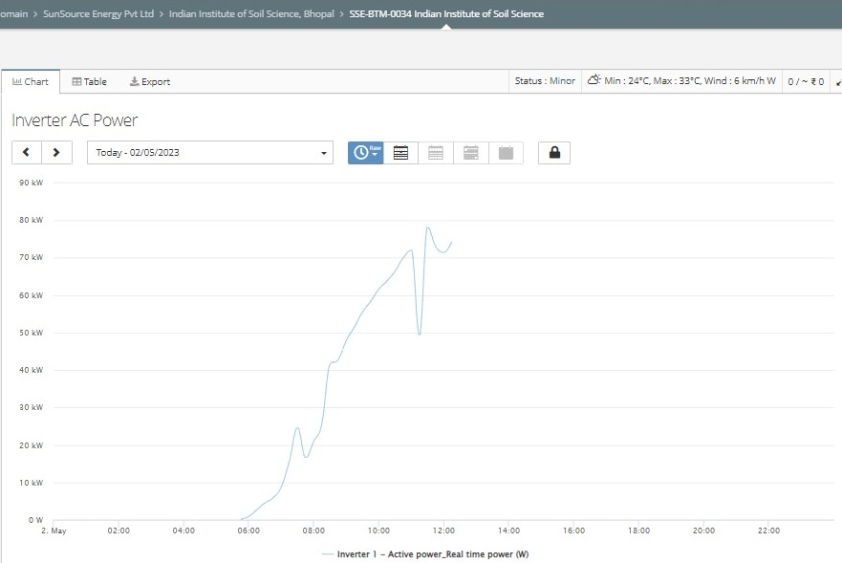

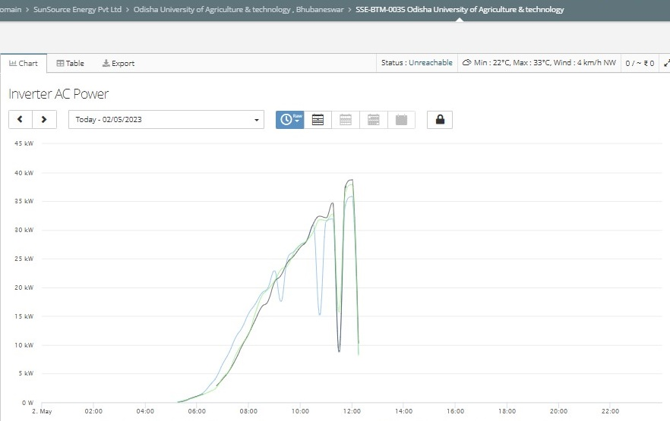

|  |  |
| --- | --- |
| **PART E** | **DISCLAIMER** |

* + - 1. No employee or member of R.K Associates has any direct/ indirect interest in the Project.
      2. This report is prepared based on the copies of the documents/ information which the Bank/ Company has provided to us out of the standard checklist of documents sought from them and further based on our assumptions and limiting conditions. All such information provided to us has been relied upon in good faith and we have assumed that it is true and correct in all respect. Verification or cross checking of the documents provided to us has not been done at our end from the originals. If at any time in future, it is found or came to our knowledge that misrepresentation of facts or incomplete or distorted information has been provided to us then this report shall automatically become null & void.
      3. This report is a general analysis of the project based on the scope mentioned in the report. This is not an Audit report, Design document, DPR or Techno-financial feasibility study. All the information gathered is based on the facts seen on the site during survey, verbal discussion & documentary evidence provided by the client and is believed that information given by the company is true best of their knowledge.
      4. All observations mentioned in the report is only based on the visual observation and the documents/ data/ information provided by the client. No mechanical/ technical tests, measurements or any design review have been performed or carried out from our side during Project assessment.
      5. Bank/FII should ONLY take this report as an Advisory document from the Financial/ Chartered Engineering firm and it’s specifically advised to the creditor to cross verify the original documents for the facts mentioned in the report which can be availed from the borrowing company directly.
      6. In case of any default in loans or the credit facility extended to the borrowing company, R.K Associates shall not be held responsible for whatsoever reason may be and any request for seeking any explanation from the employee/s of R.K Associates will not be entertained at any instance or situation.
      7. This Report is prepared by our competent technical team which includes Engineers and financial experts & analysts.
      8. This is just an opinion report and doesn’t hold any binding on anyone. It is requested from the concerned Financial Institution which is using this report for taking financial decision on the project that they should consider all the different associated relevant & related factors also before taking any business decision based on the content of this report.
      9. All Pages of the report including annexures are signed and stamped from our office. In case any paper in the report is without stamp & signature then this should not be considered a valid paper issued from this office.
      10. Though adequate care has been taken while preparing this report as per its scope, but still we can’t rule out typing, human errors, over sightedness of any information or any other mistakes. Therefore, the concerned organization is advised to satisfy themselves that the report is complete & satisfactory in all respect. Intimation regarding any discrepancy shall be brought into our notice immediately. If no intimation is received within 15 (Fifteen) days in writing from the date of issuance of the report, to rectify these timely, then it shall be considered that the report is complete in all respect and has been accepted by the client upto their satisfaction & use and further to which R.K Associates shall not be held responsible in any manner.
      11. Defect Liability Period is **15 DAYS**. We request the concerned authorized reader of this report to check the contents, data and calculations in the report within this period and intimate us in writing if any corrections are required or in case of any other concern with the contents or opinion mentioned in the report. Corrections only related to typographical, calculation, spelling mistakes, incorrect data/ figures/ statement will be entertained within the defect liability period. Any new changes for any additional information in already approved report will be regarded as additional work for which additional fees may be charged. No request for any illegitimate change in regard to any facts & figures will be entertained.
      12. R.K Associates encourages its customers to give feedback or inform concerns over its services through proper channel at le@rkassociates.org in writing within 30 days of report delivery. After this period no concern/ complaint/ proceedings in connection with the Lender’s Independent Engineering Services will be entertained due to possible change in situation and condition of the subject Project.
      13. Our Data retention policy is of **ONE YEAR**. After this period, we remove all the concerned records related to the assignment from our repository. No clarification or query can be answered after this period due to unavailability of the data.
      14. This Lender’s Independent Engineering report is governed by our (1) Internal Policies, Processes & Standard Operating Procedures, (2) Information/ Data/ Inputs given to us by the client and (3) Information/ Data/ Facts given to us by our field/ office technical team. Management of R.K Associates never gives acceptance to any unethical or unprofessional practice which may affect fair, correct & impartial assessment and which is against any prevailing law. In case of any indication of any negligence, default, incorrect, misleading, misrepresentation or distortion of facts in the report then it is the responsibility of the user of this report to immediately or at least within the defect liability period bring all such act into notice of R.K Associates management so that corrective measures can be taken instantly.
      15. R.K Associates never releases any report doing alterations or modifications from pen. In case any information/ figure of this report is found altered with pen then this report will automatically become null & void.

**FOR INTERNAL USE**

|  |  |  |  |
| --- | --- | --- | --- |
| **Place :**  **Date :**  **No. of pages:** | New Delhi  26-04-2023  37 | ***VIRTUAL SURVEY DONE BY:***  ***PREPARED BY:***  ***REVIEWED BY:*** | *Adil Afaque*  *Adil Afaque*  *Sr. V.P. Projects* |

**For R.K Associates Valuers & Techno Engineering Consultants Pvt. Ltd.**

***DEFECT LIABILITY PERIOD*** ***- In case of any query/ issue or escalation you may please contact Incident Manager by writing at valuers@rkassociates.org. We ensure 100% accuracy in the Calculations done, Rates adopted and various other data points & information mentioned in the report but still can’t rule out typing, human errors or any other mistakes. In case you find any mistake, variation, discrepancy or inaccuracy in any data point of the report, please help us by bringing all such points into our notice in writing at*** [***valuers@rkassociates.org***](mailto:valuers@rkassociates.org) ***within 30 days of the report delivery, to get these rectified timely, failing which R.K Associates Valuers Techno Engineering Consultants (P) Ltd. won’t be held responsible for any inaccuracy in any manner. Also if we will not hear back anything from you within 30 days, we will assume that report is correct in all respect and no further claim of any sort will be entertained thereafter. We would welcome and appreciate your feedback & suggestions in order to improve our services.***

***COPYRIGHT FORMAT - This report is prepared on the copyright format of R.K Associates Valuers Techno Engineering Consultants (P) Ltd. to serve our clients in the best possible way. Legally no one can copy or distribute this format without prior approval from R.K Associates. It is meant only for the organization as mentioned on the cover page of this report. Distribution or use of this format other than R.K Associates will be seen as unlawful act and necessary legal action can be taken against the defaulter***