REPORT FORMAT: CL-1 | Version: 1.0_2018

FILE No.: VIS(2022-23)-PL574-468-797 Date: 19-01-2023

- CERTIFICATE NAME: Cost Vetting Certificate for Machines and other related equipments of Telecom industry which are proposed to be installed at various locations in India.
- PREPARED FOR ORGANIZATION: State Bank of India, Commercial Branch, Gurugram
- BORROWER COMPANY’S NAME: M/s. Pratap Technocrats Pvt. Ltd.
- ASSET TYPE: Machines and other related equipments of Telecom industry.
- CURRENT LOCATION OF THE MACHINES: Proposed to be installed at various locations in India.

TO WHOM IT MAY CONCERN

S. NO. | PARTICULARS | DESCRIPTION
1. | Date of Survey | Not Applicable
2. | Date of Certificate | 19-01-2023
3. | Documents provided for perusal | - List of machinery & equipments  - Quotations from the market  - Purchase Orders
4. | Current Location of the Machines | Proposed to be installed at various locations in India.
5. | Borrowing Company | M/s. Pratap Technocrats Pvt. Ltd.
6. | Type of Asset | Machines and other related equipments of Telecom industry.
7. | Type of Assessment | Cost vetting
8. | Scope of Assessment | Cost Vetting of the machines and other related equipments of Telecom industry which are proposed to be installed at various locations in India.
9. | Nature of Machinery | Machines and other related equipments of Telecom industry (like GBT, solar panels, Battery, SMPS, CCTV Cameras etc.)
10. | Year of Manufacturing | Is currently being installed.
11. | Total Purchase Cost | Rs.53,25,903/- (excluding GST)  (Total project cost as per the List of machinery / quotations / purchase orders provided by the company).
12. | Current Estimated Market Value | The range of current market rates of such type of machinery & equipments is verified from various suppliers and also from the public domain for the new machinery and equipment’s.  As per quotes received from market, we are of the view that rate range for supply of machinery and equipments of similar kind should be in the range of Rs.50,00,000/- to Rs.55,00,000/- (for single number of all machineries and equipments). The amount is not for all the locations where the project has to be installed.  According to our observation, the rate as per the list of machinery and their total purchase price provided to us by the company/ bank are quite reasonable when compared to the rates of similar machines currently prevailing in the market.
13. | Condition of Machines | Yet to be installed.

OBSERVATIONS:
- We have been provided with the copy of quotations from the market, purchase orders with cost of machines/ equipment by the borrower company.
- As per the information provided by the company officials, these items are proposed to be installed at various locations in India.
- We have contacted several suppliers for similar items and also enquired in the public domain. Accordingly, we have got the quotation from the suppliers and we find that the price given in the list of quotations provided to us is well within the price range of similar items available in the market and seems to be reasonable.
- We have not included the installation and commissioning charges, operation and maintenance charges and corresponding replacement of the items/assets as shown in the list of machineries and equipments provided to us and we have only considered the supply of the machineries and equipments.
- For GBT, supply and erection, development and earthing is considered in the vetted cost for both 40 mtr. and 20 mtr.
- In this certificate, we have considered the value only for the main machinery and the respective equipments mentioned in the list. Due to this, there can be some differences in the price of items.
Based on the information provided by the company (M/s. Pratap Technocrats Pvt. Ltd.) and enquiries made by us in the open market and references found in the public domain for similar machines/items, it is certified that total market cost for supply of machinery and equipments of similar kind should be in the range of Rs.50,00,000/- to Rs.55,00,000/- (for single number of all machineries and equipments) and therefore the total purchase price of Rs.53,25,903/- (excluding GST) (as per the quotations, purchase orders provided to us by the company) appears to be reasonable.

Disclaimer:
  - We can’t comment about the current status of machines whether these are purchased, installed or in transit. This cost vetting is done only on the basis of Quotations, Bills and Purchase Orders provided to us by the company and we don’t recommend any sort of recommendation in our Certificate.
  - The estimated cost verification of item to item can’t exactly match as per our vetting due to several market consideration. In some of the items it is lower while in some of the items price comes to be higher but on an average the price as per list provided to us falls in the range as confirmed by us.
  - There can be variation in the estimated price if the specification & make of any items procured is different from the list provided to us during assessment.
  - The estimated cost verification is made based on the third-party information which has been replied upon in good faith.
  - The estimated price may vary at the time of actual procurement because of change in prices in the market for such kind of machinery/items for which we will not have any control. The cost vetting is only limited to the date of Certificate issued. We do not assume any responsibility in change of prices of the said machinery/items after this date.
  - This certificate doesn’t include any work related to drawing, design, sketch plan, procurement of the machines.
  - Ownership and other legal point of view in respect of the asset is not considered in this report as same is out of scope of this certificate.
  - This certificate is made at the request of the Bank.

For R.K Associates Valuers & Techno FOR INTERNAL USE Engineering Consultants (P) Ltd. TYPED BY: Er. Manas Upmanyu REVIEWED BY: XXXX

ANNEXURE: - I (COMPARISON LIST)

ANNEXURE: - II (SOME OF THE QUOTATIONS FROM THE MARKET)
10 kW solar panel:
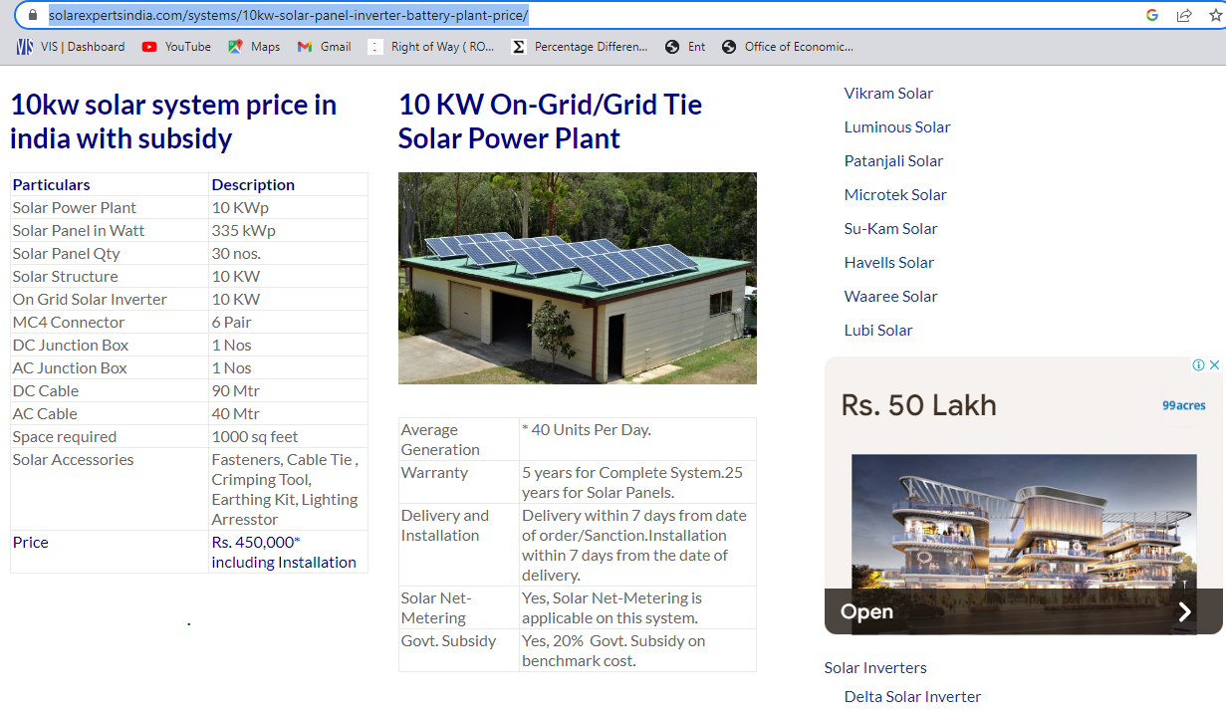

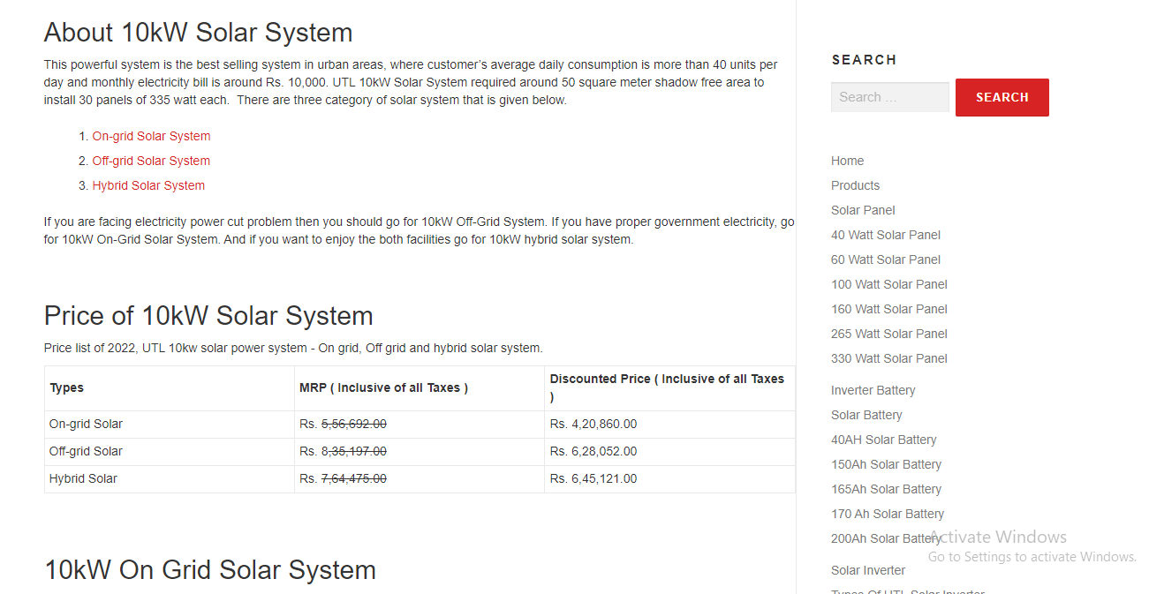

GBT 20 mtr.:
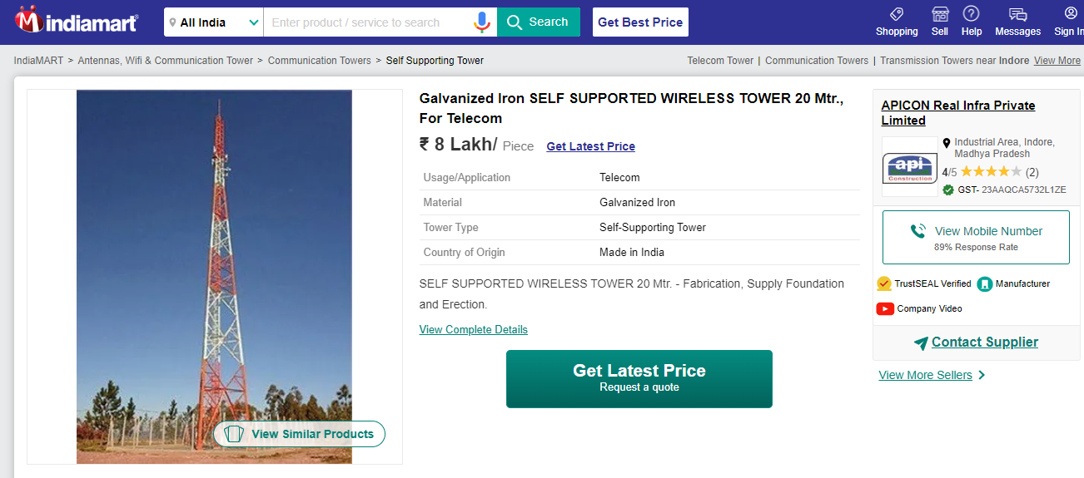

Hybrid CCU:
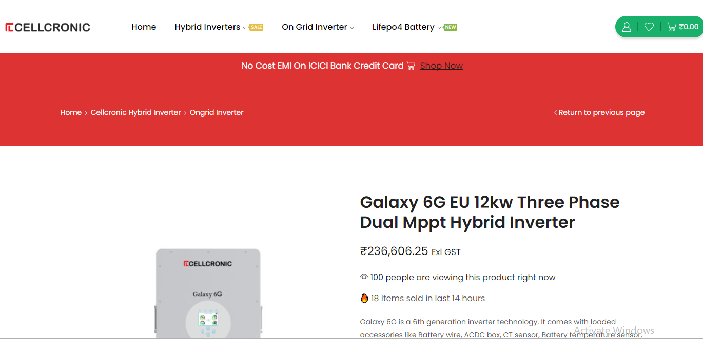

SMPS:
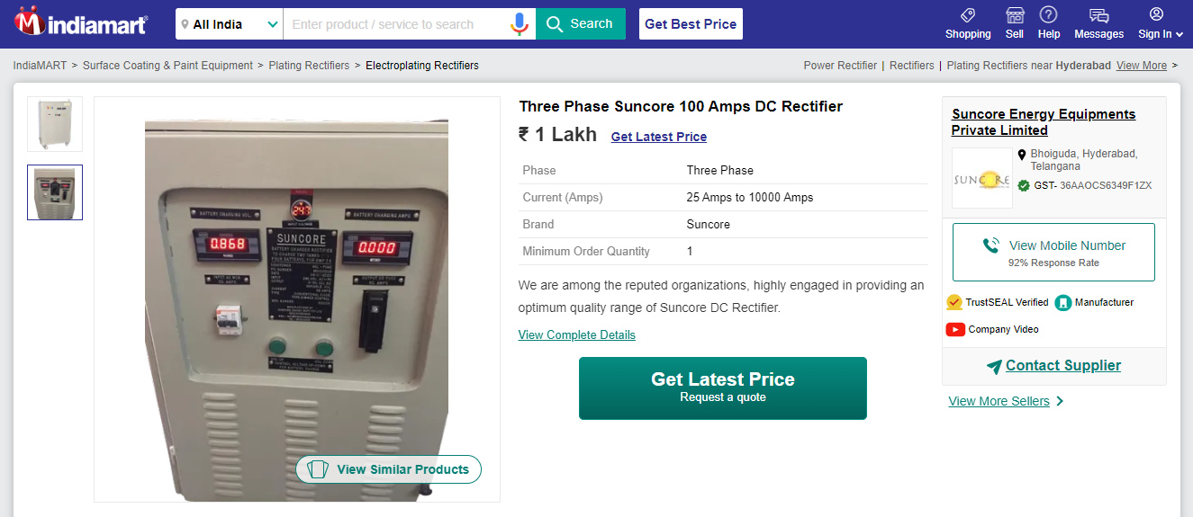
CCTV Camera:
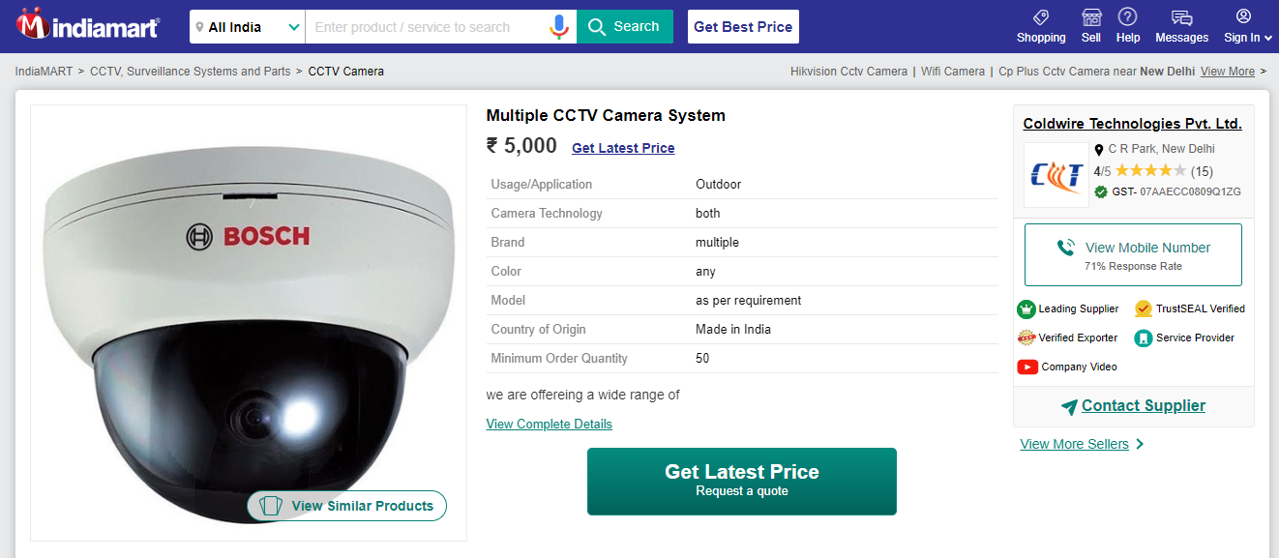

SMPS - Rectifier:
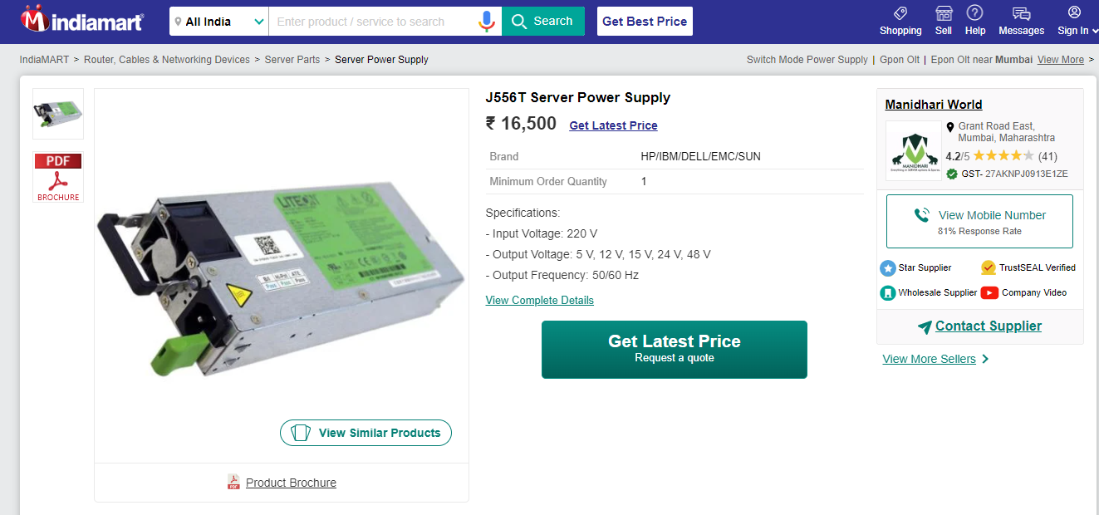
Battery Bank 48 V 1200 Ah:
