**20 mtr. GBT**

<https://www.indiamart.com/proddetail/self-supported-wireless-tower-20-mtr-23962478448.html>

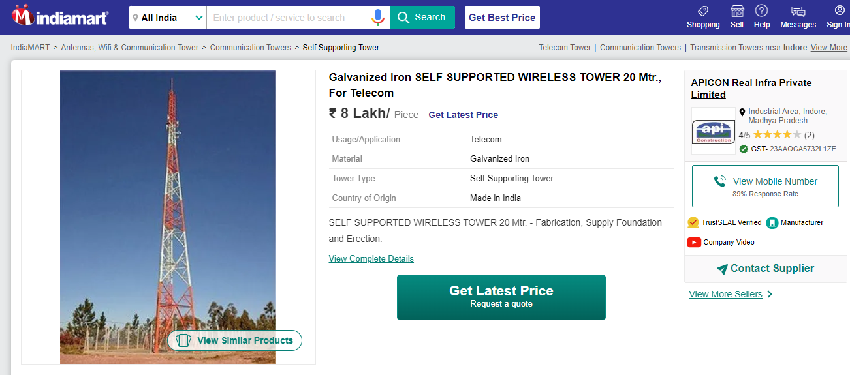

**30 mtr. GBT**

<https://www.indiamart.com/proddetail/self-supported-wireless-tower-30-mtr-23962506891.html>

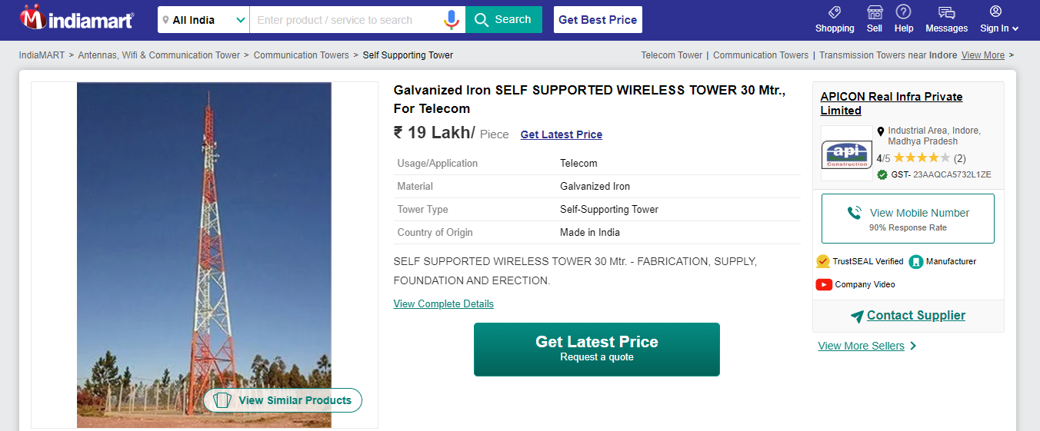

**40 mtr. GBT**

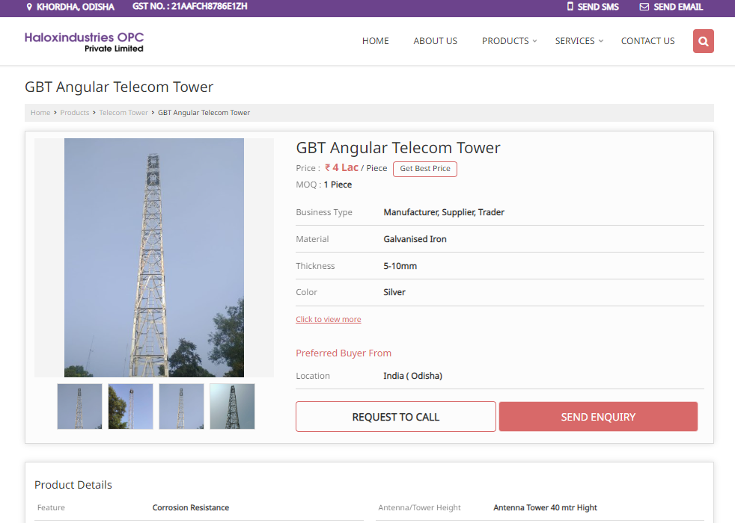

**15 KW Solar power panels**

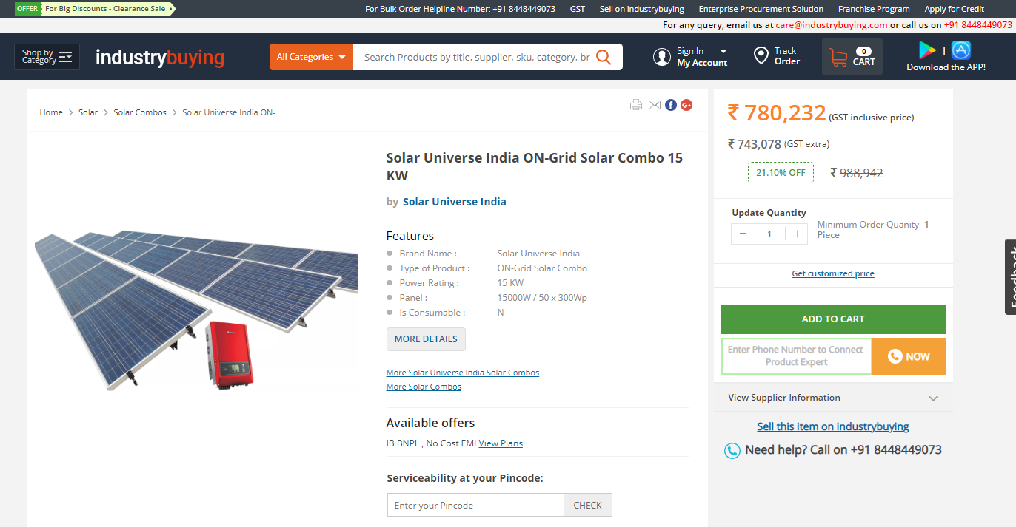

**10 kW solar power panels**

[**https://www.loomsolar.com/blogs/pricelist/10kw-solar-system-price-in-india#:~:text=Pricing,9%2C50%2C000%20in%20India**](https://www.loomsolar.com/blogs/pricelist/10kw-solar-system-price-in-india#:~:text=Pricing,9%2C50%2C000%20in%20India)

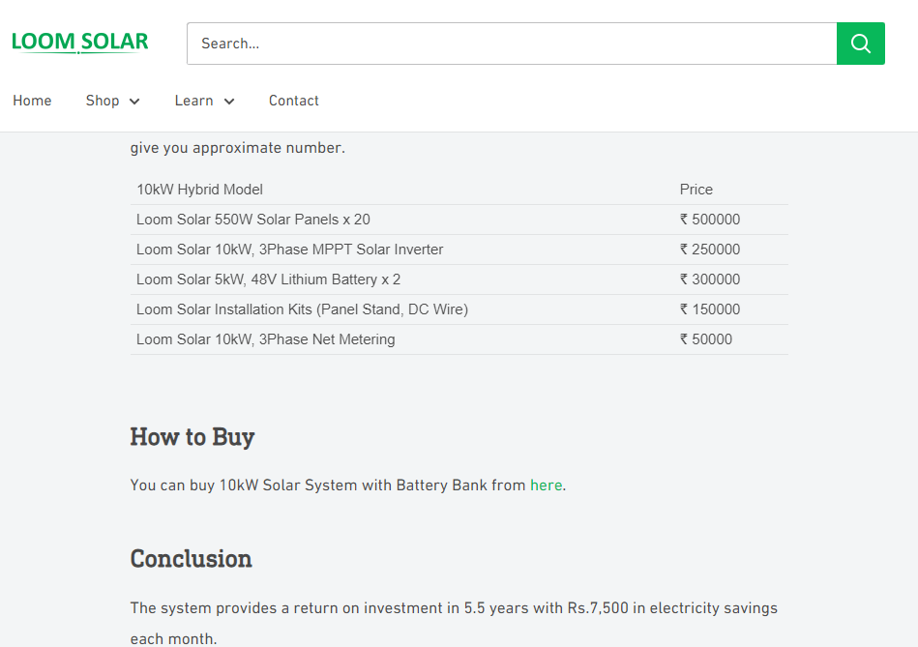

[**https://www.solarexpertsindia.com/systems/10kw-solar-panel-inverter-battery-plant-price/**](https://www.solarexpertsindia.com/systems/10kw-solar-panel-inverter-battery-plant-price/)

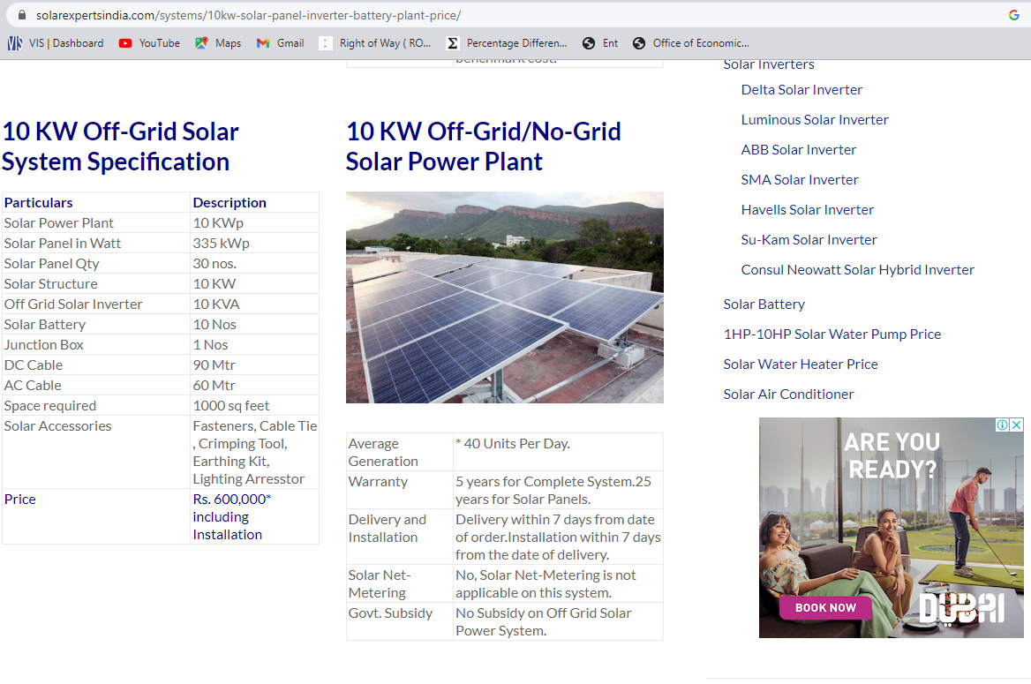

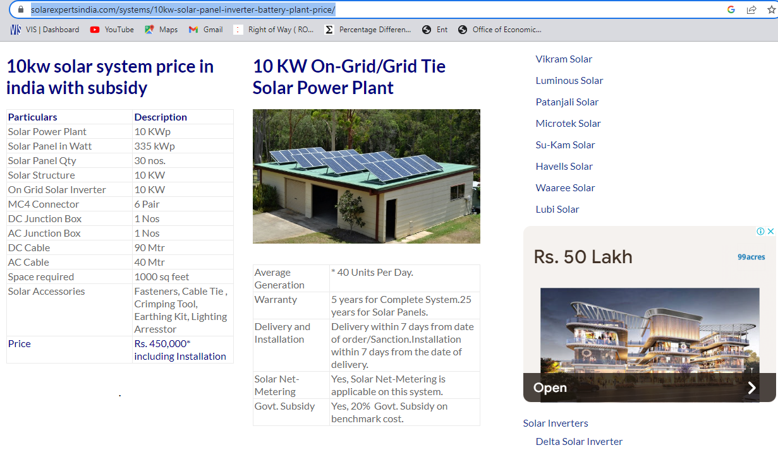

[**https://kenbrooksolar.com/system/10kw-solar-system-price**](https://kenbrooksolar.com/system/10kw-solar-system-price)

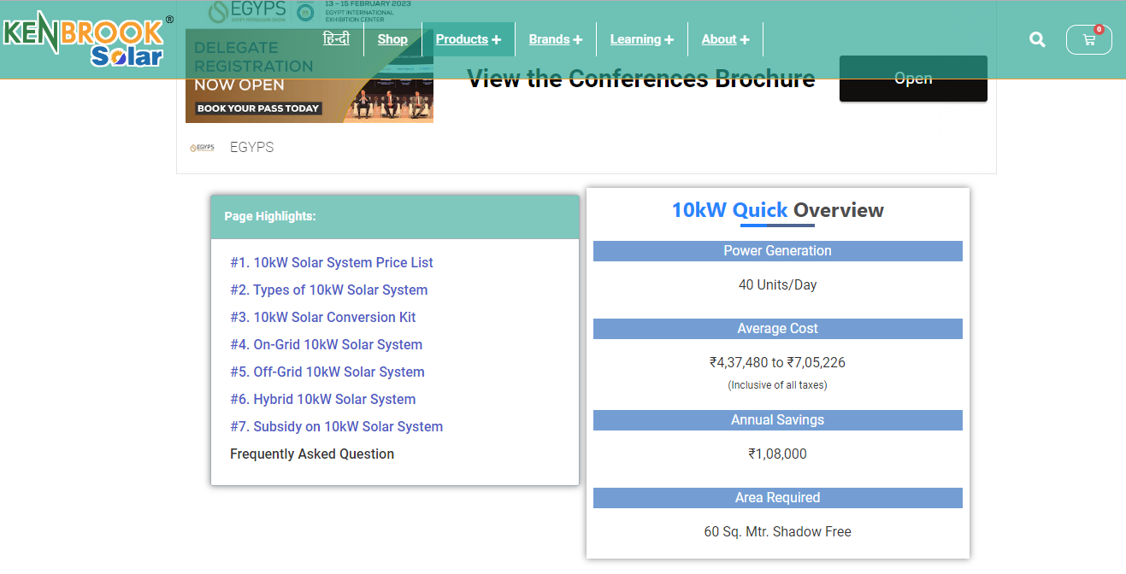

**Upgradation to 10 kW Solar Panel**

[**https://www.loomsolar.com/blogs/collections/how-to-upgrade-an-existing-5kw-solar-system-to-10kw**](https://www.loomsolar.com/blogs/collections/how-to-upgrade-an-existing-5kw-solar-system-to-10kw)

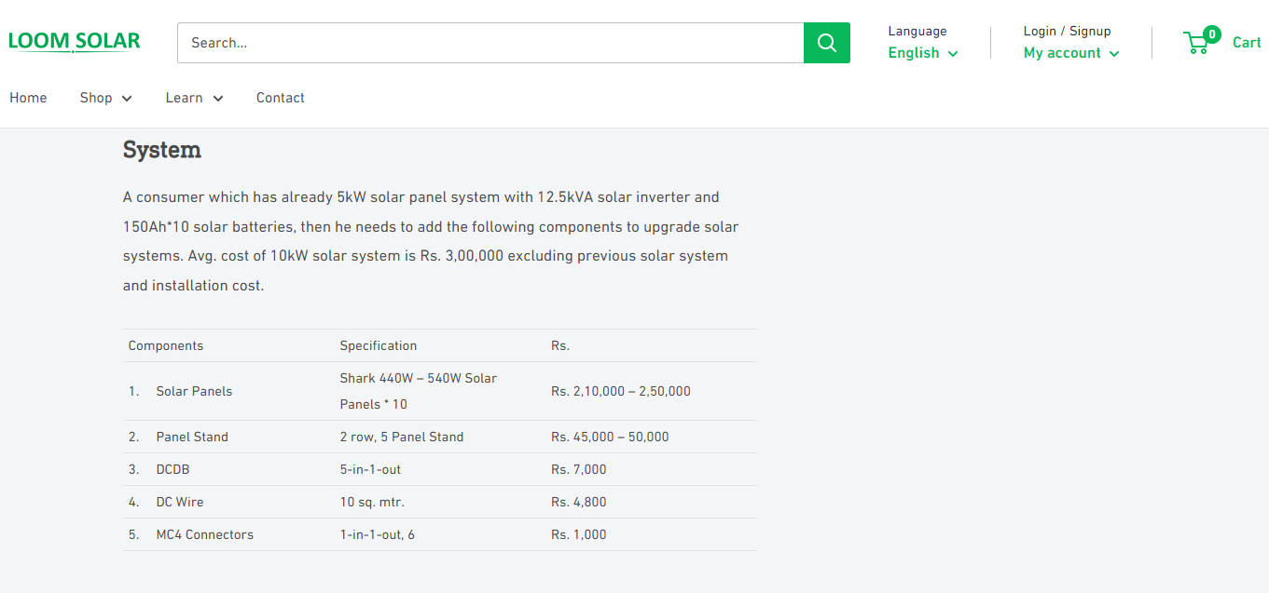

**10 KW Single Phase Alternator**

[**https://www.industrybuying.com/water-pump-sets-kirloskar-AGR.WAT.62875486/**](https://www.industrybuying.com/water-pump-sets-kirloskar-AGR.WAT.62875486/)

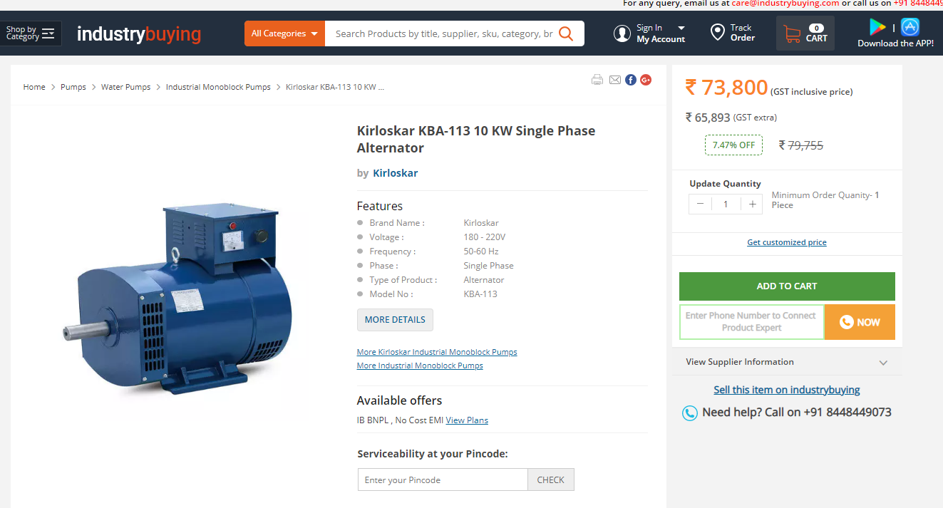

[**https://www.upsinverter.com/utl/10kw-solar-system/**](https://www.upsinverter.com/utl/10kw-solar-system/)

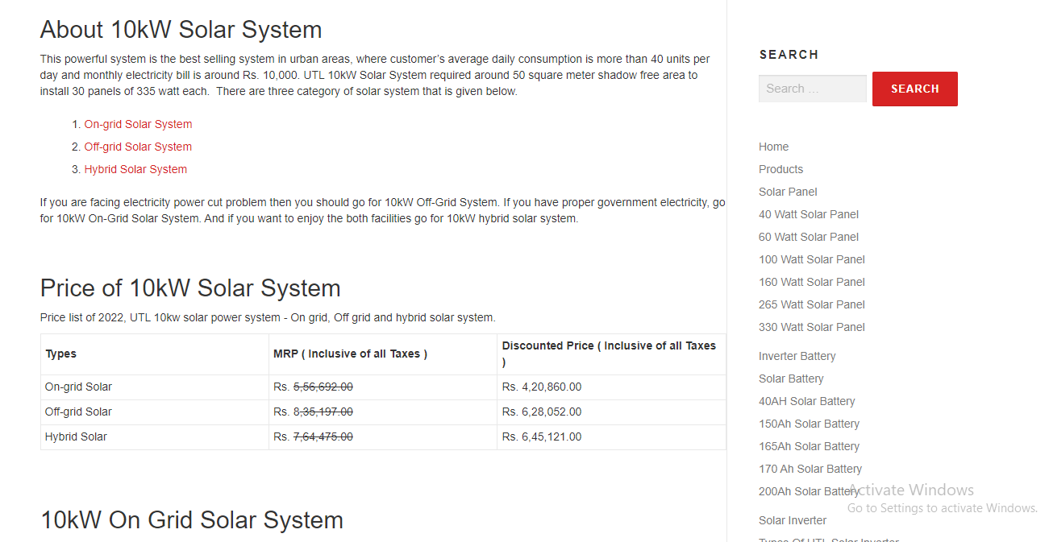

**SMPS Rectifier**

[**https://aetriotechnology.com/product/delta-4000w-rectifier-dpr-4000b-48v-ac-dc-module/**](https://aetriotechnology.com/product/delta-4000w-rectifier-dpr-4000b-48v-ac-dc-module/)

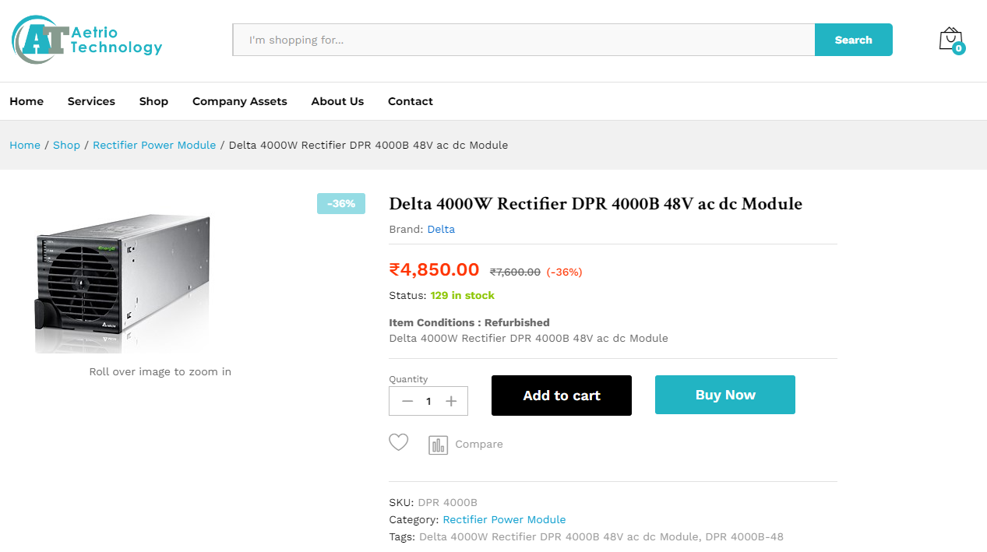

[**https://www.electronicscomp.com/24v-40amp-smps-960w-dc-metal-power-supply-nwp-india?gclid=CjwKCAiA5Y6eBhAbEiwA_2ZWIU1hX9fhX5m2rUEQUMaurEyQKN4pLLoLoBmJrBc3D6zYQgDWJ1b6jxoCtEQQAvD_BwE**](https://www.electronicscomp.com/24v-40amp-smps-960w-dc-metal-power-supply-nwp-india?gclid=CjwKCAiA5Y6eBhAbEiwA_2ZWIU1hX9fhX5m2rUEQUMaurEyQKN4pLLoLoBmJrBc3D6zYQgDWJ1b6jxoCtEQQAvD_BwE)

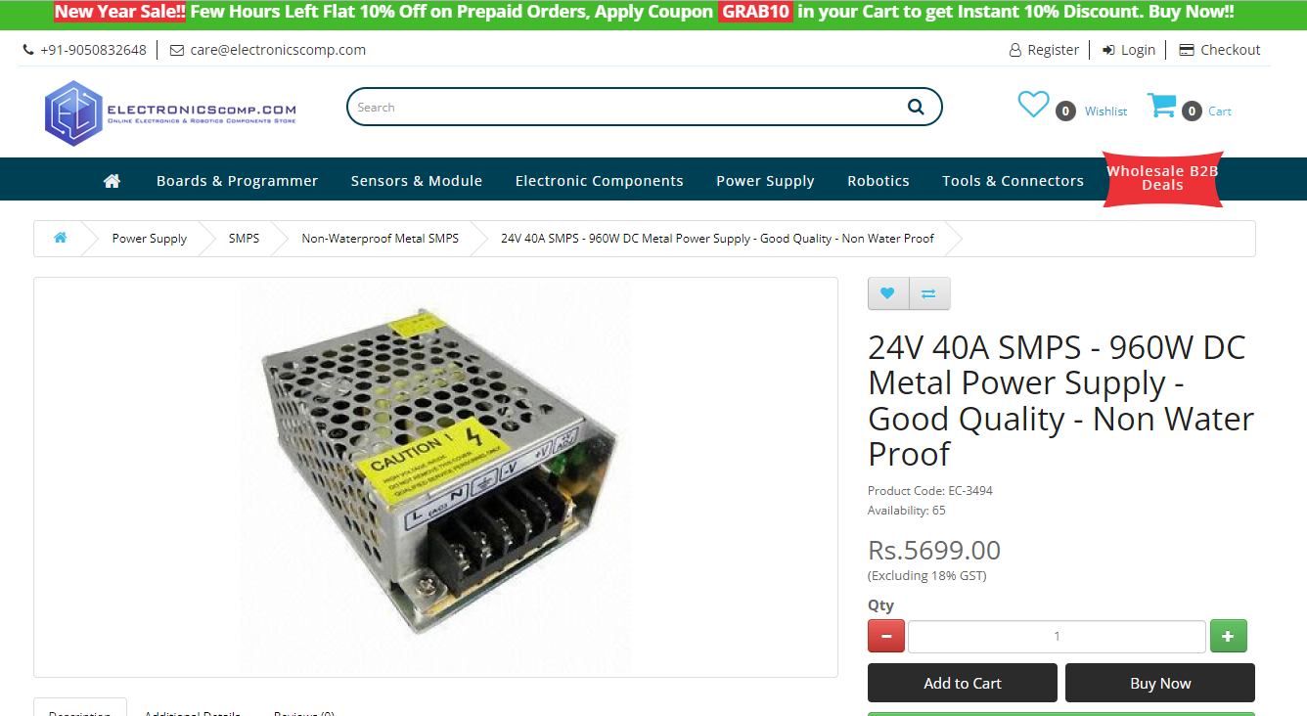

**Hybrid CCU**

[**https://cellcronic.com/product/galaxy-6g-eu-12kw-three-phase-dual-mppt-hybrid-inverter/**](https://cellcronic.com/product/galaxy-6g-eu-12kw-three-phase-dual-mppt-hybrid-inverter/)

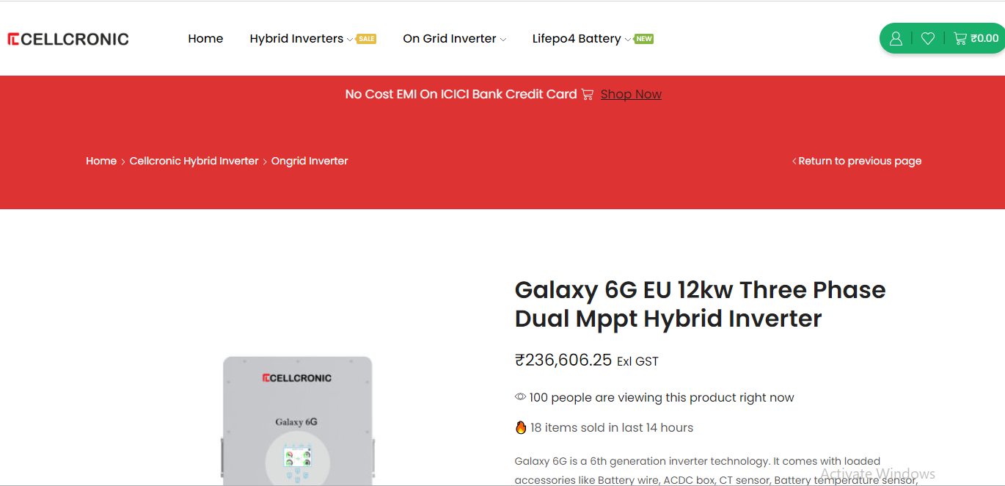

[**https://www.indiamart.com/proddetail/12kw-three-phase-hybrid-solar-inverter-26072133433.html**](https://www.indiamart.com/proddetail/12kw-three-phase-hybrid-solar-inverter-26072133433.html)

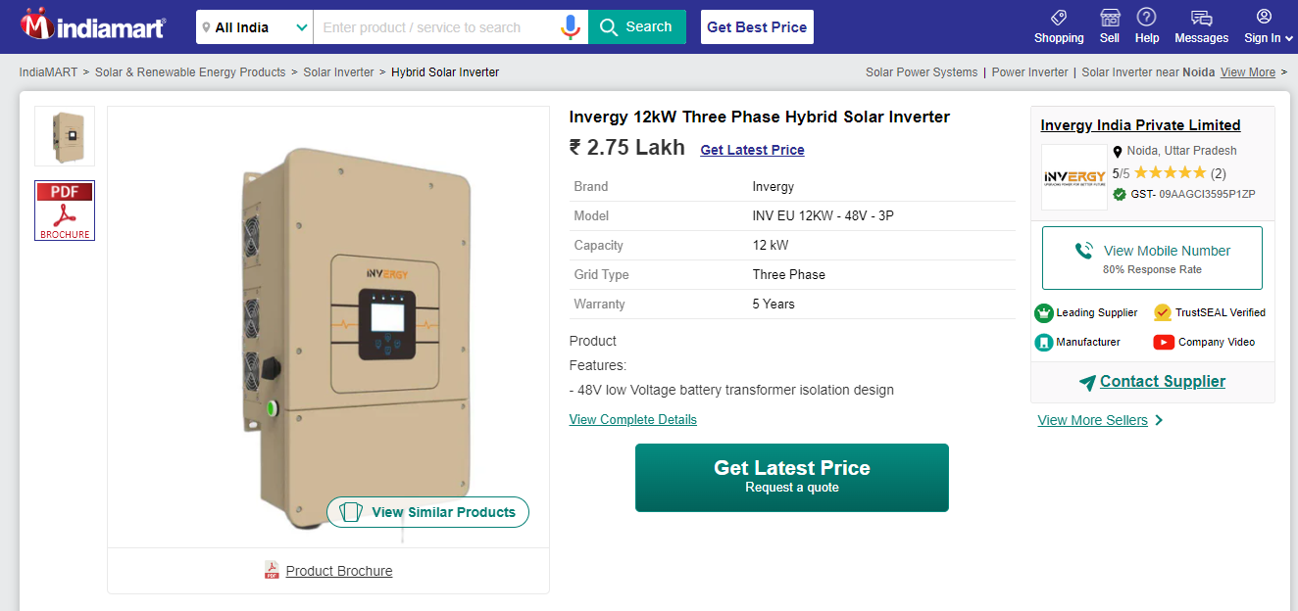

[**https://www.industrybuying.com/solar-off-grid-inverter-statcon-SOL.SOL.64536885/?utm_source=Google&utm_medium=PLA&utm_campaign=PLAPMAX_Solar&gclid=Cj0KCQiA8aOeBhCWARIsANRFrQHkTRPT8vhqIhOUB8W6z4O6ocqfjxjL0mhHM7ope4NmWrfbfTi20UsaAk_nEALw_wcB**](https://www.industrybuying.com/solar-off-grid-inverter-statcon-SOL.SOL.64536885/?utm_source=Google&utm_medium=PLA&utm_campaign=PLAPMAX_Solar&gclid=Cj0KCQiA8aOeBhCWARIsANRFrQHkTRPT8vhqIhOUB8W6z4O6ocqfjxjL0mhHM7ope4NmWrfbfTi20UsaAk_nEALw_wcB)

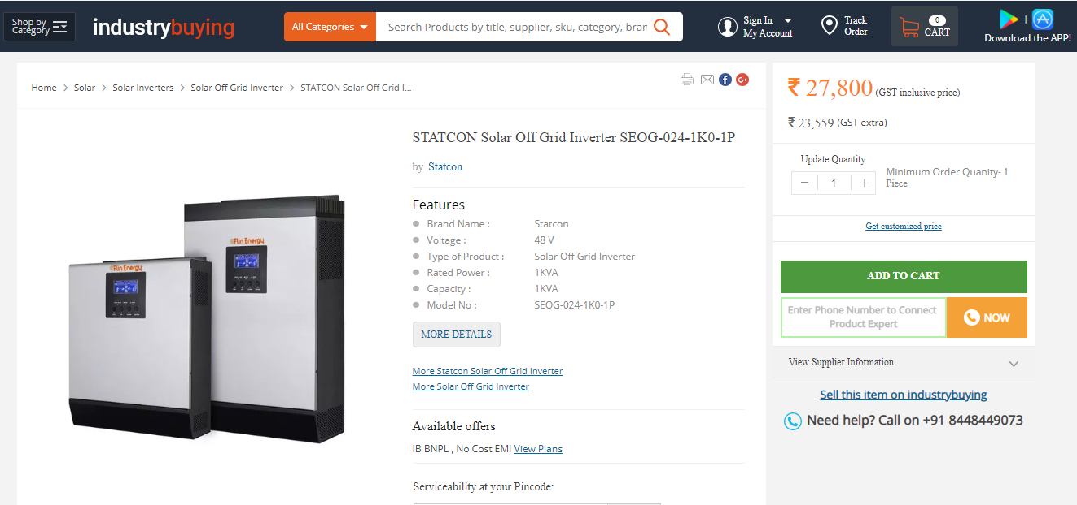

**SMPS 16500/-**

[**https://www.indiamart.com/proddetail/j556t-server-power-supply-14449107262.html**](https://www.indiamart.com/proddetail/j556t-server-power-supply-14449107262.html)

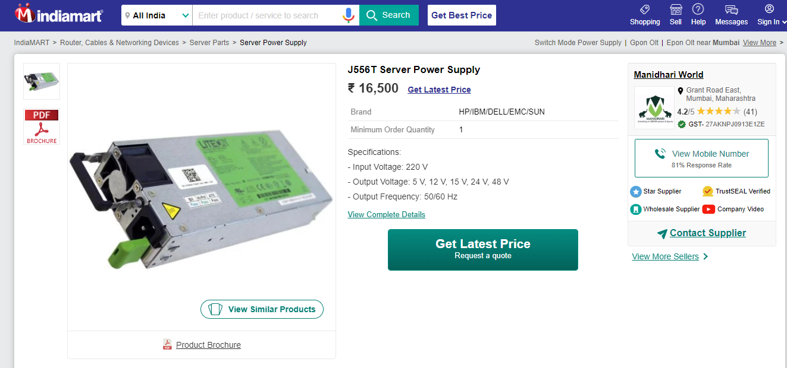

**SMPS 1,00,000/-**

[**https://www.indiamart.com/proddetail/suncore-100-amps-dc-rectifier-14214854333.html**](https://www.indiamart.com/proddetail/suncore-100-amps-dc-rectifier-14214854333.html)

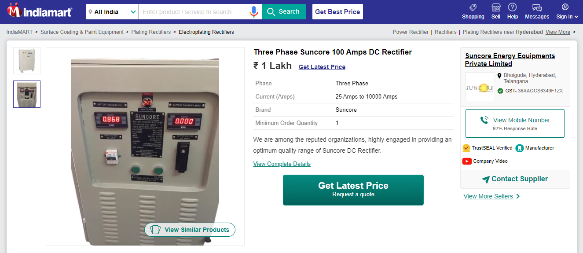

**CCTV Camera 5000/-**

[**https://www.indiamart.com/proddetail/cctv-camera-system-20437164633.html?pos=12&kwd=cctv%20camera&tags=A||||8227.221|Price|product|LSnp**](https://www.indiamart.com/proddetail/cctv-camera-system-20437164633.html?pos=12&kwd=cctv%20camera&tags=A||||8227.221|Price|product|LSnp)

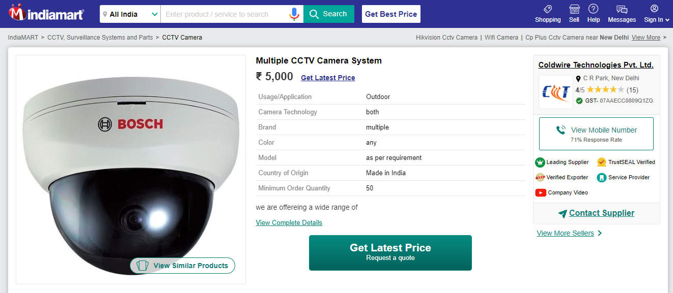

**CCTV Certificate/ License**

[**https://www.indiamart.com/proddetail/wpc-eta-approval-for-wireless-cctv-camera-21508201573.html**](https://www.indiamart.com/proddetail/wpc-eta-approval-for-wireless-cctv-camera-21508201573.html)

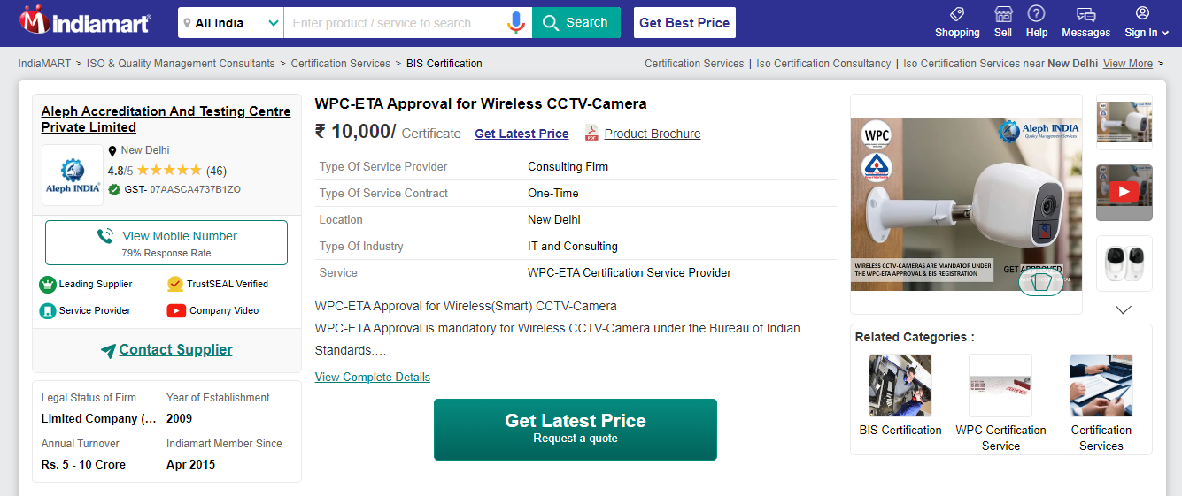

**DG Set 15 kVA**

[**https://www.indiamart.com/proddetail/15-kva-diesel-generator-set-best-price-1193079291.html**](https://www.indiamart.com/proddetail/15-kva-diesel-generator-set-best-price-1193079291.html)

