REPORT FORMAT: CL-1 | Version: 1.0_2018

FILE No.: VIS(2022-23)-PL574-468-797 Date: 19-01-2023

- CERTIFICATE NAME: Cost Vetting Certificate for Machinery & Equipment to be installed in two projects, sites of which are located across India.
- PREPARED FOR ORGANIZATION: State Bank of India, Commercial Branch, Gurugram
- BORROWER COMPANY’S NAME: M/s. Pratap Technocrats Pvt. Ltd.
- ASSET TYPE: Machinery & Equipment of Telecom industry.
- CURRENT LOCATION OF THE MACHINES: Project 1: 2,343 sites across India.
Project 2: 2,075 sites across India.

TO WHOMSOEVER IT MAY CONCERN

S. NO. | PARTICULARS | DESCRIPTION
1. | Date of Survey | Not Applicable
2. | Date of Certificate | 19-01-2023
3. | Documents provided for perusal | - List of machinery & equipments  - Purchase Orders
7. | Type of Assessment | Cost vetting
8. | Scope of Assessment | Cost Vetting of the machines and other related equipments of Telecom industry which are proposed to be installed at the above-mentioned sites.
9. | Nature of Machinery | Machinery & Equipment of Telecom industry such as Ground Based Tower, Solar Panels, Battery, SMPS, CCTV Camera, etc.
10. | Year of Manufacturing | Not applicable as the machinery are yet to be installed.
11. | Total Purchase Cost | Project 1: Rs. 709.88 Cr. (excluding GST)  Project 2: Rs. 1,602.03 Cr. (excluding GST)  Total: Rs. 2,311.91 Cr. (excluding GST)  (Total estimated project cost as per the List of machinery/ purchase orders provided to us)
12. | Current Estimated Market Value | The range of current market rates of such type of machinery & equipments is verified from various suppliers and also from the public domain for new machinery and equipment.  Based on the information received from market survey, we are of the view that rate range for supply of machinery and equipments of similar kind should be in the range of:  Project 1: Rs.30.00 Lakhs to Rs.35.00 Lakhs per site which translates to Rs.702.90 Cr. to Rs.820.05 Cr. for all 2,343 sites.  Project 2: Rs.70.00 Lakhs to Rs.80.00 Lakhs per site which translates to Rs.1,452.50 Cr. to Rs.1,660.00 Cr. for all 2,075 sites.  According to our observation, the rate as per the list of machinery and their total purchase price provided to us by the company/ bank are quite reasonable when compared to the rates of similar machines currently prevailing in the market.
13. | Condition of Machines | Yet to be installed.

Cost of Project-1
Sub Head | Items | Buy Rate  (in Rs. lakhs) | Total Sites | Total Cost (in Rs. Cr.)
 |  |  |  | As per Company | As estimated by RKA
Supply
Lithium ion Battery | Supply of Lithium ion Battery- 2 x 600Ah along with BMS | 11.40 | 2,182 | 248.73 | 250.93
SMPS Power plant | Supply of SMPS P/P 50(4+1)A - Indoor | 1.07 | 195 | 2.08 | 1.95
Charging Control Unit (CCU) | Supply of CCU | 0.28 | 1,987 | 5.46 | 5.52
Solar Panel | Upgradation of Solar Panel with minimum 10 KW capacity along with fixtures/stands | 2.35 | 1,987 | 46.69 | 49.68
Engine Alternator | Supply of E/A – 15 KVA along with proper mounting stands | 3.25 | 195 | 6.34 | 5.46
CCTV Camera | Supply of 2 CCTV Camera along with fixtures | 0.05 | 2,343 | 1.17 | 1.17
 | Total Cost of Supply |  |  | 310.48 | 314.71
I&C
Lithium ion Battery | I&C of Lithium ion Battery- 600Ah along with proper mounting stands | 0.10 | 2,182 | 2.18 | 2.18
SMPS Power plant | Installation & Commissioning of SMPS P/P 50(4+1)A – Indoor | 0.04 | 195 | 0.08 | 0.08
Charging Control Unit (CCU) | Installation & Commissioning of CCU | 0.03 | 1,987 | 0.50 | 0.50
Solar Panel | Installation & Commissioning of Solar Panel | 0.55 | 1,987 | 10.93 | 10.93
Engine Alternator | Installation & Commissioning of E/A | 0.15 | 195 | 0.29 | 0.29
CCTV Camera | Installation & Commissioning of CCTV Camera | 0.03 | 2,343 | 0.70 | 0.70
 | Total Cost of Commissioning |  |  | 14.68 | 14.68
O&M Cost
O&M of the site | Operation & Maintenance of the 4G sites | 3.24 | 2,182 | 70.70 | 70.70
O&M of the site | Operation & Maintenance of the 4G sites at IP Locations | 3.00 | 161 | 4.83 | 4.83
O&M of the site | Operation & Maintenance of cable per km for 5 years | 1.23 | 4,686 | 57.40 | 57.40
 | Total O&M Cost |  |  | 132.93 | 132.93
Supply
After 4 years (replacement) | Supply of Lithium ion Battery- 2 x 600Ah along with BMS | 11.40 | 2,182 | 248.73 | 250.93
I&C
 | I&C of Lithium ion Battery- 600Ah along with proper mounting stands | 0.14 | 2,182 | 3.05 | 3.05
 | Total Cost of Supply (after 4 Years) |  |  | 251.79 | 253.98
 | Total cost (capex + O&M) |  |  | 709.88 | 716.31

Cost of Project-2
S. No. | Type | Item | Qty. | Nett Rate  (in Rs.) | Other costs*  (in Rs.) | Total  (in Rs.) | Avg. Price as per RKA  (in Rs.)
1 | GBT | Supply and Commissioning Cost
1.1 | Supply-GBT | Supply and Erection of 40 Meter GBT | 1 | 9,99,900 | 6,14,996 | 16,14,896 | 20,73,796
1.1 | Supply-GBT | Site development and Fencing | 1 | 1,55,000 | 2,12,200 | 3,67,200 | 20,73,796
1.1 | Supply-GBT | Earthing | 1 | 40,000 | 46,600 | 86,600 | 20,73,796
Total |  |  |  | 11,94,900 |  | 20,68,696 | 20,73,796
1.2 | Supply-GBT | Supply and Erection of 20 Meter GBT | 1 | 4,95,000 | 3,72,800 | 8,67,800 | 14,31,600
1.2 | Supply-GBT | Site development and Fencing | 1 | 1,55,000 | 2,12,200 | 3,67,200 | 14,31,600
1.2 | Supply-GBT | Earthing | 1 | 40,000 | 46,600 | 86,600 | 14,31,600
Total |  |  |  | 6,90,000 |  | 13,21,600 | 14,31,600
2 | Infra-Part A | Supply and Commissioning Cost
2.1 | Supply | Civil work for making plinth for installation of BBU, Batteries and CCU/Power plants | 1 | 40,000 | 1,600 | 41,600 | 40,000
2.2 | Supply | Lithium Ion Batteries 800 AH (Including replacement of the batteries after 4 years) | 1 | 7,68,000 | 40,720 | 8,17,470 | 7,50,000
2.3 | Supply | Supply and installation of 10Kwp Solar Power Panels | 1 | 4,16,408 | 48,656 | 4,73,064 | 4,50,000
2.4 | Supply | Supply and installation of Hybrid Charging Control Unit | 1 | 2,28,205 | 12,128 | 2,40,333 | 2,36,000
2.5 | Supply | 2 CCTV Cameras at each site with License | 2 | 32,400 | 3,796 | 36,196 | 30,000
2.5 | Supply | Supply of Power Plant (SMPS) | 30% | 16,320 | 653 | 16,973 | 16,500
2.6 | Supply | SMPS - Rectifier | 1.5 | 15,750 | 630 | 16,380 | 16,800
2.7 | Supply | Supply of Engine Alternator (12.5 KVA or 10 KW) | 30% | 84,600 | 3,384 | 87,984 | 73,800
2.8 | I&C | ACDB (AMF) | 30% | 13,500 | 540 | 14,040 | 14,040
2.9 | I&C | LT Panel (at electric site) | 1 | 15,000 | 600 | 15,600 | 15,600
2.10 | I&C | Alarm Panel | 1 | 10,000 | 400 | 10,400 | 10,400
2.11 | I&C | Fire extinguisher | 1 | 4,500 | 180 | 4,680 | 4,680
2.12 | I&C | Surge Arrestors | 1 | 4,500 | 180 | 4,680 | 4,680
2.13 | I&C | Energy meter | 1 | 5,000 | 200 | 5,200 | 5,200
2.14 | I&C | Cost of Electric Connection (CAPEX) | 70% | 2,80,000 | 11,200 | 2,91,200 | 2,91,200
Total Cost Infra Supply and Commissioning Cost |  |  |  |  |  | 20,75,800 | 19,58,900
3 | Infra-Part B | Supply and Commissioning Cost (After 4 Years)
3.1 | Supply | Lithium Ion Batteries 800 AH (Including replacement of the batteries after 4 years) | 1 | 7,68,000 | 40,720 | 8,17,470 | 7,50,000
Total Cost Supply after 4 years |  |  |  |  |  | 8,17,470 | 7,50,000
4 | O&M | O&M of Site and OFC
4.1 | O&M | Cost of O&M/Security/CT | 1 | 4,500 | 180 | 4,680 | 4,680
4.2 | O&M | Cost of Energy - EB Bill | 1 | 4,96,800 | 19,872 | 5,16,672 | 5,16,672
4.3 | O&M | Cost of Diesel - For DG Sites | 30% | 6,48,000 | 25,920 | 6,73,920 | 6,73,920
4.4 | O&M | Repairing of Rectifier | 1 | 2,052 | 82 | 2,134 | 2,134
4.5 | O&M | Replacement of Rectifier | 1 | 15,120 | 605 | 15,725 | 15,725
4.6 | O&M | SMPS/CCU /Power plant repairing | 1 | 14,400 | 576 | 14,976 | 14,976
4.7 | O&M | DG repairing/Servicing | 30% | 17,280 | 691 | 17,971 | 17,971
4.8 | O&M | Earthing/Repairing | 1 | 7,200 | 288 | 7,488 | 7,488
4.9 | O&M | El Misc. Cost | 1 | 14,400 | 576 | 14,976 | 14,976
4.10 | O&M | Diesel Filling Charges | 30% | 17,820 | 713 | 18,533 | 18,533
4.11 | O&M | Operation & Maintenance of cable | 1 | 1,50,000 | - | 1,50,000 | 1,50,000
Total Cost O&M |  |  |  |  |  | 14,37,075 | 14,37,075
Grand Total Infra Cost |  |  |  |  |  | 77,20,641 | 76,51,371
*Transportation, Insurance, Civil Work, Cables, I&C and others.

OBSERVATIONS & REMARKS:
- We have been provided with the copy of purchase orders with cost of machinery & equipment.
- As per the information provided by the company officials, these machinery and equipments are for 2 no. of projects located across various locations across India.
- We have contacted several suppliers and done the market research for similar items available on public domain. Accordingly, we have retrieved the quotation from the suppliers of machinery & equipment and found that the summary of machinery & equipment provided to us is well within the price range of similar items available in the market.
- In absence of sufficient data from the company regarding the civil works, and other charges which includes but not limited to installation and commissioning charges, operation and maintenance charges as it varies from vendor to vendor and location to location, therefore, we have considered the same amount as provided to us to be fair and reasonable for the purpose of this cost vetting exercise.
- Based on the information provided to us by the bank, enquiries made in the open market and references found in the public domain for similar machinery & equipment, it is certified that total market cost for supply of machinery and equipment of similar kind should be in the range of:
Project 1: Rs.30.00 Lakhs to Rs.35.00 Lakhs per site which translates to Rs.702.90 Cr. to Rs.820.05 Cr. for all 2,343 sites.
Project 2: Rs.30.00 Lakhs to Rs.35.00 Lakhs per site which translates to Rs.1,452.50 Cr. to Rs.1,660.00 Cr. for all 2,075 sites.
- Therefore, the total purchase price of; Project 1- Rs.709.88 Cr. (excluding GST) and Project 2- Rs.1,587.66 Cr. (excluding GST) (as per the quotations, purchase orders provided to us by the company) appears to be reasonable.

Disclaimer:
  - We can’t comment about the current status of machines whether these are purchased, installed or in transit. This cost vetting is done only on the basis of Quotations, Bills and Purchase Orders provided to us by the company and we don’t recommend any sort of recommendation in our Certificate.
  - The estimated cost verification of item to item can’t exactly match as per our vetting due to several market consideration. In some of the items it is lower while in some of the items price comes to be higher but on an average the price as per list provided to us falls in the range as confirmed by us.
  - There can be variation in the estimated price if the specification & make of any items procured is different from the list provided to us during assessment.
  - The estimated cost verification is made based on the third-party information which has been replied upon in good faith.
  - The estimated price may vary at the time of actual procurement because of change in prices in the market for such kind of machinery/items for which we will not have any control. The cost vetting is only limited to the date of Certificate issued. We do not assume any responsibility in change of prices of the said machinery/items after this date.
  - This certificate doesn’t include any work related to drawing, design, sketch plan, procurement of the machines.
  - Ownership and other legal point of view in respect of the asset is not considered in this report as same is out of scope of this certificate.
  - This certificate is made at the request of the Bank.

For R.K Associates Valuers & Techno FOR INTERNAL USE Engineering Consultants (P) Ltd. TYPED BY: MANAS UPMANYU
REVIEWED BY: ADIL AFAQUE

ANNEXURE: - SOME OF THE QUOTATIONS FROM THE MARKET
10 kW solar panel:
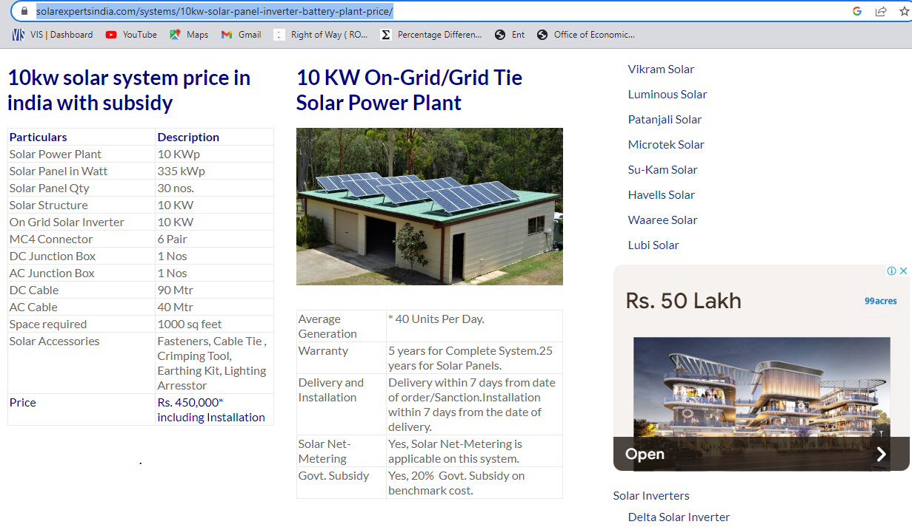

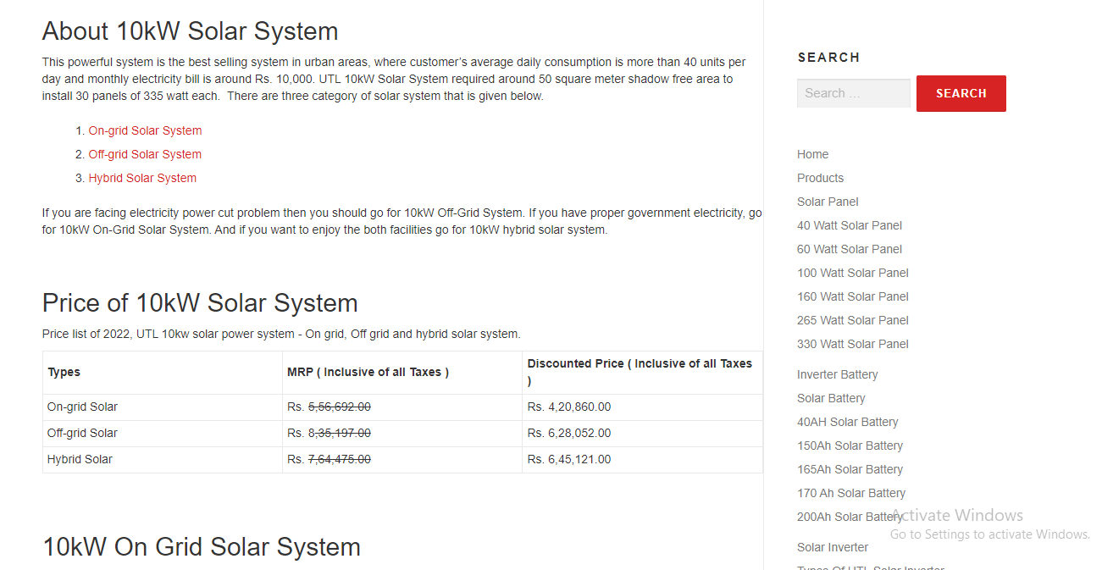

GBT 20 mtr.:
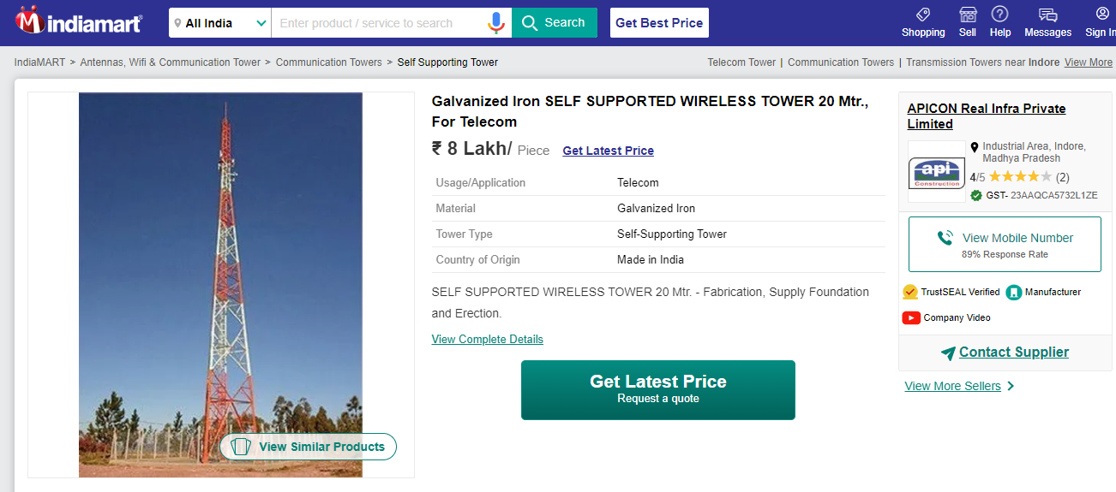

Hybrid CCU:
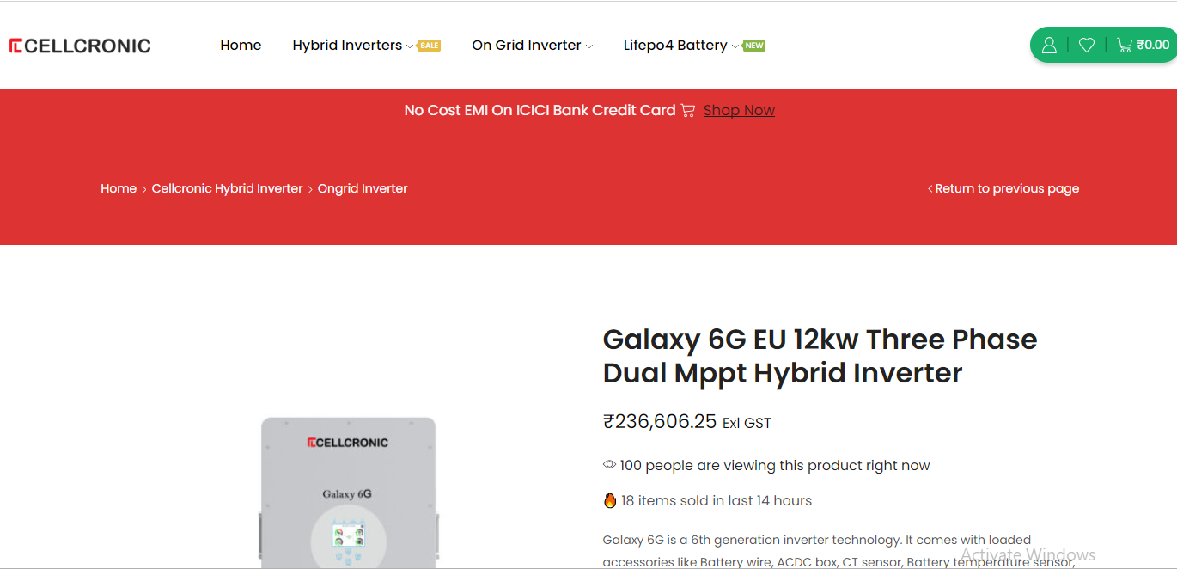

SMPS:
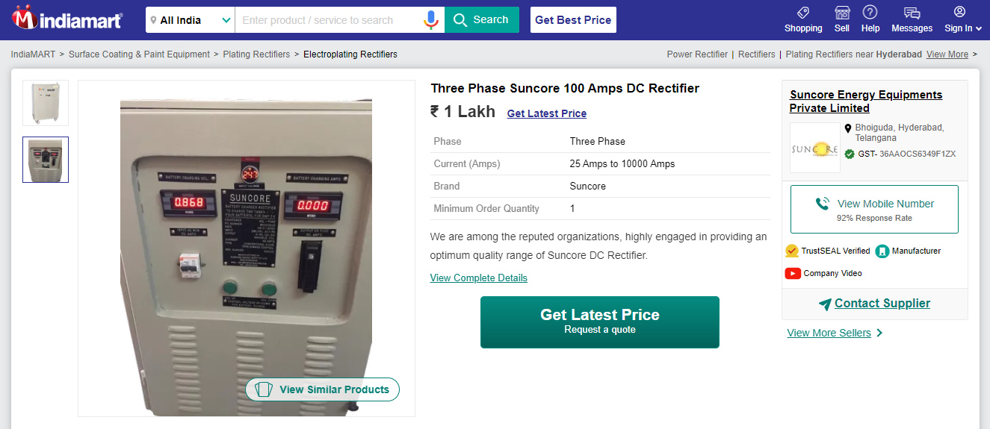
CCTV Camera:
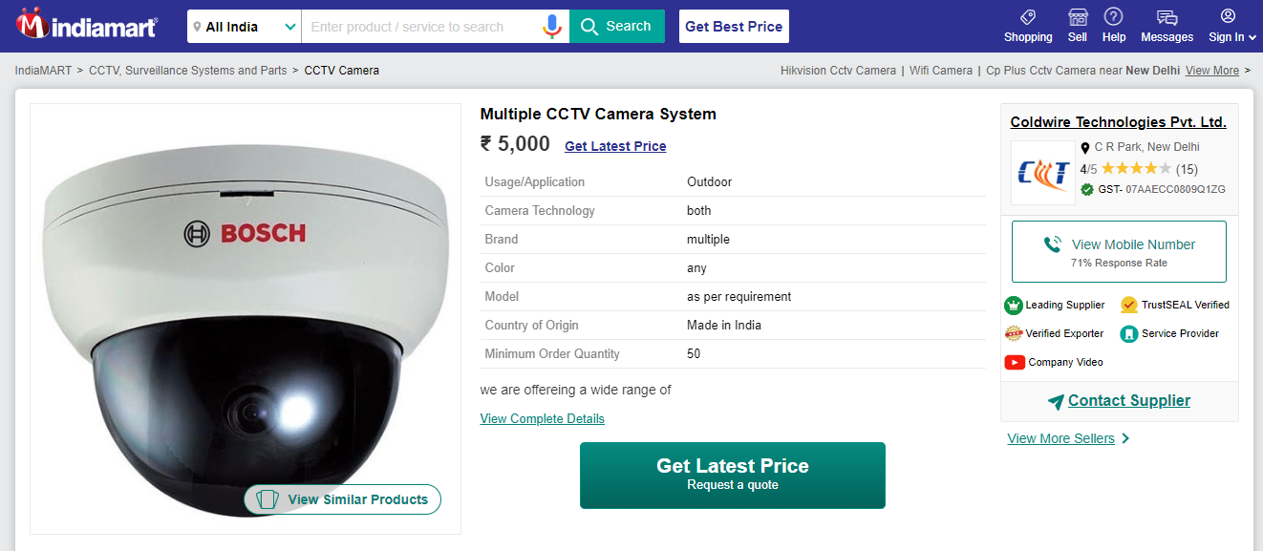

SMPS - Rectifier:
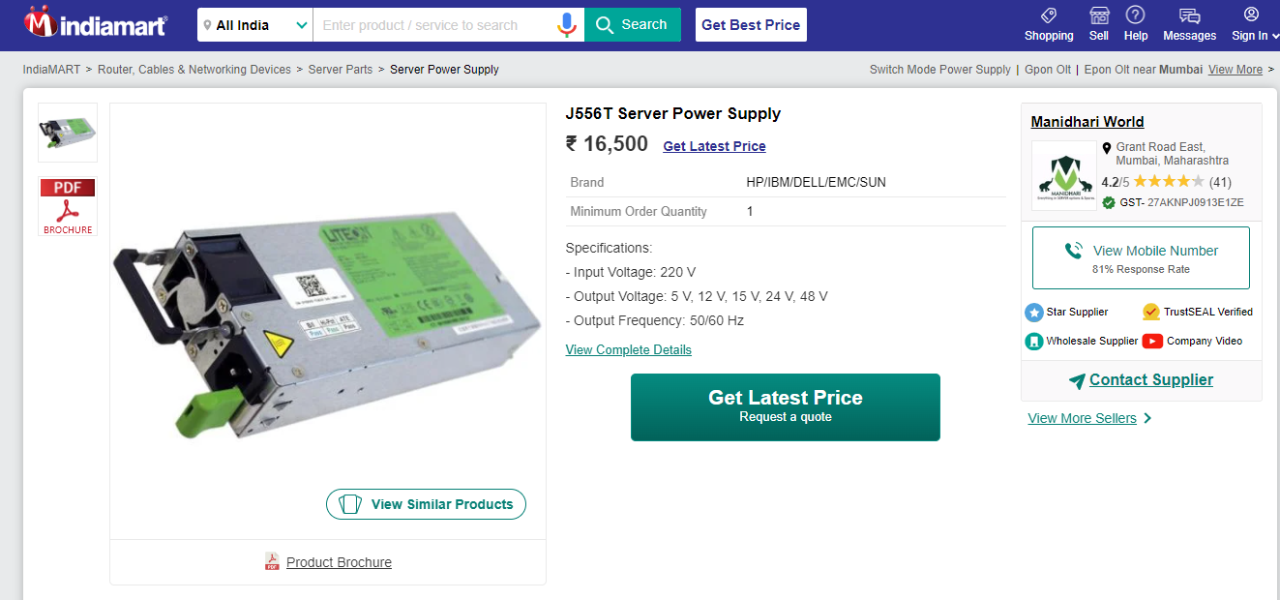
Battery Bank 48 V 1200 Ah:
