File No.: VIS (2022-23)-PL623-515-855 Dated: 28.01.2023

TECHNO-ECONOMIC VIABILITY
STUDY REPORT

OF

SUPER SPECIALITY HOSPITAL
(120 BEDS)

SETUP AS (BRAND NAME)

M/S TULA HOSPITAL

PROMOTED BY

M/S BOTHANZI MEDICALS PRIVATE LIMITED

REPORT PREPARED FOR
STATE BANK OF INDIA, SME ASAF ALI, 3/8 ASAF ALI ROAD, NEW DELHI – 110002

**Important - In case of any query/ issue or escalation you may please contact Incident Manager Valuers@rkassociates.org. We will appreciate your feedback in order to improve our services.

NOTE: As per IBA Guidelines please provide your feedback on the report within 15 days of its submission after which report will be considered to be correct.

IMPORTANT NOTICE

COPYRIGHT FORMAT: This report is prepared on the copyright format of R. K. Associates Valuers & Techno Engineering Consultants (P) Ltd. (R. K. Associates) to serve our clients with the best possible information and analysis to facilitate them to take rational business decisions. Legally no one can copy or distribute this format without prior approval from R. K. Associates. It is meant only for the advisory/ reference purpose for the organization/s as mentioned on the cover page of this report. Distribution or use of this format or report or any of its content/ information/ data by any organization or individual other than R.K Associates will be seen as an unlawful act and necessary legal action can be taken against the defaulters.
This report is intended for the sole use of the intended recipient/s and contains material that is STRICTLY CONFIDENTIAL AND PRIVATE.

DEFECT LIABILITY PERIOD: In case of any query/ issue or escalation you may please contact Incident Manager at valuers@rkassociates.org. Though adequate care has been taken while preparing this report as per its scope, but still, we can’t rule out typing, human errors, over sightedness of any information or any other mistakes. Therefore, the concerned organization is advised to satisfy themselves that the report is complete & satisfactory in all respect. Intimation regarding any discrepancy shall be brought into our notice immediately. If no intimation is received within 15 (Fifteen) days in writing from the date of issuance of the report, to rectify these timely, then it will be considered that the report is complete in all respect and has been accepted by the client up to their satisfaction & use and further to which R.K Associates shall not be held responsible in any manner.

Part N: R. K. Associates Important Disclaimer and Remarks are integral part of this report and Feasibility assessment is subject to this section. Reader of the report is advised to read all the points mentioned in these sections carefully.

TABLE OF CONTENTS
SECTIONS | PARTICULARS | PAGE NO.
Part A | Report Summary | 4-5
Part B | Introduction
 | - About the Report | 6
 | - Executive summary | 6-8
 | - Purpose of the Report | 8
 | - Scope of the Report | 9
 | - Methodology/ Model Adopted | 9-10
 | - Data Information received from | 10
 | - Documents/ Data Referred | 10
Part C | Company Profile
 | - Company Overview | 11
 | - Proposed Shareholding Details | 11-12
 | - Promoters/Directors Profile | 12-16
Part D | Infrastructure Details
 | - Proposed Location | 17
 | - Layout Plan | 17
 | - Location Map | 17-18
 | - Land Details | 18-19
 | - Site pictures | 19-21
 | - Building & Civil Works | 22-23
 | - Furniture ad Fixture for the Proposed Building | 23-25
 | - Plant and Machinery/ Equipment details | 25-26
 | - Utilities | 26
Part E | Project Technical details
 | - Proposed Capacity | 27
 | - Technical Specification of Proposed Facility | 27-29
 | - Technology Used | 29-33
 | - Source of Procurement of Equipment | 34
 | - Testing/Quality Assurance for Medical Diagnostic Centre | 34
 | - Manpower | 34-35
Part F | Services Profile
 | - Introduction | 36
 | - Services Category | 36-40
 | - Marketing, Selling & Distribution Plan | 40
Part G | Industry Overview & Analysis | 41-45
Part H | SWOT Analysis | 46
Part I | Project Cost and Means of Finance | 47-49
Part J | Project Schedule | 50-51
Part K | Statutory Approvals | Licences | NOC | 52-53
Part L | Company’s Financial Feasibility
 | - Projection of Firm | 54-59
 | - Graphical Representation of Key Financial Metrics | 59-61
 | - Sensitivity Analysis | 61-62
 | - Cost-Volume Price or Sensitivity | 62-64
 | - Loan Amortization Schedule | 64
 | - Key assumptions & Basics | 64-69
Part M | Conclusion | 70
Part N | Disclaimer | Remarks | 72-75
- | Annexure | 90-92

PART A | REPORT SUMMARY

- Name of the Company: | M/s Bothanzi Medicals Private Limited
- Reg. Address of the Company: | Eros Corporate Park, Sector-2, IMT Manesar Gurugram, Haryana-122052
- Project Name: | Tula Hospital
- Project Location: | K. No.-2015, NH -2, Delhi-Mathura Road, Near Kithwari Chowk, Krishna Colony, Palwal, Haryana -121102, India
- Project Type: | Super Specialty Hospital having Capacity of 120 Beds
- Project Industry: | Healthcare Industry
- Product Type/ Deliverables: | OPD, ICU, OTs, Nico, Dialysis centers, Eye clinic, ENT, General Medicines, Laparoscopic Surgery, Ortho and Joint replacement center, Pediatric and Neonatology, Obstetrics and Gynecology, Urology, Cardiology, Medical ecology, and surgery center, Dental clinics and surgery centers, Emergency & Trauma medical centers, Cancer clinic and radiotherapy, and Admission Beds, etc., including diagnostic services like MRI, CT-Scan, X-Ray, Color Doppler test, Ultrasound, and other Path lab tests facility
- Report Prepared for Organization: | State Bank of India, SME, Asaf Ali Road Branch, New Delhi
- TEV Consultant Firm: | M/s. R.K Associates Valuers & Techno Engineering Consultants (P) Ltd.
- Report type: | Techno-Economic Viability Report
- Purpose of the Report: | To assess Project’s Techno-Economic Viability for the purpose of seeking external financial assistance on the Project.
- Scope of the Report: | To assess, evaluate & comment on Techno-Financial Viability of the Project as per data information provided by the client, independent Industry research and data/ information available on public domain.
- Date of Report: | 28th January, 2023
- Documents referred for the Project | - PROJECT PLANNING DOCUMENTS:  - Detailed Project Report  - Financial Projections of the Project  - Project proposed Schedule  - Statutory Approval Details  - Layout and Master Plan  - PROCUREMEMNT DOCUMENTS:  - High level breakup of Equipment Cost  - Sanction/tentative/proposed map of the sites  - Land details and deeds  - Quotations of Equipment Required  - Cost Estimations
- Means of Finance: | Equity + Debt
- Key Financial Indicators | Key Indicators Value  Average Net DSCR 2.58  Maximum Net DSCR 3.05  Average EBITDA Margin 18.63%  Average EBIT Margin 12.71%

Note: Above financial indicators are based on the financial projections of the proposed project provided by the firm and assessment and analysis of the same done by us.

PART B | INTRODUCTION

- ABOUT THE REPORT:
Techno Economic Viability Study Report of 200 beds Super Specialty hospital in the brand name of Tula hospital set up by M/s Bothanzi Medicals Private Limited.

- EXECUTIVE SUMMARY:
M/s Bothanzi Medicals Private Limited was incorporated on 06th April, 2018 established for the purpose of running Hospitals, Health resorts, Nursing Homes and to give consultancy to Hospitals for all Operational & Financial Matters throughout India and abroad. The company is established as a private limited company by shares with Registration no. 332100 and Corporate Identification Number U74999DL2018PTC332100 and is promoted by the directors who appears to be well experience in healthcare industry as per the profile shared to us by the client and information available in the public domain about them.
The company is registered at Registrar of companies, Delhi having registration number 332100 and registered office at D-136, Inder Enclave Phase1, New Delhi-110041, under the directorship of Dr Viratveer Yadav, Sh. Manish Madhukar, Sh. Bharat Sadana & Smt. Pooja Tiwari. As per 31st March 2021 the company is having the authorized capital of INR 1, 00,000 and paid-up capital of INR 1, 00,000.
Bothanzi Medical Pvt. Ltd. is contributing to improving private healthcare services in India for the past many years through its consulting, advisory, and management services. Starting super speciality hospitals in tier II and tier III is the next offering of the company. And Tula Hospital, Palwal is the first step to achieve this aim. The parent organization of Tula Hospital, Palwal is Bothanzi Medicals Pvt. Ltd.
Tula Hospital is a 120-bed Super speciality hospital. It is located in heart of the city - Palwal, Haryana on NH-2, Mathura Road. The Hospital has urology, cardiology, gastroenterology, neurology, neurosurgery, ENT, etc. along with all secondary care departments. The hospital has all facilities under one roof including pathology, high-end imaging, blood bank, dialysis, etc. The hospital has 4 modular OTs, Cath Lab, and 20 ICU beds. Hence, for this purpose, they propose purchasing and installing the latest and most advanced medical equipment/testing equipment in its proposed super speciality hospital building.
As per data provided by the client/company, below table shows the details of proposed category wise capacity of beds, rooms:
Total Capacity of the proposed hospital
Total Number of Beds | Number of Rooms
Deluxe room | 1
Private Room | 30
Semiprivate | 4
OBG Ward | 5
Economy | 55
ICU | 22
NICU | 3
Total Number of Rooms | 120
As per data/information provided by the client and information available in the public domain, Bothanzi is a leading enabler of high quality affordable healthcare services available for all generation using advance technology and domain expertise by assisting, managing, and partnering with a network of healthcare establishments. Their mission is to enable healthcare providers deliver a superior standardized hospital experience for patients and to enable the patients to choose the best, transparent, and affordable healthcare from multiple available options. It seems that the promoters of the company have rich knowledge and experience in this business line.
The promoters/Directors of the company are already running a Multi-speciality Hospital i.e. Virat Hospital, of 100 beds at Rewari, Haryana. They provide quality medical treatments, test reports, medical services, and treatments with competitive pricing with other competitors and have a very rich reputation among their customers.
We R.K associate is performing the Techno-Economic Viability study for proposed Multi-specialty Hospital at Palwal, Haryana, for taking term loan of INR 12.00 Crores and CC limit of INR 2.00 Crore from State Bank of India under Bank’s Aarogyam Non-metro healthcare business loan under Loan Guarantee Scheme for Covid affected Sectors (LGSCAS) where Debt-Equity Ratio of 3:1 and Promoters Contribution Margin of 25% has been stipulated by the bank.
PROPOSED PROJECT COST: As per data/information provided by the client, the total cost of the project for establishing a Multi-speciality Hospital is being estimated as INR 24.12 Crores which is proposed to be funded through equity of INR 10.12 Crores and debt of INR 14.00 Crores.
Total Project Cost
Particulars | Already Incurred | To be Incurred | Total Cost
Construction of Building + Devlp. of Land | 5.33 | 2.57 | 7.90
Purchase of Plant and Machinery | 2.10 | 8.90 | 11.00
Furniture & Fixtures | 0.73 | 0.97 | 1.70
Preliminary Ex. | 0.00 | 0.10 | 0.10
Contingencies @ 2% | 0.00 | 0.41 | 0.41
Trade Deposits, Govt. Deposits, Rental Deposits and other Advances | 0.00 | 0.15 | 0.15
Construction period Interest | 0.00 | 0.36 | 0.36
Working Capital Gap | 0.00 | 2.50 | 2.50
Total Project Cost | 8.16 | 15.96 | 24.12
The company is planning to raise the fund for plant and machinery and furniture & fixtures through term loan and working capital loan to the initiation of the Hospital operations, hence they are approaching the financial institutions to provide the required capital.
CURRENT STATUS OF THE PROJECT: As per the information shared by the client/company, in 2021, the company took land and building at NH -2, Delhi-Mathura Road, Krishna Colony, Palwal, Haryana, on a long-term lease from its owners to establish the proposed super speciality hospital. This is a freehold land admeasuring 900 Sq. Yards. The property owner constructed a bare-shell building with a basement, ground and three floors.
After getting the sanction of the proposed building plan for this super speciality hospital, the company has started the proposed hospital's construction/modification/interior work from their self-owned source of funds. The company has already completed the civil construction work of the proposed hospital building.
During the site inspection, interior work is in progress for basement and 1st floor. Ground floor, 2nd floor and 3rd floor are all set up. From basement to 2nd floor Central HVAC (Heating, Ventilation and Air Conditioning) system had been installed. Also only private rooms are available on the 3rd floor and each room had its separate AC.
Currently, company is in discussion with financial institutions to fund the project through term loan of INR 12.00 Crore. Company plans to achieve the financial closure by February, 2023 (expected) and expected to start its commercial operations (COD) till September 2023.
Therefore, to check and assess the Techno-Economic viability of the Project for submitting the proposal to financial institutions, State Bank Of India, S.M.E Asaf Ali Road Branch, New Delhi has appointed R K Associates as TEV consultant to review technical, commercial and financial viability of the project based on our independent EIC research and information/data provided to us about the project by M/s Bothanzi Medicals Private Limited.

- PURPOSE OF THE REPORT: To assess the Techno-Economic Feasibility of the green field proposed project to take further Project funding decision for the same.

- SCOPE OF THE REPORT: To assess, evaluate & comment on Techno-Financial Feasibility of the proposed 200 beds super specialty Tula hospital set up by M/s Bothanzi Medicals Private Limited as per the data/information provided by the client/promoter/stakeholder and our independent EIC research.

NOTES:
- Project status is taken as per the information provided by the company/promoter/stakeholder. This has not been independently verified or inspected independently since this was out-of-scope of the work.
- Site inspection has been carried out for the Gurgaon location. Other existing units has also not been visited at our end. Operating details regarding the same is taken as per the information provided by the company which has been relied upon.
- Scrutiny about the company, background check, credibility, credit worthiness of the company or its promoters is out-of-scope of this report.
- This report is only an opinion in respect to Technical and Financial Feasibility of the project as per the future Projections provided by the firm and independent analysis done by us and doesn’t contain any recommendations including taking decision on the financial exposure.
- This is not an audit activity of any kind. We have relied upon the data/ information supplied by the company in good faith that it is true and without any fabrication.
- Any kind of cost vetting of Total Project Cost, Land, Building, and Plant & Machinery, Comprehensive Maintenance Cost etc.is out of scope of the work. We have relied upon the data/information and justifications provided by banker/client in good faith based on the estimated costs done by appointed parties by bank and company.
- This is not a Detailed Project Report or a detailed design or architecture document.
- Land and property details mentioned in the report is only for illustration purpose as per the information provided to us by the client. The same doesn’t tantamount for taking any responsibility regarding its legality, ownership and conforming to statutory norms.

- METHODOLOGY/ MODEL ADOPTED:
- Data/ Information collection.
- Review of Data/ Information collected related to TEV study.
- Independent review & assessment of technology used and financial projections provided by the company/promoters.
- Review and analysis of the Projections as per the market trends and futuristic growth opportunity of the industry and company.
- Projections of Revenue, Expenses, P&L, Balance Sheet, fixed assets, COGS.
- Assessment of Key Financial Ratios
- Final conclusion.

- DATA/ INFORMATION RECEIVED FROM: All the data/Information has been received from Mr. Manish Madhukar and the required details about him shown in the below table:

PERSON FROM WHOM DATA OBTAINED
Particulars | Details
Name | Mr. Manish Madhukar
Company | M/s Bothanzi Medicals Pvt. Ltd.
Email Address | mmadhukar@bothanzi.com
Contact No. | +91 9319603105

- DOCUMENTS / DATA REFFERED:
- Financial Projections of the proposed project up to FY 2029-30.
- Information memorandum and description of the company (DPR)
- Promoter’s Details.
- Proposed Total project cost.
- Lease deed/CLU of the land.
- List of Plant and Machinery along with their acquisition cost.
- Quotations and Purchase Orders provided by the client/company.
- Cost Estimations done by appointed parties for various components
- Details of Furniture & Fixtures along with acquisition cost.
- Layout Plan.
- Man power proposal
PART C | COMPANY PROFILE

- COMPANY OVERVIEW: M/s. Bothanzi Medicals Private Limited was incorporated on 06th April, 2018 with CIN: U74999DL2018PTC332100 is a private limited company having its Registered Office at D-136, Inder Enclave Phase1, New Delhi, India 110041. It is classified as Non-govt. Company and is registered at Registrar of Companies, Delhi. Its Authorised Capital is INR 1, 00,000 and paid-up capital is INR 1, 00,000. Below table shows the incorporation details of the company as per data/information available on MCA website:
Incorporation Details of the Company
Particular | Details
CIN | U74999DL2018PTC332100
Company / LLP Name | BOTHANZI MEDICALS PRIVATE LIMITED
ROC Code | RoC-Delhi
Registration Number | 332100
Company Category | Company limited by Shares
Company Subcategory | Non-govt. company
Class of Company | Private
Authorised Capital | INR 1,00,000
Paid up Capital | INR 1,00,000
Date of Incorporation | 06/04/2018
Registered Address | D-136, INDER ENCL, PH-1, NEW DELHI New Delhi DL 110041 IN
Email Id | mmadhukar@bothanzi.com
Whether Listed or not | Unlisted
Date of last AGM | 30/09/2022
Date of Balance Sheet | 31/03/2022
Company Status(for e-filing) | Active

As per brief description of the company provided by the client, M/s Bothanzi Medicals Private Limited is formed to be engaged in the business of establishing a new Multi-speciality hospital focusing on provider of high-quality affordable healthcare services available for all by creating a network of healthcare establishments, at Commercial area, K. No.-2015, NH -2, Delhi-Mathura Road, Near Kithwari Chowk, Krishna Colony, Palwal, Haryana, India admeasuring 900 Sq. Yds. to generate good income by running it.
Bothanzi Medical Pvt. Ltd. is hospital Management Company and contributing in improving private healthcare services in India for the past many years through its consulting, advisory, and management services.
The promoters of the company are Dr. Viratveer Yadav, Sh. Manish Madhukar, Sh. Bharat Sadana & Smt. Pooja Tiwari, who are also the Directors of the company. As per information provided by the client/company, the promoters/directors of the company are already running a Multi-speciality Hospital of 100 beds in the name of Virat Hospitals at Rewari, Haryana and having a qualified team of doctors, technicians, lab technicians, and other experienced teams of professionals in this existing unit. As per the background study of
The company’s promoters plan to establish a new proposed Multi-speciality Hospital to expand their business operation area in Haryana. As per data information provided by client and verbal discussion with management, Tula Hospital is set up by M/s Bothanzi Medicals Pvt. Ltd. i.e. the registered name of the hospital is M/s Bothanzi Medicals Private Limited and the proposed hospital is proposed to operate in the brand name of Tula Hospital.
Tula Hospital is proposed to provide all the medical facilities like OPD, ICU, OTs, Nico, Dialysis centres, Eye clinic, ENT, General Medicines, Laparoscopic Surgery, Ortho and Joint replacement centre, Pediatric and Neonatology, Obstetrics and Gynecology, Urology, Cardiology, Medical ecology, and surgery centre, Dental clinics and surgery centres, Emergency & Trauma medical centres, Cancer clinic and radiotherapy, and Admission Beds, etc., including diagnostic services like MRI, CT-Scan, X-Ray, Colour Doppler test, Ultrasound, and other Path lab tests facility.
At present company is looking for financial assistance and approaching financial institutions for the same to take a required term loan and working capital loan to purchase the required plant & machinery, equipment and planning to achieve the COD till September 2023 expectedly.

- PROPOSED SHAREHOLDING DETAILS: As on 31st March 2022, the Company is having an authorized share capital of Rs. 1, 00,000 and the total paid-up capital is Rs 1, 00,000 as per latest balance sheet shared by the client shown in the below table:
Particulars | As at  31st March, 2022 |  | As at  31st March, 2021
 | No of Shares | (INR) | No of Shares | (INR)
Authorised Share Capital
Equity share of Rs. 10/- each | 10,000 | 1,00,000 | 10,000 | 1,00,000
Total | 10,000 | 1,00,000 | 10,000 | 1,00,000
Issued, subscribed & fully paid up
Equity Share of Rs. 10/- each fully paid up | 10,000 | 1,00,000 | 10,000 | 1,00,000
Total | 10,000 | 1,00,000 | 10,000 | 1,00,000

However, the company has started increasing its authorized share capital and paid-up capital from Rs 100,000 to 5, 00, 00,000 (Five Crores) as per the latest information shared by the client. The proposed shareholding details of the company is mentioned below:
Proposed Shareholding Pattern
S. No. | Name | No. of shares held | % Of holding | Value @ 10/- per share
1 | Mr. Manish Madhukar | 5000 | 50 % | 50000
2 | Dr. Viratveer Yadav | 1000 | 10% | 10000
3 | Smt. Pooja Tiwari | 3000 | 30% | 30000
4 | Sh. Bharat Sadana | 1000 | 10 % | 10000
Total |  | 10,000 | 100% | 1,00,000
Source: Data/Information provided by the Client.
Two of the promoters/directors, Mr. Manish Madhukar and Smt. Pooja Tiwari are the major shareholders of the company who are holding, in total, more than 80% share of the company.

- PROMOTERS/DIRECTORS PROFILE:
Director’s details along with DIN, appointment date and qualifications/experience have been shown in the below table:
Director’s Profile
DIN | NAME | Appointment Date | Qualifications/Experience
00201922 | Mr. Manish Madhukar | 06 April 2018 | Sh. Manish Madhukar (PAN ANDPM4168P), S/o of Sh. Ramakant Chaudhary, R/o – Flat NoH-1702, Bestech Park View Grand Spa, Sec-81, Gurugram, Haryana.  As per information provided by the client, he is aged about 38 year old holding a professional experience in healthcare management with over 16 years including marketing, brand promotion, medical value travel, consultant hiring, MIS analysis, day-to-day operations, training of healthcare professionals, NABH compliance, P&L with cost control, patient care services and patient satisfaction and Business advisory role.  Extensive experience in conceptualizing and implementing focused process-driven SOPs, process improvement, resource allocation, costing, manpower & optimum resource utilization in hospital operations.  Mr. Manish Madhukar is currently CEO of M/s Bothanzi Medicals. He is responsible for managing the revenue of the cashless business of 8 hospitals as clients of Bothanzi Medicals in Northern India. He has exposure to more than 25 hospitals in Northern India by serving them in hospital management operations.
08104729 | Mrs. Pooja Tiwari | 06 April 2018 | Smt. Pooja Tiwari (PAN APAPT9214N), W/o Sh. Manish Madhukar, R/o– Flat No-H-1702, Bestech Park View Grand Spa, Sec -81, Gurugram, Haryana.  She is aged about 31 years. Pooja Tiwari has five years of Indian healthcare industry experience. Pooja has worked with clients from health insurance, private institutions, and government agencies. She has developed a strong knowledge base and skill set.  She has incorporated strong command in hospital operations, international marketing, and digital marketing by working in Apollo Hospital, Max Hospitals, and HBG Medical Assistance. Pooja is heading the Medical Tourism business of Bothanzi Medicals and has been providing international marketing support to hospitals like Jaypee Hospital, Artemis Hospital, Fortis Escorts, Global Hospital Chennai, etc.
06495081 | Mr. Bharat Sadana | 07/01/2022 | Sh. Bharat Sadana (PAN BCKPS3363K), aged 61 years, S/o Sh. Shyamsunder Khushi ram Sadana, R/O Hose No. WZ -666/2A, Nangal Raya, Delhi-110046.  Mr. Bharat Sadana started his career with Nielsen India, working in the primary research division for two years. Later, he joined IMRB International, where he headed the corporate freelancer division and managed corporate interviews among IT heads, Directors, Marketing Managers etc.  He has expertise in Mystery Audits and has monitored various mystery audits for HSBC, WLS, Reliance Vision Care, Tata Motors, Tata Sky, Landmark, etc.  Later he joined TNS India, where he monitored various customer satisfaction studies and CAPI projects in the automobile, telecom, and retail sector, including MRF, Honda, ITC, Vodafone, Idea etc.  From 2013 to 2014, he worked Independent Market Research Consultant and monitored various pre-poll and exit-poll surveys pan India. He also monitored Govt. Research projects for (TERI). He is MBA in Marketing.  He started his entrepreneurial journey in 2015 and founded Next Vision Research Solutions Pvt. Ltd. Next Vision does market research and provides services in India. Next Vision has also launched its real estate segment.  Mr. Bharat Sadana joined the board of Bothanzi Medicals Pvt. Ltd. in September 2021 to set up a chain of hospitals in India.
09352741 | Dr. Viratveer Yadav | 12/12/2022 | Dr. Viratveer Yadav (PAN AIGPV7990Q) S/o Sh. Sukhbir Singh, R/o-. House No- 7691, 4th floor, Virat Hospital complex, Circular Road, Dharuhera Chungi Rewari, Haryana.  He is aged about 35 years and has done his MBBS & MD from Santosh Medical College, Ghaziabad, in 2013. He is a paediatrician by profession.  Post-MD in Pediatrics, Dr. Viratveer Yadav set up his hospital in his native town of Rewari with the brand name Virat Hospital. Virat Hospital had initially started with 50 beds and has now grown to more than 100 beds. Dr. Viratveer Yadav joined the board of Bothanzi Medicals Pvt. Ltd. in December 2022 to set up a chain of hospitals in India.
Source: Data/Information provided by the client
Key Technical, Professional & Management Team of Project
S. No. | Name | Profile | Experience | Description
 | Manish Madhukar | CEO | 15 years | Manish Madhukar is heading the existing business of the company and the upcoming project of the company as CEO.
 | Dr. Viratveer Yadav | Medical Director | 5 Years | Dr. Viratveer Yadav is taking care the upcoming project of the company Tula Hospital, Palwal as Medical Director.
 | Parul Gautam | Empaneled Architect | 5 Years | Mrs. Parul Gautam is Architect of the project Tula Hospital, Palwal and she has designed the entire hospital.
 | Mr. Gaurav Saine | Empaneled MEP Consultant | 10 Years | Mr. Gaurav Saine is consultant for MEP for the project Tula Hospital and has designed mechanical, electrical, HVAC, Plumbing, MGPS schemes of the hospital.
 | Mr. Omprakash Chachhia | Head-MEP and Engineer Services | 20 Years | Mr. Omprakash is heading and taking care the construction, development, and installation part of the hospital.
 | Mr. Rahul Rampal | PMC | 10 years | Mr. Rahul Rampal is doing project management consultancy of Tula Hospital, Palwal.
 | Mr. Ashok Dhiman | GM-Compliance | 10 Years | Mr. Ashok Dhiman is taking care the statuary and license part of the Tula Hospital, Palwal Project.
 | Mr. Rohit Singh | DGM | 20 Years | Mr. Rohit Singh is taking care the entire functioning of the project Tula Hospital, Palwal as DGM and reporting to CEO.
 | Mr. Bansi Lal Dahiya | AGM | 20 Years | Mr. Bansi Lal Dahiya is taking care the entire functioning of the project Tula Hospital, Palwal as AGM and reporting to DGM.
 | Mr. Aalok Rawat | OM | 10 Years | Mr. Bansi Lal Dahiya is taking care the day-to-day operations of the project Tula Hospital, Palwal as OM (Operations Manager) and reporting to AGM.
Source: Data/Information provided by the Client
PART D | INFRASTRUCTURE DETAILS OF THE PROPOSED PROJECT

- PROPOSED LOCATION: Tula hospital is a new super-specialty Hospital proposed to be set up by M/s Bothanzi Medicals Private Limited at K. No.-2015, NH -2, Delhi-Mathura Road, Near Kithwari Chowk, Krishna Colony, Palwal, Haryana. During the site visit, the location is found to be appropriate and prominent residential of Palwal at NH-2, Delhi-Mathura Road (Now NH-19).
Connectivity | Details
Road | NH -2, Delhi-Mathura Road (Now Known as NH-19) is 0 km away
Rail | Palwal Railway Station, Haryana which is 1 km away
Airport | Indira Gandhi International Airport which is 81.5 km away

- PROPOSED LAYOUT PLAN: As per the shared sanction map, below is the layout plan for basement, ground floor, 1st floor, 2nd floor, 3rd floor and terrace are attached:
BASEMENT FLOOR LAYOUT PLAN
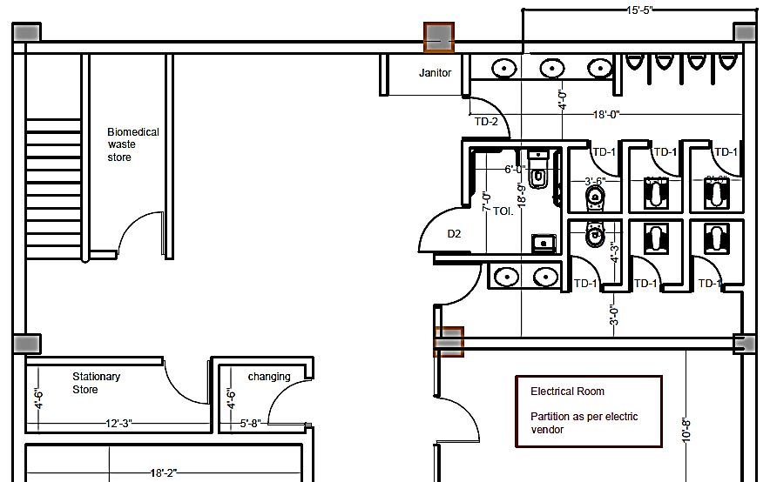
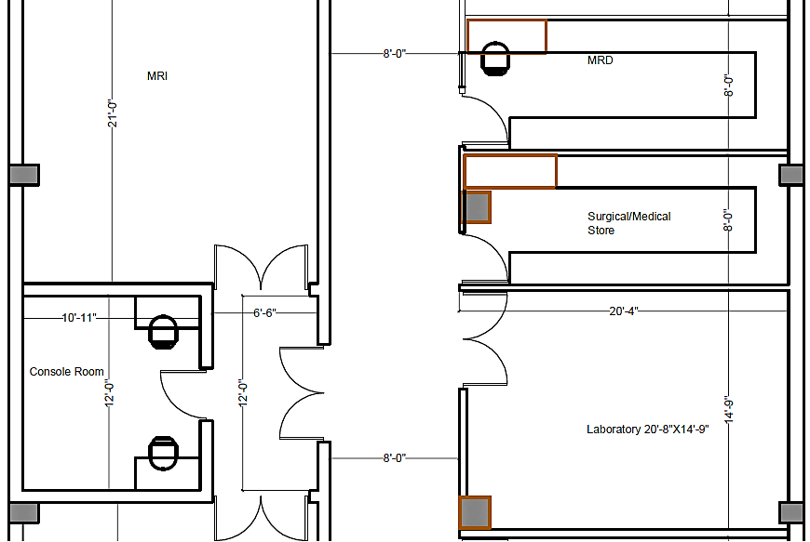
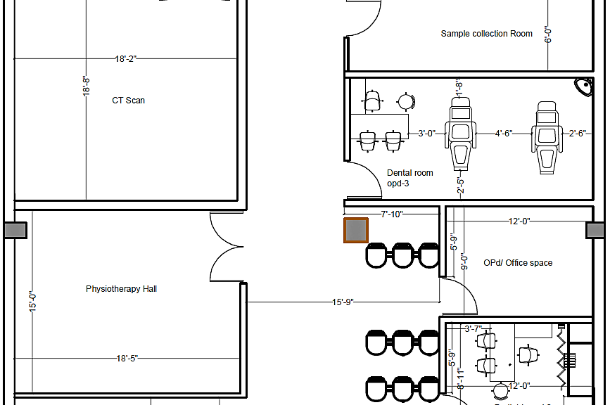
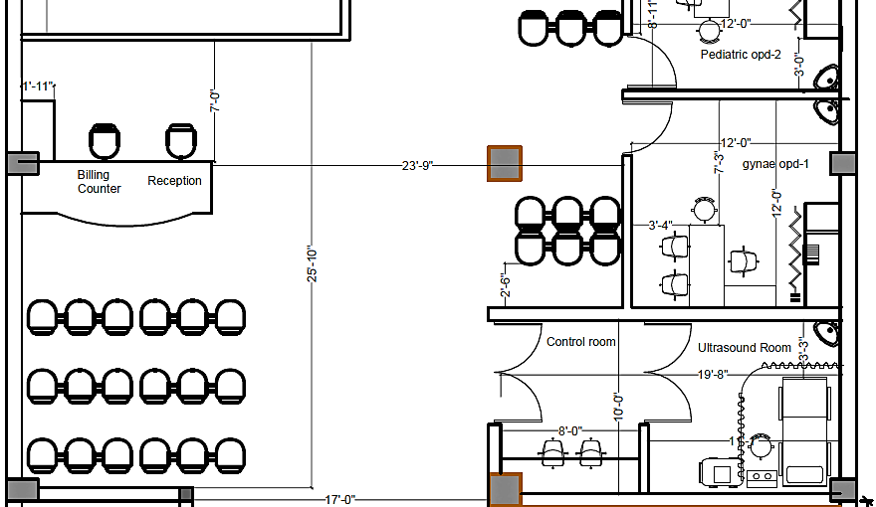
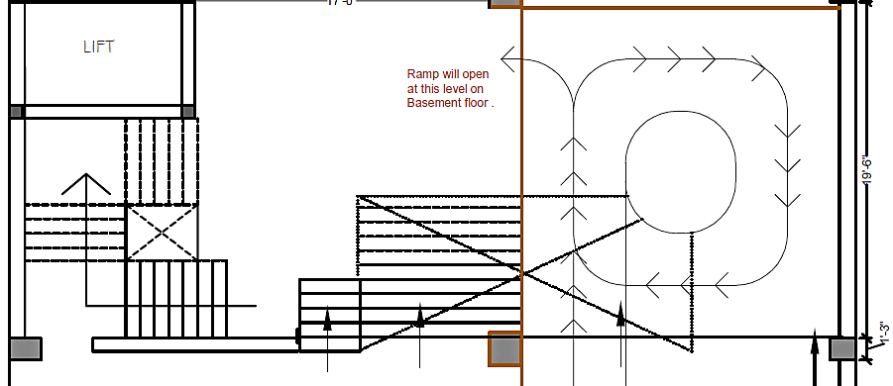
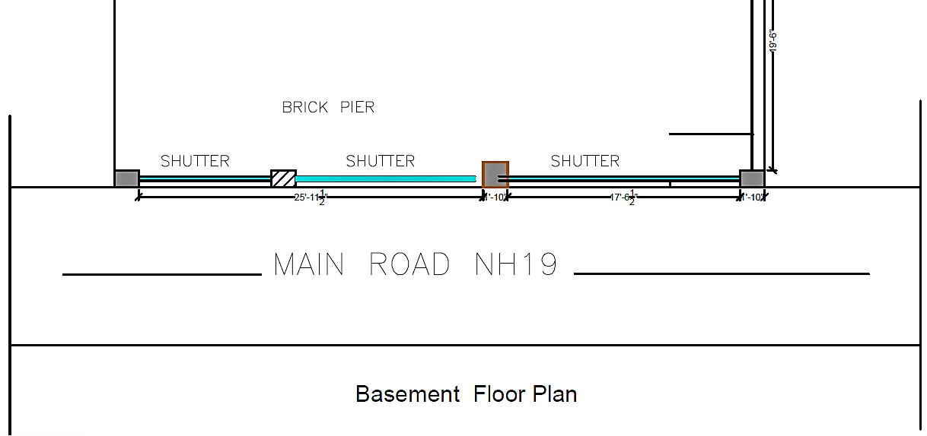
GROUND FLOOR LAYOUT PLAN
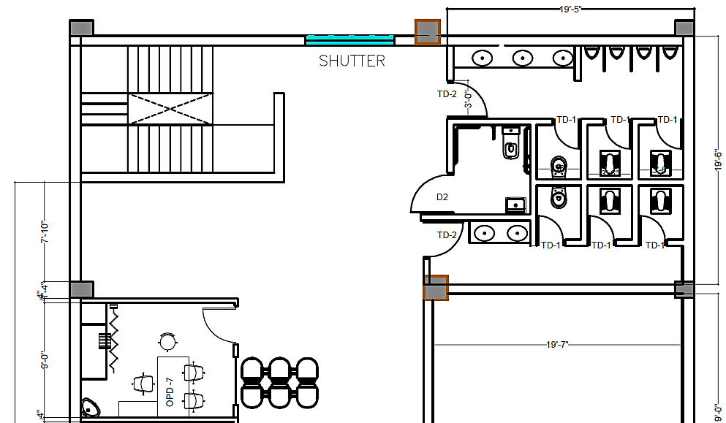
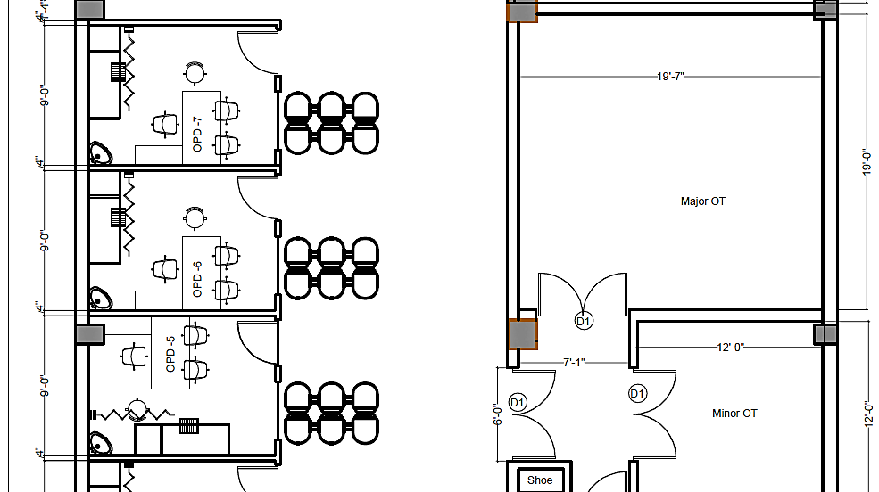
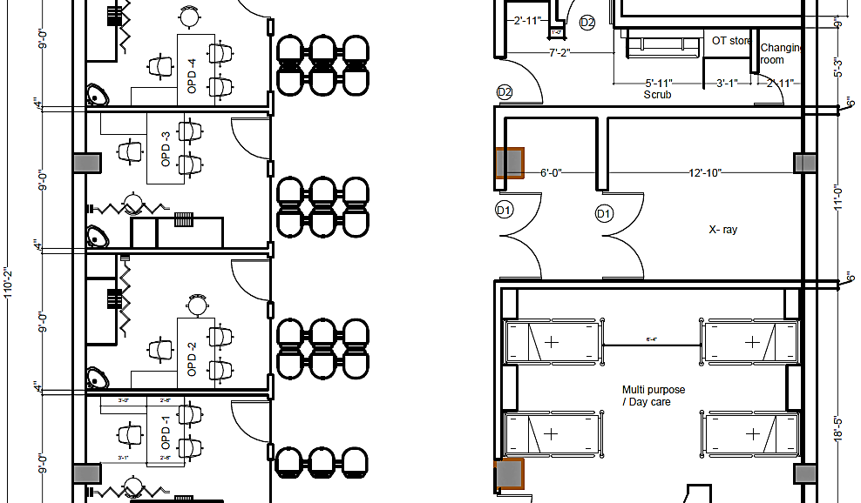
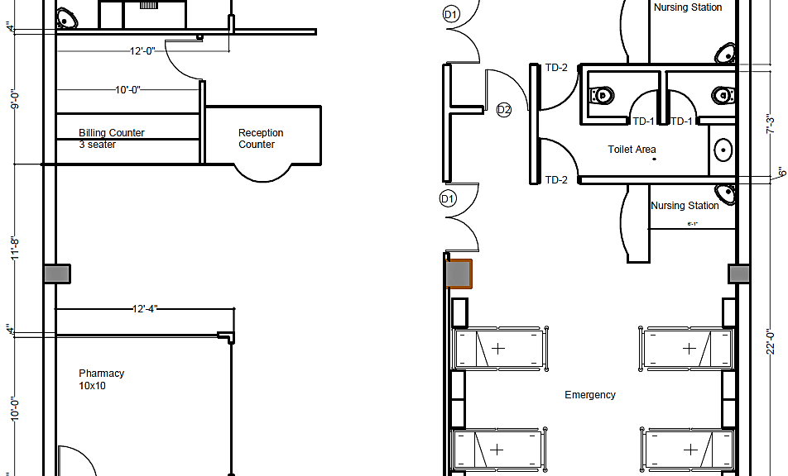
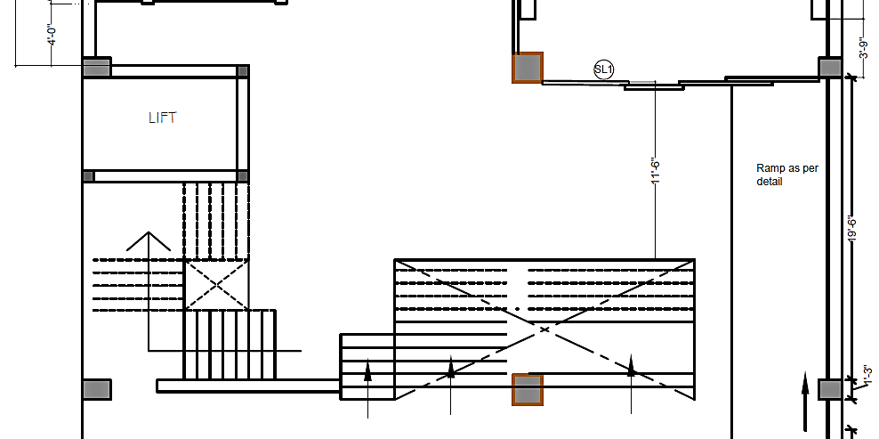
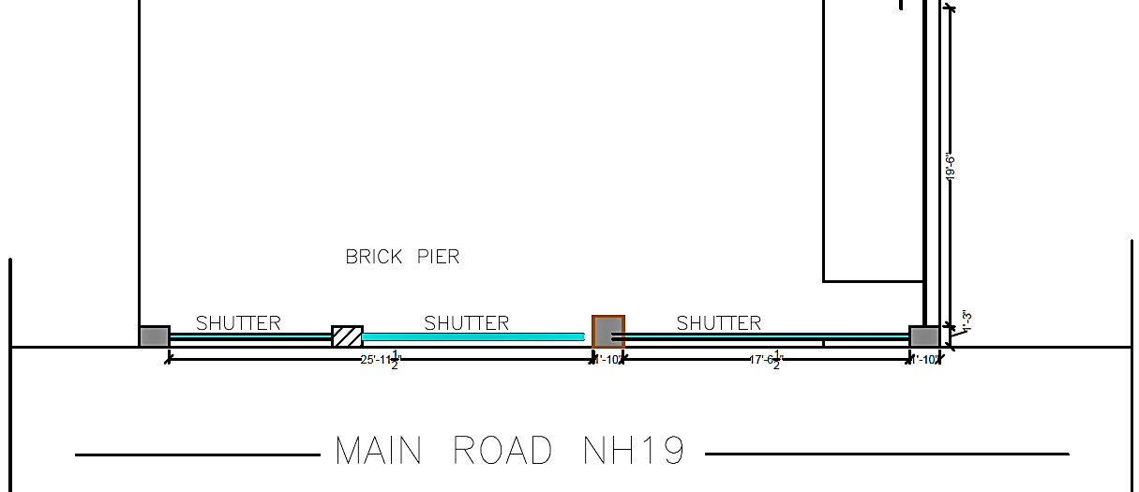
FIRST FLOOR LAYOUT PLAN
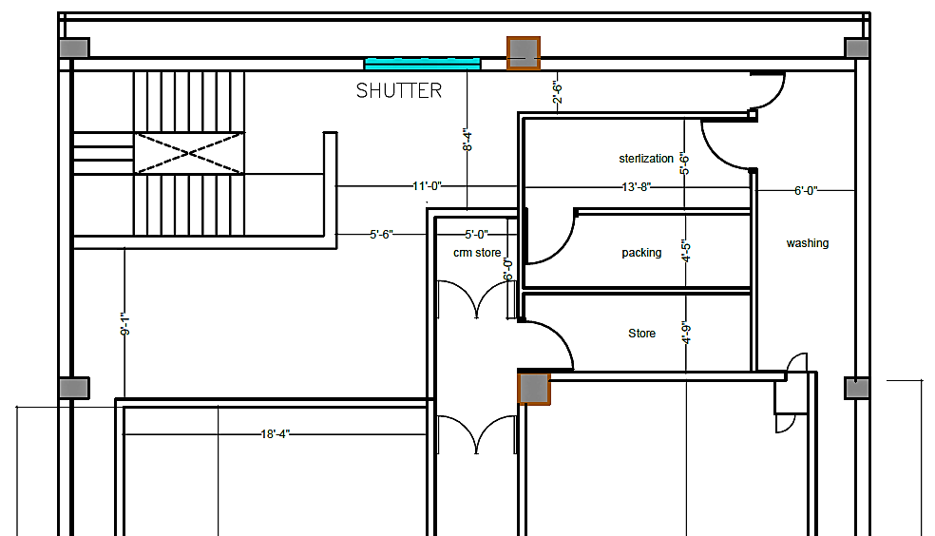
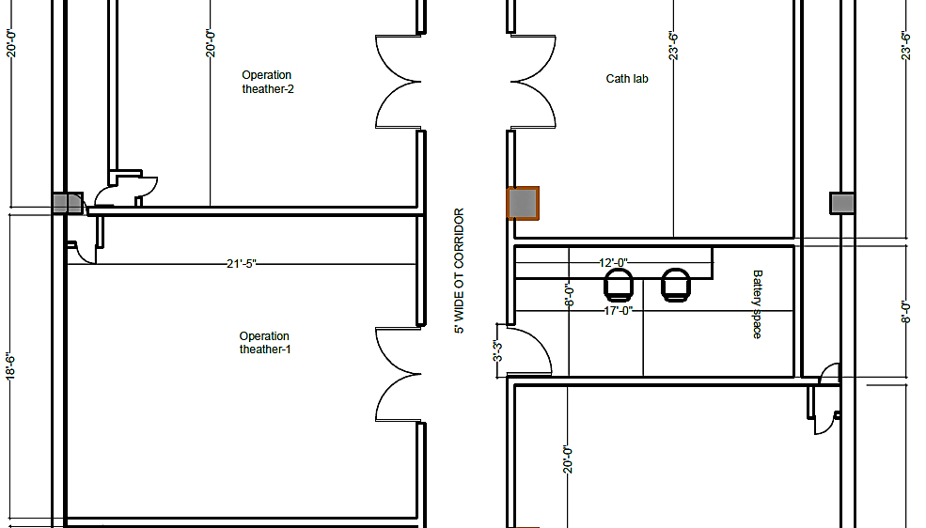
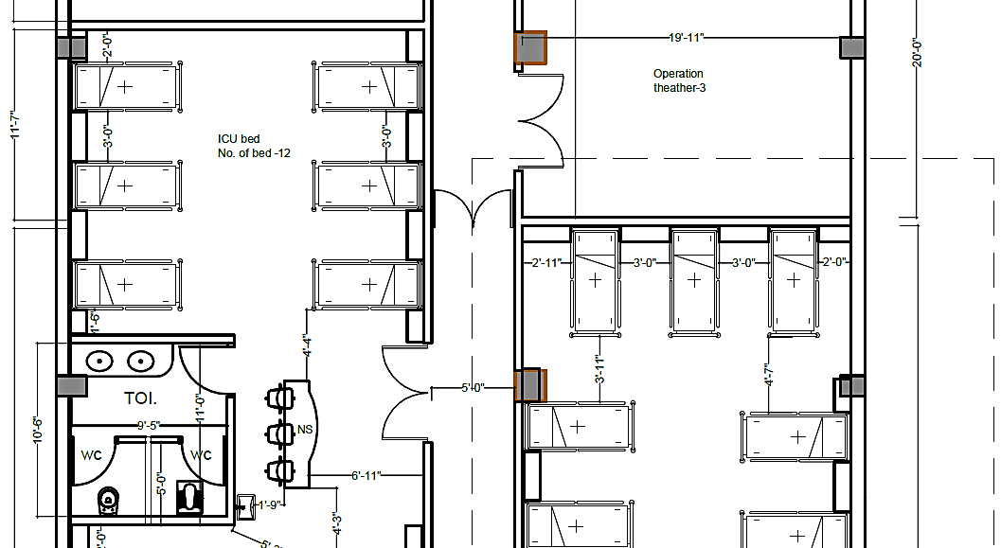
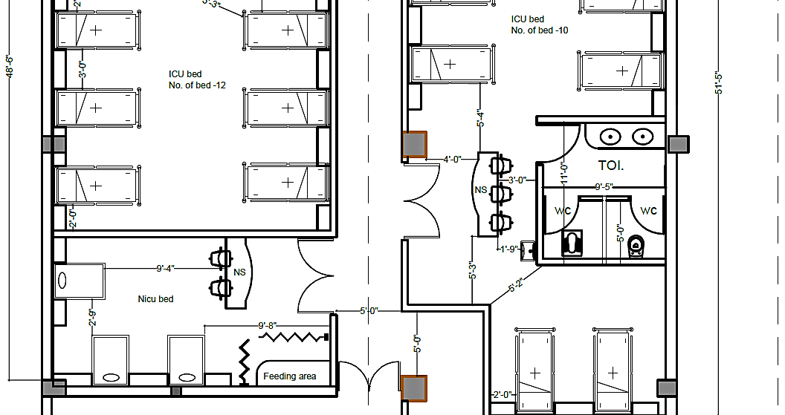
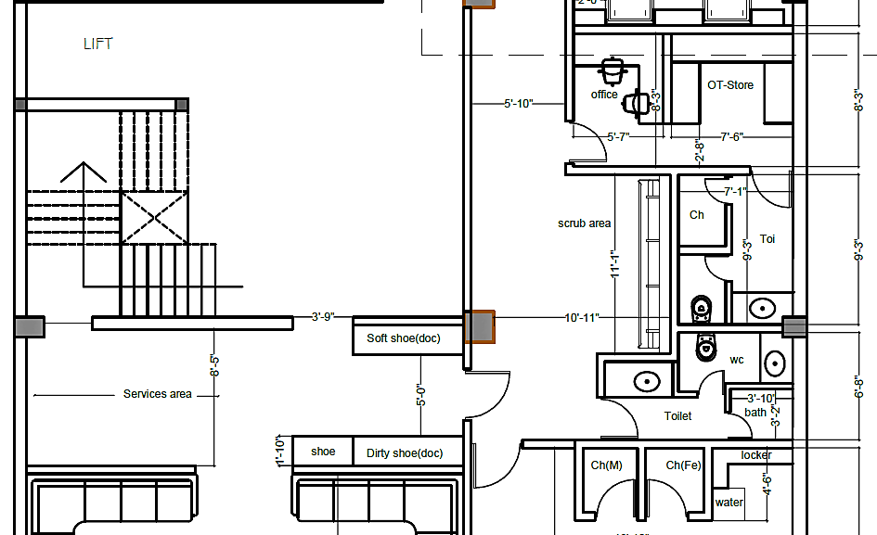
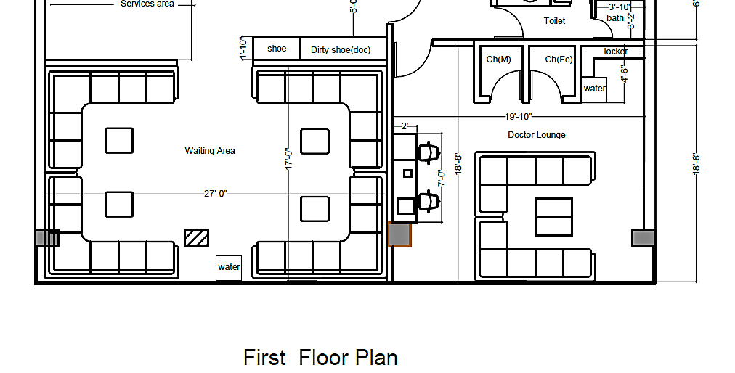
SECOND FLOOR LAYOUT PLAN
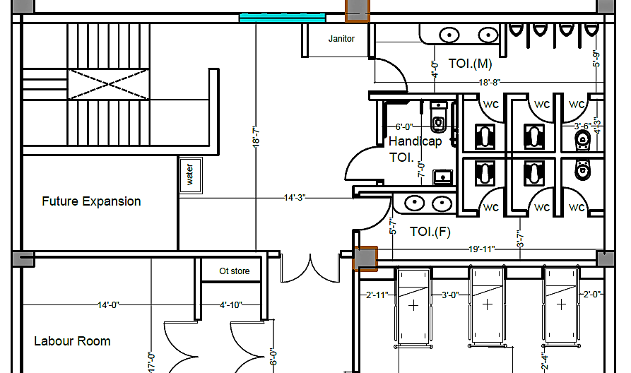
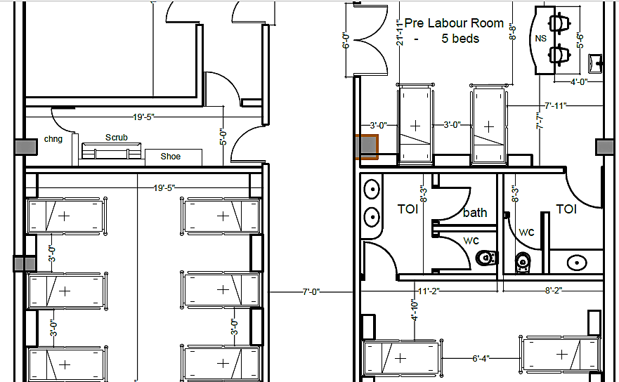
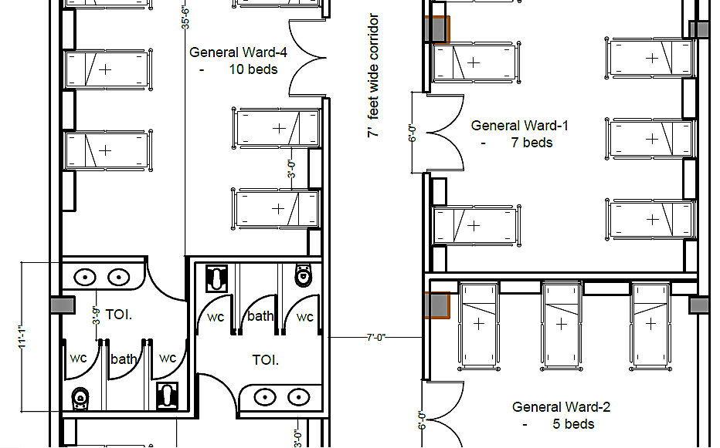
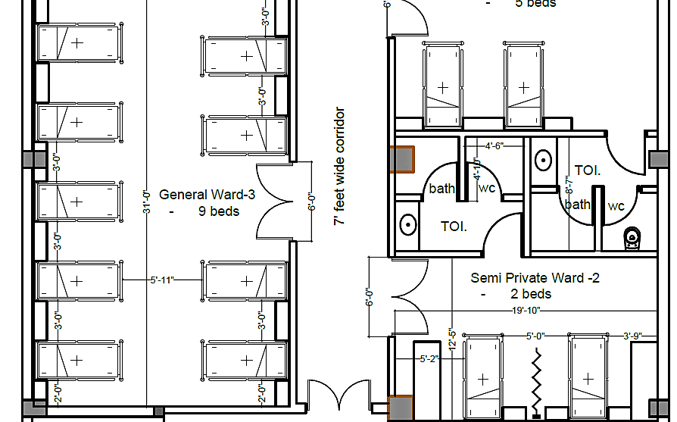
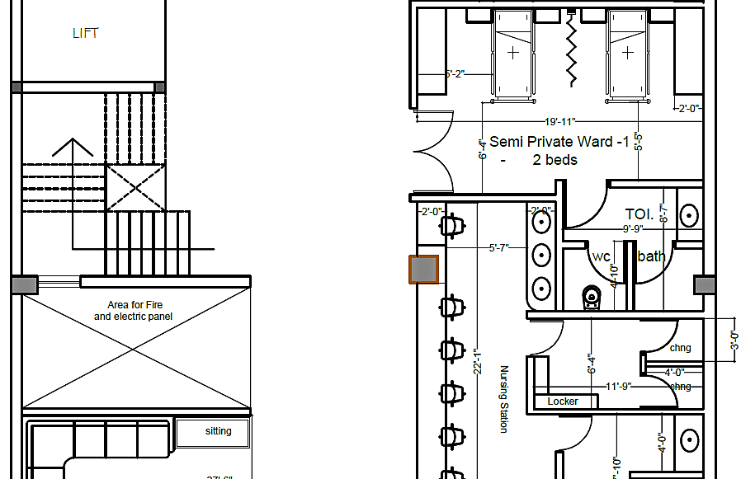
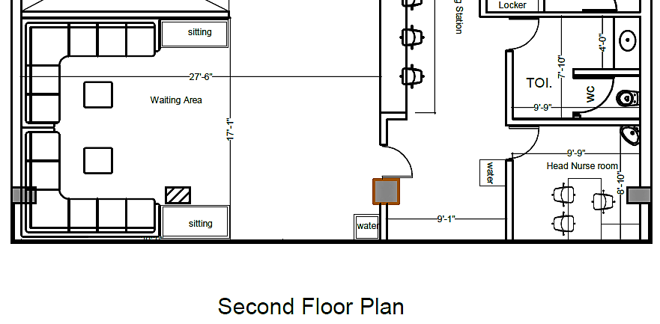
UPPER FLOOR LAYOUT PLAN
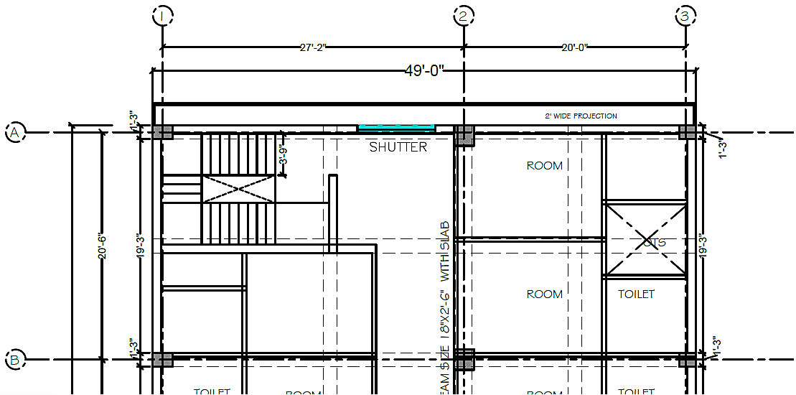
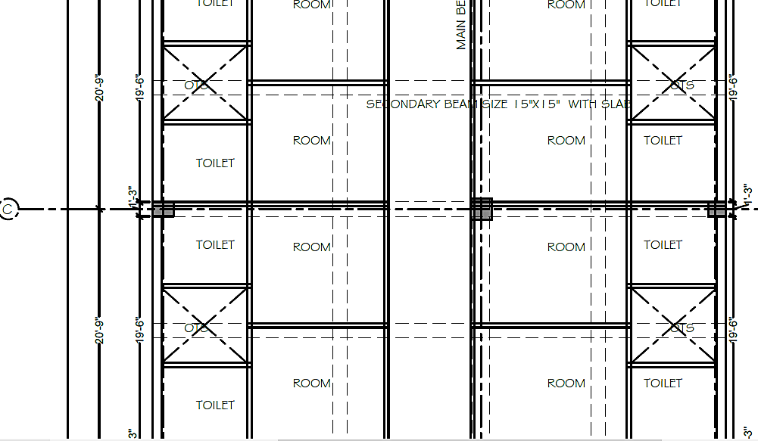
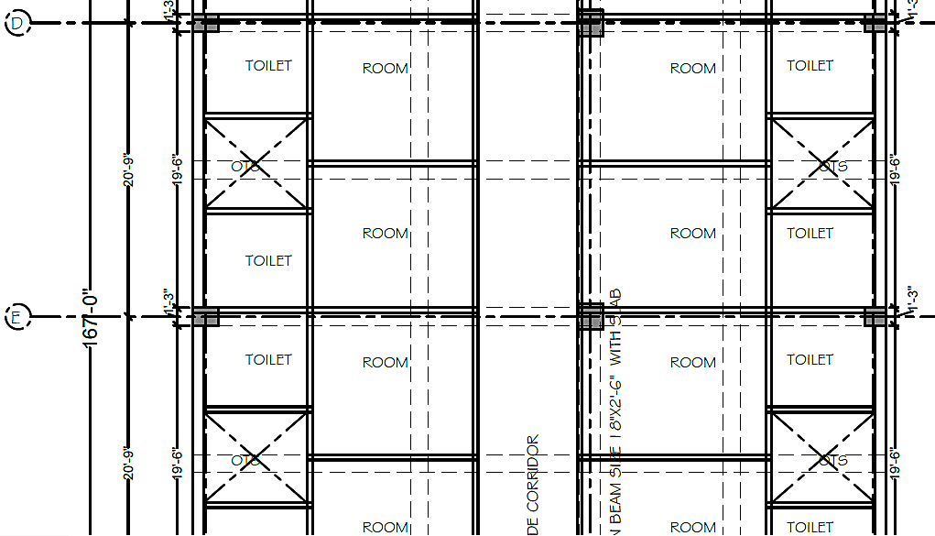
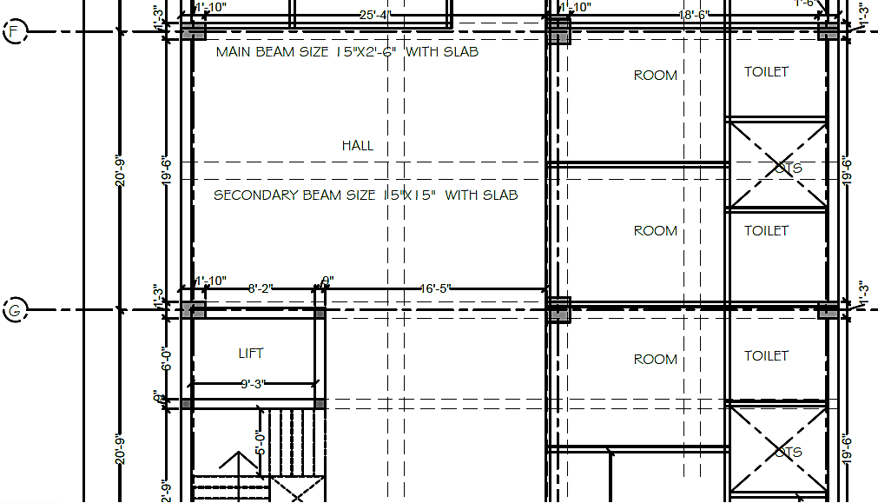
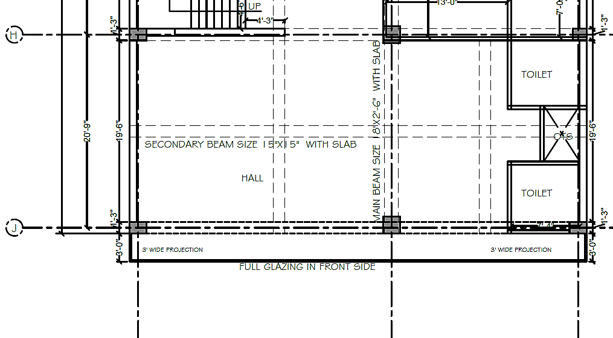
TARACE FLOOR LAYOUT PLAN
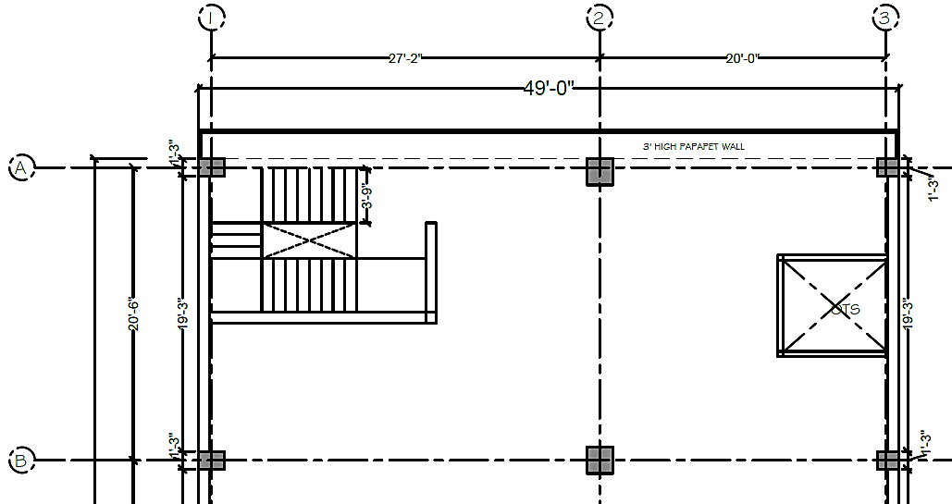
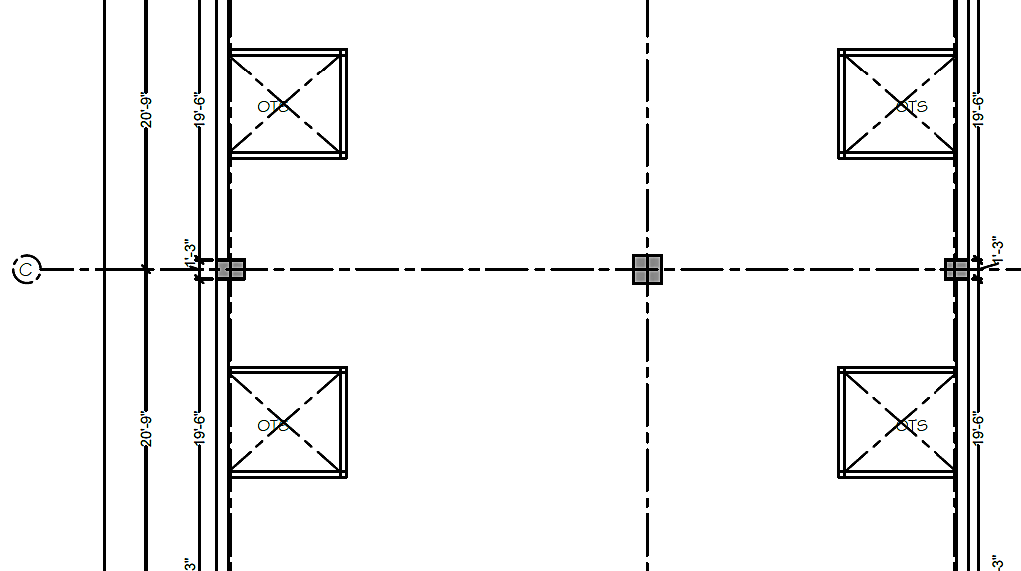
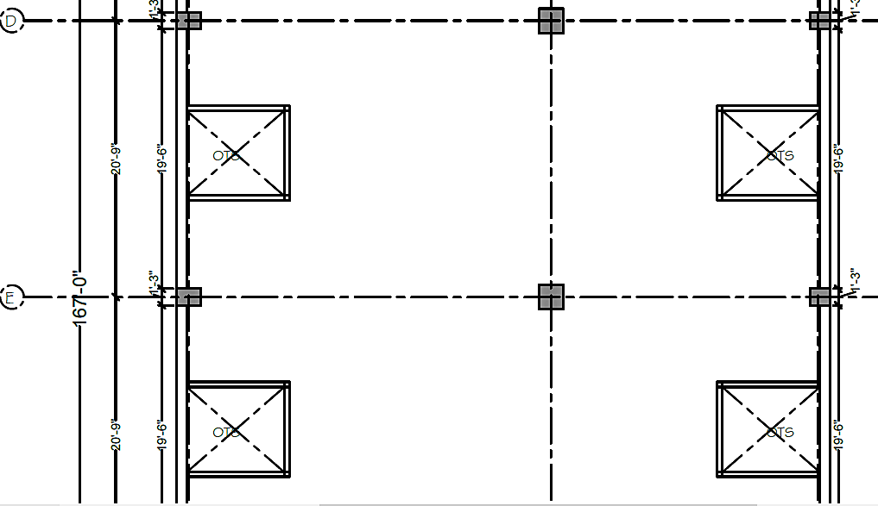
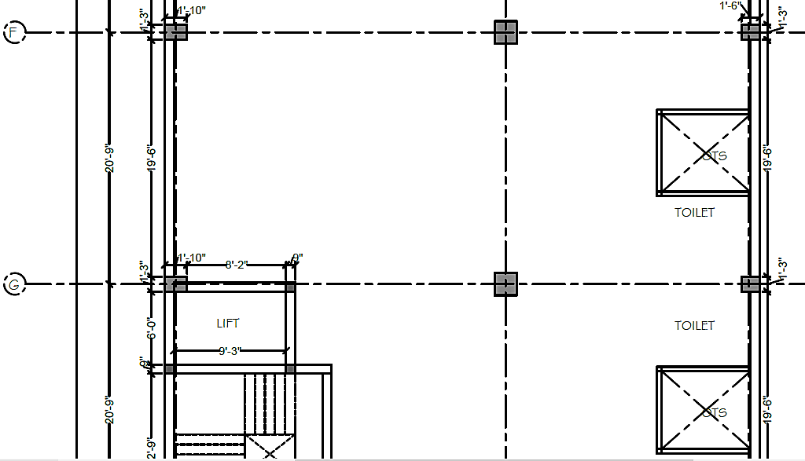
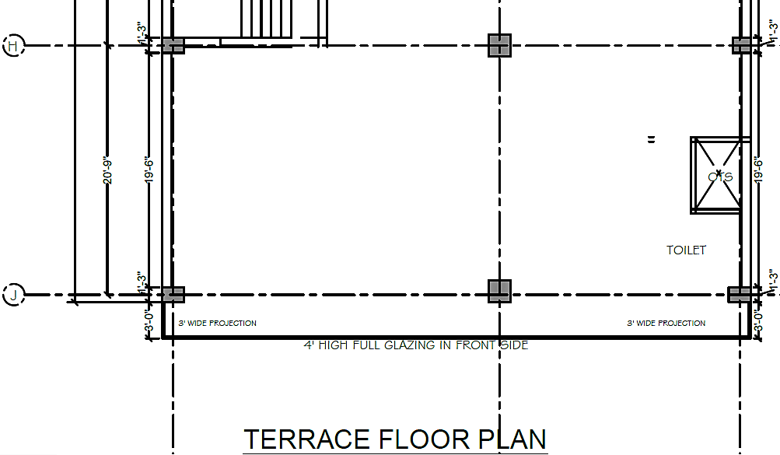
As per the sanction map shared by the client/company, the company has proposed to construct Bio medical waste store, Stationary store, Electrical room, MRI, MRD, Console room, Surgical medical store, laboratory, CT Scan, Sample collection room, Dental room, OPD/office space, Physiotherapy hall, Paediatric OPD, Billing counter, Reception, Control room, Ultrasound room, and one lift on the basement floor.
There are 3 shutter gate at NH 19 main road to enter inside the basement floor of the hospital and then there is an entry area and ramp area which will be open in front area of the lift. At ground floor there are OPDs, Minor OT, Major OT, OT store, changing room, X-ray, Multi-purpose area /day care, Nursing station, toilet area, Billing and reception counter, pharmacy area, emergency area, Ramp and lift are proposed. At first floor, sterilization, packing, store, operation theatre, Cath lab, Battery space ICU beds, NICU beds, feeding area, OT store, Shoe DOC, Service area, scrub area, office, waiting area, doctor lounge and bath are constructed majorly.
At second floor, there would be free space for future expansions, Handicap treatment, Labour & Pre labour rooms, General beds, semi-private beds, area for fire and electrical room, waiting room and head nursing area constructed. At upper floor there are beds and toilets only. At terrace area there are OTs, toilets and lift is there. The company has one patient bed lift in this hospital building and it has already been installed and working.
- LOCATION MAP:
- GOOGLE MAP: Project is located at 28°8'39.849" North and 77°20'8.743" East in Palwal, Haryana and the location as per the Google map is attached below.
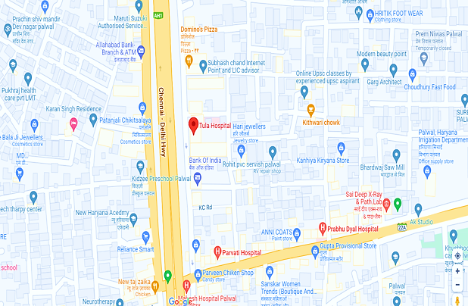
- Demarcation: Demarcation of the land on the Google map is as in the below picture.
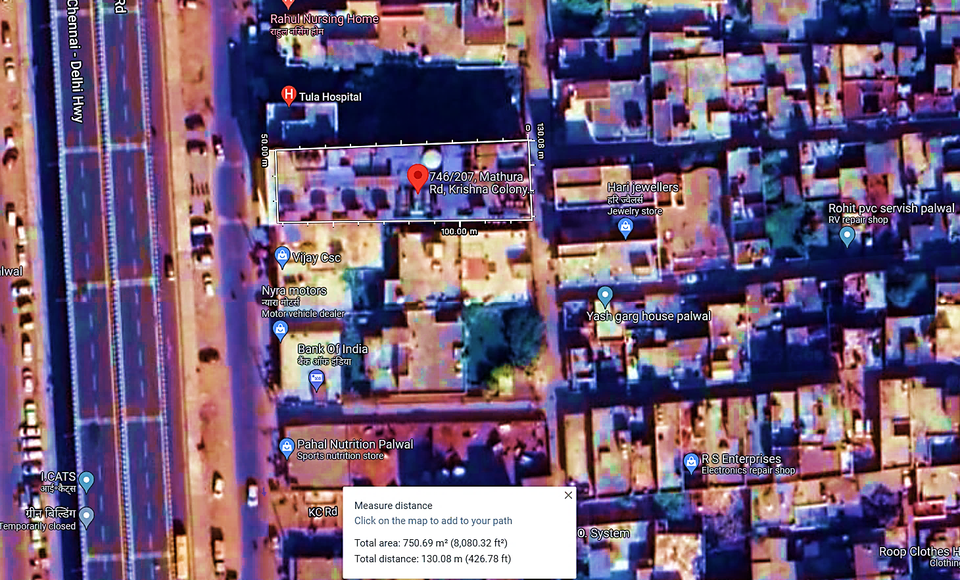

- LAND DETAILS: The Company has already taken a land admeasuring approx. 900 Sq. Yards at K. No.-2015, NH -2, Delhi-Mathura Road, Near Kithwari Chowk, Krishna Colony, Palwal, Haryana, on a long-term lease basis from its existing owners. As per the lease deed, at the time of lease, basement, ground floor + 3 floors (a bare-shell building) were already constructed. The property is open from two sides. The term of the lease deed stared from 15th June 2021, and it will end on 14th June 2030.
As per lease deed, lease rent of the above property agreed by lessee at the rate of INR 5, 75,000/- per month, for the period of 9 years. Promoters had already deposited INR 16, 50,000/- as security deposit. After the expiration of the Lease Deed, Company can extend the term of the lease again. Below table shows the escalation rate in rent for 9 years of the lease deed:
Escalation Rate as per lease deed
Year | Escalation Rate
2022 | 5%
2023 | 5%
2024 | 5%
2025 | 10%
2026 | 10%
2027 | 10%
2028 | 5%
2029 | 5%
2030 | 5%
As per communicated by the client, management has decided to convert the leased bare shell structure into the required hospital. The company expects to complete the proposed hospital building work, including installation of all the furniture fixtures and plant and machinery, by August 2023. It is expected to start its commercial operations in Sep 2023.
As per discussion with hospital promoters, per cost of bed since starting of the construction, is 25 lakhs. Instead of lease, if the land will be purchased by the promoters, it will cost them, approx. 45 Lakhs, hence management’s decision was economically and commercially viable.
As per our tertiary research, information available in various public domain and informed by various dealers, lease/rent rate of the commercial property at the said location ranges from INR 40- INR 50 per Sq. Ft. (Approx.) Accordingly, the lease/rent for a Total proposed covered area of 8085 Sq. Ft. (commercial building B+G+3) will be ranging from INR 16, 17,000 to INR 20, 21,250 Monthly, However, as per lease deed the company is paying only INR 5,75,000 per month since it was a Covid time at the time of lease agreement and lease land had bare-shell, B+G+3 floors.
Moreover, it was a garbage dumping area for local people. Also after lease agreement, company has constructed the building as per hospital requirement. Therefore, company got big discount in lease rental. Hence it was an economic decision for the company to take this land on lease.

- SITE PICTURES: During the site visit as on 23rd Jan 2023, Some of the site pictures has been taken are attached below:
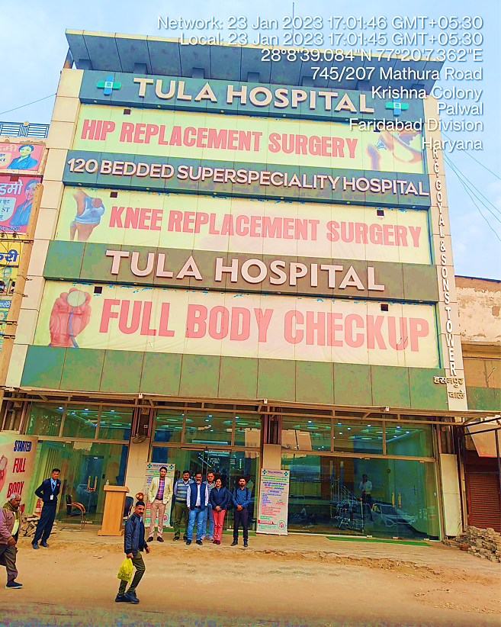
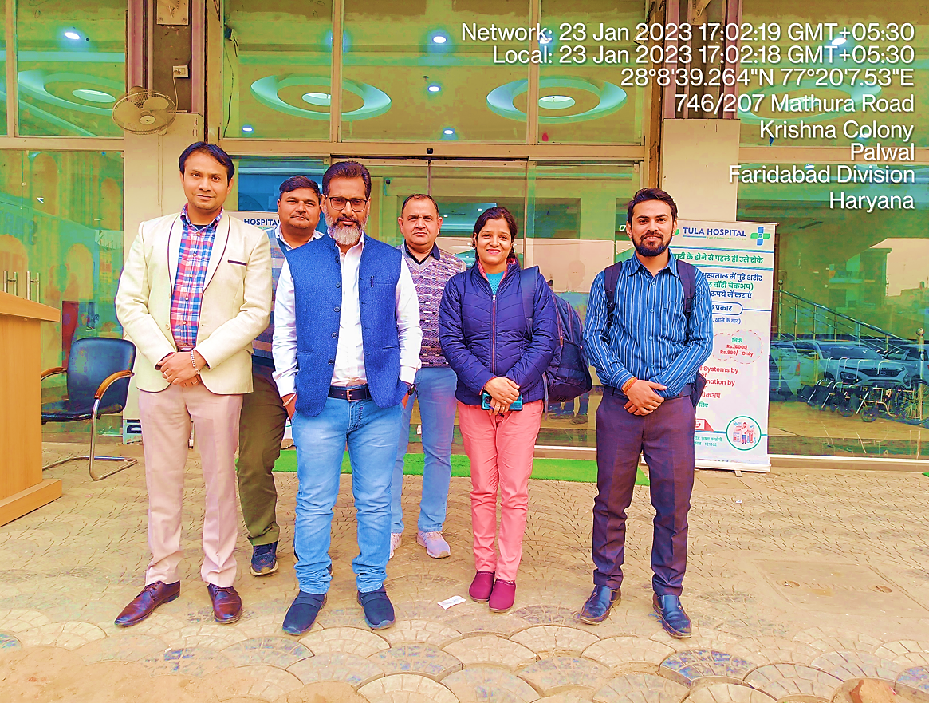
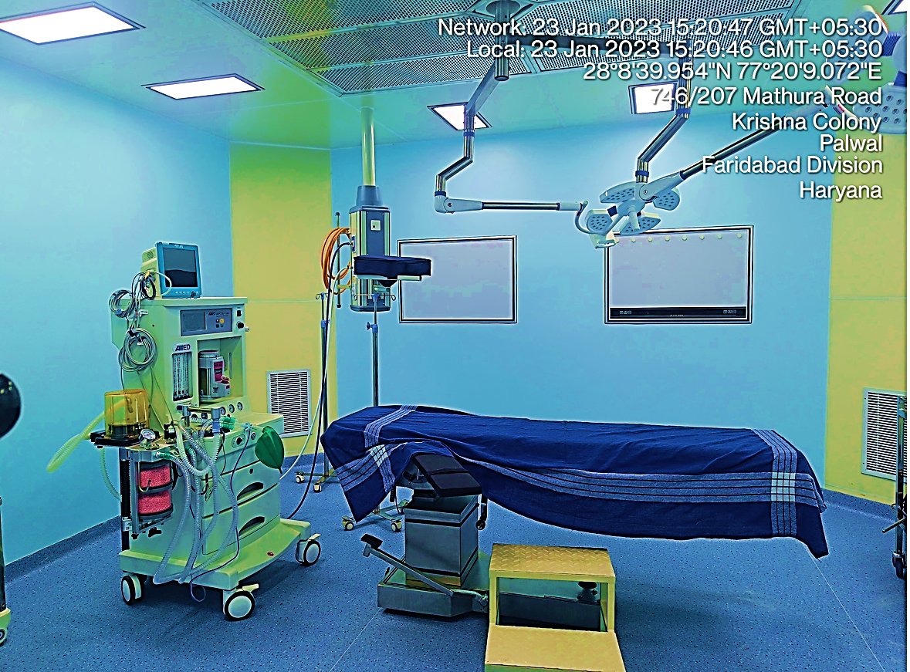
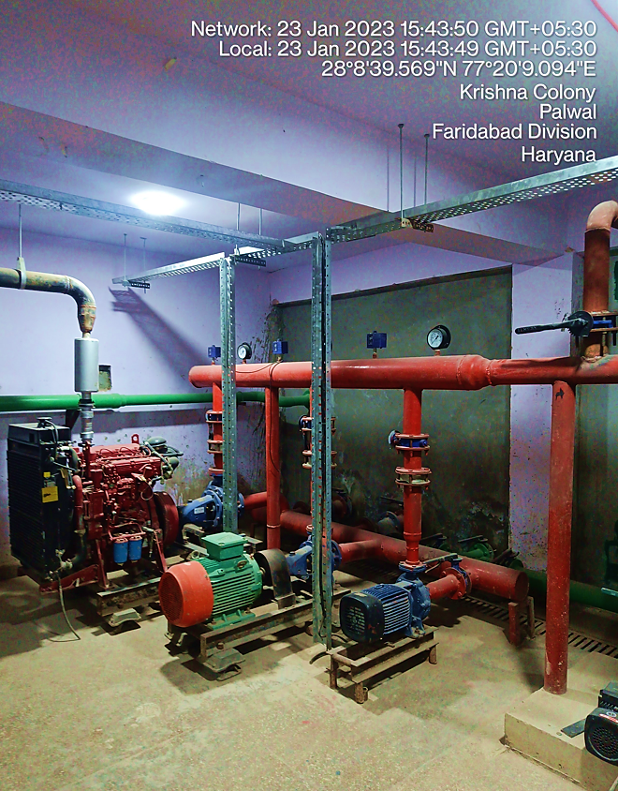
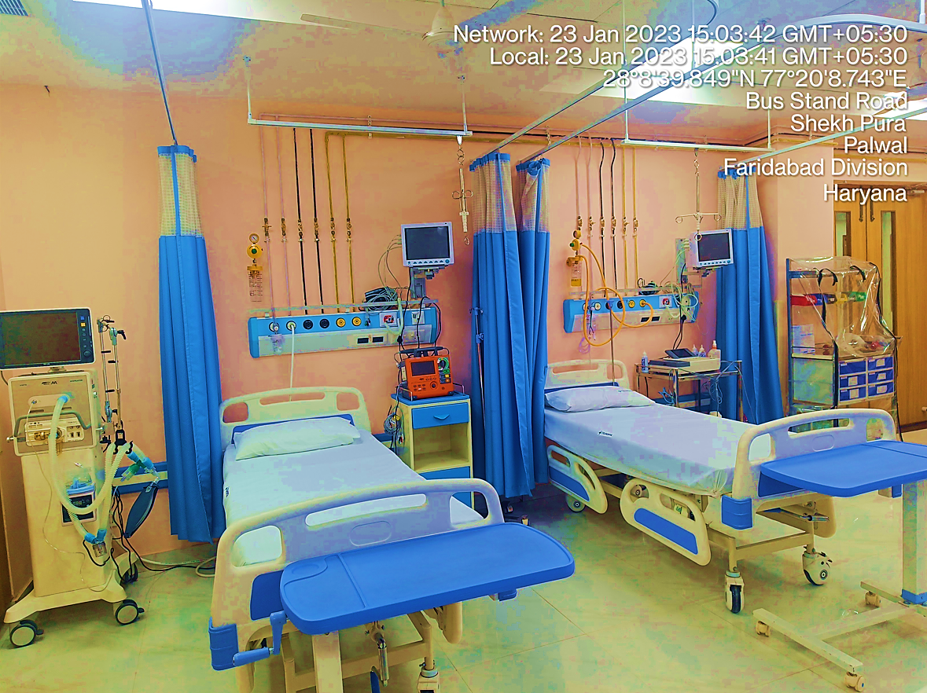
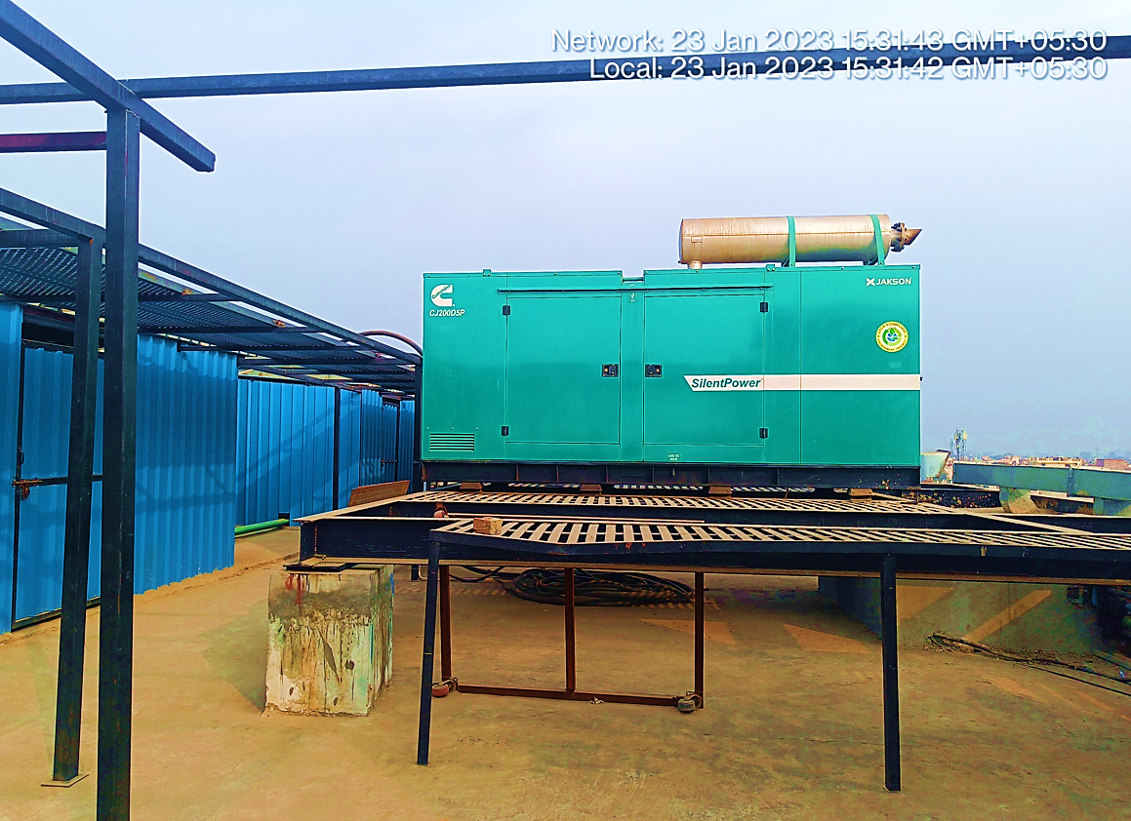
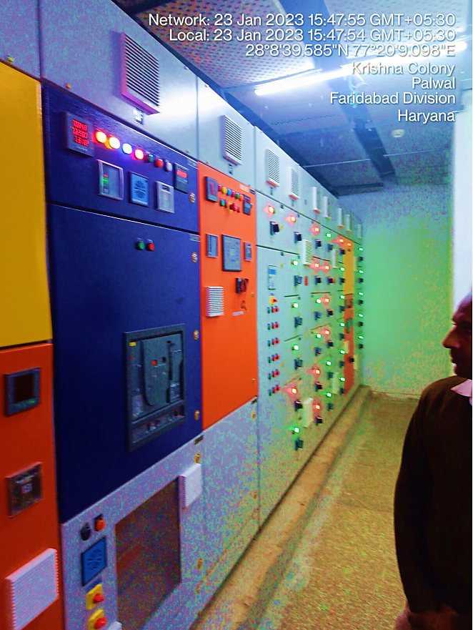
- BUILDING & CIVIL WORKS: As per information provided by the client/company, The Company took land and bare-shell building structure at Delhi-Mathura Road, Near Kithwari Chowk, Krishna Colony, Palwal, Haryana, on a long-term lease from its owners to establish the proposed super speciality hospital. This was a freehold land admeasuring 900 Sq. Yds. Registered in the property owners’ name.
After getting the sanction of the proposed building plan for super speciality hospital, the company has started the proposed hospital's construction/modification/interior work as per the required infrastructure from their self-owned source of funds. The company has already completed the civil construction work of the proposed hospital building, and the interior work is in progress.
The proposed super speciality hospital building will consist of 120 rooms, including Deluxe Private, Semi-Private, OBG ward, Economy, ICU and NICU rooms for various types of patients per the industry requirements. It will also consist Emergency ward, Doctors’ rest rooms, Kitchen, OPD rooms for doctors, OTs, Housekeeping staff area, Pharmacy, Cafeteria, MRI Scan Room, X-Ray Room, CT Scan Rooms, Sample taking areas, Lab Area, Reception, Point of Sales area, Waiting area, Admin Block, Processing area, Godown, Lab, Power room, and other utility areas for the smooth working of the proposed unit from here. As communicated by company officials, at the time of site visit, company has provisioned one patient bed lift in the proposed hospital building and it has already been installed and working.
The company has also arranged with the Gurgaon-based renowned Architectural firm Manan Planners Pvt Ltd to get help in the building, civil work & Interior work and designing of the proposed super speciality hospital per industry norms.
The proposed hospital building have basement, Ground Floor, First Floor, Second Floor, Third Floor and terrace. During the site visit we found that the Ground Floor, Second Floor and Third Floor are ready to operate post installation of required machinery and medical equipment. Interior work is in progress at Basement and First Floor.
Total proposed super built-up area is Approximately 40425 Sq. Ft. (8085*5 B+G+3). Below table shows the details of Tula Hospital Building area in Sq. Mt.:
Construction Details for Tula Hospital, Palwal
Floor Details | Area (Sq. Mt.)
Basement Floor | 743
Ground Floor | 743
First Floor | 743
Second Floor | 743
Third Floor | 743
The projected building's total construction cost, including complete civil work, interior work, open drains, Tube well and electrification, internal and external sanitary fittings, etc., is approx. INR 7.90 Crores including applicable GST charges.
The company expects to complete the proposed hospital building work, including installation of all the furniture fixtures and plant and machinery, by August 2023. It is expected to start its commercial operations in September 2023.

- FURNITURE AND FIXTURE FOR THE PROPOSED BUILDING: As per information provided by the client/company, all the furniture/fixture items will be manufactured by purchasing wood from the open market or bought from reputed dealers. Out of 120 beds in total, company had already purchased 78 beds, rest will be purchased once the all of the interior work will be finished.
A provision of INR1.70 crores have been made, and an advance amount of INR 0.73 crores have also been made to the suppliers of furniture/fixture items. We have not performed any cost estimation as per scope of work.
- PLANT & MACHINERY (EQUIPMENT): The Company The Company is proposed to provide modern plant and Machinery and medical equipment for the proposed super speciality hospital, including Fixed X-ray System, High-End Colour Doppler System, Lab Test Equipment, CT Scan Systems, MRI equipment with a complete set of tables and UPS, etc. All the items will be of standard make and to be purchased from reputed suppliers.
Major equipment suppliers have been finalized, and negotiations for final pricing are going on. Below table shows the details of major equipment, plant & machinery along with expected cost and suppliers as per quotation of the respective vendor’s shared by the client:
Cost Estimation of Major Equipment, Plant & Machinery
S. No. | Equipment | Quantity | Cost with GST | Expected Vendor / Supplier
1 | Haematology Analyser - 5 Part | 1 | 637,200.00 | Medico India Hospital Solutions
2 | Coagulation Analyser | 1 | 383,500.00 | Medico India Hospital Solutions
3 | Urine Analyser | 1 | 108,560.00 | Medico India Hospital Solutions
4 | C Arm | 1 | 1,900,001.00 | Medico India Hospital Solutions
5 | X-Ray Machine | 1 | 486,001.00 | Medico India Hospital Solutions
6 | CR System | 1 | 1,232,000.00 | Medico India Hospital Solutions
7 | Multy Para Monitor | 4 | 360,416.00 | Medico India Hospital Solutions
8 | Seven Para Monitor | 1 | 211,008.00 | Medico India Hospital Solutions
9 | ECG Machine | 1 | 118,720.00 | Medico India Hospital Solutions
10 | Infusion Pump | 1 | 25,200.00 | Medico India Hospital Solutions
11 | Syringe Pump | 1 | 19,600.00 | Medico India Hospital Solutions
12 | Suction Machine - Hi Vac | 1 | 55,440.00 | Medico India Hospital Solutions
13 | Bi Pap | 2 | 169,998.00 | Medico India Hospital Solutions
14 | Infusion Pump | 4 | 100,800.00 | Medico India Hospital Solutions
15 | Syringe Pump | 4 | 78,400.00 | Medico India Hospital Solutions
16 | Suction Machine - Low Vac | 1 | 20,552.00 | Medico India Hospital Solutions
17 | Ventilator | 1 | 940,800.00 | Medico India Hospital Solutions
18 | Defibrillator | 1 | 299,040.00 | Medico India Hospital Solutions
19 | Anaesthesia Work Station | 1 | 914,480.00 | Medico India Hospital Solutions
20 | Boyal Basic | 2 | 125,440.00 | Medico India Hospital Solutions
21 | Bio Chemistry Analyser - Semi Automatic | 1 | 266,090.00 | Medico India Hospital Solutions
22 | Ventilator | 1 | 940,800.00 | Medico India Hospital Solutions
23 | Defibrillator | 1 | 299,040.00 | Medico India Hospital Solutions
24 | ECG Machine | 1 | 118,720.00 | Medico India Hospital Solutions
25 | Multipara Monitor | 4 | 360,416.00 | Medico India Hospital Solutions
25 | Cautery Machine | 1 | 117,600.00 | Medico India Hospital Solutions
27 | Orthopaedic Power & Saw Drill | 1 | 319,200.00 | Medico India Hospital Solutions
28 | Tourniquet Double Cuff | 1 | 81,760.00 | Medico India Hospital Solutions
29 | Plaster Cutter | 1 | 8,400.00 | Medico India Hospital Solutions
30 | Elisa Reader | 1 | 241,900.00 | Medico India Hospital Solutions
31 | Electrolyte Analyser | 1 | 183,490.00 | Medico India Hospital Solutions
32 | ETO Machine | 1 | 359,900.00 | Medico India Hospital Solutions
33 | Uroflow Meter | 1 | 103,712.00 | Medico India Hospital Solutions
34 | Easy flow Pump | 1 | 117,600.00 | Medico India Hospital Solutions
35 | Mobile X-Ray | 1 | 336,000.00 | Medico India Hospital Solutions
36 | Ventilator | 2 | 1,881,600.00 | Medico India Hospital Solutions
37 | Difib | 1 | 299,040.00 | Medico India Hospital Solutions
38 | ECG Machine | 1 | 118,720.00 | Medico India Hospital Solutions
39 | Infusion Pump | 2 | 50,400.00 | Medico India Hospital Solutions
40 | Syringe Pump | 2 | 39,200.00 | Medico India Hospital Solutions
41 | Bipap | 2 | 169,792.00 | Medico India Hospital Solutions
42 | Horizontal Autoclave | 1 | 424,800.00 | Medico India Hospital Solutions
43 | Dialyses Machine | 4 | 2,576,000.00 | Medico India Hospital Solutions
44 | RO Pump | 1 | 224,000.00 | Medico India Hospital Solutions
45 | Urology Equipment | 1 | 1,825,040.00 | Medico India Hospital Solutions
46 | Camera Set | 1 | 2,016,000.00 | Medico India Hospital Solutions
47 | Laparoscopy Set | 1 | 532,000.00 | Medico India Hospital Solutions
48 | Ventilator | 2 | 2,800,000.00 | Medico India Hospital Solutions
49 | Multipara Monitor | 4 | 360,416.00 | Medico India Hospital Solutions
50 | Seven Para Monitor | 1 | 211,008.00 | Medico India Hospital Solutions
51 | Arthroscopy set | 1 | 1,260,000.00 | Medico India Hospital Solutions
52 | Incubator | 1 | 165,760.00 | Medico India Hospital Solutions
53 | Radiant Warmer | 4 | 232,960.00 | Medico India Hospital Solutions
54 | Bubble Cpap | 1 | 314,720.00 | Medico India Hospital Solutions
55 | Phototherapy Unit | 1 | 39,200.00 | Medico India Hospital Solutions
56 | Phototherapy Unit | 1 | 78,400.00 | Medico India Hospital Solutions
57 | HFNC | 1 | 224,000.00 | Medico India Hospital Solutions
58 | Neopuff | 1 | 61,600.00 | Medico India Hospital Solutions
59 | Transport Incubator With Standard Trolley Manual | 1 | 204,960.00 | Medico India Hospital Solutions
60 | Ozone Generator | 1 | 189,840.00 | Medico India Hospital Solutions
61 | RF Generator | 1 | 1,176,000.00 | Medico India Hospital Solutions
62 | Laminar Flow | 1 | 140,000.00 | Medico India Hospital Solutions
63 | Harmonic Scalpel | 1 | 1,680,000.00 | Medico India Hospital Solutions
64 | CT Scan | 1 | 12,099,999.00 | Wipro GE Healthcare
65 | USG | 1 | 1,600,000.00 | Wipro GE Healthcare
66 | Modular OT, Labour room and MGPS | Complete Hospital Work | 14,879,999.00 | Vaishno Engineering Services
66 | Hospital Electrical and HVAC System | Complete Hospital Work | 34,536,907.00 | GS Enterprises
67 | Plumbing, fire, STP, and ETP | Complete Hospital Work | 15,473,228.00 | KLN AQUA
Total (INR) |  |  | 109,927,373.00

As per communicated by client and information available in public domain the new machinery cost estimates are assessed based on present market rates and offer received from vendors/suppliers. The final decision on the selection of vendors has yet to be taken.
The cost of Plant & Machinery and other fixed Assets has been estimated at INR 11.00 crores, including purchases of all the required latest and modern medical equipment for the proposed super speciality hospital

- UTILITIES: As per data/information provided by the client/company, details of Electricity, Water and other utilities are describes as below:
- Electricity: The Hospital/Company has obtained power connection of 200 KVA and is operational. There is provision of increasing this capacity to 600/700 KVA.
- Power Back: The Hospital/Company has DG of 200 KVA installed and operational giving supply in case of power failure. One 250 KVA and other 200 KVA DG will be installed in near future.
- Fuel: The Hospital/Company is getting fuel delivered from local petrol pump for its use in DG. Company will be requiring enough fuel storage space to operate the diesel generator set to supply uninterrupted power supply to the facility in case of any power failure.
- Water: The Hospital/Company has provision of both bore well water and supply water from local water supplying authority.
- AC: The Hospital/Company is installing central air-conditioning of Carrier with features both hot and cold air depending upon requirement.
- Fresh Air: The Hospital/Company is installing Treated Fresh Air Plant for supply of treated fresh air in entire building to keep the entire ambient fresh.
- Ventilation: The Hospital/Company is installing ventilation systems at all toilets, plants, and each other required areas.
- UPS: The Hospital/Company has online UPS of 60 KVA installed and operational giving supply in case of power failure.
- Plumbing: The Hospital/Company is installing ultra-modern with backup kind of plumbing systems in entire building.
- Fire-fighting System: The Hospital/Company is installing required firefighting equipment along with water store capacity of more 1 Lac litre to be used if required.
- STP (Sewage Treatment Plant): The Hospital/Company is installing 45 KLD STP for treating all sewerage material generated.
- ETP (Effluent Treatment Plant): The Hospital/Company is installing 5 KLD ETP for treating all biomedical liquid sludge generated.
- Water Treatment Plant: The Hospital/Company is installing water treatment plant and with storage capacity of more than 60,000 litres of treated water.
- RO Plant: The Hospital/Company is installing RO Plant for supplying edible water to entire hospital. The capacity of the RO plant to purify water in an hour is 500 Litre / hour.
- Separate RO Plant for dialysis: The project/Hospital/Company is installing separate RO Plant for supplying water to entire dialysis equipment.
- MGPS: The Hospital/Company is installing medical gas pipeline required for treatment of all kinds of patients.
- Gas Manifold: The Hospital/Company is installing medical gas manifold for central supply of all kinds of gas needed.
- Suction Plant: The Hospital/Company is installing suction plant with pipeline connection to each beds of hospital for central suction points.
- CSSD: The Hospital/Company is installing CSSD for cleaning and sterilization of all equipment.
- Parking: The hospital has dedicated parking space of the capacity of ~30-40 4-wheeler vehicle.

PART E | PROJECT TECHNICAL DETAILS

- PROPOSED CAPACITY: Below table shows the proposed category wise number of beds and tests per day capacity available for indoor and OPD in multi-speciality Hospital:
Proposed Total Number of Beds
Bed Revenue: Total number of beds 120 | Number of Rooms
Deluxe room | 1
Private Room | 30
Semiprivate | 4
OBG Ward | 5
Economy | 55
ICU | 22
NICU | 3
Total Beds Availability | 120

Proposed Capacity of 120-beds Super Speciality Hospital
Particular | Indoor (Total No.) | OPD (Total No.)
In-Patient Consultation | 43,800
General OPD |  | 18,000
Special OPD |  | 6,000
Cardiac OPD |  | 3,000
Angiography | 300
Angioplasty | 150
Urology surgeries: | 300
Ortho & Spine Surgeries: | 600
Gynae Surgeries: | 300
General Procedures: | 900
Dialysis |  | 600
Day-care |  | 300
C Section | 146
Normal Delivery (Delivery Room) | 365
Admission fee | 14,600
Minor Procedures |  | 1200
MRI | 292 | 600
CT SCAN | 353 | 1,200
X-ray | 883 | 1,200
Sonography | 883 | 1,500
ECG | 3472 | 300

- LOCATION SELCTION CRITERIA:
 | Location Selection Criteria
Sr. No. | Attribute | Site Selection Parameter | Ideal/ Required Parameter
 | Scope of Services | - No super speciality Hospital presently in Palwal | - The city requires more than 1,000 beds of super speciality natures, presently not available.
 | Type of facility | - No corporate hospital presently | - There must be good hospitals offering all services under one roof with modern infra and equipment.
 | Insurance Beneficiaries | - There is good amount of government and private insurance beneficiaries who presently are not able to avail cashless services because of lack of facility.  - Tula hospital will fill this gap by providing cashless services to all insurance beneficiaries. | - Hospitals offering Cashless services to insurance companies must be in all district headquarters level at least.

- TECHNICAL SPECIFICATION OF THE PROPOSED FACILITY: For the proposed Super Speciality hospital below table shows the details of major equipment, plant & machinery along with quantity, Use and specification:
Specification of Major Proposed Equipment’s, Plant & Machinery
S. No. | Equipment | Qty. | Use | Specification
1 | Anaesthesia Work Station | 1 | Used to administer inhalation anaesthesia. It delivers a mix of anaesthesia gases and oxygen to patients while also monitoring blood pressure, pulse rate and temperature. | Positioning: Trolley  Features: Upgradeable  Automation Grade: Manual  Oxygen Flush: 0-10 LPM  Rebreathing Volume: 50ml-1500ml  Power: 220V  Weight: 20 KGS  Design: Customised  Voltage: 220V  Flow Range: 0-10 LP  Rotameters: 5 Tube Rotameters
2 | Arthroscopy set | 1 | Used to diagnose and treat conditions that affect joints. | This is a small, tube-shaped tool that's used to look inside a joint. Orthopaedic surgeons use arthroscopy to diagnose and treat joint problems.
3 | Bi Pap | 4 | It is used when a person takes in pressurized air through a mask to regulate their breathing pattern while they are asleep or when their symptoms flare. | Breath rate: 0 – 40 bpm (4 – 40 bpm in T mode), Inspiratory time: 0.5 – 3 sec, Triggering and cycling: Auto-Trak, Sensitive Auto-Trak, Flow triggering, Rise time: 1 (100 ms) – 6 (600 ms), Dimension: 21.6 cm W x 19 cm L x 11.5 cm, Noise level: 28 dBA at 10 cmH2 O, Humidification: System One humidity control and ‘Dry Box’ technology, Heated tube humidification, Alarms: Patient disconnection, Apnea, Low minute ventilation, Low tidal volume (with AVAPS/AVAPS-AE only), High respiratory rate, DC power source: 12 VDC, 5.0 A (external battery) 24 VDC, 4.2 A (power supply), Remote control: Compatible with Omni lab Direct
4 | Bio Chemistry Analyser - Semi Automatic | 1 | Used for Laboratory use, research, in-vitro diagnosis, clinical tests, and hospital use. This analyser consists of an embedded high-speed processor with a built-in thermal printer and connection to an external printer for comprehensive quality reports. | Analysis method: kinetics, end point, two point, etc. Power supply: 20w/12V halogen light, life time: 2000hr, Optical system: 340-800nm, 8 hard membrane filter: 340, 380, 405, 492, 510, 546, 578, 630nm (wavelength). Accuracy: ±2nm  Capacity: 200 test programmes can be saved, Power supply: 220V±15%, 50Hz, 70VA, Dimensions:460(L)x380(W)x200(H)mm
5 | Boyal Basic | 2 | Used to provide an accurate supply of medical gases mixed with an accurate concentration of anaesthetic vapour, and to deliver this continuously to the patient at a safe pressure and flow. | Rotameter: Two gases rotameter oxygen & nitrous oxide.  Oxygen flow meter: range100cc/min. to 10 litres/min., Nitrous oxide flow meter range 200cc/min. to 12 litres/min  Goldman type: halothane vaporizer.  Oxygen: 50mm gauges.  Nitrous Oxide: 50mm gauges.  Table top: made of stainless steel.
6 | Bubble Cpap | 1 | Bubble continuous positive airway pressure (bCPAP), a non-invasive respiratory support modality used to manage new-borns with respiratory distress, provides continuous pressure that helps prevent DE recruitment of alveoli, increasing the lungs' functional residual capacity, and thus decreasing the work of breathing. | Voltage: 110-220 V  Altitude Compensation: Fully Automatic  Ramp: 0-20 min  Pressure Range: 3-5 bar  Sound Level: 26 dBa  inbuilt Air: Oxygen Blender  Bubble generator: Pressure Manifold  Breathing Circuit: heated breathing circuit  AC: Inbuilt medical grade Air compressor
7 | C Arm | 1 | Used during orthopaedic, urology, gastroenterology surgeries, other complicated surgical, pain management and emergency procedures, cardiac and angiography studies and in therapeutic studies including stents or needle placements. | Display: Digital  Application: Orthopaedic  Feature: High Frequency, line frequency  Focus: 9 Inch  Phase: Single  Tube Current: 0.3mA - 4mA  Voltage: 220 - 380 V
8 | Camera Set | 1 | N/A | N/A
9 | Cautery Machine | 1 | Used in surgery to remove unwanted or harmful tissue. It can also be used to burn and seal blood vessels. | Frequency: 50 Hz  Display Type: LED  Phase: Single Phase  Voltage: 230 V  Packaging Type: Box
10 | Coagulation Analyser | 1 | Used for point-of-care (POC) testing devices found primarily in cardiothoracic surgical suites and cardia catheterization laboratories. | Application: Laboratory Use, Clinical Use, Hospital Use, In-Vitro Diagnostic Use  Colour: White, Blue, etc  Material: ABS  Voltage: 110-220 V  Frequency: 50-60 Hz  Temperature: 10 Degree C -40 Degree C  Dimensions: 45 cm X 41 cm X 17 cm
11 | CR System | 1 | CR is a commonly used system of digital radiographic imaging that uses plates exposed by conventional radiographic equipment and can be used like any x-ray cassette. | Machine Type: Portable  Machine Condition: New  Weight: 29 kg  Software: Musica2  Power Supply Frequency: 50 Hz  Operation Mode: Automatic  Technology Type: Digital  Tube Voltage: 220 V
12 | CT Scan | 1 | Used to visualize nearly all parts of the body and is used to diagnose disease or injury as well as to plan medical, surgical or radiation treatment. | Number Of Slices: 64 Slice  Machine Condition: New  Rotation Time: 0.7 sec  Scan Time: 0.7s, 0.8s, 0.9s, 1.0s, 1.5s, 2.0s/(360 Degree)  X-ray Tube Type: 2mhu  Warranty: 1  Image Resolution: High
13 | Defibrillator | 3 | Used to prevent or correct an arrhythmia, an uneven heartbeat that is too slow or too fast. If the heart suddenly stops, defibrillators can also help it beat again. | Application: ICU  Operation Mode: Automatic  Dimension: 235 mm x 290 mm x 205 mm  Size: 7 in  Battery:  Rechargeable: lithium-ion  Weight: 5.66 kg  Paper Size: 50 mm x 30 mm
14 | Dialyses Machine | 4 | The dialysis machine is made up of a series of membranes that act as filters and a special liquid called dialysate. The membranes filter waste products from your blood, which are passed into the dialysate fluid. | Application: Haemodialysis  Power: 1500 W  Usage: Hospital  Voltage: 220 V  Size: 380x400x1380 mm
15 | Easy flow Pump | 1 | Used for continuous infusion via intravenous, intra-arterial, epidural or subcutaneous routes. It is used in the main clinical areas in hospitals and home care treatments: anaesthesia, oncology, antibiotic and antiviral therapy, pain therapy, and thalassemia. | Power supply: 160 to 270V AC, 50Hz  Fuse: 2Amps  Flow Rate: 0 - 1200 ml/min.  Pressure Range: 0-400 mm Hg.  Temperature Range: 10o to 40o  Dimension: 26cm(d) x 36cm(w) x 17cm(h)  Weight: 6.5 kg. Max.
16 | ECG Machine | 3 | Used alongside other tests to help diagnose and monitor conditions affecting the heart. It can be used to investigate symptoms of a possible heart problem, such as chest pain, palpitations (suddenly noticeable heartbeats), dizziness and shortness of breath. | Channel: 12 Channel  Display: 5.7 Inches, Foldable  Internal ECG Storage: Up to 800 ECG Recordings  Mode: Auto Rhythm  Dimension: 420x330x105 mm
17 | Electrolyte Analyser | 1 | Used in the quantitative measurement of sodium, potassium, and chloride in whole blood, serum, or plasma. | Application: Laboratory Use  Operation Mode: Automatic  Voltage: 220 V  User Adjustable Calibration Cycles: 1-12 Hour
18 | Elisa Reader | 1 | Used to diagnose AIDS, Ebola, Lyme disease, rotavirus, cancer, anaemia, and rotavirus. During the COVID-19 outbreak, tests helped detect the presence of antibodies in the blood samples. | Type: Portable  Automation: Fully Automatic  Power Supply: 200-240 V  Plate Type: 96 Well Plate  Wavelength: 400-700nm
19 | ETO Machine | 1 | Used in healthcare facilities to sterilize critical items (and sometimes semi critical items) that are moisture or heat sensitive and cannot be sterilized by steam sterilization. | Application: Hospital  Type Of Sterilizer: Ethylene Oxide Sterilizer  Chamber Volume: 15-20 Litre  Size: 4.5 CU FT  Insulation Wall: Double Wall  Automation Grade: Fully Automatic
20 | Harmonic Scalpel | 1 | Used to simultaneously cut and cauterize tissue. Ultrasonic energy is famously used in Harmonic scalpel where ultrasonic energy is converted to mechanical energy at the active blade | Unable to find the product with same range of price i.e. 16.80 Lakhs
21 | Haematology Analyser - 5 Part | 1 | Used to run tests on blood samples. They are used in the medical field to do white blood cell counts, complete blood counts, reticulocyte analysis, and coagulation tests. | Automation: Fully Automatic  Differential Type: 5-Part  Application: Hospital/ Path lab  Number Of Chambers: 2  Instrument Type: Haematology Analyser  Type Of Blood Analyser: Cell Counter  User Input: Touch  Sample Mode: Whole Blood  No. Of Reagents Used: 3  Chamber Type: Dual Chamber
22 | HFNC | 1 | HFNC may allow patients to cough, mobilize secretions, and be suctioned, if necessary, all benefits that are often difficult to achieve when a patient is on non-invasive positive pressure ventilation (NIPPV). | Air Oxygen Blender  Humidifier  Stand with wheels and brake system  Compressor  High Flow Nasal Cannula  High Pressure Air Oxygen Hoses
23 | Horizontal Autoclave | 1 | Horizontal autoclaves are preferred throughout the world for many uses: medical, industrial, research, and education. Most of these sterilizer units are outfitted with rectangular pressure vessels. | Application: Laboratory  Shape: Horizontal  Pressure Range (psi): 5-20 psi  Chamber Volume (Litre): >10 Litre  Insulation Wall: Triple Wall  Automation Grade: Semi-Automatic  Material: Stainless Steel  Mount Type: Floor Mounted Autoclave  Power Consumption (KW): >9 KW  Voltage: 440V
24 | Hospital Electrical and HVAC System | Complete Hospital Work | N/A | N/A
25 | Incubator | 1 | An incubator is designed to provide a safe, controlled space for infants to live while their vital organs develop. | Modes: Skin, Air and Manual  Temperature: 19ºC To 39 ºC  Display: LED  Power Ac: 240V, 50Hz, 500W Maximum
26 | Infusion Pump | 7 | Infusion pumps may be capable of delivering fluids in large or small amounts, and may be used to deliver nutrients or medications – such as insulin or other hormones, antibiotics, chemotherapy drugs, and pain relievers. | Accuracy: +5%  Infusion Mode: Time Mode  Weight: 1.8KG(with clamp base)  Power Source: AC 100-240 V,50/60 Hz  Battery Type: inner battery: DC 12V,2300mAH  Bolus Rate: 5~1000 ml/h(it can be adjustable)  KVO Speed: 0.5~5ml/h(it can be adjustable)  Battery Backup: more than 8 hours(at 25ml/h)
27 | Laminar Flow | 1 | Used to work with biological samples, semiconductors or other sensitive materials, and are commonly referred to in laboratories as cell culture hoods or tissue culture hoods. | Type: Vertical  Surface Finish: GI Coated  Efficiency(%): 99.99%
28 | Laparoscopy Set | 1 | The laparoscope aids in viewing all the abdominal organs without having to cut open big and performing surgery on the relevant part without potentially damaging other parts of the body. | Laparoscopic set is a minimally invasive surgical instruments used in the abdominal and pelvic areas.
29 | Mobile X-Ray | 1 | Used to perform chest radiography to patients who cannot be moved to the Radiology department. | Display: Analog  Current: 100 mA  Peak kilo Voltage: 100 kvP  Frequency: 50-60 Hz  Operation Mode: Automatic  Application: Nursing Home, Hospital  Power Source: Electric
30 | Modular OT, Labour room and MGPS | Complete Hospital Work | N/A | N/A
31 | Multipara Monitor | 12 | In medicine, monitoring is the observation of a disease, condition or one or several medical parameters over time. Monitoring of vital parameters can include several of the ones, and most commonly include blood pressure and heart rate, and preferably also pulse oximetry and respiratory rate. | Display Size: 12.1"  No of Leads in ECG: 5  Pulse Rate Range: 20-350 bpm  Number of leads analysed for ECG in single time: 5  Display waveform of Respiration: Yes  SPO2 Measurement Technique: Nellcor  SPO2 Measurement Range: 0-100%  Type of SPO2 probe: Reusable  Waveform: Up to 9 waveforms  ST Segment Detection: -2.0mV~ +2.0 mV (Automatic)
32 | Neopuff | 1 | It can provide assisted respiratory breaths to neonates and infants (up to 10 kg) in the delivery room or neonatal intensive care unit (NICU). | Medical Grade Manometer: Superior manometer accuracy up to 80 cmH2O (+/-1.6 cmH20).  Height: 218 cm  Depth: 119.4 cm  Footprint: 119.4x63.5 cm  Floor Space: 7,582 sq cm  Mattress Size: 65x48x4 cm  Bed Capacity: 13.6 Kg  Bed Tilting: +/- 12 degrees continuous tilt. Bubble level indicates level bed.
33 | Orthopaedic Power & Saw Drill | 1 | Bone Drill is an electrically operated device, which is used by surgeons to drill holes through the bones to fix implants during orthopaedic surgeries. | Containing: Multifunction Ortho Drill & Saw set  Motor: Hand Piece, Battery Operated  Drill: Attached (Jacob Chuck type)  Adapter: Convert Adapter for Quick Coupling Drill bits  Drill: Cannulated Drill Attachment, Oscillating Saw attachment and Reamer Attachment
34 | Ozone Generator | 1 | An ozone generator is a device designed to produce the gas ozone. Ozone is used effectively in water purification, but ozone in air must reach high levels to remove air pollutants. | Automation: Automatic  Installation: Portable  Frequency: 50 Hz  Material of Construction: Stainless Steel  Power Source: Electrical
35 | Phototherapy Unit | 2 | Used rule of thumb in the NICU is to start phototherapy when the total serum bilirubin level is greater than 5 times the birth weight. | Application: Hospital  Wave Length: 420-480 nm  LED Light life: 25,000 hrs
36 | Plaster Cutter | 1 | Used by technicians to remove plaster and fiberglass casts from the patient. Meditouch cast saw are very safe. The blade oscillates very slightly thousands of times per minute, rather than spinning continuously. | Length: standard  Quality: Scratch Proof  Shape: ' L' shape  Application: To remove orthopaedic casts  Other: Maintenance Free
37 | Plumbing, fire, STP, and ETP | Complete Hospital Work | N/A | N/A
38 | Radiant Warmer | 4 | Used to maintain the body temperature of new-born infants. | Application: NICU  Material: FRP  Application: Hospital, Clinical Purpose  Operating Voltage: 220-240 VAC  Frequency: 50 Hz  Power: 700 (Max.)
39 | RF Generator | 1 | Used for testing components, receivers and test systems in a wide variety of applications including cellular communications, Wi-Fi, WiMAX, GPS, audio and video broadcasting, satellite communications, radar and electronic warfare. | Waveform: Sine  Usage: Laboratory  Type: Benchtop  Frequency (Hz): 3Ghz  Power (W): -130 dBm to +13 dBm  Modulation Type: AM/FM/Phase Modulation, as well as options for I/Q modulation and I/Q baseband output
40 | RO Pump | 1 | RO Pump used when water pressure leading into an RO system is too low, the system outputs very little water, and the water it filters is not as pure as it would be. | Pump Type: Radial Piston Pumps  Motor Horsepower: 1.2 HP  Discharge Pressure: 10 Bar  Power Source: Electric  Pressure: Low Pressure  Phase: Single Phase  Automation Grade: Automatic  Voltage: 240 V  Body Material: Stainless Steel
41 | Seven Para Monitor | 2 | Used to monitor and analyse a patient's vital physiological indicators in various hospitals, nursing homes, emergency rooms, and other health-care facilities. | Parameters Measured: PR, ECG, RESP, NIBP, SPO2, Temperature, ETCO2, IBP  Type of display: LCD  Display Size: 12.1 inch  Suitable For: Adult, Paediatric
42 | Suction Machine - Hi / Low Vac | 2 | Used for removing obstructions — like mucus, saliva, blood, or secretions — from a person's airway. | Operation Mode: Automatic  Application: Dental  Material: Stainless Steel  Pump Type: Piston Pump  Weight: 20000 Gm
43 | Syring Pump | 7 | Used to deliver a very small amount of medications, mechanically moving the piston of a syringe to send medication into IV tubing. | Product Type: Portable  Syringe Size: 2ml to 60 ml  Application: syringe  Infusion Mode: Rate Mode  Display Type 4.3  Power Source 220-240w  Display: 4.3  Dimension: 280mm*210mm*130mm  Power Supply: 240w  Batteries: lithium  Flow Rate Accuracy: +2  Bolus Rate: 2Ml to 800m/h  Material: plastic  Volume Limit: 1-0.9-9999.9 ml  KVO Speed: 150V- 50HZ
44 | Tourniquet Double Cuff | 1 | Used to safely stop or restrict arterial blood flow into a portion of an extremity by applying a uniform circumferential pressure around the extremity at a desired location. | Port: Dual Port  Automation Grade: Automatic  Display: LCD  Cuff Pressure: 500mmhg  Application: ORTHOPEDIC USE  Power: 230V AC  Weight: 2 KG
45 | Transport Incubator With Standard Trolley Manual | 1 | N/A | N/A
46 | Urine Analyser | 1 | Used in the clinical setting to perform automatic urine testing. | Application: Clinical  Parameters: PH  User Input: Touch  Automation: Semi-Automatic  Display: Digital  Calibration: Automatic
47 | Uroflow Meter | 1 | Used to measures the volume of urine released from the body, the speed with which it is released, and how long the release takes. | Max Operative Distance: 50 m (In open space)  Compatible: Laptop or Desk Top  Flow Range: 0 to 100 ml/s  Accuracy: 1%  End Scale: Automatic or Manual  Sampling Rate 10Hz  Converter 12 bit A/D  Volume Range 2000 ml
48 | Urology Equipment | 1 | Used to examine the urinary system and male reproductive organs. | N/A
49 | USG | 1 | Used for many reasons, including to: View the uterus and ovaries during pregnancy and monitor the developing baby's health. | Machine Condition: Used/ Refurbished  Imaging Mode: 3D/4D  Clinical Application: General Imaging  Connectivity Ports: 5  Type of Transducer/ Probe: Convex  Doppler Mode: Colour Doppler Velocity  Monitor Size: 19"  On Platform: Built-in  Height Adjustable Monitor: Yes  Gel Warmer: Yes  Battery Backup: Yes  Touch Screen Monitor: Yes
50 | Ventilator | 6 | Ventilators are used act as bellows to move air in and out of your lungs. | Trigger: Flow/volume trigger, Leak adapted  Trigger delay: Approx. 30 ms  Frequency: 5 to 20 Hz  Volume Guarantee Ventilation: SIMV+VG, SIPPV+VG, PSV+VG  Oxygen mixer loss (bleed flow): 0 (zero) L/min  Oxygen concentration: 21–100 vol.% oxygen  Inspiratory Pressure: 10 to 80 mbar  PEEP/CPAP: 0 to 25 mbar  Inspiratory time: 0.1 to 2 seconds  Expiratory time: 0.2 to 30 seconds
51 | X-Ray Machine | 1 | X-ray machines are used to pass x-ray beams (a form of ionizing radiation) through a part of the body to produce images of the tissue, organs, bones, or teeth inside. | N/A

- TECHNOLOGY USED: Below table shows the comparison between proposed technology and latest/modern technology prevailing in the market for the super speciality hospital:
Comparison b/w Proposed & Latest Technologies
S. No. | Equipment | Proposed Technology | Latest/Modern Technology
1. | Ventilator | - Electrically driven ventilator with Invasive and Non-Invasive Ventilation.  - Built-in turbine technology. | Turbine Based Ventilator: It involves the conversion of kinetic energy of primary agents such as air, water, steam, combustion gases into electrical energy, turbine ventilators use compressors to generate pressurised gas flow
2. | Haematology Analyser | Electrical impedance: In this traditional method, whole blood is passed between two electrodes through an aperture so narrow that only one cell can pass through at a time. The impedance changes as a cell passes through. The change in impedance is proportional to cell volume, resulting in a cell count and measure of volume.  Impedance analysis returns CBCs and three-part WBC differentials (granulocytes, lymphocytes, and monocytes) but cannot distinguish between the similarly sized granular leukocytes: eosinophils, basophils, and neutrophils. | - Flow cytometry: It is an excellent method for determining five-part WBC differentials. A single-cell stream passes through a laser beam. The absorbance is measured, and the scattered light is measured at multiple angles to determine the cell’s granularity, diameter, and inner complexity. These are the same cell morphology characteristics that can be determined manually from a slide.  - Fluorescent flow cytometry: Adding fluorescent reagents extends the use of flow cytometry to measure specific cell populations. Fluorescent dyes reveal the nucleus-plasma ratio of each stained cell. It is useful for the analysis of platelets, nucleated RBCs, and reticulocytes.
3. | Defibrillator | Biphasic: Biphasic waveform defibrillators are devices that utilize bidirectional current flow as opposed to monophasic AED, where the current flows are in one direction. | Biphasic is the latest technology available at present in the market.
4. | CT Scanner | M/s Bothanzi will use the 32-slice CT technology, which represents an innovation of great magnitude that allows for information to be obtained faster and more accurately than ever before. This technology also allows to view the coronary arteries without having to utilize a catheter and to obtain a three-dimensional image of the body part. In this USG, clarity panel detector delivers exceptional spatial resolution of 18 lp/cm to enable high quality imaging and visualization of anatomy in 3D. | High-resolution CT: This type of CT scan uses very thin slices (less than 0.1 inches), which are effective in providing greater detail in certain conditions, such as lung disease.  Helical or spiral CT: During this type of CT scan, both the patient and the X-ray beam move continuously, with the X-ray beam circling the patient. The images are obtained much more quickly than with standard CT scans.  Ultrafast CT (also called electron beam CT): This type of CT scan produces images very rapidly, thus creating a type of "movie" of moving parts of the body, such as the chambers and valves of the heart. This scan may also be used to obtain information about calcium build-up inside the coronary arteries of the heart, but the helical scanners are much more common.  Computed tomographic angiography (CTA): Angiography (or arteriography) is an X-ray image of the blood vessels. A CT angiogram uses CT technology rather than standard X-rays or fluoroscopy to obtain images of blood vessels.
5. | X-Ray | The X-Ray machine used by M/s Bothanzi is based on HF X-Ray generation technology. These X-Ray machines are most suitable for applications where ease of mobility is required in trauma cases and bedside X-Rays in hospital wards ICU’s and can be taken through elevators with ease.  The HF X-Ray generation technology used in these models offers the following advantages over the conventional 2 pulse technology:  - Elimination of motion artefacts due to lower exposure time (excellent image quality).  - Substantially lower exposure factors due to high frequency.  - Anatomical Programming Radiography (APR).  - Compact, lightweight and easy to move with small footprints.  - Negligible skin dose due to lower exposure factors (radiation safety to patients and operators). | With advancements in computer vision, machine learning (ML), artificial intelligence (AI), and deep learning algorithm technologies the field of radiology has made huge strides in analysing and interpreting imaging data. Through AI-aided X-ray interpretation, radiology professionals can improve the quality of patient care by speeding up and improving the accuracy of the diagnosis and treatment of injuries and diseases.  AI-aided X-ray interpretation analyses data and images at high speed from public and proprietary medical databases.  It then compares images with previous findings to identify patterns and anomalies.  Benefits of AI-aided X-ray interpretation in diagnostic imaging includes: Faster tracking of crucial information for diagnosis; The ability to prioritize critical cases better; Reduction of errors in reading electronic health records (EHRs).
6. | USG | GE Versana Balance USG uses Whizz dynamic image tuning to scan while the system seamlessly optimizes image quality. In the console, we have to touch Whizz button once and without pressing it again, Whizz continuously and automatically optimizes the image, even as you move from one organ or structure to another.  It uses exclusive GE Patented Technologies to display real hemodynamic, assessment of vessel patency and vascular diseases and direct visualization of blood reflectors with clear background image of the tissue as well. | 3D And 4D Real-Time Ultrasound Imaging: Four-dimensional (4D) ultrasound imaging technology is even more convenient for healthcare specialists such as gynaecologists. Compared to 3D ultrasound technology, 4D ultrasound shows live motion with the help of several images.  Artificial Intelligence: AI-enabled ultrasound machines can quickly and accurately interpret images. AI can help identify early signs of several serious diseases, including cancer, heart disease, and stroke.  Tissue Harmonic Imaging: THI is an advanced technology that produces images with greater clarity than standard ultrasound. THI technology requires less power and can be performed more quickly, making it more convenient for both patients and clinicians.  Volumetric Ultrasound: Volumetric ultrasound provides 3D images of the body by steering a 2D array transducer in a scan format, using sound waves and computer algorithms to create images of the inside of the body. This imaging modality can be helpful in identifying cancer cells, tumour cells, and other abnormalities, as well as diagnosing various conditions, such as various heart diseases.

AI, Robotics and machine control improves speed and simplifies the process. It facilitates easier maintenance. Using automated cells can integrate multiple operations. Collaborative robots come with multiple arms, servo wrists and advanced safety features. It is faster, saves time and increases throughput.
As per the above technical analysis, M/s Bothanzi is using the conventional technology which is a prevailing, going on, recognized and still trending in the market at present. Thus based on the above comparative study of technologies, it seems to be reasonable to comment that the company will be technologically viable by holding the ownership of the proposed equipment, plant & machinery.

- TESTING/QUALITY ASSURANCE: As per information shared by the company officials, Quality Assurance will be assured by the Quality Department. The department aims to improve the quality of care and patient safety in Tula Hospital. It formulates policies and procedures to ensure the safety of patients and the quality of care.
- The hospital will have a structured patient safety program and quality improvement program in place and ensures the involvement of all areas of the hospital. The department's leaders play an active role in patient safety and quality improvement with support from the top management.
- A proactive risk management plan will be in place to identify the risks to the patients and corrective and preventive actions are taken to eliminate the risk. Internal audits will be conducted to check whether the procedures are in place. The drawbacks are identified and actions are taken based on the reports.
- An extensive medication audit will be conducted by the Clinical Pharmacy team to identify the errors. The errors are classified according to the National Coordinating Council for Medication Error Reporting and Prevention (NCC MERP) index for categorizing medication errors. Errors are analysed, corrective and preventive actions are taken for errors identified.
- Safe patient care will be practiced by hospital quality indicators on structures, processes, and outcomes, especially in areas of high-risk situations, and is used for further improvements to ensure the quality of care and patient safety.
- Clinical outcomes through comparison to national benchmarks of care, while identifying and utilizing best practices. Tula hospital will be having an incident management system. All the incidents are reported in the standardized incident reporting format. Near misses, adverse events, and sentinel events are identified and intensively analysed.
- Collecting and analysing the patient feedback to ensure patient satisfaction. Tula hospital will have an efficient patient complaint management system in place.
Laboratory and Radiology: Number of reporting errors per 1000 investigations, Percentage of adherence to safety precautions by staff working in diagnostics, No. of Re-Dos.
Medication Safety: Medication errors rate, Percentage of medication charts with error-prone abbreviations, Percentage of in-patients developing adverse drug reaction(s), Compliance rate to medication prescription in capitals.
Clinical and Managerial: Appropriate handovers during shift change (To be done separately for doctors and nurses) - (per patient per shift), Incidence of needle stick injuries, Percentage of near misses, Patient fall rate (Falls per 1000 patient days) Stock out rate of emergency medications, Time is taken for discharge, Waiting time for diagnostics, Waiting time for out-patient consultation, The nurse-patient ratio for ICUs and wards, Percentage of cases who received appropriate prophylactic antibiotics within the specified timeframe, Hand hygiene compliance rate, Incidence of hospital-associated pressure ulcers after admission (Bedsore per 1000 patient days), Return to the emergency department within 72 hours with similar presenting complaints, Percentage of transfusion reactions, Percentage of surgeries where the organization’s procedure to prevent adverse events like the wrong site, wrong patient, and wrong surgery have been adhered to.
- MANPOWER: As per information shared by the client/company, an estimate of manpower requirement allowing for leave, absentecism, sickness and holidays for smooth and for efficient operation of different sections of the super-specialist Hospital, including all of its departments, has been prepared based on technical, skills and management ground primarly to indicate the order of manpower requirement.
As per information provided by the company, they have estimated around 265 workers will be required when Tula Hospital will be operational. The basic structure of the manpower will require the following kind of resources:
Proposed Manpower Details
Particulars | No. of Employee
GM Operations + Medical Superintendent + Nursing Superintendent | 1 + 1+ 1 = 3
GM – Finance + Head - Engineering & Maintenance + Head - Security | 1 + 1 + 1 = 3
Manager – Purchase + Manager - Quality Assurance + Manager HR & Training + HR Executives | 1 + 1 + 1 + 1 = 4
Manager – Operations + Patient Counselling + Front Office Manager | 1 + 1 + 2 = 4
Patient Care Executives + Coordinators /Doctors Sect. + Marketing – Executives + Billing Executives | 8 + 4 + 4 + 3 = 19
Ward Secretaries + Cooks, Helpers + Security, Parking Attendants | 3 + 6 + 15 = 24
Staff Nurse | 98
Housekeeping & GDA | 26
Electrician, Maintenance + Ambulance driver + Sr. Resident + Resident | 6 + 4 + 3 + 8 = 21
Radiology & Lab Tech | 11
Manager – Marketing + Billing Manager + MRD Manager + MRD Executive | 1 + 1 + 1 + 1 = 4
Accounts & Finance | 2
IT Executives + Store Executives + Sr. Consultants + Consultants + Jr. Consultants + Radiologists + Sr. Nurse | 2 +2 + 2 + 2 + 2 + 2 +2 = 14
Pathologist + Nurse Educators + OT In-charge + System Administrator (IT) + Store Manager + Dietician | 1 + 1 + 1 + 1 + 1 + 1 = 6
OT nurse + OT Tech + Pharmacist | 8 + 5 + 6 = 19
Biomedical Engineer + CSSD Tech | 3 + 4 = 7
Total Expected Number of work force | 265

- MARKETING, SELLING & DISTRIBUTION PLAN: As per the details shared by the client containing the information of marketing & selling strategy, Tula Hospital will adopt following arrangements to increase its subscription:
- Empanelment with TPAs and insurance companies: Tula Hospital will empanel with applicable TPA and Insurance companies dealing in medical/health insurance to provide cashless services to their beneficiaries.
- Empanelment with government sponsored health insurance schemes: Tula Hospital planning to empanel with applicable government sponsored health insurance schemes like CGHS, ECHS, and ESI dealing in medical/health insurance to provide cashless services to their beneficiaries.
- Tie up with local primary care and secondary core doctors: Tula Hospital will tie-up with all local primary care and secondary care doctors to seek referral for next level of care in our hospital.
- Branding: Tula Hospital also planning to do extensive branding to remain on top of memory of users in form of local newspaper advertisement, local cable network TV advertisement, and local FM radio advertisement; installing hoardings, banners, and posters; distributing pamphlets and leaflets, etc.
- Outreach Programs: Tula Hospital will do extensive outreach program to increase awareness of its services in its users in form of including but not limited to medical camps, medical talks, CMEs, free health check-up camp, etc.

PART F | HEALTHCARE INDUSTRY OVERVIEW & ANALYSIS

- INTRODUCTION:
Healthcare comprises hospitals, medical devices, clinical trials, outsourcing, telemedicine, medical tourism, health insurance and medical equipment. The Indian healthcare sector is growing at a brisk pace due to its strengthening coverage, services, and increasing expenditure by public as well private players.
The growth in the industry is largely volume-driven and is highly fragmented. That is, dominated by a few large (organised) players and various small and regional players. Analysts point out that 80-85% of the industry is unorganised or dominated by regional players. So far, higher life expectancy and changes in lifestyle, a health-conscious population, and improvement in testing services, could directly contribute to the growth of the companies in the diagnostics industry.
The market is highly fragmented and urbanised as standalone centres and hospital-based labs (including government labs) have an 85% share of the market. Urban areas account for 74% of the whole market, though with reasonable penetration in Tier 2 and 3 cities in terms of number of labs.
While all the indicators appear to be positive for the industry, it has pricing pressure. That is, the players in the diagnostics industry cannot take advantage of the pricing. Their services are offered at a steep discount considering the competition, particularly from small regional players.
India is a cost competitive compared to its peers in Asia and western countries. The low cost of medical services has resulted in a rise in the country’s medical tourism, attracting patients from across the world. Moreover, India has emerged as a hub for R&D activities for international players due to its relatively low cost of clinical research.

- POTENTIAL FOR GROWTH IN THE HEALTHCARE INDUSTRY IN INDIA:
According to various reports in the media, experts expect consolidation in the industry as various Government healthcare-related policies are introduced and implemented. This not only offers potential for growth in the coming years but could also offer pricing advantages for the companies. Indian diagnostics market set to double to $20 billion by FY26.
Overall health spends are expected to grow at 16-18% CAGR, driven by improving affordability and increasing incidence of non-communicable diseases. Private hospital players are expected to be largest beneficiary with 65-70% share of healthcare spends with incremental gains from standalone hospitals/nursery centres to even large corporate Hospitals during COVID.
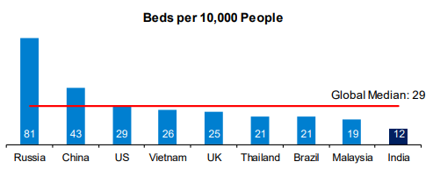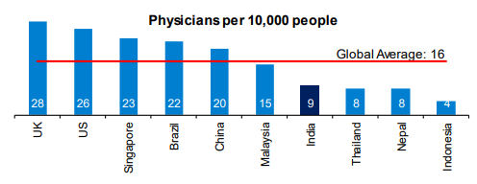
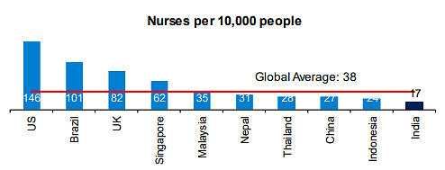
Further, the penetration of testing centres in India is still low, especially in the rural regions where the dependence on primary health centres is high. This bodes well for diagnostics companies in terms of expansion. For instance, in December last year, Lupin announced the launch of diagnostic labs. Similarly, SRL Diagnostics has planned investments for expansion purposes. Metropolis too said in a statement about expanding to smaller cities.
The diagnostics industry has two categories – pathology (offered by all and accounts for nearly 58% of the revenue in the industry) relates to testing of all major illnesses. And radiology (which accounts for 42% of revenue in the industry) relates to imaging diagnoses such as x-rays, CT scans and Ultrasound.
- MARKET SIZE:
- Indian Healthcare Sector: The Indian healthcare sector is expected to record a three-fold rise, growing at a CAGR of 22% between FY 2016-22 to reach US$ 372 billion in 2022 from US$ 110 billion in 2016. By FY22, Indian healthcare infrastructure is expected to reach US$ 349.1 billion. In FY22, premiums underwritten by health insurance companies grew to Rs. 73,582.13 crore. The health segment has a 33.33% share in the total gross written premiums earned in the country.
The Indian medical tourism market was valued at US$ 2.89 billion in 2020 and is expected to reach US$ 13.42 billion by 2026. India has been ranked 10th in the Medical Tourism Index (MTI) for 2020-21 out of 46 destinations by the Medical Tourism Association. The e-health market size is estimated to reach US$ 10.6 billion by 2025. As per Minister of Health & Family Welfare the doctor, population ratio in the country is 1:854, assuming 80% availability of 12.68 lakh registered allopathic doctors and 5.65 lakh AYUSH doctors.
- Indian Diagnostic Sector: The Indian diagnostics market, now with a size of $10 billion in FY2021, is projected to grow at a compounded annual growth rate (CAGR) of 14% to reach $20 billion by FY 2026 as per new industry research reports. Out of the $10 billion worth market, standalone centres account for 48% market share, followed by hospital labs with 37% share and national chains with 5% share. While the pathology segment contributes 57% to the diagnostic market share, radiology accounts for 43% of the market, comprising tests like computed tomography (CT) scans, magnetic resonance imaging (MRI), colour Doppler ultrasound scans, etc.
This growth will be primarily driven by increasing demographics, urbanisation, penetration, and better realisations per tests. The diagnostic industry in India is characterised by a high degree of fragmentation with over 1, 00,000 labs. This fragmentation poses a challenge in terms of capability, scalability, and quality of labs, but on the other hand, it also provides an opportunity to consolidate newer business models to evolve.
New business models around tele radiology and tele pathology to improve access, quality, and efficiency of diagnostics is an emerging area. Tele radiology was estimated to be a $356 million market in 2020 and is likely to evolve into $700 million market by 2025, growing at a CAGR of 15%. Network of partnerships and supply chain innovations, increased use of technology and digital solutions are also likely to fuel growth.
- RECENT INVESTMENTS/ RATIONALE: FDI inflow for the drugs and pharmaceuticals sector stood at US$ 19.90 billion from April 2000 to June 2022, according to the data released by Department for Promotion of Industry and Internal Trade (DPIIT).
The capex cycle, which was affected during FY21, has resumed in FY22. Aggressive Greenfield expansion due to better liquidity and attractive interest rates have aided the expansion. Despite capex, debt metrics have improved in FY22 on account of higher ARPOB and occupancy levels. Greenfield expansion is expected to continue from FY23, and large players are likely to go in for inorganic acquisitions cum expansion leading to increase in bed capacity by about 30% by FY25. Improving cash flows, prudent funding, and equity infusion will benefit credit risk profiles. Some of the recent developments in the Indian healthcare industry are as follows:
- As of November 24, 2022, more than 219.88 crore COVID-19 vaccine doses have been administered across the country. As of November 16, 2022, India has exported 28.13 crore vaccine doses.
- Multinational healthcare company Abbott has committed to converting 75 Primary Health Centres (PHCs) to Health and Wellness Centres (HWCs) in nine Indian States, in collaboration with Americares India Foundation, a non-profit organisation dedicated to relief and development in the field of health. This will benefit over 2.5 million people from under-resourced communities every year.
- In November 2022, diabetes management app BeatO raised US$ 33 million in its Series B funding round led by impact investor Light rock India.
- In August 2022, Edelweiss General Insurance partnered with the Ministry of Health, Government of India, to help Indians generate their Ayushman Bharat Health Account (ABHA) number.
- CHALLENGES WITH THE HEALTHCARE SECTOR:
India imports nearly 90% of its medical devices and for radiology equipment - X- -ray machines, MRI machines, and CT scan machines - the import dependency rises to 95%. There are hardly any multinational companies manufacturing these devices in India. For a nation pushing for self-reliance this is a major red flag. It is time to address the supply chain issues plaguing the sector with local innovation taking the centre stage.
However, key challenges facing the industry include regulatory issues, fragmented market with a low focus on quality, commoditisation and increasing competitive intensity, non-access to specialised resources, and value-conscious Indian customers. Additionally, some of the key challenges are Inadequate Access, Low Budget, Lack of Preventive Care, Lack of Medical Research, Policymaking, Shortage in Professionals, Paucity of Resources.

- GOVERNMENT INITIATIVES: Some of the major initiatives taken by the Government of India to promote the Indian healthcare industry are as follows:
- In the recently launched Union budget 2023-24, among the highlights for the health sector is an announcement to launch a new mission to eliminate Sickle Cell Anaemia disease by 2047. Other key proposals include opening of 157 new nursing colleges and starting dedicated multidisciplinary courses for the medical devices.
- In the Union Budget 2022-23: INR 86,200.65 crore was allocated to the Ministry of Health and Family Welfare. Pradhan Mantri Swasthya Suraksha Yojana (PMSSY) was allocated Rs. 10,000 crore. Human Resources for Health and Medical Education was allotted Rs. 7,500 crore. National Health Mission was allotted Rs. 37,000 crore. Ayushman Bharat – Pradhan Mantri Jan Arogya Yojana (AB-PMJAY) was allotted Rs. 6,412 crore.
- The Government of India approved continuation of ‘National Health Mission’ with a budget of Rs. 37,000 crore. INR 5,156 crore was allocated to the newly announced PM-ABHIM to strengthen India’s health infrastructure and improve the country’s primary, secondary and tertiary care services.
- The government of India approved a 100% FDI in Greenfield and Brownfield projects.
- ROAD AHEAD:
The Government aims to develop India as a global healthcare hub, and is planning to increase public health spending to 2.5% of the country's GDP by 2025. The hospital industry in India is forecast to increase to Rs. 8.6 trillion by FY 2022 from INR 4 trillion in FY17 at a CAGR of 16–17%. The growing prevalence of various chronic and infectious diseases such as cancer, cardiovascular diseases, gastrointestinal disorders, renal disorders, and urological problems has significantly increased the demand for getting diagnoses and treatments done for these diseases.
This, in turn, is expected to positively influence the growth of India diagnostic labs market. According to research papers, there were around 1,324,413 new cancer cases reported in India in 2020, out of these, 646,030 were reported in males, and 678,383 were reported in females. Similarly, the number of COVID-19 tests conducted in India as of 9th November 2022 was around 44,664,810. All these tests are conducted in diagnostic laboratories only, thereby supporting market growth.
Healthcare delivery in India witnessed a renewed focus on leveraging digital technology during the pandemic. The sector, predominantly recognized for sick care delivery, has looked at building next-gen capabilities that will be a differentiator in the decade ahead. Several reforms launched before and during the pandemic such as National Health Digital Mission (NDHM), teleconsulting guidelines combined with burgeoning health tech start-up ecosystem enabled by innovation, have evolved to make the healthcare journey better for Indian population.
However, India imports nearly 90% of its medical devices and for radiology equipment - X- -ray machines, MRI machines, and CT scan machines - the import dependency rises to 95%. For a nation pushing for self-reliance this is a major red flag. It is time to address the supply chain issues plaguing the sector with local innovation taking the centre stage.
It is good that the Private Equity/Venture Capital funding is also coming to support the health tech start up eco system. Maximizing the clinical, financial, and operational value of these new digital offerings and services requires biopharma, medtech and other health care stakeholders to reinforce digital as an entirely new business model and ecosystem to deliver better outcomes and drive stakeholder awareness, adoption, engagement, and growth.

PART G | SWOT ANALYSIS OF DIAGNOSTIC SECTOR

PART H | PROJECT COST AND MEANS OF FINANCE

As per data/information provided by the company/client, category wise proposed project cost is shown in the below table:
(INR Crores)
Total Project Cost (TPC)
Particulars | Cost
HARD COST | Already Incurred |  | To be Incurred |  | Total Cost
Construction of Building + Land Development | 5.33 |  | 2.57 |  | 7.90
Plant And Machinery | 2.10 |  | 8.90 |  | 11.00
Furniture & Fixtures | 0.73 |  | 0.97 |  | 1.70
Preliminary Expanses | 0.00 |  | 0.10 |  | 0.10
Total Cost | 8.16 |  | 12.46 |  | 20.07
SOFT COST | Already Incurred |  | To be Incurred |  | Total Cost
Contingencies @2% | 0.00 |  | 0.41 |  | 0.41
Trade Deposits, Govt. Deposits and other Advances | 0.00 |  | 0.15 |  | 0.15
Working Capital Finance | 0.00 |  | 2.50 |  | 2.50
Interest During Construction (IDC) | 0.00 |  | 0.36 |  | 0.36
Total Project Cost | 8.16 |  | 15.96 |  | 24.12
MEANS OF FINANCE
Particulars | Already Done | Proposed |  | Total
Promoters Contribution | 8.16 | 1.96 |  | 10.12
Bank Finance (Term Loan) | 0.00 | 12.00 |  | 12.00
Bank Finance (Working Capital) | 0.00 | 2.00 |  | 2.00
Total | 8.16 | 15.96 |  | 24.12
Notes:
- The company has already taken a hospital land admeasuring approx. 900 Sq. Yards along with bare shell at K. No.-2015, NH -2, Delhi-Mathura Road, Near Kithwari Chowk, Krishna Colony, Palwal, Haryana, on a long-term lease from its existing owners.
- The projected building's total construction cost, including complete civil work, interior work etc. is approx. INR 7.90 Crores, out of which the company’s promoters have already spent INR 5.33 crores to complete the civil work of the proposed hospital building.
- The cost of Plant & Machinery and other fixed Assets has been estimated at INR 11.00 crores, including purchases of all the required latest plant and Machinery for the proposed Hospital. An Advance of Rs.2.10 crores has already been made to some of the selected suppliers under this head. The cost estimates are assessed based on present market rates and offer received from vendors/suppliers. The final decision on the selection of vendors has yet to be taken.
- The cost estimates for furniture & fixtures are assessed based on present market rates and offer received from vendors/suppliers. A provision of INR 1.70 crores have been made under this head and an advance amount of INR 0.73 crores have also been made to the suppliers of these products.
- Preliminary expenses includes legal amount paid before the incorporation of the company, expenses attributed to a feasibility study or marketing survey, marketing-related costs such as logo design and branding and fees are paid for consulting and professional services during incorporation. A provision of INR 0.10 crore have been made under this head.
- Contingent expenses are considered as 2% of the project cost). Any contingencies, if they arise, beyond the stipulated amount will be borne by the company from its self-sourced funds. A provision for Trade Deposits, Govt. Deposits and other Advances has been made as INR 0.15 crores. These figures are estimated by the company after consultations with the government bodies and its consultant team for this purpose.
- The Working capital finance limit of Rs.2.50 crore has been assessed for business purposes, with a projected sale of INR 27.70 crore for FY2024. The stocks and receivables holding has been evaluated on market trends and industry-wise requirements for this business.
- The company has proposed an amount of INR 0.36 Crores for IDC, and the company is projecting construction & installation period for 8 months from Jan 2023 to Aug 2023 to construct the proposed hospital building with complete installation of the proposed plant & machinery.
- MEANS OF FINANCE: In the total project cost of INR 24.12 crores, it is proposed that the company’s promoters bring in equity of INR 10.12 crores as their share of contribution to the project. The remaining amount of Rs.14.00 crores will be met through a bank term loan of INR 12.00 crores and working capital loan of INR 2.00 crores.
Thus the company is fulfilling the criteria for term loan and WC loan of INR 24.12 Crores from State Bank of India under Bank’s Aarogyam Non-metro healthcare business loan under Loan Guarantee Scheme for Covid affected Sectors (LGSCAS) where Debt-Equity Ratio of 3:1 and Promoters Contribution Margin of 25% has been stipulated by the bank, as the company planned to establish Diagnostic Centre at Sector-53, Gurugram.

PART I | PROJECT SCHEDULE

Below is the tabulated presentation of the status of the project showing expected duration shared by the project manager of the company:

S.No. | Particulars | Activity | Expected completion date | Status
 | Land | Land Procurement | May 2021 | Achieved
 |  | Land Development | August 2022 | Achieved
 | Sanction of Rupee Term Loan | Sanction of Rupee Term Loan | February 2023 | Achieve till February 2023
 | Building & Civil Works | Appointment of Architect | May 2021 | Achieved
 |  | Building Plan Preparation | May 2021 | Achieved
 |  | Building Plan Sanction | 02 June 2021 | Achieved
 |  | Appointment of Civil contractor/ developer | June 2021 | Achieved
 |  | Building & Civil Works completion | August, 2022 | Achieved
 | Plant & Machinery | Finalization of P&M suppliers | April 2023 | Achieved till June 2023
 |  | Orders to P&M suppliers | Mid of April 2023 | Achieved till June 2023
 |  | Arrival of P&M | June-2023 | Achieved till June 2023
 |  | Installation of P&M | August 2023 | Achieved till August 2023
 |  | Utility Installation | August 2023 | Achieved till August 2023
 | Furniture and Fixtures | Purchase of other Fixed Assets / Furniture and Fixtures | August-2023 | Achieved till August 2023
 | Statutory Approvals, registrations & NOCs |  | July-2023 | Achieved Before Trial Run
 | Finishing & Trail Run |  | August - 2023 | Achieved till August-2023
 | Commercial Operation Date |  | September , 2023 | Achieved till September 2023

Notes:
- Schedule has been made as per feasibility to achieve different milestones.
- Achievement of Milestone will depend on sanction of term loan as per proposed timeline.

PART J | STATUTORY APPROVALS | LICENCES | NOC
As per the information provided by the client below is the list of Approvals required for the proposed project:
S. No. | REQUIRED APPROVALS | REFERENCE NO./ DATE | STATUS  (Approved/ Applied For/ Pending)
1. | Lease deeds of the hospital land and building.  Registrar office | 26th May 2021 | Already Obtained
2. | Building Plan & FSI (Floor Space Index) / FAR (Floor Area Ratio)  Local Authority/ Nagar Nigam (As the case may be) | June 2021 | Already Obtained
3. | Pollution Control Board Clearance  Haryana Pollution Control Board | Achieved till September 2023 | Consent to the establishment has already been taken. Final NOC on COD.
4. | Electric Load and Maximum Demand  Haryana Electrity Board | Achieved till September 2023 | Already obtained power connection of 200 KVA & Shall be applied for an expansion of 500 KVA before commercial operations.
5. | Water Supply Requirement  Local water body | To be applied in due course | Shall be applied before starting the commercial operation.
6. | Fire & Safety  Fire & Safety Department | To be applied in due course | Shall be obtained after completion of Building.
7. | Labour Law - Registration under Contract Labour law  Labour Commissioner | To be applied in due course | To be registered before COD.
9. | Establishment of Enterprises.  State Nodal Agency, Govt. of Haryana | To be applied in due course | To be obtained before the COD of the Hospital.
10. | Registration for License under Clinical Establishment Act.  State Bio-Medical Waste treatment Board or Authority | To be applied in due course | Before COD.
11. | National Accreditation Board for Testing and Calibration Laboratories (NABL) Accreditation  Accreditation from National Accreditation Board for Testing and Calibration Laboratories. | To be applied in due course | Before COD.
12. | Consent to Operation (CTO)  Member Secretary, PCB | To be applied in due course | Before COD.
13. | Licenses / Registration under various labour laws, including Contract, Appropriate Authority/ Labour Regulation & Abolition Act  Labour Department | To be applied in due course | Awaited, To be obtained before COD
14. | Registration under Shop & Establishment Act.  State body or Authority. | May 2021 | Already Obtained.
15. | Drug License.  Government of Haryana. | August 2022 | Already Obtained.
16. | BMW (Bio-Medical waste) registration.  Private waste management company registered under Haryana Government Act for this purpose. | August 2022 | Already Obtained.
17. | Clinical Establishment Act registration.  State Government | To be applied in due course | To be registered before COD.
18. | FSSAI license for running Kitchen.  Department of Food Safety and Standards Authority of India | To be applied in due course | To be registered before COD.
19. | Prenatal Diagnostic Test Act (PNDT) with State Government body. | To be applied in due course | To be registered before COD.
20. | License for operations from AERB (Atomic Energy Regulatory Board) for running radiology and X-ray centre  E-governance application-LORA (e-Licensing of Radiation Applications) | To be applied in due course | Before COD.

PART K | COMPANY’S FINANCIAL FEASIBILITY

- PROJECTIONS OF THE FIRM: The projections of the firm are done From FY 2023-24 to FY 2029-30 based on the revenue generation capacity of the proposed Tula hospital and total expected expenses are shown as below:
- PROJECTED PROFIT & LOSS ACCOUNT: Below table shows the Projected Profit & Loss Account of proposed Tula hospital from the period FY 2023-24 to FY 2029-30.
Particulars (INR Crore) | 2023-24 | 2024-25 | 2025-26 | 2026-27 | 2027-28 | 2028-29 | 2029-30
Months | 7 | 12 | 12 | 12 | 12 | 12 | 12
Capacity utilisation % | 50% | 55% | 65% | 70% | 75% | 80% | 85%
Revenue: 120 Beds | 4.42 | 8.33 | 9.84 | 10.60 | 11.35 | 12.11 | 12.87
Departmental Revenue PA | 9.92 | 18.72 | 22.12 | 23.82 | 25.52 | 27.22 | 28.92
Misc. Revenue | 0.66 | 1.24 | 1.46 | 1.57 | 1.69 | 1.80 | 1.91
Total Revenue | 15.00 | 28.28 | 33.42 | 35.99 | 38.56 | 41.13 | 43.70
Lease Rentals | 0.79 | 0.87 | 0.92 | 0.97 | 1.02 | 1.11 | 1.22
Departmental Exp. Inc. Medicine purchase | 5.46 | 10.29 | 12.17 | 13.10 | 14.04 | 14.97 | 15.91
Cost of foods, stationary, maintenance ex. | 0.20 | 0.37 | 0.44 | 0.47 | 0.51 | 0.54 | 0.57
Cost of Rooms | 0.88 | 1.67 | 1.97 | 2.12 | 2.27 | 2.42 | 2.57
Salary and wages | 3.00 | 5.66 | 6.68 | 7.20 | 7.71 | 8.23 | 8.74
Power & Fuel | 0.75 | 1.41 | 1.67 | 1.80 | 1.93 | 2.06 | 2.19
Administration & Misc. Expenses | 1.12 | 2.12 | 2.51 | 2.70 | 2.89 | 3.08 | 3.28
Other Operating Expenses | 0.15 | 0.28 | 0.33 | 0.36 | 0.39 | 0.41 | 0.44
CMC Cost | 0.10 | 0.09 | 0.07 | 0.06 | 0.05 | 0.04 | 0.04
Repair & Maintenance | 0.12 | 0.17 | 0.15 | 0.13 | 0.12 | 0.10 | 0.09
Rent Rates & Taxes (% of Building , P&M,MFA) | 0.01 | 0.02 | 0.02 | 0.02 | 0.02 | 0.02 | 0.02
Insurance | 0.12 | 0.17 | 0.15 | 0.13 | 0.12 | 0.10 | 0.09
Total Operating cost | 12.69 | 23.12 | 27.08 | 29.06 | 31.05 | 33.09 | 35.15
EBITDA | 2.30 | 5.16 | 6.34 | 6.93 | 7.51 | 8.04 | 8.55
Dep. & Amortization | 1.57 | 2.48 | 2.16 | 1.88 | 1.64 | 1.43 | 1.24
EBIT | 0.74 | 2.67 | 4.18 | 5.05 | 5.87 | 6.62 | 7.31
Interest on Term Loan | 0.56 | 0.91 | 0.81 | 0.68 | 0.55 | 0.47 | 0.18
Interest on WC | 0.09 | 0.16 | 0.16 | 0.16 | 0.16 | 0.22 | 0.22
Finance Cost | 0.65 | 1.07 | 0.97 | 0.84 | 0.71 | 0.69 | 0.40
Profit before tax | 0.09 | 1.61 | 3.22 | 4.21 | 5.16 | 5.92 | 6.91
Prel. Expenses W/Off | 0.02 | 0.02 | 0.02 | 0.02 | 0.02 | 0.00 | 0.00
Net Profit before tax | 0.07 | 1.59 | 3.20 | 4.19 | 5.14 | 5.92 | 6.91
Tax @ 30% | 0.02 | 0.48 | 0.96 | 1.26 | 1.54 | 1.78 | 2.07
Profit after taxes | 0.05 | 1.11 | 2.24 | 2.93 | 3.60 | 4.15 | 4.84

- PROJECTED BALANCE SHEET: Below table shows the Projected Balance Sheet of the proposed Tula hospital from the period FY 2024 to FY 2033.
Particulars | 2023-24 | 2024-25 | 2025-26 | 2026-27 | 2027-28 | 2028-29 | 2029-30
Capital | 10.12 | 10.12 | 10.12 | 10.12 | 10.12 | 10.12 | 10.12
Reserve & Surplus | 0.05 | 1.16 | 3.39 | 6.33 | 9.93 | 14.07 | 18.91
Long Term Borrowing | 10.80 | 9.36 | 7.56 | 5.40 | 3.00 | - | -
Short Term Liabilities | 1.20 | 1.44 | 1.80 | 2.16 | 2.40 | 3.00 | 0.00
Working Capital Loan | 2.00 | 2.00 | 2.00 | 2.00 | 2.00 | 2.00 | 2.00
Sundry Creditors | 0.93 | 1.76 | 2.08 | 2.24 | 2.40 | 2.56 | 2.72
Provision for Tax | 0.02 | 0.48 | 0.96 | 1.26 | 1.54 | 1.78 | 2.07
Shareholder’s Equity and Liabilities | 25.12 | 26.31 | 27.91 | 29.51 | 31.39 | 33.53 | 35.83
Fixed Assets | 19.80 | 17.32 | 15.16 | 13.28 | 11.65 | 10.22 | 8.98
Sundry Debtors | 2.50 | 4.71 | 5.57 | 6.00 | 6.43 | 6.86 | 7.28
Closing Stock | 2.00 | 2.60 | 4.00 | 6.00 | 8.00 | 10.00 | 12.50
Cash & Bank Balances | 0.36 | 1.00 | 2.01 | 2.96 | 3.92 | 4.81 | 5.17
Preliminary Ex. | 0.08 | 0.06 | 0.04 | 0.02 | - | - | -
Deposits with Govt. /private | 0.15 | 0.15 | 0.15 | 0.15 | 0.15 | 0.15 | 0.15
Loans & Advances | 0.23 | 0.47 | 0.98 | 1.10 | 1.25 | 1.50 | 1.75
Total Assets | 25.12 | 26.31 | 27.91 | 29.51 | 31.39 | 33.54 | 35.83

- REVENUE BUILD-UP: Total Revenue will be determined by including the estimated income from Bed Revenue, Departmental Revenue & Misc. Revenue based on the reasonable capacity utilization and rate per unit considered over the estimated period as per described in the below table:
Income Estimates: Room Revenue
Bed Revenue | Number of Rooms | Rate per day | Revenue
Deluxe room-1 no. @ 7000/- Per Day | 1 | 7000 | 7000
Private Room 30 nos. @ 4000/- Per Day | 30 | 4000 | 120000
Semi.Private-4 nos. @ 2500/- Per Day | 4 | 2500 | 10000
OBG Ward- 5nos. @ 2000/- Per Day | 5 | 2000 | 10000
Economy- 55 nos. @ 1500/- Per Day | 55 | 1500 | 82500
ICU- 22 nos. @ 8000/- Per Day | 22 | 8000 | 176000
NICU-3 nos. @ 5000/- Per Day | 3 | 5000 | 15000
Total room revenue per day |  |  | 420500
Total room revenue PM (INR) | 120 |  | 1,26,15,000

Income Estimates: Departmental Revenue
Particulars | Assumptions
Total number of Beds | 120 beds
Available beds in a year | 43800 beds
Average length of stay | 3 days
Number of admissions | 14,600
Total number of days- Indoor | 365
Total number of days-OPD | 300

Calculation of Revenue Projections
Department | Productivity |  | Avg. Rate per case |  | Income |  | Total
 | Indoor | OPD | Indoor | OPD | Indoor | OPD
In-Patient Consultation | 43800 |  | 600 |  | 26280000 |  | 26280000
General OPD |  | 18000 |  | 250 |  | 4500000 | 4500000
Special OPD |  | 6000 |  | 400 |  | 2400000 | 2400000
Cardiac OPD |  | 3000 |  | 600 |  | 1800000 | 1800000
Angiography | 300 |  | 14000 |  | 4200000 |  | 4200000
Angioplasty | 150 |  | 220000 |  | 33000000 |  | 33000000
Urology surgeries: | 300 |  | 40000
Surgeon Charges |  |  | 20000 |  | 6000000 |  | 6000000
Anaesthetist Charges |  |  | 6000 |  | 1800000 |  | 1800000
OT Charges |  |  | 10000 |  | 3000000 |  | 3000000
Consumables |  |  | 4000 |  | 1200000 |  | 1200000
Ortho & Spine Surgeries: | 600 |  | 60000
Surgeon Charges |  |  | 25000 |  | 15000000 |  | 15000000
Anaesthetist Charges |  |  | 10000 |  | 6000000 |  | 6000000
OT Charges |  |  | 15000 |  | 9000000 |  | 9000000
Consumables |  |  | 10000 |  | 6000000 |  | 6000000
Gynae Surgeries: | 300 |  | 40000
Surgeon Charges |  |  | 18000 |  | 5400000 |  | 5400000
Anaesthetist Charges |  |  | 6000 |  | 1800000 |  | 1800000
OT Charges |  |  | 8000 |  | 2400000 |  | 2400000
Consumables |  |  | 8000 |  | 2400000 |  | 2400000
Gen.Procedures | 900 |  | 45000
Surgeon Charges |  |  | 20250 |  | 18225000 |  | 18225000
Anaesthetist Charges |  |  | 4500 |  | 4050000 |  | 4050000
OT Charges |  |  | 15750 |  | 14175000 |  | 14175000
Consumables |  |  | 4500 |  | 4050000 |  | 4050000
Dialysis |  | 600 |  | 1100 |  | 660000 | 660000
Day-care |  | 300 |  | 2000 |  | 600000 | 600000
C Section | 146 |  | 60000 |  | 8760000 |  | 8760000
Normal Delivery | 365 |  | 33000 |  | 12045000 |  | 12045000
Admission fee | 14600 |  | 100 |  | 1460000 |  | 1460000
Pharmacy | 43800 | 6975 | 2000 | 2000 | 87600000 | 13950000 | 101550000
Minor Procedures |  | 1200 |  | 1500 |  | 1800000 | 1800000
Pathology | 46861 | 8730 | 1200 | 1000 | 56233200 | 8730000 | 64963200
MRI | 292 | 600 | 6600 | 6000 | 1927200 | 3600000 | 5527200
CT SCAN | 353 | 1200 | 3300 | 3000 | 1165626 | 3600000 | 4765626
X-ray | 883 | 1200 | 275 | 200 | 242839 | 240000 | 482839
Sonography | 883 | 1500 | 880 | 800 | 777084 | 1200000 | 1977084
ECG | 3472 | 300 | 220 | 200 | 763884 | 60000 | 823884
Total Revenue PA @ 100% Capacity |  |  |  |  |  |  | 37,80,94,833
Less: 10% discount on account of charity and Professional referral cases. |  |  |  |  |  |  | 3,78,09,483
Net Revenue PA on 100% capacity |  |  |  |  |  |  | 34,02,85,349
Monthly revenue (INR) |  |  |  |  |  |  | 2,83,57,112

Income Estimates: Misc. Revenue | Revenue-Per Annum
Canteen/ Kitchen in house @ 500/- PD/Per Bed | 21900000
Rent from cafeteria | 150000
Certificates/ Passes | 438000
Total Revenue-PA (INR) | 2,24,88,000
- ESTIMATED KEY FINANCIAL RATIOS/METRICS:
Particulars | 2023-24 | 2024-25 | 2025-26 | 2026-27 | 2027-28 | 2028-29 | 2029-30
EBITDA Margin % | 15.36% | 18.24% | 18.97% | 19.25% | 19.47% | 19.55% | 19.57%
EBIT Margin % | 4.90% | 9.46% | 12.51% | 14.03% | 15.23% | 16.09% | 16.72%
Net Profit Margin | 0.31% | 3.93% | 6.70% | 8.15% | 9.33% | 10.08% | 11.07%
YoY Growth Rate |  | 88.57% | 18.18% | 7.69% | 7.14% | 6.67% | 6.25%
Current ratio | 1.23 | 1.55 | 1.84 | 2.10 | 2.35 | 2.48 | 3.93
TOL/TNW | 1.47 | 1.33 | 1.07 | 0.79 | 0.57 | 0.39 | 0.23

- GRAPHICAL REPRESENTATION OF KEY FINANCIAL METRICS:
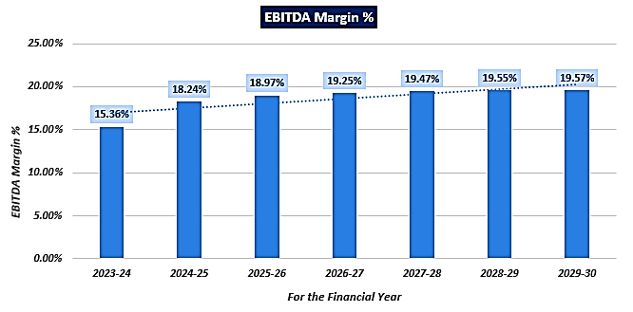
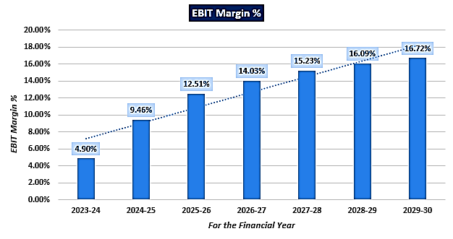
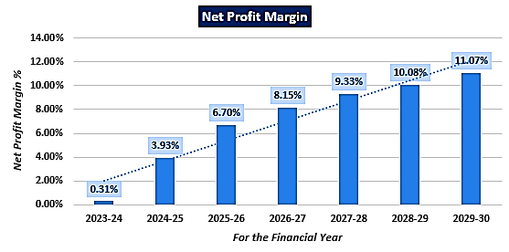
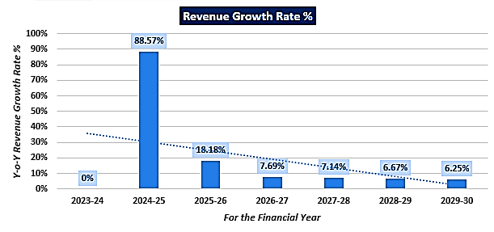
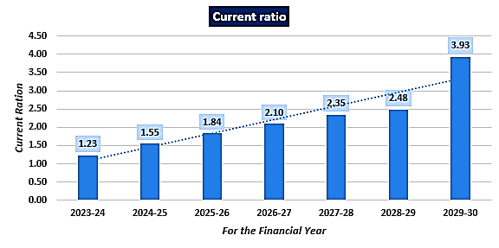
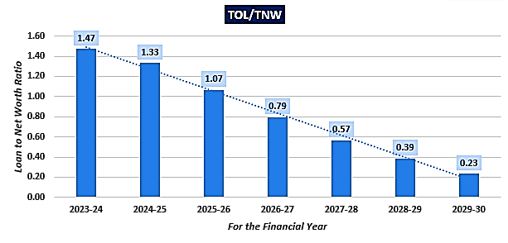

- DEBT SERVICE COVERAGE RATIO (DSCR):
Particulars | 2023-24 | 2024-25 | 2025-26 | 2026-27 | 2027-28 | 2028-29 | 2029-30
Months | 7 | 12 | 12 | 12 | 12 | 12 | 12
Capacity utilisation % | 50% | 55% | 65% | 70% | 75% | 80% | 85%
PAT | 0.05 | 1.11 | 2.24 | 2.93 | 3.60 | 4.15 | 4.84
Depreciation | 1.57 | 2.48 | 2.16 | 1.88 | 1.64 | 1.43 | 1.24
Cash Accruals (A) | 1.61 | 3.59 | 4.40 | 4.81 | 5.24 | 5.57 | 6.08
TL Interest (B) | 0.56 | 0.91 | 0.81 | 0.68 | 0.55 | 0.47 | 0.18
Total (A+B) | 2.17 | 4.50 | 5.20 | 5.49 | 5.79 | 6.05 | 6.26
TL Repayment (C) | 0.00 | 1.20 | 1.44 | 1.80 | 2.16 | 2.40 | 3.00
Total (B+C) | 0.56 | 2.11 | 2.25 | 2.48 | 2.71 | 2.87 | 3.18
Gross DSCR (A+B)/(B+C) | 3.90 | 2.13 | 2.32 | 2.22 | 2.13 | 2.10 | 1.97
Average Gross DSCR |  |  |  |  |  |  | 2.40
Max. Gross DSCR |  |  |  |  |  |  | 3.90
Net DSCR (A/C) | - | 2.99 | 3.05 | 2.67 | 2.42 | 2.32 | 2.03
Average Net DSCR |  |  |  |  |  |  | 2.58
Max. Net DSCR |  |  |  |  |  |  | 3.05

- SECURITY MARGIN AND FIXED ASSET COVERAGE RATIO (FACR):
Particulars | 2023-24 | 2024-25 | 2025-26 | 2026-27 | 2027-28 | 2028-29 | 2029-30
Months | 7 | 12 | 12 | 12 | 12 | 12 | 12
Capacity utilisation % | 50% | 55% | 65% | 70% | 75% | 80% | 85%
WDV of Fixed Assets | 19.80 | 17.32 | 15.16 | 13.28 | 11.65 | 10.22 | 8.98
Aggregate TL Outstanding | 10.80 | 9.36 | 7.56 | 5.40 | 3.00 | 0.00 | 0.00
Security Margin available | 9.00 | 7.96 | 7.60 | 7.88 | 8.65 | 10.22 | 8.98
% Margin | 45.46 | 45.96 | 50.14 | 59.35 | 74.24 | 100.00 | 100.00
Fixed asset coverage ratio (FACR) | 1.83 | 1.85 | 2.01 | 2.46 | 3.88 | - | -

- BREAK-EVEN ANALYSIS:
Particulars | 2023-24 | 2024-25 | 2025-26 | 2026-27 | 2027-28 | 2028-29 | 2029-30
Months | 7 | 12 | 12 | 12 | 12 | 12 | 12
Capacity utilisation % | 50% | 55% | 65% | 70% | 75% | 80% | 85%
Sales (S) | 15.00 | 28.28 | 33.42 | 35.99 | 38.56 | 41.13 | 43.70
PBT | 0.07 | 1.59 | 3.20 | 4.19 | 5.14 | 5.92 | 6.91
% of VC | 65.26 | 62.33 | 61.50 | 61.19 | 60.94 | 60.98 | 60.93
VC (V) | 9.79 | 17.62 | 20.55 | 22.02 | 23.50 | 25.08 | 26.63
FC (F) | 5.12 | 9.05 | 9.65 | 9.76 | 9.90 | 10.13 | 10.16
Contribution (S-V) | 5.21 | 10.65 | 12.87 | 13.97 | 15.06 | 16.05 | 17.07
Breakeven Sales (F/C*S) | 14.75 | 24.02 | 25.06 | 25.14 | 25.35 | 25.95 | 26.02
Breakeven installed capacity (F/C*U) | 0.49 | 0.47 | 0.49 | 0.49 | 0.49 | 0.50 | 0.51
Cash Breakeven Installed capacity (F-Depreciation/C*U) | 0.34 | 0.34 | 0.38 | 0.39 | 0.41 | 0.43 | 0.44

Break-Even Sales, breakeven installed capacity and cash breakeven installed capacity of the company has been shown in the above table during the forcasted period. Therefore, given the fixed costs and variable costs, and selling price of all items, Company would need to sell its services as per numbers calculated in the above table to break even.

- SENSITIVITY ANALYSIS:
Particulars | 2023-24 | 2024-25 | 2025-26 | 2026-27 | 2027-28 | 2028-29 | 2029-30
Months | 7 | 12 | 12 | 12 | 12 | 12 | 12
Capacity utilisation % | 50% | 55% | 65% | 70% | 75% | 80% | 85%
Sales % Variation | 5% | 5% | 5% | 5% | 5% | 5% | 5%
Variation expense % | 5% | 5% | 5% | 5% | 5% | 5% | 5%
Fixed expense % Variation | 5% | 5% | 5% | 5% | 5% | 5% | 5%
Sales (with Variation) | 14.25 | 26.86 | 31.75 | 34.19 | 36.63 | 39.08 | 41.52
VC (with variation) | 9.30 | 16.74 | 19.53 | 20.92 | 22.33 | 23.83 | 25.30
FC (with variation) | 4.87 | 8.60 | 9.17 | 9.27 | 9.40 | 9.62 | 9.66
PBT | 0.08 | 1.53 | 3.06 | 4.00 | 4.90 | 5.63 | 6.56
PBT % | 0.57 | 5.68 | 9.62 | 11.70 | 13.39 | 14.40 | 15.81
PAT72.18% | 0.06 | 1.10 | 2.21 | 2.89 | 3.54 | 4.06 | 4.74
Cash Accruals (A) | 1.55 | 3.46 | 4.26 | 4.67 | 5.09 | 5.42 | 5.92
TL Interest (B) | 0.53 | 0.86 | 0.77 | 0.64 | 0.52 | 0.45 | 0.17
Total (A+B) | 2.08 | 4.32 | 5.02 | 5.32 | 5.62 | 5.87 | 6.09
Total (B+C) | 0.53 | 2.06 | 2.21 | 2.44 | 2.68 | 2.85 | 3.17
Gross DSCR (A+B)/(B+C) | 3.93 | 2.09 | 2.28 | 2.18 | 2.09 | 2.06 | 1.92

- COST-VOLUME PRICE/SENSITIVITY:
Cost-Volume Price Or Sensitivity Analysis |  |  | 10% increase in variable cost | 10% decrease in volume of sales | 10% decrease in selling price | Decrease in Revenue by 5% and Increase in Opex by 5% and Interest Rate Increase by 1%
Operating Profit Before Interest | 2.30 | 5.16 | 6.34 | 6.93 | 7.51 | 8.04 | 8.55
1.Sales |  | 28.28 | 28.28 | 25.45 | 25.45 | 26.86 | 26.86
2. Variable expenses |  | 17.62 | 19.39 | 19.39 | 19.39 | 20.36
3. Contribution |  | 10.65 | 8.89 | 6.06 | 6.06 | 6.51
4. Fixed Expenses |  | 9.05 | 9.05 | 9.05 | 9.05 | 9.05
5. Operating profit (3- 4) |  | 1.61 | -0.16 | -2.98 | -2.98 | -2.54
6. Break-even sales |  | 24.02 | 28.78 | 37.98 | 37.98 | 37.35
Tax |  | 0.45 | -0.04 | -0.83 | -0.83 | -0.71
PAT |  | 1.16 | -0.11 | -2.15 | -2.15 | -1.83
Depreciation |  | 2.48 | 2.48 | 2.48 | 2.48 | 2.48
Cash Accruals (A) |  | 3.64 | 2.37 | 0.33 | 0.33 | 0.65
TL Interest (B) |  | 0.91 | 0.91 | 0.91 | 0.91 | 0.91
Total (A+B) |  | 4.55 | 3.28 | 1.24 | 1.24 | 1.56
TL Repayment (C) |  | 1.20 | 1.20 | 1.20 | 1.20 | 1.20
Total (B+C) |  | 2.11 | 2.11 | 2.11 | 2.11 | 2.11
Gross DSCR (A+B)/(B+C) |  | 2.16 | 1.55 | 0.59 | 0.59 | 0.74
Average Gross DSCR |  | 1.12
Net DSCR (A/C) |  | 3.03 | 1.97 | 0.27 | 0.27 | 0.54
Average Net DSCR |  | 1.22
Increase in Interest Rate by 1.00% |  | 0.92
Gross DSCR |  | 2.15

DSCR AT DIFFERENT CAPACITIES

Sensitivity Condition | Minimum DSCR
Base Case Scenario | 2.16
Decrease in Revenue by 10% | 0.59
Increase in Opex by 10% | 1.55
Increase in Interest rate by 1% | 2.15
Decrease in Revenue by 5% and Increase in Opex by 5% and Interest Rate Increase by 1% | 0.54
- LOAN/DEBT ASSUMPTION: As per Loan disbursement and amortization schedule shared by the banker, according to the project costs incurred during the estimated period below table shows the Debt inputs:
Particulars | Numbers in Crore
Cost of Project (COP) | 24.12
Debt-Equity Ratio | 1.19
Term Loan | 12.00
Loan Sanctioned | 12.00
No. of Instalment | 72
Gestation Period | 14
Rate of Interest | (%)
1st- 5 years | 7.95%
2nd-5 years | 11.00%

- KEY ASSUMPTIONS & BASIS:
Sl. No. | Item | Assumptions and Basis
 | General | - The projections of the firm are done for the period from FY 2023-24 to FY 2029-30, 7 years to cover the term loan period.  - We have considered Revenue and cost based model while making the financial projections.
 | Revenue Build up | - Total income for the financial year during the forecasted period will be generating from Bed Revenue, Departmental Revenue and Misc. Revenue.  - Revenue has been estimated in line of the prevailing market rates in Delhi-NCR. Since the Nulife Group is also coming up with Nuclear Medicine Centre with Gama Camera diagnosis in the adjoining premises it would be one stop centre for the patients.  - Monthly sales has been calculated based on the assumption of expected average test per day multiplied by average selling price per day and then calculated annually for all the tests.  - Total revenue has been calculated based on the assumption of, monthly sales from all the tests multiplied by assumed capacity utilisation for that particular year.  - Thus the company is generating INR 10.80 Crores in the initial year which is in the line with historical trends. Further it has increased up to INR 18.36 Crores till FY 2032-33.  - Therefor the company is achieving a revenue growth rate Y-o-Y basis, which is also in the line with industrial & economic trends and on conservative side.
 | Pricing (Average Revenue Per test Per Annum) | - The Covid-19 pandemic catalysed long-term behavioural transformation towards personal health and hygiene, health insurance, fitness and nutrition, as well as health monitoring and medical check-ups. Hence these days’ people are anxious for their regular check-ups.  - And as per secondary and tertiary research, industry trend and pricing offered by other companies and vendors in this line and data/information available in public domain, we found that the price per radiology tests are in line with industry standards.
 | Capacity Utilization | - For the proposed project, M/s Dixital is planning to build radiology and diagnostic centre to earn retained profit of 1.77 Crores in FY 2024 and then it will increase till 7.80 Crores in FY 2033.  - For the proposed new radiology centre, since the company’s promoters are having prior experience in the same industry, thus initially we have assumed a 40% capacity utilization for starting 2 months and then for next 2 years there is 10% escalation rate, then 5% escalation rate for next 4 years and then 2% and 1% escalation rate for last 2 years has been considered because the new proposed centre will take some time to achieve the economies of scale and will operate at a higher capacity in the later years.  - Hence, the company’s capacity utilization has been envisaged at 50% of available capacity for the first year, 60% in the Second, 65% in the third year, 70% in the fourth year, 75% in the fifth year, 80% in the Sixth year, 82% in the seventh and 84% in the eighth year, 85% in the Ninth year.  - We have considered the capacity utilization on conservative basis to keep a mark-up for future market & economic risks in the Project.
 | Capital Expenditure | - As per discussion with the client, company has made a decision to purchase a land through auction from HUDA, which is economically viable, since the lease/rent rate of the property at the said location is very much higher on monthly/annual basis.  - The freehold land for proposed project, costs 18.78 Lakhs to the company, the company has already spent 4.38 lakhs for the purchase land and still they have to pay 14.40 lakhs to get full authorization on land.  - The proposed building's total construction cost is approx. INR 3.46 Crores including applicable GST charges.  - The company has an agreement with Delhi-based renowned Architectural firm M/s RS Yadav & Associatesto get help in the construction, civil work, and designing of the proposed unit as per industry norms. Construction estimates of Rs. 3.46 crores have also been obtained from this architectural firm.  - The cost of Plant & Machinery and other fixed Assets has been estimated at Rs. 7.41 crores, including purchases of all the required latest and modern plant and Machinery for the proposed radiology and diagnostic centre.  - As per shared quotations and purchase orders, tertiary research and information available in the public domain, we found that the cost of proposed plant and machinery is reasonable and justifiable.  - For the expensive machines like MRI and CITY Scan machinery, company has made an economically viable decision of purchasing second hand machinery because as per the information available in public domain the new machinery will be costing approx. INR 13.00-14.00 Crore, which will be costing much higher than company’s expected budget.  - All the furniture and fixture items will be manufactured by purchasing wood from the open market or bought from reputed dealers. A provision of Rs. 1.77 crores have been made for the furniture and fixture.  - Other assets will mainly consist of Electricals Fitting & Installation, Fire Fighting Systems, Security Equipment, Office Equipment, Air Conditioners, etc. This will also include Office equipment, Computers, Printers, etc. Total cost of Rs. 0.45 crores have been considered under this head.
 | Expenses | - Major expenses includes Cost of Stationery and Medicines, power & fuels, Administration & Misc. Exp, Cost of Transportation, Salary & Wages, Other Operating Expenses, CMC Cost for Machinery Maintenance, Repair & Maintenance, Rent Rates & Taxes, Insurance etc.  - For the proposed radiology centre, the cost of stationery and medicines for full capacity will be Rs. 500000 P. Month. As per our independent research and information available on public domain this cost is proportionated to the number of test done in that year, which is in line with the industry standards.  - As per tertiary research regarding the average number of employees required to operate a radiology centre and proposed employees details shared by the client, we have considered salary and wages as 12% of the revenue earned in that particular year. The company will be having 35 employees initially to start the operations of radiology centre. Average salary is being provided by the client based on the trending in the market.  - CMC is estimated by the company as 40 lakhs which seems to be reasonable since they are purchasing pre owned MRI and City scan machinery which will be under 1 year of warranty, as per quotation provided by suppliers. And life of the machineries are expected to be 10 years. However we have relied upon these figures in good faith, as it is estimated by the experienced company officials after the discussion with technical consultant, venders and suppliers.  - All the other cost are considered as a % of revenue and are growing with the company’s revenue as it is growing Y-o-Y basis, which is also in the line with industrial & economic trends and on conservative side.  - Expenses considered are cross checked from the similar Industries which is found as per Industry trend and historical.
 | Partial Loan | - As per the discussion with the banker the bank will sanction a term loan of INR 12.00 Crore and INR 2.00 Crore of WC loan out of the total project cost of INR 24.12 Crore for the proposed super speciality hospital (120 Beds) at NH -2, Delhi-Mathura Road, Near Kithwari Chowk, Krishna Colony, Palwal, Haryana-121102.  - The loan will be sanction under Bank’s Aarogyam Non-metro healthcare business loan under Loan Guarantee Scheme for Covid affected Sectors (LGSCAS).  - Interest rate has been decided for first 5 years will be 7.95% and post 5 years it will be 11% applied by the bank.

Conclusion:
      - DSCR, EBITDA and EBIT margin is positive in all years starting from initial year on 50% utilization capacity which has assumed maximum up to 85% up to end of 7th year.
      - DSCR, has achieved more than 1 during the loan repayment period.
      - Average Net DSCR, EBIDTA margin, EBIT margin is 2.58, 18.63%, and 12.71% respectively during the estimated period.
      - Based on the above key financial ratios of the Project during the forecast period for the proposed project shows that the project looks financially viable if the Project Company & promoters are able to maintain minimum capacity utilization, revenue and can contain cost as assumed above.
PART M | CONCLUSION

Based on the technological, economical and market analysis done above, various Industry assumptions taken, pricing to be adopted by the company, the Project appears to be Techno-commercially viable subject to the risks, threats, weaknesses, limitations of the services and equipment as detailed previously.
As per financial projections for the estimated period, Average Net DSCR, EBITDA Margin of the project are 2.58, and 18.63% respectively, where higher DSCR is the indicator of the project capability to pay out its outstanding debt and EBITDA margin shows the capability of the project to generate the operating profits over the forecasted period. While it is not avoidable that the future projections may change in the upcoming years due to various factors impacting the operation, managerial, financial efficiency and economies of scale of the project.
It would be depending on the management’s capability in future that how efficiently company adopts marketing and advertisement strategy, supply chain and carry out inventory & resource management to achieve higher profitability. Company is yet to identify its key customers and to form strategic planning for tie-up & services promotion with customers to increase the capacity utilization which remains a major concern. Bank/ Financial Institution is advised to take firm plan from the company in this regard before taking any decision.
After considering the foreseen high demand of the data centres domestically and globally, various initiatives taken by government, financial analysis of the project based on the assumptions taken over the projected period, it appears reasonable to comment that the proposed project is “Technically and Economically” Viable subject to current assumptions considered and occurring the same in the upcoming years same as the forecasted period which is dependent on the sincerity and efforts of the management and various micro and macroeconomic & industry situation.
We have tried our level best to analyse the Project techno-economic feasibility of the Project based on the Industry research, Project information and various futuristic assumption taken. However achieving the financial milestones depends on the ability, sincerity and efforts of the company, promoters and its key managerial performance.

Declaration | - The undersigned does not have any direct/indirect interest in the above property.  - The information furnished herein is true and correct to the best of our knowledge, logical and scientific assumptions.  - This TEV Report is carried out by our Financial Analyst team on the request from State Bank of India, S.M.E Asaf Ali Road Branch, New Delhi.  - Meeting of Financial projections will be subject to subject to the market & economy stability factors, judicious business operations and proper & timely implementation of its process & product re-engineering & improvements plans for achieving high productivity, efficiency and achieving cost saving benefits.  - We have submitted TEV report to the Client.
Name & Address of consultant company |  |  | Signature of the authorized person
M/s. R.K. Associates Valuer & Techno Engineering Consultants Pvt. Ltd.
D-39, 2nd Floor. Sector-2, Noida- 201301
Enclosed Documents |  | Disclaimer & Remarks - 86
Number of Pages in the Report |  | 92
Financial Analyst Team worked on the report |  | PREPARED BY: Mrs Chhavi Toshan
 |  | REVIEWED BY: Mr Gaurav Kumar

For R.K Associates Valuer & Techno Place: Noida

Engineering Consultants (P) Ltd. Date: 02/01/2023

(Authorized Signatory)

PART N | DISCLAIMER | REMARKS

      - No employee or member of R.K Associates has any direct/ indirect interest in the Project.
      - This report is prepared based on the copies of the documents/ information which the Bank/ Company has provided to us out of the standard checklist of documents sought from them and further based on our assumptions and limiting conditions. The client/owner and its management/representatives warranted to us that the information they supplied was complete, accurate and true and correct to the best of their knowledge. All such information provided to us has been relied upon in good faith and we have assumed that it is true and correct in all respect. I/We shall not be liable for any loss, damages, cost or expenses arising from fraudulent acts, misrepresentations, or wilful default on part of the owner, company, its directors, employee, representative or agents. Verification or cross checking of the documents provided to us from the originals or from any Govt. departments/ Record of Registrar has not been done at our end since this is beyond the scope of our work. If at any time in future, it is found or came to our knowledge that misrepresentation of facts or incomplete or distorted information has been provided to us then this report shall automatically become null & void.
      - Legal aspects for e.g. investigation of title, ownership rights, lien, charge, mortgage, lease, sanctioned maps, verification of documents, etc. have not been done at our end and same has to be taken care by legal expert/ Advocate. It is assumed that the concerned Lender/ Financial Institution has satisfied them with the authenticity of the documents, information given to us and for which the legal verification has been already taken and cleared by the competent Advocate before requesting for this report. I/ We assume no responsibility for the legal matters including, but not limited to, legal or title concerns.
      - This report is a general analysis of the project based on the scope mentioned in the report. This is not an Audit report, Design document, DPR or Techno feasibility study. All the information gathered is based on the facts seen on the site during survey, verbal discussion & documentary evidence provided by the client and is believed that information given by the company is true best of their knowledge.
      - This Techno Economic-Viability study is prepared based on certain futuristic assumption which are intra dependent on economic, market and sectorial growth condition in future and socio-economic, socio-political condition at macro and micro level.
      - Meeting of assumption and financial ratio will entirely depend on the sincerity and efforts of the company, promoters and its key managerial performance.
      - All observations mentioned in the report is only based on the visual observation and the documents/ data/ information provided by the client. No mechanical/ technical tests, measurements or any design review have been performed or carried out from our side during Project assessment.
      - Bank/FII should ONLY take this report as an Advisory document from the Financial/ Chartered Engineering firm and its specifically advised to the creditor to cross verifies the original documents for the facts mentioned in the report which can be availed from the borrowing company directly.
      - In case of any default in loans or the credit facility extended to the borrowing company, R.K Associates shall not be held responsible for whatsoever reason may be and any request for seeking any explanation from the employee/s of R.K Associates will not be entertained at any instance or situation.
      - The documents, information, data provided to us during the course of this assessment by the client are reviewed only up to the extent required in relation to the scope of the work. No document has been reviewed beyond the scope of the work.
      - This report only contains general assessment & opinion as per the scope of work evaluated as per the information given in the copy of documents, information, data provided to us and/ and confirmed by the owner/ owner representative to us at site which has been relied upon in good faith. It doesn’t contain any other recommendations of any sort including but not limited to express of any opinion on the suitability or otherwise of entering into any transaction with the borrower.
      - We have relied on data from third party, external sources & information available on public domain also to conclude this report. These sources are believed to be reliable and therefore, we assume no liability for the truth or accuracy of any data, opinions or estimates furnished by others that have been used in this analysis. Where we have relied on data, opinions or estimates from external sources, reasonable care has been taken to ensure that such data has been correctly extracted from those sources and /or reproduced in its proper form and context, however still we can’t vouch its authenticity, correctness or accuracy.
      - This Report is prepared by our competent technical team which includes Engineers and financial experts & analysts.
      - This is just an opinion report and doesn’t hold any binding on anyone. It is requested from the concerned Financial Institution which is using this report for taking financial decision on the project that they should consider all the different associated relevant & related factors also before taking any business decision based on the content of this report.
      - All Pages of the report including annexure are signed and stamped from our office. In case any paper in the report is without stamp & signature then this should not be considered a valid paper issued from this office.
      - Though adequate care has been taken while preparing this report as per its scope, but still we can’t rule out typing, human errors, over sightedness of any information or any other mistakes. Therefore, the concerned organization is advised to satisfy themselves that the report is complete & satisfactory in all respect. Intimation regarding any discrepancy shall be brought into our notice immediately. If no intimation is received within 15 (Fifteen) days in writing from the date of issuance of the report, to rectify these timely, then it shall be considered that the report is complete in all respect and has been accepted by the client up to their satisfaction & use and further to which R.K Associates shall not be held responsible in any manner.
      - Defect Liability Period is 15 DAYS. We request the concerned authorized reader of this report to check the contents, data and calculations in the report within this period and intimate us in writing if any corrections are required or in case of any other concern with the contents or opinion mentioned in the report. Corrections only related to typographical, calculation, spelling mistakes, incorrect data/ figures/ statement will be entertained within the defect liability period. Any new changes for any additional information in already approved report will be regarded as additional work for which additional fees may be charged. No request for any illegitimate change in regard to any facts & figures will be entertained.
      - R.K Associates encourages its customers to give feedback or inform concerns over its services through proper channel at valuers@rkassociates.org in writing within 15 days of report delivery. After this period no concern/ complaint/ proceedings in connection with the Techno- Economic Viability Study Services will be entertained due to possible change in situation and condition of the subject Project.
      - Our Data retention policy is of ONE YEAR. After this period, we remove all the concerned records related to the assignment from our repository. No clarification or query can be answered after this period due to unavailability of the data.
      - This Techno Economic Viability Study report is governed by our (1) Internal Policies, Processes & Standard Operating Procedures, (2) Information/ Data/ Inputs given to us by the client and (3) Information/ Data/ Facts given to us by our field/ office technical team. Management of R.K Associates never gives acceptance to any unethical or unprofessional practice which may affect fair, correct & impartial assessment and which is against any prevailing law. In case of any indication of any negligence, default, incorrect, misleading, misrepresentation or distortion of facts in the report then it is the responsibility of the user of this report to immediately or at least within the defect liability period bring all such act into notice of R.K Associates management so that corrective measures can be taken instantly.
      - R.K Associates never releases any report doing alterations or modifications from pen. In case any information/ figure of this report is found altered with pen then this report will automatically become null & void.
      - If this report is prepared for the matter under litigation in any Indian court, no official or employee of R.K Associates will be under any obligation to give in person appearance in the court as a testimony. For any explanation or clarification, only written reply can be submitted on payment of charges by the plaintiff or respondent which will be 10% of the original fees charged where minimum charges will be Rs. 15,000/.

ANNEXURE-I (GROUPWIDE PROJECTED BALANCE SHEET)
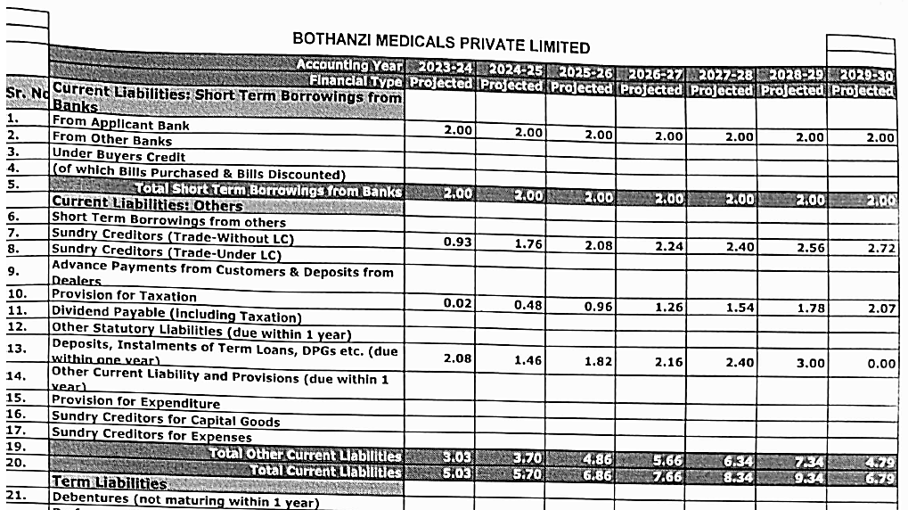
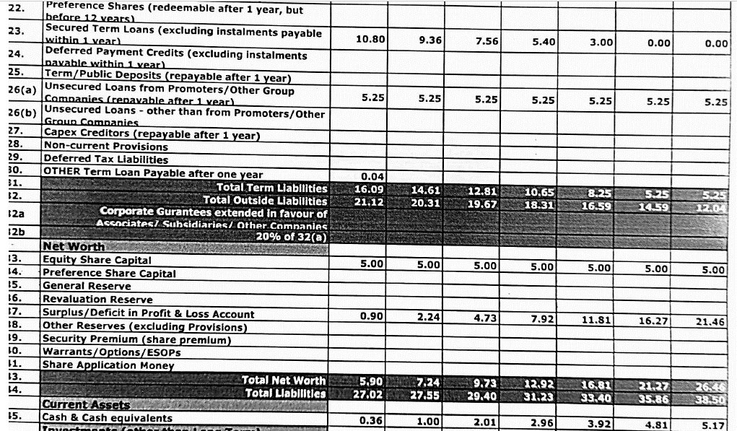
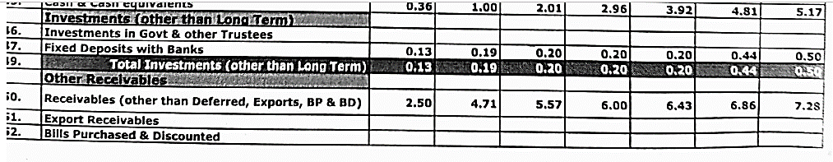
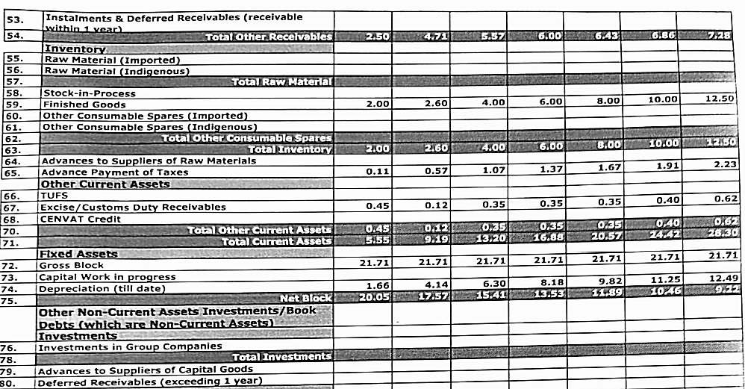
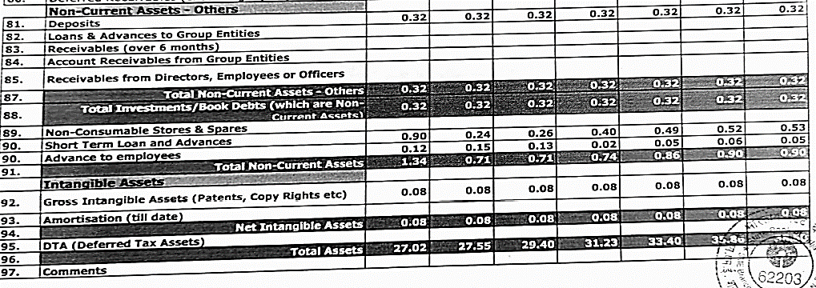

ANNEXURE-I (GROUPWIDE PROJECTED OPERATING STATEMENT)
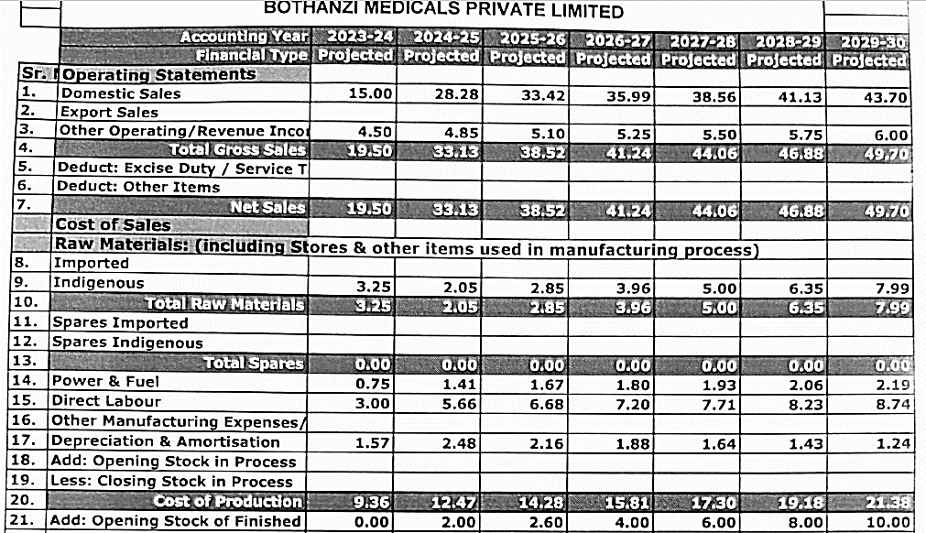
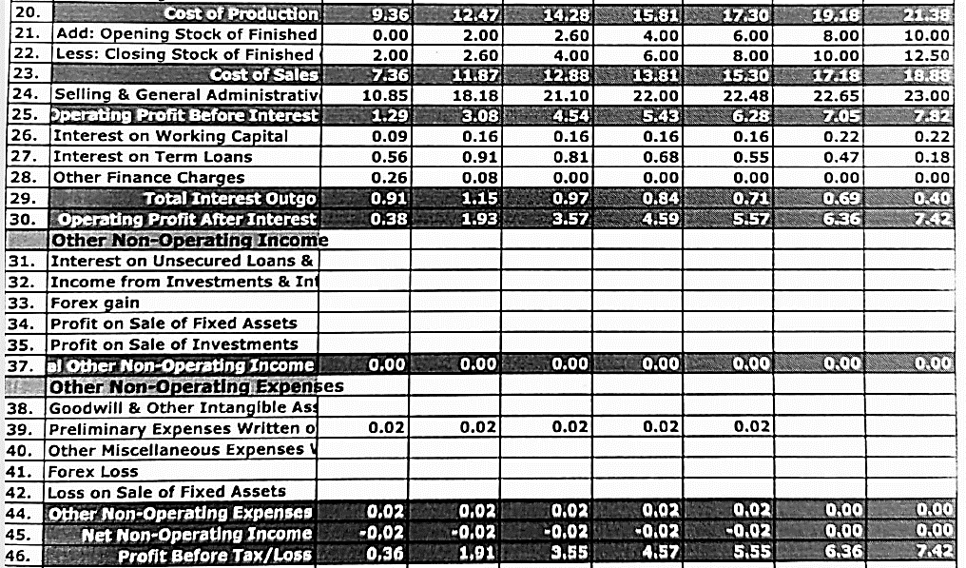
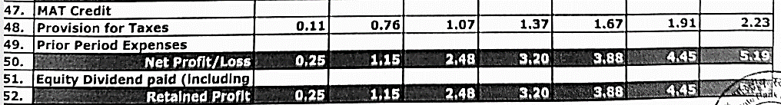

Note:
- We have not vetted and worked on the group wide data/financials/projections of the company as per scope of work.
- The above financial of the group is attached only for ready reference purpose.
- These projection of the group has been provided by the client/company/bank.

