File No.: VIS(2022-23)-PL632-523-868 Dated: 02/02/2023

CONSTRUCTION COST ESTIMATION

OF

GROUP HOUSING SOCIETY
“EDEN SENIOR LIVING & WELLNESS”

SITUATED AT
KHATA KAHTAUNI NO. 00025 (FASLI 1416 TO 1421), KHASRA NO. 39 & 40, MAUZA CHAK BHAGWANTPUR, PARGANA PACHWADOON, TEHSIL SADAR, DEHRADUN, UTTARAKHAND

PROMOTER/S
M/S. EDEN RETIREMENT LIVING PVT. LTD.
(FORMERLY KNOWN AS ALPINE CONSTRUCTION PVT. LTD. THROUGH ITS DIRECTORS MR. SANJIV VOHRA, MR. DEEPAK GUPTA & MR. SAMIR GUPTA)

REPORT PREPARED FOR
PUNJAB NATIONAL BANK, CLPC BRANCH, DEHRADUN

**Important - In case of any query/ issue or escalation you may please contact Incident Manager
at le@rkassociates.org. We will appreciate your feedback in order to improve our services.

NOTE: As per IBA Guidelines please provide your feedback on the report within 15 days of its submission after which report will be considered to be correct.

IMPORTANT NOTICE

COPYRIGHT FORMAT: This report is prepared on the copyright format of R.K Associates, to serve our clients with the best available information and analysis to facilitate them to take rational business decisions. Legally no one can copy or distribute this format without prior approval from R.K Associates. It is meant only for the advisory/ reference purpose for the organization/s as mentioned on the cover page of this report. Distribution or use of this format by any organization or individual other than R.K Associates will be seen as unlawful act and necessary legal action can be taken against the defaulters.

This report is intended for the sole use of the intended recipient/s and contain material that is STRICTLY CONFIDENTIAL AND PRIVATE.

DEFECT LIABILITY PERIOD: - In case of any query/ issue or escalation you may please contact Incident Manager: @ le@rkassociates.org. We try our level best to ensure correctness in the calculations done, rates adopted and various other data points & information mentioned in the report but still can’t rule out typing, human errors or any other mistakes. In case you find any such mistake or inaccuracy in any data point of the report please help us by bringing all such points into our notice immediately or within 15 days of the report delivery in writing, to rectify these timely failing after which R.K Associates won’t be held responsible for any such inaccuracy in any manner. We would highly appreciate your feedback in order to improve our services.

PART A | REPORT SUMMARY

S.NO. | PARTICULARS | DESCRIPTION
 | Name of the Project | Group Housing Society “Eden Senior Living & Wellness”
 | Project Location | Khata Kahtauni No. 00025 (Fasli 1416 To 1421), Khasra No. 39 & 40, Mauza Chak Bhagwantpur, Pargana Pachwadoon, Tehsil Sadar, Dehradun, Uttarakhand
 | Name of the Promotors | M/S. Eden Retirement Living Pvt. Ltd.  (Formerly Known As M/S. Alpine Construction Pvt. Ltd.)
 | Address and Phone Number | M/s. Eden Retirement Living Pvt. Ltd. D-29, 3rd Floor, Defence Colony, New Delhi
 | Prepared for Bank | Punjab National Bank, MCC Branch, Dehradun
 | Consultant Firm | M/s. R.K. Associates Valuers & Techno Engineering Consultants (P) Ltd.
 | Work Order Details | Via email dated 24-01-2023
 | Date of Survey | 24th January 2023
 | Date of Report | 03rd February 2023
 | Purpose of the Report | Evaluate construction cost incurred.
 | Scope of the work provided by the Lender | Only to comment on the following below points based on the scope of work:  - Estimation of construction cost as per current status of work  NOTE: This report doesn’t contains any other kind of recommendation or suggestions other than the above mentioned point.

PART B | INTRODUCTION

- THE PROJECT: Eden Retirement Living Pvt. Ltd. has proposed to develop Group Housing Society named ‘Eden Senior Living & Wellness’ comprising of high rise apartments having total 2 towers. Company is developing both the towers together with each tower having Basement + Stilt Floor + 10 Floors on total 1.05 acres (4,280 sq. mtr.) of land at Khata Kahtauni No. 00025 (Fasli 1416 To 1421), Khasra No. 39 & 40, Mauza Chak Bhagwantpur, Pargana Pachwadoon, Tehsil Sadar, Dehradun, Uttarakhand. The society is distributed with different types of units, viz. 2 BHK Type-I, 2 BHK Type-II, 1 BHK & Studio.

- ABOUT THE DEVELOPER COMPANY: Eden Retirement Living Pvt. Ltd., a company incorporated under the name of M/s. Alpine Construction Pvt. Ltd. in the year 1987 and then changed the name to Eden Retirement Living Pvt. Ltd. w.e.f. 2nd March, 2017, with its Directors/ Shareholders Mr. Sanjiv Vohra, Mr. Deepak Gupta & Mr. Samir Gupta.
Eden Retirement Living Pvt. Ltd. is a Delhi based company. From public domain we couldn’t gather much information about this company and its experience in real estate. However, from the information available to us, it appears that the company is mainly operated by seasoned professionals Shareholders Mr. Sanjiv Vohra, Mr. Deepak Gupta & Mr. Samir Gupta having wide Industry experience in different sectors. Out of all the Directors, Mr. Sanjiv Vohra appears to be having experience in real estate and have been engaged in the development of many real estate Projects in Dehradun like:
- Doon Trafalgar with 132 apartments in Dhorankhas, Near IT Park, Dehradun
- Princess Park 44 units along GMS Road, Opp. St. Jude School, Dehradun
- Doon Trafalgar Extn. With 72 units in Dhorankhas, Near IT Park, Dehradun
As per the Project brochure and the company’s websaite, Mr. Deepak Gupta is a qualified Chartered Accountant having over 35 years of global experience in management consulting, banking, executive search with working experience in the companies like Korn/Ferry International’s India office, DHR International’s India office & Citibank at senior positions. He began his career in management consulting with KPMG and then with PwC in Healthcare Consulting from 1983 to 1989 in USA.
Mr. Samir Gupta holds a postgraduate degree in Management and a Bachelor of Engineering degree in Electronics. He is having 27 years of business experience. As per his profile it appears that he is basically from Electronics & IT field is a Co-founder and Director of Samtech Infonet Ltd., Pyramid Cyber Security & Digital Forensic Pvt. Ltd., Olpoints InfoTech Pvt. Ltd. and Force Infosystems Pvt. Ltd.

- PROJECT OVERVIEW: Eden Retirement Living is developing a Group Housing Project named ‘Eden Senior Living and Wellness’ accommodating apartment space having approx. saleable area measuring 1,40,000 sq. ft. spread over a land area measuring 4,280 sq. mtr. at Khata Kahtauni No. 00025 (Fasli 1416 To 1421), Khasra No. 39 & 40, Mauza Chak Bhagwantpur, Pargana Pachwadoon, Tehsil Sadar, Dehradun, Uttarakhand. However as on date the latest status of saleable area is that it has increased from 1,40,000 sq. ft. to 1,57,579 sq. ft.
As per the MDDA approved building Plan, this Project envisage to construct total 96 units in 2 towers in different categories viz., 2 BHK, 1 BHK and Studio apartment. As per the information provided by developer, the builder has upgraded the units of flats in which 11 apartments has been added. However, the built-up area of the project is same the saleable area has increased.

The specification of the project is revised and the developer is now providing the facilities like AC (Centralised in the lobby and Split/ Window in the units), Kitchen Appliances (Refrigerator, Over and other item), Washing Machines.

Total proposed project cost was estimated to be Rs.54.74 crore. However, as per latest CA certificate provided by the company it has now been revised to Rs.88.52 crores.

For the construction purpose, Eden Retirement Living Pvt. Ltd. has signed a Construction Agreement with M/s. Shraddha Nirman Pvt. Ltd. on 17th December, 2019, to construct proposed Group Housing Society having 2,27,000 sq. ft. of estimated construction area.

For the purpose of the development of the Project, Eden Retirement Living has engaged a main Architect M/s. VYOM Architects & Interior Designer for the Design and Structural Services. Eden Retirement Living Pvt. Ltd. has engaged M/s. Shraddha Nirman Pvt. Ltd. to construct proposed Group Housing Society having built-up area of 2,27,000 sq. ft. as per below mentioned Terms & Conditions:

Estimated Area of Construction | 2,27,000 sq. ft (Basement + Stilt + 10 Floors) excluding elevation features & swimming pool which will be measured and priced separately.
Contract Value | Rs.690 per sq. ft + GST
Type of contract | With material, labour, all the labour, material, tools and Equipment except Steel which will be provided by the Project owner.
Mobilization Advance | ---
Performance Security | 2% of payment of entire contract
Time of completion | 18 months from the date of signing the agreement and structure in 15 months from the date of this agreement.
Other conditions | Payment shall be made as per payment schedule attached herewith and only 75% Payment will be made on submission of the bill by the contractor against their running bill and balance of 23% of the balance payment within 10 days of submission after deducting statutory dues and adjustment of mobilization advance. 2% of payment of entire contract will be kept as performance guarantee & will be released after satisfactory completion of the contract and settlement of final bill.  Fixed price contract with no escalation clause.

- PHYSICAL CONSTRUCTION STATUS: As per the observations made during the site visit, tabulated below is the status of physical construction:
S. No. | Different Parameters | Weightage | Tower-1 | Tower-2
1 | Cutting, Filling and Levelling | 1% | 100% | 100%
3 | Footings | 6% | 100% | 100%
4 | Slab Casting | 25% | 100% | 100%
5 | Common Staircase, lift and lobby etc. | 2% | 100% | 100%
7 | Brickwork | 6% | 100% | 92%
9 | Plaster | 5% | 92% | 50%
10 | Flooring | 10% | 58% | 42%
11 | MEP Services | 20% | 92% | 83%
12 | Door/ Window | 10% | 0% | 0%
13 | Finishing | 15% | 0% | 0%
Completion status (in %) |  | 100% | 69% | 63%
Average Completion Status (in %) |  |  | 66%

Observations and Remarks
Tower – 1
- Slab Work completed of basement + stilt + 10th floor
- Blockwork/brickwork completed from 1st to 10th floor.
- MEP Services: Completed till 1st to 9th Floor
- Plastering: it is completed externally and internally it is completed till 5th Floor
- Electrical works: 1st to 10th Wall conducting done.
Electrical wiring 1st to 8th floor completed.
- Flooring: 1st to 5th floor completed
- Railings: In Apartments it is completed in all the floors and on staircase it is yet to start.
- Door/ window: It is yet to start.
- Finishing works: It is yet to start.

Tower – 2
- Slab Work completed of basement + stilt + 10th floor
- Blockwork/brickwork completed from 1st to 9th floor.
- MEP Services: Completed till 1st to 7th Floor and partially on 8th floor
- Plastering: Externally it is yet to start and Internally it is completed till 7th Floor
- Electrical works: 1st to 10th Wall conducting done.
Electrical wiring 1st to 6th floor completed.
- Flooring: In corridors it is completed from 1st to 3th floor and in other area it is yet to start.
- Railings: In Apartments it is completed till 4th floor and on staircase it is yet to start.
- Door/ window: It is yet to start.
- Finishing works: It is yet to start.
Therefore, as per the observations made during the site visit, it is assumed that the physical progress of the two towers is approx. 66% complete.

- COST INCURRED IN THE CONSTRUCTION OF BUILDING: As per the CA Certificate dated 13-12-2022, the company has incurred an amount of Rs. 3,160.14 Lakhs in the construction of the building. Tabulated below is the cost break-up as per the provided CA Certificate:

(Amount in Rs. Lakhs)
Particulars | Original Project Cost | Present position as on 13-12-2022 | Revised Cost of Project | Escalation in Cost of Project
Land | 834.36 | 834.36 | 834.36 | -
Construction of Building | 4,458.50 | 3,438.50 | 7,432.73 | 2,974.23
Pre-Operative and Preliminary expenses & other Misc. | 181.18 | 324.50 | 585.12 | 403.94
Total | 5,474.04 | 4,597.36 | 8,852.21 | 3,378.17
Source: CA Certificate dated 13-12-22

Detailed Break-up of the cost incurred as per CA certificate/ company has been tabulated below:
(Amount in Rs. Lakhs)
S. No. | Particulars | Revised Cost  of Project | Present position  as on 13-12-2022
1 | Cost of Land & Land Development | 834.36 | 834.36
2 | Cost of construction | 6,370.17 | 3,160.14
3 | Legal Consultation & Other Charges | 39.75 | 15.98
4 | Cost of Approvals | 290.00 | 290.00
5 | Marketing Expenses & Others | 349.51 | 59.88
6 | Pre-Operative and preliminary expenses | 621.78 | 34.50
7 | Bank Interest | 346.64 | 202.51
Total |  | 8,852.21 | 4,597.36
Source: Company

- OBSERVATIONS, REMARKS AND CONCLUSION BY RKA
- It is assumed that the average basic construction cost of such type of towers is approx. Rs. 2,000/- per sq. ft. along with finishing.
- As per our assessment approx. 66% of the construction out of the total 2.27 Lakhs sq. ft. of built-up area has been completed.
- This assessment is only limited to the construction done at site and not to the advances paid and material lying on the site.
- The estimated cost by us doesn’t include any raw material lying on the site.
- Therefore, the estimated cost incurred for the construction of these towers as per the present status of work has been tabulated below:

S. No. | Particulars | Figure | UOM
1 | Built-up area | 2.27 | Lakh sq. ft.
2 | Construction Rate adopted | 2,000 | Rs. Per sq. ft.
3 | % Completion (as estimated by us) | ~66 | %
4 | Estimated Cost incurred as per RKA | ~2,987.00 | Rs. Lakhs
5 | Actual cost incurred as per CA certificate | 3,160.14 | Rs. Lakhs
*Difference between cost incurred estimated by us and as mentioned in the CA Certificate is ~5% which is fine as per the industrial trend.

As shown in the above table, the estimated rate at which the cost of construction is assessed by us is ~Rs. 1,316/- per sq. ft. against the total cost shown in the CA Certificate i.e. Rs.1,392/- per sq. ft. which seems to be fair and reasonable as per the observations made during the site visit.

PART C | DISCLAIMER

      - No employee or member of R.K Associates has any direct/ indirect interest in the Project.

      - This report is prepared based on the copies of the documents/ information which the Bank/ Company has provided to us out of the standard checklist of documents sought from them and further based on our assumptions and limiting conditions. All such information provided to us has been relied upon in good faith and we have assumed that it is true and correct in all respect. Verification or cross checking of the documents provided to us has not been done at our end from the originals. If at any time in future, it is found or came to our knowledge that misrepresentation of facts or incomplete or distorted information has been provided to us then this report shall automatically become null & void.

      - This report is a general analysis of the project based on the scope mentioned in the report. This is not an Audit report, Design document, DPR or Techno-financial feasibility study. All the information gathered is based on the facts seen on the site during survey, verbal discussion & documentary evidence provided by the client and is believed that information given by the company is true best of their knowledge.

      - All observations mentioned in the report is only based on the visual observation and the documents/ data/ information provided by the client. No mechanical/ technical tests, measurements or any design review have been performed or carried out from our side during Project assessment.

      - Bank/FII should ONLY take this report as an Advisory document from the Financial/ Chartered Engineering firm and it’s specifically advised to the creditor to cross verify the original documents for the facts mentioned in the report which can be availed from the borrowing company directly.

      - In case of any default in loans or the credit facility extended to the borrowing company, R.K Associates shall not be held responsible for whatsoever reason may be and any request for seeking any explanation from the employee/s of R.K Associates will not be entertained at any instance or situation.

      - This is just an opinion report and doesn’t hold any binding on anyone. It is requested from the concerned Financial Institution which is using this report for taking financial decision on the project that they should consider all the different associated relevant & related factors also before taking any business decision based on the content of this report.
      - All Pages of the report including annexures are signed and stamped from our office. In case any paper in the report is without stamp & signature then this should not be considered a valid paper issued from this office.

      - Though adequate care has been taken while preparing this report as per its scope, but still we can’t rule out typing, human errors, over sightedness of any information or any other mistakes. Therefore, the concerned organization is advised to satisfy themselves that the report is complete & satisfactory in all respect. Intimation regarding any discrepancy shall be brought into our notice immediately. If no intimation is received within 15 (Fifteen) days in writing from the date of issuance of the report, to rectify these timely, then it shall be considered that the report is complete in all respect and has been accepted by the client upto their satisfaction & use and further to which R.K Associates shall not be held responsible in any manner.

      - Defect Liability Period is 15 DAYS. We request the concerned authorized reader of this report to check the contents, data and calculations in the report within this period and intimate us in writing if any corrections are required or in case of any other concern with the contents or opinion mentioned in the report. Corrections only related to typographical, calculation, spelling mistakes, incorrect data/ figures/ statement will be entertained within the defect liability period. Any new changes for any additional information in already approved report will be regarded as additional work for which additional fees may be charged. No request for any illegitimate change in regard to any facts & figures will be entertained.

      - R.K Associates encourages its customers to give feedback or inform concerns over its services through proper channel at le@rkassociates.org in writing within 30 days of report delivery. After this period no concern/ complaint/ proceedings in connection with the Lender’s Independent Engineering Services will be entertained due to possible change in situation and condition of the subject Project.

      - Our Data retention policy is of ONE YEAR. After this period, we remove all the concerned records related to the assignment from our repository. No clarification or query can be answered after this period due to unavailability of the data.

      - This Lender’s Independent Engineering report is governed by our (1) Internal Policies, Processes & Standard Operating Procedures, (2) Information/ Data/ Inputs given to us by the client and (3) Information/ Data/ Facts given to us by our field/ office technical team. Management of R.K Associates never gives acceptance to any unethical or unprofessional practice which may affect fair, correct & impartial assessment and which is against any prevailing law. In case of any indication of any negligence, default, incorrect, misleading, misrepresentation or distortion of facts in the report then it is the responsibility of the user of this report to immediately or at least within the defect liability period bring all such act into notice of R.K Associates management so that corrective measures can be taken instantly.

      - R.K Associates never releases any report doing alterations or modifications from pen. In case any information/ figure of this report is found altered with pen then this report will automatically become null & void.
PREPARED BY | REVIEWED BY
Adil Afaque  (Sr. Engineer Valuation) | VP Valuation
Date: 02nd February 2023 | Date: 03rd February 2023

DEFECT LIABILITY PERIOD - In case of any query/ issue or escalation you may please contact Incident Manager by writing at valuers@rkassociates.org. We ensure 100% accuracy in the Calculations done, Rates adopted and various other data points & information mentioned in the report but still can’t rule out typing, human errors or any other mistakes. In case you find any mistake, variation, discrepancy or inaccuracy in any data point of the report, please help us by bringing all such points into our notice in writing at valuers@rkassociates.org within 30 days of the report delivery, to get these rectified timely, failing which R.K Associates Valuers Techno Engineering Consultants (P) Ltd. won’t be held responsible for any inaccuracy in any manner. Also, if we will not hear back anything from you within 30 days, we will assume that report is correct in all respect and no further claim of any sort will be entertained thereafter. We would welcome and appreciate your feedback & suggestions in order to improve our services.

COPYRIGHT FORMAT - This report is prepared on the copyright format of R.K Associates Valuers Techno Engineering Consultants (P) Ltd. to serve our clients in the best possible way. Legally no one can copy or distribute this format without prior approval from R.K Associates. It is meant only for the organization as mentioned on the cover page of this report. Distribution or use of this format other than R.K Associates will be seen as unlawful act and necessary legal action can be taken against the defaulter

PART D | PHOTOGRAPHS

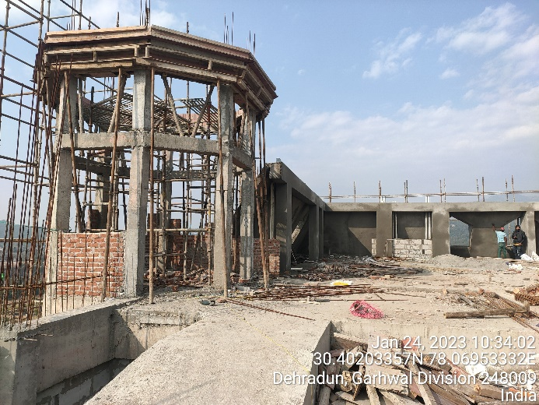 | 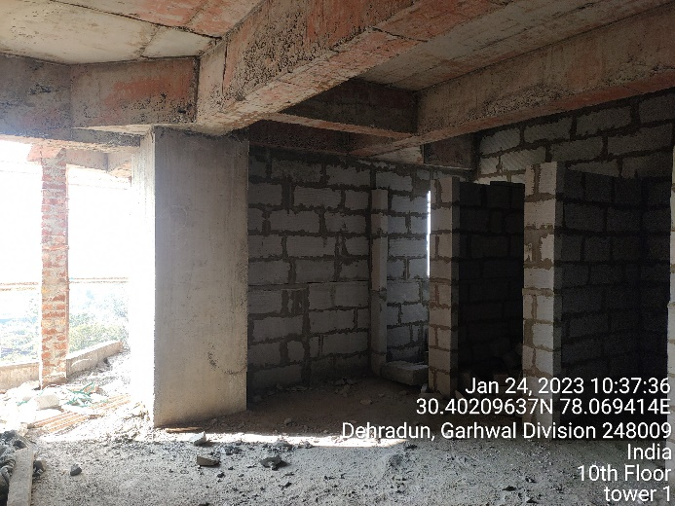
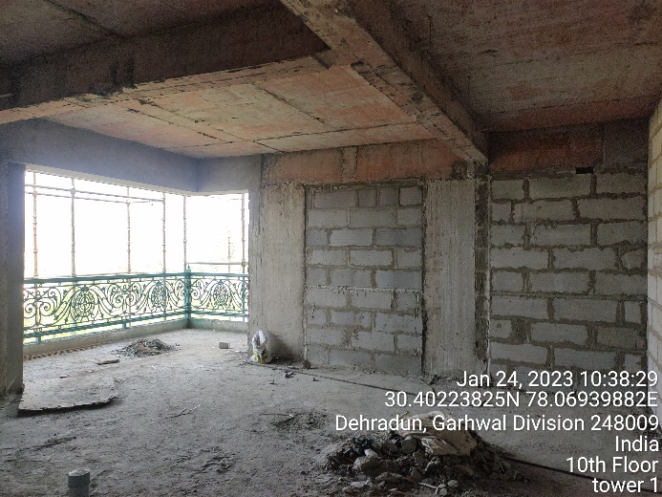 | 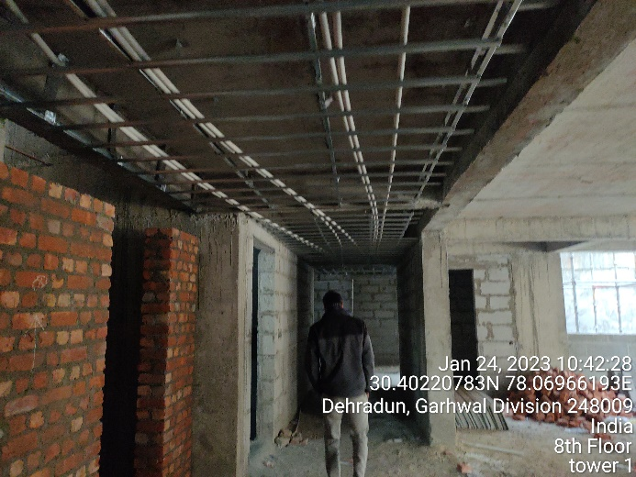
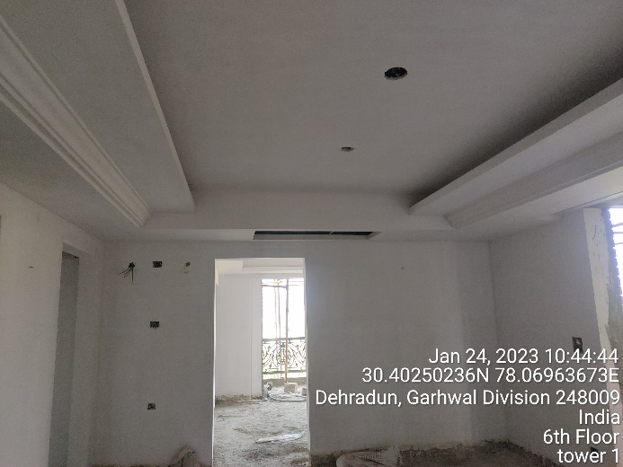 | 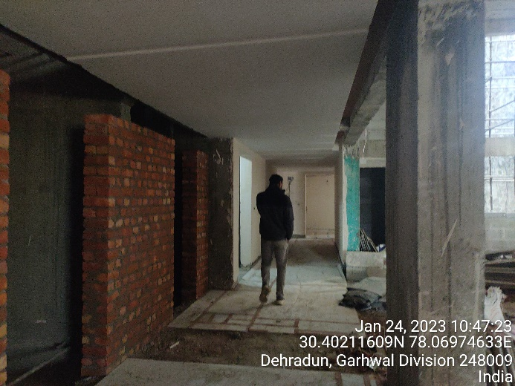

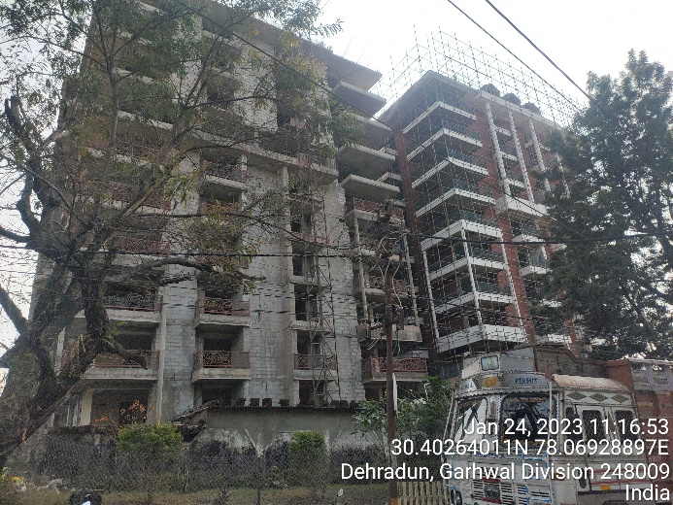 | 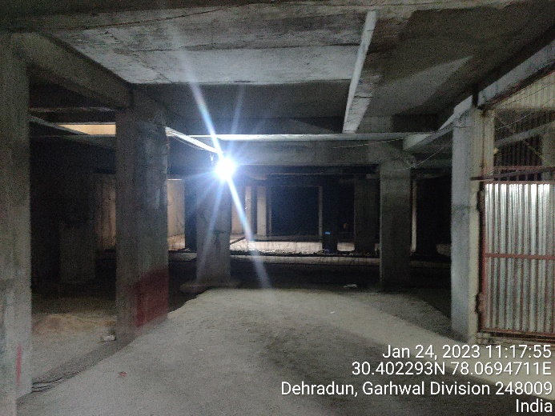
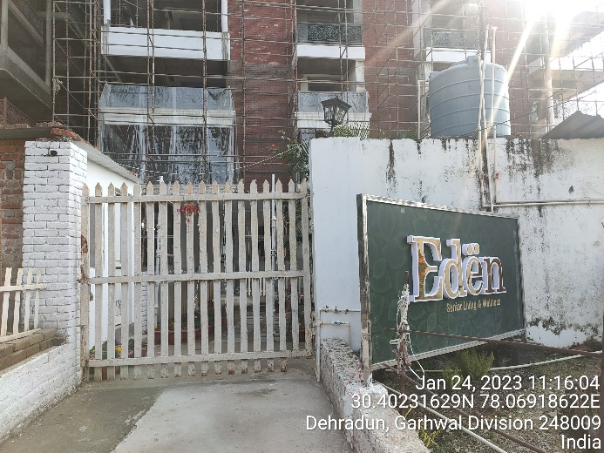 | 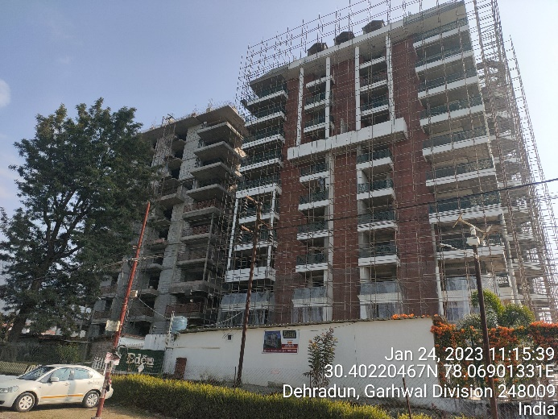
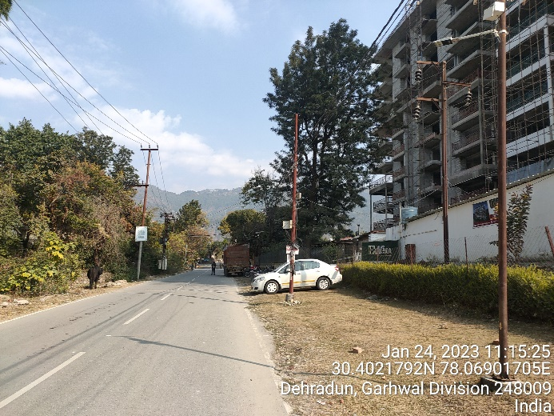 | 