REPORT FORMAT: CL-1 | Version: 1.0_2018

FILE No.: VIS(2022-23)-PL643-535-901 Date: 09-02-2023

- CERTIFICATE NAME: Cost Vetting Certificate for a printing machine which is proposed to be installed at the address mentioned below..
- PREPARED FOR ORGANIZATION: Punjab National Bank, Mid Corporate Centre, P-Block Connaught Place. New Delhi
- BORROWER COMPANY’S NAME: M/s. Azure Press Private Limited
- ASSET TYPE: Printing Machine
Komori Lithrone Sheet-Fed Offset Printing Machine 640 Plus Coater.
Komori-Matic Dampening.
Extended Delivery
POC Console
SAPC
Preloader
Pieery IR Dryer.
Plate Cocking.
Dampening Chillers
- CURRENT LOCATION OF THE MACHINES: Proposed to be installed at Plot No. 74, Sector-16, HSIIDC, Bahadurgarh, Haryana-124507

TO WHOMSOEVER IT MAY CONCERN

S. NO. | PARTICULARS | DESCRIPTION
1. | Date of Survey | Not Applicable
2. | Date of Certificate | 09-02-2023
3. | Documents provided for perusal | Purchase Order
7. | Type of Assessment | Cost vetting
8. | Scope of Assessment | Cost Vetting of a new machinery which has to be/ already purchased by the company
10. | Year of Manufacturing | The machinery is yet to arrive at the location.
11. | Total Purchase Cost | Rs.1.90 Cr. (excluding GST)  (Total project Cost including supply and installation as per the copy of proforma invoice provided by the bank).
12. | Current Estimated Market Value | The range of current market rate of such type of machinery & equipments is verified from various suppliers and also from the public domain for the new machinery and equipment.  As per quotes received from market we are of the view that rate range for installing similar kind of machinery should be around Rs. 2.00 Cr. (excluding GST)  In our view, the rate mentioned in the copy of proforma invoice for the subject machine provided to us by the company/ bank are quite reasonable when compared to the rates of similar machines currently prevailing in the market.
13. | Condition of Machines | Yet to arrive at the subject location

OBSERVATIONS:
- The bank has provided us a copy of proforma invoice of the subject machinery which is to be installed at the afore-mentioned location.
- As per the information provided by the bank, the subject printing machine is yet to be delivered at the subject location.
- We have contacted several suppliers for similar item and also enquired in the public domain. Accordingly we have got the quotation from the suppliers and we find that the price given in the proforma invoice provided to us is well within the price range of similar items available in the market and seems to be reasonable.
- Based on the information provided by the bank and enquiries made by us in the open market and references found in the public domain for similar machine/ item, it is certified that total market cost for installing a printing machine of similar specification should be around Rs. 2.00 Cr. and therefore the total purchase price of Rs.1.90 Cr. (excluding GST) (as per the proforma invoice provided to us by the bank) appears to be reasonable.
Disclaimer:
  - We can’t comment about the current status of machines whether these are purchased, installed or in transit. This cost vetting is done only on the basis of proforma invoice provided to us by the bank and we don’t recommend any sort of recommendation in our Certificate.
  - The estimated cost verification of the item can’t exactly match as per our vetting due to several market consideration. The average price of the market comparables falls in the range as confirmed by us.
  - There can be variation in the estimated price if the specification & make of any items procured is different from the list provided to us during assessment.
  - The estimated cost verification is made based on the third party information which has been replied upon in good faith.
  - The estimated price may vary at the time of actual procurement because of change in prices in the market for such kind of machinery/items for which we will not have any control. The cost vetting is only limited to the date of Certificate issued. We do not assume any responsibility in change of prices of the said machinery/items after this date.
  - This certificate doesn’t include any work related to drawing, design, sketch plan, procurement of the machines.
  - Ownership and other legal point of view in respect of the asset is not considered in this report as same is out of scope of this certificate.
  - This certificate is made at the request of the Bank.

For R.K Associates Valuers & Techno  Engineering Consultants (P) Ltd. | FOR INTERNAL USE  TYPED BY: Adil Afaque  REVIEWED BY: Abhinav Chaturvedi

ANNEXURE: - I PROFORMA INVOICE

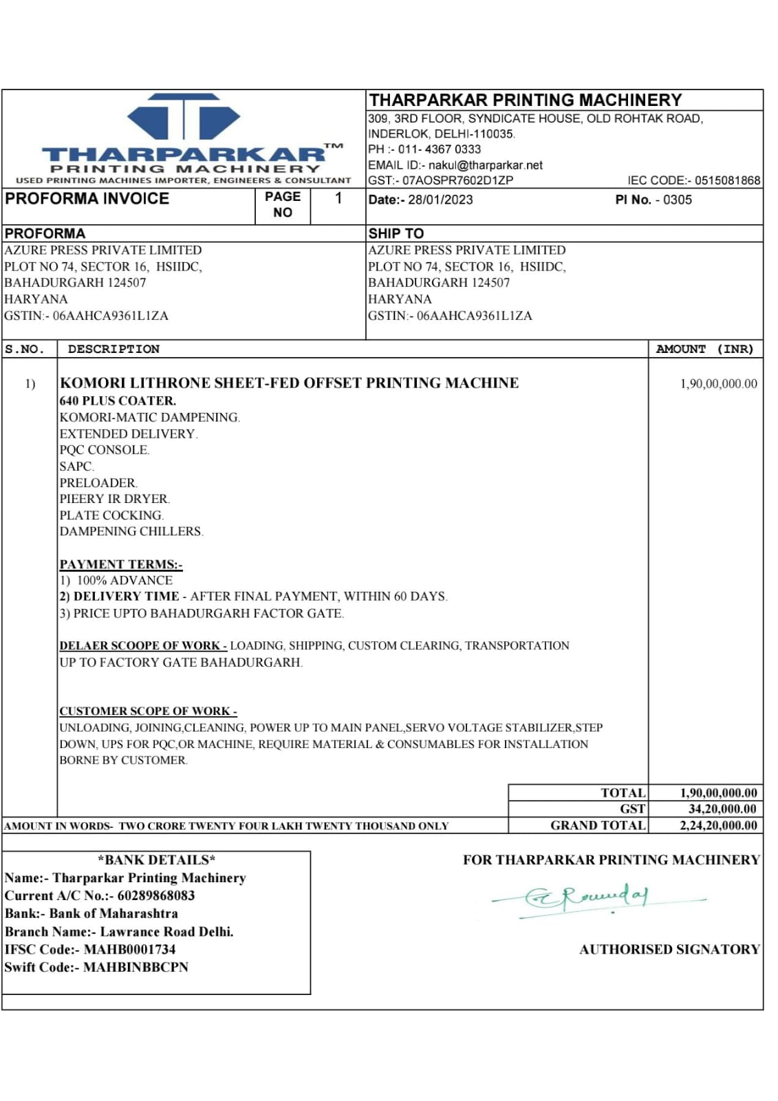

ANNEXURE: - II QUOTATION FROM MARKET
M/s. R. Manubhai and Sons
Make: Year 2000  Asking Price: ~Rs. 2.0 Cr.  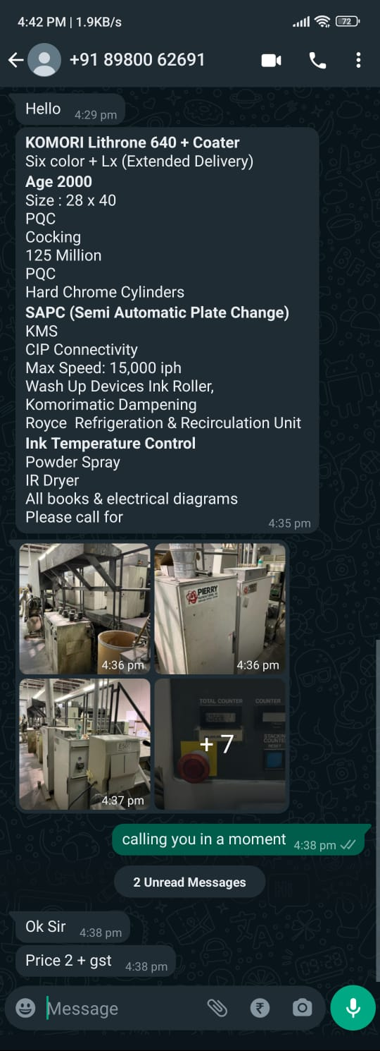 | Make: Year 2001  Asking Price: ~Rs. 2.1 Cr.  