**File No.: VIS(2022-23)-PL644-536-902 Dated: 14/02/2023**

**LENDER’S INDEPENDENT ENGINEERING REPORT**

**OF**

**~2 MWp ROOFTOP SOLAR POWER PLANT**

**TO BE SET-UP AT**

**2 LOCATIONS IN BENGALURU AND 1 IN PUDUCHERRY**

**SELLAR: JYOTIKIRAN ENERGY MUMBAI PRIVATE LIMITED**

**BUYER: STRIDES PHARMA SCIENCE LIMITED**

**TO BE SUBMITTED AT**

**STATE BANK OF INDIA, SME BRANCH, SOUTH EXTENSION, DELHI**

***\*\*Important - In case of any query/ issue or escalation you may please contact Incident Manager***

***at le@rkassociates.org. We will appreciate your feedback in order to improve our services.***

***NOTE: As per IBA Guidelines please provide your feedback on the report within 15 days of its submission after which report will be considered to be correct.***

**IMPORTANT NOTICE**

***COPYRIGHT FORMAT:*** *This report is prepared on the copyright format of R.K Associates to serve our clients with the best possible information and analysis to facilitate them to take rational business decisions. Legally no one can copy or distribute this format without prior approval from R.K Associates. It is meant only for the advisory/ reference purpose for the organization/s as mentioned on the cover page of this report. Distribution or use of this format by any organization or individual other than R.K Associates will be seen as an unlawful act and necessary legal action can be taken against the defaulters.*

*This report is intended for the sole use of the intended recipient/s and contains material that is STRICTLY CONFIDENTIAL AND PRIVATE.*

***DEFECT LIABILITY PERIOD:*** *- In case of any query/ issue or escalation you may please contact Incident Manager at*[*le@rkassociates.org*](mailto:le@rkassociates.org)*.*

*Though adequate care has been taken while preparing this report as per its scope, but still we can’t rule out typing, human errors, over sightedness of any information or any other mistakes. Therefore, the concerned organization is advised to satisfy themselves that the report is complete & satisfactory in all respect. Intimation regarding any discrepancy shall be brought into our notice immediately. If no intimation is received within 15 (Fifteen) days in writing from the date of issuance of the report, to rectify these timely, then it shall be considered that the report is complete in all respect and has been accepted by the client upto their satisfaction & use and further to which R.K Associates shall not be held responsible in any manner.*

|  |  |  |
| --- | --- | --- |
| **TABLE OF CONTENTS** | | |
|  | | |
| **SECTIONS** | **PARTICULARS** | **PAGE NO.** |
| **Part A** | **REPORT SUMMARY** | 03 |
| **Part B** | **INTRODUCTION** | 04 |
|  | 1. Name of the Project | 04 |
| 1. Project Overview | 04 |
| 1. Scope of the Report | 06 |
| 1. Purpose of the Report | 06 |
| 1. Methodology Adopted | 06 |
| **Part C** | **PROJECT LOCATION AND CAPACITY** | 07 |
| **Part D** | **KEY TECHNICAL PARAMETERS & CONFIGURATION** | 08 |
| **Part E** | **IRRADIATION & ENERGY YEILD ASSESSMENT** | 10 |
| **Part F** | **CURRENT STATUS OF WORK** | 12 |
| **Part G** | **POWER PURCHASE AGREEMENT TERMS** | 14 |
| **Part H** | **PROJECT COST & EXPENDITURE** | 15 |
| **Part I** | **PHOTOGRAPHS** | 17 |
| **Part J** | **DISCLAIMER** | 27 |

|  |  |
| --- | --- |
| **PART A** | **REPORT SUMMARY** |

|  |  |  |  |
| --- | --- | --- | --- |
|  | **Name of the Project** | ~2 MWp Grid Tied Rooftop Solar Power Plant | |
|  | **Project Location** | 1. **KRSG Plant** | |
| Strides Pharma Science Limited, KRS Gardens, Suragajakkanahalli, Indlavadi Cross, Anekal Taluk Bengaluru, Karnataka 562106 | |
| 1. **Chandpura Plant** | |
| Strides Pharma Science Limited, No.19/1, 19/3, Alibommasandra, Muttanalluru Post, Sarjapura Hobli, Anekal Taluk, Bengaluru, Karnataka 560099 | |
| 1. **Puducherry Plant** | |
| Strides Pharma Science Limited, Medical College Road, Periyakalapet, Puducherry 605014 | |
|  | **Seller Company** | M/s Jyotikiran Energy Mumbai Private Limited | |
|  | **Buyer Company** | M/s Strides Pharma Science Limited | |
|  | **Prepared for Organization** | State Bank of India, SME Branch, South Extension, Delhi | |
|  | **LIE Consultant Firm** | M/s. R.K. Associates Valuers & Techno Engineering Consultants (P) Ltd | |
|  | **Date of Survey** | 1. **KRSG Plant** | 06-02-2023 |
| 1. **Chandpura Plant** | 06-02-2023 |
| 1. **Puducherry Plant** | 07-02-2023 |
|  | **Date of Report** | 14-02-2023 | |
|  | **Details & documents provided by** | Mr. Prashant Malhotra  Senior Manager, Project Finance of M/s SunSource Energy Pvt. Ltd. | |
|  | **Survey in presence of** | Mr. Md. Inzamam | |
|  | **Report Type** | Lender’sIndependent Engineering Report | |
|  | **Purpose of the Report** | Review, evaluate & comment on project implementation & present status details to facilitate bankers to take credit decision on the Project. | |
|  | **Scope of the Report** | To review Project cost, expenditure and examine the current status of installation/ Commissioning of the Project. | |
|  | **Documents produced for Perusal** | 1. Copy of Inverter 2. Copy of Module Data Sheets 3. Copy of Plant Layout 4. Copy of SLD 5. Copy of PV Syst reports for all three projects 6. Copy of Power Purchase Agreement (PPA) 7. Addendum to PPA 8. Novation PPA Agreement 9. Copy of EPC Agreement | |
|  | **Annexure with the Report** | Photographs and report by Global Solar Atlas by World Bank Group | |

|  |  |
| --- | --- |
| **PART B** | **INTRODUCTION** |

1. **NAME OF THE PROJECT:** ~2 MWp rooftop solar power plant to be installed and commissioned at 3 locations which are described in Part A.2 above by M/s Jyotikiran Energy Mumbai Private Limited (JEMPL); an SPV of SunSource Energy Private Limited.
2. **PROJECT OVERVIEW:** SunSource Energy Private Limited (SSEPL) is a company incorporated under the provisions of companies Act 2013, dated 18/01/2010. SunSource Energy Private Limited is a solar project development and turnkey execution company, founded by Mr. Adarsh Das and Mr. Kushagra Nandan in 2010.

As per the National Energy Policy which commits the Government to promote electricity generation from renewable energy resources and had set the target of 175 GW to be generated from renewable energy by 2022. However, as per the news article by The Hindu dated 23rd September 2022, India has so far installed 66% of its targeted renewable energy installation of 175 GW with only Gujarat, Rajasthan, Karnataka and Telangana meeting State-wise targets, according to a report by Global Energy Think-tank Ember.

As per an article by the Press Information Bureau, GOI, dated 09th September 2022, the country’s vision is to achieve Net Zero Emissions by 2070, in addition to attaining the short-term targets which include:

* Increasing renewables capacity to 500 GW by 2030,
* Meeting 50% of energy requirements from renewables,

Ministry of New and Renewable Energy (MNRE), Government of India desires to implement Grid Connected Rooftop Solar PV Projects on the vacant roofs of Government Buildings/ Offices as a part of its Renewable Energy Initiatives. To pursue the above target, the MNRE introduced the PPP/RESCO model policy setting tariff rates for solar to be arrived on transparent competitive bidding model through PPP route.

*The RESCO model is one of the methods of implementing rooftop solar installations. Under the RESCO model, a renewable energy service company ("****RESCO****"), (i.e., an energy service company that provides energy to consumers from renewable energy sources), develops, installs, finances, operates and owns the rooftop solar power project ("****Project****"), and supplies power generated from the Project to the consumer on whose premises the Project is set up ("****Customer****") or to the grid through net-metering.*

*'Build, Own, Operate and Transfer' (BOOT) is a special kind of RESCO model in which the RESCO constructs, owns, operates, and transfers the ownership of the Project to the Customer after the expiry of a predefined period. The RESCO and the Customer enter into a long-term power purchase agreement ("****PPA****") for an agreed tenure, which sets out, among others, the terms at which the power generated from the Project will be sold to the Customer and the tariff at which the power will be sold. Excess power from the Project (if any) could be sold by the Customer to the distribution utility through net metering system – the net metering regulations differ from state to state.*

*Under the PPA, the RESCO owns the Project and is responsible for its installation as well as its operation and maintenance of the Project throughout the tenure of the Project, and at the end of the PPA term, the ownership of the Project is transferred to the Customer. Thereafter, the Customer may either choose to retain the RESCO for operation and maintenance services or engage a third-party operator.*

*If the entity on whose premises the Project is located does not intend to buy the power generated from the Project and does not entered into a PPA with the RESCO, that entity can either lease the rooftop premises to the RESCO by means of a lease agreement or enter into a license agreement granting the RESCO the right to use the premises for the limited purpose of setting up and operating the Project. The RESCO then operates the Project and exports the energy generated to the local distribution utility at a predetermined feed-intariff (FiT) approved by the State Electricity Regulator under relevant schemes issued by the relevant state.*

As per the discussion with the management of the company and documents shared, initially there were 4 sites where the project was to be installed, however, Site-4: Vivimed Alathur has been eliminated from the subject project because of the company’s internal reasons and its capacity has been adjusted among the other 3 sites which is within limits of the clauses applicable as per the PPA/ addendum to PPA.

The scope of the work for the subject seller includes construction, operation and maintenance of the plant at the sites and supply the entire electricity (as defined in PPA) generated from the plant to the buyer on the terms and conditions contained in the PPA.

1. **SCOPE OF THE REPORT:** To verify the Project cost, expenditures and examine the commissioning, installation status of Solar Power Plants set-up/ being set-up by M/s. Jyotikiran Energy Mumbai Pvt. Ltd.

* *Industry/ sector research and demand & supply trend is out of scope of the report.*
* *Financial feasibility study of the Project is out of scope of the report.*
* *Providing any kind of design report or map is out-of-scope of the report.*
* *Scrutiny of contracts, Agreements and arrangement between the parties from legal perspective is out-of-scope of this report.*
* *Energy yield calculation is out-of-scope of this report.*
* *Location feasibility is ascertained based on the PVSyst Report provided by the client.*

*All the assessment carried out for the Project is done based on the documents and information provided to us and its correlation by the Engineering team through physical and virtual site inspection and various other discussions with the Project proponents and thus forming an opinion out of it.*

*Component wise verification is not carried out but Project installation & commissioning has been verified as a whole.*

*Any kind of technical & economic feasibility of the Project is out-of-scope of this Report. This report is only limited & related to the verification and examination of what has already been setup.*

1. **PURPOSE OF THE REPORT:**  To provide fair detailed analysis report to the Bank based on the “in-scope points” mentioned above for facilitating them to take appropriate business decision on the Project.
2. **METHADOLOGY ADOPTED:**
3. To gather relevant data/ information/ documents related to Project planning, execution, current status.
4. Study of copy of Project Planning documents/ Agreements to know the scope of work of the company.
5. To procure, study and analysis of any additional information, data, documents required/ provided by the company.
6. Physical site inspection for ascertaining the status of work and shadow analysis.
7. Research about the Project/ sector from the sources in the public domain.
8. Correlation of the provided information against Industry/ sector benchmarks/ trend.
9. Information compilation, analysis and reporting.

|  |  |
| --- | --- |
| **PART C** | **PROJECT LOCATION AND CAPACITY** |

As per the e-mail dated 23-01-2023 and copy of documents provided, details of 3 plants has been tabulated below:

|  |  |  |  |  |  |
| --- | --- | --- | --- | --- | --- |
| **S. No.** | **Name of the Plant** | **Capacity as per PPA in** **KWp**  **(+/- 10%)** | **Actual Capacity**  **(in KWp)**  **(+/- 10%)** | **Address** | **Status**  **(as per company)** |
| 1 | KRSG Plant | 881.6 | 995 | Strides Pharma Science Limited, KRS Gardens, Suragajakkanahalli, Indlavadi Cross, Anekal Taluk Bengaluru, Karnataka 562106 | Project almost implemented; expected to be completed in Feb-2023 |
| 2 | Chandpura Plant | 313.6 | 320 | Strides Pharma Science Limited, No.19/1, 19/3, Alibommasandra, Muttanalluru Post, Sarjapura Hobli, Anekal Taluk, Bengaluru, Karnataka 560099 | Project Implemented |
| 3 | Puducherry Plant | 710.4 | 659 | Strides Pharma Science Limited, Medical College Road, Periyakalapet, Puducherry 605014 | Under Progress |
| **Total** | | **1,905.60** | **1,975** |  |  |

***Source:*** *Via e-mail from company dated 23-01-2023*

|  |  |
| --- | --- |
| **PART D** | **KEY TECHNICAL PARAMETERS & CONFIGURATION** |

Key Technical Parameters & Configuration of the projects like Modules, Inverter, tilt angle, capacity, etc. are tabulated below:

1. **KRSG Plant:**

|  |  |  |  |  |  |  |
| --- | --- | --- | --- | --- | --- | --- |
| **Array** | **Roof Name** | **No. of**  **Modules** | **kWp** | **Array**  **Azimuth** | **Tilt** | **Size of Inverter** |
| 1 | Industrial Shed | 160 | 51.20 | -172o | 8o | 25 kW - 1 No.  110 kW – 1 No. |
| 2 | 440 | 140.80 | 8o | 8o |
| 3 | Packing Shed &  RCC | 800 | 256.00 | -172o | 8o | 110 kW – 3 No.  20 kW – 1 No. |
| 4 | 680 | 218.00 | 8o | 8o |
| 5 | 100 | 32.00 | 8o | 15o |
| 6 | Industrial Shed  & RCC | 72 | 23.04 | 8o | 15o | 80 kW – 1 No. |
| 7 | 67 | 21.44 | -172o | 15o |
| 8 | 70 | 22.40 | 8o | 15o |
| 9 | 140 | 44.80 | 82o | 5o | 40 kW – 1 No. |
| 10 | 234 | 74.88 | 8o | 15o | 80 kW – 1 No. |
| 11 | 86 | 27.52 | 8o/ -82o | 15o |
| 12 | 80 | 25.60 | -82o | 15o |
| 13 | Canteen (Shed) | 100 | 32.00 | 8o | 12o | 50 kW – 1 No. |
| 14 | 80 | 25.60 | -172o | 12o |
| **Total** | | **3,109** | **995.28** |  | | |

1. **Chandpura Plant:**

|  |  |  |  |  |  |  |
| --- | --- | --- | --- | --- | --- | --- |
| **Array** | **Roof Name** | **No. of**  **Modules** | **kWp** | **Array**  **Azimuth** | **Tilt** | **Size of Inverter** |
| 1 | Industrial Shed | 500 | 160 | -162o | 5o | 110 kW – 2 No. |
| 2 | 500 | 160 | 18o | 5o |
| **Total** | | **1,000** | **320** |  | | |

1. **Puducherry Plant:**

| **Array** | **Roof Name** | **No. of**  **Modules** | **kWp** | **Array**  **Azimuth** | **Tilt** | **Size of Inverter** |
| --- | --- | --- | --- | --- | --- | --- |
| 1 | Shed Scrap Yard | 315 | 100.80 | 13o | 2o | 80 kW - 1 No. |
| 2 | Shed Unit 3 | 54 | 17.28 | -167o | 8o | 30 kW - 1 No. |
| 3 | 34 | 10.88 | -167o | 17o |
| 4 | 28 | 8.96 | 13o | 17o |
| 5 | Industrial Shed | 19 | 6.08 | -167o | 8o | 110 kW - 3 No.  50 kW - 1 No. |
| 6 | Industrial Shed | 51 | 16.32 | 13o | 8o |
| 7 | RCC | 60 | 19.20 | 13o | 15o |
| 8 | RCC | 60 | 19.20 | 13o | 15o |
| 9 | Industrial Shed | 133 | 42.56 | -167o | 8o |
| 10 | Industrial Shed | 340 | 108.80 | -77o | 5o |
| 11 | Industrial Shed | 860 | 275.20 | 103o | 5o |
| 12 | Industrial Shed | 72 | 23.04 | 13o | 8o |
| 13 | Industrial Shed | 36 | 11.52 | -167o | 8o |
| **Total** | | **2,062** | **659.84** |  | | |

**Technical details as per EPC Contract**

|  |  |  |  |
| --- | --- | --- | --- |
| **S. No.** | **ITEM** | **TECHNICAL SPECIFICATION** | **Make** |
| 1 | Solar Modules | Tier 1 , Poly Crystalline - 330 Wp | Reputed Make |
| 2 | Inverter | Central Inverter – for ground mount | Delta |
| 3 | String Inverter – for rooftop | Growatt |
| 4 | Structure | Fabricated structure for rooftop/ ground mount | Reputed Make |
| 5 | DC Cables | cu/At, EBXL XLPO 1200 Insulated & Sheathed, 1.8kV DC Solar, Class 5 Red/Black | Reputed Make |
| 6 | AC Cables | Cu/Al, HLPE Insulated & Unarmoured/ Armoured PVC Sheathed 1.1kV Power Cable. | Reputed Make |
| 7 | Earthing Cables | PVC Insulated & Un sheathed Cable 1.1kV,Class 5 -Green. | Reputed Make |
| 8 | Power Transformer | Step up Transformer, 0.400/ 11kV | Reputed Make |
| 9 | HT Panel | 630A, 11kV, 50Hz, VCB Panel | Reputed Make |
| 10 | AC Combiner Box | 415V, 50HZ, IP-65 rated (Al Busbar), with foundation | Reputed Make |
| 11 | AC Combiner cum Disconnect Box | 415V, 50/60Hz, IP-54 Rated with PV meter | Reputed Make |
| 12 | Data Logger | Data Logger | Reputed Make |
| 13 | Weather sensors | Pyranometer + Ambient Temp. Sensor + Module temp. Sensor | Reputed Make |
| 14 | Lightning Arrester | Ion Streamer – Radius Protection | Reputed Make |
| 15 | Earthing Kit | Earthing Kit - CU bonded UL listed (Chemical Earthine with Clamps) with Accessories | Reputed Make |
| 16 | Conduit | As per requirement | Standard |
| 17 | Cable Tray | As per requirement With accessories | Standard |
| 18 | BOS | As per requirement | Standard |

***Note:*** *The supplier's scope of supply within the contract price shall not be limited to items listed above but shall include all works & services required to complete and commission the project on turnkey basis as per Best Industry Practice*.

|  |  |
| --- | --- |
| **PART E** | **IRRADIATION & ENERGY YIELD ASSESSMENT** |

Company has used PVSyst V7.2.21 to assess energy yield calculation which is the standard Industry practice. The yearly average of main results of irradiation and energy yield from the provided PVSyst is as under:

|  |  |  |  |  |  |  |  |  |  |
| --- | --- | --- | --- | --- | --- | --- | --- | --- | --- |
| **S. No.** | **Plant Location** | **Global Hor**  **(kWh/m2)** | **Diff Hor**  **(kWh/m2)** | **T_Amb**  **(oC)** | **Glob Inc**  **(kWh/m2)** | **Glob Eff**  **(kWh/m2)** | **E Array**  **(MWh)** | **E_Grid**  **(MWh)** | **PR (Ratio)** |
| 1 | KRSG Plant | 1,967.4 | 898.19 | 22.54 | 1,968.8 | 1,832.2 | 1,496.1 | 1,446.2 | 0.738 |
| 2 | Chandpura Plant | 1,979.8 | 905.49 | 22.75 | 1,976.6 | 1,844.2 | 484.37 | 470.24 | 0.743 |
| 3 | Puducherry Plant | 2,009.4 | 923.60 | 28.23 | 2,004.9 | 1,869.9 | 987.1 | 951.86 | 0.720 |

As per the PVSyst reports of each plant, the last year’s month wise production and performance ratio chart has been depicted below:

| **Normalized Production**  **(per installed kWp)** | **Performance Ratio PR** |
| --- | --- |
| 1. **KRSG Plant** |  |
| 1. **Chandpura Plant** |  |
| 1. **Puducherry Plant** |  |

**Notes:**

1. As per World Energy Council 2007, the worldwide annual average global horizontal irradiance (GHI) is 170 watts per square meter (W/m2). However, many regions receive much more. Most of Southeast Asia receives an annual average GHI of 180–230 W/m2 (equivalent to 1,600–2,000 kilowatt-hours per square meter per year [kWh/m2 /year]. This is adequate for a solar PV system, considering that Germany, the global leader in solar PV installed capacity (REN21 2013), receives just over 1,300 kWh/m2 /year even in the area with highest irradiation (the south of the country).
2. As per Global Solar Atlas by World Bank Group, the location wise Annual Averages- Direct Normal Irradiation are:
3. KRSG Plant: 1,455.8 kWh/m2
4. Chandpura Plant: 1,461.0 kWh/m2
5. Puducherry Plant: 1443.1 kWh/m2

|  |  |
| --- | --- |
| **PART F** | **CURRENT STATUS OF WORK** |

As per the observations made during the site visit, status of various arrays installed/ to be installed has been tabulated below:

1. **KRSG Plant:**

|  |  |  |  |  |  |
| --- | --- | --- | --- | --- | --- |
| **Array** | **Roof Name** | **No. of**  **Modules** | **kWp** | **Remarks**  **(as per RKA)** | **Operational Status** |
| 1 | Industrial Shed | 160 | 51.20 | All modules, inverters, data logger, walkway, etc. have been installed and are in operation. However, the access to the roof was not granted as a permit and a harness is required for safety purpose. | Operational |
| 2 | 440 | 140.80 |
| 3 | Packing Shed &  RCC | 800 | 256.00 | All modules, inverters, data logger, walkway, etc. have been installed and are in operation. | Operational |
| 4 | 680 | 218.00 |
| 5 | 100 | 32.00 | The structure installation is in process, Modules are kept packed and will be installed once the mounts are installed. | Not Operational |
| 6 | Industrial Shed  & RCC | 72 | 23.04 | Only baseplates and structures are shifted and yet to be installed. | Not Operational |
| 7 | 67 | 21.44 | All modules, inverters, data logger, walkway, etc. have been installed and are in operation. | Operational |
| 8 | 70 | 22.40 |
| 9 | 140 | 44.80 |
| 10 | 234 | 74.88 | The structures and modules have been shifted on the roof and are yet to be installed | Not Operational |
| 11 | 86 | 27.52 |
| 12 | 80 | 25.60 |
| 13 | Canteen (Shed) | 100 | 32.00 | All modules, inverters, data logger, walkway, etc. have been installed and are in operation. | Operational |
| 14 | 80 | 25.60 |
| **Total** | | **3,109** | **995.28** |  |  |

Note:

1. As per the information received during the site visit, the plant installation work started in June 2022
2. Out of the total 3,109 no. of modules, 572 no. (~183 kW) are yet to be installed.
3. The plant installation is expected to be completed by the end of March 2023.
4. Photographs of the site are annexed with the report.
5. **Chandpura Plant:**

|  |  |  |  |  |
| --- | --- | --- | --- | --- |
| **Array** | **Roof Name** | **No. of**  **Modules** | **kWp** | **Operational**  **Status** |
| 1 | Industrial Shed | 500 | 160 | Operational |
| 2 | 500 | 160 |
| **Total** | | **1,000** | **320** |  |

Note:

1. The installation work started in June 2022, completed in July 2022 and is operational since then.
2. During the site visit, the subject plant could not be accessed as there was a honeycomb/ beehive was present on the staircase. We asked the buyer’s representative to give access to the plant but it was denied and the same is informed to the company as well. However, the plant is fully operational as observed through the inverters.
3. **Puducherry Plant:**

| **Array** | **Roof Name** | **No. of**  **Modules** | **kWp** | **Operational**  **Status** |
| --- | --- | --- | --- | --- |
| 1 | Shed Scrap Yard | 315 | 100.80 | Not Operational |
| 2 | Shed Unit 3 | 54 | 17.28 |
| 3 | 34 | 10.88 |
| 4 | 28 | 8.96 |
| 5 | Industrial Shed | 19 | 6.08 |
| 6 | Industrial Shed | 51 | 16.32 |
| 7 | RCC | 60 | 19.20 |
| 8 | RCC | 60 | 19.20 |
| 9 | Industrial Shed | 133 | 42.56 |
| 10 | Industrial Shed | 340 | 108.80 |
| 11 | Industrial Shed | 860 | 275.20 |
| 12 | Industrial Shed | 72 | 23.04 |
| 13 | Industrial Shed | 36 | 11.52 |
| **Total** | | **2,062** | **659.84** |  |

**Note:**

1. As per the observations made during the site visit, all the equipments like inverters, modules along with other accessories have been arrived at the site.
2. There are a few compliances from the buyer which are to be fulfilled like retrofitting in the shed (done), Sheet replacement, etc.
3. On Array 2, shadow of a tree is falling, the seller has proposed to either cut the tree or relocate this array on the roof of Power house building. Once it is done, the installation work shall start.
4. The installation work shall start once the roof access is allowed by the buyer fulfilling their compliances.

**Therefore, the entire project shall achieve its COD at the end of March 2023**

|  |  |
| --- | --- |
| **PART G** | **POWER PURCHASE AGREEMENT TERMS** |

As per the PPA, basic/ floor tariff has been agreed @ Rs. 3.75 per unit levelised for 25 years of plant operation / PPA tenure. Initially, the PPA was signed between M/s Suryaurja Four Private Limited (Sellar) and M/s Strides Pharma Science Limited (Buyer). However, later via Novation agreement dated 5th June 2022 made between M/s Suryaurja Four Private Limited (Transferor), M/s Strides Pharma Science Limited (Consumer/ Power User) and M/s Jyotikiran Energy Mumbai Private Limited (Transferee/ Power Producer) the Transferor has transferred all it’s rights, liabilities, duties, and obligations mentioned in the novation agreement and the principal PPA. and the Transferee undertakes to perform all the obligations of the Transferor under the Principal Agreement and to be bound by all the terms and conditions, undertakings, stipulations, representations and warranties thereof in all respects as if the Transferee had been the Party to the Principal Agreement in place of the Transferor with effect from the date of the Principal Agreement.

The scope of the work for the subject seller includes construction, operation and maintenance of the plant at the sites and supply the entire electricity (as defined in PPA) generated from the plant to the buyer on the terms and conditions contained in the PPA for a period of 25 years.

As per information shared by the company’s representative, the company has not opted for any insurance/ incentive policy.

|  |  |
| --- | --- |
| **PART H** | **PROJECT COST & EXPENDITURE** |

The company has shared a copy of EPC agreement dated 6th June 2022 for the installation of the subject plant, details of the same has been tabulated below:

| **S. No.** | **Particulars** | **Details** |
| --- | --- | --- |
|  | Date of the Agreement | 6th June 2022 |
|  | Effective Date | 2nd May 2022 |
|  | Place of execution of the Agreement | Noida Uttar Pradesh |
|  | Name of Offtaker | Strides Pharma Science Limited |
|  | Total Capacity (+/- 10%) | 1.906 MWp |
|  | Site Address | 1. **Site-1** (KRSG)-881.6 kWp (+/-10%) 2. **Site-2** (Chandapura)- 313.6 kWp (+/- 10%) 3. **Site-3** (Puducherry)- 710.4 kWp (+/- 10%) 4. **Site-4** (Vivimed Alathur)-100 kWp (+/- 10%) |
|  | Agreement Price | Rs.8.50 Cr. (incl. GST) |
|  | The Buyer and Address of the Buyer for the purpose of Clause 30.1 | **M/s Jyotikiran Energy Mumbai Private Limited** (CIN: U74900UP2010PTC039281),  **Corporate Office:** B-14, Sector-132, Noida, U.P. – 201301 |
|  | The supplier and Address of the Supplier for the purpose of Clause 30.1 | **M/s SunSource Energy Private Limited** (CIN: UP74900UP2010PTC039281),  **Corporate Office:** B-14, Sector-132, Noida, U.P. – 201301 |

***Note:***

1. *Since, the entire project is being executed through a EPC contract agreement, therefore, the invoices/ bills shall be raised once the entire project gets commissioned.*
2. *The project cost provided to us appears to be in line as per the benchmark cost of Grid Connected Rooftop Solar Photo Voltaic system of Ministry of New & Renewable Energy (MNRE).*

|  |  |  |  |  |  |
| --- | --- | --- | --- | --- | --- |
| **S. No.** | **Particulars** | **Benchmark Cost**  **(In Rs./kW)** | **Project Capacity**  **(In MW)** | **Total Project Cost**  **(Excluding GST)**  **(In Rs.)** | **Total Project Cost**  **(Including 12% GST)**  **(In Rs.)** |
| 1 | As per Ministry of New & Renewable Energy | 39,080 | ~2.0 | 7,81,60,000 | 8,75,39,200 |
| **Or say** | | | **~2.0 MWp** |  | **~Rs.8.75 Cr.** |

**Note:**

1. Project cost is analyzed based on lumpsum cost only and not item wise.
2. Project cost is assessed for the current date only and due to price fluctuations it may vary at the time of actual purchase or installation.
3. The project cost is well within the range of benchmark cost of Grid Connected Rooftop Solar Photo Voltaic system of Ministry of New & Renewable Energy (MNRE).

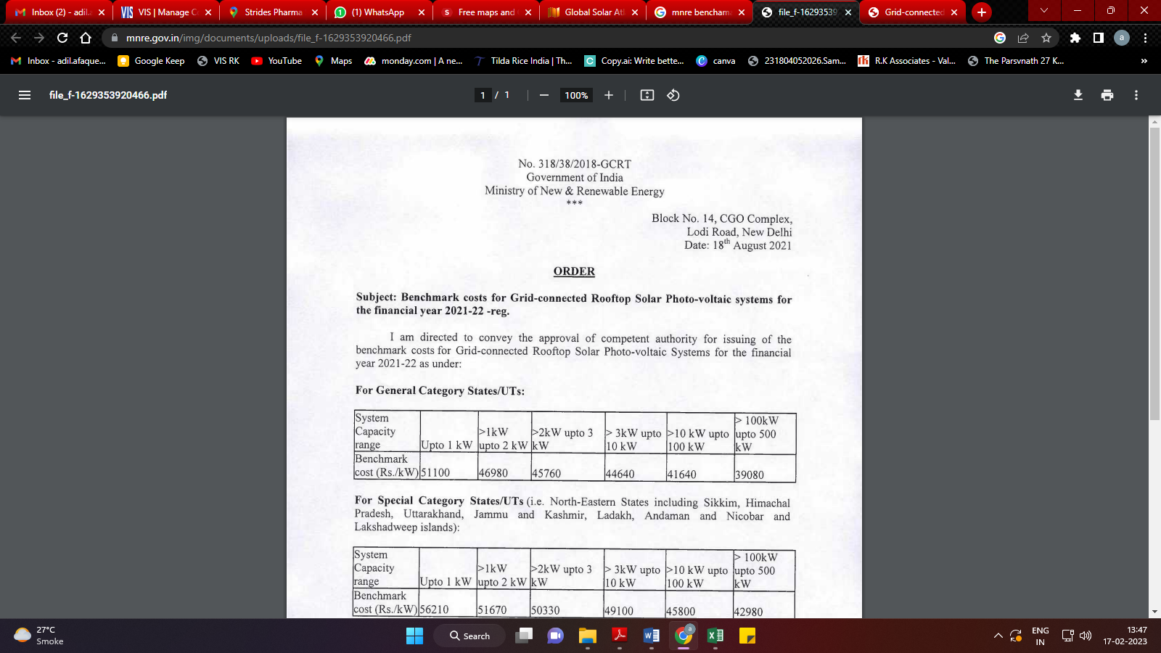

|  |  |
| --- | --- |
| **PART I** | **PHOTOGRAPHS** |

1. **KRSG Plant**

|  |  |
| --- | --- |
| **Z:\In Progress Files\Adil Afaque\uploads\VIS(2022-23)-PL644-536-902-Jyotikiran Energy -Stride Pharma\Site Image\KRSG Plant, Bengaluru-994.88 kWp\1675856340064.jpg** | **Z:\In Progress Files\Adil Afaque\uploads\VIS(2022-23)-PL644-536-902-Jyotikiran Energy -Stride Pharma\Site Image\KRSG Plant, Bengaluru-994.88 kWp\1675856340042.jpg** |
| **Z:\In Progress Files\Adil Afaque\uploads\VIS(2022-23)-PL644-536-902-Jyotikiran Energy -Stride Pharma\Site Image\KRSG Plant, Bengaluru-994.88 kWp\1675856340093.jpg** | **Z:\In Progress Files\Adil Afaque\uploads\VIS(2022-23)-PL644-536-902-Jyotikiran Energy -Stride Pharma\Site Image\KRSG Plant, Bengaluru-994.88 kWp\1675856340308.jpg** |
| **Z:\In Progress Files\Adil Afaque\uploads\VIS(2022-23)-PL644-536-902-Jyotikiran Energy -Stride Pharma\Site Image\KRSG Plant, Bengaluru-994.88 kWp\1675856340225.jpg** | **Z:\In Progress Files\Adil Afaque\uploads\VIS(2022-23)-PL644-536-902-Jyotikiran Energy -Stride Pharma\Site Image\KRSG Plant, Bengaluru-994.88 kWp\1675856340377.jpg** |

|  |  |
| --- | --- |
| **Z:\In Progress Files\Adil Afaque\uploads\VIS(2022-23)-PL644-536-902-Jyotikiran Energy -Stride Pharma\Site Image\KRSG Plant, Bengaluru-994.88 kWp\1675856340403.jpg** | **Z:\In Progress Files\Adil Afaque\uploads\VIS(2022-23)-PL644-536-902-Jyotikiran Energy -Stride Pharma\Site Image\KRSG Plant, Bengaluru-994.88 kWp\1675856340420.jpg** |
| **Z:\In Progress Files\Adil Afaque\uploads\VIS(2022-23)-PL644-536-902-Jyotikiran Energy -Stride Pharma\Site Image\KRSG Plant, Bengaluru-994.88 kWp\1675856340445.jpg** | **Z:\In Progress Files\Adil Afaque\uploads\VIS(2022-23)-PL644-536-902-Jyotikiran Energy -Stride Pharma\Site Image\KRSG Plant, Bengaluru-994.88 kWp\1675856340512.jpg** |
| **Z:\In Progress Files\Adil Afaque\uploads\VIS(2022-23)-PL644-536-902-Jyotikiran Energy -Stride Pharma\Site Image\KRSG Plant, Bengaluru-994.88 kWp\1675856340533.jpg** | **Z:\In Progress Files\Adil Afaque\uploads\VIS(2022-23)-PL644-536-902-Jyotikiran Energy -Stride Pharma\Site Image\KRSG Plant, Bengaluru-994.88 kWp\1675856340019.jpg** |

1. **Chandpura Plant**

|  |  |
| --- | --- |
| **Z:\In Progress Files\Adil Afaque\uploads\VIS(2022-23)-PL644-536-902-Jyotikiran Energy -Stride Pharma\Site Image\Chandpura Plant, Bengaluru-320 kWp\1675856339797.jpg** | **Z:\In Progress Files\Adil Afaque\uploads\VIS(2022-23)-PL644-536-902-Jyotikiran Energy -Stride Pharma\Site Image\Chandpura Plant, Bengaluru-320 kWp\1675856339889.jpg** |
| **Z:\In Progress Files\Adil Afaque\uploads\VIS(2022-23)-PL644-536-902-Jyotikiran Energy -Stride Pharma\Site Image\Chandpura Plant, Bengaluru-320 kWp\1675856339924.jpg** | **Z:\In Progress Files\Adil Afaque\uploads\VIS(2022-23)-PL644-536-902-Jyotikiran Energy -Stride Pharma\Site Image\Chandpura Plant, Bengaluru-320 kWp\1675856339940.jpg** |
| **Z:\In Progress Files\Adil Afaque\uploads\VIS(2022-23)-PL644-536-902-Jyotikiran Energy -Stride Pharma\Site Image\Chandpura Plant, Bengaluru-320 kWp\1675856339947.jpg** | **Z:\In Progress Files\Adil Afaque\uploads\VIS(2022-23)-PL644-536-902-Jyotikiran Energy -Stride Pharma\Site Image\Chandpura Plant, Bengaluru-320 kWp\1675856339766.jpg** |

1. **Puducherry Plant**

|  |  |
| --- | --- |
| **Z:\In Progress Files\Adil Afaque\uploads\VIS(2022-23)-PL644-536-902-Jyotikiran Energy -Stride Pharma\Site Image\Puducherry Plant\1675856339698.jpg** | **Z:\In Progress Files\Adil Afaque\uploads\VIS(2022-23)-PL644-536-902-Jyotikiran Energy -Stride Pharma\Site Image\Puducherry Plant\1675856339754.jpg** |
| **Z:\In Progress Files\Adil Afaque\uploads\VIS(2022-23)-PL644-536-902-Jyotikiran Energy -Stride Pharma\Site Image\Puducherry Plant\1675856339604.jpg** | **Z:\In Progress Files\Adil Afaque\uploads\VIS(2022-23)-PL644-536-902-Jyotikiran Energy -Stride Pharma\Site Image\Puducherry Plant\1675856339624.jpg** |
| **Z:\In Progress Files\Adil Afaque\uploads\VIS(2022-23)-PL644-536-902-Jyotikiran Energy -Stride Pharma\Site Image\Puducherry Plant\1675856339689.jpg** | **Z:\In Progress Files\Adil Afaque\uploads\VIS(2022-23)-PL644-536-902-Jyotikiran Energy -Stride Pharma\Site Image\Puducherry Plant\1675856339562.jpg** |

**Data by Global Solar Atlas by World Bank Group**

1. **KRSG Plant**

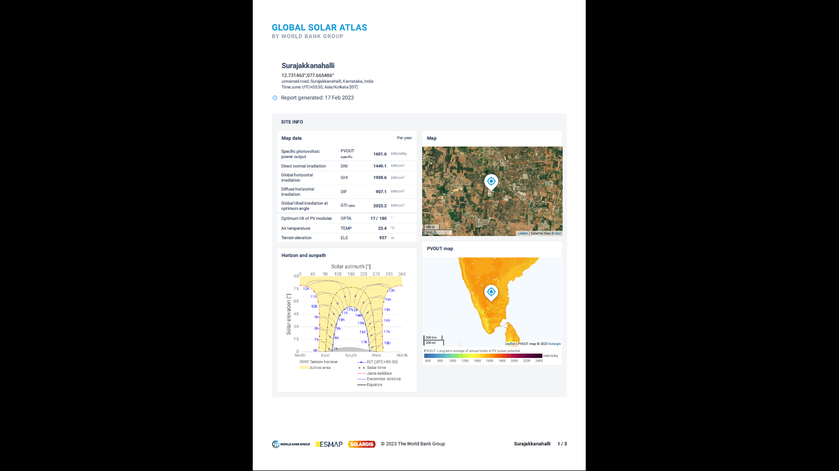

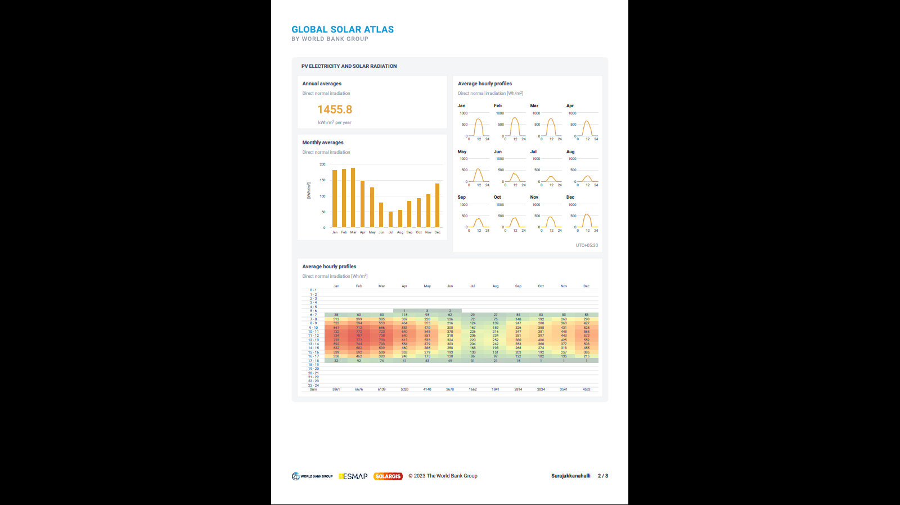

1. **Chandpura Plant**

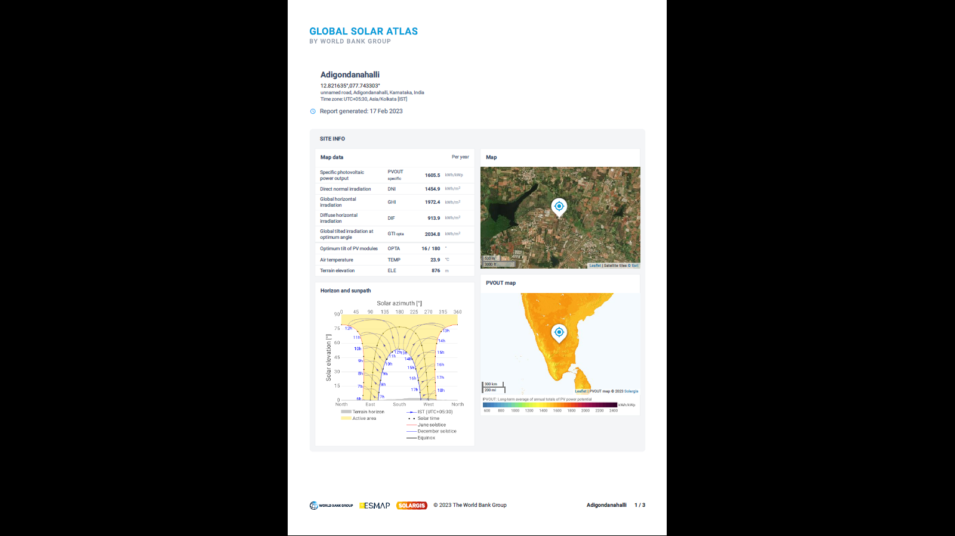

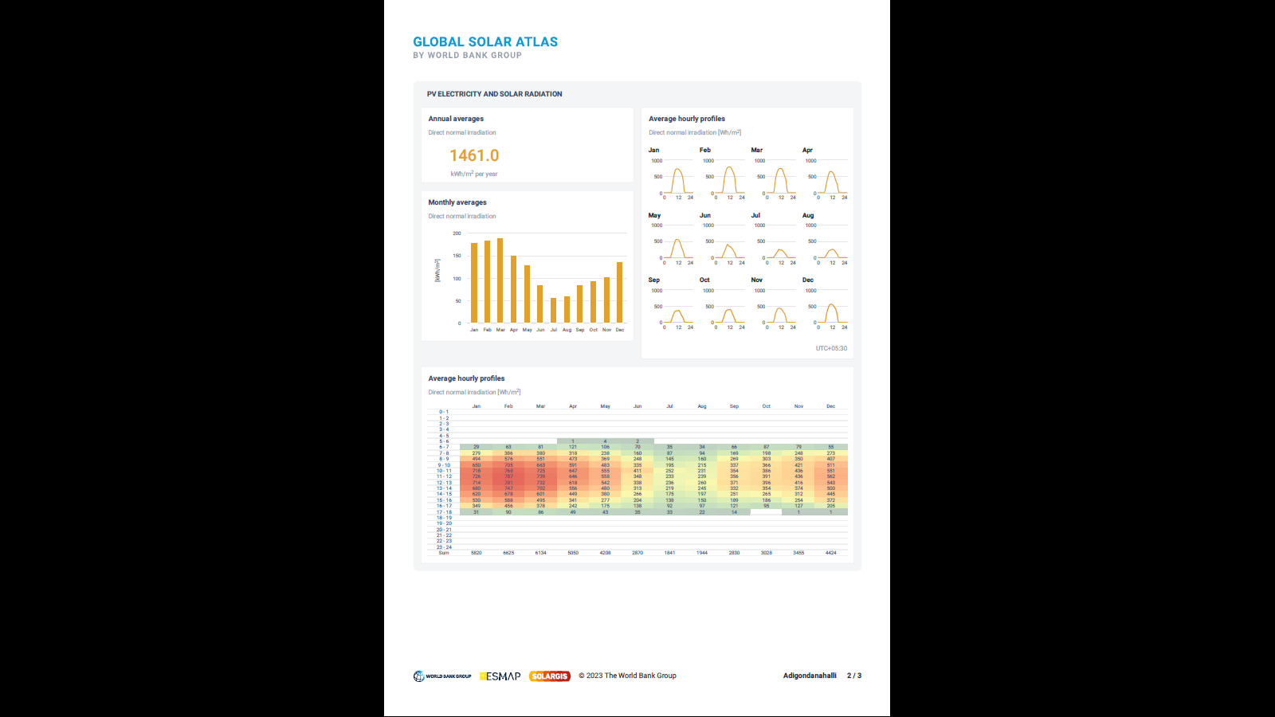

1. **Puducherry Plant**

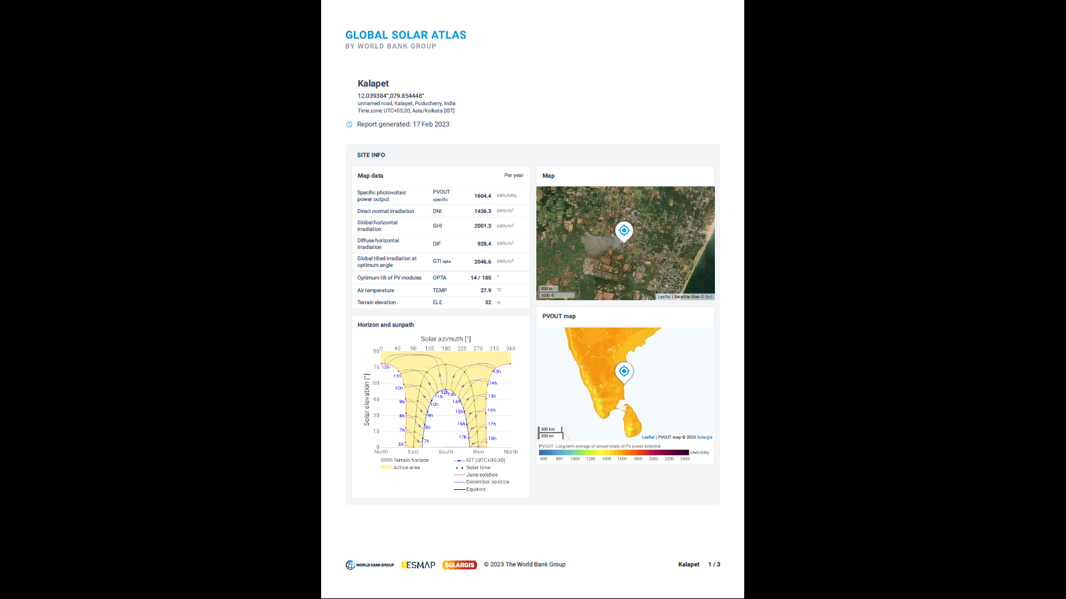

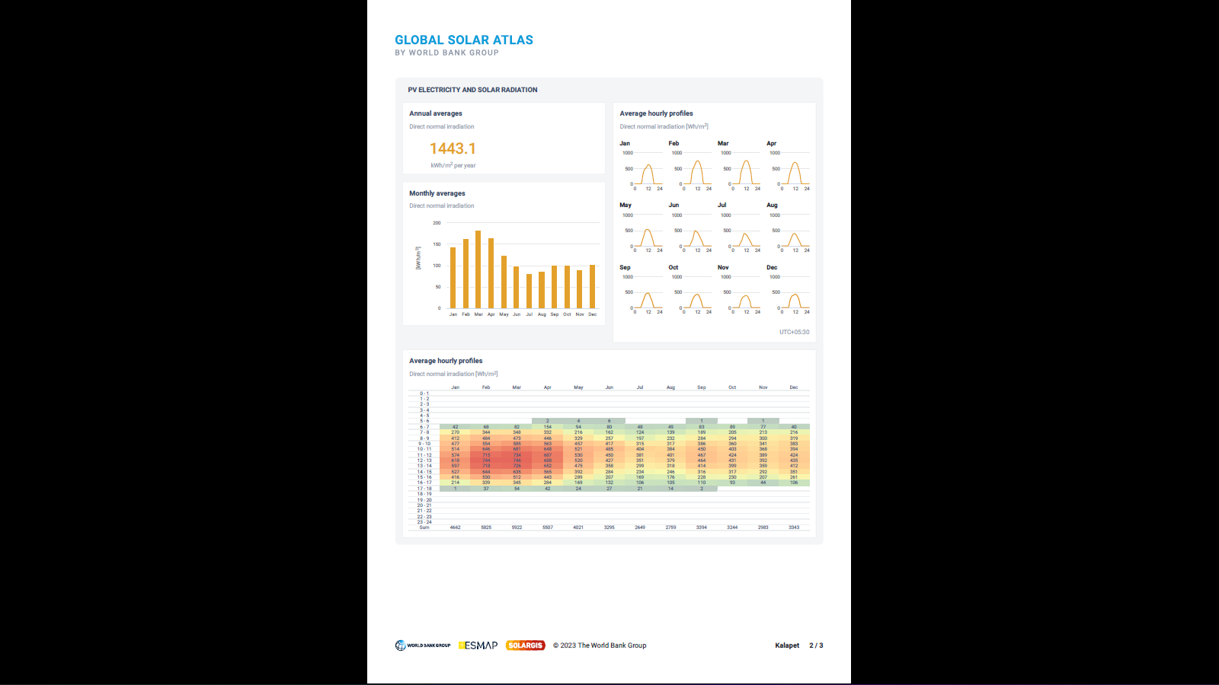

|  |  |
| --- | --- |
| **PART J** | **DISCLAIMER** |

* + - 1. No employee or member of R.K Associates has any direct/ indirect interest in the Project.
      2. This report is prepared based on the copies of the documents/ information which the Bank/ Company has provided to us out of the standard checklist of documents sought from them and further based on our assumptions and limiting conditions. All such information provided to us has been relied upon in good faith and we have assumed that it is true and correct in all respect. Verification or cross checking of the documents provided to us has not been done at our end from the originals. If at any time in future, it is found or came to our knowledge that misrepresentation of facts or incomplete or distorted information has been provided to us then this report shall automatically become null & void.
      3. This report is a general analysis of the project based on the scope mentioned in the report. This is not an Audit report, Design document, DPR or Techno-financial feasibility study. All the information gathered is based on the facts seen on the site during survey, verbal discussion & documentary evidence provided by the client and is believed that information given by the company is true best of their knowledge.
      4. All observations mentioned in the report is only based on the visual observation and the documents/ data/ information provided by the client. No mechanical/ technical tests, measurements or any design review have been performed or carried out from our side during Project assessment.
      5. Bank/FII should ONLY take this report as an Advisory document from the Financial/ Chartered Engineering firm and it’s specifically advised to the creditor to cross verify the original documents for the facts mentioned in the report which can be availed from the borrowing company directly.
      6. In case of any default in loans or the credit facility extended to the borrowing company, R.K Associates shall not be held responsible for whatsoever reason may be and any request for seeking any explanation from the employee/s of R.K Associates will not be entertained at any instance or situation.
      7. This Report is prepared by our competent technical team which includes Engineers and financial experts & analysts.
      8. This is just an opinion report and doesn’t hold any binding on anyone. It is requested from the concerned Financial Institution which is using this report for taking financial decision on the project that they should consider all the different associated relevant & related factors also before taking any business decision based on the content of this report.
      9. All Pages of the report including annexures are signed and stamped from our office. In case any paper in the report is without stamp & signature then this should not be considered a valid paper issued from this office.
      10. Though adequate care has been taken while preparing this report as per its scope, but still we can’t rule out typing, human errors, over sightedness of any information or any other mistakes. Therefore, the concerned organization is advised to satisfy themselves that the report is complete & satisfactory in all respect. Intimation regarding any discrepancy shall be brought into our notice immediately. If no intimation is received within 15 (Fifteen) days in writing from the date of issuance of the report, to rectify these timely, then it shall be considered that the report is complete in all respect and has been accepted by the client upto their satisfaction & use and further to which R.K Associates shall not be held responsible in any manner.
      11. Defect Liability Period is **15 DAYS**. We request the concerned authorized reader of this report to check the contents, data and calculations in the report within this period and intimate us in writing if any corrections are required or in case of any other concern with the contents or opinion mentioned in the report. Corrections only related to typographical, calculation, spelling mistakes, incorrect data/ figures/ statement will be entertained within the defect liability period. Any new changes for any additional information in already approved report will be regarded as additional work for which additional fees may be charged. No request for any illegitimate change in regard to any facts & figures will be entertained.
      12. R.K Associates encourages its customers to give feedback or inform concerns over its services through proper channel at le@rkassociates.org in writing within 30 days of report delivery. After this period no concern/ complaint/ proceedings in connection with the Lender’s Independent Engineering Services will be entertained due to possible change in situation and condition of the subject Project.
      13. Our Data retention policy is of **ONE YEAR**. After this period, we remove all the concerned records related to the assignment from our repository. No clarification or query can be answered after this period due to unavailability of the data.
      14. This Lender’s Independent Engineering report is governed by our (1) Internal Policies, Processes & Standard Operating Procedures, (2) Information/ Data/ Inputs given to us by the client and (3) Information/ Data/ Facts given to us by our field/ office technical team. Management of R.K Associates never gives acceptance to any unethical or unprofessional practice which may affect fair, correct & impartial assessment and which is against any prevailing law. In case of any indication of any negligence, default, incorrect, misleading, misrepresentation or distortion of facts in the report then it is the responsibility of the user of this report to immediately or at least within the defect liability period bring all such act into notice of R.K Associates management so that corrective measures can be taken instantly.
      15. R.K Associates never releases any report doing alterations or modifications from pen. In case any information/ figure of this report is found altered with pen then this report will automatically become null & void.

|  |  |
| --- | --- |
| Place : Noida  Date : 14.02.2023  Note : This report contains 29 pages | **FOR INTERNAL USE**  ***SURVEYED BY: Adil Afaque***  ***PREPARED BY: Adil Afaque***  ***REVIEWED BY: MA Team*** |

**For R.K Associates Valuers** **& Techno Engineering Consultants (P) Ltd.**

1. ***DEFECT LIABILITY PERIOD - In case of any query/ issue or escalation you may please contact Incident Manager by writing at valuers@rkassociates.org. We ensure 100% accuracy in the Calculations done, Rates adopted and various other data points & information mentioned in the report but still can’t rule out typing, human errors or any other mistakes. In case you find any mistake, variation, discrepancy or inaccuracy in any data point of the report, please help us by bringing all such points into our notice in writing at*** [***valuers@rkassociates.org***](mailto:valuers@rkassociates.org)***within 30 days of the report delivery, to get these rectified timely, failing which R.K Associates Valuers Techno Engineering Consultants (P) Ltd. won’t be held responsible for any inaccuracy in any manner. Also if we will not hear back anything from you within 30 days, we will assume that report is correct in all respect and no further claim of any sort will be entertained thereafter. We would welcome and appreciate your feedback & suggestions in order to improve our services.***

***COPYRIGHT FORMAT - This report is prepared on the copyright format of R.K Associates Valuers Techno Engineering Consultants (P) Ltd. to serve our clients in the best possible way. Legally no one can copy or distribute this format without prior approval from R.K Associates. It is meant only for the organization as mentioned on the cover page of this report. Distribution or use of this format other than R.K Associates will be seen as unlawful act and necessary legal action can be taken against the defaulter***