**File No.: VIS(2022-23)-PL644-536-902 Dated: 14/02/2023**

**LENDER’S INDEPENDENT ENGINEERING REPORT**

**OF**

**~2 MWp ROOFTOP SOLAR POWER PLANT**

**TO BE SET-UP AT**

**2 LOCATIONS IN BENGALURU AND 1 IN PUDUCHERRY**

**SELLER: JYOTIKIRAN ENERGY MUMBAI PRIVATE LIMITED**

**BUYER: STRIDES PHARMA SCIENCE LIMITED**

**TO BE SUBMITTED AT**

**STATE BANK OF INDIA, SME BRANCH, SOUTH EXTENSION, DELHI**

***\*\*Important - In case of any query/ issue or escalation you may please contact Incident Manager***

***at le@rkassociates.org. We will appreciate your feedback in order to improve our services.***

***NOTE: As per IBA Guidelines please provide your feedback on the report within 15 days of its submission after which report will be considered to be correct.***

**IMPORTANT NOTICE**

***COPYRIGHT FORMAT:*** *This report is prepared on the copyright format of R.K Associates to serve our clients with the best possible information and analysis to facilitate them to take rational business decisions. Legally no one can copy or distribute this format without prior approval from R.K Associates. It is meant only for the advisory/ reference purpose for the organization/s as mentioned on the cover page of this report. Distribution or use of this format by any organization or individual other than R.K Associates will be seen as an unlawful act and necessary legal action can be taken against the defaulters.*

*This report is intended for the sole use of the intended recipient/s and contains material that is STRICTLY CONFIDENTIAL AND PRIVATE.*

***DEFECT LIABILITY PERIOD:*** *- In case of any query/ issue or escalation you may please contact Incident Manager at*[*le@rkassociates.org*](mailto:le@rkassociates.org)*.*

*Though adequate care has been taken while preparing this report as per its scope, but still we can’t rule out typing, human errors, over sightedness of any information or any other mistakes. Therefore, the concerned organization is advised to satisfy themselves that the report is complete & satisfactory in all respect. Intimation regarding any discrepancy shall be brought into our notice immediately. If no intimation is received within 15 (Fifteen) days in writing from the date of issuance of the report, to rectify these timely, then it shall be considered that the report is complete in all respect and has been accepted by the client upto their satisfaction & use and further to which R.K Associates shall not be held responsible in any manner.*

|  |  |  |
| --- | --- | --- |
| **TABLE OF CONTENTS** | | |
|  | | |
| **SECTIONS** | **PARTICULARS** | **PAGE NO.** |
| **Part A** | **REPORT SUMMARY** | 03 |
| **Part B** | **INTRODUCTION** | 04 |
|  | 1. Name of the Project | 04 |
| 1. Project Overview | 04 |
| 1. Scope of the Report | 06 |
| 1. Purpose of the Report | 06 |
| 1. Methodology Adopted | 06 |
| **Part C** | **PROJECT LOCATION AND CAPACITY** | 07 |
| **Part D** | **KEY TECHNICAL PARAMETERS & CONFIGURATION** | 08 |
| **Part E** | **IRRADIATION & ENERGY YEILD ASSESSMENT** | 10 |
| **Part F** | **CURRENT STATUS OF WORK** | 12 |
| **Part G** | **POWER PURCHASE AGREEMENT TERMS** | 14 |
| **Part H** | **PROJECT COST & EXPENDITURE** | 15 |
| **Part I** | **PHOTOGRAPHS** | 17 |
| **Part J** | **DISCLAIMER** | 27 |

|  |  |
| --- | --- |
| **PART A** | **REPORT SUMMARY** |

|  |  |  |  |
| --- | --- | --- | --- |
|  | **Name of the Project** | ~2 MWp Grid Tied Rooftop Solar Power Plant | |
|  | **Project Location** | 1. **KRSG Plant** | |
| Strides Pharma Science Limited, KRS Gardens, Suragajakkanahalli, Indlavadi Cross, Anekal Taluk Bengaluru, Karnataka 562106 | |
| 1. **Chandpura Plant** | |
| Strides Pharma Science Limited, No.19/1, 19/3, Alibommasandra, Muttanalluru Post, Sarjapura Hobli, Anekal Taluk, Bengaluru, Karnataka 560099 | |
| 1. **Puducherry Plant** | |
| Strides Pharma Science Limited, Medical College Road, Periyakalapet, Puducherry 605014 | |
|  | **Seller Company** | M/s Jyotikiran Energy Mumbai Private Limited | |
|  | **Buyer Company** | M/s Strides Pharma Science Limited | |
|  | **Prepared for Organization** | State Bank of India, SME Branch, South Extension, Delhi | |
|  | **LIE Consultant Firm** | M/s. R.K. Associates Valuers & Techno Engineering Consultants (P) Ltd | |
|  | **Date of Survey** | 1. **KRSG Plant** | 06-02-2023 |
| 1. **Chandpura Plant** | 06-02-2023 |
| 1. **Puducherry Plant** | 07-02-2023 |
|  | **Date of Report** | 14-02-2023 | |
|  | **Details & documents provided by** | Mr. Prashant Malhotra  Senior Manager, Project Finance of M/s SunSource Energy Pvt. Ltd. | |
|  | **Survey in presence of** | Mr. Md. Inzamam (Company’s Employee, +91-74881.69827) | |
|  | **Report Type** | Lender’sIndependent Engineering Report | |
|  | **Purpose of the Report** | Review, evaluate & comment on project implementation & present status details to facilitate bankers to take business decision on the Project. | |
|  | **Scope of the Report** | To review Project cost and examine the current status of installation/ Commissioning of the Project. | |
|  | **Documents produced for Perusal** | 1. Copy of Power Purchase Agreement (PPA) 2. Addendum to PPA 3. Novation PPA Agreement 4. Copy of EPC Agreement 5. Copy of Inverter specifications 6. Copy of Module Data Sheets 7. Copy of Plant Layout 8. Copy of SLD 9. Copy of PV Syst reports for all three projects | |
|  | **Annexure with the Report** | Photographs and report by Global Solar Atlas by World Bank Group | |

|  |  |
| --- | --- |
| **PART B** | **INTRODUCTION** |

1. **NAME OF THE PROJECT:** ~2 MWp rooftop solar power plant to be installed and commissioned at 3 locations which are described in Part A.2 above by M/s Jyotikiran Energy Mumbai Private Limited (JEMPL); an SPV of M/s SunSource Energy Private Limited.
2. **PROJECT OVERVIEW:** M/sStrides Pharma Science Limited is a global pharmaceutical company headquartered in Bangalore, India. It is having plants at Suragajakkanahalli (Bengaluru), Alibommasandra (Bengaluru) and Periyakalapet (Puducherry) intends to implement rooftop solar power plants to meet the respective plants’ internal power requirements.

In this respect, a Power Purchase Agreement (PPA) dated 11th February 2022 is signed between M/s Suryaurja Four Private Limited (hereinafter referred to as “Seller” which is engaged in the business of construction and operation of rooftop solar power plants) and Strides Pharma Science Limited (hereinafter referred to as “The Buyer” who is the owner of the properties located at the locations) where solar plant is being setup. As per the PPA, rooftop solar power plants were to be setup for total capacity of 2,919.64 KWp at basic / Floor Tariff: Rs. 3.75 per unit levelised for 25 years of plant operation / PPA tenure.

Further, an addendum to PPA dated 21st April 2022 was signed between the parties in which the capacity were revised i.e. Site-1 (KRSG) - 881.6 kWp (+/- 10%), Site 2 (Chandapura) - 313.6 kWp (+/- 10%), Site-3 (Puducherry) - 710.4 kWp (+/- 10%) and Site-4 (Vivimed Alathur) – 100 kWp (+/- 10%), therefore, **total capacity of the plant was revised to ~2 MWp.** As per the addendum, plant installationfor at least a minimum of 1 MWp was to be achieved prior to 30th June 2022 and the remaining 1 MWp prior to 31st July 2022.

Later, a Novation Agreement dated 5th June 2022 is signed between M/s Suryaurja Four Private Limited (Transferor), M/s Strides Pharma Science Limited (Consumer/ Power User) and M/s Jyotikiran Energy Mumbai Private Limited (Transferee/ Power Producer) where the Transferor has transferred all its rights, liabilities, duties, and obligations mentioned in the novation agreement and the principal PPA to the transferee. Therefore, M/s Jyotikiran Energy Mumbai Private Limited became obligatory to construct, operate and maintain the plants at the sites and supply the entire Electricity generated from the Plant to the Buyer on the terms and conditions contained in PPA, addendum to PPA and Novation Agreement.

As per the verbal information shared by the management of the company and documents shared, initially there were 4 sites, where the subject project was to be installed, however, Site-4: Vivimed Alathur has been eliminated from the subject project because of the company’s internal reasons and its capacity has been adjusted among the other 3 sites which is within limits of the clauses applicable as per the PPA/ addendum to PPA. Amended capacity of other 3 sites are mentioned in the later section of the report. However, as per information given by the company, these changes are not recorded in writing yet and is under progress to record in writing.

For the implementation of the Project, M/s Jyotikiran Energy Mumbai Private Limited has appointed M/s Sunsource Energy Pvt. Ltd. as a supplier/ EPC contractor vide EPC Agreement dated 06th June 2022, who shall provide all the equipment required to complete and commission and are necessary for the design, engineering, manufacturing, supply & performance or completeness of the roof top solar plants at the above 4 locations for total ~2 MWp in total at agreed price of Rs.8.5 Cr. inclusive of GST. Effective agreement date was 2nd May 2022. As per the agreement, COD is scheduled to be within 12 months from the date of signing the EPC agreement or handover of the roof and electrical infrastructure at the respective sites for execution of the project, whichever is later or such extended period as may be mutually decided by the parties to the EPC Agreement.

M/s Jyotikiran Energy Mumbai Private Limited has approached SBI for credit facility to construct these Plants who have in turned appointed M/s R.K Associates Valuers & Techno Engineering Consultants Pvt. Ltd. as Lenders Independent Engineer for knowing the status of these plants.

As per the terms of Addendum to PPA, the complete project has to be completed by 31st July 2022. However as per EPC agreement given by M/s Jyotikiran Energy to EPC contractor the date of completion set was for May, 2023. But, as per the discussion with the company they are planning to implement and achieve the COD by the end of March 2023.

As per recent site visit by our engineer, Site-1 (KRSG) is operational at a capacity of 812.24 kW, Site 2 (Chandapura) is fully operational, and Site-3 (Puducherry) is not operational as the modules are yet to be installed.

1. **SCOPE OF THE REPORT:** To verify the Project cost, expenditures and examine the commissioning, installation status of Solar Power Plants set-up/ being set-up by M/s. Jyotikiran Energy Mumbai Pvt. Ltd.

* *Industry/ sector research and demand & supply trend is out of scope of the report.*
* *Financial feasibility study of the Project is out of scope of the report.*
* *Providing any kind of design report or map is out-of-scope of the report.*
* *Scrutiny of contracts, Agreements and arrangement between the parties from legal perspective is out-of-scope of this report.*
* *Energy yield calculation is out-of-scope of this report.*
* *Location feasibility is ascertained based on the PVSyst Report provided by the client.*

*All the assessment carried out for the Project is done based on the documents and information provided to us and its correlation by the Engineering team through physical and virtual site inspection and various other discussions with the Project proponents and thus forming an opinion out of it.*

*Component wise verification is not carried out but Project installation & commissioning has been verified as a whole.*

*Any kind of technical & economic feasibility of the Project is out-of-scope of this Report. This report is only limited & related to the verification and examination of what has already been setup.*

1. **PURPOSE OF THE REPORT:**  To provide fair detailed analysis report to the Bank based on the “in-scope points” mentioned above for facilitating them to take appropriate business decision on the Project.
2. **METHADOLOGY ADOPTED:**
3. To gather relevant data/ information/ documents related to Project planning, execution, current status.
4. Study of copy of Project Planning documents/ Agreements to know the scope of work of the company.
5. To procure, study and analysis of any additional information, data, and documents required/ provided by the company.
6. Physical site inspection for ascertaining the status of work and shadow analysis.
7. Research about the Project/ sector from the sources in the public domain.
8. Correlation of the provided information against Industry/ sector benchmarks/ trend.
9. Information compilation, analysis and reporting.

|  |  |
| --- | --- |
| **PART C** | **PROJECT LOCATION AND CAPACITY** |

As per the e-mail dated 23-01-2023 and copy of documents provided, details of 3 plants has been tabulated below:

|  |  |  |  |  |  |
| --- | --- | --- | --- | --- | --- |
| **S. No.** | **Name of the Plant** | **Capacity as per PPA in** **KWp**  **(+/- 10%)** | **Actual Capacity**  **(in KWp)**  **(+/- 10%)** | **Address** | **Status**  **(as per company)** |
| 1 | KRSG Plant | 881.6 | 995 | Strides Pharma Science Limited, KRS Gardens, Suragajakkanahalli, Indlavadi Cross, Anekal Taluk Bengaluru, Karnataka 562106 | Project almost implemented; expected to be completed in Feb-2023 |
| 2 | Chandpura Plant | 313.6 | 320 | Strides Pharma Science Limited, No.19/1, 19/3, Alibommasandra, Muttanalluru Post, Sarjapura Hobli, Anekal Taluk, Bengaluru, Karnataka 560099 | Project Implemented |
| 3 | Puducherry Plant | 710.4 | 659 | Strides Pharma Science Limited, Medical College Road, Periyakalapet, Puducherry 605014 | Under Progress |
| **Total** | | **1,905.60** | **1,975** |  |  |

***Source:*** *Via e-mail from company dated 23-01-2023*

**Note:**

1. *As per PPA and addendum PPA, there were 4 sites, viz. Site-1 (KRSG) - 881.6 kWp (+/- 10%), Site 2 (Chandapura) - 313.6 kWp (+/- 10%), Site-3 (Puducherry) - 710.4 kWp (+/- 10%) and Site-4 (Vivimed Alathur) – 100 kWp (+/- 10%).*
2. *However Site-4: Vivimed Alathur has been eliminated with mutual understanding between the parties from the subject project because of the company’s internal reasons and its capacity has been adjusted among the other 3 sites which is within limits of the clauses applicable as per the PPA/ addendum to PPA. However, as per information given by the company, these changes are not recorded in writing yet and is under progress to record in writing.*

|  |  |
| --- | --- |
| **PART D** | **KEY TECHNICAL PARAMETERS & CONFIGURATION** |

As per the copy of module layout plans of all the sites, Key Technical Parameters & Configuration of the projects like Modules, Inverter, tilt angle, capacity, etc. are tabulated below:

1. **KRSG Plant:**

|  |  |  |  |  |  |  |
| --- | --- | --- | --- | --- | --- | --- |
| **Array** | **Roof Name** | **No. of**  **Modules** | **kWp** | **Array**  **Azimuth** | **Tilt** | **Size of Inverter** |
| 1 | Industrial Shed | 160 | 51.20 | -172o | 8o | 25 kW - 1 No.  110 kW – 1 No. |
| 2 | 440 | 140.80 | 8o | 8o |
| 3 | Packing Shed &  RCC | 800 | 256.00 | -172o | 8o | 110 kW – 3 No.  20 kW – 1 No. |
| 4 | 680 | 218.00 | 8o | 8o |
| 5 | 100 | 32.00 | 8o | 15o |
| 6 | Industrial Shed  & RCC | 72 | 23.04 | 8o | 15o | 80 kW – 1 No. |
| 7 | 67 | 21.44 | -172o | 15o |
| 8 | 70 | 22.40 | 8o | 15o |
| 9 | 140 | 44.80 | 82o | 5o | 40 kW – 1 No. |
| 10 | 234 | 74.88 | 8o | 15o | 80 kW – 1 No. |
| 11 | 86 | 27.52 | 8o/ -82o | 15o |
| 12 | 80 | 25.60 | -82o | 15o |
| 13 | Canteen (Shed) | 100 | 32.00 | 8o | 12o | 50 kW – 1 No. |
| 14 | 80 | 25.60 | -172o | 12o |
| **Total** | | **3,109** | **995.28** |  | | |

1. **Chandpura Plant:**

|  |  |  |  |  |  |  |
| --- | --- | --- | --- | --- | --- | --- |
| **Array** | **Roof Name** | **No. of**  **Modules** | **kWp** | **Array**  **Azimuth** | **Tilt** | **Size of Inverter** |
| 1 | Industrial Shed | 500 | 160 | -162o | 5o | 110 kW – 2 No. |
| 2 | 500 | 160 | 18o | 5o |
| **Total** | | **1,000** | **320** |  | | |

1. **Puducherry Plant:**

| **Array** | **Roof Name** | **No. of**  **Modules** | **kWp** | **Array**  **Azimuth** | **Tilt** | **Size of Inverter** |
| --- | --- | --- | --- | --- | --- | --- |
| 1 | Shed Scrap Yard | 315 | 100.80 | 13o | 2o | 80 kW - 1 No. |
| 2 | Shed Unit 3 | 54 | 17.28 | -167o | 8o | 30 kW - 1 No. |
| 3 | 34 | 10.88 | -167o | 17o |
| 4 | 28 | 8.96 | 13o | 17o |
| 5 | Industrial Shed | 19 | 6.08 | -167o | 8o | 110 kW - 3 No.  50 kW - 1 No. |
| 6 | Industrial Shed | 51 | 16.32 | 13o | 8o |
| 7 | RCC | 60 | 19.20 | 13o | 15o |
| 8 | RCC | 60 | 19.20 | 13o | 15o |
| 9 | Industrial Shed | 133 | 42.56 | -167o | 8o |
| 10 | Industrial Shed | 340 | 108.80 | -77o | 5o |
| 11 | Industrial Shed | 860 | 275.20 | 103o | 5o |
| 12 | Industrial Shed | 72 | 23.04 | 13o | 8o |
| 13 | Industrial Shed | 36 | 11.52 | -167o | 8o |
| **Total** | | **2,062** | **659.84** |  | | |

**Technical Details of Module installed/ to be installed:**

|  |  |  |
| --- | --- | --- |
| **S. No.** | **Particular** | **Description** |
| 1 | Make/ Model | Adani |
| 2 | Module Type | ASP-7-320 |
| 3 | Max. Power (Pmax) | 323.43 W |
| 4 | Open Circuit Voltage (Voc +/- 3%) | 45.07 V |
| 5 | Short Circuit Current (Isc +/- 3%) | 9.38 A |
| 6 | Maximum Power Voltage (Vmp) | 36.59 V |
| 7 | Maximum Power Current (Imp) | 8.84 A |
| 8 | Maximum System-Voltage | 1500 V |
| 9 | Maximum Series Fuse Rating | 15 A |

**Technical details as per EPC Contract**

|  |  |  |  |
| --- | --- | --- | --- |
| **S. No.** | **ITEM** | **TECHNICAL SPECIFICATION** | **Make** |
| 1 | Solar Modules | Tier 1 , Poly Crystalline - 330 Wp | Reputed Make |
| 2 | Inverter | Central Inverter – for ground mount | Delta |
| 3 | String Inverter – for rooftop | Growatt |
| 4 | Structure | Fabricated structure for rooftop/ ground mount | Reputed Make |
| 5 | DC Cables | cu/At, EBXL XLPO 1200 Insulated & Sheathed, 1.8kV DC Solar, Class 5 Red/Black | Reputed Make |
| 6 | AC Cables | Cu/Al, HLPE Insulated & Unarmoured/ Armoured PVC Sheathed 1.1kV Power Cable. | Reputed Make |
| 7 | Earthing Cables | PVC Insulated & Un sheathed Cable 1.1kV,Class 5 -Green. | Reputed Make |
| 8 | Power Transformer | Step up Transformer, 0.400/ 11kV | Reputed Make |
| 9 | HT Panel | 630A, 11kV, 50Hz, VCB Panel | Reputed Make |
| 10 | AC Combiner Box | 415V, 50HZ, IP-65 rated (Al Busbar), with foundation | Reputed Make |
| 11 | AC Combiner cum Disconnect Box | 415V, 50/60Hz, IP-54 Rated with PV meter | Reputed Make |
| 12 | Data Logger | Data Logger | Reputed Make |
| 13 | Weather sensors | Pyranometer + Ambient Temp. Sensor + Module temp. Sensor | Reputed Make |
| 14 | Lightning Arrester | Ion Streamer – Radius Protection | Reputed Make |
| 15 | Earthing Kit | Earthing Kit - CU bonded UL listed (Chemical Earthine with Clamps) with Accessories | Reputed Make |
| 16 | Conduit | As per requirement | Standard |
| 17 | Cable Tray | As per requirement With accessories | Standard |
| 18 | BOS | As per requirement | Standard |

***Note:*** *The supplier's scope of supply within the contract price shall not be limited to items listed above but shall include all works & services required to complete and commission the project on turnkey basis as per Best Industry Practice*.

|  |  |
| --- | --- |
| **PART E** | **IRRADIATION & ENERGY YIELD ASSESSMENT** |

Company has used PVSyst V7.2.21 to assess energy yield calculation which is the standard Industry practice. The yearly average of main results of irradiation and energy yield from the provided PVSyst is as under:

|  |  |  |  |  |  |  |  |  |  |
| --- | --- | --- | --- | --- | --- | --- | --- | --- | --- |
| **S. No.** | **Plant Location** | **Global Hor**  **(kWh/m2)** | **Diff Hor**  **(kWh/m2)** | **T_Amb**  **(oC)** | **Glob Inc**  **(kWh/m2)** | **Glob Eff**  **(kWh/m2)** | **E Array**  **(MWh)** | **E_Grid**  **(MWh)** | **PR (Ratio)** |
| 1 | KRSG Plant | 1,967.4 | 898.19 | 22.54 | 1,968.8 | 1,832.2 | 1,496.1 | 1,446.2 | 0.738 |
| 2 | Chandpura Plant | 1,979.8 | 905.49 | 22.75 | 1,976.6 | 1,844.2 | 484.37 | 470.24 | 0.743 |
| 3 | Puducherry Plant | 2,009.4 | 923.60 | 28.23 | 2,004.9 | 1,869.9 | 987.1 | 951.86 | 0.720 |

As per the PVSyst reports of each plant, the last year’s month wise production and performance ratio chart has been depicted below:

| **Normalized Production**  **(per installed kWp)** | **Performance Ratio PR** |
| --- | --- |
| 1. **KRSG Plant** |  |
| 1. **Chandpura Plant** |  |
| 1. **Puducherry Plant** |  |

**Summary:**

|  |  |  |  |  |  |  |  |
| --- | --- | --- | --- | --- | --- | --- | --- |
| **S. No.** | **Plant** | **As per Addendum to PPA - Schedule-3** | | | **PVsyst - Simulation report** | | |
| **Min Generation Guarantee* (MWh/Year)** | **Energy Output/Deemed Generation* (MWh/Year)** | **Performance Ratio (%)** | **Produced Energy (MWh/Year)** | | **Performance Ratio (%)** |
| **P50** | **P90** |
| 1 | KRSG Plant | 1,083.16 | 1,274.30 | 73.39 | 1,446.00 | 1,360 | 73.83 |
| 2 | Chandpura Plant | 388.88 | 457.50 | 73.85 | 470.20 | 444 | 74.34 |
| 3 | Puducherry Plant | 868.19 | 1,021.40 | 71.79 | 951.90 | 895 | 71.95 |
| **Total** | | **2,340.22** | **2,753.20** |  | **2,868.10** | **2,699** |  |

*Energy Generation numbers may change +/- 10%, subject to actual installation capacity of the Plant.

**Observations and Remarks:**

1. As per the PVsyst - Simulation reports dated 12th December 2022, the actual energy produced by the subject plants per year and their respective performance ratio is more than as agreed in the PPA/ Addendum to PPA.
2. As per Global Solar Atlas by World Bank Group, the location wise Annual Averages- Direct Normal Irradiation are but this without considering the module configuration:
3. KRSG Plant: 1,455.8 kWh/m2
4. Chandpura Plant: 1,461.0 kWh/m2
5. Puducherry Plant: 1443.1 kWh/m2

|  |  |
| --- | --- |
| **PART F** | **CURRENT STATUS OF WORK** |

As per the observations made during the site visit, status of various arrays installed/ to be installed has been tabulated below:

1. **KRSG Plant:**

|  |  |  |  |  |  |
| --- | --- | --- | --- | --- | --- |
| **Array** | **Roof Name** | **No. of**  **Modules** | **kWp** | **Remarks**  **(as per RKA)** | **Operational Status** |
| 1 | Industrial Shed | 160 | 51.20 | All modules, inverters, data logger, walkway, etc. have been installed and are in operation. However, the access to the roof was not granted as a permit and a harness is required for safety purpose. | Operational |
| 2 | 440 | 140.80 |
| 3 | Packing Shed &  RCC | 800 | 256.00 | All modules, inverters, data logger, walkway, etc. have been installed and are in operation. | Operational |
| 4 | 680 | 218.00 |
| 5 | 100 | 32.00 | The structure installation is in process, Modules are kept packed and will be installed once the mounts are installed. | Not Operational |
| 6 | Industrial Shed  & RCC | 72 | 23.04 | Only baseplates and structures are shifted and yet to be installed. | Not Operational |
| 7 | 67 | 21.44 | All modules, inverters, data logger, walkway, etc. have been installed and are in operation. | Operational |
| 8 | 70 | 22.40 |
| 9 | 140 | 44.80 |
| 10 | 234 | 74.88 | The structures and modules have been shifted on the roof and are yet to be installed. | Not Operational |
| 11 | 86 | 27.52 |
| 12 | 80 | 25.60 |
| 13 | Canteen (Shed) | 100 | 32.00 | All modules, inverters, data logger, walkway, etc. have been installed and are in operation. | Operational |
| 14 | 80 | 25.60 |
| **Total** | | **3,109** | **995.28** |  |  |

**Observations and Remarks:**

1. As per the information received during the site visit, the plant installation work started in June 2022.
2. Out of the total 3,109 no. of modules, 572 no. (~183 kW) are yet to be installed.
3. The plant installation is expected to be completed by the end of March 2023.
4. Photographs of the site are annexed with the report.
5. The seller has started selling electricity to the Buyer, however, as per the information received over the mail from the company, billing of power has not been started yet. Joint Measurement Record (JMR) and billing are under process and will be done in next few days.
6. **Chandpura Plant:**

|  |  |  |  |  |
| --- | --- | --- | --- | --- |
| **Array** | **Roof Name** | **No. of**  **Modules** | **kWp** | **Operational**  **Status** |
| 1 | Industrial Shed | 500 | 160 | Operational |
| 2 | 500 | 160 |
| **Total** | | **1,000** | **320** |  |

**Observations and Remarks:**

1. The installation work started in June 2022, completed in July 2022 and is operational since then.
2. During the site visit, the subject plant could not be accessed as there was a honeycomb/ beehive present on the staircase. We asked the buyer’s representative to give access to the plant but it was denied and the same is informed to the company as well. However, the plant is fully operational as observed through the inverters.
3. The seller has started selling electricity to the Buyer, however, as per the information received over the mail from the company, billing of power has not been started yet. Joint Measurement Record (JMR) and billing are under process and will be done in next few days.
4. **Puducherry Plant:**

| **Array** | **Roof Name** | **No. of**  **Modules** | **kWp** | **Operational**  **Status** |
| --- | --- | --- | --- | --- |
| 1 | Shed Scrap Yard | 315 | 100.80 | Not Operational |
| 2 | Shed Unit 3 | 54 | 17.28 |
| 3 | 34 | 10.88 |
| 4 | 28 | 8.96 |
| 5 | Industrial Shed | 19 | 6.08 |
| 6 | Industrial Shed | 51 | 16.32 |
| 7 | RCC | 60 | 19.20 |
| 8 | RCC | 60 | 19.20 |
| 9 | Industrial Shed | 133 | 42.56 |
| 10 | Industrial Shed | 340 | 108.80 |
| 11 | Industrial Shed | 860 | 275.20 |
| 12 | Industrial Shed | 72 | 23.04 |
| 13 | Industrial Shed | 36 | 11.52 |
| **Total** | | **2,062** | **659.84** |  |

**Observations and Remarks:**

1. As per the observations made during the site visit, all the equipments like inverters, modules along with other accessories have been arrived at the site.
2. There are a few compliances from the buyer which are to be fulfilled like retrofitting in the shed (done), Sheet replacement, etc.
3. On Array 2, shadow of a tree is falling, the seller has proposed to either cut the tree (it may require some approval from the concerned authority) or relocate this array on the roof of Power house building. Once it is done, the installation work shall start.
4. The installation work shall start once the roof access is allowed by the buyer fulfilling their compliances.

**Note:**

**Therefore, based on the information received from the company and observations made during the site visit, it is assumed that the entire project shall achieve its COD at the end of March 2023, provided, handover of the roof and electrical infrastructure at the respective sites are available.**

|  |  |
| --- | --- |
| **PART G** | **POWER PURCHASE AGREEMENT TERMS** |

1. Initially, the PPA was signed between M/s Suryaurja Four Private Limited (Seller) and M/s Strides Pharma Science Limited (Buyer).
2. However, later via Novation agreement dated 5th June 2022 made between M/s Suryaurja Four Private Limited *(Transferor)*, M/s Strides Pharma Science Limited *(Consumer/ Power User)* and M/s Jyotikiran Energy Mumbai Private Limited *(Transferee/ Power Producer)* the Transferor has transferred all it’s rights, liabilities, duties, and obligations mentioned in the novation agreement and the principal PPA and the Transferee undertakes to perform all the obligations of the Transferor under the Principal Agreement and to be bound by all the terms and conditions, undertakings, stipulations, representations and warranties thereof in all respects as if the Transferee had been the Party to the Principal Agreement in place of the Transferor with effect from the date of the Principal Agreement.
3. The scope of the work for the subject seller includes construction, operation and maintenance of the plant at the sites and supply the entire electricity (as defined in PPA) generated from the plant to the buyer on the terms and conditions contained in the PPA for a period of 25 years.
4. Major clauses from the PPA has been depicted below:

**Clause 6 - Commencement of Power Supply and Offtake:**

**6.1** The Seller shall ensure that the Commercial Operation Date occurs on or prior to the Scheduled Commercial Operation Date, unless it is extended as a result of:

(a) a Force Majeure Event,

(b) breach by the Buyer of any of the provisions of this Agreement,

(c) by mutual agreement of the Parties.

At least fifteen (15) Business Days prior to the Commercial Operation Date, the Seller shall provide notice to the Buyer indicating the Seller’s readiness to commence the supply of Electricity.

**6.2** The Buyer shall commence the offtake of Electricity from the Commercial Operation Date.

**6.3** The Buyer agrees to purchase one hundred percent (100%) of the Electricity

**6.4** The annual guaranteed, Electricity is as provided in Schedule 3 of Addendum to PPA.

**6.5** The total Electricity supplied by the Seller to the Buyer shall be determined based on the reading from the Main Metering System at the Delivery Point

**Clause 7 - Tariff, Energy Accounting, Billing and Payment:**

**7.1 Tariff: (a) Pricing:** As per the PPA, basic/ floor tariff has been agreed @ Rs. 3.75 per unit levelised for 25 years of plant operation / PPA tenure to be as described in SCHEDULE 4.

**7.2 Invoice: (a)** The Seller shall invoice the Buyer on the 01st day of each calendar month (each, an "Invoice Date") commencing on the first Invoice Date to occur after the Commercial Operation Date.

**7.3 Time of payment: (a)** The Buyer shall pay all amounts due hereunder within ten (10) Business Days after the date of the receipt of the invoice via email or post ("Due Date").

**7.4 Late Payment Surcharge:** In case payment of any invoice is delayed by the Buyer beyond 3 working days over its Due Date, a late payment surcharge shall be payable by the Buyer at the rate of one point five percent (1.5%) per month ("Late Payment Surcharge") calculated on the amount of outstanding Tariff Payment, on a day to day basis for each day of the delay, compounded on monthly rests. The Late Payment Surcharge shall be claimed by the Seller through its subsequent Invoices.

**Clause 8 - Right of Access to the premise:**

**8.1** The Buyer shall grant to the Seller a license which is co-terminus with the Term of Agreement and the period until the Transfer of Plant under Article 20, containing all the rights necessary for the Seller to use the Premises for installation, operation and maintenance and decommissioning of the Plant in accordance with the terms of the PPA.

**Clause 9 - Construction, Operation, Maintenance, Ownership and Expansion of the Plant:**

**9.1** The Seller shall construct and install the Plant at the Site. The Seller shall provide and lay the dedicated electrical cables for transmission of Electricity up to the Delivery Point on the Premises with a prior approval from the Buyer

**9.2** The transmission or distribution of Electricity beyond the Delivery Point will be the responsibility of the Buyer.

**9.3** Unless otherwise specifically permitted in this Agreement, the title to the Plant and all improvements thereto placed on the Site by the Seller during the Term shall be held by the Seller

**9.4** Unless otherwise agreed, the Buyer shall not have any right, title or interest in or to the ownership of Plant or any part thereof.

**Clause 10 - Plant Parameter:**

**10.1 Guaranteed Electricity:** The Seller agrees and undertakes to generate the amount of Electricity on an annual basis as per Schedule 3, subject to global horizontal irradiation and module degradation factor.

The minimum guaranteed generation as per Schedule 3 is calculated on annual basis and any amount of lower generation than the guaranteed generation shall be payable to the Buyer in the immediate invoice raised on the Seller for the next calendar year. (i.e. in the invoice of the month of January of next calendar year for the loss of preceding year)

**10.2** **Guaranteed Uptime** (a) After commencement of supply of Electricity, the Seller shall maintain a minimum Plant Availability in accordance with Schedule 5 (Plant Availability) (“Guaranteed Uptime”).

**Clause 15 - Title and Lien:**

**15.1** Plant Ownership (a) The Seller or its assignee shall be the legal and beneficial owner of the Plant at all times. The Plant is a movable and personal property of the Seller or the Financing Party or their assignee and shall not attach to or be deemed a part of, or fixture to, the Premises.

**16.2** In the event, the Buyer transfers (by sale, lease, or otherwise) all or a portion of its interest in the Site and/or Premises, the Buyer shall remain primarily liable to the Seller for the performance of the obligations of the Buyer hereunder notwithstanding such transfer.

**Clause 17 - Metering:**

**17.1** The Seller shall (at its cost), install, own and maintain the Main Metering System.

**17.2** The Buyer shall install the Main Meter and the Check Meter on its side of the Delivery Point

**Clause 19 - Insurance:**

**19.1 Coverage:** The Seller (or a contractor on behalf of the Seller) shall each maintain the insurance coverage as appropriately required to cover the Seller’s Plant and assets in the Premises during the Term of Agreement for plant operations.

**Clause 20** - **Transfer of Solar Plant**:

Both the Parties agree that the ownership of this Project will be transferred from the Seller to the Buyer after the Expiry Date of this Agreement.

**Clause 23 - Financing and Sale:**

**23.1** **Financing Arrangements:** The Seller may at its sole discretion mortgage, pledge, grant security interests, assign, or otherwise encumber its interests in this Agreement to any Financing Party.

**23.2** **Sale or Consent to Collateral Assignment:** The Buyer hereby consents to the sale of the Plant to a Financing Party or an Independent Third Party and the collateral assignment to the Financing Party or the Independent Third Party of the Seller’s right, title and interest in and to this Agreement either in full or in part under the terms of an agreement containing provisions similar to this Agreement and with the same tariff agreed upon under this Agreement. The Buyer further agrees to comply and provide any additional credit comfort that may be required by the Financing Party(ies) for the Financial Closure and/ or in case the credit rating of the Buyer deteriorates during the PPA Term.

1. Other important facts of PPA

* Description of the Site and Premises shall be as per SCHEDULE 1 of Addendum to PPA.
* The type of solar panel used for M/s. Strides pharma science (all sites) shall be greater than or equal to 335 wp/panel rating
* Deemed Generation and/or Minimum Guaranteed Generation (MGG) YoY basis shall be as per Schedule 3 of Addendum to PPA.
* Monthly Electricity Purchase Rate • Basic / Floor Tariff: Rs. 3.75 per unit levelised for 25 years of plant operation / PPA tenure to be as described in SCHEDULE 4.
* Plant Availability Plant Availability shall mean the continuous functioning and performance of the Plant at a performance ratio as mentioned in Schedule 3 of Addendum to PPA..
* In case the Buyer provides the termination notice to the Seller, the Buyer shall pay the Termination Compensation as per Schedule 11.

*Please note that the above main clauses of PPA are mentioned only for illustration purpose of the convenience of the lenders to analyse the Project in terms of technicality. However this shall not be construed as professional opinion on the contract legality which is out of scope of this report.*

|  |  |
| --- | --- |
| **PART H** | **PROJECT COST & EXPENDITURE** |

The company has shared a copy of EPC agreement dated 6th June 2022 for the installation of the subject plant, details of the same has been tabulated below:

| **S. No.** | **Particulars** | **Details** |
| --- | --- | --- |
|  | Date of the Agreement | 6th June 2022 |
|  | Effective Date | 2nd May 2022 |
|  | Place of execution of the Agreement | Noida Uttar Pradesh |
|  | Name of Offtaker | Strides Pharma Science Limited |
|  | Total Capacity (+/- 10%) | 1.906 MWp |
|  | Site Address | 1. **Site-1** (KRSG)-881.6 kWp (+/-10%) 2. **Site-2** (Chandapura)- 313.6 kWp (+/- 10%) 3. **Site-3** (Puducherry)- 710.4 kWp (+/- 10%) 4. **Site-4** (Vivimed Alathur)-100 kWp (+/- 10%) |
|  | Agreement Price | Rs.8.50 Cr. (incl. GST) |
|  | The Buyer and Address of the Buyer for the purpose of Clause 30.1 | **M/s Jyotikiran Energy Mumbai Private Limited** (CIN: U74900UP2010PTC039281),  **Corporate Office:** B-14, Sector-132, Noida, U.P. – 201301 |
|  | The supplier and Address of the Supplier for the purpose of Clause 30.1 | **M/s SunSource Energy Private Limited** (CIN: UP74900UP2010PTC039281),  **Corporate Office:** B-14, Sector-132, Noida, U.P. – 201301 |

**Observations and Remarks:**

1. Since, the entire project is being executed through a EPC contract agreement, therefore, the invoices/ bills shall be raised once the entire project gets commissioned.
2. In the past couple of years an escalation is seen in Solar power plant establishment cost. The major reasons behind this escalation are as below:

* The government announced a 40% basic customs duty (BCD) on solar modules in 2021 and 25% BCD on solar cells. These came into effect on 1st April 2022 and Benchmark cost is for FY21-22. The price increase is mostly due to a significant increase in the price of [polysilicon](https://www.pv-magazine-india.com/2021/07/23/polysilicon-shortage-will-continue-through-2021/), a vital input for cell and module manufacturing. [Metal prices](https://www.pv-magazine-india.com/2021/05/25/iea-highlights-solars-dependence-on-chinese-copper-processing/) have recently increased, putting increasing pressure on the overall capital cost of solar generating installations
* With effect from 1st October 2021, the Finance Ministry has announced a 12% goods and services tax (GST) rate for solar photovoltaic (PV) modules and other renewable energy equipment and Benchmark cost for FY21-22 was released on 18th August 2021.

1. Thus, the project cost amounting to Rs.8.50 Cr. inclusive of GST for the installation of subject rooftop solar power plant seems to be reasonable due to economic reasons mentioned above.
2. Project cost calculated basis the Benchmark cost provided by the MNRE has been tabulated below:

|  |  |  |  |  |  |
| --- | --- | --- | --- | --- | --- |
| **S. No.** | **Particulars** | **Benchmark Cost**  **(In Rs./kW)** | **Project Capacity**  **(In MW)** | **Total Project Cost**  **(Excluding GST)**  **(In Rs.)** | **Total Project Cost**  **(Including 12% GST)**  **(In Rs.)** |
| 1 | As per Ministry of New & Renewable Energy | 35,886 | ~2.0 | 7,17,72,000 | 8,03,84,640 |
| **Or say** | | | **~2.0 MWp** |  | **~Rs.8.04 Cr.** |

1. Out the total capacity of ~2 MWp, the modules are installed for a total capacity of 1,132.24 kW i.e. ~57%.
2. Therefore, it is assumed that the amount of Work done is approx. Rs.4.85 Cr. *(Does not include the cost of equipment lying on site).*
3. As per Clause 19 of the PPA, the company has to take an Insurance Policy. Accordingly, company has taken the below mentioned “Erection All Risk Insurance Policy”:

|  |  |  |  |  |  |
| --- | --- | --- | --- | --- | --- |
| **S. No.** | **Plant** | **Insured Name** | **Policy** | **Total Sum Insured**  **(in Rs.)** | **Premium (incl. of GST)**  **(in Rs.)** |
| 1 | KRSG Plant | M/s SunSource Energy Private Limited | Erection All Risk Policy | 4,23,47,514 | 29,549 |
| 2 | Chandpura Plant | 1,39,41,568 | 9,728 |
| 3 | Puducherry Plant | 2,87,10,917 | 20,034 |
| **Total** | | | | **8,49,99,999** | **59,311** |

***Note:***

* *Project cost is analyzed based on lump sum cost only and not item wise.*
* *Project cost is assessed for the date of this report only and due to price fluctuations it may vary from time to time.*

|  |  |
| --- | --- |
| **PART I** | **PHOTOGRAPHS** |

1. **KRSG Plant**

|  |  |
| --- | --- |
| **Z:\In Progress Files\Adil Afaque\uploads\VIS(2022-23)-PL644-536-902-Jyotikiran Energy -Stride Pharma\Site Image\KRSG Plant, Bengaluru-994.88 kWp\1675856340064.jpg** | **Z:\In Progress Files\Adil Afaque\uploads\VIS(2022-23)-PL644-536-902-Jyotikiran Energy -Stride Pharma\Site Image\KRSG Plant, Bengaluru-994.88 kWp\1675856340042.jpg** |
| **Z:\In Progress Files\Adil Afaque\uploads\VIS(2022-23)-PL644-536-902-Jyotikiran Energy -Stride Pharma\Site Image\KRSG Plant, Bengaluru-994.88 kWp\1675856340093.jpg** | **Z:\In Progress Files\Adil Afaque\uploads\VIS(2022-23)-PL644-536-902-Jyotikiran Energy -Stride Pharma\Site Image\KRSG Plant, Bengaluru-994.88 kWp\1675856340308.jpg** |
| **Z:\In Progress Files\Adil Afaque\uploads\VIS(2022-23)-PL644-536-902-Jyotikiran Energy -Stride Pharma\Site Image\KRSG Plant, Bengaluru-994.88 kWp\1675856340225.jpg** | **Z:\In Progress Files\Adil Afaque\uploads\VIS(2022-23)-PL644-536-902-Jyotikiran Energy -Stride Pharma\Site Image\KRSG Plant, Bengaluru-994.88 kWp\1675856340377.jpg** |

|  |  |
| --- | --- |
| **Z:\In Progress Files\Adil Afaque\uploads\VIS(2022-23)-PL644-536-902-Jyotikiran Energy -Stride Pharma\Site Image\KRSG Plant, Bengaluru-994.88 kWp\1675856340403.jpg** | **Z:\In Progress Files\Adil Afaque\uploads\VIS(2022-23)-PL644-536-902-Jyotikiran Energy -Stride Pharma\Site Image\KRSG Plant, Bengaluru-994.88 kWp\1675856340420.jpg** |
| **Z:\In Progress Files\Adil Afaque\uploads\VIS(2022-23)-PL644-536-902-Jyotikiran Energy -Stride Pharma\Site Image\KRSG Plant, Bengaluru-994.88 kWp\1675856340445.jpg** | **Z:\In Progress Files\Adil Afaque\uploads\VIS(2022-23)-PL644-536-902-Jyotikiran Energy -Stride Pharma\Site Image\KRSG Plant, Bengaluru-994.88 kWp\1675856340512.jpg** |
| **Z:\In Progress Files\Adil Afaque\uploads\VIS(2022-23)-PL644-536-902-Jyotikiran Energy -Stride Pharma\Site Image\KRSG Plant, Bengaluru-994.88 kWp\1675856340533.jpg** | **Z:\In Progress Files\Adil Afaque\uploads\VIS(2022-23)-PL644-536-902-Jyotikiran Energy -Stride Pharma\Site Image\KRSG Plant, Bengaluru-994.88 kWp\1675856340019.jpg** |

|  |  |
| --- | --- |
| **Z:\In Progress Files\Adil Afaque\VIS(2022-23)-PL644-536-902-Jyotikiran Energy -Stride Pharma\Site Image\KRSG Plant, Bengaluru-994.88 kWp\1675856340236.jpg** | **Z:\In Progress Files\Adil Afaque\VIS(2022-23)-PL644-536-902-Jyotikiran Energy -Stride Pharma\Site Image\KRSG Plant, Bengaluru-994.88 kWp\1675856340231.jpg** |
| **Z:\In Progress Files\Adil Afaque\VIS(2022-23)-PL644-536-902-Jyotikiran Energy -Stride Pharma\Site Image\KRSG Plant, Bengaluru-994.88 kWp\1675856340247.jpg** | **Z:\In Progress Files\Adil Afaque\VIS(2022-23)-PL644-536-902-Jyotikiran Energy -Stride Pharma\Site Image\KRSG Plant, Bengaluru-994.88 kWp\1675856340242.jpg** |
| **Z:\In Progress Files\Adil Afaque\VIS(2022-23)-PL644-536-902-Jyotikiran Energy -Stride Pharma\Site Image\KRSG Plant, Bengaluru-994.88 kWp\1675856340283.jpg** | **Z:\In Progress Files\Adil Afaque\VIS(2022-23)-PL644-536-902-Jyotikiran Energy -Stride Pharma\Site Image\KRSG Plant, Bengaluru-994.88 kWp\1675856340275.jpg** |

1. **Chandpura Plant**

|  |  |
| --- | --- |
| **Z:\In Progress Files\Adil Afaque\uploads\VIS(2022-23)-PL644-536-902-Jyotikiran Energy -Stride Pharma\Site Image\Chandpura Plant, Bengaluru-320 kWp\1675856339797.jpg** | **Z:\In Progress Files\Adil Afaque\uploads\VIS(2022-23)-PL644-536-902-Jyotikiran Energy -Stride Pharma\Site Image\Chandpura Plant, Bengaluru-320 kWp\1675856339889.jpg** |
| **Z:\In Progress Files\Adil Afaque\uploads\VIS(2022-23)-PL644-536-902-Jyotikiran Energy -Stride Pharma\Site Image\Chandpura Plant, Bengaluru-320 kWp\1675856339924.jpg** | **Z:\In Progress Files\Adil Afaque\uploads\VIS(2022-23)-PL644-536-902-Jyotikiran Energy -Stride Pharma\Site Image\Chandpura Plant, Bengaluru-320 kWp\1675856339940.jpg** |
| **Z:\In Progress Files\Adil Afaque\uploads\VIS(2022-23)-PL644-536-902-Jyotikiran Energy -Stride Pharma\Site Image\Chandpura Plant, Bengaluru-320 kWp\1675856339947.jpg** | **Z:\In Progress Files\Adil Afaque\uploads\VIS(2022-23)-PL644-536-902-Jyotikiran Energy -Stride Pharma\Site Image\Chandpura Plant, Bengaluru-320 kWp\1675856339766.jpg** |

1. **Puducherry Plant**

|  |  |
| --- | --- |
| **Z:\In Progress Files\Adil Afaque\uploads\VIS(2022-23)-PL644-536-902-Jyotikiran Energy -Stride Pharma\Site Image\Puducherry Plant\1675856339698.jpg** | **Z:\In Progress Files\Adil Afaque\uploads\VIS(2022-23)-PL644-536-902-Jyotikiran Energy -Stride Pharma\Site Image\Puducherry Plant\1675856339754.jpg** |
| **Z:\In Progress Files\Adil Afaque\uploads\VIS(2022-23)-PL644-536-902-Jyotikiran Energy -Stride Pharma\Site Image\Puducherry Plant\1675856339604.jpg** | **Z:\In Progress Files\Adil Afaque\uploads\VIS(2022-23)-PL644-536-902-Jyotikiran Energy -Stride Pharma\Site Image\Puducherry Plant\1675856339624.jpg** |
| **Z:\In Progress Files\Adil Afaque\uploads\VIS(2022-23)-PL644-536-902-Jyotikiran Energy -Stride Pharma\Site Image\Puducherry Plant\1675856339689.jpg** | **Z:\In Progress Files\Adil Afaque\uploads\VIS(2022-23)-PL644-536-902-Jyotikiran Energy -Stride Pharma\Site Image\Puducherry Plant\1675856339562.jpg** |

**Benchmark Cost by MNRE:**

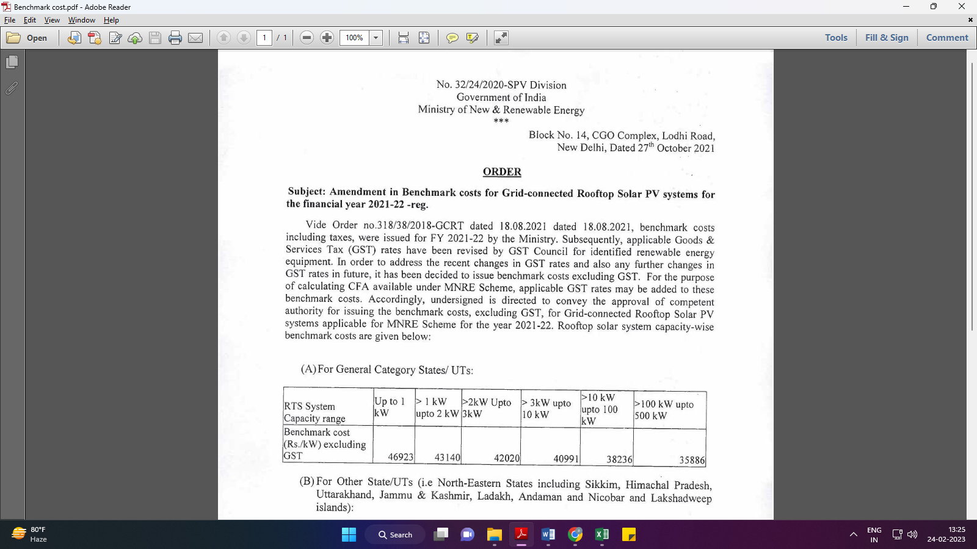

**Data by Global Solar Atlas by World Bank Group**

1. **KRSG Plant**

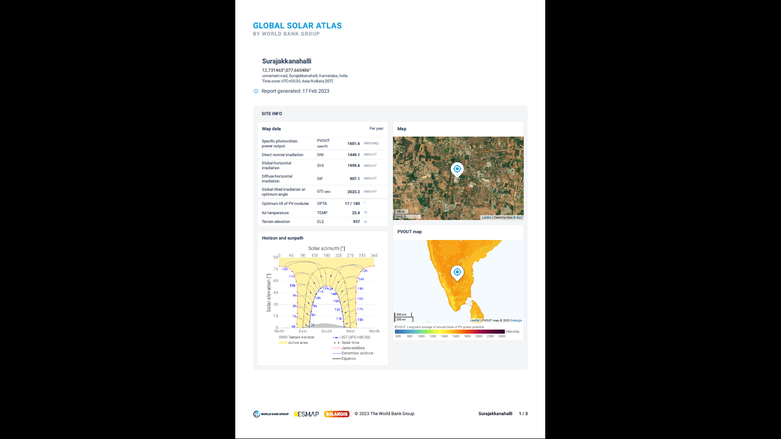

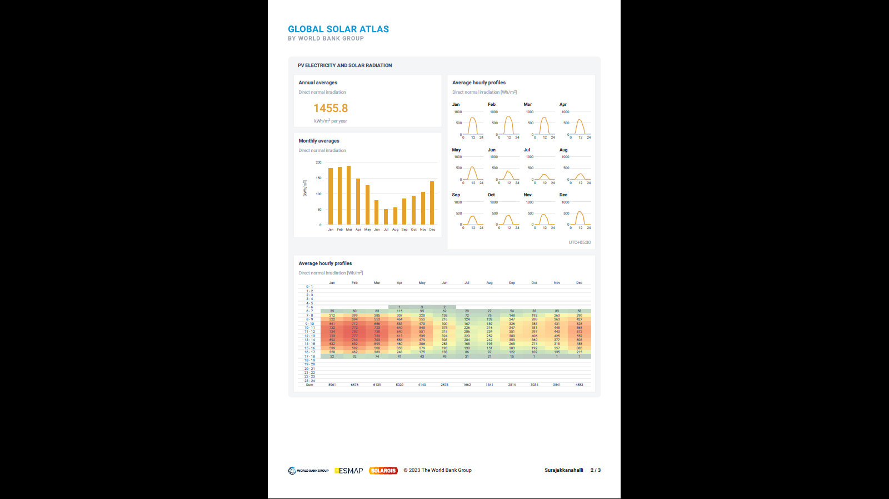

1. **Chandpura Plant**

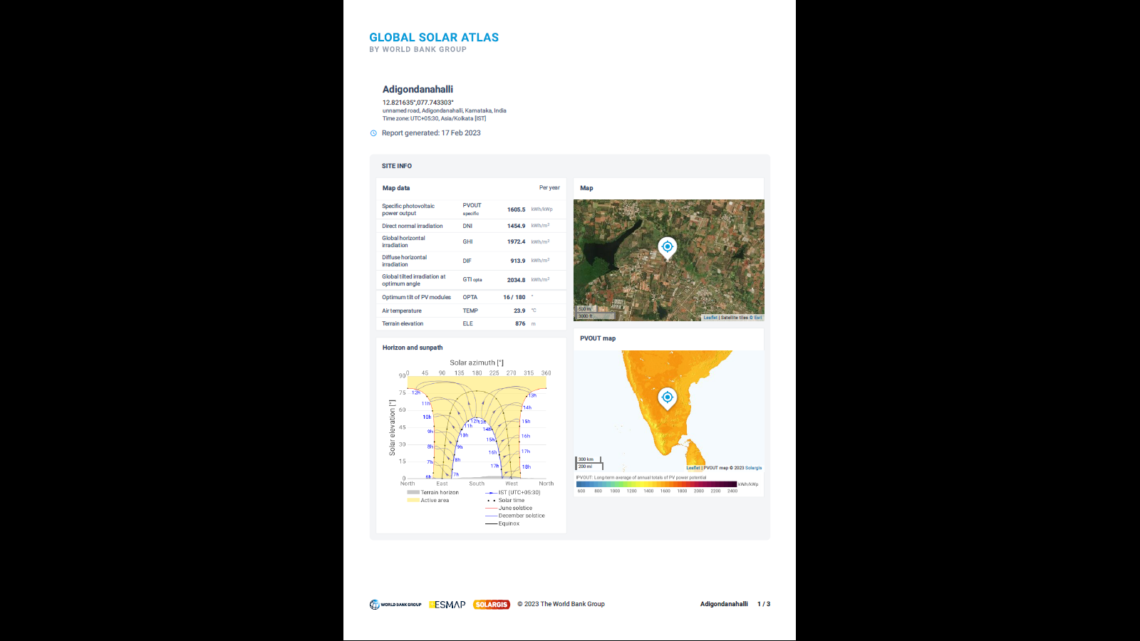

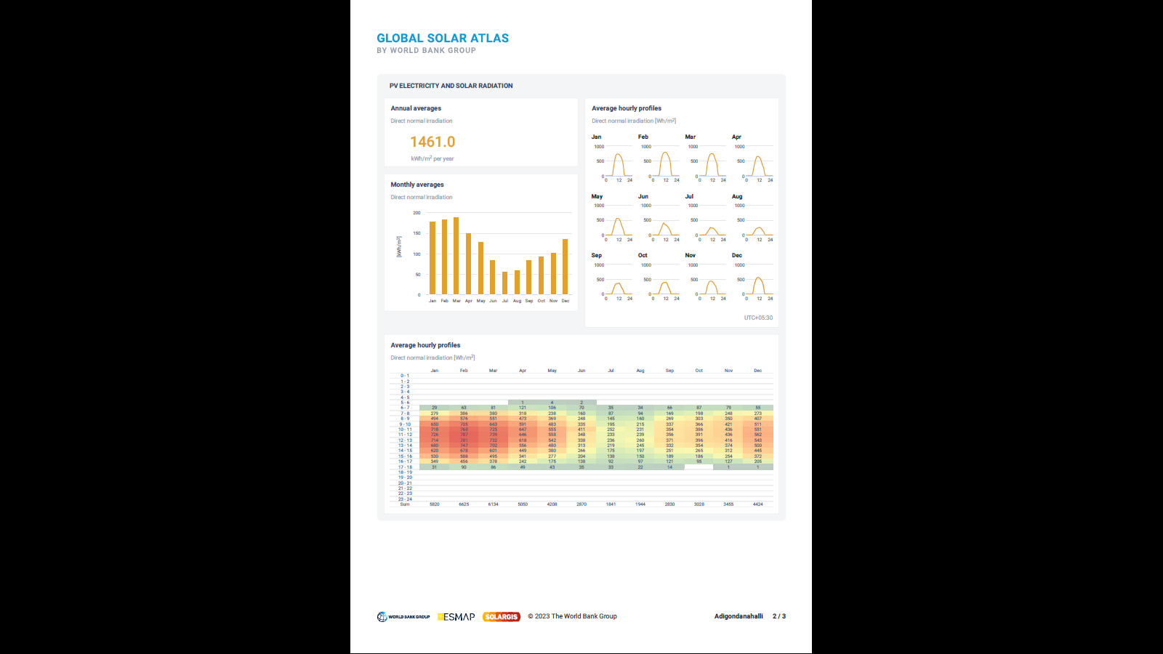

1. **Puducherry Plant**

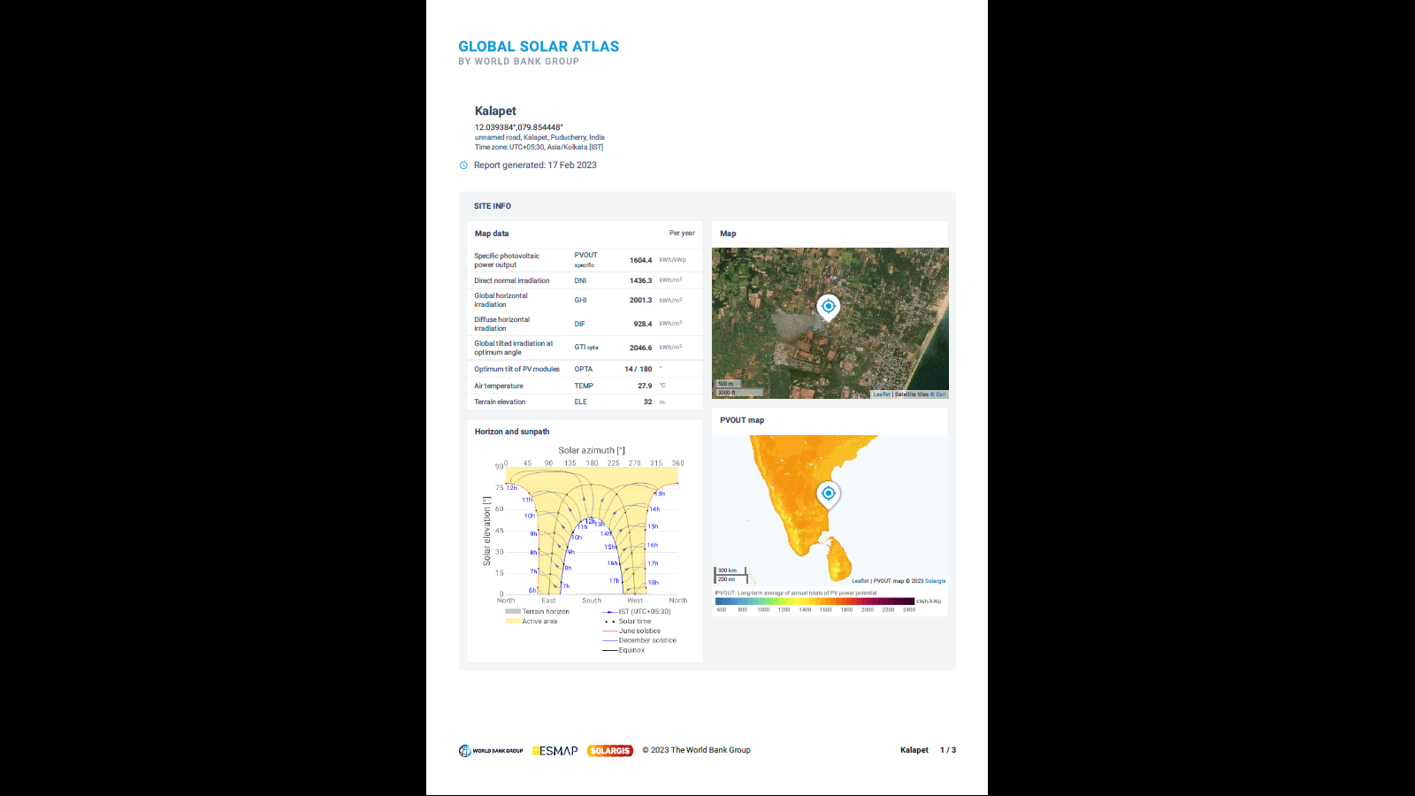

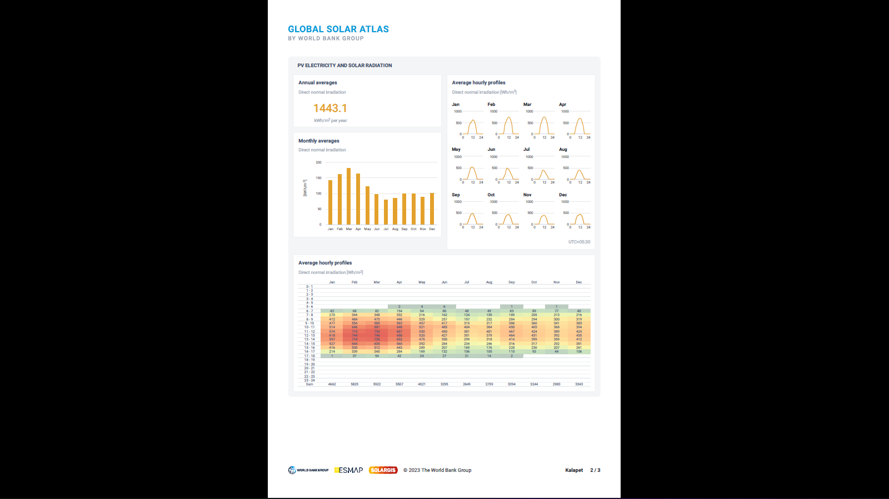

**Insurance Policies**

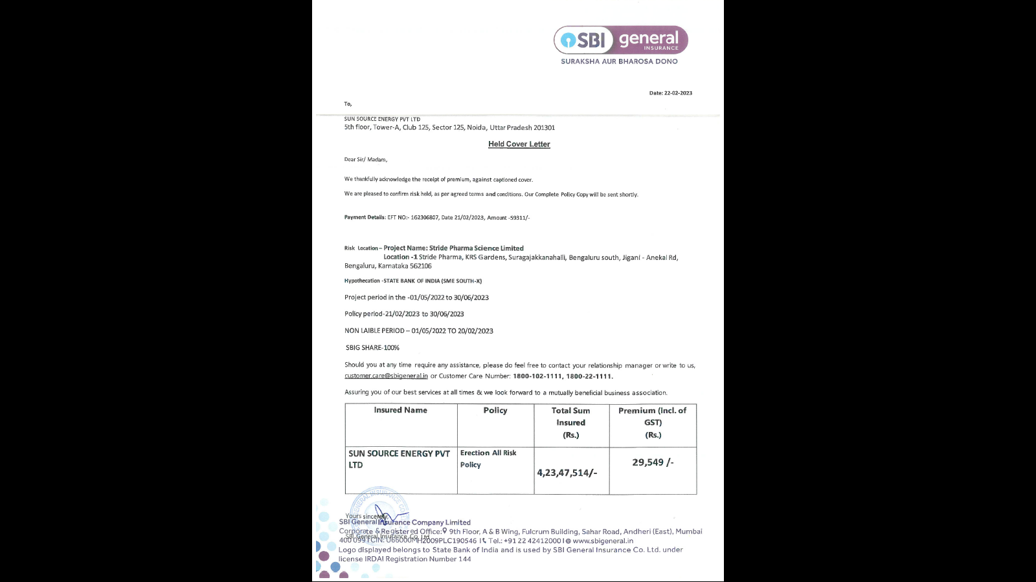

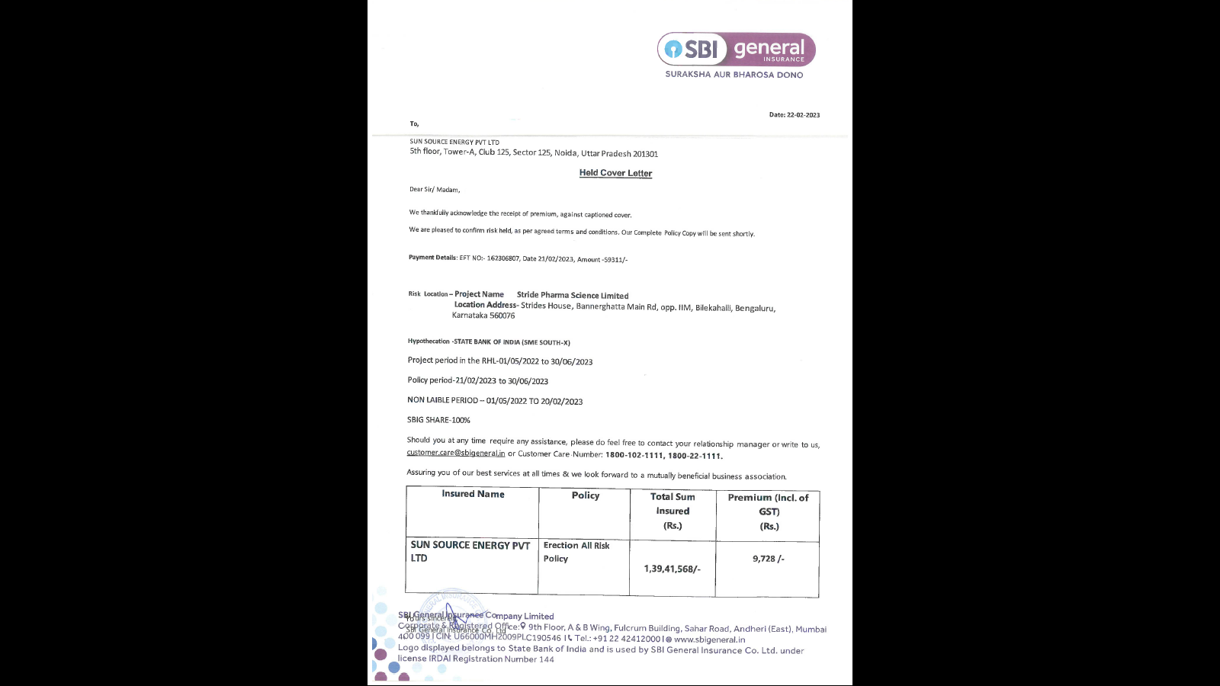

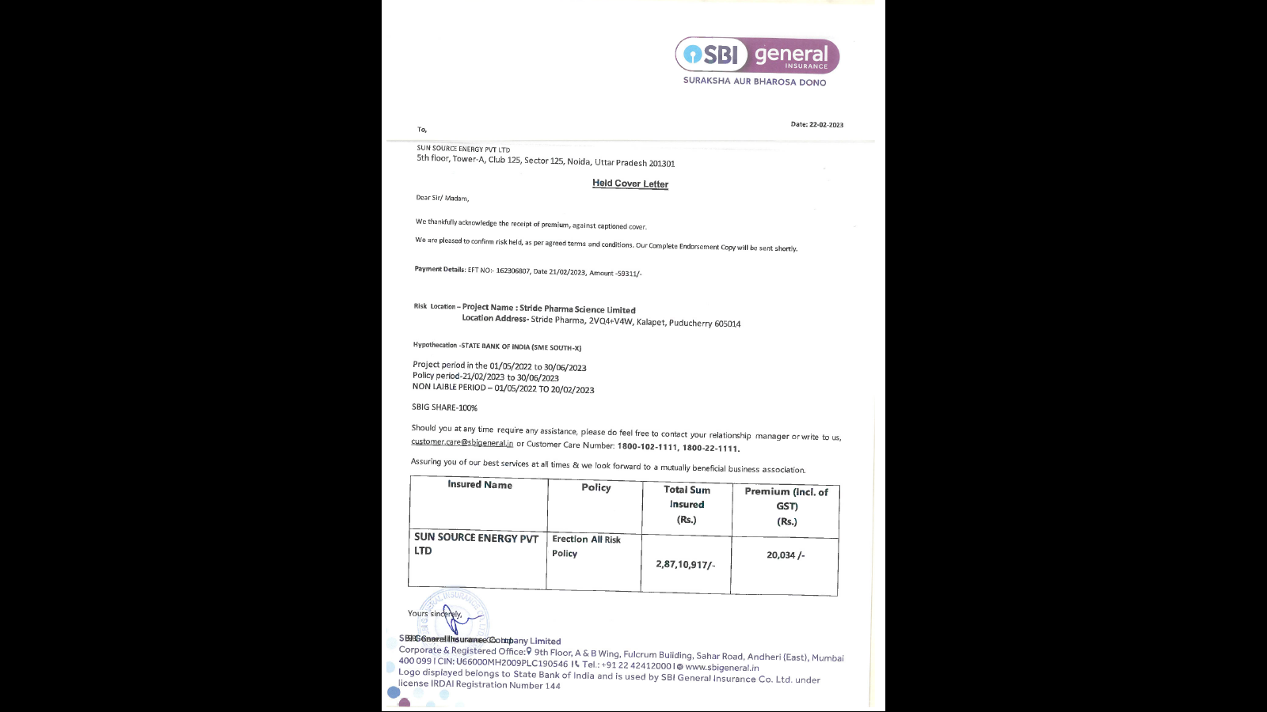

|  |  |
| --- | --- |
| **PART J** | **DISCLAIMER** |

* + - 1. No employee or member of R.K Associates has any direct/ indirect interest in the Project.
      2. This report is prepared based on the copies of the documents/ information which the Bank/ Company has provided to us out of the standard checklist of documents sought from them and further based on our assumptions and limiting conditions. All such information provided to us has been relied upon in good faith and we have assumed that it is true and correct in all respect. Verification or cross checking of the documents provided to us has not been done at our end from the originals. If at any time in future, it is found or came to our knowledge that misrepresentation of facts or incomplete or distorted information has been provided to us then this report shall automatically become null & void.
      3. This report is a general analysis of the project based on the scope mentioned in the report. This is not an Audit report, Design document, DPR or Techno-financial feasibility study. All the information gathered is based on the facts seen on the site during survey, verbal discussion & documentary evidence provided by the client and is believed that information given by the company is true best of their knowledge.
      4. All observations mentioned in the report is only based on the visual observation and the documents/ data/ information provided by the client. No mechanical/ technical tests, measurements or any design review have been performed or carried out from our side during Project assessment.
      5. Bank/FII should ONLY take this report as an Advisory document from the Financial/ Chartered Engineering firm and it’s specifically advised to the creditor to cross verify the original documents for the facts mentioned in the report which can be availed from the borrowing company directly.
      6. In case of any default in loans or the credit facility extended to the borrowing company, R.K Associates shall not be held responsible for whatsoever reason may be and any request for seeking any explanation from the employee/s of R.K Associates will not be entertained at any instance or situation.
      7. This Report is prepared by our competent technical team which includes Engineers and financial experts & analysts.
      8. This is just an opinion report and doesn’t hold any binding on anyone. It is requested from the concerned Financial Institution which is using this report for taking financial decision on the project that they should consider all the different associated relevant & related factors also before taking any business decision based on the content of this report.
      9. All Pages of the report including annexures are signed and stamped from our office. In case any paper in the report is without stamp & signature then this should not be considered a valid paper issued from this office.
      10. Though adequate care has been taken while preparing this report as per its scope, but still we can’t rule out typing, human errors, over sightedness of any information or any other mistakes. Therefore, the concerned organization is advised to satisfy themselves that the report is complete & satisfactory in all respect. Intimation regarding any discrepancy shall be brought into our notice immediately. If no intimation is received within 15 (Fifteen) days in writing from the date of issuance of the report, to rectify these timely, then it shall be considered that the report is complete in all respect and has been accepted by the client upto their satisfaction & use and further to which R.K Associates shall not be held responsible in any manner.
      11. Defect Liability Period is **15 DAYS**. We request the concerned authorized reader of this report to check the contents, data and calculations in the report within this period and intimate us in writing if any corrections are required or in case of any other concern with the contents or opinion mentioned in the report. Corrections only related to typographical, calculation, spelling mistakes, incorrect data/ figures/ statement will be entertained within the defect liability period. Any new changes for any additional information in already approved report will be regarded as additional work for which additional fees may be charged. No request for any illegitimate change in regard to any facts & figures will be entertained.
      12. R.K Associates encourages its customers to give feedback or inform concerns over its services through proper channel at le@rkassociates.org in writing within 30 days of report delivery. After this period no concern/ complaint/ proceedings in connection with the Lender’s Independent Engineering Services will be entertained due to possible change in situation and condition of the subject Project.
      13. Our Data retention policy is of **ONE YEAR**. After this period, we remove all the concerned records related to the assignment from our repository. No clarification or query can be answered after this period due to unavailability of the data.
      14. This Lender’s Independent Engineering report is governed by our (1) Internal Policies, Processes & Standard Operating Procedures, (2) Information/ Data/ Inputs given to us by the client and (3) Information/ Data/ Facts given to us by our field/ office technical team. Management of R.K Associates never gives acceptance to any unethical or unprofessional practice which may affect fair, correct & impartial assessment and which is against any prevailing law. In case of any indication of any negligence, default, incorrect, misleading, misrepresentation or distortion of facts in the report then it is the responsibility of the user of this report to immediately or at least within the defect liability period bring all such act into notice of R.K Associates management so that corrective measures can be taken instantly.
      15. R.K Associates never releases any report doing alterations or modifications from pen. In case any information/ figure of this report is found altered with pen then this report will automatically become null & void.

|  |  |
| --- | --- |
| Place : Noida  Date : 14.02.2023  Note : This report contains 29 pages | **FOR INTERNAL USE**  ***SURVEYED BY: Adil Afaque***  ***PREPARED BY: Adil Afaque***  ***REVIEWED BY: MA Team*** |

**For R.K Associates Valuers** **& Techno Engineering Consultants (P) Ltd.**

1. ***DEFECT LIABILITY PERIOD - In case of any query/ issue or escalation you may please contact Incident Manager by writing at valuers@rkassociates.org. We ensure 100% accuracy in the Calculations done, Rates adopted and various other data points & information mentioned in the report but still can’t rule out typing, human errors or any other mistakes. In case you find any mistake, variation, discrepancy or inaccuracy in any data point of the report, please help us by bringing all such points into our notice in writing at*** [***valuers@rkassociates.org***](mailto:valuers@rkassociates.org)***within 30 days of the report delivery, to get these rectified timely, failing which R.K Associates Valuers Techno Engineering Consultants (P) Ltd. won’t be held responsible for any inaccuracy in any manner. Also if we will not hear back anything from you within 30 days, we will assume that report is correct in all respect and no further claim of any sort will be entertained thereafter. We would welcome and appreciate your feedback & suggestions in order to improve our services.***

***COPYRIGHT FORMAT - This report is prepared on the copyright format of R.K Associates Valuers Techno Engineering Consultants (P) Ltd. to serve our clients in the best possible way. Legally no one can copy or distribute this format without prior approval from R.K Associates. It is meant only for the organization as mentioned on the cover page of this report. Distribution or use of this format other than R.K Associates will be seen as unlawful act and necessary legal action can be taken against the defaulter***