REPORT FORMAT: CL-1 | Version: 1.0_2018

FILE No.: VIS(2022-23)-PL653-544-914 Date: 02-03-2023

- CERTIFICATE NAME: Progress Report of the machines and equipment’s for manufacturing Rigid PVC Sheets installed or proposed to be installed at Khasra No. 361/2, 361/3, 396/1, Village Bhogpur, Pargana Jwalapur, Distrisct Haridwar, Uttarakhand.
- FOR ORGANIZATION: State Bank of India, SME Branch, Ranipur, Haridwar.
- BORROWER COMPANY’S NAME: M/s. Polypals Global Private Limited.
- ASSET TYPE: Machines for manufacturing Rigid PVC Sheet.
- CURRENT LOCATION OF THE MACHINES: Part of Khasra No. 361/2, 361/3, 396/1, Village Bhogpur, Pargana Jwalapur, District Haridwar, Uttarakhand.
TO WHOMSOEVER IT MAY CONCERN

S. NO. | PARTICULARS | DESCRIPTION
1. | Date of Survey | 17-02-2023
2. | Date of Certificate | 02-03-2022
3. | Documents provided for perusal | List of machines, Invoices/Performa Invoices, No Objection Certificates.
4. | Current Location of the Machines | Part of Khasra No. 361/2, 361/3, 396/1, Village Bhogpur, Pargana Jwalapur, District Haridwar, Uttarakhand.
5. | Borrowing Company | M/s. Polypals Global Private Limited
6. | Type of Asset | Machinery required for installing Rigid PVC Sheet Film plant.
7. | Type of Assessment | Progress of machines purchased, installed at site.
8. | Scope of Assessment | Progress of machines purchased, installed at site.
9. | Nature of Machinery | Machines for manufacturing Rigid PVC Sheets
10. | Current Progress of the machines | As per physical inspection made during site visit, company has purchased and installed all the machines as per the list provided.
11. | Condition of Machines | Purchased machines and equipment are new and ready for production.

OBSERVATIONS:

- We have been provided with the list of machines that has to be purchased/ installed by the borrower company.
- Based on the information provided by the subject company (M/s. Polypals Global Private Limited), it is certified that the following machines are purchased and installed at the above-mentioned site address.

LIST OF MACHINES AND EQUIPMENTS
S. NO. | NAME OF MACHINERY | Progress
1 | AIR COMPRESSOR (PMGC) | Purchased & installed
2 | THERMIC FLUID HEATER (NEOTECH) | Purchased & installed
3 | COOLING TOWER (NORTH STREET) | Purchased & installed
4 | CALENDER LINE (SHANGHAI) | Purchased & installed
5 | CORE CUTTING | Purchased & installed
6 | ONLINE SHEET CUTTING (EN PLAST) | Purchased & installed
7 | SLITTING MACHINE (GUPTA ENTERPRISES) | Purchased & installed
8 | DG SET 400KVA (JAKSON) | Purchased & installed
9 | DG SET 200KVA (JAKSON) | Purchased & installed
10 | EOT CRANE (VENUS ENGINEERS) | Purchased & installed
11 | QA TESTING (DEEPAK POLYPLAST) | Purchased & installed
12 | CORONA TREATMENT SYSTEM (IEEC) | Purchased & installed
13 | AIR HANDLING UNIT (INFANITE) | Purchased & installed
14 | FIRE FIGHTING SYSTEM | Purchased & installed
15 | TRANSFORMER 800KVA (JAYBEE INDUSTRIES) | Purchased & installed
16 | SERVO STABLIZER (RED PHASE) | Purchased & installed
17 | ELECTRIC PANEL (ZAD) | Purchased & installed
18 | MACHINE INSTALLATION (SK ENGINEER) | Purchased & installed
19 | MISC TOOLS (SKARC) | Purchased & installed
20 | X RAY SCANNER (JASCH) | Purchased & installed
21 | INDUSTRIAL PROCESS CHILLER (REYNOLD) | Purchased & installed
22 | GRINDER MACHINE (VIJAY ENGINEER) | Purchased & installed
23 | MISC TOOLS (INDUSTRIAL EQUIPMENT SYNDICATE) | Purchased & installed
24 | Other Misc. Items (OM ENTERPRISES) | Purchased & installed

Disclaimer:

  - This progress report is stated on the basis of the site visit by the surveyor and we don’t recommend any sort of recommendation in our Certificate.
  - As per physical inspection and observation made during site visit dated 17th February 2023. Company has installed all the machines mentioned in the provided list.
  - As on date of site survey i.e. 17th February 2023, we were informed that the plant to be start by 23rd February 2023. We have requested the company to share the copy of Electricity Bill or capacity utilization as a proof of machines are running. However, we have not received the same.
  - This certificate doesn’t include any work related to drawing, design, sketch plan, and technical specifications of the machines.
  - Ownership and other legal point of view in respect of the asset is not considered in this report as same is out of scope of this certificate.
  - This certificate is made at the request of the Bank.

For R.K Associates Valuers & Techno FOR INTERNAL USE Engineering Consultants (P) Ltd.
TYPED BY: Er. Abhinav Chaturvedi
REVIEWED BY: Er. Rahul Gupta

ANNEXURE: LIST OF MACHINES AS PROVIDED BY THE CLIENT

S. NO. | NAME OF MACHINERY
1 | AIR COMPRESSOR (PMGC)
2 | THERMIC FLUID HEATER (NEOTECH)
3 | COOLING TOWER (NORTH STREET)
4 | CALENDER LINE (SHANGHAI)
5 | CORE CUTTING
6 | ONLINE SHEET CUTTING (EN PLAST)
7 | SLITTING MACHINE (GUPTA ENTERPRISES)
8 | DG SET 400KVA (JAKSON)
9 | DG SET 200KVA (JAKSON)
10 | EOT CRANE (VENUS ENGINEERS)
11 | QA TESTING (DEEPAK POLYPLAST)
12 | CORONA TREATMENT SYSTEM (IEEC)
13 | AIR HANDLING UNIT (INFANITE)
14 | FIRE FIGHTING SYSTEM
15 | TRANSFORMER 800KVA (JAYBEE INDUSTRIES)
16 | SERVO STABLIZER (RED PHASE)
17 | ELECTRIC PANEL (ZAD)
18 | MACHINE INSTALLATION (SK ENGINEER)
19 | MISC TOOLS (SKARC)
20 | X RAY SCANNER (JASCH)
21 | INDUSTRIAL PROCESS CHILLER (REYNOLD)
22 | GRINDER MACHINE (VIJAY ENGINEER)
23 | MISC TOOLS (INDUSTRIAL EQUIPMENT SYNDICATE)
24 | Other Misc. Items (OM ENTERPRISES)

ANNEXURE: PHOTOGRAPHS

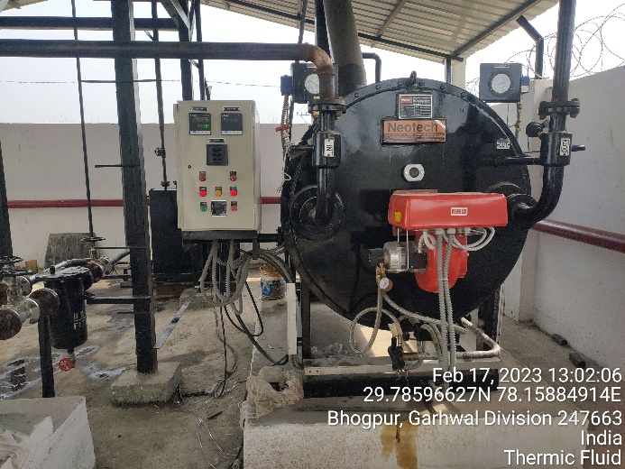 | 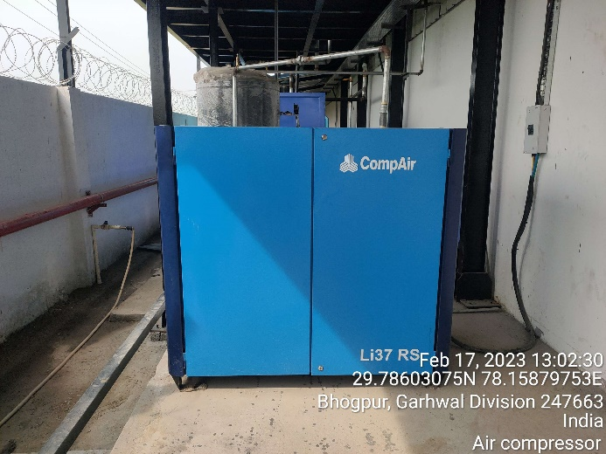
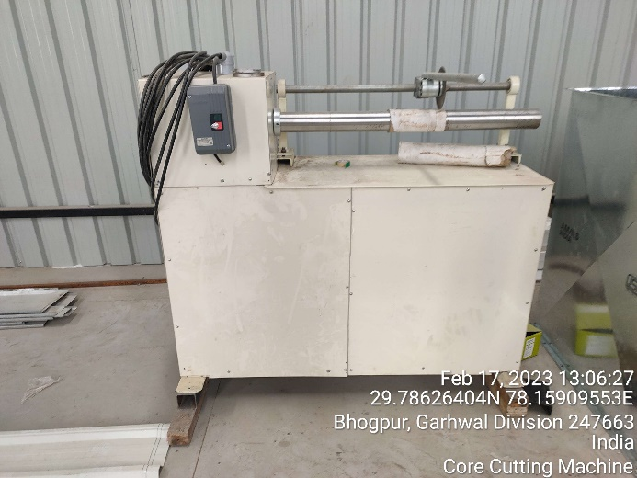 | 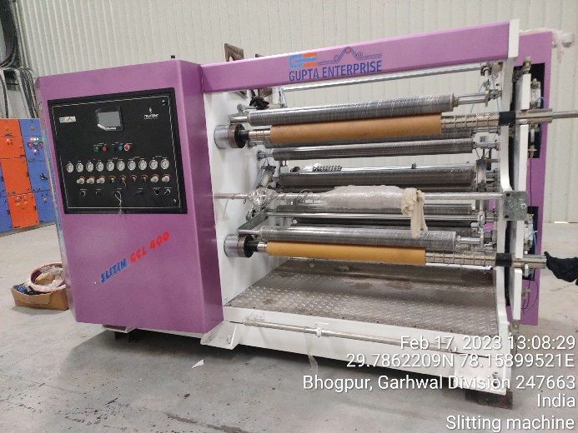
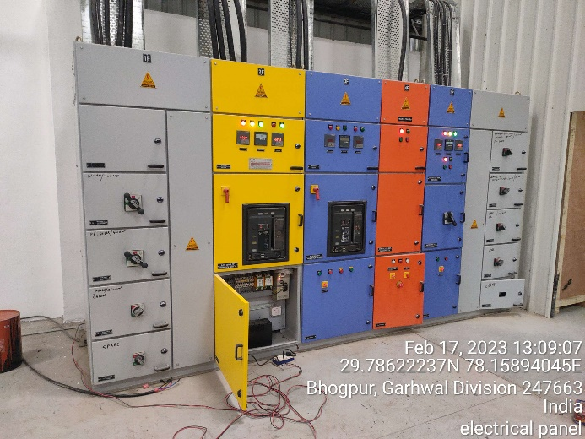 | 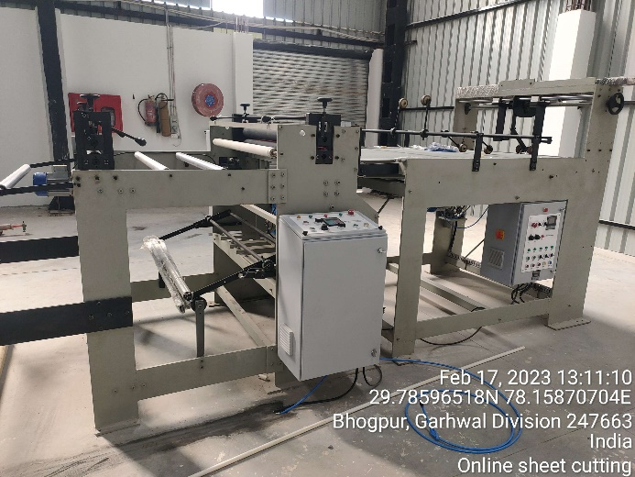

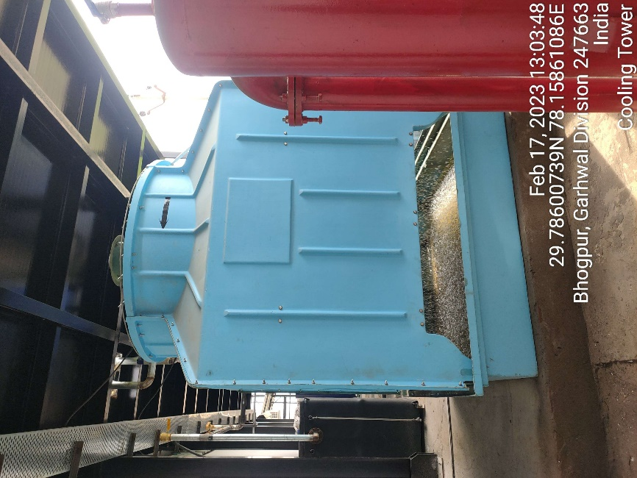 | 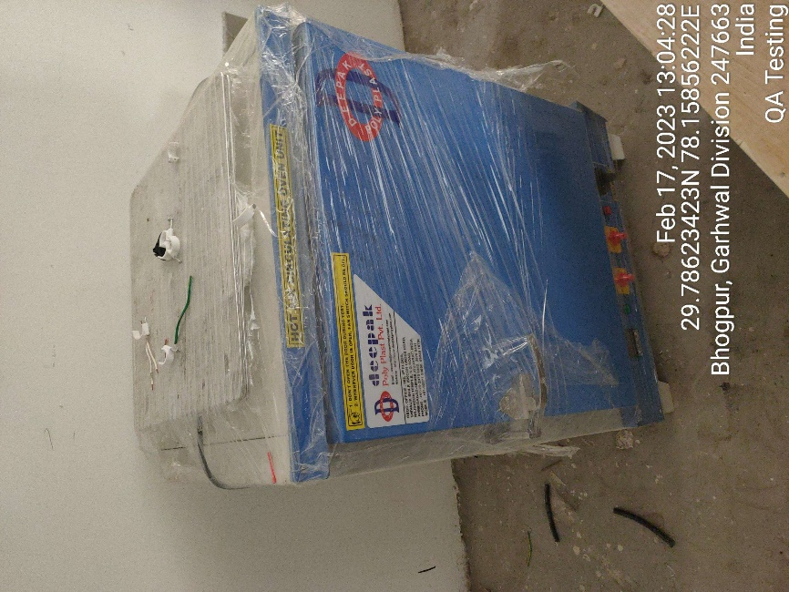
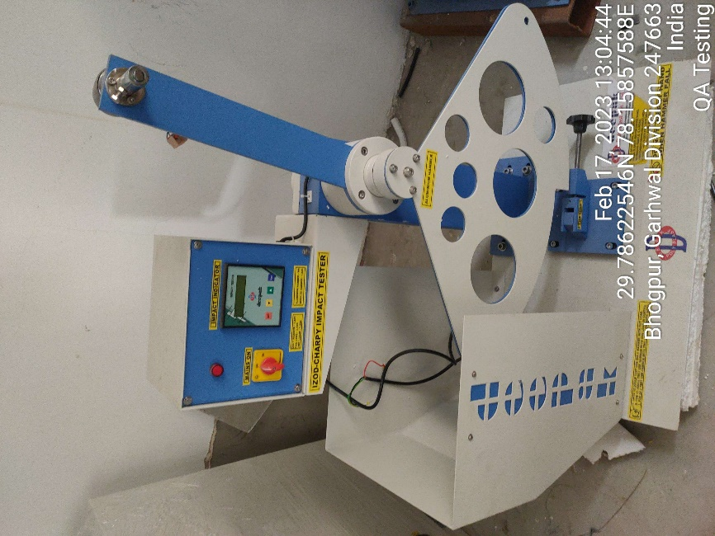 | 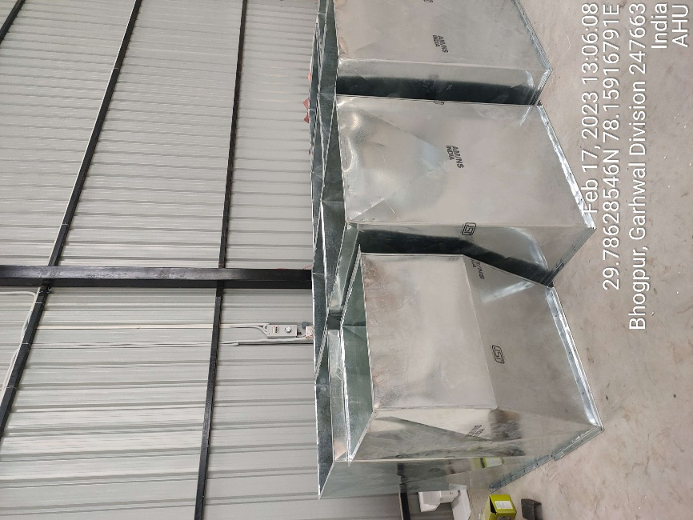

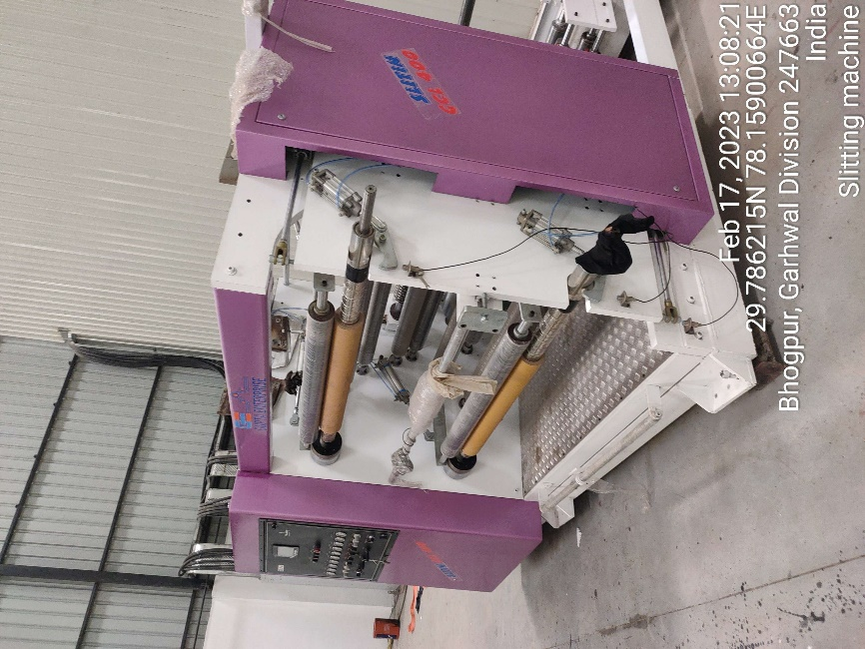 | 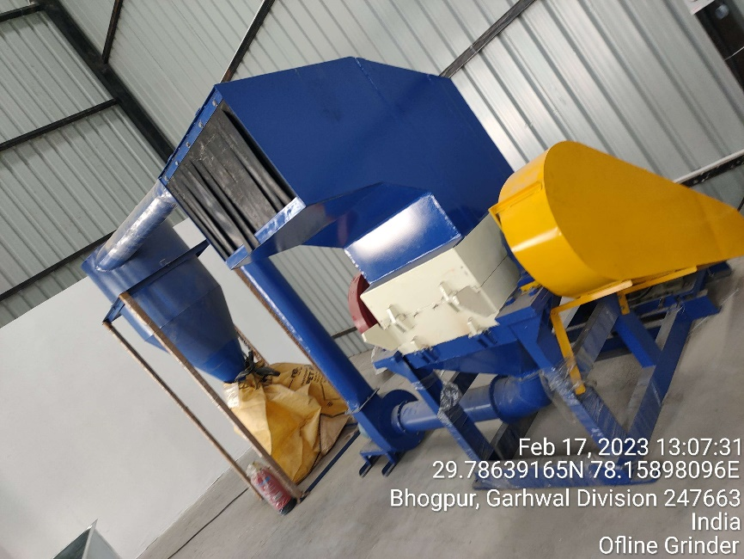
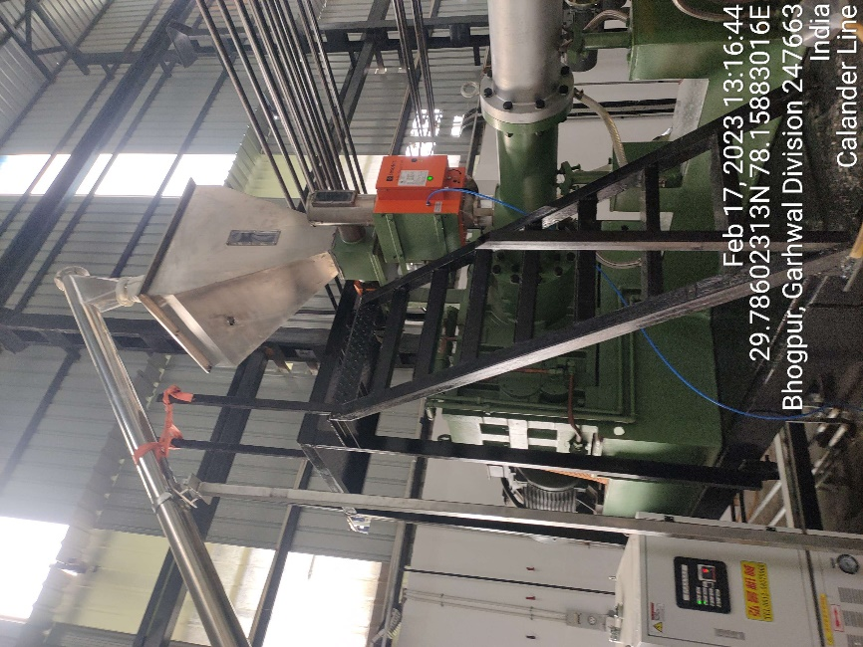 | 