**REPORT FORMAT:** V-L11 (Enterprise Valuation) | Version: 1.0_2018

**File No.: VIS (2022-23)- PL656-555-928 Dated: 01.03.2023**

**ENTERPRISE VALUATION REPORT**

**OF**

**SUB-CRITICAL COAL-FIRED THERMAL POWER PLANT 3600 MW (6x600 MW)**

**(3 UNITS UNDER CWIP)**

**SITUATED AT**

**DISTRICT JANJGIR- CHAMPA, CHHATTISGARH, INDIA**

**OWNER/ PROMOTER**

**M/S KSK MAHANADI POWER COMPANY LIMITED (KMPCL)**

**REPORT PREPARED FOR**

**BANK OF INDIA, MUMBAI LARGE CORPORATE BRANCH, BANK OF INDIA BUILDING, 4TH FLOOR, 70-80, M.G. ROAD, FORT, MUMBAI - 400001**

***\*\*Important - In case of any query/ issue/ concern or escalation you may please contact Incident Manager @ valuers@rkassociates.org. We will appreciate your feedback in order to improve our services.***

***NOTE: Please provide your feedback on the report within 15 days of its submission after which report will be considered to be accepted & correct. Valuation Terms of Services & Valuer’s Important Remarks are available at*** [***www.rkassociates.org***](http://www.rkassociates.org) ***for reference.***

**IMPORTANT NOTICE**

***COPYRIGHT FORMAT:*** *This report is prepared on the copyright format of R. K. Associates Valuers & Techno Engineering Consultants (P) Ltd. (R. K. Associates) to serve our clients with the best possible information and analysis to facilitate them to take rational business decisions. Legally no one can copy or distribute this format without prior approval from R. K. Associates. It is meant only for the advisory/ reference purpose for the organization/s as mentioned on the cover page of this report. Distribution or use of this format or report or any of its content/ information/ data by any organization or individual other than R.K Associates will be seen as an unlawful act and necessary legal action can be taken against the defaulters.*

*This report is intended for the sole use of the intended recipient/s and contains material that is STRICTLY CONFIDENTIAL AND PRIVATE.*

***DEFECT LIABILITY PERIOD:****In case of any query/ issue or escalation you may please contact Incident Manager at valuers@rkassociates.org. Though adequate care has been taken while preparing this report as per its scope, but still, we can’t rule out typing, human errors, over sightedness of any information or any other mistakes. Therefore, the concerned organization is advised to satisfy themselves that the report is complete & satisfactory in all respect. Intimation regarding any discrepancy shall be brought into our notice immediately. If no intimation is received within 15 (Fifteen) days in writing from the date of issuance of the report, to rectify these timely, then it shall be considered that the report is complete in all respect and has been accepted by the client up to their satisfaction & use and further to which R.K Associates shall not be held responsible in any manner.*

***Part H: R. K. Associates Important Disclaimer and Remarks*** *are integral part of this report and Feasibility assessment is subject to this section. Reader of the report is advised to read all the points mentioned in these sections carefully.*

| **TABLE OF CONTENTS** | | |
| --- | --- | --- |
|  | | |
| **SECTIONS** | **PARTICULARS** | **PAGE NO.** |
| **Part A** | **INTRODUCTION** | **4** |
| 1. About the Report | 4 |
| 1. Background of the Project | 4 |
| 1. Type of Report | 7 |
| 1. Purpose of the Report | 7 |
| 1. Scope of the Report | 7 |
| 1. Methodology/ Model Adopted | 7 |
| 1. Documents/ Data Referred | 8 |
| **Part B** | **Project Company** | **9** |
| 1. Brief Description About the Company/ Promoters | 9 |
| 1. Capital Structure | 9 |
| 1. Shareholding Pattern | 9 |
| 1. Snapshot of the Outstanding Debt of the Company | 10 |
| 1. Current Status of the Project | 10 |
| **Part C** | **The Project** | **12** |
| 1. Brief Description of the Project | 12 |
| 1. Project Location | 12 |
| 1. Land Requirement | 13 |
| 1. Implementation Agreement or EPC Contract | 14 |
| 1. Water Requirement | 15 |
| 1. Railway Siding | 16 |
| 1. Coal Linkage or Fuel Supply Agreement | 16 |
| 1. Power Purchase Agreement | 17 |
| 1. Power Evacuation Arrangement | 18 |
|  | 1. Operations and Maintenance Agreements | 18 |
| **Part D** | **Market Overview on Power Sector** | **20** |
| 1. Introduction | 20 |
| 1. Market Size | 20 |
| 1. Government Initiatives | 21 |
| 1. Recent Investments | 22 |
| 1. Way Forward | 23 |
| **Part E** | **Financial Performance** | **24** |
| 1. Historical Profit & Loss Statement | 24 |
| 1. Key Financial Ratios | 25 |
| 1. Graphical Representation of the Key Financials of the Company | 25 |
| **Part F** | **Valuation of the Company** | **27** |
| 1. Methodology/ Model Adopted | 27 |
| 1. Calculation of Free Cash Flow to Firm | 28 |
| 1. Key Inputs used to discount Cash Flows during the Projection Period | 29 |
| 1. Calculation of Enterprise Value | 30 |
| 1. Sensitivity Analysis | 31 |
| 1. Key Assumptions and Workings | 32 |
| **Part G** | **Important Definition** | **37** |
| **Part H** | **Disclaimer | Remarks** | **39** |

|  |  |
| --- | --- |
| **PART A** | **INTRODUCTION** |

1. **ABOUT THE REPORT:** Enterprise Valuation Report of (6 x 600) MW Pulverized Coal Fired Sub–Critical Thermal Power Plant set by M/s. KSK Mahanadi Power Company Limited (KMPCL) at Villages Nariyara, Rogada, Amora & Tarod of Tehsil Akaltara, Janjgir-Champa District of Chhattisgarh.
2. **BACKGROUND OF THE PROJECT:** M/s KSK Mahanadi Power Company Limited (“KMPCL”) is a Special Purpose Vehicle (SPV) promoted by KSK Energy Ventures Limited (KSK) (a power plant development company) based at Hyderabad. KMPCL was incorporated to establish a 6x600 MW coal fired thermal power plant located at village Nariyara, district Janjgir-Champa in the state of Chhattisgarh. The group structure of the M/s KSK Mahanadi Power Company Limited is shown below:

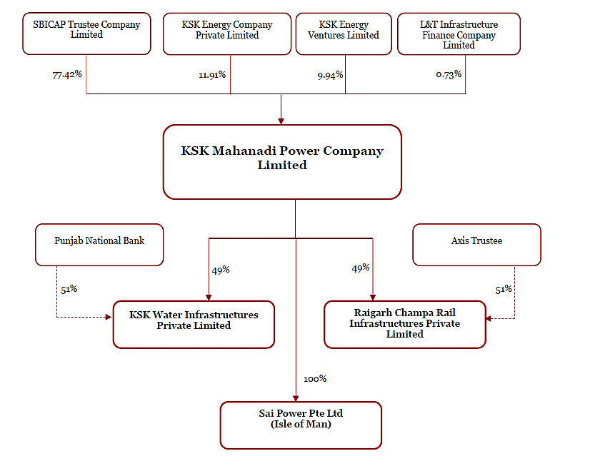

The basic details of the plant are as below:

|  |  |
| --- | --- |
| **Particulars** | **Details** |
| Location | Nariyara Village, Chhattisgarh |
| Factory Area | Approx. 2132.00 Acres |
| Number of Units | 6 units of 600 MW each (6x600 MW) |
| Operational Status | 3 units commissioned |

Out of the six units, unit number 2, 3 & 4 are already into commercial operation and construction of the balance 3 units is on hold from more than 5 years. The present status of all 6 units is as below:

|  |  |  |  |
| --- | --- | --- | --- |
| **Unit No.** | **Date of Contractual Schedule** | **COD Achieved** | **Current Status** |
| **Unit-2** | 25-Mar-13 | 28-Feb-18 | Currently Operational |
| **Unit-3** | 25-Jul-12 | 14-Aug-13 |
| **Unit-4** | 25-Nov-12 | 26-Aug-14 |
| **Unit-1** | 25-Nov-13 | - | Stalled condition. No construction activity ongoing since April 2018 |
| **Unit-5** | 25-Jul-13 | - |
| **Unit-6** | 25-Mar-14 | - |

During the site survey, 3 units were commissioned out of the proposed 6 units and construction of the balance 3 units is on hold from more than 5 years. The manpower is demobilized from the site and the balance work is standstill. The company is under CIRP at present.

Out of the three commissioned units, only two were operational during the site survey. The overall condition of the plant of the commissioned units is good. CWIP main equipment & machines are also found to be packed and preserved properly under shed except structural material which is lying in open yards.

As per data/information provided by the client, below table shows the historical financial performance of the company from FY 2017-18 to Provisional Balance sheet dated 31.12.2022:

***(Figures in INR Crores)***

|  |  |  |  |  |  |  |
| --- | --- | --- | --- | --- | --- | --- |
| **Particulars** | **FY 2018 A** | **FY 2019 A** | **FY 2020 A** | **FY 2021 A** | **FY 2022 A** | **FY 2023 E** |
| Total revenue | 2,805.06 | 3,900.91 | 4,770.71 | 4,511.85 | 4,272.33 | 5,671.19 |
| Total expenses | 2,174.68 | 3,681.74 | 4,382.57 | 3,543.22 | 2,781.92 | 4,055.85 |
| **EBITDA** | **630.38** | **219.17** | **388.14** | **968.63** | **1,490.41** | **1,615.33** |
| Dep. & Amor. Expenses | 518.82 | 697.91 | 695.21 | 679.41 | 672.38 | 675.91 |
| **EBIT** | **111.56** | **-478.74** | **-307.07** | **289.22** | **818.03** | **939.43** |
| Finance costs | 1,851.45 | 76.78 | 54.97 | 36.31 | 38.94 | 32.61 |
| **Profit / (loss) before tax** | **-1,739.89** | **-555.52** | **-362.04** | **252.91** | **779.09** | **906.81** |
| Deferred tax | -178.74 | 153.97 | 162.09 | 166.96 | 447.67 | 264.06 |
| **Profit / (loss) after tax** | **-1,561.15** | **-709.49** | **-524.13** | **85.95** | **331.42** | **642.75** |
| **EBITDA Margin %** | 22.95% | 5.96% | 8.77% | 22.65% | 35.55% | 32.15% |
| **EBIT Margin %** | 4.06% | -13.03% | -6.94% | 6.76% | 19.51% | 18.70% |
| **Net Profit Margin %** | -56.84% | -19.31% | -11.84% | 2.01% | 7.90% | 12.79% |
| **Revenue Growth Rate (Y.O.Y.)** | **-** | 33.78% | 20.48% | -3.42% | -1.94% | 19.83% |

As per the historical analysis, it is observed that EBITDA Margin of the company is showing an upward trend as it has gone up from 22.95% in FY 2017-18 to 32.15% in FY 2022-23. EBIT Margin is also showing an upward trend as it has gone up from 4.06% in FY 2017-18 to 18.70% in FY 2022-23.

Although, Revenues Growth of the company is constantly declining during the past five years historically. As per the historical analysis, it is observed that Net Profit Margin of the company is rising continuously from -56.84% in FY 2017-18 to 12.79% in FY 2022-23.

The BOP systems such as DM Plant, Chlorination plant, Dosing plant, ETP, Sewage treatment plant, CAS, H2 generation, HVAC, firefighting system etc. are majorly ready and in operation. These systems are common for all 6 units. However, the required ducting, piping cabling, hooks-up etc. with the BTG packages for unit under construction (Unit 1, 5 & 6) are yet to be completed.

Major works of CHP is completed and the capacity commissioned is sufficient to handle operation of more than three units. The AHP system is common for all the six units and major portion are in operation (which are catering to the operating units no. 2, 3 and 4) except bottom ash and fly ash system of Unit 1, 5 and 6.

Both bottom ash pond and fly ash dyke is ready. The Fuel Oil Handling System is common for all six units and it is in operation, however, the fuel oil line for under construction units is yet to be laid and commissioned. Out of five numbers of clarifiers, two are in operation.

Two major support infrastructures for the power plant, namely, the Railway Siding and the Water Intake System have been constructed by separate SPVs of KSK Group. Following entities own the above infrastructure: -

1. **Raigarh - Champa Rail Infrastructure Private Ltd. (RCRIPL)** - Owns and operates the Railway siding outside the Plant boundary.
2. **KSK Water Infrastructure Private Ltd. (KWIPL)** - Owns and operates the Raw Water Intake System.

**Hence, Bank of India (BOI) being one of the consortium lenders has appointed us to determine the Fair Market Value/Enterprise Value of this power plant only without considering the SPVs to take appropriate course of action on this stressed account.**

**However, valuation of the subject plant along with the SPVs was carried out by us in the year 2018, October 2022 and January 2023 also. Since, the company is now under CIRP and IRP is appointed, therefore, during the current valuation exercise there is data & information limitation. Thus, for the purpose of the current valuation, we have referred to previous data/ information which were available with us.**

1. **TYPE OF REPORT:** This report is performed to assess the Enterprise Value of the project.
2. **PURPOSE OF THE REPORT:** To assess & determine Enterprise Value of the Project under implementation as a whole as required by the lenders.
3. **SCOPE OF THE REPORT:** To estimate & determine current Enterprise Value of the Company based on Income Based Approach (Discounted Cash Flow) method.

* *This is just the enterprise valuation of the project based on the Income generating capacity of the project in future years. This Valuation shall not be construed as the physical asset or should not be related directly to cost approach or Project cost.*
* *This Enterprise Valuation report doesn't cover vetting of the documents/ financial data/ projections or any other information provided to us by the Bank.*
* *This Valuation only covers the cash flow from operation of the company. It does not cover any transaction with the subject company’s subsidiary/ associate/ Joint Venture Companies, as per the requirement by the lender.*
* *This Valuation is prepared based on the current financial status and projections of the company, financial data/ model, future projections, other facts & information provided by the company/ lender/ Client in writing & verbal discussions held during the course of the assignment and based on independent assessment of certain assumptions which are specifically mentioned in the Valuation section of the Report.*
* *It doesn't contain the principles of physical asset valuation and is not based on the site inspection of the project.*
* *We have assumed that the information provided to us is correct and is not manipulated or distorted.*
* *The Market and Industrial assessment of the given company’s industry/ sector has not been done at our end. So, this valuation doesn’t cover the market & industrial scenario in terms of the product demand & market potential.*

1. **METHODOLOGY/ MODEL ADOPTED:** Income-based Approach (Discounted Cash Flow Model) for the calculation of Enterprise Value of the Company.
2. **DOCUMENTS / DATA REFFERED:**

* Audited Financial Statements and Notes provided by the Company.
* Provisional Financial Statement dated 31st December 2022.
* Purchase Power Agreements.
* Monthly Generation Data.
* Valuation Report prepared by R K Associates dated 05-06-2018 and 05-01-2023.
* Technical Study Report prepared by L&T- Sargent and Lundy Ltd. dated 04-01-2021.
* Information Memorandum.

|  |  |
| --- | --- |
| **PART B** | **PROJECT COMPANY** |

1. **BRIEF DESCRIPTION ABOUT THE COMPANY:** M/s KSK Mahanadi Power Company Limited operates a Coal Based power project in the state of Chhattisgarh. This is a 3600 MW power project comprising 6 units of 600 MW each. The entire 3600 MW project is being implemented through a turnkey EPC contract, which was executed on 1st April 2009 with Shandong Electric Power Construction Corporation, China (SEPCO) with amendments executed thereto as required from time to time. Currently the company has 3 operational units and the rest of the units are under various stages of construction.

The incorporation details of the Project Company are provided in the table below:

|  |  |
| --- | --- |
| **INCORPORATION DETAILS OF THE COMPANY** | |
| **Name of the Company** | M/s KSK Mahanadi Power Company Limited |
| **CIN** | U40300TG2009PLC064062 |
| **Address** | **Registered Office:** 8-2-293/82/A/431/A, Road No. 22, Jubilee Hills, Hyderabad, Telangana – 500033, India.  **Plant Address:** Nariyara Village, Champa District, Chhattisgarh. |
| **Constitution** | Public Limited Company / Limited by Shares |
| **Date of Incorporation** | 19th June 2009 |
| **Authorised Capital** | INR 10,000 Crore |
| **Paid up Capital (Equity)** | INR 3,609.50 Crore |

1. **CAPITAL STRUCTURE:** Below table shows the capital structure of the company as on 31st March 2022:

| **Particulars** | **Amount (In INR Crores)** |
| --- | --- |
| Authorized Share Capital | 10,000 |
| Issued, Subscribed and Paid-up Capital | 3,609.50 |

1. **SHAREHOLDING PATTERN:** As per audited financials for FY 2022 shared by the client/company, below are the details of shareholders holding more than 5% of the outstanding shares:

|  |  |  |  |
| --- | --- | --- | --- |
| **Shareholders Holding More Than 5% of the Outstanding Shares** | | | |
| **S. No.** | **Name of the shareholder** | **No. of shares held** | **% Of shares held** |
| 1 | SBICAP trustee company limited | 279.45 | 77.42% |
| 2 | KSK Energy Ventures Limited | 35.86 | 9.94% |
| 3 | KSK Energy Company Private Limited | 25.00 | 6.93% |

1. **SNAPSHOT OF THE OUTSTANDING DEBT OF THE COMPANY:** As per the information shared by the client/company and information available on the company’s website, the amount of the claims of creditors as on 8th February 2023 is as below:

|  |  |  |  |  |
| --- | --- | --- | --- | --- |
| **S. No.** | **Category of Creditors** | **Amount Claimed (INR)** | **Claims admitted** | **Contingent Claim** |
| 1 | Financial Creditors | 3,06,39,54,79,925.90 | 2,95,01,55,27,422.88 | 1,83,38,03,022.00 |
| 2 | Financial Creditors (Related Party) | 15,95,03,40,270.72 | 1,35,38,97,315.00 | - |
| 3 | Operational Creditors (other than Workmen and Employees) | 66,07,37,18,926.45 | 27,60,39,24,280.83 | 4,44,15,06,079.75 |
| 4 | Operational Creditors (only Workmen and Employees) | 13,09,21,968.48 | 11,62,83,804.00 | - |
| 5 | Other Creditors/Stakeholders | 1,72,30,145.11 | 1,71,00,555.11 | - |
| **Total** | | **3,88,56,76,91,236.66** | **3,24,10,67,33,377.82** | **6,27,53,09,101.75** |

1. **CURRENT STATUS OF THE PROJECT**: M/s KSK Mahanadi Power Company Limited is a Public Company domiciled in India and incorporated under the provisions of Companies Act applicable in India. The Company was incorporated to engage in the business of generation and sale of power through its power plant of 6 x 600 MW situated at Janjgir - Champa District, Chhattisgarh.

This plant is approved for 6 Units of 600 MW each. However, out of the total 6 units, only 3 units (Unit- 2nd, 3rd & 4th) are commissioned and the balance 3 units are at various stages of construction since long and currently all construction is on hold from last more than 5 years. At the time of site inspection, all three units (i.e., 2nd, 3rd and 4th units) were in operation.

The Company is undergoing Corporate Insolvency Resolution Process (CIRP) under the provisions of the Insolvency and Bankruptcy Code, 2016 (IBC) in terms of order of Hon’ble National Company Law Tribunal (NCLT), Hyderabad on 03 October 2019.

Pursuant to the initiation of CIRP, vide aforesaid order, the NCLT had appointed Mr. Mahendar Kumar Khandelwal as Interim Resolution Professional (IRP) and later on Committee of Creditors (CoC) approved the appointment of Mr. Sumit Binani, as Resolution Professional (RP) which was approved by Hon’ble NCLT, Hyderabad vide its order dated 16th June 2020. The Powers of Board of Directors was suspended by virtue of NCLT order in accordance with Section 17(1)(b) of IBC and the same is being exercised by the RP.

**Hence, Bank of India (BOI) has appointed R.K. Associates to determine the Fair Market Value/Enterprise Value of the Business/Company to take appropriate course of action on this stressed account.**

|  |  |
| --- | --- |
| **PART C** | **THE PROJECT** |

1. **BRIEF DESCRIPTION OF THE PROJECT****:** M/s. KSK Mahanadi Power Company Limited (hereinafter referred to as KMPCL), a subsidiary of KSK Energy Ventures is setting up a 3,600 MW (6x600) pulverized coal fired Sub- Critical Thermal Power Plant at villages Nariyara, Rogada, Amora & Tarod of Akaltara Tehsil in Janjgir- Champa district of Chhattisgarh State in India.

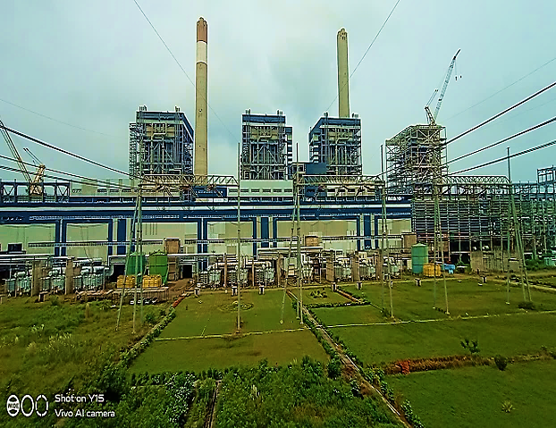

1. **PROJECT LOCATION:** The location of the project is right in the heart of the coal belt in Chhattisgarh-Orissa region which ensures ample availability of high grade of coal nearby. The Project is located at Akaltara Tehsil in Janjgir - Champa District of Chhattisgarh and the Project site is well connected by air, rail & road. The nearest town to the project site is Akaltara which is 10 km north east by road from the site. The National Highway NH-200 runs 0.5 km from the site.

The Bilaspur – Janjgir – Champa – Jharsugudha broad gauge railway line passes within a distance of 5 km from the site. Water is available in adequate quantity from the major perennial river Mahanadi. Thus, the two major ingredients that are required for the functioning of a thermal power plant are easily available nearby, which is a big advantage for it.

For this reason, a number of other new independent power producers have set up or are in the process of setting up coal fired thermal power plants of a total capacity of more than 4000 MW within a radius of 100-150 Km of this plant.

The nearest airport is on the outskirts of Bilaspur, about 43 km from the project site. The condition of the roads is average, which provides connectivity to the Project Site.

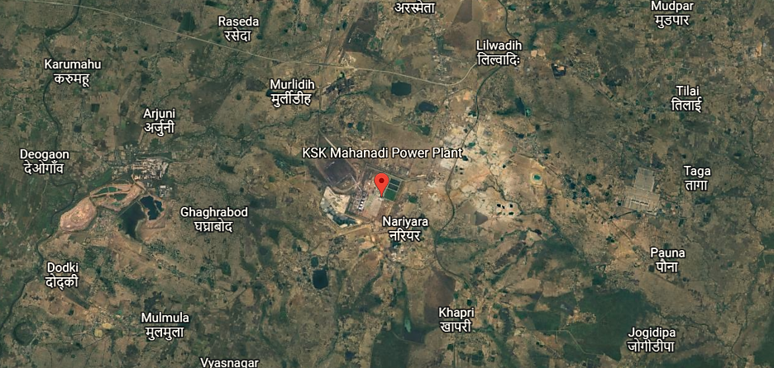

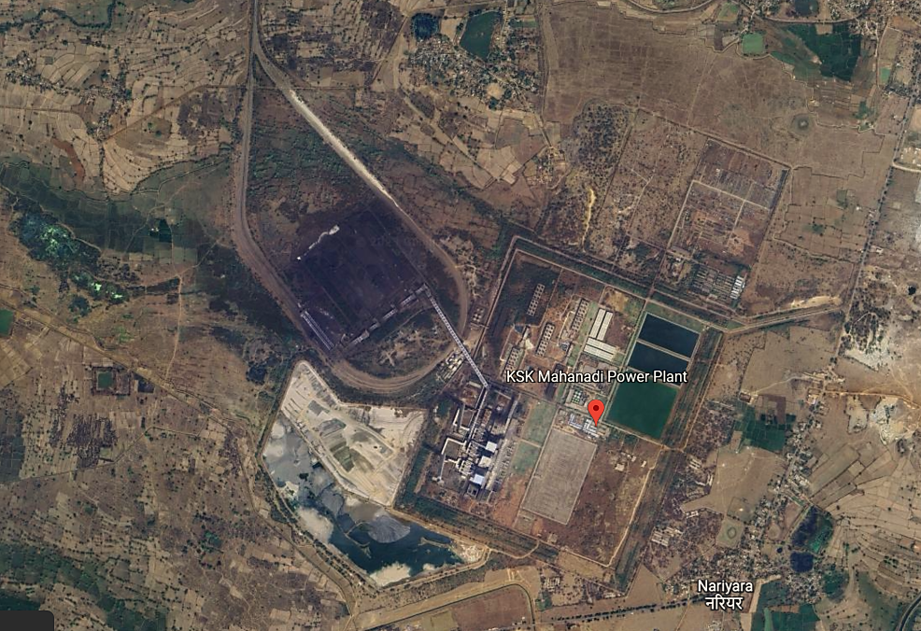

1. **LAND REQUIREMENT:**

For the purpose of setting up the Plant, KMPCL has acquired total land area of 2132.74 acres for the Power Project as shown in the table below:

|  |  |  |  |  |  |  |  |  |  |
| --- | --- | --- | --- | --- | --- | --- | --- | --- | --- |
| **PROJECT LAND AREA: 6x600 MW COAL BASED THERMAL POWER PLANT OF M/S. KSK MAHANADI POWER COMPANY LIMITED, CHHATTISGARH** | | | | | | | | | |
| **S. No.** | **Village** | **Private Land Acquisition** | | **Private Purchase** | | **Govt. Land** | | **Total** | |
| **Acres** | **Hect.** | **Acres** | **Hect.** | **Acres** | **Hect.** | **Acres** | **Hect.** |
| 1 | Nariyana | 111.46 | 45.13 | 554.45 | 224.47 | 284.71 | 115.27 | 950.62 | 384.87 |
| 2 | Tarod | 58.29 | 23.60 | 390.55 | 158.11 | 66.83 | 27.06 | 515.67 | 208.77 |
| 3 | Amora | 138.86 | 56.22 | 123.96 | 50.19 | 72.33 | 29.28 | 335.15 | 135.69 |
| 4 | Rogda | 125.43 | 50.78 | 117.04 | 47.39 | 88.83 | 35.96 | 331.30 | 134.13 |
| **Total** | | 434.04 | 175.72 | 1186.00 | 480.16 | 512.70 | 207.57 | **2132.74** | **863.46** |

*Source: KSKMPCL Management*

1. **IMPLEMENTATION AGREEMENT OR EPC CONTRACT:** The Project is being implemented through a turnkey contract. The Engineering, Procurement and Construction (EPC) contract was executed with M/s. Shangdong Electric Power Construction Corporation (SEPCO), a China based EPC Contractor on 1st April 2009. The brief scope of EPC Contract is as under:
2. Offshore supply:Design, engineering, manufacture, procurement, assembling, shop testing, seaworthy packing, forwarding and delivery of the plant and equipment including commissioning spares, consumables on CFR basis.
3. Offshore services:Basic engineering, design & engineering services, technical services including interfacing integration and demonstration of Performance Guarantee Values of Units as well as training of KMPCL personnel.
4. Onshore supply:Design, engineering, approval of drawings, manufacture, procurement, assembling, shop testing, packing, forwarding, transportation and delivery of the plant and equipment at the site including commissioning spares and consumables.
5. Onshore services: Detailed services including project management, inspection, expediting, supervision of erection, testing and commissioning and such services as may be required from time to time for timely commissioning of the plant.
6. Construction contract:Undertake earthworks, dewatering during construction, grading and leveling, excavation, foundations, buildings, all other civil works, architectural works, structural works, procurement services, project management, expediting, site mobilization, supervising, co-ordination, inspection, contractor’s permits and clearances etc.

**Non- EPC Contracts:** Project Company has also executed Non-EPC Contracts which includes:

* River water Intake System up to the raw water reservoir within plant boundary – Separate SPV
* Rail infrastructure covering tracks for Coal, fuel oil system etc. - Separate SPV
* Wagon Tippler, Training Simulator, CCTV for plant Surveillance, Development of Green belt area
* Transmission lines, External Boundary Wall, Peripheral Storm Drain

According to the philosophy of construction in Phase-I, Phase-II and Phase-III, all Engineering, procurement, supply, construction, commissioning etc. including BOP, CHP, AHP, Switchyard, Rail infrastructure, Water infrastructure, Transmission lines etc. were planned and executed. Therefore, the 1st unit commissioned was Unit-3, then Unit-4 and finally Unit-2.

Main machinery of the plant includes Boiler, Turbine, Generator, Coal Handling Plant, Ash Handling Plant, Water Treatment Plant, Switchyard, Transmission line, Water pipeline system to bring raw water to the plant, and other auxiliary machinery for running the plant. Plant is distributed into different blocks comprising of different buildings as per their utility. These mainly comprise of Industrial Structures consisting of massive steel structural members embedded in RCC base and covered by Industrial heavy duty corrugated steel sheets. Also, some buildings are made out of brickwork and RCC with RCC Roofs.

Some of the Buildings like Power House Building, Steel Structure for Raw Water Pump House etc. are capitalized in the Miscellaneous Equipment’s under P&M head. The list of the buildings capitalized under this head was not provided to us on request. So, it is not possible for our team to segregate the buildings. We have considered the buildings capitalized in the FAR of the subject company for the Valuation purpose under the buildings head in the Fixed Asset Register provided to us for the 3 commissioned units.

Detailed break-up of the Buildings under Buildings head in the FAR is annexed with the report for reference however valuation is done on a complete block of buildings as a whole instead of individual structure. Main sections of the Plant include Boiler House, ESP Building, ESP Control Room, Power House, Service Building, Coal bunker, Switchyard Control room, Control Room, Fly Ash Silos, Chimney among other buildings & sections.

1. **WATER REQUIREMENT & RAW WATER INTAKE SYSTEM:** The total water requirement for the Project is estimated to be 8655 m3/hr. The water will be sourced from River Mahanadi which is about 45 km from the Project Site. To meet the lean flow period of 2 months in the river, it was decided by the Project Company to store 16 MCM of water at an intermediate reservoir.

Presently, the raw water is being pumped from Basantpur pump house to the reservoir in the plant which can cater to the three units of the plant; water is sufficiently available in the plant. It was informed that during the summer months KMPCL can pump 22.51 MCM (12.51 MCM from Basantpur + 10 MCM from Seorinarayan).

1. **RAILWAY SIDING:** As per the information gathered from the last valuation report, the railway siding work from Akaltara railway station till up to the plant boundary and return rail over rail bridges outside the plant boundary was being carried out by the SPV; RCRIPL. The siding work inside the plant boundary is being done by KMPCL only and contracts have been awarded to M/s Jhajharia Nirman Pvt. Ltd. for inside power plant boundary and Track and Towers Pvt. Ltd. for outside the power plant boundary.

However, the railway siding work outside the boundary wall of the subject plant is owned, operated and carried out by RCRIPL which is not under scope of the present valuation, hence, the same is not included in this valuation.

1. **COAL LINKAGE OR FUEL SUPPLY AGREEMENT AND TRANSPORTATION:** For KMPCL, the main source of the fuel is Indigenous Coal which will be supplied from various subsidiaries of Coal India Limited. However, we have not got any latest information about the coal linkage or FSA status in the present exercise on our request. However, below we have described the details available from the previous report in this regard only for reference purpose:

The total requirement of coal for operation of 3,600 MW at 85% PLF works out to ~16 MTPA based on gross station heat rate of 2,240 kcal/kWh and average gross calorific value of about 4,000 kcal/kg. Initially, coal for the Project was to be supplied from the Gare Pelma-III and Morga-II mines through GIDC/GMDC. To offset any delay in start of production from the new Morga-II mine, KMPCL was allocated tapering linkage of 7.49 MTPA for supply of coal to first three units. Subsequently, KMPCL had also entered into Fuel Supply Agreement (FSA) with South Eastern Coalfields Ltd. (SECL) for tapering linkage of 4.994 MTPA and with Eastern Coalfields Ltd. (ECL) for 1.76 MTPA.

However, the coal blocks were de-allocated after the Supreme Court judgment of 24th September 2014. Further, pursuant to directives from Ministry of Coal (MoC), the tapering FSA with SECL has ceased and a Memorandum of Understanding (MoU) has been executed on 13th July 2015 for supplying 67% of LOA quantity on “best effort basis”. Coal will be supplied under this MoU up to 31st March 2016 or until a policy in this regard is formulated by MoC, whichever is earlier.

As per previous report, KMPCL has been sourcing fuel from the open market including under the special forward e-auction for power sector by Coal India Limited (CIL) and coal imports, post the de-allocation of the Morga II and Gare Pelma III coal blocks tied up by the company as per the Supreme Court order dated September 24, 2014. However, the company was able to secure fuel linkage for supply of 6 MTPA (metric tons per annum) through the first reverse auction held by CIL for allocation of coal linkages under the SHAKTI policy.

Govt. of India in the month of May 2017 announced a policy for allocation of coal linkage auction for power sector, under ‘Shakti’ Scheme. Coal linkage under the policy for IPP’s with PPA’s would be based on bid for discount to existing tariffs. KMPCL had participated in the ‘Shakti’ Scheme for allocation of coal linkage for the existing units wherein the PPA tie up was in place. The fuel supply agreement (FSA) under this linkage was expected to be signed shortly with CIL, however we do not have the present status with us. This linkage was estimated to be sufficient for meeting about 38% of the fuel requirement of the project at 80% PLF. However, the fuel supply risk persisted for the remaining capacity.

KMPCL has been declared successful bidder pursuant to the Auction Process under ‘Shakti Scheme’, and was allocated the following:

|  |  |  |  |
| --- | --- | --- | --- |
| **Successful Bidder** | | | |
| **S. No.** | **CIL Subsidiary** | **Quantity Allotted (Tonnes)** | **Indicative Grade of Coal** |
| **1** | Mahanadi Coalfields Limited | 11,00,000 | G12-G14 |
| **2** | South Eastern Coalfields Limited | 12,00,000 | G5-G6 |
| **3** | South Eastern Coalfields Limited | 45,00,000 | G10-G15 |
| **4** | Mahanadi Coalfields Limited | 20,700 | G13 |
| **Total** | | **68,20,700** |  |

For imported coal KMPCL had signed a sale agreement with M/s Ask RE Ltd. on 15th October, 2015 for a quantity of 1,50,000 MT+/- 4% having a typical GCV of 5900 kcal/kg and a rejection limit of less than 5700 kcal/kg. The coal shall be sourced from Gangavaram port. Akaltara railway station is the nearest station to the power plant (10 km). As per previous report, Coal that will be transported to the Project by rail will use the Indian Railway network up to Akaltara railway station and thereafter use the railway siding up to the power plant for the transportation of coal.

1. **POWER PURCHASE AGREEMENT:** As per the Technical Study Report preparedby L&T – Sargent & Lundy Ltd. dated 16th December, 2020; the subject company has executed various Power Purchase Agreements (PPA) with Power DISCOMs as given in the table below:

| **PPA Details** | | | | |
| --- | --- | --- | --- | --- |
| **S. No.** | **Counter Party** | **Contracted Capacity (MW)** | **Original PPA Date** | **PPA Term** |
| 1 | GUVNL (under sub judice with GSERC) | 1010 MW | 03-Jun-2010 | 25 years |
| 2 | CSPTradeco | ~90 MW (5% aggregate capacity of the Unit or the Power Station; 90 MW considering 3 units in operation) | 18-Oct-2013 | Perpetual |
| 3 | TANGEDCO | 500 MW | 27-Nov-2013 | 15 years |
| 4 | UP DISCOM | 1000 MW | 26-Feb-2014 | 25 years |
| **Total** | | **2,600 MW** |  |  |

**PPA executed with GUVNL of 1010 MW is under sub-judice before Hon’ble GERC. Therefore, total capacity for which PPAs have been executed is 1,590 MW only.**

1. **POWER EVACUATION ARRANGEMENT:** As per Fixed Asset Valuation Report (VIS (2022-23)-PL463-Q102-454-776), the initial plan for power evacuation was through 2 double circuit 400 kV lines to PGCIL’s 800 kV HVDC/765 kV/400 kV Champa pooling station, but due to the delay in commissioning of the Champa substation, the Generated power was being evacuated through a 400 kV double circuit LILO connection with PGCIL’s existing Raipur–Raigarh transmission line i.e., Line 1.
2. **OPERATIONS AND MAINTENANCE (O&M) AGREEMENTS:** As per the Technical Study Report preparedby L&T – Sargent & Lundy Ltd. dated 16th December, 2020; the subject company has engaged various O&M (Operations & Maintenance) contractors for various O&M activities of different activities of the plant as tabulated below:

| **O & M Agreement Details** | | | |
| --- | --- | --- | --- |
| **S. No.** | **Package Description** | **Agency Name** | **Contract Completion Date** |
| 1 | Ash Handling Plant (AHP) | Globus Engineers | 31-10-2021 |
| 2 | Coal Handling Plant (CHP) | McNally Bharat | 31-10-2021 |
| 3 | BTG & BOP (Non-Water Block)-O&M Services | Power Mech Projects Limited | 31-07-2021 |
| 4 | BOP-Chemistry O&M Services-Contract | Ion Exchange India Limited | 31-07-2021 |
| 5 | Analysis of Coal & Ash Samples (outside Plant) | Therapeutics Chemical Research Corporation | 30-04-2021 |
| 6 | Electrical and C&I Except CHP & AHP | Voltech O and M Services Pvt. Ltd | 30-06-2021 |
| 7 | Coal and Ash Sampling (Inside Plant) | Quality Services and Solutions | 31-07-2021 |
| 8 | Occupational Health Centre (OHC) | Renuka Diagnosis | 31-07-2021 |
| 9 | Coal Yard Management, Coal Quality & Quality Management and Crushing of coal | Refex Industries Limited | 30-04-2021 |
| 10 | O&M Special Services of BTG & it's Auxiliaries of 3 Units | Operational Energy Group India Ltd | 30-04-2021 |
| 11 | O&M Special Services of BOP (Excluding CHP & AHP) of 3 Units | Operational Energy Group India Ltd | 30-04-2021 |
| 12 | O&M Special Services of C&I systems of BTG & BOP (Excluding CHP & AHP) of 3 Units | Operational Energy Group India Ltd | 30-04-2021 |
| 13 | O&M Special Services of Electrical systems of BTG & BOP (Excluding CHP & AHP) of 3 Units | Operational Energy Group India Ltd | 30-04-2021 |
| 14 | Facility Management Services | Operational Energy Group India Ltd | 30-09-2021 |
| 15 | O&M Services of PS-1, Plant end switchyard, pipeline and Transmission Line Electrical systems of BTG & BOP (Excluding CHP & AHP) of 3 Units | ACB(INDIA) Power Limited | 31-05-2021 |
| 16 | Private Railway Siding | ACB(INDIA) Power Limited | 31-05-2021 |
| 17 | O&M of 400kV Double Circuit Line (Water) | ACB(INDIA) Power Limited | 31-05-2021 |
| 18 | Disposal of Fly Ash | Ramky Infrastructure Limited | 31-05-2021 |
| 19 | Disposal of Pond Ash | Ramky Infrastructure Limited | 31-05-2021 |
| 20 | Post Project Environmental Monitoring Studies | Vimta Labs Limited | 31-03-2021 |
| 21 | Round the clock Security Services for Open Material Store Yard Area Inside Plant | Megha Security Services | 30-06-2021 |

***All these contracts have been expired already and there is no latest information on whether these are renewed or not has been provided to us by the company.***

|  |  |
| --- | --- |
| **PART D** | **MARKET OVERVIEW ON POWER SECTOR** |

1. **INTRODUCTION:** Indian economy is continuously moving on a higher trajectory since last 2 decades. In last 10 years India has continuously maintained GDP growth rate in the range of 5.5% to 8%. Post Covid Recovery resulting Gross Domestic Product GDP growth rate for year 2021 is 8.7%. Due to adverse impact of Covid pandemic GDP growth rate in 2020 was negative (-6.60%) while average of last two decades is still shows a number of 5.88%.

Power is one of the most critical components of infrastructure, crucial for the economic growth and welfare of nations. The existence and development of adequate infrastructure is essential for sustainable growth of the Indian economy.

Electricity demand in the country has increased rapidly and is expected to rise further in the years to come. In order to meet the increasing demand for electricity in the country, massive addition to the installed generating capacity is required. India ranked sixth in the list of countries to make significant investments in clean energy at US$ 90 billion. India is the only country among the G20 nations that is on track to achieve the targets under the Paris Agreement.

Indian power sector is undergoing a significant change that has redefined the industry outlook. Sustained economic growth continues to drive electricity demand in India. The Government of India’s focus on attaining ‘Power for all’ has accelerated capacity addition in the country. India was ranked fourth in wind power, fifth in solar power and fourth in renewable power installed capacity, as of 2020. India is the only country among the G20 nations that is on track to achieve the targets under the Paris Agreement.

1. **MARKET SIZE:** India is the third-largest producer and consumer of electricity worldwide, with an installed power capacity of 408.71 GW of which 39.7 percent was generated from renewable sources as of October 31, 2022. Total installed generation capacity of 384GW transformed country from a power deficit to a power surplus country. India is well on its way to achieving and surpassing its nationally determined contribution (NDC) target which was 40% capacity by non-fossil-fuel sources by 2030.

As of October 31, 2022, India’s installed renewable energy capacity (including hydro) stood at 165.94 GW. Solar energy is estimated to contribute 61.62 GW, followed by 41.84 GW from wind power, 10.70 GW from biomass, 4.92 GW from small hydropower, and 46.85 GW from hydropower. The non-hydro renewable energy capacity addition stood at 4.2 GW for the first three months of FY23 against 2.6 GW for the first three months of FY22.

With electricity generation (including renewable sources) of 846.18 BU in India between April-September 2022, the country witnessed a growth of 10.67% YoY. According to data from the Ministry of Power, India's power consumption increased 1.64% YoY in October 2022 to 114.64 BU. The peak power demand in the country stood at 210.79 GW on June 9, 2022. All India actual PLF of thermal power plants stood at 68.24% in June 2022, compared with 67.92% in May 2022.

Conventional power generation capacity to be commissioned by 2024-25 is at various stages of construction in the country which includes Thermal 36,765 MW, Hydro 10,164.50 MW and Nuclear 9,900 MW. The private sector in the power industry in India generates 49.4% of the country’s thermal power, whereas States and the Centre generate 24.6% and 26.0%, respectively.

As of May 2022, India has a total Thermal installed capacity of 236.1 GW of which 58.6% of the thermal power is obtained from coal and the rest from Lignite, Diesel, and Gas. About 80525 MT of biomass has been co-fired in 35 Thermal power plants in the country with a cumulative capacity of 55335 MW till 24th July 2022. While 14 out of these plants belong to NTPC, there are 21 power plants from the State and Private sector, thus, quadrupling the number of plants within a year.

1. **GOVERNMENT INITIATIVES:** The Government of India has identified power sector as a key sector of focus to promote sustained industrial growth. Some initiatives by the Government to boost the Indian power sector are as below:

* 100% FDI allowed in the power sector has boosted FDI inflow in this sector.
* Schemes such as Deen Dayal Upadhyay Gram Jyoti Yojana (DDUGJY) and Integrated Power Development Scheme (IPDS) are expected to augment electrification across the country.
* Under the Union Budget 2022-23, the government announced the issuance of sovereign green bonds, as well as conferring infrastructure status to energy storage systems, including grid-scale battery systems.
* In the Union Budget 2022-23, the government allocated Rs. 19,500 crore (US$ 2.57 billion) for a PLI scheme to boost manufacturing of high-efficiency solar modules.
* As of August 24, 2022, over 36.86 crore LED bulbs, 72.18 lakh LED tube lights and 23.59 lakh energy-efficient fans have been distributed across the country, saving around 48,411 million kWh per year and around Rs. 19,332 crore (US$ 2.47 billion) in cost savings.
* As of November 2022, over 51.62 lakh smart metres have been deployed under the National Smart Grid Mission (NSGM), with a further 61.13 lakh to be deployed.
* Under the Union Budget 2022-23, the government announced the issuance of sovereign green bonds, as well as conferring infrastructure status to energy storage systems, including grid-scale battery systems.
* In the Union Budget 2022-23, the government allocated Rs. 19,500 crore (US$ 2.57 billion) for a PLI scheme to boost manufacturing of high-efficiency solar modules.
* As of August 24, 2022, over 36.86 crore LED bulbs, 72.18 lakh LED tube lights and 23.59 lakh energy-efficient fans have been distributed across the country, saving around 48,411 million kWh per year and around Rs. 19,332 crore (US$ 2.47 billion) in cost savings.
* As of November 2022, over 51.62 lakh smart metres have been deployed under the National Smart Grid Mission (NSGM), with a further 61.13 lakh to be deployed.
* Industries and infrastructure sectors including the power/energy efficiency sectors with in-house R&D centers get a write-off in revenues and capital expenditure incurred on R&D.
* India offers additional incentives for industrial projects in certain states. Incentives are in areas such as rebates in land cost, the relaxation of stamp duty exemption on the sale and lease of land, power tariff incentives, a concessional rate of interest on loans, investment subsidies, tax incentives, backward area subsidies and special incentive packages for mega projects.

1. **RECENT INVESTMENTS:** Total FDI inflows in the power sector reached US$ 16.39 billion between April 2000-June 2022, accounting for 2.71% of the total FDI inflow in India. Some major investments and developments in the Indian power sector are as follows:

* In October 2022, SJVN started commissioning its 75 MW Solar Power Project in Parasan Solar Park which is located at Tehsil Kalpi, District Jalaun near Kanpur, Uttar Pradesh.
* In August 2022, NHPC Limited and the Government of Himachal Pradesh inked an implementation agreement for the 500 MW Dugar Hydroelectric Project in the Chamba District of Himachal Pradesh.
* In June 2022, SJVN signed investment agreements worth Rs. 80,000 crore (US$ 10.24 billion) with the Uttar Pradesh government for implementing three solar power projects in the state.
* In August 2022, Norfund, who manage the Norwegian Climate Investment Fund, and KLP, Norway’s biggest pension company, signed an agreement to buy a 49% share of a 420 MW solar power plant in Rajasthan for Rs. 2.8 billion (US$ 35.05 million), Tata Power Green Energy Limited (TPGEL), a wholly-owned subsidiary of Tata Power, commissioned a 225MW hybrid power project in Rajasthan & NHPC signed a MoU with the Investment Board Nepal (IBN) to develop 750 MW West Seti and 450 MW SR-6 Hydroelectric Projects in Nepal.
* In July 2022, NTPC signed a MoU with MASEN (Moroccan Agency for Sustainable Energy) for cooperation in the renewable energy sector.
* In June 2022, NHPC signed an engineering, procurement, and construction (EPC) contract with Adani Infra Limited to develop a 600 MW solar project under the Central Public Sector Undertaking program (Phase-II).
* In March 2022, NTPC announced that it was ready to start partial power generation of 10 GW from a 92 MW floating solar energy plant being set up at NTPC's unit at Kayamkulam in Kerala and NTPC announced that it will start commercial operations of 74.88 MW capacity of its 296 MW Fatehgarh solar project in Rajasthan.
* In March 2022, Adani Solar and Smart Power India (SPI), a subsidiary of Rockefeller Foundation, signed a non-financial and non-commercial MoU promote the usage of solar rooftop panels in rural India.

1. **WAY FORWARD:** India is firmly on a growth path and government’s focus on infrastructure, housing, manufacturing bodes well for the electricity demand in the country in the long run. To reinvigorate the ailing DISCOMS, government has introduced UDAY scheme and most of the states have already joined it. The DISCOMS should be able to gradually improve their performance if they continue to pursue the prescribed operational reforms.

The Government of India is preparing a 'rent a roof' policy for supporting its target of generating 40 GW of power through solar rooftop projects by 2022. It also plans to set up 21 new nuclear power reactors with a total installed capacity of 15,700 MW by 2031.

The Central Electricity Authority (CEA) estimates India’s power requirement to grow to reach 817 GW by 2030. Also, by 2029-30, CEA estimates that the share of renewable energy generation would increase from 18% to 44%, while that of thermal energy is expected to reduce from 78% to 52%. The government plans to establish renewable energy capacity of 500 GW by 2030.

|  |  |
| --- | --- |
| **PART E** | **FINANCIAL PERFORMANCE** |

As per the audited financial statements provided by the company/client, below table shows the historical performance of the company.

1. **HISTORICAL PROFIT & LOSS STATEMENT: (FY 2018-19 to FY 2021-22)**

*(Figures in INR Crores)*

|  |  |  |  |  |  |  |  |
| --- | --- | --- | --- | --- | --- | --- | --- |
| **Particulars** | **FY 2018 A** | **FY 2019 A** | **FY 2020 A** | **FY 2021 A** | **FY 2022 A** | **DEC. 2022 P** | **FY 2023 E\*** |
| Revenue from operations | 2,746.73 | 3,674.45 | 4,427.06 | 4,275.69 | 4,192.55 | 3,767.85 | 5,023.80 |
| Other income | 58.33 | 226.46 | 343.65 | 236.16 | 79.78 | 485.54 | 647.39 |
| **Total revenue** | **2,805.06** | **3,900.91** | **4,770.71** | **4,511.85** | **4,272.33** | **4,253.39** | **5,671.19** |
| Cost of fuel consumed | 1,755.07 | 1,726.08 | 2,800.58 | 2,108.53 | 2,012.61 | 3,198.49 | 3,198.49 |
| Employee benefits expenses | 55.92 | 77.82 | 65.42 | 76.28 | 79.65 | 79.51 | 79.51 |
| Other expenses | 363.69 | 1,877.84 | 1,516.57 | 1,358.41 | 689.66 | 777.85 | 777.85 |
| **Total expenses** | **2,174.68** | **3,681.74** | **4,382.57** | **3,543.22** | **2,781.92** | **4,055.85** | **4,055.85** |
| **EBITDA** | **630.38** | **219.17** | **388.14** | **968.63** | **1,490.41** | **1,615.33** | **1,615.33** |
| Dep. & amortization expenses | 518.82 | 697.91 | 695.21 | 679.41 | 672.38 | 675.91 | 675.91 |
| **EBIT** | **111.56** | **-478.74** | **-307.07** | **289.22** | **818.03** | **939.43** | **939.43** |
| Finance costs | 1,851.45 | 76.78 | 54.97 | 36.31 | 38.94 | 32.61 | 32.61 |
| **Profit / (loss) before tax** | **-1,739.89** | **-555.52** | **-362.04** | **252.91** | **779.09** | **906.81** | **906.81** |
| Deferred tax | -178.74 | 153.97 | 162.09 | 166.96 | 447.67 | - | - |
| Income Tax Expense |  |  |  |  |  |  | 264.06 |
| **Total tax expenses / (income)** | **-178.74** | **153.97** | **162.09** | **166.96** | **447.67** | **0.00** | **264.06** |
| **Profit / (loss) after tax** | **-1,561.15** | **-709.49** | **-524.13** | **85.95** | **331.42** | **906.81** | **642.75** |
| Items that will not be reclassified to profit & loss | -0.18 | -1.88 | -2.66 | -1.83 | 3.08 | - | - |
| Income tax relating to items that will not be reclassified to profit & loss | 0.06 | 0.66 | 0.93 | 0.64 | -0.77 | - | - |
| **Total Comprehensive Income** | **-1,561.27** | **-710.71** | **-525.86** | **84.76** | **333.73** | **906.81** | **642.75** |

**\*Note:** To calculate the FY 2023’s data**,** we have estimated on the basis of provisional data dated 31st december 2023 to deduce the annual financial numbers and assumed a corporate tax rate of 29.12% as the deferred tax is nil as per the notes in the provisional report dated 31st December 2023.

1. **KEY FINANCIAL RATIOS:**

|  |  |  |  |  |  |  |
| --- | --- | --- | --- | --- | --- | --- |
| Particular | FY 2018 A | FY 2019 A | FY 2020 A | FY 2021 A | FY 2022 A | FY 2023 E |
| EBITDA Margin % | 22.95% | 5.96% | 8.77% | 22.65% | 35.55% | 32.15% |
| EBIT Margin % | 4.06% | -13.03% | -6.94% | 6.76% | 19.51% | 18.70% |
| Net Profit Margin% | -56.84% | -19.31% | -11.84% | 2.01% | 7.90% | 12.79% |
| Revenue Growth (Y.O.Y.) | - | 33.78% | 20.48% | -3.42% | -1.94% | 19.83% |

1. **GRAPHICAL REPRESENTATION OF THE KEY FINANCIALS OF THE COMPANY:**

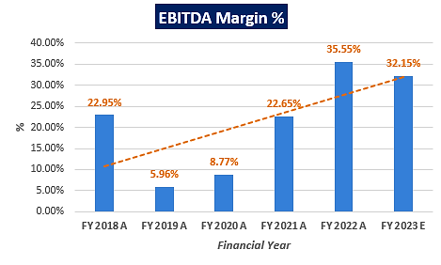

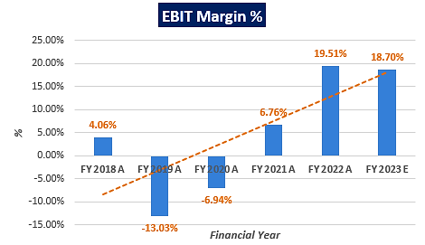

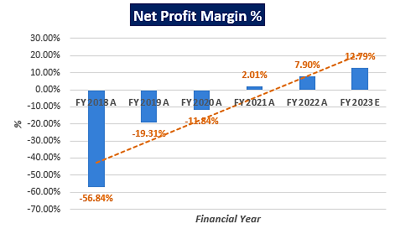

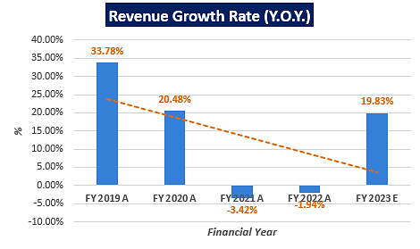

***Notes:***

As per the historical analysis, it is observed that EBITDA Margin of the company is showing an upward trend as it has gone up from 22.95% in FY 2017-18 to 35.55% in FY 2021-22 but dipped to 32.15% in FY2022-23 due to increase in cost of fuel.

As per the historical analysis, it is observed that EBIT Margin of the company is showing an upward trend as it has gone up from 4.06% in FY 2017-18 to 19.51% in FY 2021-22 but dipped to 18.70% in FY2022-23 due to increase in cost of fuel.

As per the historical analysis, it is observed that Net Profit Margin of the company is rising continuously from -56.84% in FY 2017-18 to 12.79% in FY 2022-23.

Revenues Growth of the company is constantly declining during the past recent years historically but jumped in the FY 2022-23 as per the provisional quarterly numbers shared by the company/client.

|  |  |
| --- | --- |
| **PART F** | **VALUATION OF THE COMPANY** |

1. **METHODOLOGY/ MODEL ADOPTED:** Out of the various models & theories available, we have adopted the most widely used & acceptable approach to calculate the Enterprise Value of the Company, which is, Income based approach (Discounted Cash Flow Model).
2. The free cash flow method is similar to the method used for public companies.
3. FCFF is more practical when substantial capital changes are expected because weighted average cost of capital (WACC) is less sensitive to the cost of equity.
4. In this method, we calculate the free cash flow to firm (FCFF) for the projected period.
5. Finally, we calculate the present value of future cash flows by using a required rate of return based on the riskiness of the project, which we determine by using the Weighted Average Cost of Capital (WACC).

**RATIONALE FOR USING DCF METHOD FOR ENTERPRISE VALUATION:**

1. The three broadly used approaches of the company/Business Valuations are – Income based approach (Discounted Cash Flow Model), Asset Based Approach (Net Asset Value Method) and Relative Valuation Approach (Market Multiple method).
2. Asset Based Model is inappropriate as the Company is a going concern and the model is unable to capture the Value of the company.
3. Market Multiple Approach is also not suitable as the company is not listed and no proper similar recent comparable transactions are available.
4. Instead, DCF method is used which determines the value of a business based on its ability to generate desired economic benefit/ cash flows for the owners. Thus, considering the nature of business, we have used DCF method for valuing the Company.
5. The DCF Model gives us a variety of input options to use while calculating the Value of the firm - Dividend, Free Cash Flow to the Firm, Free Cash Flow to Equity, Capitalized Cash Flows and Residual Earnings.
6. Dividends cannot be used as the Company has no history of paying dividends and we don’t foresee any dividend payments to occur in the future due to the high leverage of the firm.
7. The best method input option for the PV Model in the case of M/s KSK Mahanadi Power Company Limited will be FCFF as it represents the benefits accruable to all the stakeholders in the Business enterprise.

**FCFF Model Formula and Key Inputs:**

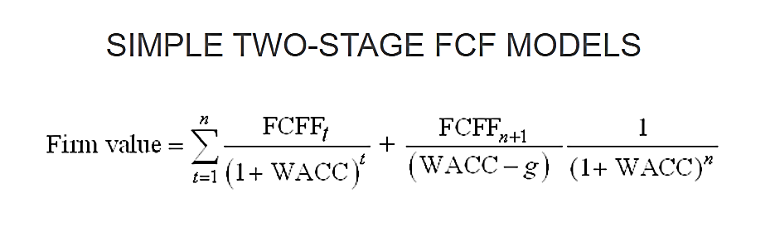

* **Free Cash Flow to Firm (FCFF):** FCFF is the [cash](http://www.investinganswers.com/node/5011) available to pay investors after a company pays its costs of doing business, invests in short-term assets like [inventory](http://www.investinganswers.com/node/2474), and invests in assets like property, plants and equipment.

*FCFF = Net Income + Non-Cash Charges + Interest (1 - tax rate) – Working Capital Investment – Fixed Capital Investment.*

* **Weighted Average Cost of Capital (WACC):**The weighted average cost of capital (WACC) is the rate that a company is expected to pay on average to all its security holders to finance its assets. The WACC is commonly referred to as the firm’s cost of capital. WACC is used as the discount rate to discount FCFF.

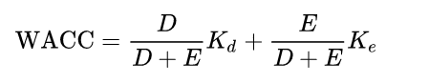

Where D is the total debt, E is the shareholders equity and Kd and Ke are the cost of debt and cost of equity, respectively.

1. **CALCULATION OF FREE CASH FLOW TO FIRM:**

(Value in INR Crores)

|  |  |  |  |  |  |  |
| --- | --- | --- | --- | --- | --- | --- |
| **Particulars** | **FY 2023 E** | **FY 2024 E** | **FY 2025 E** | **FY 2026 E** | **FY 2027 E** | **Perpetuity** |
| **No. of Months** | **1** | **12** | **12** | **12** | **12** |
| Revenue from operations | 5,023.80 | 5,099.16 | 5,175.64 | 5,266.22 | 5,358.38 | 5,425.36 |
| Other Income | 647.39 | 309.02 | 313.66 | 319.15 | 324.73 | 328.79 |
| **Total revenue** | **5,671.19** | **5,408.18** | **5,489.30** | **5,585.37** | **5,683.11** | **5,754.15** |
| Cost of fuel consumed | 3,198.49 | 2,848.03 | 2,890.75 | 2,941.34 | 2,992.81 | 3,030.22 |
| Employee benefits expenses | 79.51 | 92.62 | 94.01 | 95.65 | 97.33 | 98.54 |
| Other expenses | 777.85 | 742.53 | 753.67 | 766.86 | 780.28 | 790.03 |
| **Total expenses** | **4,055.85** | **3,683.18** | **3,738.43** | **3,803.85** | **3,870.42** | **3,918.80** |
| **EBITDA** | **1,615.33** | **1,725.00** | **1,750.88** | **1,781.52** | **1,812.69** | **1,835.35** |
| Depreciation and amortisation expenses | 675.91 | 585.17 | 554.78 | 525.97 | 498.66 | 498.66 |
| **EBIT** | **939.43** | **1,139.83** | **1,196.09** | **1,255.55** | **1,314.04** | **1,336.70** |
| Tax Rate (T) | 29.12% | 29.12% | 29.12% | 29.12% | 29.12% | 29.12% |
| (1-T) | 70.88% | 70.88% | 70.88% | 70.88% | 70.88% | 70.88% |
| **NOPAT= EBIT*(1-T)** | 665.87 | 807.91 | 847.79 | 889.93 | 931.39 | 947.45 |
| Add: Depreciation & Amortization | 675.91 | 585.17 | 554.78 | 525.97 | 498.66 | 498.66 |
| Less: Changes in Working Capital | 0.00 | 0.00 | 0.00 | 0.00 | 0.00 | 0.00 |
| Less: CAPEX | 0.00 | 0.00 | 0.00 | 1,026.00 | 1,026.00 | 0.00 |
| **Free Cash Flow to Firm (FCFF)** | 1,341.77 | 1,393.08 | 1,402.57 | 389.90 | 404.05 | 1,446.11 |
| **FCFF for Remaining Year** | **111.81** | **1,393.08** | **1,402.57** | **389.90** | **404.05** | **1,446.11** |
| **Discount Rate (WACC)** | 14.25% | | | | | |
| **Growth Rate** | 1.25% | | | | | |
| Period | 0.08 | 1.08 | 2.08 | 3.08 | 4.08 | - |
| Discount Factor | 0.99 | 0.87 | 0.76 | 0.66 | 0.58 | - |
| Terminal Value |  |  |  |  | 11,123.89 | - |
| **PV of FCFF** | **110.58** | **1,205.87** | **1,062.65** | **258.56** | **234.52** | - |
| **PV of terminal Value** |  |  |  |  | 6,456.70 | - |
| **PV of FCFF + PV of TV** | 110.58 | 1,205.87 | 1,062.65 | 258.56 | 6,691.22 | - |
| **Enterprise Value of the Firm** | **9,328.88 Crores** | | | | | |

1. **KEY INPUTS USED TO DISCOUNT CASH FLOWS DURING THE PROJECTION PERIOD:**

|  |  |
| --- | --- |
| **Inputs** | |
| **Valuation Date** | **1st March 2023** |
| **Discount Rate** | **14.25 %** |
| **Discount Rate Change** | **1%** |
| **Tax Rate** | **29.12 %** |

**Calculation of WACC for M/s KMPCL**

|  |  |
| --- | --- |
| **Weighted Average Cost of Capital** | |
| Expected Market Return (Rm) Nifty Fifty 10-year return 2022 | 13.00% |
| Company Risk Premium | 1.25% |
| **Appropriate Discount Rate** | **14.25%** |

***Note:*** *Discount Rate Change of 1% is used to calculate the Sensitivity of the Enterprise Valuation with +/- changes in discount rate.*

1. **CALCULATION OF ENTERPRISE VALUE:**

(Value in INR Crores)

|  |  |  |  |
| --- | --- | --- | --- |
| **Discount Rate** | **13.25%** | **14.25%** | **15.25%** |
| **PV of Free Cash Flow Over Projection Period** | 2,919.12 | 2,872.19 | 2,826.60 |
| **PV of Terminal Value** | 7,250.41 | 6,456.70 | 5,785.91 |
| **Enterprise Value** | 10,169.54 | **9,328.88** | 8,612.51 |

Thus, M/s KSK Mahanadi Power Company Limited is having an Enterprise value of INR 9,328.88 Crores while all the assumptions according to company’s audited financials have been considered.

|  |
| --- |
| **ENTERPRISE VALUE OF M/S KSK MAHANADI POWER COMPANY LIMITED** |
| **INR NINE THOUSAND THREE HUNDRED TWENTY-EIGHT CRORES AND EIGHTY-EIGHT LAKHS**  **(INR 9,328.88 CRORES)** |

***NOTE:***

* *This is just the enterprise valuation of the project based on its income generating capacity in future years. This Valuation shall not be construed as the physical asset or should be directly related to cost approach or Project cost.*
* *Currently, the company has signed PPAs of 1590 MW out of the installed capacity of 1800 MW and the prospective buyer/investor/company can benefit from signing additional PPAs to use its full installed capacity.*
* *In absence of the operational details of the plant, we have relied upon the historical data to forecast the financial projections as per the industry standards.*
* *For the prospective buyer/investor/company, there is an additional advantage in acquiring this plant as the company has already incurred about 20%-25% of CAPEX to double its installed capacity to 3600 MW from the current level of 1800 MW. Hence, the investor can expand the capacity of the plant by incurring only partial CAPEX.*
* *We are of the viewpoint that the power industry growth and demand for the power consumption will be higher in the future years, which will increase the demand for the thermal power generation plants as a result of it.*

1. **SENSITIVITY ANALYSIS:**
2. **WACC** is the key input which has strong impact on the firm’s value with respect to percentage change. We have considered a change of **1%** to perform the sensitivity analysis.

|  |  |
| --- | --- |
| **Scenario** | **WACC** |
| **Optimistic Case** | 13.25% |
| **Base Case** | 14.25% |
| **Pessimistic Case** | 15.25% |

1. **REVENUE GROWTH RATE (FOR FIRST 5 YEARS)** is the key input to calculate the Enterprise Value during assessing the firm’s value. We have considered a change of **1.50%** to perform the sensitivity analysis.

|  |  |
| --- | --- |
| **Scenario** | **Growth Rate** |
| **Optimistic Case** | 3.00% - 3.25% |
| **Base Case** | 1.50% - 1.75% |
| **Pessimistic Case** | 0.00% - 0.25% |

1. **ENTERPRISE VALUE OF THE FIRM IN THE DIFFERENT SCENARIO:**

|  |  |  |  |  |
| --- | --- | --- | --- | --- |
| **INR 9,328.88 Crore** | | **Revenue Growth Rate (for first 5 years)** | | |
| ***0.00% - 0.25%*** | ***1.50% - 1.75%*** | ***3.00% - 3.25%*** |
| **Discount Rate** | ***13.25%*** | 9,666.82 | 10,169.54 | 10,692.88 |
| ***14.25%*** | 8,870.63 | **9,328.88** | 9,805.78 |
| ***15.25%*** | 8,192.22 | 8,612.51 | 9,049.76 |

Thus, in the base case M/s KMPCL is having the Enterprise Value **INR 9,328.88 Crore** and it may vary up to **INR 10,692.88 Crore** as optimistic case and **INR 8,192.22 Crore** as the pessimistic case. However, as per sensitivity analysis, the final transaction price will be dependent on the bargaining power of market participants to reach out to a successful outcome for all the concerned parties.

Hence, using two-stage DCF Model, considering as a base case the Enterprise Value of “M/s KSK Mahanadi Power Company Limited” is being calculated as **INR 9,328.88 Crores**, subject to the current assumptions and inputs used during the forecasted period, as well as the revenue growth rate (for first five years) and WACC used to calculate the EV.

*This is only a general assessment of the Enterprise/Business Value of the firm based on the data/ input Company officials could provide to us against our questions/ queries and information available in the public domain. In no manner this should be regarded as an audit activity/ report and NO micro analysis or detailed or forensic audit/ scrutiny of the financial transactions or accounts of any kind has been carried out at our end.*

1. **KEY ASSUMPTIONS AND WORKINGS:** Assumptions in the Valuation assessment have been taken based on data/ information/ documents shared by the Company, Operating History of the Plant, Annual Reports of the company, Market & Industry analysis. Assumptions have been considered after thoroughly reviewing their feasibility.
2. **FREE CASH FLOW TO FIRM:**  After the preparation of projections, we have calculated the Free Cash Flow to Firm for the particular year during the explicit period, which was calculated after adjusting the Non-Cash Expenses, Working Capital Changes and Capex with the Net Operating Profit after taxes (NOPAT).
3. **OTHER INCOME & OPERATING EXPENSES:** In the absence of the relevant information available with us we have the estimated the Other Income and Operating Expenses during the projection period we have used the average of the historical expenses with respect to the operating revenues as per the best practices used in the industry.

|  |  |  |  |  |  |  |  |
| --- | --- | --- | --- | --- | --- | --- | --- |
| **Particulars** | **FY 2018 A** | **FY 2019 A** | **FY 2020 A** | **FY 2021 A** | **FY 2022 A** | **FY 2023 E** | **Average** |
| Other income | 2.12% | 6.16% | 7.76% | 5.52% | 1.90% | 12.89% | 6.06% |
| Cost of Fuel | 63.90% | 46.98% | 63.26% | 49.31% | 48.00% | 63.67% | 55.85% |
| Employee benefits expenses | 2.04% | 2.12% | 1.48% | 1.78% | 1.90% | 1.58% | 1.82% |
| Other Expenses W/O Prov. | 13.24% | 51.11% | 13.21% | 13.10% | 16.45% | 15.48% | 14.56% |

***Note:*** *For other expenses percentage with respect to operating revenue, we have excluded extraordinary expenses incurred during a particular year to find a more accurate estimation of the forecasted numbers.*

1. **GROWTH RATE:**

* **Projected Period (For first five years):** The annual growth rate for the projections of the first two years has been considered as 1.50% and as per our independent research and the information available on the public domain, the implementation of FGD would raise the electricity tariff, which has been considered in our valuation exercise. Hence, post FGD installation which is from 3rd Year onwards, we have considered annual growth year of 1.75% (an annual increment of 0.25% to the projected years’ annual growth rate of 1.50%), which is in the line and on conservative side in comparison with the respective sector and industry.

**Due to above reasons, the operating income in the upcoming years might fluctuate in accordance to the tariff adjustments made by the respective authorities to incorporate the cost of installing FGD units for operational and brown-field projects.**

* **Perpetual Period:** Perpetual Growth rate has been considered as 1.25%, which is in the line and on conservative side in comparison with the respective sector and industry.

1. **DEPRECIATION:** As per historical trend, we have considered the escalation rate for depreciation as 5.19% with respect to total depreciable assets for those years, which seems to be reasonable to keep a mark-up for future market & economic risks in the Project.
2. **OTHER INCOME:** Historically, other income consists of the interest earned on the fixed deposit, and as per information provided by client, a clause is added in the [Request for Resolution Plan](http://www.lavasa.com/pdf/RfRP-dated-21052019.pdf) (RFRP) Document which states that all cash balances and cash equivalent available with the Corporate Debtor as on the Cut-Off Date, whether freely available or lien marked, shall be for the sole benefit, and to the order of, the financial creditors and shall be paid to the financial creditors in the same manner as the Upfront Cash Recovery payable to financial creditors. Hence, in the projected years, other income is considered as zero.
3. **DISCOUNT RATE:** Due to unavailability of comparable and sensitivity of company with respect to the market we cannot determine the cost of equity and debt easily**,** hence in this scenario we have considered the Nifty Fifty 10-Year Return as a proxy for WACC (required rate of return for an unbiased investor), which is 13%.
4. **COMPANY RISK PREMIUM:** As the company has been under the CIRP since October 2019, the company has halted the development of the 3 remaining units for the next five years and for a fully functioning entity M/s KMPCL is dependent on the other 2 SPVs and any prospective investor will also have to purchase them to run a successful business which makes this company a risky prospect for any investor in comparison to the market return. Due to these reasons, we have assumed a company-wide risk premium of 1.25% which covers all the associated expected risks.
5. **CAPEX:** Thecompany will be required to invest in FGD installation in the foreseeable future as mandated by the regulatory authorities. As per our independent research and latest information available on the public domain, it is found that the project cost for wet limestone-based FGD technology was INR 39 Lakhs per MW initially but it has now reached approximately INR 1.14 crores per MW, which is 2.9 times of the initial cost, which will be costing to implement FGD for M/s. KMPCL as INR 2,052 Crores expectedly. For valuation purposes, we have assumed that the cost will be incurred during the 3rd and 4th forecasted years.

|  |  |
| --- | --- |
| **Estimation of FGD Cost** | |
| Cost per MW (A) | INR 1.14 Crores |
| Operational Capacity of the Plant (B) | 1800 MW |
| Total Cost (A * B) | INR 2,052 Crores |

1. **CHANGE IN WORKING CAPITAL:** In the absence of relevant information to estimate the working capital, we have assumed that the working capital will remain constant during the forecasted period, hence the changes in working capital is considered as zero.
2. **TERMINAL VALUE:** Terminal value (TV) is used to estimate the value of a project beyond the forecast period. It is the present value of the sum of all future cash flows to the project or company and assumes the free cash flow will grow at a constant rate of 1.25% in this case. The formula for calculating the terminal value is as follows:

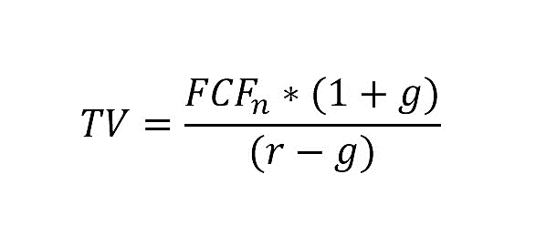

To calculate the terminal value, we have used the financial data of the last projected year, i.e., FY 2026-27 and multiplied the revenue of FY 2026-27 with (1 + Perpetual Growth Rate of 1.25%) and calculated the rest of data as per the projected periods’ assumptions and then divide the Free Cash Flow of the terminal period with the difference of required rate of return (WACC) and Perpetual Growth Rate (g) i.e., (WACC - g).

**Hence, the calculated Fair Market Value/Enterprise Value of M/s KSK Mahanadi Power Company Limited is INR 9,328.88 Crores, subject to the current micro & macro-economic assumptions, market, industry trends and inputs used during the forecasted period, as well as the growth rate and WACC used to calculate the EV.**

|  |  |  |
| --- | --- | --- |
| **Declaration** | 1. *Since this is Enterprise Valuation hence no site inspection was carried out by us.* 2. *The undersigned does not have any direct/indirect interest in the above property.* 3. *The information furnished herein is true and correct to the best of our knowledge.* 4. *This valuation work is carried out by our Financial Analyst team on the request from Bank of India, Mumbai Large Corporate Branch, Bank of India Building, 4th Floor, 70-80, M.G. Road, Fort, Mumbai – 400001.* 5. *We have submitted Valuation report to the Client.* | |
| **Name & Address of Valuer company** | | **Signature of the authorized person** |
| M/s R.K. Associates Valuers & Techno Engineering Consultants Pvt. Ltd.  D-39, Second Floor, Sector-2, Noida, UP-201301, India. | |  |
| **Number of Pages in the Report** | | **44** |
| **Financial Analyst Team worked on the report** | | ***PREPARED BY: Mr. Rachit Gupta*** |
| ***REVIEWED BY: Mr. Gaurav Kumar*** |

**For R.K Associates Valuers & Techno Place: Noida**

**Engineering Consultants (P) Ltd. Engineering Consultants (P) Ltd. Date: 1st March 2023**

**(Authorized Signatory)**

**Valuations**

|  |  |
| --- | --- |
| **PART G** | **IMPORTANT DEFINITION** |

***Definitions:***

* ***Enterprise Value:*** *Enterprise value (EV) is the corporate valuation of a company, determined by using market capitalization and total debt. Market cap comprises preference stocks, common stocks, and minority interest; total debt comprises short-term and long-term liabilities of the company. Enterprise value (EV) refers to the overall valuation—equity, debt, cash, and cash equivalents. In other words, it is the cost of acquiring a firm. The EV/EBITDA is an enterprise multiple. It correlates EV with earnings before interest, taxes, depreciation, and amortization. The metric determines whether the firm is undervalued or overvalued.*

*EV is computed using the following formula: EV = (Market Capitalization + Market Value of Debt – Cash and Equivalents).*

* ***Fair Market Value****suggested by the competent Valuer is that prospective estimated amount in his expert & prudent opinion of the subject asset without any prejudice after he has carefully & exhaustively evaluated the facts & information came in front of him related to the subject asset at which the subject asset should be exchanged between a willing buyer and willing seller at an arm’s length transaction in an open & unrestricted market, after proper marketing, wherein the parties, each acted knowledgeably, prudently and without any compulsion on the date of the Valuation.*

*Forced, under compulsion & constraint, obligatory sales transactions data doesn’t indicate the Fair Market Value.*

* ***Realizable Value*** *is the minimum prospective estimated value of the Company which it may be able to realize at the time of actual transaction factoring in the potential prospects of deep negotiations carried out between the buyer & seller for ultimately finalizing the transaction across the table. Realizable value may be 10-20% less than the Fair Market Value depending on the various salability prospects of the subject asset and the needs of the buyer & the seller.*
* ***Forced/ Distress Sale Value*** *is the value when the company has to be sold due to any compulsion or constraint like financial encumbrances, dispute, as a part of a recovery process, legal issues or any such condition or situation. In this type of sale, minimum fetch value is assessed which can be 15-25% less than the estimated Fair Market Value. In this type of sale, negotiation power of the buyer is always more than the seller and eagerness & pressure of selling the asset is more than buying it. Therefore, the Forced/ Distress Sale Value will always fetch significantly less value compare to the estimated Fair Market Value.*
* ***Liquidation Value*** *is the amount that would be realized when an asset or group of assets are sold on a piecemeal basis that is without consideration of benefits (or detriments) associated with a going-concern business. Liquidation value can be either in an orderly transaction with a typical marketing period or in a forced transaction with a shortened marketing period.*
* ***Difference between Costs, Price & Value:*** *Generally, these words are used and understood synonymously. However, in reality each of these has a completely different meaning, premise and also have different definitions in the professional & legal terms. Therefore, to avoid confusion, it is our professional responsibility to describe the definitions of these words to avoid ambiguity & confusion in the minds of the user of this report.*
* *The* ***Cost*** *of an asset represents the actual amount spend in the construction/ actual creation of the asset.*
* *The* ***Price*** *is the amount paid for the procurement of the same asset.*
* *The* ***Value*** *is defined as the present worth of future rights in the asset and depends to a great extent on combination of various factors such as demand and supply, market situation, purpose, situation & needs of the buyer & seller, salability outlook, usability factor, market perception & reputation. Needs of the buyer & seller, salability outlook, usability factor, market perception & reputation.*
* *Therefore, in actual for the same asset, cost, price & value remain different since these terms have different usage & meaning.*

|  |  |
| --- | --- |
| **PART H** | **DISCLAIMER | REMARKS** |

* + - 1. No employee or member of R.K Associates has any direct/ indirect interest in the Project.
      2. This is just an opinion report on Valuation based on the copy of the documents/ information provided to us by the client which has been relied upon in good faith and the assessment and assumptions done by us.
      3. This report is prepared based on the copies of the documents/ information which the Bank/ Company has provided to us out of the standard checklist of documents sought from them and further based on our assumptions and limiting conditions. The client/owner and its management/representatives warranted to us that the information they supplied was complete, accurate and true and correct to the best of their knowledge. All such information provided to us has been relied upon in good faith and we have assumed that it is true and correct in all respect. I/We shall not be liable for any loss, damages, cost or expenses arising from fraudulent acts, misrepresentations, or willful default on part of the owner, company, its directors, employee, representative or agents. Verification or cross checking of the documents provided to us from the originals or from any Govt. departments/ Record of Registrar has not been done at our end since this is beyond the scope of our work. If at any time in future, it is found or came to our knowledge that misrepresentation of facts or incomplete or distorted information has been provided to us then this report shall automatically become null & void.
      4. This Valuation is prepared based on the current financial status of the company, financial data, other facts & information provided by the client in writing & during verbal discussion during the course of the assignment and based on certain assumptions which are specifically mentioned in the Valuation section of the Report.
      5. Key assumptions in the report are taken based on data, information, inputs, financial statements etc. provided by the client to us during the course of the assessment and on the basis of the assessment done by us and we have assumed that all such information is true & factual to the best of the knowledge of the promoter company.
      6. Sale transaction method of the asset is assumed as free market transaction while assessing Prospective Fair Market Value of the asset.
      7. Legal aspects for e.g., investigation of title, ownership rights, lien, charge, mortgage, lease, sanctioned maps, verification of documents, etc. have not been done at our end and same has to be taken care by legal expert/ Advocate. It is assumed that the concerned Lender/ Financial Institution has satisfied them with the authenticity of the documents, information given to us and for which the legal verification has been already taken and cleared by the competent Advocate before requesting for this report. I/ We assume no responsibility for the legal matters including, but not limited to, legal or title concerns.
      8. All observations mentioned in the report is only based on the visual observation and the documents/ data/ information provided by the client. No mechanical/ technical tests, measurements or any design review have been performed or carried out from our side during Project assessment.
      9. Bank/FII should ONLY take this report as an Advisory document from the Financial/ Chartered Engineering firm and its specifically advised to the creditor to cross verify the original documents for the facts mentioned in the report which can be availed from the borrowing company directly.
      10. In case of any default in loans or the credit facility extended to the borrowing company, R.K Associates shall not be held responsible for whatsoever reason may be and any request for seeking any explanation from the employee/s of R.K Associates will not be entertained at any instance or situation.
      11. We have relied on data from third party, external sources & information available on public domain also to conclude this report. These sources are believed to be reliable and therefore, we assume no liability for the truth or accuracy of any data, opinions or estimates furnished by others that have been used in this analysis. Where we have relied on data, opinions or estimates from external sources, reasonable care has been taken to ensure that such data has been correctly extracted from those sources and /or reproduced in its proper form and context, however still we can’t vouch its authenticity, correctness or accuracy.
      12. This Report is prepared by our competent technical team which includes financial experts & analysts. This report is a general analysis of the project based on the scope mentioned in the report. This is not an Audit report, Design document, DPR or Techno feasibility study. All the information gathered is based on the facts seen on the site during survey, verbal discussion & documentary evidence provided by the client and is believed that information given by the company is true best of their knowledge.
      13. Value varies with the Purpose/ Date/ Condition of the market. This report should not to be referred if any of these points are different from the one mentioned aforesaid in the Report.
      14. Analysis and conclusions adopted in the report are limited to the reported assumptions, conditions and information came to our knowledge during the course of the work.
      15. This report is having limited scope as per its fields to provide only the general indication of the Value of Equity of the companies prevailing in the market based on the documents/ data/ information/ financial statements provided by the client and the assessment and assumption taken by us. The suggested value should be considered only if transaction is happened as free market transaction.
      16. Secondary/ Tertiary costs related to transaction like Stamp Duty, Registration charges, Brokerage, etc. pertaining to the sale/ purchase of the company are not considered while assessing the Market Value.
      17. Appropriate methodology & assumptions are rationally adopted based on the facts of the case came to our knowledge during the course of the assignment considering many factors like nature of Industry, current market situation and trends.
      18. Valuation is a subjective field and opinion may differ from consultant to consultant. To check the right opinion, it is important to evaluate the methodology adopted and various factors/ basis considered during the course of assessment before reaching to any conclusion.
      19. At the outset, it is to be noted that Value analysis cannot be regarded as an exact science and the conclusions arrived at in many cases will, of necessity, be subjective and dependent on the exercise of individual judgment. Given the same set of facts and using the same assumptions, expert opinions may differ due to the number of different factors, which have to be made. Therefore, there can be no standard formulae to establish an indisputable exchange ratio. In the event of a transaction, the actual transaction value achieved may be higher or lower than our indicative analysis of value depending upon the circumstances of the transaction. The knowledge, negotiability and motivations of the buyers and sellers and the applicability of a discount or premium for control will also affect actual price achieved. Accordingly, our indicative analysis of value will not necessarily be the price at which any agreement proceeds. The final transaction price is something on which the parties themselves have to agree. However, our Valuation analysis can definitely help the stakeholders to make them informed and wise decision about the Value of the asset and can help in facilitating the arm’s length transaction.
      20. This report is prepared on the Enterprise Valuation format as per the client requirement. This report is having limited scope as per its fields to provide only the indicative Fair value of the company based on the current financial position, future prospects & current Industry trends. The Valuation assessed in this Valuation Report should hold well only if transaction is happened as per free market transaction. No detailed analysis or verification of the information is carried upon pertaining to the value of the shares of the subject companies. No claim for any extra information will be entertained whatsoever be the reason. For any extra work over and above the fields mentioned in the report will have an extra cost which has to be borne by the customer.
      21. As per the scope of the report no site survey has been carried out by us and no thorough vetting of the documents/ information provided to us has been done at our end.
      22. This is just an opinion report and doesn’t hold any binding on anyone. It is requested from the concerned stakeholder which is using this report that they should consider all the different associated relevant & related factors also before taking any business decision based on the content of this report.
      23. Though adequate care has been taken while preparing this report as per its scope, but still, we can’t rule out typing, human errors, over sightedness of any information or any other mistakes. Therefore, the concerned organization is advised to satisfy themselves that the report is complete & satisfactory in all respect. Intimation regarding any discrepancy shall be brought into our notice immediately. If no intimation is received within 15 (Fifteen) days in writing from the date of issuance of the report, to rectify these timely, then it shall be considered that the report is complete in all respect and has been accepted by the client up to their satisfaction & use and further to which R.K Associates shall not be held responsible in any manner.
      24. This Valuation report is prepared based on the facts of the companies provided to us during the course of the assignment. However, in future the assumptions taken may change or may go worse due to impact of Govt. policies or effect of World economy, Industry/ market scenario may change, etc. Hence before taking any business decision the user of this report should take into consideration all such future risk.
      25. The documents, information, data provided to us during the course of this assessment by the client is reviewed only up to the extent required in relation to the scope of the work. No document has been reviewed beyond the scope of the work.
      26. In case of any default in repayment of credit facility extended to the borrowing company, as estimated by us, R.K Associates shall not be held responsible for whatsoever reason may be and any request for seeking any explanation from the employee/s of R.K Associates will not be entertained at any instance or situation.
      27. This report only contains general assessment & opinion as per the scope of work evaluated and based on technical & market information which came to knowledge during course of the assignment as per the information given in the copy of documents, information, data provided to us and/ and confirmed by the owner/ owner representative to us at site which has been relied upon in good faith. It doesn’t contain any other recommendations of any sort including but not limited to express of any opinion on the suitability or otherwise of entering into any transaction with the borrower.
      28. This Valuation is conducted based on the macro analysis of the asset/ property and operations of the companies and not based on the micro, component or item wise analysis. Analysis done is a general assessment and is not investigative in nature.
      29. This report is prepared following our Standard Operating Procedures & Best Practices, Limitations, Conditions, Remarks, Important Notes, Valuation TOR.
      30. Valuation is done based on the industry wide general accepted norms and based on the international standards & best practices for equity valuations.
      31. Any kind of unpaid statutory, utilities, lease, interest or any other pecuniary dues on the asset has not been factored in the Valuation.
      32. All Pages of the report including annexures are signed and stamped from our office. In case any paper in the report is without stamp & signature then this should not be considered a valid paper issued from this office.
      33. Defect Liability Period is **15 DAYS**. We request the concerned authorized reader of this report to check the contents, data and calculations in the report within this period and intimate us in writing if any corrections are required or in case of any other concern with the contents or opinion mentioned in the report. Corrections only related to typographical, calculation, spelling mistakes, incorrect data/ figures/ statement will be entertained within the defect liability period. Any new changes for any additional information in already approved report will be regarded as additional work for which additional fees may be charged. No request for any illegitimate change in regard to any facts & figures will be entertained.
      34. R.K Associates encourages its customers to give feedback or inform concerns over its services through proper channel at valuers@rkassociates.org in writing within 15 days of report delivery. After this period no concern/ complaint/ proceedings in connection with the Financial Feasibility Study Services will be entertained due to possible change in situation and condition of the subject Project.
      35. Our Data retention policy is of **ONE YEAR**. After this period, we remove all the concerned records related to the assignment from our repository. No clarification or query can be answered after this period due to unavailability of the data.
      36. This Enterprise Valuation report is governed by our (1) Internal Policies, Processes & Standard Operating Procedures, (2) R.K Associates Quality Policy, (3) Valuation & Survey Best Practices Guidelines formulated by management of R.K Associates, (4) Information input given to us by the customer and (4) Information/ Data/ Facts given to us by our field/ office technical team. Management of R.K Associates never gives acceptance to any unethical or unprofessional practice which may affect fair, correct & impartial assessment and which is against any prevailing law. In case of any indication of any negligence, default, incorrect, misleading, misrepresentation or distortion of facts in the report then it is the responsibility of the user of this report to immediately or at least within the defect liability period bring all such act into notice of R.K Associates management so that corrective measures can be taken instantly.
      37. R.K Associates never releases any report doing alterations or modifications from pen. In case any information/ figure of this report is found altered with pen then this report will automatically become null & void.
      38. If this report is prepared for the matter under litigation in any Indian court, no official or employee of R.K Associates will be under any obligation to give in person appearance in the court as a testimony. For any explanation or clarification, only written reply can be submitted on the additional payment of charges.