**File No.: VIS(2022-23)-PL661-550-922 Dated: 17.02.2022**

# To,

Mr. Ankita Goel

(IE Partapur)

The SBI, IE Pratapur Branch, Meerut,

Uttar Pradesh.

**SUB: Cost vetting of an estimate provided to us for the proposed construction of Mahelka motors/Iconic KIA showroom at Plot No. 3,4,5 Preeti Vihar Industrial Area, Muzaffarnagar.**

# Dear Sir,

## Cost vetting of the estimate provided to us for the proposed construction of Mahelka motors/Iconic KIA showroom, at Plot No.3,4,5 Preeti Vihar Industrial Area, Muzaffarnagar.

Our view is in line with the CPWD latest DSOR/ local PWD and prevailing market rates of the items as per the material specifications and type & quality of construction mentioned in the estimate. Covered area measurements are considered as per the provided unsanctioned map.

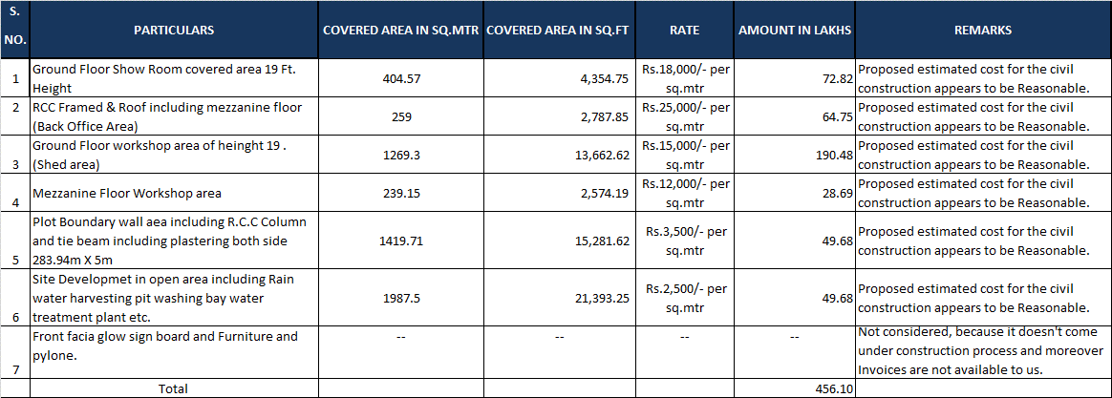

***NOTE:***

1. ***We have not considered the “Front Facia Glow Sign Board and Furniture and pylone in this cost vetting certificate. Since these items are not come under construction process and moreover invoices of such item is not available to us.***
2. ***Cost vetting is done on the basis of the cost estimate and unsanctioned architect map provided to us by the bank only.***

***Disclaimer: Estimate Vetting can vary from the final actual construction cost as the actual construction cost comes as per final plans and prevailing market rates for the material & labour at that point of time.***

**For R.K Associates Valuers & Techno Engg. Consultants (P) Ltd.**

**Authorised Signatory**

*PS: This is a Onetime verification of the cost of the enclosed construction Estimate. For any further scrutiny of the same case, separate fees will be charged.*

|  |  |  |  |
| --- | --- | --- | --- |
| **1.** | **DECLARATION** | | |
|  | 1. This cost vetting is done based on the documents/ details/ information provided by the customer. 2. The undersigned does not have any direct/indirect interest in the above property. 3. The information furnished herein is true and correct to the best of our knowledge. 4. We have submitted this certificate directly to the Bank. 5. This estimate is carried out by our Engineering team on the request from **SBI, IE Pratapur Branch, Meerut.** | | |
| **2.** | **Name & Address of Valuer company** | | **Signature of the authorized person** |
| M/s R.K. Associates Valuers & Techno Engineering  Consultants Pvt. Ltd. D-39, Sector-2, Noida, U.P. | |  |
| **3.** | **Enclosed Documents** | 1. Detailed Estimate 2. Unsanctioned Architect’s map | |
| **4.** | **Total Number of Pages in the Report with Enclosures** | 05 | |
| **5.** | **Engineering Team worked on the report** | ***SURVEYED BY:*** NA | |
| ***PREPARED BY:*** *Er****.*** Rahul Gupta | |
| ***REVIEWED BY:*** *Er.**Rajani Gupta* | |

**R.K ASSOCIATES IMPORTANT NOTES:**

1. ***DEFECT LIABILITY PERIOD*** *- In case of any query/ issue or escalation you may please contact Incident Manager by writing at* [*valuers@rkassociates.org.*](mailto:valuers@rkassociates.org) *We ensure 100% accuracy in the Calculations done, Rates adopted and various other data points &*

information mentioned in the report but still can’t rule out typing, human errors or any other mistakes. In case you find any mistake, variation, discrepancy or inaccuracy in any data point of the report, please help us by bringing all such points into our notice in writing at [valuers@rkassociates.org](mailto:valuers@rkassociates.org)within 30 days of the report delivery, to get these rectified timely, failing which R.K Associates won’t be held responsible for any inaccuracy in any manner. Also if we will not hear back anything from you within 30 days, we will assume that report is correct in all respect and no further claim of any sort will be entertained thereafter. We would welcome and appreciate your feedback & suggestions in order to improve our services.

1. ***COPYRIGHT FORMAT*** *- This report is prepared on the copyright format of R.K Associates to serve our clients in the best possible way. Legally no one can copy or distribute this format without prior approval from R.K Associates. It is meant only for the*

organization as mentioned on the cover page of this report. Distribution or use of this format other than R.K Associates will be seen as unlawful act and necessary legal action can be taken against the defaulters.

***IF REPORT IS USED FOR BANK/ FIs***

**NOTE:** As per IBA Guidelines in case the valuation report submitted by the valuer is not in order, the banks / FIs shall bring the same to the notice of the valuer within 15 days of submission for rectification and resubmission. In case no such communication is received, it shall be presumed that the valuation report has been accepted.

***At our end we have not verified the authenticity of any documents provided to us. Bank is advised to verify the genuineness of the property documents before taking any credit decision.***

***ENCLOSURES***

***ARCHITECT MAP.***

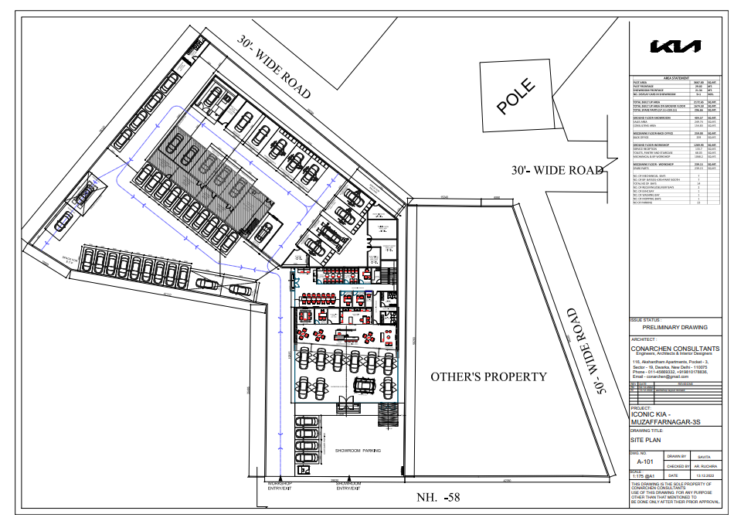

***ENCLOSURE - II***

***PROVIDED ESTIMATE***

