File No.: VIS(2022-23)-PL665-556-930 Dated: 07/02/2023

CONSTRUCTION PROGRESS REPORT

OF

GROUP HOUSING SOCIETY
“DEVELOPED BY M/S GUPTA DEVELOERS”

SITUATED AT
PART OF KHASRA NO. 21/1 M. & 33/1 M, VILLAGE MALAKPUR LATIFPUR, (UNDER NAGAR NIGAM LIMITS) ROORKEE, PARGANA AND TEHSIL ROORKEE, DISTRICT HARIDWAR, UTTARAKHAND.

PROMOTER/S
SHRI. NIRAJ KUMAR GUPTA S/O SHRI GYAN PRAKASH GUPTA

REPORT PREPARED FOR
SBI, SME BRANCH, ROORKEE, DISTRICT HARIDWAR

**Important - In case of any query/ issue or escalation you may please contact Incident Manager
at le@rkassociates.org. We will appreciate your feedback in order to improve our services.

NOTE: As per IBA Guidelines please provide your feedback on the report within 15 days of its submission after which report will be considered to be correct.

IMPORTANT NOTICE

COPYRIGHT FORMAT: This report is prepared on the copyright format of R.K Associates, to serve our clients with the best available information and analysis to facilitate them to take rational business decisions. Legally no one can copy or distribute this format without prior approval from R.K Associates. It is meant only for the advisory/ reference purpose for the organization/s as mentioned on the cover page of this report. Distribution or use of this format by any organization or individual other than R.K Associates will be seen as unlawful act and necessary legal action can be taken against the defaulters.

This report is intended for the sole use of the intended recipient/s and contain material that is STRICTLY CONFIDENTIAL AND PRIVATE.

DEFECT LIABILITY PERIOD: - In case of any query/ issue or escalation you may please contact Incident Manager: @ le@rkassociates.org. We try our level best to ensure correctness in the calculations done, rates adopted and various other data points & information mentioned in the report but still can’t rule out typing, human errors or any other mistakes. In case you find any such mistake or inaccuracy in any data point of the report please help us by bringing all such points into our notice immediately or within 15 days of the report delivery in writing, to rectify these timely failing after which R.K Associates won’t be held responsible for any such inaccuracy in any manner. We would highly appreciate your feedback in order to improve our services.

PART A | REPORT SUMMARY

S.NO. | PARTICULARS | DESCRIPTION
 | Name of the Project | Group Housing Society developed by M/s Gupta Developer.
 | Project Location | Part Of Khasra No. 21/1 M. & 33/1 M, Village Malakpur Latifpur, (Under Nagar Nigam Limits) Roorkee, Pargana And Tehsil Roorkee, District Haridwar, Uttarakhand.
 | Name of the Promoter’s | Shri. Niraj Kumar Gupta S/O Shri Gyan Prakash Gupta
 | Address and Phone Number | Situated at 1279/1-44 Civil Line Roorkee Pargana and Tehsil Roorkee District Haridwar.
 | Prepared for Bank | SBI, SME Branch, Roorkee, District Haridwar.
 | Consultant Firm | M/s. R.K. Associates Valuers & Techno Engineering Consultants (P) Ltd.
 | Work Order Details | Via email dated 21-02-2023
 | Date of Survey | 21st February 2023
 | Date of Report | 07th March 2023
 | Purpose of the Report | Construction Progress Report.
 | Scope of the work provided by the Lender | Only to comment on the following below points based on the scope of work:  - Construction Progress Report  NOTE: This report doesn’t contains any other kind of recommendation or suggestions other than the above mentioned point.

PART B | INTRODUCTION

- THE PROJECT: M/s Gupta Developer are developing Group Housing Society named ‘The Oasis ’ comprising of high rise apartments having total 2 Blocks namely Block ‘1’ and Block ‘2’ as per the sanctioned building plan reference number 2482 dated 24/01/2020. Company is developing the project on total 0.9 acres/4,000 sq. mtr. Project comprises of Block 1 and Block 2, both the blocks together with each block having Basement + Stilt Floor + 8 Floors at Khasra No. 21/1 M. & 33/1 M, Village Malakpur Latifpur, (Under Nagar Nigam Limits) Roorkee, Pargana And Tehsil Roorkee, District Haridwar, Uttarakhand.
The proposed society is a residential project with different types of units, viz. 3 BHK and 4 BHK ultra luxurious apartments as per information available on public domain.

- PROJECT OVERVIEW: : M/s Gupta Developer developing a Group Housing Project named ‘The Oasis’ accommodating apartment space having total covered area admeasuring 11,468.858 sq.mtr spread over a land area measuring 4,000 sq. mtr. at Part Of Khasra No. 21/1 M. & 33/1 M, Village Malakpur Latifpur, (Under Nagar Nigam Limits) Roorkee, Pargana And Tehsil Roorkee, District Haridwa, Uttarakhand.
As per the MDDA approved building Plan dated 24/01/2020, this Project envisage to construct total 80 units in 2 Blocks namely Block ‘1’ and Block ‘2’ in different categories viz., 3 BHK and 4 BHK apartment and total constructed area from basement to 8th Floor totalling to 11,468.858 sq. mtr. or 1, 23,449.76 sq. ft.
As per the sanctioned site plan provided by bank/client, the total permissible & proposed FAR area is 7,200 sq.mtr and 7158.479 sq.mtr respectively.
- PHYSICAL CONSTRUCTION STATUS: As per the observations made during the site visit, tabulated below is the status of physical construction:
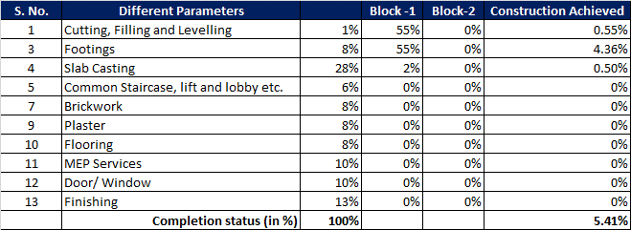
Observations and Remarks:
BLOCK – 1

- Excavation Work and Levelling work has been completed.
- Raft foundation of this Block has been completed and column erected above ground level.
- Slab Work: Only basement slab work has been completed having covered area app.1144 sq.mtr.and .
- Block work/ brick work is not started yet.
- MEP Services: It is not started yet.
- Plastering: It is not started yet.
- Electrical works: It is not started yet.
Electrical wiring: It is not started yet.
- Flooring: It is not started yet.
- Railings: It is not started yet.
- Door/ window: It is not started yet.
- Finishing works: It is not started yet.

BLOCK – 2

- Construction of Block 2 has not been started yet.

Therefore, as per the observations made during the site visit, it is observed that the physical progress of the two Blocks 1 and 2 is approx. 5.41% of the total project.

- COST INCURRED IN THE CONSTRUCTION OF BUILDING: As per the CA Certificate dated 03-03-2022 by Singh Amit and Associates having FRN No: 019157C, the company has incurred an amount of Rs. 515.05 Lakhs approximately in the construction of the building.
- OBSERVATIONS, REMARKS AND CONCLUSION

- It is assumed that the average present construction cost of such type of towers is approx. Rs. 2,000/- per sq. ft. along with finishing. However, as per site survey the present construction progress of the project is on initial stage.
- As per our assessment approx. ~5.41% of the construction out of the total and 1,144 sq. mtr. of built-up area has been completed.
- This assessment is only limited to the construction done at site and not to the advances paid and material lying on the site.
- Therefore, the estimated cost incurred for the construction of these towers as per the present status of work has been tabulated below:
S. No. | Particulars | Figure | UOM
1 | Total Proposed Construction area | 1,23,449 | sq. ft.
2 | As on date Constructed area | 12,313 | sq. ft.
3 | Construction cost adopted as on date | 1650 | Rs. Per sq. ft.
4 | % Completion (as estimated by us) | ~5.41 | %
5 | Estimated Cost incurred as per RKA | ~203.16 | Rs lakhs
6 | Actual cost incurred as per CA certificate  (Inclusive of Investment and cost of work done) | ~515.05 | Rs. Lakhs

Note:
- Our assessment is based on physical inspection of project site only. No structural audit has been done on the site.
- The bank has provided us the invoices of material purchase but no quantity surveying has been done. Further no BOQ was provided.

PART C | DISCLAIMER

      - No employee or member of R.K Associates has any direct/ indirect interest in the Project.

      - This report is prepared based on the copies of the documents/ information which the Bank/ Company has provided to us out of the standard checklist of documents sought from them and further based on our assumptions and limiting conditions. All such information provided to us has been relied upon in good faith and we have assumed that it is true and correct in all respect. Verification or cross checking of the documents provided to us has not been done at our end from the originals. If at any time in future, it is found or came to our knowledge that misrepresentation of facts or incomplete or distorted information has been provided to us then this report shall automatically become null & void.

      - This report is a general analysis of the project based on the scope mentioned in the report. This is not an Audit report, Design document, DPR or Techno-financial feasibility study. All the information gathered is based on the facts seen on the site during survey, verbal discussion & documentary evidence provided by the client and is believed that information given by the company is true best of their knowledge.

      - All observations mentioned in the report is only based on the visual observation and the documents/ data/ information provided by the client. No mechanical/ technical tests, measurements or any design review have been performed or carried out from our side during Project assessment.

      - Bank/FII should ONLY take this report as an Advisory document from the Financial/ Chartered Engineering firm and it’s specifically advised to the creditor to cross verify the original documents for the facts mentioned in the report which can be availed from the borrowing company directly.

      - In case of any default in loans or the credit facility extended to the borrowing company, R.K Associates shall not be held responsible for whatsoever reason may be and any request for seeking any explanation from the employee/s of R.K Associates will not be entertained at any instance or situation.

      - This is just an opinion report and doesn’t hold any binding on anyone. It is requested from the concerned Financial Institution which is using this report for taking financial decision on the project that they should consider all the different associated relevant & related factors also before taking any business decision based on the content of this report.
      - All Pages of the report including annexures are signed and stamped from our office. In case any paper in the report is without stamp & signature then this should not be considered a valid paper issued from this office.

      - Though adequate care has been taken while preparing this report as per its scope, but still we can’t rule out typing, human errors, over sightedness of any information or any other mistakes. Therefore, the concerned organization is advised to satisfy themselves that the report is complete & satisfactory in all respect. Intimation regarding any discrepancy shall be brought into our notice immediately. If no intimation is received within 15 (Fifteen) days in writing from the date of issuance of the report, to rectify these timely, then it shall be considered that the report is complete in all respect and has been accepted by the client upto their satisfaction & use and further to which R.K Associates shall not be held responsible in any manner.

      - Defect Liability Period is 15 DAYS. We request the concerned authorized reader of this report to check the contents, data and calculations in the report within this period and intimate us in writing if any corrections are required or in case of any other concern with the contents or opinion mentioned in the report. Corrections only related to typographical, calculation, spelling mistakes, incorrect data/ figures/ statement will be entertained within the defect liability period. Any new changes for any additional information in already approved report will be regarded as additional work for which additional fees may be charged. No request for any illegitimate change in regard to any facts & figures will be entertained.

      - R.K Associates encourages its customers to give feedback or inform concerns over its services through proper channel at le@rkassociates.org in writing within 30 days of report delivery. After this period no concern/ complaint/ proceedings in connection with the Lender’s Independent Engineering Services will be entertained due to possible change in situation and condition of the subject Project.

      - Our Data retention policy is of ONE YEAR. After this period, we remove all the concerned records related to the assignment from our repository. No clarification or query can be answered after this period due to unavailability of the data.

      - R.K Associates never releases any report doing alterations or modifications from pen. In case any information/ figure of this report is found altered with pen then this report will automatically become null & void.
PREPARED BY | REVIEWED BY
Rahul Gupta  (Sr. Engineer Valuation) | Mr. Ashish Sawe
Date: 07th March 2023 | Date: 07th March 2023

DEFECT LIABILITY PERIOD - In case of any query/ issue or escalation you may please contact Incident Manager by writing at valuers@rkassociates.org. We ensure 100% accuracy in the Calculations done, Rates adopted and various other data points & information mentioned in the report but still can’t rule out typing, human errors or any other mistakes. In case you find any mistake, variation, discrepancy or inaccuracy in any data point of the report, please help us by bringing all such points into our notice in writing at valuers@rkassociates.org within 30 days of the report delivery, to get these rectified timely, failing which R.K Associates Valuers Techno Engineering Consultants (P) Ltd. won’t be held responsible for any inaccuracy in any manner. Also, if we will not hear back anything from you within 30 days, we will assume that report is correct in all respect and no further claim of any sort will be entertained thereafter. We would welcome and appreciate your feedback & suggestions in order to improve our services.

COPYRIGHT FORMAT - This report is prepared on the copyright format of R.K Associates Valuers Techno Engineering Consultants (P) Ltd. to serve our clients in the best possible way. Legally no one can copy or distribute this format without prior approval from R.K Associates. It is meant only for the organization as mentioned on the cover page of this report. Distribution or use of this format other than R.K Associates will be seen as unlawful act and necessary legal action can be taken against the defaulter

PART D | PHOTOGRAPHS

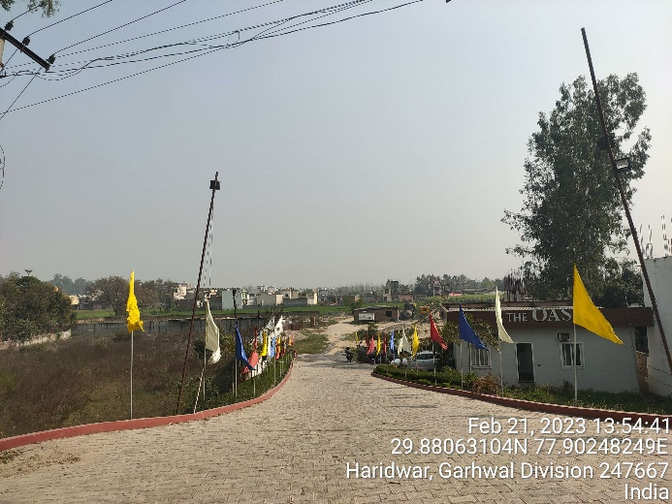 | 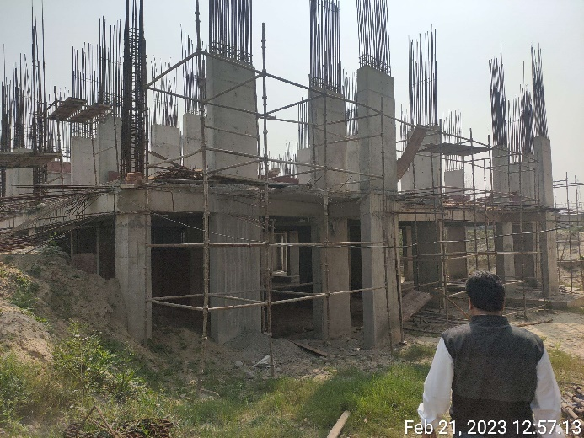
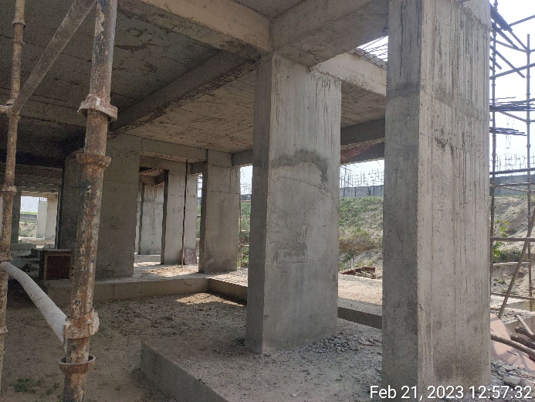 | 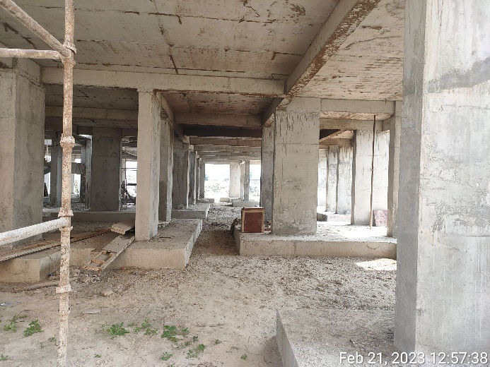
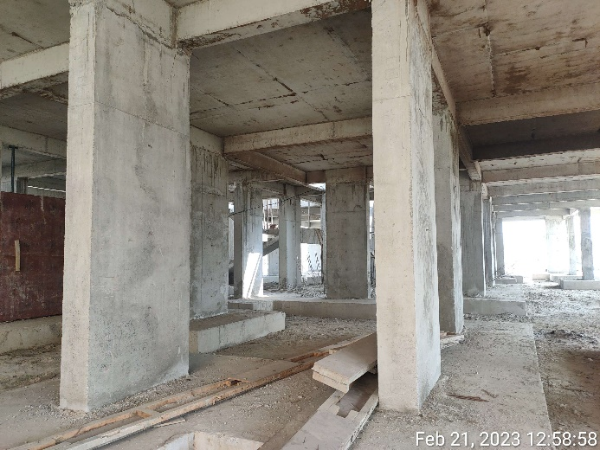 | 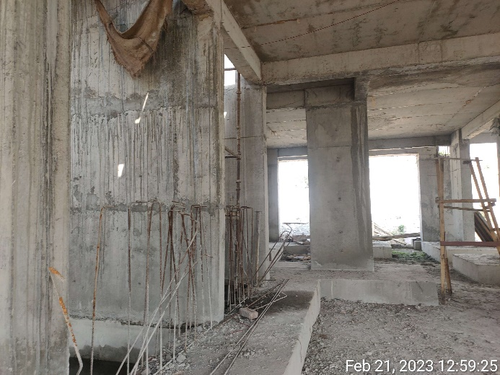

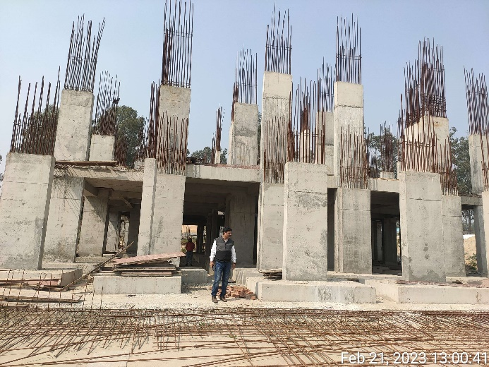 | 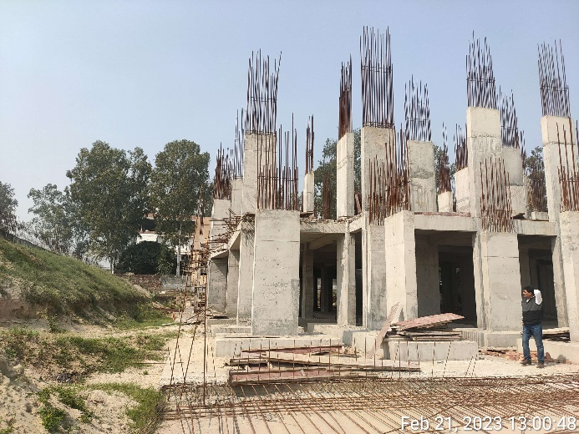
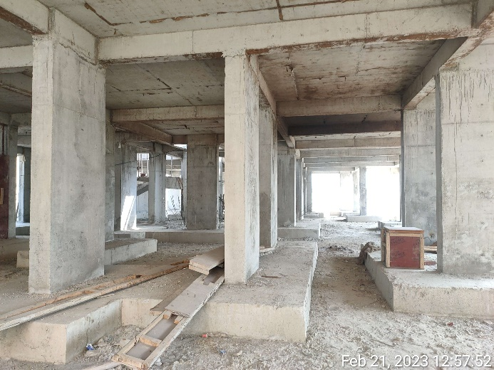 | 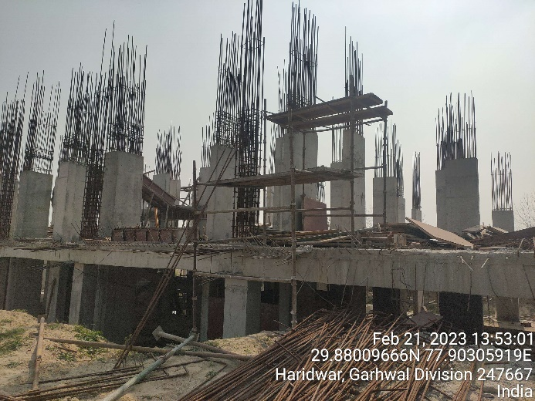
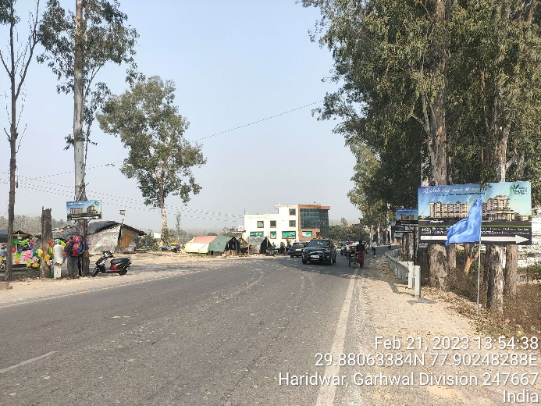 | 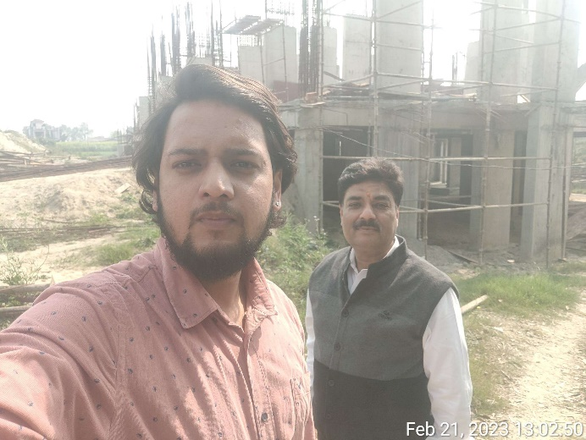

CA Certificate:
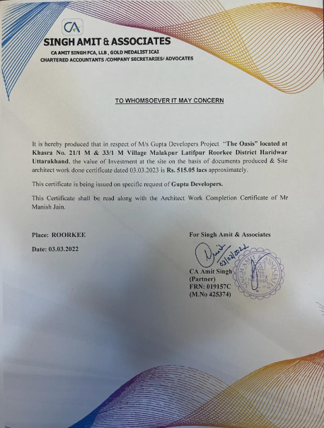

Architect Certificate:
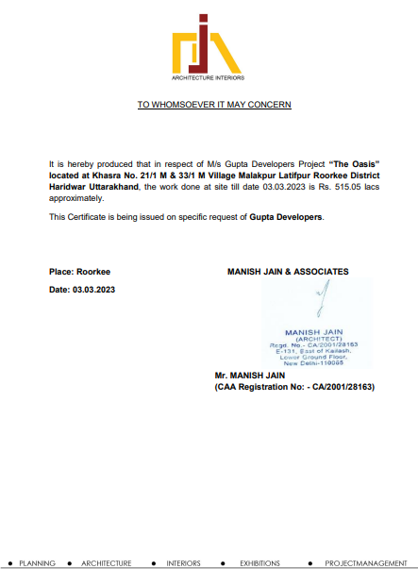

Building Plan
