File No.: VIS(2022-23)-PL675-566-938 Dated: 07/03/2023

LENDER’S INDEPENDENT ENGINEERING REPORT

OF

~4925 KWp GROUNG MOUNTED SOLAR POWER PLANT

TO BE SET-UP AT
VILLAGE- DHANSA, DISTRICT- SOUTH WEST DELHI, DELHI-110073

SELLER: M/S TALF ENERGY INDIA PVT. LTD.
BUYER: ALL INDIA SOCIETY FOR HEALTH AND AID EDUCATION & RESEARCH (A.S.H.A.)

TO BE SUBMITTED AT
STATE BANK OF INDIA, SME BRANCH, SOUTH EXTENSION, DELHI

**Important - In case of any query/ issue or escalation you may please contact Incident Manager
at le@rkassociates.org. We will appreciate your feedback in order to improve our services.
NOTE: As per IBA Guidelines please provide your feedback on the report within 15 days of its submission after which report will be considered to be correct.

IMPORTANT NOTICE

COPYRIGHT FORMAT: This report is prepared on the copyright format of R.K Associates to serve our clients with the best possible information and analysis to facilitate them to take rational business decisions. Legally no one can copy or distribute this format without prior approval from R.K Associates. It is meant only for the advisory/ reference purpose for the organization/s as mentioned on the cover page of this report. Distribution or use of this format by any organization or individual other than R.K Associates will be seen as an unlawful act and necessary legal action can be taken against the defaulters.
This report is intended for the sole use of the intended recipient/s and contains material that is STRICTLY CONFIDENTIAL AND PRIVATE.

DEFECT LIABILITY PERIOD: - In case of any query/ issue or escalation you may please contact Incident Manager at le@rkassociates.org.
Though adequate care has been taken while preparing this report as per its scope, but still we can’t rule out typing, human errors, over sightedness of any information or any other mistakes. Therefore, the concerned organization is advised to satisfy themselves that the report is complete & satisfactory in all respect. Intimation regarding any discrepancy shall be brought into our notice immediately. If no intimation is received within 15 (Fifteen) days in writing from the date of issuance of the report, to rectify these timely, then it shall be considered that the report is complete in all respect and has been accepted by the client upto their satisfaction & use and further to which R.K Associates shall not be held responsible in any manner.

TABLE OF CONTENTS
SECTIONS | PARTICULARS | PAGE NO.
Part A | REPORT SUMMARY | 03
Part B | INTRODUCTION | 04
 | - Name of the Project | 04
 | - Project Overview | 04
 | - Scope of the Report | 05
 | - Purpose of the Report | 06
 | - Methodology Adopted | 06
Part C | PAA/LOI DETAILS | 07
Part D | KEY TECHNICAL PARAMETERS & CONFIGURATION | 08
Part E | IRRADIATION & ENERGY YEILD ASSESSMENT | 10
Part F | CONTRACTOR’S DETAILS | 12
Part G | CURRENT STATUS OF WORK | 15
Part H | PROJECT COST & EXPENDITURE | 19
Part I | PHOTOGRAPHS | 21
Part J | OTHER DOCUMENTS & REFERENCES | 27
Part K | DISCLAIMER | 36

PART A | REPORT SUMMARY

 | Name of the Project | 4925 KWp Ground Mounted Solar Power Plant
 | Project Location | Khasra No. 7/6, 7/15, 7/16, 7/25, 8/19/1, 8/20, 8/21, 8/1, 13/1, 14/5/1, Village- Dhansa, District-South Delhi, Delhi- 110073
 | Seller Company | M/s TALF Energy India Private Limited
 | Buyer Company | All India Society for Health and Aid Education & Research (A.S.H.A.)
 | Prepared for Organization | State Bank of India, SME Branch, South Extension, Delhi
 | LIE Consultant Firm | M/s. R.K. Associates Valuers & Techno Engineering Consultants (P) Ltd
 | Date of Survey | 03-03-2023
 | Date of Report | 07-03-2023
 | Details & documents provided by | Mr. Meenakshi Madaan  Company Secretary and Banking of M/s TALF Energy India Private Limited
 | Survey in presence of | Mr. Ashish Jain (Project Manager, +91 88995 14255)
 | Report Type | Lender’s Independent Engineering Report
 | Purpose of the Report | Review, evaluate & comment on project implementation & present status details to facilitate bankers to take business decision on the Project.
 | Scope of the Report | To review Project cost and examine the current status of installation/ Commissioning of the Project.
 | Documents produced for Perusal | - Copy of Power Purchase Agreement (PPA)  - Copy of EPC Agreement  - Copy of Inverter specifications  - Copy of Plant Layout  - Copy of PV Syst report  - Copy for Lease Deed  - Time Schedule
 | Annexure with the Report | Photographs and report by Global Solar Atlas by World Bank Group

PART B | INTRODUCTION

- NAME OF THE PROJECT: 4925 KWp Ground Mounted Solar Power Plant to be installed and commissioned by M/s TALF Energy India Private Limited (TEIPL).

- PROJECT OVERVIEW: The project will be implemented by TALF Energy India Private Limited (“TEIPL”), a wholly owned Subsidiary of TALF Solar India Private Limited (“TSIPL”). TEIPL was incorporated on 16th September 2021 under the Companies Act, 2013. It is a Private Limited Company registered with Registrar of Companies, Delhi. The Company is having its corporate identification number (CIN No.) U29190DL2021PTC386684 with its registered office at B-9, 6428, Vasant Kunj, New Delhi-110070.
As per information and details provided, company intends to install a ground mounted solar plant of 4925 KWp at Village-Dhansa, District-South Delhi, Delhi. For the installation of solar plant company has leased of total land area of 7.96 acre or 32,213 sq.mtr. from local farmers for a period of 27 years and 3 months starting from 19th December 2022. Details of lease deed are tabulated below:-
Lessor | Lessee | Date of Deed | Land Area  (In Acre) | Lease Period | Average yearly lease rent
Mr. Dharampal &  Mr. Satpal | M/s TALF Energy India Private Limited | 19-12-2022 | 7.96 | From  19-12-2022 to  18-02-2050 | Rs. 1,44,276/-  Per acre

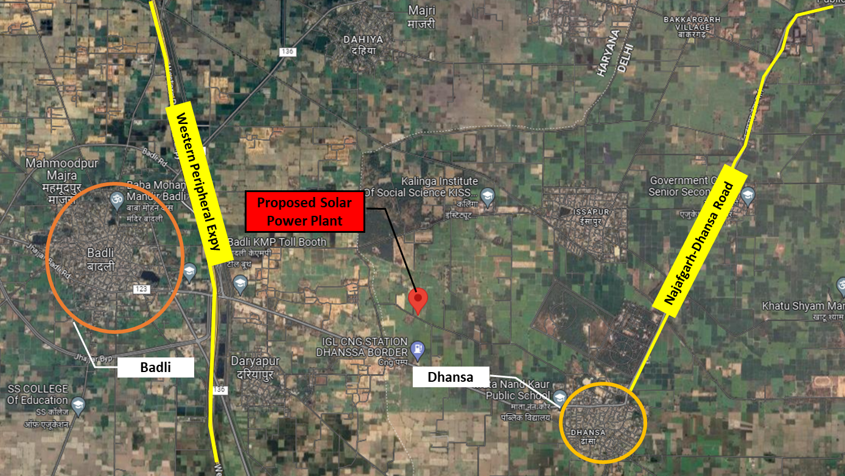
GPS Coordinates:- 28°34'00.2"N 76°50'44.5"E
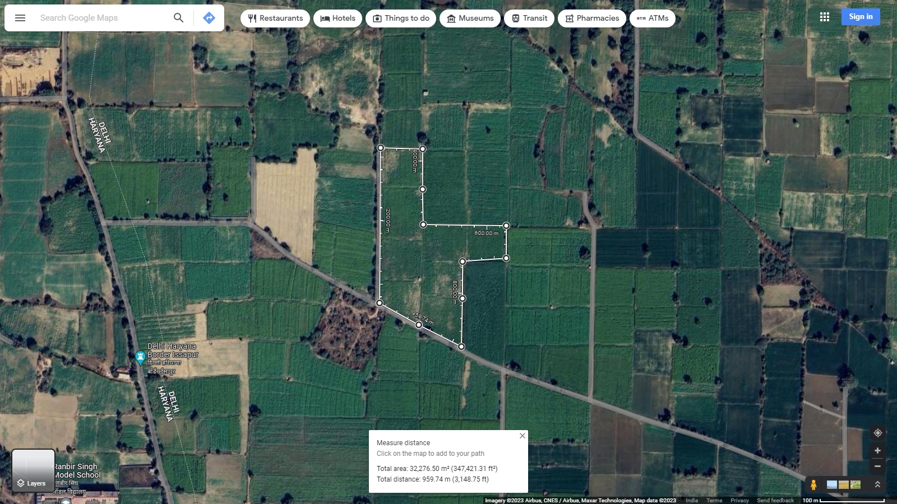

- SCOPE OF THE REPORT: To verify the Project cost, expenditures and examine the commissioning, installation status of Solar Power Plants set-up/ being set-up by M/s. TAFL Energy India Pvt. Ltd.
- Industry/ sector research and demand & supply trend is out of scope of the report.
- Financial feasibility study of the Project is out of scope of the report.
- Providing any kind of design report or map is out-of-scope of the report.
- Scrutiny of contracts, Agreements and arrangement between the parties from legal perspective is out-of-scope of this report.
- Energy yield calculation is out-of-scope of this report.
- Location feasibility is ascertained based on the PVSyst Report provided by the client.

All the assessment carried out for the Project is done based on the documents and information provided to us and its correlation by the Engineering team through physical and virtual site inspection and various other discussions with the Project proponents and thus forming an opinion out of it.
Component wise verification is not carried out but Project installation & commissioning has been verified as a whole.
Any kind of technical & economic feasibility of the Project is out-of-scope of this Report. This report is only limited & related to the verification and examination of what has already been setup.

- PURPOSE OF THE REPORT: To provide fair detailed analysis report to the Bank based on the “in-scope points” mentioned above for facilitating them to take appropriate business decision on the Project.

- METHADOLOGY ADOPTED:
- To gather relevant data/ information/ documents related to Project planning, execution, current status.
- Study of copy of Project Planning documents/ Agreements to know the scope of work of the company.
- To procure, study and analysis of any additional information, data, and documents required/ provided by the company.
- Physical site inspection for ascertaining the status of work and shadow analysis.
- Research about the Project/ sector from the sources in the public domain.
- Correlation of the provided information against Industry/ sector benchmarks/ trend.
- Information compilation, analysis and reporting.

PART C | PAA/LOI DETAILS

As per information provided by the company, the total proposed capacity of ground mounted solar power plant is 4925 kW. As on date, company have signed PPA to supply power of 4075 kW and received LOI of 450 kW. Details PAA/LOI are tabulated below:
S. No. | Power Purchaser | Power Agreement  (in KWp) | Address | Remark
1 | A.S.H.A | 4,000 | Sector 18-A, Dwarka | Company has signed a PPA of 4000 KWp with Venkateshwar Hospital operated by A.S.H.A. The PAA was signed on 31-03-2022 for a period of 25 years.
2 | Himanshu Education Society | 75 | Jindal Public School, Dashrathpuri, Dwarka | Company has signed a PPA of 75 KWp with Jindal Public School operated by Himanshu Education Society. The PAA was signed on 30-06-2022 for a period of 25 years.
3 | Diamond Educational Welfare Society | 400 | Shri Venkateshwar International School, Sector-18, Delhi | Company has signed a PPA of 400 KWp with Shri Venkateshwar International School operated by Diamond Educational Welfare Society. The PAA was signed on 09-08-2022 for a period of 25 years.
4 | PGDAV College | 450 | Nehru Nagar, Lajpat Nagar | Company have received LOI on 15-02-2023 from PGDAV College, Delhi to supply 450 kW grid connected power supply. However, the PPA is yet to be signed.
Total |  | 4,925
Source: Details provided by the company

- Important Clauses: Some of the important clauses as per 3 nos. of signed PPA’s are as follows:-
Clause: 2- Terms & Termination
2.2. Terms
(i) The term of this agreement will be for a period of 25 years from COD, unless extended.
(ii) The term of this agreement shall be extended by one month for each payment default by the Power Purchaser.
(iii) The term of this agreement shall be extended until all overdue amounts payable by the Power Purchaser under any invoice or otherwise are paid in full along with applicable Late Payment Surcharges.
(iv) The parties may, with mutual agreement, extend the term of this agreement beyond the agreed period of 25 years from COD, and the parties shall record the terms of such extension in the form of an amendment to this agreement.

2.3. Purchase Option/ purchase Obligation
(i) Any time after 5 years from COD, the Power Purchaser has the option to purchase the Solar Power Plant ("Purchase Option") by paying the Power Producer the Purchase price as per Schedule ll to this Agreement ("Purchase Price").
(ii) To exercise its Purchase Option, the Power Purchaser shall provide written notice to the Power Producer of the Power Purchaser's intent to exercise its option under clause (i) above, at least 90 days prior to the desired date of such purchase by the Power Purchaser ("Desired Purchase Date").
(iii) ln the event the Power Purchaser exercises its Purchase Option:
- lt shall pay to the Power Producer at least 5 (five) Business Days prior to the Desired Purchase Date:
- The purchase price: and
- Payment for Delivered Energy until the Desired Purchase Date (based on an estimate provided by the Power Producer for expected generation)
- Upon payment as per clause (A):
- The Parties shall promptly execute all documents necessary to cause title to the Solar Power Plant to pass to the Power Purchaser on the Desired Purchase Date, free and clear of all liens.
- The Power Producer shall assign all vendor warranties for the Solar Power Plant to the Power Purchaser, and either execute a sub-lease in favour of the Purchaser for the installed Space or take all actions necessary at its end to get the installed Space leased directly to the Purchaser. The Purchaser accepts the Power Producer is dependent on cooperation from the owner of the installed Space for such transfer of lease/ execution of sub-lease.
- This Agreement shall terminate.
(iv) The purchaser acknowledge the solar power plant transferred to it pursuant to this clause shall be in used but operating condition.

2.4. Early Cancellation Right
The purchase shall have the right to terminate this agreement on the 18th anniversary of COD without the payment of any penalty. If the purchaser indents to exercise such rights, t must send the power producer notice of at least 6 months. (Early Cancellation Right only valid for Venkateshwar Hospital).
Clause: 3- Lease and Access Rights
3.1. Access Rights
The power producer hereby grants the purchaser the right to enter the installed space of the purposes of observing the solar power plant, upon the producer submitting a request to the power producer for such a visit at least 5 business days ahead of the proposed visit.
3.2. Lease Rights
Any lease rights associated with the Installed Space shall remain solely with the Power Producer until the exercise of the Payment Option by the Power Purchaser and payment of the Purchase Price.
Clause: 4- Construction and O&M of the Solar Power Plant
4.1. Capacity
In the event the Solar Power Plant is of a higher or lower capacity than the intended Power (4 MW_{DC} for Venkateshwar Hospital, 400 KW_{DC} for Venkateshwar International School and 75 KW_{DC} for Jindal Public School) as per the Parties' mutual agreement (as recorded in writing) or as per the requirements of the Distribution Utility, the clauses pertaining to such system size as set out under this Agreement shall be adjusted proportionately to account for such variation in capacity.
4.2. Interconnection
The Power Producer shall provide and lay the dedicated electrical cables for transmission of Solar Power from the Solar Power Plant up to the Interconnection Point. Transmission or distribution of Solar Power beyond this point will be the responsibility of the Distribution Utility.
4.3. Construction Timeline
The Power Producer shall install, commission and complete the Solar Power Plant and achieve COD within 9 months from the Effective Date, provided the Power Purchaser has fulfilled its obligations under clause 5 and no Force Majeure Event has occurred.
4.4. Commissioning
The Power Producer shall notify the power purchaser at least 3 business days before the likely COD.
4.5. Maintenance
(i) The Power Producer shall be responsible for the ongoing maintenance of the Solar Power Plant and any spares/ replacements so required.
(ii) The Power Producer shall be responsible for regular cleaning of the Solar Power Plant.
(iii) The Power Producer shall be entitled to suspend delivery of Solar Power from the Solar Power Plant for up to 2 days per calendar year for the purpose of major maintenance or repair works. The Power Producer must intimate the Power Purchaser NOTARY suspension of supply within 2 Business Days of the end of such suspension and the Power Purchaser accepts that the Committed Generation for the period in question shall be proportionately reduced.

PART D | KEY TECHNICAL PARAMETERS & CONFIGURATION

As per details provided by the company, technical specification of solar power plant are tabulated below:-
S. No. | Category | Specifications
1 | Design Ambient Temperature | 50 Degree
2 | Altitude | 300 mtrs
3 | MMS Configuration | Fixed Tilt Elevated Structure Suitable for Agriculture Beneath SPV Modules
4 | Plant DC Capacity | 1x 4.925 MWp
5 | Plant AC Capacity | 3.8 MW @ Unity Power Factor
6 | Module Wp | 545 Wp
7 | String configuration | 28 Nos. module per string
8 | Inverter Type and capacity | Sungrow brand of invertors from Sungrow power supply company Multi-MPPT String Inverter for 1500 Vdc System-295 KVA at 50 deg C
9 | DC Ohmic loss | 1.5% avg.
10 | AC Ohmic loss | 1.5% avg.
11 | Design Wind Speed | 170 km/hr as per IS 875
12 | PV Modules | Rayzon make monocrystalline 545 Wp Total Nos. 9083
13 | Inverters | Sungrow brand of String Inverters  - Type: Compatible with Module Connector, MC4  - Rated Voltage: 1500V dc (as per configuration offered)  - Current Rating: 15A / 30A / as per design requirement  13 Nos.
14 | PV Connectors | MC 4 connector without fuse; Current Rating: 15A / 30A as per design requirement
15 | UPS/Battery | Capacity-5 kVA  Input Voltage Variation 415/230/240V±10%  Phase of input supply- 3φ  Backup time- 30 min.
16 | SCADA | Without any type of redundancy and Cloud storage facility  SCADA own database
17 | Cables | 11 kV Cable Direct buried in ground
As per Drawing
 | Module Rating | 545 Wp
 | Total DC Capacity | 4925 Wp
 | Total AC Capacity | 3825Wp
 | Pitch | 5.8 mtr
 | Tilt | 10°

PART E | IRRADIATION & ENERGY YIELD ASSESSMENT

Company has used PVSyst V7.2.4 to assess energy yield calculation which is the standard Industry practice. The yearly average of main results of irradiation and energy yield from the provided PVSyst is as under:

S. No. | Global Hor  (kWh/m²) | Diff Hor  (kWh/m²) | T_Amb  (ºC) | Glob Inc  (kWh/m²) | Glob Eff  (kWh/m²) | E Array  (MWh) | E_Grid  (MWh) | PR (Ratio)
1 | 1813.9 | 865.9 | 25.44 | 1925.0 | 1864.6 | 7537.1 | 7338.1 | 0.773

As per the PVSyst reports of each plant, the last year’s month wise production and performance ratio chart has been depicted below:
Normalized Production  (per installed kWp) | Performance Ratio PR
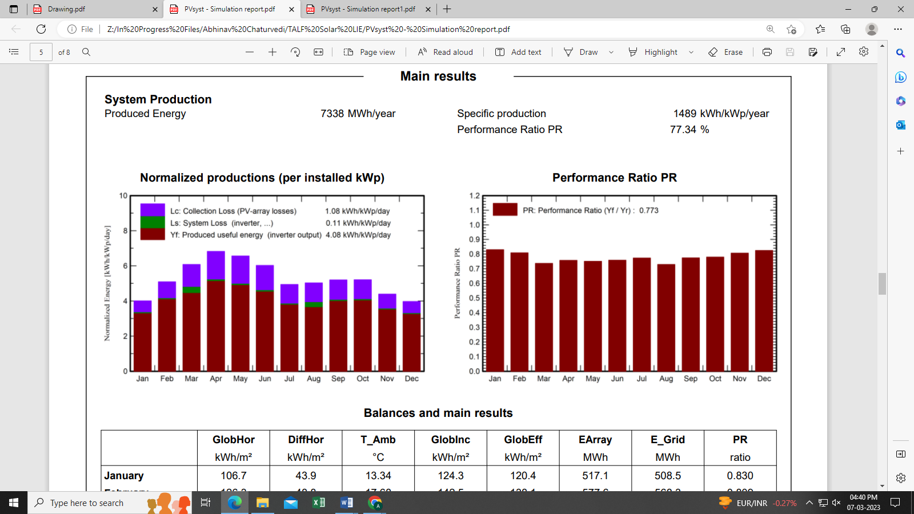 | 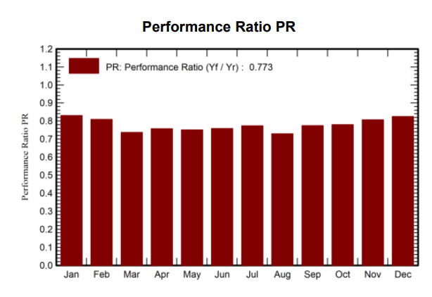

Summary:
S. No. | Plant | PVsyst - Simulation report
 |  | Produced Energy  (MWh/Year) |  | Performance Ratio (%)
 |  | P50 | P90
1 | Dhansa Plant | 7338.00 | 7048.00 | 77.34
Total |  | 7338.00 | 7048.00
*Energy Generation numbers may change +/- 10%, subject to actual installation capacity of the Plant.

PART F | CONTRACTOR’S DETAILS

On 21st February 2023, TALF Energy India Private Limited has signed an Engineering, Procurement and Construction Contract with TALF Solar India Private Limited to design, construct and install ground mounted solar plant having an aggregate AC Capacity of 3790KW and DC capacity of 4925 KW. Some of the agreement details as mentioned in the signed contract area as follows:-
- Binding & Final Agreement
  - This agreement shall enter into effect from the date of its execution, and from such date, shall constitute a binding contract between the Parties for the duration of the Agreement.
  - This Agreement terminates and supersedes all prior understandings or agreements on the subject matter hereof, and is binding upon each Party and its successors and assigns.
  - No waiver or modification of this Agreement will be binding upon either Party unless made in writing and signed by a duly authorized representative of each such Party or Parties and no failure or delay in enforcing any right will be deemed a waiver.

- Purpose & Scope of the Agreement
  - The purpose of this Agreement includes design, manufacture, supply, erection, testing and commissioning including warranty (as offered back to back by the supplier / OEM), for the "Solar Ground Mounted Plant".
  - Each Solar Ground Mounted Plant shall be considered Commissioned when it has been synchronized with the grid, i.e. is capable (technically and with all requisite permissions) of injecting electricity into the grid, and date of such commissioning shall be the "Commissioning Date".
  - The technical specifications that need to be adhered to by the CONTRACTOR in implementing the Ground Mounted Solar PV Plant for the CLIENT shall be as per the guidelines in the Railways Tender.

- Roles and Responsibilities

S. No. | Description | Primary Responsibility
1 | Permit and approvals
1.1 | DISCOM & Nodal Agency Approval for PV Plant | Contractor
1.2 | Any other DISCOM Approvals/ wiring upgradation | Contractor
1.3 | Tax Exemption (If Any) | Contractor
1.4 | Net metering equipment/Statutory Charges | Contractor
1.5 | Line Charging & Connectivity from DISCOM | Contractor
1.6 | Power supply for operations | Contractor
1.7 | Post Commissioning Asset Insurance | Client
1.8 | Land Identification and Lease Registration | Contractor
2 | ENGINEERING & PREPARATION
2.1 | Project DPR, Implementation Plan | Contractor
2.2 | Design Basis Document, Creation of Engineering Drawings, specification, construction drawings | Contractor
2.3 | Land Development | Contractor
3 | PROCUREMENT
3.1 | Solar PV modules | Contractor
3.2 | Module mounting structures -Fixed Tilt | Contractor
3.3 | DC & AC Cables | Contractor
3.4 | Inverters & String Combiner Box | Contractor
3.5 | LV/MV AC Equipment & Accessories including metering | Contractor
3.6 | Earthling Material, Fire Extinguishers & Weather Monitoring | Contractor
3.7 | Any other procurement (as per Rfs) | Contractor
4 | LOGISTICS
4.1 | Comprehensive marine, transit, storage, erection all risk insurance cover | Contractor
5 | CONSTRUCTION ACTIVITIES
5.1 | Site Preparation (Level ground) | Contractor
5.2 | Civil Engineering Works | Contractor
5.3 | Electrical Engineering Works | Contractor
5.4 | Other Miscellaneous Systems | Contractor
6 | PROJECT AND CONSTRUCTION MANAGEMENT
6.1 | Project Management, scheduling & tracking | Contractor
6.2 | Site Supervision | Contractor
6.3 | Health Safety & Environment Monitoring | Contractor
6.4 | Quality Assurance/Quality Control | Contractor
7 | POST CONSTRUCTION ACTIVITIES
7.1 | As built drawings. | Contractor
7.2 | Handing over copies of manuals and test report for all project components. | Contractor
8 | TESTING AND COMMISSIONING
8.1 | Mechanical completion test | Contractor
8.2 | PR acceptance test | Contractor
8.3 | Any other testing/reports required by Railways | Contractor

- Contract Price; Payment to Contractor
  - Contract Price
The Contractor shall be paid a total contract price of Rs. 62.39.
Item | Rs./Wp (DC)  Base Rate | GST | Rs./Wp (DC)  Total Rate
Solar System Supply & Design & Installation  Land Development, Solar Modules (Panels), Invertors, AC Supply, DC Supply, MMS, WMS/RMS, Civil Works, Transportation Warehouse, Liaising (EPC+Net Metering), PNC, Testing& Commissioning | 54.83 | 7.57 | 62.39

  - Payment Terms

Solar System Supply & Design & Installation  Land Development, Solar Modules (Panels), Invertors, AC Supply, DC Supply, MMS, WMS/RMS, Civil Works, Transportation Warehouse, Liaising (EPC+Net Metering), PNC, Testing& Commissioning | On actuals as per the contractor’s invoices of estimated procurement and cost, with the contractor’s margin payable on project commissioning

  - Variation in Contract Price
In case of any statutory variations in the rate of applicable taxes and duties, or imposition of new taxes & duties, including but not limited to, anti-dumping duties, during the tenure of this Agreement, the same shall be borne by the Client.

- Completion & Completion Period
  - The Contractor shall submit to the Client an implementation plan within 5 working days of the Effective Date (or such time as mutually agreed between the parties), charting out all key activities along with their timelines, from the Effective Date until Commissioning of all Solar Ground Mounted Plants (the "Implementation Plan").
  - Each Solar Ground Mounted Plant shall be considered commissioned whenever it is synchronized with the Grid.
  - Each Solar Ground Mounted Plant shall be erected and commissioned by 31 August 2023 ("Scheduled Commissioning Date"), unless mutually agreed by both Parties.
  - The Scheduled Commissioning Date shall be extended:
- In the event of payment delays by the Client, by the number of days of such delay.
- In the event of the Client not approving within 3 working days the designs, or variations to any designs, submitted by the Contractor, by the number of additional days taken by the Client to provide its approvals.
- In the event of the Client not approving within 3 working days the vendors and rates negotiated jointly by the Client and Contractor, by the number of additional days taken by the Client to provide its approvals.
- In the event of inhibited site access, by the number of days the Contractor are not provided uninhibited site access.
- In the event of any Force Majeure, by the number of days such Force Majeure persists.

PART G | CURRENT STATUS OF WORK

Observations and Remarks:
- As per observation made during site visit, the work related to installation of solar panels is yet to be started. Only electricity poles and electric meter connection have been installed on the site.
- Since the subject location is an agricultural land and mustered crop were lying on land. The installation work related solar power plant is expected to be started in April 2023.
- As per information provided during the site visit, the material and panels is yet to be purchased.
- As per project timeline shared by the company, the project was expected to start from 01-03-2023 and SCOD of the project is 31-08-2023.
- As per copy of EPC agreement dated 21st February 2023, TALF Energy India Pvt. Ltd. (Client) signed an agreement with TALF Solar India Pvt. Ltd. (Contractor) for Design, Supply & Installation of ground mounted solar power plant at the rate of Rs. 62.39/- per Wp(DC) (including GST).
- Photographs of the site are annexed with the report.

Note:
- Therefore, based on the information received from the company and observations made during the site visit, the project is yet to be started.
- Time schedule for completion of the Project is 31st August 2023.

PART H | PROJECT COST & EXPENDITURE

Project Cost: We have requested latest available CA certificate of the project from the company. As per information shared, CA certificate of the project is not prepared yet. However, we have been shared cost breakup of the project. Details of the same are tabulated below:-
Particulars | Amount (In Rs. Cr.)
EPC Contractor
Solar modules | 14.29
invertors | 1.14
MMS | 4.43
BoS | 1.48
Misc. Items | 1.48
EPC Contractor Margin | 2.28
GST | 3.46
Sub-total: A | 28.56
Lease registration charges | 0.25
land development costs | 0.49
IDC | 1.05
consultants (Incl. GST) | 0.25
Sub-total: B | 30.60
Other Cost
Lease Deposit | 0.11
Upfront Fee | 0.26
DSRA | 0.95
Pre-op & Other Devp. Costs (Incl. GST) | 0.10
Sub-total: C | 1.42
Grand Total (A+B+C) | 32.02

Expenditure: As per observation made during the site survey, the installation work related to power plant is yet to be started. As per information provided by the company only lease registration charges, lease deposit, pre-operative expenses have been incurred. However, details of the same are not shared with us. Thus, we cannot comment upon total cost incurred till date on the project.

Observations and Remarks:
- Project cost calculated on the basis of market comparable. Details as per market comparable available are tabulated below:-
S. No. | Particulars | Excluding GST | Including GST | Remark
 |  | Per MW Cost  (In Rs. Cr.) | Per MW Cost  (In Rs. Cr.)
1 | Project Installation Cost as per EPC Agreement | 5.10 | 5.80 | As per EPC Agreement
Market Research Details
2 | Market Research | 4.87 | 5.54 | Refer Annexure-1
3 | WAAREE Solar | 4.00 | 4.55 | Refer Annexure-2
4 | As per Solar Square | 4.50 | 5.12 | Refer Annexure-3
5 | Market Quotation (Tata Solar) | 6.00 | 6.83 | Refer Annexure-3
- As per our analysis and market research, the installation cost of Ground Mounted Solar Power Plant varies from Rs. 4.55 Cr. per MW to Rs. 6.83 Cr. per MW.
- The project cost is solely dependent upon project location, contractors profit, type of land, type of module supporting structures etc.
- Based upon the above mentioned details, we can say the total project of the said project is fair and reasonable.

- Since, the entire project is being executed through an EPC contract agreement, therefore, the invoices/ bills shall be raised once the entire project gets commissioned.
Note:
- Project cost is analyzed based on lump sum cost only and not item wise.
- Project cost is assessed for the date of this report only and due to price fluctuations it may vary from time to time.

PART I | PHOTOGRAPHS

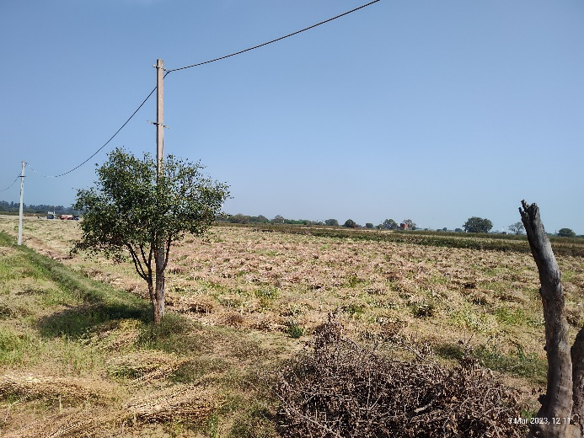 | 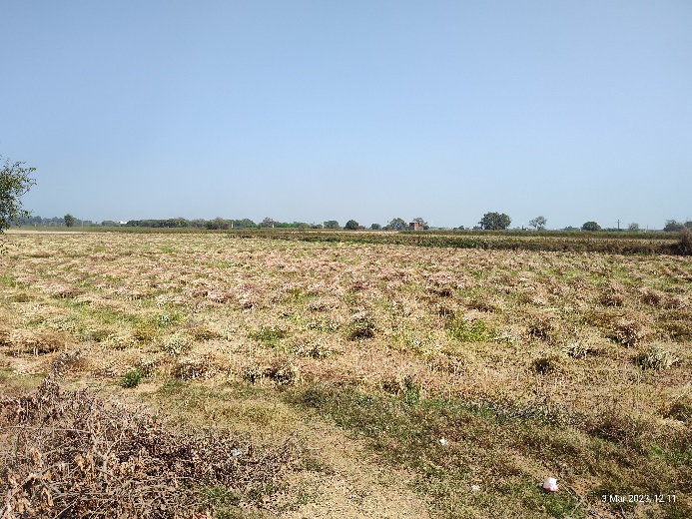
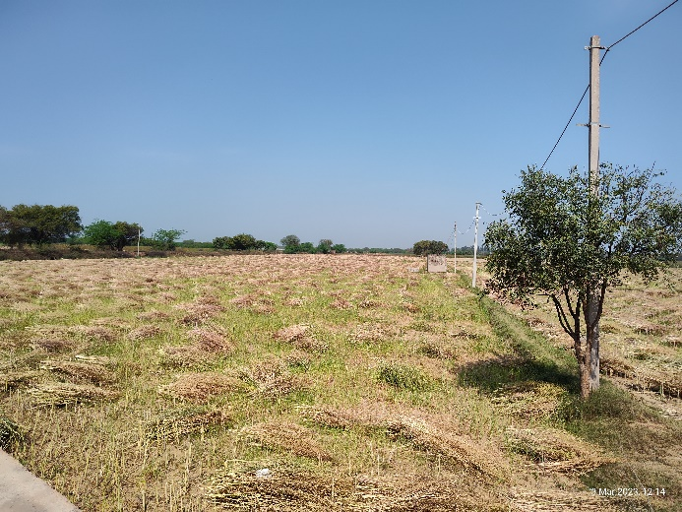 | 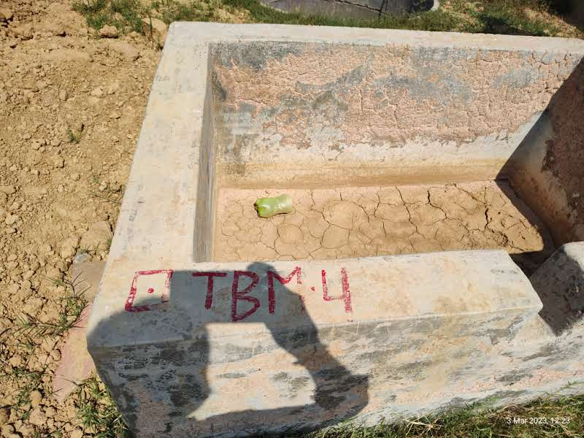
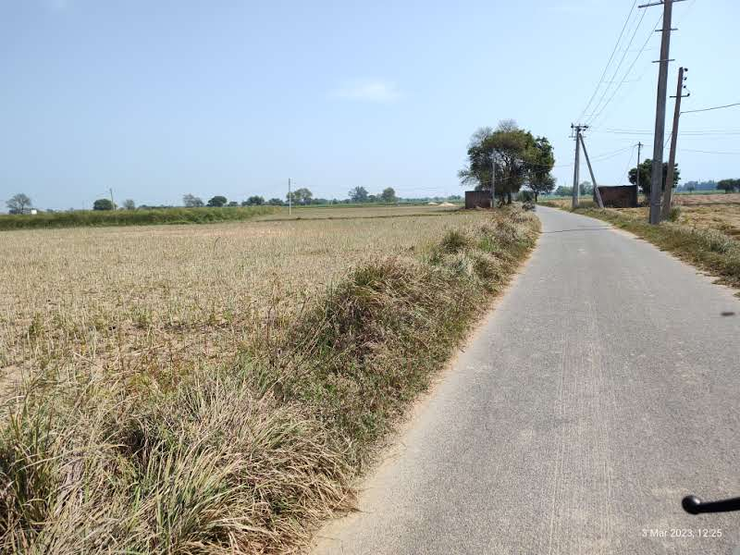 | 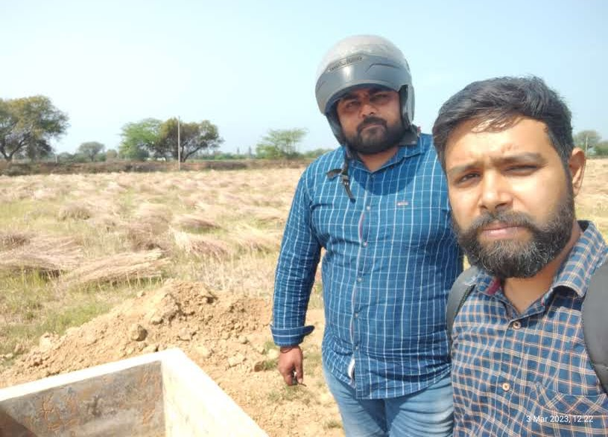

Annexure-1

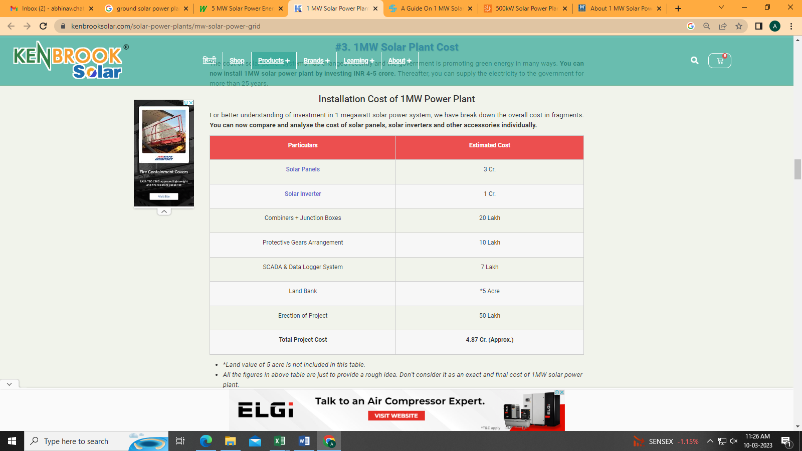

Annexure-2

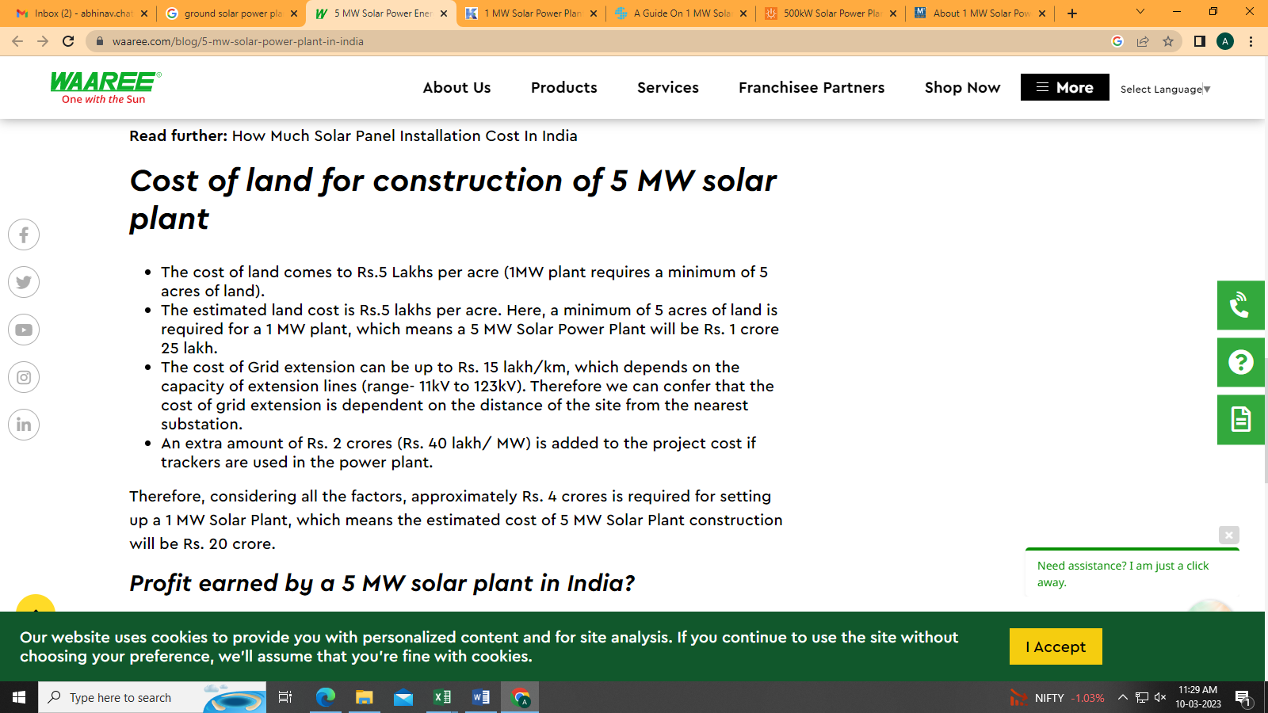

Annexure-3

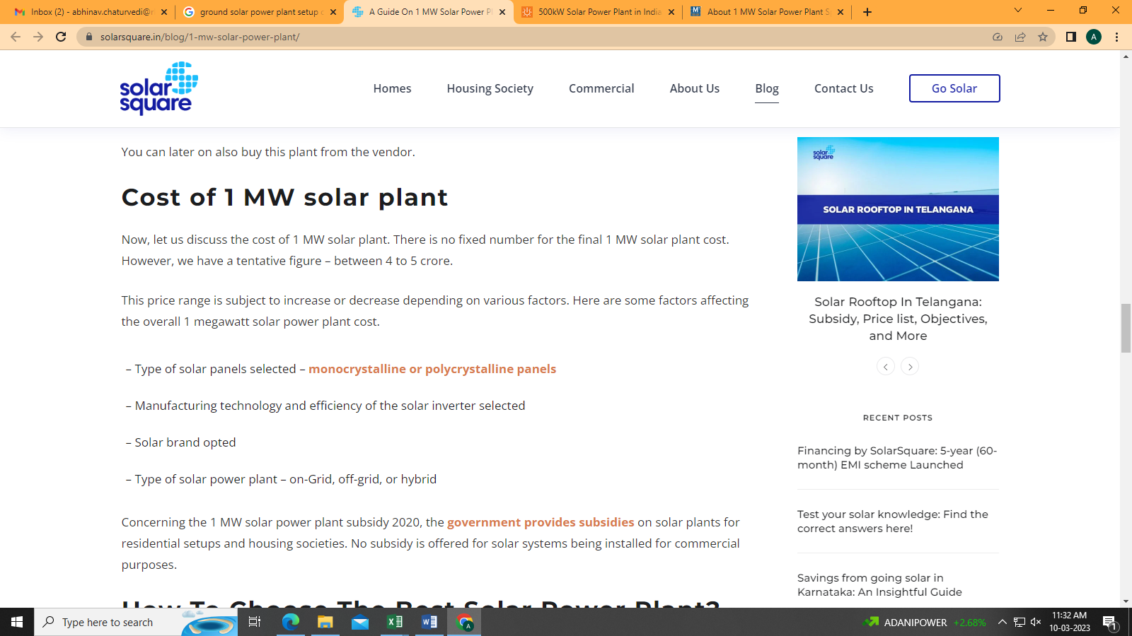

Annexure-4

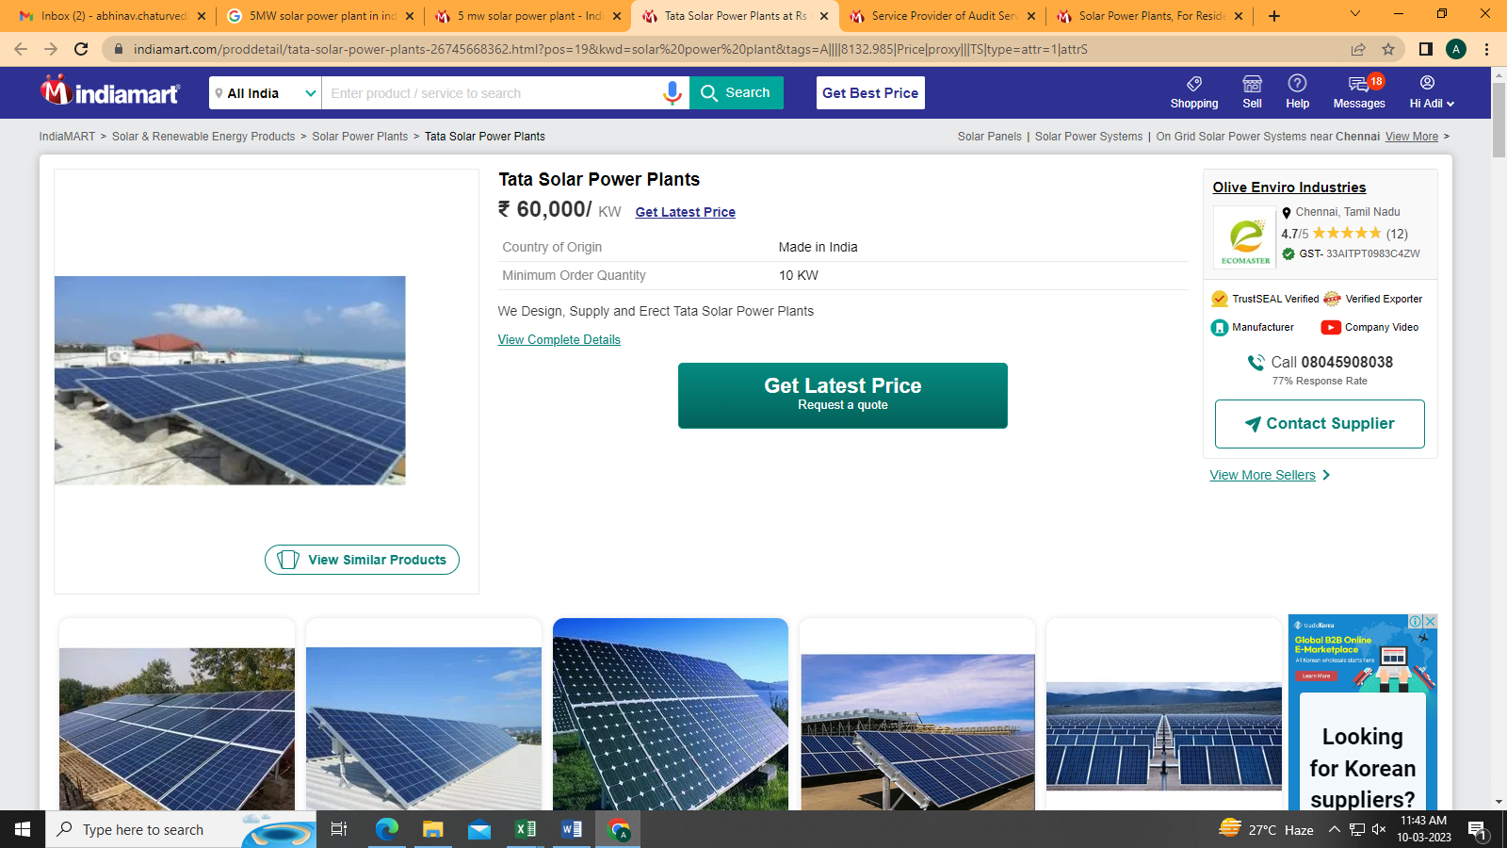
PART J | OTHER DOCUMENTS & REFERENCES
Data by Global Solar Atlas by World Bank Group
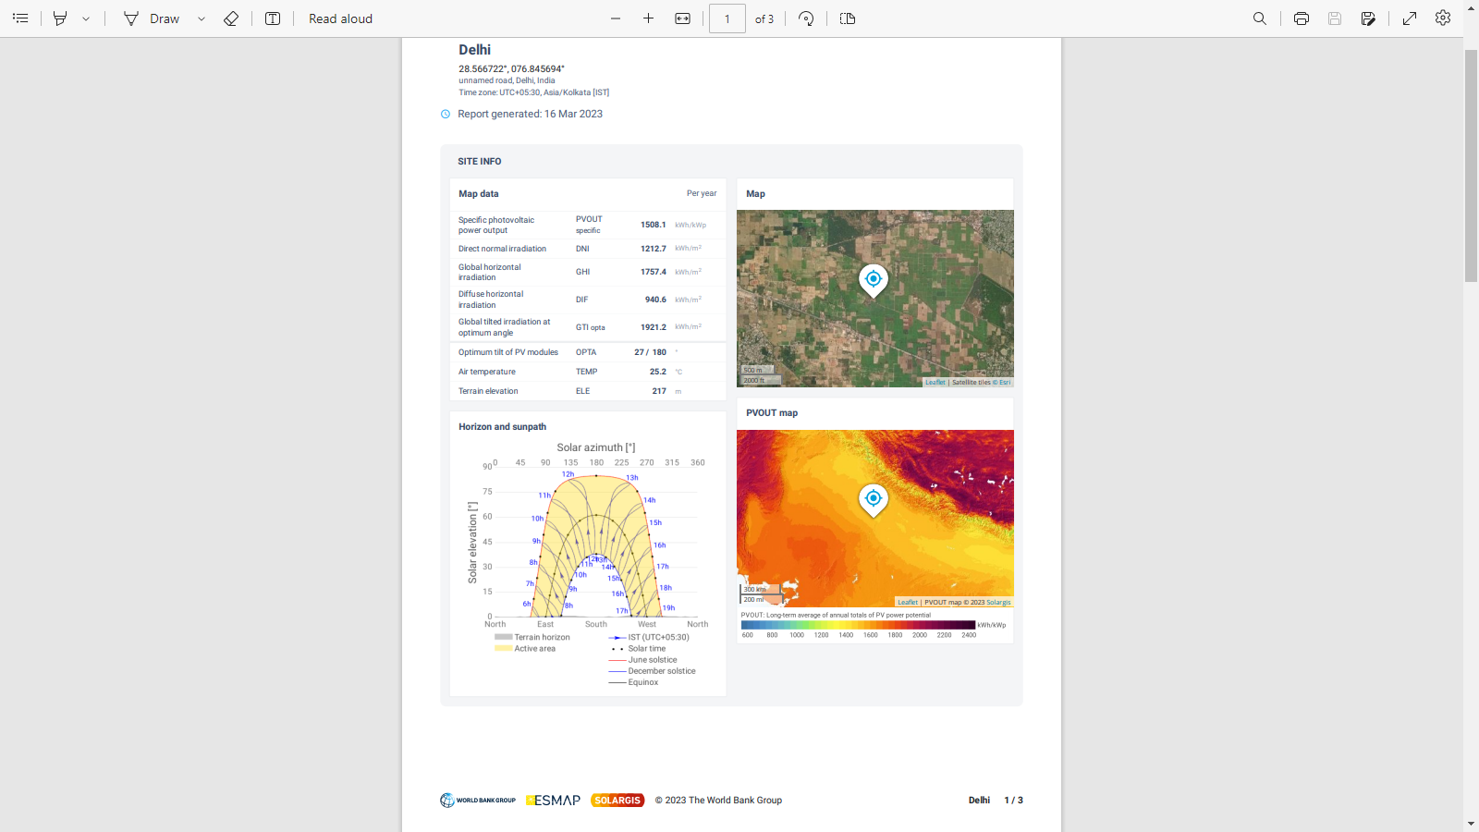

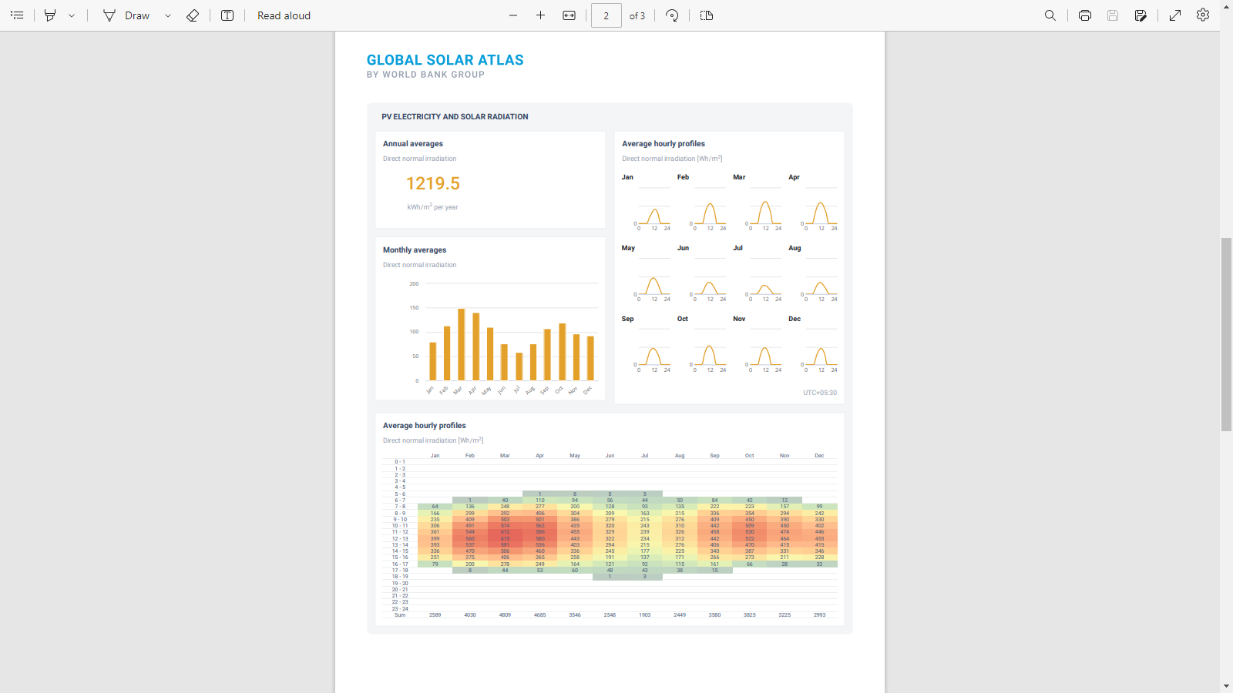

Lease Deed
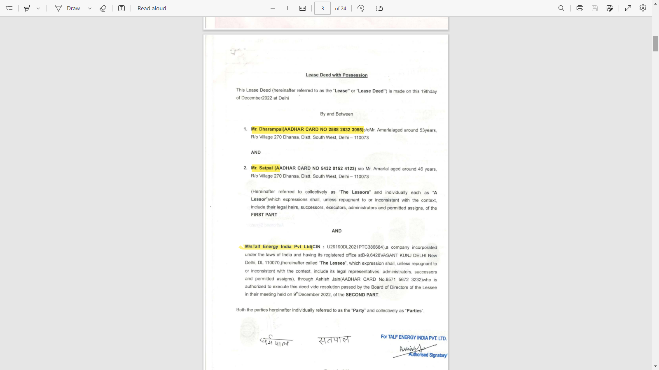

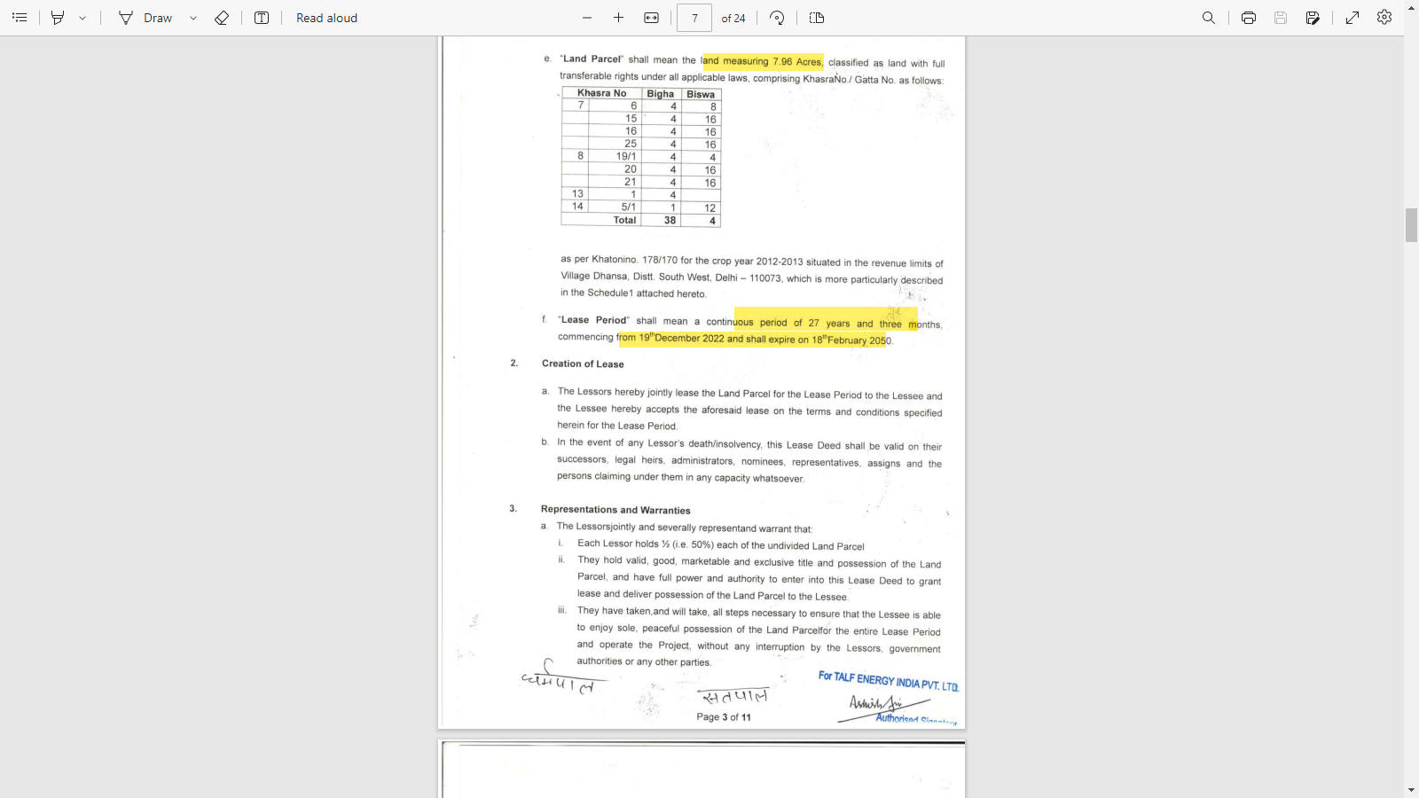

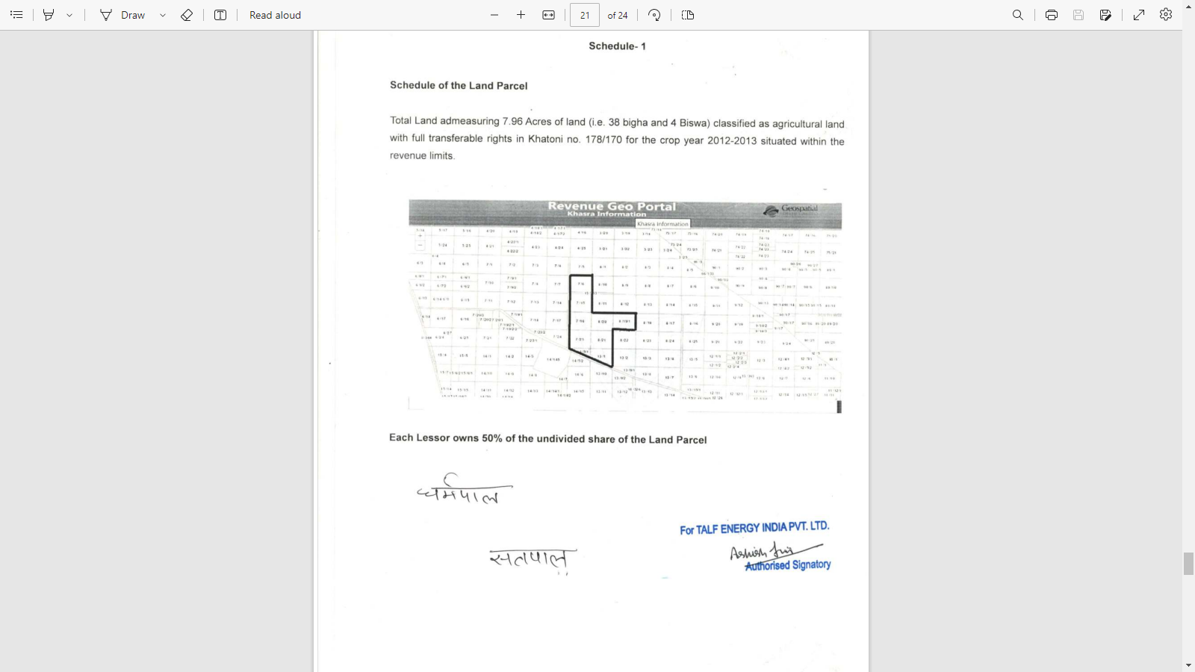

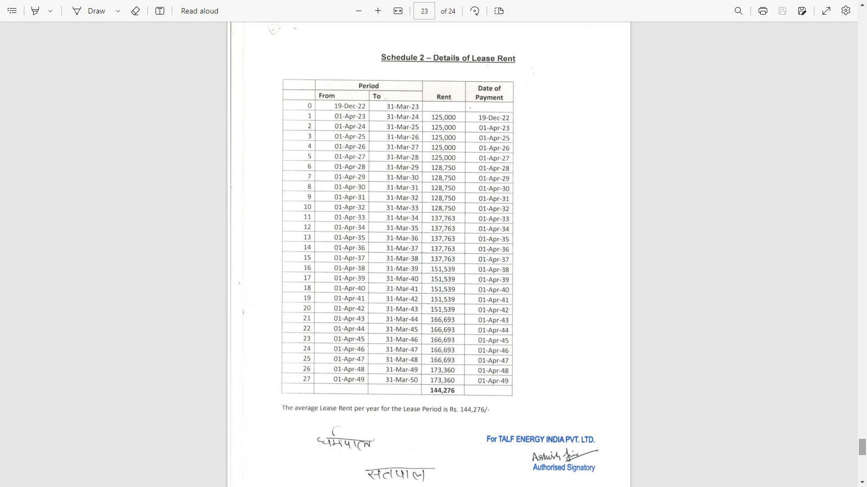

Time Schedule
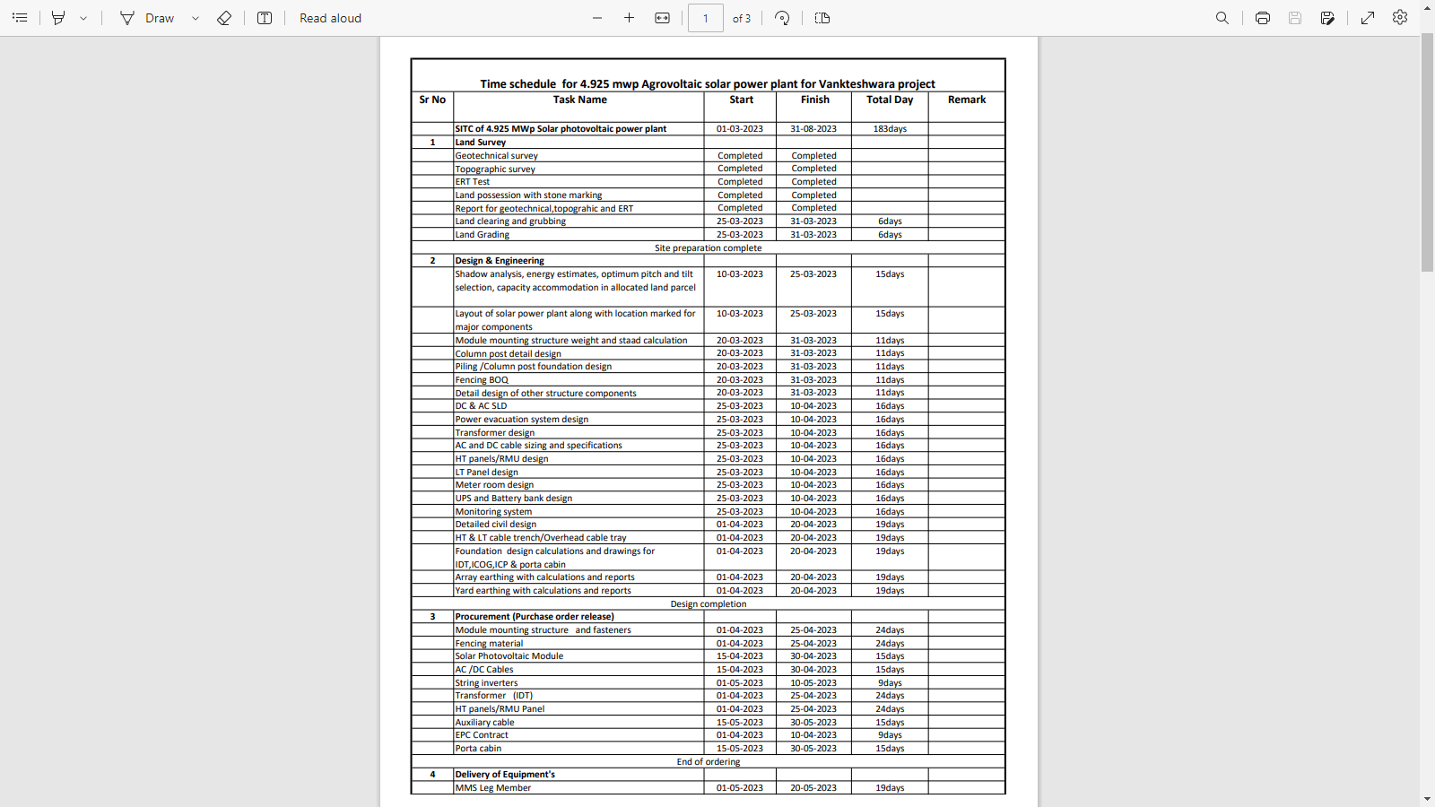

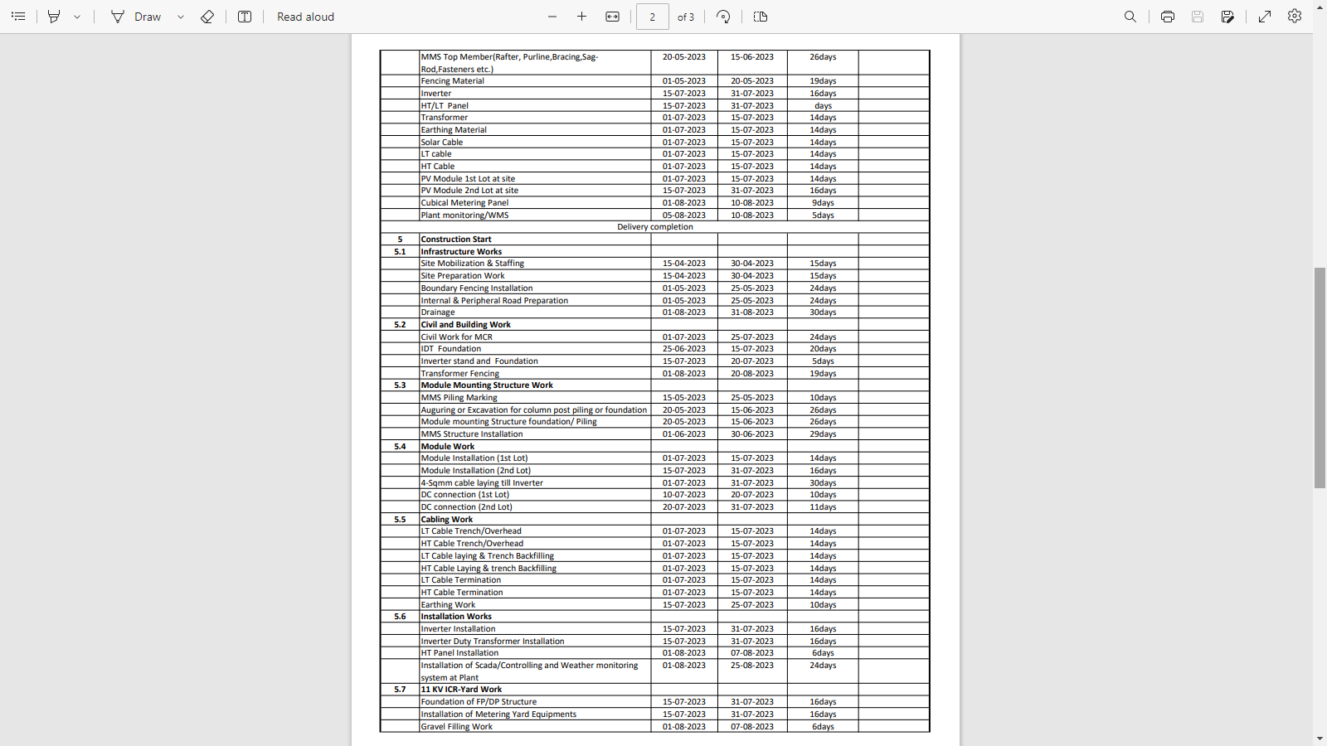

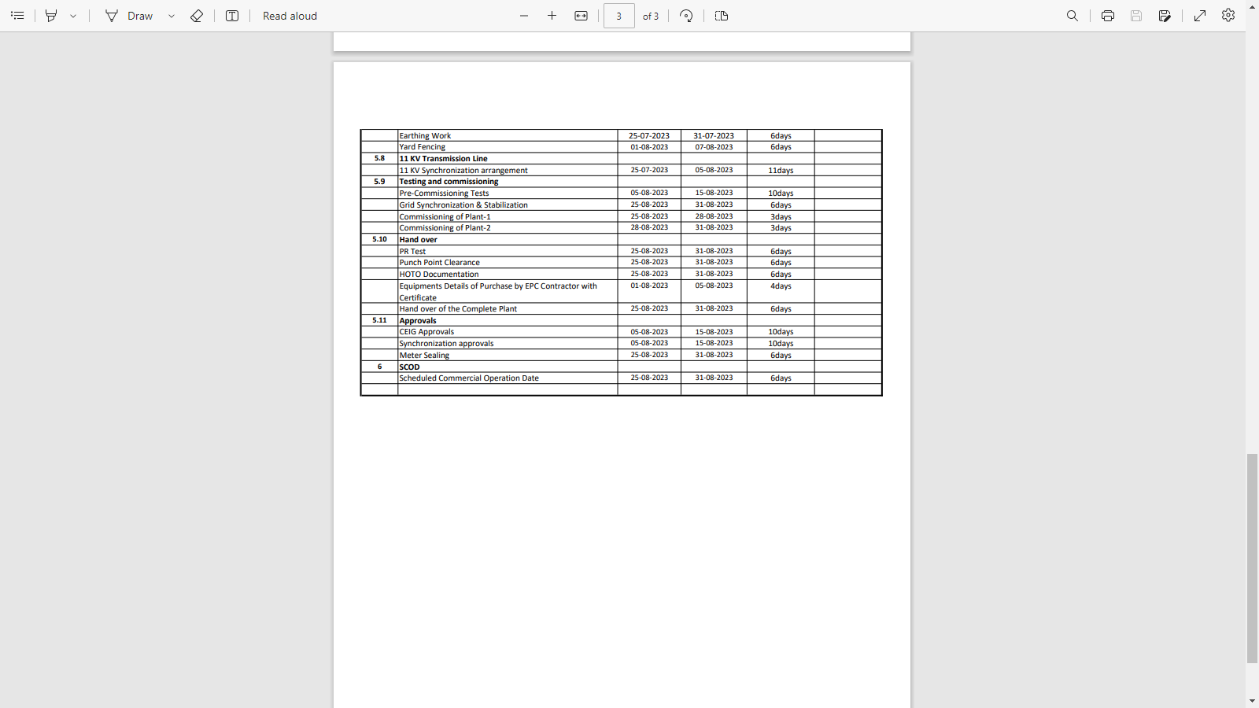

EPC Contract
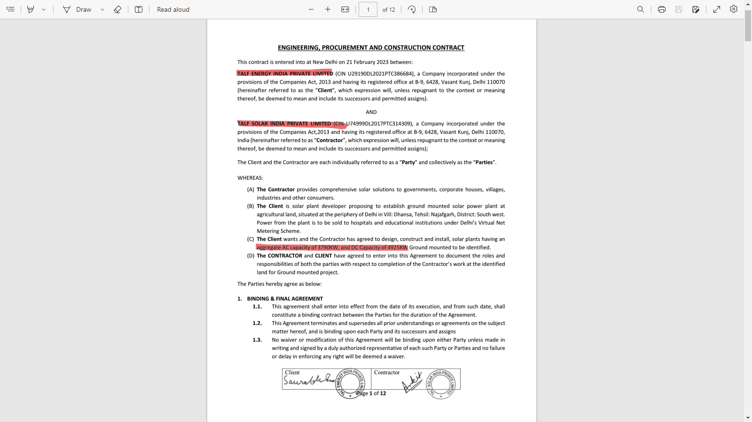

Solar Plant Drawing
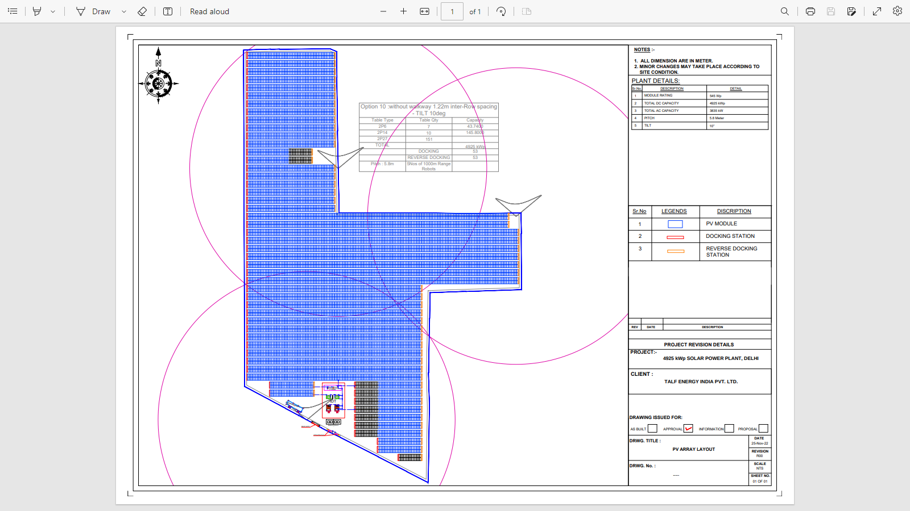

Venkateshwar Hospital PPA
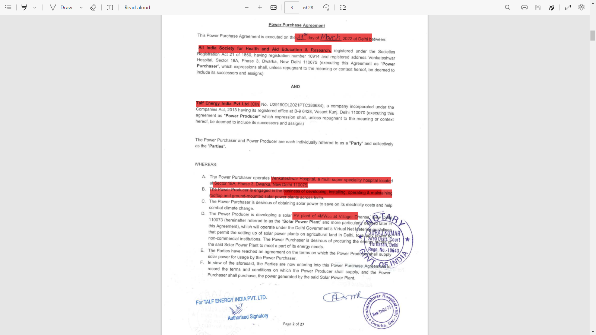

Shri Venkateshwar International School PAA
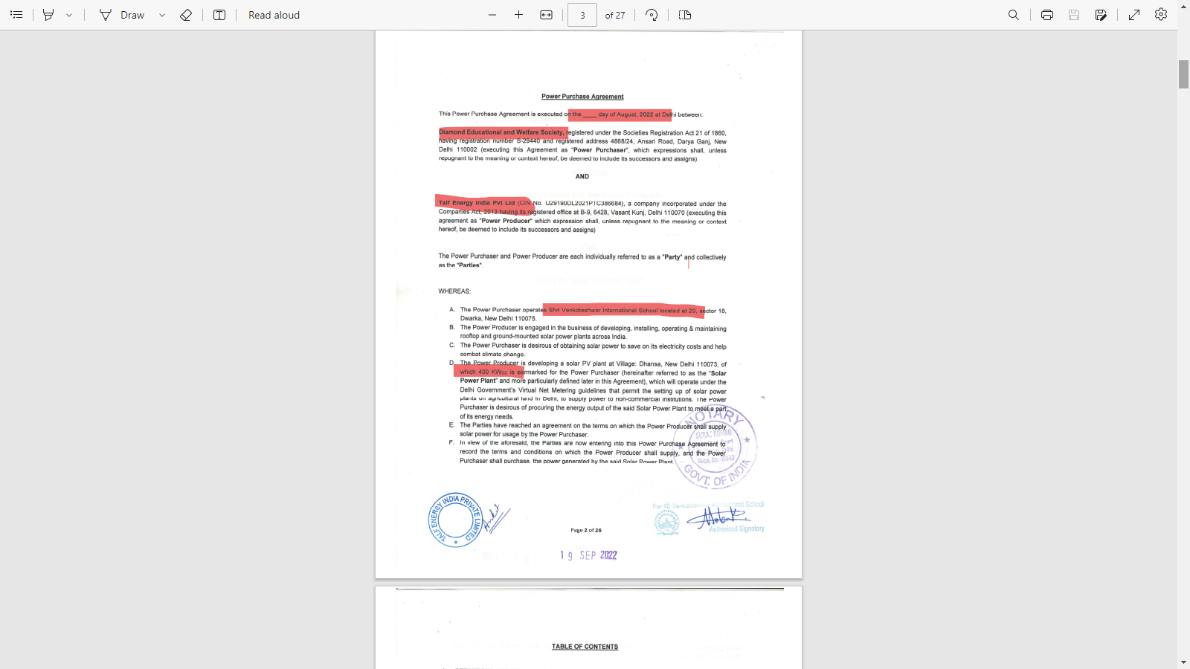

Jindal Public School PAA
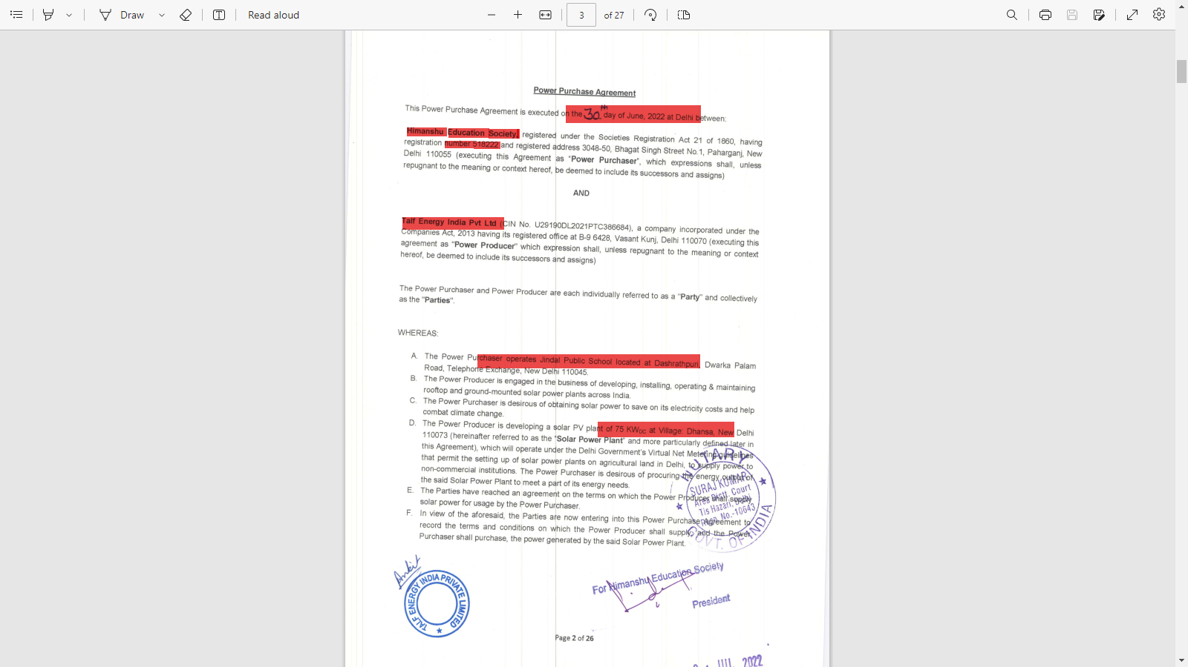

P.G.D.A.V. College PPA
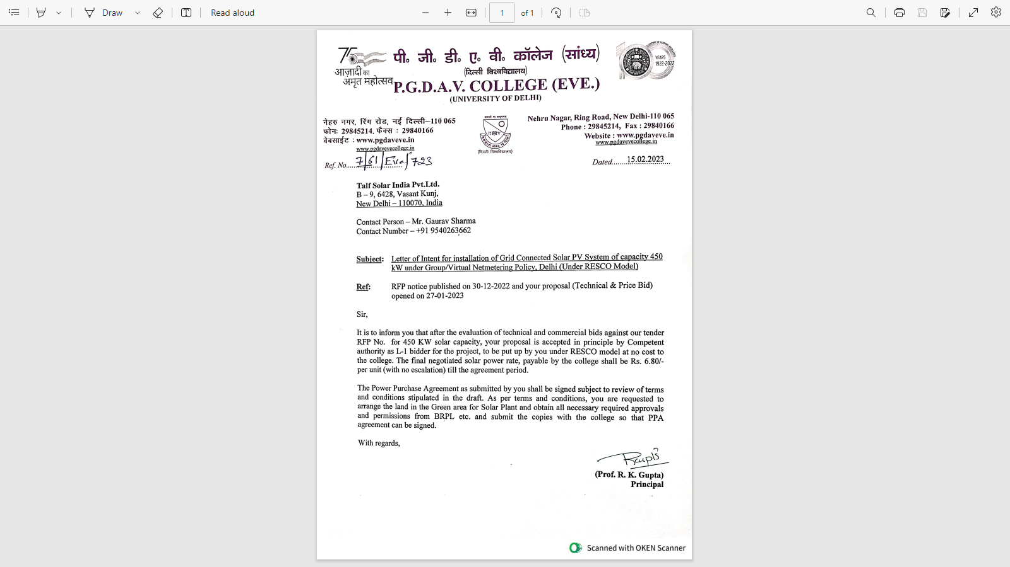

PART K | DISCLAIMER

      - No employee or member of R.K Associates has any direct/ indirect interest in the Project.
      - This report is prepared based on the copies of the documents/ information which the Bank/ Company has provided to us out of the standard checklist of documents sought from them and further based on our assumptions and limiting conditions. All such information provided to us has been relied upon in good faith and we have assumed that it is true and correct in all respect. Verification or cross checking of the documents provided to us has not been done at our end from the originals. If at any time in future, it is found or came to our knowledge that misrepresentation of facts or incomplete or distorted information has been provided to us then this report shall automatically become null & void.
      - This report is a general analysis of the project based on the scope mentioned in the report. This is not an Audit report, Design document, DPR or Techno-financial feasibility study. All the information gathered is based on the facts seen on the site during survey, verbal discussion & documentary evidence provided by the client and is believed that information given by the company is true best of their knowledge.
      - All observations mentioned in the report is only based on the visual observation and the documents/ data/ information provided by the client. No mechanical/ technical tests, measurements or any design review have been performed or carried out from our side during Project assessment.
      - Bank/FII should ONLY take this report as an Advisory document from the Financial/ Chartered Engineering firm and it’s specifically advised to the creditor to cross verify the original documents for the facts mentioned in the report which can be availed from the borrowing company directly.
      - In case of any default in loans or the credit facility extended to the borrowing company, R.K Associates shall not be held responsible for whatsoever reason may be and any request for seeking any explanation from the employee/s of R.K Associates will not be entertained at any instance or situation.
      - This Report is prepared by our competent technical team which includes Engineers and financial experts & analysts.
      - This is just an opinion report and doesn’t hold any binding on anyone. It is requested from the concerned Financial Institution which is using this report for taking financial decision on the project that they should consider all the different associated relevant & related factors also before taking any business decision based on the content of this report.
      - All Pages of the report including annexures are signed and stamped from our office. In case any paper in the report is without stamp & signature then this should not be considered a valid paper issued from this office.
      - Though adequate care has been taken while preparing this report as per its scope, but still we can’t rule out typing, human errors, over sightedness of any information or any other mistakes. Therefore, the concerned organization is advised to satisfy themselves that the report is complete & satisfactory in all respect. Intimation regarding any discrepancy shall be brought into our notice immediately. If no intimation is received within 15 (Fifteen) days in writing from the date of issuance of the report, to rectify these timely, then it shall be considered that the report is complete in all respect and has been accepted by the client upto their satisfaction & use and further to which R.K Associates shall not be held responsible in any manner.
      - Defect Liability Period is 15 DAYS. We request the concerned authorized reader of this report to check the contents, data and calculations in the report within this period and intimate us in writing if any corrections are required or in case of any other concern with the contents or opinion mentioned in the report. Corrections only related to typographical, calculation, spelling mistakes, incorrect data/ figures/ statement will be entertained within the defect liability period. Any new changes for any additional information in already approved report will be regarded as additional work for which additional fees may be charged. No request for any illegitimate change in regard to any facts & figures will be entertained.
      - R.K Associates encourages its customers to give feedback or inform concerns over its services through proper channel at le@rkassociates.org in writing within 30 days of report delivery. After this period no concern/ complaint/ proceedings in connection with the Lender’s Independent Engineering Services will be entertained due to possible change in situation and condition of the subject Project.
      - Our Data retention policy is of ONE YEAR. After this period, we remove all the concerned records related to the assignment from our repository. No clarification or query can be answered after this period due to unavailability of the data.
      - This Lender’s Independent Engineering report is governed by our (1) Internal Policies, Processes & Standard Operating Procedures, (2) Information/ Data/ Inputs given to us by the client and (3) Information/ Data/ Facts given to us by our field/ office technical team. Management of R.K Associates never gives acceptance to any unethical or unprofessional practice which may affect fair, correct & impartial assessment and which is against any prevailing law. In case of any indication of any negligence, default, incorrect, misleading, misrepresentation or distortion of facts in the report then it is the responsibility of the user of this report to immediately or at least within the defect liability period bring all such act into notice of R.K Associates management so that corrective measures can be taken instantly.
      - R.K Associates never releases any report doing alterations or modifications from pen. In case any information/ figure of this report is found altered with pen then this report will automatically become null & void.

Place : Noida  Date : 07.03.2023  Note : This report contains 39 pages | FOR INTERNAL USE  SURVEYED BY: Abhinav Chaturvedi  PREPARED BY: Abhinav Chaturvedi  REVIEWED BY: Ashish Sawe
For R.K Associates Valuers & Techno Engineering Consultants (P) Ltd.

- DEFECT LIABILITY PERIOD - In case of any query/ issue or escalation you may please contact Incident Manager by writing at valuers@rkassociates.org. We ensure 100% accuracy in the Calculations done, Rates adopted and various other data points & information mentioned in the report but still can’t rule out typing, human errors or any other mistakes. In case you find any mistake, variation, discrepancy or inaccuracy in any data point of the report, please help us by bringing all such points into our notice in writing at valuers@rkassociates.orgwithin 30 days of the report delivery, to get these rectified timely, failing which R.K Associates Valuers Techno Engineering Consultants (P) Ltd. won’t be held responsible for any inaccuracy in any manner. Also if we will not hear back anything from you within 30 days, we will assume that report is correct in all respect and no further claim of any sort will be entertained thereafter. We would welcome and appreciate your feedback & suggestions in order to improve our services.

COPYRIGHT FORMAT - This report is prepared on the copyright format of R.K Associates Valuers Techno Engineering Consultants (P) Ltd. to serve our clients in the best possible way. Legally no one can copy or distribute this format without prior approval from R.K Associates. It is meant only for the organization as mentioned on the cover page of this report. Distribution or use of this format other than R.K Associates will be seen as unlawful act and necessary legal action can be taken against the defaulter

