REPORT FORMAT: CL-1 | Version: 1.0_2018

FILE No.: VIS(2022-23)-PL676-567-939 Date: 04-03-2023

- CERTIFICATE NAME: Cost Vetting Certificate of Copper Strip, Coils, Sheet and Foil Manufacturing Plant in addition to existing Copper Manufacturing Facility which is proposed to be installed in Plot No.530, 531, RIICO Industrial Area, Chopanki, Bhiwadi, Rajasthan-301019.
- PREPARED FOR ORGANIZATION: State Bank of India, SME Branch, Shahdara, Delhi.
- BORROWER COMPANY’S NAME: M/s. J M W India Private Limited (JMW).
- ASSET TYPE: Copper Strip, Coils, Sheet and Foil Manufacturing Plant in addition to existing Copper Manufacturing Facility
- CURRENT LOCATION OF THE MACHINES: Proposed to be installed at Plot No.530, 531, RIICO Industrial Area, Chopanki, Bhiwadi, Rajasthan-301019.
TO WHOM IT MAY CONCERN

S. NO. | PARTICULARS | DESCRIPTION
1. | Date of Survey | Not Applicable (only Cost Vetting Certificate)
2. | Date of Certificate | 04-03-2023
3. | Documents provided for perusal | Quotations from the market (and list of Machine/Assets to be installed)
4. | Current Location of the Machines | Plot No.530, 531, RIICO Industrial Area, Chopanki, Bhiwadi, Rajasthan-301019
5. | Borrowing Company | M/s. J M W India Private Limited.
6. | Type of Asset | Machinery required for the manufacturing of Copper Strip, Coils, Sheet and Foil Plant in addition to existing Copper Manufacturing.
7. | Type of Assessment | Cost Vetting Certificate
8. | Scope of Assessment | Cost Vetting of the new equipment which has to be/ already purchased by the company.
9. | Nature of Machinery | Copper Strip, Coils, Sheet and Foil Manufacturing Plant and other general machines.
10. | Year of Manufacturing | Plant to be installed (Proposed)
11. | Total Purchase Cost | Rs.21.72 Cr. (Including GST) (Total project Cost including supply and installation as per the List of machinery / quotations / invoices / purchase orders provided by the company).
12. | Current Estimated Market Value | The range of current market rates of such type of machinery & equipment’s is verified from various suppliers and also from the public domain for the new machinery and equipment’s.  As per quotes received from market, we are of the view that rate range for establishing the machinery with similar specifications for Copper Strip, Coils, Sheet and Foil Manufacturing Plant should be in the range from Rs.21.50 Cr to Rs.23.00 Cr. (Inclusive @18 % GST).  According to our observation, the rate as per the list of machinery and their total purchase price provided to us by the company/ bank are quite reasonable when compared to the rates of similar machines currently prevailing in the market.
13. | Condition of Machines | Some of the machines are received and some are yet to be purchased.

OBSERVATIONS:
- We have been provided with the copy of quotations from the market and machines/ equipment list to be installed by the borrower company.
- As per the information provided by the company officials these items are planned to be installed at the aforesaid address.
- We have contacted several suppliers for similar items and also enquired in the public domain. Accordingly, we have got the quotations from the suppliers and we find that the price given in the list of quotations provided to us is well within the price range of similar items available in the market and seems to be reasonable.
- We have not vetting the freight and installations of the assets in this cost vetting certificate as it varies with respect to supplier depending upon their location.
- In this certificate, we have considered the value only for the plant and machinery which to be installed at the site as mentioned in the DPR shared.
- Based on the information provided by the company (M/s. JMW India Private Limited) and enquiries made by us in the open market and references found in the public domain for similar machines/items, it is certified that total market cost for setting up plants of similar specification should be in range of Rs. 21.50 Cr. to Rs. 23.00 Cr (Including GST) and therefore the total purchase price of Rs.21,72,90,541/- (Including GST) (as per the quotations, bills & purchase orders provided to us by the company) appears to be fair and reasonable.

Disclaimer:
  - We can’t comment about the current status of machines whether these are purchased, installed or in transit. This cost vetting is done only on the basis of Quotations, Bills and Purchase Orders provided to us by the company and we don’t recommend any sort of recommendation in our Certificate.
  - The estimated cost verification of item to item can’t exactly match as per our vetting due to several market consideration. In some of the items it is lower while in some of the items price comes to be higher but on an average the price as per list provided to us falls in the range as confirmed by us.
  - There can be variation in the estimated price if the specification & make of any items procured is different from the list provided to us during assessment.
  - The estimated cost verification is made based on the third party information which has been replied upon in good faith.
  - The estimated price may vary at the time of actual procurement because of change in prices in the market for such kind of machinery/items for which we will not have any control. The cost vetting is only limited to the date of Certificate issued. We do not assume any responsibility in change of prices of the said machinery/items after this date.
  - This certificate doesn’t include any work related to drawing, design, sketch plan, procurement of the machines.
  - Ownership and other legal point of view in respect of the asset is not considered in this report as same is out of scope of this certificate.
  - This certificate is made at the request of the Bank.

For R.K Associates Valuers & Techno FOR INTERNAL USE Engineering Consultants (P) Ltd. TYPED BY: Er. Rahul Gupta REVIEWED BY: Er. Abhinav Chaturvedi

ANNEXURE: - I (MACHINES/ASSETS COMPARISON LIST)

S. No. | Party Name | Machinery Name | Amount by Client (Including GST) | Market Price (Including GST)
1 | Vaid Engineering | Rolling Mill | 3,89,40,000 | 3,89,40,000
2 | Integrated Electric | DC Motors for Rolling Mill | 88,85,400 | 88,85,400
3 | Beijing Holland | 6HI Rolling Mill | 4,24,80,000 | 4,24,80,000
4 | ` | Control Panel | 52,92,300 | 52,92,300
5 | Apex Furnaces | Annealing Furnace | 47,20,000 | 47,20,000
6 | Apex Furnaces | Annealing Furnace Cost in Our Scope | 13,86,500 | 13,86,500
7 | Divine Machines | Slitting Line | 1,71,10,000 | 1,88,80,000
8 | Jasch Industries | Gama Ray | 95,58,000 | 1,29,80,000
9 |  | Filtration System | 29,50,000 | 29,50,000
10 | NUBERG ENGINEERING LTD | Nitrogen Generator | 35,40,000 | 35,40,000
11 | HMT | Roll Grinder | 94,40,000 | 59,00,000
12 | NBS ENGINEERING SOLUTION PVT LTD | Picking Line +ETP | 1,18,00,000 | 1,18,00,000
13 |  | Sleeves | 47,20,000 | 47,20,000
14 |  | Crane | 59,00,000 | 59,00,000
15 | Svasca Industries | Transformers 33KVA | 32,60,057 | 30,68,000
16 |  | Spare Parts | 1,77,00,000 | 1,77,00,000
17 |  | Installation | 1,18,00,000 | 1,18,00,000
18 |  | Mandreal + Spacer + Cutter | 29,50,000 | 29,50,000
19 | Nagpur Krishna Machine Tools Pvt Ltd | Chain Type Draw Bench - Heavy Duty | 17,70,000 | 17,70,000
20 | Beijing Holland | Rolling Machine Main Motor | 15,85,862 | 15,85,862
21 | K k engineers | Panel for contact wire machine | 7,67,000 | 7,67,000
22 | Maxwell scientific corporation | Industrial kelvin double bridge lab equipment | 61,950 | 61,950
23 | Metres scientific instruments pvt ltd | Hot plate & hot air oven lab equipment | 41,300 | 53,100
24 | Milhard sales pvt ltd | Digital micrometre lab equipment | 57,453 | 68,440
25 | Mundawaria electricals | Control & relay panel | 5,97,670 | 5,97,670
26 | Mundawaria electricals | Earth plating | 1,50,450 | 1,50,450
27 | Mundawaria electricals | Aluminium armed cable & earthling plating | 1,43,074 | 1,43,074
28 | Mundawaria electricals | Aluminium lugs terminal block | 2,14,507 | 2,14,507
29 | Mundawaria electricals | Copper lugs & harder busbar link | 2,92,954 | 2,92,954
30 | Mundawaria electricals | Main panel & lt panel kv do set | 32,01,724 | 32,01,724
31 | Radical scientific equipments | Metallurgical microscope | 4,15,360 | 6,60,800
32 | Techno scient manfacturing co. | Compression testing machine lab equipment | 49,560 | 49,560
33 | Tomer engg. Works pvt ltd | Contact wire mahinery pay off stand punching m/c | 43,48,890 | 54,28,000
34 | Tomer engg. Works pvt ltd | Portable takeup | 7,88,830 | 11,80,000
35 | Tomer engg. Works pvt ltd | Captsan ring with flange | 2,95,000 | 2,95,000
36 | Vaid engg industries | Edger unit of rolling mill | 76,700 | 76,700
Total |  |  | 21,72,90,541 | 22,04,88,991

ANNEXURE: - II (QUOTATIONS SHARED BY CLIENT)

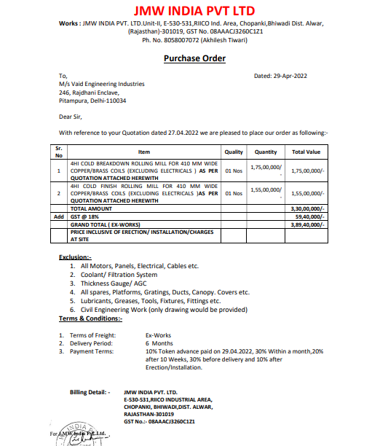

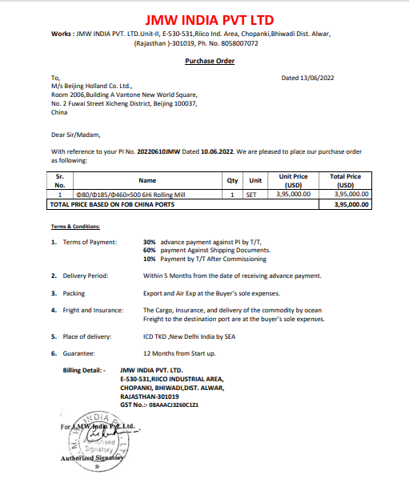
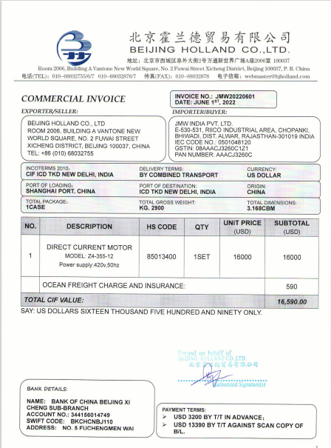
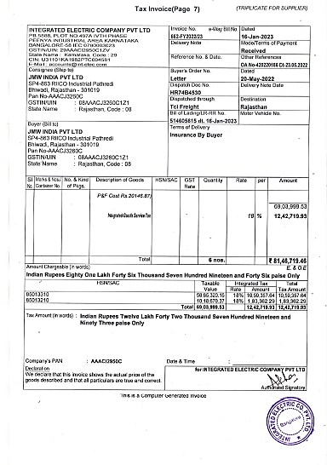

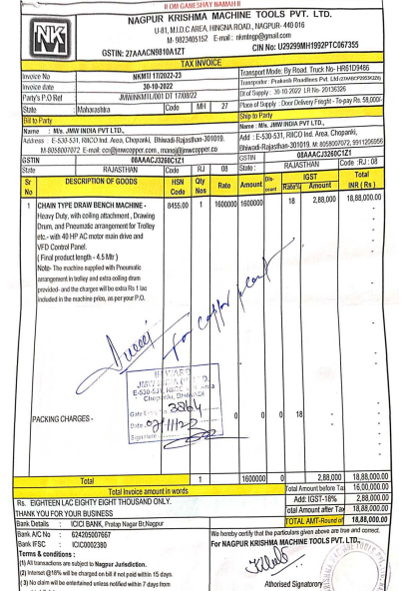
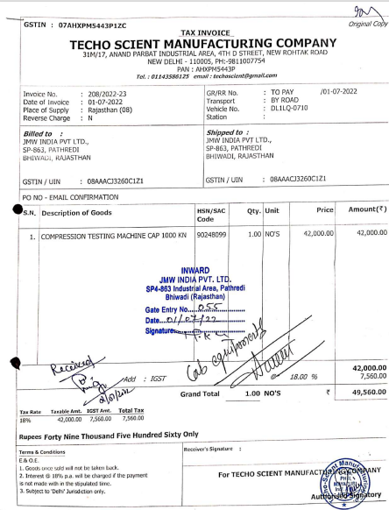

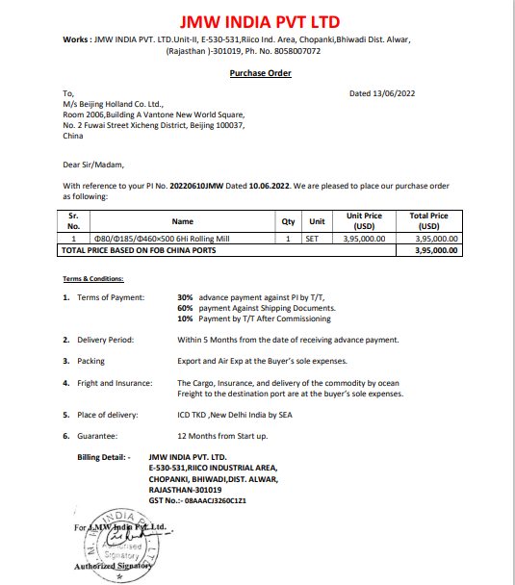
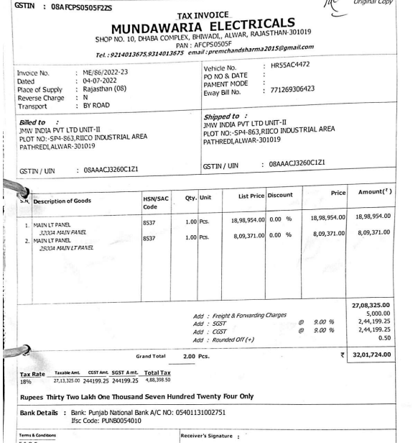
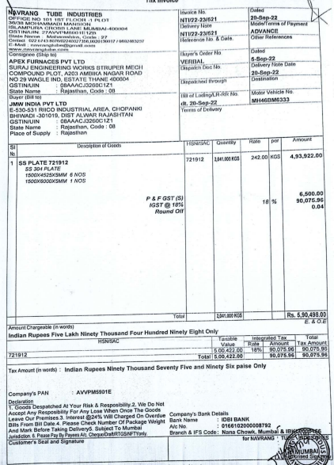

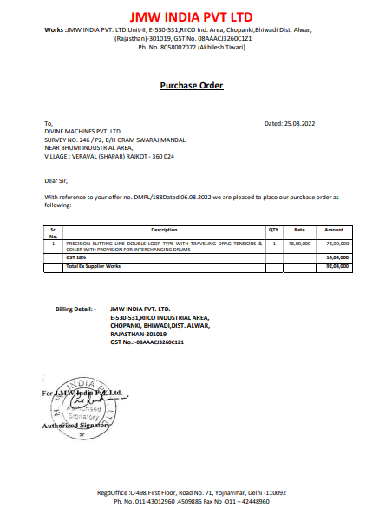

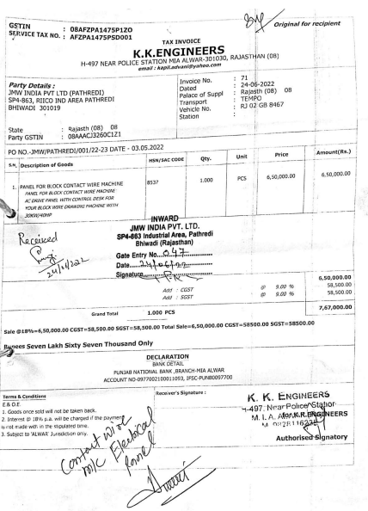

ANNEXURE: - III (MARKET REASEARCH)

