File No.: VIS(2022-23)-PL704-593-969 Dated: 15/03/2023

COST VETTING REPORT

OF

ALTURA UMELE

SITUATED AT
SURVEY NO. 23A, HISSA NO. 1, 2 & 3, VILLAGE- UMELE, TALUKA- VASAI, DISTRICT-PALGHAR, MAHARASHTRA

PROMOTER/S
M/S RUBY LIFESPACES

REPORT PREPARED FOR
STATE BANK OF INDIA, SME, GOREGAON EAST, MUMBAI

**Important - In case of any query/ issue or escalation you may please contact Incident Manager
at le@rkassociates.org. We will appreciate your feedback in order to improve our services.

NOTE: As per IBA Guidelines please provide your feedback on the report within 15 days of its submission after which report will be considered to be correct.

IMPORTANT NOTICE

COPYRIGHT FORMAT: This report is prepared on the copyright format of R.K Associates, to serve our clients with the best available information and analysis to facilitate them to take rational business decisions. Legally no one can copy or distribute this format without prior approval from R.K Associates. It is meant only for the advisory/ reference purpose for the organization/s as mentioned on the cover page of this report. Distribution or use of this format by any organization or individual other than R.K Associates will be seen as unlawful act and necessary legal action can be taken against the defaulters.

This report is intended for the sole use of the intended recipient/s and contain material that is STRICTLY CONFIDENTIAL AND PRIVATE.

DEFECT LIABILITY PERIOD: - In case of any query/ issue or escalation you may please contact Incident Manager: @ le@rkassociates.org. We try our level best to ensure correctness in the calculations done, rates adopted and various other data points & information mentioned in the report but still can’t rule out typing, human errors or any other mistakes. In case you find any such mistake or inaccuracy in any data point of the report please help us by bringing all such points into our notice immediately or within 15 days of the report delivery in writing, to rectify these timely failing after which R.K Associates won’t be held responsible for any such inaccuracy in any manner. We would highly appreciate your feedback in order to improve our services.

PART A | REPORT SUMMARY

S.NO. | PARTICULARS | DESCRIPTION
 | Name of the Project | Altura Umele
 | Project Location | Survey No. 23a, Hissa No. 1, 2 & 3, Village- Umele, Taluka- Vasai, District-Palghar, Maharashtra
 | Name of the Promotors | M/s Ruby Lifespaces
 | Address and Phone Number | Survey No. 23a, Hissa No. 1, 2 & 3, Village- Umele, Taluka- Vasai, District-Palghar, Maharashtra
 | Prepared for Bank | State Bank of India, SME, Goregaon East, Mumbai
 | Consultant Firm | M/s. R.K. Associates Valuers & Techno Engineering Consultants (P) Ltd.
 | Work Order Details | Via email dated 11-03-2023
 | Date of Survey | 06th March 2023
 | Date of Report | 16th March 2023
 | Purpose of the Report | Evaluate construction cost incurred.
 | Scope of the work provided by the Lender | Only to comment on the following below points based on the scope of work:  - Estimation of construction cost as per current status of work  NOTE: This report doesn’t contains any other kind of recommendation or suggestions other than the above mentioned point.

PART B | INTRODUCTION

- THE PROJECT: This cost vetting report is prepared for the Under-construction Residential Group Housing Society situated at the aforesaid address having total land area admeasuring 4547.47 sq. mtr. The subject property is under-construction Residential Group Housing Society having Wing-A (G/S+16), Wing-B (G/S+16) & Wing-C (G/S+17-Part) upper storey RCC structures. The project is named as “Altura Umele”.

- ABOUT THE COMPANY: M/s Ruby Lifespaces is a partnership firm established on 1st November 2016 by M/s Ruby Structures, Mr. Pravin Vartak and Mr. Bhuvnesh Magdani. The company is presently developing the project named as “ALTURA UMELE” Ruby Lifespace has its presence in Real Estate sector since three decades focusing primarily on developing medium to large sized residential complexes. M/s Ruby lifespaces has completed construction of over 4 Million Square Feet and delivered over 2500 residential l houses in and around the Mumbai Metropolitan Region.

The Group has developed over 14.15 million square feet properties till date. The group has developed large residential at Vasai West and Mira Road which houses over 2500+ residential units across multiple projects.

- PROJECT OVERVIEW: The Company is developing a residential project at Vasai comprising of 272 residential and commercial units. The project site is located at, Vasai East. The under-construction project comprises of 3 Sale Building of Ground+16th Upper Floors in Wing-A & Wing-B and Ground+17th Upper floors in Wing-C with 272 units in towers. The project is registered with RERA via registration number P99000048381.
Approval status:
Approval Type | Approval Authority | Approval Reference number | Approval Date
Fire NOC | Vasai–Virar City Municipal Corporation Fire and Emergency Department | VVMC/FIRE/HQ/1141/2020-21 | 31-03-2021
Tree NOC | Vasai–Virar City Municipal Corporation Tree NOC Department | VVMC/TREE/438/2020-21 | 25-01-2021
Commencement Certificate | Vasai–Virar City Municipal Corporation | VVCMC/TP/CC/VP/6061/320/2022-23 | 20-10-2022

Cost of Project till Dec-22:
Particulars | Estimated Total Cost (In Rs. Cr.) | Incurred Till Dec 2022 (In Rs. Cr.) | To be Incurred  (In Rs. Cr.)
Land Acquisition Cost | 4.07 | 4.07 | -
Construction Cost - Sale Building | 47.34 | 1.44 | 45.90
Selling and Marketing | 5.00 | - | 5.00
Professional Fees and Admin expenses | 4.00 |  | 4.00
Contingency | 2.37 | - | 2.37
Finance Cost | 3.37 | - | 3.37
Total Project Cost | 66.15 | 5.51 | 60.64

Means of Finance till Dec-2022:
Particulars | Amount  (in Rs. Cr.) | Brought in  (in Rs. Cr.) | To be incurred  (in Rs. Cr.) | Margin  (in Rs. Cr.)
Equity / Partnership Capital | 6.78 | 5.51 | 1.27 | 10.25%
Unsecured Loans from promoters | - | - | 0.00 | 0.00%
Advance from Units already sold | 27.37 | 0.23 | 27.14 | 41.38%
Advance from Future bookings | 22.00 | - | 22.00 | 33.26%
Bank Finance - Working Capital | 10.00 | - | 10.00 | 15.12%
Total | 66.15 | 5.74 | 60.41 | 100.00%

Sold/Unsold Inventory till Dec-2022:
As per the Sold / Unsold inventory data sheet provided by the company, the total saleable area details has been tabulated below:
Configuration | Sold |  | Unsold |  | Total
 | Units | Carpet Area  (In sqft) | Units | Carpet Area  (In sqft) | Units | Carpet Area  (In sqft)
1 BHK | 36 | 14,070 | 94 | 36,332 | 130 | 50,402
2 BHK | 23 | 13,217 | 117 | 67,603 | 140 | 80,820
Shops | - | - | 2 | 2,738 | 2 | 2,738
Total | 59 | 27,287 | 213 | 1,06,673 | 272 | 1,33,960

- PHYSICAL CONSTRUCTION CURRENT: As per information provided during site visit, the construction work of the project was started on 18th November 2022 and is expected to be completed within 3 years. As per observation made during site visit, pilling & footing work on ongoing. Tower-wise construction details are as follows:-
S. No. | Different Parameters | Weightage | Wing-A | Wing-B | Wing-C
1 | Cutting, Filling and Levelling | 10% | 100% | 76% | 100%
3 | Footings | 4% | 0% | 0% | 0%
4 | Slab Casting | 25% | 0% | 0% | 0%
5 | Common Staircase, lift and lobby etc. | 5% | 0% | 0% | 0%
7 | Brickwork | 10% | 0% | 0% | 0%
9 | Plaster | 8% | 0% | 0% | 0%
10 | Flooring | 10% | 0% | 0% | 0%
11 | MEP Services | 12% | 0% | 0% | 0%
12 | Door/ Window | 8% | 0% | 0% | 0%
13 | Finishing | 8% | 0% | 0% | 0%
Completion status (in %) |  | 100% | 10% | 8% | 10%
Average Completion Status (in %) |  |  | 9.22%

- COST INCURRED ON THE CONSTRUCTION OF PROJECT: As per estimation shared by the company, the total construction cost of the project is Rs. 47,34,00,000/- . bifurcation of the same is tabulated below:-
S. No. | Particulars | Unit | Amount  (In Rs.)
1 | Piling - 295 piles foundation at an average depth of 25 meters per pile and the pile caps work |  | 5,52,00,000
2 | Material & Labour charges for constructing RCC and other allied works of building as per mentioned scope of work | 3 wings | 40,42,21,665
3 | Other Amenities - ON GRID SOLAR – to generate electricity for your common areas (Lift, Staircase, Common Passage, Lobbies, Water pump) |  | 1,39,78,335
Total Construction Cost |  |  | 47,34,00,000

Actual Cost Incurred on Building Construction:

As per information shared by the company there are total 295 pile foundation. Out of which 271 piles have laid foundation. Only 24 piles of Wing-B yet to be constructed. As per our market research the construction cost of pile work is in the range of Rs. 4000/- to Rs. 8000/- per mtr. Depending upon surface, location, type of soil and depth of pile etc. Since the subject project is near the ocean and having black soil containing sand. Thus, we have assumed that Rs. 7000/- per mtr. shall be required for the construction of piles.
Description | Wing-A | Wing-B | Wing-C | Unit
Total Piles 295 | 98 | 99 | 98 | Nos.
Constructed piles | 98 | 75 | 98 | Nos.
Average Depth of each pile | 25 | 25 | 25 | Mtr
Total Depth constructed | 2,450 | 1,875 | 2,450 | Mtr
Pile construction cost | 7,000 | 7,000 | 7,000 | Rs. Per mtr
Total Amount Incurred on Construction Piles | 1,71,50,000 | 1,31,25,000 | 1,71,50,000 | Rs.
Grand Total | 4,74,25,000 |  |  | Rs.

- OBSERVATIONS, REMARKS AND CONCLUSION BY RKA
- As per our analysis, the total expenditure on project construction is about Rs. 4,74,25,000/- till 06th March 2023.
- As per details shared by the company, the total expenditure on construction of project is Rs. 1.44 Cr. (including all taxes) as of December 2022 which is about 3.04% of the total project construction cost.
- As per our assessment during site survey, the physical progress is approx. 9.22% of the total progress.
- This assessment is only limited to the construction done at site and not to the advances paid and material lying on the site.

PART C | DISCLAIMER

      - No employee or member of R.K Associates has any direct/ indirect interest in the Project.

      - This report is prepared based on the copies of the documents/ information which the Bank/ Company has provided to us out of the standard checklist of documents sought from them and further based on our assumptions and limiting conditions. All such information provided to us has been relied upon in good faith and we have assumed that it is true and correct in all respect. Verification or cross checking of the documents provided to us has not been done at our end from the originals. If at any time in future, it is found or came to our knowledge that misrepresentation of facts or incomplete or distorted information has been provided to us then this report shall automatically become null & void.

      - This report is a general analysis of the project based on the scope mentioned in the report. This is not an Audit report, Design document, DPR or Techno-financial feasibility study. All the information gathered is based on the facts seen on the site during survey, verbal discussion & documentary evidence provided by the client and is believed that information given by the company is true best of their knowledge.

      - All observations mentioned in the report is only based on the visual observation and the documents/ data/ information provided by the client. No mechanical/ technical tests, measurements or any design review have been performed or carried out from our side during Project assessment.

      - Bank/FII should ONLY take this report as an Advisory document from the Financial/ Chartered Engineering firm and it’s specifically advised to the creditor to cross verify the original documents for the facts mentioned in the report which can be availed from the borrowing company directly.

      - In case of any default in loans or the credit facility extended to the borrowing company, R.K Associates shall not be held responsible for whatsoever reason may be and any request for seeking any explanation from the employee/s of R.K Associates will not be entertained at any instance or situation.

      - This is just an opinion report and doesn’t hold any binding on anyone. It is requested from the concerned Financial Institution which is using this report for taking financial decision on the project that they should consider all the different associated relevant & related factors also before taking any business decision based on the content of this report.
      - All Pages of the report including annexures are signed and stamped from our office. In case any paper in the report is without stamp & signature then this should not be considered a valid paper issued from this office.

      - Though adequate care has been taken while preparing this report as per its scope, but still we can’t rule out typing, human errors, over sightedness of any information or any other mistakes. Therefore, the concerned organization is advised to satisfy themselves that the report is complete & satisfactory in all respect. Intimation regarding any discrepancy shall be brought into our notice immediately. If no intimation is received within 15 (Fifteen) days in writing from the date of issuance of the report, to rectify these timely, then it shall be considered that the report is complete in all respect and has been accepted by the client upto their satisfaction & use and further to which R.K Associates shall not be held responsible in any manner.

      - Defect Liability Period is 15 DAYS. We request the concerned authorized reader of this report to check the contents, data and calculations in the report within this period and intimate us in writing if any corrections are required or in case of any other concern with the contents or opinion mentioned in the report. Corrections only related to typographical, calculation, spelling mistakes, incorrect data/ figures/ statement will be entertained within the defect liability period. Any new changes for any additional information in already approved report will be regarded as additional work for which additional fees may be charged. No request for any illegitimate change in regard to any facts & figures will be entertained.

      - R.K Associates encourages its customers to give feedback or inform concerns over its services through proper channel at le@rkassociates.org in writing within 30 days of report delivery. After this period no concern/ complaint/ proceedings in connection with the Lender’s Independent Engineering Services will be entertained due to possible change in situation and condition of the subject Project.

      - Our Data retention policy is of ONE YEAR. After this period, we remove all the concerned records related to the assignment from our repository. No clarification or query can be answered after this period due to unavailability of the data.

      - R.K Associates never releases any report doing alterations or modifications from pen. In case any information/ figure of this report is found altered with pen then this report will automatically become null & void.
PREPARED BY | REVIEWED BY
Abhinav Chaturvedi  ( Engineer Valuation) | Rajani Gupta
Date: 16th March 2023 | Date: 16th March 2023

DEFECT LIABILITY PERIOD - In case of any query/ issue or escalation you may please contact Incident Manager by writing at valuers@rkassociates.org. We ensure 100% accuracy in the Calculations done, Rates adopted and various other data points & information mentioned in the report but still can’t rule out typing, human errors or any other mistakes. In case you find any mistake, variation, discrepancy or inaccuracy in any data point of the report, please help us by bringing all such points into our notice in writing at valuers@rkassociates.org within 30 days of the report delivery, to get these rectified timely, failing which R.K Associates Valuers Techno Engineering Consultants (P) Ltd. won’t be held responsible for any inaccuracy in any manner. Also, if we will not hear back anything from you within 30 days, we will assume that report is correct in all respect and no further claim of any sort will be entertained thereafter. We would welcome and appreciate your feedback & suggestions in order to improve our services.

COPYRIGHT FORMAT - This report is prepared on the copyright format of R.K Associates Valuers Techno Engineering Consultants (P) Ltd. to serve our clients in the best possible way. Legally no one can copy or distribute this format without prior approval from R.K Associates. It is meant only for the organization as mentioned on the cover page of this report. Distribution or use of this format other than R.K Associates will be seen as unlawful act and necessary legal action can be taken against the defaulter

PART D | PHOTOGRAPHS

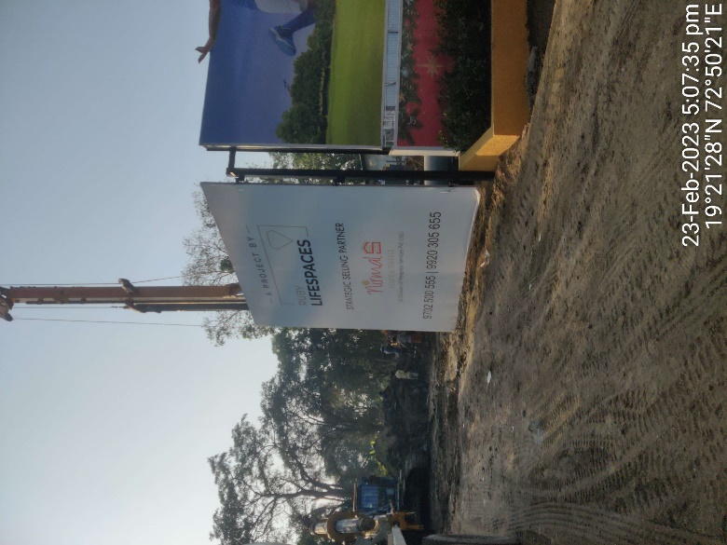 | 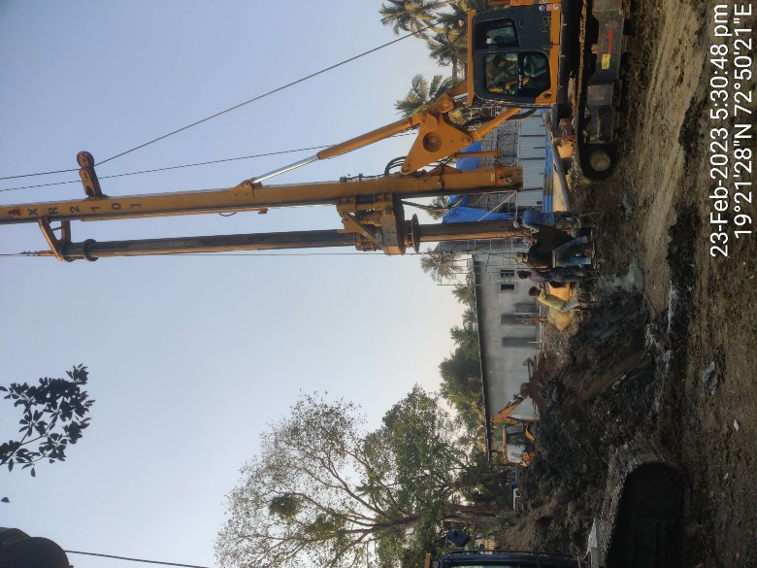
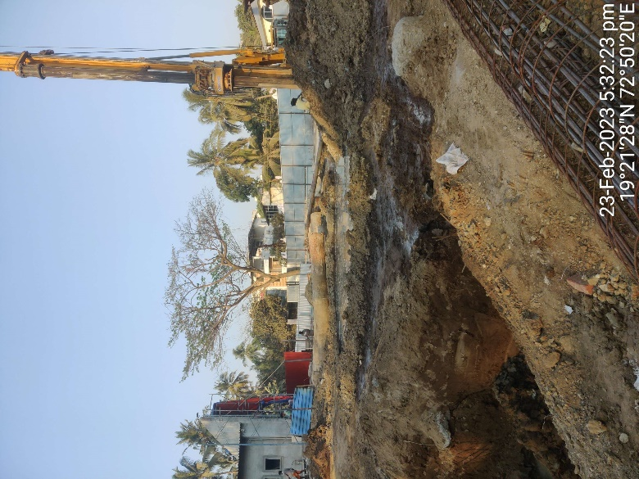 | 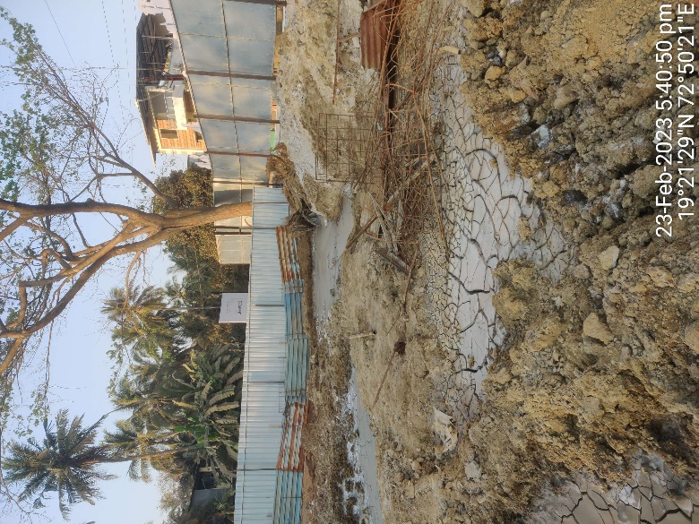

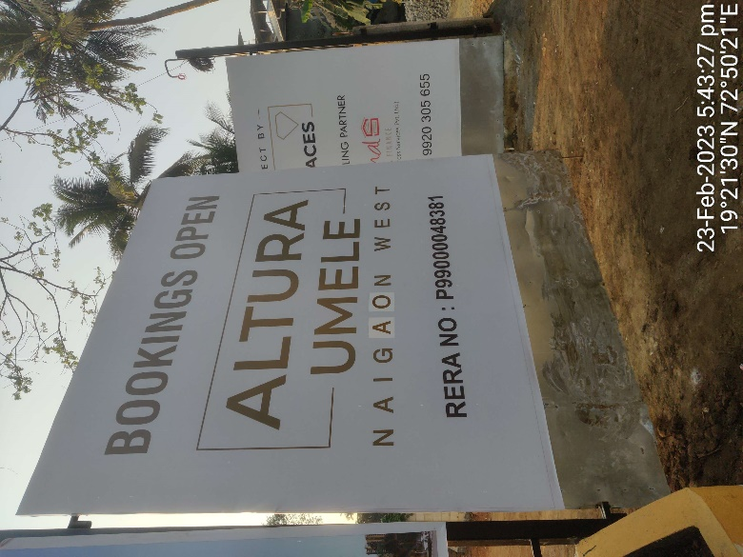 | 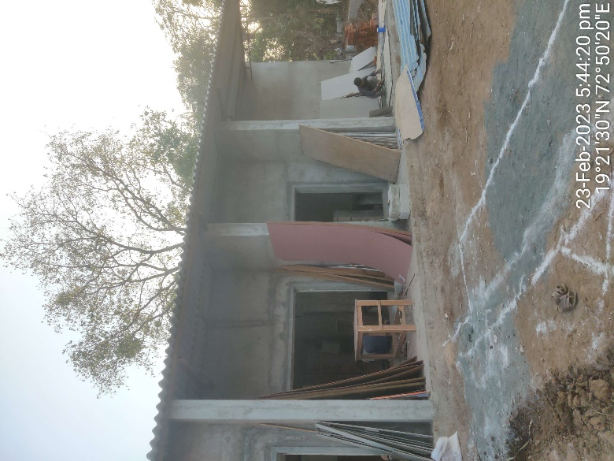
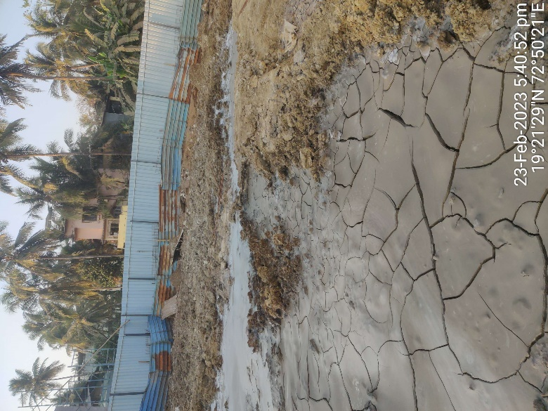 | 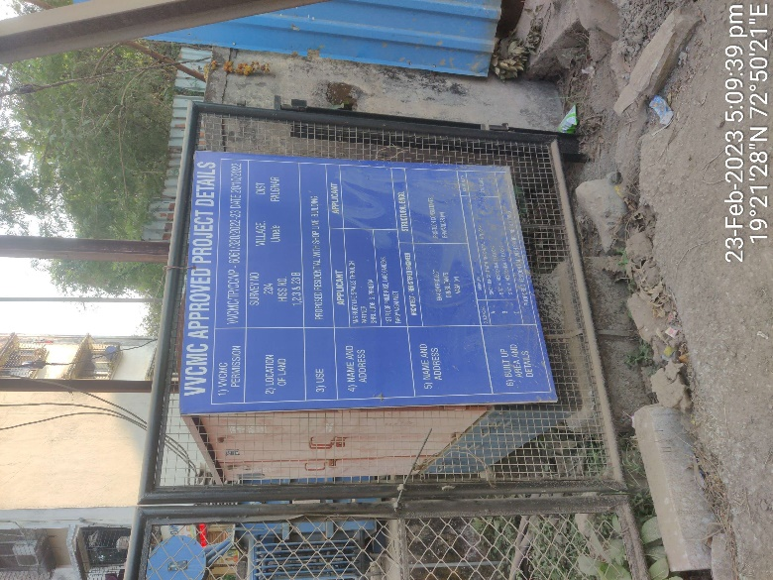

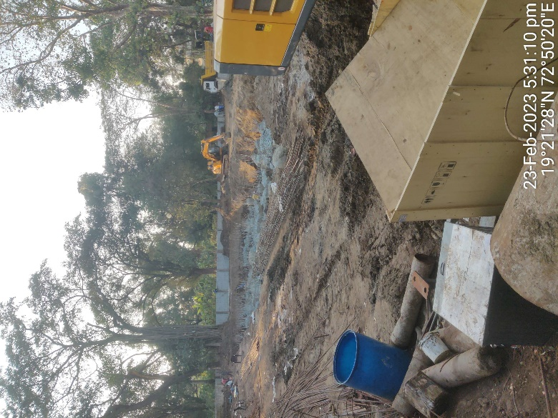 | 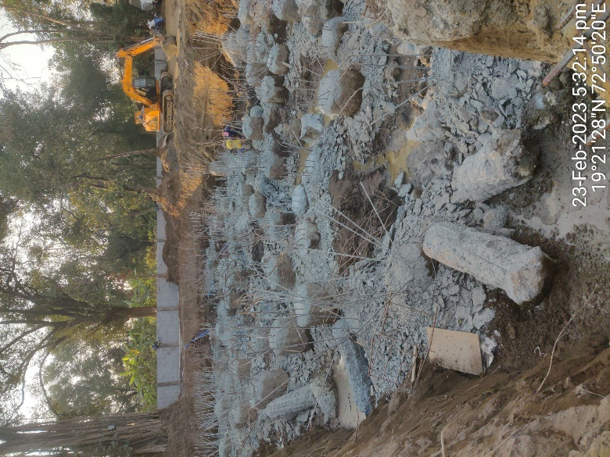
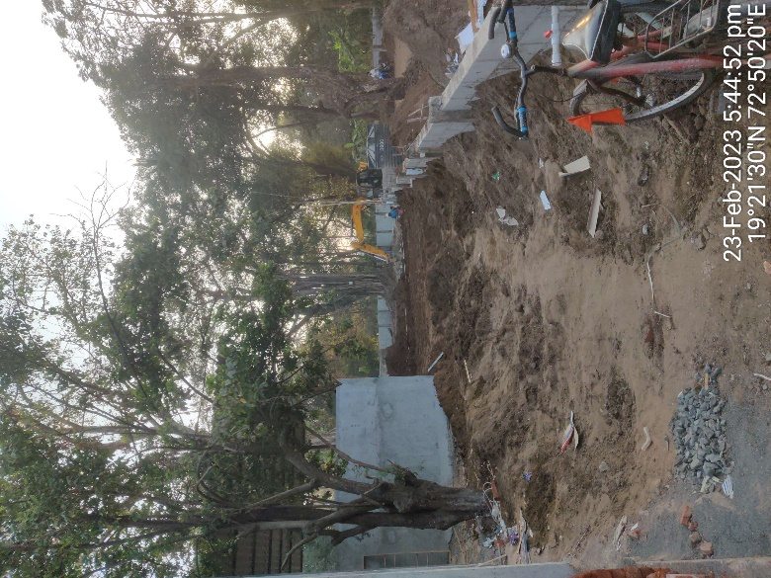 | 