**REPORT FORMAT:** V-L3 (Medium) | Version: 6.0_2018

**File No.: RKA/FY18-19/396 Dated:21.09.2018**

**VALUATION REPORT**

**OF**

**COMMERCIAL PROPERTY**

**SITUATED AT**

**MUNICIPAL CORPORATION NO. 4098, NAYA BAZAAR, NEW DELHI-110006**

**OWNER/S**

**MRS. RAM BAI W/O MR. HAR NARAIN & MRS. USHA RANI W/O MR. RAJINDER KUMAR**

**BORROWER: M/S. SHRI LAL MAHAL LIMITED**

**REPORT PREPARED FOR**

**STATE BANK OF INDIA, SAM-I BRANCH, MOHAN SINGH PLACE, CONNAUGHT PLACE, NEW DELHI**

***\*\*Important - In case of any query/ issue or escalation you may please contact Incident Manager***

***at valuers@rkassociates.org. We will appreciate your feedback in order to improve our services.***

***NOTE: As per IBA Guidelines please provide your feedback on the report within 15 days of its submission after which report will be considered to be correct.***

|  |  |
| --- | --- |
| **PART A** | **SUMMARY OF THE VALUATION REPORT** |

|  |  |  |  |  |  |  |
| --- | --- | --- | --- | --- | --- | --- |
| **S.NO.** | **CONTENTS** | **DESCRIPTION** | | | | |
|  | **GENERAL DETAILS** | | | | | |
|  | Report prepared for | Bank | | | | |
|  | Name & Address of Organization | State Bank of India, SAM-I Branch, Mohan Singh Place, Connaught Place, New Delhi | | | | |
|  | Name ofBorrower unit | M/s. Shri Lal Mahal Limited | | | | |
|  | Name of Property Owner | Mrs. Ram Bai w/o Mr. Har Narain & Mrs. Usha Rani w/o Mr. Rajinder Kumar | | | | |
|  | Address & Phone Number of the Borrower | Corp Address:- Shri Lal Mahal Ltd., Shri Lal Mahal House, B-6, Bhagwan Dass Nagar, Punjabi Bagh, New Delhi- 110 026 | | | | |
|  | Type of the Property | Independent Commercial Plotted Property | | | | |
|  | Type of Loan | Business Loan | | | | |
|  | Type of Valuation | Independent Commercial Plotted Property Value | | | | |
|  | Report Type | Plain Asset Valuation | | | | |
|  | Date of Inspection of the Property | 21 September 2018 | | | | |
|  | Date of Valuation Report | 26 September 2018 | | | | |
|  | Surveyed in presence of | Owner's representative | | Mr. Rajesh Singh | | |
|  | Purpose of the Valuation | General Value Assessment | | | | |
|  | Scope of the Report | Non Binding Opinion on General Prospective Valuation Assessment of the Property. | | | | |
|  | Documents provided for perusal | **Documents Requested** | | **Documents Provided** | | **Documents Reference No.** |
| Total**05**documents requested. | | Total**02**Documents provided. | | **--------** |
| Property Title document | | Sale Deed | | Dated 12.08.1974 |
| Approved Map | | Old Valuation Report | | Dated September, 2016 |
| Copy of TIR | | NA | | NA |
| Last paid Electricity Bill | | NA | | NA |
| Last paid Municipal Tax Receipt | | NA | | NA |
|  | Identification of the property | ☒ | Cross checked from boundaries or address of the property mentioned in the deed | | | |
| ☒ | Done from the name plate displayed on the property | | | |
| ☒ | Identified by theOwner'srepresentative | | | |
| ☐ | Enquired from local residents/ public | | | |
| ☐ | Identification of the property could not be done properly | | | |
| ☐ | Survey was not done | |  | |

|  |  |  |
| --- | --- | --- |
|  | **BRIEF DESCRIPTION OF THE PROPERTY UNDER VALUATION** | |
|  | \\Server\f\RK CENTRAL DATA\Technical\Reports Supported Documents\FY 2018-19\PRIVATE\Delhi\396\DSCF0887.JPG  ***Snapshot of the Asset/ Property Under Valuation***  This valuation report is prepared for the Commercial Property situated at the aforesaid address having land area admeasuring 241 sq.yds.  The plot area of the subject property as per the copy of sale deed is 241 sq.yd. (201.50 sq.mt.).  During our site visit we were not allowed to inspect the whole property. We have only inspected the area which is occupied by the owner. Some portion of the property is occupied by an old tenant M/s. Public Goods Transport Co. with whom the owners are apparently not on good terms and that portion could not be inspected from inside by our surveyor. Also, for the portion at the back, our site surveyor was not allowed by the owner’s representative at the site to physically enter it.  This Valuation is done only for the Land & Building of the property. As some portion of the property is under the occupation of an old tenant with whom the owner is not on good terms, this fact will have some bearing on the market value of the property and this fact has been considered while arriving at the value of the property in this report.  The Property under valuation is bearing Municipal Corporation No. 4098, Naya Bazaar, Delhi 110006. The property is located on main road of Naya Bazaar and the width of the road is approx. 50 feet. The front part of the property comprises of Ground and Mezzanine floor whereas the rear portion of the property comprises of Ground plus Three floor structure. The total covered area of the property is 5310 sq. ft. as per the measurement carried out at the site by our surveyor.  This Valuation is done only for the Land& Building of the property. The building is extremely old though we do not have any definite information regarding it’s age. | |
|  | **VALUATION SUMMARY** | |
|  | Total Govt. Guideline Value | **Rs. 4,60,93,838/-** |
|  | Total Prospective Fair Market Value | **Rs.18,34,00,000/-** |
|  | Total Expected Realizable/ Fetch Value | **Error! Reference source not found.** |
|  | DistressValue | **Error! Reference source not found.** |
|  | Valuation for the purpose of Insurance | **Not Applicable** |
|  | **ENCLOSURES** | |
|  | **Part B** | **Valuation Report as per SBI Format Annexure-II** |
|  | **Part C** | **Area description of the Property** |
|  | **Part D** | **Valuation Assessment of the Property** |
|  | Enclosure 1 | Valuer’s Remark - Page No.23,24 |
|  | Enclosure 2 | Screenshot of the price trend references of the similar related properties available on public domain - Page No.25,26 |
|  | Enclosure 3 | Google Map – Page No.27 |
|  | Enclosure 4 | Photographs – Pages28,29 |
|  | Enclosure 5 | Copy of Circle Rate – Pages30,31 |
|  | Enclosure 6 | Survey Summary Sheet – Pages 02 |
|  | Enclosure 7 | Copy of relevant papers from the property documents referred in the Valuation – Pages |

|  |  |
| --- | --- |
| **PART B** | **SBI FORMAT OF VALUATION REPORT - ANNEXURE - II** |

|  |  |
| --- | --- |
| Name & Address of Branch | State Bank of India, SAM-I Branch, New Delhi |
| Name of Customer (s)/ Borrower Unit | M/s. Shri Lal Mahal limited |

|  |  |  |
| --- | --- | --- |
| **S.NO.** | **CONTENTS** | **DESCRIPTION** |
|  | **INTRODUCTION** | |
|  | Name of Property Owner | Mrs. Ram Bai W/o Mr. Har Narain & Mrs. Usha Rani W/o Mr. Rajinder Kumar |
| Address & Phone Number of the Owner | Corp Address:- Shri Lal Mahal Ltd., Shri Lal Mahal House, B-6, Bhagwan Dass Nagar, Punjabi Bagh, New Delhi- 110 026 |
|  | Purpose of the Valuation | General Value Assessment |
|  | Date of Inspection of the Property | 21 September 2018 |
|  | Date of Valuation Report | 26 September 2018 |
|  | Name of the Developer of the Property | Not applicable. The property was built by one of the previous owners of the property. |
| Type of Developer | Property built from owner self resources |

|  |  |  |  |  |  |  |  |  |
| --- | --- | --- | --- | --- | --- | --- | --- | --- |
|  | **PHYSICAL CHARACTERISTICS OF THE PROPERTY** | | | | | | | |
|  | **Location attribute of the property** | | | | | | | |
|  | Nearby Landmark | | Lahori Gate Mosque | | | | | |
|  | Postal Address of the Property | | Municipal Corporation No. 4098, Naya Bazaar, New Delhi 11006 | | | | | |
|  | Area of the Plot/ Land | | 241 sq.yd. (201.50sq.mtr) | | | | | |
|  | Type of Land | | Solid/ On road level | | | | | |
|  | Independent access/ approach to the property | | Clear independent access is available | | | | | |
|  | Google Map Location of the Property with a neighborhood layout map | | Enclosed with the Report | | | | | |
| Coordinates or URL: 28°39'33.2"N 77°13'05.9"E | | | | | |
|  | Details of the roads abutting the property | | | | | | | |
|  | 1. Main Road Name & Width | | Shyama Prasad Mukherjee Road | | | | approx. 75 feet | |
|  | 1. Front Road Name & width | | Naya Bazar Road | | | | approx. 50 feet | |
|  | 1. Type of Approach Road | | Bituminous Road | | | | | |
|  | 1. Distance from the Main Road | | Approx. 300 meter | | | | | |
|  | Description of adjoining property | | Other Commercial shops | | | | | |
|  | Municipal Corporation No./ Plot No. | | 4098/ Plot no. 27, Naya Bazar | | | | | |
|  | Zone/ Block | | Delhi City Zone | | | | ---- | |
|  | Sub registrar | | Kashmeri Gate | | | | | |
|  | District | | Delhi | | | | | |
|  | 1. Identification of the property | | ☒ | Cross checked from boundaries or address of the property mentioned in the deed | | | | |
| ☒ | Done from the name plate displayed on the property | | | | |
| ☒ | Identified by the company representative | | | | |
| ☐ | Enquired from local residents/ public | | | | |
| ☐ | Identification of the property could not be done properly | | | | |
| ☐ | Survey was not done | | | | |
|  | 1. Is property clearly demarcatedby permanent/ temporary boundary on site | | Yes | | | | | |
|  | 1. Is the property merged or colluded with any other property | | No, it is an independent single bounded property | | | | | |
| ---- | | | | | |
|  | 1. City Categorization | | Metro City | | | | Urban | |
|  | 1. Characteristics of the locality | | Excellent | | | | Within conjusted commercial market | |
|  | 1. Property location classification | | Road Facing | | | ---- | | ---- |
|  | 1. Property Facing | | East Facing | | | | | |
|  | Covered Built-up area description  *(Plinth/ Carpet/ Saleable Area)* | | 5,310 sq.ft. (493.31 sq.mtr.) | | | | | |
| *Also please refer to Part C - Area description of the property.* | | | | | |
|  | **Boundaries schedule of the Property** | | | | | | | |
|  | Are Boundaries matched | | **Yes from the available documents** | | | | | |
|  | **Directions** | **As per copy of Sale Deed** | | | **Actual found at Site** | | | |
| East | Main Road Naya Bazaar | | | Road approx. 50 feet | | | |
| West | Gali | | | Service Lane | | | |
| North | Property of Tejpal Om Prakash | | | Property No. 4099 | | | |
| South | Property of Prahalad Rai Sat Narain | | | Property No. 4097 | | | |

|  |  |  |  |
| --- | --- | --- | --- |
|  | **TOWN PLANNING/ ZONING PARAMETERS** | | |
|  | Master Plan provisions related to property in terms of Land use | Commercial | |
| 1. Any conversion of land use done | No | |
| 1. Current activity done in the property | Used as Commercial Shop& office | |
| 1. Is property usage as per applicable zoning | Yesused as commercial as per zoning | |
| 1. Any notification on change of zoning regulation | No | |
| 1. Street Notification | Commercial | |
|  | Provision of Building by-laws as applicable | **PERMITTED** | **CONSUMED** |
| 1. FAR/ FSI | Please refer to area chart description | Please refer to area chart description |
| 1. Ground coverage | ----------------do------------- | ----------------do------------- |
| 1. Number of floors | ----------------do------------- | ----------------do------------- |
| 1. Height restrictions | ----------------do------------- | ----------------do------------- |
| 1. Front/ Back/ Side Setback | ----------------do------------- | ----------------do------------- |
|  | Status of Completion/ Occupational certificate | No information provided to us | No information provided to us |
|  | Comment on unauthorized construction if any | Can’t comment since approved map is not available. | |
|  | Comment on Transferability of developmentalrights | As per regulation of DDA. | |
|  | 1. Planning Area/ Zone | Master Plan Delhi | |
| 1. Master Plan currently in force | Delhi Master Plan | |
| 1. Municipal limits | North Delhi Municipal Corporation | |
|  | Developmental controls/ Authority | Delhi Development Authority (DDA) | |
|  | Zoning regulations | Commercial | |
|  | Comment on the surrounding land uses & adjoining properties in terms of uses | All adjacent properties are used for commercial purpose | |
|  | Comment of Demolition proceedings if any | No | |
|  | Comment on Compounding/ Regularization proceedings | Not applicable. The property was constructed very long back. | |
|  | Any other aspect | Not applicable | |
| 1. Any information on encroachment | No information available to us | |
| 1. Is the area part of unauthorized area/ colony | No | |

|  |  |  |  |  |  |  |
| --- | --- | --- | --- | --- | --- | --- |
|  | **DOCUMENT DETAILS AND LEGAL ASPECTS OF THE PROPERTY** | | | | | |
|  | Ownership documents provided | Sale deed | ----- | | | ------ |
|  | Names of the Legal Owner/s | Mrs. Ram Bai w/o Mr. Har Narain & Mrs. Usha Rani w/o Mr. Rajinder Kumar | | | | |
|  | Constitution of the Property | Free hold, complete transferable rights | | | | |
|  | Agreement of easement if any | Not required | | | | |
|  | Notice of acquisition if any and area under acquisition | Not in our knowledge | | | | |
|  | Notification of road widening if any and area under acquisition | Not in our knowledge | | | | |
|  | Heritage restrictions, if any | No | | | | |
|  | Comment on Transferability of the property ownership | Free hold, complete transferable rights | | | | |
|  | Comment on existing mortgages/ charges/ encumbrances on the property, if any | Yes, mortgaged already | | | To SBI | |
|  | Comment on whether the owners of the property have issued any guarantee*(personal or corporate)* as the case may be | Not Known to us | | | Not Known to us | |
|  | **Building plan sanction:** | | | | | |
| 1. Authority approving the plan | Cannot comment since copy of approved building plan not provided to us | | | | |
| 1. Name of the office of the Authority | Cannot comment since copy of approved building plan not provided to us | | | | |
| 1. Any violation from the approved Building Plan | Can’t comment since approved map is not available | | | | |
|  | Whether Property is Agricultural Land if yes, any conversion is contemplated | No not an agricultural property | | | | |
|  | Whether the property SARFAESI complaint | Yes | | | | |
|  | 1. Information regarding municipal taxes *(property tax, water tax, electricity bill)* | Tax name | | No information provided | | |
| Receipt number | | No information provided | | |
| Receipt in the name of | | No information provided | | |
| Tax amount | | No information provided | | |
| 1. Observation on Dispute or Dues if any in payment of bills/ taxes | No information provided to us | | | | |
| 1. Is property tax been paid for this property | No information provided to us | | | | |
| 1. Property or Tax Id No. | Not provided to us | | | | |
|  | Whether entire piece of land on which the unit is set up / property is situated has been mortgaged or to be mortgaged | Yes | | | | |
|  | Qualification in TIR/Mitigation suggested if any | Copy of TIR not made available to us | | | | |
|  | 1. Since how long owners owing the Property | Around 45 years | | | | |
| 1. Year of Acquisition/ Purchase | Year 1974 | | | | |
| 1. Property presently occupied/ possessed by | Partially occupied by owners and partially by tenants | | | | |
| 1. Title verification | To be done by the competent Advocate | | | | |
| 1. Details of leases if any | Not applicable | | | | |

|  |  |  |
| --- | --- | --- |
|  | **ECONOMIC ASPECTS OF THE PROPERTY** | |
|  | Reasonable letting value/ Expected market monthly rental | Not applicable |
|  | Is property presently on rent | Yes, a portion of it |
| 1. Number of tenants | One, as per information available at the site |
| 1. Since how long lease is in place | No information available to us. |
| 1. Status of tenancy right | No information available to us. |
| 1. Amount of monthly rent received | No information available to us. |
|  | Taxes and other outgoing | No information available to us |
|  | Property Insurance details | No information available to us |
|  | Monthly maintenance charges payable | Not applicable |
|  | Security charges, etc. | Not applicable |
|  | Any other aspect | Not applicable |

|  |  |  |
| --- | --- | --- |
|  | **SOCIO - CULTURAL ASPECTS OF THE PROPERTY** | |
|  | Descriptive account of the location of the property in terms of Social structure of the area in terms of population, social stratification, regional origin, age groups, economic levels, location of slums/squatter settlements nearby, etc. | Commercial area |
|  | Whether property belongs to social infrastructure like hospital, school, old age homes etc. | No |

|  |  |  |  |  |  |  |  |
| --- | --- | --- | --- | --- | --- | --- | --- |
|  | **FUNCTIONAL AND UTILITARIAN SERVICES, FACILITIES & AMENITIES** | | | | | | |
|  | Description of the functionality & utility of the property in terms of : | | | | | | |
|  | 1. Space allocation | | | | Yes | | |
| 1. Storage spaces | | | | Yes | | |
| 1. Utility of spaces provided within the building | | | | Yes | | |
| 1. Car parking facilities | | | | No | | |
| 1. Balconies | | | | No | | |
|  | Any other aspect | | | | | | |
|  | 1. Drainage arrangements | | | | Yes | | |
| 1. Water Treatment Plant | | | | No | | |
| 1. Power Supply arrangements | | Permanent | | Yes | | |
| Auxiliary | | No | | |
| 1. HVAC system | | | | No | | |
| 1. Security provisions | | | | No | | |
| 1. Lift/ Elevators | | | | No | | |
| 1. Compound wall/ Main Gate | | | | No | | |
| 1. Whether gated society | | | | No | | |
| 1. Internal development | | | | | | |
| Garden/ Park/ Land scraping | Water bodies | | Internal roads | | Pavements | Boundary Wall |
| No | No | | No | | No | No |

|  |  |  |  |  |  |  |  |  |
| --- | --- | --- | --- | --- | --- | --- | --- | --- |
|  | **INFRASTRUCTURE AVAILABILITY** | | | | | | | |
|  | Description of Aqua Infrastructure availability in terms of: | | | | | | | |
|  | 1. Water Supply | | | | Yes | | | |
| 1. Sewerage/ sanitation system | | | | Underground | | | |
| 1. Storm water drainage | | | | Yes | | | |
|  | Description of other Physical Infrastructure facilities in terms of: | | | | | | | |
|  | 1. Solid waste management | | | | Yes | | | |
| 1. Electricity | | | | Yes | | | |
| 1. Road and Public Transport connectivity | | | | Yes | | | |
| 1. Availability of other public utilities nearby | | | | Public transport, Market, Hospital etc. available nearby | | | |
|  | Proximity & availability of civic amenities & social infrastructure | | | | | | | |
|  | School | Hospital | Market | Bus Stop | | Railway Station | Metro | Airport |
| 500 meter | 01 km. | 0 Km | 02 km. | | 2 Km.  *(New Delhi railway station)* | 2 Km. | 20 km  *(IGI)* |
|  | Availability of recreation facilities (parks, open spaces etc.) | | | Yes ample recreational facilities are available in the vicinity. | | | | |

|  |  |  |  |  |  |
| --- | --- | --- | --- | --- | --- |
|  | **MARKETABILITY ASPECTS OF THE PROPERTY:** | | | | |
|  | Marketability of the property in terms of | | | | |
|  | 1. Location attribute of the subject property | Excellent | | | |
| 1. Scarcity | Not many properties are available for sale/purchase in this area | | | |
| 1. Market condition related to demand and supply of the kind of the subject property in the area | There should be very good demand for such property normally, but the fact of an old tenant being in possession of a portion of it may affect it’s market value. | | | |
| 1. Comparable Sale Prices in the locality | Please refer to Part C: Valuation Assessment of the Property. | | | |
|  | Any other aspect which has relevance on the value or marketability of the property | Only the fact of an old tenant being in occupation of a portion of the property may affect it’s market value | | | |
|  | 1. Any New Development in surrounding area | No | --- | | |
| 1. Any negativity/ defect/ disadvantages in the property/ location | No | --- | | |
|  | **ENGINEERING AND TECHNOLOGY ASPECTS OF THE PROPERTY:** | | | | |
|  | Type of construction & design | RCC framed pillar beam column structure on RCC slab. | | | |
|  | Method of construction | Construction done based on daily hire mason & labourers using average quality matierial | | | |
|  | Specifications | | | | |
| 1. Class of construction | RCC: Class C construction (Simple/ Average) | | | |
| 1. Appearance/ Condition of structures | Internal -Average | | | |
| External -Average | | | |
| 1. Roof | **Floors/ Blocks** | | | **Type of Roof** |
| G+M+3 Floors | | | RCC |
| 1. Floor height | Approx. 12’ | | | |
| 1. Type of flooring | Marble chips | | | |
| 1. Doors/ Windows | Wooden frame & panel doors | | | |
| 1. Interior Finishing | Simple plastered walls | | | |
| 1. Exterior Finishing | Simple plastered walls | | | |
| 1. Interior decoration/ Special architectural or decorative feature | Simple plain looking structure. | | | |
| 1. Class of electrical fittings | Internal/ Normal quality fittings | | | |
| 1. Class of sanitary & water supply fittings | Internal/ Normal quality fittings | | | |
|  | Maintenance issues | The building requires good degree of maintenance | | | |
|  | Age of building/ Year of construction | Probably more than 60-65 years from the looks of it | | Not known to us exactly | |
|  | Total life of the structure/ Remaining life expected | Approx. 65-70 Years | | Approx.20 years subjected to timely and proper maintenance | |
|  | Extent of deterioration in the structure | No deterioration came into notice through visual observation but the building is very old and run down | | | |
|  | Structural safety | Structure built on RCC technique so it can be assumed as structurally stable. However no structural stability certificate is available | | | |
|  | Protection against natural disasters viz. earthquakes etc. | Should be able to withstand moderate intensity earthquakes | | | |
|  | Visible damage in the building if any | No visible damages in the structure but it is a very old building which looks run down | | | |
|  | System of air conditioning | No Aircondition installed | | | |
|  | Provision of firefighting | No firefighting system installed | | | |
|  | Status of Building Plans/ Maps | Building Map/Plans not provided to us, hence cannot comment | | | |
|  | 1. Is Building as per approved Map | Building Plan/ Map not provided to us, hence cannot comment | | | |
| 1. Details of alterations/ deviations/ illegal construction/ encroachment noticed in the structure from the original approved plan | ☐Not Applicable | | | ---- |
| ----- | | | --- |
| 1. Is this being regularized | Not applicable | | | |

|  |  |  |
| --- | --- | --- |
|  | **ENVIRONMENTAL FACTORS:** | |
|  | Use of environment friendly building materials like fly ash brick, other Green building techniques if any | No |
|  | Provision of rainwater harvesting | No |
|  | Use of solar heating and lighting systems, etc. | No |
|  | Presence of environmental pollution in the vicinity of the property in terms of industries, heavy traffic, etc. if any | Yes, normal vehicular and dust pollution present |

|  |  |  |
| --- | --- | --- |
|  | **ARCHITECTURAL AND AESTHETIC QUALITY OF THE PROPERTY:** | |
|  | Descriptive account on whether the building is modern, old fashioned, etc., plain looking or with decorative elements, heritage value if applicable, presence of landscape elements,  etc. | Plain looking simple structure |

|  |  |  |
| --- | --- | --- |
|  | **VALUATION:** | |
|  | Methodology of Valuation – Procedures adopted for arriving at the Valuation | Please refer to ***Sub-Point ‘n’ of Point 1 of Part D: Valuation Assessment Factors*** of the report. |
|  | Prevailing Market Rate/ Price trend of the Property in the locality/ city from property search sites | Please refer to the ***Sub-Point ‘o’ of Point 1of Part D: Valuation Assessment Factors*** of the report and the screenshot annexure in the report. |
|  | Guideline Rate obtained from Registrar’s office/ State Govt. gazette/ Income Tax Notification | Please refer to ***Part D: Valuation Assessment Factors*** of the report and the screenshot annexure in the report. |
|  | **Summary of Valuation** | For detailed Valuation calculation please refer to ***Point 1, 2, 3 & 4 of the Part D: Valuation Assessment Factors*** of the report. |
| 1. **Guideline Value** | **Rs. 4,60,93,838/-** |
| 1. **Land** | **Rs. 4,23,64,414/-** |
| 1. **Building** | **Rs. 37,29,424/-** |
| 1. **Prospective Fair Market Value** | **Rs.18,34,00,000/-** |
| 1. **Expected Realizable Value** | **Rs.15,58,90,000/-** |
| 1. **Distress Value** | **Rs.13,75,50,000/-** |
| 1. **Valuation of structure for Insurance purpose** | **Not Applicable** |
|  | 1. Justification for more than 20% difference in Market & Circle Rate | Circle rates are determined by the District administration as per their own theoretical internal policy and Market rates are adopted based on current practical market dynamics which is explained clearly in Valuation assessment factors. |
| 1. Details of last two transactions in the locality/ area to be provided, if available | No authentic last two transactions details could be known. However prospective transaction details as per information available on public domain and gathered during site survey is mentioned in ***Point ‘o’***of **Part D: Valuation Assessment Factors** of the report and the screenshots of the references are annexed in the reportfor reference. |

|  |  |  |
| --- | --- | --- |
|  | **Declaration**  *(Also see Enclosure: 1 Valuer’s Remarks)* | 1. The information provided is true and correct to the best of my knowledge and belief. 2. The analysis and conclusions are limited by the reported assumptions, limiting conditions and the information came to knowledge during the course of the work. Please see the Assumptions Remarks & Limiting conditions described in Part D: Valuation assessment section of the Report. 3. I/ firm have read the Handbook on Policy, Standards and Procedures for Real Estate Valuation by Banks and HFIs in India, 2011 issued by IBA and NHB, fully understood the provisions of the same and followed the provisions of the same to the best of my ability and this report is in conformity to the Standards of Reporting enshrined in the above Handbook. 4. No employee or member of R.K Associates has any direct/ indirect interest in the property. 5. Our authorized surveyor by name of SE Rajkumar has visited the subject property on21 September 2018 in the presence of the owner’s representative. 6. I am a registered Valuer under Section 34 AB of Wealth Tax Act, 1957. 7. I/ firm is an approved Valuer under SARFAESI Act – 2002 and approved by the Bank. 8. We have submitted Valuation report directly to the Bank. 9. This valuation work is carried out by our Engineering team on the request from **State** **Bank of India, SAM-1 Branch, Mohan Singh Place, Connaught Place, New Delhi.** |

|  |  |  |  |
| --- | --- | --- | --- |
|  | **VALUATION COMPANY DETAILS:** | | |
|  | **Name & Address of Valuer company** | **Wealth Tax Registration No.** | **Signature of the authorized person** |
|  | **M/s R.K. Associates Valuers & Techno Engineering Consultants Pvt. Ltd. G-183, Preet Vihar, Delhi-110092** | 2303/ 1988 |  |
|  | **Total Number of Pages in the Report with enclosures** |  | |
|  | **Engineering Team worked on the report** | ***SURVEYED BY:*** *SE Rajkumar* | |
| ***PREPARED BY:*** *SE Sachin Agrahari* | |
| ***REVIEWED BY: HOD Valuations*** | |

|  |  |  |
| --- | --- | --- |
|  | **ENCLOSED DOCUMENTS:** | |
|  | Layout plan sketch of the area in which the property is located with latitude and longitude | Google Map enclosed with coordinates |
|  | Building Plan | Not Available |
|  | Floor Plan | Not Available |
|  | Photograph of the property (including geo-stamping with date) and owner (in case of housing loans, if borrower is available) including a “Selfie’ of the Valuer at the site | Enclosed with the report |
|  | Certified copy of the approved / sanctioned plan wherever applicable from the concerned office | Not Available |
|  | Google Map location of the property | Enclosed with the Report |
|  | Price trend of the property in the locality/city from property search sites viz Magickbricks.com, 99Acres.com, Makan.com etc | Enclosed with the Report |
|  | Any other relevant documents/extracts  *(All enclosures & annexures to remain integral part & parcel of the main report)* | 1. **Part C: Area Description of the Property** 2. **Part D: Valuation Assessment of the Property** 3. Assumption, Remarks& Limiting conditions 4. Valuer’s Remark - Page No.23,24 5. Google Map – Page No.27 6. Photographs – Pages28,29 7. Copy of Circle Rate – Pages30,31 8. Survey Summary Sheet – Pages 02 9. Copy of relevant papers from the property documents referred in the Valuation – Pages |

|  |  |
| --- | --- |
| **PART C** | **AREA DESCRIPTION OF THE PROPERTY** |

|  |  |  |  |
| --- | --- | --- | --- |
|  | Land Area | 241 sq.yd. (201.50 sq.mtr.) | |
| Area adopted on the basis of | Property documents & site survey both | |
| Remarks & observations, if any | Not Applicable | |
|  | Ground Coverage Area | Permissible  (x% of Plot area) | Not Applicable |
| Proposed(x%) | Not Applicable |
| Present Status | Not Applicable |
|  | FAR | Permissible | Not Applicable |
| Proposed(x%) | Not Applicable |
| Present Status | Not Applicable |
|  | Constructed Area considered for Valuation  (As per IS 3861-1966) | Covered Area | 5,310 sq.ft. (493.31 sq.mt.) |
| Area adopted on the basis of | Site survey measurement only since no relevant document was available | |
| Remarks & observations, if any | Not Applicable | |

|  |  |
| --- | --- |
| **PART D** | **VALUATION ASSESSMENT OF THE PROPERTY** |

|  |  |  |  |  |  |  |  |  |  |  |  |
| --- | --- | --- | --- | --- | --- | --- | --- | --- | --- | --- | --- |
|  | **ASSESSMENT FACTORS** | | | | | | | | | | |
|  | Valuation Type | | | Land & Building Value | | | | | | Commercial Land & Building Value | |
|  | Scope of the Valuation | | | Non binding opinion on the assessment of Plain Asset Valuation of the property identified by the owner or through his representative | | | | | | | |
|  | Property Use factor | | | **Current Use** | | | | | **Highest &Best Use** | | |
| Commercial | | | | | Commercial | | |
|  | Legality Aspect Factor  *(Refer sub clause I & j of Point 7)* | | | Positive as per documents produced to us | | | | | | | |
|  | Land Physical factors | | | **Shape** | | **Size** | | **Level** | | | **Frontage to depth ratio** |
| Rectangle | | Medium | | On Road Level | | | Normal frontage |
|  | Property location category factor | | | **City Categorization** | | **Locality Categorization** | | **Property location classification** | | | **Floor Level** |
| Metro City | | Average | | On Road | | | Not Applicable |
| Property within conjusted commercial market | | Well established and busiest market | | |
| NA | | |
| **Property Facing** | | East Facing | | | | | |
|  | Any New Development in surrounding area | | | No new development | | | ---- | | | | |
|  | Any specific advantage/ drawback in the property | | | None, except that there is one very old tenant occupying a portion of the property. | | | | | | | |
|  | Overall property usability Factor | | | Good | | | | | | | |
|  | Comment on Property Salability Outlook | | | Easily sellable | | | | | | | |
|  | Comment on Demand & Supply in the Market | | | Good demand of such properties in the market | | | | | | | |
|  | Sale transaction method assumed | | | Free market transaction at arm's length wherein the parties, after full market survey each acted knowledgeably, prudently and without any compulsion. | | | | | | | |
|  | Best Sale procedure to realize maximum Value | | | Free market transaction at arm's length wherein the parties, after full market survey each acted knowledgeably, prudently and without any compulsion. | | | | | | | |
|  | Methodology/ Basis of Valuation | | | **Govt. Guideline Value:**Collector rates of DDA 2014 | | | | | | | |
| **Market Value:**Land Value is calculated on the basis of 'Market Comparable Sales approach' and Building construction value is calculated on the basis of Disposable lumpsum Value' | | | | | | | |
| *For knowing comparable market sales, significant local enquiries has been made from our side representing ourselves as both buyer and seller of the similar property and thereafter based on this information and various factors of the property, a rate has been judiciously taken seeing the market scenario. Kindly please refer below section to know the name & contact numbers from whom enquiries have been made..* | | | | | | | |
|  | References on prevailing market Rate/Price trend of the property and Details of the sources from where the information is gathered *(from property search sites & local information)* | | | | | | | | | | |
|  | Name: | | | Mr. Sonu sharma | | | | | | |
| Contact No.: | | | 9152526514  7011931375 | | | | | | |
| Nature of reference: | | | Property Consultant | | | | | | |
| Size of the Property: | | | 222 sq.yd. | | | | | | |
| Location: | | | Naya Bazaar | | | | | | |
| Rates/ Price informed: | | | Rs. 10,00,000 per sq.yd. | | | | | | |
| Any other details/ Discussion held: | | | The dealer was having a particular commercial land along with building structure of ground, mezzanine plus 3 floor available in Naya Bazaar.which is situated on a very short distance from the subject property. | | | | | | |
|  | Name: | | | Cross section of the local people | | | | | | |
| Contact No.: | | | Not applicable | | | | | | |
| Nature of reference: | | | Rates of properties in this area | | | | | | |
| Size of the Property: | | | Normal | | | | | | |
| Location: | | | Naya Bazar | | | | | | |
| Rates/ Price informed: | | | Rs. 7,00,000/- to Rs. 8,00,000/- per sq. yd. | | | | | | |
| Any other details/ Discussion held: | | | There is no land available. Only constructed building properties might be available. But since the buildings are mostly very old, their value is negligible compared to the value of the land | | | | | | |
|  | Name: | | | ---- | | | | | | |
| Contact No.: | | | ---- | | | | | | |
| Nature of reference: | | | ---- | | | | | | |
| Size of the Property: | | | ---- | | | | | | |
| Location: | | | ---- | | | | | | |
| Rates/ Price informed: | | | ---- | | | | | | |
| Any other details/ Discussion held: | | | ---- | | | | | | |
|  | Adopted Rates Justification | | *As per the verbal & telephonic conversation with the local property dealers, commercial land parcels in Naya Bazaar is ranging from Rs.9,00,000/- per sq.yd. to Rs.12,00,000/- per sq.yd. but the local people have informed that the rates are between Rs. 7,00,000/- to Rs. 10,00,000/- per sq. yd. Based on this information we have adopted Rs.7,50,000/- per sq,yd for our subject property.* | | | | | | | | |

|  |  |  |  |
| --- | --- | --- | --- |
|  | **VALUATION OF LAND**  ***Applicable*** | | |
|  | **Particulars** | **Govt. Circle/ Guideline Value** | **Prospective Fair Market Value** |
|  | Prevailing Rate range | Rs. 70,080/- X 3 (Commercial usage factor) per sq. mtr. | Rs. 7,00,000-10,00,000/- per sq. yd.. |
|  | Rate adopted considering all characteristics of the property | Rs. 2,10,240/- per sq. mtr | Rs 7,50,000/- per sq. yd.. |
|  | Total Land Area considered *(documents vs site survey whichever is less)* | 201.50 sq.mtr. | 241 sq.yd. (201.50 sq. mtr.) |
|  | **Total Value of land (A)** | Rs. 2,10,240/- per sq. mtr.X201.50 sq. mtr | Rs 7,50,000/- per sq. yd.X 241sq.yd. |
| **Rs. 4,23,64,414** | **Rs. 18,07,50,000/-** |

|  |  |  |  |  |
| --- | --- | --- | --- | --- |
|  | **VALUATION OF BUILDING CONSTRUCTION** | | | |
|  | **Particulars** | | **Govt. Circle/ Guideline Value** | **Depreciated Replacement Value** |
|  | Structure Construction Value | Rate range | 0.7(Age factor)X. Rs. 10,800 per sq.mtr. | Rs. 500/- to Rs. 700/- per sq.ft. |
| Rate adopted | Rs. 7,560 per sq.mtr. | Rs. 500/- per sq.ft. |
| Covered Area | 493.31 sq.mtr. | 5,310 sq.ft. |
| Class of construction | Not Applicable | Class C construction (Simple/ Average) |
| Valuation Calculation | Rs. 7,560 per sq. mtr.X 493.31 sq.mtr. | Rs. 500 per sq.ft.X 5310 sq. ft. |
| **Total Value** | **Rs. 37,29,424/-** | **Rs. 26,55,000/-** |
|  | Depreciation percentage  *(assuming salvage value % per year)* | | --- | ----  *(Above replacement rate is calculated after deducting the prescribed depreciation)* |
|  | Age Factor | | 1970-1980 | Construction older than 30 years |
|  | Structure Type/ Condition | | Pucca (1.0) | RCC framed structure/ Average |
|  | Construction Depreciated Replacement Value**(B)** | | **----** | **Rs. 26,55,000/-** |

|  |  |  |  |
| --- | --- | --- | --- |
|  | **VALUATION OF ADDITIONAL BUILDING & SITE AESTHETIC WORKS** | | |
|  | **Particulars** | **Specifications** | **Depreciated Replacement Value** |
|  | Add extra for Architectural aesthetic developments, improvements  *(add lump sum cost)* | ---- | ---- |
|  | Add extra for fittings & fixtures  *(doors, windows, wood work, cupboards, modular kitchen, electrical/ sanitary fittings)* | ---- | ---- |
|  | Add extra for services  *(Water, Electricity, Sewerage, Main gate, Boundary, Lift, Auxiliary power, AC, HVAC, Firefighting etc.)* | ---- | ---- |
|  | Add extra for internal & external development  *(Internal roads, Landscaping, Pavements, Street lights, Green area development, External area landscaping, Land development, Approach road, etc.)* | ---- | ---- |
|  | **Depreciated Replacement Value (C)** | **-----** | **------** |

|  |  |  |  |
| --- | --- | --- | --- |
|  | **CONSOLIDATED VALUE** | | |
|  | **Particulars** | **Govt. Circle/ Guideline Value** | **Prospective Fair Market Value** |
|  | Land (A) | **Rs. 4,23,64,414/-** | **Rs. 18,07,50,000/-** |
|  | Structure Construction Value (B) | **Rs. 37,29,424/-** | **Rs. 26,55,000/-** |
|  | Additional Building & Site Aesthetic Works Value (C) | ----- | ----- |
|  | **Total Add (A+B+C** | **Rs. 4,60,93,838/-** | **Rs. 18,34,05,000/-** |
|  | Additional Premium if any | **-----** | **-----** |
| Details/ Justification | **-----** | **-----** |
|  | Deductions charged if any | **-----** | **-----** |
| Details/ Justification | **------** |
|  | **Total Prospective Fair Market Value#** |  | **Rs.18,34,05,000/-** |
|  | **Rounded Off** | ---- | **Rs.18,34,00,000/-** |
|  | **EXPECTED REALIZABLE VALUE^(@ ~15% less)** | ---- | **Rs.15,58,90,000/-** |
|  | **EXPECTED FORCED/ DISTRESS VALUE*(@ ~30% less)** | ---- | **Rs.13,75,50,000/-** |
|  | Valuation of structure for Insurance purpose | ----- | **Not applicable since this building is extremely old** |

|  |  |  |
| --- | --- | --- |
|  | **Concluding comments if any** | 1. Valuation of the asset is done as found on as-is-where basis. 2. Distress Value has been taken at 25% less considering the current weak market, very less demand for such expensive residential properties. 3. Any kind of unpaid statutory, utilities, lease, interest or any other pecuniary dues on the asset has not been factored in the Valuation. 4. Secondary/ Tertiary costs related to asset transaction like Stamp Duty, Registration charges, Brokerage, Bank interest etc. pertaining to the sale/ purchase of this property are not considered while assessing the Market Value. 5. As per the scope of the assignment,Value assessment is subject to **Assumptions, Remarks & Limiting Conditions mentioned in Point ‘7’ below, R.K Associates Important Notes and Valuer’s Remarks*(Enclosure: 1)*& other enclosed documents**with the Report which will remain part & parcel of the report. Without these enclosures/ documents report shall stand null & void. |

**(Rupees Eighteen Crores Thirty Four Lakhs Only)**

**ENCLOSURE: 3– GOOGLE MAP LOCATION**

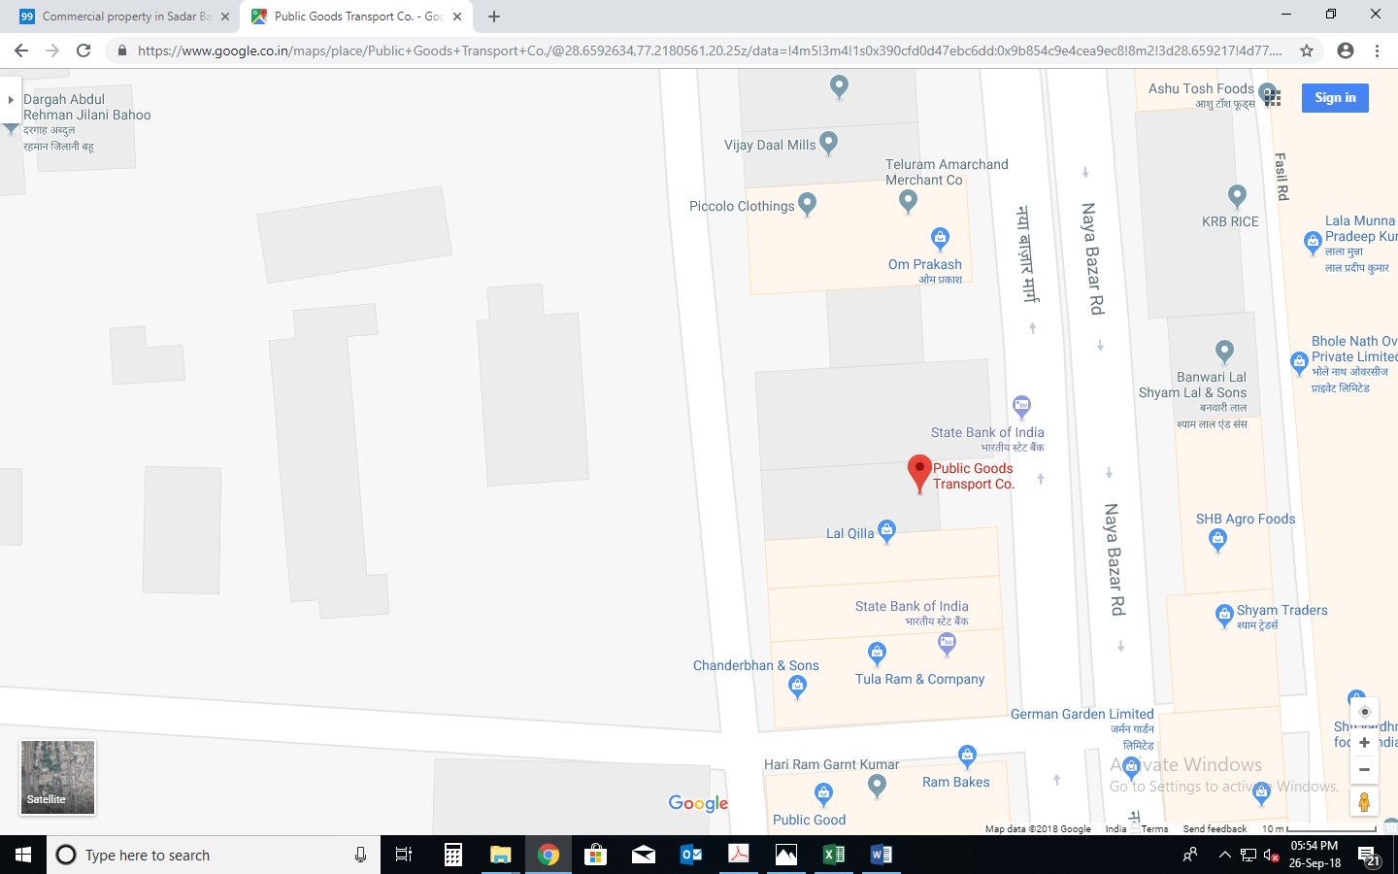

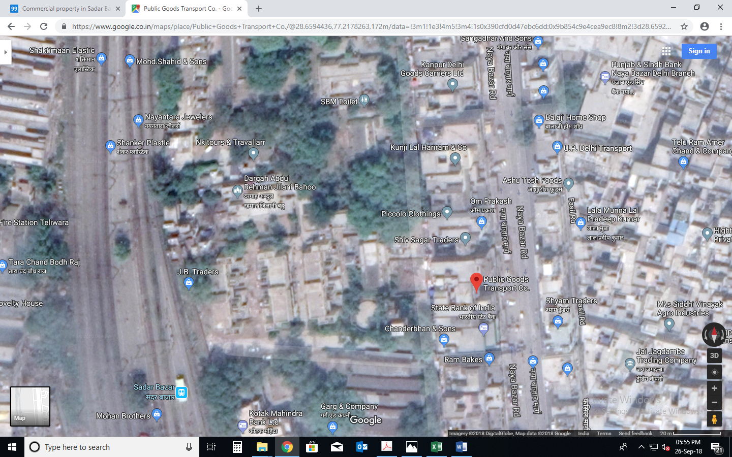

**ENCLOSURE: 4– PHOTOGRAPHS OF THE PROPERTY**

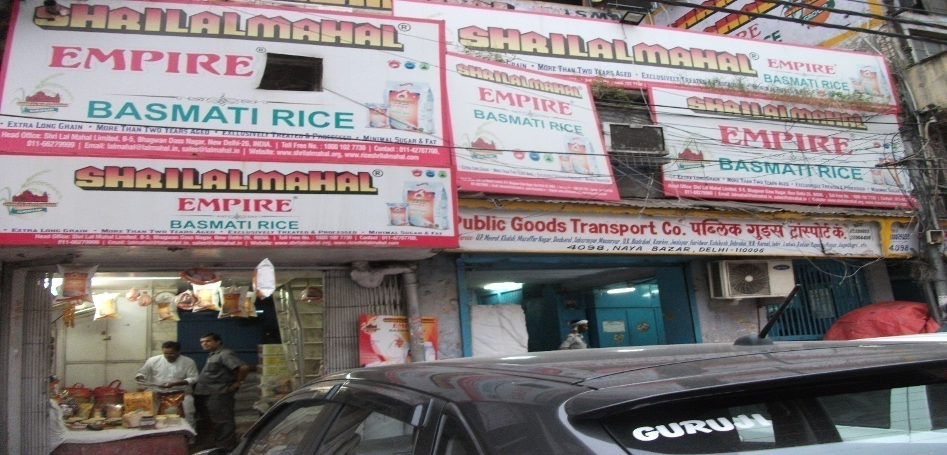

**External view of the Subject Property**

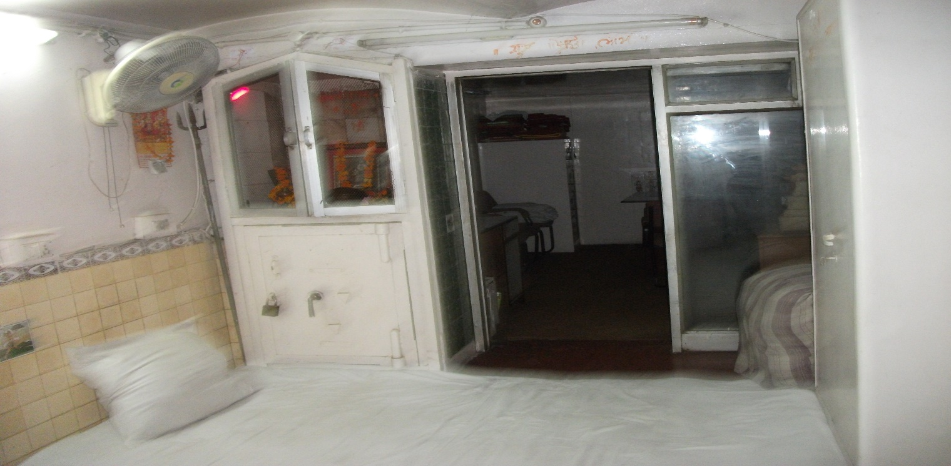

**Internal view of the Subject Property**

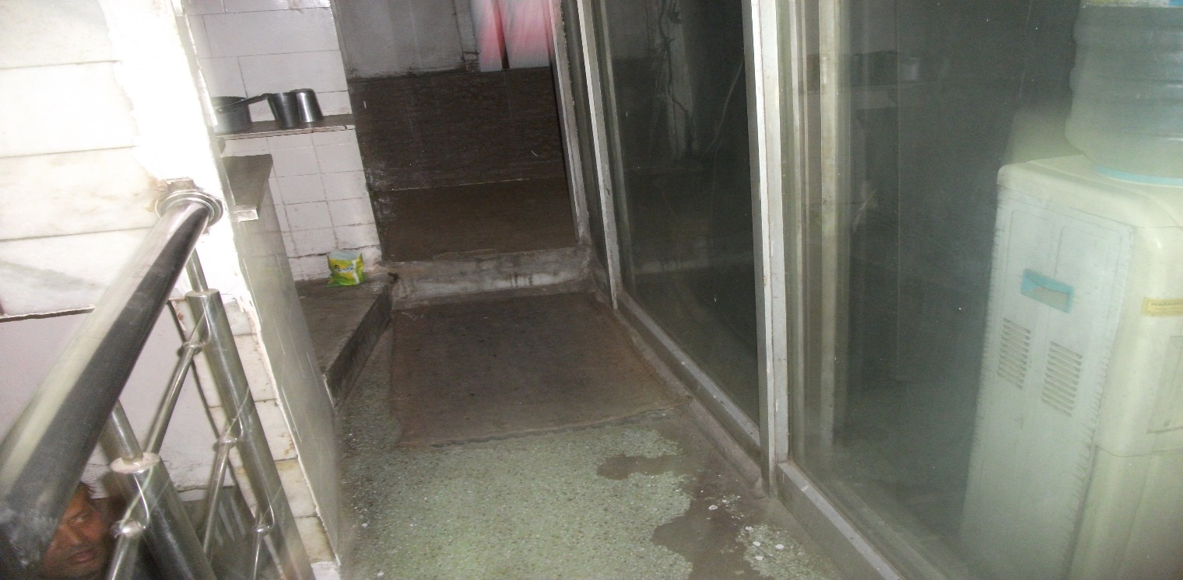

**Internal view of the Subject Property**

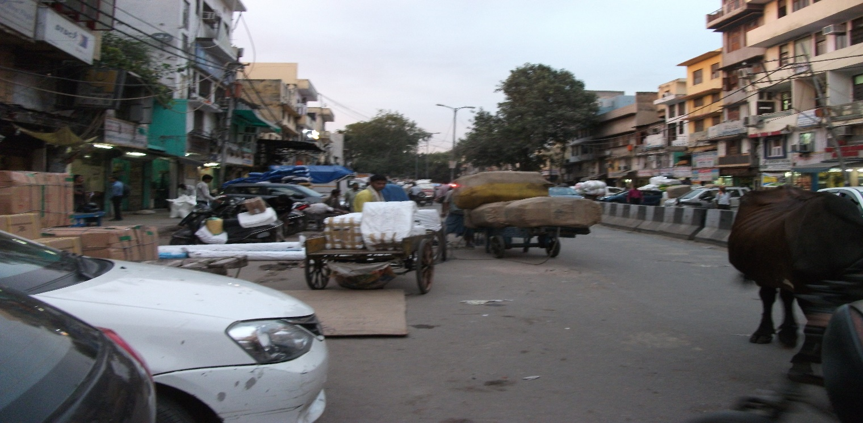

**View of Approach road**

**Copy of Circle Rate**

