File No.: VIS(2022-23)-PL716-Q131-622-1011 Dated: 24/03/2023

LENDER’S INDEPENDENT ENGINEER’s REPORT

OF

~5 MWp ROOFTOP SOLAR POWER PLANT

TO BE SET-UP AT
7 LOCATIONS IN PALI, BHARATPUR AND BIKANER

DEVELOPER:
M/S OPPL SPV CG PRIVATE LIMITED

TO BE SUBMITTED AT
STATE BANK OF INDIA, SME BRANCH, SOUTH EXTENSION, DELHI

**Important - In case of any query/ issue or escalation you may please contact Incident Manager
at le@rkassociates.org. We will appreciate your feedback in order to improve our services.
NOTE: As per IBA Guidelines please provide your feedback on the report within 15 days of its submission after which report will be considered to be correct.
IMPORTANT NOTICE

COPYRIGHT FORMAT: This report is prepared on the copyright format of R.K Associates to serve our clients with the best possible information and analysis to facilitate them to take rational business decisions. Legally no one can copy or distribute this format without prior approval from R.K Associates. It is meant only for the advisory/ reference purpose for the organization/s as mentioned on the cover page of this report. Distribution or use of this format by any organization or individual other than R.K Associates will be seen as an unlawful act and necessary legal action can be taken against the defaulters.
This report is intended for the sole use of the intended recipient/s and contains material that is STRICTLY CONFIDENTIAL AND PRIVATE.

DEFECT LIABILITY PERIOD: - In case of any query/ issue or escalation you may please contact Incident Manager at le@rkassociates.org.
Though adequate care has been taken while preparing this report as per its scope, but still we can’t rule out typing, human errors, over sightedness of any information or any other mistakes. Therefore, the concerned organization is advised to satisfy themselves that the report is complete & satisfactory in all respect. Intimation regarding any discrepancy shall be brought into our notice immediately. If no intimation is received within 15 (Fifteen) days in writing from the date of issuance of the report, to rectify these timely, then it shall be considered that the report is complete in all respect and has been accepted by the client upto their satisfaction & use and further to which R.K Associates shall not be held responsible in any manner.

TABLE OF CONTENTS
SECTIONS | PARTICULARS | PAGE NO.
Part A | REPORT SUMMARY | 03
Part B | INTRODUCTION | 04
 | - Name of the Project | 04
 | - Project Overview | 04
 | - Scope of the Report | 07
 | - Purpose of the Report | 07
 | - Methodology Adopted | 07
Part C | PROJECT DETAILS AND KEY TECHNICAL PARAMETERS | 08
Part D | ENERGY YIELD ASSESSMENT | 13
Part E | POWER PURCHASE AGREEMENT TERMS | 14
Part F | CURRENT STATUS OF WORK | 19
Part G | PROJECT COST & EXPENDITURE | 20
Part H | PHOTOGRAPHS | 22
Part I | OTHER DOCUMENTS & REFERENCES | 23
Part J | DISCLAIMER | 39

PART A | REPORT SUMMARY

 | Name of the Project | ~5 MWp Grid Tied Rooftop Solar Power Plant
 | Project Location | S. No. City Buyer Name & Address Capacity-DC (kWp)  1 Pali Shree Bangur Hospital, Suraj Pole, Pali, Rajasthan-306401 320  2 Govt. Medical College, NH-62, Sumerpur Road, Pali, Rajasthan 420  3 Bharatpur RBM Govt. Hospital, Bharatpur, Rajasthan, 321001 240  4 Janana Hospital, Bharatpur, Rajasthan-321001 420  5 Govt. Medical College, Bharatpur 480  6 Bikaner P.B.M. Hospital, Bikaner, Rajasthan-334001 2,020  7 Sardar Patel Medical College, Bikaner, Rajasthan-334001 1,200  Total Capacity 5,080
 | Seller Company | M/s OPPL SPV CG Private Limited
 | Prepared for Organization | State Bank of India, SME Branch, South Extension, Delhi
 | LIE Consultant Firm | M/s. R.K. Associates Valuers & Techno Engineering Consultants (P) Ltd
 | Date of Survey | As per the mail dated 24-03-2023, the management of the subject company has confirmed that there is no work done at any of the 7 subject sites, therefore, site survey has not been done.
 | Date of Report | 24-03-2023
 | Details & documents provided by | Mr. Mohit Jangra  Assistance Manager Finance and Accounts M/s Oriana Power Pvt. Ltd.
 | Report Type | Lender’s Independent Engineering Report
 | Purpose of the Report | Review, evaluate & comment on project implementation & present status details to facilitate bankers to take business decision on the Project.
 | Scope of the Report | To review Project cost and examine the current status of installation/ Commissioning of the Project.
 | Documents produced for Perusal | - Copy of Power Purchase Agreements (PPA) along with Novation Agreements  - Copy of Techno-Commercial offer from OPPL to OPPL SPV CG Pvt. Ltd.  - Copy of Plant Layout  - Copy of SLD  - Copy of PV Syst reports
 | Annexure with the Report | - Benchmark Cost by MNRE  - Market Comparables  - Global Solar Atlas by World Bank Group  - Layout Plans

PART B | INTRODUCTION

- NAME OF THE PROJECT: 5 MWp rooftop solar power plant to be installed at 7 locations which are described in Part A.2 above by M/s OPPL SPV CG Pvt. Ltd.; an SPV of M/s Oriana Power Private Limited.
- PROJECT OVERVIEW: M/s Oriana Power Private Limited which is the parent company of M/s OPPL SPV CG Pvt. Ltd. is an associate company of Trinix Impex & BCS Switchgear Industries. It is a MNRE approved channel partner and into the industry of Solar EPC / Design & Supply of BoS (Balance of System – Module Mounting Structure, LT/ ACCB/ ACDB/ DCCB Panel, Weather Monitoring Sensors, LA, Earthing, Cable Tray, etc.) for PV Solar Plants in India. The subject company is developing 7 rooftop solar power plants in Pali, Bharatpur and Bikaner having a total DC capacity of 5080 KWp.

In this respect, 7 Power Purchase Agreements (PPA) dated between 1st March 2023 to 11th March 2023 were signed between M/s OPWR DEL SPV Private Limited (hereinafter referred to as “Seller” which is engaged in the business of design, supply, erection, testing, commissioning, operating and maintenance of power plants, including grid connected Solar power projects. Whereas, Shree Bangur Hospital-Pali, Govt. Medical College-Pali, RBM hospital-Bharatpur, Janana Hospital-Bharatpur, Govt. Medical College-Bharatpur, P.B.M. Hospital-Bikaner and Sardar Patel Medical College-Bharatpur (hereinafter referred to as “The Purchasers”) are the owners of the respective properties where solar plant is being setup. As per the PPA, rooftop solar power plants were to be setup for a total capacity (AC) of 4,575 KWp at basic / Floor Tariff: Rs. 4.05/KWh levelised for 25 years of plant operation / PPA tenure.
On the same dates of PPAs, a Novation Agreement which supplemental to each PPA was signed between all 7 Purchasers, M/s OPWR DEL SPV Private Limited (Transferor) and M/s OPPL SPV CG Pvt. Ltd. (Transferee) where the Transferor has transferred all its rights, liabilities, duties, and obligations mentioned in the novation agreements and the principal PPA to the transferee. Therefore, M/s OPPL SPV CG Pvt. Ltd. became obligatory to construct, operate and maintain the plants at the sites and supply the entire Electricity generated from the Plant to the Buyer on the terms and conditions contained in PPAs and Novation Agreements.
For the implementation of the subject project, M/s OPPL has shared a Techno-Commercial offer to the subject company and as per the verbal information shared by the management of the subject company, the same has been accepted and no written document has been signed between them. As per the same, the total project cost is estimated at a price of Rs.25.01 Cr. including duties and taxes.
M/s OPPL SPV CG Pvt. Ltd. has approached SBI for credit facility to construct these plants who have in turned appointed M/s R.K Associates Valuers & Techno Engineering Consultants Pvt. Ltd. as Lenders Independent Engineer for knowing the status of these plants.
As per the mail dated 24-03-2023, the management of the subject company has confirmed that there is no work done at any of the 7 subject sites, therefore, site survey has not been done.

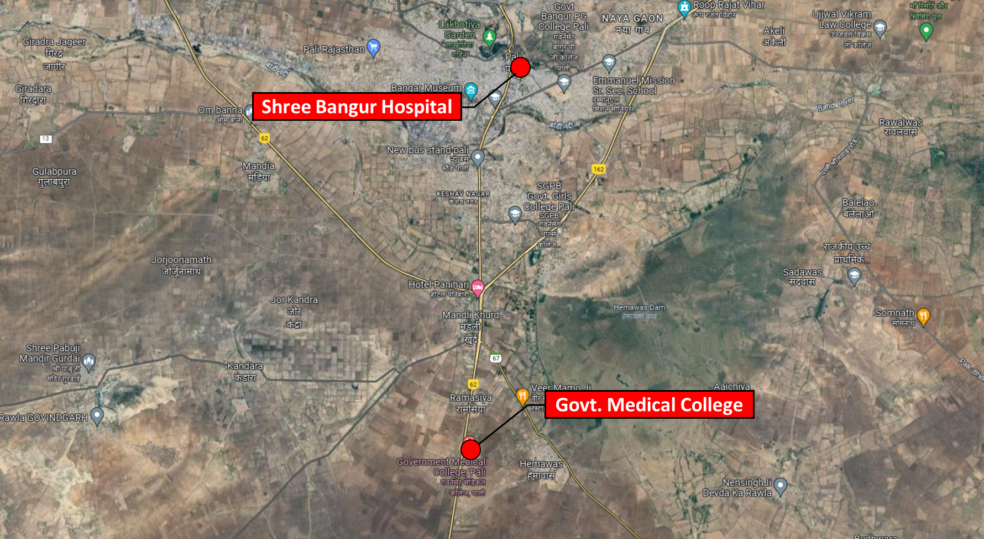
Shree Bangur Hospital: 25°46'36.2"N 73°19'54.9"E City: Pali
Govt. Medical College: 25°42'15.2"N 73°19'21.4"E
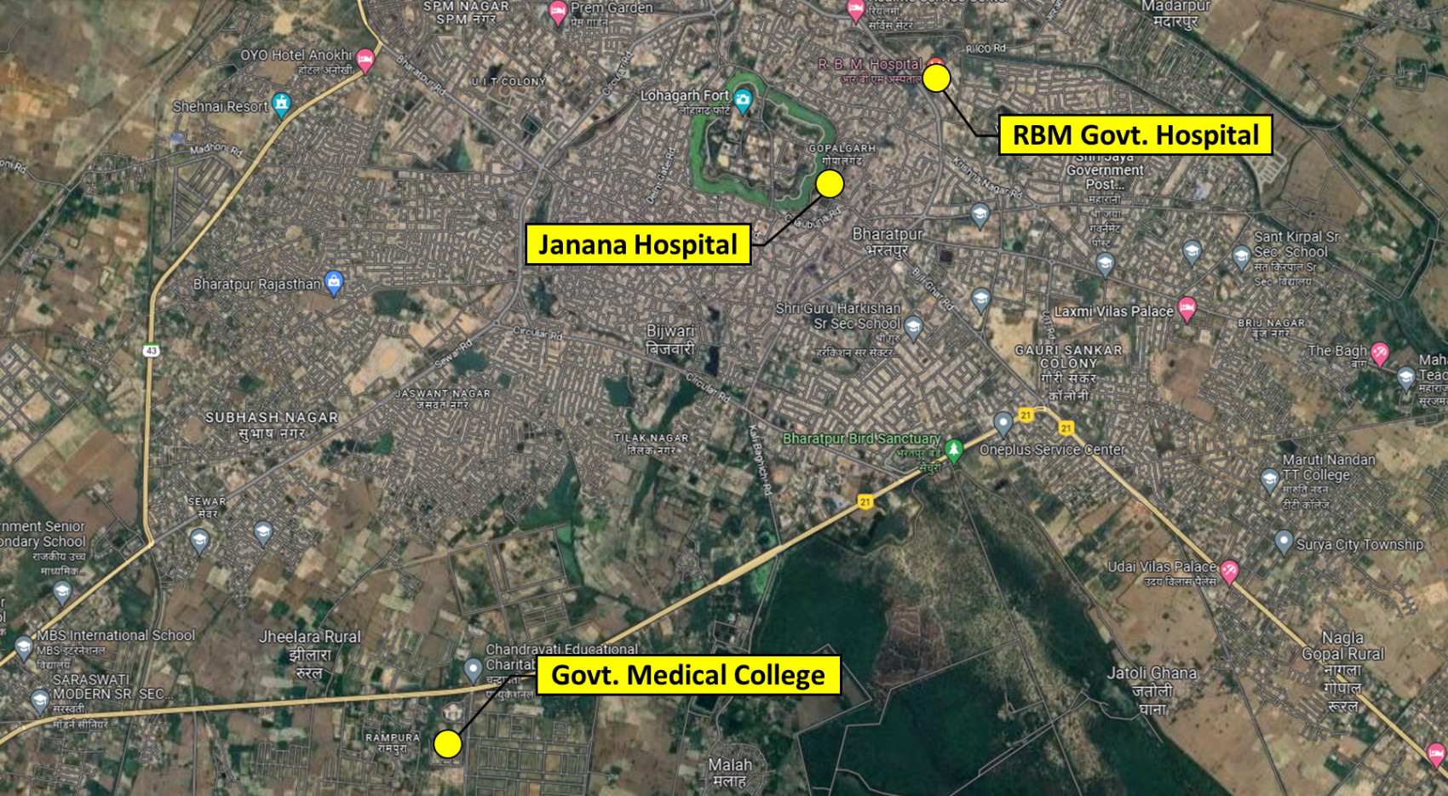
RBM Govt. Hospital: 27°13'25.5"N 77°30'23.3"E City: Bharatpur
Janana Hospital: 27°13'06.4"N 77°29'58.3"E
Govt. Medical College: 27°11'17.3"N 77°28'36.3"E

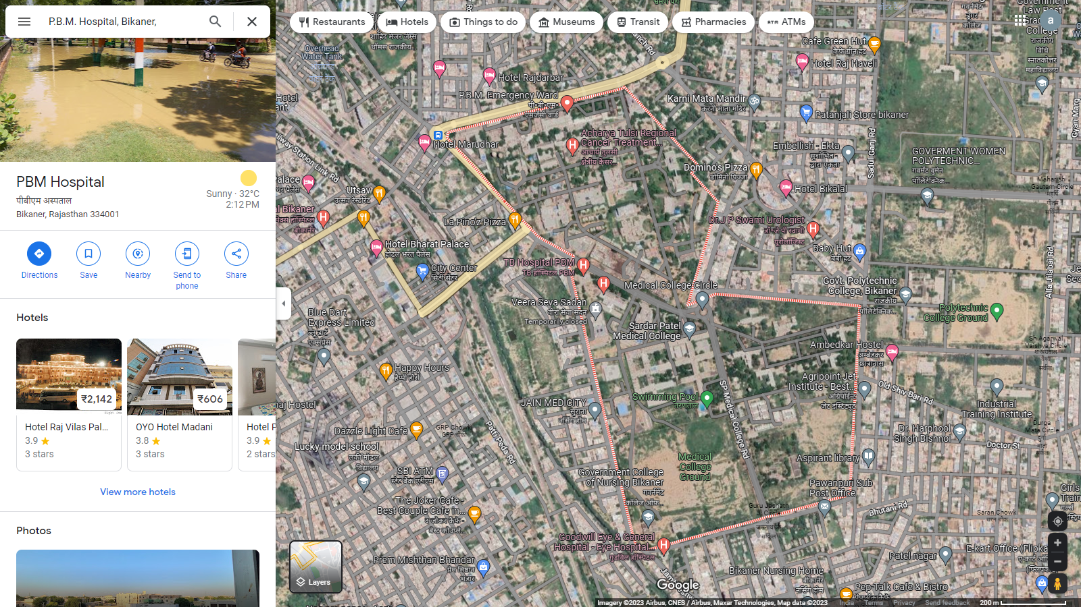
P.B.M. Hospital: 28°00'39.2"N 73°19'39.1"E City: Bikaner
Sardar Patel Medical College: 28°00'22.0"N 73°19'49.8"E
- SCOPE OF THE REPORT: To verify the Project cost, expenditures and examine the commissioning, installation status of Solar Power Plants set-up/ being set-up by M/s OPPL SPV CG Pvt. Ltd.
- Industry/ sector research and demand & supply trend is out of scope of the report.
- Financial feasibility study of the Project is out of scope of the report.
- Providing any kind of design report or map is out-of-scope of the report.
- Scrutiny of contracts, Agreements and arrangement between the parties from legal perspective is out-of-scope of this report.
- Location feasibility is ascertained based on the PVSyst Report provided by the client.

All the assessment carried out for the Project is done based on the documents and information provided to us and its correlation by the Engineering team through physical and virtual site inspection and various other discussions with the Project proponents and thus forming an opinion out of it.
Component wise verification is not carried out but Project installation & commissioning has been verified as a whole.
Any kind of technical & economic feasibility of the Project is out-of-scope of this Report. This report is only limited & related to the verification and examination of what has already been setup.

- PURPOSE OF THE REPORT: To provide fair detailed analysis report to the Bank based on the “in-scope points” mentioned above for facilitating them to take appropriate business decision on the Project.

- METHADOLOGY ADOPTED:
- To gather relevant data/ information/ documents related to Project planning, execution, current status.
- Study of copy of Project Planning documents/ Agreements to know the scope of work of the company.
- To procure, study and analysis of any additional information, data, and documents required/ provided by the company.
- Research about the Project/ sector from the sources in the public domain.
- Correlation of the provided information against Industry/ sector benchmarks/ trend.
- Information compilation, analysis and reporting.

PART C | PROJECT DETAILS AND KEY TECHNICAL PARAMETERS

As per the e-mail dated 24-03-2023 and copy of documents provided, detail of the subject plants has been tabulated below:
S. No. | City | Buyer Name & Address | Capacity-DC (kWp) | Capacity-AC as per PPA (kWp)
1 | Pali | Shree Bangur Hospital, Suraj Pole,  Pali, Rajasthan-306401 | 320 | 270
2 |  | Govt. Medical College, NH-62,  Sumerpur Road, Pali, Rajasthan | 420 | 350
3 | Bharatpur | RBM Govt. Hospital, Bharatpur,  Rajasthan, 321001 | 240 | 350
4 |  | Janana Hospital, Bharatpur,  Rajasthan-321001 | 420 | 200
5 |  | Govt. Medical College, Bharatpur | 480 | 200
6 | Bikaner | P.B.M. Hospital, Bikaner,  Rajasthan-334001 | 2,020 | 2,020
7 |  | Sardar Patel Medical College,  Bikaner, Rajasthan-334001 | 1,200 | 1,185
Total Capacity |  |  | 5,080 | 4,575

As per the copy of module layout plans of all the sites, Key Technical Parameters & Configuration of the projects like Modules, Inverter, tilt angle, capacity, etc. are tabulated below:
- Shree Bangur Hospital-PALI
S. No. | Particular | Figure | UOM
1 | Proposed Capacity | 320 | kWp
2 | Total No. of PV Modules | 956 | No.
3 | PV Modules Capacity (Multi-Crystalline) | 335 | Wp
4 | PV Module Dimension | 1961 x 991 x 35 | Mm
5 | PV Module Mounting Orientation | Portrait
6 | Module Mounting Structure Angle | 20º
- Govt. Medical College-PALI
S. No. | Particular | Figure | UOM
1 | Proposed Capacity | 420 | kWp
2 | Total No. of PV Modules | 1,254 | No.
3 | PV Modules Capacity (Multi-Crystalline) | 335 | Wp
4 | PV Module Dimension | 1961 x 991 x 35 | Mm
5 | PV Module Mounting Orientation | Portrait
6 | Module Mounting Structure Angle | 20°

- RBM Govt. Hospital-BHARATPUR
S. No. | Particular | Figure | UOM
1 | Proposed Capacity | 240 | kWp
2 | Total No. of PV Modules | 717 | No.
3 | PV Modules Capacity (Multi-Crystalline) | 335 | Wp
4 | PV Module Dimension | 1961 x 991 x 35 | Mm
5 | PV Module Mounting Orientation | Portrait
6 | Module Mounting Structure Angle | 20°
- Janana Hospital-BHARATPUR
S. No. | Particular | Figure | UOM
1 | Proposed Capacity | 420 | kWp
2 | Total No. of PV Modules | 1,254 | No.
3 | PV Modules Capacity (Multi-Crystalline) | 335 | Wp
4 | PV Module Dimension | 1961 x 991 x 35 | Mm
5 | PV Module Mounting Orientation | Portrait
6 | Module Mounting Structure Angle | 20°
- Govt. Medical College-BHARATPUR
S. No. | Particular | Figure | UOM
1 | Proposed Capacity | 480 | kWp
2 | Total No. of PV Modules | 1,433 | No.
3 | PV Modules Capacity (Multi-Crystalline) | 335 | Wp
4 | PV Module Dimension | 1961 x 991 x 35 | Mm
5 | PV Module Mounting Orientation | Portrait
6 | Module Mounting Structure Angle | 20°
- P.B.M. Hospital-BIKANER
S. No. | Particular | Figure | UOM
1 | Proposed Capacity | 2,000 | kWp
2 | Total No. of PV Modules | 5,971 | No.
3 | PV Modules Capacity (Multi-Crystalline) | 335 | Wp
4 | PV Module Dimension | 1961 x 991 x 35 | Mm
5 | PV Module Mounting Orientation | Portrait
6 | Module Mounting Structure Angle | 20°
- Sardar Patel Medical College-BIKANER:
S. No. | Particular | Figure | UOM
1 | Proposed Capacity | 1,200 | kWp
2 | Total No. of PV Modules | 3,583 | No.
3 | PV Modules Capacity (Multi-Crystalline) | 335 | Wp
4 | PV Module Dimension | 1961 x 991 x 35 | Mm
5 | PV Module Mounting Orientation | Portrait
6 | Module Mounting Structure Angle | 20°

Technical details as per Techno-Commercial offer from Orient Power
S. No. | Item Description | Technical Specifications | Quantity | Unit | Make
A | PV Section
1 | Solar PV module | 230Wp-550Wp  Mono-PERC/Multi-Si 25yrs. Linear warranty  Certifications:  IEC 61215, IEC 61730 & UL 1703; IEC 62804 (PID) IEC  62716 (Ammonia Resistance), IEC 60068-2-68 (Blowing Sand) IEC 61701 (Salt Mist level 6), , ISO 11925-2 (Class E) ISO 9001: 2015, ISO 14001: 2004,  OHSAS 18001: 2007 | 5 | MWp. | ALMM Approved/As per Policy
2 | Connectors (male & female) pair MC4 | Connectors (male & female) pair, MC4 Connector Pin Copper with tin coating Insulation Voltage: 1000V | As per requirement | Nos. | Multi Contact
3 | Solar String Inverter –  50/100/250kVA, 415V | 50/100/250kVA, 415V output, Outdoor type-IP65, Eff. >98% | As per Design | Nos. | Sungrow/ Grow att /Equivalent
B | Structures
1 | Design & Supply of Module Mounting structure supply. | Roof Mounted Ballasted Solar Module Mounting Structure.  Material: MS HDG Grade: E 250 Galvanisation: 80micron  Structure designed at 170kmph wind speed as per IS- 875  Ground Clearance 1 mtr. | As per requirement |  | Oriana Power
2 | Structure & Module Mounting Accessories. | Material: SS Grade: SS 304  Structure designed at 170kmph wind speed as per IS-875 | As per requirement |  | Oriana Power
C | Remote Monitoring System
1 | Ambient Temperature sensor | PT1000 sensor element | 1 | Set | IMT
2 | Module Back Surface Temperature sensor | PT1000 sensor element | 1 | Set | IMT
3 | Solar Irradiation sensor for radiation  measurement | Cell Based sensor with calibration certificate | 1 | Set | IMT
4 | 2 Pair Twisted Un - armoured communication cable, Cu |  | As per Design | Mtr | K-flex/parasheild
5 | HDPE DWC Conduit, Size of 32/26mm & Accessories (PVC bends & couplers etc.) | Double Wall Corrugated HDPE Conduit for communication cable laying over shed. Conduit will be fixed with shed using GI Saddles and aluminum pop rivets. | As per Design | Mtrs | Duraline/ equivalent
6 | 3C 1.5Sq. mm Armored Copper Cable - Data Logger Power cable |  | As per Design | Mtr | Polycab
7 | CAT 6 cable |  | As per Design | Mtr | Dlink
8 | Data logger Installation and IP 65 Box | For Remote monitoring | As per  Design | Nos | Webdyn
9 | SCADA for Solar Plant monitoring and Grid monitoring | Visual inter-facing for plant monitoring and data analysis | As per Design | Lot | Webdyn
D | DC side - Cables & Accessories
1 | 1 Core 4 Sq mm Cu Solar Cable | Solar DC cable, Tin-coated copper cable as per EN standard. UV protected double sheathed XLPO, Halogen free cable. | As per Design | Mtrs | Apar/Siechem/ Equivalent
2 | 1C 2.5 Sq mm Green  Cable (for Earthing), with accessories | 2.5sqmm. Single core flexible PVC insulated cable for  module to module earthing with SS-304 fasteners, teeth washer and copper thimbles. | As per Design | Mtrs | Polycab/KEI
3 | DC Electrical accessories | (Consumables like Lugs, Glands, Ferrules, Cable Ties, uPVC tape, uPVC saddle, Cable clips etc.) | As per Design | Set | As per Design RFQ
4 | HDPE DWC Conduit, Size of 32/26mm & Accessories (PVC bends  & couplers, T Joints etc.) | Double Wall Corrugated HDPE Conduit for DC cable laying over shed. Conduit will be fixed with shed using GI Saddles and aluminum pop rivets. | As per Design | Mtrs | Apollo/ Duraline/ equivalent
E | AC side - Cables & Accessories
1 | 4 C, 25 Sq.mm Cu PVC Flexible Cable. | 1.1kV insulated, Copper conductor, PVC insulated, PVC outer sheathed cable | As per Design | Mtrs | Polycab/KEI/ Havells
2 | 3.5 C, 150 Sq.mm AL XLPE Arm Cable. | 1.1kV insulated, Aluminium conductor, XLPE insulated, GI strip armoured, PVC outer sheathed  cable as per IS-7098 Part-1 | As per Design | Mtrs | Polycab/KEI/ Havells
3 | Cable for earthing- 1C 10 sq.mm Cu flexible (for Inverter earthing) |  | As per Design | Mtrs | As per Design RFQ
4 | Field ACDB for inverters output | 3 phase, 415 V, 50 Hz ACCB Panel with  - Enclosure material made of CRCA with Powder coated paint  - 4P, MCCB’s - as per requirement  - 4P, Isolator  - 3 phase, 4 W, AL, bus bar.  - IP 65 with canopy  - Panel with double door & lock  - SPD Type 2  - with mounting arrangement | As per Design | Nos | Breakers Make: L&T
5 | Isolator Panel near Metering Panel | 3 phase, 415 V, 50 Hz ACCB Panel with  - Enclosure material made of CRCA with Powder coated paint  - 4P, 700A MCCB’s  - 3 phase, 4 W, AL, bus bar.  - IP 54 with canopy  - Panel with single door & lock  - with mounting arrangement | As per Design | Nos | Breakers Make: L&T
4 | Cable tray for AC cable laying after inverter | 50mmX50mmX2mm Hot dip galvanized cable tray with cover and other accessories i.e. cable tray stand, cable tray cover clamp, cable tray coupler, M8  MS HDG Fasteners, anchor bolts etc. | As per Design | Nos | Oriana Power
F | Civil Works
1 | As per site requirement | Civil work for Structure, electrical panel foundations, Structure Foundation, earthing pit chamber construction. | 1 | Set | As per RFQ
G | Safety & Protections
1 | Fire extinguisher With sand bucket ( 4 Kg ABC type ) | 4 Kg ABC type fire extinguishers with stand | As per design | Set | As per Design RFQ
2 | Earthing Kit for plant AC and DC earthing | Copper Bonded rods 3m, 17.2 mm, chemical bags and other required accessories. Earthing pit chamber will be constructed and Cast iron cover will be installed | 1 | Set | VNT/JMV/GS Electrode
3 | Lightning Arrester for protection of solar power  plant | ESE Type, GI mast, 2 Earthing pit , 1 C 70 mm2 Cu PVC cable, 2 set of earthing for one lightning  arrester, R-109 Meter , Stay Set support. | As per design | Nos. | VNT/JMV/Allied Power
4 | GI Strip 25X3 mm for DC side | Hot dip galvanized earthing strip with minimum 80 micron. Material grade E-250 | As per Site Req | Meter | As per Design RFQ
H | Services
1 | Installation, testing and  Commissioning | Complete plant service work | 5 | MWp | As per Design RFQ
2 | Module cleaning system with uPVC pipe line system and pump. | 1 HP, 230V Centrifugal pump,  CPVC Pipe (1/2 inch) line over roof with shut-off valves, CPVC pipe will be fixed over roof with SS saddles gitti-pench. Flexible Hosepipe (1 inch) of 40 Meter length, Wiper 1.5 Meter length, Extendable Pole Piping for Each Roof, Piping as per detail drawing | 1 | Set | Ashirwad/Astral/  Equivalent

Client’s Scope of work
- Provision of permission to work on site
- Clear shadow free area / Tin shed for the installation of PV modules & equipment’s.
- Entrance/working permission for local labor for loading/un-loading work.
- Electrical power point nearby to site for electricity requirement during construction.
- Water tap points (minimum 1 inch ) at PV plant site for module cleanings system
- Internet / SIM card with data packs shall be provided at site for remote monitoring of inverters and other devices.
- Documents required for CEIG approval/DISCOM NOC/Bi-directional Meters.
PART D | ENERGY YIELD ASSESSMENT

Company has used PVSyst V7.2.21 to assess energy yield calculation which is the standard Industry practice. The yearly average of main results of irradiation and energy yield from the provided PVSyst is as under:
S. No. | City | Plant Location | Annual production probability  (MWh) |  | Specific Production  (kWh/kWp/year) |  | Per.  Ratio (%)
 |  |  | P50 | P90 | As per PPA | As per PVsyst
1 | Pali | Shree Bangur Hospital | 547.1 | 532.7 | 1,500 | 1,708 | 83.40
2 |  | Govt. Medical College | 751.9 | 684.1 | 1,500 | 1,748 | 84.83
3 | Bharatpur | RBM Govt. Hospital | 400.8 | 390.2 | 1,500 | 1,666 | 85.39
4 |  | Janana Hospital | 700.0 | 681.5 | 1,500 | 1,666 | 85.40
5 |  | Govt. Medical College | 815.8 | 794.2 | 1,500 | 1,696 | 85.27
6 | Bikaner | P.B.M. Hospital | 3,364 | 3,110 | 1,500 | 1,681 | 85.58
7 |  | Sardar Patel Medical College | 2,021 | 1,968 | 1,500 | 1,684 | 85.49

Observations and Remarks:
- As per the PVsyst - Simulation reports dated 16th March 2023, the estimated energy that can be produced by the subject plants and their respective performance ratio is more than as agreed in the PPA.
- As per Global Solar Atlas by World Bank Group, the location wise Annual Averages- Direct Normal Irradiation are:
- Pali: 1,860.7 kWh/m²
- Bharatpur: 1,461.0 kWh/m²
- Bikaner: 1443.1 kWh/m²

PART E | POWER PURCHASE AGREEMENT TERMS

As per the information provided by the company, the total proposed capacity of the subject rooftop solar power plant is 5 MW. As on date, company has signed 7 no. of PPAs to supply power these 7 locations. Details of the same are tabulated below:
S. No. | State | Buyer Name & Address | kWp  (AC) | Tariff  (Rs./kWh) | PPA and Novation Date
1 | Pali | Shree Bangur Hospital, Suraj Pole,  Pali, Rajasthan-306401 | 270 | 4.05 | 01-03-2023
2 |  | Govt. Medical College, NH-62,  Sumerpur Road, Pali, Rajasthan | 350 | 4.05 | 01-03-2023
3 | Bharatpur | RBM Govt. Hospital, Bharatpur,  Rajasthan, 321001 | 350 | 4.05 | 01-03-2023
4 |  | Janana Hospital, Bharatpur,  Rajasthan-321001 | 200 | 4.05 | 01-03-2023
5 |  | Govt. Medical College, Bharatpur | 200 | 4.05 | 01-03-2023
6 | Bikaner | P.B.M. Hospital, Bikaner,  Rajasthan-334001 | 2,020 | 4.05 | 13-03-2023
7 |  | Sardar Patel Medical College,  Bikaner, Rajasthan-334001 | 1,185 | 4.05 | 11-03-2023
Capacity |  |  | 4,575
Source: Details provided by the company

Important Clauses: Some of the important clauses as per 3 nos. of signed PPA’s are as follows:-
Clause-3: Terms & Termination
3.1. Term
- The term of this agreement will be for a period of 25 years from COD, pursuant to the provisions of the Agreement. i.e., if COD is any date between 01-04-2023 and 31-03-2024, then the 25-year term shall continue till 31-03-2048.
- After the Term, the ownership of the System shall be transferred to the Purchaser free of cost at the discretion of Power Purchaser.

3.2. Purchase Option/ purchase Obligation
So long as a Purchaser default shall not have occurred and be continuing. Purchaser has the option to purchase the System by paying the Power Producer the Purchase price as per Schedule III to the Agreement.
Clause-4: Construction, Testing and Commission of the System:
4.1. Installation Work
h) If the Power Producer is unable to commence supply of Solar Power to the Purchaser by the Scheduled Completion Date, other than for the reasons specified in Article 11 and 12.2 (Force Majeure or Purchaser Default), the Power Producer or its contractor shall pay genuine pre-estimated liquidated damages for the delay in such commencement of supply of Solar Power as per the clause of the REIL RFS REIL/BID/RTS(C)/2019-20/001 dated 04-10-2019 appended as Schedule VI format as per respective RFS document to this Agreement.

i) The Purchaser shall ensure that all arrangements and infrastructure for receiving Solar Power beyond the Delivery Point are ready on or prior to the Commercial Operation Date and is maintained in such state in accordance with applicable laws through the Term of the Agreement.

Clause-5: System Operations
  - The Power Producer as Owner and Operator
The System will be legally and beneficially owned by the Power Producer and will be operated and maintained and, as necessary, repaired by the Power Producer at its sole cost and expense.
Power Producer shall not be responsible for any work done by others on any part of the System/Project authorized by the Purchaser and not authorized in advance by the Power Producer in writing.
Power Producer shall not be responsible for any loss, damage, cost or expense arising out of or resulting from the improper operation or 'maintenance of the System by Purchaser or anyone instructed to do such work by Purchaser.
Caluse-6: Delivery of Solar Power
6.1 Purchaser Requirement:
Purchaser agrees to purchase one hundred per cent (100%) of the Solar Power generated by the System and made available by the Power Producer to Purchaser at the Delivery Point during each relevant month of the Term.
Caluse-7: Tariff and Payments
7.1.(ii) whether any Solar Power has been injected, whether inadvertently or otherwise, into the grid of the Distribution Utility. The Power Producer will bill the Purchaser for each KWh metered as above at the Delivery Point, at the Tariff prevailing at that point of time as detailed in Schedule - II, the Tariff will be equal to Rs. 4.05/kWh. The 'year' considered shall be the financial year which April 1st to 31st March of every year. Schedule II provides a detailed year on year tariff schedule.
Clause-8: General Covenants
8.1 Power Producer’s Covenants
(c) The system shall meet minimum guaranteed generation with Performance Ratio (PR) at the time of commissioning and related Capacity Utilization Factor (CUF) as per the daily normalized irradiance levels of the location during the O&M period. PR shall be minimum of 75% at the time of inspection for initial Project acceptance.
(d) Governmental Approvals: While providing the Installation work, solar Power and System Operations, the Power Producer shall obtain and maintain and secure all Governmental Approval required to be obtained and maintained and secured by the Power Producer and to enable the Power Producer to perform such obligations.

Clause-12: Default:
12.1 Power Producer Defaults and Power Purchaser Remedies
(b) Purchaser’s Remedies
(iii.) Following the issue of Purchaser Preliminary Default Notice, it shall be the responsibility of the Parties to discuss as to what steps shall be taken with a view to mitigate the consequences of the relevant Power Producer's Default having regard to all the circumstances. If the Power Producer Default is not cured within a period of sixty (60) days of the issue of Purchaser Preliminary Default Notice or any other such period mutually agreed upon by the Parties, the Purchaser shall have the right to terminate this Agreement by issuing a Purchaser Termination Notice.

(iv) Upon the delivery of the Purchaser Termination Notice, this Agreement shall stand terminated. The Power Producer shall have the liability to make payment within sixty (60) days from the date of Purchaser Termination Notice towards compensation to Purchaser equivalent to the difference between the Tariff and the grid rate notified by the relevant Government Authority for that point in time multiplied by the estimated Solar Power generated for a period of two years following the termination, considered on normative capacity utilization factor.

12.2 Power Purchaser Defaults and Power Producer Remedies
(b) Power Producer's Remedies:
If a Purchaser Default described in Sections 12.2 (a) has occurred and is continuing, in addition to other remedies expressly provided herein, and subject to Section 13, the Power Producer shall be entitled to terminate this Agreement by serving a fifteen (15) days' notice and upon such termination. (A) the Power Producer shall be entitled to receive from Purchaser the Purchase Price. The Purchase Price payable shall be the Purchase Price Specified in Schedule III that falls on such date. Upon the payment of the Purchase Price, the Power Producer shall cause the title of the System to transfer to the Purchaser and (b) the Power Producer may exercise any other remedy it may have at law or equity or under the Agreement.

Clause-14: Assignment & Novation
14.1 Assignment
Notwithstanding anything contained herein, the Power Producer has the right to assign all or any of its rights under this Agreement (including rights over any assets hereunder), to any third party including, though not restricted to any lender, equipment lessor or other party("Assignment"), without the consent of the Power Purchaser. In the event of such assignment, the Purchaser will be able to hold the Power Producer as well as the party to whom the benefits under this contract are assigned, to be jointly and severally responsible for performing the obligations under this contract.

14.2 Novation
The Parties agree and acknowledge that the Power Producer may intend to novate the Agreement to a party and has the right to transfer any or all of its rights and obligations under this Agreement to a party or any other third party ("New Party"), with the consent of the Power Purchaser. The Power Purchaser shall not unreasonably withhold such consent. Upon Novation, the New Party shall automatically and without any further action be entitled to all the same rights and assume the same obligations, under this Agreement, as if it were originally a party to this Agreement. Further, the Purchaser hereby agrees and undertakes that, promptly upon receiving a request from the Power Producer, the Purchaser shall execute such further writings, deeds and/or agreements and take all such further actions as may be necessary for effecting or implementing the transfer of any or all of the Power Producer's rights and/or obligations under this Agreement to the New Party. If the parties agree to do Novation, then separate Novation agreement shall be executed.

Clause-17: Miscellaneous
17.14 Insurance
The Power Producer shall maintain at its own costs, throughout the tenure of this Agreement and any extensions thereof all mandatory insurance coverage for adequate amount including but not restricted to comprehensive general liability insurance including theft and vandalism, covering the System and accidental losses, bodily harm, injury, death of all individuals employed/ assigned by the Power Producer to perform the services required under this Agreement.

Other important facts of PPA
- Description of the Site and Premises shall be as per SCHEDULE 1 of PPAs.
- Yearly degradation of Module & PV System considered in generation data is 1% per annum.
- Deemed Generation and/or expected yearly energy generation shall be as per Schedule IV of PPA.
- Monthly Electricity Purchase Rate • Basic / Floor Tariff: Rs. 4.05 per unit levelised for 25 years of plant operation / PPA tenure to be as described in SCHEDULE II.
Please note that the above main clauses of PPA are mentioned only for illustration purpose of the convenience of the lenders to analyze the Project in terms of technicality. However, this shall not be construed as professional opinion on the contract legality which is out of scope of this report.

PART F | CURRENT STATUS OF WORK

As per information and documents shared by the company’s representative, following are our observations and remarks on the current status of the project:
- The work related to installation of modules is yet to start.
- The materials and panels are yet to be purchased.
- As per the information shared by the management of the company via email dated 24th March 2023, the expected COD of the project at different locations has been tabulated below:
S. No. | City | Buyer Name & Address | Capacity -DC (kWp) | Expected  COD
1 | Pali | Shree Bangur Hospital, Suraj Pole,  Pali, Rajasthan-306401 | 320 | October 2023
2 |  | Govt. Medical College, NH-62,  Sumerpur Road, Pali, Rajasthan | 420 | December 2023
3 | Bharatpur | RBM Govt. Hospital, Bharatpur,  Rajasthan, 321001 | 240 | October 2023
4 |  | Janana Hospital, Bharatpur,  Rajasthan-321001 | 420 | January 2024
5 |  | Govt. Medical College, Bharatpur | 480 | November 2023
6 | Bikaner | P.B.M. Hospital, Bikaner,  Rajasthan-334001 | 2,020 | April 2024
7 |  | Sardar Patel Medical College,  Bikaner, Rajasthan-334001 | 1,200 | April 2024
Total Capacity |  |  | 5,080

PART G | PROJECT COST & EXPENDITURE

Project cost has been taken from the Copy of Techno-Commercial offer from M/s OPPL to M/s OPPL SPV CG Pvt. Ltd. dated 1st March 2023, for the installation of Roof Mounted Grid Tie Solar PV plant located at 7 sites in Rajasthan. The terms of engagement are tabulated below:
S. No. | Description | Amount  (Including duties and taxes)
1 | Solar Panel: multi/Mono-Si, IEC certification, BIS certification and other relevant standard as per Government | Rs. 13,83,40,000/-
2 | Solar Inverter: String inverter with multiple MPPT provision, Outdoor Mounted, IP65 Protection and all relevant standards as per Government | Rs. 1,93,04,000/-
3 | BOS: Module Mounting Structure, DC Cable, AC Cable, LT Panel, Civil material, Conduit, MCS, RMS, Earthing and Protection Systems, Lightning Arrester, Weather Sensor and monitoring system, Metering Unit, DISCOM approvals etc. | Rs. 7,58,95,200/-
4 | I&C: Supply of civil material, Installation, testing and commissioning of Solar Power plant as per site requirement | Rs. 1,65,60,800/-
Total |  | Rs. 25,01,00,000/-
- Freight & Transit Insurance: Inclusive
- Taxes GST- as per government norms
- Net-metering fee will be paid by consumer
- Any changes in Tax/Duties shall be borne by the Purchase
- Excludes-
Any approval
Anything out of BOQ

- Expenditure: As per information/details shared by the company, the installation work related to power plant is yet to start. Thus, the expenditure incurred till date on the project is NIL.

Observations and Remarks:
- Project cost calculated on the basis of the Benchmark cost provided by the MNRE has been tabulated below:
S. No. | Particulars | Benchmark Cost  (In Rs./kW) | Project Capacity  (In MW) | Total Project Cost  (Excluding GST)  (In Rs.) | Total Project Cost  (Including ~14% GST)  (In Rs.)
1 | As per Ministry of New & Renewable Energy | 35,886* | 5.0 | 18,23,00,880 | 20,74,21,941
 |  |  | 5.0 MWp |  | ~Rs.20.74 Cr.
*Benchmark cost for 2021-22

- Project cost calculated on the basis of market comparable:
S. No. | Particulars | Excluding GST | Including GST | Remark
 |  | Per KW Cost  (In Rs.) | Per KW Cost  (In Rs.)
1 | Subject project installation cost | - | 49,232 | as per Techno-Commercial offer from OPPL
Market Research Details
2 | MNRE Benchmark Cost | 39,080 | - | Refer Annexure-1
3 | Market Research | 48,700 | 55,400 | Refer Annexure-2
4 | WAAREE Solar | 40,000 | 45,500 | Refer Annexure-3
5 | As per Solar Square | 45,000 | 51,200 | Refer Annexure-3
6 | Market Quotation (Tata Solar) | 60,000 | 68,300 | Refer Annexure-4

- As per our analysis and market research, the installation cost of Rooftop Mounted Solar Power Plant varies from Rs. 45,500/- per KW to Rs. 68,300/- per KW.
- The project cost is solely dependent upon project location, contractors profit, type of module and its supporting structures, etc.
- Based upon the above mentioned details, the project cost amounting to Rs.25.01 Cr. inclusive of GST for the installation of subject rooftop solar power plant seems to be reasonable.
- As per the mail dated 24-03-2023, the management of the subject company has confirmed that there is no work done at any of the 7 subject sites, therefore, site survey has not been done.
- As per Clause 17.14 of the PPA, the subject company has to take an Insurance Policy. However, it is yet to be executed
Note:
- Project cost is analyzed based on lump sum cost only and not item wise.
- Project cost is assessed for the date of this report only and due to price fluctuations it may vary from time to time.

PART H | PHOTOGRAPHS

Since the installation work related to solar panels is yet to start and this is just DESKTOP LIE based upon documents provided. Thus, Photographs are not available.

PART I | OTHER DOCUMENTS & REFERENCES

Annexure-1: Benchmark Cost by MNRE:

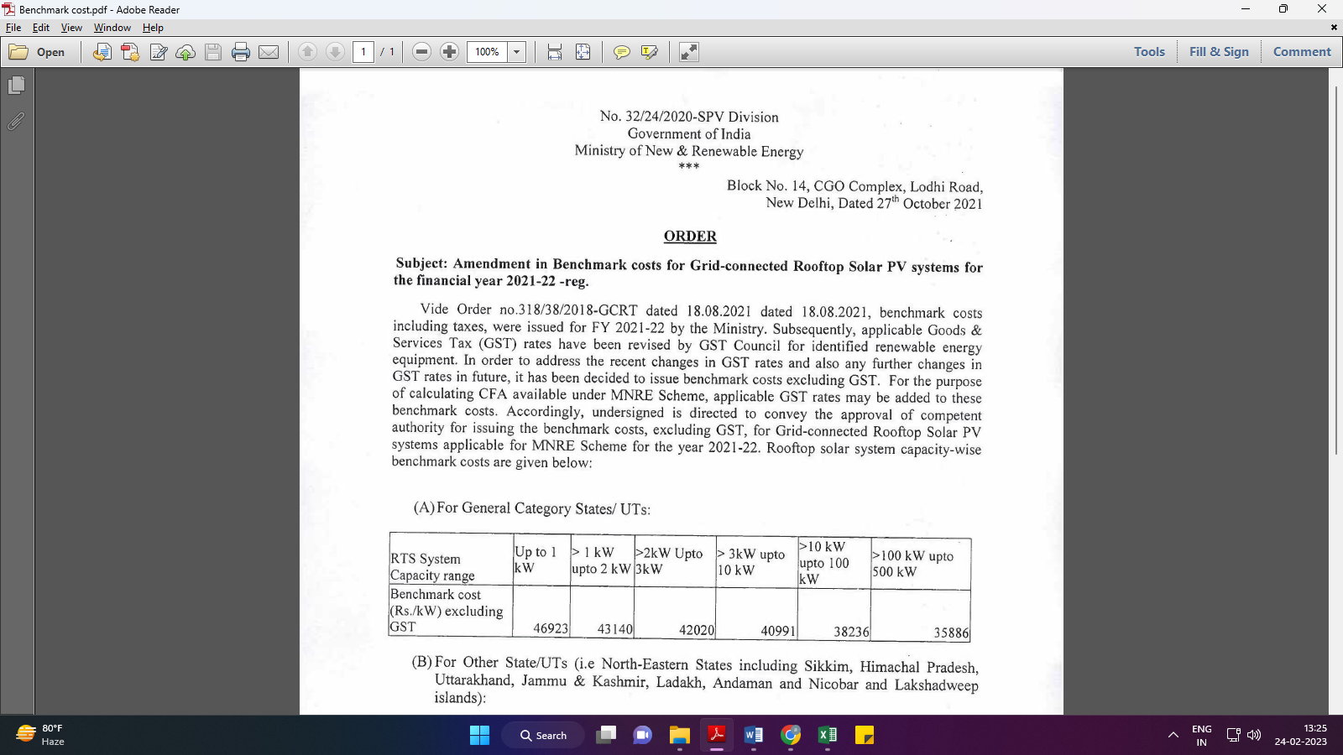
Market Comparables:
Annexure-2
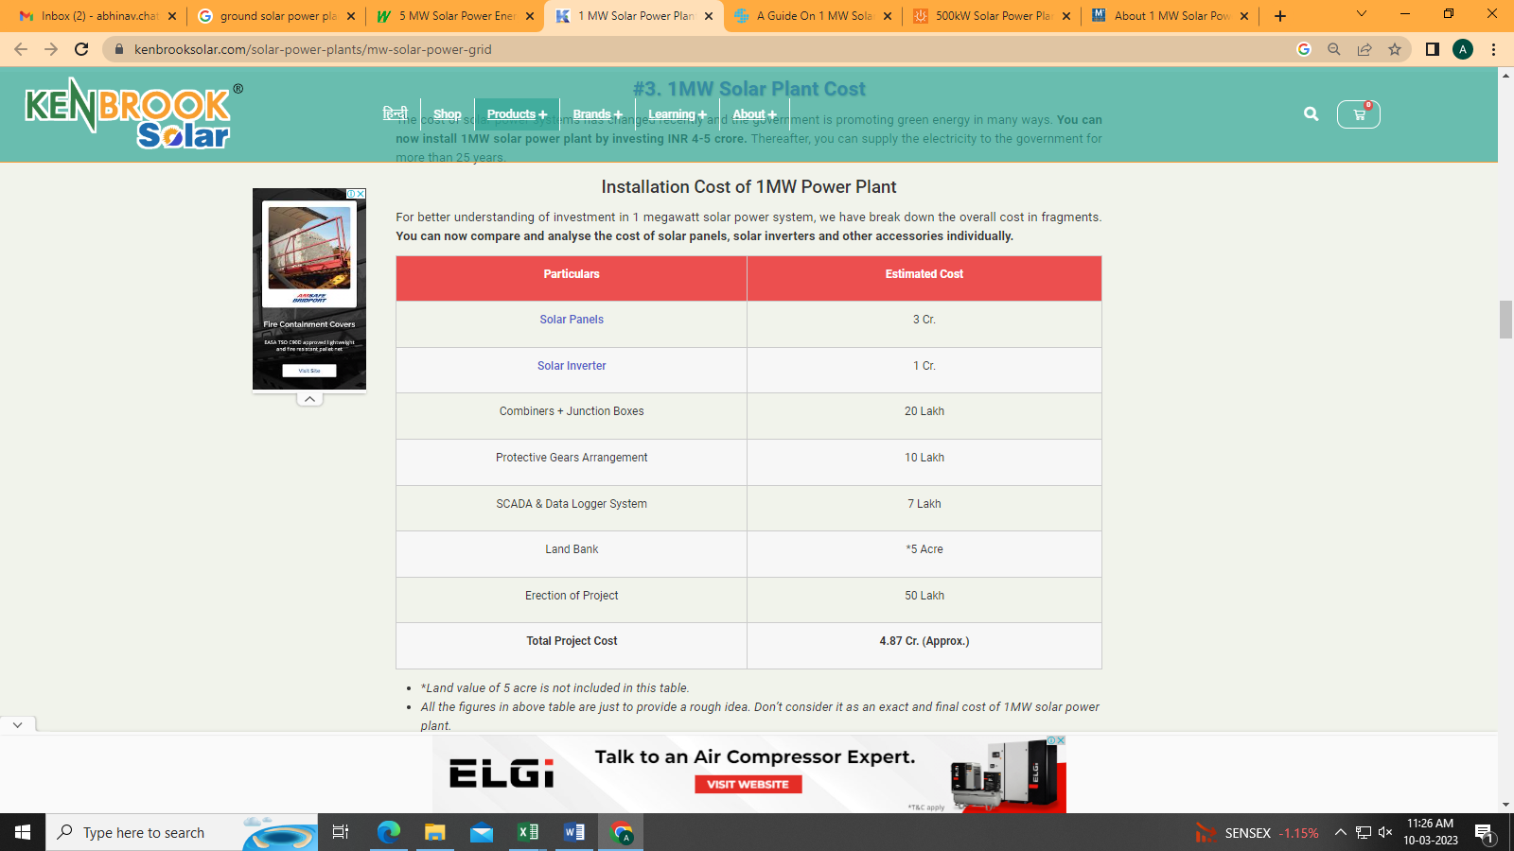

Annexure-3

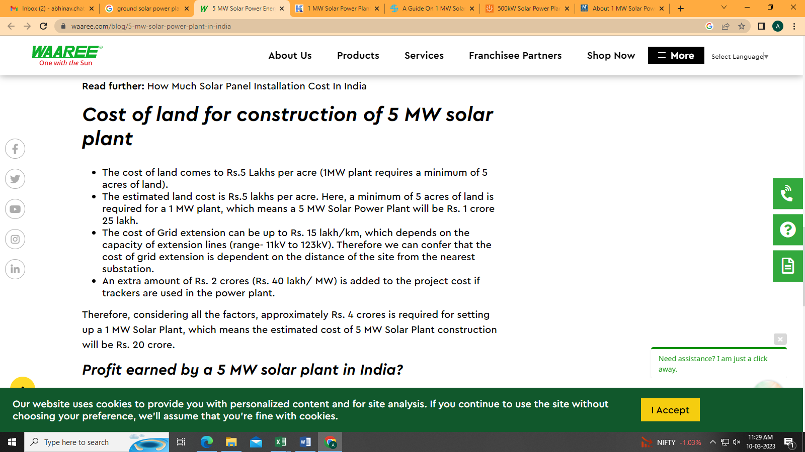

Annexure-4

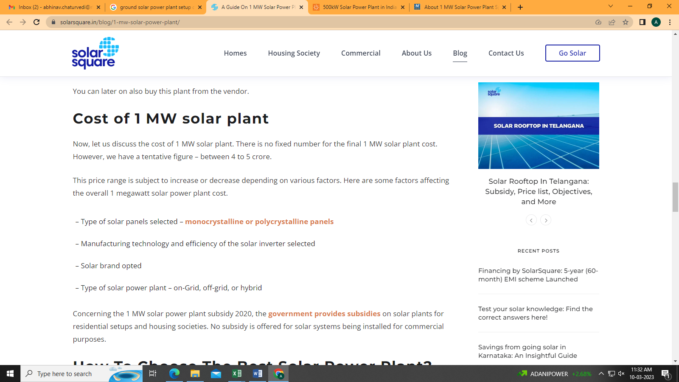

Annexure-5

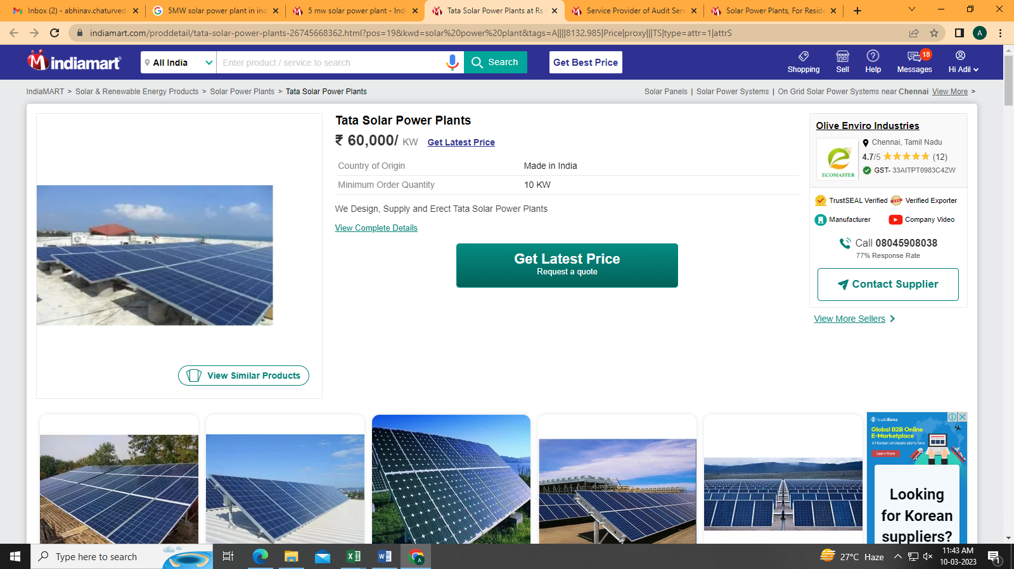

Data by Global Solar Atlas by World Bank Group
- Pali
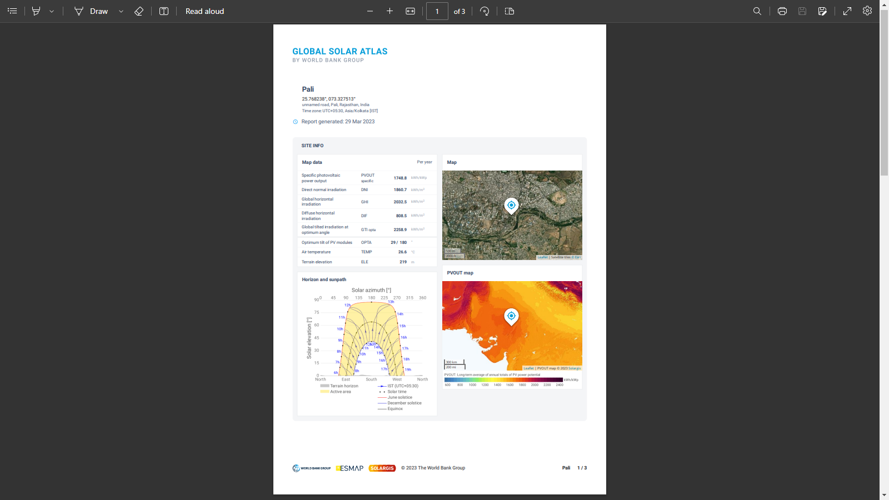
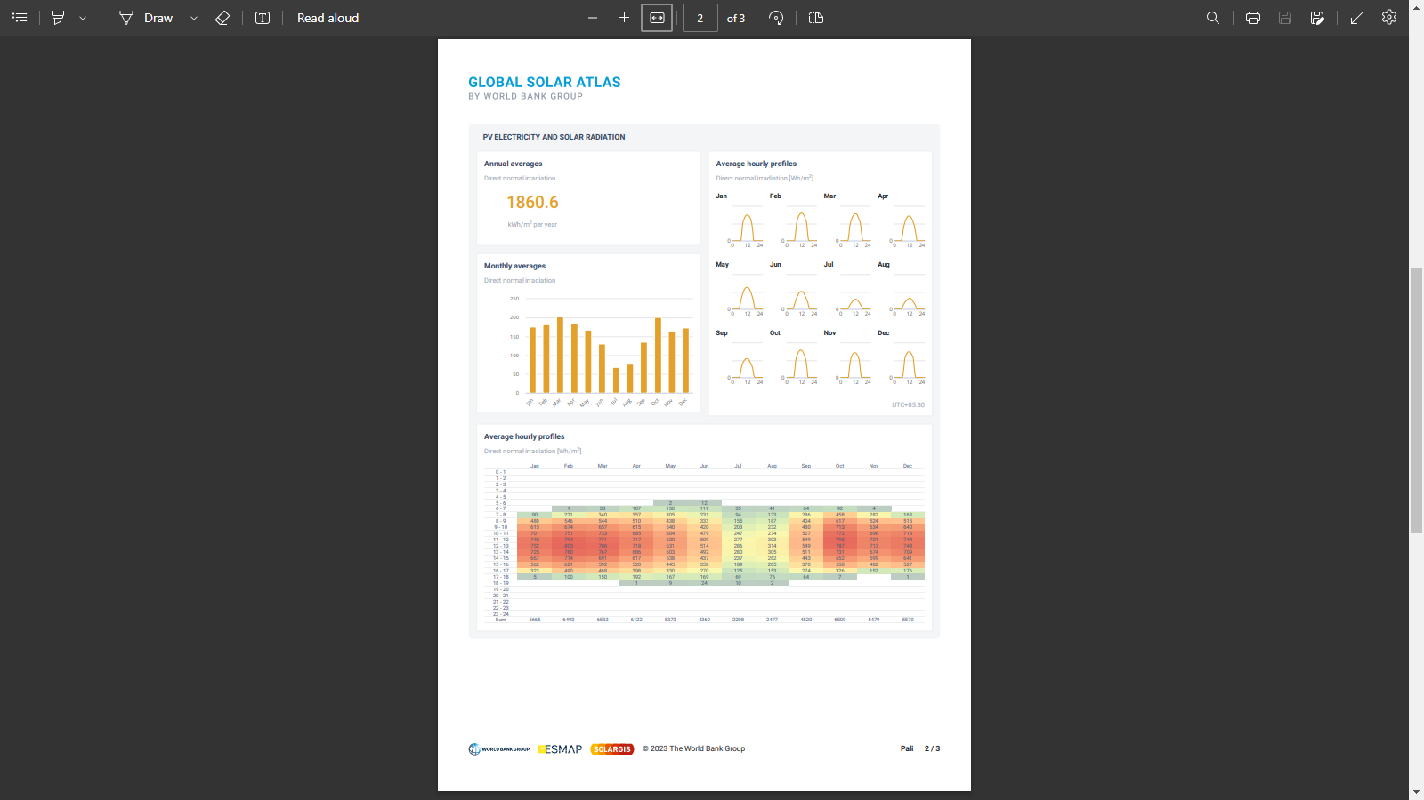

- Bikaner
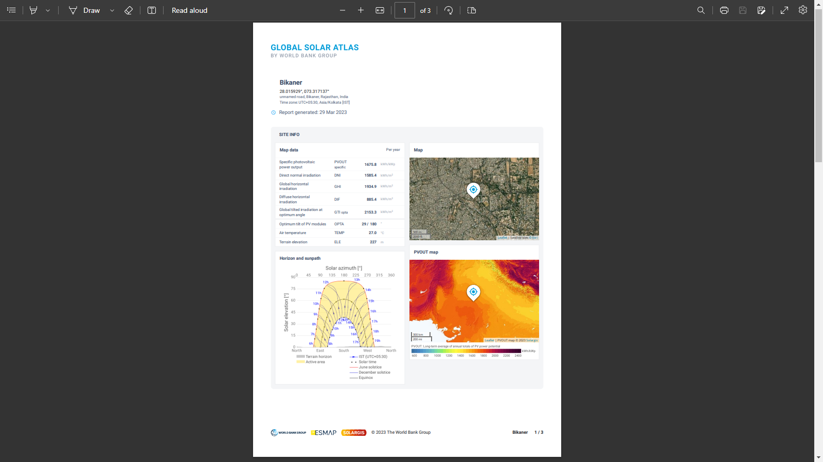
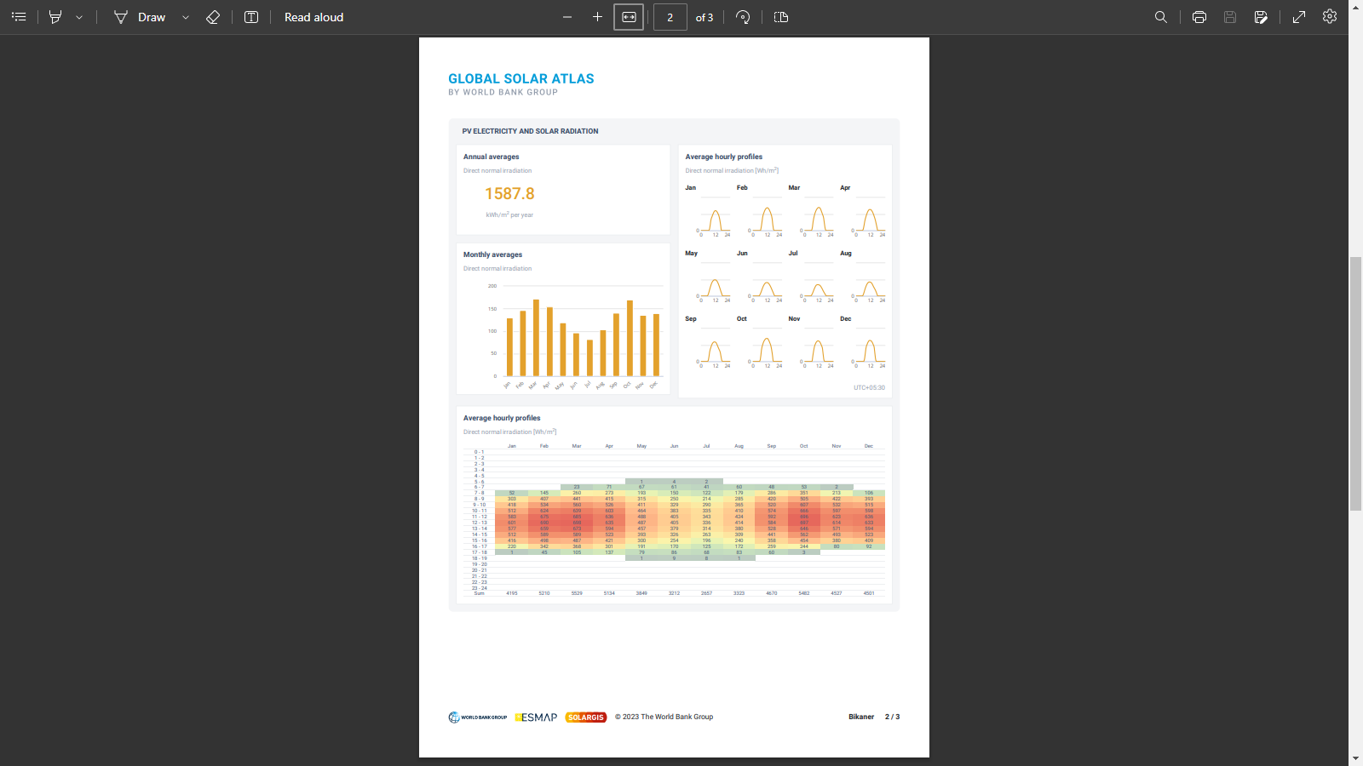

- Bharatpur
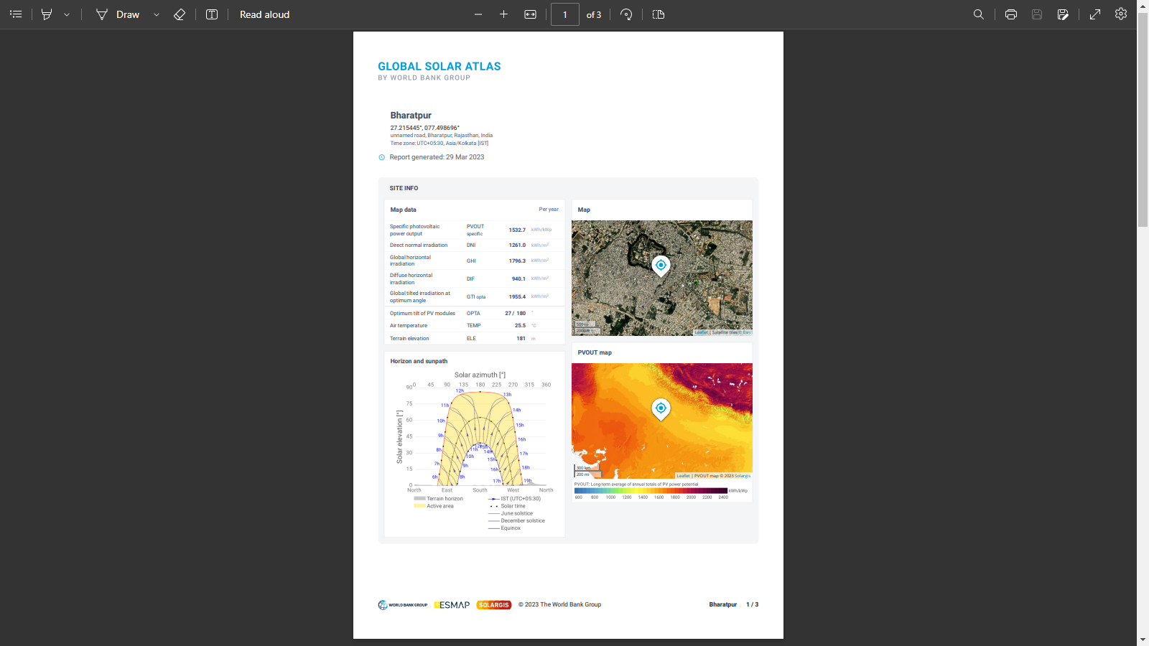

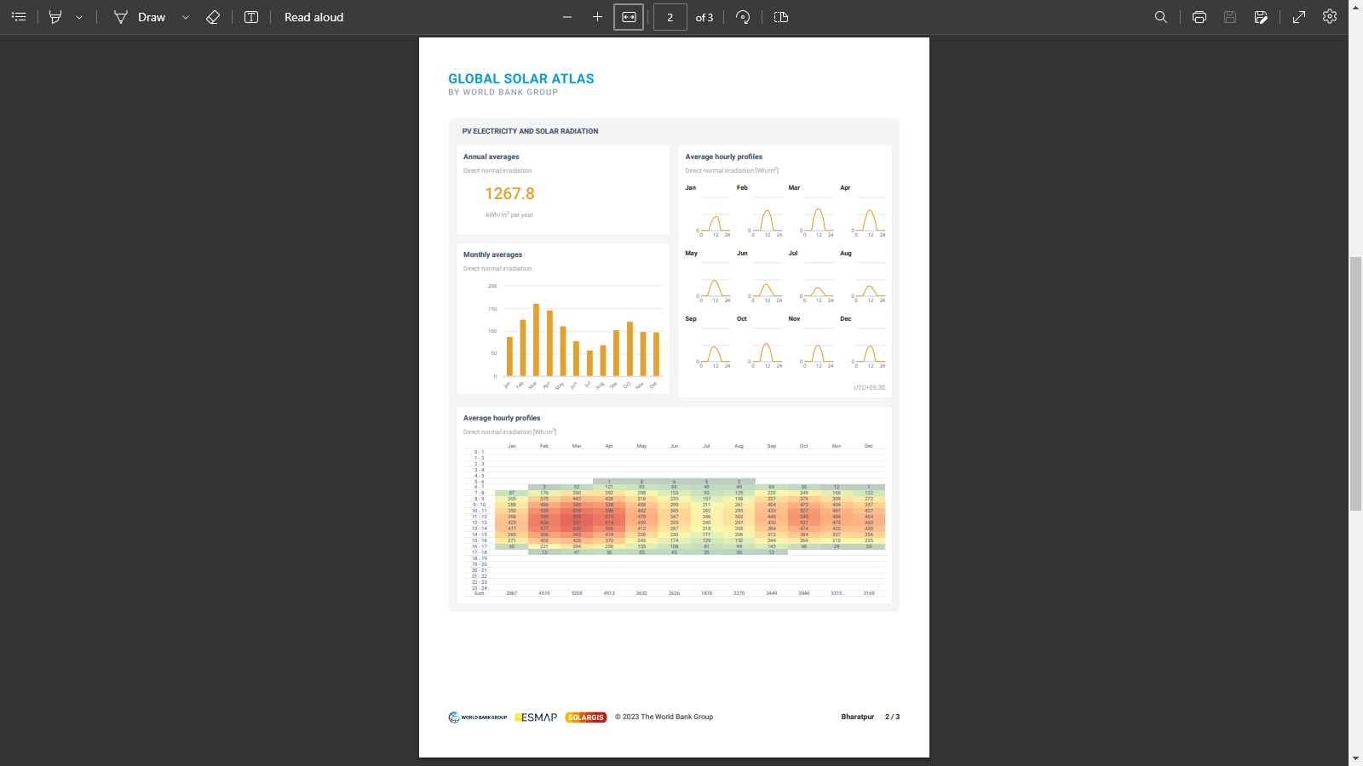

Layout Plans
- Shree Bangur Hospital, Pali
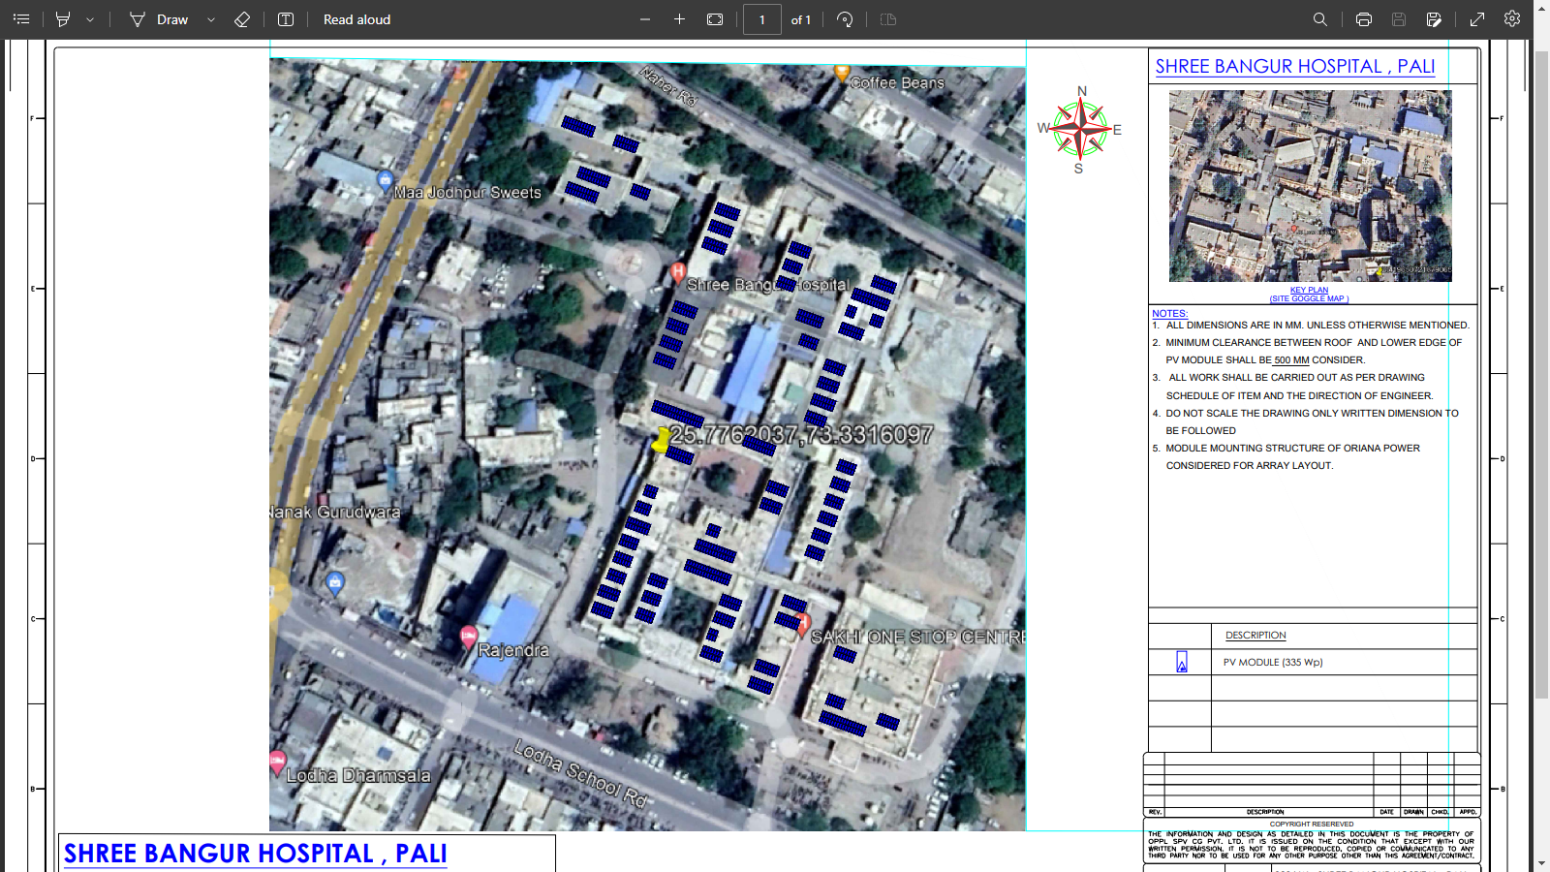

- Govt. Medical College, Pali
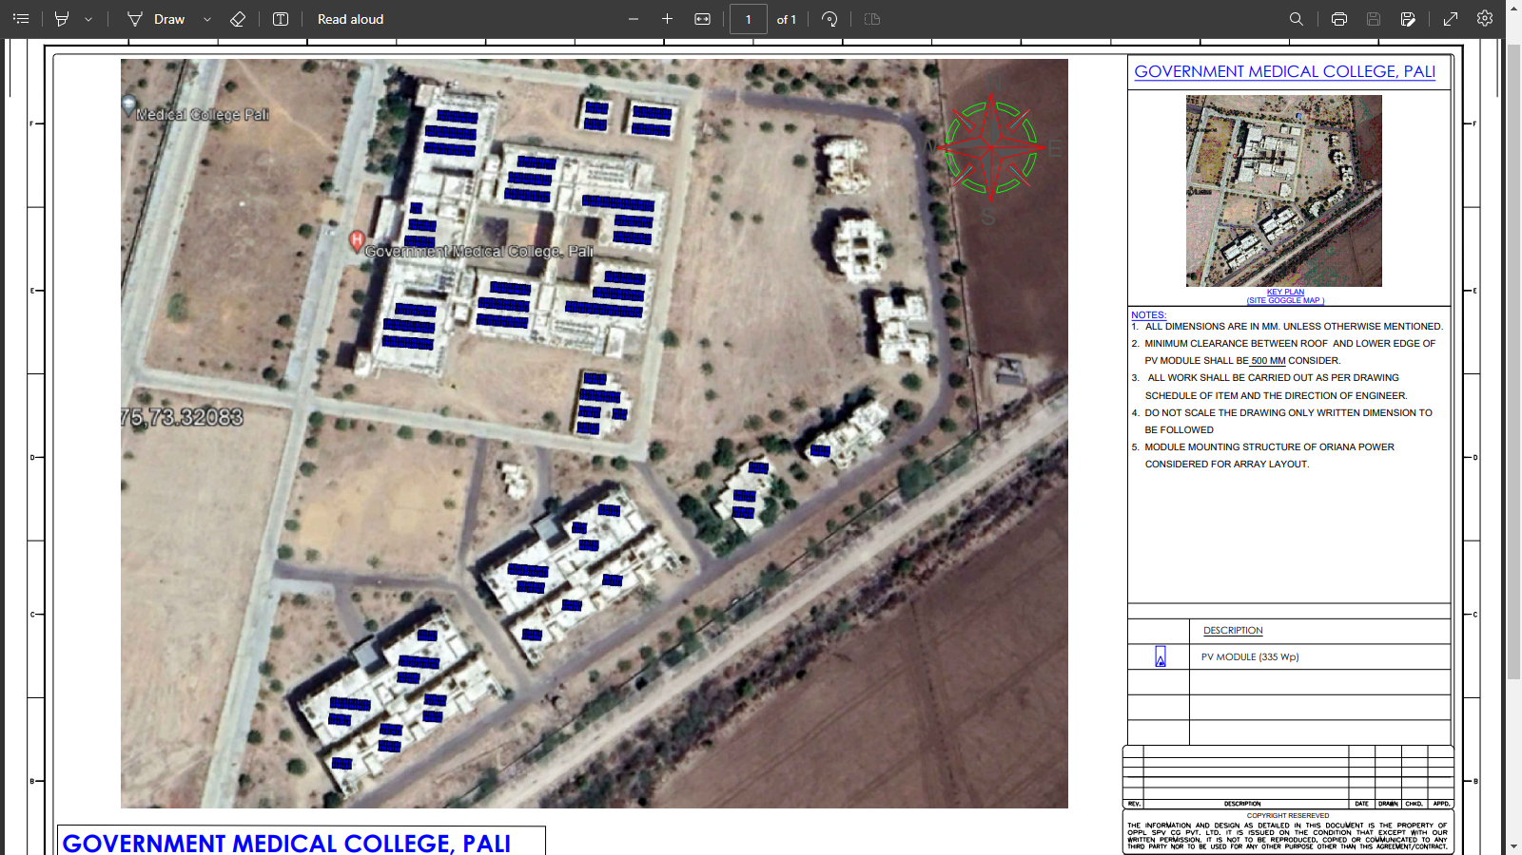

- R.B.M. Govt. Hospital, Bharatpur
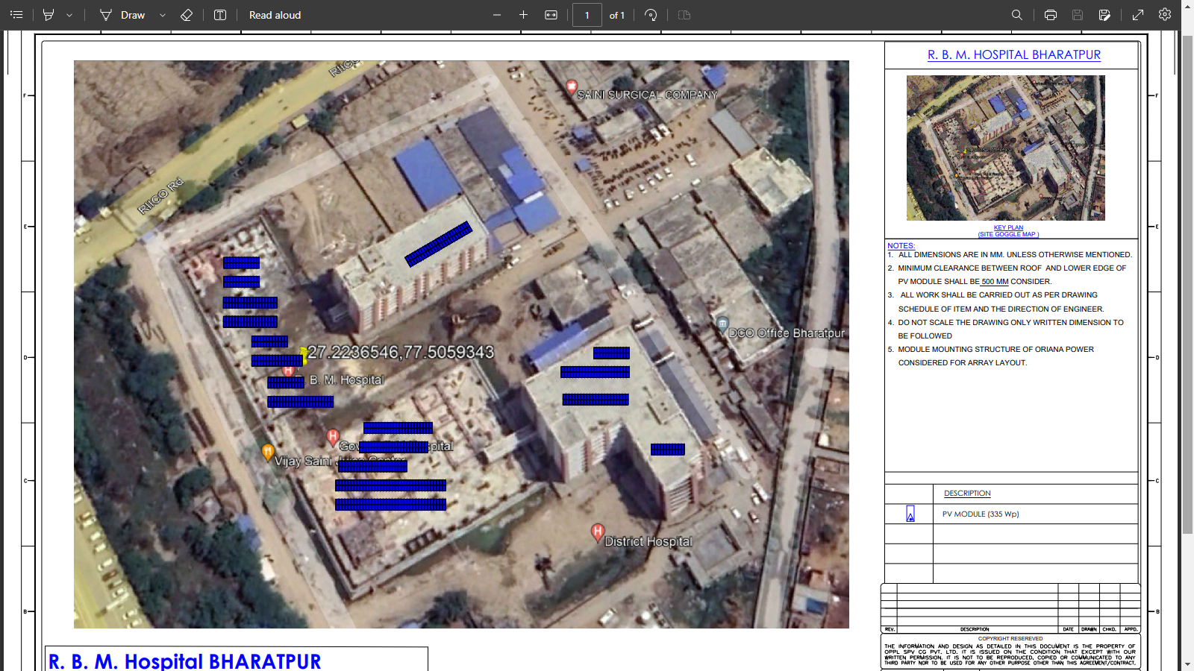

- Janana Hospital, Bharatpur
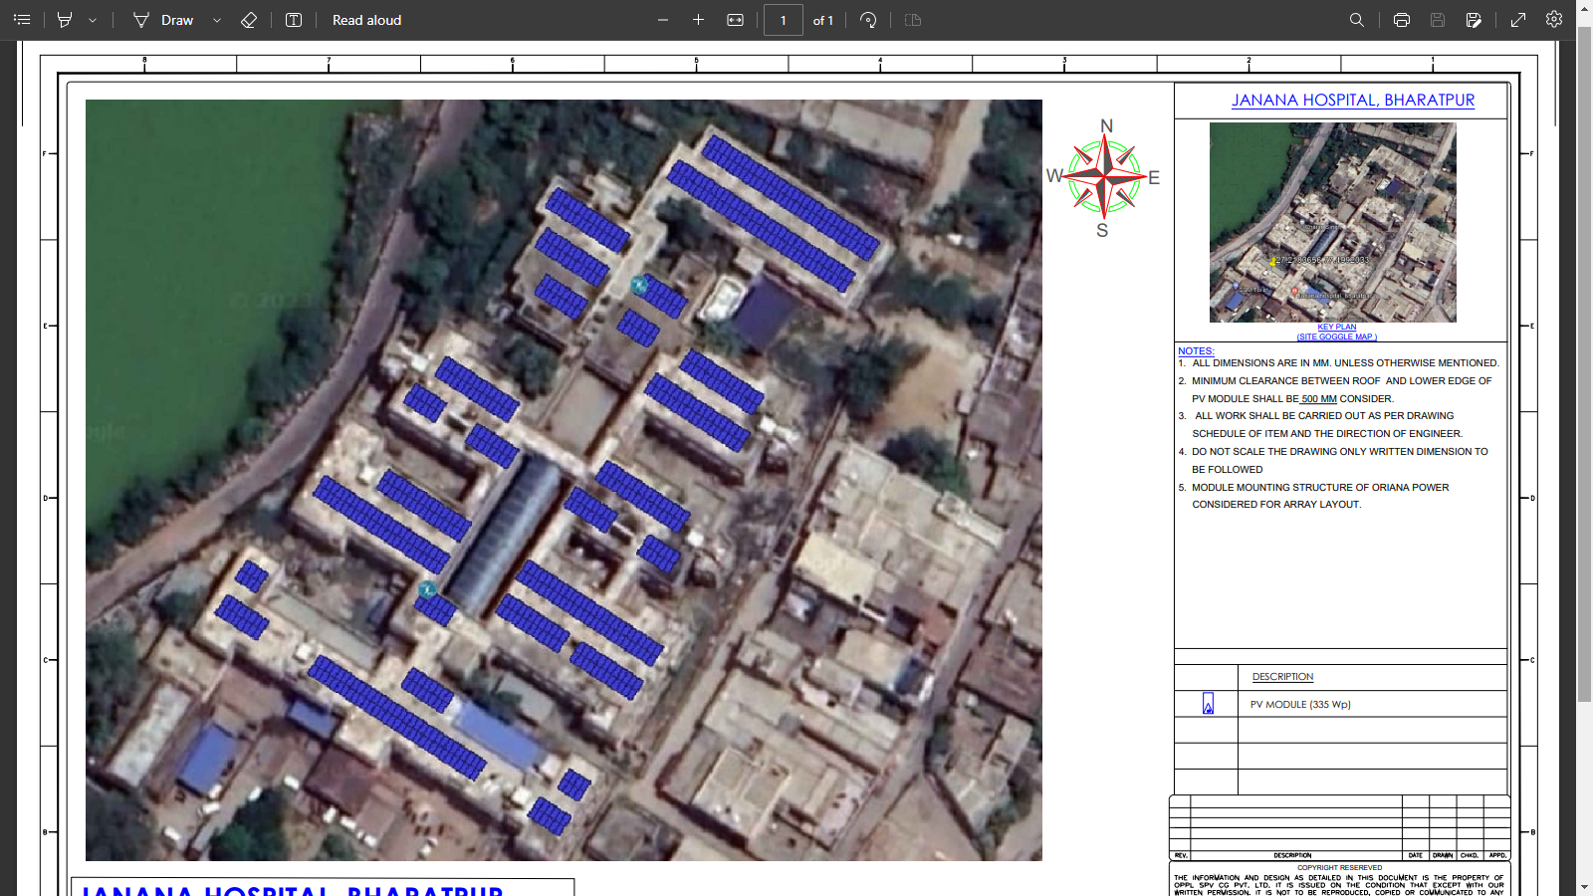

- Govt. Medical College, Bharatpur
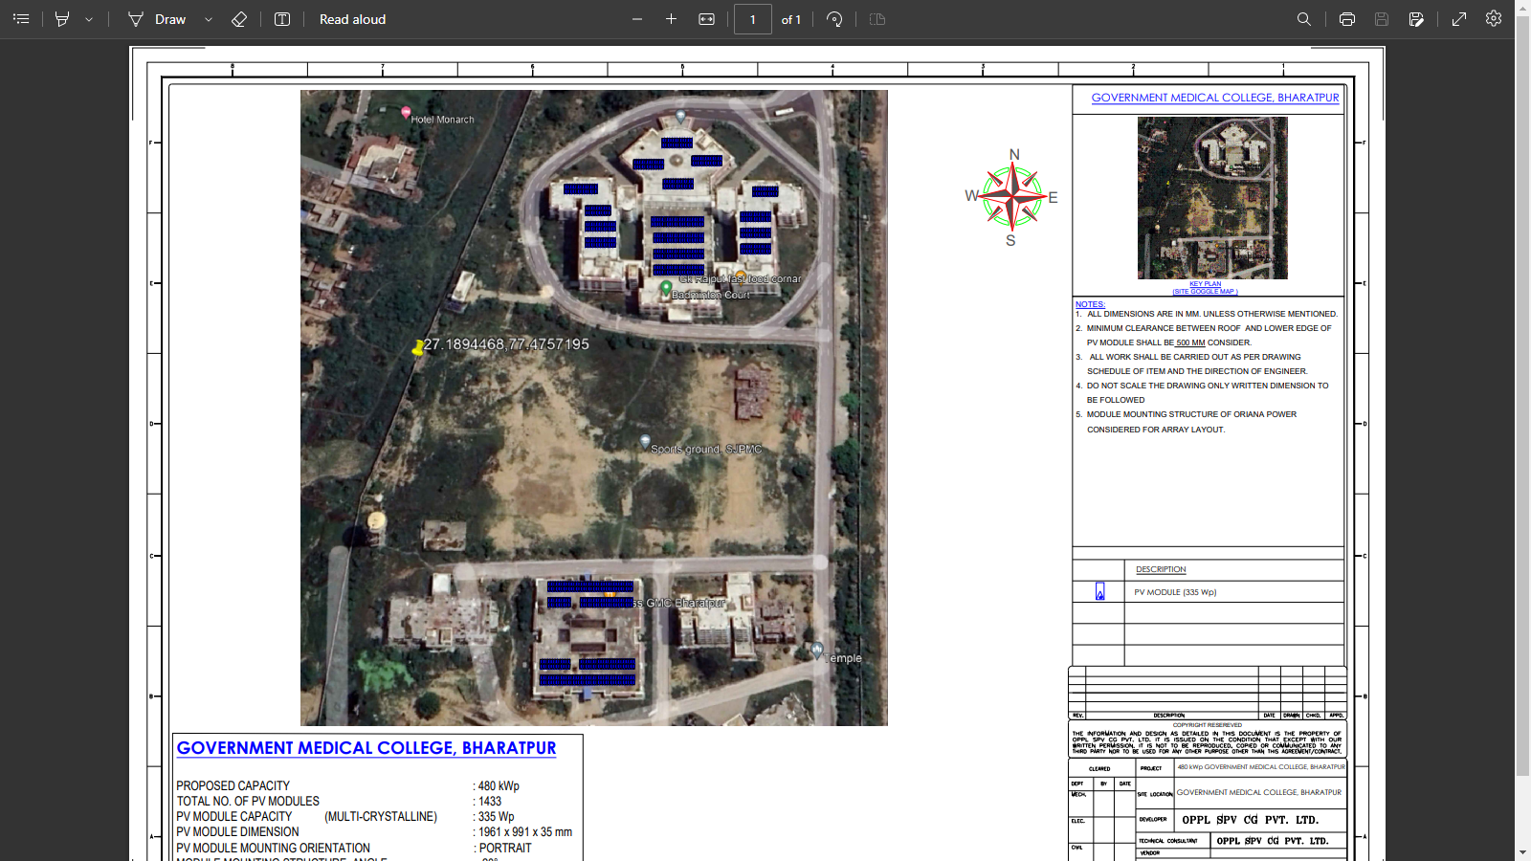
- P.B.M. Hospital, Bikaner
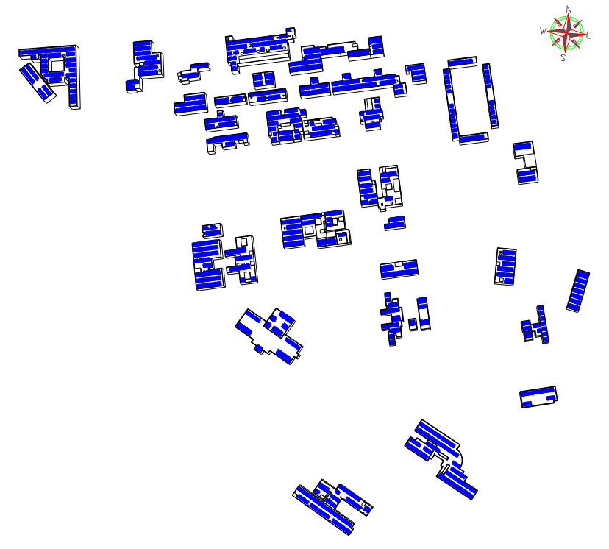
- Sardar Patel Medical College, Bikaner
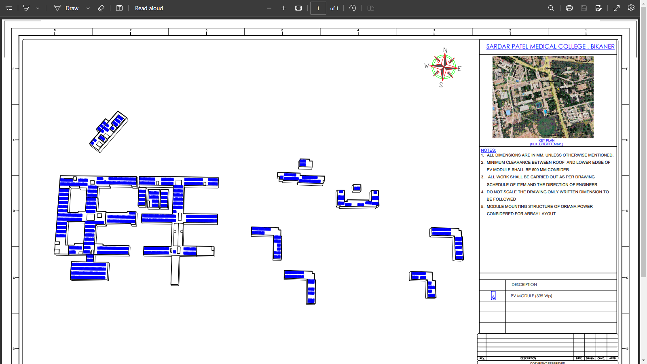

PART J | DISCLAIMER

      - No employee or member of R.K Associates has any direct/ indirect interest in the Project.
      - This report is prepared based on the copies of the documents/ information which the Bank/ Company has provided to us out of the standard checklist of documents sought from them and further based on our assumptions and limiting conditions. All such information provided to us has been relied upon in good faith and we have assumed that it is true and correct in all respect. Verification or cross checking of the documents provided to us has not been done at our end from the originals. If at any time in future, it is found or came to our knowledge that misrepresentation of facts or incomplete or distorted information has been provided to us then this report shall automatically become null & void.
      - This report is a general analysis of the project based on the scope mentioned in the report. This is not an Audit report, Design document, DPR or Techno-financial feasibility study. All the information gathered is based on the facts seen on the site during survey, verbal discussion & documentary evidence provided by the client and is believed that information given by the company is true best of their knowledge.
      - All observations mentioned in the report is only based on the visual observation and the documents/ data/ information provided by the client. No mechanical/ technical tests, measurements or any design review have been performed or carried out from our side during Project assessment.
      - Bank/FII should ONLY take this report as an Advisory document from the Financial/ Chartered Engineering firm and it’s specifically advised to the creditor to cross verify the original documents for the facts mentioned in the report which can be availed from the borrowing company directly.
      - In case of any default in loans or the credit facility extended to the borrowing company, R.K Associates shall not be held responsible for whatsoever reason may be and any request for seeking any explanation from the employee/s of R.K Associates will not be entertained at any instance or situation.
      - This Report is prepared by our competent technical team which includes Engineers and financial experts & analysts.
      - This is just an opinion report and doesn’t hold any binding on anyone. It is requested from the concerned Financial Institution which is using this report for taking financial decision on the project that they should consider all the different associated relevant & related factors also before taking any business decision based on the content of this report.
      - All Pages of the report including annexures are signed and stamped from our office. In case any paper in the report is without stamp & signature then this should not be considered a valid paper issued from this office.
      - Though adequate care has been taken while preparing this report as per its scope, but still we can’t rule out typing, human errors, over sightedness of any information or any other mistakes. Therefore, the concerned organization is advised to satisfy themselves that the report is complete & satisfactory in all respect. Intimation regarding any discrepancy shall be brought into our notice immediately. If no intimation is received within 15 (Fifteen) days in writing from the date of issuance of the report, to rectify these timely, then it shall be considered that the report is complete in all respect and has been accepted by the client upto their satisfaction & use and further to which R.K Associates shall not be held responsible in any manner.
      - Defect Liability Period is 15 DAYS. We request the concerned authorized reader of this report to check the contents, data and calculations in the report within this period and intimate us in writing if any corrections are required or in case of any other concern with the contents or opinion mentioned in the report. Corrections only related to typographical, calculation, spelling mistakes, incorrect data/ figures/ statement will be entertained within the defect liability period. Any new changes for any additional information in already approved report will be regarded as additional work for which additional fees may be charged. No request for any illegitimate change in regard to any facts & figures will be entertained.
      - R.K Associates encourages its customers to give feedback or inform concerns over its services through proper channel at le@rkassociates.org in writing within 30 days of report delivery. After this period no concern/ complaint/ proceedings in connection with the Lender’s Independent Engineering Services will be entertained due to possible change in situation and condition of the subject Project.
      - Our Data retention policy is of ONE YEAR. After this period, we remove all the concerned records related to the assignment from our repository. No clarification or query can be answered after this period due to unavailability of the data.
      - This Lender’s Independent Engineering report is governed by our (1) Internal Policies, Processes & Standard Operating Procedures, (2) Information/ Data/ Inputs given to us by the client and (3) Information/ Data/ Facts given to us by our field/ office technical team. Management of R.K Associates never gives acceptance to any unethical or unprofessional practice which may affect fair, correct & impartial assessment and which is against any prevailing law. In case of any indication of any negligence, default, incorrect, misleading, misrepresentation or distortion of facts in the report then it is the responsibility of the user of this report to immediately or at least within the defect liability period bring all such act into notice of R.K Associates management so that corrective measures can be taken instantly.
      - R.K Associates never releases any report doing alterations or modifications from pen. In case any information/ figure of this report is found altered with pen then this report will automatically become null & void.

Place : Noida  Date : 24.03.2023  Note : This report contains 42 pages | FOR INTERNAL USE  SURVEYED BY: Desktop LIE  PREPARED BY: Adil Afaque  REVIEWED BY: Abhinav Chaturvedi

For R.K Associates Valuers & Techno Engineering Consultants (P) Ltd.

DEFECT LIABILITY PERIOD - In case of any query/ issue or escalation you may please contact Incident Manager by writing at valuers@rkassociates.org. We ensure 100% accuracy in the Calculations done, Rates adopted and various other data points & information mentioned in the report but still can’t rule out typing, human errors or any other mistakes. In case you find any mistake, variation, discrepancy or inaccuracy in any data point of the report, please help us by bringing all such points into our notice in writing at valuers@rkassociates.org within 30 days of the report delivery, to get these rectified timely, failing which R.K Associates Valuers Techno Engineering Consultants (P) Ltd. won’t be held responsible for any inaccuracy in any manner. Also if we will not hear back anything from you within 30 days, we will assume that report is correct in all respect and no further claim of any sort will be entertained thereafter. We would welcome and appreciate your feedback & suggestions in order to improve our services.

COPYRIGHT FORMAT - This report is prepared on the copyright format of R.K Associates Valuers Techno Engineering Consultants (P) Ltd. to serve our clients in the best possible way. Legally no one can copy or distribute this format without prior approval from R.K Associates. It is meant only for the organization as mentioned on the cover page of this report. Distribution or use of this format other than R.K Associates will be seen as unlawful act and necessary legal action can be taken against the defaulter

