**REPORT FORMAT:** CL-1 | Version: 1.0_2018

**VETTING REPORT**

**Case No.: VIS(2022-23)-PL717-602-986 Date: 30-Mar-23**

* ***VETTING OF VALUATION METHODOLOGY***
* ***PREPARED FOR BANK: Bank of India SME, Kolkata***
* ***ASSET TYPE****: Ground Floor with Five Floors of Staff Quarter in an industrial set-up*
* ***ASSET LOCATION****: Garirchak, P.O.- Narghat, P.S.- Nandakumar, District- Purba Medinipur, Pin -721669 West Bengal (As per the copy of documents provided to us)*
* ***PURPOSE OF CERTIFICATE*:** *Vetting the methodology of valuation.*

|  |  |  |
| --- | --- | --- |
| **S. NO.** | **PARTICULARS** | **DESCRIPTION** |
|  | Date of Survey | NA |
|  | Date of Certificate | 30-03-2023 |
|  | Documents provided for perusal | Copy of two number of valuation report prepared by   1. Novara Consultancy Services, Dated-17/11/2022 2. Basudev Dey, Dated- 1/12/2022 |
|  | Location Address where Property is located | Garirchak, P.O.- Narghat, P.S.- Nandakumar, District- Purba Medinipur, Pin -721669 West Bengal (As per the copy of documents provided to us) |
|  | Type of Asset | Industrial land and building |
|  | Scope of Assessment | To comment upon the appropriate methodology adopted by two independent valuers |
|  | Nature of Property | Ground Floor with Five Floors of Staff Quarter in an industrial set-up |

**BACKGROUND:**

As per information and 2 No. of valuation report provided by the bank, subject property is a G+5 storied RCC structure located in aforesaid address being used as staff quarter. Only 2nd and 3rd floor of the subject property was sold to M/s. Rising Tide Ventures Pvt. Ltd. and remaining floors are still under possession/owned by Mr. Ashok Jana. Hence the entire property is owned by two different owners i.e., M/s. Rising Tide Ventures Pvt. Ltd. and Mr. Ashok Jana.

**VALUATION APPROACHES ADOPTED BY THE OTHER VALUERS:**

We have been provided with the copy of two valuation report, details of the same are as follows-

1. Novara Consultancy Services: As per the copy of valuation report dated 17/11/2022, the valuation approach/methodology adopted is sale comparison method, the total area of the subject property is 4778 sq.ft. (2nd Floor & 3rd Floor area) as per the conveyance deed and rate considered is Rs.3,250/- per sq.ft. which includes the rate of both land and building (Rs.1,450/- per sq.ft. for land & Rs.1,800/- per sq.ft. for building). Further a 10% depreciation is taken on the building rate i.e., 10% on Rs.1,800/- per sq.ft. Final rate arrived is Rs.3,070/- per sq.ft. Multiplying the same rate with the total area the final value has been derived.
2. Basudev Dey: As per copy of valuation report dated 01/12/2022, the valuation approach/methodology adopted is Composite Method of Valuation where the land share is proportionately divided between owners of each floor according to the area of the floor. Land area taken 9.5 Decimal/4138.2 decimal as per the conveyance deed and total built-up area is 9,556 sq.ft. and occupied area is 4,778 sq.ft. (2nd Floor & 3rd Floor area). Undivided land share is calculated which comes to be 2,069 sq.ft. / 4.74 Decimal. From the above-mentioned details built-up area and proportionate land area value is fetched through rates of Rs.1,600/- per sq.ft. and Rs. 3,00,000/- per decimal respectively.

**OBSERVATION BY RKA:**

We have been asked to comment on the selling of floors in residential staff quarter in an industrial set-up. The bank has informed us that the whole factory unit is under sale except for the staff quarter floor wise.

In the event of floor sale, the built part, holds Undivided share of land and construction along with the development values and the amenities which the resident of floors enjoys.

In our case we have assumed the salability of such floor in an open market without any restriction. We have received sale deed document mentioning such floors detail, so the methodology of floor sale is appropriate and holds good to assess the valuation of the staff quarter.

The valuation has limitation of the location of the subject property since this is inside the industrial setup. Our assumption that this property is freely accessible. By careful scrutiny of both the report of the aforementioned valuers i.e., Novara Consultancy Services & Basudev Dey, we found the approach of Mr. Basudev Dey Valuer to be near to the floor sale**.**

**Conclusion :**

Based on thefacts, documents presented and our experiencewe are of the opinionthat the valuation report presented by Basudev Dey is much more scientifically proven and technically sound.

***Disclaimer:***

1. *This Certificate is to be referred only for the purpose of the vetting of the provided valuation reports.*
2. *We have not verified any of the rates adopted by the aforementioned valuers.*
3. *The construction cost with CPWD or any of the given authority is not verified.*
4. *We have not verified the comparable available or the valuation of the property.*
5. *This certificate doesn’t include Map, design, and sketch plan in the scope of work.*
6. *This certificate doesn’t include the verification or study of Building Bye-laws and it is assumed that the concerned Architect has made the Plan based on the prescribed building bye-laws of the municipal or development or urban authority of the concerned region.*
7. *Ownership and non-encumbrance legal point of view in respect of the Property are not considered in this report.*
8. *This certificate is made on the request of* ***Bank of India SME, Kolkata***
9. *If this report is prepared for the matter under litigation in any Indian court, no official or employee of R.K Associates will be under any obligation to give in person appearance in the court as a testimony. For any explanation or clarification, only written reply can be submitted on payment of charges by the plaintiff or respondent which will be 10% of the original fees charged where minimum charges will be Rs.5000/-.*

***Annexures:***

1. *Sale Deed.*
2. *Novara Valuation Report.*
3. *Basudev Dey Valuation Report.*

***Annexure 1***

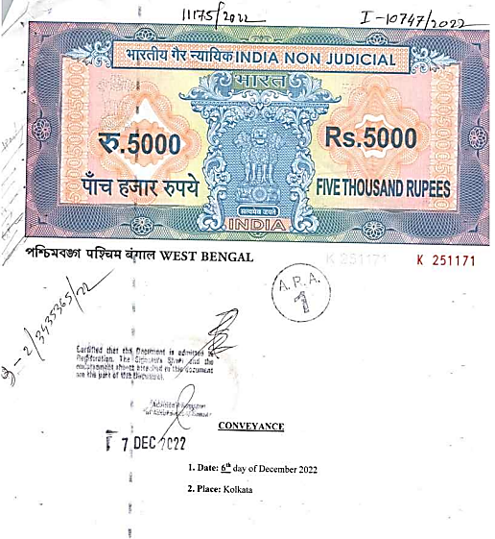

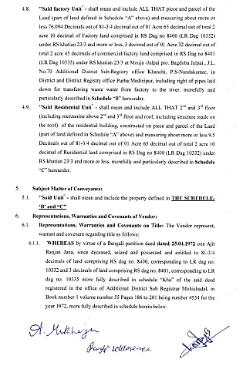

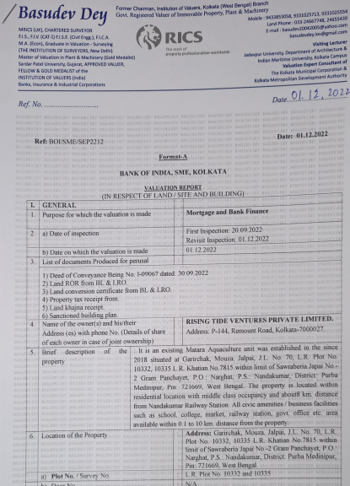

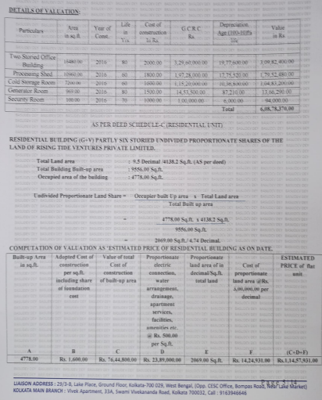

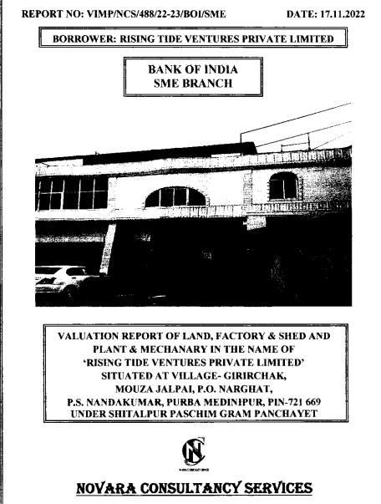

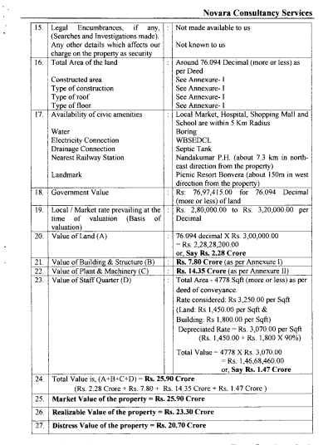

**For R.K Associates Valuers** **& Techno** **FOR INTERNAL USE**

**Engineering Consultants (P) Ltd. *TYPED BY: Er. Arup Banerjee***

***REVIEWED BY: Ashish Sawe***

**(Project Team)**