**REPORT FORMAT:** CL-1 | Version: 1.0_2018

**Case No.: VIS(2022-23)-PL717-602-986 Date: 30-Mar-23**

* ***CERTIFICATE TYPE:*** *Opinion on Valuation Methodology*
* ***PREPARED FOR BANK:*** *Bank of India SME, Kolkata*
* ***ASSET TYPE****: 2nd & 3rd floor of the residential staff quarter in industrial set-up.*
* ***ASSET LOCATION****: Garirchak, P.O.- Narghat, P.S.- Nandakumar, District- Purba Medinipur, Pin -721669 West Bengal (As per the copy of documents provided to us)*
* ***PURPOSE OF CERTIFICATE*:** *Vetting of methodology of other valuation report.*

|  |  |  |
| --- | --- | --- |
| **S. NO.** | **PARTICULARS** | **DESCRIPTION** |
|  | Date of Certificate | 30-03-2023 |
|  | Documents provided for perusal | Copy of two number of valuation report prepared by   1. Novara Consultancy Services, Dated-17/11/2022 2. Basudev Dey, Dated- 1/12/2022 3. Conveyance Deed, Dated- 07/12/2022 |
|  | Location Address where Property is located | Garirchak, P.O.- Narghat, P.S.- Nandakumar, District- Purba Medinipur, Pin -721669 West Bengal (As per the copy of documents provided to us) |
|  | Type of Asset | Residential staff quarter in industrial set-up |
|  | Scope of Assessment | To comment upon the appropriate methodology adopted by two independent valuers |
|  | Nature of Property | 2nd & 3rd floor of the residential staff quarter in industrial set-up |

**VETTING OPINION REPORT**

1. **BACKGROUND:**

This certificate is to give opinion on the methodology of the two valuation certificates for the subject property 2nd & 3rd floor in a G+5 floors residential staff quarter building, situated within premises of factory compound of Rising Tide at Garirchak, P.O.- Narghat, P.S.- Nandakumar, District- Purba Medinipur, Pin -721669 West Bengal.

M/s. Rising Tide Ventures Pvt. Ltd. has purchased this factory premises from Mr. Ashok Jana but Mr. Ashok Jana has retained ground, first, fourth and fifth floors out of the G+5 floors residential staff quarter building in the premises.

Along with other factory premises, only 2nd and 3rd floor of the residential staff quarter was sold to M/s. Rising Tide Ventures Pvt. Ltd.

For the purpose of mortgage, Bank of India has sought 2 valuation reports from the competent valuers, M/s Novara Consultancy Services and Mr. Basudev Dey.

Both the competent valuers have submitted their reports to the Bank for the factory premises portion now owned by M/s Rising Tide Ventures Pvt. Ltd. including 2nd and 3rd floor of the residential staff quarter. Since within the premises only the previous owner still owns a portion of the property ground, first, fourth and fifth floors out of the G+5 floors residential staff quarter building and 2nd & 3rd floor is owned by new owner M/s Rising Tide Ventures Pvt. Ltd., therefore Bank has asked both the valuers to give separate valuation certificate for 2nd & 3rd floor of the G+5 floors residential staff quarter building, which has also been submitted by both the valuers.

Both the valuers have used different approaches for computing the subject valuation of 2nd & 3rd floor in a G+5 floors residential staff quarter building; therefore, Bank has requested M/s R.K Associates to give opinion on the right methodology and approach adopted in both the valuation reports.

1. **VALUATION APPROACHES ADOPTED BY THE OTHER VALUERS:**

We have been provided with the copy of two valuation report, details of the same are as follows-

1. **Novara Consultancy Services:** As per the copy of valuation report dated 17/11/2022, the valuation approach/methodology adopted by the competent valuer is sales comparison method. The total area of the subject property considered in the valuation is 4778 sq.ft. (2nd Floor & 3rd Floor area) as per the conveyance deed and rate considered is Rs.3,250/- per sq.ft. which includes the rate of both land and building (Rs.1,450/- per sq.ft. for land & Rs.1,800/- per sq.ft. for building) compositely. Therefore, it can be derived that the competent valuer has used composite valuation method in which rate of land and building is compositely taken together. Further a 10% depreciation is taken on the building rate i.e., 10% on Rs.1,800/- per sq.ft. Final rate arrived is Rs.3,070/- per sq.ft. Multiplying the same rate with the total area the final value has been derived.

It is also to be noted that the competent valuer above has taken Rs.1,450/- per sq.ft. for land which translates into Rs.6,30,7750/- per decimal. Whereas in his own complete factory report same valuer has adopted Rs.3,00,000/- per decimal rate. It is not clear that why different rates are been taken for the same parcel of land while estimating 2nd Floor & 3rd Floor valuation. It is also not clear that on what basis, final composite rate is taken. Moreover, in the nearby location up to lengths, direct sales comparable for such unit wise or floor wise is not available, therefore in our view composite method using direct sales comparable approach may not be appropriate method.

1. **Sh. Basudev Dey:** As per copy of valuation report dated 01/12/2022, the competent valuer has mentioned in his report to have used Composite Method of Valuation. However, in actual he has computed the valuation of land and building separately.

In Land valuation, competent valuer has proportionately divided land share between owners of each floor according to the area of the floor. Land area taken is 9.5 Decimal/ 4138.2 sq.ft. as per the conveyance deed and total built-up area is 9,556 sq.ft. and occupied area is 4,778 sq.ft. (2nd Floor & 3rd Floor area). As per the valuation report, Undivided land share is calculated which comes to be 2,069 sq.ft. / 4.74 Decimal. Mr. Dey has adopted Rs. 3,00,000/- per decimal for calculating the value of the land and Rs.1,600/- per sq.ft. for the valuation of built-up area.

1. **OBSERVATION BY RKA:**

We have been asked to give opinion on the right methodology and approach adopted in both the valuation reports for the subject property, i.e., 2nd and 3rd floor of the residential staff quarter out of the G+5 floors in an industrial set-up.

Since these residential units are part of the residential staff quarter in an industrial set-up and located in a remote area where at lengths such type of residential towers and units are not present. Therefore the composite comparable rates as such are not available to be adopted as reference.

The next best method is to evaluate it from normal market comparable sales approach for estimating valuation of land and the construction portion through depreciated replacement cost approach method for which more reliable information in terms of land comparables must be available in that area. In such kind of units sale, the built part holds undivided share of land and construction along with the development values and the amenities which the resident of floors enjoys. Mr.Dey’s report has calculated the undivided share of the land for 2nd and 3rd floor and accordingly arrived at the value by calculating it from the prevailing land rates in that area. Mr.Dey has adopted the same rates for the land which he has taken for the factory land which is also right to do since the residential portion is within the premises of the industrial set-up as confirmed to us by the client and therefore the whole land parcel will enjoy the same rates in actual since it is not seperately demarcated but closely part of the industrial setup and large land parcel only. Separate land area in the deed must have been defined only for clarity purpose between the parties but in actual this is still part of the large land parcel.

If these units would have been in a seperately bounded & gated residential society’s tower in a city area where comparable sales rate for a specific similar units would have been available and a relaible information can be formed out of it, then composite rate method would have been a better approach. However the situation is different in the subject case and therefore land & building comparable sales method is better methdology to be adopted.

In Novora consultancy report it is mentioned that the residential portion in the industrial setup is bounded seperately from 3 sides and open towards the road. This point also needs to be corrected from the actual facts of the site since the client has confirmed us contrary to this.

In Mr. Dey’s report, method used has to be correctly mentioned *(land from market sales comparable sales method and building from cost approach)* Vs actually mentioned in the report as *composite Method of Valuation.*

Therefore based on the above analysis, by careful scrutiny of both the report of the aforementioned valuers i.e., Novara Consultancy Services & Basudev Dey, we found the approach of Mr. Basudev Dey Valuer to be more appropriate based on the situation of the property**.**

1. **CONCLUSION:**

Based on thefacts, documents presented and our experiencewe are of the opinionthat the methodoloy/ approach presented in the valuation report of Mr. Basudev Dey is much more scientific and technically sound.

***Disclaimer:***

1. *This Certificate is to be referred only for the purpose of giving our opinion the method provided valuation reports.*
2. *We have not verified any of the rates adopted by the aforementioned valuers.*
3. *We have not verified the comparable available or the valuation of the property.*
4. *The subject property has not been specifically visited by us and the our opinion is only based on the copies of the valuation report presented before us.*
5. *No opinion in regard to ownership or verification or study of Building Bye-laws is given.*
6. *This certificate is made on the request of* ***Bank of India SME, Kolkata.***

***Annexures:***

1. *Sale Deed.*
2. *Novara Valuation Report.*
3. *Basudev Dey Valuation Report.*

***Annexure 1***



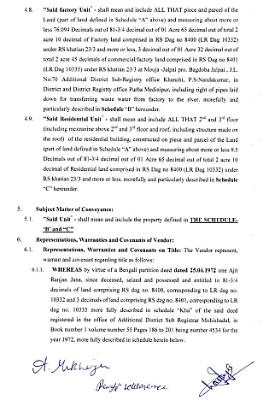

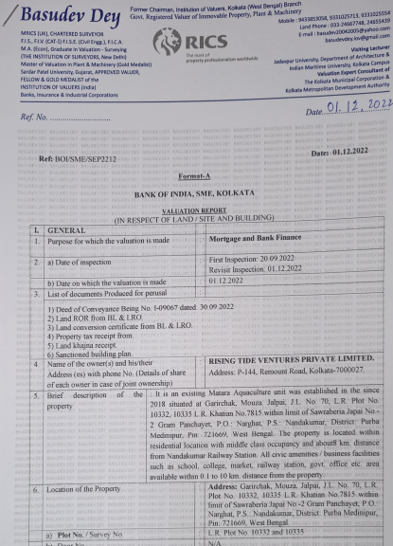

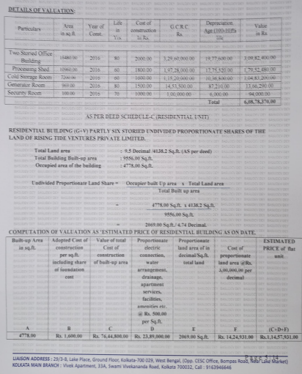

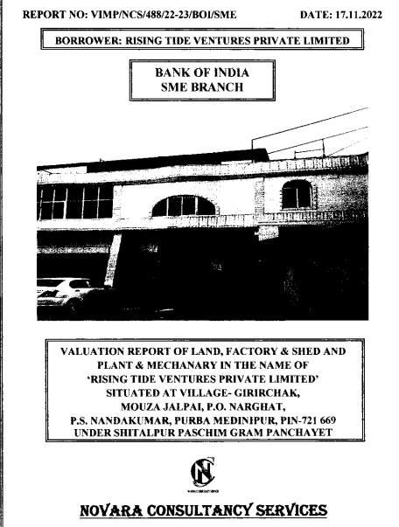

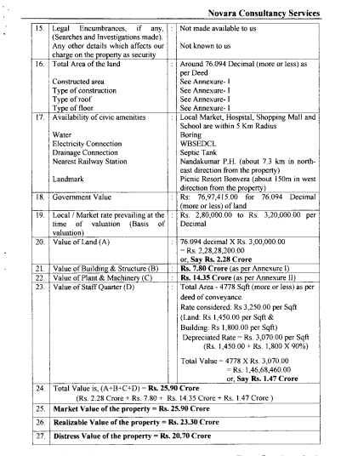

**For R.K Associates Valuers** **& Techno** **FOR INTERNAL USE**

**Engineering Consultants (P) Ltd. *TYPED BY: Er. Arup Banerjee***

***REVIEWED BY: Ashish Sawe***

**(Project Team)**