REPORT FORMAT: CL-1 | Version: 1.0_2018

FILE No.: VIS(2022-23)-PL728-613-1013

- CERTIFICATE NAME: Technical vetting certificate.
- PREPARED FOR ORGANIZATION: Bank of India SME branch, Kolkata.
- BORROWER COMPANY’S NAME: M/s. Rising Tide.
- ASSET TYPE: Machines required for Shrimp processing plant to enhance the capacity of the installed plant from 5000 MTPA OR (24 MTPD) TO 8000 MTPA OR (34 MTPD).
- CURRENT LOCATION OF THE MACHINES: Proposed to be installed Garirchak, P.O-Narghat, P.S.-Nandakumar, District- Purba Medinipur, Pin-721669, West Bengal.

S. NO. | PARTICULARS | DESCRIPTION
 | Date of Work Order | 17-03-2023
 | Documents provided for perusal | Quotations from the market (and list of Machine/Assets to be installed)
 | Project Location | Garirchak, P.O-Narghat, P.S.-Nandakumar, District- Purba Medinipur, Pin-721669, West Bengal.
 | Borrowing Company | M/s. Rising Tide.
 | Type of Asset | Machines required for Shrimp processing plant to enhance the capacity of the installed plant from 5000 MTPA or (24 MTPD) to 8000 MTPA or (34 MTPD).
 | Type of Assessment | Vetting Certificate
 | Scope of Assessment | - Cost Vetting for the Plant & Machinery & Building & Civil works for capacity expansion/ enhancement Project of Shrimp processing plant from current installed capacity 5000 MTPA to 8000 MTPA  - To verify if the adequate power supply is available for installation and running of the proposed new machineries  - To verify if the adequate space is available in the Plant required for the installation of the proposed new machineries  - To check any of the proposed new machineries are same as of existing machines in terms of capacity, type and production.
 | Nature of Plant | For Shrimp processing plant to enhance the capacity of the installed plant from 5000 MTPA or (24 MTPD) to 8000 MTPA or (34 MTPD).
 | Total Project Cost | Rs.15.11 Cr. (Excluding GST) (including supply and installation as per the List/ quotations / invoices / purchase orders provided by the company of machineries and civil works)
 | Comment on Project Cost by consultant | As per our analysis, the cost of expansion of such a shrimp processing plant as proposed by the company will not be less than Rs.15.11 Cr. (Excluding GST). Please refer to PART A for analysis details.
 | Comment on Power supply arrangement for proposed expansion | Power supply arrangement is available for proposed expansion as per our analysis based on the details provided by the client. Please refer to PART B for analysis details.
 | Comment on adequate space availability for proposed expansion | Adequate space is available for the proposed expansion as per our analysis based on the details provided by the client. Please refer to PART C for analysis details.
 | To check any of the proposed new machineries are same as of existing machines in terms of capacity, type and production. | Please refer to PART D
 | Total number of pages with Annexure. | 40

SURVEY ANALYST | VALUATION ENGINEER | L1/ L2 REVIEWER
Rajat Choudhary | Rahul Gupta | Sr.VP Projects

PART A | PROJECT COST VETTING

LIST OF PLANT & MACHINERY AND CIVIL WORKS
S.No. | Machine Name | Quantity | Capacity | Amount By Client (without GST) | Approved Cost | Consultant’s Remarks
Plant & Machinery Details
1 | Plate Freezer along with motors | 2 | 336 slabs & No. of Plates 15 | 1,11,24,900 | 1,11,24,900 | As per industry analysis, cost of the machines appears to be reasonable. In some of the machines cost by the other vendors are quoted even higher than the cost shown by the company. However difference may be due to the fact that this is an expansion Project in which some of the accessories or auxiliary unit required in some of the machines may not be required since this is an expansion Project to existing operating unit.
2 | Blast Freezer | 1 | 4000 Kg per Charge | 72,26,400 | 72,26,400
3 | In Feed Conveyor Belt | 1 |  | 15,25,000 | 15,25,000
4 | ICE Machine | 2 | 30 Ton Per day | 77,50,000 | 77,50,000
5 | Hardner Tunnel for IQF | 1 |  | 23,45,000 | 23,45,000
6 | Glazer and Return Conveyor belt for IQF | 1 |  | 52,50,000 | 52,50,000
7 | Production Automation (Installation and Commissioning ) | 1 |  | 1,14,65,000 | 1,14,65,000
8 | Preprocessing Area Automation | 1 |  | 96,75,000 | 96,75,000
10 | Cold Store Room Automation | 1 |  | 89,65,000 | 89,65,000
11 | Grading Machine | 2 | 2-3 ton shrimp per hour | 1,53,00,000 | 1,53,00,000
12 | Vaccum Tumbler with Washing Machine for IQF Production | 1 | 3 Metric Ton per Hour | 76,75,000 | 76,75,000
13 | Compressor |  |  | 75,00,000 | 75,00,000
14 | Solar Panel Installation on roof top 200 KVA | 1 |  | 95,00,000 | 95,00,000
15 | Diesel Generator set | 2 | 520 KVA | 72,50,000 | 72,50,000
16 | Waste water system |  |  | 55,50,000 | 55,50,000
17 | Shrimps Peeling & Dehading section Up gradation and automation & Conveyor |  |  | 65,00,000 | 65,00,000
 | Total |  |  | 12,46,00,050 | 12,46,00,050

S.No. | Particulars | Area in Sq.ft | Cost per Sq.ft | Total Cost in INR | Approved Cost in INR | Consultant’s Remarks
Building & Civil Works
1 | Labour quarter 3rd and 4th Floor level, 2nd Floor roof quarter, shuttering ROD Binding, casting, Brick Work, Plastering, Door fixing, MS window Putty, Net Cement. | 8250 | 1235 | 1,01,88,750 | 1,01,88,750 | - Rates considered in the cost estimate is within market range.  - However in respect to area measurement we can’t comment due to non-availability of any map or drawing.  - As per item descriptions as planned and present structure on site, like labour quarter 2nd floor roof area is approximately only ~2045 sq.ft so construction of 8250 sq.ft on top of existing structure will not be possible.
2 | Floor Level above ETP & Machine room, Cold Store, Shuttering ROD Binding, Casting, Brick work, Plastering door windows, MS Window, Putty, Net Cement. (With Material) | 9250 | 1235 | 1,14,23,750 | 1,14,23,750
3 | Material Lifting charges, for 3rd and 4 th Floor Level, 2nd Floor roof. | 8250 | 265 | 21,86,250 | 21,86,250
4 | Material Lifting charges for floor level at ETP & Cold Store. | 9250 | 230 | 21,27,500 | 21,27,500
5 | Structure Engineer Fees. |  |  | 5,75,000 | 5,75,000
 | Total |  |  | 2,65,01,250 | 2,65,01,250

OBSERVATIONS:
Plant & Machinery
- We have been provided with the copy of quotations from the market and machines/ equipment to be installed by the borrower company.
- As per the information provided by the company officials these items are planned to be installed at the aforesaid address.
- We have contacted several suppliers for similar items and also enquired in the public domain. Accordingly we have got the quotations from the suppliers and we found that the price given in the list of quotations provided to us is well within the price range of similar items available in the market and seems to be reasonable.
- As per our market research and the quotes received from the machine suppliers, we are of the view that rate range for establishing the machinery with similar specifications for the requirement of enhancement in capacity of Shrimp processing plant and other general machines considered is fine. The turnkey Project cost including civil works may range from Rs. 15.00 Cr to Rs.16.00 Cr. (Excluding GST).
- We have not considered the freight and installation charges of the assets in this cost vetting certificate as it varies with respect to supplier depending upon their location.
- Market quotations for reference are attached in annexure A.

Civil Works:
- For ascertaining the estimated cost of civil works, we have requested for the Building Map and BOQ. However same was not available with the company to provide us.
- Rates considered in the cost estimate is within market range. However in respect to area measurement we can’t comment due to non-availability of any map or drawing.
- Due to unavailability of proposed map, BoQ & specifications, we couldn’t vet the civil works cost but if the area mentioned as planned will be constructed then this is reasonable cost.
- As per item descriptions as planned and present structure on site, like labour quarter 2nd floor roof area is approximately only ~2045 sq.ft so construction of 8250 sq.ft on top of existing structure will not be possible.
- Our Engineer has visited the site and has observed new construction as attached below. However, as per discussion with M/s Rising Tide management team some more structures are planned for construction on the plant site.
S.No | Block and Building Name | Floor | Floor Height | Year of construction | Type of construction | Structure Progress | Area in Sq.ft
 | Generator DG Section | Ground | 4.15 mtr | 2023 | RCC roof | Work in Progress | 1,638
 | Generator DG Section | First | 3.2 mtr | 2023 | Tin shed and brick wall | Work in Progress | 1,638
 | Construction Over Labour Quarter | Top Floor | 2.5 mtr | 2023 | Tin shed and brick wall | Completed | 1,334
 | Construction above factory | Top Floor | 2.822 mtr | 2023 | Tin shed and brick wall | Completed | 919
 | Construction above factory | Top Floor | 2.9 mtr | 2023 | Tin shed and brick wall | Completed | 280
 | Construction above factory | Top Floor | 2.9 mtr | 2023 | Tin shed and brick wall | Completed | 1,674
 | Security Guard Room | Ground | 2.74 mtr | 2023 | Tin shed and brick wall | Completed | 69
 | Total |  |  |  |  |  | 7,553

Special Notes:
  - We can’t comment about the current status of machines whether these are purchased, installed or in transit. This cost vetting is done only on the basis of Quotations, Bills and Purchase Orders provided to us by the company and we don’t recommend any sort of recommendation in our Certificate.
  - The estimated cost verification of item to item can’t exactly match as per our vetting due to several market consideration. In some of the items it is lower while in some of the items price comes to be higher but on an average the price as per list provided to us falls in the range as confirmed by us.
  - There can be variation in the estimated price if the specification & make of any items procured is different from the list provided to us during assessment.
  - The estimated cost verification is made based on the third-party information which has been relied upon in good faith.
  - The estimated price may vary at the time of actual procurement because of change in prices in the market for such kind of machinery/items for which we will not have any control. The cost vetting is only limited to the date of Certificate issued. We do not assume any responsibility in change of prices of the said machinery/items after this date.
  - This certificate doesn’t include any work related to drawing, design, sketch plan, procurement of the machines.
  - Ownership and other legal point of view in respect of the asset is not considered in this report as same is out of scope of this certificate.
  - This certificate is made at the request of the Bank.

PART B | VERIFICATION OF THE ADEQUACY POWER SUPPLY FOR EXPANSION

S.No. | Particulars | Capacity
 | Present Electricity connection Contract demand | 900 KVA
 | Load Capacity of Existing unit | 519 KW
 | Load description per KVA as per Bills | Bill Date | Normal | Peak | Off-Peak
 |  | 03/10/2022 | 444 | 501 | 456
 |  | 04/11/2022 | 478 | 486 | 452
 |  | 02/12/2022 | 474 | 471 | 431
 |  | 02/02/2023 | 435 | 419 | 425
 |  | 03/03/2023 | 396 | 363 | 168
 | Proposed after expansion (including existing) | 796 KW
 | Transformer capacity (As per information provided) | 1250 KVA

NOTES:
- As per our analysis and the details provided by the client, Plant is already having electricity connection of 900 KVA which is visible as per the copies of the electricity Bills provided.
- Presently as per the list provided, machines are of rated capacity of 519 KW when the Plant is at 5000 ton per annum.
- Now company is expanding the capacity from 5000 ton per annum or (24 TPD) to 8000 ton per annum or (34) TPD which is 60% enhancement in the existing capacity.
- As per the list provided by the company, Rated capacity of the machines after proposed expansion is 796 KW. If we go by simple calculation of increasing the power consumption as per percentage of capacity augmentation then it will come out to be 830.4 KW, whereas as per the data given by the company is 798 KW which is also ~54% enhancement in power consumption.
- Company is already having 900 KVA power connection and 1250 KVA of transformer (more than the proposed power consumption after capacity enhancement).
- In case anytime the power load crosses, 900 KVA then company may have to seek additional load from the electricity department. In case anytime load crosses 1250 KVA then additional power infrastructure including transformer and LT/ HT infrastructure has to be augmented.
- For the assessment, Electricity Bill and Machines rated power consumption letter is referred which is also annexed in Annexure B.
- Therefore, from the above analysis it appears that the company is having adequate power infrastructure for the proposed expansion.
PART C | VERIFICATION OF THE ADEQUATE SPACE AVAILABLITY FOR EXPANSION

S.No. | Machine Name | Quantity | Location to be installed | Remarks
1 | Plate Freezer along with motors | 2 | Main Shed | Purchased and Installation under progress.
2 | Blast Freezer | 1 | Main Shed | Space available
3 | In Feed Conveyor Belt | 1 | Main Shed | Space available. Currently used crates will be replaced by conveyors.
4 | ICE Machine | 2 | Near Flake Machine Room | Space available
5 | Hardener Tunnel for IQF | 1 | Main Shed | Space available
6 | Glazer and Return Conveyor belt for IQF | 1 | Main Shed | Space available
7 | Production Automation (Installation and Commissioning ) | 1 | Main Shed | Space available. Currently used crates will be replaced by conveyors.
8 | Preprocessing Area Automation | 1 | Main Shed | Space available. Currently used crates will be replaced by conveyors.
10 | Cold Store Room Automation | 1 | Main Shed | Space available. Currently used crates will be replaced by conveyors.
11 | Grading Machine | 2 | Main Shed | Already installed at site.
12 | Vaccum Tumbler with Washing Machine for IQF Production | 1 | Main Shed | Already installed at site.
13 | Compressor |  | Above DG Room | New construction is done for this to accommodate this machine.
14 | Solar Panel Installation on roof top 200 KVA | 1 | To be installed on roof. | For 200 KVA roof top solar panels, around ~12000 sq.ft roof area will be required. The plant have much more space is available on its shed roof. However we can’t comment on the stability of the shed structure to bear the weight/load of the panels.
15 | Diesel Generator set | 2 | New room is under construction | New room is under construction
16 | Waste water system |  | Near Existing ETP | Not Purchased Yet
17 | Shrimps Peeling & Dehading section Up gradation and automation & Conveyor |  | Main Shed | Space available. Currently used crates will be replaced by conveyors.

Note:
- To ascertain the space availability of the expansion, we have requested machine layout of the plant from the company. However, same was not available & provided.
- During the site inspection, our engineer with the help of the company’s representative, has drawn the sketch for the location of the machines which is attached below, for which we have ascertained that which machine will be placed where and if the adequate space is available for the same or not.
- During the site visit it was observed that the construction work was going on for the setup and installation of the proposed new machines at site.
- As per site visit, some of the proposed machineries was installed at site and some machines was laying in the packed condition.
- The construction of the Generator section room for the installation of DG set and compressor was under progress. The ground floor RCC work was completed and 1st floor tin shed work was in completion stage in G+1 structure. The DG set was laying in packed condition.
- The cold storage extension area with puff panel construction work was not started yet. However adequate space is available on site for construction.
- For the automation, conveyor system is purchased which will replace the current crate system with the conveyors.
PROPOSED MACHINERY INSTALLATION LOCATION

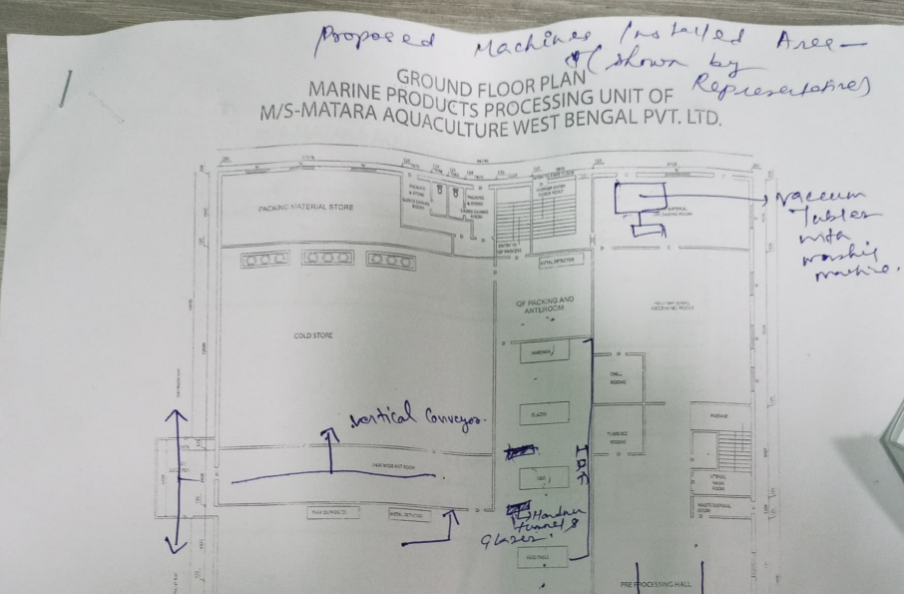
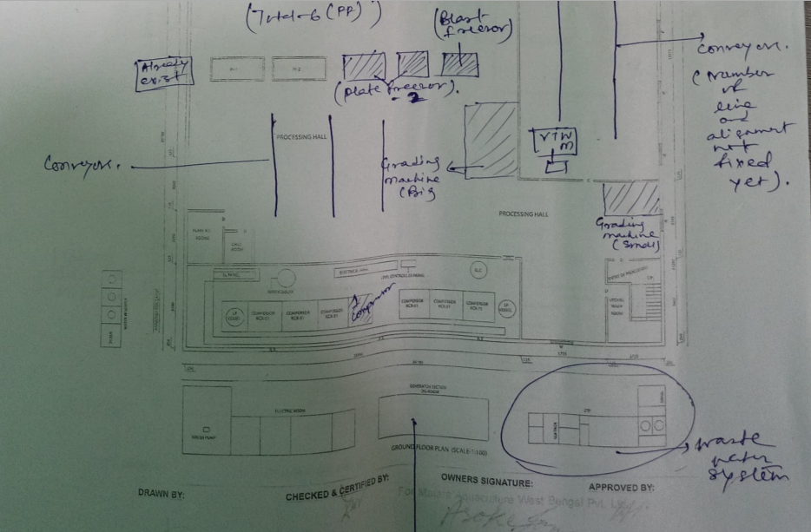

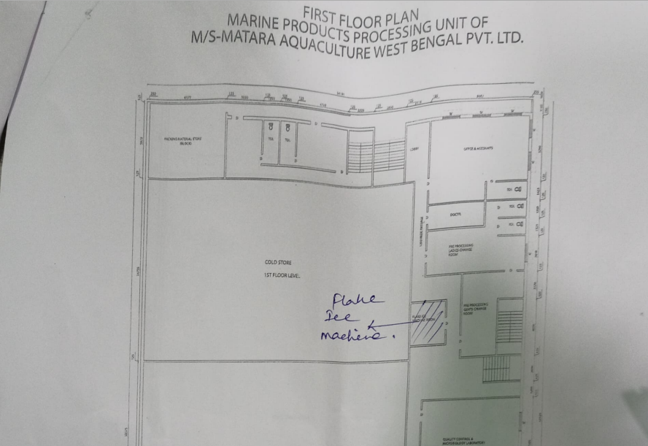
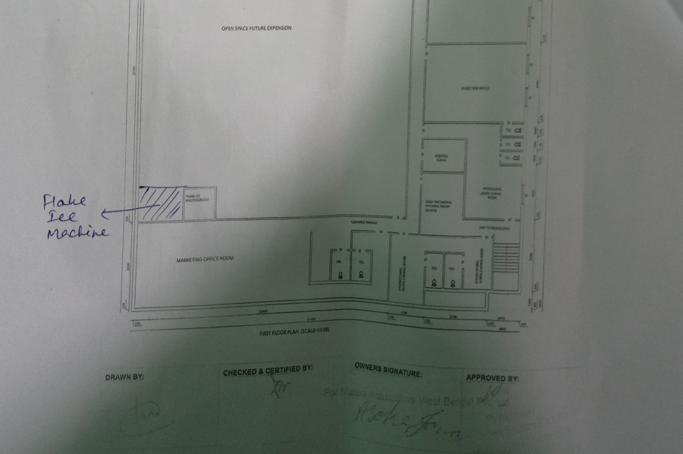

PART D | TO CHECK ANY OF THE PROPOSED NEW MACHINERIES ARE SAME AS OF EXISTING MACHINES IN TERMS OF CAPACITY, TYPE AND PRODUCTION

For the purpose of checking if any of the proposed new machineries are same as of existing machines in terms of capacity, type and production, our engineer has conducted the site inspection and compared the proposed new machineries list with the existing machines in terms of capacity, type and production.
We have observed that the company has installed and purchased some of the proposed machineries mentioned in the list provided to us for the enhancement of its current capacity. In the below list we have compared the new proposed machine from the existing machines to cover this point.
 | EXISTING MACHINES |  | PROPOSED MACHINES
S.No | Existing Machines | Supplier Name Existing | Proposed Machines | Supplier Name Proposed | Specifications Proposed
 | Pump | Hermetic Pumps Singapore Pte Ltd | - | - | -
 | Pump | Hermetic Pumps Singapore Pte Ltd | - | - | -
 | Compressor | Kirloskar Pnuematic Company Ltd | - | - | -
 | Compressor | Kirloskar Pnuematic Company Ltd | Compressor KCX 72 and KCX 42 | KR Refrigeration | Maximum discharge pressure 84 bar
 | Compressor | Kirloskar Pnuematic Company Ltd | - | - | -
 | Compressor | Kirloskar Pnuematic Company Ltd | - | - | -
 | Compressor | Kirloskar Pnuematic Company Ltd | - | - | -
 | Compressor | Kirloskar Pnuematic Company Ltd | - | - | -
 | Kirloskar Motor | Industrial Motor & Cable Co | - | - | -
 | Seamless Pipe | Shakti Refregeration ( Kolkata ) | - | - | -
 | Seamless Pipe | Shakti Refregeration ( Kolkata ) | - | - | -
 | Weight Machine | ISHIDA INDIA PVT LTD | - | - | -
 | Weight Machine | ISHIDA INDIA PVT LTD | - | - | -
 | Software Develop | ISHIDA INDIA PVT LTD | - | - | -
 | WEIGHT MACHINE | THE SOUTH POINT | - | - | -
 | WEIGHT MACHINE | THE SOUTH POINT | - | - | -
 | WEIGHT MACHINE | THE SOUTH POINT | - | - | -
 | CAMERA | TECHNO SOLUTIONS | - | - | -
 | CAMERA | TECHNO SOLUTIONS | - | - | -
 | CAMERA | TECHNO SOLUTIONS | - | - | -
 | CAMERA | TECHNO SOLUTIONS | - | - | -
 | CAMERA | TECHNO SOLUTIONS | - | - | -
 | CAMERA | TECHNOSOFT COMPUTER SOLUTIONS | - | - | -
 | CAMERA | TECHNOSOFT COMPUTER SOLUTIONS | - | - | -
 | CAMERA | TECHNOSOFT COMPUTER SOLUTIONS | - | - | -
 | CAMERA | TECHNOSOFT COMPUTER SOLUTIONS | - | - | -
 | CAMERA | TECHNOSOFT COMPUTER SOLUTIONS | - | - | -
 | CAMERA | TECHNOSOFT COMPUTER SOLUTIONS | - | - | -
 | CAMERA | TECHNOSOFT COMPUTER SOLUTIONS | - | - | -
 | CAMERA | TECHNOSOFT COMPUTER SOLUTIONS | - | - | -
 | CAMERA | TECHNOSOFT COMPUTER SOLUTIONS | - | - | -
 | CAMERA | TECHNOSOFT COMPUTER SOLUTIONS | - | - | -
 | CAMERA | TECHNOSOFT COMPUTER SOLUTIONS | - | - | -
 | Sheet | Ratilal Brothers | - | - | -
 | Valve | Super Sales India | - | - | -
 | Locker | Punjab Safe & Electoronics | - | - | -
 | AC | ROHIT REFREIGERATION | - | - | -
 | AC | NEW EDGE REALITY SOLUTIONS | - | - | -
 | AC | KHOSLA ELECTRONICS | - | - | -
 | AC | SALES Emporium | - | - | -
 | BUNDER BED | SENCO HOSPITAL SUPPLY & COMPAN | - | - | -
 | FURNITURE - TABLE | RAJ & RAJ | - | - | -
 | FURNITURE - CHAIR | STEELCO FURNITURE PVT LTD | - | - | -
 | FURNITURE - TABLE | STEELCO FURNITURE PVT LTD | - | - | -
 |  | A ONE SCIENTIFIC EQUIPMENT | - | - | -
 | PIPE | ANNAPURNA TAKE & TUBES | - | - | -
 | PIPE | ANNAPURNA TAKE & TUBES | - | - | -
 | ICE Box 100 Ltr | Nilkamal | - | - | -
 | crate & syntax | Nilkamal | - | - | -
 | crate & syntax | Nilkamal | - | - | -
 | crate & syntax | Nilkamal | - | - | -
 | crate & syntax | Nilkamal | - | - | -
 | crate & syntax | Nilkamal | - | - | -
 | crate & syntax | Nilkamal | - | - | -
 | Water Treatment | Watreat Engineers | - | - | -
 | Water Treatment | Watreat Engineers | - | - | -
 | ETP System | Watreat Engineers | - | - | -
 | ETP System | Watreat Engineers | Waste water system | KR Refrigeration
 | Metal Detector | SMMS Engineering Systems Pvt Ltd | - | - | -
 | Depanning Conveyour with  Accessories | Jeya Industries and Engineering Pvt Lt | Different Types of Conveyors | KR Refrigeration | 40 mtr Long overall
 | Socket & Bearing | Jeya Industries and Engineering Pvt Lt | - | - | -
 | Socket & Bearing | Jeya Industries and Engineering Pvt Lt | - | - | -
 | Labour Charge | Jeya Industries and Engineering Pvt Lt | - | - | -
 | Evaporative Condensor | KR Refregeration | - | - | -
 | Evaporative Condensor | KR Refregeration | - | - | -
 | Evaporative Condensor | KR Refregeration | - | - | -
 | INSTALLATION & COMM | KR Refregeration | - | - | -
 | Grading Machine | KR Refregeration | Grading Machine | KR Refrigeration | 2-3 Ton shrimp per hour
 | Plate Freezer | KR Refregeration LLP | Plate Freezer | KR Refrigeration | 336 slabs and 15 Nos Plates
 | Plate Freezer | KR Refregeration LLP | - | - | -
 | Plate Freezer | KR Refregeration LLP | - | - | -
 | Plate Freezer | KR Refregeration LLP | - | - | -
 | Erection & comm | KR Refregeration LLP | - | - | -
 | IQF | Ramtech Refregeration Pvt ltd | Blast Freezer | KR Refrigeration | 4000 kg per charge
 | PLC ELECTRIC PAN | Ramtech Refregeration Pvt ltd | Cold Store Room Automation | KR Refrigeration | 31240 No. of boxes and 10 No. stacking on each floor
 | Insulated Puff Pa | Ramtech Refregeration Pvt ltd | Vaccum Tumbler with Washing Machine for IQF Production | KR Refrigeration | 3 Metric Ton per hour
 | Glazer & Air Defr | Ramtech Refregeration Pvt ltd | Glazer and Return Conveyor belt for IQF | KR Refrigeration | Return conveyor 5 mtr
 | Errection & comm | Ramtech Refregeration Pvt ltd | - | - | -
 | Air Defrosting Sys | Ramtech Refregeration Pvt ltd | - | - | -
 | PLC TOUCH PANE | Ramtech Refregeration Pvt ltd | - | - | -
 | Feeding Conveyo | Ramtech Refregeration Pvt ltd | - | - | -
 | Puff Panel | Rinac Engineering Evolution | - | - | -
 | Puff Panel | Rinac Engineering Evolution | - | - | -
 | Puff Panel | Rinac Engineering Evolution | - | - | -
 | Puff Panel | Rinac Engineering Evolution | - | - | -
 | Puff Panel | Rinac Engineering Evolution | - | - | -
 | Puff Panel | Rinac Engineering Evolution | - | - | -
 | Puff Panel, Refreg | Rinac Engineering Evolution | - | - | -
 | Installation | Rinac Engineering Evolution | - | - | -
 | Installation | Rinac Engineering Evolution | - | - | -
 | Drain Heater | Rinac Engineering Evolution | - | - | -
 | SS TABLE | Thankachen George Engineering Work | - | - | -
 | Weight Table | Thankachen George Engineering Work | - | - | -
 | Tray | Thankachen George Engineering Work | - | - | -
 | SS TABLE | Thankachen George Engineering Work | - | - | -
 | SS Foot Rest | Thankachen George Engineering Work | - | - | -
 | Tray | Thankachen George Engineering Work | - | - | -
 | Tray | Thankachen George Engineering Work | - | - | -
 | Electrical Panel | TSR Enterprise | - | - | -
 | Electrical Panel | TSR Enterprise | - | - | -
 | Electrical work | Chakraborty Electricals Pvt. Ltd. | - | - | -
 | Transformer | Power Control Nigam | - | - | -
 | SD | WBSEDCL | - | - | -
 | Expense | WBSEDCL | - | - | -
 | SD | WBSEDCL | - | - | -
 | Laboratory Items | Universal Laboratory Equipments | - | - | -
 | Laboratory Items | Universal Laboratory Equipments | - | - | -
 | Laboratory Items | Universal Laboratory Equipments | - | - | -
 | Laboratory Items | Universal Laboratory Equipments | - | - | -
 | Laboratory Items | Universal Laboratory Equipments | - | - | -
 | Laboratory Items | Universal Laboratory Equipments | - | - | -
 | Laboratory Items | Universal Laboratory Equipments | - | - | -
 | Laboratory Items | Universal Laboratory Equipments | - | - | -
 | Laboratory Items | Universal Laboratory Equipments | - | - | -
 | Laboratory Items | Universal Laboratory Equipments | - | - | -
 | Flake Ice Machine | Patils Industries & Refrigeration | Ice Machine | KR Refrigeration | 30 Ton per Day
 | Flake Ice Machine | Patils Industries & Refrigeration | - | - | -
 | Flake Ice Machine | Flake Ice & Refrigeration Systems Pvt Ltd. | - | - | -
 | - | - | Hardner Tunnel for IQF | KR Refrigeration | -
 | - | - | Production Automation (Installation and Commissioning ) | KR Refrigeration | -
 | - | - | Preprocessing Area Automation | KR Refrigeration | -
 | - | - | Cold Store Room Automation | KR Refrigeration | -
 | - | - | Solar Panel Installation on roof top | KR Refrigeration | 200 KVA
 | - | - | Diesel Generator set | KR Refrigeration | 500 KVA

SURVEY ANALYST | VALUATION ENGINEER | L1/ L2 REVIEWER
Rajat Choudhary | Rahul Gupta | Sr.VP Projects

DISCLAIMERS

- The client/ owner and its management/ representatives warranted to us that the information they have supplied was complete, accurate and true and correct to the best of their knowledge. All such information provided to us either verbally, in writing or through documents has been relied upon in good faith and we have assumed that it is true & correct without any fabrication or misrepresentation. I/We shall not be held liable for any loss, damages, cost or expenses arising from fraudulent acts, misrepresentations, or willful default on part of the owner, company, its directors, employee, representative or agents.
- Legal aspects for eg. Investigation of title, ownership rights, lien, charge, mortgage, lease, sanctioned maps, and verification of documents provided to us such as title documents, Map, etc. from any concerned Govt. office etc. have to be taken care by legal expert/ Advocate and same is not done at our end. I/ We assume no responsibility for the legal matters including, but not limited to, legal or title concerns.
- Wherever any details are mentioned in the report in relation to any legal aspect of the property such as name of the owner, leases, etc. is only for illustration purpose and should not be construed as a professional opinion. Legal aspects are out of scope of this report. Details mentioned related to legal aspect are only based on the copy of the documents provided to us and whatever we can interpret as a non-legally trained person. This should be cross validated with a legal expert. We do not vouch any responsibility regarding the same.
- We have relied on the data from third party, external sources & information available on public domain to conclude the valuation. These sources are believed to be reliable and therefore, we assume no liability for the truth or accuracy of any data, opinions or estimates furnished by others that have been used in this analysis. Where we have relied on the data, opinions or estimates from external sources, reasonable care has been taken to ensure that such data is extracted from authentic sources, however we still can’t vouch its authenticity, correctness, or accuracy.
- Documents, information, data including title deeds provided to us during the course of this assessment by the client is reviewed only upto the extent required in relation to the scope of the work. No document has been reviewed beyond the scope of the work. These are not reviewed in terms of legal rights for which we do not have expertise. Wherever any information mentioned in this report is mentioned from the documents like owners name, etc., it is only for illustration purpose and may not necessary represent accuracy.

PART A - ANNEXURE

PROPOSED AND CURRENT CAPACITY

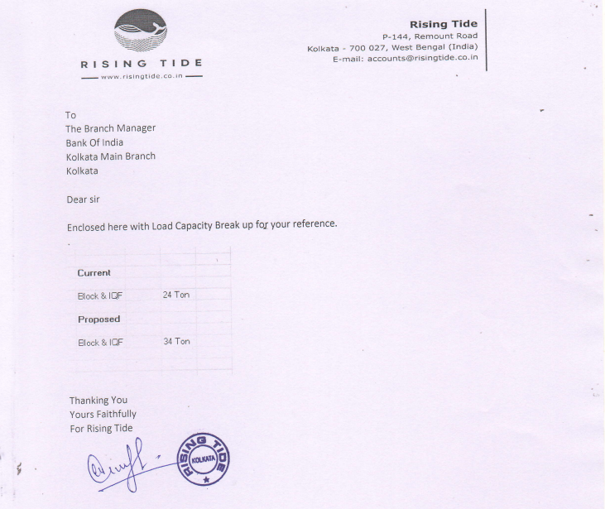
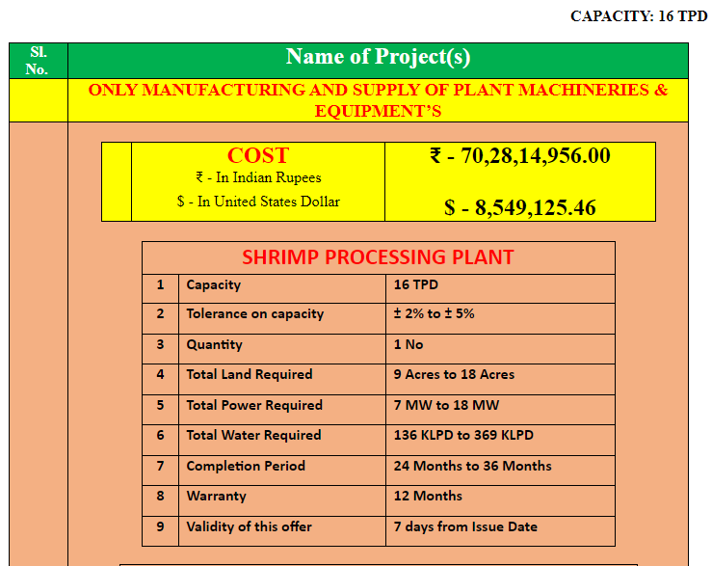
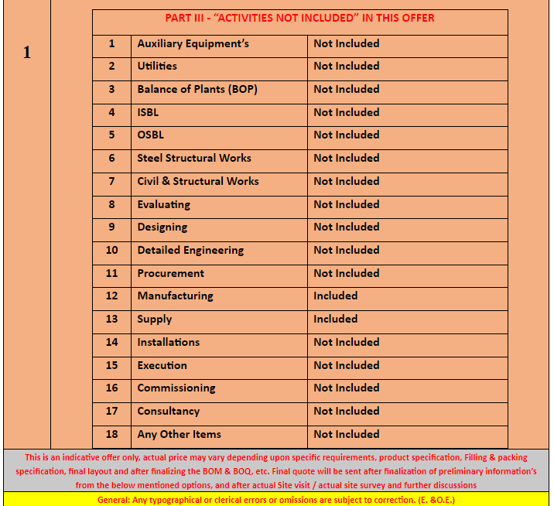

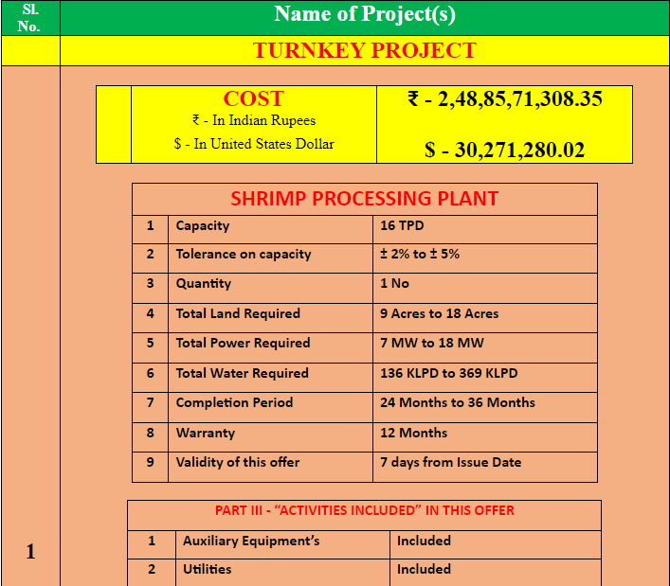
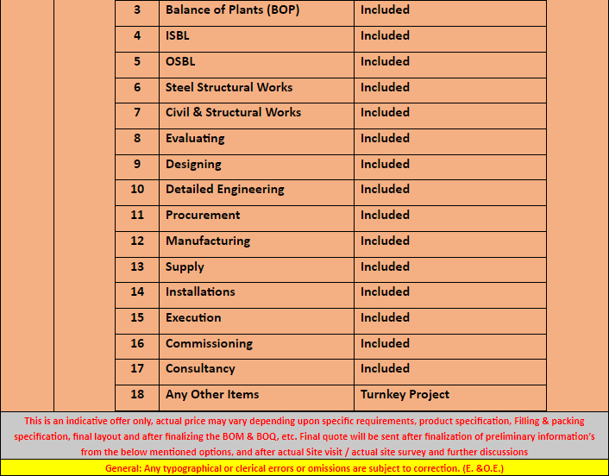

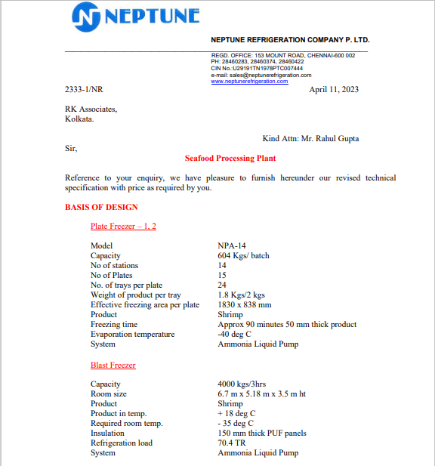

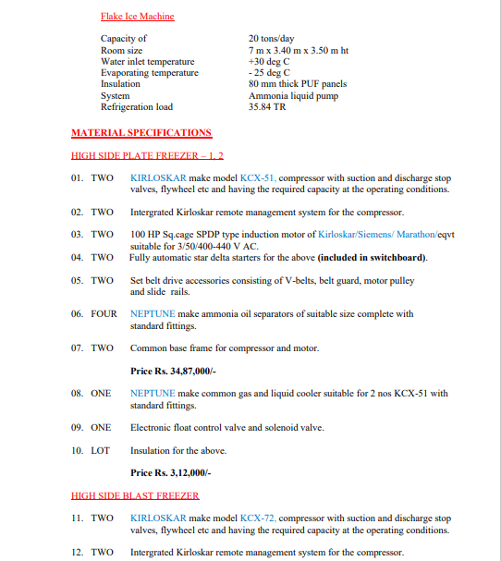

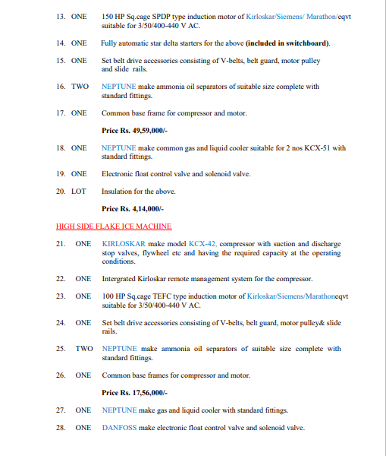
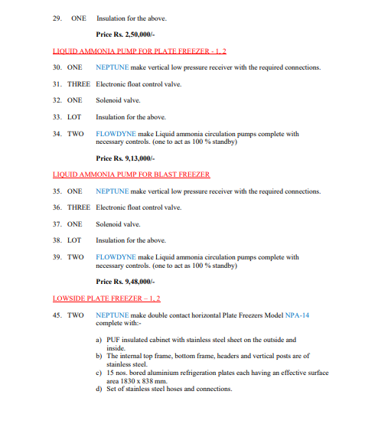
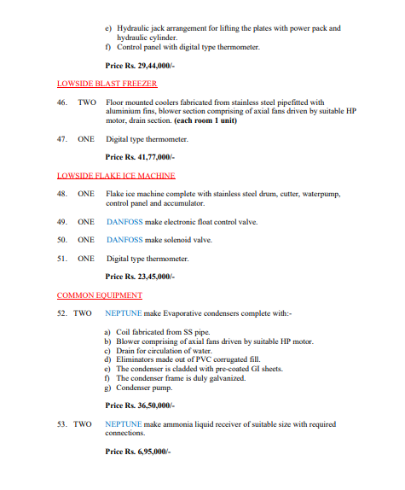
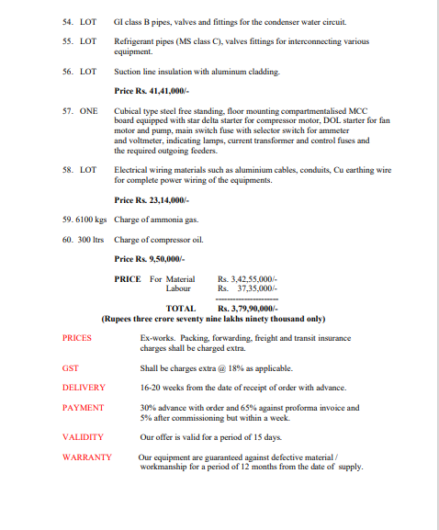
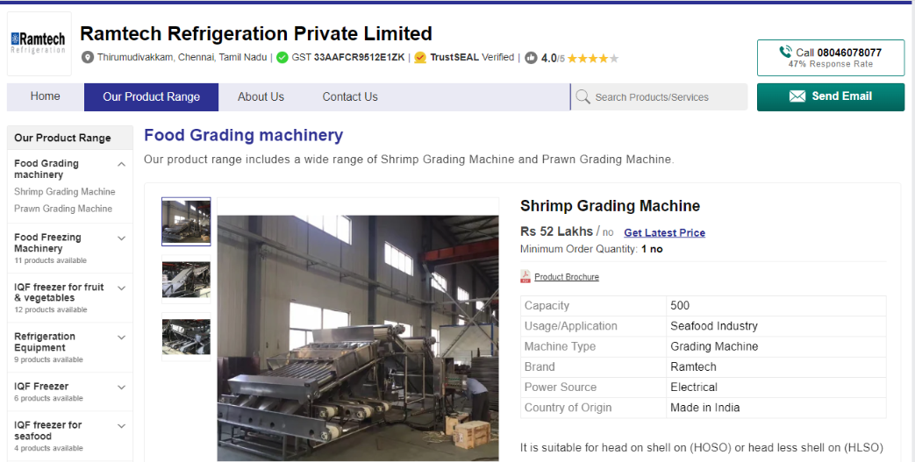
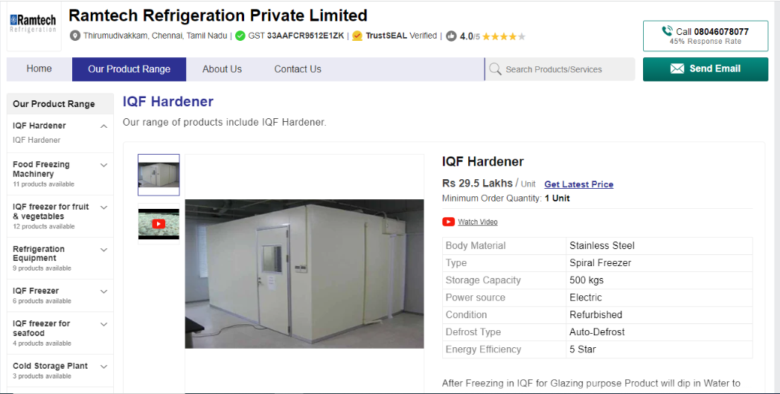
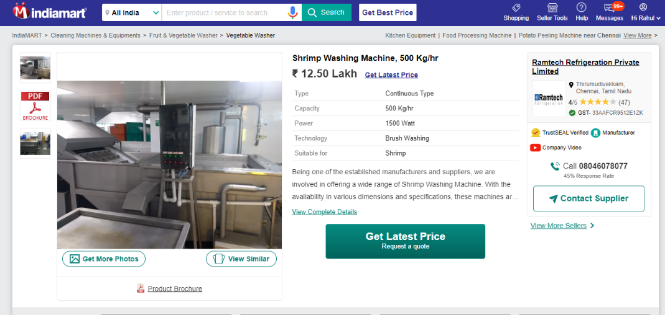
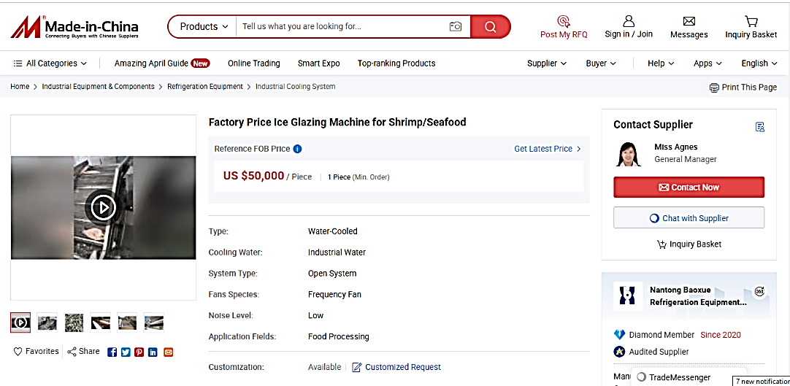
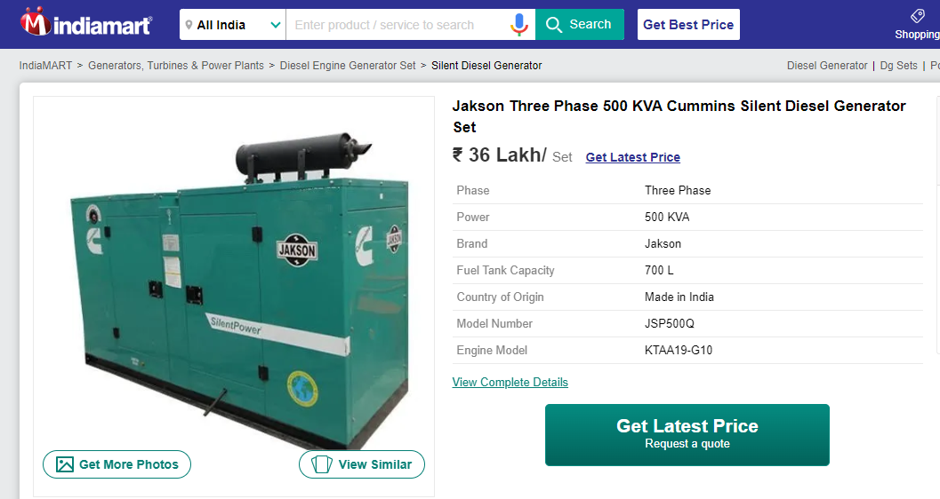
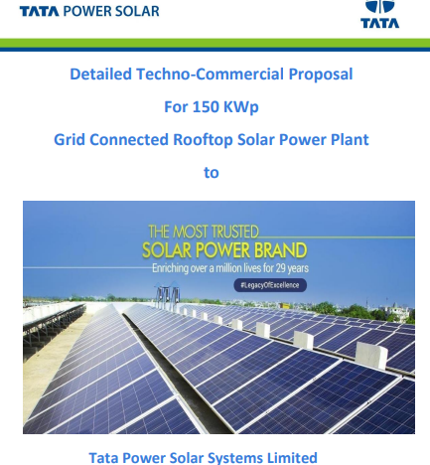
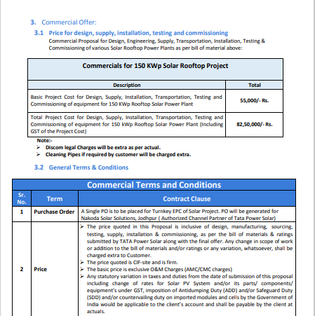
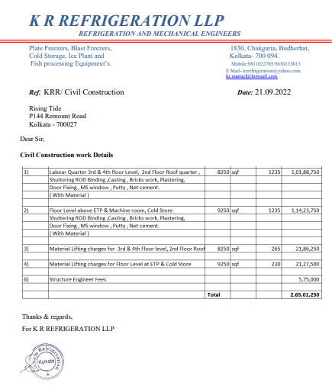

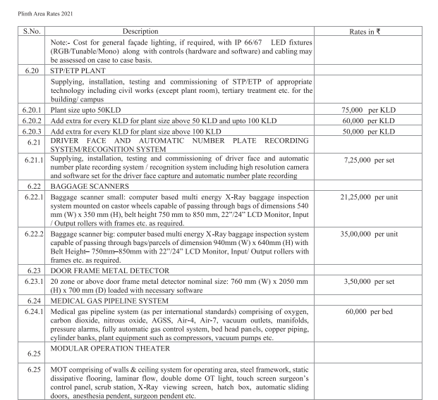
Proposed Civil Works Description

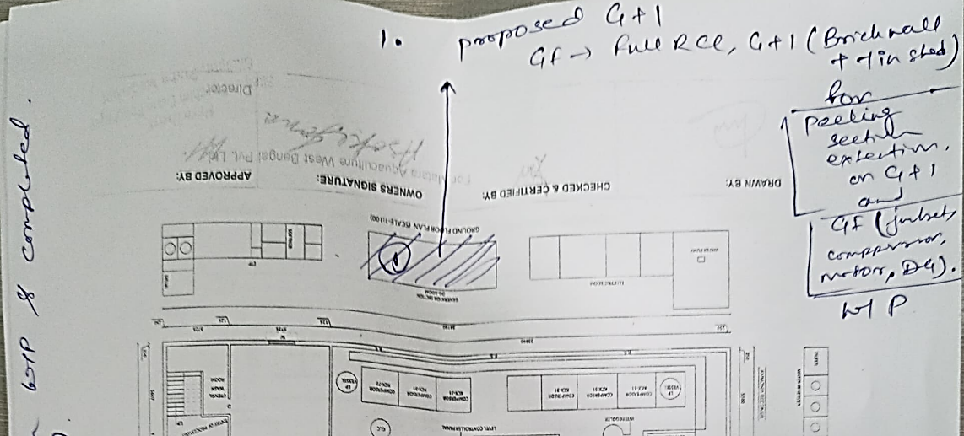
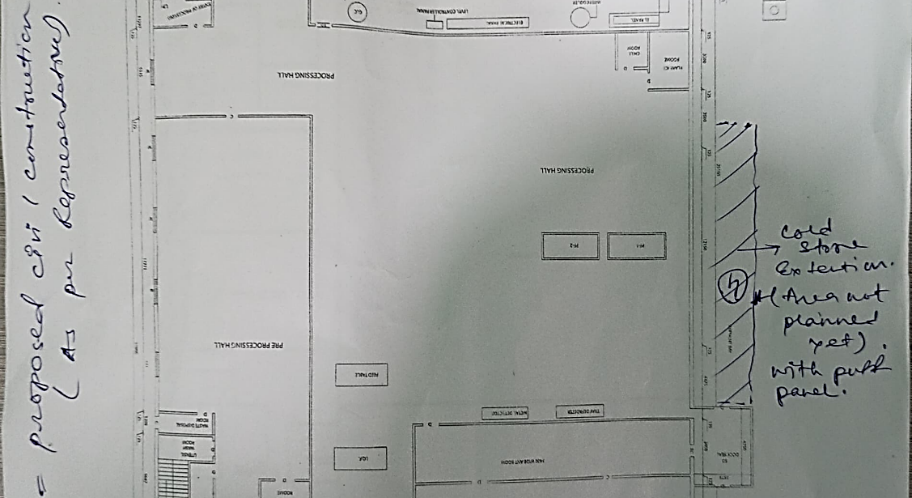
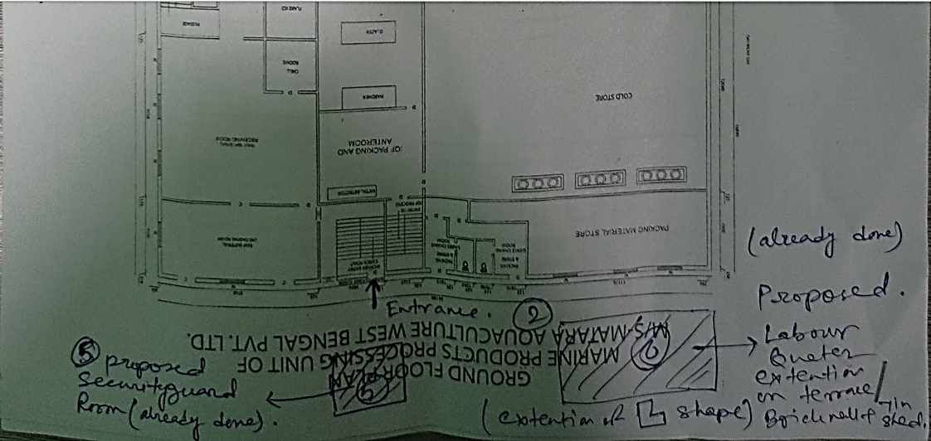
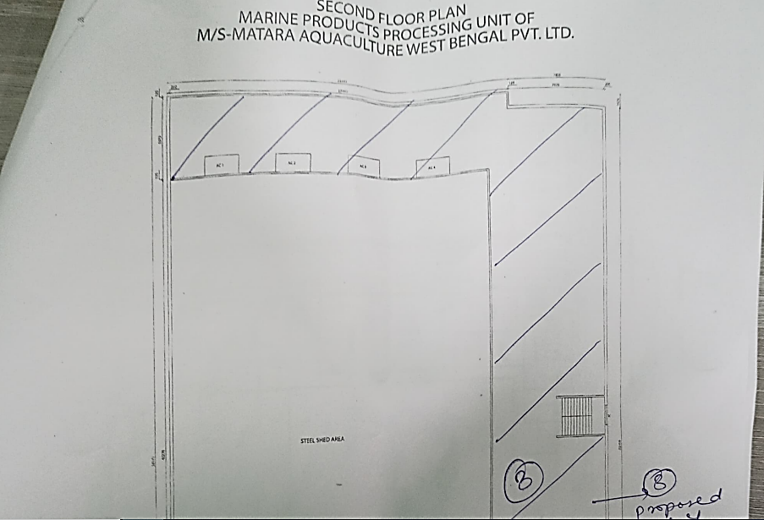
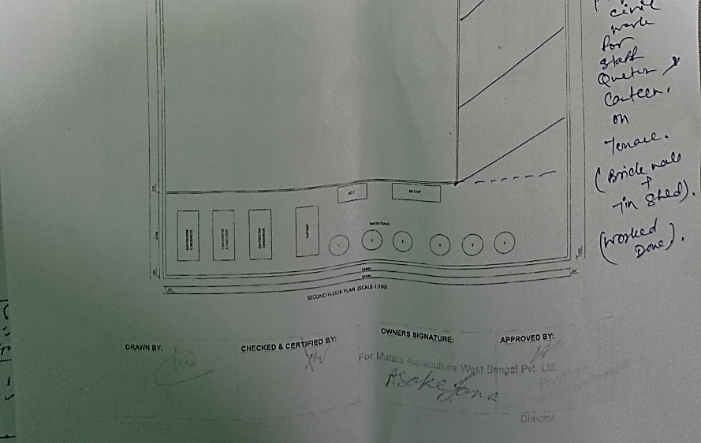
PART B - ANNEXURE

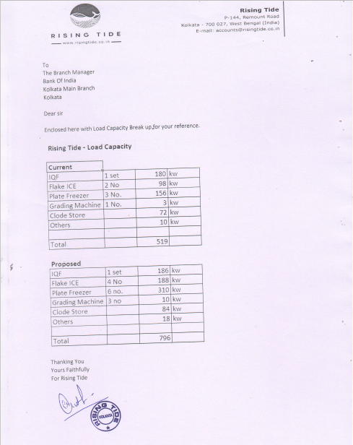

ELECTRICITY BILL
