File No.: VIS (2022-23) - PL732-618-1006 Dated: 25.03.2023

TECHNO-ECONOMIC VIABILITY
STUDY REPORT

OF

39600 TPA (120 TPD) KRAFT PAPER WITH 0.5 MW POWER PLANT

SETUP BY

M/S ARAMCO PAPERS PRIVATE LIMITED

PROMOTED BY

BALAJI GROUP

REPORT PREPARED FOR

STATE BANK OF INDIA, SME BRANCH, MUZAFFARNAGAR

**Important - In case of any query/ issue or escalation you may please contact Incident Manager Valuers@rkassociates.org. We will appreciate your feedback in order to improve our services.

NOTE: As per IBA Guidelines please provide your feedback on the report within 15 days of its submission after which report will be considered to be correct.

IMPORTANT NOTICE

COPYRIGHT FORMAT: This report is prepared on the copyright format of R. K. Associates Valuers & Techno Engineering Consultants (P) Ltd. (R. K. Associates) to serve our clients with the best possible information and analysis to facilitate them to take rational business decisions. Legally no one can copy or distribute this format without prior approval from R. K. Associates. It is meant only for the advisory/ reference purpose for the organization/s as mentioned on the cover page of this report. Distribution or use of this format or report or any of its content/ information/ data by any organization or individual other than R.K Associates will be seen as an unlawful act and necessary legal action can be taken against the defaulters.
This report is intended for the sole use of the intended recipient/s and contains material that is STRICTLY CONFIDENTIAL AND PRIVATE.

DEFECT LIABILITY PERIOD: In case of any query/ issue or escalation you may please contact Incident Manager at valuers@rkassociates.org. Though adequate care has been taken while preparing this report as per its scope, but still we can’t rule out typing, human errors, over sightedness of any information or any other mistakes. Therefore, the concerned organization is advised to satisfy themselves that the report is complete & satisfactory in all respect. Intimation regarding any discrepancy shall be brought into our notice immediately. If no intimation is received within 15 (Fifteen) days in writing from the date of issuance of the report, to rectify these timely, then it will be considered that the report is complete in all respect and has been accepted by the client up to their satisfaction & use and further to which R.K Associates shall not be held responsible in any manner.

Part N: R. K. Associates Important Disclaimer and Remarks are integral part of this report and Feasibility assessment is subject to this section. Reader of the report is advised to read all the points mentioned in these sections carefully.

TABLE OF CONTENTS
SECTIONS | PARTICULARS | PAGE NO.
Part A | Report Summary | 4-5
Part B | INTRODUCTION
Part B | - About the Report | 6
Part B | - Executive summary | 6
Part B | - Purpose of the Report | 9
Part B | - Scope of the Report | 9
Part B | - Methodology/ Model Adopted | 10
Part B | - Data Information received from | 10
Part B | - Documents/ Data Referred | 10
Part C | Company Profile
Part C | - Company Overview | 11
Part C | - Proposed Shareholding Details | 12
Part C | - Promoters/Directors Profile | 13
Part D | Proposed Unit’s Infrastructure Details
Part D | - Proposed Location | 17
Part D | - Location Map | 17
Part D | - Land Details | 18
Part D | - Site pictures | 19
Part D | - Building & Civil Works | 26
Part D | - Plant and Machinery/ Equipment details | 27
Part D | - Utilities | 28
Part E | Project Technical details
Part E | - Capacity of Manufacturing Facility | 29
Part E | - Technical Specification of the Proposed Manufacturing Facility | 29
Part E | - Technology Used | 31
Part E | - Source of Procurement of Equipment’s | 32
Part E | - Testing Standards For Production | 34
Part E | - Manpower | 35
Part F | Product Profile
Part F | - Introduction | 37
Part F | - Product Category | 37
Part F | - Manufacturing Flow Chart | 38
Part F | - Marketing, Selling & Distribution Plan | 39
Part G | Industry Overview & Analysis | 40
Part H | SWOT Analysis | 46
Part I | Project Cost and Means of Finance | 47
Part J | Project Schedule | 49
Part K | Statutory Approvals | Licences | NOC | 51
Part L | Company’s Financial Feasibility | 52
Part M | Conclusion | 73
Part N | Disclaimer | Remarks | 75

PART A | REPORT SUMMARY

- Name of the Company: | M/s Aramco Papers Private Limited
- Address of the Company: | Registered Office: C-12/436, Yamuna Vihar, Shahdara, East Delhi, Delhi-110053, India.
- Project Name: | 18 B.F AND 20 B.F Kraft Paper for packaging industry
- Project Location: | Khasra No. 549, 550, Village Shernagar, Jansath Road, Muzaffarnagar, Uttar Pradesh.
- Project Type: | 39600 TPA (120 TPD) Kraft Paper with 0.5 MW Power Plant
- Project Industry: | Paper Manufacturing Industry
- Product Type/ Deliverables: | High B.F. Quality Kraft Paper
- Report Prepared for Organization: | State Bank of India, SME Branch, Muzaffarnagar
- TEV Consultant Firm: | M/s. R.K Associates Valuers & Techno Engineering Consultants (P) Ltd.
- Report type: | Techno-Economic Viability Report
- Purpose of the Report: | To assess the Project’s Techno-Economic Viability for the purpose of seeking external financial assistance on the Project.
- Scope of the Report: | To assess, evaluate & comment on Techno-Financial Viability of the Project as per data information provided by the client, independent Industry research and data/ information available on public domain.
- Date of Report: | 25th March, 2023
- Documents referred for the Project | - PROJECT PLANNING DOCUMENTS:  - Detailed Project Report  - Financial Projections of the Project  - Project proposed Schedule  - Statutory Approval Details  - Process Flow of manufacturing  - PROCUREMEMNT DOCUMENTS:  - High level breakup of Plant & Machinery Cost  - Land (Lease) details and conversion Certificate (CLU)  - List of major customers of the company  - Proposed manpower details  - Water and Electricity arrangements details
- Means of Finance: | Equity + Debt
- Key Financial Indicators
  Key Indicators | Value
  Average DSCR | 2.95
  Average EBITDA Margin | 6.6%
  Average EBIT Margin | 4.95
  NPV | INR 13.70 Crore (+)
  IRR | 12.10%
  Debt to Equity Ratio | 2.28
  Payback Period | 4 Years 11 Months

Note: Above financial indicators are based on the financial projections of the proposed project provided by the firm and assessment and analysis of the same done by us.

PART B | INTRODUCTION

- ABOUT THE REPORT:
Techno Economic Viability Study Report of the High B.F. quality Kraft paper manufacturing unit to be set by M/s Aramco Paper Private Limited with an installed capacity of 39,600 TPA.

- EXECUTIVE SUMMARY:
M/s Aramco Papers Private Limited was incorporated on 29th January, 2019 registrar of Companies Delhi vide CIN No. U21000DL2019PTC345136. M/s Aramco Papers Private Limited is an arm of Balaji Group of Industries having exposure to Books Publication and other related products. The group promoted Publication units, Poly Packing unit and also having exposure to waste paper and finished paper trading. The present project of company is being promoted by Industrialist Shri Ashish Kumar Chariya and his associates.
The company is established as a private company limited by shares with Registration no. 345136 and Tax Deduction and Collection Account Number (TAN) is DELA52968G. The Permanent Account Number (PAN) of the company is AARCA8538R and GSTIN is 09AARCA8538R1ZH and is promoted by the directors who appears to be well experience in businesses of paper manufacturing as per the profile shared to us by the client and information available in the public domain about them.
The company is registered at Registrar of companies, Delhi having registered office at C-12/436, Yamuna Vihar, Shahdara, East Delhi, Delhi-110053, India under the directorship of Shri Ashish Kumar Chariya and his associates. As per the information available on the MCA website, the company is having an authorized capital of INR 4,50,00,000 and the paid-up capital of INR 4,50,00,000.
As per Udhyam registration certificate provided by the client, the company is categorised as MICRO enterprise and having the Udyam Registration Number UDYAM-DL-02-0029530. The Consent to Establish (CTE) for New Unit/Expansion/Diversification under the provisions of Water (Prevention and control of pollution) Act, 1974 as amended and Air (Prevention and control of Pollution) Act, 1981 as amended is granted on 20th March 2023 for 125 MTPD as per the information provided by the client/company.
As per data/information provided by the company, currently company is having 8060 Square meter land at Khasra No. 549, 550, Village Shernagar, Jansath Road, Muzaffarnagar, Uttar Pradesh. Below table shows the TPA capacity of the proposed manufacturing plant for at initially proposed level and at revised proposed level.
Particular | Initially Proposed Capacity | Revised Proposed Capacity
Location | TPA | TPA
Khasra No. 549, 550, Village Shernagar, Jansath Road, Muzaffarnagar, Uttar Pradesh | 33,000 | 39,600
Total | 33,000 | 39,600
Source: Information provided by the company
As per the latest proposed plan of manufacturing unit taping the market of kraft paper in India and as per the growing demand of the finished goods which is the most important raw material in the Packaging Industry particularly after the ban on plastic, M/s Aramco Papers Private Limited is planning to increase the earlier proposed manufacturing capacity up to 39,600 TPA from the initially proposed capacity of 33,000 TPA to increase the scope and scale of the production at Khasra No. 549, 550, Village Shernagar, Jansath Road, Muzaffarnagar, Uttar Pradesh.
We R.K associate is performing the Techno-Economic Viability study for setting up proposed manufacturing facility at Khasra No. 549 & 550, Village Shernagar, Jansath Road, Muzaffarnagar, Uttar Pradesh, for taking a term loan of INR 12.00 Crore and cash credit limit of INR 2.00 Crores from financial institutions for building construction and Plant & Machinery purchase & installation work.

PROPOSED PROJECT COST: The total cost of the project for setting up of the manufacturing facility is being estimated as INR 21.66 Crores, which is proposed to be funded through equity of INR 6.60 Crores, unsecured loan of INR 3.06 Crores and debt of INR 12.00 Crores.
Particulars (INR Crores) | Total Cost
Land & Site Development | 0.00
Building & Civil Works | 0.45
Plant & Machinery | 12.11
Plant & Machinery- Additional | 6.30
Misc. Fixed Assets | 0.12
Interest During Construction Period Assets | 0.49
Escalation & Contingencies | 0.57
Pre-Operative Exp | 0.07
Security Deposit | 0.33
Margin Money For W/C | 1.22
Total | 21.66
As per the discussion with client/company officials, for the proposed manufacturing unit of 39,600 TPA capacity, the company has already purchased the land during the inception of existing manufacturing facility.
The major heads in the Total Project Cost will be Purchase & installation cost of plant & machinery, for which they are taking a term loan of INR 12 Crores. Rest most of the heads will be funded through equity and approximately 3.00% of building and Plant & Machinery is considered as contingencies which will also be funded through equity.
The company is planning to fund the project through term loan to setup the manufacturing unit and SBI has sanctioned INR 8.00 Crores and the company is approaching the financial institutions to provide the remaining required capital of INR 4.00 Crores.
CURRENT STATUS OF THE PROJECT: The Company was proposing to install Kraft Paper manufacturing plant with installed capacity of 33000 TPA at Khasra No. 549, 550, Village Shernagar, Jansath Road, Muzaffarnagar, Uttar Pradesh with financial assistance to the tune of 8.00 Crores by way of Term Loan & Rs.2.00 Crores as working capital and accordingly State Bank of India has sanctioned requested credit facilities, however in view of the changing environment and demand of the time and large scale production management has decided to increase the capacity of the plant from 33000 TPA to 39600 TPA and hence company has revised the project and requesting the bank for sanction of additional Term Loan of Rs. 4.00 Crores to part fund the enhance for the additional capex of INR 6.50 Crore in the plant & machinery. Since the capacity of the plant can be enhanced unto 125 TPD for higher GSM quality paper with the proposed machinery which seems to be reasonable and in the line with industry standards.
As per the information provided by the client/company, the company was supposed to achieve the COD in January 2023 earlier but due to expanded plant & machinery cost is expected to achieve the COD by April, 2023 since the CAPEX creditors of the company are outstanding. However, the company has attempted a successful trial run of the pulper plant, boiler plant and other major machineries as per verified during the site visit.
Therefore, to check and assess the Techno-Economic viability of the Project for submitting the proposal to financial institutions, State Bank of India, SME Branch, Muzaffarnagar has appointed us as TEV consultant to review technical, commercial and financial viability of the project based on our independent EIC research and information/data provided to us about the project by client/company.

- PURPOSE OF THE REPORT: To assess the Techno-Economic Feasibility of the green field proposed project to take further Project funding decision for the same.

- SCOPE OF THE REPORT: To assess, evaluate & comment on Techno-Financial Feasibility of the proposed Kraft paper manufacturing unit being set up by M/s Aramco Papers Private Limited as per the data/information provided by the client/promoter/stakeholder and our independent EIC research.
NOTES:
- Project status is taken as per the information provided by the company/promoter/stakeholder and verified during the site visit as on 24th March 2023
- This has not been independently verified or inspected independently since this was out-of-scope of the work. Reviewing existing unit infrastructural details is out of scope of the work.
- Site inspection has been carried out for the proposed units and operating details regarding the unit is taken as per the information provided by the company which has been relied upon.
- Scrutiny about the company, background check, and credibility, credit worthiness of the company or its promoters is out-of-scope of this report.
- This report is only an opinion in respect to Technical and Financial Feasibility of the project as per the future Projections provided by the firm and independent analysis done by us and doesn’t contains any recommendations including taking decision on the financial exposure.
- This is not an audit activity of any kind. We have relied upon the data/ information supplied by the company in good faith that it is true and without any fabrication.
- This is not a Detailed Project Report or a detailed design or architecture document. Land and property details mentioned in the report is only for illustration purpose as per the information provided to us by the client. The same doesn’t tantamount for taking any responsibility regarding its legality, ownership and conforming to statutory norms.

- METHODOLOGY/ MODEL ADOPTED:
- Data/ Information collection as per our standard checklist.
- Review of Data/ Information collected related to TEV study.
- Review and analysis of the Projections as per the market trends and futuristic growth opportunity of the industry and company.
- Independent review & assessment of technology used provided by the company/promoters.
- Projections of Revenue, Expenses, P&L, Balance Sheet, fixed assets, COGS.
- Assessment of Key Financial Metrics.
- Final conclusion.

- DATA/ INFORMATION RECEIVED FROM: All the data/Information has been received from Mr. Ashish Chhariya (Director) and the required details about him shown in the below table:
Particulars | Details
Designation | Director
Company | M/s Aramco Papers Private Limited
Email Address | sbjpub@gmail.com
Contact No. | +91 9412807296

- DOCUMENTS / DATA REFFERED:
- Detailed Project Report & Proposed project cost.
- Memorandum of Association and Director’s details.
- Manufacturing Process Flow Chart
- Lease deed for the procured land
- Civil and construction details
- Details of utilities
- List of proposed Plant & Machinery.
- Invoices/quotations
- Description of suppliers and buyers of the company.
- Electricity bill, Man power proposal, Land conversion certificate, MSME Certificate, GST Certificate, Enrolment Certificate.
PART C | COMPANY PROFILE

- COMPANY OVERVIEW:
M/s. Aramco Papers Private Limited was incorporated on 29th January 2019 with CIN: U21000DL2019PTC345136 is a private limited company having its Registered Office at C-12/436 Yamuna Vihar, Shahdara, East Delhi, Delhi - 110053, India. It is classified as Non-govt Company and is registered at Registrar of Companies, Delhi. Its Authorised Capital is INR 4,50,00,000 and paid-up capital is INR 4,50,00,000.
The proposed project is for setting-up a unit for manufacturing High B.F. Quality Kraft Paper with an installed capacity of 39600 TPA. The proposed unit will come up at Khasra No. 549, 550, Village Shernagar, Jansath Road, Muzaffarnagar, Uttar Pradesh. The product to be manufactured under the envisaged project is HIGH B.F. KRAFT PAPER, which is the most important raw material in the Packaging Industry particularly after the ban on plastic.
As per the discussion with the company official, initially the company was planning to establish a proposed manufacturing facility with 33,000 TPA capacity for which State Bank of India has already sanctioned INR 8.00 Crores by way of Term Loan & INR 2.00 Crores as working capital loan. The company has already achieved COD for the said plan and a trail run was also conducted. However, in view of the changing environment and demand of the time and large-scale production management has decided to increase the capacity of the plant from 33000 TPA to 39600 TPA and hence company has revised the project.
The Proposed Project is being taken-up by M/s Aramco Papers Private Limited, a flagship Company of Balaji Group, which, besides this Company, has several successful industrial ventures under its belt, is being managed by established, experienced and of high substance promoters. The proposed project is in hands of persons who have vast experience in Paper sector.
As per the information available in the public domain about them and information provided by the company, the promoters of the Company are also interested in the following industrial units:
S. No. | Name of Company | Interested Partners/Directors
1. | SHRI BALAJI POLYPACKS | - Ashish Kumar Chariya  - Prabhat Kumar  - Krishan Pal Malik  - Neeraj Bhardwaj  - Manoj Ruhela
2. | SHRI BALAJI PUBLICATION | - Ashish Kumar Chariya  - Prabhat Kumar  - Krishan Pal Malik  - Neeraj Bhardwaj  - Manoj Ruhela
3. | AVIRAL PUBLICATIONS | - Ashish Kumar Chariya  - Prabhat Kumar  - Krishan Pal Malik  - Neeraj Bhardwaj  - Manoj Ruhela

All the above units are performing well. The firms are regular in repayment of institutional dues. The company is having an adroit team of employees, which keeps themselves abreast with advanced manufacturing techniques and designs.

- PROPOSED SHAREHOLDING DETAILS: As on 31st March 2022, the Company is having authorized share capital of INR 4, 50, 00,000 and the total paid-up capital is INR 4, 50, 00,000 as per the data available on the MCA website. As per the information provided by the company, the shareholding details of the company is mentioned below:
S. No. | Name of the Shareholder | No. of Shares Allotted | Amount | % Of Holding
1 | Wajida Khatoon | 3,85,000 | 38,50,000 | 8.56%
2 | Anupama Sharma | 1,24,000 | 12,40,000 | 2.76%
3 | Mohd Yameen | 10,25,000 | 1,02,50,000 | 22.78%
4 | Ashish Kumar Chhariya | 2,00,000 | 20,00,000 | 4.44%
5 | Krishna Pal Malik | 5,00,000 | 50,00,000 | 11.11%
6 | Manoj Kumar Ruhela | 2,50,000 | 25,00,000 | 5.56%
7 | Renu | 3,50,000 | 35,00,000 | 7.78%
8 | Neeraj Bhardwaj | 1,50,000 | 15,00,000 | 3.33%
9 | Neha Bhardwaj | 1,26,000 | 12,60,000 | 2.80%
10 | Sangita Ruhela | 1,09,000 | 10,90,000 | 2.42%
11 | Sanjay Chhariya | 1,50,000 | 15,00,000 | 3.33%
12 | Sarla Malik | 2,00,000 | 20,00,000 | 4.44%
13 | Zainuddin | 1,60,000 | 16,00,000 | 3.56%
14 | Kartik | 67,500 | 6,75,000 | 1.50%
15 | Kaseem Ali | 2,67,500 | 26,75,000 | 5.94%
16 | Mohd Suhail | 3,00,000 | 30,00,000 | 6.67%
17 | Prabhat Kumar | 65,000 | 6,50,000 | 1.44%
18 | Naman | 71,000 | 7,10,000 | 1.58%
 | Total | 45,00,000 | 4,50,00,000 | 100%
Source: Data/Information provided by the Client.

- PROMOTERS/DIRECTORS PROFILE: As per data/information provided by the client/banker, Director’s details have been shown in the below table:
DIN | Name | Appointment Date | Qualifications/Experience
03066599 | Mr. Krishan Pal Malik | 22nd January 2022 | Krishan Pal Malik director of the company is also having more than 25 years of experience in the publication of books and packaging material.  He is also partner in three firms namely Shri Balaji Publication, Shri Balaji Polypacks and Aviral Publications. All the unit are running well and having very good track record.  He is also operating a Petrol Pump in Delhi and is a man of wealth
08345199 | Wajida Khatoon | 29th January 2019 | Wajida Khatoon wife of Mohd Yameen is also looking after various trading firms engaged in the trading of waste paper and have vast experience in the paper industry.
08345200 | Mohd. Yameen | 29th January 2019 | Mohd Yameen director of the company is having more than 20 years of experience in the trading of waste paper and having vast knowledge of the paper trade.
08983710 | Mr. Prabhat Kumar | 10th December 2021 | Mr. Prabhat Kumar director of the company is also having more than 20 years of experience in the publication of books and packaging material.  He is also partner in three firms namely Shri Balaji Publication, Shri Balaji Polypacks and Aviral Publications.
08983711 | Mr. Ashish Kumar Chariya | 10th December 2021 | Mr. Ashish Kumar Chariya director of the company is having more than 21 years of experience in the publication of books and packaging material.  He is presently running successfully three firms namely Shri Balaji Publication, Shri Balaji Polypacks and Aviral Publications. All the unit are running well and having very good track record.  There is not a single instance in the delay of payment of financial dues. He has sufficient funds to invest in the company in the case of any requirement.
09467479 | Mr. Neeraj Kumar Bhardwaj | 22nd January 2022 | Mr. Neeraj Bhardwaj director of the company is also having more than 22 years of experience in the publication of books and packaging material. He is also partner in three firms namely Shri Balaji Publication, Shri Balaji Polypacks and Aviral Publications.
09472394 | Mr. Manoj Kumar Ruhela | 22nd January 2022 | Mr. Manoj Ruhela director of the company is also having more than 24 years of experience in the publication of books and packaging material.  He is also partner in three firms namely Shri Balaji Publication, Shri Balaji Polypacks and Aviral Publications. All the unit are running well and having very good track record.
Source: Data/Information provided by the client
To give a brief overview of the background of Directors we have listed down the basic company information as found on public domain in general/ tertiary category research.
(Mr. Krishan Pal Malik)
S. No. | CIN/FCRN | Company Name | Begin Date
1 | U21000DL2019PTC345136 | ARAMCO PAPERS PRIVATE LIMITED | 22/01/2022
Source: Information extracted from MCA & public domain
(Ms. Wajida Khatoon)
S. No. | CIN/FCRN | Company Name | Begin Date
1 | U21000DL2019PTC345136 | ARAMCO PAPERS PRIVATE LIMITED | 29/01/2019
Source: Information extracted from MCA & public domain
(Mr. Mohd Yameen)
S. No. | CIN/FCRN | Company Name | Begin Date
1 | U21000DL2019PTC345136 | ARAMCO PAPERS PRIVATE LIMITED | 29/01/2019
Source: Information extracted from MCA & public domain
(Mr. Prabhat Kumar)
S. No. | CIN/FCRN | Company Name | Begin Date
1 | U21000DL2019PTC345136 | ARAMCO PAPERS PRIVATE LIMITED | 10/12/2021
2 | U15100UP2020PTC126580 | GOVELA FARMS PRIVATE LIMITED | 30/11/2021
Source: Information extracted from MCA & public domain
S. No. | LLPIN/FLLPIN | LLP Name | Begin Date
1 | AAU-9511 | SHRI BALAJI INFOSOFT LLP | 04/12/2020
Source: Information extracted from MCA & public domain
(Mr. Ashish Kumar Chariya)
S. No. | CIN/FCRN | Company Name | Begin Date
1 | U21000DL2019PTC345136 | ARAMCO PAPERS PRIVATE LIMITED | 10/12/2021
2 | U15100UP2020PTC126580 | GOVELA FARMS PRIVATE LIMITED | 30/11/2021
Source: Information extracted from MCA & public domain
S. No. | LLPIN/FLLPIN | LLP Name | Begin Date
1 | AAU-9511 | SHRI BALAJI INFOSOFT LLP | 04/12/2020
Source: Information extracted from MCA & public domain
(Mr. Neeraj Kumar Bhardwaj)
S. No. | CIN/FCRN | Company Name | Begin Date
1 | U21000DL2019PTC345136 | ARAMCO PAPERS PRIVATE LIMITED | 22/01/2022
Source: Information extracted from MCA & public domain
(Mr. Manoj Kumar Ruhela)
S. No. | CIN/FCRN | Company Name | Begin Date
1 | U21000DL2019PTC345136 | ARAMCO PAPERS PRIVATE LIMITED | 22/01/2022
Source: Information extracted from MCA & public domain

PART D | PROPOSED UNIT’S INFRASTRUCTURE DETAILS

In this section, proposed extension of plant details are mentioned. Existing plant is already in operation and therefore infrastructure details related to it, has not been specifically mentioned here since this is out of scope of the work.
- PROPOSED LOCATION: The Company proposes establishing a new Kraft Paper Manufacturing Plant at Khasra No. 549 & 550, Village Shernagar, Jansath Road, Muzaffarnagar, Uttar Pradesh, India which is spread over an area of 8060 Square meter as per information shared by client/company. This factory site is near to Vardhman Hospital Muzaffarnagar and it is connected with NH 334. During the site visit the location is found to be appropriate and prominent. The factory site is just 125 KM from Inland Container Depots (ICD) Dadri. This is good for all export and import related activity. Company will does bulk export of kraft paper from factory. Entire Delhi NCR is within 150 to 200 KM range from the proposed factory. The demand for consumption of kraft paper in Delhi NCR market is very high. Therefore, because of prime location of the company, it has advantage to supply kraft paper in short notice in Delhi NCR market. The feasibility to the civic amenities like school, hospital, bus stop, market etc are within 7-8 Km radius.
Connectivity | Details
Rail | Muzaffarnagar Railway Station, Uttar Pradesh, which is ~6 km away
Airport | Indira Gandhi International Airport which is 134.5 km away

- LOCATION MAP:
- Google Map: Location: Project location would be 29°26'13.3" North and 77°44'22.1" East in Jansath Road Muzaffarnagar U.P. and the location as per the Google map is attached below.
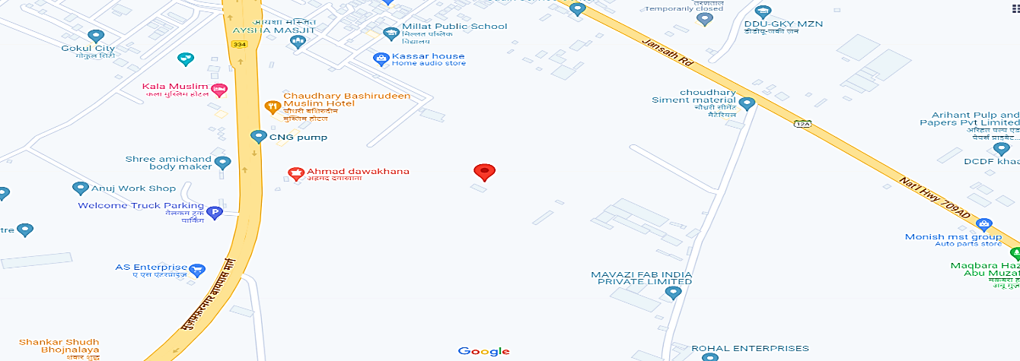
- Demarcation: Demarcation of the land on the Google map is attached below:
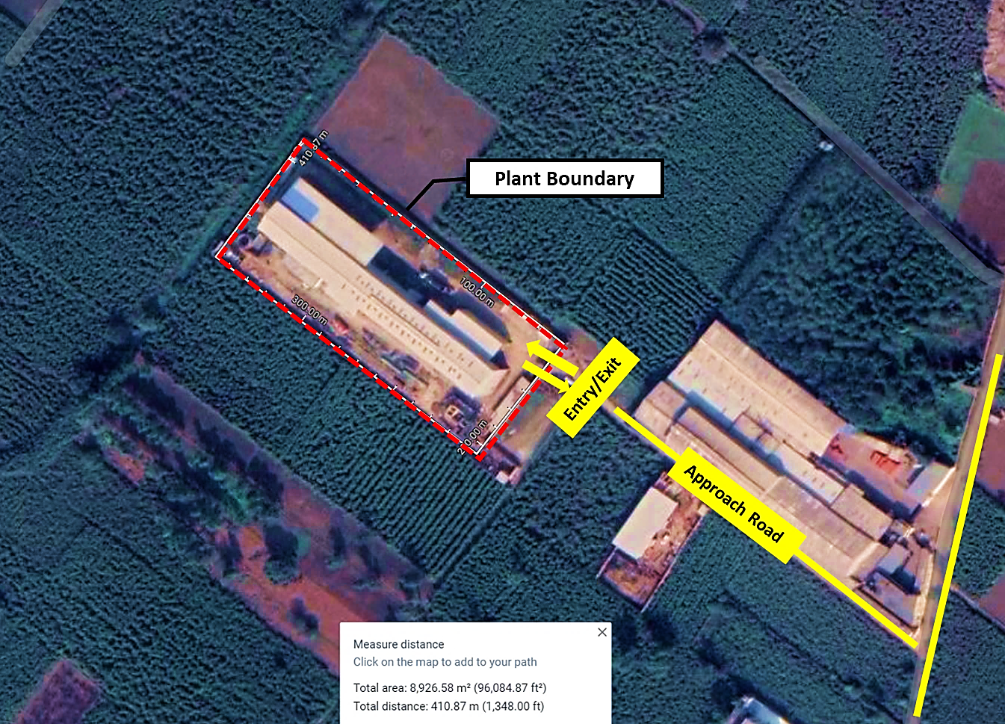

- LAND DETAILS: The Company has acquired the rectangular freehold land on lease for the proposed plant land in February 2022, admeasuring approx. 8060 Sq. Mt. at Khasra No. 549 and 550, Village Shernagar, Jansath Road, Muzaffarnagar, Uttar Pradesh, 251003, in the company’s name. As per lease deed, M/s Aramco paper has taken the lease for the period of 30 years on a yearly rent of 60,000/-.The proposed paper factory is planned for manufacturing plant with installed capacity of 39600 TPA of kraft paper.
The surrounding area of the factory site is developing area and land is levelled with topographical conditions. As per the valuation of the land done by Er. S.K. Jain recently, the rates for land in the subject locality varies within the range of Rs. 3,200/- Rs. 3,300/- per sq.mtr. depending upon the various attributes of the land and distance from the main road. We have relied upon the same assessment. According to that valuation report: the fair market value of the land the adopted rate of valuation is Rs. 3,200/-. According to the report the entire property includes land, building and services like water supply arrangement, drainage arrangement, compound walls, C.B. deposits and fittings and electric fittings etc.
Hence as per valuation report the fair market of the land in today’s scenario is 3.61 crores. And as per the Lease Deed Company has a lease agreement of 60,000/- INR per year for 30 years. Therefore, the decision of lease of land taken by the management was economically and commercially viable.
- SITE PICTURES: Some of the site pictures has been taken during the site survey, are attached below:
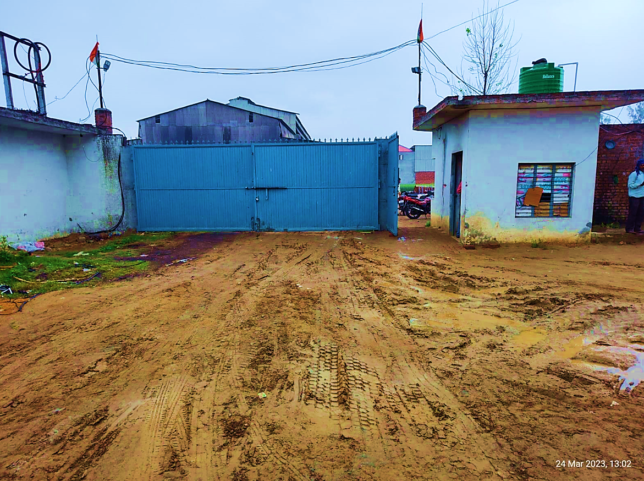
Main Gate
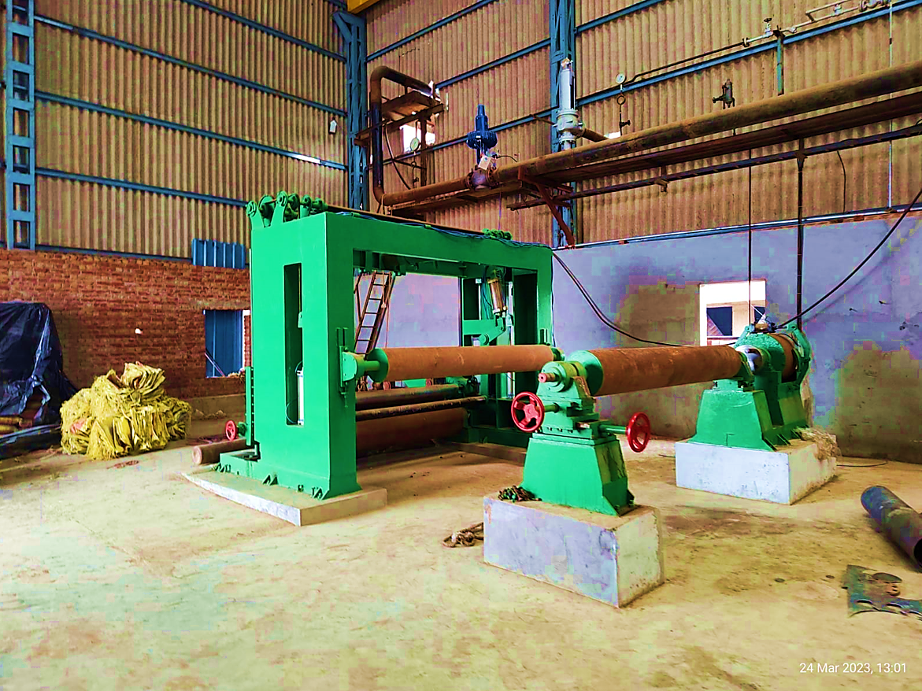
Paper Cutter
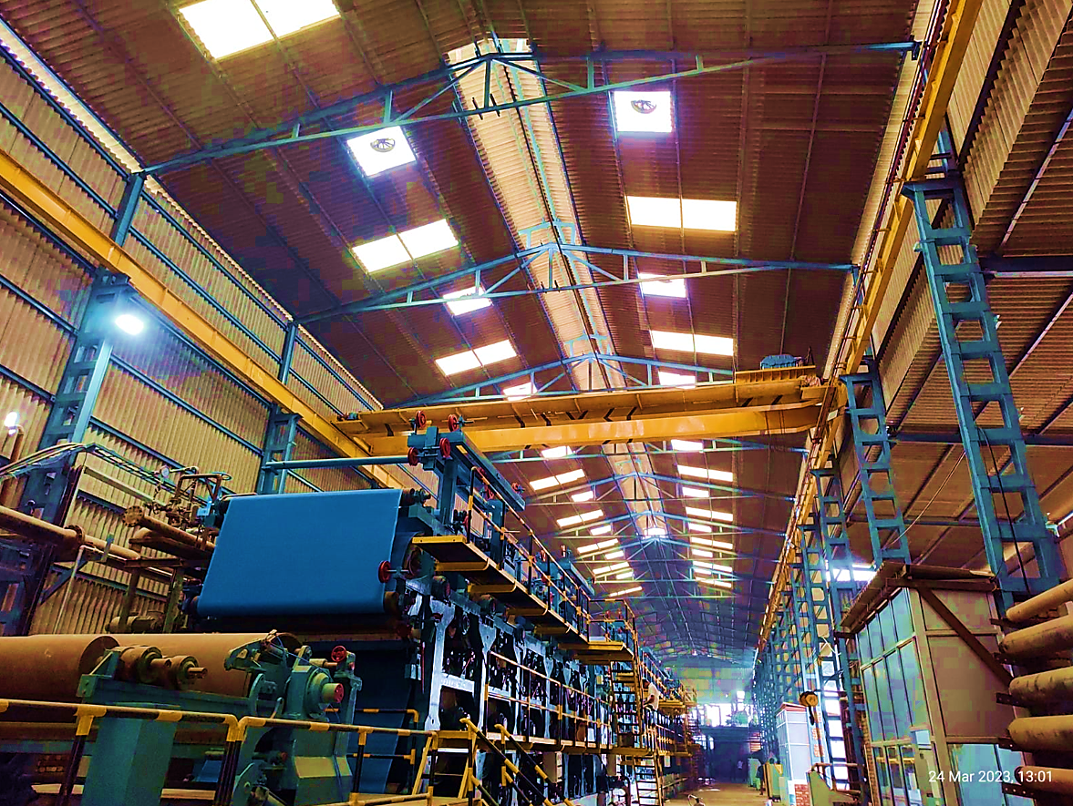
Paper Machine
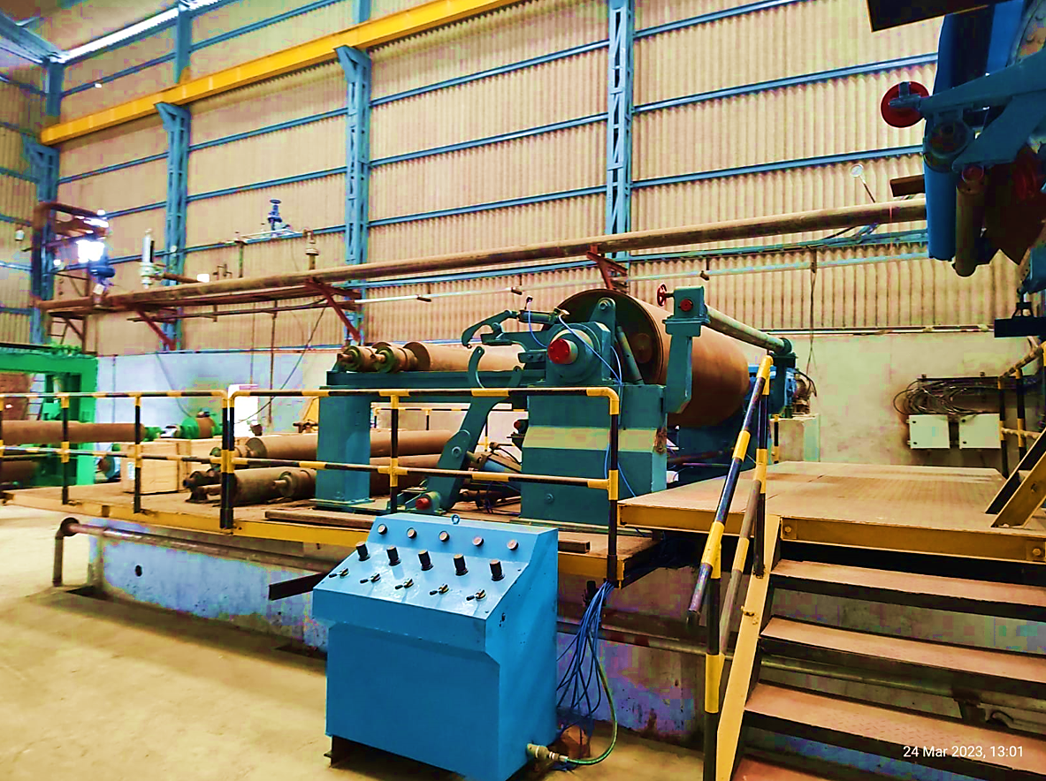
Rewinder
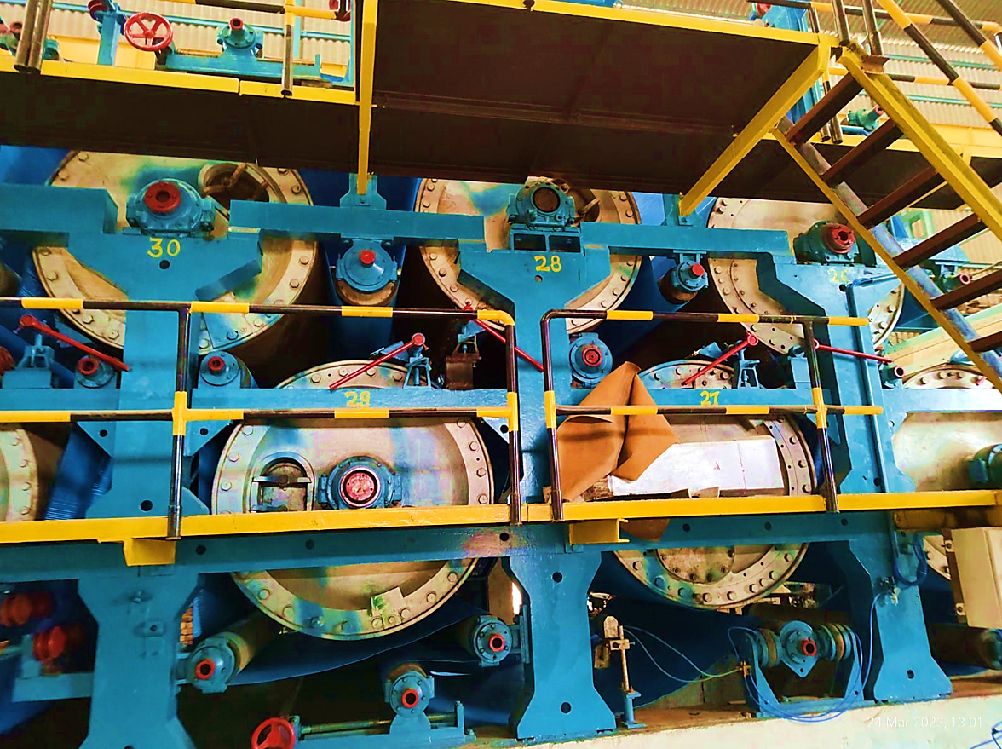
Dryers
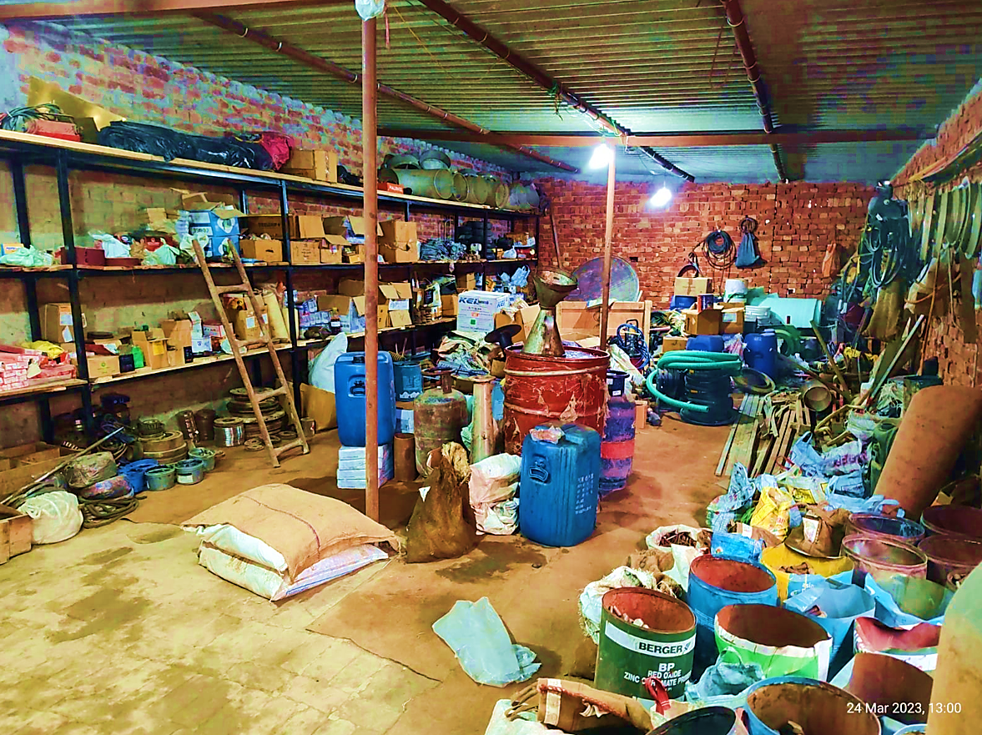
Store Room
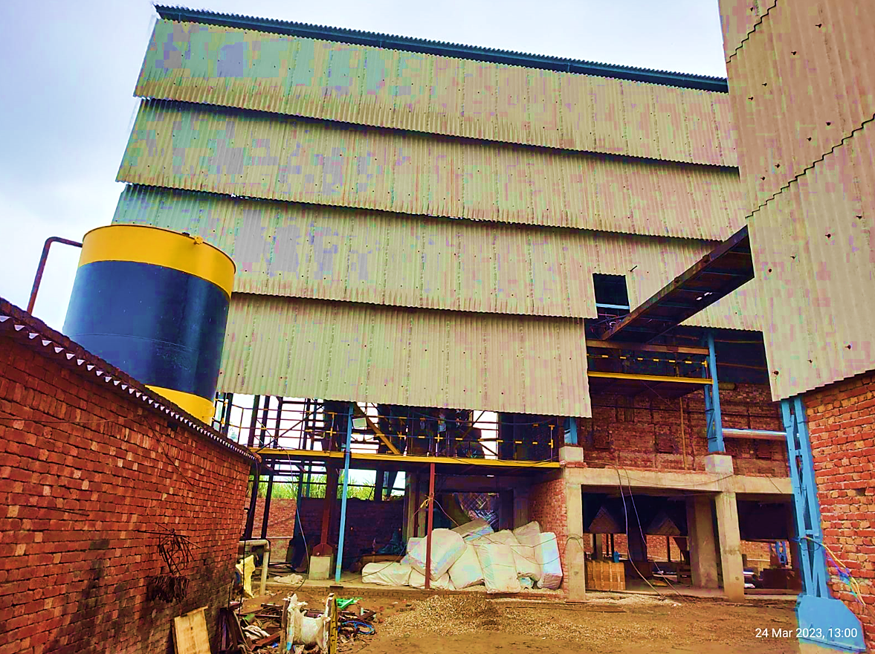
Boiler
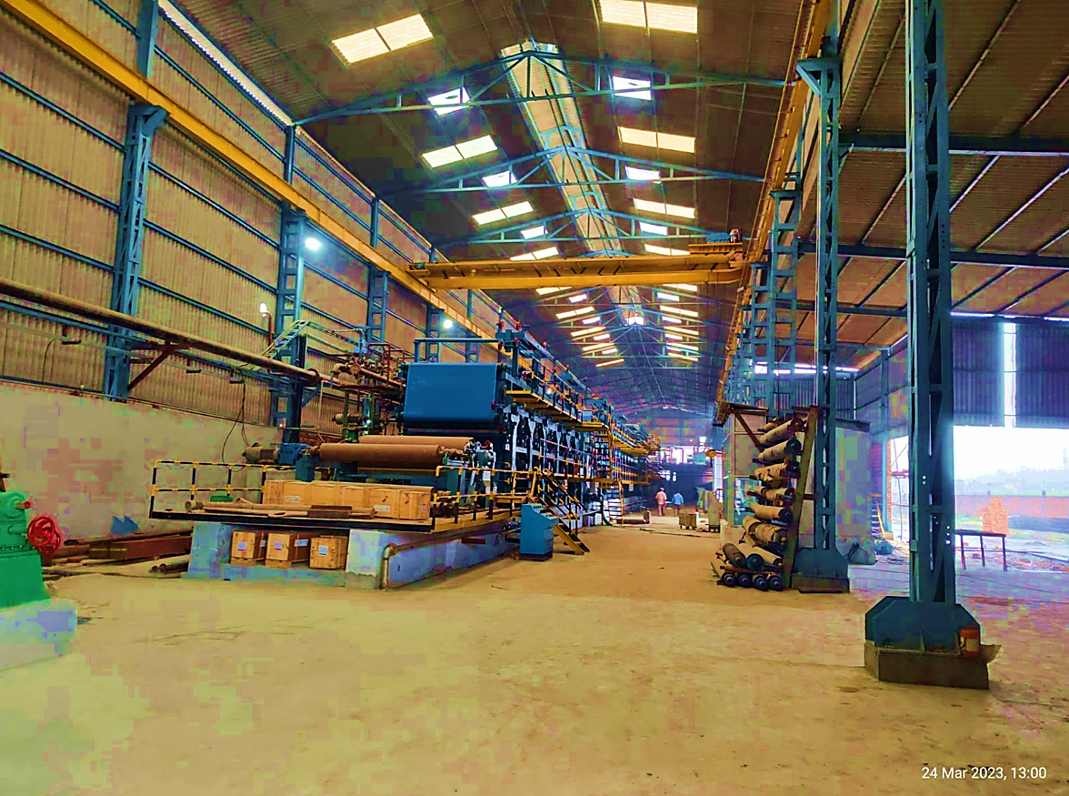
Paper Mill Shed
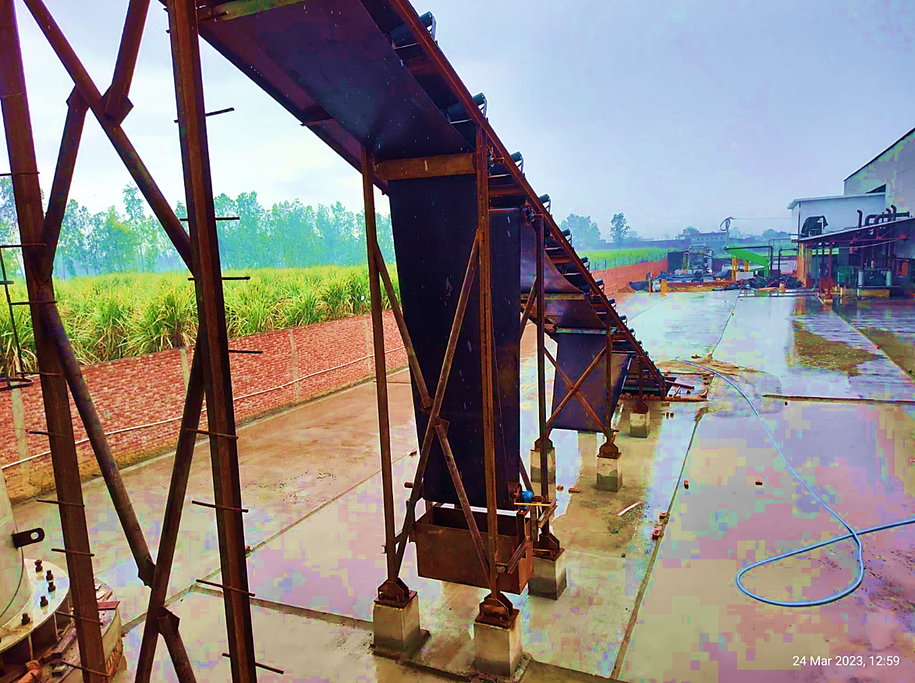
Boiler Convayer Belt
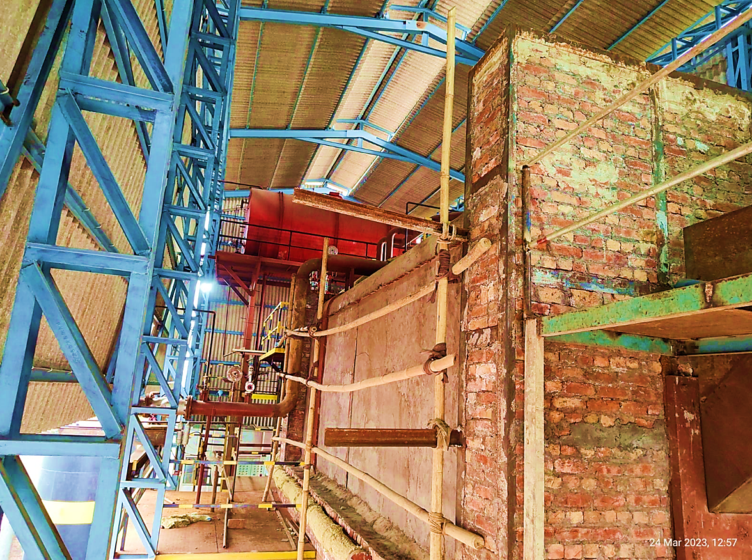
14 TPH Boiler
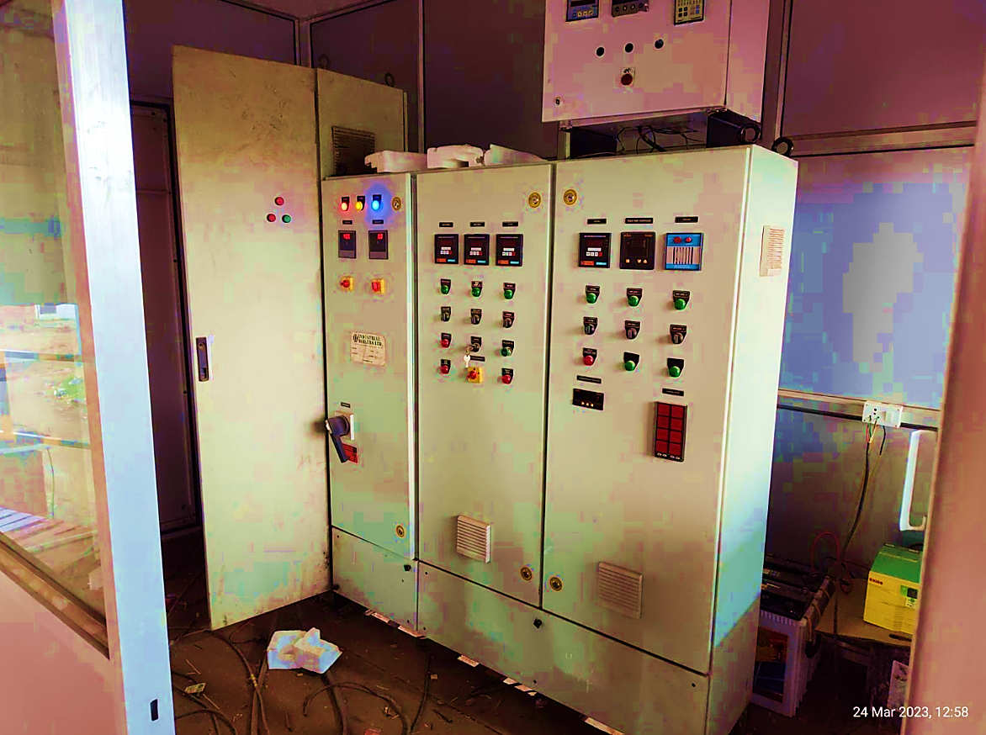
Boiler Control Room
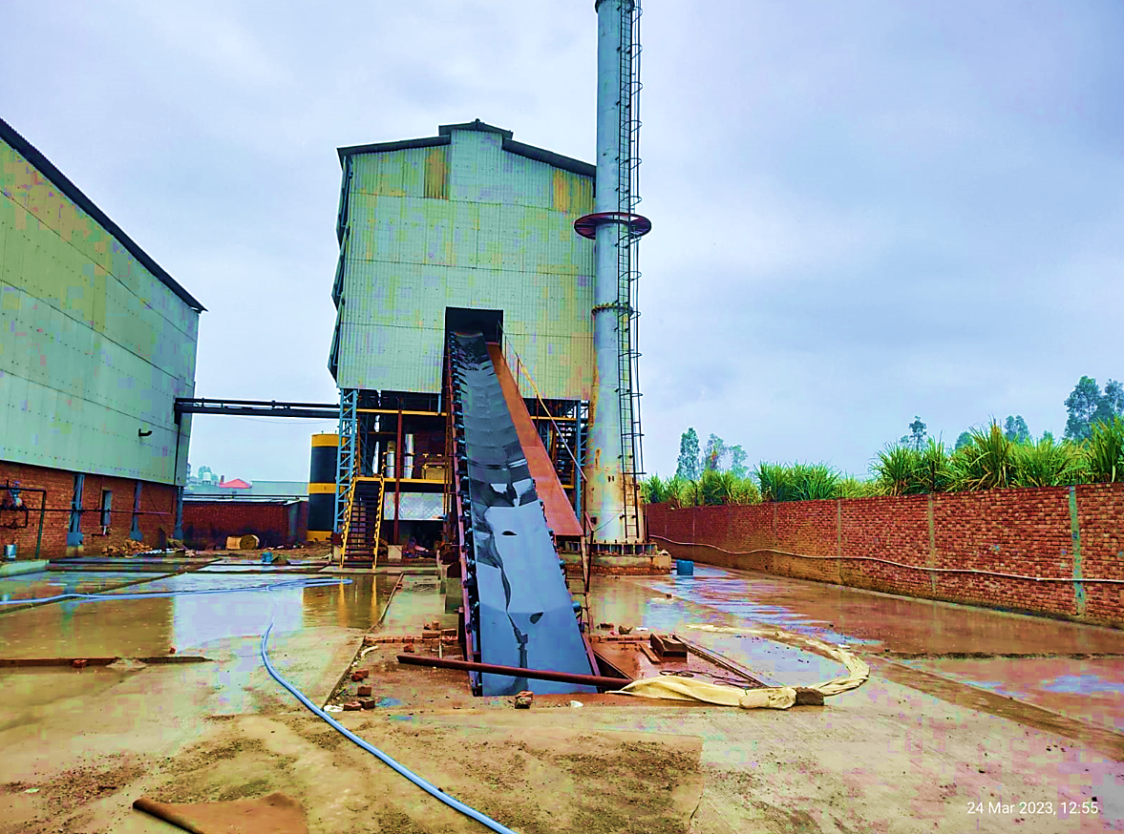
Boiler
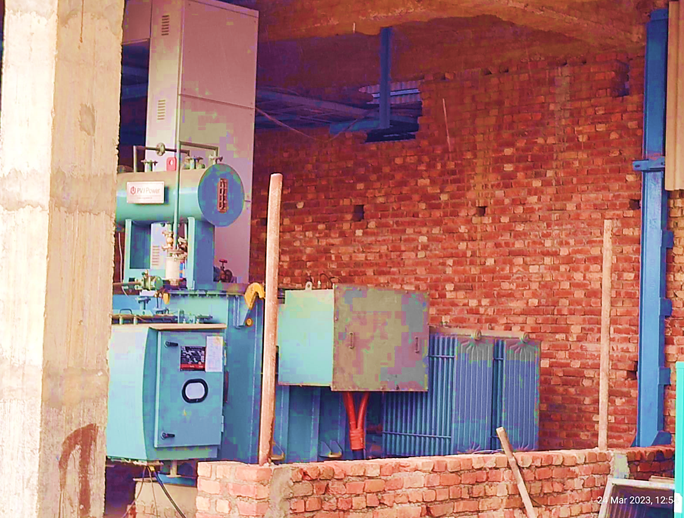
Tranformer
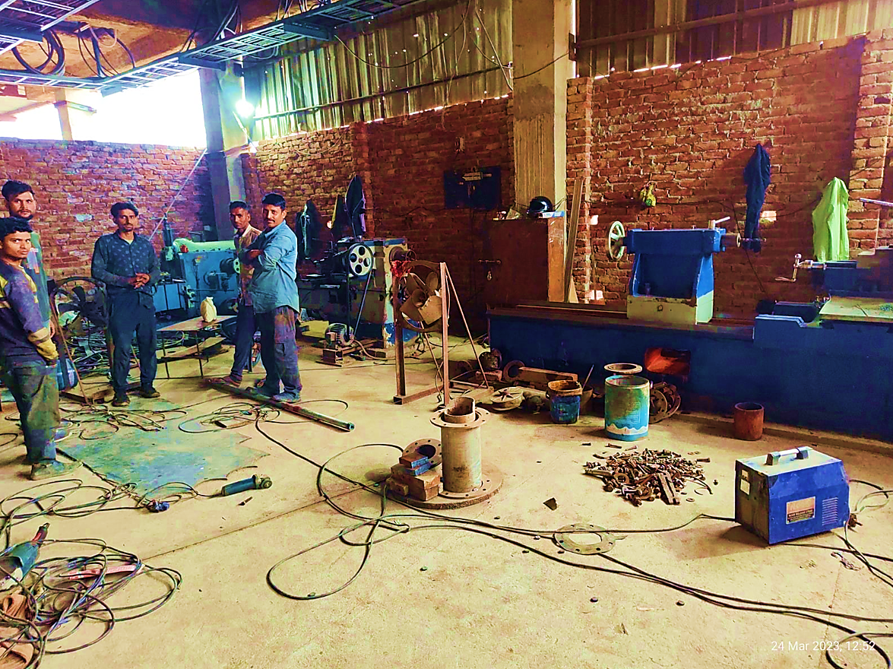
Work Shop
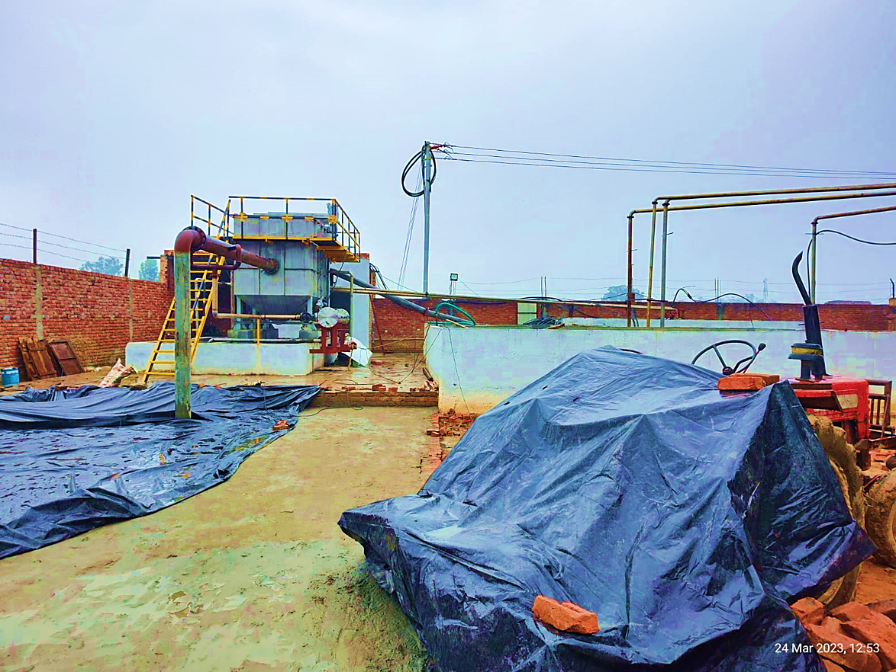
ETP
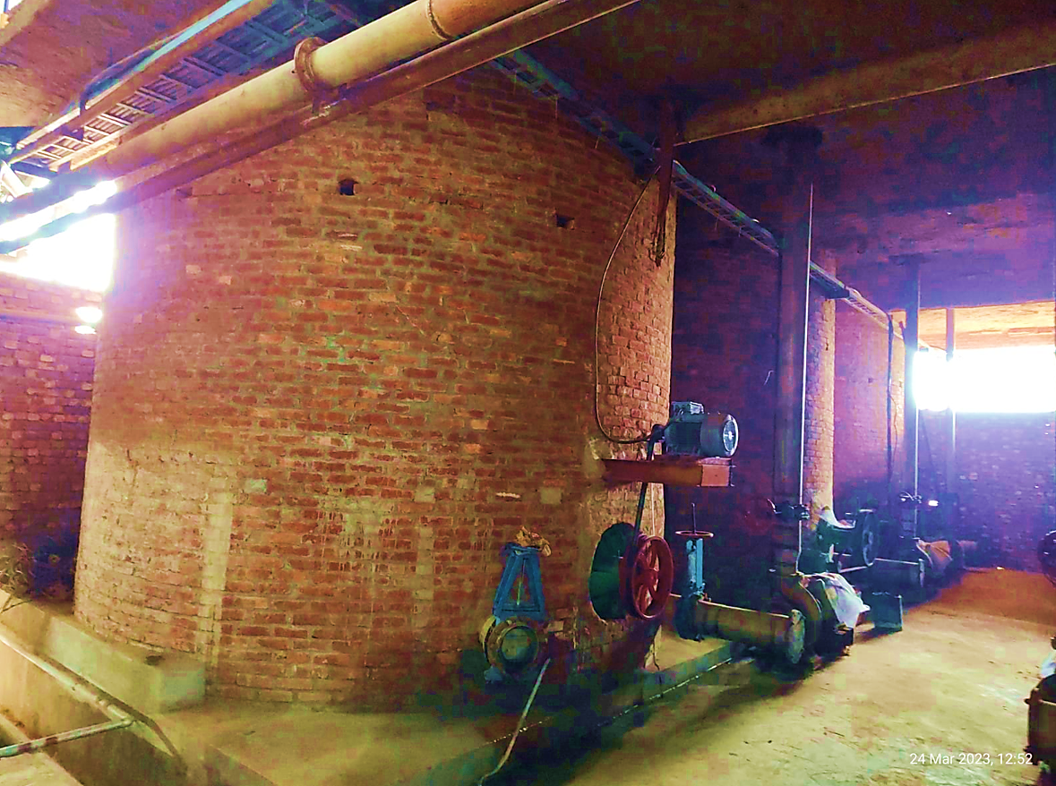
Pulp Pits
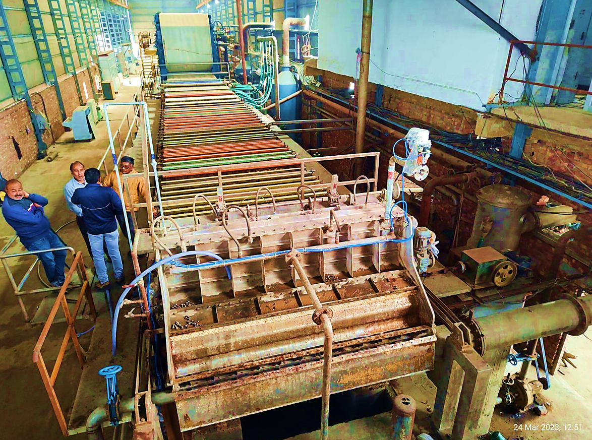
Wire Part
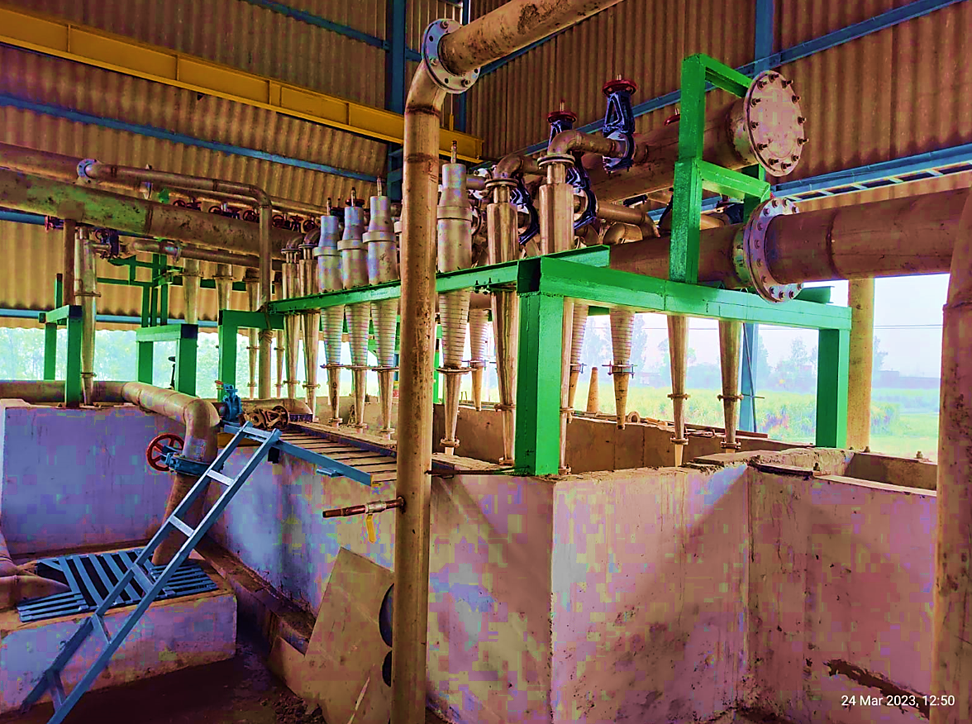
HD Cleaner
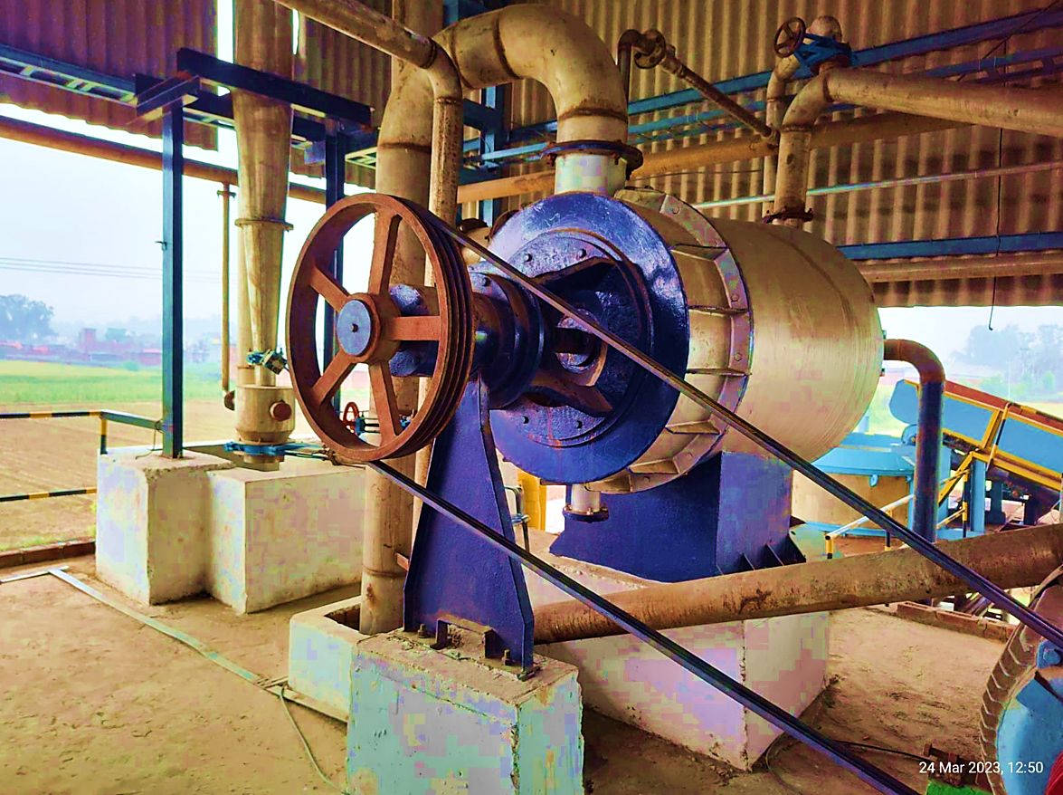
Drums
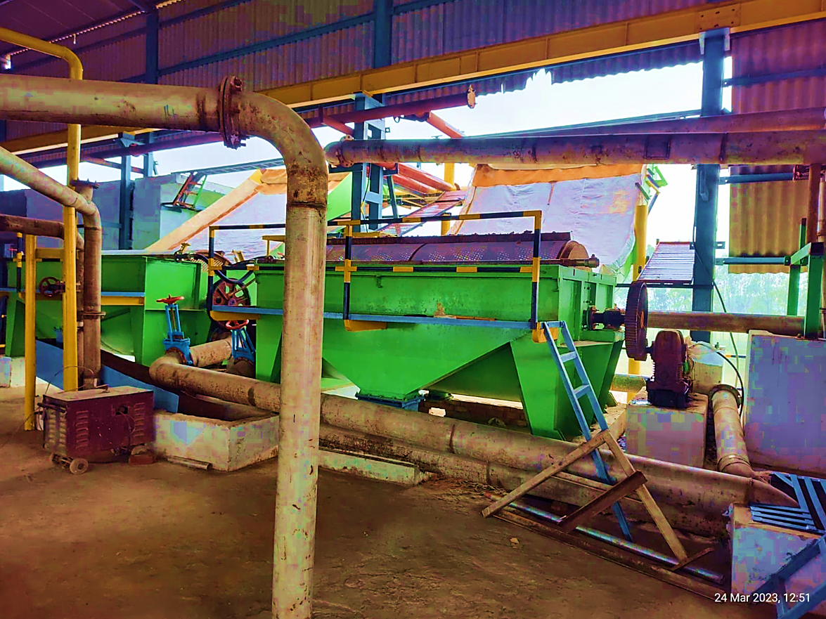
Screen
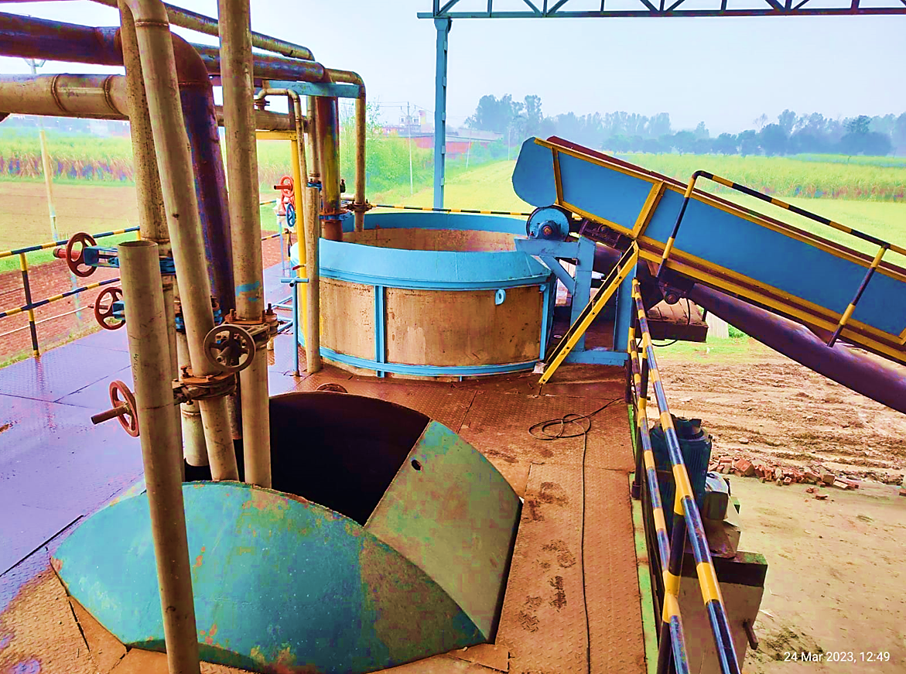
Pulper
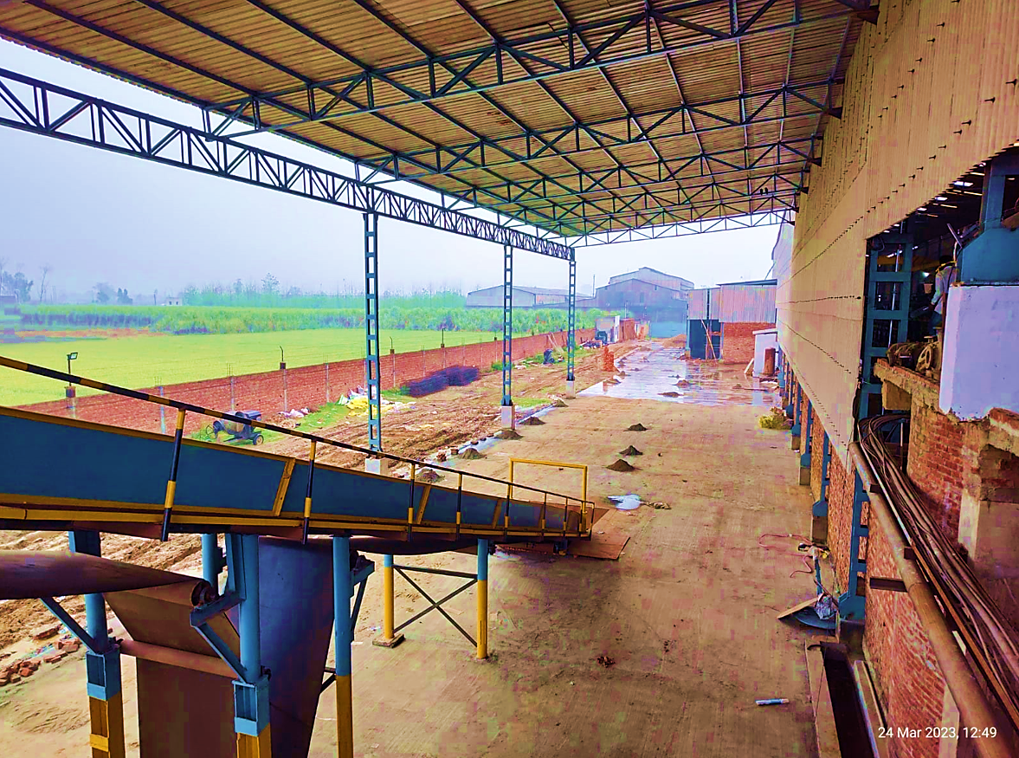
Raw Material Feeding Point
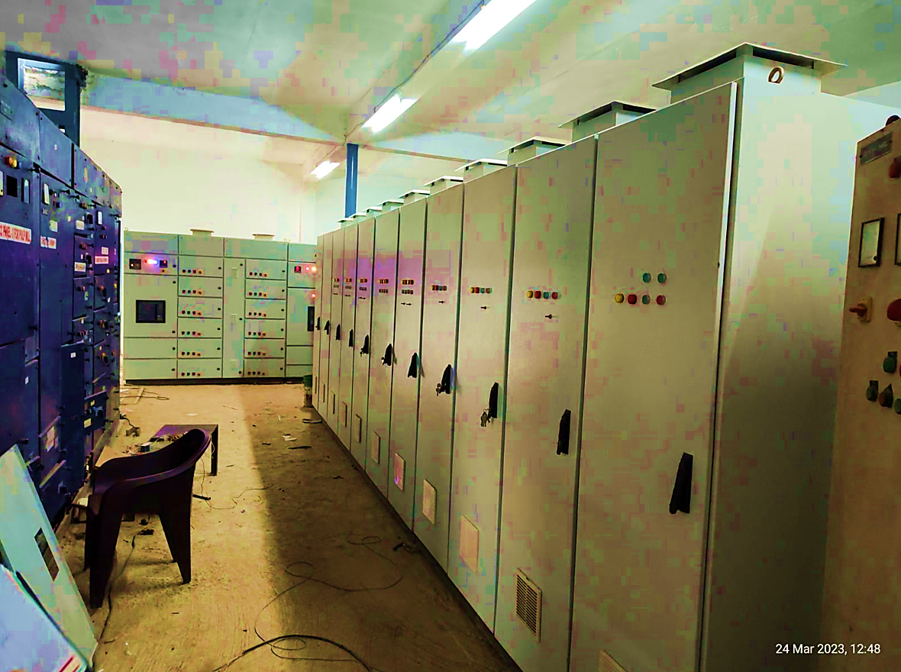
LT/HT Room

- BUILDING & CIVIL WORKS: The proposed kraft paper factory buildings shall be constructed per the sanctioned map plan. It will consist of the Buildings, cylo tank, CC pits, Seal Pit, Wire Pit, Sole Plate Foundation, Pulper Pit, Vacuum Pump room, Compressor Room, Boundary wall & Steel Gate and other utility areas for the smooth working of the proposed unit from here among other supportive facilities like adequate parking space and other public utilities. As per the information provided by the company all the construction work and civil work of the proposed plant is completed. Project is at a very promising conceptual stage of implementation. Below table shows the details about buildings:
S.No. | Item | Covered Area  (In sq ft) | Type Of Construction | Rate  (In Rs./sqft) | Amount  (In Rs. Cr.)
1 | Work Shed 300 X 48 X 33ft | 14,400 | A. C. Sheet roofing over steel column with Channel steel trusses | 200 | 0.29
2 | Vertical Chest 90 Cum.X 6 | 540 | A. C. Sheet roofing over Steel Column with tubelar Steel Trusses | 400 | 0.02
3 | Cylo Tank 20 cumX 1 |  |  | L.S. | 0.02
4 | CC Pits |  |  | L.S. | 0.01
5 | Seal Pit |  |  | L.S. | 0.01
6 | Wire Pit |  |  | L.S. | 0.01
7 | Sole Plate Foundation |  |  | L.S. | 0.01
8 | Pulper Pit |  |  | L.S. | 0.01
9 | Vacuum Pump room |  | 1st class brick work in C.M., RCC roofing slab | L.S. | 0.01
10 | Compressor Room |  | Steel doors & window CC flooring complete. | L.S. | 0.01
11 | Boundary wall & Steel Gate |  |  | L.S. | 0.05
TOTAL |  |  |  |  | 0.45

As per the survey done by us for the proposed kraft paper factory, Plant demarcated by boundary walls of height about 8 ft with wire fencing. Plant majorly comprises shade structure having Asbestos Cement (AC) roofing sheets. Staff rooms were found under construction during the site inspection.
- PLANT & MACHINERY (EQUIPMENT): Aramco Paper Mills Pvt Ltd is setting up a 120 TPD Kraft paper mill in Muzaffarnagar Nagar, Uttar Pradesh, however the capacity can be increased up to 125 TPD with respect to GSM of the Kraft paper. The mill is equipped with rolls and dryers from Servall Engineering, pulp mill equipments from Krofta Engineering Ltd, WF Filter Fabriks Pvt Ltd, Wires and Fabriks (S.A.) Limited, Gangotri Plasticisers Pvt Ltd etc and Industrial boiler from IBL.
As per informed by client Aramco paper mill have 36 rolls / Dryers, 6 pulp pits with per pit capacity of 3 tons, an industrial boiler with 14 tons of capacity, Kraft paper machine with capacity of 100 to 120 tons per day and 2450 mm deckle, Cylinder dryer of 1500 mm etc. All these machinery had been verified by us during the site visit on 24th March, 2023.
The waste paper based unit will produce final kraft paper product in 18 BF and 20 BF with an investment of Rs. 21.66 crores approx. The mill is expected to start with the commercial production by April, 2023 to cater the markets of Uttarakhand, Uttar Pradesh and Delhi NCR and Haryana. We have checked about the supplier companies for which quotations have been shared, which appears to be reputed and renowned suppliers for such type of machines as per information available on the public domain.
As per communicated by client and information available in public domain the new machinery cost estimates are assessed based on present market rates and offer received from vendors/suppliers. Also some parts of kraft paper machinery are pre-owned by company which are found in good condition during site visit.
- UTILITIES:
Details of Water, Electricity and other utilities are describes as below:
- Electricity: The power requirement of the proposed Unit is estimated at 1700 KVA which will be obtained from the U.P. electricity board, as per information provided by company, application for the same has already been submitted. Further Company will also install a turbine of 0.5 MW.

- Fuel: Company will be requiring 0.40 MT/Hr. fuel storage space to operate the diesel generator set to supply uninterrupted power supply to the facility in case of any power failure.

- Water: The source of water to meet the plant’s make up water requirement will be through Bore wells. Company had already obtained NOC certificate for ground water from Uttar Pradesh government.

PART E | PROJECT TECHNICAL DETAILS

- PROPOSED CAPACITY: The proposed High Quality Kraft Paper plant is for 39600 TPA manufacturing capacity. Below table shows the details of proposed capacity of the plant:
Year | Installed Capacity Mt | Capacity Utilisation% | Production in M.T. | Sales in M.T.
2024 | 39600 | 60% | 23760 | 23256
2025 | 39600 | 65% | 25740 | 25698
2026 | 39600 | 70% | 27720 | 27678
2027 | 39600 | 75% | 29700 | 29658
2028 | 39600 | 80% | 31,680 | 31638
2029 | 39600 | 85% | 33660 | 33618
2030 | 39600 | 90% | 35640 | 35598
2031 | 39600 | 95% | 37620 | 37578
2032 | 39600 | 100% | 39600 | 39558

- TECHNICAL SPECIFICATION OF THE PROPOSED FACILITY: For the proposed paper plant below table shows the details of major equipment, plant & machinery along with quantity and Amount:
List of Major Proposed Equipment’s, Plant & Machinery
S. No. | Item/Machine | Quantity | Amount in Crores
 | Kraft paper Machine
1 | Dryers | 36 | 1.800
2 | Wire Part | 1 | 1.100
3 | Head Box | 1 | 0.030
4 | Slotted Screen | 1 | 0.100
5 | Pope Reel | 1 | 0.080
6 | Turbo | 2 | 0.120
7 | Rewinder | 1 | 0.200
8 | Decker | 2 | 0.150
9 | All Frame | 1 | 0.550
10 | Dryer Cylinder- 1500 mm | 7 | 0.374
11 | Felt Drive Roll | 6 | 0.065
12 | Felt Roll | 150 | 0.103
13 | Felt Auto Guide | 14 | 0.091
14 | Felt Stretcher | 14 | 0.082
15 | Dryer Frame | 1 | 0.168
16 | Docter Blade Assembly | 28 | 0.098
17 | Paper Roll | 4 | 0.011
18 | Sole Plate | 20 | 0.055
19 | Sizing Chemical Kitchen |  | 0.180
20 | Vacuum Pumps |  | 0.497
21 | Bearings |  | 0.119
22 | Hydraulic System |  | 0.075
23 | D. Screen Felt |  | 0.081
24 | Wire Part Hirrofoils |  | 0.041
25 | Felt |  | 0.060
26 | Stature Set | 11
27 | Auto Gide | 12
28 | Agitator | 4
29 | Felt Roll Housing | 300 | 0.180
30 | Misc. Fitting Materials |  | 0.181
31 | Framings for Dryer, press section etc. |  | 0.320
32 | Reconditioning of Dryers |  | 0.050
33 | 2500 KVA Transformer |  | 0.199
34 | Line Charges & System Loading |  | 0.769
35 | Boiler (Complete) |  | 1.140
36 | Turbine (Complete) |  | 0.510
37 | E.T.P. (Complete) |  | 0.685
 | TOTAL |  | 10.266
 | ADD : GST @ 18% |  | 1.848
 | GRAND TOTAL |  | 12.114

List of Additional Proposed Equipment’s, Plant & Machinery
S. No. | Item/Machine | Quantity | Specifications | Amount in Crores
1 | Electric Motors | 7 | Electric Motors | 0.145
2 | Computers, Others | 10 | Computers, LED, Printers UPS | 0.074
3 | Electrcity |  | Common items used in electricity installation | 1.000
4 | Supply of Fabrocate Conveyor | 28.1 MTR, 2 Nos | Conveyor Rolls, Erection & Installation Charges, CI Spout | 0.082
5 | Ventuary wet Scrubber | 110 Kg. | Ventuary & Scrubber and Erection | 0.075
6 | Conveyor Belt | 48*2 MTR | Conveyor Belt | 0.024
7 | Steam Syste and Boiler Line Insulation |  | 24 Gauge Aluminium Sheet for insulation and laggaing charges | 0.195
8 | Screw Air Compressor | 1 | 230 CFM, 8 Kg., 50 HP Screw Compressor | 0.067
9 | H Type Press Frame, Steam Condensate Tank | 3 | 1st Press, 2nd & 3rd Press H - Type, Frame & Rolls, Steam Condensate Tank | 0.435
10 | Wire | 12 | Synthetic Fabric Wire for Dryer (5 Group) | 0.111
11 | Felt (Synthetic Fabric) | 2 | Synthetic Fabric Hyflex for Wire Part | 0.067
12 | Johnson Screen, Hill Screen, Conveyor | 2,2,120 Mtr | Jonson Screen, Hill Screen, Conveyor | 0.234
13 | Doctor Blades | 45 | PB Doctor Blade, Fiber Glass Epoxy | 0.015
14 | Cables | 9760 MTR | Cables for Plant | 0.287
15 | Automation | 9 Pcs, 400 MTR | Mitsubishi Make HMI, Relay, Multi-Channel cards, CC Link Cables, Lan Cables, Program Installation Charges | 0.081
16 | Panel Installation | 1 | VFD Control Desk & MCC Control Desk, PCC, MCC & VFD Panel And Installation | 0.085
17 | Drives VFD | 15 | Yashkawa VFD Drives | 0.185
18 | Various Electric Panels | 26 | Electric Panels, Control Deck, Bushbar, Control Box | 0.345
19 | Steel and SS Pipe Lines |  | Steel for Boiler, ETP Strucher & Pipe Lines | 0.473
20 | Micro Process Basis Weight Valve Actuator | 1 | Plant Automation | 0.020
21 | Calibration, Valve Controller, Sr Box |  | Valve Controller, Sr Box Control System and Calibrate, Annexure Attached | 0.036
22 | Forklift | 2 | Electric Forklift for 3 Tons | 0.320
23 | Rope Feeding System | 3 set | Rope Stretchers, Rope Pulley Set, Paper Role Pulley | 0.082
24 | Cascade Based Steam &Condensate | 1 | Forbes Marshall Cascade Steam System & Condensate | 0.210
25 | Turbine | 1 | Turbine | 0.600
 | TOTAL |  |  | 5.250
 | ADD : GST and Freight @ 20% |  |  | 1.050
 | GRAND TOTAL |  |  | 6.299

- TECHNOLOGY USED: The Company has informed that the Production Capacity of the plant will be 120 TPD and list of machinery provided by the company includes imported and domestic machines both. As per discussion with the company, the main kraft paper making machine is having 120 TPD production capacity. However, its auxiliary parts and equipment are being purchased for the same estimated production capacity.
The advanced technology-based Kraft paper machines can be semi-automated kraft paper machines or automated kraft paper machines. These Machines have advance technology they can improved the production rate of Kraft paper. The latest technology in kraft paper machineries is automatic PLC control system. A Programmable logic controller (PLC) is an industrial microprocessor-based controller with programmable memory used to store program instructions and various functions.
This high-end technology has paved the way to an easy manufacturing process in the pulp and paper industry. With the help of automatic PLC system, the machine gains ample speed and faster manufacturing with lesser human efforts. The increased speed reduced the time taken for manufacturing of the products and thus, saves energy and power.
As per information provided by company, it is producing recycled kraft paper. This type of kraft paper is developed from recycled paper and paper products. The fibres of recycled kraft paper are smaller in size and it has less bright appearance than other kraft papers.
Kraft paper machine used by company, mainly consists of three sectional systems namely forming section, press section, drying section, and lastly the calendar section. Kraft Paper machines systems are the drive systems that increase the performance of the machine and delivers improved quality of the paper. During the site visit we found that company is using fully automatic kraft paper machinery to produce kraft paper, which is based on advanced in kraft paper market.
We also found that new machinery cost estimates are assessed based on present market rates and offer received from vendors/suppliers. Also some parts of kraft paper machinery are pre-owned by company which are found in good condition during site visit.
As per the above technical analysis, M/s Aramco Paper Pvt. Ltd. is using the conventional technology which is a prevailing, going on, recognized and trending in the market at present. Thus based on the above analysis, it seems to be reasonable to comment that the company will be technologically viable by holding the ownership of the proposed equipment, plant & machinery.
- SOURCE OF PROCUREMENT OF EQUIPMENTS: As per the information shared by the company, they have finalize the vendors/ suppliers and the final negotiation with some vendors is in process. Below is the details of expected suppliers and equipments shared by the company:
Supplier of Major Proposed Equipment’s, Plant & Machinery
S. No. | Item/Machine | Supplier
1 | Kraft paper Machine | Gangotri Plasticisers Pvt Ltd
2 | Capacity 100-120 Ton /Day | Gangotri Plasticisers Pvt Ltd
3 | 120-200 GSM | Gangotri Plasticisers Pvt Ltd
4 | 2450 mm Deckle | Gangotri Plasticisers Pvt Ltd
5 | Dryers | Gangotri Plasticisers Pvt Ltd
6 | Wire Part | Gangotri Plasticisers Pvt Ltd
7 | Head Box | Gangotri Plasticisers Pvt Ltd
8 | Slotted Screen | Gangotri Plasticisers Pvt Ltd
9 | Pope Reel | Gangotri Plasticisers Pvt Ltd
10 | Turbo | Gangotri Plasticisers Pvt Ltd
11 | Rewinder | Gangotri Plasticisers Pvt Ltd
12 | Decker | Gangotri Plasticisers Pvt Ltd
13 | All Frame | Gangotri Plasticisers Pvt Ltd
14 | Dryer Cylinder- 1500 mm | Gangotri Plasticisers Pvt Ltd
15 | Felt Drive Roll | Gangotri Plasticisers Pvt Ltd
16 | Felt Roll | Gangotri Plasticisers Pvt Ltd
17 | Felt Auto Guide | Gangotri Plasticisers Pvt Ltd
18 | Felt Stretcher | Gangotri Plasticisers Pvt Ltd
19 | Dryer Frame | Gangotri Plasticisers Pvt Ltd
20 | Docter Blade Assembly | Gangotri Plasticisers Pvt Ltd
21 | Paper Roll | Gangotri Plasticisers Pvt Ltd
22 | Sole Plate | Gangotri Plasticisers Pvt Ltd
23 | Sizing Chemical Kitchen | Gangotri Plasticisers Pvt Ltd
24 | Vacuum Pumps | Kakati Karshak Industries Private Limited
25 | Bearings | CTC Impex (India) Pvt Ltd
26 | Hydraulic System | ACE Automation Engineers
27 | D. Screen Felt | Wires & Fabrics(S.A.) Ltd
28 | Wire Part Hirrofoils | Bhilwara Hi-Tech Engineering
29 | Felt | Dinesh Felts
30 | Stature Set | Bhagwati Engineering Works
31 | Auto Gide | Bhagwati Engineering Works
32 | Agitator | Bhagwati Engineering Works
33 | Felt Roll Housing | Bhagwati Engineering Works
34 | Misc. Fitting Materials | Agarwal Mill Store
35 | Framings for Dryer, press section etc | Stark Engineering Pvt Ltd
36 | Reconditioning of Dryers | Stark Engineering Pvt Ltd
37 | 2500 Kva Transformer | PVJ Power
38 | Line Charges & System Loading | Sharma Electric Works
39 | Boiler (Complete) | Industrial Boilers Ltd
40 | Turbine (Complete) | IB Turbo Private Limited
41 | E.T.P. (Complete) | Shri Krsna Envirotech

Supplier of Additional Proposed Equipment’s, Plant & Machinery
S. No. | Item/Machine | Supplier
1 | Electric Motors | Verma Engineers
2 | Computers, Others | Shri Tirupati Infotech
3 | Electrcity | Sharma Electric Works
4 | Supply of Fabrocate Conveyor | Shree Radhey Enginring Works
5 | Ventuary wet Scrubber | Shree Radhey Enginring Works
6 | Conveyor Belt | Manpreet Trading Company
7 | Steem Syste and Boiler Line Insultion | R S Industries
8 | Screw Air Compressor | Aiura Air Compressure
9 | H Type Press Frame, Steam Condensate Tank | Stark Enginering
10 | Wire | WF
11 | Felt (Sythentic Fabric) | Wires & Fabric
12 | Jhonson Screen, Hill Screen, Conveyor | Bhagwati Engineering Works
13 | Doctor Blades | Marg Engineering
14 | Cables | Mahendra Electric Works
15 | Automation | Falcon Automation
16 | Pannel Instlation | Aavni Electricals
17 | Drives VFD | Eletromech Engineers
18 | Various Eletric Pannels | Eletromech Engineers
19 | Steel and SS Pipe Lines | Goel Glass Emporium
20 | Micro Process Basis Weight Valve Actuator | A to Z Instrument & Automation
21 | Calibratation, Valve Controller, Sr BoX | A to Z Instrument & Automation
22 | Forklift | Satya Forklift
23 | Rope Feeding System | Shivalik Engineering Works
24 | Cascade Based Steam &Condensate | Forbes Marshal
25 | Turbine | IB Turbo

- TESTING/QUALITY ASSURANCE FOR FOAM MANUFACTURER: Quality is an important ingredient of kraft paper manufacturing process. Utmost emphasis is placed on the quality of the products of the company. Every Kraft Paper Product undergoes stringent quality tests, across various parameters, at different stages of manufacture. Below are the list of critaria to check the quality of the product:
- Strength
- Burst, Tear and Moisture
- GSM (Grams per Square Meter)
- Load Bearing Capacity
- Surface Finish
- Cobb Value
- Dimensions
All tests are conducted at company’s Quality Assurance laboratory under the supervision of the Quality Inspectors. All the contemporary machines are equipped for efficient drying and quality control. This ensures the production of high quality Kraft Paper with uniform and superior basis weight and moisture that meet International Quality Standards. The multiple-wire paper gives amazing tear strength and stiffness to Kraft Paper. The automatic control equipment ensures high conversion yields while maintaining Burst Factor (BF). The perfectly wound reels can be used all the way to the core without any wastage and with minimum changes to the corrugating machine.
- MANPOWER: As per information shared by the client/company, an estimate of manpower requirement allowing for leave, absentecism, sickness and holidays for smooth and for efficient operation of different sections of the kraft paper manufacturing plant, including all of its departments, has been prepared based on technical, skills and management ground primarly to indicate the order of manpower requirement.
In estimating the manpower requirement, a proper ratio between the administrative & managerial staff, Machanical Engineer, Foreman, Fitter, Electrical Engineer, manager (Quality Control), General Manager, Manager (Pulp Mill), Manager - Finance & Accounts, Purchase Manager, Shift Incharge, Workmen – unskilled, Chemist, Stores Executives, Godown Assistants, Time Office Assistants, foor staff has been maintained with a view to affording proper industrial and professional management at various levels.
As per information provided by the company, they have estimated around 75 workers will be required when paper manufactoring plant will be operational. The basic structure of the manpower will require the following kind of resources:
S.No. | Particulars | Nos. | Expected Salary | Amount (INR)
Production Staff
1 | Mechanical Engineer | 1 | 25000 | 300000
2 | Foreman | 1 | 25000 | 300000
3 | Fitter | 5 | 15000 | 900000
4 | Electrical Engineer | 1 | 20000 | 240000
5 | Manager (Quality Control) | 1 | 15000 | 180000
6 | Shift In-charge | 9 | 10000 | 1080000
7 | Workmen - unskilled | 40 | 7500 | 3600000
8 | Chemist | 2 | 15000 | 360000
 | Total | 60 |  | 6960000
 | Amount in Crores |  |  | 0.70
 | Add: 10% for Fringe Benefit in Crores |  |  | 0.07
 | Total Salary of Production Staff for 1st Year in Crores |  |  | 0.77

S.No. | Particulars | Nos. | Expected Salary | Amount (INR)
Administrative & Managerial Staff
1 | General Manager | 1 | 75000 | 900000
2 | Manager (Pulp Mill) | 1 | 25000 | 300000
3 | Stores Executives | 2 | 15000 | 360000
4 | Godown Assistants | 2 | 12000 | 288000
5 | Time Office Assistants | 1 | 8000 | 96000
6 | Purchase Manager | 1 | 15000 | 180000
7 | Manager - Finance & Accounts | 1 | 40000 | 480000
8 | Clerical & Office staff | 4 | 15000 | 720000
9 | Peons and miscellaneous helper | 2 | 7500 | 180000
 | Total | 15 |  | 3504000
 | Amount in Crores |  |  | 0.35
 | Add: 10% for Fringe Benefit in Crores |  |  | 0.04
 | Total Salary of Administrative Staff for 1st Year in Crores |  |  | 0.39

PART F | PRODUCT PROFILE

- INTRODUCTION:
Kraft paper is the most used material in packaging. It is made by the sulphate pulping process. The product to be manufactured under the envisaged project is high B.F. Kraft paper, which is the most important raw material in the Packaging Industry particularly after the ban on plastic.
The major raw materials used by the company for production of High-quality Kraft Paper are: Imported Waste Paper and Indian Waste Paper. The ratio of Imported Waste Paper and Indian Waste Paper in raw-materials mix is kept at approximately 15% & 85% and yield of 90% to 92% respectively to produce High quality Kraft Paper of required strength. Further, Some Chemicals like Caustic Soda, Rosin & Starch etc. are used as per requirement during the process of manufacturing.

- PRODUCT CATEGORY:
- 18 BF KRAFT PAPER, GSM: 120 – 200: M/s Aramco Paper Private Limited produces 18 BF Kraft Paper. Company source quality range of Kraft papers, which is available in various length and thickness as per the client' specifications. Company’s array of Kraft papers is made with premium grade paper pulp owing to which the products have deluxe fair surface, smoothness and high strength. These Kraft papers are used in varied paper based applications due to their perfect finishing and high seal-ability. Furthermore, Aramco’s range is also suitable for any type of cartons for FMCG products.
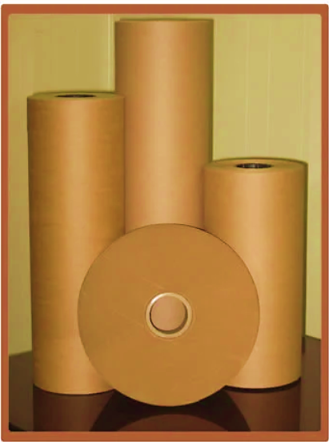
- 20 BF KRAFT PAPER, GSM: 120 – 200: M/s Aramco Paper Private Limited is presenting an excellent quality assortment of 20 BF Kraft Paper. With the assistance of the dedicated team of professionals, company is providing a premium quality range of 20 BF Kraft Paper Roll.
These Kraft Papers are used for roll type packaging. Company’s capacious warehouse is installed with all required amenities essential for safe storage of the products. Furthermore, the warehousing system is efficiently managed by the team of experts. M/s Aramco is one of the steadfast providers of the finest range of the product in Muzaffarnagar (India).


- MANUFACTURING FLOW CHART: Below is the manufacturing flow chart of Kraft paper production for M/s Aramco paper mill:
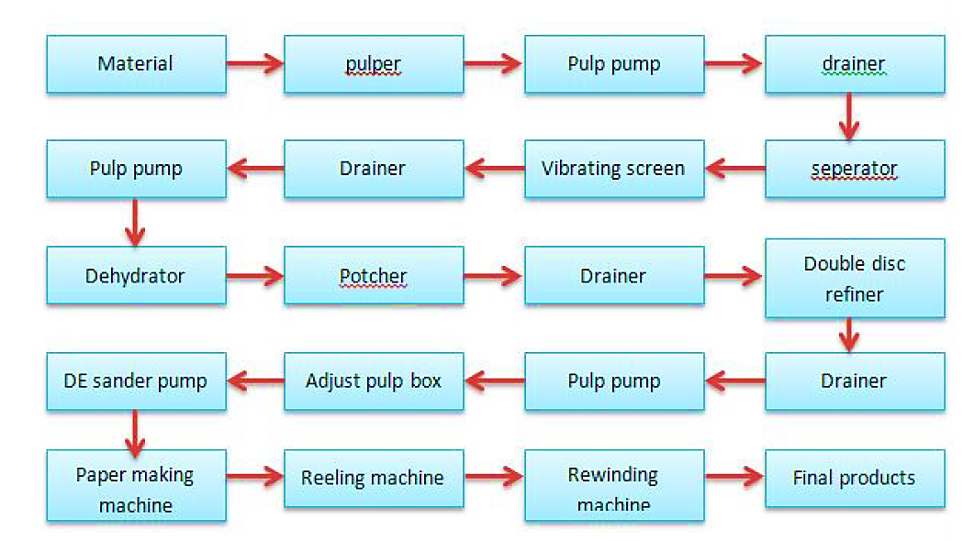
- MARKETING, SELLING & DISTRIBUTION PLAN:
The pulp & paper industry is witnessing interesting times. While there has been a rapid decline in the demand for newsprint over the last few years, whereas the packaging segment is doing phenomenally well. Growth in FMCG products like packaged beverages & personal care products, evolving e-commerce sector, and the ban on single-use plastics are some of the major demand drivers.
All these exciting changes in the industry have paved the way for new opportunities. However, for a business to succeed, the products must be known to potential buyers. Hence, it is the appropriate time for paper manufacturers to develop marketing strategies and use them to create product awareness. Marketing helps to boost brand awareness; it provides life to each and every department by tackling an array of functions such as research, advertising, public relations, digital, data analysis, customer service, and communications.
As per information provided by the company: engaging with customers, understanding product quality, and providing good services are the three marketing mantras of M/s Aramco Papers. Company will sell its products through local distributers in the market.
As per our market research and information available in the public domain, some of the top most competitor of M/s Aramco Papers Pvt Ltd in a range of around 80-100km of muzaffarnagar. M/s Aramco knows that Intertwining empathy and marketing is extremely important. When marketers know their customers, they are able to connect with them on an emotional level and develop a product as per their requirements. This will be a win-win situation for both the businesses as well as the consumers.
We also found that company is developing its own website, it is under construction. Once the website will be ready, it will also give online exposure of selling of the products of the company.

PART G | INDUSTRY OVERVIEW & ANALYSIS

- INTRODUCTION:
Kraft paper refers to a strong paperboard material that is composed of recycled materials or wood pulp produced in the Kraft process. The pulp is bleached with chemicals to enhance the thickness, durability, and strength of the fibres while sustaining lightweight characteristics. Some common varieties of Kraft paper include white, printed, coloured, black, etc. They can be easily recycled, reused, and decomposed completely. As a result, Kraft paper is widely utilized in numerous packaging applications, including envelopes, bags, sacks, composite cans, pouches, cartons, etc.

- MARKET OVERVIEW: The India Kraft paper market size reached 9.4 Million Tons in 2022. Looking forward, it is expected that the market will reach to 15.6 Million Tons by 2028, exhibiting a growth rate (CAGR) of 8.9% during 2023-2028.
The growing usage of compostable and sustainable packaging materials owing to the increasing awareness regarding the detrimental impact of plastic and other non-biodegradable variants is primarily propelling the growth of the Indian Kraft paper market. In addition to this, the elevating use of Kraft paper in gift wrapping, events, weddings, etc., due to its colourful creativity, aesthetic appeal, and textured properties, is also fuelling the market growth.
Furthermore, the escalating demand for highly technical saturated Kraft paper in the construction sector to meet unique needs related to countertop, partition and flooring applications is acting as another significant growth-inducing factor.
Also the inclination of millennials towards crafting, rises the demand for Kraft paper that fuelling the market of the paper machine. Also, this paper is the best option for a simple, biodegradable, and cheap snack holder.
In the market there are different varieties of Kraft papers are available for the holding of chips, pastries, burgers, and many other food purposes. So there is a good option for the people to invest in the papermaking machine market and generate more revenue.
Kraft papers, chemical production, increases the elasticity and tear resistance, enhancing the strength and durability of the paper which is used for multiple purposes such as packaging. Paper, derived from wood pulp, is an essential part of the human world especially when it comes to education and the literacy world. Kraft paper and paper board with high tensile strength and gram mage of 40 to 135 g/m2 can be made from various raw materials which take 45 to 50 percent of the total cost of production which is mostly extracted from the forest with an average estimated percentage of 43, agro-based raw materials comprising of 28 percent, and other with 29 percent. The traditional form of using paper is still in huge demand and see no future without it even with the modernized world, the paper industry is grounded deepening its core value in the life of humans.
As per the data released by Centre for Monitoring Indian Economy (CMIE), there have been around 73.5 lakhs job losses in April 2021 alone. Indian Kraft paper industry is fragmented across India and not even a single mill has more than 1% of market share, mostly all are into the MSME Sector and there are around 600 mills scattered across the country. Most of these units are located at some of the most backward and offer millions of jobs to rag pickers, sorters, loaders, unloaders, truckers, etc. These Kraft paper mills are real eco-friendly turning waste paper into a quality Kraft Paper. It’s the paper waste recyclers who handle the waste and produce good quality packaging paper and supply to the converters who make the boxes for the end consumers.

- KEY MARKET PLAYERS: Mondi (Austria), Segezha group (Russia), Klabin(Brazil), Billerudkorsnas (Sweden), Stora Enso (Finland), Daio Paper constrution (Japan), Nordic Paper (Sweden), Glatfelter(US), and Gascogne Papier (Austria) are the key players operating in the kraft paper market.

- TECHNOLOGIES AND RELATED ISSUES: Large number of industries has been facing issues due to obsolescence of technology used by them for paper making operations. The major problem in upgradation and modernization is due to the high capital requirement for up gradation and scale of operation at which no standard state of the art equipment and machinery are available.

The large number of small and micro level units operating in India face problems in technology up gradation, as most of them are based on decade’s old machinery. Three segments of industry namely-wood, agro and recycled fibre based have different technological levels. Many of the agro and recycled paper mills still use conventional process technology which is otherwise obsolete by international standards. Some of the wood based mills and few agro / recycled mills have upgraded the technology from time to time for improvement in the quality of paper, energy efficiency and reduction in the pollution load.
There have been remarkable developments in technology in global paper industry particularly in US and Europe which have resulted in optimal use of inputs, resulting in cost effective production along with reduced environmental loads. Even neighboring countries like China, Malaysia, Indonesia and Thailand have kept pace with the technological advancement and paper industry in these countries have achieved the benefits of advanced technology.
The foremost difference between the Indian paper industry and global leaders lies in the economies of scale. As compared to international capacities, we lag far behind. Scandinavian countries, USA, the Russian Federation, China, Indonesia and Japan are the major players in the field of pulp and paper. These countries have some of the best available raw materials for paper production, cutting edge technologies and control the global trade. However, only a few mills in India employ the state-of-art technologies. One of the serious implications of technological obsolescence is the environmental impact which can be overcome only through appropriate technology upgradation and modernization.
To address the various issues, the need for technology upgradation and modernization in Indian paper industry is strongly emphasized as level of technology in Indian paper industry is lagging behind as compared to that in developed countries. The technological interventions required to fulfil the technology gaps may be taken up through a dedicated technology modernization programme in the wood and agro based & recycled fibre based paper mills. Technology modernisation should basically aim to improve the competitiveness of industry through acquisition of state-of-art technologies. This can be achieved through:

- Acquisition of proven technology of foreign or indigenous origin/design and drawing.
- Acquisition / license of patent rights.
- Acquisition of capital goods for transfer of process technology.
- Contractual R&D activities leading to technology upgradation of the units.

The technology modernisation & upgradation should lead to emergence of core competencies in critical areas including quantifiable increase in productivity, quality improvement with reduced cost, improvement in energy efficiency norms and better compliance with environmental protection legislations, safeguards for Eco sustainability of products as well as also compliance with legislation relating to patent as per the WTO regime. Issues faced by paper industry:

- Raw material upgradation.
- Resource conservation.
- Product quality.
- Process improvement.
- Energy conservation.
- Environmental compliance.
- Research & Development.

- STATUS OF TECHNOLOGY IN INDIA: The foremost difference between the Indian paper industry and global leaders lies in the economies of scale. As compared to international capacities, India lag far behind. Scandinavian countries, USA, the Russian Federation, China, Indonesia and Japan are the major players in the field of pulp and paper. These countries have some of the best available raw materials for paper production, cutting edge technologies and control the global trade.
However, only a few mills in India employ the state-of-art technologies. Table below shows variety wise production of paper by different categories of mills in India, the status of technologies employed by these mills and their comparison with the major global paper producing countries.

Variety of paper | Globally |  | India
 | World’s leading manufacturers | Cutting edge technologies used | No. of Mills using advanced technology | Status of technology in Indian mills
Printing + Writing / Coated / uncoated Wood free paper | USA Germany Brazil Indonesia Turkey China Italy Japan Finland | - Proficient debarking & chipping systems | 5 wood based mills and 3 agro based mills | - Low Kappa pulping, ECF bleaching, Efficient washing, screening, cleaning & chemical recovery systems in 5 wood based mills
Printing + Writing / Coated / uncoated Wood free paper |  | - Low Kappa pulping, Efficient washing screening & centric leaning | 5 wood based mills and 3 agro based mills | - Drum Pulpers and efficient deinking systems in RCF based mills.
Printing + Writing / Coated / uncoated Wood free paper |  | - ECF & TCF Bleaching Efficient chemical recovery | 5 wood based mills and 3 agro based mills | - Only 3 mills have paper machines above 1000 m/min speed
Printing + Writing / Coated / uncoated Wood free paper |  | - Modern high speed paper machines | 5 wood based mills and 3 agro based mills
Packaging /Wrapping other paper | USA Turkey China Germany Italy Australia Sweden Finland | - Low Kappa Pulping | 3 wood based mills, 6 RCF based mills | - Low Kappa pulping, Efficient washing, screening, cleaning & chemical recovery systems in 3 wood based mills.
Packaging /Wrapping other paper | USA Turkey China Germany Italy Australia Sweden Finland | - Efficient washing & chemical recovery | 3 wood based mills, 6 RCF based mills | - Drum pulpers & pulp screening and cleaning systems in 6 RCF based mills
Packaging /Wrapping other paper | USA Turkey China Germany Italy Australia Sweden Finland | - modern high speed paper machines | 3 wood based mills, 6 RCF based mills
Newsprint | Canada China Japan USA Germany | - High yield pulping | 1 wood based mills, 10 RCF based mills | - CTMP pulping in 1 wood based mill.
Newsprint | Canada China Japan USA Germany | - Efficient washing | 1 wood based mills, 10 RCF based mills | - Hi consistency pulpers and deinking systems in 6 RCF based mills.
Newsprint | Canada China Japan USA Germany | - Modern high speed paper machines with super calendar | 1 wood based mills, 10 RCF based mills | - 4 high speed machines with calendars
Household & Sanitary Paper | USA China Japan Italy Turkey | - Low Kappa pulping | 2 wood-based mills | - 2 modern paper machines in wood based mills
Household & Sanitary Paper | USA China Japan Italy Turkey | - Efficient washing, screening & cleaning | 2 wood-based mills
Household & Sanitary Paper | USA China Japan Italy Turkey | - Modern stock preparation and additives systems. | 2 wood-based mills
Household & Sanitary Paper | USA China Japan Italy Turkey | - Modern tissue paper machines | 2 wood-based mills

The India Kraft paper market size reached 9.4 Million Tons in 2022. Looking forward, it is expected that the market to reach 15.6 Million Tons by 2028, exhibiting a growth rate (CAGR) of 8.9% during 2023-2028.
The rising focus of the Indian government authorities on banning the use of plastics is also creating a positive outlook for the Kraft paper market across the country. For instance, in June 2022, the Central Pollution Control Board (CPCB), a federal agency under the Ministry of Environment, issued a list of steps to be taken to prohibit the use of specific single-use plastic products. Numerous other factors, such as the inflating popularity of Kraft paper in the printing and publication sectors and the introduction of advanced packaging solutions, including stand-up pouches, zipper pouches, etc., are anticipated to stimulate the Indian Kraft paper market over the forecasted period
Paper consumption in India is likely to witness 6 to 7 per cent annual growth and will reach 30 million tonnes by FY 2026-27, largely driven by emphasis on education and literacy coupled with growth in organised retail, according to industry body Indian Paper Manufacturers Association (IPMA).
The paper Industry holds immense potential for growth in India as the per capita consumption globally is one of the lowest. Around 15 per cent of the world population stays in India but consumes only 5 per cent of the total paper produced in the world. Paper Industry in the country has undergone a transformation of sorts in the last few years. The industry has gone up the sustainability curve and has become far more technologically advanced.

PART H | SWOT ANALYSIS

SWOT ANALYSIS OF KRAFT PAPER INDUSTRY

PART I | PROJECT COST AND MEANS OF FINANCE

As per data/information shared by the client, below are the details of Total project Cost (TPC) and means of finance for the same. Category wise proposed project cost is shown in the below table:
INR (Crores)
PROJECT COST
PARTICULARS | Amount
HARD COST
Land & Site Development | 0.00
Building & Civil Works | 0.45
Plant & Machinery | 12.11
Plant & Machinery- Additional | 6.30
Misc. Fixed Assets | 0.12
SOFT COST
Interest During Construction Period | 0.49
Escalation & Contingencies | 0.57
Pre-Operative Expenses | 0.07
Security Deposit | 0.33
Margin Money For W/C | 1.22
Total Project Cost | 21.66
Note: Cost projections have been provided by the company.

MEANS OF FINANCE
PARTICULARS | Proposed
Promoters Contribution | 6.60
Unsecured Loans | 3.06
Bank Finance (Term Loan) Existing | 8.00
Bank Finance (Term Loan) Additional | 4.00
Total | 21.66
Notes:
- Since the Land has been procured on the lease basis for 30 years for a nominal charge of INR 60,000 per year, which is not a capitalised charge and will be expensed out on a yearly basis. Hence, we have not considered it as a part of TPC.
- Civil construction cost is borne by the promotors from their own contributions which is costing approximately INR 45 lakhs including GST, plumbing, electrification, supervision charges.
- Plant & Machinery cost has been taken as per the details provided by the client and as per the break-up, the total cost of INR 18.41 Crores has been considered including GST & transportation cost, which is found to be reasonable based on the tertiary research and verbal communication with random vendors and players in this Industry and information available in the public domain and quotations/invoices shared by the client/company.
- Miscellaneous Fixed Assets cost is being considered as per information provided by the client and industry benchmark which is found reasonable during our tertiary research.
- Preliminary & Pre-Operative Expenses has been taken as lump sum based on the time period of construction and estimate of company’s resources involvement during this time in supervision & monitoring of the construction.
- Contingency cost of INR 57.00 Lakhs has been considered as a part of app. 3% of PP&E and building based on general assumption and professional experience.

PART J | PROJECT SCHEDULE

Below is the tabulated presentation of the status of the project showing expected duration shared by the project manager of the company. Trial run has been done successfully.
S. No. | Particulars | Activity | Expected completion date | Status
1. | Acquisition of Land | Land Procurement | February 2022 | Allotment Done.
1. | Acquisition of Land | Land Development | March 2022 | Already developed
2. | Sanction of Rupee Term Loan | Sanction of Rupee Term Loan | 31th March 2023 | Achieve till March 2023
3. | Building & Civil Works | Appointment of Architect | April 2022 | Already Done
3. | Building & Civil Works | Building Plan Preparation | April 2022 | Already Done
3. | Building & Civil Works | Building Plan Sanction | April 2022 | Already Done
3. | Building & Civil Works | Appointment of Civil contractor/ developer | May 2022 | Already Done
3. | Building & Civil Works | Building & Civil Works completion | December, 2022 | Already Done
4. | Plant & Machinery | Finalization of P&M suppliers | January, 2022 | Achieved in January 2022
4. | Plant & Machinery | Orders to P&M suppliers | January, 2022 | Achieved in January 2022
4. | Plant & Machinery | Arrival of P&M | January 2023 | Achieved in January 2023
4. | Plant & Machinery | Installation of P&M | March 2023 | Achieved in March 2023
4. | Plant & Machinery | Utility Installation | March 2023 | Achieved in March 2023
5. | Furniture and Fixtures | Purchase of other Fixed Assets/ Furniture & Fixtures | November 2022 | Achieved in November 2022
6. | Statutory Approvals, registrations & NOCs | Most of the approvals are taken from the respective authorities. | March 2023 | Achieved Before Trial Run
7. | Trail Run | Done | March 2023 | Achieve in March 2023
8. | Commercial Operation Date |  | April 2023 | Achieve in April 2023

Notes:
- Schedule has been made as per feasibility to achieve different milestones.
- Achievement of Milestone will depend on sanction of term loan as per proposed timeline.

PART K | STATUTORY APPROVALS | LICENCES | NOC
As per the information provided by the client below is the list of Approvals required for the proposed project:
S.No. | REQUIRED APPROVALS | REFERENCE NO./ DATE | STATUS  (Approved/ Applied For/ Pending)
 | Lease Deeds of the Land | February, 2022 | Already Achieved
 | Land conversion to Industrial/Non agriculture | September, 2019 | Already Achieved
 | Building sanction Plan Approval  Concerned local development authority | January, 2022 | Already Achieved
 | Certificate of Incorporation | January, 2019 | Already Achieved
 | GST Registration Certificate | February, 2021 | Already Achieved
 | Fire NOC (on completion)  Fire Services Department | Pending | To be applied in due course
 | Power Load Sanction  Electric Supply Corporation | February, 2023 | Already Achieved
 | Consent to establish (under Water Act & Air Act)  Utter Pradesh Pollution Control Board | March 2023 | Already Achieved
 | Permission for extraction of ground water | March 2021 | Already Achieved
 | Boiler Certificate | January, 2023 | Already Achieved
 | MSME Registration Certificate | May, 2022 | Already Achieved
 | Trade License | Pending | To be applied in due course

Observation Note: Fire NOC and Trade Licence pending and will be applied in due course.
PART L | COMPANY’S FINANCIAL FEASIBILITY

- PROJECTIONS OF THE FIRM: The projections of the firm are prepared as per the expected COD, from FY 2023-24 to FY 2031-32 based on the revenue generation capacity of the project and total expected expenses.
Projections has been prepared for next 9 years as per the best practice in industry for a Greenfield project to assess the financial feasibility of the project considering the proposed installed capacity of 39,600 MTPA.
- PROJECTED PROFIT & LOSS ACCOUNT (FROM FY 2023-24 TO FY 2031-32): Below table shows the Projected Profit & Loss Account of M/s Aramco Papers Private Limited from the period FY 2023-24 to FY 2031-32.
(INR Crore)
Particulars | FY 2024 | FY 2025 | FY 2026 | FY 2027 | FY 2028 | FY 2029 | FY 2030 | FY 2031 | FY 2032
Installed Capacity (MT) | 39600 | 39600 | 39600 | 39600 | 39600 | 39600 | 39600 | 39600 | 39600
Capacity Utilisation% | 60% | 65% | 70% | 75% | 80% | 85% | 90% | 95% | 100%
Production in M.T. | 23760 | 25740 | 27720 | 29700 | 31680 | 33660 | 35640 | 37620 | 39600
Sales in M.T. | 23256 | 25698 | 27678 | 29658 | 31638 | 33618 | 35598 | 37578 | 39558
Total Sales | 89.86 | 99.30 | 106.95 | 114.60 | 122.25 | 129.90 | 137.55 | 145.20 | 152.85
Less: GST | 9.63 | 10.64 | 11.46 | 12.28 | 13.10 | 13.92 | 14.74 | 15.56 | 16.38
Net Sales | 80.23 | 88.66 | 95.49 | 102.32 | 109.15 | 115.98 | 122.81 | 129.64 | 136.48
Cost of Sales | 82.18 | 88.85 | 95.63 | 102.47 | 109.31 | 116.14 | 122.96 | 129.80 | 136.63
Raw Materials | 65.05 | 70.47 | 75.89 | 81.31 | 86.73 | 92.15 | 97.58 | 103.00 | 108.42
Chemicals | 2.63 | 2.85 | 3.07 | 3.29 | 3.51 | 3.73 | 3.95 | 4.17 | 4.39
Power | 4.30 | 4.66 | 5.01 | 5.37 | 5.73 | 6.09 | 6.45 | 6.80 | 7.16
Fuel | 0.41 | 0.44 | 0.48 | 0.51 | 0.55 | 0.58 | 0.62 | 0.65 | 0.68
Consumable Stores | 1.19 | 1.29 | 1.39 | 1.49 | 1.58 | 1.68 | 1.78 | 1.88 | 1.98
Repair & Maintenance | 0.18 | 0.20 | 0.22 | 0.24 | 0.27 | 0.29 | 0.32 | 0.35 | 0.39
Factory Insurance | 0.15 | 0.13 | 0.11 | 0.10 | 0.08 | 0.07 | 0.06 | 0.05 | 0.05
Production Salaries | 0.77 | 0.81 | 0.85 | 0.89 | 0.94 | 0.98 | 1.03 | 1.08 | 1.14
Depreciation | 2.77 | 2.39 | 2.06 | 1.77 | 1.53 | 1.31 | 1.13 | 0.98 | 0.84
Sub Total | 77.45 | 83.24 | 89.08 | 94.97 | 100.91 | 106.90 | 112.91 | 118.96 | 125.04
Add: Op.Stock of WIP | 0.00 | 0.35 | 0.38 | 0.40 | 0.43 | 0.46 | 0.49 | 0.51 | 0.54
Sub Total | 77.45 | 83.59 | 89.46 | 95.37 | 101.34 | 107.36 | 113.40 | 119.47 | 125.58
Less: Cl.Stock of WIP | 0.35 | 0.38 | 0.40 | 0.43 | 0.46 | 0.49 | 0.51 | 0.54 | 0.57
Sub Total | 77.10 | 83.21 | 89.06 | 94.94 | 100.88 | 106.87 | 112.89 | 118.93 | 125.01
Add: Op.Stock of FG | 0.00 | 1.60 | 1.76 | 1.89 | 2.01 | 2.14 | 2.26 | 2.39 | 2.52
Sub Total | 77.10 | 84.81 | 90.82 | 96.83 | 102.90 | 109.00 | 115.16 | 121.33 | 127.53
Ded.: Cl.Stock of FG | 1.60 | 1.76 | 1.89 | 2.01 | 2.14 | 2.26 | 2.39 | 2.52 | 2.65
Subtotal (Total Cost of Sales) | 75.50 | 83.05 | 88.93 | 94.82 | 100.76 | 106.74 | 112.77 | 118.81 | 124.88
Administrative Expenses
- Admin Salaries | 0.39 | 0.41 | 0.43 | 0.45 | 0.47 | 0.50 | 0.52 | 0.55 | 0.58
- Office & General Expenses | 0.05 | 0.05 | 0.06 | 0.06 | 0.06 | 0.06 | 0.07 | 0.07 | 0.07
Selling & Distribution Exp. | 1.60 | 1.77 | 1.91 | 2.05 | 2.18 | 2.32 | 2.46 | 2.59 | 2.73
Sub Total | 77.55 | 85.28 | 91.33 | 97.37 | 103.48 | 109.62 | 115.81 | 122.02 | 128.26
Operating Profit before interest | 2.69 | 3.38 | 4.16 | 4.95 | 5.67 | 6.36 | 7.00 | 7.63 | 8.21
(a) Interest on T/L | 1.07 | 1.02 | 0.93 | 0.84 | 0.72 | 0.58 | 0.40 | 0.21 | 0.03
(b) Interest on W/C | 0.18 | 0.18 | 0.18 | 0.18 | 0.18 | 0.18 | 0.18 | 0.18 | 0.18
(c) Other Finance & Bank Charges | 0.05 | 0.05 | 0.06 | 0.06 | 0.06 | 0.06 | 0.07 | 0.07 | 0.07
Operating Profit after interest | 1.39 | 2.13 | 2.99 | 3.87 | 4.71 | 5.54 | 6.35 | 7.17 | 7.93
Preliminary Exp. w/o | 0.01 | 0.01 | 0.01 | 0.01 | 0.01 | 0.00 | 0.00 | 0.00 | 0.00
Profit Before Tax | 1.37 | 2.12 | 2.98 | 3.86 | 4.70 | 5.54 | 6.35 | 7.17 | 7.93
Provision for Taxes | 0.28 | 0.48 | 0.70 | 0.93 | 1.14 | 1.35 | 1.56 | 1.76 | 1.95
Net Profit | 1.09 | 1.63 | 2.27 | 2.93 | 3.56 | 4.19 | 4.80 | 5.41 | 5.98

- PROJECTED BALANCE SHEET: Below table shows the Projected Balance Sheet of M/s Aramco Papers Private Limited from the period FY 2023-24 to FY 2031-32.
(INR Crore)
Liabilities | FY 2024 | FY 2025 | FY 2026 | FY 2027 | FY 2028 | FY 2029 | FY 2030 | FY 2031 | FY 2032
Equity Share Capital | 6.60 | 6.60 | 6.60 | 6.60 | 6.60 | 6.60 | 6.60 | 6.60 | 6.60
Profit & Loss Account | 1.09 | 2.72 | 5.00 | 7.92 | 11.48 | 15.67 | 20.46 | 25.87 | 31.86
Term Loan | 10.92 | 9.84 | 8.76 | 7.32 | 5.52 | 3.36 | 1.20 | 0.00 | 0.00
Current Maturity of Term Loan | 0.72 | 1.08 | 1.08 | 1.44 | 1.80 | 2.16 | 2.16 | 1.20 | 0.00
Cash Credit | 2.00 | 2.00 | 2.00 | 2.00 | 2.00 | 2.00 | 2.00 | 2.00 | 2.00
Unsecured Loans | 3.06 | 3.06 | 3.06 | 3.06 | 3.06 | 3.06 | 3.06 | 3.06 | 3.06
Sundry Creditors | 3.95 | 4.13 | 4.44 | 4.76 | 5.07 | 5.39 | 5.71 | 6.02 | 6.34
Provision for Taxation | 0.28 | 0.48 | 0.70 | 0.93 | 1.14 | 1.35 | 1.56 | 1.76 | 1.95
Other Current Liabilities | 1.51 | 1.66 | 1.78 | 1.90 | 2.02 | 2.13 | 2.26 | 2.38 | 2.50
Shareholder’s Equity and liabilities | 30.13 | 31.57 | 33.42 | 35.93 | 38.69 | 41.73 | 45.01 | 48.90 | 54.31
Fixed Assets | 20.05 | 20.05 | 20.05 | 20.05 | 20.05 | 20.05 | 20.05 | 20.05 | 20.05
Depreciation | 2.77 | 5.16 | 7.22 | 8.99 | 10.52 | 11.83 | 12.96 | 13.94 | 14.78
Net Block | 17.27 | 14.89 | 12.83 | 11.06 | 9.53 | 8.22 | 7.08 | 6.11 | 5.27
Long Term Investment | 0.00 | 0.00 | 2.00 | 4.00 | 7.00 | 10.00 | 14.00 | 20.00 | 25.00
CURRENT ASSETS
Raw Material | 2.28 | 2.47 | 2.66 | 2.85 | 3.04 | 3.22 | 3.41 | 3.60 | 3.79
Chemicals | 0.24 | 0.26 | 0.28 | 0.30 | 0.32 | 0.34 | 0.36 | 0.38 | 0.40
Fuel | 0.02 | 0.02 | 0.02 | 0.02 | 0.02 | 0.03 | 0.03 | 0.03 | 0.03
Finished Goods | 1.60 | 1.76 | 1.89 | 2.01 | 2.14 | 2.26 | 2.39 | 2.52 | 2.65
Stock in Process | 0.35 | 0.38 | 0.40 | 0.43 | 0.46 | 0.49 | 0.51 | 0.54 | 0.57
Consumable Stores | 0.22 | 0.23 | 0.25 | 0.27 | 0.29 | 0.31 | 0.32 | 0.34 | 0.36
Sundry Debtors | 2.46 | 2.72 | 2.93 | 3.14 | 3.35 | 3.56 | 3.77 | 3.98 | 4.19
Cash & Bank Balances | 0.42 | 1.22 | 1.20 | 1.54 | 0.90 | 1.30 | 0.78 | 1.72 | 1.04
Advance to Suppliers | 3.00 | 5.00 | 6.00 | 7.00 | 8.00 | 8.00 | 8.00 | 5.00 | 6.00
Advance Tax | 0.28 | 0.48 | 0.70 | 0.93 | 1.14 | 1.35 | 1.56 | 1.76 | 1.95
Other Current Assets | 1.60 | 1.77 | 1.91 | 2.05 | 2.18 | 2.32 | 2.46 | 2.59 | 2.73
Misc. Expenditure | 0.06 | 0.04 | 0.03 | 0.01 | 0.00 | 0.00 | 0.00 | 0.00 | 0.00
Security Deposit | 0.33 | 0.33 | 0.33 | 0.33 | 0.33 | 0.33 | 0.33 | 0.33 | 0.33
Total Assets | 30.13 | 31.57 | 33.42 | 35.93 | 38.69 | 41.73 | 45.01 | 48.90 | 54.31

- PROJECTED CASH FLOW STATEMENT: Below table shows the Projected Cash flow of M/s Aramco Papers Private Limited from the period FY 2023-24 to FY 2031-32.
(INR Crore)
Particulars | FY 2024 | FY 2025 | FY 2026 | FY 2027 | FY 2028 | FY 2029 | FY 2030 | FY 2031 | FY 2032
Sources Of Funds
Term Loan | 12.00 | - | - | - | - | - | - | - | 0.00
Share Capital | 6.60 | - | - | - | - | - | - | - | -
Cash Accruals | 3.87 | 4.04 | 4.34 | 4.71 | 5.10 | 5.50 | 5.93 | 6.39 | 6.82
Unsecured Loans | 3.06 | - | - | - | - | - | - | - | -
Cash Credit Limit | 2.00 | - | - | - | - | - | - | - | -
Total | 27.54 | 4.04 | 4.34 | 4.71 | 5.10 | 5.50 | 5.93 | 6.39 | 6.82
Use Of Funds
Capital Expenditure | 20.05 | - | - | - | - | - | - | - | -
Long Term Investment | - | - | 2.00 | 2.00 | 3.00 | 3.00 | 4.00 | 6.00 | 5.00
Working Capital | 1.71 | 0.35 | 0.15 | 0.16 | 0.16 | 0.16 | 0.15 | 0.16 | 0.16
Repayment of T/L | 0.36 | 0.72 | 1.08 | 1.08 | 1.44 | 1.80 | 2.16 | 2.16 | 1.20
Advance to Suppliers etc. | 3.00 | 2.00 | 1.00 | 1.00 | 1.00 | - | - | (3.00) | 1.00
Other Current Assets | 1.60 | 0.17 | 0.14 | 0.14 | 0.14 | 0.14 | 0.14 | 0.14 | 0.14
Other non-current assets | 0.07 | - | - | - | - | - | - | - | -
Security Deposit | 0.33 | - | - | - | - | - | - | - | -
TOTAL | 27.12 | 3.24 | 4.37 | 4.38 | 5.74 | 5.10 | 6.45 | 5.46 | 7.50
Surplus/(Deficit) | 0.42 | 0.80 | (0.02) | 0.34 | (0.64) | 0.41 | (0.52) | 0.93 | (0.67)
Opening Balance | - | 0.42 | 1.22 | 1.20 | 1.54 | 0.90 | 1.30 | 0.78 | 1.72
Closing Balance | 0.42 | 1.22 | 1.20 | 1.54 | 0.90 | 1.30 | 0.78 | 1.72 | 1.04

- KEY FINANCIAL RATIO:
Particular | FY 2024 | FY 2025 | FY 2026 | FY 2027 | FY 2028 | FY 2029 | FY 2030 | FY 2031 | FY 2032
Revenue | 80.23 | 88.66 | 95.49 | 102.32 | 109.15 | 115.98 | 122.81 | 129.64 | 136.48
EBITDA | 5.45 | 5.75 | 6.20 | 6.70 | 7.19 | 7.68 | 8.13 | 8.60 | 9.05
EBITDA Margin % | 6.79% | 6.49% | 6.50% | 6.55% | 6.58% | 6.62% | 6.62% | 6.64% | 6.63%
Average EBITDA Margin | 6.60%
EBIT | 2.67 | 3.36 | 4.15 | 4.93 | 5.66 | 6.36 | 7.00 | 7.63 | 8.21
EBIT Margin % | 3.33% | 3.79% | 4.34% | 4.82% | 5.19% | 5.48% | 5.70% | 5.88% | 6.02%
Average EBIT Margin | 4.95%
Net profit | 1.09 | 1.63 | 2.27 | 2.93 | 3.56 | 4.19 | 4.80 | 5.41 | 5.98
Net Profit Margin % | 1.36% | 1.84% | 2.38% | 2.86% | 3.26% | 3.61% | 3.91% | 4.17% | 4.38%
Average Net Profit Margin | 3.09%
Revenue | 80.23 | 88.66 | 95.49 | 102.32 | 109.15 | 115.98 | 122.81 | 129.64 | 136.48
Revenue Growth Rate % |  | 10.50% | 7.70% | 7.15% | 6.68% | 6.26% | 5.89% | 5.56% | 5.27%
Average Revenue Growth Rate | 6.88%
Note: EBITDA Margins are positive and increasing fairly during the estimated period. Net profit margins have increased from 1.36% in FY 2023-24 to 4.38% in FY 2031-32. Revenue growth rate is also ranging from 5% to 11% during the forecasted period.
- GRAPHICAL REPRESENTATION OF KEY RATIOS: Below is the graphical representation of the key financial metrics of the company, showing the efficiency and financial performance of the company throughout the forecasted period:
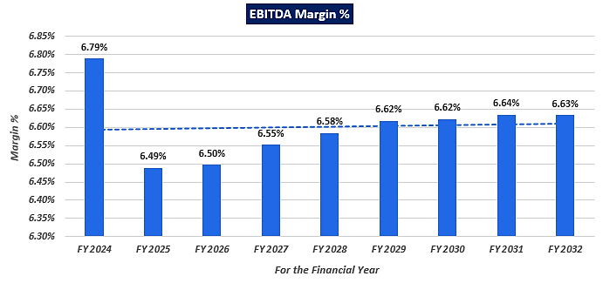
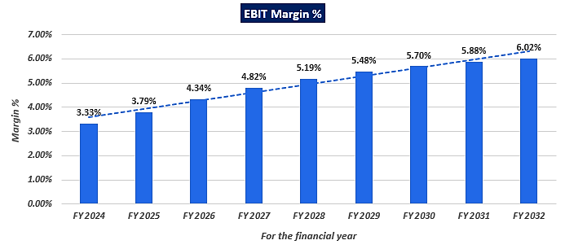
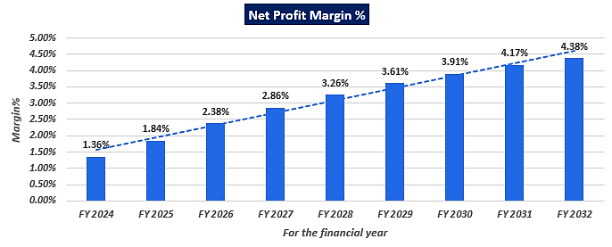
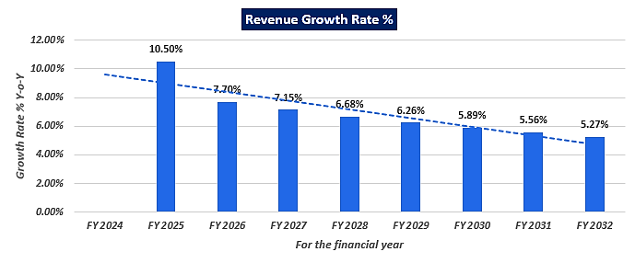
- REVENUE BUILD-UP: Production has been considered based on the capacity utilization of 60% as a base case and escalated by 5% during forecasted period.
Particulars | FY 2024 | FY 2025 | FY 2026 | FY 2027 | FY 2028 | FY 2029 | FY 2030 | FY 2031 | FY 2032
Capacity Utilisation % | 60% | 65% | 70% | 75% | 80% | 85% | 90% | 95% | 100%
Opening Balance | 0 | 504 | 546 | 588 | 630 | 672 | 714 | 756 | 798
Add: Production | 23760 | 25740 | 27720 | 29700 | 31680 | 33660 | 35640 | 37620 | 39600
Less: Closing Stock (7 days) | 504 | 546 | 588 | 630 | 672 | 714 | 756 | 798 | 840
Saleable Quantity | 23256 | 25698 | 27678 | 29658 | 31638 | 33618 | 35598 | 37578 | 39558
Sales (INR Crores) | 80.23 | 88.66 | 95.49 | 102.32 | 109.15 | 115.98 | 122.81 | 129.64 | 136.48
GST @12% | 9.63 | 10.64 | 11.46 | 12.28 | 13.10 | 13.92 | 14.74 | 15.56 | 16.38
Total Sales (INR Crores) | 89.86 | 99.30 | 106.95 | 114.60 | 122.25 | 129.90 | 137.55 | 145.20 | 152.85

SALES REALIZATION AT 100% CAPACITY UTILIZATION
Production (MT) | Proportion | Sales Price/MT (INR) | INR Crore
39600 | 1.00 | 34500 | 136.62
@ 100% Utilization | - | - | 136.62
Total | 1.00 | 34500 | 136.62

- ESTIMATED KEY FINANCIAL METRICS:
DEBT SERVICE COVERAGE RATIO (DSCR)
Particular | FY 2024 | FY 2025 | FY 2026 | FY 2027 | FY 2028 | FY 2029 | FY 2030 | FY 2031 | FY 2032
Cash Accruals | 3.87 | 4.04 | 4.34 | 4.71 | 5.10 | 5.50 | 5.93 | 6.39 | 6.82
Intt. on Term Loan | 1.07 | 1.02 | 0.93 | 0.84 | 0.72 | 0.58 | 0.40 | 0.21 | 0.03
Total "A" | 4.95 | 5.05 | 5.28 | 5.55 | 5.82 | 6.08 | 6.33 | 6.59 | 6.85
Instalment of T/L | 0.36 | 0.72 | 1.08 | 1.08 | 1.44 | 1.80 | 2.16 | 2.16 | 1.20
Intt. on Term Loan | 1.07 | 1.02 | 0.93 | 0.84 | 0.72 | 0.58 | 0.40 | 0.21 | 0.03
Total "B" | 1.43 | 1.74 | 2.01 | 1.92 | 2.16 | 2.38 | 2.56 | 2.37 | 1.23
D.S.C.R. (A/B) | 3.45 | 2.91 | 2.62 | 2.90 | 2.69 | 2.56 | 2.47 | 2.79 | 5.58
Average D.S.C.R. | 2.95
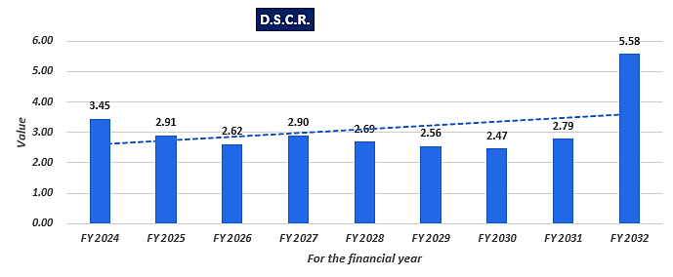
OTHER FINANCIAL RATIOS TO ASSESS THE PROJECT

Particulars | FY 2024 | FY 2025 | FY 2026 | FY 2027 | FY 2028 | FY 2029 | FY 2030 | FY 2031 | FY 2032
Net Sales | 80.23 | 88.66 | 95.49 | 102.32 | 109.15 | 115.98 | 122.81 | 129.64 | 136.48
PBT | 1.37 | 2.12 | 2.98 | 3.86 | 4.70 | 5.54 | 6.35 | 7.17 | 7.93
PAT | 1.09 | 1.63 | 2.27 | 2.93 | 3.56 | 4.19 | 4.80 | 5.41 | 5.98
Paid-up Capital | 6.60 | 6.60 | 6.60 | 6.60 | 6.60 | 6.60 | 6.60 | 6.60 | 6.60
Tangible Net Worth | 7.63 | 9.28 | 11.57 | 14.51 | 18.08 | 22.27 | 27.06 | 32.47 | 38.46
TOL/TNW | 2.94 | 2.40 | 1.89 | 1.48 | 1.14 | 0.87 | 0.66 | 0.51 | 0.41
PBT/Total Tangible Assets (%) | 4.56% | 6.71% | 8.92% | 10.74% | 12.14% | 13.28% | 14.12% | 14.66% | 14.60%
Net Sales/TTA (times) | 2.67 | 2.81 | 2.86 | 2.85 | 2.82 | 2.78 | 2.73 | 2.65 | 2.51
Bank Borrowings/TTA (%) | 6.65% | 6.34% | 5.99% | 5.57% | 5.17% | 4.79% | 4.44% | 4.09% | 3.68%
Total Tangible Assets | 30.08 | 31.53 | 33.40 | 35.92 | 38.69 | 41.73 | 45.01 | 48.90 | 54.31
Bank Borrowings | 2.00 | 2.00 | 2.00 | 2.00 | 2.00 | 2.00 | 2.00 | 2.00 | 2.00
Liquidity Ratios
Current Assets | 12.47 | 16.32 | 18.24 | 20.53 | 21.83 | 23.18 | 23.59 | 22.46 | 23.71
Current Liabilities | 8.46 | 9.35 | 10.00 | 11.02 | 12.03 | 13.04 | 13.68 | 13.36 | 12.78
Current Ratio | 1.47 | 1.75 | 1.82 | 1.86 | 1.81 | 1.78 | 1.72 | 1.68 | 1.85
Quick Ratio | 0.92 | 1.20 | 1.27 | 1.33 | 1.29 | 1.27 | 1.21 | 1.13 | 1.24

- NPV, IRR AND PAY BACK PERIOD OF THE PROJECT:
Particular | FY 2023 | FY 2024 | FY 2025 | FY 2026 | FY 2027 | FY 2028 | FY 2029 | FY 2030 | FY 2031 | FY 2032
EBIT |  | 2.69 | 3.38 | 4.16 | 4.95 | 5.67 | 6.36 | 7.00 | 7.63 | 8.21
NOPAT |  | 2.03 | 2.55 | 3.14 | 3.74 | 4.29 | 4.80 | 5.29 | 5.76 | 6.20
Depreciation |  | 2.77 | 2.39 | 2.06 | 1.77 | 1.53 | 1.31 | 1.13 | 0.98 | 0.84
CAPEX | 21.66 | 0.00 | 0.00 | 0.00 | 0.00 | 0.00 | 0.00 | 0.00 | 0.00 | 0.00
Investment in WC |  | 4.01 | 2.96 | 1.26 | 1.27 | 0.30 | 0.34 | -0.23 | -0.81 | 1.82
FCFF | (21.66) | 0.79 | 1.98 | 3.93 | 4.23 | 5.52 | 5.78 | 6.65 | 7.55 | 5.22
IRR | 12.10%
Discount rate | 13% (10-year average return of Nifty-50)
Expected growth rate(Terminal) | 1%
Period | 0.00 | 1.00 | 2.00 | 3.00 | 4.00 | 5.00 | 6.00 | 7.00 | 8.00 | 9.00
Discount Factor | 1.00 | 0.88 | 0.78 | 0.69 | 0.61 | 0.54 | 0.48 | 0.43 | 0.38 | 0.33
PV of FCF | -21.66 | 0.70 | 1.55 | 2.73 | 2.60 | 2.99 | 2.77 | 2.83 | 2.84 | 1.74
Terminal Value |  |  |  |  |  |  |  |  |  | 43.92
PV of Terminal Value |  |  |  |  |  |  |  |  |  | 14.62
FCF+Terminal Value | -21.66 | 0.70 | 1.55 | 2.73 | 2.60 | 2.99 | 2.77 | 2.83 | 2.84 | 16.36
NPV | INR 13.70 Crore
Cash Accrual |  | 3.87 | 4.04 | 4.34 | 4.71 | 5.10 | 5.50 | 5.93 | 6.39 | 6.82
Accumulated CA |  | 3.87 | 7.91 | 12.26 | 16.97 | 22.07 | 27.57 | 33.50 | 39.89 | 46.71
Project Cost | INR 21.66 Crore
Pay Back Period | 4 Years 11 Months

- BREAK-EVEN ANALYSIS:
Particulars | FY 2024 | FY 2025 | FY 2026 | FY 2027 | FY 2028 | FY 2029 | FY 2030 | FY 2031 | FY 2032
Fixed Overheads
Administrative Salaries | 0.39 | 0.41 | 0.43 | 0.45 | 0.47 | 0.50 | 0.52 | 0.55 | 0.58
Other Admn. Expenses | 0.05 | 0.05 | 0.06 | 0.06 | 0.06 | 0.06 | 0.07 | 0.07 | 0.07
Factory Insurance | 0.15 | 0.13 | 0.11 | 0.10 | 0.08 | 0.07 | 0.06 | 0.05 | 0.05
Repair & Maintenance | 0.05 | 0.05 | 0.05 | 0.06 | 0.07 | 0.07 | 0.08 | 0.09 | 0.10
Interest On Term Loan | 1.07 | 1.02 | 0.93 | 0.84 | 0.72 | 0.58 | 0.40 | 0.21 | 0.03
Other Finance Charges | 0.05 | 0.05 | 0.06 | 0.06 | 0.06 | 0.06 | 0.07 | 0.07 | 0.07
Depreciation | 2.77 | 2.39 | 2.06 | 1.77 | 1.53 | 1.31 | 1.13 | 0.98 | 0.84
Preliminary Expenses | 0.01 | 0.01 | 0.01 | 0.01 | 0.01 | 0.00 | 0.00 | 0.00 | 0.00
Total Fixed Overheads | 4.54 | 4.11 | 3.71 | 3.35 | 3.01 | 2.66 | 2.33 | 2.01 | 1.74
Net Sales | 82.18 | 88.85 | 95.63 | 102.47 | 109.31 | 116.14 | 122.96 | 129.80 | 136.63
Variable Overheads
Raw Materials | 65.05 | 70.47 | 75.89 | 81.31 | 86.73 | 92.15 | 97.58 | 103.00 | 108.42
Chemicals | 2.63 | 2.85 | 3.07 | 3.29 | 3.51 | 3.73 | 3.95 | 4.17 | 4.39
Power & Fuel | 4.71 | 5.10 | 5.49 | 5.88 | 6.28 | 6.67 | 7.06 | 7.45 | 7.85
Consumable Stores | 1.19 | 1.29 | 1.39 | 1.49 | 1.58 | 1.68 | 1.78 | 1.88 | 1.98
Direct Factory Wages | 0.77 | 0.81 | 0.85 | 0.89 | 0.94 | 0.98 | 1.03 | 1.08 | 1.14
Selling & Distribution Expenses | 1.60 | 1.77 | 1.91 | 2.05 | 2.18 | 2.32 | 2.46 | 2.59 | 2.73
Interest on Working Capital | 0.18 | 0.18 | 0.18 | 0.18 | 0.18 | 0.18 | 0.18 | 0.18 | 0.18
Repair & Maintenance | 0.14 | 0.15 | 0.16 | 0.18 | 0.20 | 0.22 | 0.24 | 0.27 | 0.29
Variable heads | 76.27 | 82.62 | 88.94 | 95.27 | 101.60 | 107.94 | 114.28 | 120.62 | 126.97
Contribution | 5.92 | 6.23 | 6.69 | 7.20 | 7.71 | 8.20 | 8.69 | 9.18 | 9.67
Break Even Point | 46.09% | 42.91% | 38.84% | 34.84% | 31.24% | 27.59% | 24.16% | 20.82% | 17.95%
CASH B.E.P. | 17.83% | 17.84% | 17.17% | 16.25% | 15.25% | 13.97% | 12.42% | 10.72% | 9.25%

- SENSITIVITY ANALYSIS:
WHEN THERE IS A DECREASE IN PRICE BY 5%
Particulars | FY 2024 | FY 2025 | FY 2026 | FY 2027 | FY 2028 | FY 2029 | FY 2030 | FY 2031 | FY 2032
Income
Net Sales( With stock Adjustment) | 78.17 | 84.42 | 90.86 | 97.36 | 103.85 | 110.34 | 116.82 | 123.32 | 129.81
Expenditure
Running Expenses | 76.72 | 83.08 | 89.42 | 95.76 | 102.11 | 108.46 | 114.83 | 121.20 | 127.58
Finance Expenses | 1.30 | 1.25 | 1.17 | 1.07 | 0.96 | 0.82 | 0.65 | 0.46 | 0.28
Depreciation | 2.77 | 2.39 | 2.06 | 1.77 | 1.53 | 1.31 | 1.13 | 0.98 | 0.84
Preliminary Expenses | 0.01 | 0.01 | 0.01 | 0.01 | 0.01 | - | - | - | -
Total Expenditure | 80.81 | 86.73 | 92.66 | 98.62 | 104.61 | 110.60 | 116.61 | 122.63 | 128.70
Income before Tax | (2.64) | (2.32) | (1.80) | (1.26) | (0.76) | (0.26) | 0.21 | 0.69 | 1.11
Taxation | - | - | - | - | - | - | 0.05 | 0.17 | 0.27
Income after Tax | (2.64) | (2.32) | (1.80) | (1.26) | (0.76) | (0.26) | 0.16 | 0.52 | 0.84
Cash Accruals | 0.13 | 0.07 | 0.26 | 0.51 | 0.77 | 1.06 | 1.29 | 1.50 | 1.68
Interest on T/L | 1.07 | 1.02 | 0.93 | 0.84 | 0.72 | 0.58 | 0.40 | 0.21 | 0.03
Instalments of T/L | 0.36 | 0.72 | 1.08 | 1.08 | 1.44 | 1.80 | 2.16 | 2.16 | 1.20
DSCR | 0.84 | 0.63 | 0.59 | 0.70 | 0.69 | 0.69 | 0.66 | 0.72 | 1.39

COST OF RAW MATERIAL INCREASED BY 5%
Particulars | FY 2024 | FY 2025 | FY 2026 | FY 2027 | FY 2028 | FY 2029 | FY 2030 | FY 2031 | FY 2032
Income
Net Sales( With stock Adjustment) | 82.18 | 88.85 | 95.63 | 102.47 | 109.31 | 116.14 | 122.96 | 129.80 | 136.63
Expenditure
Running Expenses | 79.98 | 86.61 | 93.21 | 99.82 | 106.44 | 113.07 | 119.71 | 126.35 | 133.00
Finance Expenses | 1.30 | 1.25 | 1.17 | 1.07 | 0.96 | 0.82 | 0.65 | 0.46 | 0.28
Depreciation | 2.77 | 2.39 | 2.06 | 1.77 | 1.53 | 1.31 | 1.13 | 0.98 | 0.84
Preliminary Expenses | 0.01 | 0.01 | 0.01 | 0.01 | 0.01 | - | - | - | -
Total Expenditure | 84.07 | 90.26 | 96.45 | 102.68 | 108.95 | 115.21 | 121.49 | 127.78 | 134.13
Income before Tax | (1.88) | (1.41) | (0.82) | (0.21) | 0.36 | 0.93 | 1.47 | 2.02 | 2.51
Taxation | - | - | - | - | 0.09 | 0.23 | 0.36 | 0.49 | 0.61
Income after Tax | (1.88) | (1.41) | (0.82) | (0.21) | 0.27 | 0.70 | 1.11 | 1.53 | 1.89
Cash Accruals | 0.91 | 0.99 | 1.25 | 1.58 | 1.81 | 2.02 | 2.25 | 2.50 | 2.74
Interest on T/L | 1.07 | 1.02 | 0.93 | 0.84 | 0.72 | 0.58 | 0.40 | 0.21 | 0.03
Instalments of T/L | 0.36 | 0.72 | 1.08 | 1.08 | 1.44 | 1.80 | 2.16 | 2.16 | 1.20
DSCR | 1.38 | 1.16 | 1.09 | 1.26 | 1.17 | 1.09 | 1.03 | 1.14 | 2.25

- LOAN AMORTIZATION SCHEDULE: As per Loan disbursement and amortization schedule shared by the client, according to the project costs incurred during the estimated period below table shows the closing balance of principle and intrest during the forecasted period.
Repayment Schedule
 | TERM LOAN -1 |  |  |  |  | TERM LOAN -2
YEAR | % PAYMENT | NO. OF INSTALLMENTS | TOTAL PAYMENT | INSTALLMENT | BALANCE | % PAYMENT | NO. OF INSTALLMENTS | TOTAL PAYMENT | INSTALLMENT | BALANCE
2023-24 | 3.00% | 6 | 0.24 | 0.04 | 7.76 | 3.00% | 6 | 0.12 | 0.02 | 3.88
2024-25 | 6.00% | 12 | 0.48 | 0.04 | 7.28 | 6.00% | 12 | 0.24 | 0.02 | 3.64
2025-26 | 9.00% | 12 | 0.72 | 0.06 | 6.56 | 9.00% | 12 | 0.36 | 0.03 | 3.28
2026-27 | 9.00% | 12 | 0.72 | 0.06 | 5.84 | 9.00% | 12 | 0.36 | 0.03 | 2.92
2027-28 | 12.00% | 12 | 0.96 | 0.08 | 4.88 | 12.00% | 12 | 0.48 | 0.04 | 2.44
2028-29 | 15.00% | 12 | 1.20 | 0.10 | 3.68 | 15.00% | 12 | 0.60 | 0.05 | 1.84
2029-30 | 18.00% | 12 | 1.44 | 0.12 | 2.24 | 18.00% | 12 | 0.72 | 0.06 | 1.12
2030-31 | 18.00% | 12 | 1.44 | 0.12 | 0.80 | 18.00% | 12 | 0.72 | 0.06 | 0.40
2031-32 | 10.00% | 6 | 0.80 | 0.13 | - | 10.00% | 6 | 0.40 | 0.07 | -
Total | 100.00% | 96 | 8.00 |  |  | 100.00% | 96 | 4.00

SUMMARY OF TERM LOAN
Particulars | FY 2024 | FY 2025 | FY 2026 | FY 2027 | FY 2028 | FY 2029 | FY 2030 | FY 2031 | FY 2032 | FY 2024
Term Loan (O/S) | 12.00 | 11.64 | 10.92 | 9.84 | 8.76 | 7.32 | 5.52 | 3.36 | 1.20 | 0.00
Instalments | - | 0.36 | 0.72 | 1.08 | 1.08 | 1.44 | 1.80 | 2.16 | 2.16 | 1.20
CM Of Term Loan | 0.36 | 0.72 | 1.08 | 1.08 | 1.44 | 1.80 | 2.16 | 2.16 | 1.20 | -
Rest Of Term Loan | 11.64 | 10.92 | 9.84 | 8.76 | 7.32 | 5.52 | 3.36 | 1.20 | 0.00 | 0.00
Interest | 0.49 | 1.07 | 1.02 | 0.93 | 0.84 | 0.72 | 0.58 | 0.40 | 0.21 | 0.03

CALCULATION OF INTEREST CUM REPAYMENT SCHEDULE OF TERM LOAN
Particulars | TL-I | TL-II
Amount Of Term Loan | 8.00 | 4.00
Rate Of Interest | 9.00% | 9.00%
Scheduled Commercial Operation Date | Apr-23 | Apr-23
Disbursal Start Date | Jun-22 | Jan-23
Repayment Start Date | Oct-23 | Oct-23
Repayment Period (Years) | 8 | 8
Total Monthly Installments | 96 | 96
Moratorium From First Drawl (Months) | 16 | 7 Months
Moratorium Period (Excluding Disbursement Period)Months | 10 | 7 Months
Door To Door Tenure (Months) | 112 | 103

- TERM LOAN ADMISSIBILTY :
Term Loan Admissibility Schedule
S. No. | Item | Basic Cost | Margin % | Amount | PBF
1 | Land & Site Development | 0.00 | 100% | - | -
2 | Building & Civil Work | 0.45 | 100% | 0.45 | -
3 | Plant & Machinery | 18.41 | 30% | 5.52 | 12.89
4 | Miscellaneous Fixed Assets | 0.12 | 25% | 0.03 | 0.09
5 | Interest During Const. Period | 0.49 | 100% | 0.49 | -
6 | Escalation & Contingencies | 0.57 | 100% | 0.57 | -
7 | Pre-Operative Expenses | 0.07 | 100% | 0.07 | -
8 | Security Deposits | 0.33 | 100% | 0.33 | -
9 | Margin Money For Working Cap. | 1.22 | 100% | 1.22 | -
Total |  | 21.66 |  | 8.68 | 12.98
Term Loan Requested |  | 12.00 Crores

- WORKING CAPITAL REQUIREMENT:
S.No. | Particulars | Days | Amount
1 | Raw Materials
 | -Indian Waste Paper | 10 | 2.28
 | -Imported Waste Paper | 20 | 2.28
2 | Chemicals | 30 | 0.24
3 | Stores & Spares | 60 | 0.22
4 | Work in Progress ( % of Completion = 75 % ) | 2 | 0.35
5 | Finished Goods | 7 | 1.60
6 | Fuels | 15 | 0.02
7 | Sundry Debtors | 10 | 2.46
 |  |  | 7.16
8 | Less: Sundry Creditors | 20 | 3.95
TOTAL (A) |  |  | 3.22
PERMISSIBLE BANK FINANCE:
(a) | 75.00% of item (1+2+3+4+5+6-8) |  | 2.05
(b) | 60.00% of item (7) |  | 2.05
TOTAL (B) |  |  | 2.05
MARGIN MONEY FOR WORKING CAPITAL:
TOTAL (A) |  |  | 3.22
LESS : | Working Capital Facility Required |  | 2.00
Margin Money Required |  |  | 1.22

- DEPRECIATION SCHEDULE: Depreciation schedule is prepared based on the Companies Act, 2013 and Written Down Value Method (WDV) is used to determine it. Below table shows the Depreciation Schedule along with applicable rate and allocated pre-opeartional and contingent expenses:
Particulars | Amount | FY 2024 | FY 2025 | FY 2026 | FY 2027 | FY 2028 | FY 2029 | FY 2030 | FY 2031 | FY 2032
Building | 0.47 | 0.05 | 0.04 | 0.04 | 0.03 | 0.03 | 0.03 | 0.02 | 0.02 | 0.02
Plant & Machinery | 19.45 | 2.71 | 2.33 | 2.01 | 1.73 | 1.49 | 1.28 | 1.10 | 0.95 | 0.82
Misc. Fixed Assets | 0.12 | 0.02 | 0.02 | 0.02 | 0.01 | 0.01 | 0.01 | 0.01 | 0.01 | 0.00
Total | 20.05 | 2.77 | 2.39 | 2.06 | 1.77 | 1.53 | 1.31 | 1.13 | 0.98 | 0.84

Particulars | Rate | Use Full Life
Building | 9.50% | 30
Plant & Machinery | 13.91% | 20
Misc. Fixed Assets | 18.10% | 15

- KEY ASSUMPTIONS & BASIS:
Sl. No. | Item | Assumptions and Basis
 | General | - The projections of the firm are done for the period from FY 2023-24 to FY 2031-32, 9 years, to cover the term loan period as per the industry best practices.  - Revenue and expense modelling has been done based on the capacity utilization during the respective year.
 | Revenue Build up | - Total income for the respective financial years during the forecasted period will be generating from selling of different category of Kraft papers.  - To calculate the operating revenue at 100% capacity utilization, Sales price has been considered as INR 34500 per MT based on the data/information provided by the client and based on our tertiary research and information available in the public domain.  - Sales Value of the production has been calculated by multiplying the average price to the total production at the respective year capacity.  - Thus the company is generating INR 89.86 Crore in the initial year, further it has increased up to INR 152.85 Crore till FY 2031-32.  - Therefor the company is achieving a revenue growth rate Y-o-Y basis between 5% to 11%, which is also in the line with industrial & economic trends and on conservative side.
 | Pricing (Average Price Per Metric Ton) | - As per data/information shared by the client, company will be selling its finished (Kraft paper) product through distributors at a pre decided price of INR 34500 Per MT.  - Also as per secondary and tertiary research, industry trend and pricing offered by other companies and vendors in this line and data/information available in public domain, we found that the price per MT ranges from INR 26000 per MT to INR 56000 Per MT for 18 BF & more than 100 GSM paper and INR 25000-55000 Per MT for 20 BF & more than 100 GSM depending on the quality and specification of the product.  - Thus, justifiably average price has been considered as INR 34500 per MT, which is reasonable and on conservative side and is in the line with industry trends.
 | Capacity Utilization | - For the proposed facility, the company is planning to install new plant & machinery of total capacity of 39600 TPA.  - We have considered the capacity utilisation at 60% in the first year, which has been escalated by 5% for the projected years up to 100% in FY 2031-32.  - Thus to start the capacity utilization from 60% is in the line with industry and it is reasonable and on conservative side to keep a mark-up for future market & economic risks in the Project.  - As per the Kraft paper manufacturing sectoral trends, it is assumed that the project will be achieving a 100% capacity utilization in 9th year of the forecasted period.
 | Capital Expenditure | - The Land has been procured on the lease basis for 30 years for a nominal charge of INR 60,000 per year, which is not a capitalised charge and will be expensed out on a yearly basis. Hence, we have not considered it as a part of TPC.  - Civil construction cost is borne by the promotors from their own contributions which is costing approximately INR 45 lakhs including GST, plumbing, electrification, supervision charges.  - Plant & Machinery cost has been taken as per the details provided by the client and as per the break-up, the total cost of INR 18.41 Crores has been considered including GST & transportation cost, which is found to be reasonable based on the tertiary research and verbal communication with random vendors and players in this Industry and information available in the public domain and quotations/invoices shared by the client/company.  - Miscellaneous Fixed Assets cost is being considered as per information provided by the client and industry benchmark which is found reasonable during our tertiary research.  - Preliminary & Pre-Operative Expenses has been taken as lump sum based on the time period of construction and estimate of company’s resources involvement during this time in supervision & monitoring of the construction.  - Contingency cost of INR 57.00 Lakhs has been considered as a part of app. 3% of PP&E and building based on general assumption and professional experience.
 | Expenses | - Major expenses includes raw material, power and fuel, salaries and wages, Repair and maintenance, SG&A, pre-operative expenses etc.  - For the proposed plant and machinery, quantity of raw material will be from both indigenous and imported waste paper in the ratio of 85%:15% which will be yielding at 90% and 92% respectively. The rate of indigenous waste paper is considered as INR 24500 and imported waste paper is considered as INR 26000 per MT at 100% capacity utilization.  - ARAMCO Paper Mill Ltd. will get the synergies from the parent group (Balaji Group) in regard to the raw material supply and one of the director Mr. Yameen is also having two operational firms which are already suppling waste paper on a large scale. Hence, this forward integration will be beneficial for the group as a whole.  - Since, the muzaffarnagar area is well-known for the paper industry and the easy availability of the raw material will be an added advantage for the company. However, we can’t avoid the risk of forex fluctuations.  - As per our independent research and information available on public domain raw material price ranging from Rs. 22000/- to Rs 28000/- per MT. The cost estimated by the company was also verified by the invoices/quotations shared by the client.  - Thus we considered the average price as INR 24500 and INR 26000 per MT for indigenous and imported waste paper respectively which is reasonable and in the line with industrial trends and multiplied it by raw material quantity used, to calculate total cost of raw material used.  - A power connection of 1700 KVA is sufficient to run the plant smoothly, which is already installed for to run the current plant. Also company has proposed to install a 0.50 MW power plant to meet their electricity demands.  - Hence the total annual charges at 100% capacity level will be INR 7.16 crores. Total units consumed in different years would be calculated by multiplying the total power consumed per year with the % of capacity utilisation for that year.  - To calculate total power cost we have considered demand charges on 1700 KVA @ Rs. 7/- per unit, with a load factor of 0.80 and power factor of 0.95.  - In estimating the manpower requirement, salary and wages, a proper ratio between the administrative, managerial, supervisory and shop floor staff has been maintained with a view to affording proper industrial and professional management at various levels. The fringe benefits has been taken 10% of the basic salary. Also we have considered 5% escalation rate in every year.  - Pre-operative and preliminary expenses include Authorised capital increase expenses, Processing, Legal & Professional Fees and engineering & consultancy fees, which in total, comes out INR 7 lakh.  - Selling & Administrative Expenses has been estimated at 2% of sales realisation for each respective projected year.  - Factory insurance has been considered at 0.75% of the opening balance of Net Block of Fixed Asset of the respective projected year.  - Annual cost of consumables and stores at 100% capacity is estimated at INR 1.98 Crore. The cost of per MT production is assumed to be INR 500.  - The fuel consumption is estimated at 0.40 MT/hour with an average rate of INR 2000 and Turbine running & maintenance charge of INR 5 lakhs per annum, which makes an annual cost of fuel to be INR 0.68 Crores at 100% capacity.  - In the total operating cost at 100% capacity utilization, approximately 80% of revenue is the cost contribution of raw material.
 | Term Loan | - The company is planning to fund the project through term loan to setup the manufacturing unit and SBI has sanctioned INR 8.00 Crores and the company is approaching the financial institutions to provide the remaining required capital of INR 4.00 Crores.  - As per the discussion with the client, company will apply for the loan to procure plant and machinery which is estimated to be costing around INR 18.41 Crores.  - The tenure of the loan will be 8 years and Interest rate has been considered as 9%.  - Also the loan repayment period will be from FY 2023-24 to FY 2031-32.  - The company will be required a Fund Based Cash Credit Limit of INR 2.00 crores from FY 2023-24 onwards.
Conclusion:
      - DSCR, EBITDA and EBIT margins are positive in all years starting from initial year on 60% capacity utilization which has assumed maximum up to 100% till the end of 9th year with 5% escalation rate in later years.
      - DSCR, has achieved more than 1 during the loan repayment period. Average DSCR, EBIDTA margin, EBIT margin is 2.95, 6.60%, and 4.95% respectively during the estimated period.
      - The company is having a positive NPV and IRR of INR 13.70 Crore and 12.10% respectively at the base cases while it may vary with changes in the assumptions & micro and macro-economic trends considered as on date.
      - Based on the above key financial ratios of the proposed Project during the forecast period shows that the project looks financially viable if the Project Company & promoters are able to maintain minimum capacity utilization, revenue and can contain cost as assumed above.
PART M | CONCLUSION

Based on the technological, economical and market analysis done above, various assumptions of sectoral trends taken, product pricing to be adopted by the company, the Project appears to be Techno-commercially viable subject to the risks, threats, weaknesses, limitations of the product as detailed previously.
As per financial projections for the estimated period, Average DSCR, EBITDA Margin and EBIT Margin of the project are 2.95, 6.60% and 4.95% respectively, where higher DSCR is the indicator of the project capability to pay out its outstanding debt and EBITDA margin shows the capability of the project to generate the operating profits over the forecasted period.
The expanded manufacturing facility is having a positive NPV and IRR as INR 13.70 Crore positive and 12.10% respectively at a 60% capacity (base case) utilization initially and 1.0% expected terminal growth rate as the industry is expectedly growing at a CAGR of 3-5.5% during the forecasted period. While it is not avoidable that the future projections may change in the upcoming years due to various factors impacting the operation, managerial, financial efficiency and economies of scale of the project.
While it would be depending on the management’s capability in future that how efficiently company adopts marketing and advertisement strategy, supply chain and carry out inventory & resource management to achieve higher profitability. Company is yet to identify its key customers and to form strategic planning for tie-up & product promotion with overseas and domestic customers for selling & distribution of its product which remains a major concern. Bank/ Financial Institution is advised to take firm plan from the company in this regard before taking any decision.
After considering the foreseen demand of the plastic and by-products domestically and globally, various initiatives taken by government, financial analysis of the project based on the assumptions taken over the projected period, it appears reasonable to comment that the proposed project is “Technically and Economically” Viable subject to current assumptions considered and occurring the same in the upcoming years same as the forecasted period which is dependent on the sincerity and efforts of the management and various micro and macroeconomic & industry situation.
We have tried our level best to analyse the Project techno-economic feasibility of the Project based on the Industry research, Project information and various futuristic assumption taken. However achieving the financial milestones depends on the ability, sincerity and efforts of the company, promoters and its key managerial performance.
Declaration | - The undersigned does not have any direct/indirect interest in the above property.  - The information furnished herein is true and correct to the best of our knowledge, logical and scientific assumptions.  - This TEV Report is carried out by our Financial Analyst team on the request from State Bank of India, SME, Muzaffarnagar.  - Meeting of Financial projections will be subject to subject to the market & economy stability factors, judicious business operations and proper & timely implementation of its process & product re-engineering & improvements plans for achieving high productivity, efficiency and achieving cost saving benefits.  - We have submitted TEV report to the Client.
Name & Address of consultant company |  |  | Signature of the authorized person
M/s. R.K. Associates Valuer & Techno Engineering Consultants Pvt. Ltd.
D-39, 2nd Floor. Sector-2, Noida- 201301
Enclosed Documents |  | Disclaimer & Remarks 75-78
Number of Pages in the Report |  | 78
Financial Analyst Team worked on the report |  | PREPARED BY: Mr. Rachit Gupta & Mrs. Chhavi Toshan
 |  | REVIEWED BY: Mr. Gaurav Kumar

For R.K Associates Valuer & Techno Place: Noida

Engineering Consultants (P) Ltd. Date: 25/03/2023

(Authorized Signatory)

PART N | DISCLAIMER | REMARKS

      - No employee or member of R.K Associates has any direct/ indirect interest in the Project.
      - This report is prepared based on the copies of the documents/ information which the Bank/ Company has provided to us out of the standard checklist of documents sought from them and further based on our assumptions and limiting conditions. The client/owner and its management/representatives warranted to us that the information they supplied was complete, accurate and true and correct to the best of their knowledge. All such information provided to us has been relied upon in good faith and we have assumed that it is true and correct in all respect. I/We shall not be liable for any loss, damages, cost or expenses arising from fraudulent acts, misrepresentations, or wilful default on part of the owner, company, its directors, employee, representative or agents. Verification or cross checking of the documents provided to us from the originals or from any Govt. departments/ Record of Registrar has not been done at our end since this is beyond the scope of our work. If at any time in future, it is found or came to our knowledge that misrepresentation of facts or incomplete or distorted information has been provided to us then this report shall automatically become null & void.
      - Legal aspects for e.g. investigation of title, ownership rights, lien, charge, mortgage, lease, sanctioned maps, verification of documents, etc. have not been done at our end and same has to be taken care by legal expert/ Advocate. It is assumed that the concerned Lender/ Financial Institution has satisfied them with the authenticity of the documents, information given to us and for which the legal verification has been already taken and cleared by the competent Advocate before requesting for this report. I/ We assume no responsibility for the legal matters including, but not limited to, legal or title concerns.
      - This report is a general analysis of the project based on the scope mentioned in the report. This is not an Audit report, Design document, DPR or Techno feasibility study. All the information gathered is based on the facts seen on the site during survey, verbal discussion & documentary evidence provided by the client and is believed that information given by the company is true best of their knowledge.
      - This Techno Economic-Viability study is prepared based on certain futuristic assumption which are intra dependent on economic, market and sectorial growth condition in future and socio-economic, socio-political condition at macro and micro level.
      - Meeting of assumption and financial ratio will entirely depend on the sincerity and efforts of the company, promoters and its key managerial performance.
      - All observations mentioned in the report is only based on the visual observation and the documents/ data/ information provided by the client. No mechanical/ technical tests, measurements or any design review have been performed or carried out from our side during Project assessment.
      - Bank/FII should ONLY take this report as an Advisory document from the Financial/ Chartered Engineering firm and its specifically advised to the creditor to cross verifies the original documents for the facts mentioned in the report which can be availed from the borrowing company directly.
      - In case of any default in loans or the credit facility extended to the borrowing company, R.K Associates shall not be held responsible for whatsoever reason may be and any request for seeking any explanation from the employee/s of R.K Associates will not be entertained at any instance or situation.
      - The documents, information, data provided to us during the course of this assessment by the client are reviewed only up to the extent required in relation to the scope of the work. No document has been reviewed beyond the scope of the work.
      - This report only contains general assessment & opinion as per the scope of work evaluated as per the information given in the copy of documents, information, data provided to us and/ and confirmed by the owner/ owner representative to us at site which has been relied upon in good faith. It doesn’t contain any other recommendations of any sort including but not limited to express of any opinion on the suitability or otherwise of entering into any transaction with the borrower.
      - We have relied on data from third party, external sources & information available on public domain also to conclude this report. These sources are believed to be reliable and therefore, we assume no liability for the truth or accuracy of any data, opinions or estimates furnished by others that have been used in this analysis. Where we have relied on data, opinions or estimates from external sources, reasonable care has been taken to ensure that such data has been correctly extracted from those sources and /or reproduced in its proper form and context, however still we can’t vouch its authenticity, correctness or accuracy.
      - This Report is prepared by our competent technical team which includes Engineers and financial experts & analysts.
      - This is just an opinion report and doesn’t hold any binding on anyone. It is requested from the concerned Financial Institution which is using this report for taking financial decision on the project that they should consider all the different associated relevant & related factors also before taking any business decision based on the content of this report.
      - All Pages of the report including annexure are signed and stamped from our office. In case any paper in the report is without stamp & signature then this should not be considered a valid paper issued from this office.
      - Though adequate care has been taken while preparing this report as per its scope, but still we can’t rule out typing, human errors, over sightedness of any information or any other mistakes. Therefore, the concerned organization is advised to satisfy themselves that the report is complete & satisfactory in all respect. Intimation regarding any discrepancy shall be brought into our notice immediately. If no intimation is received within 15 (Fifteen) days in writing from the date of issuance of the report, to rectify these timely, then it shall be considered that the report is complete in all respect and has been accepted by the client up to their satisfaction & use and further to which R.K Associates shall not be held responsible in any manner.
      - Defect Liability Period is 15 DAYS. We request the concerned authorized reader of this report to check the contents, data and calculations in the report within this period and intimate us in writing if any corrections are required or in case of any other concern with the contents or opinion mentioned in the report. Corrections only related to typographical, calculation, spelling mistakes, incorrect data/ figures/ statement will be entertained within the defect liability period. Any new changes for any additional information in already approved report will be regarded as additional work for which additional fees may be charged. No request for any illegitimate change in regard to any facts & figures will be entertained.
      - R.K Associates encourages its customers to give feedback or inform concerns over its services through proper channel at valuers@rkassociates.org in writing within 15 days of report delivery. After this period no concern/ complaint/ proceedings in connection with the Techno- Economic Viability Study Services will be entertained due to possible change in situation and condition of the subject Project.
      - Our Data retention policy is of ONE YEAR. After this period, we remove all the concerned records related to the assignment from our repository. No clarification or query can be answered after this period due to unavailability of the data.
      - This Techno Economic Viability Study report is governed by our (1) Internal Policies, Processes & Standard Operating Procedures, (2) Information/ Data/ Inputs given to us by the client and (3) Information/ Data/ Facts given to us by our field/ office technical team. Management of R.K Associates never gives acceptance to any unethical or unprofessional practice which may affect fair, correct & impartial assessment and which is against any prevailing law. In case of any indication of any negligence, default, incorrect, misleading, misrepresentation or distortion of facts in the report then it is the responsibility of the user of this report to immediately or at least within the defect liability period bring all such act into notice of R.K Associates management so that corrective measures can be taken instantly.
      - R.K Associates never releases any report doing alterations or modifications from pen. In case any information/ figure of this report is found altered with pen then this report will automatically become null & void.
      - If this report is prepared for the matter under litigation in any Indian court, no official or employee of R.K Associates will be under any obligation to give in person appearance in the court as a testimony. For any explanation or clarification, only written reply can be submitted on payment of charges by the plaintiff or respondent which will be 10% of the original fees charged where minimum charges will be Rs. 15,000/.

