REPORT FORMAT: V-L6 (Bank – P&M) | Version: 11.0_2022

CASE NO: VIS(2022-23)-PL749-636-1031 DATED: 25/03/2023

COST VERIFICATION AND VALUATION REPORT
OF

NATURE OF ASSETS | PLANT & MACHINERY AND OTHER FIXED ASSETS
CATEGORY OF ASSETS | INDUSTRIAL
TYPE OF ASSETS | INDUSTRIAL PLANT

SITUATED AT

M/S. ECO CARE VENTURE PVT. LTD., INDUSTRIAL AREA, KHASRA NO. 203 & 203/2, VILLAGE MASSORIE, MAWANA ROAD, MEERUT -250001, U.P

OWNER/S
M/S. ECO CARE VENTURE PVT. LTD.

REPORT PREPARED FOR
STATE BANK OF INDIA, I.E. BRANCH, PARTAPUR, MEERUT

**Important - In case of any query/ issue/ concern or escalation you may please contact Incident Manager @ valuers@rkassociates.org. We will appreciate your feedback in order to improve our services.
NOTE: As per IBA Guidelines please provide your feedback on the report within 15 days of its submission after which report will be considered to be accepted & correct.
Valuation Terms of Services & Valuer’s Important Remarks are available at www.rkassociates.org for reference.

PART A | SNAPSHOT OF THE PLANT/ MACHINERY UNDER VALUATION

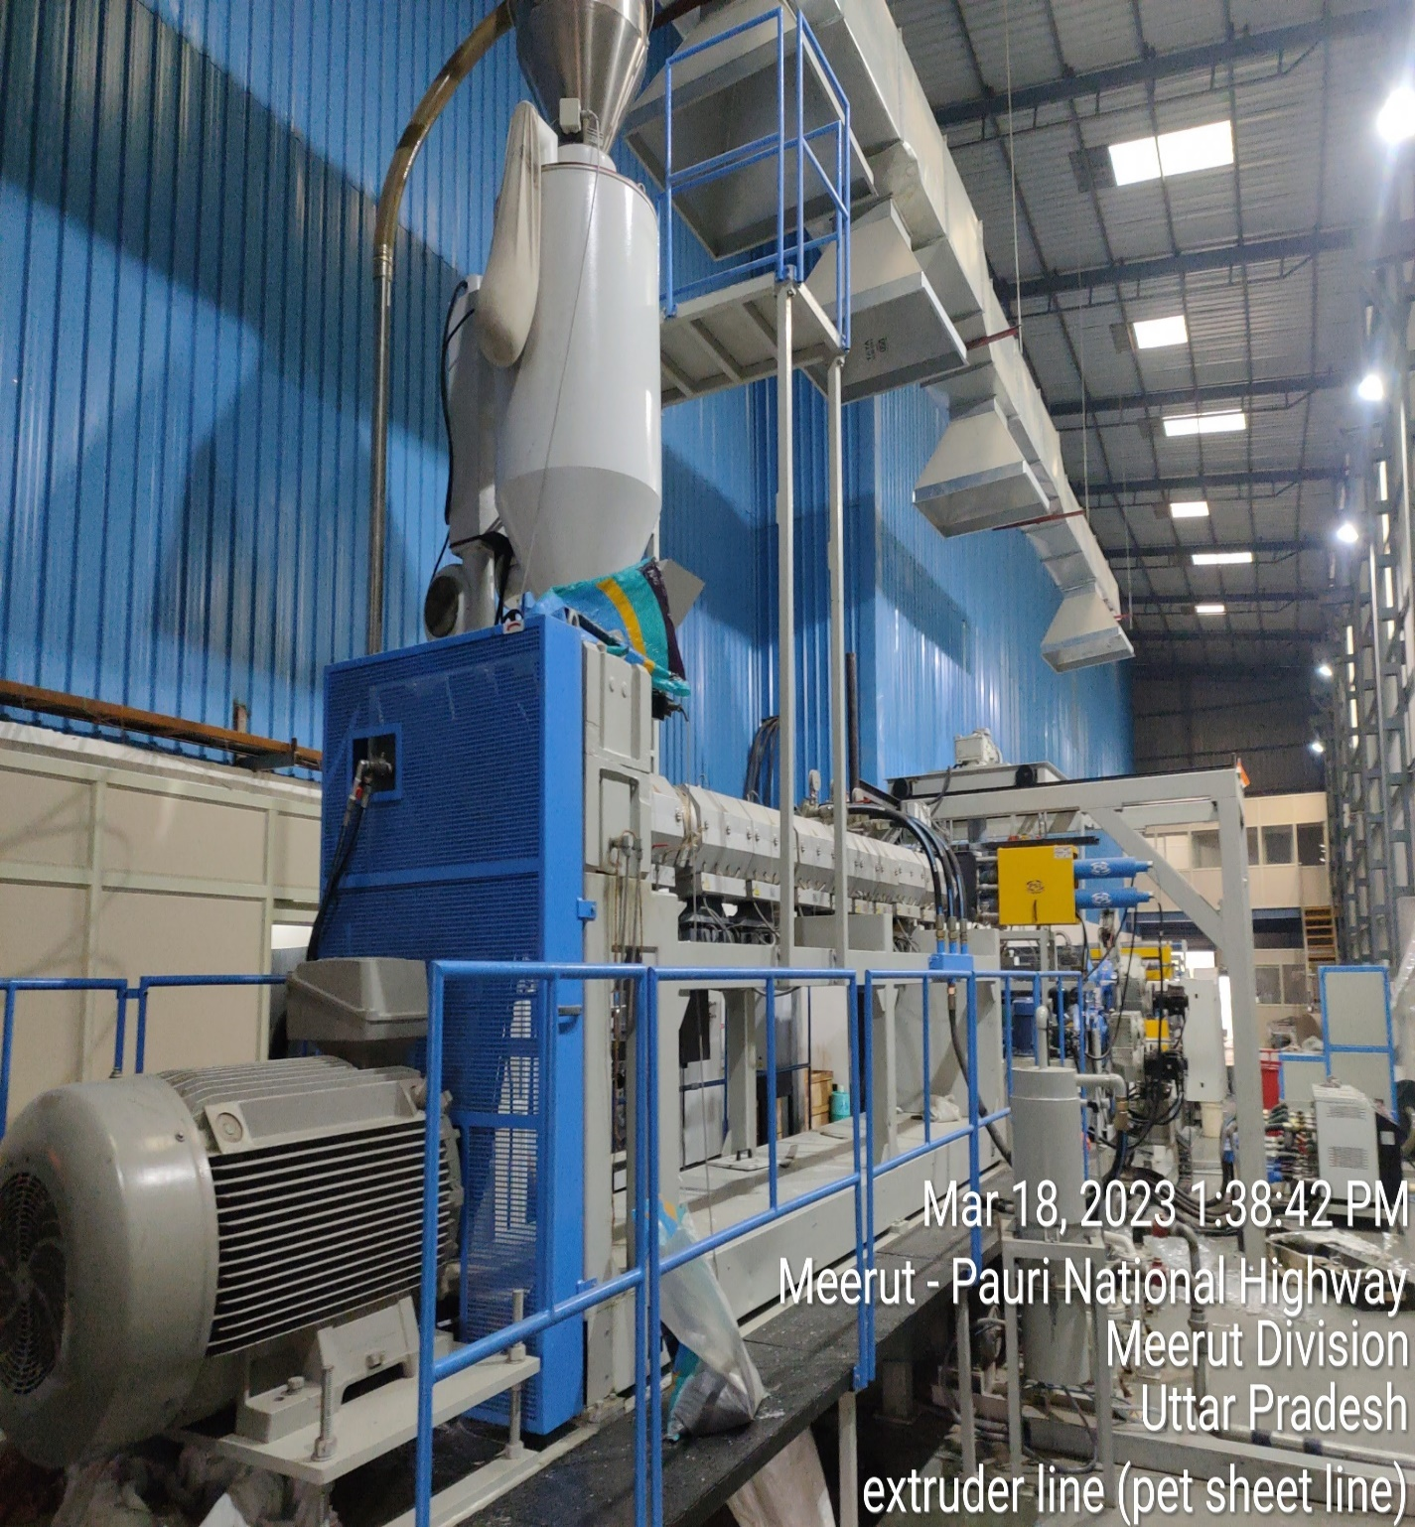

SITUATED AT
ECOCARE VENTURE PVT. LTD., INDUSTRIAL AREA, KHASRA NO. 203 & 203/2, VILLAGE MASSORIE, MAWANA ROAD, MEERUT -250001, U.P -250001
PART B | SUMMARY OF THE VALUATION REPORT

S.NO. | CONTENTS | DESCRIPTION
 | GENERAL DETAILS
 | Report prepared for | Bank
 | Name & Address of Organization | State Bank of India, I.E Branch, Partapur Meerut.
 | Work Order No. & Date | Via email dated 27-02-2023
 | Address at which machines are located | M/s. Eco Care Venture Pvt. Ltd., Industrial Area, Khasra No. 203 & 203/2, Village Massorie, Mawana Road, Meerut -250001, U.P.
 | Type of the Plant/ Machinery | Small scale Manufacturing Unit
 | Nature of Industry | Plastic Recycling Industry
 | Type of Valuation | Industrial Plant & Machinery Valuation
 | Report Type | Plain Asset Valuation
 | Date of Appointment | 27 February 2023
 | Date of Inspection of the Property | 18 March 2023
 | Date of Valuation | 25 March 2023
 | Date of Valuation Report | 25 March 2023
 | Plant Technical person name, contact number & designation assisted for Survey | Name | Relationship with Owner | Contact Number
 |  | Mr. Anurag | Representative | +91 9837009631
 | Purpose of the Valuation | For Value assessment of the asset for creating collateral mortgage for Bank Loan purpose
 | Scope of the Assessment | Non Binding Opinion on General Prospective Valuation Assessment of the Plant & Machineries as found on site on as-is-where basis.
 | Out-of-Scope of the Assessment | - Verification of authenticity of documents from originals or cross checking from any Govt. dept. is not done at our end.  - Legal aspects & rights of the Stocks/Inventory are out-of-scope of this report.  - Preparing inventory list of stock is out of scope of work.  - Componentization of stocks is out of scope of this report.  - Identification of the Stocks is only limited to cross verification of major machines & production lines.  - Technical/ mechanical/ operational testing of the machines is out-of-scope of the report.  - Comment/ determination on technological aspect is out of scope of this report.  - Any kind of machine/ process design is out of scope of the report.

 | Information provided/ available for assessment | Documents Requested |  | Documents Provided
 | Information provided/ available for assessment | Total 02 documents requested. |  | Total 02 documents provided.
 | Information provided/ available for assessment | Invoices/ Bills |  | Invoices/ Bills
 | Information provided/ available for assessment | Detailed Fixed Asset Register/ Inventory Sheet |  | Fixed Assets Register
 | Details of the Person providing the Information | Name |  | Mr. Anurag
 | Details of the Person providing the Information | Contact Number |  | +91 9837009631
 | Details of the Person providing the Information | Email id |  | -
 | Manner in which identification of the Assets is done | ☐ | Cross checked from the name of the machines mentioned in the old valuation report/invoice list name plate displayed on the machine
 | Manner in which identification of the Assets is done | ☑ | Identified by the Owner's representative
 | Manner in which identification of the Assets is done | ☑ | Identified from the available Invoices
 | Manner in which identification of the Assets is done | ☐ | Identification of the machines could not be done properly
 | Manner in which identification of the Assets is done | ☐ | Due to large number of inventory, only major machines have been checked
 | Manner in which identification of the Assets is done | ☑ | From name plate displayed on the property
 | Manner in which identification of the Assets is done | ☐ | Physical inspection of the machines could not be done

 | VALUATION SUMMARY
 | Total Prospective Fair Market Value | Rs.5,89,00,000/-
 | Total Expected Realizable | Rs.5,00,65,000 /-
 | Distress Value | Rs.4,41,75,000 /-

 | ENCLOSURES
 | Part A | SNAPSHOT OF THE STOCKS UNDER VALUATION
 | Part B | SUMMARY OF THE VALUATION REPORT
 | Part C | CHARACTERISTICS DESCRIPTION OF PLANT/ MACHINERY
 | Part D | PROCEDURE OF VALUATION ASSESMENT
 | Enclosure 1 | Google Map
 | Enclosure 2 | Photographs
 | Enclosure 3 | Valuer’s Important Remarks

PART C | CHARACTERISTICS DESCRIPTION OF PLANT/ MACHINERY

S.NO. | CONTENTS | DESCRIPTION
 | TECHNICAL DESCRIPTION OF THE PLANT/ MACHINERY
 | Nature of Plant & Machinery | Plastic Recycling Industry
 | Size of the Plant | - Small scale Plant
 | Type of the Plant | - Semi Automatic
 | Year of Installation/ Commissioning/ COD (Commercial Operation Date) | - Year 2022
 | Production Capacity | 7000 Kg per day / 240 ton per month
 | Capacity at which Plant was running at the time of Survey | ~7000 Kg per day (As per information provided on site)
 | Number of Production Lines | Three, PET Sheet Line, Bottle Wash Line, Pet Flakes manufacturing line.
 | Condition of machines | Good.
 | Status of the Plant | Fully operational
 | Products Manufactured in this Plant | PET Sheet, PET flakes
 | Recent maintenance carried out on | NA, as it is newly commissioned.
 | Recent upgradation, improvements if done any | Yes, in Bottle Wash Line and PET Flakes Line.
 | Total Gross Block & Net Block of Assets | Gross Block | Net Block
 | Total Gross Block & Net Block of Assets | Rs. 6,00,67,908 /- | No information available
 | Any other Details if any | M/s Eco Care Venture Pvt. Ltd. is a PET sheet and PET flakes manufacturing plant. However, this valuation report is for PET Sheet line and some machines in Bottle wash line and Pet flakes manufacturing line. (As per our work order dated 27/02/2023).

 | MANUFACTURING PROCESS
 | 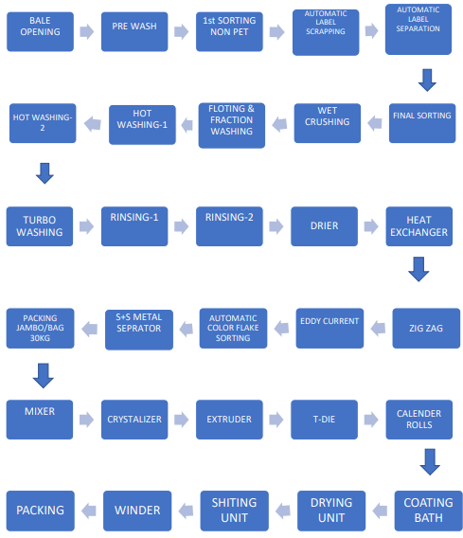
 | TECHNOLOGY TYPE/ GENERATION USED AND TECHNOLOGICAL COLLABORATIONS IF ANY
 | - Technology Type/ Generation Used in this Plant | - Present Generation
 | Technological Collaborations If Any | - No
 | Current Technology used for this Industry in Market | - Semi-Automatic Plant.
 | RAW MATERIALS REQUIRED & AVAILABILITY
 | Type of Raw Material | 1. Scrap Plastic Bottles for PET Flakes.  2. PET Flakes for PET Sheet Line.
 | Availability | Easily Available
 | AVAILABILITY & STATUS OF UTILITIES
 | Power/ Electricity | Available
 | Water | Available
 | Road/ Transport | Available
 | COMMENT ON AVAILABILITY OF LABOUR
 | Availability | Appears to be easily & adequately available and no labour issues came to our knowledge during site inspection.
 | Number of Labours working in the Factory | Approximately 20 (Including Skilled and Unskilled )
 | SALES TRANSACTIONAL PROSPECTS OF SUCH PLANTS/ MACHINERY
 | Strategic Sale as part of the ongoing concern company.
 | Reason: This is a small scale plant and all are general used machines which can be used in similar industry and cost of dismantling and transporation will not be very high. So, for fetching maximum value is through strategic sale to the players who are already into same or similar Industry who have plans for expansion or any large conglomefrate who plans to enter into this new Industry.
 | DEMAND OF SUCH PLANT & MACHINERY IN THE MARKET
 | Appears to be good as per general information available in public domain.
 | INSPECTION/ SURVEY DETAILS
 | Plant has been surveyed by our Engineering Team on 18/03/2023.
 | Site inspection was done in the presence of Owner's representative. Mr. Anurag and Mr. Durgesh Shukla (Employee at M/s. Eco Care venture Pvt. Ltd.) who was available to furnish any specific detail about the machines.
 | Our team examined & physically verified the machines from the list provided by the bank/client/promoter.
 | During the site visit we have verified the invoices of machines as per the list provided to us.
 | Photographs have also been taken of all the machines and its accessories installed there.
 | Plant was found operational and working in a good condition at the time of survey.
 | Details have been cross checked as per the machine list provided to us by the company on the site during the survey. The machines installed in the PET sheet line, Bottle wash Line, PET Flakes manufacturing line.
 | Condition of the machines is checked through visual observation only. No technical/ mechanical/ operational testing has been carried out to ascertain the condition and efficiency of machines.
 | Site survey has been carried out on the basis of the physical existence of the assets rather than their technical expediency.

PART D | PROCEDURE OF VALUATION ASSESMENT

 | GENERAL INFORMATION
 | Important Dates | Date of Appointment |  | Date of Inspection of the Property | Date of Valuation Assessment | Date of Valuation Report
 | Important Dates | 27 February 2023 |  | 18 March 2023 | 25 March 2023 | 25 March 2023
 | Client | State Bank of India, I.E Branch, Partapur Meerut
 | Intended User | State Bank of India, I.E Branch, Partapur Meerut
 | Intended Use | To know the general idea on the market valuation trend of the property as per free market transaction. This report is not intended to cover any other internal mechanism, criteria, and considerations of any organization as per their own need, use & purpose.
 | Purpose of Valuation | For Value assessment of the asset for creating collateral mortgage for Bank Loan purpose
 | Scope of the Assessment | Non binding opinion on the assessment of Plain Physical Asset Valuation of the property identified to us by the owner or through his representative.
 | Restrictions | This report should not be referred for any other purpose, by any other user and for any other date other then as specified above.
 | Manner in which identification of the Assets is done | ☑ | Cross checked from the name of the machines mentioned in the FAR/ Inventory list name plate displayed on the machine
 | Manner in which identification of the Assets is done | ☑ | Identified by the Owner's representative
 | Manner in which identification of the Assets is done | ☑ | Identified from the available Invoices
 | Manner in which identification of the Assets is done | ☐ | Identification of the machines could not be done properly
 | Manner in which identification of the Assets is done | ☐ | Due to large number of machines/ inventories, only major production lines & machines have been checked
 | Manner in which identification of the Assets is done | ☐ | Enquired from local residents/ public
 | Manner in which identification of the Assets is done | ☐ | Physical inspection of the machines could not be done
 | Manner in which identification of the Assets is done | ☑ | From name pate displayed on the property.
 | Type of Survey conducted | Full survey (inside-out for verification of assets with photographs)

 | ASSESSMENT FACTORS
 | Valuation Standards considered | Mix of standards such as IVS and others issued by Indian authorities & institutions and improvised by the RKA internal research team as and where it is felt necessary to derive at a reasonable, logical & scientific approach. In this regard proper basis, approach, working, definitions considered is defined below which may have certain departures to IVS.
 | Nature of the Valuation | Fixed Assets Valuation
 | Nature/ Category/ Type/ Classification of Asset under Valuation | Nature |  | Category |  |  | Type
 |  | PLANT & MACHINERY |  | INDUSTRIAL |  |  | INDUSTRIAL PLANT
 |  | Classification |  | Only business use asset
 | Type of Valuation (Basis of Valuation as per IVS) | Primary Basis |  | Fair Market Value
 | Type of Valuation (Basis of Valuation as per IVS) | Secondary Basis |  | On-going concern basis
 | Present market state of the Asset assumed (Premise of Value as per IVS) | Under Normal Marketable State
 |  | Reason: Asset under free market transaction state
 | Physical Infrastructure availability factors of the locality | Water Supply | Sewerage/ sanitation system |  |  | Electricity |  | Road and Public Transport connectivity
 | Physical Infrastructure availability factors of the locality | Yes | Underground |  |  | Yes |  | Easily available
 | Physical Infrastructure availability factors of the locality | Availability of other public utilities nearby |  |  |  | Availability of communication facilities
 | Physical Infrastructure availability factors of the locality | Transport, Market, Hospital etc. are available in close vicinity |  |  |  | Major Telecommunication Service Provider & ISP connections are available
 | Neighbourhood amenities | Good
 | Any New Development in surrounding area | None |  |  | None
 | Any specific advantage/ drawback in the plant and machines | No
 | Machines overall usability/ utility Factor | Normal
 | Subject Industrial sector/ product manufactured outlook | Fair
 | Best Sale procedure to realize maximum Value (in respect to Present market state or premise of the Asset as per point (iv) above) | Fair Market Value
 |  | Free market transaction at arm's length wherein the parties, after full market survey each acted knowledgeably, prudently and without any compulsion.
 | Hypothetical Sale transaction method assumed for the computation of valuation | Fair Market Value
 |  | Free market transaction at arm's length wherein the parties, after full market survey each acted knowledgeably, prudently and without any compulsion.
 | Approach & Method of Valuation Used | Approach of Valuation |  |  |  | Method of Valuation
 | Approach & Method of Valuation Used | Cost Approach |  |  |  | Depreciated Replacement Cost Method
 | Type of Source of Information | Level 3 Input (Tertiary)
 | Any other aspect which has relevance on the value or marketability of the machines | The marketability for the machines depends upon the industry outlook, make, market condition, raw material, maintenance, raw material, usability, capacity.  This Valuation report is prepared based on the facts of the assets & market situation on the date of the survey. It is a well-known fact that the market value of any asset varies with time & socio-economic conditions prevailing in the region/ country. In future assets market may go down, asset conditions may change or may go worse, plant vicinity conditions may go down or become worse, plant sector outlook may change due to impact of Govt. policies or effect of domestic/ world economy, usability prospects of the Plant may change, etc. Hence user of this report should take into consideration all such future risk while taking any business decision.
 | Basis of computation & working
Main Basis:
- Basic Methodology: For arriving at fair market value of inventory/stocks, our engineering team has applied ‘Cost Approach (Depreciated Replacement Cost Method) & sales comparison approach (market approach)’. The fair market value of machines on the date of valuation is its cost of reproduction depending upon their Technical, Economic, Functional specifications.
- Machine Valuation is done keeping in mind various factors like technology used, machines availability, its condition, average age, maintenance & service and parts replacement availability of the machines and more importantly demand in the market.
- Provided Capitalization cost include soft cost incurred during the Project establishment like Pre-operative, IDC & Finance cost expenses also. On our request we have not got break-up of hard & soft cost separately hence we have to go by the given figure.
- For calculating Replacement Cost of the machines as on date, Cost Inflation Index is taken into consideration.
- On the Depreciated Replacement Cost (DRC) deduction for obsolescence/ deterioration for additional depletion has been taken to arrive at the estimated Prospective Fair Market Value of the machines due to its poor condition.
- Underline assumption for the evaluation of these machines is that it will be sold as an Integrated Plant and not as discrete/ piecemeal machinery basis.
- Market & Industry scenario is also explored for demand of such Plants and it is found that many other PET Sheet manufacturing plant, PET flakes manufacturing line are also present in different states of the India.
- Valuation of the asset is done as found on as per the details provided to us on the site, as identified to us by owner representative during site inspection by our engineer/s unless otherwise mentioned in the report.
- The valuation of the Plant/ Machinery has been done considering the plant as a whole. The individual value for machines shown is for illustration purpose,
- Valuation of the machine is done taking into consideration that whether it is specific purpose machines or general used machines.
- Consolidated valuation sheet of machines and other asset items are mentioned below with depreciated current market value as per different category of the machines/assets cumulated together. Our engineering team has separated the Cost of Equipment’s in the different sections of the plant. The cost of equipment considered from P&M List includes Pre-operative, Finance, and IDC Charges etc. The capitalized/ purchase cost of machinery considered from P&M List consists of final commissioning of machines which includes freight, taxes, insurance, etc.
Other Basis:
- Analysis and conclusions adopted in the report are limited to the reported assumptions, conditions and information came to our knowledge during the course of the work and based on the Standard Operating Procedures, Best Practices, Caveats, Limitations, Conditions, Remarks, Important Notes, Valuation TOR and definition of different nature of values.
- The indicative value has been suggested based on the prevailing market rates that came to our knowledge during secondary & tertiary market research and is not split into formal & informal payment arrangements. Most of the deals takes place which includes both formal & informal payment components. Deals which takes place in complete formal payment component may realize relatively less actual transaction value due to inherent added tax, stamp registration liabilities on the buyer.
- Secondary/ Tertiary costs related to asset transaction like Installation, maintenance and Logistics costs pertaining to the sale/ purchase of the assets are not considered separately while assessing the indicative estimated Market Value and is assumed to be included in the Cost of capitalization provided by the client.
- The condition assessment and the estimation of the residual economic life of the machinery and assets are only based on the visual observations and appearance found during the site survey. We have not carried out any physical tests to assess the working and efficiency of the machines and assets.
- Any kind of unpaid statutory, utilities, lease, interest or any other pecuniary dues on the asset or on its owners has not been factored in the Valuation.
- Valuation is done for the asset found on as-is-where basis which owner/ owner representative/ client/ bank has shown to us on site of which some reference has been taken from the information/ data given in the copy of documents provided to us which have been relied upon in good faith and we have assumed that it to be true and correct.
 | ASSUMPTIONS
- Information/ Data provided by the client/ property owner or his representative both written & verbally is true and correct without any fabrication and has been relied upon in good faith.
- The assets and interests therein have been valued free and clear of any liens or encumbrances unless stated otherwise. No hidden or apparent conditions regarding the subject assets or their ownership are assumed to exist. No opinion of title is rendered in this report and a good title is assumed unless stated otherwise.
- It is assumed that the concerned Lender/ Financial Institution has asked for the valuation of that property after satisfying the authenticity of the documents given to us and for which the legal verification has been already taken and cleared by the competent Advocate before requesting for the Valuation report. I/ We assume no responsibility for the legal matters including, but not limited to, legal or title concerns.
- Payment condition during transaction in the Valuation has been considered on all cash basis which includes both formal & informal payment components as per market trend.
- Sale transaction method of the asset is assumed as Free market transaction without any compulsion unless otherwise mentioned while assessing Indicative & Estimated Fair Prospective Market Value of the asset unless otherwise stated.
 | SPECIAL ASSUMPTIONS
 | None
 | LIMITATIONS
 | No
"Valuation of Plant and Machinery M/s Eco Care Venture Pvt. Ltd."
S. No. | Asset Description | Purchase date | Cost of Capitalization | Economic Life | Estimated Replacement Cost | Estimated Fair Market Value | Remarks
1 | Pet Sheet Line Rrsl 120/45v3(Part 1) | 16-07-2022 | 1,06,29,000 | 20 | 1,07,50,102 | 1,04,53,130 | Purchase Cost of the asset appears to be reasonable.
2 | Pet Sheet Line Rrsl 120/45v3(Part 2) | 17-07-2022 | 61,95,250 | 20 | 62,65,836 | 60,93,525 | Purchase Cost of the asset appears to be reasonable.
3 | Pet Sheet Line Rrsl 120/45v3(Part 3) | 01-09-2022 | 1,58,68,950 | 20 | 1,60,21,670 | 1,56,69,193 | Purchase Cost of the asset appears to be reasonable.
4 | Corona Trator | 01-09-2022 | 13,46,340 | 20 | 13,59,297 | 13,29,392 | Purchase Cost of the asset appears to be reasonable.
5 | Pet Sheet Line Thickness Measuring Gauge | 21-09-2022 | 21,96,660 | 20 | 21,92,776 | 21,50,016 | Purchase Cost of the asset appears to be reasonable.
6 | Process Chiller With Pump | 03-08-2022 | 13,71,750 | 15 | 13,57,380 | 13,11,229 | Purchase Cost of the asset appears to be reasonable.
7 | Process Chiller With Pump | 19-09-2022 | 13,71,750 | 15 | 14,85,458 | 14,46,341 | Purchase Cost of the asset appears to be reasonable.
8 | Double Screen Vibro | 06-02-2022 | 2,71,400 | 15 | 2,86,956 | 2,68,735 | Purchase Cost of the asset appears to be reasonable.
9 | Ss304 Vibro Screen | 26-03-2022 | 2,00,600 | 15 | 2,07,166 | 1,95,737 | Purchase Cost of the asset appears to be reasonable.
10 | Double Deck Vibro Screen | 20-05-2022 | 2,98,540 | 15 | 3,08,311 | 2,94,078 | Purchase Cost of the asset appears to be reasonable.
11 | Double Deck Vibro Screen With Frame Ring Set | 08-07-2022 | 6,40,740 | 15 | 6,39,673 | 6,15,259 | Purchase Cost of the asset appears to be reasonable.
12 | Double Deck Vibro Screen | 01-09-2022 | 2,77,300 | 15 | 2,76,838 | 2,68,718 | Purchase Cost of the asset appears to be reasonable.
13 | Double Deck Vibro Screen | 01-09-2022 | 5,54,600 | 15 | 5,73,741 | 5,56,911 | Purchase Cost of the asset appears to be reasonable.
14 | 250 Kva Online Ups | 22-09-2022 | 20,67,000 | 15 | 20,59,866 | 20,06,653 | Purchase Cost of the asset appears to be reasonable.
15 | Lable Blower System | 09-09-2022 | 8,37,800 | 20 | 8,40,451 | 8,22,802 | Purchase Cost of the asset appears to be reasonable.
16 | Pre Wash System | 09-09-2022 | 35,75,400 | 20 | 35,86,715 | 35,11,394 | Purchase Cost of the asset appears to be reasonable.
17 | Cooling Tower | 14-09-2022 | 1,77,000 | 15 | 1,77,000 | 1,72,192 | Purchase Cost of the asset appears to be reasonable.
18 | Scrap Granulator With Electric Motor | 24-09-2022 | 11,22,180 | 15 | 11,25,731 | 10,97,025 | Purchase Cost of the asset appears to be reasonable.
19 | Hot Wash Tank | 26-08-2022 | 21,24,000 | 20 | 20,45,139 | 19,98,867 | Purchase Cost of the asset appears to be reasonable.
20 | Heat Exchanger With Screw | 19-07-2022 | 7,08,000 | 20 | 7,13,628 | 6,94,182 | Purchase Cost of the asset appears to be reasonable.
21 | Dryer | 25-11-2022 | 6,01,800 | 20 | 6,02,275 | 5,95,349 | Purchase Cost of the asset appears to be reasonable.
22 | Dryer Rooter Ss | 10-06-2022 | 4,30,700 | 20 | 4,36,553 | 4,22,529 | Purchase Cost of the asset appears to be reasonable.
23 | Dryer | 04-07-2022 | 2,36,000 | 20 | 2,37,876 | 2,30,948 | Purchase Cost of the asset appears to be reasonable.
24 | Grinder Cum Cutter With Motor | 23-10-2022 | 21,24,000 | 20 | 21,29,037 | 20,96,037 | Purchase Cost of the asset appears to be reasonable.
25 | Conveyar With Frame | 20-09-2022 | 11,80,000 | 20 | 12,02,334 | 11,78,739 | Purchase Cost of the asset appears to be reasonable.
26 | Boiler Parts | 11-05-2022 | 3,68,160 | 20 | 3,85,992 | 3,72,193 | Purchase Cost of the asset appears to be reasonable.
27 | New Bay For Pcc Banel | 29-06-2022 | 5,52,476 | 20 | 5,60,657 | 5,43,978 | Purchase Cost of the asset appears to be reasonable.
28 | Ams Box | 27-07-2022 | 16,638 | 20 | 16,978 | 16,532 | Purchase Cost of the asset appears to be reasonable.
29 | Cable Alu Armoured | 06-12-2022 | 2,07,146 | 20 | 2,10,218 | 2,08,090 | Purchase Cost of the asset appears to be reasonable.
30 | Cable Alu Armoured | 21-04-2022 | 1,06,876 | 20 | 98,512 | 94,744 | Purchase Cost of the asset appears to be reasonable.
31 | Cable Alu Armoured | 18-05-2022 | 1,26,567 | 20 | 1,17,720 | 1,13,614 | Purchase Cost of the asset appears to be reasonable.
32 | Ss Plate & Flat | 26-07-2022 | 5,56,215 | 20 | 5,31,185 | 5,17,175 | Purchase Cost of the asset appears to be reasonable.
33 | Gi Sheets | 24-04-2022 | 53,380 | 45 | 49,201 | 48,373 | Purchase Cost of the asset appears to be reasonable.
34 | Gi Sheets | 24-04-2022 | 9,57,538 | 45 | 8,82,571 | 8,67,714 | Purchase Cost of the asset appears to be reasonable.
35 | Fibre Glass Sheet | 17-06-2022 | 35,400 | 45 | 34,311 | 33,834 | Purchase Cost of the asset appears to be reasonable.
36 | Cutter Rooter | 21-07-2022 | 53,100 | 15 | 54,200 | 52,249 | Purchase Cost of the asset appears to be reasonable.
37 | Ms Channel, Ms Round | 20-04-2022 | 3,49,789 | 20 | 2,98,843 | 2,87,375 | Purchase Cost of the asset appears to be reasonable.
38 | Erection Expenses (Installation Expenses) |  | 49,680 |  |  | 49,680 | Installation charges dependent upon each vendor. Thus, the same is considered as fair Value
39 | Erection Expenses (Installation Expenses) |  | 35,815 |  |  | 35,815
40 | Erection Expenses (Installation Expenses) |  | 35,183 |  |  | 35,183
41 | Erection Expenses (Installation Expenses) |  | 1,33,071 |  |  | 1,33,071
42 | Erection Expenses (Installation Expenses) |  | 14,071 |  |  | 14,071
43 | Erection Expenses (Installation Expenses) |  | 10,043 |  |  | 10,043
Total |  |  | 6,00,67,908 |  | 6,01,22,196 | 5,89,12,712

SUMMARY OF PLANT & MACHINERY M/s. ECOCARE VENTURE PVT.LTD. , VILLAGE: MASOORIE, MAWANA ROAD, MEERUT U.P
S. No. | Particulars | Estimated Reproduction Cost of the Asset | Gross Block | Fair Market Value
1 | Plant and Machinery and Other Miscellaneous assets | ₹ 6,01,22,196 | ₹ 6,00,67,908 | ₹ 5,89,12,712
Total |  | ₹ 6,01,22,196 | ₹ 6,00,67,908 | ₹ 5,89,12,712
      - Assets items pertaining to M/S. EcoCare Venture Private Limited, Industrial area Khasra No. 203&203/2,Village Masoorie, Mawana Road, Meerut-250001.
      - Eco Care Venture Pvt. Ltd. has provided us the Fixed Assets Register (FAR) for the purpose of valuation. This FAR has the capitalizations of items based on the capex incurred under various heads and shown it in.
      - This valuation report is for the newly installed PET Sheet line machines .However, some machines mentioned in the list are installed in bottle wash line and PET flakes manufacturing line that is also present in the same premises.
      - For evaluating the useful life for calculation of depreciation chart of companies act 2013.
      - Useful life of Primary machines of the plant like PET sheet Line, Electrical panel and cables, Corona treater, label blower, hot wash tank, dryers, grinder cutter etc. is taken as 20 years. For other auxiliary machines & equipment varies from 10 to 15 years.
      - Cost of civil structure such as GI shed and fiber glass sheet structure also considered in this report.
      - For evaluating the Gross reproduction cost of the machines and equipment’s, we have adopted the cost approach methodology (cost indexation factor).
      - During the site visit, the plant was in operational condition and running at the capacity of 7 Ton per day/240 Metric ton per month as per the information provided to us from the owner representative.
      - We have verified the invoices of the machines mentioned in list provided to us by the bank/client.
      - We have verified the copies of invoice provided by the client and conducted the secondary market research to verify the purchase price. As per our analysis, the purchase amount of Rs. 6,00,67,908/- is appears to fair & reasonable.

 | CONSOLIDATED VALUATION ASSESSMENT OF THE PLANT AND MACHINERY
S. No. | Particulars | Gross Block | Indicative & Estimated Prospective Fair Market Value
 | Plant & Machinery Value | Rs. 6,00,67,908/- | Rs. 5,89,12,712/-
 | Additional Premium if any | -- | --
 | Details/ Justification | -- | --
 | Deductions charged if any | --- | --
 | Details/ Justification | --- | --
 | Total Indicative & Estimated Prospective Fair Market Value | --- | Rs. 5,89,12,712/-
 | Rounded Off | --- | Rs. 5,89,00,000/-
 | Indicative & Estimated Prospective Fair Market Value in words | Rupees Five Crore and Eighty Nine Lakhs Only
 | Expected Realizable Value (@ ~15% less) |  | Rs. 5,00,65,000 /-
 | Expected Distress Sale Value (@ ~25% less) |  | Rs. 4,41,75,000 /-
 | Concluding Comments/ Disclosures if any
- We are independent of client/ company and do not have any direct/ indirect interest in the property.
- This valuation has been conducted by R.K Associates Valuers & Techno Engineering Consultants (P) Ltd. and its team of experts.
- This Valuation is done for the property found on as-is-where basis as shown on the site by the Bank/ customer of which photographs is also attached with the report.
- Reference of the property is also taken from the copies of the documents/ information which interested organization or customer could provide to us out of the standard checklist of documents sought from them and further based on our assumptions and limiting conditions. All such information provided to us has been relied upon in good faith and we have assumed that it is true and correct. However we do not vouch the absolute correctness of the property identification, exact address, physical conditions, etc. based on the documents provided to us since property shown to us may differ on site Vs as mentioned in the documents or incorrect/ fabricated documents may have been provided to us.
- Legal aspects for eg. investigation of title, ownership rights, lien, charge, mortgage, lease, verification of documents from originals or from any Govt. department, etc. has to be taken care by legal experts/ Advocates and same has not been done at our end.
- The valuation of an asset is an estimate of the worth of that asset which is arrived at by the Valuer in his expert opinion after factoring in multiple parameters and externalities. This may not be the actual price of that asset and the market may discover a different price for that asset.
- This report only contains opinion based on technical & market information which came to our knowledge during the course of the assignment. It doesn’t contain any recommendations.
- This report is prepared following our Standard Operating Procedures & Best Practices and will be subject to Limitations, Conditions, Valuer’s Remarks, Important Notes, Valuation TOS and basis of computation & working as described above.
- The use of this report will become valid only after payment of full fees as per the Payment Terms. Using this report or any part content created in this report without payment of charges will be seen as misuse and unauthorized use of the report.
 | IMPORTANT KEY DEFINITIONS
Fair Value suggested by the competent Valuer is that prospective estimated amount in his expert & prudent opinion of the subject asset/ property without any prejudice after he has carefully & exhaustively evaluated the facts & information came in front of him or which he could reasonably collect during the course of the assessment related to the subject asset on an as-is, where-is basis in its existing conditions, with all its existing advantages & disadvantages and its potential possibilities which is just & equitable at which the subject asset/ property should be exchanged between a willing buyer and willing seller at an arm’s length transaction in an open & unrestricted market, in an orderly transaction after proper marketing, wherein the parties, each acted knowledgeably, prudently without any compulsion on the date of the Valuation.
Fair Value without using the term “Market” in it describes that the value suggested by the Valuer may not mandatorily follow or may not be in complete consonance to the established Market in his expert opinion. It may or may not follow market dynamics. But if the suggested value by the valuer is not within the prevailing Market range or is assessed for an asset is located in an un-established Market then the valuer will give reasonable justification & reasoning that for what reasons the value suggested by him doesn’t follow the prevailing market dynamics.
Fair Market Value suggested by the competent Valuer is that prospective estimated amount in his expert & prudent opinion of the subject asset/ property without any prejudice in consonance to the Market dynamics after he has carefully & exhaustively evaluated the facts & information came in front of him or which he could reasonably collect during the course of assessment related to the subject asset on an as-is, where-is basis in its existing conditions, with all its existing advantages & disadvantages and its potential possibilities which is just & equitable at which the subject asset/ property should be exchanged between a willing buyer and willing seller at an arm’s length transaction in an open & unrestricted market, in an orderly transaction after proper marketing, wherein the parties, each acted knowledgeably, prudently without any compulsion on the date of the Valuation.
Here the words “in consonance to the established Market” means that the Valuer will give opinion within the realms & dynamics of the prevailing market rates after exhaustively doing the micro market research. However due to the element of “Fair” in it, valuer will always look for the factors if the value should be better than the market realms which is just & equitable backed by strong justification and reasoning.
Market Value suggested by the competent Valuer is that prospective estimated amount which is average price of the similar comparable assets prevailing in an open & established market during the near period of the date of valuation at which the subject asset/ property should be exchanged between a willing buyer and willing seller on an as-is, where-is basis in its existing conditions, with all its existing advantages & disadvantages and its potential possibilities at an arm’s length transaction in an open, established & unrestricted market, in an orderly transaction, wherein the parties, each acted without any compulsion on the date of the Valuation.
Using the term “Market Value” without “Fair” omits the elements of proper marketing, acting knowledgeably & prudently.
Market and market participants can be sentimental, inclined towards the transaction without the element of complete knowledge & prudence about facts or due diligence of the asset therefore “each acted knowledgeably, prudently” has been removed from the marker Value definition.
 | Realizable Value is that minimum prospective estimated value of the asset/ property which it may be able to fetch at the time of actual property transaction factoring in the element of discount due to the prospects of deep negotiations between the buyer & seller when the parties in-principally find Fair Market Value reasonable and sits together to close the deal and the transaction across the table. Discount percentage on the Fair Market Value due to negotiation will depend on the nature, size, various salability prospects of the subject asset, the needs of the buyer & the seller and kind of payment terms. In some of the cases Realizable and Fair Market Value may also be equal.
 | Distress Sale Value* is that value when the property is attached with any process such as mortgaged financing, financial or operational dues which is under any stress condition or situation and the stakeholders are under process of finding resolution towards it to save the property from being attached to a formal recovery process. In this type of sale, minimum fetch value assessed will always be less than the estimated Fair Market Value where the discount of percentage will depend upon various circumstances and factors such as nature, size, salability prospects of the property and kind of encumbrance on the property. In this type of sale, negotiation power of the buyer is always more than the seller and eagerness & pressure of selling the property will be more on the seller than the buyer.
 | Liquidation Value is the amount that would be realized when an asset or group of assets are sold due to any compulsion or constraints such as in a recovery process guided by statute, law or legal process, clearance sale or any such condition or situation thereof where the pressure of selling the asset/ property is very high to realize whatever maximum amount can be from the sale of the assets in a limited time for clearance of dues or due to closure of business. In other words, this kind of value is also called as forced sale value.
Difference between Cost, Price & Value: Generally, these words are used and understood synonymously. However, in reality each of these has a completely different meaning, premise and also having different definitions in professional & legal terms. Therefore, it is our professional responsibility to describe the definitions of these words to avoid ambiguity & confusion in the minds of the user of this report.
The Cost of an asset represents the actual amount spend in the construction/ actual creation of the asset.
The Price is the amount paid for the procurement of the same asset.
The Value is defined as the present worth of future rights in the property/ asset and is a hypothetical or notional price that buyers and sellers are most likely to conclude for a good or service. Value is not a fact, but an estimate of the likely price to be paid for a good or service at a given time in accordance with a particular definition of value.
Therefore, in actual for the same asset/ property, cost, price & value remain different since these terms have different usage & meaning.
Enclosures with the Report:
- Enclosure: I – Google Map Location
- Enclosure: II – Photographs of the property
- Enclosure III – Valuer’s Important Remarks

IMPORTANT NOTES

DEFECT LIABILITY PERIOD - In case of any query/ issue or escalation you may please contact Incident Manager by writing at valuers@rkassociates.org. We try our level best to ensure maximum accuracy in the Calculations done, Rates adopted and various other data points & information mentioned in the report but still can’t rule out typing, human errors, assessment or any other mistakes. In case you find any mistake, variation, discrepancy or inaccuracy in any data point mentioned in the report, please help us by bringing all such points into our notice in writing at valuers@rkassociates.org within 30 days of the report delivery, to get these rectified timely, failing which R.K Associates shouldn’t be held responsible for any inaccuracy in any manner. Also, if we do not hear back anything from you within 30 days, we will assume that the report is correct in all respect and no further claim of any sort will be entertained thereafter. We would welcome and appreciate your feedback & suggestions in order to improve our services.

Our DATA RETENTION POLICY is of ONE YEAR. After this period we remove all the concerned records related to the assignment from our repository. No clarification or query can be answered after this period due to unavailability of the data.

COPYRIGHT FORMAT - This report is prepared on the copyright format of R.K Associates to serve our clients in the best possible way. Legally no one can copy or distribute this format without prior approval from R.K Associates. It is meant only for the organization as mentioned on the cover page of this report. Distribution or use of this format or any content of this report wholly or partially other than R.K Associates will be seen as unlawful act and necessary legal action can be taken against the defaulters.

NOTE: As per IBA Guidelines in case the valuation report submitted by the valuer is not in order, the banks / FIs shall bring the same to the notice of the valuer within 15 days of submission for rectification and resubmission. In case no such communication is received, it shall be presumed that the valuation report has been accepted.

At our end we have not verified the authenticity of any documents provided to us. Bank is advised to verify the genuineness of the property documents before taking any credit decision.

Valuation Terms of Services & Valuer’s Important Remarks are available at www.rkassociates.org for reference.

SURVEY ANALYST | VALUATION ENGINEER | L1/ L2 REVIEWER
Sachin Pandey and Rahul Gupta | Rahul Gupta | Abhinav Chaturvedi

ENCLOSURE: 1– GOOGLE MAP LOCATION

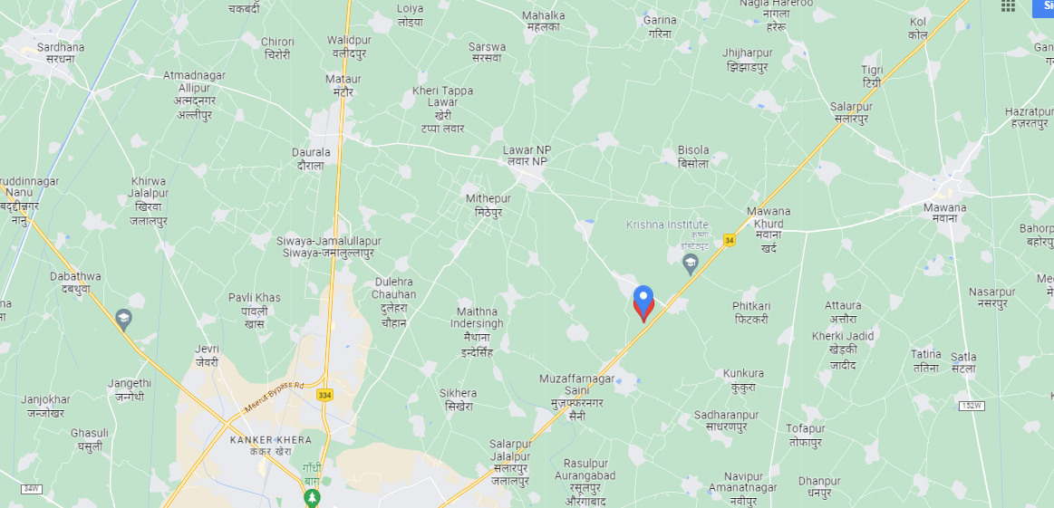
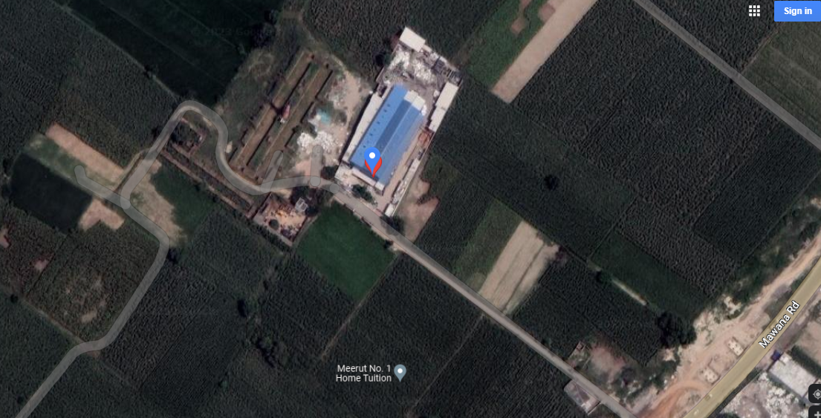

ENCLOSURE: 2– PHOTOGRAPHS OF THE PROPERTY

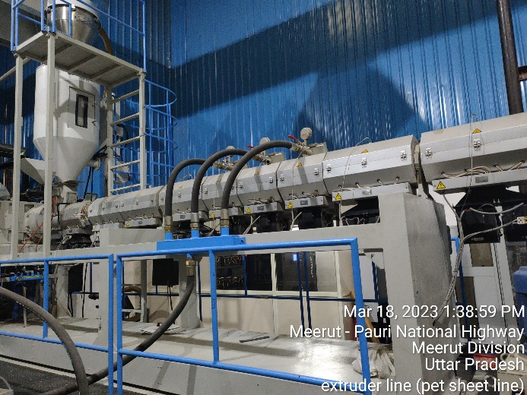 | 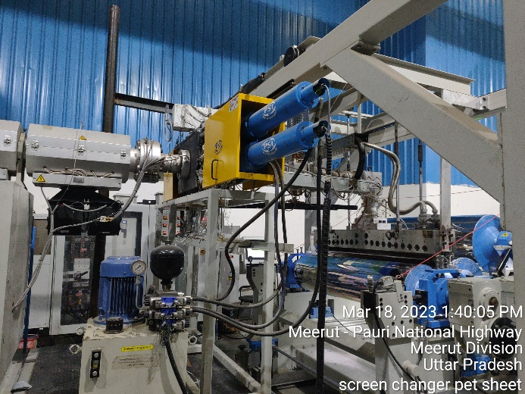
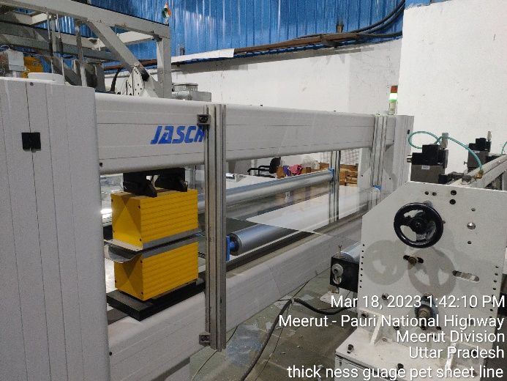 | 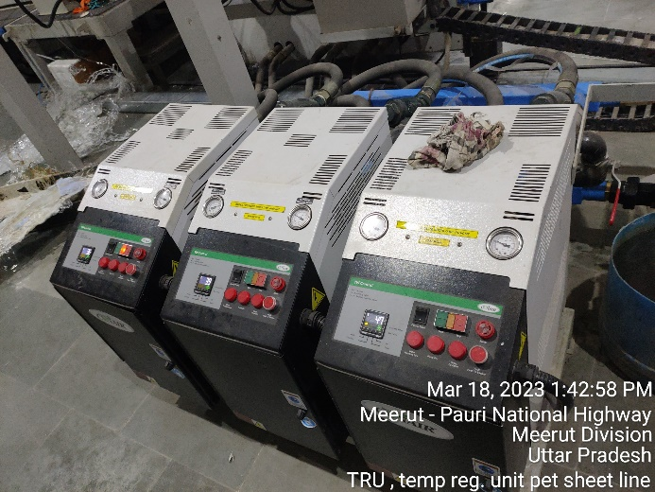
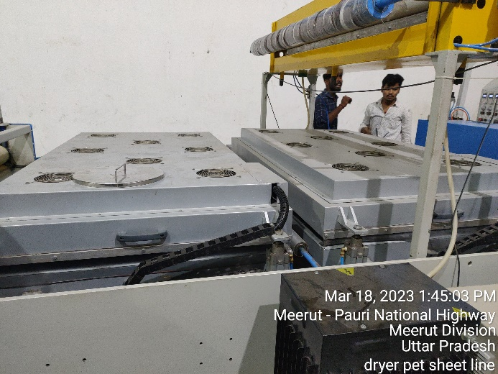 | 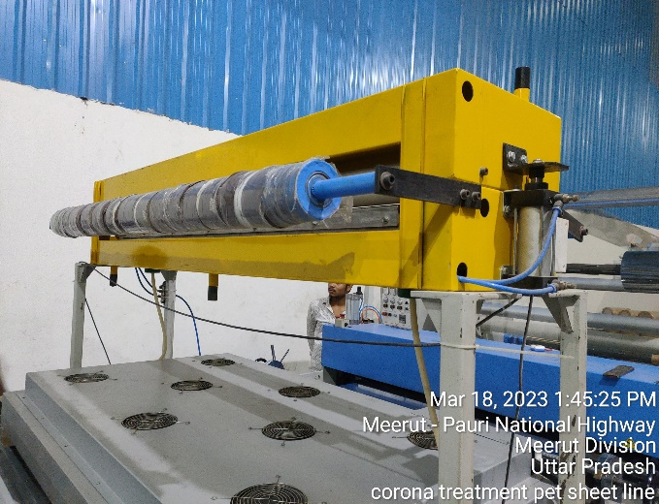

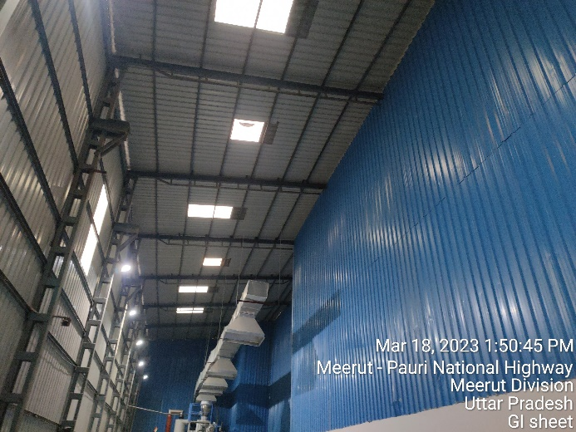 | 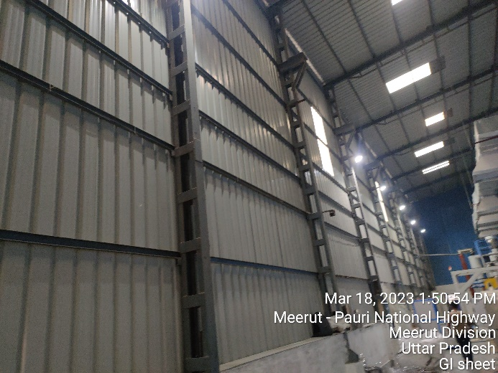
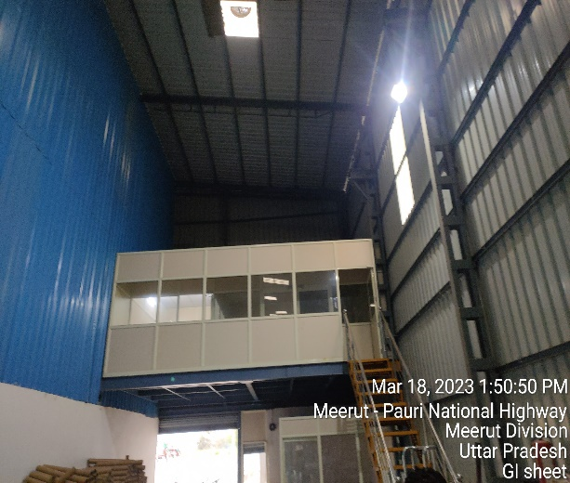 | 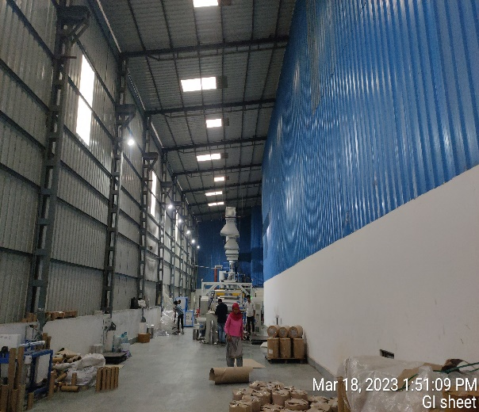
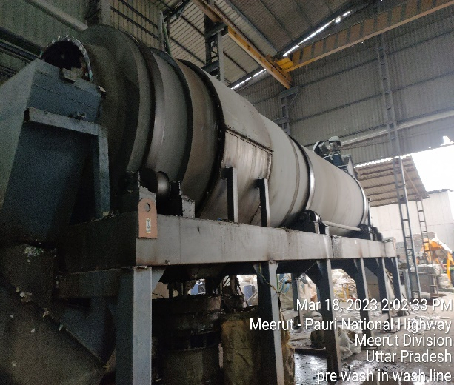 | 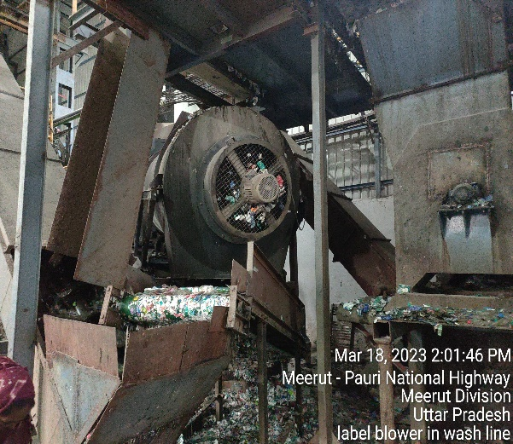

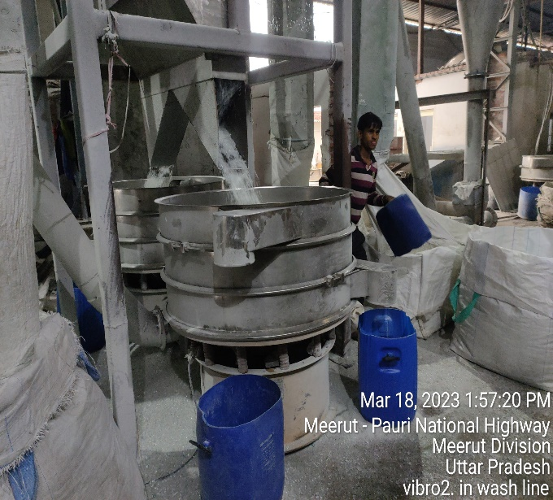 | 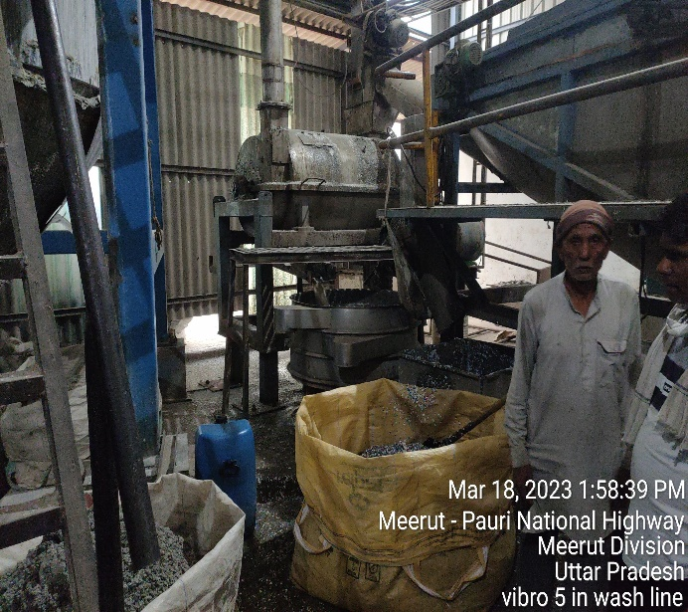
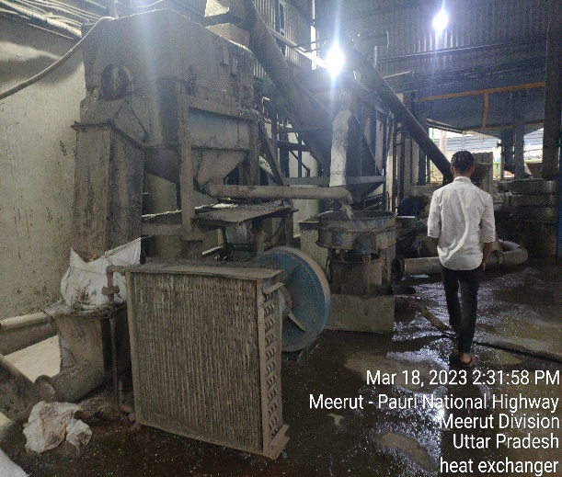 | 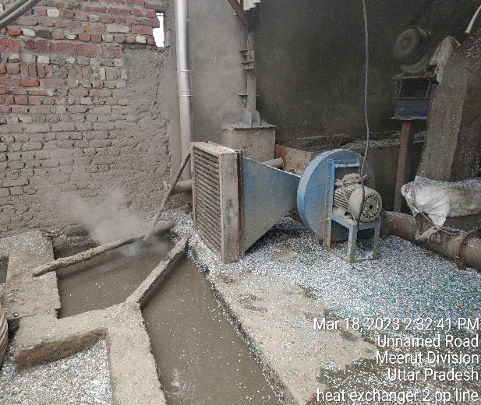
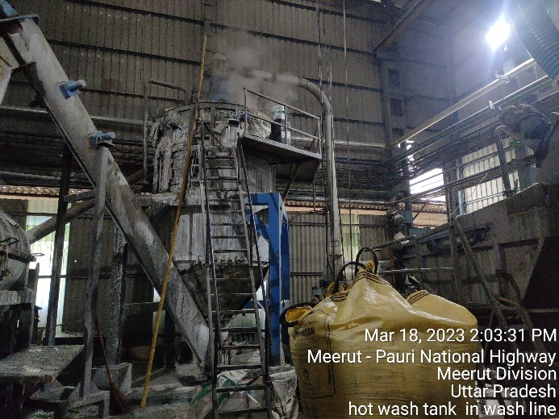 | 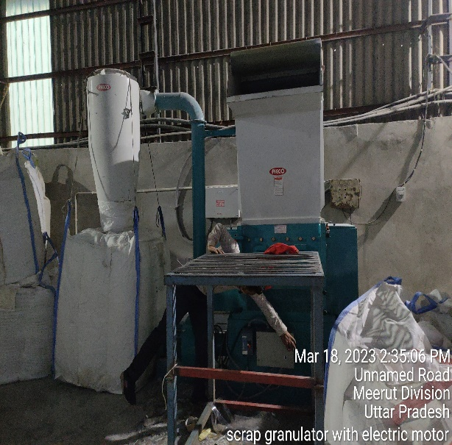

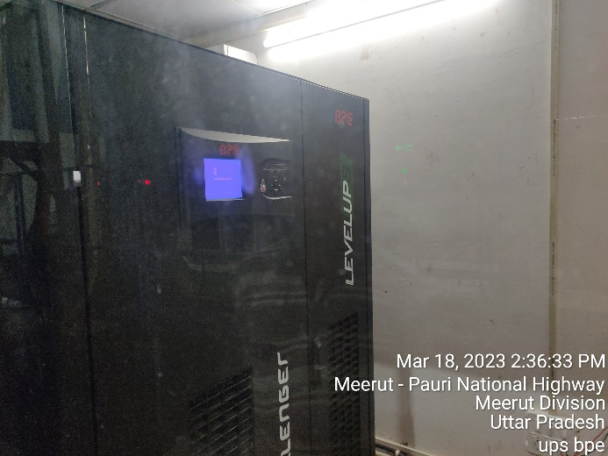 | 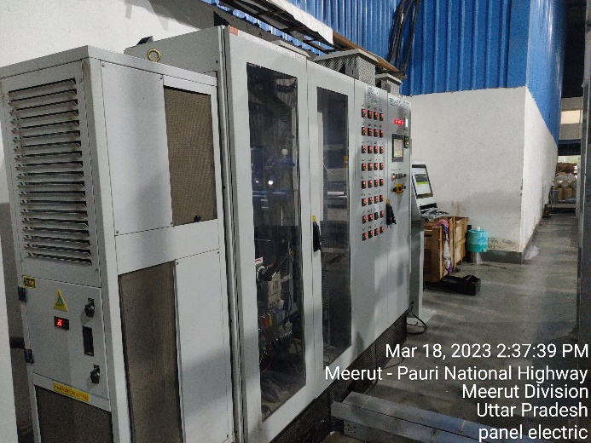
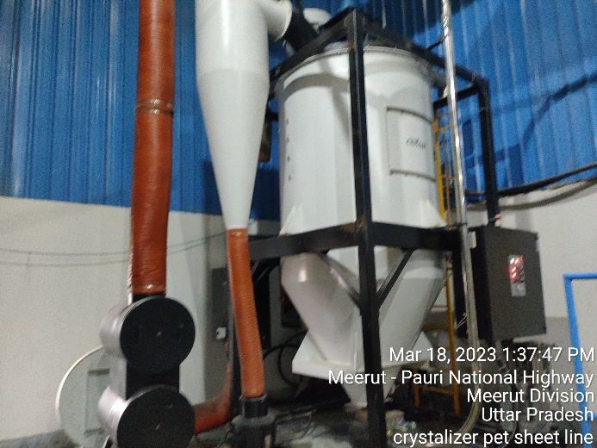 | 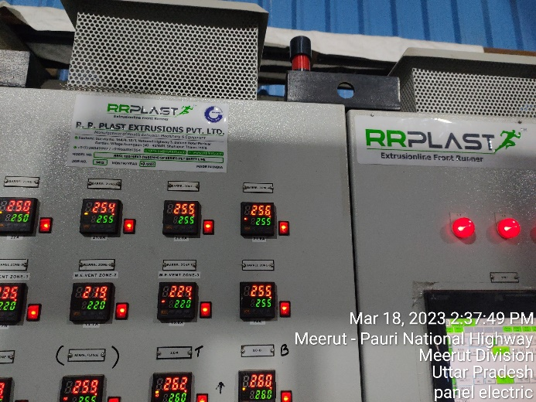
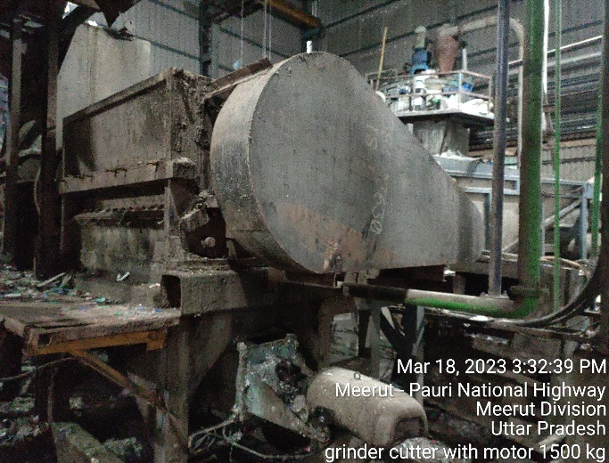 | 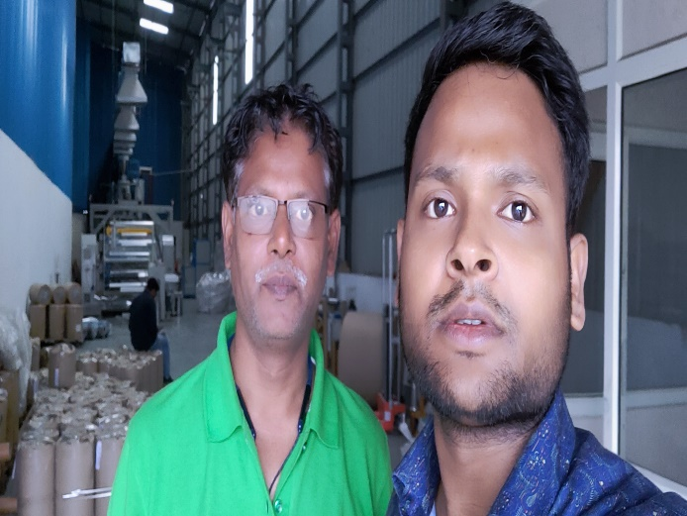

INVOICES OF THE ASSETS

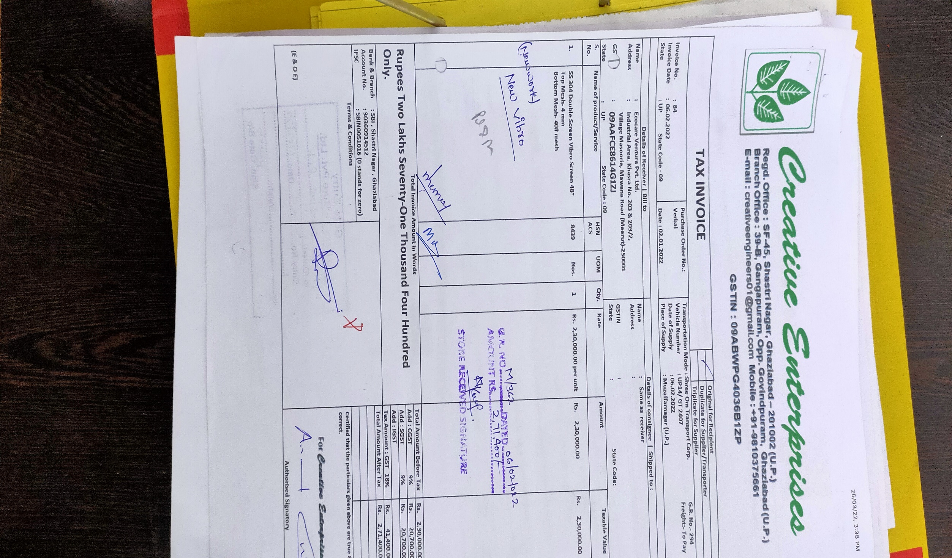

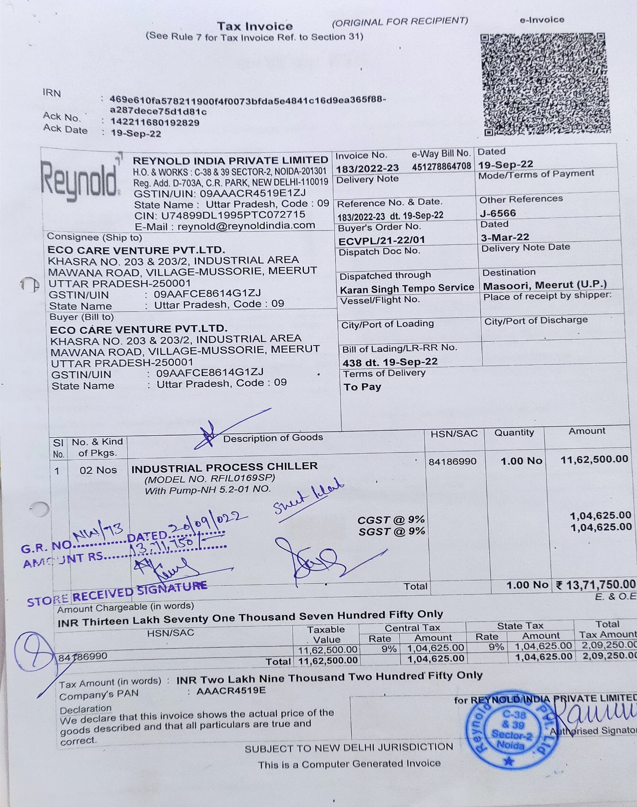
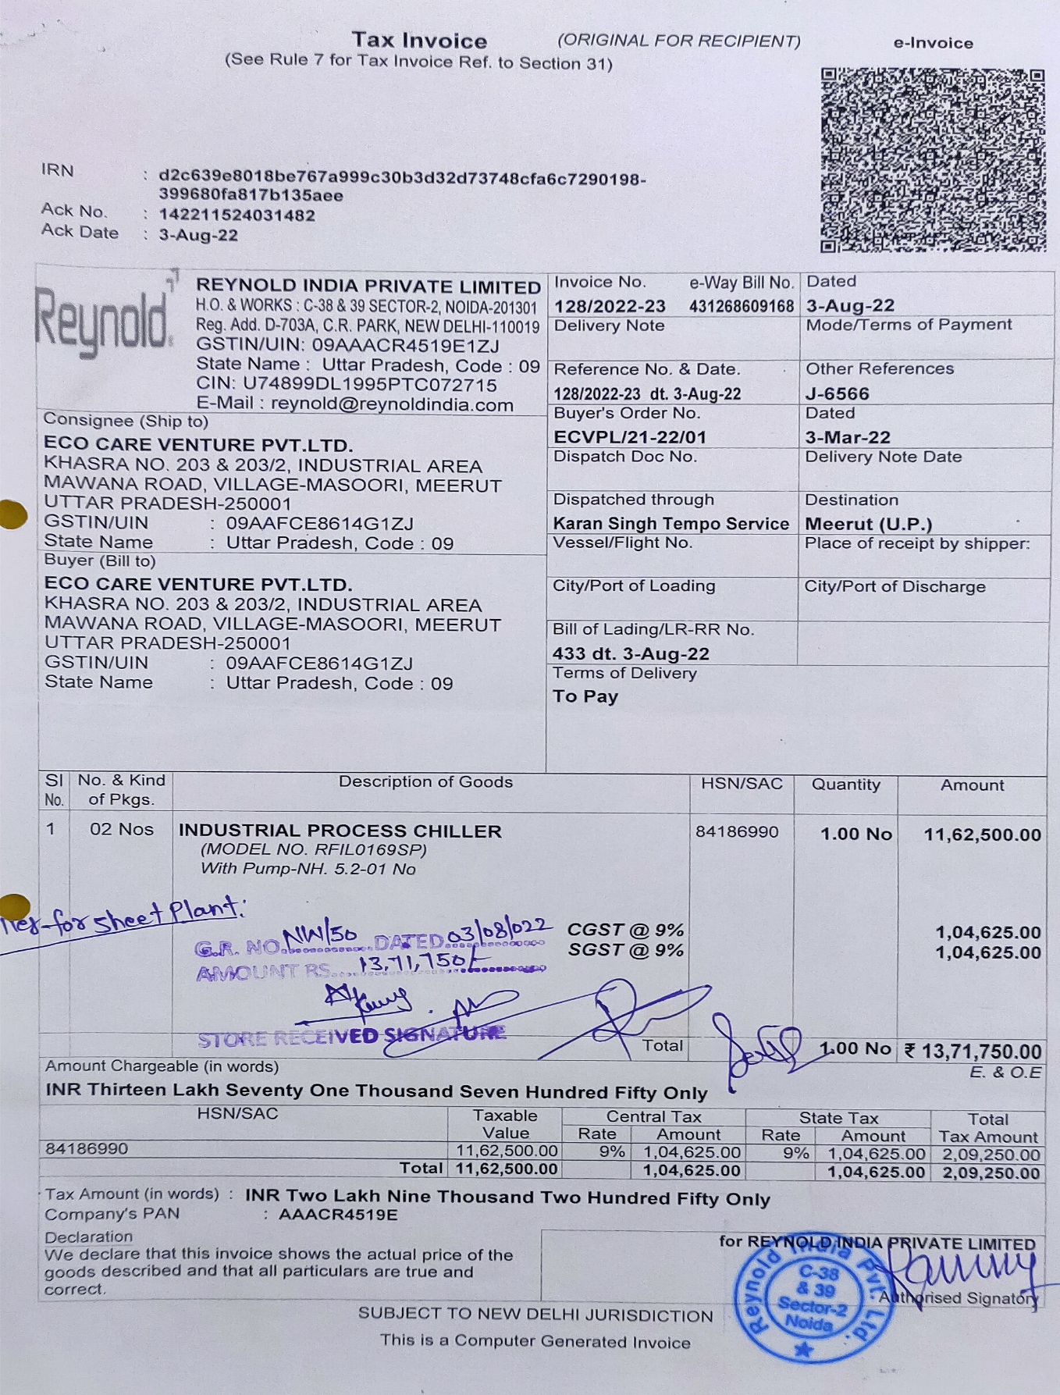
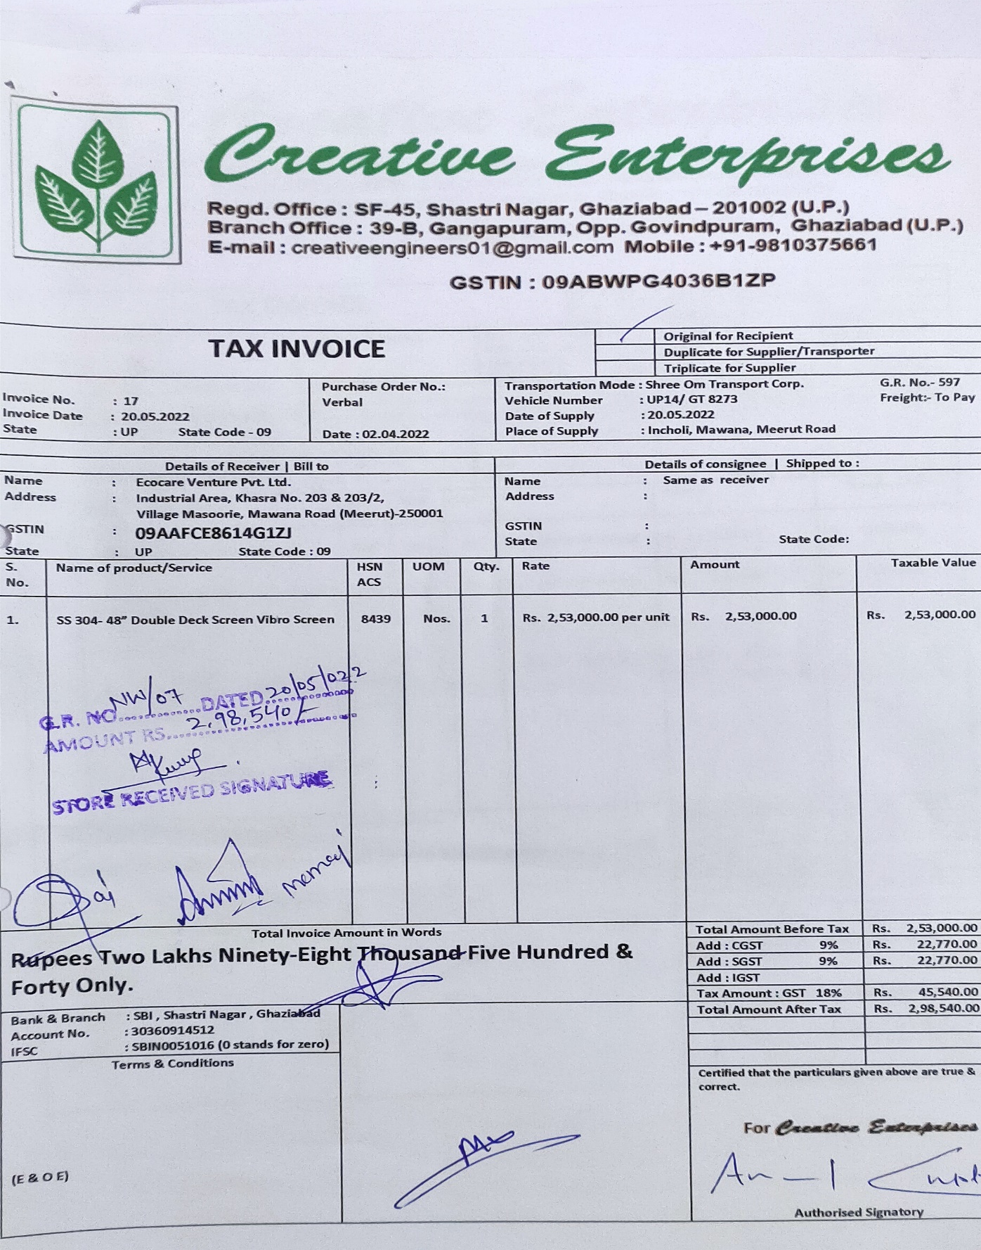
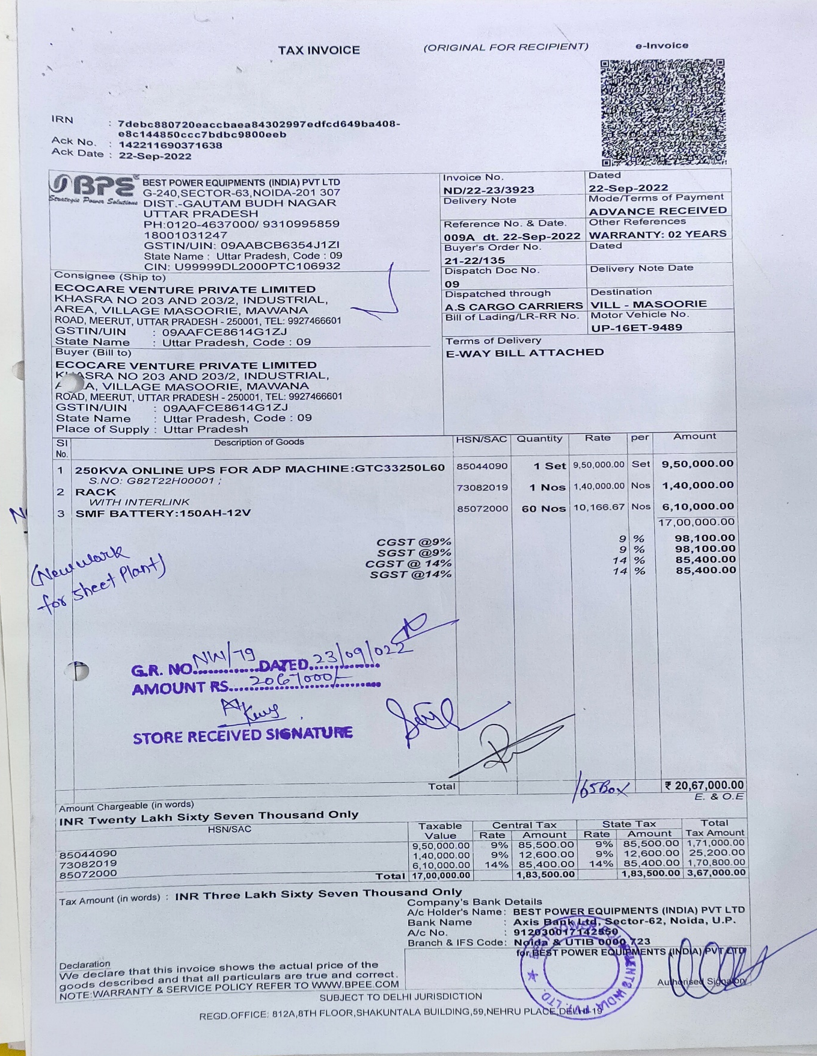
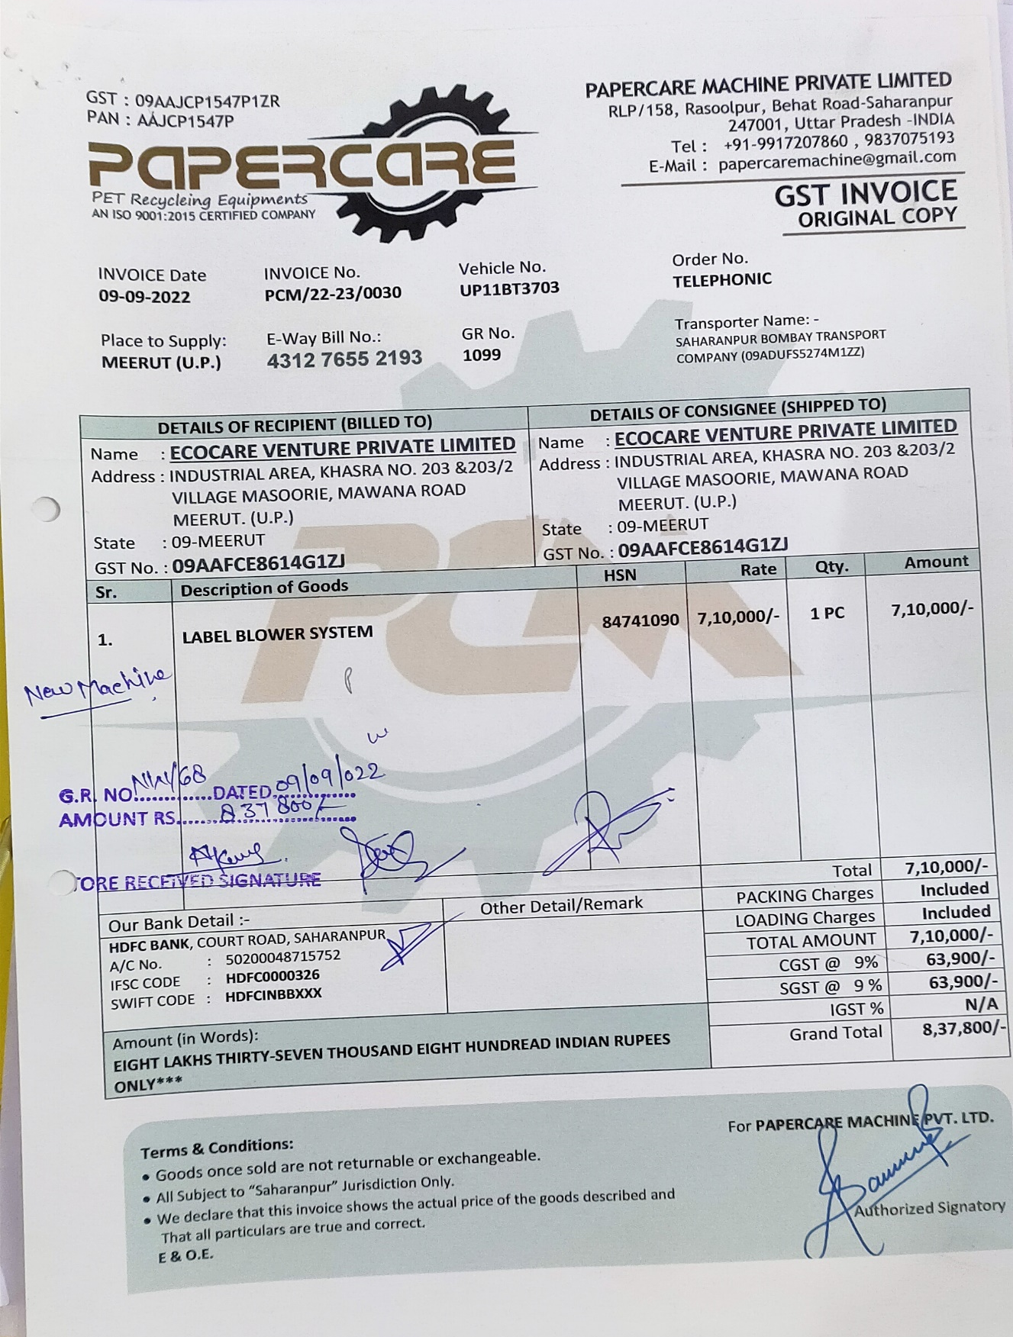
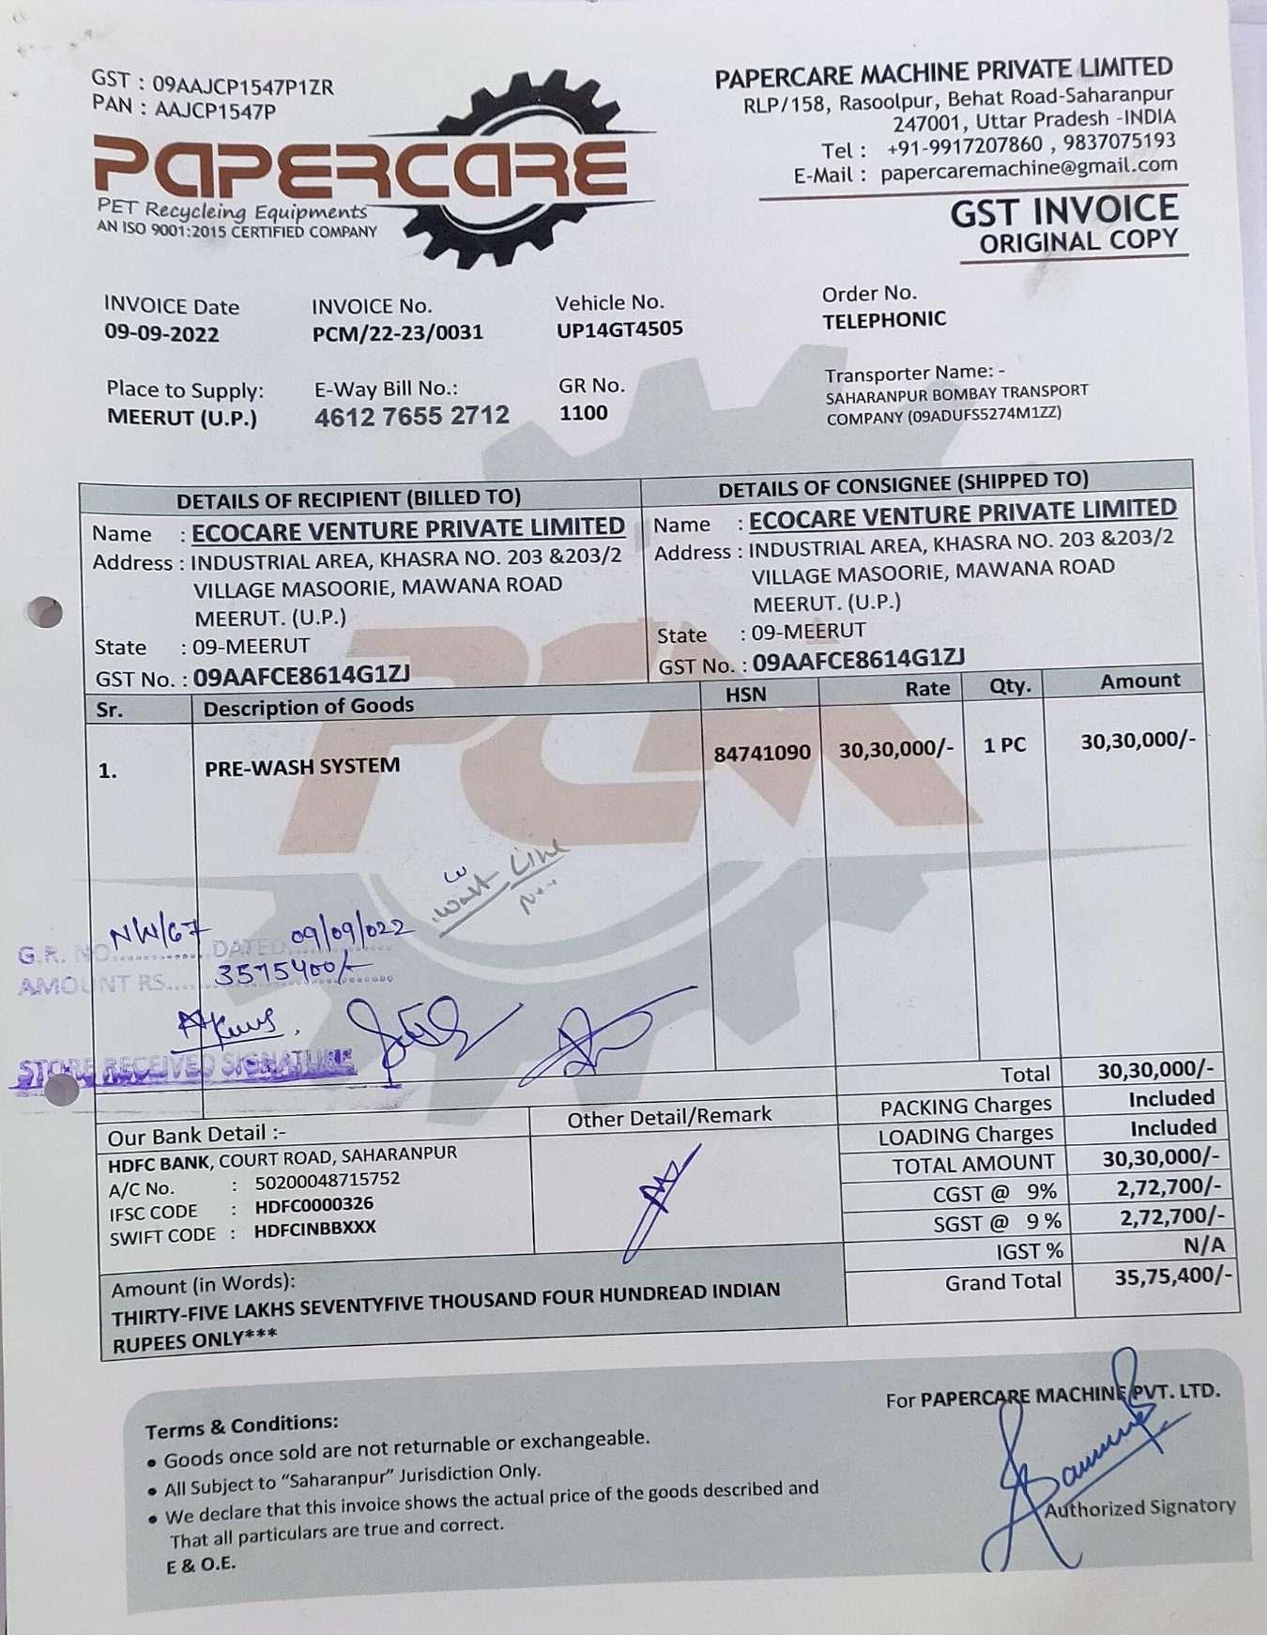
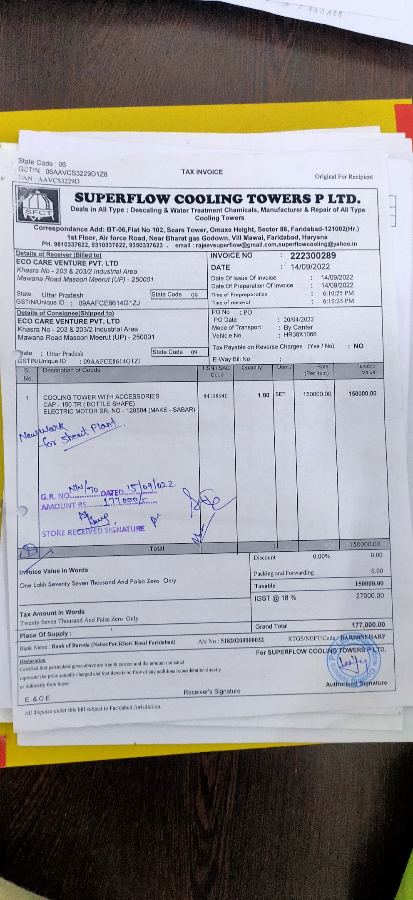
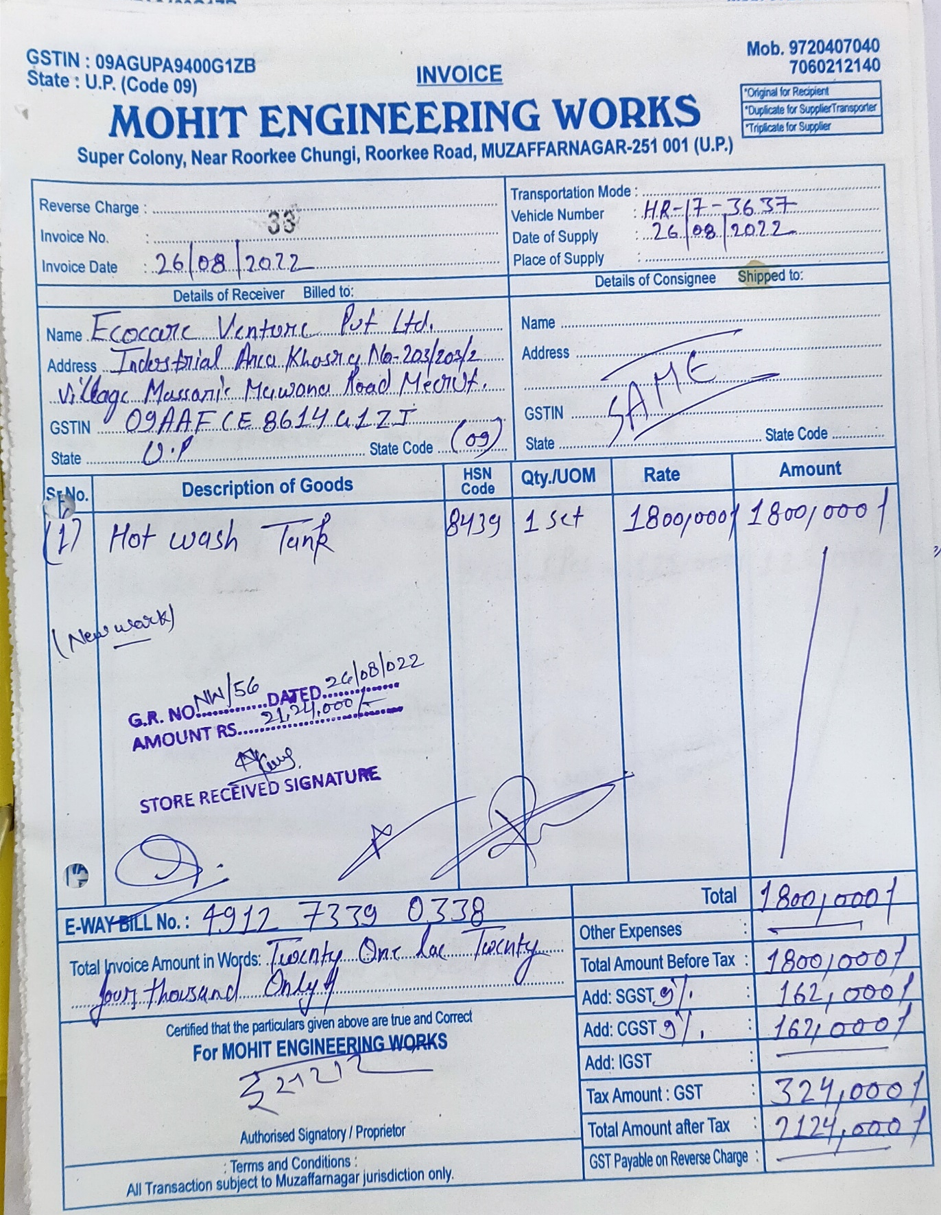
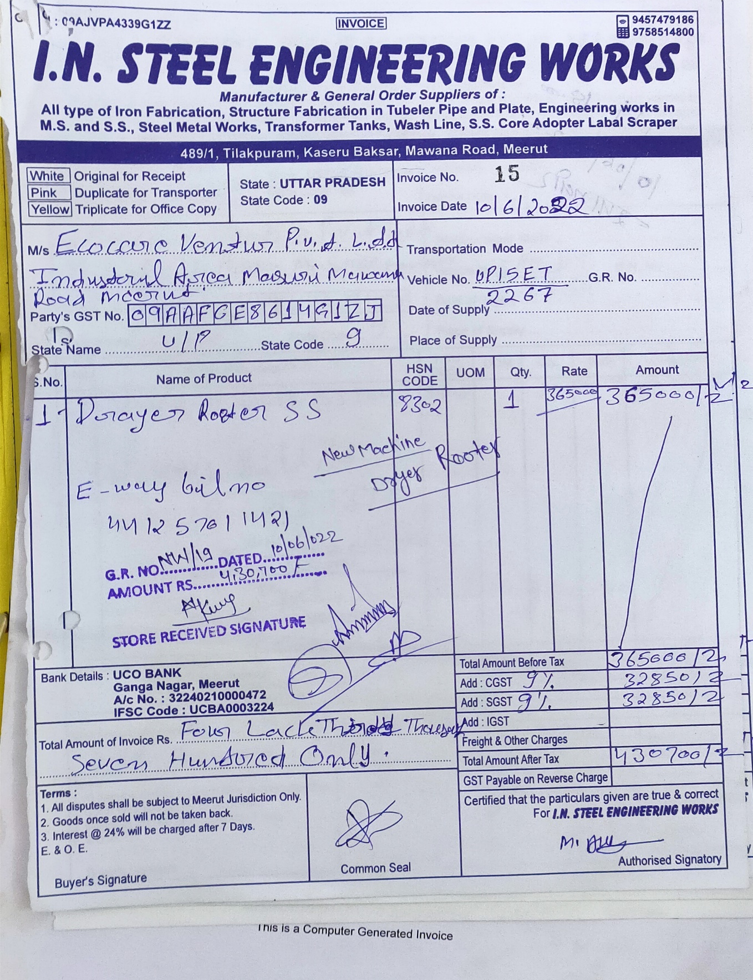
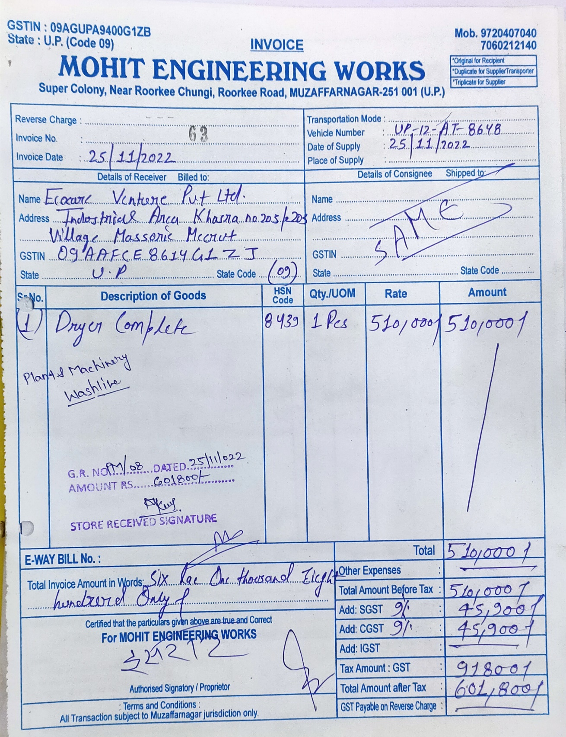

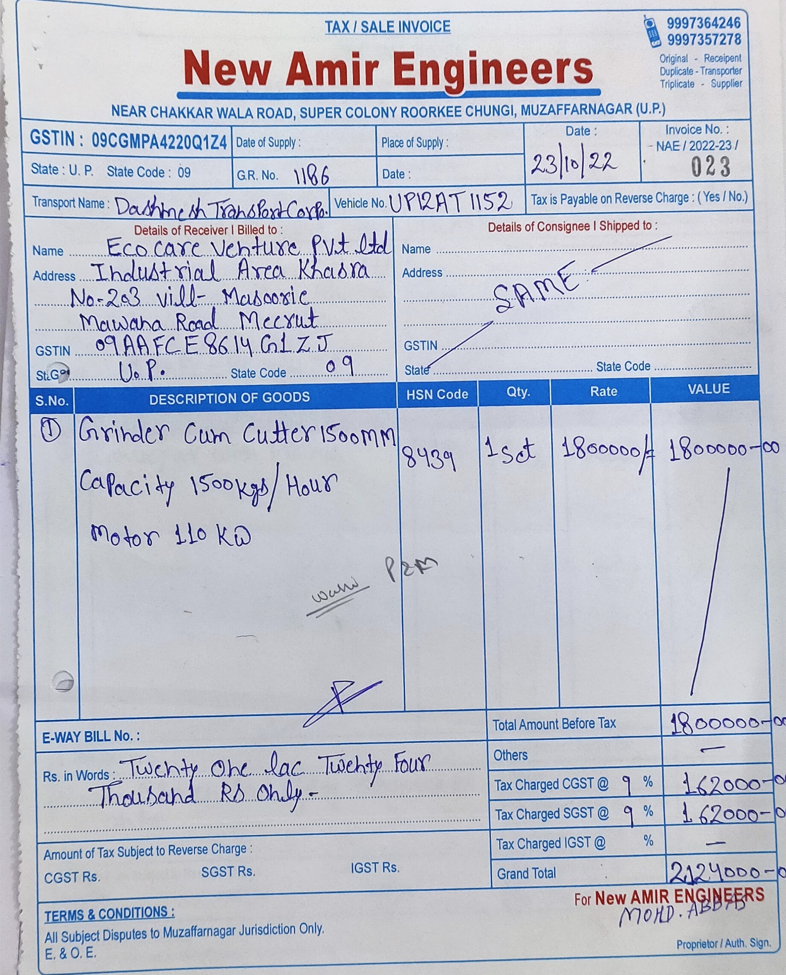
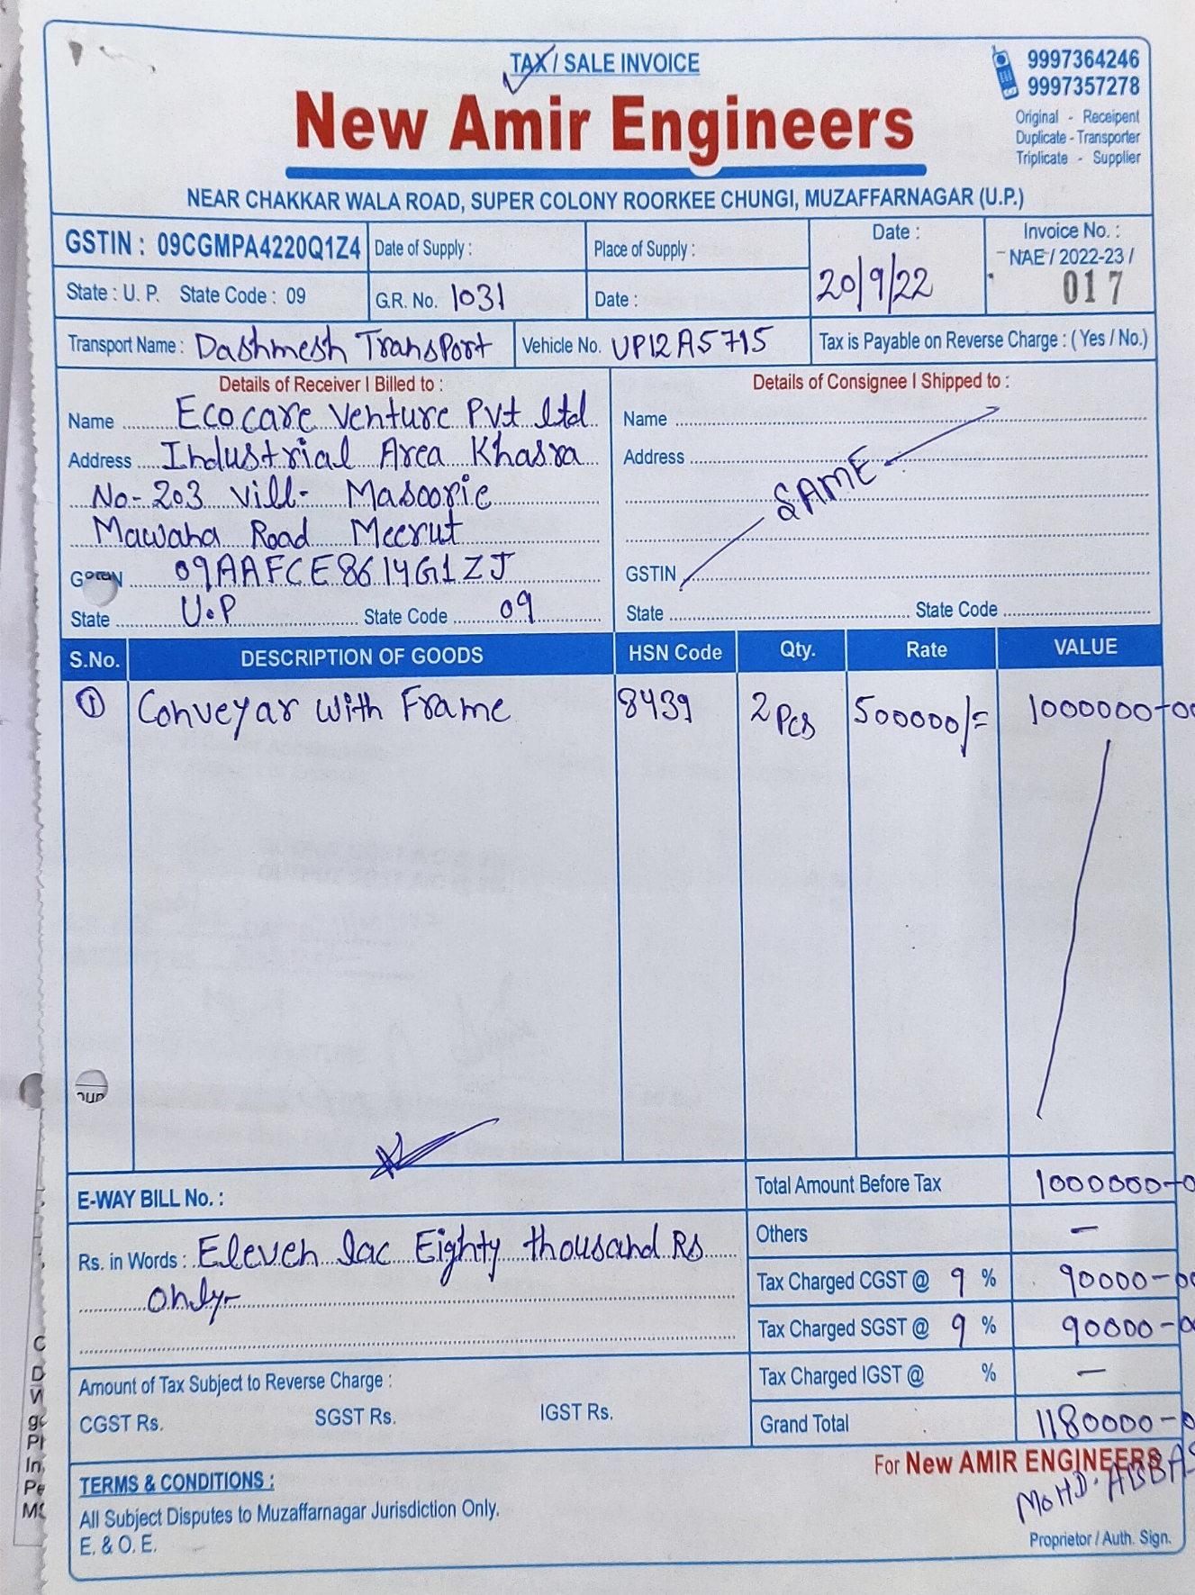
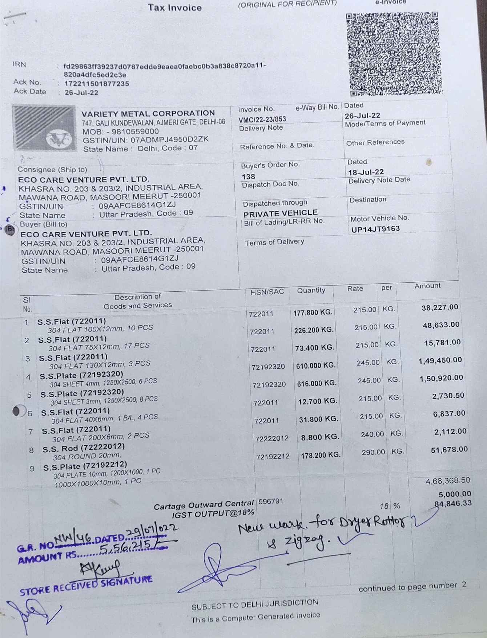
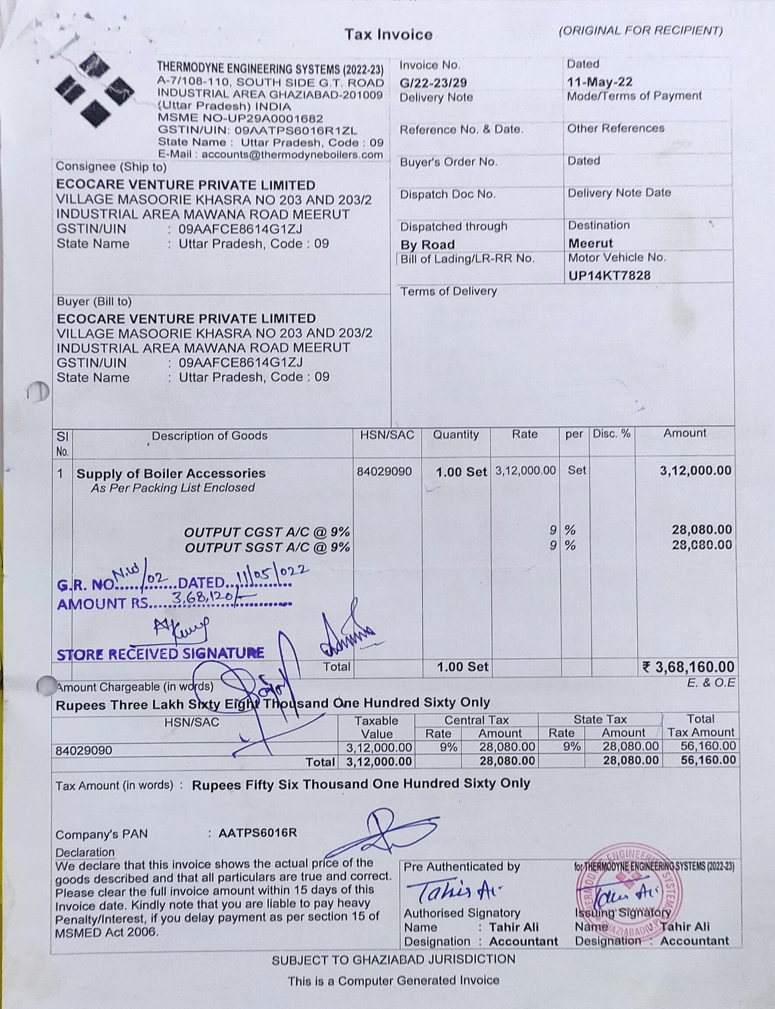

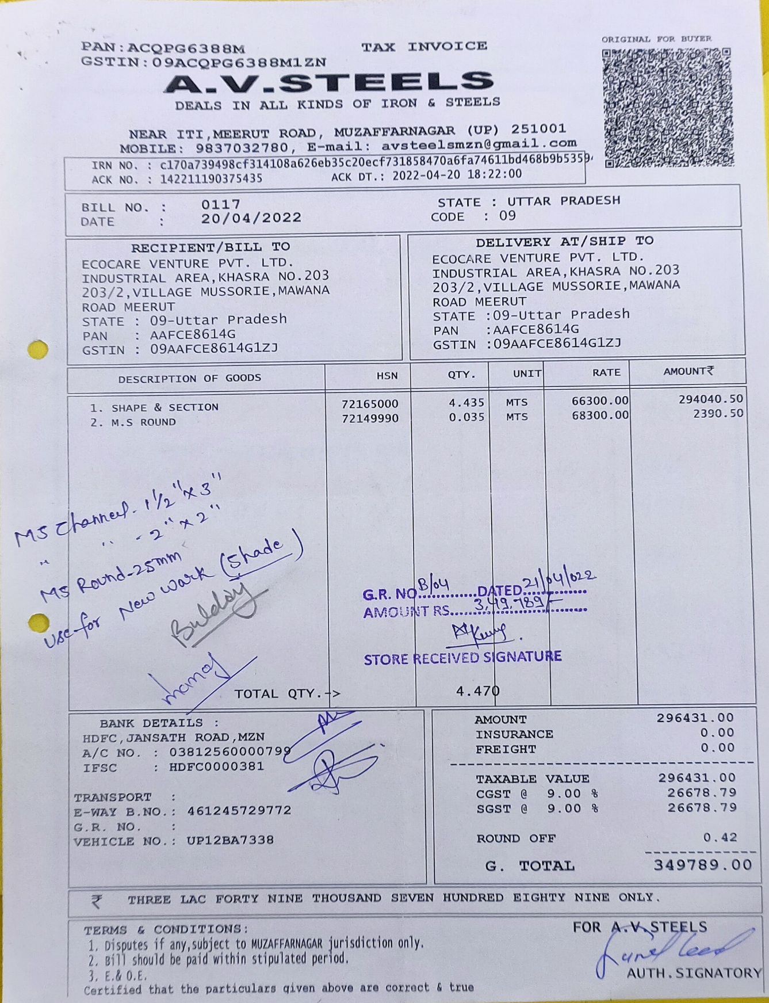
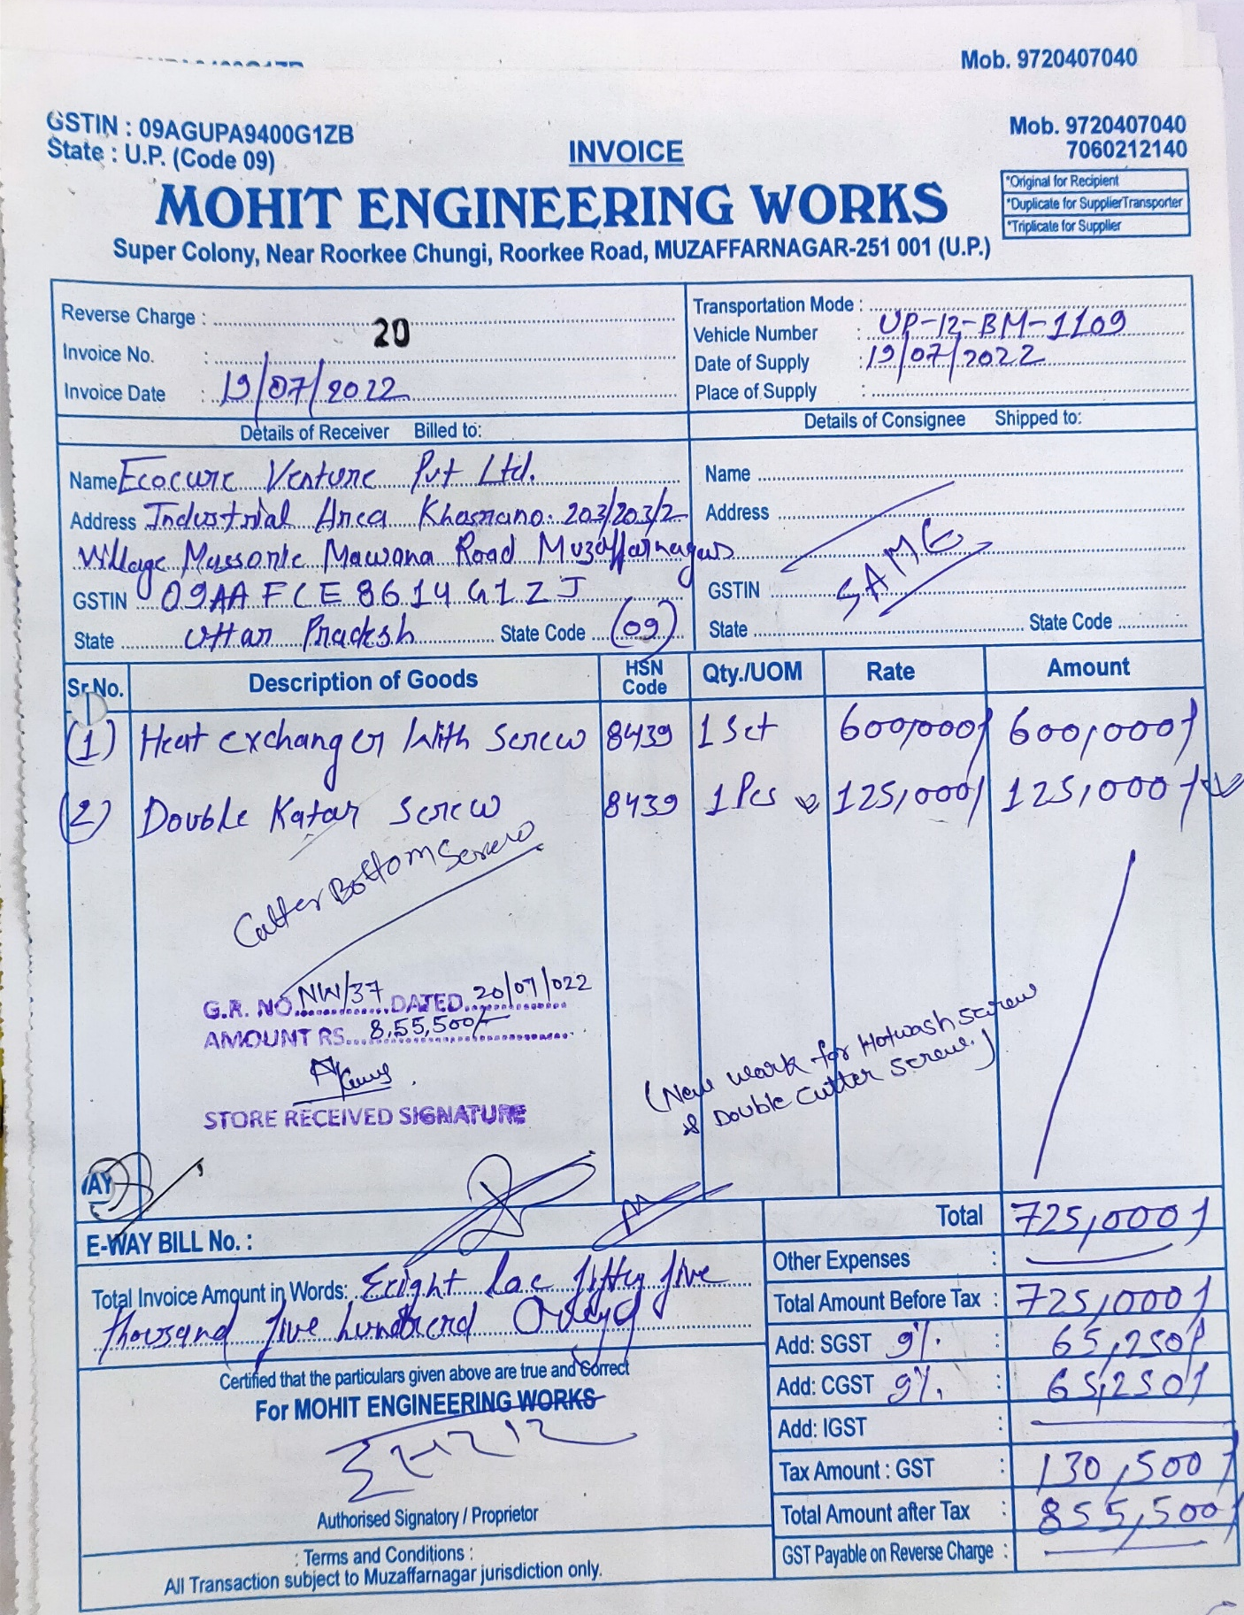

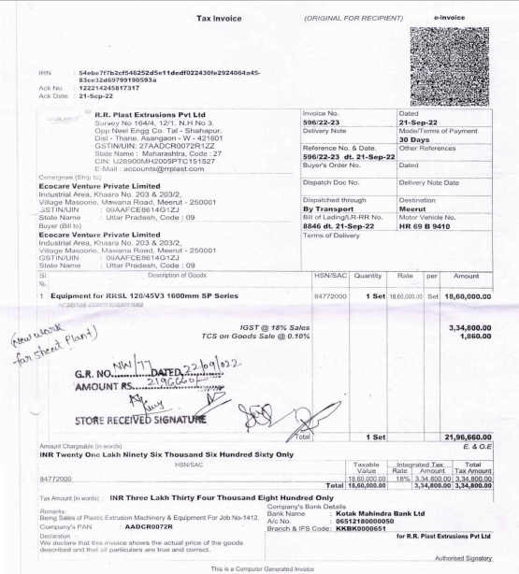
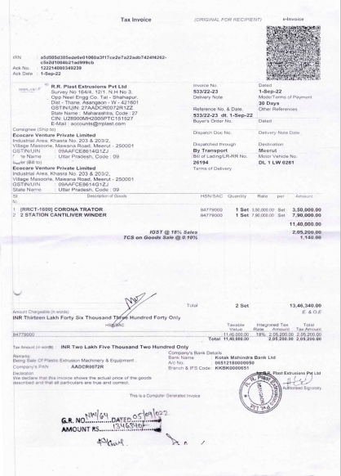
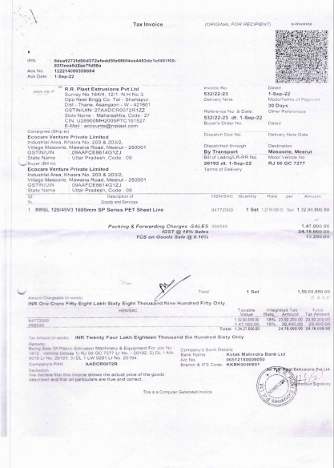
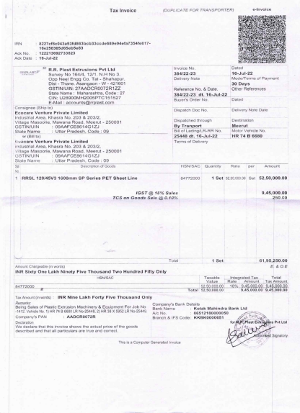
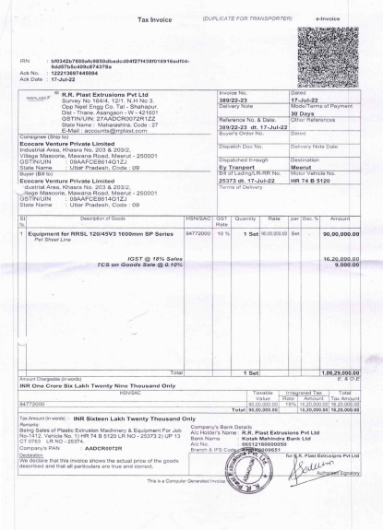
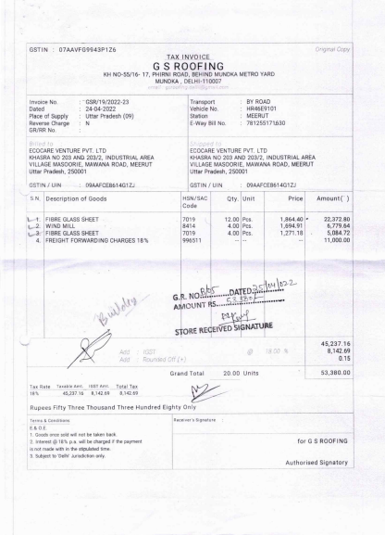
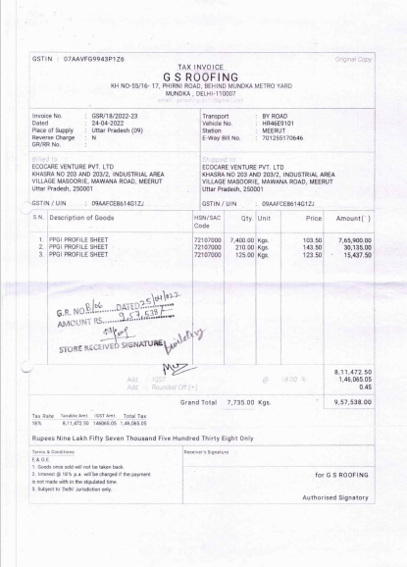
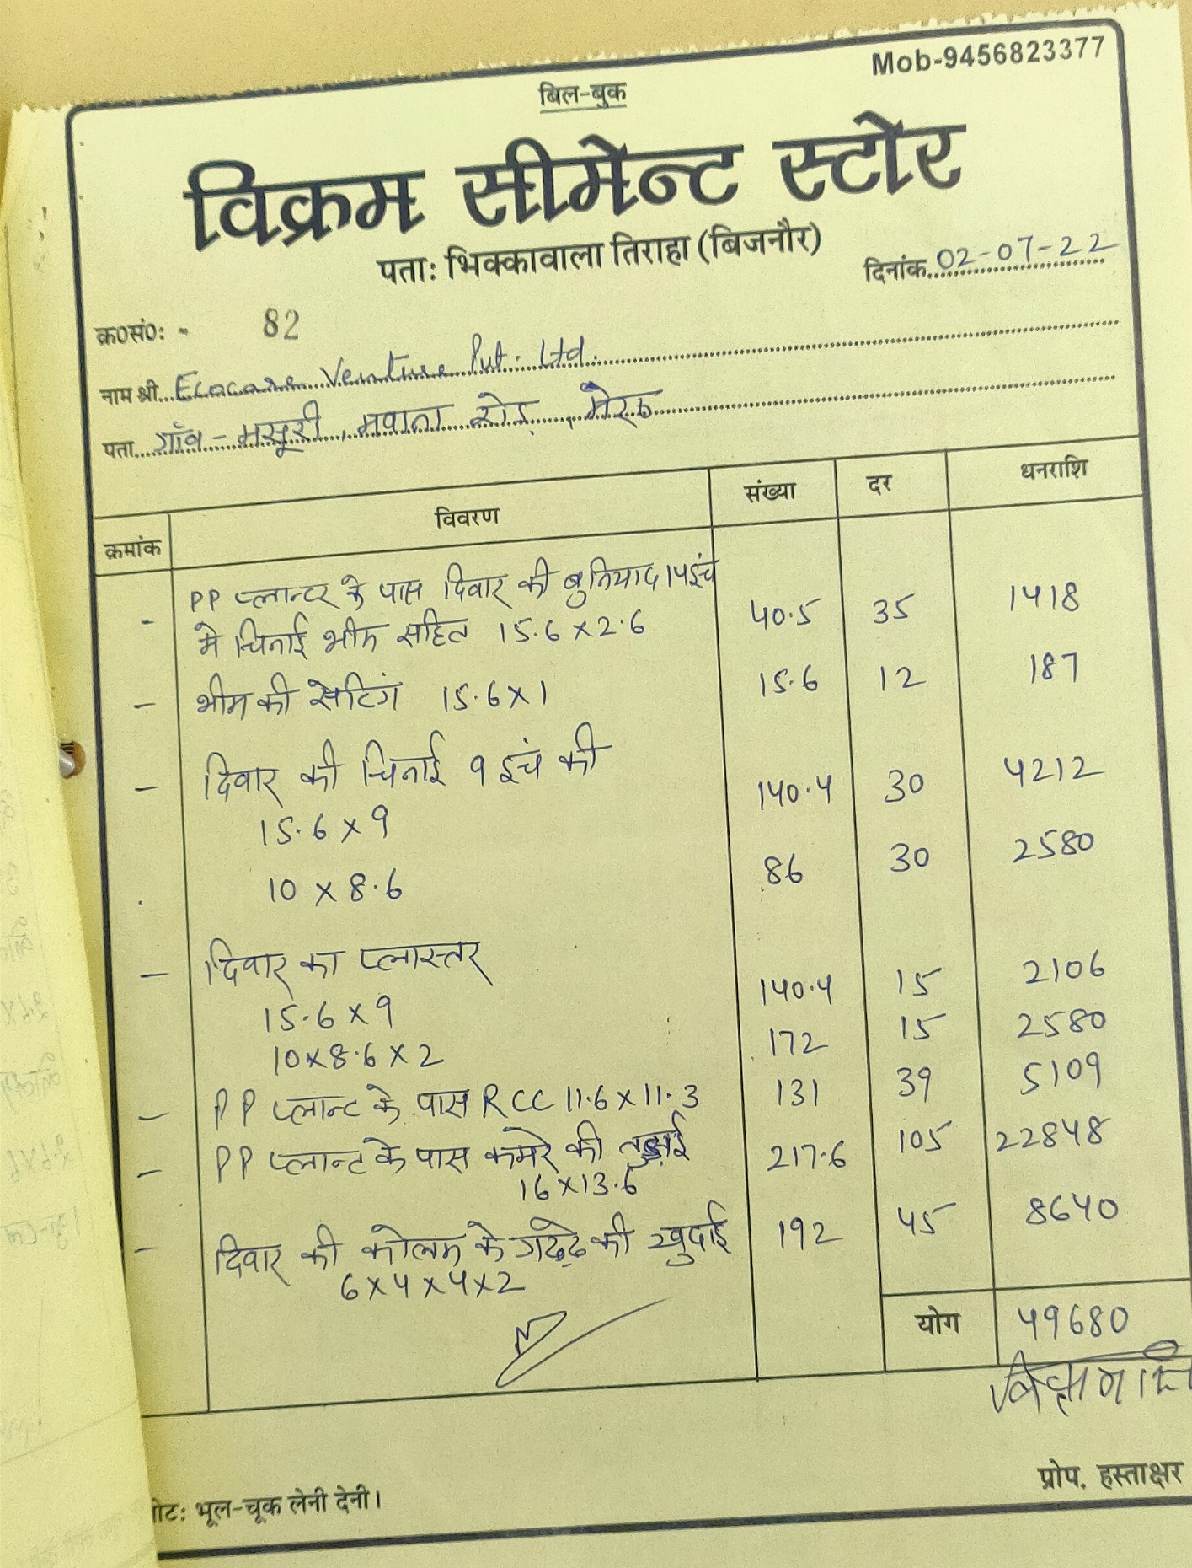
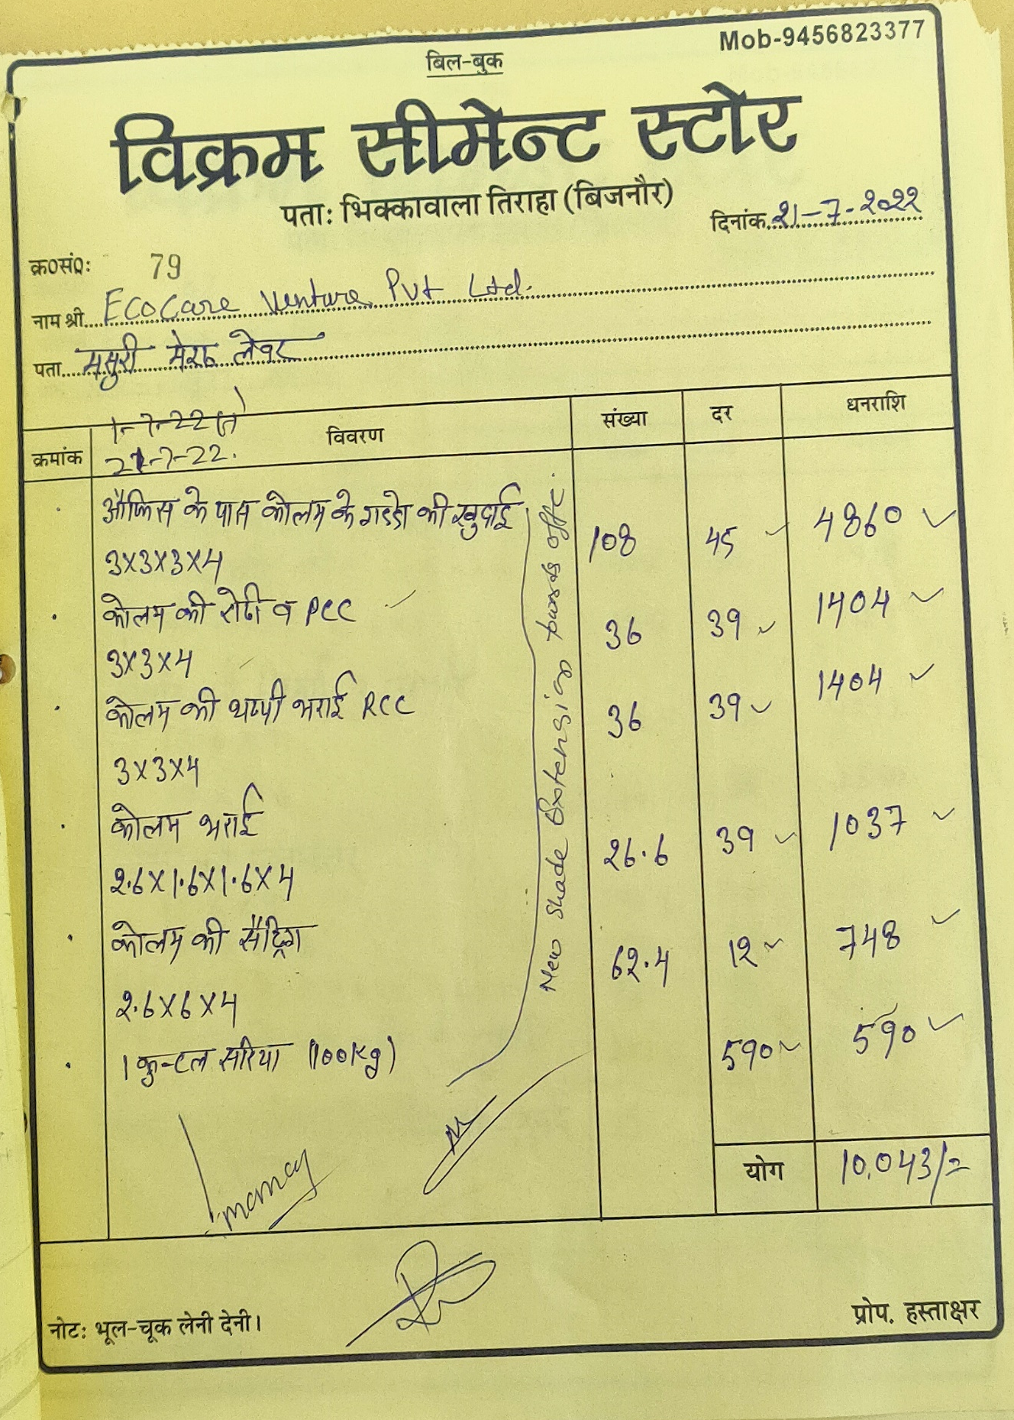
ENCLOSURE: 3 – VALUER’S IMPORTANT REMARKS

Valuation is done for the asset found on as-is-where basis which owner/ owner representative/ client/ bank has shown/ identified to us on the site unless otherwise mentioned in the report of which some reference has been taken from the information/ data given in the copy of documents provided to us and informed verbally or in writing out of the standard checklist of documents sought from the client & its customer which they could provide within the reasonable expected time out of the standard checklist of documents sought from them and further based on certain assumptions and limiting conditions. The information, facts, documents, data which has become primary basis of the report has been supplied by the client which has been relied upon in good faith and is not generated by the Valuer.
The client/ owner and its management/ representatives warranted to us that the information they have supplied was complete, accurate and true and correct to the best of their knowledge. All such information provided to us either verbally, in writing or through documents has been relied upon in good faith and we have assumed that it is true & correct without any fabrication or misrepresentation. I/We shall not be held liable for any loss, damages, cost or expenses arising from fraudulent acts, misrepresentations, or willful default on part of the owner, company, its directors, employee, representative or agents.
Legal aspects for eg. Investigation of title, ownership rights, lien, charge, mortgage, lease, sanctioned maps, verification of documents provided to us such as title documents, Map, etc. from any concerned Govt. office etc. have to be taken care by legal expert/ Advocate and same is not done at our end. It is assumed that the concerned Lender/ Financial Institution has asked for the valuation of that property after satisfying the authenticity of the documents given to us for which the legal verification has been already taken and cleared by the competent Advocate before requesting for the Valuation report. I/ We assume no responsibility for the legal matters including, but not limited to, legal or title concerns.
In the course of the valuation, we were provided with both written and verbal information. We have however, evaluated the information provided to us through broad inquiry, analysis and review but have not carried out a due diligence or audit of the information provided for the purpose of this engagement. Our conclusions are based on the assumptions and other information provided to us by the client during the course of the assessment.
Getting cizra map or coordination with revenue officers for site identification is a separate activity and is not part of the Valuation services and same has not been done in this report unless otherwise stated.
Wherever any details are mentioned in the report in relation to any legal aspect of the property such as name of the owner, leases, etc. is only for illustration purpose and should not be construed as a professional opinion. Legal aspects are out of scope of this report. Details mentioned related to legal aspect are only based on the copy of the documents provided to us and whatever we can interpret as a non-legally trained person. This should be cross validated with a legal expert. We do not vouch any responsibility regarding the same.
We have made certain assumptions in relation to facts, conditions & situations affecting the subject of, or approach to this exercise that has not been verified as part of the engagement rather, treated as “a supposition taken to be true”. If any of these assumptions prove to be incorrect then our estimate on value will need to be reviewed.
This is just an opinion report based on technical & market information having general assessment & opinion on the indicative, estimated Market Value of the property for which Bank has asked to conduct the Valuation. It doesn’t contain any other recommendations of any sort including but not limited to express of any opinion on the suitability or otherwise of entering into any transaction with the borrower.
We have relied on the data from third party, external sources & information available on public domain to conclude the valuation. These sources are believed to be reliable and therefore, we assume no liability for the truth or accuracy of any data, opinions or estimates furnished by others that have been used in this analysis. Where we have relied on the data, opinions or estimates from external sources, reasonable care has been taken to ensure that such data is extracted from authentic sources, however we still can’t vouch its authenticity, correctness, or accuracy.
Analysis and conclusions adopted in the report are limited to the reported assumptions, conditions and information came to our knowledge during the course of the work and based on the Standard Operating Procedures, Best Practices, Caveats, Limitations, Conditions, Remarks, Important Notes, Valuation TOR and definition of different nature of values.
Value varies with the Purpose/ Date/ Asset Condition & situation/ Market condition, demand & supply, asset utility prevailing on a particular date/ Mode of sale. The indicative & estimated prospective Value of the asset given in this report is restricted only for the purpose and other points mentioned above prevailing on a particular date as mentioned in the report. If any of these points are different from the one mentioned aforesaid in the Report then this report should not be referred.
Our report is meant ONLY for the purpose mentioned in the report and should not be used for any other purpose. The Report should not be copied or reproduced for any purpose other than the purpose for which it is prepared for. I/we do not take any responsibility for the unauthorized use of this report.
We owe responsibility only to the authority/client that has appointed us as per the scope of work mentioned in the report. We will not be liable for any losses, claims, damages or liabilities arising out of the actions taken, omissions or advice given by any other person. In no event shall we be liable for any loss, damages, cost or expenses arising in any way from fraudulent acts, misrepresentations or willful default on part of the client or companies, their directors, employees or agents.
This report is having limited scope as per its fields & format to provide only the general basic idea of the value of the property prevailing in the market based on the site inspection and documents/ data/ information provided by the client. The suggested indicative prospective estimated value should be considered only if transaction is happened as free market transaction.
The sale of the subject property is assumed to be on an all cash basis. Financial arrangements would affect the price at which the property may sell for if placed on the market.
The actual realizable value that is likely to be fetched upon sale of the asset under consideration shall entirely depend on the demand and supply of the same in the market at the time of sale.
While our work has involved an analysis & computation of valuation, it does not include detailed estimation, design/ technical/ engineering/ financial/ structural/ environmental/ architectural/ compliance survey/ safety audit & works in accordance with generally accepted standards of audit & other such works. The report in this work in not investigative in nature. It is mere an opinion on the likely estimated valuation based on the facts & details presented to us by the client and third party market information came in front of us within the limited time of this assignment, which may vary from situation to situation.
Where a sketched plan is attached to this report, it does not purport to represent accurate architectural plans. Sketch plans and photographs are provided as general illustrations only.
Documents, information, data including title deeds provided to us during the course of this assessment by the client is reviewed only upto the extent required in relation to the scope of the work. No document has been reviewed beyond the scope of the work. These are not reviewed in terms of legal rights for which we do not have expertise. Wherever any information mentioned in this report is mentioned from the documents like owners name, etc., it is only for illustration purpose and may not necessary represent accuracy.
The report assumes that the borrower/company/business/asset complies fully with relevant laws and regulations applicable in its area of operations and usage unless otherwise stated, and that the companies/business/assets is managed in a competent and responsible manner. Further, as specifically stated to the contrary, this report has given no consideration to matters of a legal nature, including issues of legal title and compliance with relevant laws, and litigations and other contingent liabilities that are not recorded/reflected in the documents/ details/ information/ data provided to us.
This valuation report is not a qualification for accuracy of land boundaries, schedule (in physical terms), dimensions & identification. For this land/ property survey report can be sought from a qualified private or Govt. surveyor.
This Valuation report is prepared based on the facts of the property on the date of the survey. Due to possible changes in market forces, socio-economic conditions, property conditions and circumstances, this valuation report can only be regarded as relevant as at the valuation date. Hence before financing, Banker/ FI should take into consideration all such future risk and should loan conservatively to keep the advanced money safe in case of the downward trend of the property value.
Valuation of the same asset/ property can fetch different values under different circumstances & situations. For eg. Valuation of a running/ operational shop/ hotel/ factory will fetch better value and in case of closed shop/ hotel/ factory it will have considerable lower value. Similarly, an asset sold directly by an owner in the open market through free market transaction then it will fetch better value and if the same asset/ property is sold by any financer due to encumbrance on it, will fetch lower value. Hence before financing, Lender/ FI should take into consideration all such future risks while financing and take decision accordingly.

Valuation is done for the property identified to us by the owner/ owner representative. At our end we have just visually matched the land boundaries, schedule (in physical terms) & dimensions of the property with reference to the documents produced for perusal. Method by which identification of the property is carried out is also mentioned in the report clearly. Responsibility of identifying the correct property to the Valuer/ its authorized surveyor is solely of the client/ owner for which Valuation has to be carried out. It is requested from the Bank to cross check from their own records/ information if this is the same property for which Valuation has to be carried out to ensure that owner has not misled the Valuer company or misrepresented the property due to any vested interest. Where there is a doubt about the precision position of the boundaries, schedule, dimensions of site & structures, it is recommended that a Licensed Surveyor be contacted.
In India more than 70% of the geographical area is lying under rural/ remote/ non municipal/ unplanned area where the subject property is surrounded by vacant lands having no physical demarcation or having any display of property survey or municipal number / name plate on the property clearly. Even in old locations of towns, small cities & districts where property number is either not assigned or not displayed on the properties clearly and also due to the presence of multiple/ parallel departments due to which ownership/ rights/ illegal possession/ encroachment issues are rampant across India and due to these limitations at many occasions it becomes tough to identify the property with 100% surety from the available documents, information & site whereabouts and thus chances of error, misrepresentation by the borrower and margin of chances of error always persists in such cases. To avoid any such chances of error it is advised to the Bank to engage municipal/ revenue department officials to get the confirmation of the property to ensure that the property shown to Valuer/ Banker is the same as for which documents are provided.
If this Valuation Report is prepared for the Flat/ dwelling unit situated in a Group Housing Society or Integrated Township then approvals, maps of the complete group housing society/ township is out of scope of this report and this report will be made for the specific unit based on the assumption that complete Group Housing Society/ Integrated Township and the subject unit must be approved in all respect.
Due to fragmented & frequent change in building/ urban planning laws/ guidelines from time to time, different laws/ guidelines between regions/ states and no strict enforceability of Building Bye-Laws in India specially in non-metro and scale b & c cities & Industrial areas, property owners many times extend or make changes in the covered area/ layout from the approved/ applicable limits. There are also situations where properties are decades old when there was no formal Building Bye-Laws applicable the time when the construction must have been done. Due to such discrete/ unplanned development in many regions sometimes it becomes tough for the Valuer to determine the exact lawful situation on ground. Unless otherwise mentioned in the report, the covered area present on the site as per site survey will be considered in the Valuation.
Area of the large land parcels of more than 2500 sq.mtr or of uneven shape in which there can be practical difficulty in sample measurement, is taken as per property documents which has been relied upon unless otherwise stated.

Drawing Map, design & detailed estimation of the property/ building is out of scope of the Valuation services.
Valuation is a subjective field and opinion may differ from consultant to consultant. To check the right opinion, it is important to evaluate the methodology adopted and various data point/ information/ factors/ assumption considered by the consultant which became the basis for the Valuation report before reaching to any conclusion.
Although every scientific method has been employed in systematically arriving at the value, there is, therefore, no indisputable single value and the estimate of the value is normally expressed as falling within a likely range.
Value analysis of any asset cannot be regarded as an exact science and the conclusions arrived at in many cases will, of necessity, be subjective and dependent on the exercise of individual judgment. Given the same set of facts and using the same assumptions, expert opinions may differ due to the number of separate judgment decisions, which have to be made. Therefore, there can be no standard formula to establish an indisputable exchange ratio. In the event of a transaction, the actual transaction value achieved may be higher or lower than our indicative analysis of value depending upon the circumstances of the transaction. The knowledge, negotiability and motivations of the buyers and sellers, demand & supply prevailing in the market and the applicability of a discount or premium for control will also affect actual price achieved. Accordingly, our indicative analysis of value will not necessarily be the price at which any agreement proceeds. The final transaction price is something on which the parties themselves have to agree. However, our Valuation analysis can definitely help the stakeholders to take informed and wise decision about the Value of the asset and can help in facilitating the arm’s length transaction.
This Valuation is conducted based on the macro analysis of the asset/ property considering it in totality and not based on the micro, component, or item wise analysis. Analysis done is a general assessment and is not investigative in nature.
This report is prepared on the RKA V-L1 (Basic) Valuation format as per the client requirement and scope of work. This report is having limited scope as per its fields & format to provide only the general estimated & indicative basic idea of the value of the property prevailing in the market based on the information provided by the client. No detailed analysis, audit or verification has been carried out of the subject property. There may be matters, other than those noted in this report, which might be relevant in the context of the transaction and which a wider scope might uncover.
This is just an opinion report and doesn’t hold any binding on anyone. It is requested from the concerned Client/ Bank/ Financial Institution which is using this report for mortgaging the property that they should consider all the different associated relevant & related factors & risks before taking any business decision based on the content of this report.
All Pages of the report including annexures are signed and stamped from our office. In case any paper in the report is without stamp & signature then this should not be considered a valid paper issued from this office.
As per IBA Guidelines & Bank Policy, in case the valuation report submitted by the valuer is not in order, the banks / FIs shall bring the same to the notice of the valuer within 15 days of submission for rectification and resubmission. In case no such communication is received, it shall be presumed that the valuation report has been accepted.
Defect Liability Period is 15 DAYS. We request the concerned authorized reader of this report to check the contents, data, information, and calculations in the report within this period and intimate us in writing at valuers@rkassociates.org within 15 days of report delivery, if any corrections are required or in case of any other concern with the contents or opinion mentioned in the report. If no intimation is received within 15 (Fifteen) days in writing from the date of issuance of the report, then it shall be considered that the report is complete in all respect and has been accepted by the client upto their satisfaction & use and further to which R.K Associates shall not be held responsible in any manner. After this period no concern/ complaint/ proceedings in connection with the Valuation Services will be entertained due to possible change in situation and condition of the property.
Though adequate care has been taken while preparing this report as per its scope, but still we can’t rule out typing, human errors, over sightedness of any information or any other mistakes. Therefore, the concerned organization is advised to satisfy themselves that the report is complete & satisfactory in all respect. Intimation regarding any discrepancy shall be brought into our notice immediately. If no intimation is received within 15 (Fifteen) days in writing from the date of issuance of the report, to rectify these timely, then it shall be considered that the report is complete in all respect and has been accepted by the client upto their satisfaction & use and further to which R.K Associates shall not be held responsible in any manner.
Our Data retention policy is of ONE YEAR. After this period we remove all the concerned records related to the assignment from our repository. No clarification or query can be answered after this period due to unavailability of the data.
This Valuation report is governed by our (1) Internal Policies, Processes & Standard Operating Procedures, (2) R.K Associates Quality Policy, (3) Valuation & Survey Best Practices Guidelines formulated by management of R.K Associates, (4) Information input given to us by the customer and (4) Information/ Data/ Facts given to us by our field/ office technical team. Management of R.K Associates never gives acceptance to any unethical or unprofessional practice which may affect fair, correct & impartial assessment and which is against any prevailing law. In case of any indication of any negligence, default, incorrect, misleading, misrepresentation or distortion of facts in the report then we request the user of this report to immediately or atleast within the defect liability period to bring all such act into notice of R.K Associates management so that corrective measures can be taken instantly.
R.K Associates never releases any report doing alterations or modifications by pen. In case any information/ figure of this report is found altered with pen then this report will automatically become null & void.
We are fully aware that based on the opinion of value expressed in this report, we may be required to give testimony or attend court / judicial proceedings with regard to the subject assets, although it is out of scope of the assignment, unless specific arrangements to do so have been made in advance, or as otherwise required by law. In such event, the party seeking our evidence in the proceedings shall bear the cost/professional fee of attending court / judicial proceedings and my / our tendering evidence before such authority shall be under the applicable laws.
The final copy of the report shall be considered valid only if it is in hard copy on the company’s original letter head with proper stamp and sign on it of the authorized official upon payment of the agreed fees. User shall not use the content of the report for the purpose it is prepared for only on draft report, scanned copy, email copy of the report and without payment of the agreed fees. In such a case the report shall be considered as unauthorized and misused.

