**FILE NO.: VIS(2022-23)-PL011-009-009 Dated: 07/04/2023**

**COST ASSESSMENT AND REQUIREMENT ANALYSIS REPORT**

**OF**

**~150 kW ROOFTOP MOUNTED SOLAR POWER PROJECT**

**PROPOSED TO BE SET UP AT**

**M/S SUNRISE AGRI IMPEX**

**COMPANY/PROMOTER**

**M/S SUNRISE AGRI IMPEX**

**REPORT PREPARED FOR**

**YES BANK HOUSE, MUMBAI**

***\*\*Important - In case of any query/ issue or escalation you may please contact Incident Manager***

***at le@rkassociates.org. We will appreciate your feedback in order to improve our services.***

***NOTE: As per IBA Guidelines please provide your feedback on the report within 15 days of its submission after which report will be considered to be correct.***

**IMPORTANT NOTICE**

***COPYRIGHT FORMAT:*** *This report is prepared on the copyright format of R.K Associates to serve our clients with the best possible information and analysis to facilitate them to take rational business decisions. Legally no one can copy or distribute this format without prior approval from R.K Associates. It is meant only for the advisory/ reference purpose for the organization/s as mentioned on the cover page of this report. Distribution or use of this format by any organization or individual other than R.K Associates will be seen as an unlawful act and necessary legal action can be taken against the defaulters.*

*This report is intended for the sole use of the intended recipient/s and contains material that is STRICTLY CONFIDENTIAL AND PRIVATE.*

***DEFECT LIABILITY PERIOD:*** *- In case of any query/ issue or escalation you may please contact Incident Manager at*[le@rkassociates.org](mailto:le@rkassociates.org)*.*

*Though adequate care has been taken while preparing this report as per its scope, but still, we can’t rule out typing, human errors, over sightedness of any information or any other mistakes. Therefore, the concerned organization is advised to satisfy themselves that the report is complete & satisfactory in all respect. Intimation regarding any discrepancy shall be brought into our notice immediately. If no intimation is received within 15 (Fifteen) days in writing from the date of issuance of the report, to rectify these timely, then it shall be considered that the report is complete in all respect and has been accepted by the client up to their satisfaction & use and further to which R.K Associates shall not be held responsible in any manner.*

|  |  |
| --- | --- |
| **PART A** | **REPORT SUMMARY** |

|  |  |  |
| --- | --- | --- |
| **S.NO.** | **PARTICULARS** | **DESCRIPTION** |
|  | Name of the Project | Setting up of ~150 kW Rooftop Solar Project |
|  | Project Location | M/s Sunrise Agri Impex Located At Survey No. 635, At Lamdapura Bus Stand, Manjusar-Savli Highway, Taluka-Savli, Vadodara-391770 |
|  | Name of the Company | M/s Sunrise Agri Impex |
|  | Prepared for Bank | Yes Bank, Mumbai |
|  | LIE Consultant Firm | M/s. R.K. Associates Valuers & Techno Engineering Consultants (P) Ltd. |
|  | Work Order Details | Via mail dated 05-04-2023 |
|  | Date of Survey | Only Desktop Report |
|  | Date of Report | 07th April 2023 |
|  | Purpose of the Report | To review Estimated Project cost and capacity requirement. |
|  | Scope of the work provided by the Lender | Only to comment on the following below points based on the documents provided to us:   * Estimated Project cost * Requirement analysis of 150 KW rooftop solar Plant.   *NOTE: This report doesn’t contains any other kind of recommendation or suggestions other than the above 2 points.* |
|  | Documents perused for Proposal: | 1. GEDA Letter 2. PVSyst Report 3. Bill of Material (BOM) 4. Copies of Electricity Bills |
|  | Annexure with the report: | 1. Copies of Electricity Bills 2. Market Comparable 3. GEDA Letter 4. Photographs shared by the client |

|  |  |
| --- | --- |
| **ART B** | **PEOJECT DESPCRIPTION** |

1. **NAME OF THE PROJECT:** Installation and Commissioning of ~150 kW of Roof Mounted Grid Connected Solar Power Project.
2. **PROJECT OVERVIEW:** As per information shared by the bank, company is proposing to set-up a Rood Top Grid Connected Solar Power Project of ~150kW. As per information shared by company official, the company is in the business of manufacturing of agricultural based processed.

The company wants to reduce its electricity expenditure by installing ~150kW Rooftop Solar Power Plant. As per information shared by the company officials, the company has approx. RCC building area of 20,000 ft for installing solar panel.

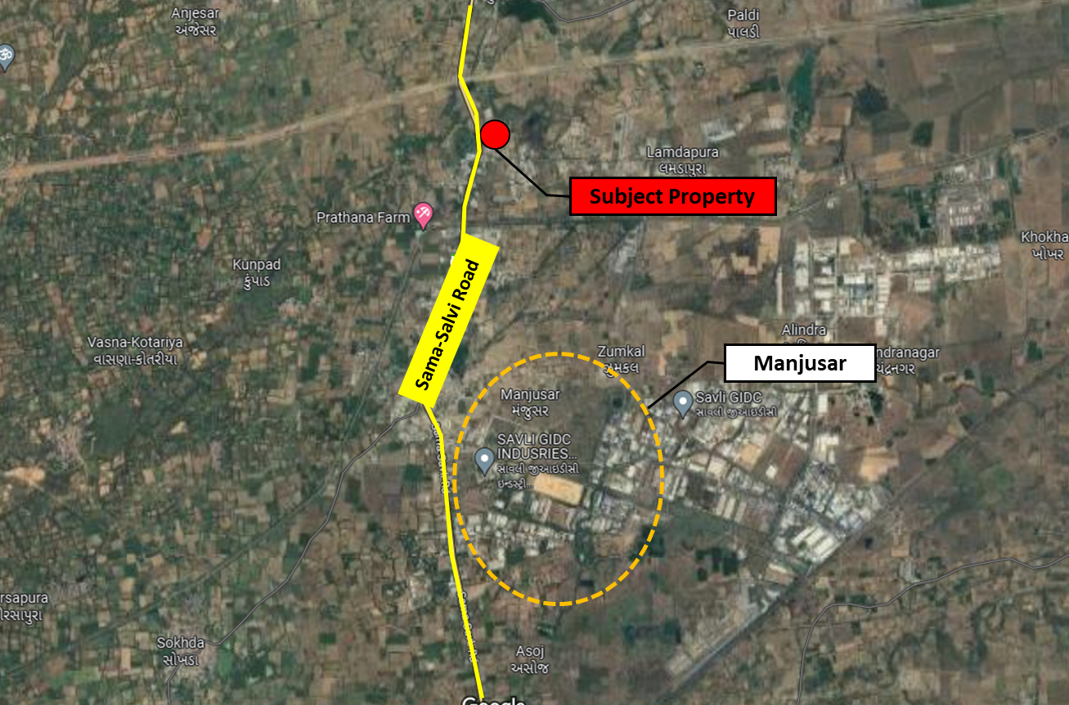

**Subject Property**

**GPS Coordinates:** 22°28'05.3"N 73°11'42.2"E

In this respect Bank has approached us to comment specifically on the cost to be incurred for installation of Roof Top Solar Power Plant and the requirement of 150KW based on the copies of the electricity bills provided to us.

|  |  |
| --- | --- |
| **PART C** | **POWER REQUIREMENT ANALYSIS** |

1. **POWER CONSUMPTION:** As per the copy of electricity bills for the month Sep-22, Oct-22, Nov-22, Dec-22, Jan-23 & Feb-23 shared, company has a contract load of 90 KW from Madhya Gujarat VIJ Company Limited. Thus, as per government policy Company may install max. Capacity of 150kW Rooftop Solar Power Plant. However, as per letter no. MG/IND/10105612 dated 23-03-2023 from Gujarat Energy Development Agency, company received NoC for installation of 150kW Rooftop Grid Connected Solar Power Plant irrespective of to the Sanctioned Load i.e 90 KW. Important details extracted from the bills for the power requirement analysis are tabulated below:-

|  |  |  |  |
| --- | --- | --- | --- |
| **Bill Date** | **Meter Reading (kWh)** | **Max Demand (KW)** | **Bill Amount Paid**  **(In Rs.)** |
| 15-10-2022 | 35,277 | 108.1 | 3,00,955 |
| 22-11-2022 | 49,746 | 103.28 | 4,15,566 |
| 27-12-2022 | 47,304 | 103.66 | 3,96,164 |
| 16-01-2023 | 55,397 | 98.46 | 4,68,693 |
| 20-02-2023 | 54,949 | 93.42 | 4,65,984 |
| 18-03-2023 | 41,128 | 91.46 | 3,53,682 |

As per copy of GEDA letter, the installed DC Capacity of the plant shall be 150KW and AC supply shall be 125KW.

**Conclusion:** Based on the above analysis as shown in table above, it appears that as per current usage as reflected from the copy of electricity bills and power requirement by Roof Top Solar Power Plant claimed by the customer that this Plant has the requirement of ~150 KW roof top solar power plant and excess power shall be sold to DISCOM.

|  |  |
| --- | --- |
| **PART D** | **COST ASSESSMENT** |

1. **COST ASSESSMENT:** The benchmark costfor setting up a Roof Top Solar Power Plant prescribed by Ministry of New & Renewable Energy, Government of India (NMRE) is Rs. 35,886/- per kW excluding GST. As persecondary market research conducted by team of RKA, the cost for setting up a rooftop photovoltaic system varies from Rs. 46,480/- to Rs. 56,900/- per kW including GST depending upon the location, size of the project, type of installation, type of developer etc.

|  |  |  |  |  |  |
| --- | --- | --- | --- | --- | --- |
| **S. No.** | **Particulars** | **Project Capacity**  **(In kW)** | **Total Project Cost**  **(Including GST)** | **Cost**  **(In Rs. Per kW)** | **Refer** |
| 1 | Infrax Solar | 243 | Rs. 1,12,94,737/- | 46,480 | Annexure-2 |
| 2 | Solar Nation | 150 | Rs. 72,00,000/- | 48,000 | Annexure-3 |
| 3 | Tata Solar | 150 | Rs. 82,50,000/- | 55,000 | Annexure-4 |
| 4 | Oscorp Technologies | 150 | Rs. 85,35,000/- | 56,900 | Annexure-5 |

**Note:**

1. As per our analysis, the Project cost for the installation of 150kW Roof Top Solar Power Plant shall be about Rs. 78,00,000/- including GST.
2. Project cost is analyzed based on lumsum cost only and not item wise.
3. Project cost is assessed for the current date only and due to price fluctuations it may vary at the time of actual purchase or installation.

|  |  |
| --- | --- |
| **PART E** | **DISCLAIMER** |

* + - 1. No employee or member of R.K Associates has any direct/ indirect interest in the Project.
      2. This report is prepared based on the copies of the documents/ information which the Bank/ Company has provided to us out of the standard checklist of documents sought from them and further based on our assumptions and limiting conditions. All such information provided to us has been relied upon in good faith and we have assumed that it is true and correct in all respect. Verification or cross checking of the documents provided to us has not been done at our end from the originals. If at any time in future, it is found or came to our knowledge that misrepresentation of facts or incomplete or distorted information has been provided to us then this report shall automatically become null & void.
      3. This report is a general analysis of the project based on the scope mentioned in the report. This is not an Audit report, Design document, DPR or Techno-financial feasibility study. All the information gathered is based on the facts seen on the site during survey, verbal discussion & documentary evidence provided by the client and is believed that information given by the company is true best of their knowledge.
      4. All observations mentioned in the report is only based on the visual observation and the documents/ data/ information provided by the client. No mechanical/ technical tests, measurements or any design review have been performed or carried out from our side during Project assessment.
      5. Bank/FII should ONLY take this report as an Advisory document from the Financial/ Chartered Engineering firm and it’s specifically advised to the creditor to cross verify the original documents for the facts mentioned in the report which can be availed from the borrowing company directly.
      6. In case of any default in loans or the credit facility extended to the borrowing company, R.K Associates shall not be held responsible for whatsoever reason may be and any request for seeking any explanation from the employee/s of R.K Associates will not be entertained at any instance or situation.
      7. This is just an opinion report and doesn’t hold any binding on anyone. It is requested from the concerned Financial Institution which is using this report for taking financial decision on the project that they should consider all the different associated relevant & related factors also before taking any business decision based on the content of this report.
      8. All Pages of the report including annexures are signed and stamped from our office. In case any paper in the report is without stamp & signature then this should not be considered a valid paper issued from this office.
      9. Though adequate care has been taken while preparing this report as per its scope, but still we can’t rule out typing, human errors, over sightedness of any information or any other mistakes. Therefore, the concerned organization is advised to satisfy themselves that the report is complete & satisfactory in all respect. Intimation regarding any discrepancy shall be brought into our notice immediately. If no intimation is received within 15 (Fifteen) days in writing from the date of issuance of the report, to rectify these timely, then it shall be considered that the report is complete in all respect and has been accepted by the client upto their satisfaction & use and further to which R.K Associates shall not be held responsible in any manner.
      10. Defect Liability Period is **15 DAYS**. We request the concerned authorized reader of this report to check the contents, data and calculations in the report within this period and intimate us in writing if any corrections are required or in case of any other concern with the contents or opinion mentioned in the report. Corrections only related to typographical, calculation, spelling mistakes, incorrect data/ figures/ statement will be entertained within the defect liability period. Any new changes for any additional information in already approved report will be regarded as additional work for which additional fees may be charged. No request for any illegitimate change in regard to any facts & figures will be entertained.
      11. R.K Associates encourages its customers to give feedback or inform concerns over its services through proper channel at le@rkassociates.org in writing within 30 days of report delivery. After this period no concern/ complaint/ proceedings in connection with the Lender’s Independent Engineering Services will be entertained due to possible change in situation and condition of the subject Project.
      12. Our Data retention policy is of **ONE YEAR**. After this period, we remove all the concerned records related to the assignment from our repository. No clarification or query can be answered after this period due to unavailability of the data.
      13. This Lender’s Independent Engineering report is governed by our (1) Internal Policies, Processes & Standard Operating Procedures, (2) Information/ Data/ Inputs given to us by the client and (3) Information/ Data/ Facts given to us by our field/ office technical team. Management of R.K Associates never gives acceptance to any unethical or unprofessional practice which may affect fair, correct & impartial assessment and which is against any prevailing law. In case of any indication of any negligence, default, incorrect, misleading, misrepresentation or distortion of facts in the report then it is the responsibility of the user of this report to immediately or at least within the defect liability period bring all such act into notice of R.K Associates management so that corrective measures can be taken instantly.
      14. R.K Associates never releases any report doing alterations or modifications from pen. In case any information/ figure of this report is found altered with pen then this report will automatically become null & void.

|  |  |
| --- | --- |
| **PREPARED BY** | **REVIEWED BY** |
|  |  |
| **Abhinav Chaturvedi**  **(Valuation Engineer)** | **Mohit Agarwal**  **(Sr. Vice President – Projects)** |
| **Date: 07th April 2023** | **Date: 07th April 2023** |

***DEFECT LIABILITY PERIOD - In case of any query/ issue or escalation you may please contact Incident Manager by writing at valuers@rkassociates.org. We ensure 100% accuracy in the Calculations done, Rates adopted and various other data points & information mentioned in the report but still can’t rule out typing, human errors or any other mistakes. In case you find any mistake, variation, discrepancy or inaccuracy in any data point of the report, please help us by bringing all such points into our notice in writing at*** [***valuers@rkassociates.org***](mailto:valuers@rkassociates.org) ***within 30 days of the report delivery, to get these rectified timely, failing which R.K Associates Valuers Techno Engineering Consultants (P) Ltd. won’t be held responsible for any inaccuracy in any manner. Also, if we will not hear back anything from you within 30 days, we will assume that report is correct in all respect and no further claim of any sort will be entertained thereafter. We would welcome and appreciate your feedback & suggestions in order to improve our services.***

***COPYRIGHT FORMAT - This report is prepared on the copyright format of R.K Associates Valuers Techno Engineering Consultants (P) Ltd. to serve our clients in the best possible way. Legally no one can copy or distribute this format without prior approval from R.K Associates. It is meant only for the organization as mentioned on the cover page of this report. Distribution or use of this format other than R.K Associates will be seen as unlawful act and necessary legal action can be taken against the defaulter***

|  |  |
| --- | --- |
| **PART F** | **ANNEXURES** |

**Annexure-1: Benchmark Cost as per MNRE**

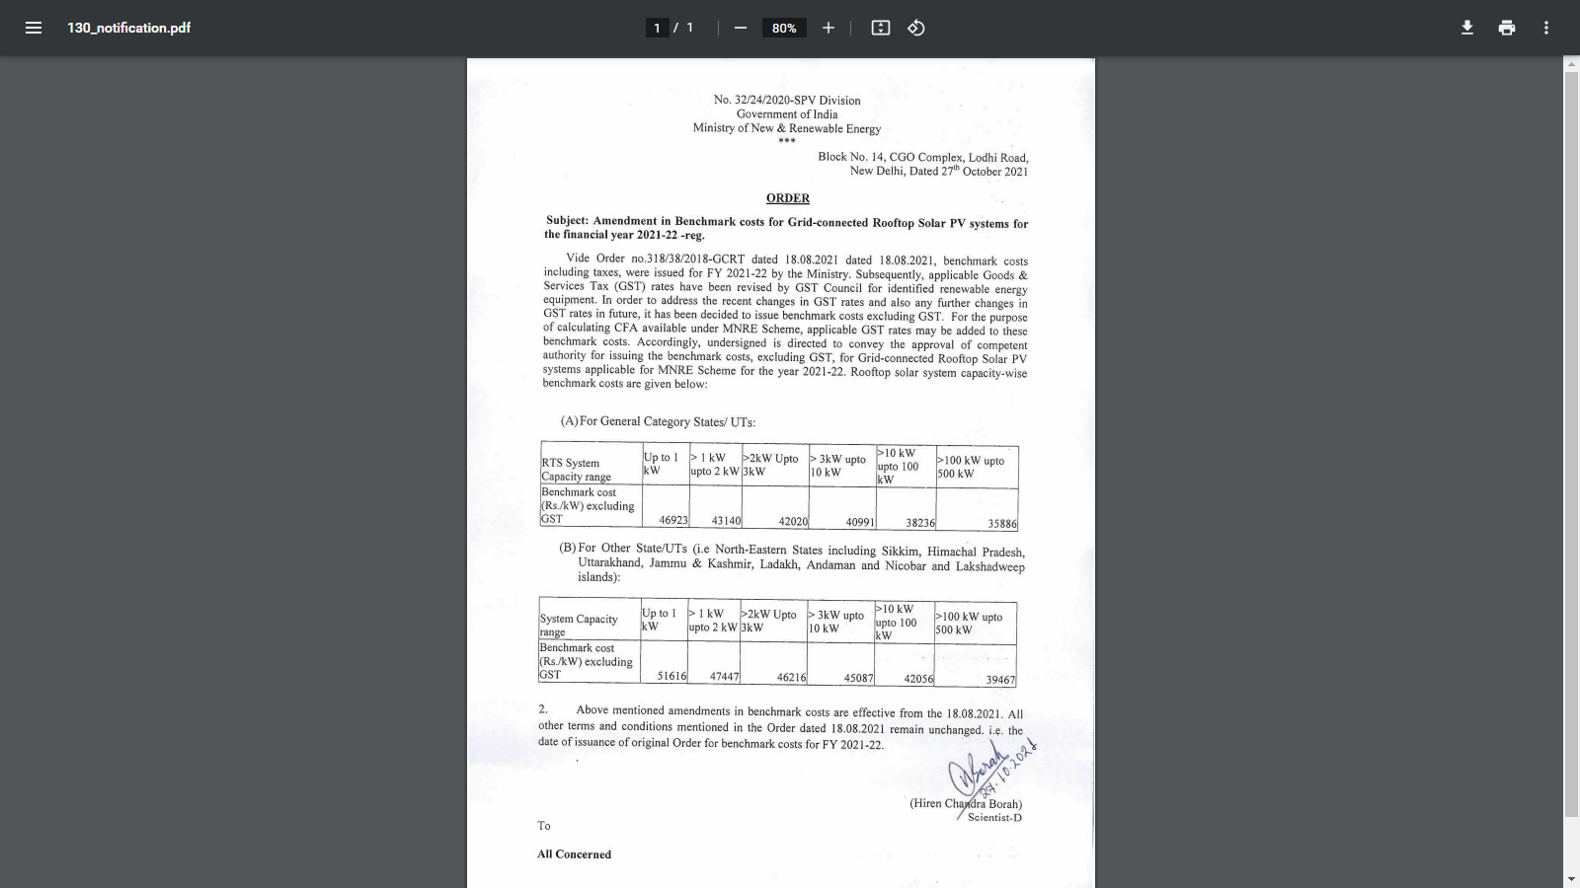

**Benchmark Cost as per MNRE Calculator (without GST)**

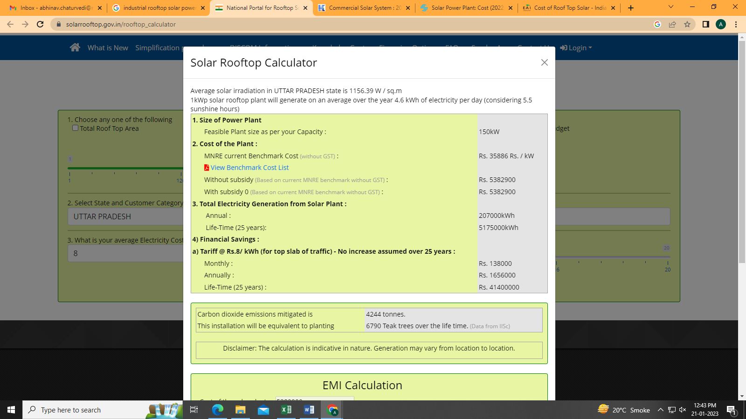

**Annexure-2: Infrax Solar**

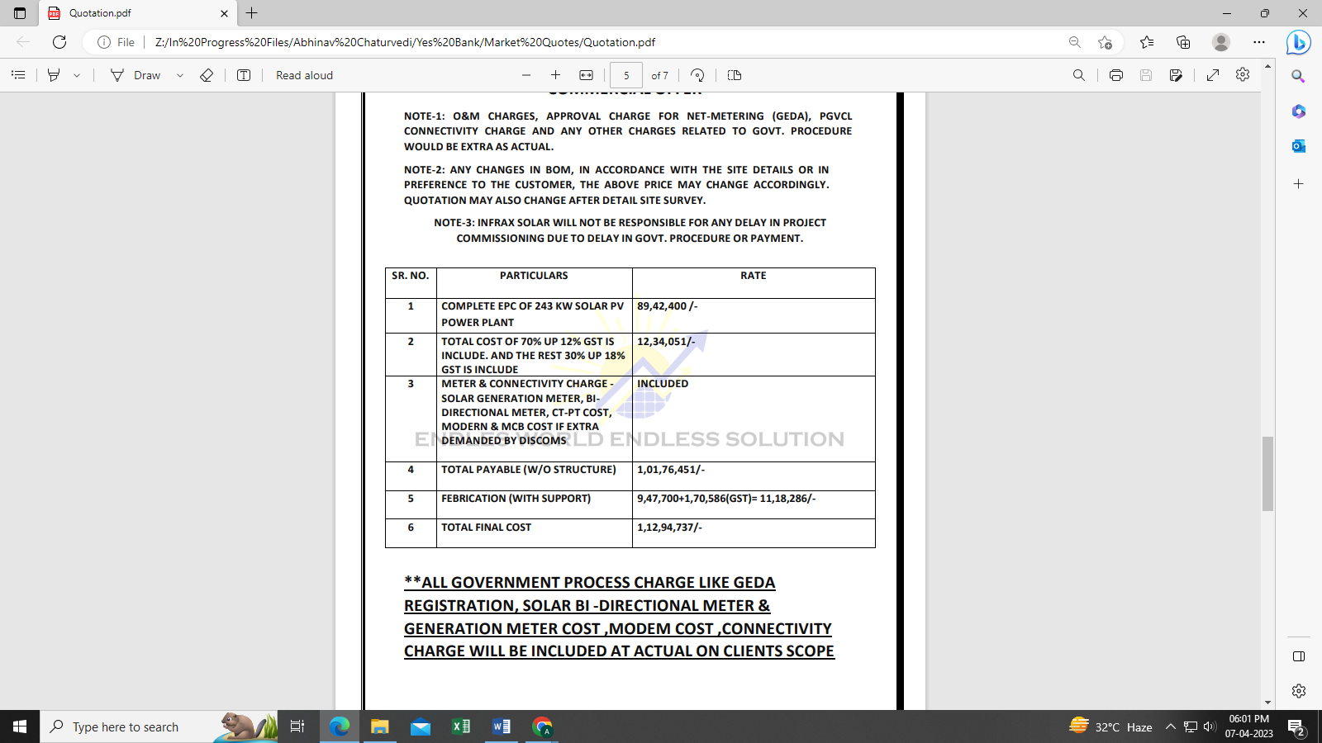

**Annexure-3: Quotation from Solar Nation**

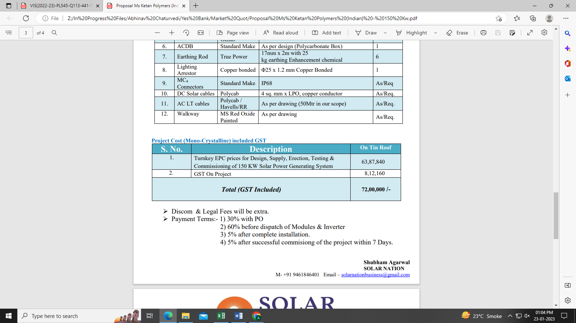

**Annexure-4: Quotation from Tata Solar**

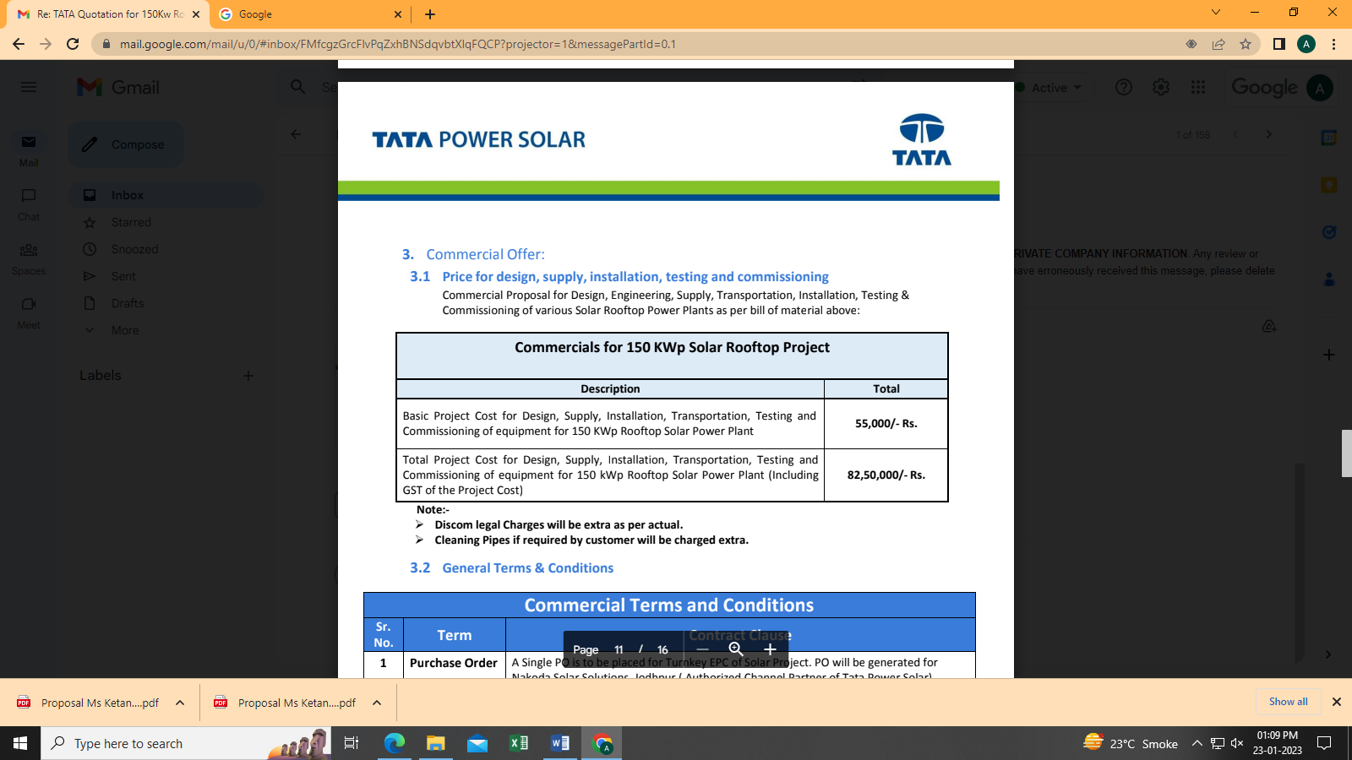

**Annexure-2: Oscorp Technologies**

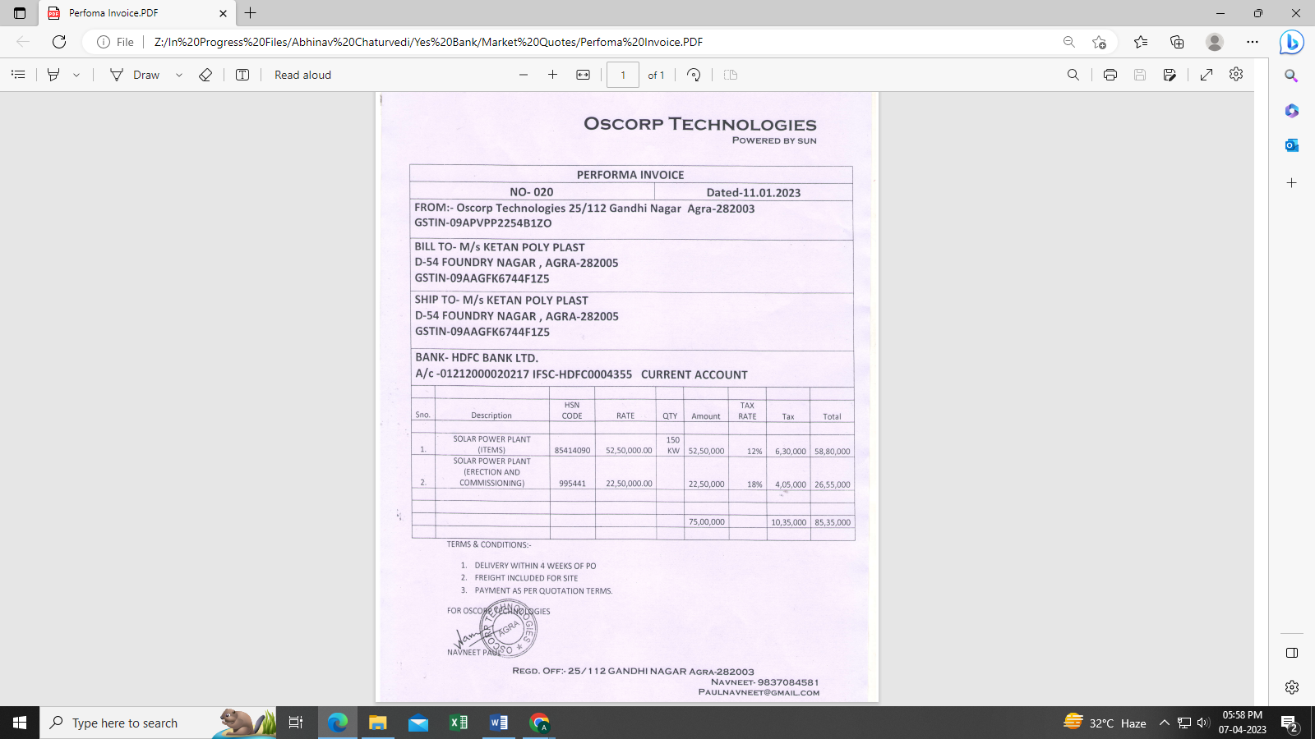

**Building Photographs shared by the client**

|  |
| --- |
| **Z:\In Progress Files\Abhinav Chaturvedi\Yes Bank\Photos\WhatsApp Image 2023-04-06 at 18.04.04 (1).jpeg** |
| **Z:\In Progress Files\Abhinav Chaturvedi\Yes Bank\Photos\WhatsApp Image 2023-04-06 at 18.04.05 (2).jpeg** |
| **Z:\In Progress Files\Abhinav Chaturvedi\Yes Bank\Photos\WhatsApp Image 2023-04-06 at 18.04.05.jpeg** |

**GEDA Approval Letter**

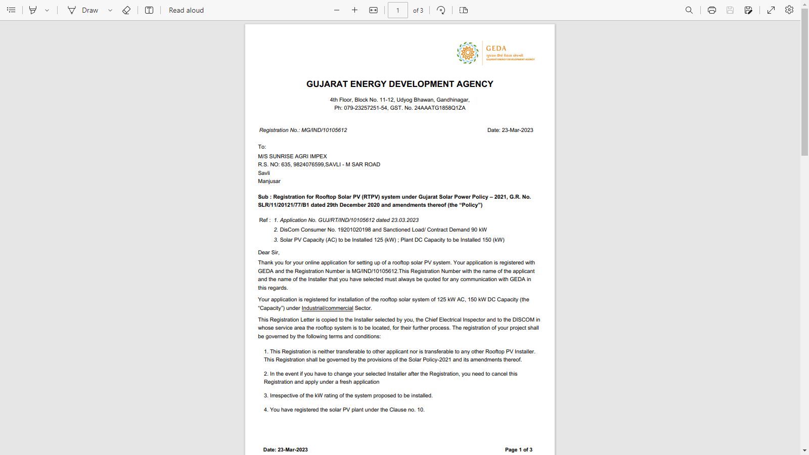

**Electricity Bills**

