**REPORT FORMAT:** CL-1 | Version: 1.0_2018

# FILE No.: VIS(2023-24)-PL023-020-020 Date: 20-04-2023

* **CERTIFICATE NAME:**
  + Cost Vetting for the Plant & Machinery and Building & Civil works for capacity expansion and Automation of Yarn Manufacturing plant from current installed capacity 30 MTPD to 32.5 MTPD.
* **PREPARED FOR ORGANIZATION:** SBI SME Commercial Branch, Ville Parle.
  + **ASSET TYPE**: Yarn manufacturing plant.
* **CURRENT LOCATION OF THE MACHINES**: Installed at Plot No. 9 Sector 9, SIDCUL Industrial area, Pant Nagar, Uttarakhand.

**TO WHOM IT MAY CONCERN**

|  |  |  |
| --- | --- | --- |
| **S. NO.** | **PARTICULARS** | **DESCRIPTION** |
| 1. | Date of Survey | 17/04/2023 |
| 2. | Date of Certificate | 20-04-2023 |
| 3. | Documents provided for perusal | Invoices of the installed machines (and list of Machine/Assets installed) |
| 4. | Current Location of the Machines | Plot No. 9 Sector 9, SIDCUL Industrial area, Pant Nagar, Uttarakhand. |
| 5. | Borrowing Company | M/s. BST Textile Mills Pvt Ltd. |
| 6. | Type of Asset | Plant & Machinery and Building & Civil works required for capacity expansion and Automation of Yarn Manufacturing plant from current installed capacity 30 MTPD to 32.5 MTPD |
| 7. | Type of Assessment | Cost Vetting Certificate |
| 8. | Scope of Assessment | Cost Vetting of the new equipment which has to be/ already purchased by the company. |
| 9. | Nature of Machinery | Yarn Manufacturing plant. |
| 10. | Total Purchase Cost | **Rs. 6.05 Cr.** **(Including GST)** (*Total project Cost including supply and installation as per the List of machinery / quotations / invoices / purchase orders provided by the company)*. |
| 11. | Current Estimated Market Value | The range of current market rates of such type of machinery & equipment is verified from various suppliers and also from the information available on public domain for the new machinery and equipment.  As per quotes received from market, we are of the view that rate Plant & Machinery & Building & Civil works required for capacity expansion and Automation of Yarn Manufacturing plant and other general machines should be in the range from **Rs. 6.00 Cr to Rs. 6.50 Cr. (Including GST).**  According to our observation, the rate as per the list of machinery and their total purchase price provided to us by the company/ bank are quite reasonable when compared to the rates of similar machines currently prevailing in the market. |

**OBSERVATIONS:**

1. We have been provided with the copy of invoices of the machines/ equipment to be installed by the borrower company.
2. As per the information provided by the company officials and physical site inspection dated 17th April 2023 by our Survey Engineer Mr. Sachin Pandey verified these items are installed at the aforesaid address.
3. We have contacted several suppliers for similar items and also enquired in the public domain. Accordingly we have got the quotations from the suppliers and we find that the price given in the list of quotations provided to us is well within the price range of similar items available in the market and seems to be reasonable.
4. We have also verified the amount of invoices on sample basis with the references available on public domain and with different suppliers/contractors.
5. We have not considered the freight and installation charges of the assets in this cost vetting certificate as it varies with respect to supplier depending upon their location.
6. In this certificate, we have considered the value only for the plant and machinery and civil construction which is to be installed at the site.
7. Based on the information provided by the company (M/s. BST Textiles Mills Pvt Ltd.) and enquiries made by us in the open market and references found in the public domain for similar Plant & Machinery & Building & Civil works , it is certified that total market cost for setting up plants of similar specification should be around **Rs. 6.00 Cr. to Rs. 6.50 Cr** **(Including GST)** and therefore the total purchase price of **Rs. 6,05,77,287/- (Including GST)** (as per the quotations, bills & purchase orders provided to us by the company) appears to be reasonable.

***Disclaimer:***

* 1. *We can’t comment about the current status of machines whether these are purchased, installed or in transit. This cost vetting is done only on the basis of Quotations, Bills and Purchase Orders provided to us by the company and we don’t recommend any sort of recommendation in our Certificate.*
  2. *The estimated cost verification of item to item can’t exactly match as per our vetting due to several market consideration. In some of the items it is lower while in some of the items price comes to be higher but on an average the price as per list provided to us falls in the range as confirmed by us.*
  3. *There can be variation in the estimated price if the specification & make of any items procured is different from the list provided to us during assessment.*
  4. *The estimated cost verification is made based on the third party information which has been replied upon in good faith.*
  5. *The estimated price may vary at the time of actual procurement because of change in prices in the market for such kind of machinery/items for which we will not have any control. The cost vetting is only limited to the date of Certificate issued. We do not assume any responsibility in change of prices of the said machinery/items after this date.*
  6. *This certificate doesn’t include any work related to drawing, design, sketch plan, procurement of the machines.*
  7. *Ownership and other legal point of view in respect of the asset is not considered in this report as same is out of scope of this certificate.*
  8. *This certificate is made at the request of the Bank.*

**For R.K Associates Valuers** **& Techno** **FOR INTERNAL USE Engineering Consultants (P) Ltd. *TYPED BY: Er. Rahul Gupta***  ***REVIEWED BY: Er. Abhinav Chaturvedi***

# ANNEXURE: - I

# LIST OF PLANT & MACHINERY & CIVIL WORK

|  |  |  |  |  |  |  |  |
| --- | --- | --- | --- | --- | --- | --- | --- |
| **Sr.**  **No** | **INV. No.** | **Invoice. Date** | **Supplier Name** | **Machinery Description** | **Amount By Client (With GST)** | **Approved Cost** | **Remarks** |
| 1 | 22110818 | 23.06.2022 | Lakshmi Life Sciences Pvt Ltd | Lr6s/1200 Spindles/620cc/Blt Position At End Stock/Plated Peg Tray/With Out Quickoff-12 Sets with Necessary Tools. | 22,84,008 | 22,84,008 | As per industry analysis, cost of the machines and attachments for automation appears to be reasonable. |
| 2 | 22810817 | 23.06.2022 | 23,26,488 | 23,26,488 |
| 3 | 22111132 | 22.07.2022 | 22,84,008 | 22,84,008 |
| 4 | 22111133 | 22.07.2022 | 22,84,008 | 22,84,008 |
| 5 | 22111638 | 31.08.2022 | 22,84,008 | 22,84,008 |
| 6 | 22111639 | 31.08.2022 | 22,84,008 | 22,84,008 |
| 7 | 22112066 | 30.09.2022 | 22,84,008 | 22,84,008 |
| 8 | 22112065 | 30.09.2022 | 22,84,008 | 22,84,008 |
| 9 | 22112230 | 15.10.2022 | 22,84,008 | 22,84,008 |
| 10 | 22112231 | 15.10.2022 | 22,84,008 | 22,84,008 |
| 11 | 22112418 | 02.11.2022 | 22,84,008 | 22,84,008 |
| 12 | 22112419 | 02.11.2022 | 22,84,008 | 22,84,008 |
| 13 | TM2200045 | 02.05.2022 | Rima Machines Pvt Ltd | Double Stock TFO Twister (Spun) Model "Jc-6a-Dd-130/150 Mm" Pot Dia Having 384 Position Spindles (192 Spindles Peer Deck) | 21,94,800 | 21,94,800 |
| 14 | TM2200373 | 28.12.2022 | Rima Machines Pvt Ltd | Single Deck TFO Twister (SPUN) Model "JC-6A-SD-130/150mm" POT Dia Having 192 Position/Spindles- 2 Nos | 15,15,120 | 15,15,120 |
| 15 | TM2200380 | 07.01.2023 | Rima Machines Pvt Ltd | 15,16,635 | 15,16,635 |
| 16 | A01/INM/16 | 05.05.2022 | Peass Industrial Engineers Pvt Ltd | Cheese Winding Peass Pricision Propeller Assembly Winder Machine Of 24 Spindle Model Ppw-A-Ds 2 Ply | 15,15,120 | 15,15,120 |
| 17 | A01/INM/157 | 29.12.2022 | Peass Industrial Engineers Pvt Ltd | Extension Of 24 Spindles Of Peass Precision Propeller Assembly Winder, Model Ppw-A With 2 Ply Ex Works Packed Navsari | 14,79,720 | 14,79,720 |
| 22 | 93/M/22-23 | 17.12.2022 | Am Innospin Systems Pvt Ltd | FIX-Flow, Motorised roving bobbin transport system, connecting two no,s S/F and 12 No's R/F of 1200 SPL each (Totalling 14400 SPL), Minly containing | 27,14,000 | 27,14,000 |
| 23 | 116/M/22-23 | 08.02.2023 | Am Innospin Systems Pvt Ltd | 2,76,592 | 2,76,592 |
| 25 | PEL/1007797 | 31.01.2023 | Premier Evolvics Pvt Ltd | Individual Spindle monitoring system and roving stop motion suitable for ring frame (Model LR6-12 SETS 26784 SPINDLES) | 76,46,400 | 76,46,400 |
| 26 | PEL/1007799 | 31.01.2023 | Premier Evolvics Pvt Ltd | 38,23,200 | 38,23,200 |
| **Total** | | | | | **5,28,84,867** | **5,28,84,867** |

|  |  |  |  |  |  |  |  |
| --- | --- | --- | --- | --- | --- | --- | --- |
| **Sr.No** | **INV. No.** | **Invoice. Date** | **Supplier Name** | **Machinery Description** | **Amount By Client (With GST)** | **Approved Cost** | **Consultants Remarks** |
| **Building and Civil Work** | | | | | | | |
| 18 | CIPL/22-23/31624 | 13.02.2023 | Chawla Ispat (P) Ltd. | Profile Sheet 0.50, AZ150,550 MPA, Make-JSW Coloron, Plus, QTY 42000 | 1,15,546 | 1,15,546 | As per industry analysis, cost of the fixing and material cost appears to be reasonable. |
| 19 | CIPL/22-23/31622 | 13.02.2023 | Both Side ALuPet Foil and Both Side Flanges 1.13 m Wx 30m L=33.9sq.mtr | 13,98,724 | 13,98,724 |
| 20 | CIPL/22-23/31623 | 13.02.2023 | Both Side ALuPet Foil and Both Side Flanges 1.13 m Wx 30m L=33.9sq.mtr | 13,98,726 | 13,98,726 |
| 21 | CIPL/22-23/31621 | 13.02.2023 | Both Side ALuPet Foil and Both Side Flanges 1.13 m Wx 30m L=33.9sq.mtr | 13,98,724 | 13,98,724 |
| 24 | SERVICE ORDER | 07.12.2022 | AALA TECHNOCRAT | Removing of Existing ACC roofing sheet i/c ridges, screws and other hardware,fixing of o.5 mm thick (TCT) trim deck Galvalume profile sheet and fitting of its accessories, fixing of end cap corner flashing made of Galvalume materials with AZ 150 coating as per material specification, Fixing of 13 mm thick XLPE insulation with both side Aluminium foil/Lamination as per manufacturer's specification of 100 GSM coated GI mesh of 75x75x1.5 mm and welding mesh 100x100x2 mm supply. | 33,80,700 | 33,80,700 |
| **Total** | | | | | **76,92,420** | **76,92,420** |
| **Grand Total** | | | | | **6,05,77,287** | **6,05,77,287** |  |

# ANNEXURE: - II (QUOTATION FROM MARKET)

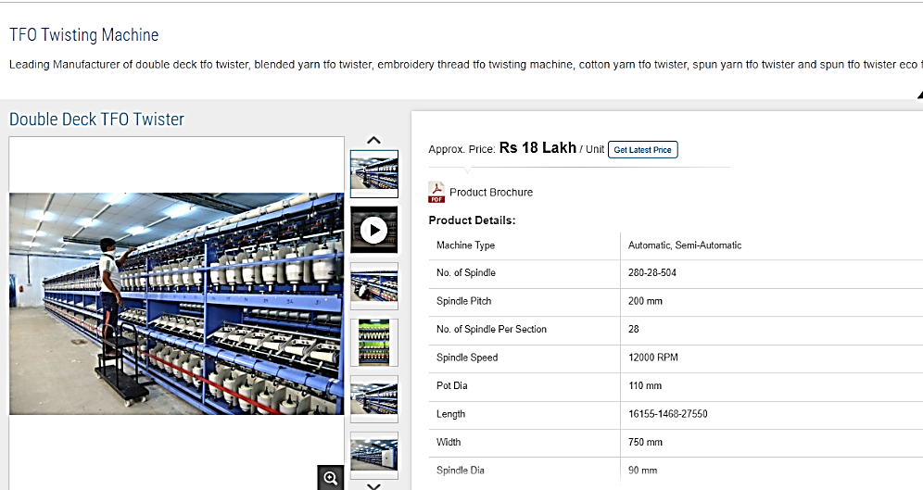

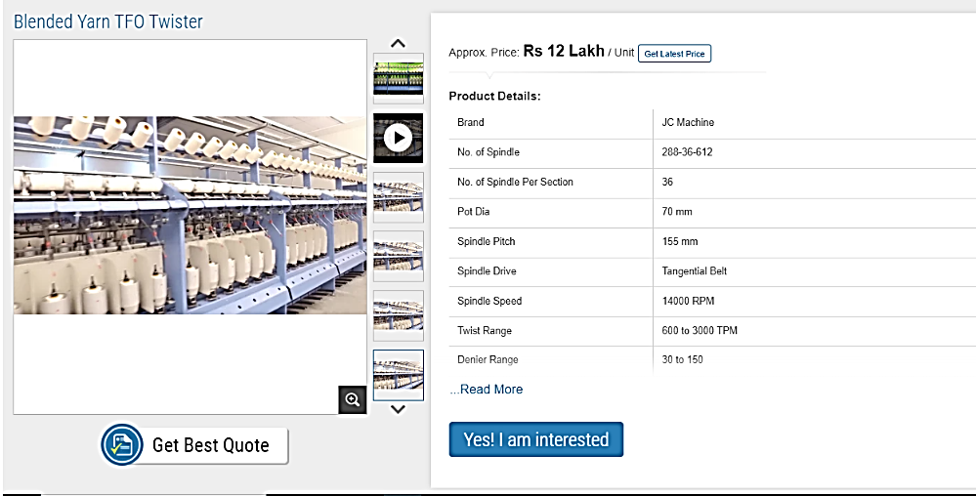

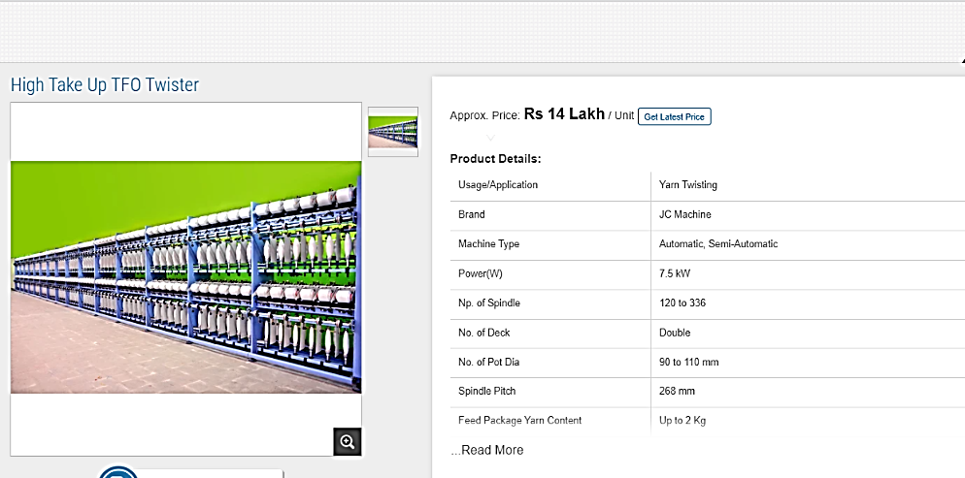

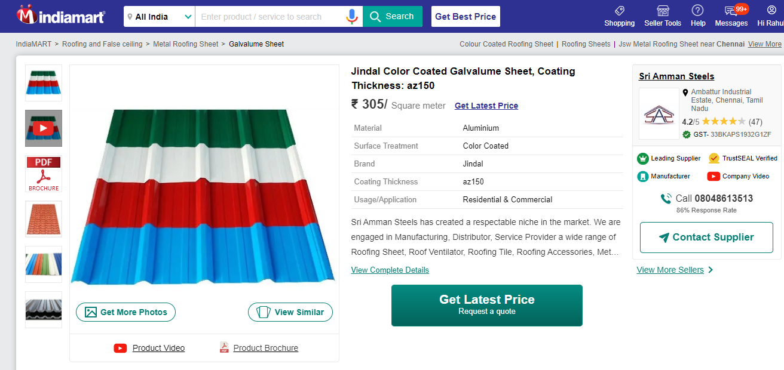

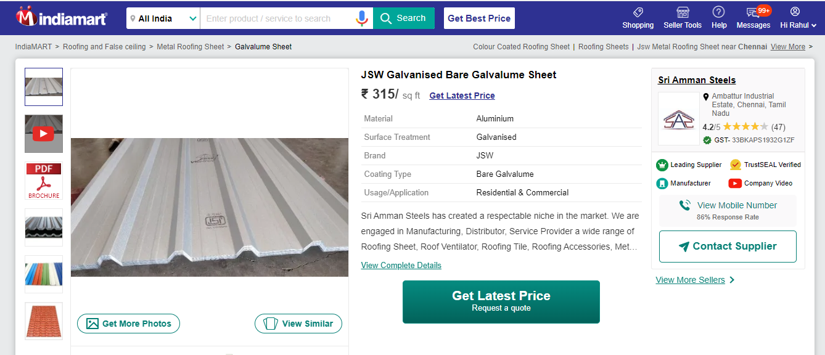

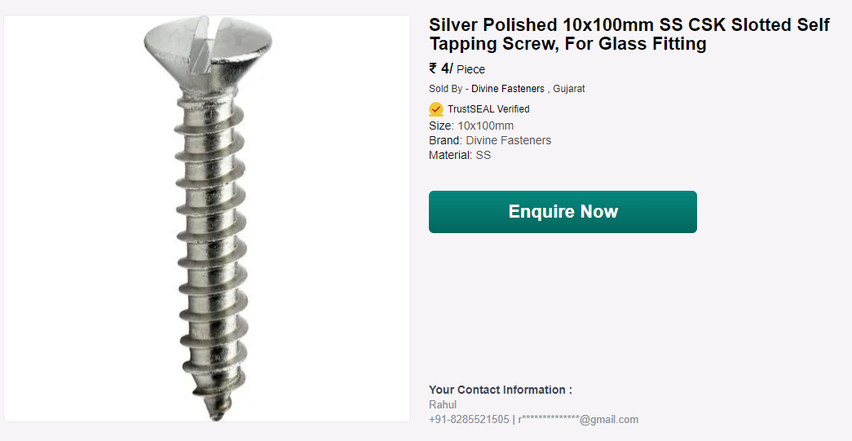

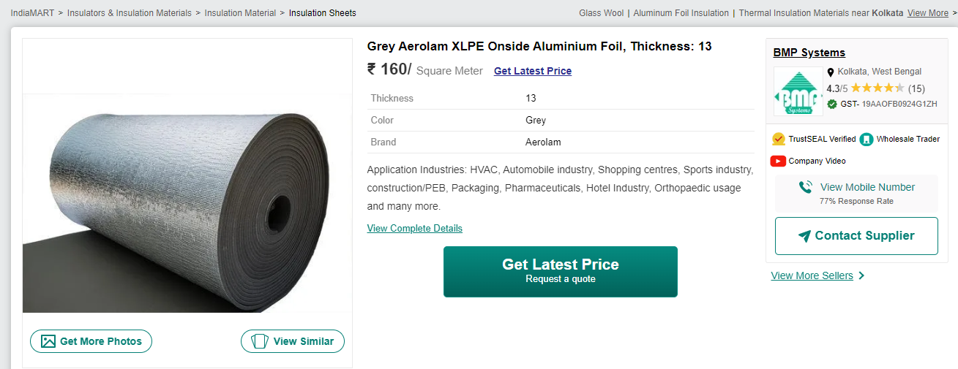

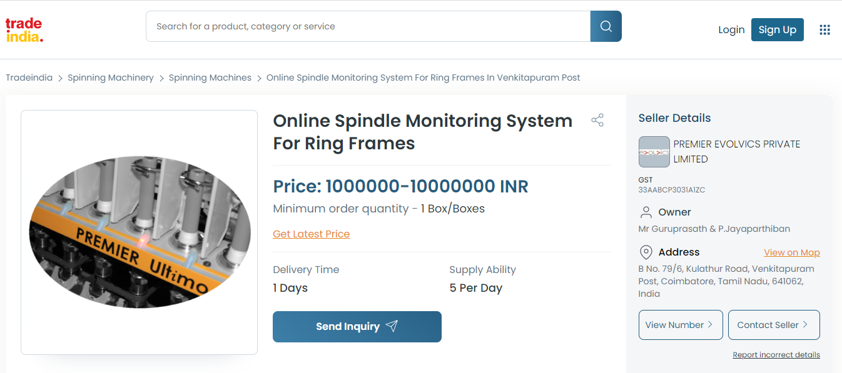

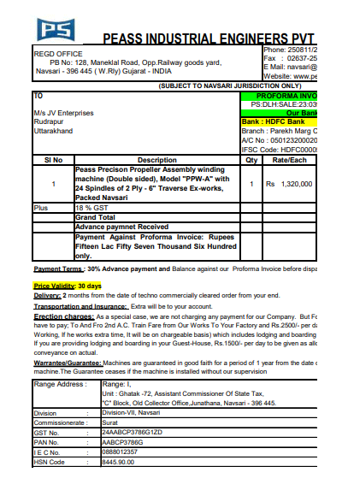

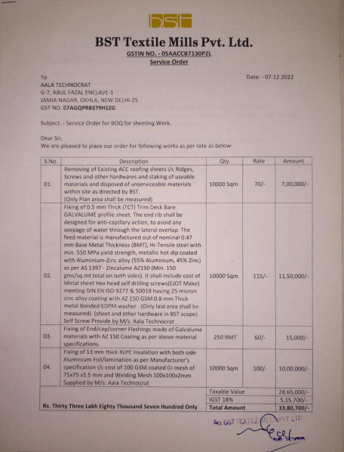

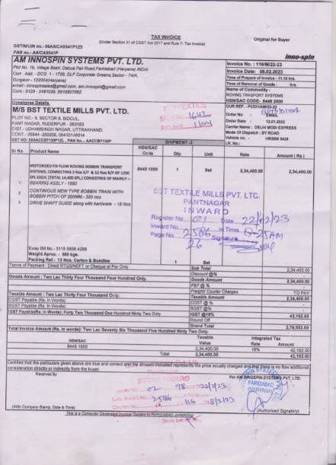

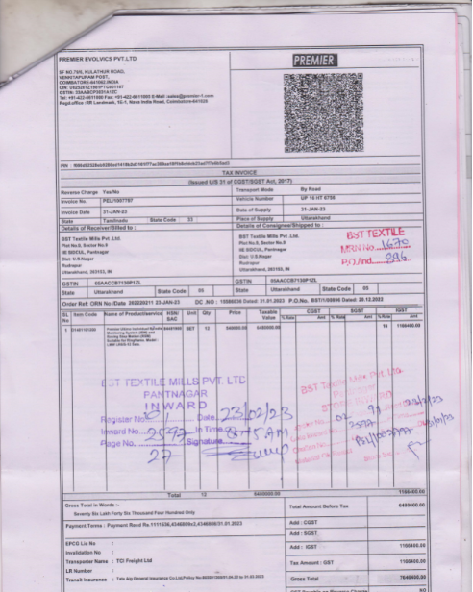

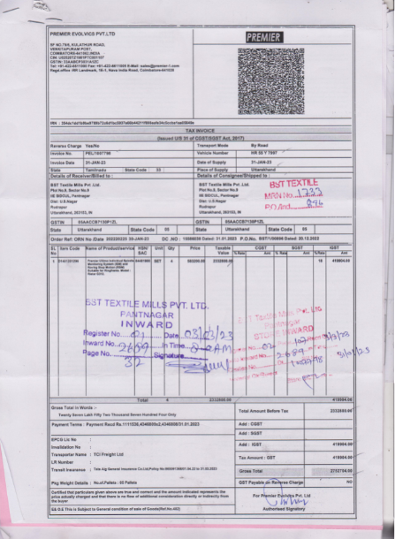

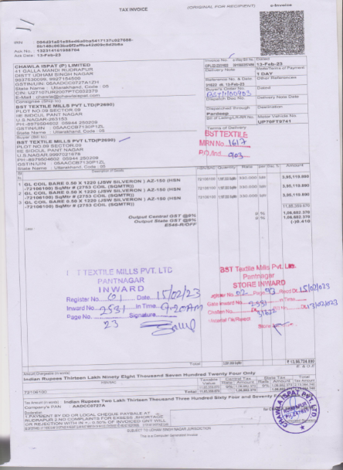

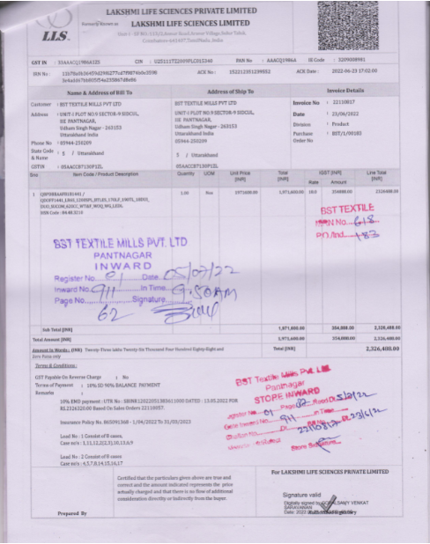

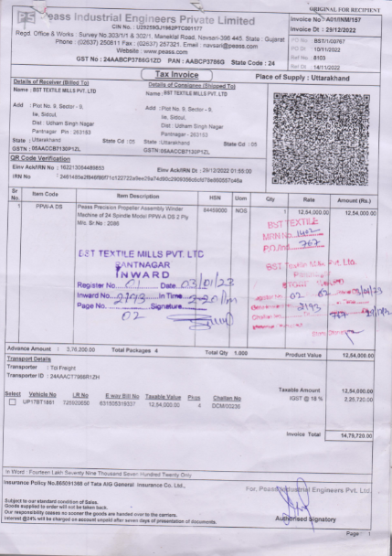

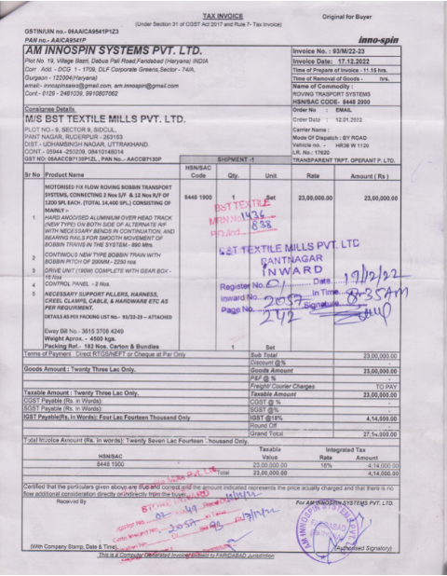

**Photographs of the Assets**

|  |  |
| --- | --- |
|  |  |
|  |  |
|  |  |
|  |  |

|  |  |
| --- | --- |
|  |  |
|  |  |
|  |  |

|  |  |
| --- | --- |
|  |  |
|  |  |
|  |  |
|  |  |