**FILE NO.: VIS(2023-24)-PL030-026-026 Dated: 02/05/2023**

**SITE INSPECTION REPORT**

**OF**

**M/S. BASTI CARE HOSPITAL PRIVATE LIMITED**

**SITUATED AT**

**PART OF KHASRA NO. 11, VILLAGE HARDIYA BUJURG, DISTRICT BASTI, UTTAR PRADESH**

**REPORT PREPARED FOR**

**IFCI VENTURE CAPITAL FUNDS LIMITED**

***\*\*Important - In case of any query/ issue or escalation you may please contact Incident Manager***

***at le@rkassociates.org. We will appreciate your feedback in order to improve our services.***

***NOTE: As per IBA Guidelines please provide your feedback on the report within 15 days of its submission after which report will be considered to be correct.***

**IMPORTANT NOTICE**

***COPYRIGHT FORMAT:*** *This report is prepared on the copyright format of R.K Associates to serve our clients with the best possible information and analysis to facilitate them to take rational business decisions. Legally no one can copy or distribute this format without prior approval from R.K Associates. It is meant only for the advisory/ reference purpose for the organization/s as mentioned on the cover page of this report. Distribution or use of this format by any organization or individual other than R.K Associates will be seen as an unlawful act and necessary legal action can be taken against the defaulters.*

*This report is intended for the sole use of the intended recipient/s and contains material that is STRICTLY CONFIDENTIAL AND PRIVATE.*

***DEFECT LIABILITY PERIOD:*** *- In case of any query/ issue or escalation you may please contact Incident Manager at*[le@rkassociates.org](mailto:le@rkassociates.org)*.*

*Though adequate care has been taken while preparing this report as per its scope, but still, we can’t rule out typing, human errors, over sightedness of any information or any other mistakes. Therefore, the concerned organization is advised to satisfy themselves that the report is complete & satisfactory in all respect. Intimation regarding any discrepancy shall be brought into our notice immediately. If no intimation is received within 15 (Fifteen) days in writing from the date of issuance of the report, to rectify these timely, then it shall be considered that the report is complete in all respect and has been accepted by the client up to their satisfaction & use and further to which R.K Associates shall not be held responsible in any manner.*

|  |  |
| --- | --- |
| **PART A** | **REPORT SUMMARY** |

|  |  |  |
| --- | --- | --- |
| **S.NO.** | **PARTICULARS** | **DESCRIPTION** |
|  | Name of the Project | Basti Care Hospital & Eye Centre |
|  | Project Location | Part Of Khasra No. 11, Village Hardiya Bujurg, District Basti, Uttar Pradesh |
|  | Nearest Landmark | Badevan Chauraha |
|  | Site Coordinate | 26°49'11.3"N 82°43'43.8"E |
|  | Land Owners | Mrs. Ramrati w/o Mr. Ramkeval  (As per the copy of documents provided to us) |
|  | Name of the promoters | Mr. Sanjay Kumar & Mr. Manoj Kumar |
|  | Prepared for Bank | IFCI Venture Capital Funds Limited |
|  | Consultant Firm | M/s. R.K. Associates Valuers & Techno Engineering Consultants (P) Ltd. |
|  | Work Order Details | IFCI Venture / VCF-SC/ 2023-24 dated 13.04.2023 |
|  | Date of Survey | 25.04.2023 |
|  | Date of Report | 02.05.2023 |
|  | Purpose of the Report | Site inspection & Macro market overview |
|  | Scope of the work provided by the Lender | Only to comment on the following below points based on the scope of work:   * Site inspection details. * Summary of the interaction made with the promoter / director of the project. * Overview of macro market of the subject location. * Photographs of the subject site.   *NOTE: This report doesn’t contains any other kind of recommendation or suggestions other than the above mentioned point.* |

|  |  |
| --- | --- |
| **PART B** | **BRIEF DETAILS ABOUT SITE SURVEY** |

M/s. Basti Care Hospital Private Limited has proposed to construct a hospital addressed as Khasra No. 11, Village Hardiya, Bujurg, District Basti, Uttar Pradesh. The subject building is being developed on 126.5 sq. mtr. / 1,362 sq. ft. of land area as per the sale deed copy provided to us. As per the copy of sale deed nature of land is defined as residential whereas currently the subject property is proposed to be built as a hospital. Since the subject property is located on main road/NH therefore commercial/Institutional usage of the subject property is permissible and approval of building plan for setting up a hospital have been taken from Gram Panchayat Authority.

Our site surveyor Mr. Sachin Pandey had visited the site on 25th April, 2023 accompanied by Dr. Sanjay Kumar of the hospital. The followings are the observation was gathered by our surveyor during site visit:

|  |  |
| --- | --- |
| **Description** | **Remarks** |
| Total Land Area | 126.5 sq. mtr. / 1,362 sq. ft. |
| Number of proposed building | 1 No. |
| Configuration of building (taken for this progress report) | Basement + Ground + First Floor |
| Configuration of each floor | 1) Basement: Two Bedrooms, 1 washroom, 1 kitchen, 1 hallway.  2) Ground Floor: Reception area, OT room, Testing room, Ward room comprises of 8 beds.  3) First Floor: Under Finishing |
| Usage of each floor | 1) Basement: Residential  2) Ground Floor: Hospital  3) First Floor: Under finishing |
| Opening date of hospital | 17/01/2023 |
| Carpet Area of each floor (as per site survey) | Approx. 1260 sq. ft. |
| Adjoining property details | East: Entrance / Road  West: Other’s Property  North: Other’s Property  South: House of Mr. Sanjay Singh (Promoter) |
| Name of main road & width | Lucknow – Gorakhpur Road (~120 ft. wide) |
| Name of approach road and width | NH 28 (~ 40 ft. wide) |
| Distance of approach road from main road | ~1km |
| Type of approach road | Bituminous |
| Availability of parking | Open parking spaces available for small and light vehicles like motorcycle, car or ambulance. |
| Any other observation | The property is used as preliminary healthcare village unit. At the time of visit patients were seen for checkup as can see in photographs also. |

**Physical Progress of the proposed project is given below floor wise:**

|  |  |
| --- | --- |
| **Floor** | **Current Status** |
| Basement | * RCC structure work of Basement is completed. * Being used as residential by caretakers of hospital. * MEP services installed. * PCC flooring. * Plastering work is yet to done in some part of the internal wall. |
| Ground Floor | * RCC structure work of Ground floor completed. * Being used as hospital. * MEP services installed. * Finishing work completed & floor is used as hospital. |
| First Floor | * RCC structure work of first floor completed. * Finishing work is in progress. * Floor and plastering work is approx. 50% completed. * MEP services not installed yet. * Doors, Windows fittings and other finishing works are remaining. |

|  |  |
| --- | --- |
| **PART C** | **SUMMARY OF THE INTERACTION MADE WITH THE PROMOTER** |

On 9th May, 2023 our analyst team of two members Mr. Babul Akhtar Gazi & Mr. Rachit Gupta had an interaction through video conference with the project proponent, Mr. Sanjay Kumar of the project. The brief summary of the interaction has been sent to us later in documented form which is attached below:

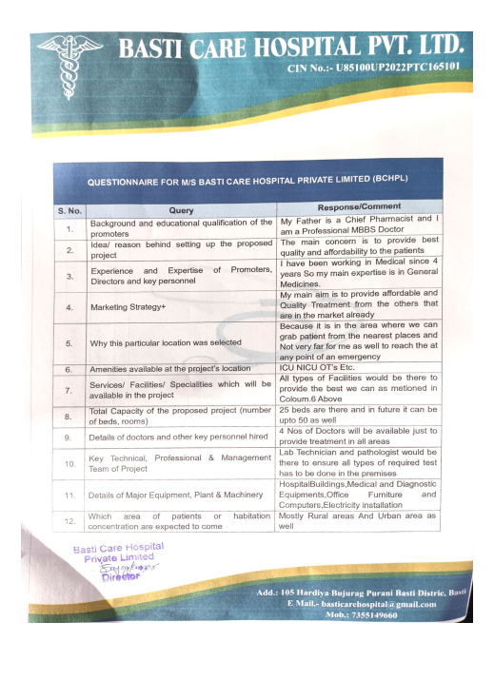

**Note:** Interaction Video with the customer is shared over email to IFCI Ventures.

|  |  |
| --- | --- |
| **PART C** | **MACRO OVERVIEW OF SUBJECT LOCATION** |

The subject property is located in the small village of Hardiya Bujurg, which is part of the Basti district of the Uttar Pradesh state in northern India. The settlement is located approximately 6-7 km southwest of Basti. Agriculture is the main livelihood in Hardiya Bujurg, as it is in many other nearby villages.

School, a health center, market, a post office are just a few of the essential services that Hardiya Bujurg offers. Although there are a few tiny stores in the village that supply necessities, locals typically travel to neighboring towns for larger-scale shopping. Through a network of highways (mainly NH27, NH28), Hardiya Bujurg is well connected to nearby villages and towns in terms of transportation. The closest airport is in Gorakhpur, about 76 kilometers away, and the closest railway station is in Basti, about 5 kilometers away.

In general, Hardiya Bujurg is a typical Uttar Pradeshi rural village with a largely agrarian economy and minimal services. The village's close-knit community, cultural traditions, and straightforward way of life are its defining features.

The following general information has been presented in relation to our subject property's accessibility to other essential civic amenities.

**Approachability of the subject land:**

The subject property can be abutted by ~40 ft. wide NH 28 road which is ~1 km. away from main Lucknow – Gorakhpur Road. Type of approach road is bituminous.

**Proximity to the nearest civic amenities & social infrastructure like school, hospital, bus stop, market, etc.**

|  |  |  |  |  |  |  |
| --- | --- | --- | --- | --- | --- | --- |
| School | Hospital | Market | Bus Stop | Railway Station | Metro | Airport |
| ~ 2 km. | ~ 1.5 kms. | ~4 kms. | ~ 4.5 km. | ~5 km.  (Basti Railway station) | NA | ~76 kms.  (Gorakhpur Airport) |

**Physical Infrastructure availability factors of the locality:**

|  |  |  |  |
| --- | --- | --- | --- |
| Water Supply | Sewerage/ sanitation system | Electricity | Road and Public Transport connectivity |
| Yes | Underground | Yes | Easily available |
| Availability of other public utilities nearby | | Availability of communication facilities | |
| Transport, Market, Hospital etc. are available in close vicinity | | Major Telecommunication Service Provider & ISP connections are available | |

|  |  |
| --- | --- |
| **PART D** | **GOOGLE MAP LOCATION** |

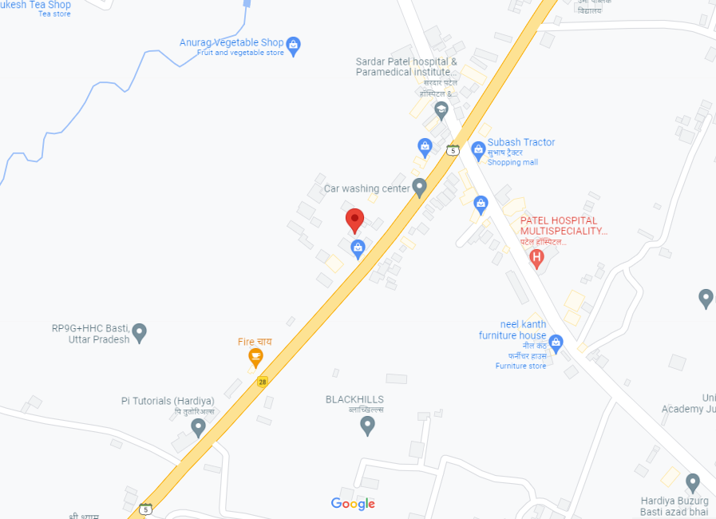

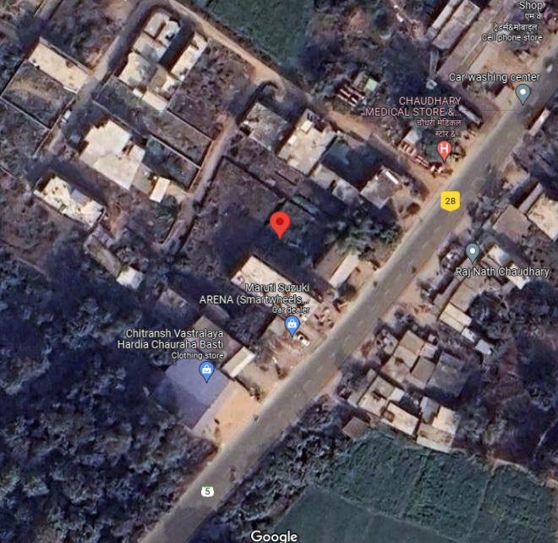

|  |  |
| --- | --- |
| **PART E** | **PHOTOGRAPHS OF THE PROPERTY** |

|  |  |
| --- | --- |
| Z:\In Progress Files\Babul\uploads\VIS(2022-23)-PL419-Q096-343-619 (Basti Care Hospital Pvt. Ltd.)\Progress report\Photos\TC_04416.jpg | Z:\In Progress Files\Babul\uploads\VIS(2022-23)-PL419-Q096-343-619 (Basti Care Hospital Pvt. Ltd.)\Progress report\Photos\TC_04417.jpg |
| Z:\In Progress Files\Babul\uploads\VIS(2022-23)-PL419-Q096-343-619 (Basti Care Hospital Pvt. Ltd.)\Progress report\Photos\TC_04401.jpg | Z:\In Progress Files\Babul\uploads\VIS(2022-23)-PL419-Q096-343-619 (Basti Care Hospital Pvt. Ltd.)\Progress report\Photos\TC_04411.jpg |
| Z:\In Progress Files\Babul\uploads\VIS(2022-23)-PL419-Q096-343-619 (Basti Care Hospital Pvt. Ltd.)\Progress report\Photos\TC_04407.jpg | Z:\In Progress Files\Babul\uploads\VIS(2022-23)-PL419-Q096-343-619 (Basti Care Hospital Pvt. Ltd.)\Progress report\Photos\TC_04408.jpg |
| Z:\In Progress Files\Babul\uploads\VIS(2022-23)-PL419-Q096-343-619 (Basti Care Hospital Pvt. Ltd.)\Progress report\Photos\TC_04414.jpg | Z:\In Progress Files\Babul\uploads\VIS(2022-23)-PL419-Q096-343-619 (Basti Care Hospital Pvt. Ltd.)\Progress report\Photos\TC_04413.jpg |

|  |  |
| --- | --- |
| Z:\In Progress Files\Babul\uploads\VIS(2022-23)-PL419-Q096-343-619 (Basti Care Hospital Pvt. Ltd.)\Progress report\Photos\TC_04393.jpg | Z:\In Progress Files\Babul\uploads\VIS(2022-23)-PL419-Q096-343-619 (Basti Care Hospital Pvt. Ltd.)\Progress report\Photos\TC_04389.jpg |
| Z:\In Progress Files\Babul\uploads\VIS(2022-23)-PL419-Q096-343-619 (Basti Care Hospital Pvt. Ltd.)\Progress report\Photos\TC_04391.jpg | Z:\In Progress Files\Babul\uploads\VIS(2022-23)-PL419-Q096-343-619 (Basti Care Hospital Pvt. Ltd.)\Progress report\Photos\TC_04386.jpg |
| Z:\In Progress Files\Babul\uploads\VIS(2022-23)-PL419-Q096-343-619 (Basti Care Hospital Pvt. Ltd.)\Progress report\Photos\TC_04385.jpg | Z:\In Progress Files\Babul\uploads\VIS(2022-23)-PL419-Q096-343-619 (Basti Care Hospital Pvt. Ltd.)\Progress report\Photos\TC_04387.jpg |
| Z:\In Progress Files\Babul\uploads\VIS(2022-23)-PL419-Q096-343-619 (Basti Care Hospital Pvt. Ltd.)\Progress report\Photos\TC_04403.jpg | Z:\In Progress Files\Babul\uploads\VIS(2022-23)-PL419-Q096-343-619 (Basti Care Hospital Pvt. Ltd.)\Progress report\Photos\TC_04404.jpg |

|  |  |
| --- | --- |
| **PART F** | **IMPORTANT PROPERTY DOCUMENTS EXHIBIT** |

**COPY OF SALE DEED:**

**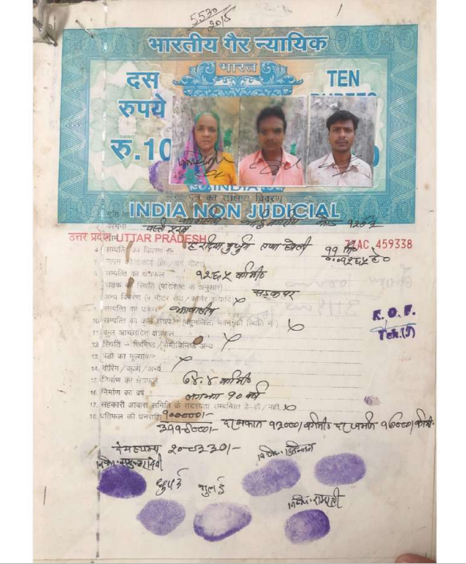**

**COPY OF BUILDING APPROVAL LETTER:**

**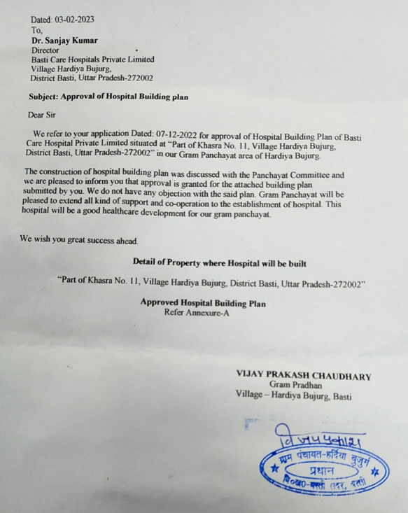**

|  |  |
| --- | --- |
| **PART G** | **DISCLAIMER** |

* + - 1. No employee or member of R.K Associates has any direct/ indirect interest in the Project.
      2. This report is prepared based on the copies of the documents/ information which the Bank/ Company has provided to us out of the standard checklist of documents sought from them and further based on our assumptions and limiting conditions. All such information provided to us has been relied upon in good faith and we have assumed that it is true and correct in all respect. Verification or cross checking of the documents provided to us has not been done at our end from the originals. If at any time in future, it is found or came to our knowledge that misrepresentation of facts or incomplete or distorted information has been provided to us then this report shall automatically become null & void.
      3. This report is a general analysis of the project based on the scope mentioned in the report. This is not an Audit report, Design document, DPR or Techno-financial feasibility study. All the information gathered is based on the facts seen on the site during survey, verbal discussion & documentary evidence provided by the client and is believed that information given by the company is true best of their knowledge.
      4. All observations mentioned in the report is only based on the visual observation and the documents/ data/ information provided by the client. No mechanical/ technical tests, measurements or any design review have been performed or carried out from our side during Project assessment.
      5. Bank/FI should ONLY take this report as an Advisory document from the Financial/ Chartered Engineering firm and it’s specifically advised to the creditor to cross verify the original documents for the facts mentioned in the report which can be availed from the borrowing company directly.
      6. In case of any default in loans or the credit facility extended to the borrowing company, R.K Associates shall not be held responsible for whatsoever reason may be and any request for seeking any explanation from the employee/s of R.K Associates will not be entertained at any instance or situation.
      7. This is just an opinion report and doesn’t hold any binding on anyone. It is requested from the concerned Financial Institution which is using this report for taking financial decision on the project that they should consider all the different associated relevant & related factors also before taking any business decision based on the content of this report.
      8. All Pages of the report including annexures are signed and stamped from our office. In case any paper in the report is without stamp & signature then this should not be considered a valid paper issued from this office.
      9. Though adequate care has been taken while preparing this report as per its scope, but still we can’t rule out typing, human errors, over sightedness of any information or any other mistakes. Therefore, the concerned organization is advised to satisfy themselves that the report is complete & satisfactory in all respect. Intimation regarding any discrepancy shall be brought into our notice immediately. If no intimation is received within 15 (Fifteen) days in writing from the date of issuance of the report, to rectify these timely, then it shall be considered that the report is complete in all respect and has been accepted by the client upto their satisfaction & use and further to which R.K Associates shall not be held responsible in any manner.
      10. Defect Liability Period is **15 DAYS**. We request the concerned authorized reader of this report to check the contents, data and calculations in the report within this period and intimate us in writing if any corrections are required or in case of any other concern with the contents or opinion mentioned in the report. Corrections only related to typographical, calculation, spelling mistakes, incorrect data/ figures/ statement will be entertained within the defect liability period. Any new changes for any additional information in already approved report will be regarded as additional work for which additional fees may be charged. No request for any illegitimate change in regard to any facts & figures will be entertained.
      11. R.K Associates encourages its customers to give feedback or inform concerns over its services through proper channel at le@rkassociates.org in writing within 30 days of report delivery. After this period no concern/ complaint/ proceedings in connection with the Lender’s Independent Engineering Services will be entertained due to possible change in situation and condition of the subject Project.
      12. Our Data retention policy is of **ONE YEAR**. After this period, we remove all the concerned records related to the assignment from our repository. No clarification or query can be answered after this period due to unavailability of the data.
      13. This report is governed by our (1) Internal Policies, Processes & Standard Operating Procedures, (2) Information/ Data/ Inputs given to us by the client and (3) Information/ Data/ Facts given to us by our field/ office technical team. Management of R.K Associates never gives acceptance to any unethical or unprofessional practice which may affect fair, correct & impartial assessment and which is against any prevailing law. In case of any indication of any negligence, default, incorrect, misleading, misrepresentation or distortion of facts in the report then it is the responsibility of the user of this report to immediately or at least within the defect liability period bring all such act into notice of R.K Associates management so that corrective measures can be taken instantly.
      14. R.K Associates never releases any report doing alterations or modifications from pen. In case any information/ figure of this report is found altered with pen then this report will automatically become null & void.

|  |  |  |
| --- | --- | --- |
| **SURVEYED BY** | **PREPARED BY** | **REVIEWED BY** |
| Sachin Pandey | Babul Akhtar Gazi | Sr. V.P. Projects |
|  |  |  |

***DEFECT LIABILITY PERIOD - In case of any query/ issue or escalation you may please contact Incident Manager by writing at valuers@rkassociates.org. We ensure 100% accuracy in the Calculations done, Rates adopted and various other data points & information mentioned in the report but still can’t rule out typing, human errors or any other mistakes. In case you find any mistake, variation, discrepancy or inaccuracy in any data point of the report, please help us by bringing all such points into our notice in writing at*** [***valuers@rkassociates.org***](mailto:valuers@rkassociates.org) ***within 30 days of the report delivery, to get these rectified timely, failing which R.K Associates Valuers Techno Engineering Consultants (P) Ltd. won’t be held responsible for any inaccuracy in any manner. Also, if we will not hear back anything from you within 30 days, we will assume that report is correct in all respect and no further claim of any sort will be entertained thereafter. We would welcome and appreciate your feedback & suggestions in order to improve our services.***

***COPYRIGHT FORMAT - This report is prepared on the copyright format of R.K Associates Valuers Techno Engineering Consultants (P) Ltd. to serve our clients in the best possible way. Legally no one can copy or distribute this format without prior approval from R.K Associates. It is meant only for the organization as mentioned on the cover page of this report. Distribution or use of this format other than R.K Associates will be seen as unlawful act and necessary legal action can be taken against the defaulter.***