**REPORT FORMAT:** V-L1 (Basic) | Version: 8.0_2019

**FILE NO. VIS(2023-24)-PL050-043-041 DATED:26/04/2023**

**FIXED ASSETS VALUATION REPORT**

**OF**

|  |  |
| --- | --- |
| **NATURE OF ASSETS** | **BUILT-UP UNIT** |
| **CATEGORY OF ASSETS** | **COMMERCIAL** |
| **TYPE OF ASSETS** | **COMMERCIAL FLOOR UNIT** |

**SITUATED AT**

**EASTERN SIDE HALF PORTION THIRD FLOOR WITHOUT ROOF RIGHT, PORTION D, MUNICIPAL NO. 11099, WARD NO. XIV, KHASRA NO. 158/71, BLOCK D, SHIDIPURA, DORIWALAN, KAROL BAGH, NEW DELHI.**

**OWNER/S**

**MR. O.P RAJGARIA S/O LATE MR. DEEP CHAND RAJGARIA**

**A/C: M/S. OVERNITE EXPRESS LIMITED**

**REPORT PREPARED FOR**

**M/S OMKARA ASSETS RECONSTRUCTION PRIVATE LIMITED**

***\*\*Important - In case of any query/ issue or escalation you may please contact Incident Manager***

***at valuers@rkassociates.org. We will appreciate your feedback in order to improve our services.***

***NOTE: As per IBA & Bank’s Guidelines please provide your feedback on the report within 15 days of its submission after which report will be considered to be correct.***

***Valuation Terms of Services & Valuer’s Important Remarks are available at*** [***www.rkassociates.org***](http://www.rkassociates.org) ***for reference.***

|  |
| --- |
| **SNAPSHOT OF THE ASSET/ PROPERTY UNDER VALUATION** |

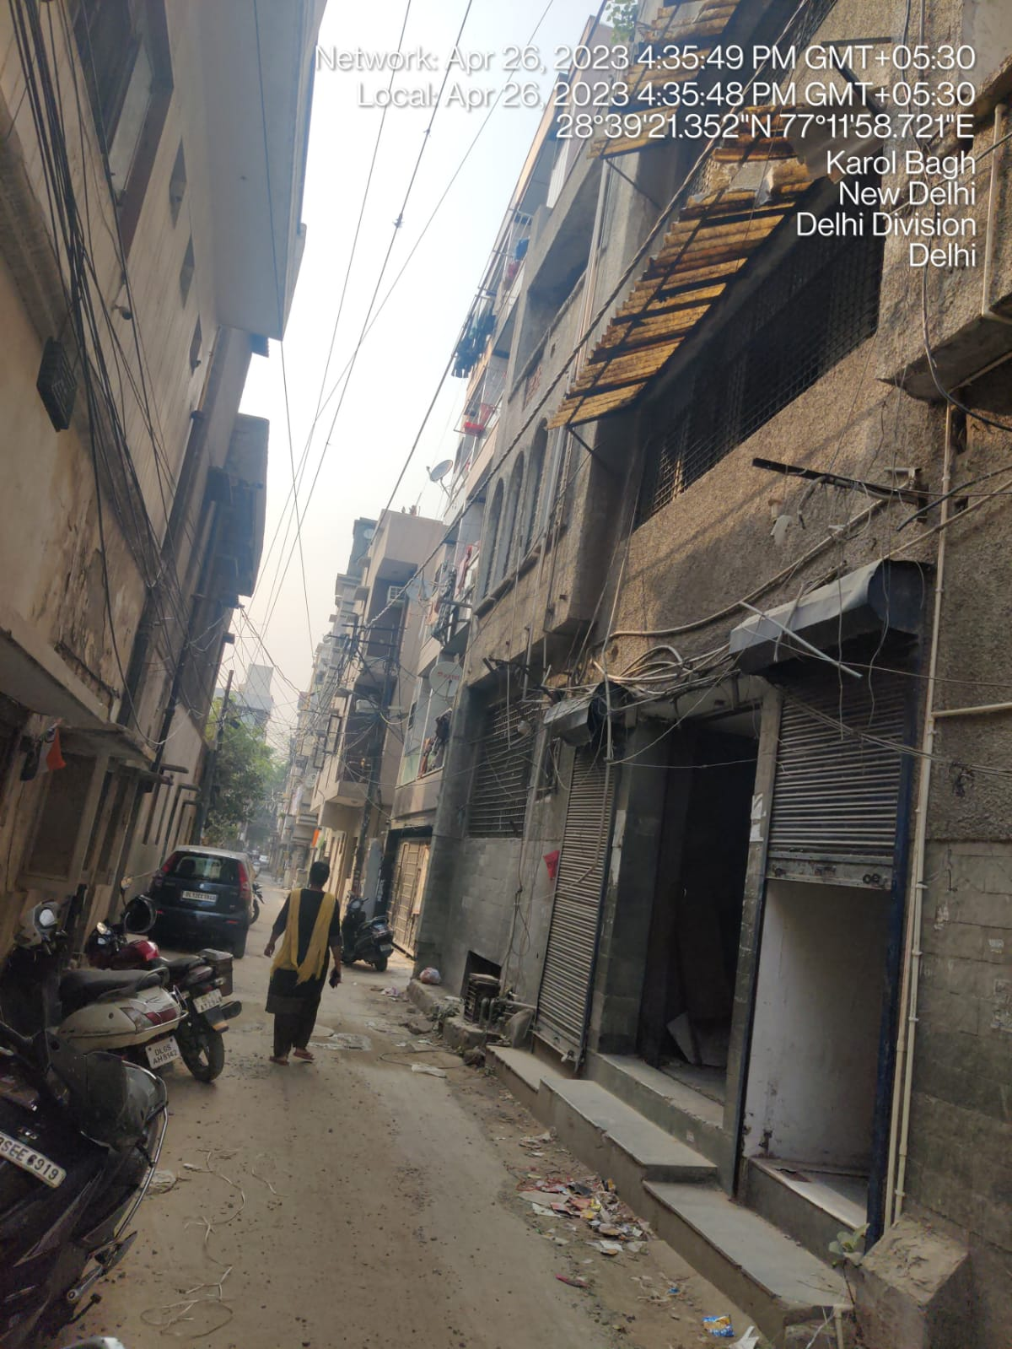

|  |
| --- |
| **VALUATION ASSESSMENT AS PER RKA FORMAT** |

|  |  |
| --- | --- |
| Name & Address of Branch: | M/s. Omkara Assets Reconstruction Private Limited  NO.9, M.P.Nagar First Street, Kongu Nagar Extension, Tirupur, Coimbatore, Tamil Nadu-641607 |
| Name of Customer (s)/ Borrower Unit | M/s. Overnite Express Limited |

|  |  |  |  |  |  |  |  |  |  |  |  |  |  |  |  |
| --- | --- | --- | --- | --- | --- | --- | --- | --- | --- | --- | --- | --- | --- | --- | --- |
|  | **Customer Details** | | | | | | | | | | | | | | |
|  | Name of the Owner(s) | | Mr. O. P Rajgaria S/O Late Mr. Deep Chand Rajgari | | | | | | | | | | | | |
|  | Application No. | | NA | | | | | | | | | | | | |
|  | **Property Details** | | | | | | | | | | | | | | |
|  | Address | | Eastern Side Half Portion Third Floor Without Roof Right, Portion D, Municipal No. 11099, Ward No. XIV, Khasra No. 158/71, Block D, Shidipura, Doriwalan, Karol Bagh, New Delhi. | | | | | | | | | | | | |
|  | Nearby Landmark | | Village Prem Dhaba / D. Mart | | | | | | | | | | | | |
|  | Google Map | | Enclosed with the Report | | | | | | | | | | | | |
| Coordinates or URL: 28°39'20.9"N 77°11'58.8"E | | | | | | | | | | | | |
|  | Independent access to the property | | Clear independent access is available | | | | | | | | | | | | |
|  | Type of ownership | | Single ownership | | | | | | | | | | | | |
|  | Constitution of the Property | | Free Hold | | | | | | | | | | | | |
|  | Is the property merged or colluded with any other property | | Yes | | | | | | | | | | | | |
| Comments: The subject property is merged with the adjacent property bearing No. 11099/C | | | | | | | | | | | | |
|  | **Document Details** | | **Status** | | | **Name of Approving Auth.** | | | | | | **Approval No.** | | | |
|  | Layout Plan | | Not available | | | DDA | | | | | | --- | | | |
|  | Building plan | | Not available | | | DDA | | | | | | --- | | | |
|  | Construction Permission | | Not available | | | DDA | | | | | | --- | | | |
|  | Legal Documents | | Available | | Sale Deed | | | | Municipal Tax Receipt | | | | | | Copy of TIR |
|  | **Physical Details of the Property** | | | | | | | | | | | | | | |
|  | Adjoining Properties | | **Directions** | | **As per Sale Deed** | | | | | | | | **Actual found at Site** | | |
| **North** | | Portion “B” Part of property bearing Municipal No. XIV/11099 | | | | | | | | Other Property | | |
| **South** | | Street | | | | | | | | Entry | | |
| **East** | | Portion “C” Part of property bearing Municipal No. XIV/11099 | | | | | | | | Portion “C” Part of property bearing Municipal No. XIV/11099 | | |
| **West** | | Other’s Property | | | | | | | | Other’s Property | | |
|  | Are Boundaries matched | | Yes, from the documents | | | | | | | | | | | | |
|  | Plot demarcation | | NA | | | | | | | | | | | | |
|  | Approved land Use | | Commercialas per property documents | | | | | | | | | | | | |
|  | Type of Property | | Commercial Floor | | | | | | | | Commercial Floor | | | | |
|  | No. of bed rooms | Living/ Dining area | | Toilets | | | | Kitchen | | | | | | Other rooms | |
| NA | NA | | NA | | | | NA | | | | | | 01 | |
|  | Total no. of floors of the property | | 5 (Basement + Ground + First + Second + Third Flooor) | | | | | | | | | | | | |
|  | Floor on which the property is located | | Third Floor | | | | | | | | | | | | |
|  | Approx. age of the property | | 32 years approx. | | | | | | | | | | | | |
|  | Residual age of the property | | Approx. 28 years subjected to proper and timely maintenance | | | | | | | | | | | | |
|  | Type of structure | | RCC load bearing structure on pillar beam column and 9" brick walls | | | | | | | | | | | | |
|  | Condition of the Structure | | Ordinary | | | | | | | | | | | | |
|  | Finishing of the building | | Average | | | | | | | | | | | | |
|  | **Tenure/ Occupancy/ Possession Details** | | | | | | | | | | | | | | |
|  | Property presently possessed/ occupied by | | | | | | Vacant | | | | | | | | |
|  | Status of Tenure | | | | | | NA | | | | | | | | |
|  | No. of years of occupancy | | | | | | As on the date of survey the property was locked and appears to be vacant | | | | | | | | |
|  | Relationship of tenant or owner | | | | | | NA | | | | | | | | |
|  | **Stage of Construction** | | | | | |  | | | | | | | | |
|  | If under construction then extent of completion | | | | | | NA | | | | | | | | |
|  | **Violation in the property** | | | | | | | | | | | | | | |
|  | 1. **Violation if any observed** | | 1. **Nature and extent of violation** | | | | | | | 1. **Any other negativity, defect or drawback in the property** | | | | | |
|  | The map is approved for residential purpose, however the property is used for commercial purposes. | | The map is approved for residential purpose, however the property is used for commercial purposes. | | | | | | | None | | | | | |

|  |  |  |  |  |
| --- | --- | --- | --- | --- |
|  | **AREA DETAILS OF THE PROPERTY** | | | |
|  | **Land area***(as per documents/ site survey, whichever is less)*  *(Not considered since this is a Built-up Dwelling Unit Valuation)* | | | |
|  | **Area as per documents** | **Area as per site survey** | **Area considered for Valuation** | |
| NA | NA | NA | |
| Area adopted on the basis of | NA | | |
| Remarks & Observations | Area measurements considered in the Valuation Report pertaining to Land is adopted from relevant documents produced to us or actual site measurement, whichever is less. All area measurements are on approximate basis only. Verification of the area measurement of the property is done based on sample random checking only. Area of the large land parcels of more than 2500 sq.mtr or of uneven shape, is taken as per property documents which has been relied upon. | | |
|  | **Constructed Covered Area***(As per IS 3861-1966)* | | | |
|  | **Area as per documents** | **Area as per site survey** | | **Area considered for Valuation** |
| 2,000 sq.ft./185.80 sq. mtr. | 2,000 sq.ft./185.80 sq. mtr. | | 2,000 sq.ft./185.80 sq. mtr. |
| Area adopted on the basis of | Property documents & site survey both | | |
| Remarks & Observations | Area measurements considered in the Valuation Report pertaining to Building is adopted from relevant documents produced to us or actual site measurement, whichever is less. All area measurements are on approximate basis only. Verification of the area measurement of the property is done based on sample random checking only. | | |

|  |  |  |  |  |  |  |  |  |  |
| --- | --- | --- | --- | --- | --- | --- | --- | --- | --- |
|  | **VALUATION ASSESSMENT** | | | | | | | | |
|  | **ASSESSMENT FACTORS** | | | | | | | | |
|  | Valuation Type | Built-up unit value (sold-purchased as a seperate dwelling unit) | | | | | | Commercial Floor Value | |
|  | Scope of the Valuation | Non binding opinion on the assessment of Plain Asset Valuation of the property identified to us by the owner or through his representative. | | | | | | | |
|  | Property Use factor | **Current Use** | | | | | **Highest &Best Use** | | |
| Commercial | | | | | Commercial | | |
|  | Legality Aspect Factor | Assumed to be positive as per copy of documents & information produced to us. However, Legal aspects of the property are out-of-scope of the Valuation Services.  Verification of authenticity of documents from originals or cross checking from any Govt. deptt. have to be taken care by Legal expert/ Advocate. | | | | | | | |
|  | Land Physical factors | **Shape** | | **Size** | | | **Level** | | **Frontage to depth ratio** |
| Rectangle | | Small | | | On Road Level | | Normal frontage |
|  | Property location category factor | **City Categorization** | | **Locality Categorization** | | | **Property location classification** | | **Floor Level** |
| Metro City | | Good | | | Near to Market | | Third Floor |
| Urban developed | | Within clustered commercial activity market | | | None | |
| None | |
| **Property Facing** | | South Facing | | | | | |
|  | Any New Development in surrounding area | None | | | ---- | | | | |
|  | Any specific advantage/ drawback in the property | None | | | | | | | |
|  | Property overall usability Factor | Good | | | | | | | |
|  | Comment on Property Saleability Outlook | Easily sellable | | | | | | | |
|  | Comment on Demand & Supply in the Market | Good demand of such properties in the market | | | | | | | |
|  | Any other aspect which has relevance on the value or marketability of the property | Valuation of the same asset/ property can fetch different values under different circumstances & situations. For eg. Valuation of a running/ operational shop/ hotel/ factory will fetch better value and in case of closed shop/ hotel/ factory it will fetch considerably lower value. Similarly, an asset sold directly by an owner in the open market through free market arm’s length transaction then it will fetch better value and if the same asset/ property is sold by any financer or court decree or Govt. enforcement agency due to any kind of encumbrance on it then it will fetch lower value. Hence before financing, Lender/ FI should take into consideration all such future risks while financing.  This Valuation report is prepared based on the facts of the property & market situation on the date of the survey. It is a well-known fact that the market value of any asset varies with time & socio-economic conditions prevailing in the region/ country. In future property market may go down, property conditions may change or may go worse, property reputation may differ, property vicinity conditions may go down or become worse, property market may change due to impact of Govt. policies or effect of domestic/ world economy, usability prospects of the property may change, etc. Hence before financing, Banker/ FI should take into consideration all such future risk while financing. | | | | | | | |
|  | Sale transaction method assumed | Free market transaction at arm's length wherein the parties, after full market survey each acted knowledgeably, prudently and without any compulsion. | | | | | | | |
|  | Best Sale procedure to realize maximum Value | Free market transaction at arm's length wherein the parties, after full market survey each acted knowledgeably, prudently and without any compulsion. | | | | | | | |
| 1. DD | Methodology/ Basis of Valuation | **Govt. Guideline Value: Collector rates of Delhi-2021.** | | | | | | | |
| **Market Value:**Market Comparable Sales approach | | | | | | | |
| * *Valuation of the asset is done as found on as-is-where basis on the site as identified to us by client/ owner/ owner representative during site inspection by our engineer/s unless otherwise mentioned in the report.* * *Analysis and conclusions adopted in the report are limited to the reported assumptions, conditions and information came to our knowledge during the course of the work and based on the Standard Operating Procedures, Best Practices, Caveats, Limitations, Conditions, Remarks, Important Notes, Valuation TOR and definition of different nature of values.* * *For knowing comparable market rates, significant discreet local enquiries have been made from our side based on the hypothetical/ virtual representation of ourselves as both buyer and seller for the similar type of properties in the subject location and thereafter based on this information and various factors of the property, rate has been judiciously taken considering the factors of the subject property, market scenario and weighted adjusted comparison with the comparable properties unless otherwise stated.* * *References regarding the prevailing market rates and comparable are based on the verbal/ informal/ secondary/ tertiary information which are collected by our team from the local people/ property consultants/ recent deals/ demand-supply/ internet postings are relied upon as may be available or can be fetched within the limited time & resources of the assignment during market survey in the subject location. No written record is generally available for such market information and analysis has to be derived mostly based on the verbal information which has to be relied upon.* * *Market Rates are rationally adopted based on the facts of the property which came to our knowledge during the course of the assessment considering many factors like nature of the property, size, location, approach, market situation and trends and comparative analysis with the similar assets. During comparative analysis, valuation metrics is prepared and necessary adjustments are made on the subject asset.* * *The indicative value has been suggested based on the prevailing market rates that came to our knowledge during secondary & tertiary market research and is not split into formal & informal payment arrangements. Most of the deals takes place which includes both formal & informal payment components. Deals which takes place in complete formal payment component may realize relatively less actual transaction value due to inherent added tax, stamp registration liabilities on the buyer.* * *Secondary/ Tertiary costs related to asset transaction like Stamp Duty, Registration charges, Brokerage, Commission, Bank interest, Selling cost, Marketing cost, etc. pertaining to the sale/ purchase of this property are not considered while assessing the indicative estimated Market Value.* * *This report includes both, Govt. Guideline Value and Indicative Estimated Prospective Market Value as described above. As per the current market practice, in most of the cases, formal transaction takes place for an amount less than the actual transaction amount and rest of the payment is normally done informally.* * *Area measurements considered in the Valuation Report pertaining to asset/ property is adopted from relevant approved documents or sample site measurement whichever is less unless otherwise mentioned. All area measurements are on approximate basis only.* * *Verification of the area measurement of the property is done based on sample random checking only.* * *Area of the large land parcels of more than 2500 sq.mtr or of uneven shape in which there can be practical difficulty in sample measurement, is taken as per property documents which has been relied upon unless otherwise stated.* * *Drawing, Map, design & detailed estimation of the property/ building is out of scope of the Valuation services.* * *Construction rates are adopted based on the present market replacement cost of construction and calculating applicable depreciation & deterioration factor as per its age, existing condition & specifications based on visual observation only of the structure. No structural, physical tests have been carried out in respect of it. No responsibility is assumed for latent defects of any nature whatsoever, which may affect value, or for any expertise required to disclose such conditions.* * *Construction rates are adopted based on the plinth area rates prevailing in the market for the structure as a whole and not based on item wise estimation or Bills of Quantity method unless otherwise stated.* * *The condition assessment and the estimation of the residual economic life of the structure are only based on the visual observations and appearance found during the site survey. We have not carried out any structural design or stability study; nor carried out any physical tests to assess structural integrity & strength.* * *Any kind of unpaid statutory, utilities, lease, interest or any other pecuniary dues on the asset or on its owners has not been factored in the Valuation.* * *This Valuation is conducted based on the macro analysis of the asset/ property considering it in totality and not based on the micro, component or item wise analysis. Analysis done is a general assessment and is neither investigative in nature nor an audit activity.* * *Valuation is done for the asset found on as-is-where basis which owner/ owner representative/ client/ bank has shown to us on site of which some reference has been taken from the information/ data given in the copy of documents provided to us which have been relied upon in good faith and we have assumed that it to be true and correct.*   **Assumptions:**   1. *Documents/ Information/ Data provided by the client/ property owner or his representative both written & verbally is true and correct without any fabrication and has been relied upon in good faith.* 2. *Local verbal enquiries during micro market research came to our knowledge are assumed to be taken on record as true & factual.* 3. *The assets and interests therein have been valued free and clear of any liens or encumbrances unless stated otherwise. No hidden or apparent conditions regarding the subject assets or their ownership are assumed to exist. No opinion of title is rendered in this report and a good title is assumed unless stated otherwise.* 4. *It is assumed that the concerned Lender/ Financial Institution has asked for the valuation of that property after satisfying the authenticity of the documents given to us and for which the legal verification has been already taken and cleared by the competent Advocate before requesting for the Valuation report. I/ We assume no responsibility for the legal matters including, but not limited to, legal or title concerns.* 5. *Payment condition during transaction in the Valuation has been considered on all cash bases which includes both formal & informal payment components as per market trend.* 6. *Sale transaction method of the asset is assumed as Free market transaction without any compulsion unless otherwise mentioned while assessing Indicative & Estimated Fair Prospective Market Value of the asset unless otherwise stated.* 7. *If this Valuation Report is prepared for the Flat/ dwelling unit situated in a Group Housing Society or Integrated Township then approvals, maps of the complete group housing society/ township is out of scope of this report. This valuation report is prepared for the specific unit based on the assumption that complete Group Housing Society/ Integrated Township is approved and complied with all relevant laws and the subject unit is also approved within the Group Housing Society/ Township.*   **IMPORTANT KEY DEFINITIONS**  ***Fair Value*** *suggested by the competent Valuer is that prospective estimated amount in his expert & prudent opinion of the subject asset/ property without any prejudice after he has carefully & exhaustively evaluated the facts & information came in front of him or which he could reasonably collect during the course of the assessment related to the subject asset on an as-is, where-is basis in its existing conditions, with all its existing advantages & disadvantages and its potential possibilities which is just & equitable at which the subject asset/ property should be exchanged between a willing buyer and willing seller at an arm’s length transaction in an open & unrestricted market, in an orderly transaction after proper marketing, wherein the parties, each acted knowledgeably, prudently without any compulsion on the date of the Valuation.*  *Fair Value without using the term “Market” in it describes that the value suggested by the Valuer may not mandatorily follow or may not be in complete consonance to the established Market in his expert opinion. It may or may not follow market dynamics. But if the suggested value by the valuer is not within the prevailing Market range or is assessed for an asset is located in an un-established Market then the valuer will give reasonable justification & reasoning that for what reasons the value suggested by him doesn’t follow the prevailing market dynamics.*  ***Fair Market Value*** *suggested by the competent Valuer is that prospective estimated amount in his expert & prudent opinion of the subject asset/ property without any prejudice in consonance to the Market dynamics after he has carefully & exhaustively evaluated the facts & information came in front of him or which he could reasonably collect during the course of assessment related to the subject asset on an as-is, where-is basis in its existing conditions, with all its existing advantages & disadvantages and its potential possibilities which is just & equitable at which the subject asset/ property should be exchanged between a willing buyer and willing seller at an arm’s length transaction in an open & unrestricted market, in an orderly transaction after proper marketing, wherein the parties, each acted knowledgeably, prudently without any compulsion on the date of the Valuation.*  *Here the words “in consonance to the established Market” means that the Valuer will give opinion within the realms & dynamics of the prevailing market rates after exhaustively doing the micro market research. However due to the element of “Fair” in it, valuer will always look for the factors if the value should be better than the market realms which is just & equitable backed by strong justification and reasoning.*  ***Market Value*** *suggested by the competent Valuer is that prospective estimated amount which is average price of the similar comparable assets prevailing in an open & established market during the near period of the date of valuation at which the subject asset/ property should be exchanged between a willing buyer and willing seller on an as-is, where-is basis in its existing conditions, with all its existing advantages & disadvantages and its potential possibilities at an arm’s length transaction in an open, established & unrestricted market, in an orderly transaction, wherein the parties, each acted without any compulsion on the date of the Valuation.*  *Using the term “Market Value” without “Fair” omits the elements of proper marketing, acting knowledgeably & prudently.*  *Market and market participants can be sentimental, inclined towards the transaction without the element of complete knowledge & prudence about facts or due diligence of the asset therefore “each acted knowledgeably, prudently” has been removed from the marker Value definition.*  ***Realizable Value*** *is that minimum prospective estimated value of the asset/ property which it may be able to fetch at the time of actual property transaction factoring in the element of discount due to the prospects of deep negotiations between the buyer & seller when the parties in-principally find Fair Market Value reasonable and sits together to close the deal and the transaction across the table. Discount percentage on the Fair Market Value due to negotiation will depend on the nature, size, various salability prospects of the subject asset, the needs of the buyer & the seller and kind of payment terms. In some of the cases Realizable and Fair Market Value may also be equal.*  ***Distress Sale Value\**** *is that value when the property is attached with any process such as mortgaged financing, financial or operational dues which is under any stress condition or situation and the stakeholders are under process of finding resolution towards it to save the property from being attached to a formal recovery process. In this type of sale, minimum fetch value assessed will always be less than the estimated Fair Market Value where the discount of percentage will depend upon various circumstances and factors such as nature, size, salability prospects of the property and kind of encumbrance on the property. In this type of sale, negotiation power of the buyer is always more than the seller and eagerness & pressure of selling the property will be more on the seller than the buyer.*  ***Liquidation Value*** *is the amount that would be realized when an asset or group of assets are sold due to any compulsion or constraints such as in a recovery process guided by statute, law or legal process, clearance sale or any such condition or situation thereof where the pressure of selling the asset/ property is very high to realize whatever maximum amount can be from the sale of the assets in a limited time for clearance of dues or due to closure of business. In other words, this kind of value is also called as forced sale value.*  ***Difference between Cost, Price & Value:*** *Generally, these words are used and understood synonymously. However, in reality each of these has a completely different meaning, premise and also having different definitions in professional & legal terms. Therefore, it is our professional responsibility to describe the definitions of these words to avoid ambiguity & confusion in the minds of the user of this report.*  *The* ***Cost*** *of an asset represents the actual amount spend in the construction/ actual creation of the asset.*  *The* ***Price*** *is the amount paid for the procurement of the same asset.*  *The* ***Value*** *is defined as the present worth of future rights in the property/ asset and is a hypothetical or notional price that buyers and sellers are most likely to conclude for a good or service. Value is not a fact, but an estimate of the likely price to be paid for a good or service at a given time in accordance with a particular definition of value.*  *Therefore, in actual for the same asset/ property, cost, price & value remain different since these terms have different usage & meaning.* | | | | | | | |
| 1. oo | References on prevailing market Rate/ Price trend of the property and Details of the sources from where the information is gathered *(from property search sites & local information)* |  | Name: | | | Madaan Properties Consultants | | | |
| Contact No.: | | | +91-98114 84484 | | | |
| Nature of reference: | | | Property Consultant | | | |
| Size of the Property: | | | Approx. 2000 sq. ft. | | | |
| Location: | | | Karol Bagh | | | |
| Rates/ Price informed: | | | Rs.10,000/- to Rs.15,000/- per sq. ft. | | | |
| Any other details/ Discussion held: | | | None | | | |
|  | Name: | | | Jagdamba Property Delaer | | | |
| Contact No.: | | | +91-99998 22008 | | | |
| Nature of reference: | | | Property Consultant | | | |
| Size of the Property: | | | Approx 2,000 sq.ft. | | | |
| Location: | | | Karol Bagh | | | |
| Rates/ Price informed: | | | Rs.10,000/- to Rs.15,000/- per sq. ft. | | | |
| Any other details/ Discussion held: | | | None | | | |
|  | Name: | | | NA | | | |
| Contact No.: | | | NA | | | |
| Nature of reference: | | | NA | | | |
| Size of the Property: | | | NA | | | |
| Location: | | | NA | | | |
| Rates/ Price informed: | | | NA | | | |
| Any other details/ Discussion held: | | | NA | | | |
| *NOTE: The given information above can be independently verified to know its authenticity.* | | | | | | | | |
|  | Adopted Rates Justification | *As observed during the site survey, the subject property is used for godown purpose and currently lying vacant (no use). The rates of commercial space in main road in this locality is having area approx. 2000 sq. ft. are around Rs.2.00 Cr. to Rs.3.00 Cr. on the third floors which translates to a rate of Rs.10,000/- to Rs.15,000/- per sq. ft. The subject property is currently lying vacant and no maintenance has been carried out since long time. Therefore, Considering all the factors like shape, floor, size, age, location, etc. we have adopted the rate of Rs.13,000/- per sq. ft. for the purpose of this valuation exercise, which seems reasonable in our view.* | | | | | | | |
|  | ***NOTE:*** *We have taken due care to take the information from reliable sources. The given information above can be independently verified from the provided numbers to know its authenticity. However due to the nature of the information most of the market information came to knowledge is only through verbal discussion with market participants which we have to rely upon where generally there is no written record.*  *Related postings for similar properties on sale are also annexed with the Report wherever available.* | | | | | | | | |

|  |  |  |  |  |  |  |
| --- | --- | --- | --- | --- | --- | --- |
|  | **VALUATION CALCULATION** | | | | | |
|  | **GUIDELINE/ CIRCLE VALUE** | | | | | |
|  | **Land Value** | **Total Land Area considered as per documents/ site survey** *(whichever is less)* | **Prevailing Rates Range** | | | **Rates adopted**  (considering all characteristics& assessment factors of the property) |
| NA | NA | | | NA |
| ***Total Land Value (a)*** | NA | | | | |
| **NA** | | | | |
|  | **Built-up Commercial Unit Value** | **Built-Up unit value** | | | | |
| **Structure Type** | **Construction category** | | | **Age Factor** |
| RCC load bearing structure on pillar beam column and 9" brick walls | Class C construction (Simple/ Average) | | | Construction older than 15 years and above |
| **Rate range** | **Rate adopted** | | | **Covered Area** |
| Please see the attached list | Please see the attached list | | | Please see the attached list |
| ***TotalConstruction Estimated Depreciated Replacement Value(b)*** | NA | | | | |
| **NA** | | | | |
|  | **TOTAL GUIDELINE/ CIRCLE RATE VALUE: (a+b)** | **Rs.8,00,66,851/-** | | | | |
|  | | | | | | |
|  | **INDICATIVE ESTIMATED PROSPECTIVE FAIR MARKET VALUE** | | | | | |
| 1. X 2 | **Land Value** | **Total Land Area considered as per documents/ site survey** *(whichever is less)* | **Prevailing Rates Range** | | | **Rate adopted**  (considering all characteristics& assessment factors of the property) |
| NA | NA | | | NA |
| ***Total Land Value (a)*** | NA | | | | |
| **NA** | | | | |
|  | **Built-up Commercial Unit** | **Structure cost/ Construction Value** | | | | |
| **Structure Type** | **Construction category** | | | **Structure Condition** |
| RCC load bearing structure on pillar beam column and 9" brick walls | Class C construction (Simple/ Average) | | | Ordinary |
| **Age Factor** | | | **Covered Area** | |
| Construction older than 15 years and above | | | 2000 sq.ft./185.80 sq.mtr. | |
| **Rate range** | | | **Rate adopted** | |
| Rs.10,000/- to Rs.15,000/- per sq.ft. | | | Rs.13,000/- per sq.ft. | |
| ***Total Depreciated Replacement Value (b)*** | Rs.13,000/- per sq.ft. X Rs.2000 sq.ft. | | | | |
| **Rs.2,60,00,000/-** | | | | |
|  | **Add extra for Architectural aesthetic developments, improvements *(c)***  *(add lump sum cost)* | | | NA | | |
|  | **Add extra for fittings & fixtures *(d)***  *(doors, windows, wood work, cupboards, modular kitchen, electrical/ sanitary fittings)* | | | NA | | |
|  | **Add extra for services*(e)***  *(water, electricity, sewerage, main gate, boundary, lift, etc.)* | | | NA | | |
|  | **TOTAL VALUE: (a+b+c+d+e)** | | | **Rs.2,60,00,000/-** | | |
|  | **Additional Premium if any** | | | **NA** | | |
| **Details/ Justification** | | | **NA** | | |
|  | **Deductions charged if any** | | | **NA** | | |
| **Details/ Justification** | | | **NA** | | |
|  | **TOTAL INDICATIVE ESTIMATEDPROSPECTIVE FAIR MARKET VALUE#: (vi+vii+viii)** | | | **Rs.2,60,00,000/-** | | |
|  | **ROUND OFF** | | | **Rs.2,60,00,000/-** | | |
|  | **IN WORDS** | | | **Rupees Two Crore Sixty Lakhs Only** | | |
|  | **EXPECTED REALIZABLE/ FETCH VALUE^(@ ~15% less)** | | | **Rs.2,21,00,000/-** | | |
|  | **EXPECTEDFORCED/ DISTRESS SALE VALUE*(@ ~25% less)** | | | **Rs**.**1,95,00,000/-** | | |
|  | **VALUE FOR THE INSURANCE PURPOSE** | | | **NA** | | |
|  | **Justification for more than 20% difference in Market & Circle Rate** | Circle rates are determined by the District administration as per their own theoretical internal policy and Market rates are adopted based on current practical market dynamics which is explained clearly in Valuation Assessment Factors | | | | |
|  | **Concluding comments& Disclosures if any** | 1. During our site survey, we have seen that the property is not in use and locked from outside so, site inspection from inside the property could not be done. 2. The subject property is merged with the remaining portion of plot having municipal No. 11099/C, having common entrance. However, the property is separated by a separate wall from inner side. 3. We are independent of client/ company and do not have any direct/ indirect interest in the property. 4. This valuation has been conducted by R.K Associates Valuers & Techno Engineering Consultants (P) Ltd. and its team of experts. 5. This Valuation is done for the property found on as-is-where basis as shown on the site by the Bank/ customer of which photographs is also attached with the report. 6. Reference of the property is also taken from the copies of the documents/ information which interested organization or customer could provide to us out of the standard checklist of documents sought from them and further based on our assumptions and limiting conditions. All such information provided to us has been relied upon in good faith and we have assumed that it is true and correct. However, we do not vouch the absolute correctness of the property identification, exact address, physical conditions, etc. based on the documents provided to us since property shown to us may differ on site Vs as mentioned in the documents or incorrect/ fabricated documents may have been provided to us. 7. Legal aspects for eg. investigation of title, ownership rights, lien, charge, mortgage, lease, verification of documents from originals or from any Govt. department, etc. has to be taken care by legal experts/ Advocates and same has not been done at our end. 8. The valuation of an asset is an estimate of the worth of that asset which is arrived at by the Valuer in his expert opinion after factoring in multiple parameters and externalities. This may not be the actual price of that asset and the market may discover a different price for that asset. 9. This report only contains opinion based on technical & market information which came to our knowledge during the course of the assignment. It doesn’t contain any recommendations. 10. This report is prepared following our Standard Operating Procedures & Best Practices and will be subject to Limitations, Conditions, Valuer’s Remarks, Important Notes, Valuation TOS and basis of computation & working as described above. 11. The use of this report will become valid only after payment of full fees as per the Payment Terms. Using this report or any part content created in this report without payment of charges will be seen as misuse and unauthorized use of the report. | | | | |

|  |  |
| --- | --- |
|  | **ASSUMPTIONS | REMARKS | LIMITING CONDITIONS** |
|  | Qualification in TIR/Mitigation Suggested, if any:***None.*** |
|  | Is property SARFAESI compliant:***Yes*** |
|  | Whether property belongs to social infrastructure like hospital, school, old age home etc.:***No*** |
|  | Whether entire piece of land on which the unit is set up / property is situated has been mortgaged or to be mortgaged: ***NA, as valuation for a built-up floor only*** |
| 1. J | Details of last two transactions in the locality/area to be provided, if available:***Information couldn’t be found****.* |
|  | Any other aspect which has relevance on the value or marketability of the property:This report is prepared following our standard operating procedures & best practices, limitations, conditions, remarks, Important Notes, Valuation TOR. |
| 1. This Valuation report is prepared based on the copies of the documents/ information which interested organization or customer could provide to us out of the standard checklist of documents sought from them and further based on our assumptions and limiting conditions. All such information provided to us has been relied upon in good faith and we have assumed that it is true and correct. Verification or cross checking of the copy of the documents provided to us from the originals has not been done at our end. |
| 1. Legal aspects for eg. investigation of title, ownership rights, lien, charge, mortgage, lease, etc. are not considered in this report. It is assumed and taken into account that the concerned Bank/ Financial Institution has got the legal verification cleared by the competent Advocate while requesting for the Valuation report. |
| 1. Value varies with the Purpose/ Date/ Condition prevailing in the market. We recommend not to refer the Value of the asset given in this report if any of these points are different from the one mentioned aforesaid in the Report. We also recommend that the indicative estimated Value in the Valuation Report holds good only upto the period of 3 months from the date of Valuation. |

|  |  |  |  |  |  |
| --- | --- | --- | --- | --- | --- |
|  | **DECLARATION** | | | | |
|  | 1. The property was inspected by our authorized surveyor on 26 April 2023 by name Praveen Sharma and no site representative was present during the time of survey. 2. The undersigned does not have any direct/indirect interest in the above property. 3. The information furnished herein is true and correct to the best of our knowledge. 4. We have submitted Valuation report directly to the Client. 5. This valuation report is carried out by our Engineering team on the request fromM/s Omkara Assets Reconstruction Private Limited | | | | |
|  | **Name & Address of Valuer company** | M/s R.K. Associates Valuers & Techno Engineering Consultants Pvt. Ltd. D- 39, 2nd floor, Sector- 2, Noida | | | |
|  | **Enclosed Documents** | **S. No.** | **Documents** | | **No. of Pages** |
|  | General Details | | 02 |
|  | Screenshot of the price trend references of the similar related properties available on public domain | | 01 |
|  | Google Map | | 01 |
|  | Photographs | | 01 |
|  | Copy of Circle Rate | | 01 |
|  | Survey Summary Sheet | | 02 |
|  | Valuer’s Remark | | 02 |
|  | Copy of relevant papers from the property documents referred in the Valuation | | 02 |
|  | **Total Number of Pages in the Report with Enclosures** | 21 | | | |
|  | **Engineering Team worked on the report** | ***SURVEYED BY:*** *Er. Praveen Sharma* | |  | |
| ***PREPARED BY:*** *Er. Adil Afaque* | |  | |
| ***REVIEWED BY:*** *Er. Abhinav Chaturvedi* | |  | |

**R.K ASSOCIATES IMPORTANT NOTES: ANNEXURE - I**

***DEFECT LIABILITY PERIOD****- In case of any query/ issue or escalation you may please contact Incident Manager by writing at valuers@rkassociates.org. We try our level best to ensure maximum accuracy in the Calculations done, Rates adopted and various other data points & information mentioned in the report but still can’t rule out typing, human errors or any other mistakes. In case you find any mistake, variation, discrepancy or inaccuracy in any data point of the report, please help us by bringing all such points into our notice in writing at* [*valuers@rkassociates.org*](mailto:valuers@rkassociates.org)*within 30 days of the report delivery, to get these rectified timely, failing which R.K Associates won’t be held responsible for any inaccuracy in any manner. Also if we will not hear back anything from you within 30 days, we will assume that report is correct in all respect and no further claim of any sort will be entertained thereafter. We would welcome and appreciate your feedback & suggestions in order to improve our services.*

*Our* ***DATA RETENTION POLICY*** *is of* ***ONE YEAR****. After this period we remove all the concerned records related to the assignment from our repository. No clarification or query can be answered after this period due to unavailability of the data.*

***COPYRIGHT FORMAT*** *- This report is prepared on the copyright format of R.K Associates to serve our clients in the best possible way. Legally no one can copy or distribute this format without prior approval from R.K Associates. It is meant only for the organization as mentioned on the cover page of this report. Distribution or use of this format other than R.K Associates will be seen as unlawful act and necessary legal action can be taken against the defaulters.*

***IF REPORT IS USED FOR BANK/ FIs***

***NOTE:*** *As per IBA Guidelines in case the valuation report submitted by the valuer is not in order, the banks / FIs shall bring the same to the notice of the valuer within 15 days of submission for rectification and resubmission. In case no such communication is received, it shall be presumed that the valuation report has been accepted.*

***At our end we have not verified the authenticity of any documents provided to us. Bank is advised to verify the genuineness of the property documents before taking any credit decision.***

|  |  |  |  |  |  |  |  |
| --- | --- | --- | --- | --- | --- | --- | --- |
| **GENERAL DETAILS** | | | | | | | |
|  | Report prepared for | M/S Omkara Assets Reconstruction Private Limited. | | | | | |
|  | Name & Address of the Organization | M/s. Omkara Assets Reconstruction Private Limited  NO.9, M.P.Nagar First Street, Kongu Nagar Extension, Tirupur, Coimbatore, Tamil Nadu-641607 | | | | | |
|  | Name of Owner/ Borrower | Mr. O.P Rajgaria S/O Late Mr. Deep Chand Rajgaria | | | | | |
|  | Type of Loan | NA | | | | | |
|  | Date of Valuation | 26 April 2023 | | | | | |
|  | Date of Survey | 26 April 2023 | | | | | |
|  | Type of the Property | Commercial Floor (Third) | | | | | |
|  | Type of Survey | Only photographs taken (No sample measurement verification),since property was locked at the time of survey. | | | | | |
|  | Type of Valuation | Commercial Floor value | | | | | |
|  | Report Type | Plain Asset Valuation | | | | | |
|  | Surveyed in presence of | Self Identified since no one was available | | Name: | | NA  (🕿-NA) | |
|  | Purpose of Valuation | For Distress Sale of mortgaged assets under NPA a/c | | | | | |
|  | Scope of the Report | Non binding opinion on indicative estimated prospective valuation assessment of the property identified by property owner or through its representative | | | | | |
|  | Important Disclosures | 1. Legal aspects of the property have to be taken care by legal expert/ advocate. 2. Verification of authenticity of documents from originals or cross checking from any Govt. deptt. has to be taken care by legal expert/ advocate. 3. This is just an opinion report on Valuation based on the copy of the documents/ information provided to us by the client and has been relied upon in good faith of the property found as per the information given in the documents provided to us and/ or confirmed by the owner/ owner representative to us on site. 4. Getting cizra map or coordination with revenue officers for site identification is a separate activity and is not part of the Valuation services. 5. Measurement verification is only limited upto sample random measurement against the documents produced to us. 6. Drawing Map & design of the property is out of scope of the Valuation services. | | | | | |
|  | Documents provided for perusal | **Documents Requested** | | **Documents Provided** | | | **Documents Reference No.** |
| Total **05**documents requested. | | Total **02** documents provided. | | | 02 |
| Property Title document | | Sale Deed | | | Dated:09/08/2001 |
| Old Valuation Report | | Old Valuation Report | | | Dated: 15/11/2021 |
| Agreement to Sell | | None | | | -- |
| Last paid Electricity Bill | | None | | | -- |
| Last paid Municipal Tax Receipt | | None | | | --- |
|  | Documents received from | Customer | | | | | |
|  | Identification of the property  *(Identification of the property is only limited to cross verification from its boundaries at site if mentioned in the provided documents).* | **C:\Users\engineer9\Desktop\Check.pngC:\Users\engineer9\Desktop\Check.png** | Cross checked from the boundaries of the property or address mentioned in the deed | | | | |
|  | Done from the name plate displayed on the property | | | | |
| ☐ | Identified by the owner/ owner’s representative | | | | |
| **C:\Users\engineer9\Desktop\Check.png** | Enquired from local residents/ public | | | | |
| ☐ | Identification of the property could not be done properly | | | | |
| ☐ | Survey was not done | |  | | |
|  | Enclosures | 1. **Valuation Report as per RKA Format Annexure-1** 2. R.K Associates Important Notes 3. Screenshot of the Price trend references of the similar related   properties available on public domain - Page No.16   1. Google Map – Page No. 17 2. Photographs – Pages 18 3. Copy of Circle Rate – Pages No. 19 4. Survey Summary Sheet – Pages 02 5. Valuer’s Remark - Page No.20-21 6. Copy of relevant papers from the property documents referred in the Valuation – Pages 2 | | | | | |

**ENCLOSURE: III - REFERENCES ON PRICE TREND OF THE SIMILAR RELATED PROPERTIES AVAILABLE ON PUBLIC DOMAIN**

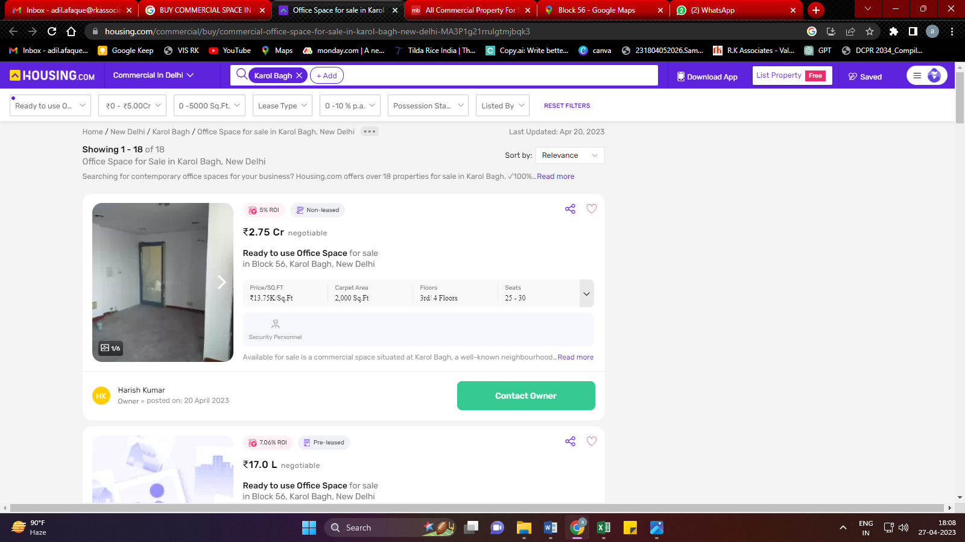

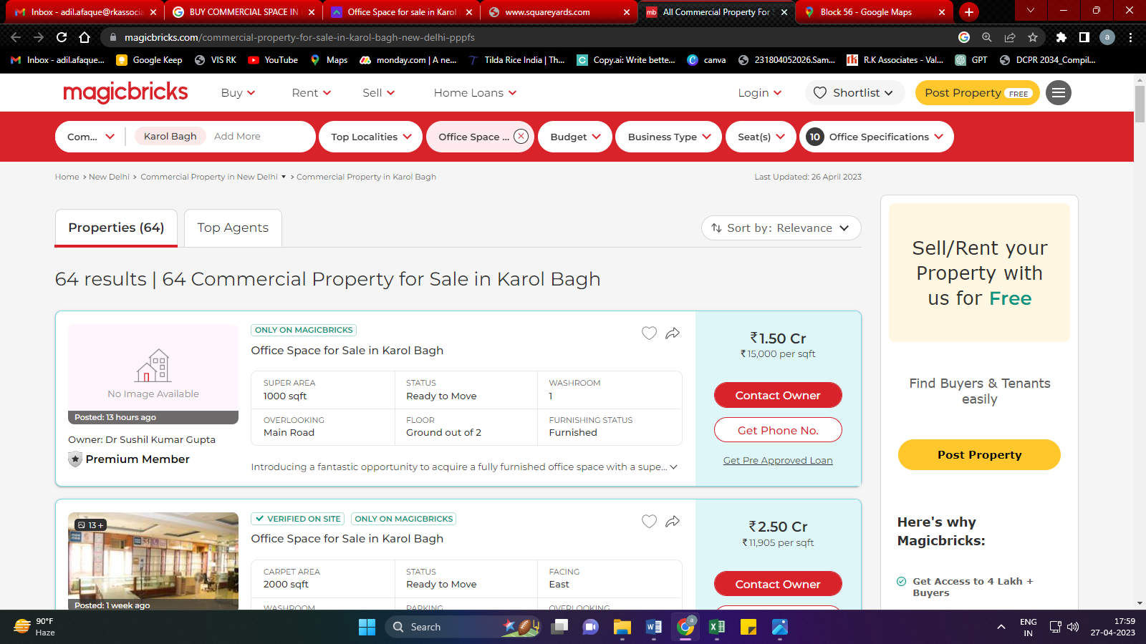

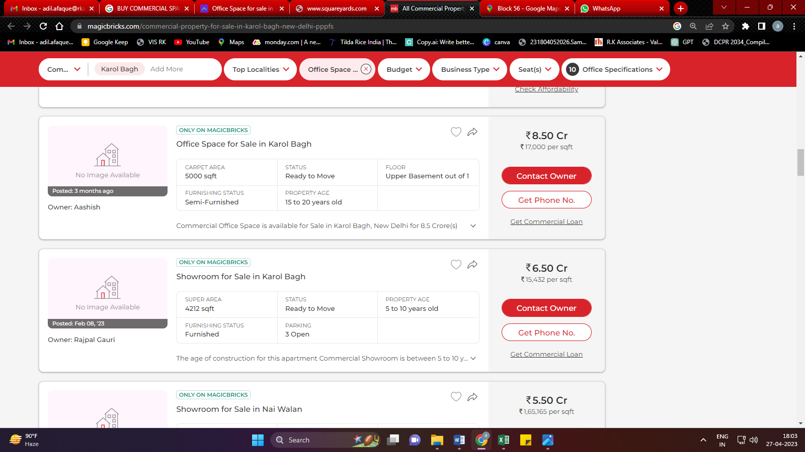

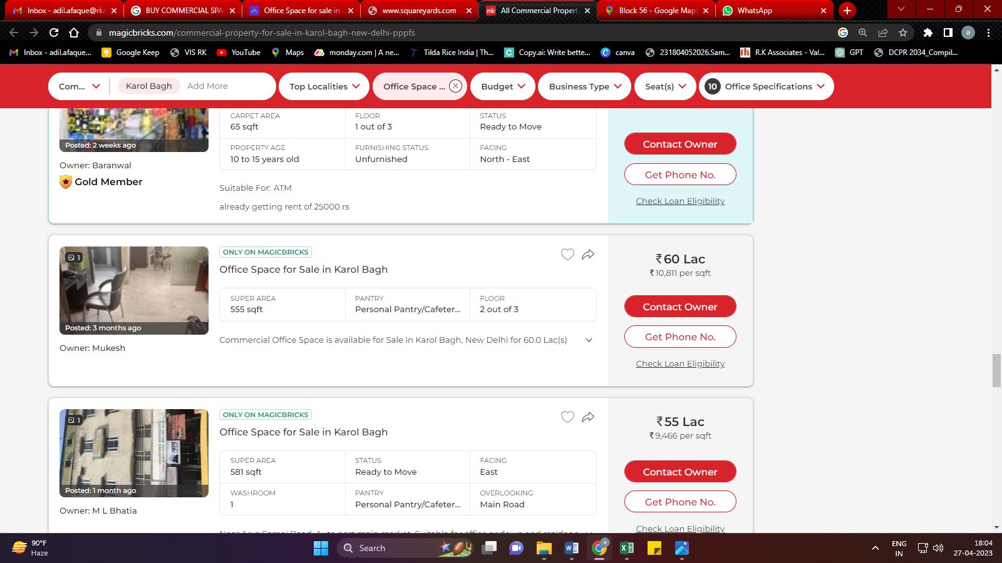

**ENCLOSURE: IV – GOOGLE MAP LOCATION**

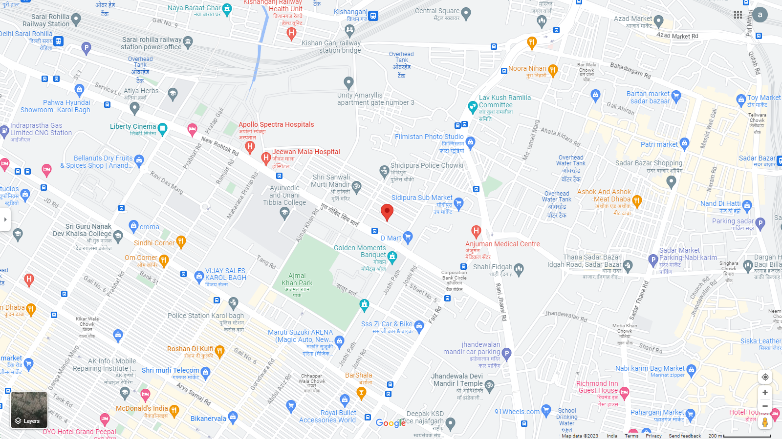

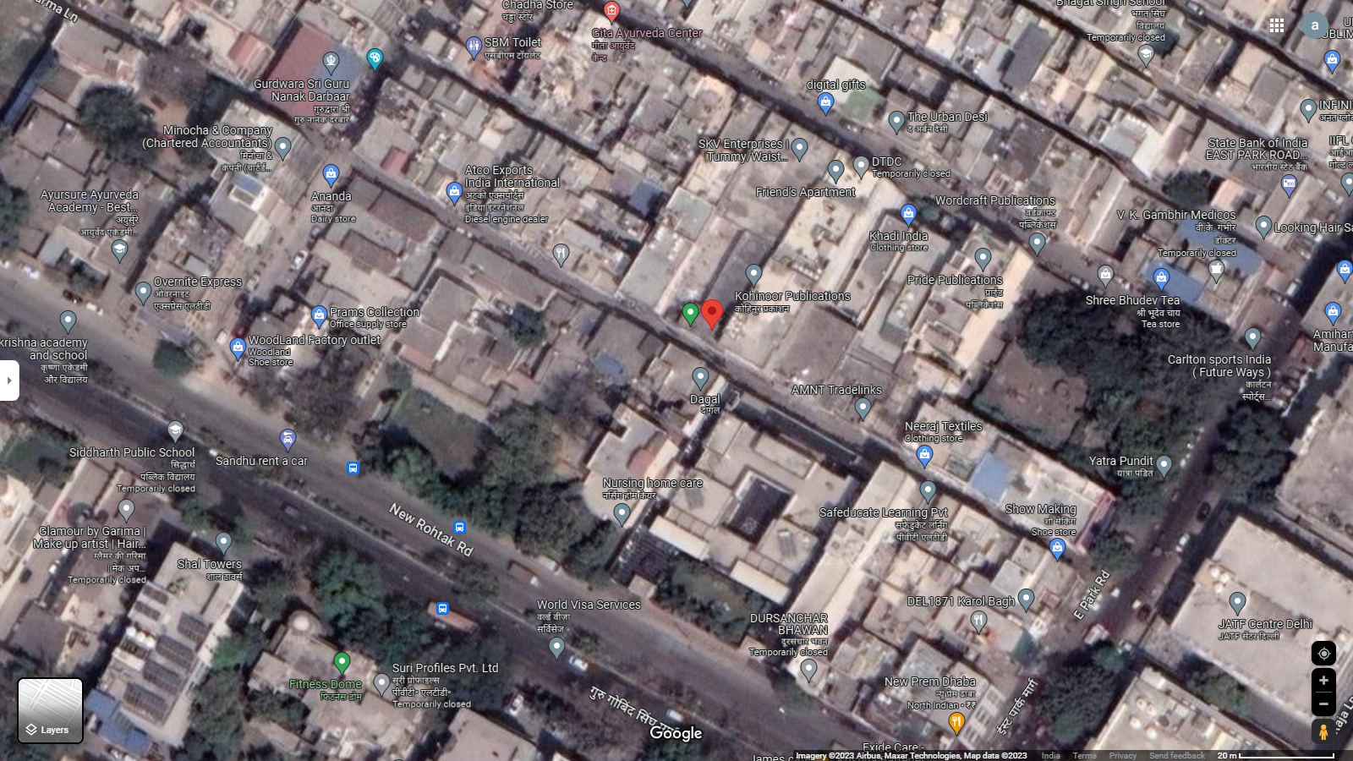

**ENCLOSURE: V– PHOTOGRAPHS OF THE PROPERTY**

|  |  |
| --- | --- |
| **D:\Desktop\Completed\Overnite\Photos\WhatsApp Image 2023-04-28 at 13.25.14.jpeg** | **D:\Desktop\Completed\Overnite\Photos\WhatsApp Image 2023-04-28 at 13.25.07 (2).jpeg** |
| **D:\Desktop\Completed\Overnite\Photos\WhatsApp Image 2023-04-28 at 13.25.08 (2).jpeg** | **D:\Desktop\Completed\Overnite\Photos\WhatsApp Image 2023-04-28 at 13.25.15 (1).jpeg** |

**ENCLOSURE: VI – COPY OF CIRCLE RATE**

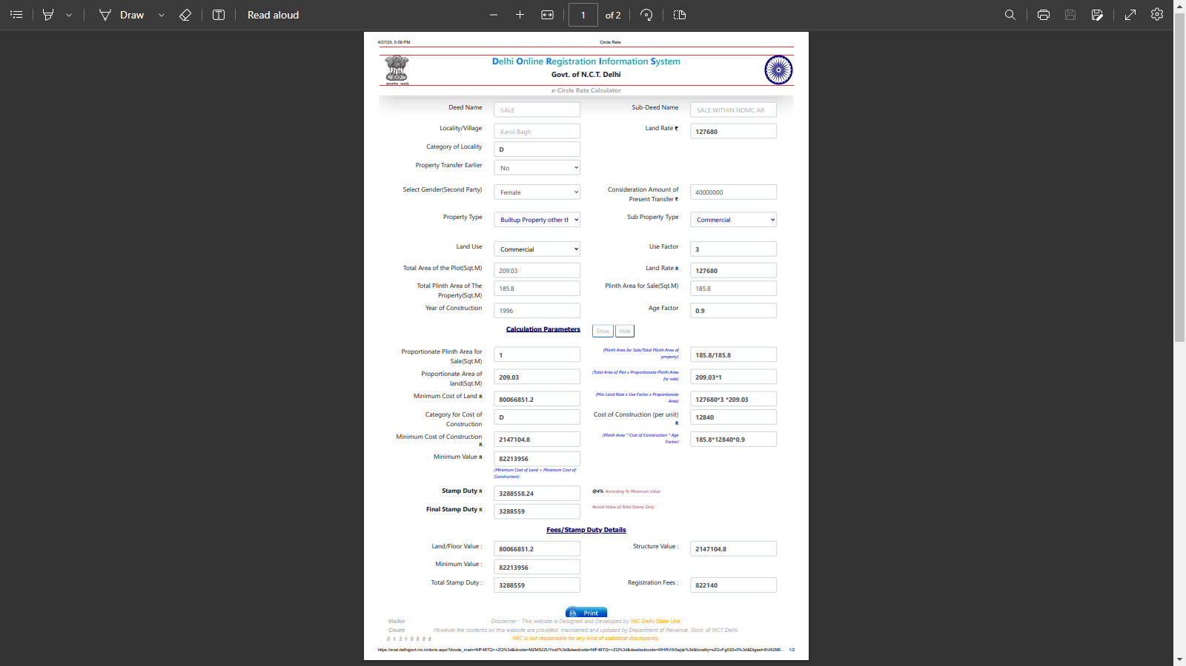

**ENCLOSURE: VIII – VALUER’S REMARKS**

|  |  |
| --- | --- |
|  | This Valuation report is prepared based on the copies of the documents/ information which interested organization or customer could provide to us out of the standard checklist of documents sought from them and further based on our assumptions and limiting conditions. All such information provided to us has been relied upon in good faith and we have assumed that it is true and correct. Verification or cross checking of the documents provided to us from the originals has not been done at our end. |
|  | Legal aspects for eg. investigation of title, ownership rights, lien, charge, mortgage, lease, verification of documents, etc. have to be taken care by legal expert/ Advocate and same are not done at our end. It is assumed that the concerned Lender/ Financial Institution has asked for the valuation of that property for which the legal verification has been already taken and cleared by the competent Advocate before requesting for the Valuation report. |
|  | Analysis and conclusions adopted in the report are limited to the reported assumptions, conditions and information came to our knowledge during the course of the work. |
|  | Value varies with the Purpose/ Date/ Condition prevailing in the market. We recommend not to refer the indicative & estimated prospective Value of the asset given in this report if any of these points are different from the one mentioned aforesaid in the Report. We also recommend that the indicative estimated Value in the Valuation Report holds good only upto the period of 3 months from the date of Valuation. |
|  | This report is having limited scope as per its fields & format to provide only the general basic idea of the value of the property prevailing in the market based on the documents/ data/ information provided by the client. The suggested indicative prospective estimated value should be considered only if transaction is happened as free market transaction. |
|  | This Valuation report is prepared based on the facts of the property on the date of the survey. It is a well-known fact that the market value of any asset varies with time & socio-economic conditions prevailing in the country. In future property Market may go down, property conditions may change or may go worse, Property reputation may differ, Property vicinity conditions may go down or become worse, Property market may change due to impact of Govt. policies or effect of World economy, Usability prospects of the property may change, etc. Hence before financing, Banker/ FI should take into consideration all such future risk and should loan conservatively to keep the advanced money safe in case of the downward trend of the property value. |
|  | Valuation of the same asset/ property can fetch different values in different situations. For eg. Valuation of a running/ operational shop/ hotel/ factory will fetch better value and in case of closed shop/ hotel/ factory it will have considerable lower value. Similarly an asset sold directly by an owner in the market will fetch better value and if the same asset/ property is sold by any financer due to encumbrance on it will fetch lower value. Hence before financing, Banker/ FI should take into consideration all such future risks and should loan conservatively to keep the advanced money safe in case of any such situation. |
|  | Getting cizra map or coordination with revenue officers for site identification is not done at our end. |
|  | Valuation is done for the property identified to us by the owner/ owner representative. At our end we have just cross verified the identification of the property with reference to the documents produced for perusal. Method by which identification of the property is carried out is also mentioned in the report clearly. Responsibility of identifying the correct property to the Valuer/ its authorized surveyor is solely of the client/ owner for which Valuation has to be carried out.It is requested from the Bank to cross check from their own records/ information if this is the same property for which Valuation has to be carried out to ensure that owner has not misled the Valuer company or misrepresented the property due to any vested interest. |
|  | In India more than 70% of the geographical area is lying under rural/ remote/ non municipal/ unplanned area where the subject property is surrounded by vacant lands having no physical demarcation or having any display of property survey or municipal number / name plate on the property clearly. Even in old locations of towns, small cities & districts where property number is either not assigned or not displayed on the properties clearly and also due to the presence of multiple/ parallel departments due to which ownership/ rights/ illegal possession/ encroachment issues are rampant across India and due to these limitations at many occasions it becomes tough to identify the property with 100% surety from the available documents, information & site whereabouts and thus chances of error, misrepresentation by the borrower and margin of chances of error always persists in such cases. To avoid any such chances of error it is advised to the Bank to engage municipal/ revenue department officials to get the confirmation of the property to ensure that the property shown to Valuer/ Banker is the same as for which documents are provided. |
|  | If this Valuation Report is prepared for the Flat/ dwelling unit situated in a Group Housing Society or Integrated Township then approvals, maps of the complete group housing society/ township is out of scope of this report and this report will be made for the specific unit based on the assumption that complete Group Housing Society/ Integrated Township must be approved in all respect.. |
|  | Due to fragmented & frequent change in building/ urban planning laws/ guidelines from time to time, different laws/ guidelines between regions/ states and no strict enforceability of Building Bye-Laws in India specially in non-metro and scale b & c cities & Industrial areas, property owners many times extend or make changes in the covered area/ layout from the approved/ applicable limits. There are also situations where properties are decades old when there was no formal Building Bye-Laws applicable when the construction must have been done. Due to such discrete/ unplanned development in many regions sometimes it becomes tough to determine the exact lawful situation on ground for the Valuer. In case nothing specific is noted on the covered built-up area considered in the Valuation Report, the covered area present on the site as per site survey will be considered in the Valuation. |
|  | Valuation is a subjective field and opinion may differ from consultant to consultant. To check the right opinion, it is important to evaluate the methodology adopted and various data point/ information/ factors/ assumption considered by the consultant which became the basis for the Valuation report before reaching to any conclusion. |
|  | Value analysis of any asset cannot be regarded as an exact science and the conclusions arrived at in many cases will, of necessity, be subjective and dependent on the exercise of individual judgment. Given the same set of facts and using the same assumptions, expert opinions may differ due to the number of separate judgment decisions, which have to be made. Therefore, there can be no standard formula to establish an indisputable exchange ratio. In the event of a transaction, the actual transaction value achieved may be higher or lower than our indicative analysis of value depending upon the circumstances of the transaction. The knowledge, negotiability and motivations of the buyers and sellers and the applicability of a discount or premium for control will also affect actual price achieved. Accordingly, our indicative analysis of value will not necessarily be the price at which any agreement proceeds. The final transaction price is something on which the parties themselves have to agree. However our Valuation analysis can definitely help the stakeholders to make them informed and wise decision about the Value of the asset and can help in facilitating the arm’s length transaction. |
|  | This report is prepared on the RKA V-L1 (Basic) Valuation format as per the client requirement and scope of work. This report is having limited scope as per its fields & format to provide only the general estimated & indicative basic idea of the value of the property prevailing in the market based on the information provided by the client. No detailed analysis, audit or verification has been carried out of the subject property. |
|  | This is just an opinion report and doesn’t hold any binding on anyone. It is requested from the concerned Client/ Bank/ Financial Institution which is using this report for mortgaging the property that they should consider all the different associated relevant & related factors & risks before taking any business decision based on the content of this report. |
|  | All Pages of the report including annexures are signed and stamped from our office. In case any paper in the report is without stamp & signature then this should not be considered a valid paper issued from this office. |
|  | Defect Liability Period is **30 DAYS**. We request the concerned authorized reader of this report to check the contents, data and calculations in the report within this period and intimate us in writing if any corrections are required or in case of any other concern with the contents or opinion mentioned in the report. Corrections only related to typographical, calculation, spelling mistakes will be entertained within the defect liability period. No request for any illegitimate value revision, date change or any other change will be entertained other than the one mentioned above. |
|  | R.K Associates encourages its customers to give feedback or inform concerns over its services through proper channel at [**valuers@rkassociates.org**](mailto:valuers@rkassociates.org) in writing within 30 days of report delivery. After this period no concern/ complaint/ proceedings in connection with the Valuation Services can be entertained due to possible change in situation and condition of the property. |
|  | Our Data retention policy is of **ONE YEAR**. After this period we remove all the concerned records related to the assignment from our repository. No clarification or query can be answered after this period due to unavailability of the data. |
|  | This Valuation report is governed by our (1) Internal Policies, Processes & Standard Operating Procedures, (2) R.K Associates Quality Policy, (3) Valuation & Survey Best Practices Guidelines formulated by management of R.K Associates, (4) Information input given to us by the customer and (4) Information/ Data/ Facts given to us by our field/ office technical team. Management of R.K Associates never gives acceptance to any unethical or unprofessional practice which may affect fair, correct & impartial assessment and which is against any prevailing law. In case of any indication of any negligence, default, incorrect, misleading, misrepresentation or distortion of facts in the report then it is the responsibility of the user of this report to immediately or atleast within the defect liability period bring all such act into notice of R.K Associates management so that corrective measures can be taken instantly. |
|  | R.K Associates never releases any report doing alterations or modifications by pen. In case any information/ figure of this report is found altered with pen then this report will automatically become null & void. |