**REPORT FORMAT:** CL-1 | Version: 1.0_2018

# FILE No.: VIS(2023-24)-PL064-054-061 Date: 10-05-2023

* **CERTIFICATE NAME:** Progress Report of the machines and equipment’s for Paper Mill installed or proposed to be installed at 8.5 KM, Jansath Road, Village Sher Nagar, Muzaffarnagar. Uttar Pradesh.
* **FOR ORGANIZATION:** State Bank of India, SME Branch, Roorkee, and District Haridwar.
* **BORROWER COMPANY’S NAME:** M/s. Hanumant Paper Mills Private Limited.
* **ASSET TYPE**: Paper Mill.
* **CURRENT LOCATION OF THE MACHINES:** 8.5 KM, Jansath Road, Village Sher Nagar, Muzaffarnagar. Uttar Pradesh.

**TO WHOMSOEVER IT MAY CONCERN**

|  |  |  |
| --- | --- | --- |
| **S. NO.** | **PARTICULARS** | **DESCRIPTION** |
| 1. | Date of Survey | 08-05-2023 |
| 2. | Date of Certificate | 10-05-2023 |
| 3. | Documents provided for perusal | List of machines, Invoices/Performa Invoices, No Objection Certificates. |
| 4. | Current Location of the Machines | 8.5 KM, Jansath Road, Village Sher Nagar, Muzaffarnagar, Uttar Pradesh. |
| 5. | Borrowing Company | M/s. Hanumant Paper Mills Private Limited. |
| 6. | Type of Asset | Machinery and shed work required for installation of Paper Mill. |
| 7. | Type of Assessment | Progress of machines purchased, installed at site. |
| 8. | Scope of Assessment | Progress of machines purchased, installed at site. |
| 9. | Nature of Machinery | Machines required for Paper Mill. |
| 10. | Current Progress of the machines | As per physical inspection made during site visit, company has purchased and installed almost all the machines as per the list provided to us. |
| 11. | Condition of Machines | Purchased machines and equipment are new and ready for production. As per site inspection trial run of machines going on. |

## OBSERVATIONS:

1. We have been provided with the list of machines that has to be purchased/ installed by the borrower company.
2. As per the physical site inspection almost all the machines are installed and the plant was under trial run.
3. During the course of our site visit, some of the machines were not purchased and installed at site which is mentioned in the list provided to us such as generator, compressor, Lab Instrument etc.
4. Based on the information provided by the Bank/Client, it is certified that the following machines are purchased and installed at the above-mentioned site address.

|  |  |  |  |  |  |  |
| --- | --- | --- | --- | --- | --- | --- |
| **LIST OF MACHINES AND EQUIPMENTS** | | | | | | |
| **S.no** | **Particulars of Machines** | **Actual Quotation (in Rs. Lakhs)** | **GST** | **Total Amount (In Rs. Lakhs)** | **Supplier Name** | **Status** |
| 1 | Rewinder | 16 | 2.88 | 18.88 | Rashed Ahmed & Sons, Muzaffarnagar / Hardayal Engineering Works | Purchased &Installed |
| 2 | Complete Pulper System | 150 | 27 | 177 | Parason Machinery Pvt. Ltd. / Dhiman Machineries / Samarth Paper Machines Pvt. Ltd. | Purchased &Installed |
| 3 | Pulper Conveyor (Slat Conveyor) | 20 | 3.6 | 23.6 | Surya Chain Pvt. LTd., Saharanpur | Purchased &Installed |
| 4 | Electric Motors | 75.06 | 13.51 | 88.57 | Uttam Electric Store, Muzaffarnagar / Swastic Engineers, Muzaffarnagar | Purchased &Installed |
| 5 | VFD and Panel | 105.21 | 18.94 | 124.15 | Falcon Automations, Roorkee / Vrinda Automation Pvt. Ltd. | Purchased &Installed |
| 6 | Pipe Lines | 70.85 | 12.75 | 83.6 | Americo Steel House / Maa Padmavati Metal, Delhi / Delhi Machiery Store, Delhi | Purchased &Installed |
| 7 | Valves | 49.99 | 9 | 58.99 | Maruti Industries, Ahmedabad / Delhi Machinery Store, Delhi | Purchased &Installed |
| 8 | Pumps | 30 | 5.4 | 35.4 | Hytek Pumps & Engineers, Saharanpur | Purchased &Installed |
| 9 | Bare Vaccum Pumps | 56.41 | 10.15 | 66.56 | Premier Pumps Pvt. Ltd. /  Kakati Karshak Industries Pvt. Ltd, Chennai / Garuda Pumps | Purchased &Installed |
| 10 | Boiler | 130 | 23.4 | 153.4 | Industrial Boilers Limited | Purchased &Installed |
| 11 | Boiler Parts | 15 | 2.7 | 17.7 | Industrial Boilers Ltd | Purchased &Installed |
| 12 | Gear Box | 70 | 12.6 | 82.6 | Premier Transmission Pvt. Ltd. / Swastic Engineers, Muzaffarnagar | Purchased &Installed |
| 13 | Wire | 19.33 | 3.48 | 22.81 | Sacsonss Internation, Sonipat. / Wires & Fabrics (S.A.) Ltd. | Purchased &Installed |
| 14 | Dryer Screen Felt | 23.77 | 4.28 | 28.05 | Sacsonss Internation, Sonipat / Damani- Shree Sudershan Industries / Voith Paper Fabrics India Limited / Shri Dinesh Mills Ltd. | Purchased &Installed |
| 15 | Hydraulic System | 7.5 | 1.35 | 8.85 | ACE Automation Engineers | Purchased &Installed |
| 16 | Cables | 50 | 9 | 59 | Virat Electricals, Muzaffarnagar / Swastic Engineers, Muzaffarnagar / K.D. Engineers/Cubic Engineers | Purchased &Installed |
| 17 | Roll Coating | 42.38 | 7.63 | 50.01 | Ashoka Rolls Mfrs. Pvt. Ltd. / Zenith Rubber /  Lutian Equipments & Forge Pvt. Ltd. | Purchased &Installed |
| 18 | Drive Roll and Screen Rolls | 82.5 | 14.85 | 97.35 | Ashoka Rolls Mfrs. Pvt. Ltd. /  Zenith Reubber | Purchased &Installed |
| 19 | Bearing | 60.04 | 10.81 | 70.85 | Rajesh Bearing Pvt. Ltd. /  ZKL India Pvt. Ltd. | Purchased &Installed |
| 20 | Workshop | 13.01 | 2.34 | 15.35 | Sangam Machine Tools, Batala | Purchased &Installed |
| 21 | Fire Fighting Pipe Lines | 15 | 2.7 | 17.7 | Lord Krishna Trading Co | Purchased &Installed |
| 22 | Transformers | 25 | 4.5 | 29.5 | Annu Electricals / Power Stark Electric | Purchased &Installed |
| 23 | Generator | 12 | 2.16 | 14.16 | U.P. Engines Services /  Jakson Limited | **Not Purchased** |
| 24 | Condensate System | 80 | 14.4 | 94.4 | Forbes Marshal Pvt. Ltd, Delhi | Purchased &Installed |
| 25 | Dryers | 350 | 63 | 413 | Hardayal Engineering Works | Purchased &Installed |
| 26 | Pope Reel with Tambour Roll- 10 No's | 23.8 | 4.28 | 28.08 | Hardayal Engineering Works | Purchased &Installed |
| 27 | Drives | 5 | 0.9 | 5.9 | Hardayal Engineering Works | Purchased &Installed |
| 28 | Sole Plate |  |  |  | Hardayal Engineering Works | Purchased &Installed |
| 29 | Doctor Holder and Adaptor | 40 | 7.2 | 47.2 | Hardayal Engineering Works / Magnum | Purchased &Installed |
| 30 | Dewatering Elements | 15 | 2.7 | 17.7 | Hardayal Engineering Works | Purchased &Installed |
| 31 | Shawer | 20 | 3.6 | 23.6 | Hardayal Engineering Works | Purchased &Installed |
| 32 | Wire part Modification | 25 | 4.5 | 29.5 | Hardayal Engineering Works | Purchased &Installed |
|  | **China Market** |  |  |  |  |  |
| 34 | Size Press Jumbo & Head Box | 80 | 14.4 | 94.4 | The Time Group Companies Ltd | Purchased &Installed |
| 35 | ETP Equipment’s | 68 | 12.24 | 80.24 | Ishan Paryavaran Krofta  / Beta Blowers, Noida / krofta Engineering Ltd. | **Purchased, Installation under progress** |
| 36 | Boiler Stack (Chimney) | 1 | 0.18 | 1.18 | Self-Made | Purchased & Installed |
| 37 | Ht. Yard | 7.5 | 1.35 | 8.85 | Annu Electricals (with in transformer quotation) | Purchased & Installed |
| 38 | Electric Panel | 10 | 1.8 | 11.8 | Falcon Automations, Roorkee /Asian Electricals & Power Control System | Purchased & Installed |
| 39 | Weight Bridge | 2 | 0.36 | 2.36 |  | Purchased & Installed |
| 40 | Lab | 2 | 0.36 | 2.36 |  | **Not Purchased** |
| 41 | R/O Repair | 5 | 0.9 | 5.9 |  | Purchased & Installed |
| 42 | Raw Material Shed | 30 | 5.4 | 35.4 |  | As per information shared on site it is installed over boiler not raw material storage side. |
| 43 | Store & Spares | 20 | 3.6 | 23.6 |  | Purchased & Installed |
|  | **Machine** |  |  |  |  |  |
| 45 | Senti Cleaner Complete | 10 | 1.8 | 11.8 | Bajrang Industries | Purchased and Installed |
| 46 | Separator Tank With Pump | 1.55 | 0.28 | 1.83 | Regant Hytech Pvt. Ltd. | Purchased and Installed |
| 47 | Compressor | 4.39 | 0.79 | 5.18 | Airgen Equipment Company / A. S. Equipmetns | **Not Purchased** |
| 48 | Host Crane -2 No’s (Loading) | 24.96 | 4.49 | 29.45 | Surajpur Udhyog / R.P. Crane | Purchased and Installed |
| 49 | Lab Instrument Complete | 2 | 0.36 | 2.36 |  | **Not Purchased** |
| 50 | Basic Control Valve | 3 | 0.54 | 3.54 | Masco Technologies | Purchased and Installed |
|  |  | **1969.25** | **354.47** | **2323.72** |  |  |

***Disclaimer:***

* 1. *As per physical inspection and observation made during site visit dated 08th May 2023. Company has installed almost all the machines mentioned in the provided list.*
  2. *As on date of site survey i.e. 08th May 2023, we were informed that the plant started its trail run on 24th March 2023.*
  3. *This certificate doesn’t include any work related to drawing, design, sketch plan, and technical specifications of the machines.*
  4. *This progress report is stated on the basis of the site visit by the surveyor and we don’t recommend any sort of recommendation in our Certificate.*
  5. *Ownership and other legal point of view in respect of the asset is not considered in this report as same is out of scope of this certificate.*
  6. *This certificate is made at the request of the Bank.*

**For R.K Associates Valuers & Techno FOR INTERNAL USE Engineering Consultants (P) Ltd.**

***TYPED BY:*** *Er. Rahul Gupta*

***REVIEWED BY:*** *Er. Abhinav Chaturvedi*

# ANNEXURE: LIST OF MACHINES AS PROVIDED BY THE CLIENT

|  |  |  |  |  |  |
| --- | --- | --- | --- | --- | --- |
| **LIST OF MACHINES AND EQUIPMENTS** | | | | | |
| **S.no** | **Particulars of Machines** | **Actual Quotation in Lakhs** | **GST** | **Total Amount (In Lakhs)** | **Supplier Name** |
| 1 | Rewinder | 16 | 2.88 | 18.88 | Rashed Ahmed & Sons, Muzaffarnagar / Hardayal Engineering Works |
| 2 | **Complete Pulper System** | 150 | 27 | 177 | Parason Machinery Pvt. Ltd. / Dhiman Machineries / Samarth Paper Machines Pvt. Ltd. |
| 3 | Pulper Conveyor (Slat Conveyor) | 20 | 3.6 | 23.6 | Surya Chain Pvt. LTd., Saharanpur |
| 4 | Electric Motors | 75.06 | 13.51 | 88.57 | Uttam Electric Store, Muzaffarnagar / Swastic Enginners, Muzaffarnagar |
| 5 | VFD and Panel | 105.21 | 18.94 | 124.15 | Falcon Automations, Roorkee / Vrinda Automation Pvt. Ltd. |
| 6 | Pipe Lines | 70.85 | 12.75 | 83.6 | Americo Steel House / Maa Padmavati Metal, Delhi / Delhi Machiery Store, Delhi |
| 7 | Valves | 49.99 | 9 | 58.99 | Maruti Industries, Ahemdabad / Delhi Machiery Store, Delhi |
| 8 | Pumps | 30 | 5.4 | 35.4 | Hytek Pumps & Engineers, Saharanpur |
| 9 | Bare Vacuum Pumps | 56.41 | 10.15 | 66.56 | Premier Pumps Pvt. Ltd. /  Kakati Karshak Industries Pvt. Ltd, Chennai / Garuda Pumps |
| 10 | Boiler | 130 | 23.4 | 153.4 | Industrial Boilers Limited |
| 11 | Boiler Parts | 15 | 2.7 | 17.7 | Industrial Boilers Ltd |
| 12 | Gear Box | 70 | 12.6 | 82.6 | Premier Transmission Pvt. Ltd. / Swastic Enginners, Muzaffarnagar |
| 13 | Wire | 19.33 | 3.48 | 22.81 | Sacsonss Internation, Sonipat. / Wires & Fabrics (S.A.) Ltd. |
| 14 | Dryer Screen Felt | 23.77 | 4.28 | 28.05 | Sacsonss Internation, Sonipat / Damani- Shree Sudershan Industries / Voith Paper Fabrics India Limited / Shri Dinesh Mills Ltd. |
| 15 | Hydraulic System | 7.5 | 1.35 | 8.85 | ACE Automation Engineers |
| 16 | Cables | 50 | 9 | 59 | Virat Electricals, Muzaffarnagar / Swastic Enginners, Muzaffarnagar / K.D. Engineers/Cubic Engineers |
| 17 | Roll Coating | 42.38 | 7.63 | 50.01 | Ashoka Rolls Mfrs. Pvt. Ltd. / Zenith Rubber /  Lutian Equipments & Forge Pvt. Ltd. |
| 18 | Drive Roll and Screen Rolls | 82.5 | 14.85 | 97.35 | Ashoka Rolls Mfrs. Pvt. Ltd. /  Zenith Reubber |
| 19 | Bearing | 60.04 | 10.81 | 70.85 | Rajesh Bearing Pvt. Ltd. /  ZKL India Pvt. Ltd. |
| 20 | Workshop | 13.01 | 2.34 | 15.35 | Sangam Machine Tools, Batala |
| 21 | Fire Fighting Pipe Lines | 15 | 2.7 | 17.7 | Lord Krishna Trading Co |
| 22 | Transformers | 25 | 4.5 | 29.5 | Annu Electricals / Power Stark Electric |
| 23 | Generator | 12 | 2.16 | 14.16 | U.P. Engines Services /  Jakson Limited |
| 24 | Condensate System | 80 | 14.4 | 94.4 | Forbes Marshal Pvt. Ltd, Delhi |
| 25 | Dryers | 350 | 63 | 413 | Hardayal Engineering Works |
| 26 | Pope Reel with Tambour Roll- 10 No's | 23.8 | 4.28 | 28.08 | Hardayal Engineering Works |
| 27 | Drives | 5 | 0.9 | 5.9 | Hardayal Engineering Works |
| 28 | Sole Plate |  |  |  | Hardayal Engineering Works |
| 29 | Doctor Holder and Adaptor | 40 | 7.2 | 47.2 | Hardayal Engineering Works / Magnum |
| 30 | Dewatering Elements | 15 | 2.7 | 17.7 | Hardayal Engineering Works |
| 31 | Shawer | 20 | 3.6 | 23.6 | Hardayal Engineering Works |
| 32 | Wire part Modification | 25 | 4.5 | 29.5 | Hardayal Engineering Works |
|  | **China Market** |  |  |  |  |
| 34 | Size Press Jumbo & Head Box | 80 | 14.4 | 94.4 | The Time Group Compamies Ltd |
| 35 | ETP Equipment’s | 68 | 12.24 | 80.24 | Ishan Paryavaran Krofta  / Beta Blowers, Noida / krofta Engineering Ltd. |
| 36 | Boiler Stack (Chimney) | 1 | 0.18 | 1.18 | Self Made |
| 37 | Ht. Yard | 7.5 | 1.35 | 8.85 | Annu Electricls (with in tranformer quotation) |
| 38 | Electric Panel | 10 | 1.8 | 11.8 | Falcon Automations, Roorkee /  Asian Elecricals & Power Control System |
| 39 | Weight Bridge | 2 | 0.36 | 2.36 |  |
| 40 | Lab | 2 | 0.36 | 2.36 |  |
| 41 | R/O Repair | 5 | 0.9 | 5.9 |  |
| 42 | Raw Material Shed | 30 | 5.4 | 35.4 |  |
| 43 | Store & Spares | 20 | 3.6 | 23.6 |  |
|  | **Machine** |  |  |  |  |
| 45 | Senti Cleaner Complete | 10 | 1.8 | 11.8 | Bajrang Industries |
| 46 | Sheprator Tank With Pump | 1.55 | 0.28 | 1.83 | Regant Hytech Pvt. Ltd. |
| 47 | Compressor | 4.39 | 0.79 | 5.18 | Airgen Equipment Company / A. S. Equipmetns |
| 48 | Host Crane -2 No'S (Loading) | 24.96 | 4.49 | 29.45 | Surajpur Udhyog / R.P. Crane |
| 49 | Lab Instrument Complete | 2 | 0.36 | 2.36 |  |
| 50 | Basic Control Valve | 3 | 0.54 | 3.54 | MascoTechnologies |
|  |  | **1969.25** | **354.47** | **2323.72** |  |

# ANNEXURE: PHOTOGRAPHS

|  |  |  |  |  |  |  |  |  |  |
| --- | --- | --- | --- | --- | --- | --- | --- | --- | --- |
| |  |  | | --- | --- | |  |  | |  |  | |  |  | |  |  | |  |

|  |  |  |  |  |  |  |  |  |  |
| --- | --- | --- | --- | --- | --- | --- | --- | --- | --- |
| |  |  | | --- | --- | |  |  | |  |  | |  |  | |  |  | |  |
|  |  |

|  |  |  |  |  |  |  |  |  |  |
| --- | --- | --- | --- | --- | --- | --- | --- | --- | --- |
| |  |  | | --- | --- | |  |  | |  |  | |  |  | |  |  | |  |
|  |  |

|  |  |
| --- | --- |
|  |  |
|  |  |
|  |  |
|  |  |

|  |  |
| --- | --- |
|  |  |
|  |  |
|  |  |
|  |  |

**INVOICES OF THE MACHINES**

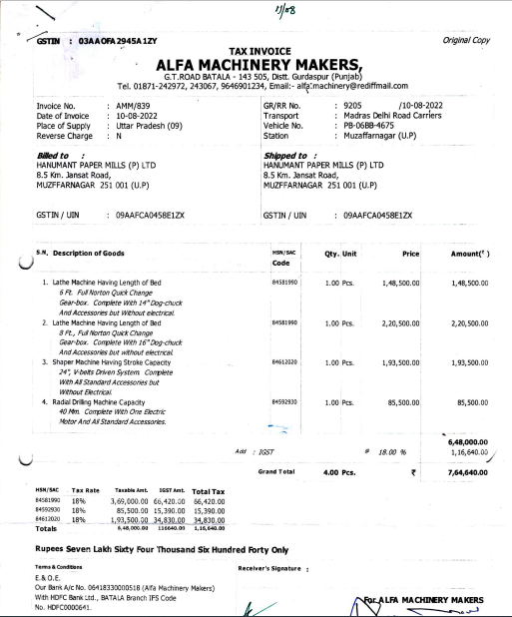

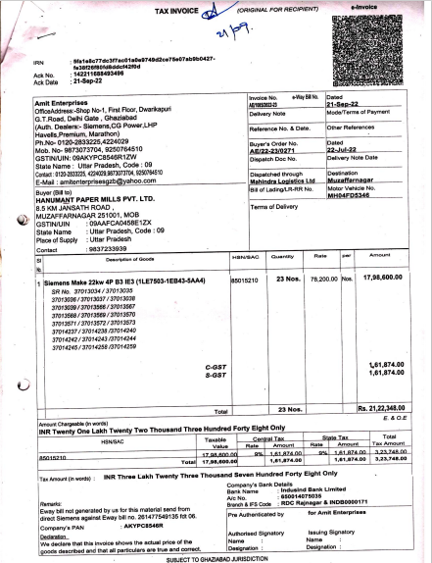

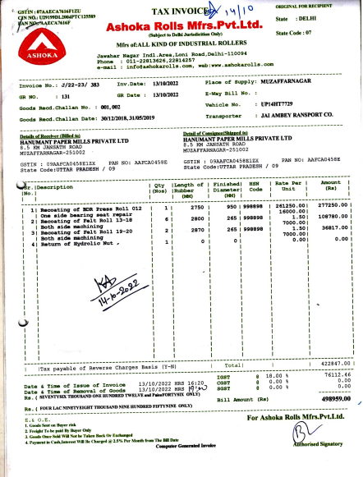

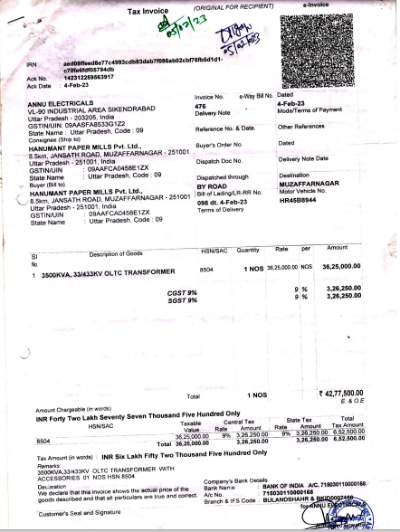

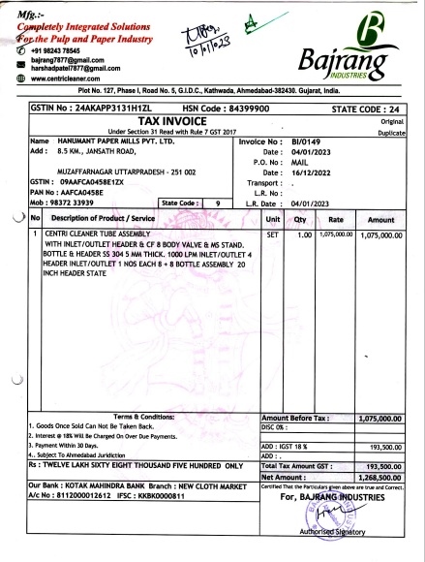

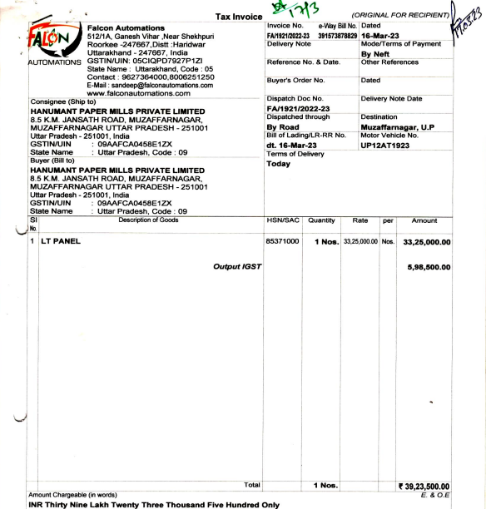

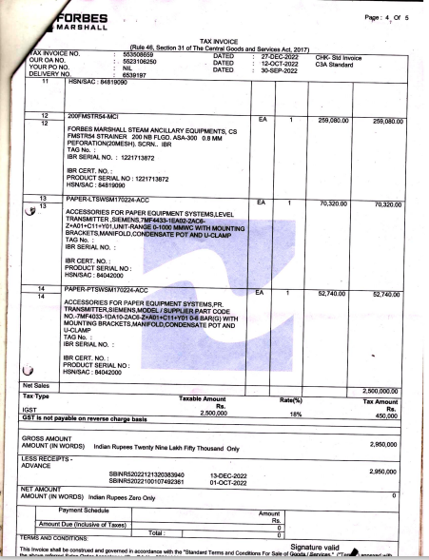

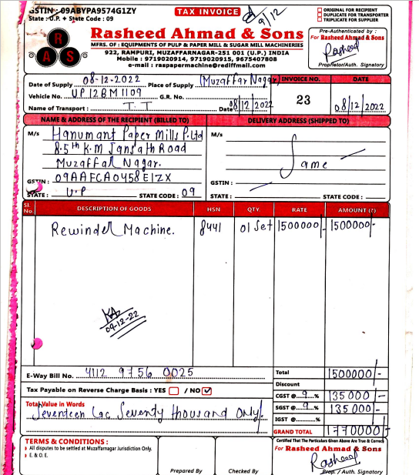

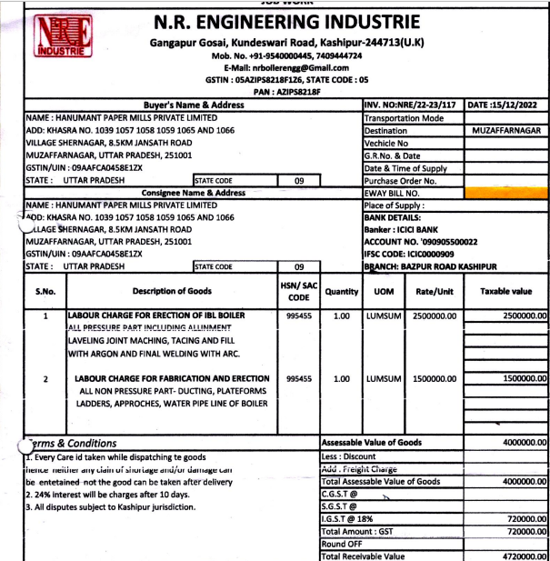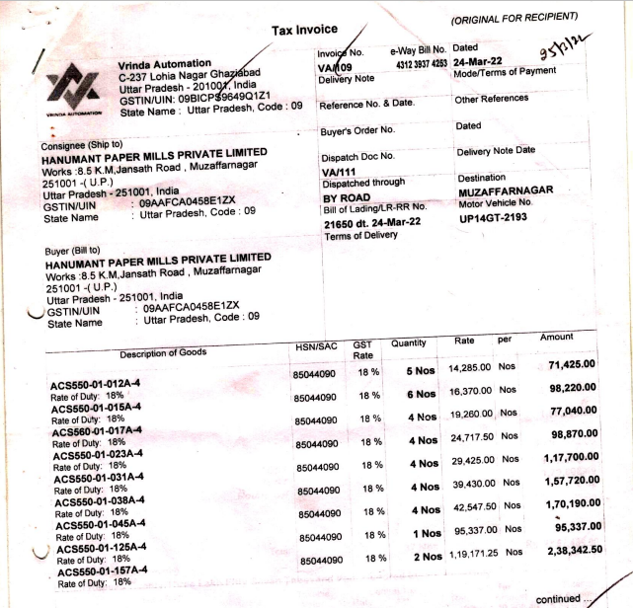

**NO OBJECTION CERTIFICATE AND APPROVALS**

