REPORT FORMAT: CL-1 | Version: 1.0_2018

FILE No.: VIS(2023-24)-PL064-054-061 Date: 10-05-2023

- CERTIFICATE NAME: Progress Report of the machines and equipment’s for Paper Mill installed or proposed to be installed at 8.5 KM, Jansath Road, Village Sher Nagar, Muzaffarnagar. Uttar Pradesh.
- FOR ORGANIZATION: State Bank of India, SME Branch, Roorkee, and District Haridwar.
- BORROWER COMPANY’S NAME: M/s. Hanumant Paper Mills Private Limited.
- ASSET TYPE: Paper Mill.
- CURRENT LOCATION OF THE MACHINES: 8.5 KM, Jansath Road, Village Sher Nagar, Muzaffarnagar. Uttar Pradesh.
TO WHOMSOEVER IT MAY CONCERN

S. NO. | PARTICULARS | DESCRIPTION
1. | Date of Survey | 08-05-2023
2. | Date of Certificate | 10-05-2023
3. | Documents provided for perusal | List of machines, Invoices/Performa Invoices, No Objection Certificates.
4. | Current Location of the Machines | 8.5 KM, Jansath Road, Village Sher Nagar, Muzaffarnagar, Uttar Pradesh.
5. | Borrowing Company | M/s. Hanumant Paper Mills Private Limited.
6. | Type of Asset | Machinery and shed work required for installation of Paper Mill.
7. | Type of Assessment | Progress of machines purchased, installed at site.
8. | Scope of Assessment | Progress of machines purchased, installed at site.
9. | Nature of Machinery | Machines required for Paper Mill.
10. | Current Progress of the machines | As per physical inspection made during site visit, company has purchased and installed almost all the machines as per the list provided to us.
11. | Condition of Machines | Purchased machines and equipment are new and ready for production.

OBSERVATIONS:

- We have been provided with the list of machines that has to be purchased/ installed by the borrower company.
- As per the physical site inspection almost all the machines are installed.
- During the course of our site visit, some of the machines were not purchased and installed at site which is mentioned in the list provided to us such as generator, compressor, Lab Instrument etc.
- Based on the information provided by the Bank/Client, it is certified that the following machines are purchased and installed at the above-mentioned site address.

LIST OF MACHINES AND EQUIPMENTS
S.no | Particulars of Machines | Actual Quotation in Lakhs | GST | Total Amount (In Lakhs) | Proposed  Supplier Name | Actual Supplier Name | Progress
1 | Rewinder | 16 | 2.88 | 18.88 | Rashed Ahmed & Sons, Muzaffarnagar / Hardayal Engineering Works | Rashed Ahmed & Sons Muzaffarnaga | Purchased &Installed
2 | Complete Pulper System | 150 | 27 | 177 | Parason Machinery Pvt. Ltd. / Dhiman Machineries / Samarth Paper Machines Pvt. Ltd. | Parason Machinery Pvt. Ltd. | Purchased &Installed
3 | Pulper Conveyor (Slat Conveyor) | 20 | 3.6 | 23.6 | Surya Chain Pvt. Ltd., Saharanpur | Surya Chain Pvt. Ltd., Saharanpur | Purchased &Installed
4 | Electric Motors | 75.06 | 13.51 | 88.57 | Uttam Electric Store, Muzaffarnagar / Swastic Enginners, Muzaffarnagar | Amit Enterprises Ghaziabad | Purchased &Installed
5 | VFD and Panel | 105.21 | 18.94 | 124.15 | Falcon Automations, Roorkee / Vrinda Automation Pvt. Ltd. | Falcon Automations, Roorkee , Vrinda Automation Pvt. Ltd. | Purchased &Installed
6 | Pipe Lines | 70.85 | 12.75 | 83.6 | Americo Steel House / Maa Padmavati Metal, Delhi / Delhi Machiery Store, Delhi | Americo Steel House, Pipe and Sections | Purchased &Installed
7 | Valves | 49.99 | 9 | 58.99 | Maruti Industries, Ahemdabad / Delhi Machiery Store, Delhi | Maruti Industries, Ahemdabad, Delhi Machiery Store, Delhi | Purchased &Installed
8 | Pumps | 30 | 5.4 | 35.4 | Hytek Pumps & Engineers, Saharanpur | Hytek Pumps & Engineers, Saharanpur | Purchased &Installed
9 | Bare Vaccum Pumps | 56.41 | 10.15 | 66.56 | Premier Pumps Pvt. Ltd. / Kakati Karshak Industries Pvt. Ltd, Chennai / Garuda Pumps | Premier Pumps Pvt. Ltd., Kakati Karshak Industries Pvt. Ltd, Chennai | Purchased &Installed
10 | Boiler | 130 | 23.4 | 153.4 | Industrial Boilers Limited | Industrial Boilers Limited | Purchased &Installed
11 | Boiler Parts | 15 | 2.7 | 17.7 | Industrial Boilers Ltd | Industrial Boilers Ltd | Purchased &Installed
12 | Gear Box | 70 | 12.6 | 82.6 | Premier Transmission Pvt. Ltd. / Swastic Enginners, Muzaffarnagar | Premier Transmission Pvt. Ltd. ,Shree Krishna Engineers | Purchased &Installed
13 | Wire | 19.33 | 3.48 | 22.81 | Sacsonss Internation, Sonipat. / Wires & Fabrics (S.A.) Ltd. | Mahavir Netting Pvt Ltd | Purchased &Installed
14 | Dryer Screen Felt | 23.77 | 4.28 | 28.05 | Sacsonss Internation, Sonipat / Damani- Shree Sudershan Industries / Voith Paper Fabrics India Limited / Shri Dinesh Mills Ltd. | Shree Sudershan Industries | Purchased &Installed
15 | Hydrolic System | 7.5 | 1.35 | 8.85 | ACE Automation Engineers | ACE Automation Engineers | Purchased &Installed
16 | Cables | 50 | 9 | 59 | Virat Electricals, Muzaffarnagar / Swastic Enginners, Muzaffarnagar / K.D. Engineers/Cubic Engineers | Virat Electricals, Muzaffarnagar, Uttam Electrical | Purchased &Installed
17 | Roll Coating | 42.38 | 7.63 | 50.01 | Ashoka Rolls Mfrs. Pvt. Ltd. / Zenith Rubber / Lutian Equipments & Forge Pvt. Ltd. | Ashoka Rolls Mfrs. Pvt. Ltd., Lutian Equipment’s | Purchased &Installed
18 | Drive Roll and Screen Rolls | 82.5 | 14.85 | 97.35 | Ashoka Rolls Mfrs. Pvt. Ltd. / Zenith Reubber | Hardayal Engineering Works, Lutian Equipment’s & Forge Pvt. Ltd. | Purchased &Installed
19 | Bearing | 60.04 | 10.81 | 70.85 | Rajesh Bearing Pvt. Ltd. / ZKL India Pvt. Ltd. | Rajesh Bearing Ltd, Jain Enterprises | Purchased &Installed
20 | Workshop | 13.01 | 2.34 | 15.35 | Sangam Machine Tools, Batala | Alfa Engineers | Purchased &Installed
21 | Fire Fighting Pipe Lines | 15 | 2.7 | 17.7 | Lord Krishna Trading Co | Shakti Industriers | Purchased &Installed
22 | Transformers | 25 | 4.5 | 29.5 | Annu Electricals / Power Stark Electric | Annu Electricals | Purchased &Installed
23 | Generator | 12 | 2.16 | 14.16 | U.P. Engines Services / Jakson Limited | -- | Not Purchased and Installed
24 | Condensate System | 80 | 14.4 | 94.4 | Forbes Marshal Pvt. Ltd, Delhi | Forbes Marshal Pvt. Ltd, Delhi | Purchased &Installed
25 | Dryers | 350 | 63 | 413 | Hardayal Engineering Works | Hardayal Engineering Works | Purchased &Installed
26 | Pope Reel with Tambour Roll- 10 No's | 23.8 | 4.28 | 28.08 | Hardayal Engineering Works | Hardayal Engineering Works | Purchased &Installed
27 | Drives | 5 | 0.9 | 5.9 | Hardayal Engineering Works | Hardayal Engineering Works | Purchased &Installed
28 | Sole Plate |  |  |  | Hardayal Engineering Works | Hardayal Engineering Works | Purchased &Installed
29 | Doctor Holder and Adaptor | 40 | 7.2 | 47.2 | Hardayal Engineering Works / Magnum | Rs Engineers Vapi Gujarat | Purchased &Installed
30 | Dewatering Elements | 15 | 2.7 | 17.7 | Hardayal Engineering Works | Hardayal Engineering Works | Purchased &Installed
31 | Shawer | 20 | 3.6 | 23.6 | Hardayal Engineering Works | Sidhu Engineer Works | Purchased &Installed
32 | Wire part Modification | 25 | 4.5 | 29.5 | Hardayal Engineering Works | Hardayal Engineering Works | Purchased &Installed
 | China Market
34 | Size Press Jambo & Head Box | 80 | 14.4 | 94.4 | The Time Group Companies Ltd | The Time Group Companies Ltd | Purchased &Installed
35 | ETP Equipments | 68 | 12.24 | 80.24 | Ishan Paryavaran Krofta / Beta Blowers, Noida / krofta Engineering Ltd. | Dhiman Machines | Purchased & Installed
36 | Boiler Stack (Chimni) | 1 | 0.18 | 1.18 | Self-Made | Self-Made | Purchased & Installed
37 | Ht. Yard | 7.5 | 1.35 | 8.85 | Annu Electricls (with in tranformer quotation) | Annu Electricls | Purchased & Installed
38 | Electric Pannel | 10 | 1.8 | 11.8 | Falcon Automations, Roorkee / Asian Elecricals & Power Control System | Falcon Automations, Roorkee | Purchased & Installed
39 | Weight Bridge | 2 | 0.36 | 2.36 |  | Sagar Scale System | Purchased & Installed
40 | Lab | 2 | 0.36 | 2.36 |  | -- | Not Purchased and Installed
41 | R/O Repair | 5 | 0.9 | 5.9 |  | Intex Engineers Ghaziabad | Purchased & Installed
42 | Raw Material Shed | 30 | 5.4 | 35.4 |  | Mittal Cement Agency | As per information shared on site it is installed over boiler not raw material storage side.
43 | Store & Spares | 20 | 3.6 | 23.6 |  |  | Purchased & Installed
 | Machine
45 | Senti Cleaner Complete | 10 | 1.8 | 11.8 | Bajrang Industries | Bajrang Industries | Purchased and Installed
46 | Seprator Tank With Pump | 1.55 | 0.28 | 1.83 | Regant Hytech Pvt. Ltd. | Dhiman Machines | Purchased and Installed
47 | Compressor | 4.39 | 0.79 | 5.18 | Airgen Equipment Company / A. S. Equipmetns | - | Not Purchased and Installed
48 | Host Crane -2 No'S (Loading) | 24.96 | 4.49 | 29.45 | Surajpur Udhyog / R.P. Crane | RS industries, Bijnore | Purchased and Installed
49 | Lab Instrument Complete | 2 | 0.36 | 2.36 |  |  | Not Purchased and Installed
50 | Basic Control Valve | 3 | 0.54 | 3.54 | MascoTechnologies | Maruti Industries | Purchased and Installed
 |  | 1969.25 | 354.47 | 2323.72

Disclaimer:

  - As per physical inspection and observation made during site visit dated 08th May 2023. Company has installed almost all the machines mentioned in the provided list.
  - This certificate doesn’t include any work related to drawing, design, sketch plan, and technical specifications of the machines.
  - This progress report is stated on the basis of the site visit by the surveyor and we don’t recommend any sort of recommendation in our Certificate.
  - Ownership and other legal point of view in respect of the asset is not considered in this report as same is out of scope of this certificate.
  - This certificate is made at the request of the Bank.

For R.K Associates Valuers & Techno FOR INTERNAL USE Engineering Consultants (P) Ltd.
TYPED BY: Er. Rahul Gupta
REVIEWED BY: Er. Abhinav Chaturvedi

ANNEXURE: LIST OF MACHINES AS PROVIDED BY THE CLIENT

LIST OF MACHINES AND EQUIPMENTS
S.no | Particulars of Machines | Actual Quotation in Lakhs | GST | Total Amount (In Lakhs) | Supplier Name
1 | Rewinder | 16 | 2.88 | 18.88 | Rashed Ahmed & Sons, Muzaffarnagar / Hardayal Engineering Works
2 | Complete Pulper System | 150 | 27 | 177 | Parason Machinery Pvt. Ltd. / Dhiman Machineries / Samarth Paper Machines Pvt. Ltd.
3 | Pulper Conveyor (Slat Conveyor) | 20 | 3.6 | 23.6 | Surya Chain Pvt. LTd., Saharanpur
4 | Electric Motors | 75.06 | 13.51 | 88.57 | Uttam Electric Store, Muzaffarnagar / Swastic Enginners, Muzaffarnagar
5 | VFD and Panel | 105.21 | 18.94 | 124.15 | Falcon Automations, Roorkee / Vrinda Automation Pvt. Ltd.
6 | Pipe Lines | 70.85 | 12.75 | 83.6 | Americo Steel House / Maa Padmavati Metal, Delhi / Delhi Machiery Store, Delhi
7 | Valves | 49.99 | 9 | 58.99 | Maruti Industries, Ahemdabad / Delhi Machiery Store, Delhi
8 | Pumps | 30 | 5.4 | 35.4 | Hytek Pumps & Engineers, Saharanpur
9 | Bare Vacuum Pumps | 56.41 | 10.15 | 66.56 | Premier Pumps Pvt. Ltd. / Kakati Karshak Industries Pvt. Ltd, Chennai / Garuda Pumps
10 | Boiler | 130 | 23.4 | 153.4 | Industrial Boilers Limited
11 | Boiler Parts | 15 | 2.7 | 17.7 | Industrial Boilers Ltd
12 | Gear Box | 70 | 12.6 | 82.6 | Premier Transmission Pvt. Ltd. / Swastic Enginners, Muzaffarnagar
13 | Wire | 19.33 | 3.48 | 22.81 | Sacsonss Internation, Sonipat. / Wires & Fabrics (S.A.) Ltd.
14 | Dryer Screen Felt | 23.77 | 4.28 | 28.05 | Sacsonss Internation, Sonipat / Damani- Shree Sudershan Industries / Voith Paper Fabrics India Limited / Shri Dinesh Mills Ltd.
15 | Hydraulic System | 7.5 | 1.35 | 8.85 | ACE Automation Engineers
16 | Cables | 50 | 9 | 59 | Virat Electricals, Muzaffarnagar / Swastic Enginners, Muzaffarnagar / K.D. Engineers/Cubic Engineers
17 | Roll Coating | 42.38 | 7.63 | 50.01 | Ashoka Rolls Mfrs. Pvt. Ltd. / Zenith Rubber / Lutian Equipments & Forge Pvt. Ltd.
18 | Drive Roll and Screen Rolls | 82.5 | 14.85 | 97.35 | Ashoka Rolls Mfrs. Pvt. Ltd. / Zenith Reubber
19 | Bearing | 60.04 | 10.81 | 70.85 | Rajesh Bearing Pvt. Ltd. / ZKL India Pvt. Ltd.
20 | Workshop | 13.01 | 2.34 | 15.35 | Sangam Machine Tools, Batala
21 | Fire Fighting Pipe Lines | 15 | 2.7 | 17.7 | Lord Krishna Trading Co
22 | Transformers | 25 | 4.5 | 29.5 | Annu Electricals / Power Stark Electric
23 | Generator | 12 | 2.16 | 14.16 | U.P. Engines Services / Jakson Limited
24 | Condensate System | 80 | 14.4 | 94.4 | Forbes Marshal Pvt. Ltd, Delhi
25 | Dryers | 350 | 63 | 413 | Hardayal Engineering Works
26 | Pope Reel with Tambour Roll- 10 No's | 23.8 | 4.28 | 28.08 | Hardayal Engineering Works
27 | Drives | 5 | 0.9 | 5.9 | Hardayal Engineering Works
28 | Sole Plate |  |  |  | Hardayal Engineering Works
29 | Doctor Holder and Adaptor | 40 | 7.2 | 47.2 | Hardayal Engineering Works / Magnum
30 | Dewatering Elements | 15 | 2.7 | 17.7 | Hardayal Engineering Works
31 | Shawer | 20 | 3.6 | 23.6 | Hardayal Engineering Works
32 | Wire part Modification | 25 | 4.5 | 29.5 | Hardayal Engineering Works
 | China Market
34 | Size Press Jumbo & Head Box | 80 | 14.4 | 94.4 | The Time Group Compamies Ltd
35 | ETP Equipment’s | 68 | 12.24 | 80.24 | Ishan Paryavaran Krofta / Beta Blowers, Noida / krofta Engineering Ltd.
36 | Boiler Stack (Chimney) | 1 | 0.18 | 1.18 | Self Made
37 | Ht. Yard | 7.5 | 1.35 | 8.85 | Annu Electricls (with in tranformer quotation)
38 | Electric Panel | 10 | 1.8 | 11.8 | Falcon Automations, Roorkee / Asian Elecricals & Power Control System
39 | Weight Bridge | 2 | 0.36 | 2.36
40 | Lab | 2 | 0.36 | 2.36
41 | R/O Repair | 5 | 0.9 | 5.9
42 | Raw Material Shed | 30 | 5.4 | 35.4
43 | Store & Spares | 20 | 3.6 | 23.6
 | Machine
45 | Senti Cleaner Complete | 10 | 1.8 | 11.8 | Bajrang Industries
46 | Sheprator Tank With Pump | 1.55 | 0.28 | 1.83 | Regant Hytech Pvt. Ltd.
47 | Compressor | 4.39 | 0.79 | 5.18 | Airgen Equipment Company / A. S. Equipmetns
48 | Host Crane -2 No'S (Loading) | 24.96 | 4.49 | 29.45 | Surajpur Udhyog / R.P. Crane
49 | Lab Instrument Complete | 2 | 0.36 | 2.36
50 | Basic Control Valve | 3 | 0.54 | 3.54 | MascoTechnologies
 |  | 1969.25 | 354.47 | 2323.72

ANNEXURE: PHOTOGRAPHS
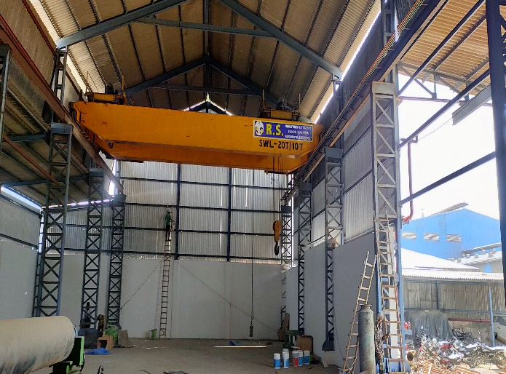 | 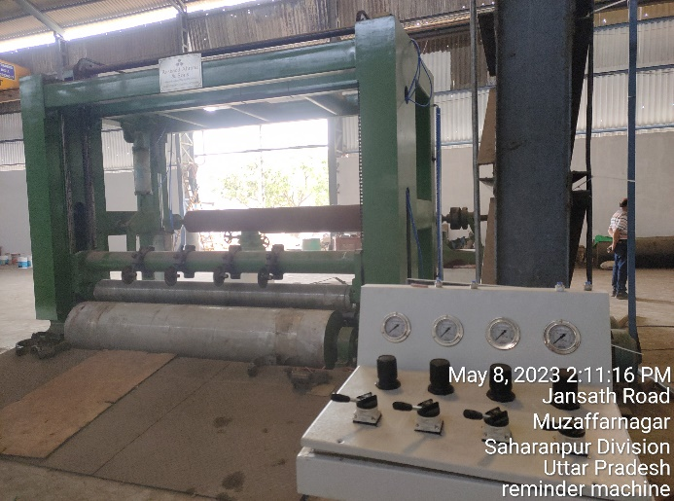
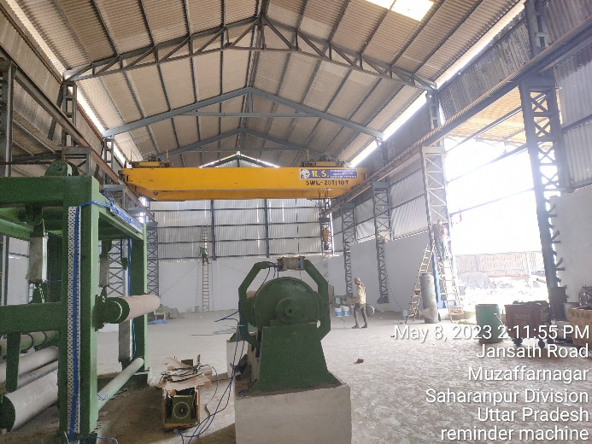 | 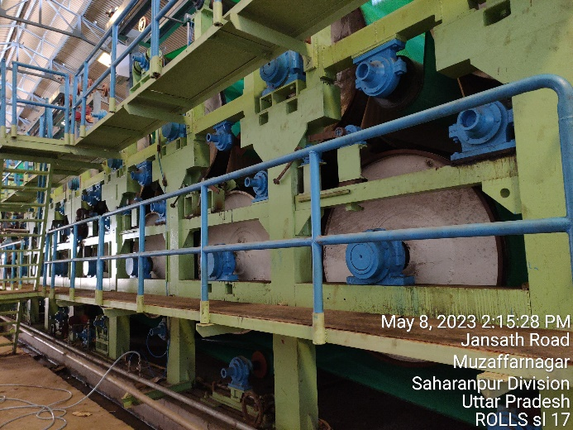
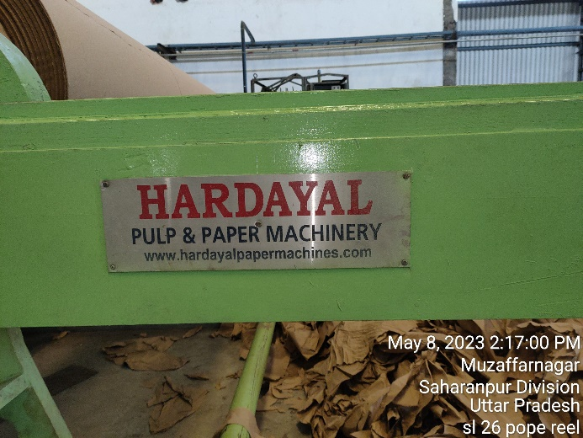 | 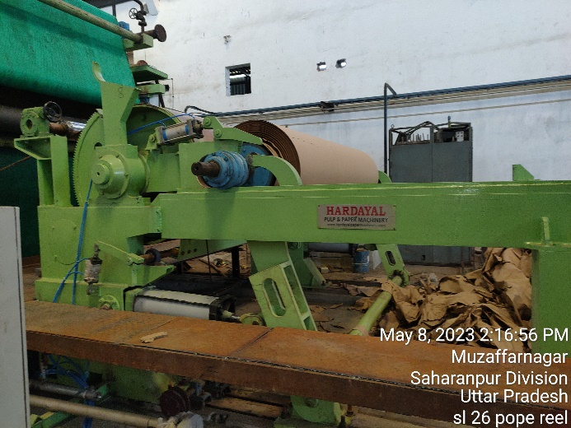
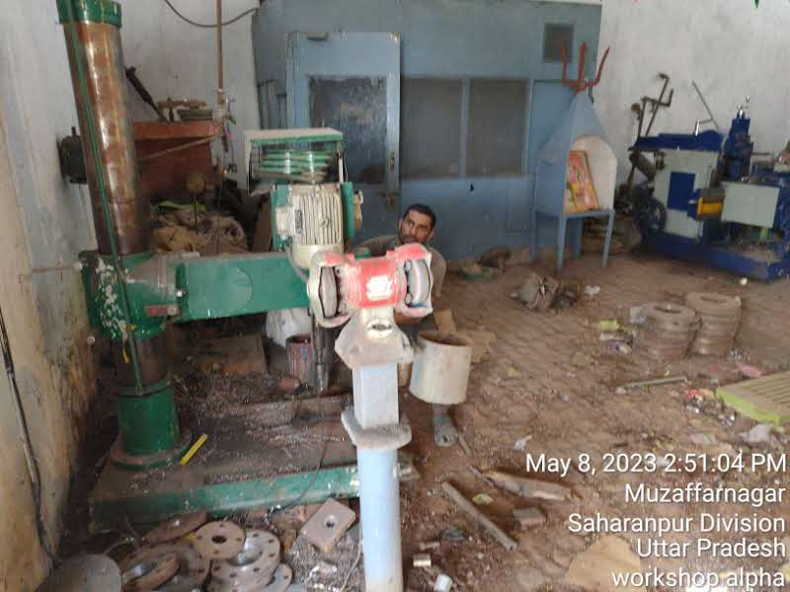 | 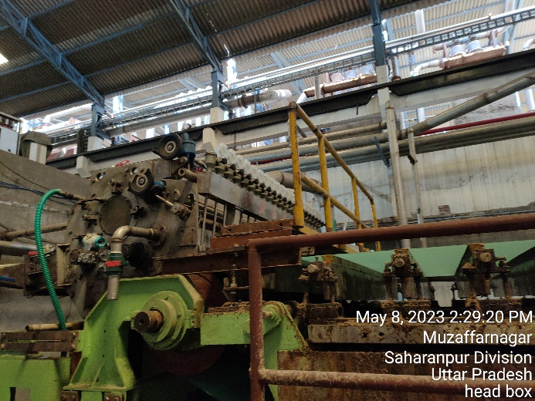

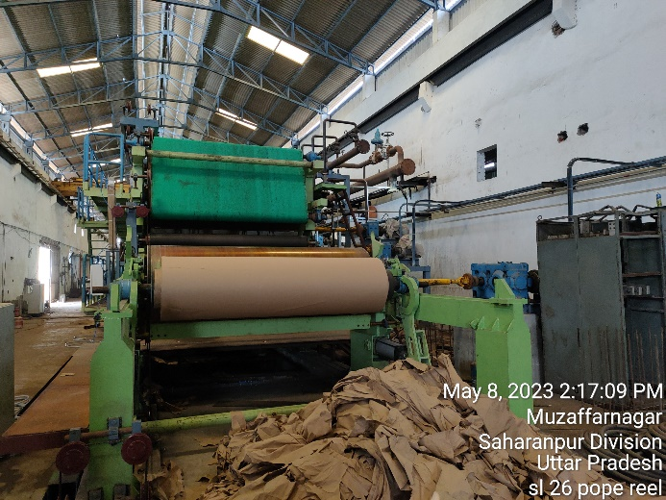 | 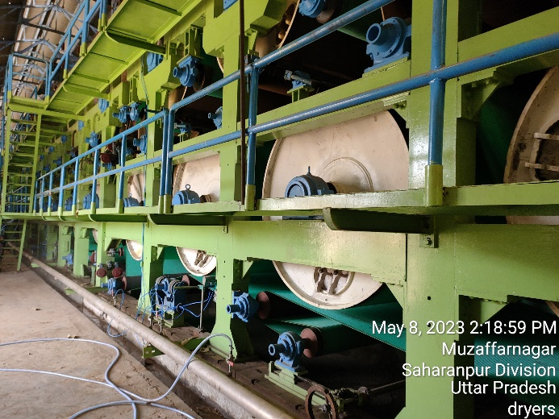
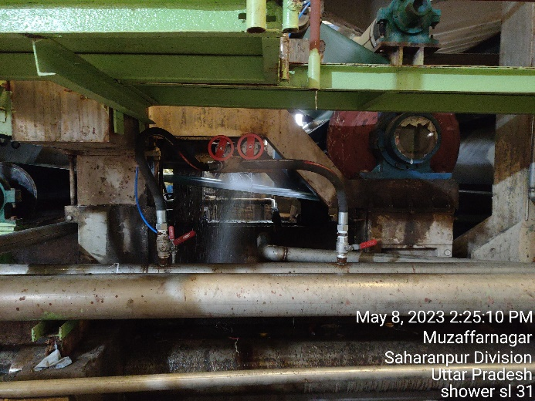 | 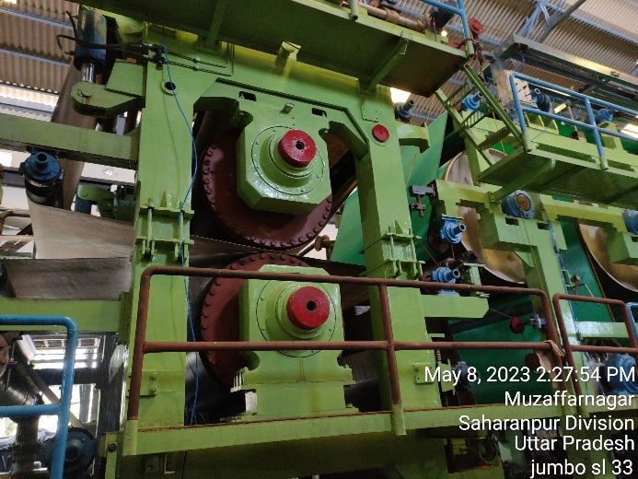
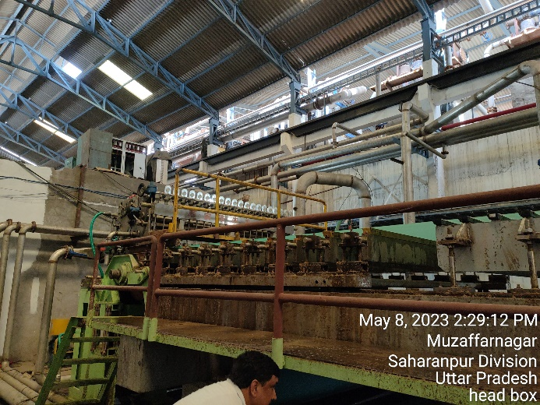 | 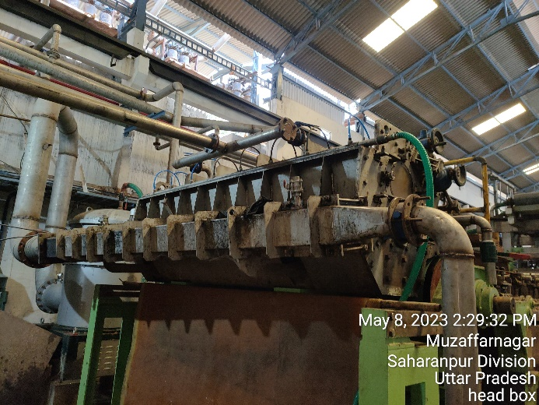
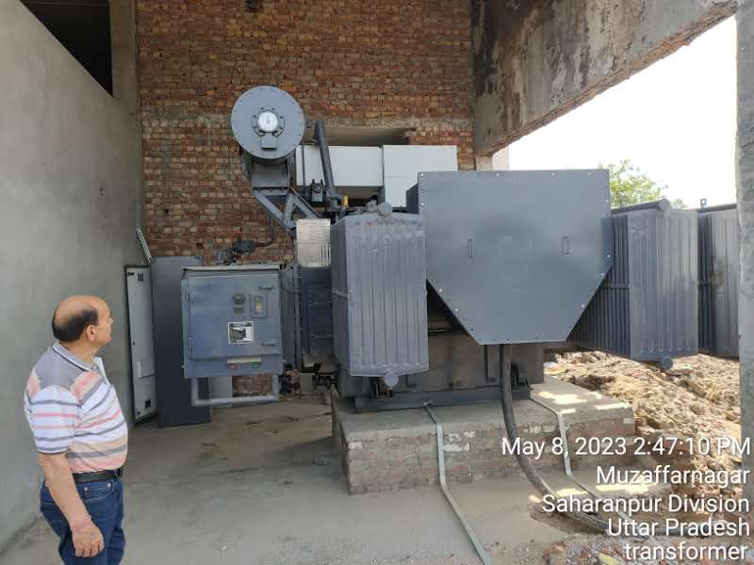 | 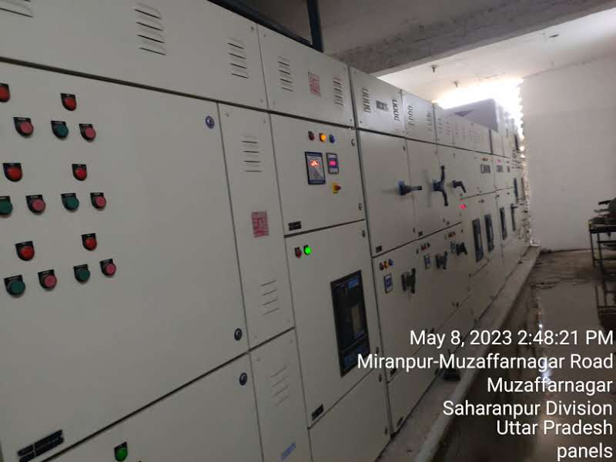

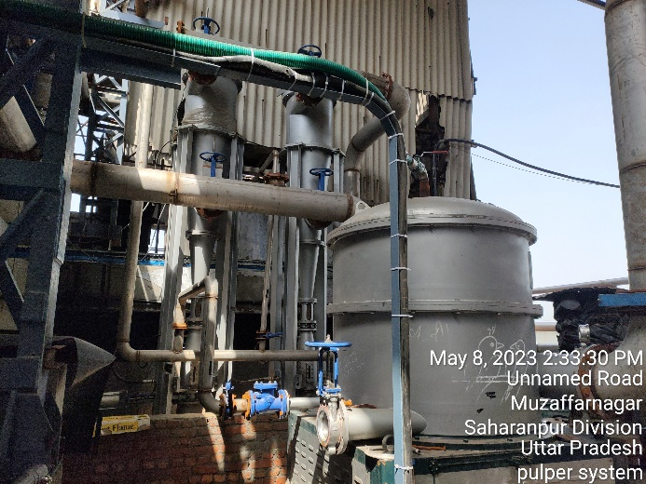 | 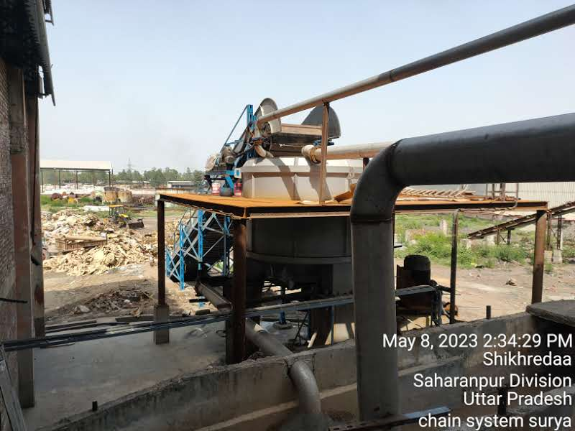
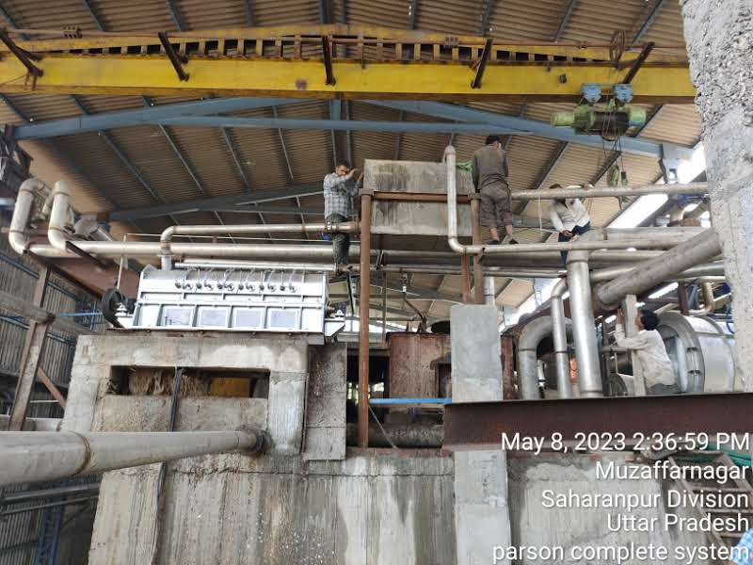 | 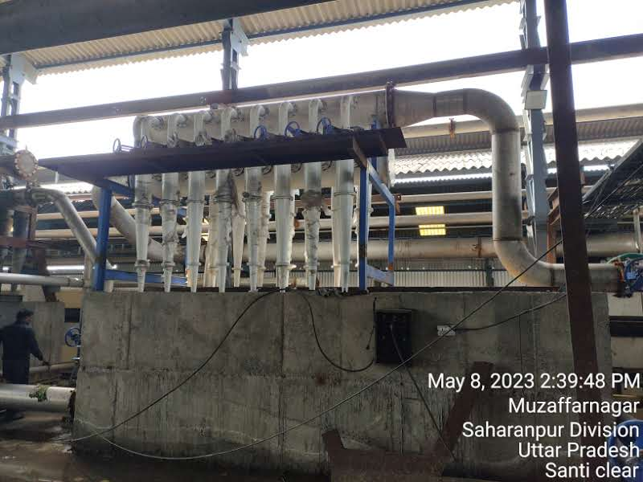
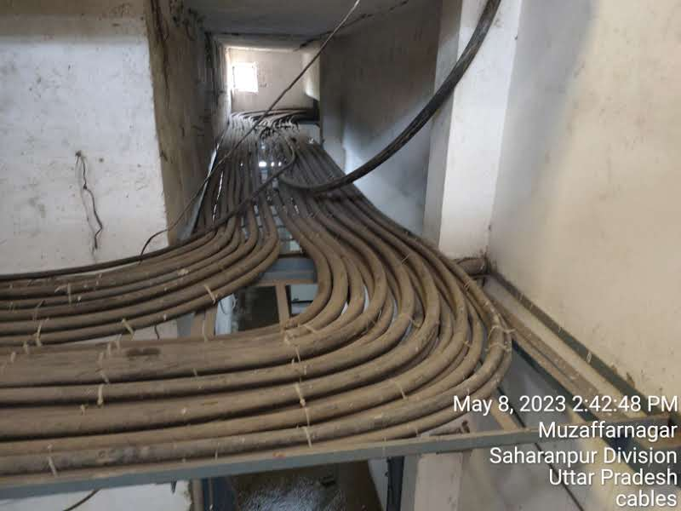 | 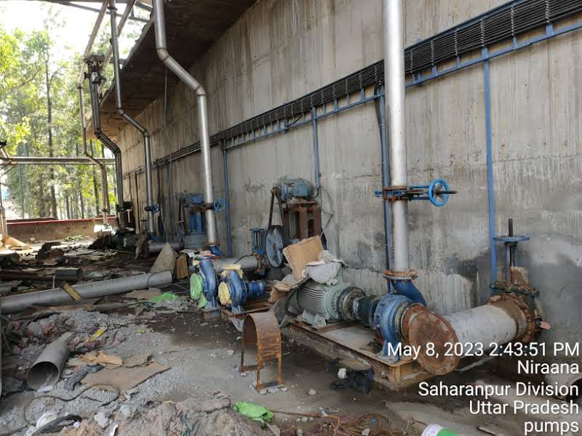
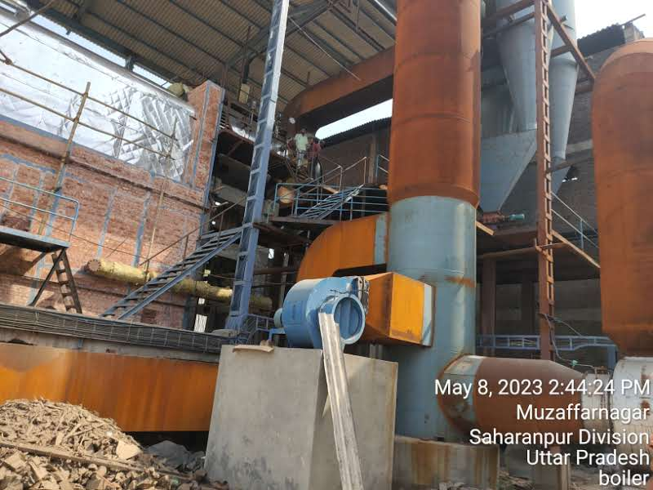 | 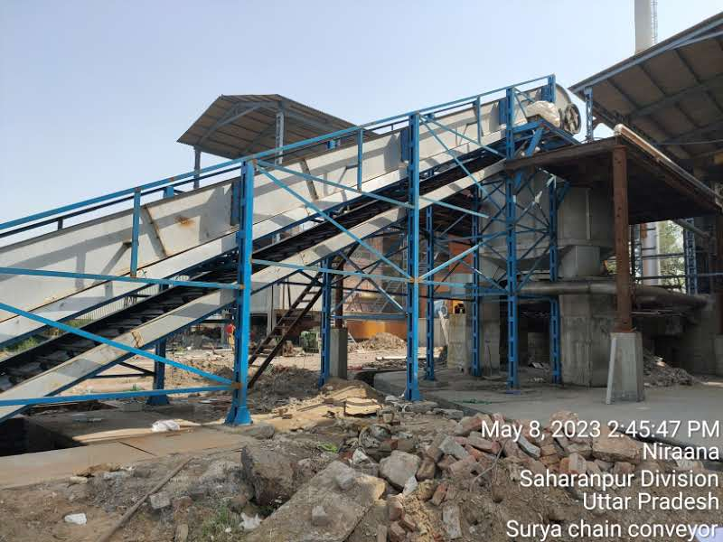

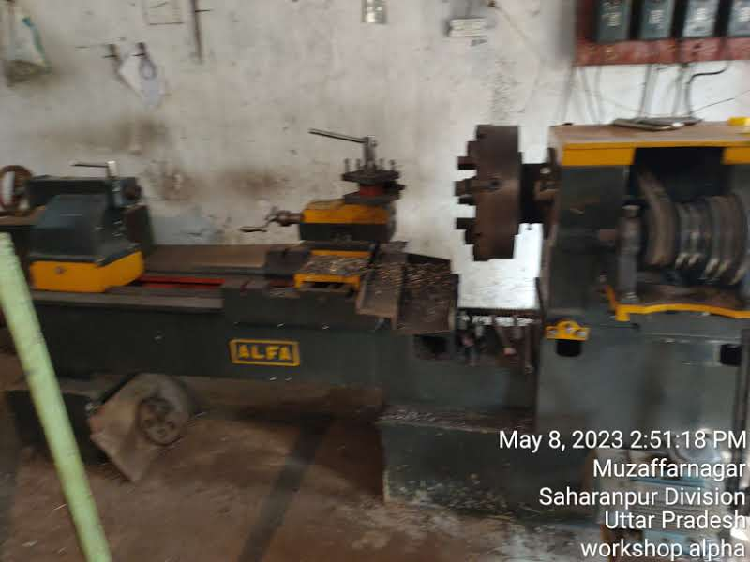 | 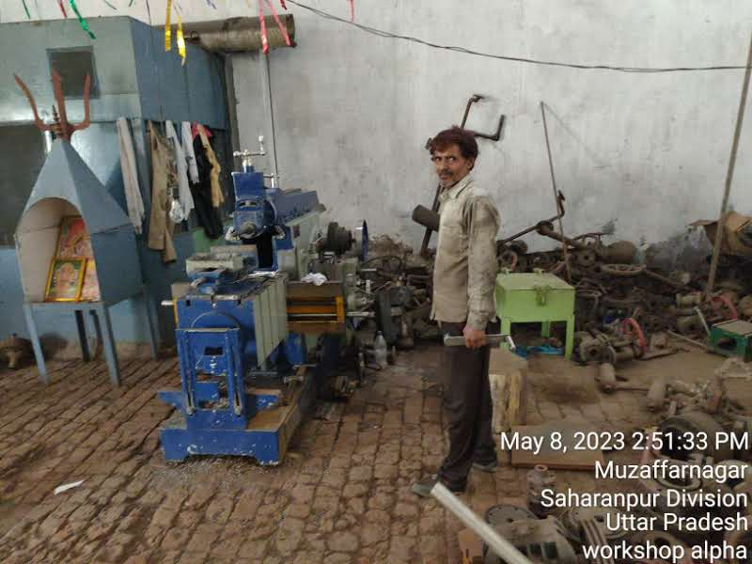
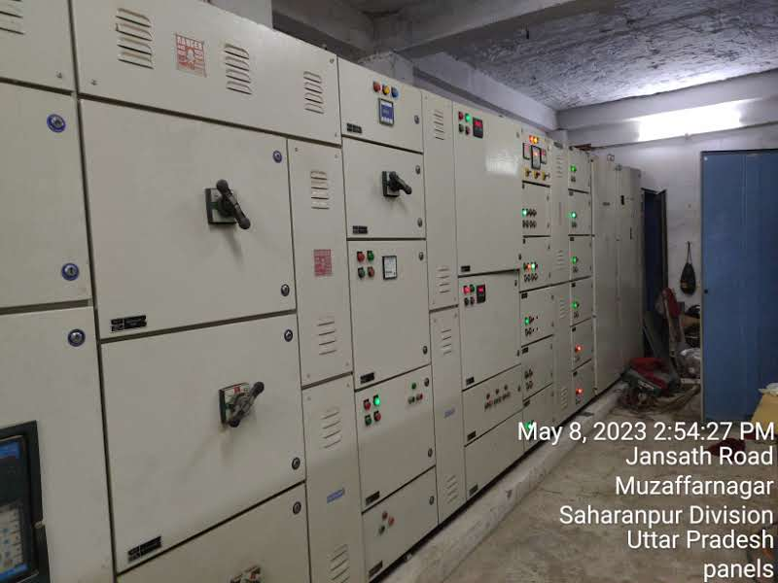 | 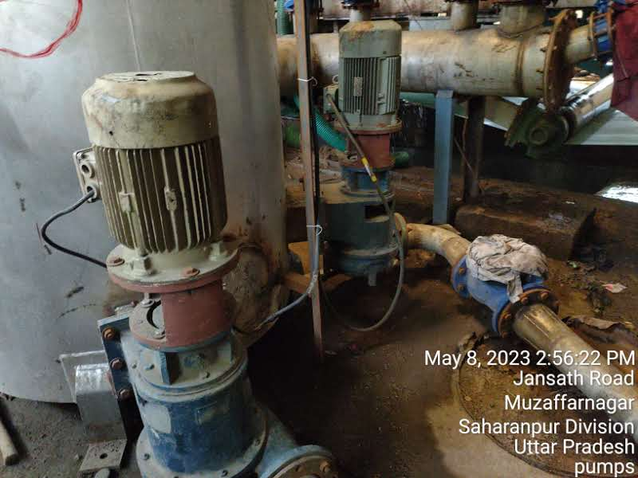
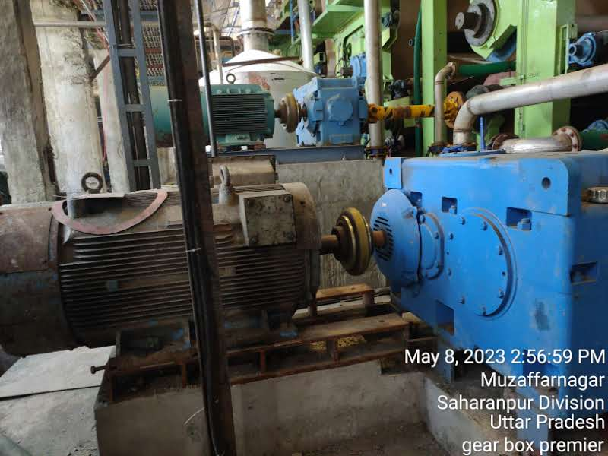 | 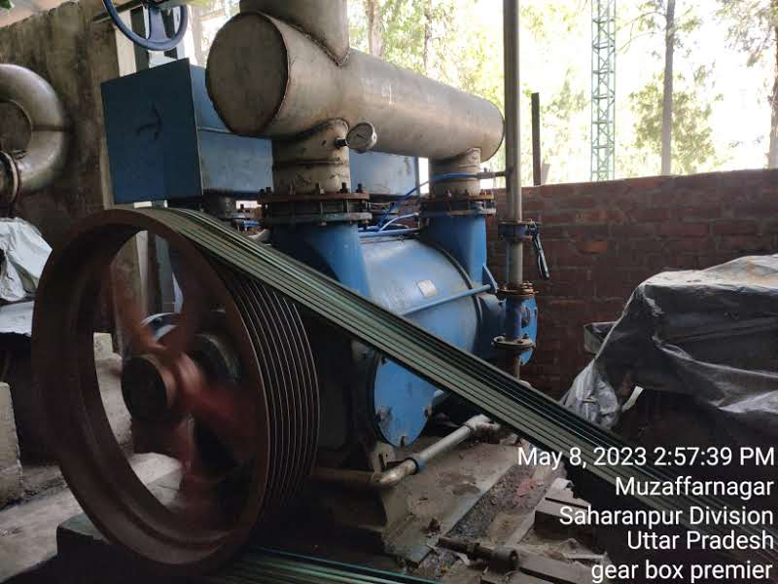
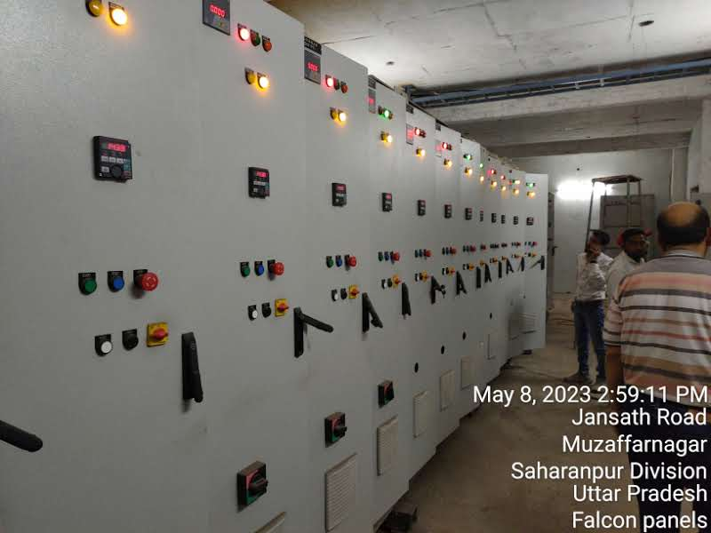 | 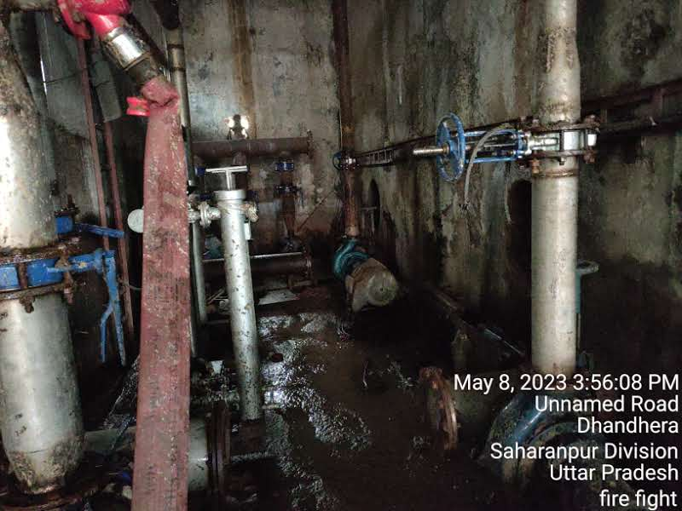

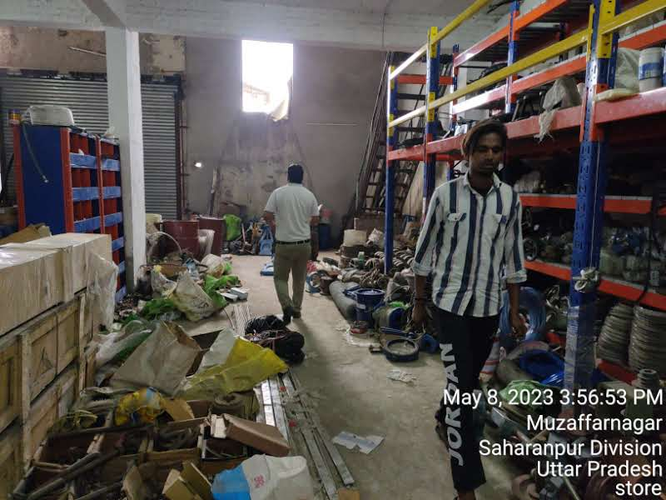 | 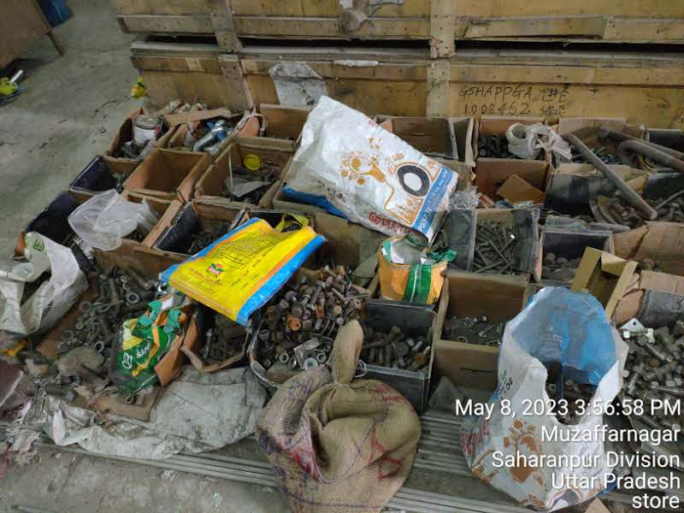
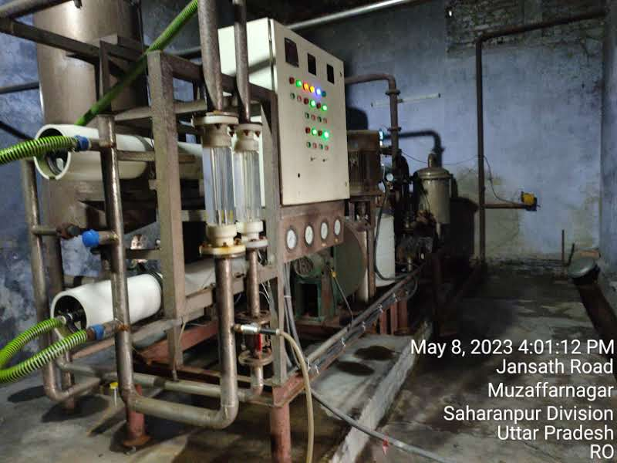 | 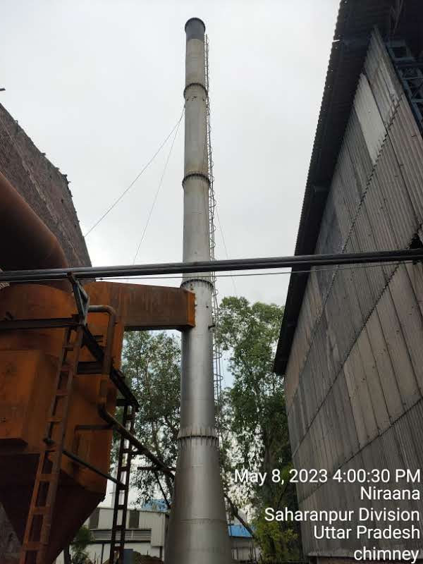
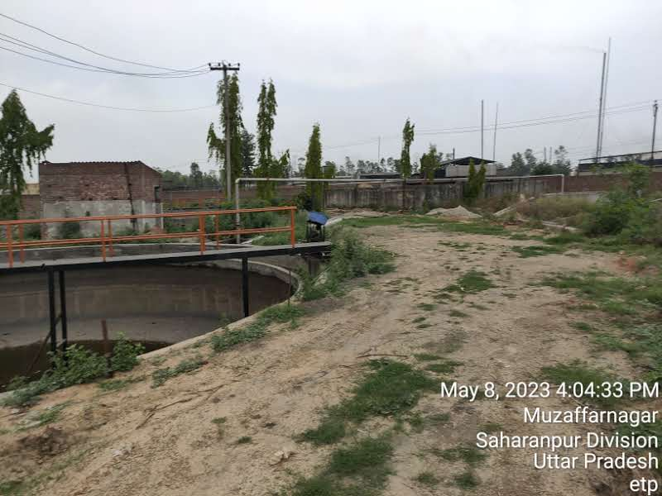 | 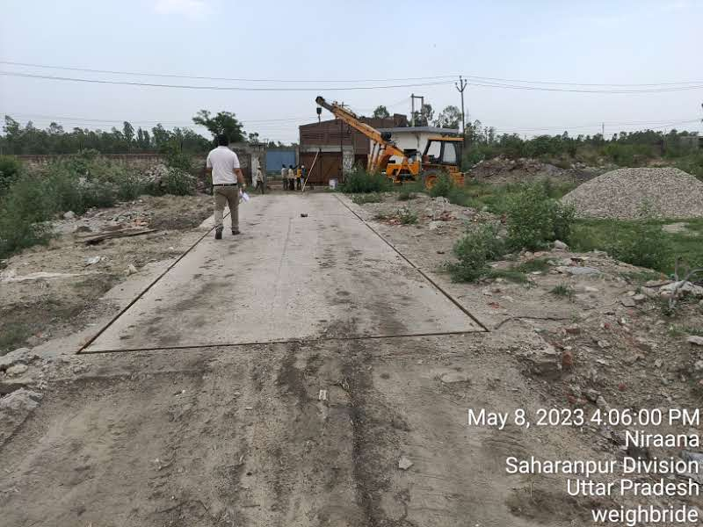
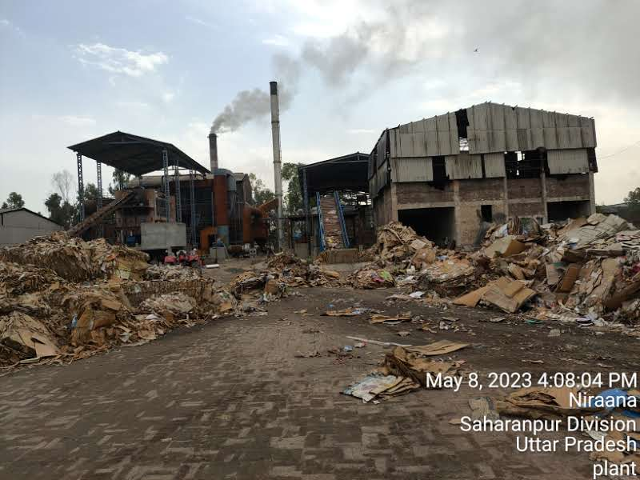 | 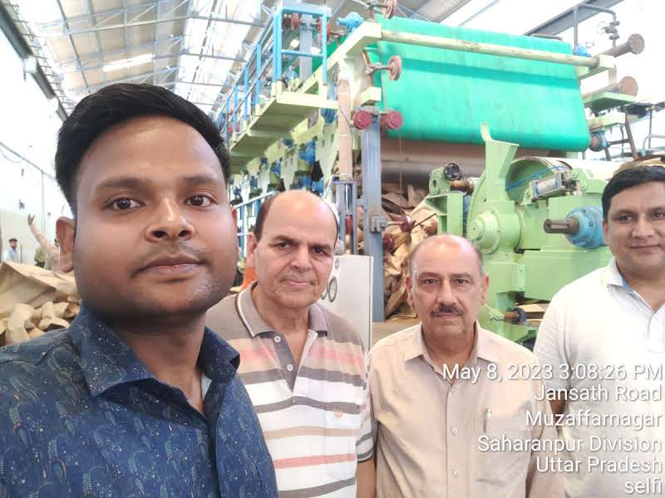

INVOICES OF THE MACHINES

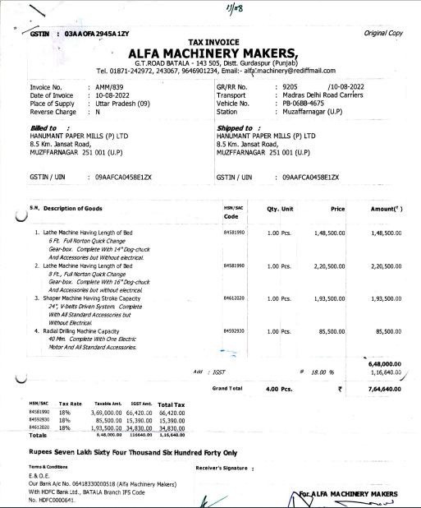

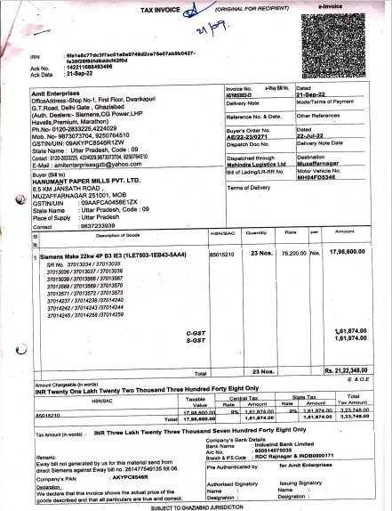

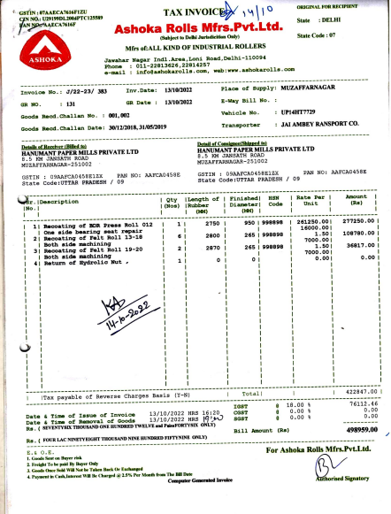
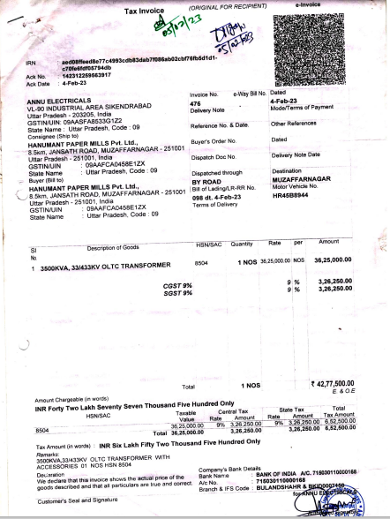

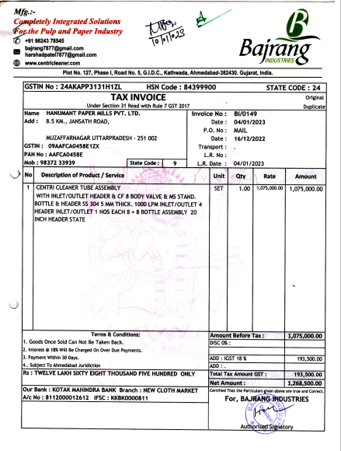
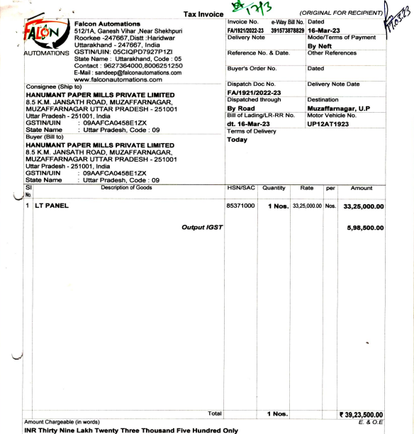
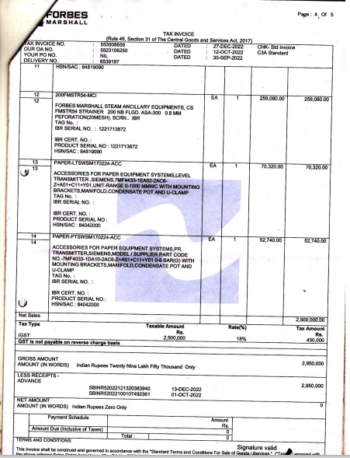
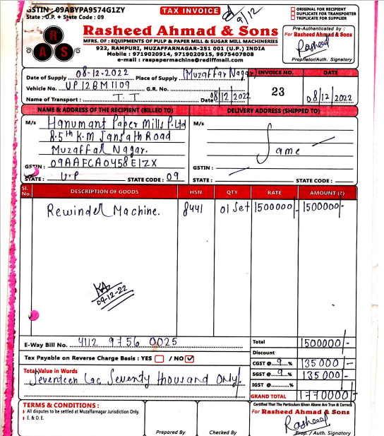
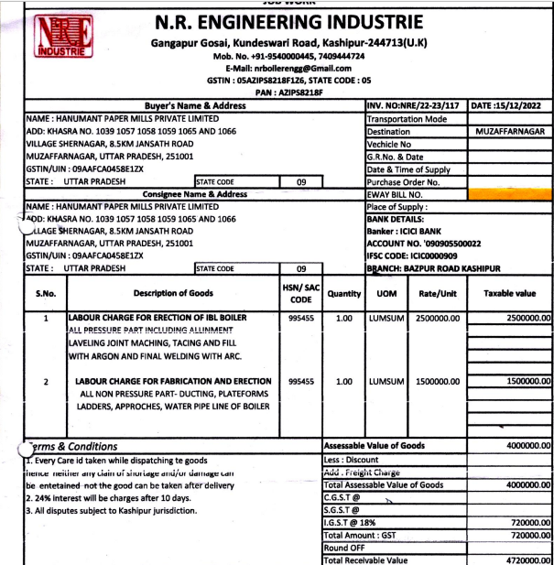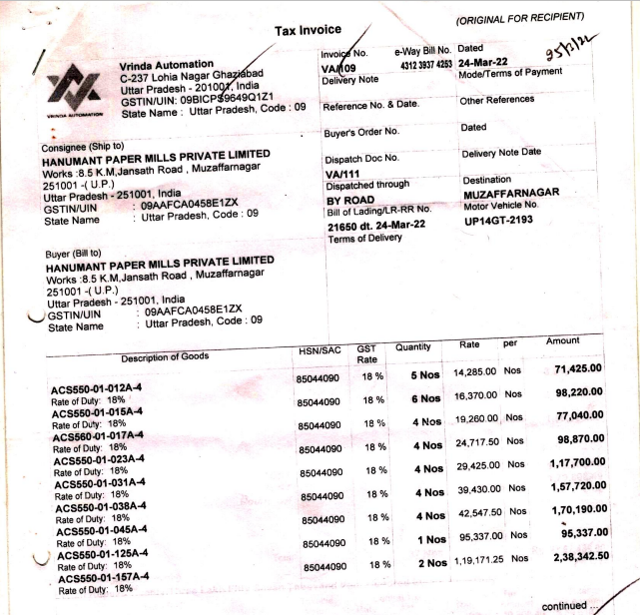

NO OBJECTION CERTIFICATE AND APPROVALS

