File No.: VIS(2023-24)-PL083-069-082 Dated: 18-05-2023

LENDER’S INDEPENDENT ENGINEER’s REPORT

OF

1.19 (± 10%) MWp GRID CONNECTED ROOF-TOP SOLAR POWER PLANT

TO BE SET-UP AT
LALPUR, DISTRICT UDHAM SINGH NAGAR, UTTARAKHAND
&
CHAKAN, PUNE, MAHARASHTRA

DEVELOPER:
M/S OPPL ASSETS PRIVATE LIMITED

TO BE SUBMITTED AT
STATE BANK OF INDIA, SME BRANCH, SOUTH EXTENSION, DELHI

**Important - In case of any query/ issue or escalation you may please contact Incident Manager
at le@rkassociates.org. We will appreciate your feedback in order to improve our services.
NOTE: As per IBA Guidelines please provide your feedback on the report within 15 days of its submission after which report will be considered to be correct.
IMPORTANT NOTICE

COPYRIGHT FORMAT: This report is prepared on the copyright format of R.K Associates to serve our clients with the best possible information and analysis to facilitate them to take rational business decisions. Legally no one can copy or distribute this format without prior approval from R.K Associates. It is meant only for the advisory/ reference purpose for the organization/s as mentioned on the cover page of this report. Distribution or use of this format by any organization or individual other than R.K Associates will be seen as an unlawful act and necessary legal action can be taken against the defaulters.
This report is intended for the sole use of the intended recipient/s and contains material that is STRICTLY CONFIDENTIAL AND PRIVATE.

DEFECT LIABILITY PERIOD: - In case of any query/ issue or escalation you may please contact Incident Manager at le@rkassociates.org.
Though adequate care has been taken while preparing this report as per its scope, but still we can’t rule out typing, human errors, over sightedness of any information or any other mistakes. Therefore, the concerned organization is advised to satisfy themselves that the report is complete & satisfactory in all respect. Intimation regarding any discrepancy shall be brought into our notice immediately. If no intimation is received within 15 (Fifteen) days in writing from the date of issuance of the report, to rectify these timely, then it shall be considered that the report is complete in all respect and has been accepted by the client upto their satisfaction & use and further to which R.K Associates shall not be held responsible in any manner.

TABLE OF CONTENTS
SECTIONS | PARTICULARS | PAGE NO.
Part A | REPORT SUMMARY | 03
Part B | INTRODUCTION | 04
 | - Name of the Project | 04
 | - Project Overview | 04
 | - Scope of the Report | 06
 | - Purpose of the Report | 06
 | - Methodology Adopted | 06
Part C | PROJECT DETAILS AND KEY TECHNICAL PARAMETERS | 07
Part D | ENERGY YIELD ASSESSMENT | 12
Part E | POWER PURCHASE AGREEMENT TERMS | 14
Part F | CURRENT STATUS OF WORK | 21
Part G | PROJECT COST & EXPENDITURE | 22
Part H | PHOTOGRAPHS | 24
Part I | OTHER DOCUMENTS & REFERENCES | 25
Part J | DISCLAIMER | 34

PART A | REPORT SUMMARY

 | Name of the Project | 1.19 (±10%) MWp Grid Connected Roof-Top Solar Power Plant
 | Project Location | - Mahindra CIE Automotive Ltd. – Stamping Division, Lalpur, Kichha, District Udham Singh Nagar Uttarakhand – 263148  GPS – 28°56'20.2"N 79°28'02.9"E  - Mahindra CIE Automotive Ltd – Gears Division, Plot No. C-23/2, Phase-II, Chakan Industrial Area, Varale Ambethan Road, Varale, Maharashtra–410501  GPS – 18°47'47.5"N 73°47'53.9"E
 | Seller Company | M/s OPPL Assets Private Limited
 | Prepared for Organization | State Bank of India, SME Branch, South Extension, Delhi
 | LIE Consultant Firm | M/s. R.K. Associates Valuers & Techno Engineering Consultants (P) Ltd
 | Date of Survey | Since, our scope of work includes only the verification and Review of total Project cost, CUF and Irradiation Data, site visit is not required.
 | Date of Report | 18-05-2023
 | Details & documents provided by | Mr. Mohit Jangra; Assistance Manager Finance and Accounts M/s Oriana Power Pvt. Ltd.
 | Report Type | Lender’s Independent Engineering Report
 | Purpose of the Report | Verification and Review of Project cost, CUF and Irradiation Data to facilitate bankers to take business decision on the Project.
 | Scope of the Report | To review Project cost and examine the current status of installation/ Commissioning of the Project.
 | Documents produced for Perusal | - Copy of Power Purchase Agreements (PPAs)  - Copy of Techno-Commercial offer from OPPL to OPPL Assets Pvt. Ltd.  - Copy of Plant Layout  - Copy of PV Syst reports
 | Annexure with the Report | - Benchmark Cost by MNRE  - Market Comparables  - Global Solar Atlas by World Bank Group  - Layout Plans

PART B | INTRODUCTION

- NAME OF THE PROJECT: 1.19 (± 10%) MWp Grid Connected Roof-Top Solar Power Plant in RESCO Model to be installed at 2 locations which are described in Part A.2 above by M/s OPPL Assets Pvt. Ltd.
- PROJECT OVERVIEW: M/s Oriana Power Private Limited which is the parent company of M/s OPPL Assets Pvt. Ltd. is an associate company of Trinix Impex & BCS Switchgear Industries. It is a MNRE approved channel partner and into the industry of Solar EPC / Design & Supply of BoS (Balance of System – Module Mounting Structure, LT/ ACCB/ ACDB/ DCCB Panel, Weather Monitoring Sensors, LA, Earthing, Cable Tray, etc.) for PV Solar Plants in India. The subject company is developing 2 roof-top solar power plants at the above mentioned locations having a total DC capacity of 1.19 kWp (± 10%).

In this respect, 2 Power Purchase Agreements (PPA) were executed in March 2023 between M/s OPPL Assets Private Limited hereinafter referred to as “Power Producer” which is engaged in the business of design, supply, erection, testing, commissioning, operating and maintenance of power plants, including grid connected Solar power projects. Whereas, M/s Mahindra CIE Automotive Limited (hereinafter referred to as “Offtaker”) are the owners of the respective properties where solar plant is to be setup. As per the PPA, rooftop solar power plants are to be setup for a total capacity of 1.19 (± 10%) MWp at basic / Floor Tariff: Rs.4.55/ KWh and Rs.4.30/ KWh for Stamping and Gears Division respectively levelised for 25 years of plant operation/ PPA tenure.
For the implementation of the subject project, M/s OPPL has shared a Techno-Commercial offer to the subject company and as per the verbal information shared by the management of the subject company, the same has been accepted and no written document has been signed between them. As per the same, the total project cost is estimated at a price of Rs.5.48 Cr. including duties and taxes.
M/s OPPL Assets Pvt. Ltd. has approached SBI for credit facility to construct these plants who have in turned appointed M/s R.K Associates Valuers & Techno Engineering Consultants Pvt. Ltd. as Lenders Independent Engineer for knowing the status of these plants.
Since, our scope of work includes only the verification and Review of total Project cost, CUF and Irradiation Data, site visit is not required.
RESCO Model: -

MNRE had introduced the PPP/RESCO model policy setting tariff rates for solar to be arrived on transparent competitive bidding model through PPP route.

The RESCO model is one of the methods of implementing rooftop solar installations. Under the RESCO model, a renewable energy service company ("RESCO"), (i.e., an energy service company that provides energy to consumers from renewable energy sources), develops, installs, finances, operates and owns the rooftop solar power project ("Project"), and supplies power generated from the Project to the consumer on whose premises the Project is set up ("Customer") or to the grid through net-metering.

'Build, Own, Operate and Transfer' (BOOT) is a special kind of RESCO model in which the RESCO constructs, owns, operates, and transfers the ownership of the Project to the Customer after the expiry of a predefined period. The RESCO and the Customer enter into a long-term power purchase agreement ("PPA") for an agreed tenure, which sets out, among others, the terms at which the power generated from the Project will be sold to the Customer and the tariff at which the power will be sold. Excess power from the Project (if any) could be sold by the Customer to the distribution utility through net metering system – the net metering regulations differ from state to state.

Under the PPA, the RESCO owns the Project and is responsible for its installation as well as its operation and maintenance of the Project throughout the tenure of the Project, and at the end of the PPA term, the ownership of the Project is transferred to the Customer. Thereafter, the Customer may either choose to retain the RESCO for operation and maintenance services or engage a third-party operator.

If the entity on whose premises the Project is located does not intend to buy the power generated from the Project and does not entered into a PPA with the RESCO, that entity can either lease the rooftop premises to the RESCO by means of a lease agreement or enter into a license agreement granting the RESCO the right to use the premises for the limited purpose of setting up and operating the Project. The RESCO then operates the Project and exports the energy generated to the local distribution utility at a predetermined feed-intariff (FiT) approved by the State Electricity Regulator under relevant schemes issued by the relevant state.

- SCOPE OF THE REPORT: To verify the Project cost, expenditures and examine the commissioning, installation status of Solar Power Plants set-up/ being set-up by M/s OPPL Assets Pvt. Ltd.
- Industry/ sector research and demand & supply trend is out of scope of the report.
- Financial feasibility study of the Project is out of scope of the report.
- Providing any kind of design report or map is out-of-scope of the report.
- Scrutiny of contracts, Agreements and arrangement between the parties from legal perspective is out-of-scope of this report.
- Location feasibility is ascertained based on the PVSyst Report provided by the client.

All the assessment carried out for the Project is done based on the documents and information provided to us and its correlation by the Engineering team through physical and virtual site inspection and various other discussions with the Project proponents and thus forming an opinion out of it.
Component wise verification is not carried out but Project installation & commissioning has been verified as a whole.
Any kind of technical & economic feasibility of the Project is out-of-scope of this Report. This report is only limited & related to the verification and examination of what has already been setup.

- PURPOSE OF THE REPORT: To provide fair detailed analysis report to the Bank based on the “in-scope points” mentioned above for facilitating them to take appropriate business decision on the Project.

- METHADOLOGY ADOPTED:
- To gather relevant data/ information/ documents related to Project planning, execution, current status.
- Study of copy of Project Planning documents/ Agreements to know the scope of work of the company.
- To procure, study and analysis of any additional information, data, and documents required/ provided by the company.
- Research about the Project/ sector from the sources in the public domain.
- Correlation of the provided information against Industry/ sector benchmarks/ trend.
- Information compilation, analysis and reporting.

PART C | PROJECT DETAILS AND KEY TECHNICAL PARAMETERS
As per the information and copy of documents shared by the management of the company, details of the subject plants has been tabulated below:
S.  No. | Offtaker | Capacity  As per Drawing  (kWp) | Capacity  As per PPA  (kWp) | Address
1 | Mahindra CIE Automotive Ltd. – Stamping Division | 650.1 | 650.16 | Lalpur, Kichha, District Udham Singh Nagar Uttarakhand – 263148
2 | Mahindra CIE Automotive Ltd – Gears Division | 540.1 | 539.46 | Plot No. C-23/2, Phase-II, Chakan Industrial Area, Varale Ambethan Road, Varale, Maharashtra–410501
Total |  | 1,190.2 | 1,189.62 | (± 10%)

As per the copy of module layout plans of both the sites, Key Technical Parameters & Configuration of the projects like Modules, Inverter, tilt angle, capacity, etc. are tabulated below:
- Mahindra CIE Automotive Ltd – Gears Division
S. No. | Particular | Figure | UOM
1 | Proposed Capacity | 540.1 | kWp
2 | Total No. of PV Modules | 982 | No.
3 | PV Modules Capacity (Mono-Crystalline) | 550 | Wp
4 | PV Module Dimension | 2284 x 1137 x 35 | mm
5 | PV Module Mounting Orientation | Landscape
6 | Module Mounting Structure Angle | As PER Tin Shed
- Mahindra CIE Automotive Ltd. – Stamping Division
S. No. | Particular | Figure | UOM
1 | Proposed Capacity | 650.1 | kWp
2 | Total No. of PV Modules | 1,182 | No.
3 | PV Modules Capacity (Multi-Crystalline) | 550 | Wp
4 | PV Module Dimension | 2279 x 1134 x 35 | mm
5 | PV Module Mounting Orientation | Portrait
6 | Module Mounting Structure Angle | As PER Tin Shed

Location Maps: -

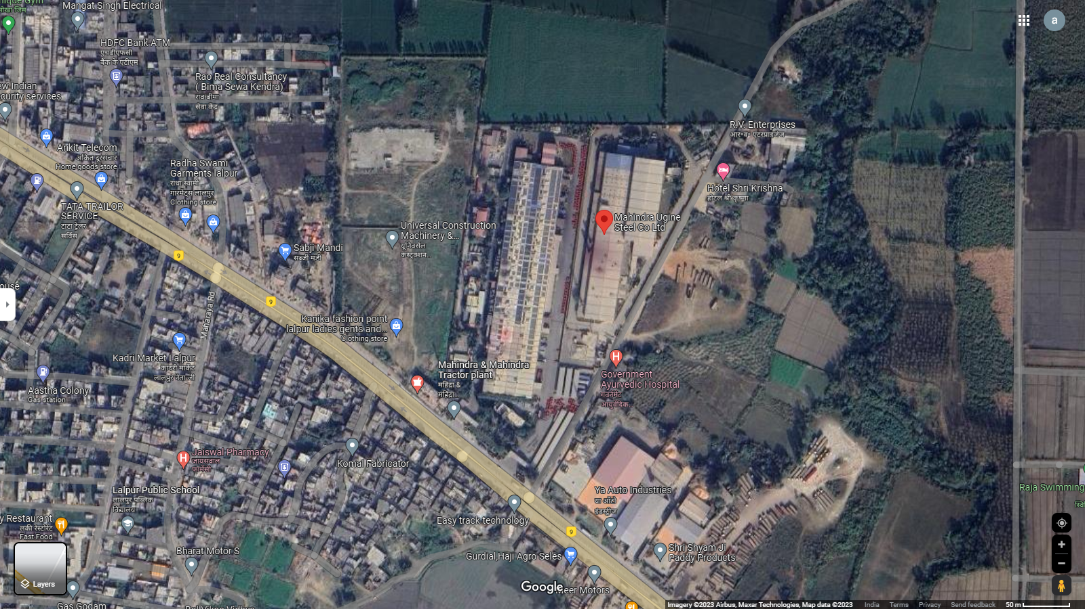
Location: Stamping Division GPS: 28°56'20.2"N 79°28'02.9"E

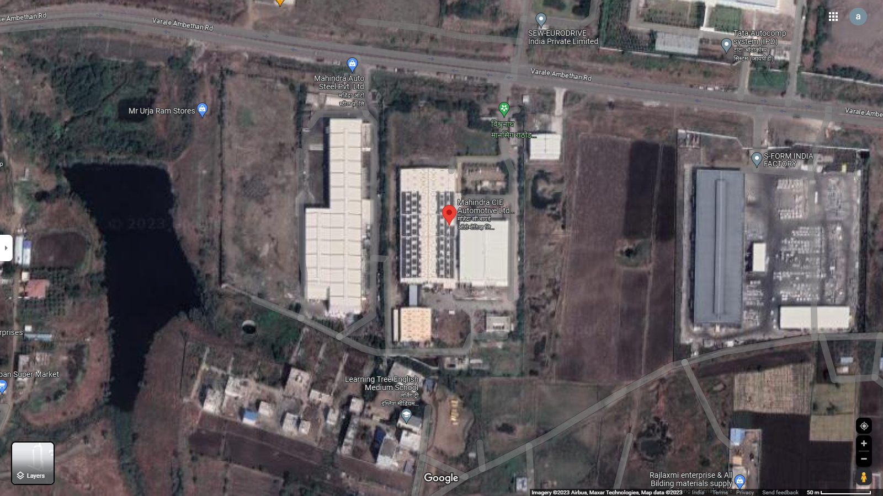
Location: Gears Division GPS: 18°47'47.5"N 73°47'53.9"E

Technical details as per Techno-Commercial offer from Orient Power
S. No. | Item Description | Technical Specifications | Quantity | Unit | Make
A | PV Section
1 | Solar PV module | 230Wp-550Wp  Mono-PERC/Multi-Si 25yrs. Linear warranty  Certifications:  IEC 61215, IEC 61730 & UL 1703; IEC 62804 (PID) IEC  62716 (Ammonia Resistance), IEC 60068-2-68 (Blowing Sand) IEC 61701 (Salt Mist level 6), , ISO 11925-2 (Class E) ISO 9001: 2015, ISO 14001: 2004,  OHSAS 18001: 2007 | 1.190 | MWp. | ALMM Approved/As per Policy
2 | Connectors (male & female) pair MC4 | Connectors (male & female) pair, MC4 Connector Pin Copper with tin coating Insulation Voltage: 1000V | As per requirement | Nos. | Multi Contact
3 | Solar String Inverter –  50/100/250kVA, 415V | 50/100/250kVA, 415V output, Outdoor type-IP65, Eff. >98% | As per Design | Nos. | Sungrow/ Grow att /Equivalent
B | Structures
1 | Design & Supply of Module Mounting structure supply. | Roof Mounted Ballasted Solar Module Mounting Structure.  Material: MS HDG Grade: E 250 Galvanisation: 80micron  Structure designed at 170kmph wind speed as per IS- 875  Ground Clearance 1 mtr. | As per requirement |  | Oriana Power
2 | Structure & Module Mounting Accessories. | Material: SS Grade: SS 304  Structure designed at 170kmph wind speed as per IS-875 | As per requirement |  | Oriana Power
C | Remote Monitoring System
1 | Ambient Temperature sensor | PT1000 sensor element | 1 | Set | IMT
2 | Module Back Surface Temperature sensor | PT1000 sensor element | 1 | Set | IMT
3 | Solar Irradiation sensor for radiation  measurement | Cell Based sensor with calibration certificate | 1 | Set | IMT
4 | 2 Pair Twisted Un - armoured communication cable, Cu |  | As per Design | Mtr | K-flex/parasheild
5 | HDPE DWC Conduit, Size of 32/26mm & Accessories (PVC bends & couplers etc.) | Double Wall Corrugated HDPE Conduit for communication cable laying over shed. Conduit will be fixed with shed using GI Saddles and aluminum pop rivets. | As per Design | Mtrs | Duraline/ equivalent
6 | 3C 1.5Sq. mm Armored Copper Cable - Data Logger Power cable |  | As per Design | Mtr | Polycab
7 | CAT 6 cable |  | As per Design | Mtr | Dlink
8 | Data logger Installation and IP 65 Box | For Remote monitoring | As per  Design | Nos | Webdyn
9 | SCADA for Solar Plant monitoring and Grid monitoring | Visual inter-facing for plant monitoring and data analysis | As per Design | Lot | Webdyn
D | DC side - Cables & Accessories
1 | 1 Core 4 Sq mm Cu Solar Cable | Solar DC cable, Tin-coated copper cable as per EN standard. UV protected double sheathed XLPO, Halogen free cable. | As per Design | Mtrs | Apar/Siechem/ Equivalent
2 | 1C 2.5 Sq mm Green  Cable (for Earthing), with accessories | 2.5 sqmm. Single core flexible PVC insulated cable for  module to module earthing with SS-304 fasteners, teeth washer and copper thimbles. | As per Design | Mtrs | Polycab/KEI
3 | DC Electrical accessories | (Consumables like Lugs, Glands, Ferrules, Cable Ties, uPVC tape, uPVC saddle, Cable clips etc.) | As per Design | Set | As per Design RFQ
4 | HDPE DWC Conduit, Size of 32/26mm & Accessories (PVC bends  & couplers, T Joints etc.) | Double Wall Corrugated HDPE Conduit for DC cable laying over shed. Conduit will be fixed with shed using GI Saddles and aluminum pop rivets. | As per Design | Mtrs | Apollo/ Duraline/ equivalent
E | AC side - Cables & Accessories
1 | 4 C, 25 Sq.mm Cu PVC Flexible Cable. | 1.1kV insulated, Copper conductor, PVC insulated, PVC outer sheathed cable | As per Design | Mtrs | Polycab/KEI/ Havells
2 | 3.5 C, 150 Sq.mm AL XLPE Arm Cable. | 1.1kV insulated, Aluminum conductor, XLPE insulated, GI strip armoured, PVC outer sheathed  cable as per IS-7098 Part-1 | As per Design | Mtrs | Polycab/KEI/ Havells
3 | Cable for earthing- 1C 10 sq.mm Cu flexible (for Inverter earthing) |  | As per Design | Mtrs | As per Design RFQ
4 | Field ACDB for inverters output | 3 phase, 415 V, 50 Hz ACCB Panel with  - Enclosure material made of CRCA with Powder coated paint  - 4P, MCCB’s - as per requirement  - 4P, Isolator  - 3 phase, 4 W, AL, bus bar.  - IP 65 with canopy  - Panel with double door & lock  - SPD Type 2  - with mounting arrangement | As per Design | Nos | Breakers Make: L&T
5 | Isolator Panel near Metering Panel | 3 phase, 415 V, 50 Hz ACCB Panel with  - Enclosure material made of CRCA with Powder coated paint  - 4P, 700A MCCB’s  - 3 phase, 4 W, AL, bus bar.  - IP 54 with canopy  - Panel with single door & lock  - with mounting arrangement | As per Design | Nos | Breakers Make: L&T
4 | Cable tray for AC cable laying after inverter | 50mmX50mmX2mm Hot dip galvanized cable tray with cover and other accessories i.e. cable tray stand, cable tray cover clamp, cable tray coupler, M8  MS HDG Fasteners, anchor bolts etc. | As per Design | Nos | Oriana Power
F | Civil Works
1 | As per site requirement | Civil work for Structure, electrical panel foundations, Structure Foundation, earthing pit chamber construction. | 1 | Set | As per RFQ
G | Safety & Protections
1 | Fire extinguisher With sand bucket ( 4 Kg ABC type ) | 4 Kg ABC type fire extinguishers with stand | As per design | Set | As per Design RFQ
2 | Earthing Kit for plant AC and DC earthing | Copper Bonded rods 3m, 17.2 mm, chemical bags and other required accessories. Earthing pit chamber will be constructed and Cast iron cover will be installed | 1 | Set | VNT/JMV/GS Electrode
3 | Lightning Arrester for protection of solar power  plant | ESE Type, GI mast, 2 Earthing pit , 1 C 70 mm2 Cu PVC cable, 2 set of earthing for one lightning  arrester, R-109 Meter , Stay Set support. | As per design | Nos. | VNT/JMV/Allied Power
4 | GI Strip 25X3 mm for DC side | Hot dip galvanized earthing strip with minimum 80 micron. Material grade E-250 | As per Site Req | Meter | As per Design RFQ
H | Services
1 | Installation, testing and  Commissioning | Complete plant service work | 5 | MWp | As per Design RFQ
2 | Module cleaning system with uPVC pipe line system and pump. | 1 HP, 230V Centrifugal pump,  CPVC Pipe (1/2 inch) line over roof with shut-off valves, CPVC pipe will be fixed over roof with SS saddles gitti-pench. Flexible Hosepipe (1 inch) of 40 Meter length, Wiper 1.5 Meter length, Extendable Pole Piping for Each Roof, Piping as per detail drawing | 1 | Set | Ashirwad/Astral/  Equivalent
The above-mentioned installations/parts are provided as per best industrial practice and can be verified after commissioning of the project. The specification for the items mentioned in the above Techno Commercial Offer to be inline and with as per government guidelines.
Client’s Scope of work
- Provision of permission to work on site
- Clear shadow free area / Tin shed for the installation of PV modules & equipment’s.
- Entrance/working permission for local labor for loading/un-loading work.
- Electrical power point nearby to site for electricity requirement during construction.
- Water tap points (minimum 1 inch ) at PV plant site for module cleanings system
- Internet / SIM card with data packs shall be provided at site for remote monitoring of inverters and other devices.
- Documents required for CEIG approval/DISCOM NOC/Bi-directional Meters.
PART D | ENERGY YIELD ASSESSMENT

Company has used PVSyst V7.2.21 to assess energy yield calculation which is the standard Industry practice. The yearly average of main results of irradiation and energy yield from the provided PVSyst is as under:
S. No. | Plant Location | Annual production probability  (MWh) |  | Specific Production  (kWh/kWp/year) |  | Expected Generation  (kWh/ annum) |  | Per.  Ratio (%)
 |  | P50 | P90 | As per PPA | As per PVsyst | As per PPA | As per PVsyst
1 | Mahindra CIE Automotive Ltd. – Stamping Division | 828.0 | 808.9 | 1,300 | 1,274 | 8,45,208 | 8,27,994 | 78.58
2 | Mahindra CIE Automotive Ltd – Gears Division | 813.7 | 794.9 | 1,500 | 1,507 | 8,09,190 | 8,13,722 | 83.06

Monthly averages- Direct normal irradiation (kWh/m²)
- Mahindra CIE Automotive Ltd. – Stamping Division
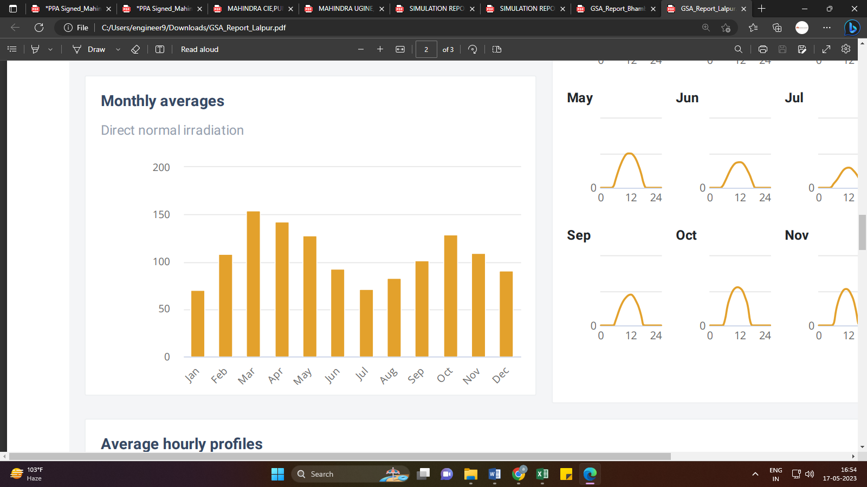
Source: Global Solar Atlas

- Mahindra CIE Automotive Ltd – Gears Division
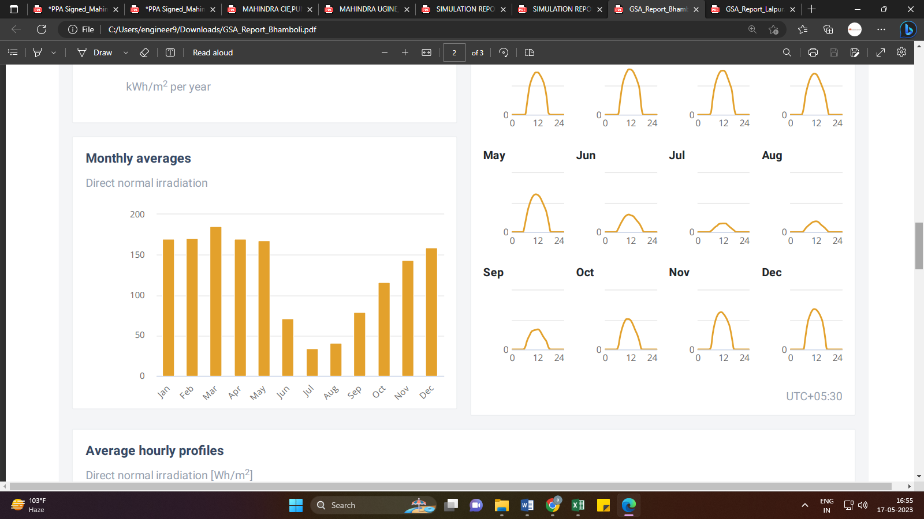
Source: Global Solar Atlas

Observations and Remarks:
- As per the PVsyst - Simulation reports dated 21st April 2023, the estimated energy that can be produced by the subject plants and their respective performance ratio is almost equal as agreed in the PPA.
- As per Global Solar Atlas by World Bank Group, the location wise Annual Averages- Direct Normal Irradiation are:
- Mahindra CIE Automotive Ltd. – Stamping Division: 1,278.7 kWh/m²
- Mahindra CIE Automotive Ltd – Gears Division: 1,508.3 kWh/m²
- As per the information provided by the management of the company, the estimated Plant Load Factor (CUF at P90) is 14.20% and 16.80% for Stamping and Gears Division respectively.

PART E | POWER PURCHASE AGREEMENT TERMS

As per the information provided by the company, the total proposed capacity of the subject roof-top solar power plant is 1.19 MWp (± 10%). As on date, company has signed 2 no. of PPAs to install the power plant and supply power at both the project sites. Details of the same are tabulated below:
S. No. | Offtaker | Capacity  (kWp) | Tariff  (Rs./kWh) | PPA Date
1 | Mahindra CIE Automotive Ltd. – Stamping Division | 650.16 | 4.55 | March-2023
2 | Mahindra CIE Automotive Ltd. – Gears Division | 539.46 | 4.30
Total |  | 1,189.62
Source: PPAs
Important Clauses: Both the PPA’s are signed for a period of 25 years with fixed tariff as stated above. Some of the important clauses from the signed PPAs are as follows:-
Clause-3: Term
  - Initial Period
The Initial Period of the agreement will start on the "Effective Date" mentioned in the Power Purchase Agreement (PPA). It will end either on the Commercial Operation Date or if the agreement is terminated as outlined in Clause 4.4. The Power Producer is responsible for ensuring that the Plant is commissioned within 120 days from the Effective Date, which is referred to as the "Scheduled Commissioning Date."
If the Power Producer fails to commission the Plant by the Scheduled Commissioning Date and the delay continues for 30 days, the Power Producer will be required to pay liquidated damages to the Offtaker. The rate of liquidated damages will be Rs.10,000/- per day/MW of delay.
If the delay extends beyond 3 months and it is not caused by an "Offtaker Event of Default," both Parties will discuss the next steps together. If they fail to reach a mutual understanding within 15 days, the Offtaker has the right to terminate the Agreement without notice. The Offtaker will not be held liable, including any liability under Clause 20.3 of the Agreement.

3.3. Operation Period
- The Operations Period will commence on the Commercial Operation Date and will terminate on completion of 25 (twenty-five) Years from the date of the Commercial Operation Date.

Clause-4: Planning, Installation and Operation of Plant:
Subject to and on the terms and conditions of this Agreement, the Power Producer shall, at its own cost and expense, procure finance for and undertake the design, engineering, procurement, construction, operation and maintenance of the Plant and observe, fulfil, comply with and perform all its obligations set out in this Agreement or arising hereunder.
The Power Producer will be responsible for the design, implementation, operation and maintenance of the Plant as detailed in SCHEDULE F. In order to ensure timely completion of the Plant by the Commercial Operation Date, the Offtaker shall be responsible for fulfilling its scope of work as more categorically defined in SCHEDULE F attached below:
S. No. | Scope of Work | Power producer's Scope | Offtker's Scope
1 | Designing, Engineering, Supply, Erection and the Commissioning of Solar System for Rooftop and selection of component for Roof top solar project | Yes | -
2 | Checking the existing roof structure stability for taking additional load of Roof top solar project and issuing Structural Stability Certificate before commencement as per clause 4.8. | Yes | -
3 | Issuing the structure stability certificate after erection of solar structure along with requisite mounting arrangement for panels. | Yes | -
4 | Access Ladder for roof access where required for metal shed across campus. | - | Yes
5 | Supply Walkway along with required safety provisions | Yes | -
6 | Provision of Lifeline on Rooftop. | Yes | -
7 | Water Access Points of Roof as required across campus and quality of water shall be less than 200 PPM. | - | Yes
8 | Laying of water pipeline for Plant Roof top Solar. Project from access points provided on the roof | Yes | -
9 | Changeover switch (ACB/VCB) of appropriate Amperage with (EDO with UV coil) and change over switch along with all necessary safety and electrical standards to meet the voltage/ current requirement. | Yes | -
10 | Provision for Reverse power Protector for DG and Grid side reverse flow protection and Synchronization. | Yes | -
11 | Discom approved Net meter (ABT/ bi-directional Meter) | Yes | -
12 | Discom approved change / replacement of CT/PT (Isolation Transformer) | - | Yes
13 | CEIG Liaisoning and Approvals for solar power plant | Yes | -
14 | Net Metering liaisoning and approval for solar power plant. | Yes | -
15 | Plant O&M including panel cleaning and preventive and breakdown maintenance for 25 years | Yes | -
Source: PPAs
h) Building infrastructure related construction, rectification, repair, replacement requirements and like any change in shed e.g. skylights, vents or damaged sheet, waterproofing, water drainage shall be in the scope of the Offtaker after the installation and commissioning of Plant till expiry or earlier termination of this Agreement. Due to natural deration / wear and tear any damage on the tin shed and its components shall be repaired and replaced by Offtaker, however any damage due to O&M activities undertaken or omitted to be undertaken by Power Producer shall be repaired and replaced by Power Producer at its own cost within Sixty (60) days of occurrence of damage or intimation from the Offaker, whichever is earlier.
4.3. Major Components of the Plant
As of the date, the Power Producer anticipates that the Plant shall consist of the major components as set forth in SCHEDULE C. During the project execution due to reasons not attributable to Power Producer, if there is a requirement to change the major components for the benefit of the project will be notified to the Offtaker by the Power Producer. However, cost and expense required for such change shall be attributable to the Power Producer.
Schedule C: Major Components of Solar Power Plant
- Solar Modules - Mono Crystalline
- Module Mounting Structures with adhesive bonding solution
- Array Junction Box
- Solar Power Inverter
- AC distribution board/LT Panel
- Cables & Accessories.
- Monitoring System
- Earthing/ Lightening Arrestors.
- Net Metering
Point of Delivery: LT Panel of Respective Buildings

4.4. Termination of Development Activities
Notwithstanding anything contained in this Agreement at any time during the Initial Period, the Power Producer shall have the right to cease development of the Plant on the Premises, for reasons only dealing with changes in law or government regulations coming into effect after the Effective Date, which would render the Plant unviable. If the Power Producer gives the Off- taker notice of such determination, this Agreement shall stand terminated effective as of the delivery of such notice without any further liability of the Parties to each other, provided that:
4.4.1. The Power Producer, at its own cost and expenses, shall remove any equipment or materials which the Power Producer has placed on the Site
4.4.2. The Power Producer, at its own cost and expenses, shall restore any portions of the Site disturbed by the Power Producer to its pre-existing condition, i.e., condition prior to the commencement of construction

Clause-5: Sale of Electric Energy
  - Sale of Electricity
Throughout the Operations Period, subject to the terms and conditions of this Agreement, the Power Producer shall sell only to Offtaker and Offtaker shall buy from Power Producer all electric energy produced by the Plant, whether or not the Offtaker is able to use all such electric energy. Title to and risk of loss with respect to the energy shall transfer from Power Producer to Offtaker at the Point of Delivery.
  - Expected Energy Supply
- The Power Producer estimates the amount of electric energy to be produced by the limits on the Plant on annual basis subject to Global Horizontal Irradiation ("GHI") based on following broad assumptions:
- Expected Energy Generation /annum = 8,45,208 kWh for 1st Year, please refer to SCHEDULED for Expected Year on Year Energy Production
- Module Degradation Factor = 2.5% for 1st Year and 0.7% thereafter
- Global Horizontal Irradiation = 2,250 kWh/m²
- Size of the Plant = 650.16 kWp
- Grid Availability
Expected Solar Generation per annum: 1300 kWh/KW (including deemed generation) i.e. 8,45,208 kWh for 1 year at the point of generation for 650.16 kWp. Minimum Guaranteed Generation per annum (90% of expected generation): 1,170 kWh/kW. (including deemed generation) i.e. 7,60,687 kWh for 1st year at the point of generation for 650.16 kWp. Annual Degradation Factor: 2.5% in first year and 0.7% per year after that.
- The Power Producer shall ensure that the 90% Expected Energy Generation (as outlined in SCHEDULE D) including deemed generation is supplied on annual basis. However, if there is any reduction in generation due to reasons attributable to or due to actual GHI, the same should be reduced from the Expected Energy Generation. In case of supply lower than 90% of Expected Energy Generation (as outlined in SCHEDULE D), the Power Producer should compensate the Offtaker for the difference in Variable Charge charged by MSEDCL and applicable Tariff as per this Agreement for Shortfall Units for that year.

Explicit understanding of 5.1 and 5.2 clause has been indicated in tabulated below SCHEDULE:

S. No. | Stamping Division |  |  | Gears Division
 | Expected Energy from Solar Plant  (in kWh) | Guaranteed Generation  (90% of Expected Generation)  in kWh |  | Expected Energy from Solar Plant  (in kWh) | Guaranteed Generation  (90% of Expected Generation)  in kWh
1 | 8,45,208 | 7,60,687 |  | 8,09,190 | 7,28,271
2 | 8,24,078 | 7,41,670 |  | 7,88,960 | 7,10,064
3 | 8,18,161 | 7,36,345 |  | 7,83,296 | 7,04,966
4 | 8,12,245 | 7,31,020 |  | 7,77,632 | 6,99,868
5 | 8,06,328 | 7,25,696 |  | 7,71,967 | 6,94,771
6 | 8,00,412 | 7,20,371 |  | 7,66,303 | 6,89,673
7 | 7,94,495 | 7,15,046 |  | 7,60,639 | 6,84,575
8 | 7,88,579 | 7,09,721 |  | 7,54,974 | 6,79,477
9 | 7,82,663 | 7,04,396 |  | 7,49,310 | 6,74,379
10 | 7,76,746 | 6,99,072 |  | 7,43,646 | 6,69,281
11 | 7,70,830 | 6,93,747 |  | 7,37,981 | 6,64,183
12 | 7,64,913 | 6,88,422 |  | 7,32,317 | 6,59,085
13 | 7,58,997 | 6,83,097 |  | 7,26,653 | 6,53,987
14 | 7,53,080 | 6,77,772 |  | 7,20,988 | 6,48,889
15 | 7,47,164 | 6,72,447 |  | 7,15,324 | 6,43,792
16 | 7,41,247 | 6,67,123 |  | 7,09,660 | 6,38,694
17 | 7,35,331 | 6,61,798 |  | 7,03,995 | 6,33,596
18 | 7,29,414 | 6,56,473 |  | 6,98,331 | 6,28,498
19 | 7,23,498 | 6,51,148 |  | 6,92,667 | 6,23,400
20 | 7,17,582 | 6,45,823 |  | 6,87,002 | 6,18,302
21 | 7,11,665 | 6,40,499 |  | 6,81,338 | 6,13,204
22 | 7,05,749 | 6,35,174 |  | 6,75,674 | 6,08,106
23 | 6,99,832 | 6,29,849 |  | 6,70,009 | 6,03,008
24 | 6,93,916 | 6,24,524 |  | 6,64,345 | 5,97,911
25 | 6,87,999 | 6,19,199 |  | 6,58,681 | 5,92,813

- Global Horizontal Irradiation: 2,200 kWh/m²
- Yearly Degradation: 2.5% in 1st Year and 0.7% thereafter yearly
- Settlement Period: One Year
- Guaranteed Power Supply 90%

Other Schedules of PPA
Schedule A: Energy Purchase rates (Year 1-25)
- Mahindra CIE Automotive Ltd. – Stamping Division: Rs. 4.30/ kWh
- Mahindra CIE Automotive Ltd – Gears Division: Rs. 4.55/ kWh
Above Tariff exclusive of all Regulatory Charges that may become applicable on consumption of energy during the subsistence of this Agreement.
Offtaker shall be responsible to bear all Regulatory Charges that may become applicable on consumption of energy during the subsistence of this Agreement

Schedule B: Buy Outs
No purchase for a period of (5) years from the Commercial Operation Date of the Plant unless in the case of termination of this Agreement on account of default by Offtaker. Buyout Values at the end of different years are provided below:
Year | Buyout Value end of the Year  (in Rs.)
 | Stamping Division | Gears Division
1 | 3,57,58,800 | 2,96,70,300
2 | 3,43,28,448 | 2,84,83,488
3 | 3,28,98,096 | 2,72,96,676
4 | 3,14,67,744 | 2,61,09,864
5 | 3,00,37,392 | 2,49,23,052
6 | 2,86,07,040 | 2,37,36,240
7 | 2,71,76,688 | 2,25,49,428
8 | 2,57,46,336 | 2,13,62,616
9 | 2,43,15,984 | 2,01,75,804
10 | 2,28,85,632 | 1,89,88,992
11 | 2,14,55,280 | 1,78,02,180
12 | 2,00,24,928 | 1,66,15,368
13 | 1,85,94,576 | 1,54,28,556
14 | 1,71,64,224 | 1,42,41,744
15 | 1,57,33,872 | 1,30,54,932
16 | 1,43,03,520 | 1,18,68,120
17 | 1,28,73,168 | 1,06,81,308
18 | 1,14,42,816 | 94,94,496
19 | 1,00,12,464 | 83,07,684
20 | 85,82,112 | 71,20,872
21 | 71,51,760 | 59,34,060
22 | 57,21,408 | 47,47,248
23 | 42,91,056 | 35,60,436
24 | 28,60,704 | 23,73,624
25 | 14,30,352 | 11,86,812
26 | Transfer @ Re. 1/- | Transfer @ Re. 1/

The Offtaker will also need to bear all taxes as may be applicable for the purchase of the Plant from the Power Producer including but not limited to indirect and direct taxes and any and all other taxes that may be applicable upon the Offtaker.
After the end of the Term, the Plant will be transferred to the Offtaker at Rs.1/-
Schedule E: Deemed Generation
Deemed generation shall be charged to Offtaker (in case of events specified under Clauses 3.2; 6.1; 7.1; 11.1; 11.3.2; 11.4 of the Agreement i.e. Grid failure/DG Operation at low load side/ Low load demand/ weekly off/ Holiday/ Any internal electrical breakdown etc./Solar Plant relocation/ in any case solar plant is ready to deliver the power and consumer unable to utilize). The applicable Tariff (under clause 7.1) shall be charged for Deemed Generation.
"Deemed Generation" for the year of operation, will be calculated based on methodology as explained below. Deemed Generation settlement will be done on Yearly.
Methodology
Deemed Generation = Downtime x Expected Units Generation
Whereas:
Downtime = Duration of Downtime, as recorded by plant performance monitoring system, in hours excluding the Plant Shut Down as provided in Clause 11
Expected Units Generation = Value of energy production in kWh/Hour. Derived as in table 1 Energy Production Yearly = 8.09 lacs kWh for 1st Year of operation, for 2nd year and rest of the Term of this Agreement Energy Production values will be summation of billed units including Deemed Generation Units in preceding year factoring the degradation for that year.
- Table-1: Methodology to Derive Expected Units Generation
Description |  | Values |  | Unit
 |  | Stamping  Division | Gears  Division
Energy Production-Yearly (EPY) | Yearly Generation | 8,45,208 | 8,09,190 | kWh/Year
Monthly Production (MP) | MP = EPY/12 | 70,434 | 67,433 | kWh/Month
Daily Production (DP) | DP = MP/30 | 2,348 | 2,248 | kWh/Day
Expected Units Generation (EUP) | EUP = DP/5.5 | 427 | 409 | kWh/Hour

Please note that the above main clauses of PPA are mentioned only for illustration purpose of the convenience of the lenders to analyze the Project in terms of technicality. However, this shall not be construed as professional opinion on the contract legality which is out of scope of this report.

PART F | CURRENT STATUS OF WORK

As per information and documents shared by the company’s representative, following are our observations and remarks on the current status of the project:
- The work related to installation of modules is yet to start.
- Some of the project related equipments have been purchased and are lying at the site, the same have not been verified as the scope of work includes the verification and Review of total Project cost, CUF and Irradiation Data only.
- The expected COD of the entire project shall be in the month of September 2023 which seems fair as per the approx. installation time taken by the other vendors in the market.

PART G | PROJECT COST & EXPENDITURE

Project cost has been taken from the Copy of Techno-Commercial offer from M/s OPPL to M/s OPPL Assets Pvt. Ltd. dated 15th March 2023, for the installation of Roof Mounted Grid Tie Solar PV plant located at 7 sites in Rajasthan. The terms of engagement are tabulated below:
S. No. | Description | Amount  (Including duties and taxes)
1 | Solar Panel: multi/Mono-Si, IEC certification, BIS certification and other relevant standard as per Government | Rs. 29,916,000/-
2 | Solar Inverter: String inverter with multiple MPPT provision, Outdoor Mounted, IP65 Protection and all relevant standards as per Government | Rs. 44,32,000/-
3 | BOS: Module Mounting Structure, DC Cable, AC Cable, LT Panel, Civil material, Conduit, MCS, RMS, Earthing and Protection Systems, Lightning Arrester, Weather Sensor and monitoring system, Metering Unit, DISCOM approvals etc. | Rs. 16,620,000/-
4 | I&C: Supply of civil material, Installation, testing and commissioning of Solar Power plant as per site requirement | Rs. 38,77,174/-
Total |  | Rs. 5,48,45,174 /-
- Freight & Transit Insurance: Inclusive
- Taxes GST- as per government norms
- Net-metering fee will be paid by consumer
- Any changes in Tax/Duties shall be borne by the Purchase
- Excludes-
Any approval
Anything out of BOQ

- Expenditure: As per information/details shared by the company, the installation work related to power plant is yet to start. Thus, the expenditure incurred till date on the project is NIL.
Observations and Remarks:
- Project cost calculated on the basis of the Benchmark Cost provided by the MNRE has been tabulated below:
S. No. | Particulars | Benchmark Cost  (In Rs./kW) | Project Capacity  (In MW) | Total Project Cost  (Excluding GST)  (In Rs.) | Total Project Cost  (Including ~14% GST)  (In Rs.)
1 | As per Ministry of New & Renewable Energy | 35,886* | 1,190.20 | 4,27,11,517 | 4,86,91,130
 |  |  | 1.19 MWp |  | ~Rs. 4.87 Cr.
*Benchmark cost for 2021-22

- Project cost calculated on the basis of market comparable:
S. No. | Particulars | Excluding GST | Including GST | Remark
 |  | Per KW Cost  (In Rs.) | Per KW Cost  (In Rs.)
1 | Subject project installation cost | - | 46,081 | as per Techno-Commercial offer from OPPL
Market Research Details
2 | MNRE Benchmark Cost | 39,080 | - | Refer Annexure-1
3 | Market Research | 48,700 | 55,400 | Refer Annexure-2
4 | Market Quotation | 37,740 | 42,500 | Refer Annexure-3
5 | As per Solar Square | 45,000 | 51,200 | Refer Annexure-3
6 | Market Quotation (Tata Solar) | 60,000 | 68,300 | Refer Annexure-4

- As per our analysis and market research, the installation cost of Rooftop Mounted Solar Power Plant varies from Rs. 45,500/- per KW to Rs. 68,300/- per KW. For the smaller setups the higher range is feasible. Whereas for large set-up, the smaller range is feasible
- The project cost is solely dependent upon project location, contractors profit, type of module and its supporting structures, etc.
- Based upon the above mentioned details, the project cost amounting to Rs. 5.48 Cr. inclusive of GST for the installation of subject rooftop solar power plant seems to be reasonable.
- As per the verbal information received from the management of the subject company, only some project related material/ equipment has been brought to the sites and no installation work has been done yet.
- Since, our scope of work includes only the verification and review of total Project cost, CUF and Irradiation Data, site visit is not required.
- As per Clause 13 of the PPAs, the subject company has to take an Insurance Policy. However, it is yet to be executed.
Note:
- Project cost is analyzed based on lump sum cost only and not item wise.
- Project cost is assessed for the date of this report only and due to price fluctuations it may vary from time to time.

PART H | PHOTOGRAPHS

Since the installation work related to solar panels is yet to start and this is just a Desktop LIE based upon documents provided. Thus, Photographs are not available.

PART I | OTHER DOCUMENTS & REFERENCES

Annexure-1: Benchmark Cost by MNRE:
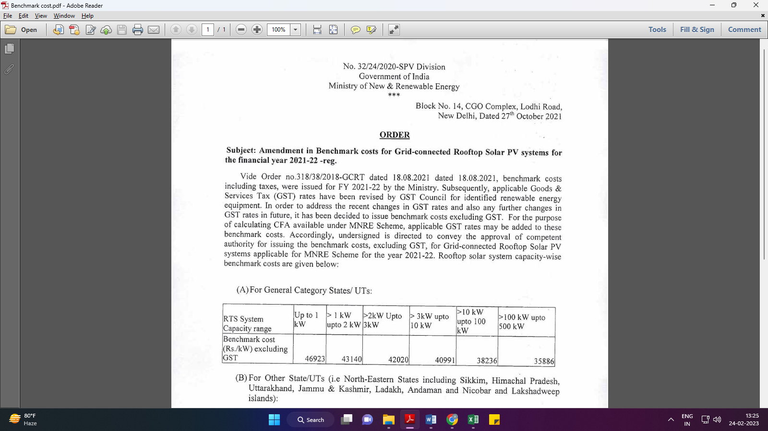
Market Comparables:
Annexure-2
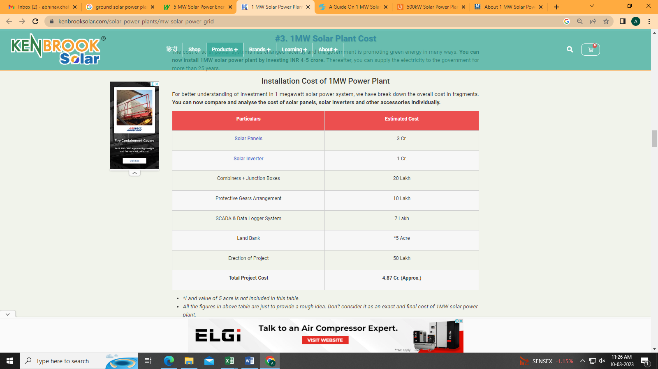

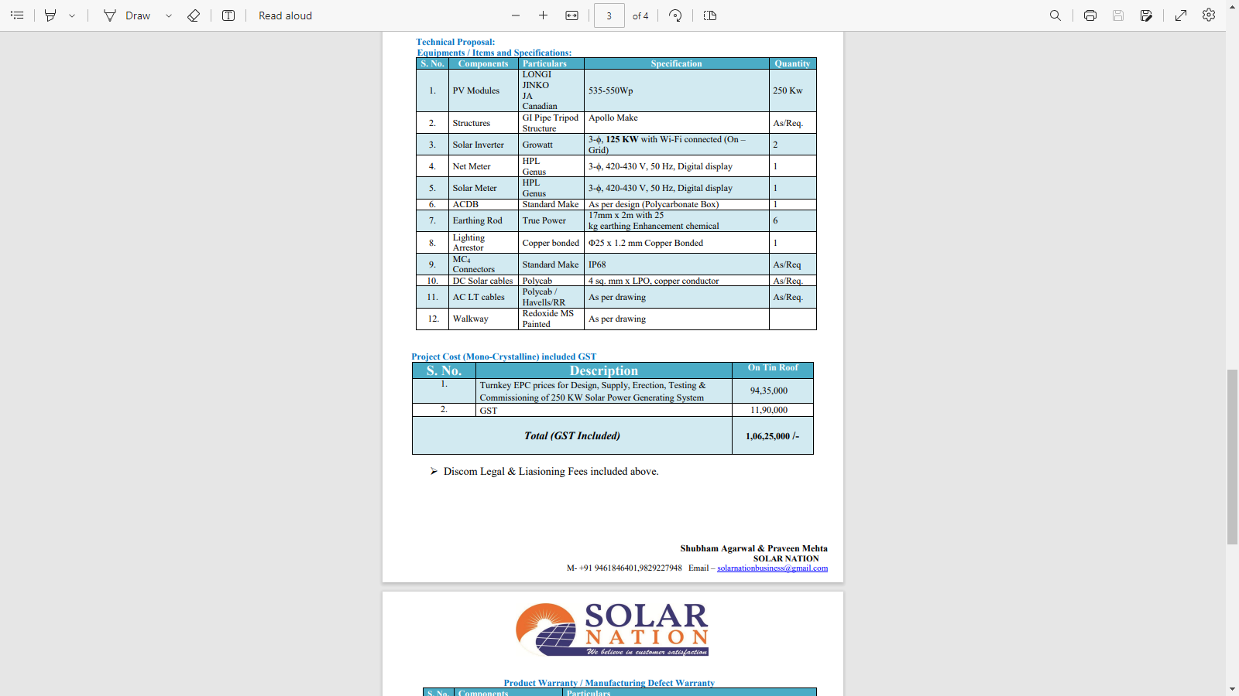

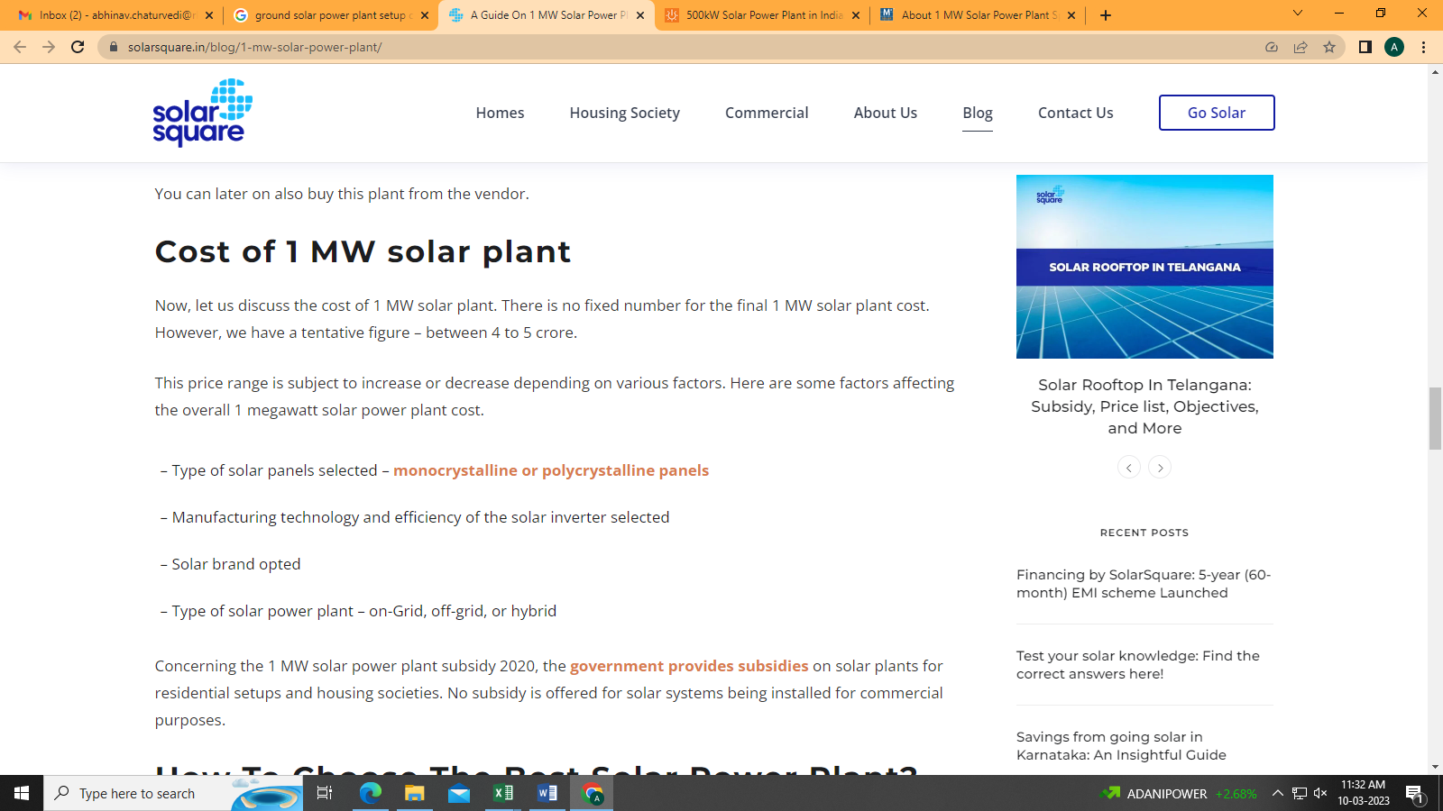
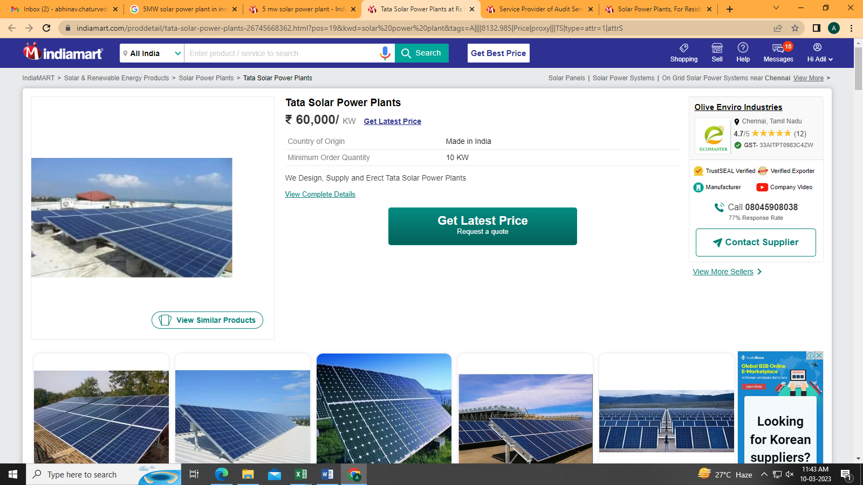

Data by Global Solar Atlas by World Bank Group
- Mahindra CIE Automotive Ltd – Stamping Division
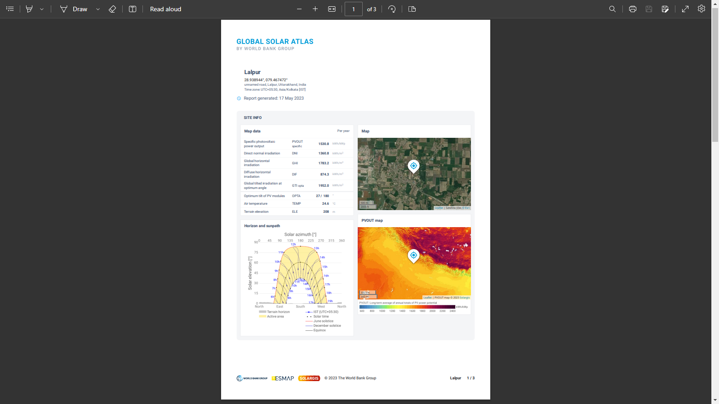
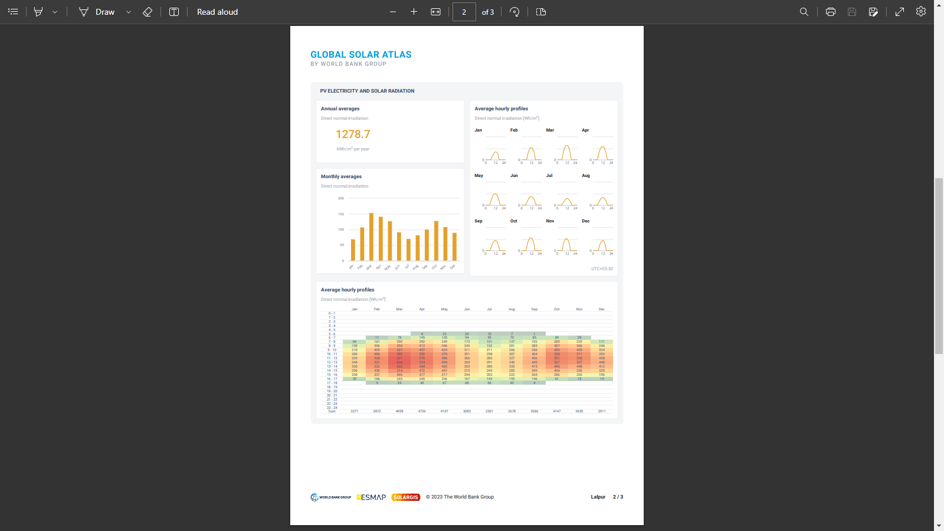

- Mahindra CIE Automotive Ltd – Gears Division
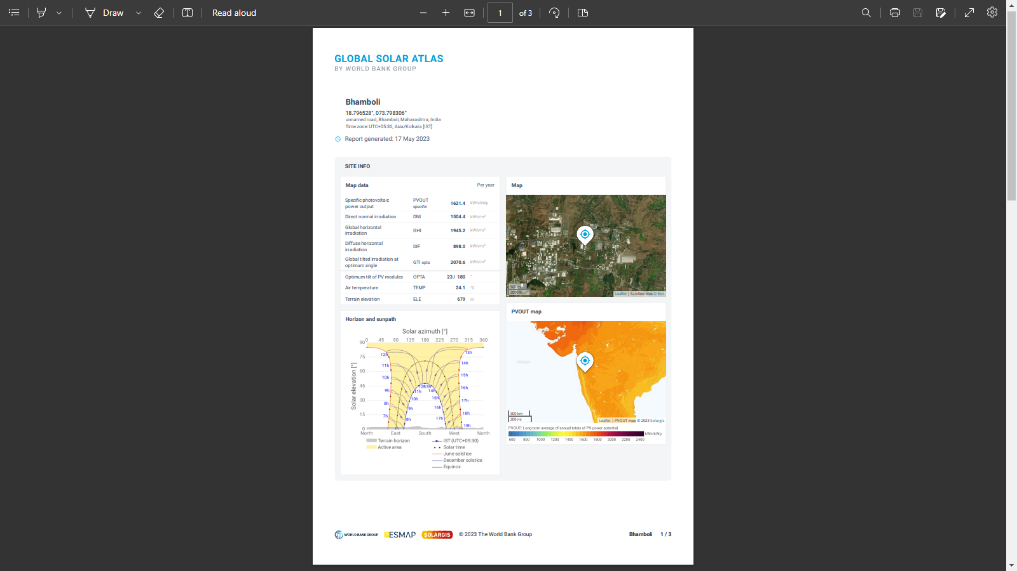

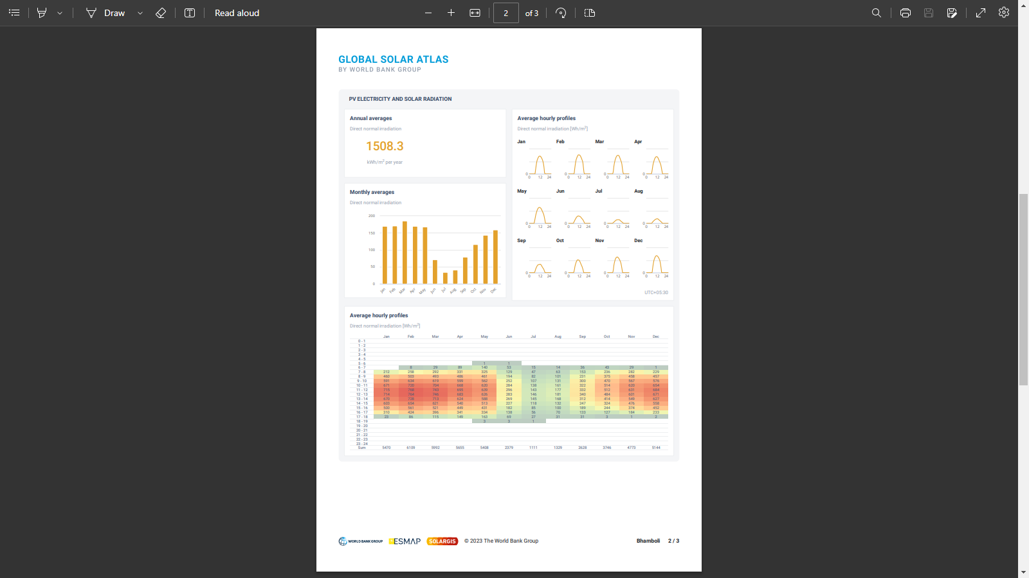

Layout Plans
- Mahindra CIE Automotive Ltd. – Stamping Division
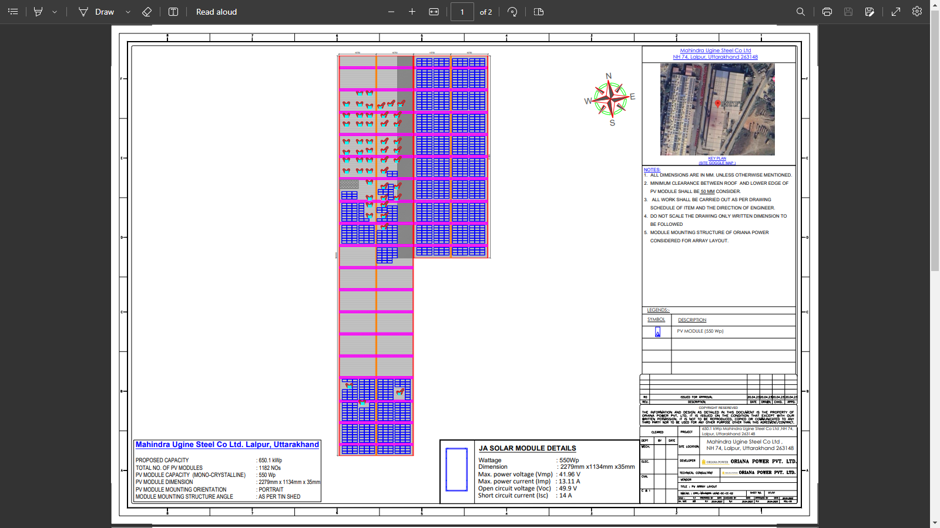

- Mahindra CIE Automotive Ltd – Gears Division
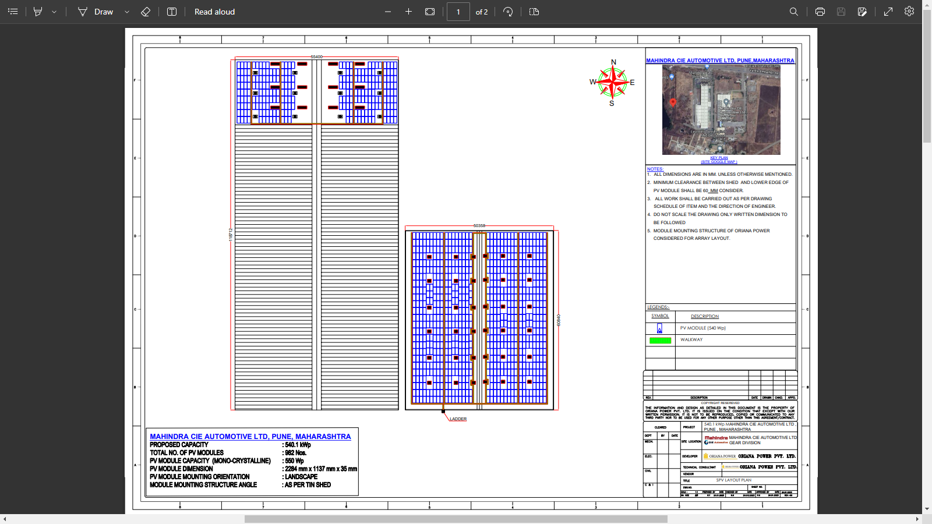
PART J | DISCLAIMER

      - No employee or member of R.K Associates has any direct/ indirect interest in the Project.
      - This report is prepared based on the copies of the documents/ information which the Bank/ Company has provided to us out of the standard checklist of documents sought from them and further based on our assumptions and limiting conditions. All such information provided to us has been relied upon in good faith and we have assumed that it is true and correct in all respect. Verification or cross checking of the documents provided to us has not been done at our end from the originals. If at any time in future, it is found or came to our knowledge that misrepresentation of facts or incomplete or distorted information has been provided to us then this report shall automatically become null & void.
      - This report is a general analysis of the project based on the scope mentioned in the report. This is not an Audit report, Design document, DPR or Techno-financial feasibility study. All the information gathered is based on the facts seen on the site during survey, verbal discussion & documentary evidence provided by the client and is believed that information given by the company is true best of their knowledge.
      - All observations mentioned in the report is only based on the visual observation and the documents/ data/ information provided by the client. No mechanical/ technical tests, measurements or any design review have been performed or carried out from our side during Project assessment.
      - Bank/FII should ONLY take this report as an Advisory document from the Financial/ Chartered Engineering firm and it’s specifically advised to the creditor to cross verify the original documents for the facts mentioned in the report which can be availed from the borrowing company directly.
      - In case of any default in loans or the credit facility extended to the borrowing company, R.K Associates shall not be held responsible for whatsoever reason may be and any request for seeking any explanation from the employee/s of R.K Associates will not be entertained at any instance or situation.
      - This Report is prepared by our competent technical team which includes Engineers and financial experts & analysts.
      - This is just an opinion report and doesn’t hold any binding on anyone. It is requested from the concerned Financial Institution which is using this report for taking financial decision on the project that they should consider all the different associated relevant & related factors also before taking any business decision based on the content of this report.
      - All Pages of the report including annexures are signed and stamped from our office. In case any paper in the report is without stamp & signature then this should not be considered a valid paper issued from this office.
      - Though adequate care has been taken while preparing this report as per its scope, but still we can’t rule out typing, human errors, over sightedness of any information or any other mistakes. Therefore, the concerned organization is advised to satisfy themselves that the report is complete & satisfactory in all respect. Intimation regarding any discrepancy shall be brought into our notice immediately. If no intimation is received within 15 (Fifteen) days in writing from the date of issuance of the report, to rectify these timely, then it shall be considered that the report is complete in all respect and has been accepted by the client upto their satisfaction & use and further to which R.K Associates shall not be held responsible in any manner.
      - Defect Liability Period is 15 DAYS. We request the concerned authorized reader of this report to check the contents, data and calculations in the report within this period and intimate us in writing if any corrections are required or in case of any other concern with the contents or opinion mentioned in the report. Corrections only related to typographical, calculation, spelling mistakes, incorrect data/ figures/ statement will be entertained within the defect liability period. Any new changes for any additional information in already approved report will be regarded as additional work for which additional fees may be charged. No request for any illegitimate change in regard to any facts & figures will be entertained.
      - R.K Associates encourages its customers to give feedback or inform concerns over its services through proper channel at le@rkassociates.org in writing within 30 days of report delivery. After this period no concern/ complaint/ proceedings in connection with the Lender’s Independent Engineering Services will be entertained due to possible change in situation and condition of the subject Project.
      - Our Data retention policy is of ONE YEAR. After this period, we remove all the concerned records related to the assignment from our repository. No clarification or query can be answered after this period due to unavailability of the data.
      - This Lender’s Independent Engineering report is governed by our (1) Internal Policies, Processes & Standard Operating Procedures, (2) Information/ Data/ Inputs given to us by the client and (3) Information/ Data/ Facts given to us by our field/ office technical team. Management of R.K Associates never gives acceptance to any unethical or unprofessional practice which may affect fair, correct & impartial assessment and which is against any prevailing law. In case of any indication of any negligence, default, incorrect, misleading, misrepresentation or distortion of facts in the report then it is the responsibility of the user of this report to immediately or at least within the defect liability period bring all such act into notice of R.K Associates management so that corrective measures can be taken instantly.
      - R.K Associates never releases any report doing alterations or modifications from pen. In case any information/ figure of this report is found altered with pen then this report will automatically become null & void.
FOR INTERNAL USE
Place : Noida  Date : 18.05.2023  Note : This report contains 36 pages | SURVEYED BY:  PREPARED BY:  REVIEWED BY: | Desktop LIE  Adil Afaque  Sr. V.P. Projects

For R.K Associates Valuers & Techno Engineering Consultants (P) Ltd.

DEFECT LIABILITY PERIOD - In case of any query/ issue or escalation you may please contact Incident Manager by writing at valuers@rkassociates.org. We ensure 100% accuracy in the Calculations done, Rates adopted and various other data points & information mentioned in the report but still can’t rule out typing, human errors or any other mistakes. In case you find any mistake, variation, discrepancy or inaccuracy in any data point of the report, please help us by bringing all such points into our notice in writing at valuers@rkassociates.org within 30 days of the report delivery, to get these rectified timely, failing which R.K Associates Valuers Techno Engineering Consultants (P) Ltd. won’t be held responsible for any inaccuracy in any manner. Also if we will not hear back anything from you within 30 days, we will assume that report is correct in all respect and no further claim of any sort will be entertained thereafter. We would welcome and appreciate your feedback & suggestions in order to improve our services.
COPYRIGHT FORMAT - This report is prepared on the copyright format of R.K Associates Valuers Techno Engineering Consultants (P) Ltd. to serve our clients in the best possible way. Legally no one can copy or distribute this format without prior approval from R.K Associates. It is meant only for the organization as mentioned on the cover page of this report. Distribution or use of this format other than R.K Associates will be seen as unlawful act and necessary legal action can be taken against the defaulter

